In-Flight performance and calibration of SPICAV SOIR on board Venus Express
A. Mahieux,^{*,1} S. Berkenbosch,¹ R. Clairquin,¹ D. Fussen,¹ N. Mateshvili,¹
E. Neefs,¹ D. Nevejans,^{1,2} B. Ristic,¹ A.C. Vandaele,¹ V. Wilquet,¹
D. Belyaev,³ A. Fedorova,³ O. Korablev,³
E. Villard,⁴ F. Montmessin,^{4,5} and J.L. Bertaux^{4,5}
¹Belgian Institute for Space Aeronomy, 3 av. Circulaire, B-1180 Brussels, Belgium.
²CONSERD, Krekelstraat 27, 9052 Gent, Belgium
³Space Research Institute (IKI), 84/32 Profsoyuznaya Str., 117997, Moscow, Russia.
⁴Service d’Aéronomie du CNRS, BP3, 91371, Verrières-le-Buisson, France; Université Pierre et Marie Curie, Paris, France.
⁵Institut Pierre Simon Laplace, Université de Versailles-Saint-Quentin, 78 Saint Quentin en Yvelines, France.
* Corresponding author: arnaud.mahieux@aeronomie.be
OCIS: 050.1950, 120.0280, 120.6200, 230.1040, 300.6340, 010.1280
Abstract

SOIR that is part of the SPICAV instrument on board Venus Express combines an echelle grating spectrometer with an Acousto-Optical Tunable Filter. It performs solar occultation measurements in the IR region at a high spectral resolution better than all previously flown planetary spectrometers. The wavelength range probed allows a detailed chemical inventory of the Venus’ atmosphere above the cloud layer with an emphasis on the vertical distribution of the gases. A general description of the instrument is given and its in-flight performances are described. The different calibrations and data corrections are investigated, in particular the dark current and thermal background, the non-linearity, and the pixel to pixel variability of the detector; the overall sensitivity of the instrument; the tuning relation and band pass function of the AOTF; the spectral calibration and resolution.

Introduction

Venus is a very warm (737 K at the mean surface) and very dry planet with a dense carbon dioxide (CO₂) atmosphere. Water is scarcely present today and it is not known yet if Venus was already dry at its formation or evolved slowly to its present state. In order to refine theories and models describing the formation and evolution of Venus and its atmosphere, to characterize the escape of D atoms from the upper atmosphere and to provide a robust explanation to the problem of the origin of water on Venus, high resolution vertically resolved measurements of H₂O and HDO and their temporal variations are needed.

Information about minor atmospheric constituents, their concentration, reactions, sources and sinks is also incomplete. In particular, photochemical models of the middle atmosphere would benefit of abundance measurements of NOx- and Cl-bearing gases.

The SOIR (Solar Occultation in the IR) spectrometer is an extension mounted on top of a copy of the SPICAM instrument [1] that is currently flying on Mars Express; the combination of both is called SPICAV/SOIR [2]. SPICAV/SOIR is one of the seven instruments on board Venus Express, a planetary mission of the European Space Agency (ESA) that was launched in November 2005 and inserted into orbit around Venus in April 2006 [3].

SOIR [4] is designed to measure at high resolution (0.15 cm⁻¹) the atmospheric transmission in the IR (2.2 – 4.3 µm). The solar occultation technique realized by SOIR allows deriving unique information about the vertical structure and composition of the Venus mesosphere. SOIR is the first high-resolution near IR spectrometer on-board a spacecraft investigating the Venusian atmosphere and it allows providing a sensitive search for new minor species from the top of the clouds up to about 125 km of altitude.

The newness of such a spectrometer and the high accuracy required for determination of minor constituents in the Venusian mesosphere demand precise calibration and an optimized observation process. Most of the important spectrometer calibrations were performed in flight while pointing to the Sun outside the atmosphere. The applied calibration scenario could serve as an example for calibration of similar spectrometers in space. This paper describes the in-flight performance of SOIR during one year of dedicated solar occultation measurements and the correction and calibration procedure applied to these measurements.

Instrument description

The SOIR instrument has already been described in detail in [4] and only a short summary will be reported here. SOIR is an innovative compact high resolution spectrometer for remote IR measurements of gaseous species, using solar occultations. The system consists of an Echelle grating spectrometer (Figure 1) working in the infrared combined with a TeO₂ Acousto-Optic Tunable Filter (AOTF) for the selection of the diffraction grating orders. Such an instrument combines the advantages of a high spectral resolution and a fast and flexible access to any part of its spectral domain, compactness and low mass.

The AOTF is a solid state optical filter that operates by the principle of acousto-optic diffraction in an anisotropic medium. The centre wavelength of the filter passband can rapidly be tuned by changing the radio frequency (RF) of the signal applied to the TeO₂ crystal’s transducer. The acoustic wave generated inside the crystal at the transducer modifies the refractive index of the crystal which, in turn, causes the entering light beam to split into an undiffracted and two diffracted beams, one horizontally and the second one vertically polarized. SOIR uses a non-collinear AOTF. The choice of this geometry has the significant advantage of simpler fabrication procedures. Moreover, the selection of one of the diffracted beams can be done without the use of polarizers. The selected diffracted beam enters the Echelle grating spectrometer through the spectrometer entrance slit.

In order to obtain a compact optical scheme for the high-resolution spectrometer a Littrow configuration was implemented, in which the usual collimating and imaging lenses are merged into a single off-axis parabolic mirror, with the additional benefit that no co-alignment of two separate lenses is needed.

The instrument line profile full width at half maximum (FWHM) is determined by the slit width and is equivalent to 2 detector pixels (60 μm). SOIR is a low power (17 W average) and a light weight instrument (7 kg), that can easily be accommodated on board of constraining planetary missions.

A periscopelike device was added in front of SOIR’s entrance aperture because VEX’ solar pointing direction is at an angle of 60° with respect to the optical axis of SOIR. As seen from Venus, the solar diameter is 40 arcmin; the entrance slit of the spectrometer corresponds to a FOV of 2x32 arcmin, while 1 pixel of the 2D detector corresponds to 1x1 arcmin. In this spectro-imager, the spectrum of each point of the slit is aligned along the lines of the 2D detector, while the slit is align with the columns.

The choice of the AOTF bandwidth is critical: it should be less than the free spectral range (FSR) of the Echelle spectrometer, i.e. the spectral interval in which there is no interference or superposition of light from adjacent orders. In the case of SOIR, the FSR equals 22.38 cm⁻¹, whereas the bandwidth of the AOTF was originally designed to be 20 cm⁻¹, as measured on ground before launch [4]. The real measured bandwidth of SOIR is ~24 cm⁻¹, creating some order leakage on the detector. The wavenumber domain that can be investigated by the SOIR instrument extends from 2256 to 4369 cm⁻¹, and is divided into 94 smaller ranges corresponding to the different orders (from 101 to 194). The detector width for orders 101 to 122 is smaller than the FSR of 22.38 cm⁻¹ and hence the detector will miss part of the spectrum. For orders 123 to 194 the inverse happens: the detector width is equal to or larger than the FSR and the detector will not be completely covered by the selected order.

The detector system is a modified SOFRADIR Integrated Detector Dewar Cooler Assembly, sensitive to radiation in the 1.7 to 4.3 µm spectral region, consisting of a two-dimensional array of photovoltaic HgCdTe pixels (320 columns x 256 rows) cooled by a Stirling type cooler (RICOR) to about 88 K.

Modes of operations

The SOIR detector has 320 columns along the wavenumber axis and 256 rows along the spatial axis. The slit is projected on 32 fixed rows only (Figure 2). Since, due to imposed telemetry limitations, only a data volume equivalent to 8 rows of 320 pixels can be retrieved per second, one is forced to bin the rows in 32 groups of 4 rows, provided only one order (or AOTF frequency setting) is used during a given second.

However, it is possible to select up to four different orders per second, allowing to gather a more versatile set of absorption lines. This reduces the maximum measurement time per order to 250 ms and implies that only 2 larger bins of 16 rows will be used if the complete slit height has to be covered. Other binning factors (2x12 rows, 4x4 rows), covering only a limited zone of the slit are also possible. These different binning configurations are illustrated in Figure 2.

To avoid detector saturation, integration times are set to 20 or 30 ms, depending on the wavelength at which the measurement is taken. In order to improve the SNR, a number of measurements can be accumulated as long as the total measuring time remains below 250 ms.

One of the advantages of using an AOTF for order selection is that it can be easily used as an electronic background chopper. Each measurement (given integration time and number of accumulations) is immediately followed by an identical measurement with the RF on the AOTF switched off. Background measurements are subtracted onboard from the measurements itself, therefore reducing the time for one measurement to 125 ms maximum, if all 4 orders are investigated within 1 second.

Several observation scenarios have been considered that will be briefly described hereafter.

Solar occultation mode

In solar occultation mode, SOIR is pointed towards the Sun while the latter sets or rises, allowing probing different layers of the atmosphere. As a baseline in this mode, 4 grating orders are scanned each second. In this case, due to the imposed available telemetry volume limits the data volume produced during each order has to be equivalent to two binned rows. Hence, a binning of 2 bins of 16 rows is used. Later, binning has been changed to 2 bins of 12 rows (Figure 2) because the external rows of the illuminated part of the detector show poor signal response.

Nadir mode

Although SOIR has been developed primarily to perform solar occultation measurements, nadir measurements have also been carried out, where the line of sight is directed towards the surface of Venus. The observed radiance corresponds to the radiation emitted by the surface, the cloud cover and the atmosphere and by sunlight reflected on the clouds. The observed signal is much lower than the direct Sun intensity during solar occultation measurements. In order to obtain a sufficiently high signal to noise ratio, first, several spectra are accumulated on board and second, transmitted spectra are summed over time periods in the order of minutes on ground. To lift the signal above the noise level, binning over the complete slit is also necessary.

Echelle order stepping modes

Two typical calibration modes, called order stepping or scan modes, exploit the ability of the AOT filter to select quickly a passband at any place in the spectral domain. In these modes, the AOTF frequency is incremented by a constant programmable value, allowing an AOTF frequency scan from a minimum to a maximum frequency, while all other parameters are kept constant.
Mini scan mode
The minimum and maximum frequencies are chosen to delimit a wavelength interval around one particular spectral feature, e.g. one deep Fraunhofer’s solar absorption line. This mode allows the precise calibration of the AOTF frequency versus wavenumber and of the AOTF bandpass function. The minimum and maximum frequency, as well as the frequency step, are chosen as a function of the type of measurement: if the goal is to derive the frequency to wavenumber relation, the frequency range defined by the minimum and maximum frequencies must cover the frequency corresponding to the wavelength of the spectral feature, and the step must be fine enough to determine unambiguously the frequency corresponding to the signal maximum. If the measurement is aimed at obtaining the AOTF bandpass function, a sufficiently large frequency interval has to be selected in order to precisely define the intensity of the main and the side lobes of the function.
Full scan mode
In this mode, the minimum and maximum frequencies correspond to the centre of SOIR’s order 101 (12915 kHz) and 194 (26325 kHz) respectively and the frequency increment is chosen such that it matches exactly the free spectral range (145 kHz). This mode of operation allows recording scans over the complete wavelength domain.

SOIR pointing calibration and correction

During measurements with SOIR, the spacecraft adopts an inertial pointing mode, meaning that the boresight of SOIR will be pointed during a predefined period of time towards a fixed position in the sky. During solar occultation measurements this position is typically a well chosen point on the solar disk. Any mechanical vector attached to the spacecraft or to SOIR instrument is defined with respect to a frame fixed to the spacecraft body (X, Y, Z), by a pair of angles (θ, φ) where φ is the angle of the direction with the plane XY, and θ is the angle of the projection of the direction on the XY plane with X axis. In particular, the boresight of SOIR is defined by nominal values θ=30°, φ=0°. An inertial pointing is commanded by asking the spacecraft to orient itself in such a way that a given celestial direction (i.e. a given point on the solar disk, determined by right ascension and declination) coincides with the desired instrument direction, i.e. the boresight.

Due to mechanical misalignment, the actual position of the SOIR boresight is not exactly the nominal one. Since this misalignment was not well measured before launch, it has been calibrated during a sequence of measurements using the solar disk as pointing target, placed at various positions (θ, φ) in the frame of the spacecraft.

Initially a raster of 9 points, with an angular spread of 30’ both in the θ- and in the φ-direction and centered around the nominal position of the boresight (θ=30° and φ=0°), was scanned. Looking at the position of the Sun and the change in intensity in the SOIR slit for these 9 points, a first approximation for the deviation between the SOIR boresight and the satellite pointing direction was derived. In consecutive pointing tests similar measurements were done with a finer grid (5’) leading to a precise measurement of the misalignment (θ=29°44’ and φ=0°04’).

The atmosphere of Venus is very dense, hence at the altitude of 65 km the air pressure is already as high (~73 mbar) as at an altitude of 18 km on Earth. At the altitude of 49.5 km the pressure reaches the same value as on the Earth’s surface. This means that refraction should be taken into account for a precise pointing.

To account for the change in apparent height of the Sun in Venus’ atmosphere and the flattening of the solar disk due to atmospheric refraction effects during sunset and sunrise, a constant offset of +10’ is added to the SOIR boresight, meaning that a point on the solar disk is pointed to, 10’ above the solar center (away from the planetary limb). The value of the offset was estimated using the Magellan mission data (http://atmos.nmsu.edu/PDS/data/mg_2401/, orbit 3212) for the air refractive coefficient. The use of progressive pointing adjustment (e.g. variable offset) would take into account even more accurately the effect of diffraction of the Sun light, and hence enhance the performance of the instrument at low altitudes.

In order to estimate the fraction of the solar disk covered by SOIR’s field of view, the position of the slit on the solar disk was calculated. The result for one particular observation (orbit 209) is presented in Figure 3. The solar disk position was modeled with (bulk solid line) and without (solid line) taking the refraction into account. The modeling shows that the slit stays within the solar disk till the boresight’s tangent height reaches an altitude of approximately 60 km and quickly discards from the solar disk at lower altitudes.

Defining a pointing direction by putting a celestial direction (α, δ) at a given angular position (θ, φ) in the frame of the spacecraft let one degree of freedom for the spacecraft orientation about the pointing direction. Spacecraft orientation is fully defined with the additional requirement that the projection of the SOIR slit becomes parallel to the Venus limb at a geometrical tangential height of approximately 65 km. At other tangential heights, the slit will have a small inclination angle with respect to the limb, degrading slightly the vertical resolution.

In-flight spectral performance and calibration measurements

Raw spectra registered by SOIR and transmitted to Earth, need dedicated processing in order to upgrade them to a calibrated data set. Therefore a number of instrumental parameters have to be characterized in flight in order to be able to calibrate and correct the spectra.

In-flight characterization is necessary since some instrumental parameters were not measured before take off, but also because they might have changed since launch, or might change during the operational life of the instrument. One noticeable change concerned the response of the AOTF: it was originally designed to be compatible with the free spectral range of the Echelle spectrometer, but it proved to have a slightly broader bandwidth after environmental testing. A thorough in-flight calibration is therefore necessary.

Below are summarized and then discussed in more detail, the different steps that are taken in the correction and calibration procedure of the SOIR spectra:

- Thermal and dark current (see 5.1) is measured and subtracted on board;
- Detector non-linearity correction (see 5.1): the detector response to incident light is not linear over the complete dynamic range of the well capacity. For low signals, a non linearity correction has to be applied;
- Bad pixel and pixel-to-pixel variability correction (see 5.2): the properties, i.e. the gain, of each pixel differ slightly. Moreover, some (bins of) pixels show an unpredictable or systematically wrong behavior. Their values are removed and replaced by values of adjacent pixels or bins;
- Sensitivity correction (see 5.3): takes into account the non-constant overall instrument sensitivity as a function of wavelength;
- AOTF frequency-to-wavenumber calibration, also named tuning relation (see 5.4): establishing an AOTF tuning relationship between the applied RF and the selected wavenumber domain and bandpass curve;
- Spectral calibration, which transforms pixel number into wavenumber and evaluates the calibration error (see 5.5);
- Division by a reference solar spectrum: ideally the reference spectrum that is taken outside the atmosphere would be measured with an identical relative slit position with respect to the solar disk. Attitude drift of the spacecraft however makes the slit float which results in a gradual linear change of the intensity. This effect is corrected for (see 6).

Finally, also the spectral resolution of the instrument has been derived from in-flight measurements and its evolution on the entire spectral domain has been investigated (see 5.6).

Thermal background, detector dark current, and non-linearity corrections

Before the start of the measurement, the detector has to be cooled down to a temperature of 90 K. This precooling lasts for 600 seconds. Thermal background and detector dark current are directly removed from the measurements on board. In fact, as already mentioned, one spectrum is the subtraction of two recordings performed one after the other: the first recording is taken with the AOTF on and corresponds to the number of signal photons S plus the number of background photons B (S+B). The second recording with AOTF off corresponds to the background only (B) and contains a contribution of the detector dark current and the thermal emission of the optics between AOTF and detector. Signals S and S+B are obtained on board after digitization of the analog output of the detector, and usually only the digital difference (S+B) – S is transmitted to ground.

For low signal intensities (below 25 % of the full well capacity) the detector has a non-linear response. It is important to correct for this behavior in order not to distort the ratios between weak and stronger absorption lines. Both absorption spectra (AOTF on) and background spectra (AOTF off) should be subject to this correction. However, since on board background subtraction ((S+B) – B) is applied, spectra containing only the signal contribution S are available on ground. Therefore an approximate method for non-linearity correction has to be used (Figure 4).

During observation sessions of the dark sky a so called linearity plot is constituted, giving the thermal background plus the detector dark signal (B) as a function of integration time.

The linearity plot in Figure 4 (Feb 21st 2006) confirms the non-linear behavior for low collected pixel charge. The pixel charge is converted by the detector read-out process into Analog-to-Digital Converter (ADC) units. In Figure 4 the ADC units have been scaled to correspond to 1 accumulation and 1 pixel. With measurement 1 (S+B) and measurement 2 (B) ADC values ADC_{S+B} and ADC_{B} correspond. Only the subtraction of these ADC values ADC_{S} = ADC_{S+B} - ADC_{B} is available on ground.

It is assumed that the linearity plot provides a good approximation (ADC’_{B}) for ADC_{B} at the given integration time of a spectrum and for the instrument temperature at the time of the measurement. Then the total signal S+B before subtraction can be estimated by adding ADC’_{B} to the transmitted ADC value ADC_{S} : ADC_{S+B} ≈ ADC’_{S+B} = ADC_{S} + ADC’_{B}.

Since the linearity plot does not give the relation between the physical amount of electrons or charge on a pixel and the recorded ADC value (no calibration has been performed) the notion of arbitrary charge units (ACU) is introduced: the integration time (in ms) at which a code ADC’_{B} is registered, is taken as the (arbitrary) charge accumulated on the pixel. The relation between ADC and ACU can be approximated by a polynomial of degree 10 for ADC values below 6000, and by a linear function for ADC values above 6000. Now the number of photons S+B and B can be expressed as ACU_{S+B} and ACU_{B} (ACU_{B} is nothing else than the integration time in ms), and the number of photons that can be attributed to the signal S (pure signal, no background), corrected for non-linear detector effects is ACU_{S} = ACU_{S+B} – ACU_{B} (Figure 4).

Pixel-to-pixel non uniformity
Flat-field correction is taking into account the difference in quantum efficiency and dark current of the detector pixels. For solar occultation observations these differences can be cancelled out by taking a solar reference spectrum outside Venus’ atmosphere under the same conditions and then dividing each atmospheric absorption spectrum by this reference spectrum. Note that this will not be the case for nadir measurements nor for any other case using raw data where no solar reference spectrum subtraction is applied, in particular measurements used for the determination of the AOTF band pass function.

The pixel to pixel non uniformity is an intrinsic characteristic of the detector. It originates from the fact that the physical properties of each pixel of the detector differ slightly. In the laboratory, pixel to pixel non uniformity is measured by illuminating the detector directly, without passing through the spectrometer, with a homogeneous light source. By repeating this measurement several times and with different exposure times, the influence of the latter is removed and random noise is reduced. After removing the continuous component of these spectra, the pixel to pixel non uniformity is obtained. This correction has to be applied to the raw signal recorded during a real measurement and will compensate for the different gains from pixel to pixel. This function needs to be monitored in time, as aging of the detector can induce variations of the pixel response.

However for SOIR, due to the very tight instrument development and test schedule, these measurements could not be performed before launch. We will show that it is possible to extract useful information from the solar spectra obtained in flight by SOIR. Solar spectra recorded in the full scan mode outside the Venus atmosphere were considered. Several orders were selected, which correspond to spectral regions where no or only very weak solar lines are present (less than 0.03 % of transmittance). High pass filtering of those spectra removes the general response curve of the AOTF, the optics and the spectrometer, leaving only the pixel to pixel non uniformity. Figure 5 illustrates the method used for determining the pixel to pixel non uniformity.

As, by definition, this non uniformity depends on the physical pixel and on the chosen binning, one must construct correction functions for every binning mode used by SOIR. In particular, in the solar occultation mode using a binning of 2x12 rows or 2x16 rows, the pixel to pixel non uniformity will be different for the ‘bin 1‘ and ‘bin 2‘ spectra.

Spectral sensitivity curve

The spectral sensitivity curve describes the dependence of the SOIR instrument as a function of the wavelength of the incoming light. Because this wavelength has been selected through the AOTF, the spectral sensitivity may be expressed in terms of AOTF frequency, after the pixel to pixel variation has been removed from the spectra. An important contribution to the irregular form of the sensitivity curve comes from the AOTF diffraction efficiency dependence on wavelength and the imperfect matching of the RF driver output impedance to the AOTF transducer impedance. In SOIR no effort is made to “equalize” this effect by tuning the AOTF power as a function of wavelength.

The spectral sensitivity curve has been obtained from direct Sun observations, with a binning of 8 groups of 4 pixel rows in the spatial direction, while SOIR is in full scan mode (see section 3.3). This is shown in Figure 6. Groups of 10 pixels have been considered in the spectral direction, to smooth out the contribution of unavoidable solar absorption lines. Linear interpolation has been done afterwards to recover the spectral sensitivity curve for all pixel rows. The spectral sensitivity curve should be monitored over time, as it reflects the intrinsic behavior of the instrument, and may slightly change during SOIR’s life. Based on the sensitivity curve, optimized integration times have been determined for each recording condition.

The sensitivity of the instrument should be taken into account when analyzing raw data. The effect of wavelength dependent instrument sensitivity cancels itself out however, when transmittances (i.e. ratios of two spectra obtained under similar conditions) are calculated. The sensitivity curve determines the signal-to-noise ratio for different spectral ranges of the instrument and the error level for the retrieval of different gaseous constituents.

Filter tuning relation and band pass response

At a fixed radiofrequency f, the AOTF selects only a narrow wavelength band. The center wavelength λ of a given band is determined by the momentum matching condition and is appreciatively given by the following expression [5], also called the tuning relation of the AOTF:
( )
where θ_{i} is the incident angle, v is the acoustic velocity, and Δn is the birefringence of the crystal. The tuning function follows approximately a 1/λ law, but not exactly because of the wavelength dependence on the refractive indices. The refractive indices of TeO₂ have been measured by Uchida [6], and the dependence of the birefringence on wavelength has been shown to follow the simple approximation formula [7]:
( )
where a, b, and λ_{c} are constants (a=7.156 nm, b=0.1338, λ_{c}=262.9 nm for TeO₂).

The intrinsic passband of an AOTF is determined by the effect of momentum mismatch caused by the deviation of wavelength from the exact wave vector momentum matching condition in the filter transmission [5]. The transmission of an AOTF can be written as
( )
in which λ₀ is the peak wavelength, T₀ is the peak transmission, sinc(x)=sin(Δx)/Δx, Δλ_{FWHM} is the bandpass full width at half maximum (FWHM), which can be approximated [5] by
( )
where L is the acoustic interaction length in the crystal:
( )
with W the transducer width (36 mm) and α the angle of incidence of acoustic wave (9°10’), b_{λ} is the dispersive constant:
( )
with the a and λ_{c} the parameters already defined in Equation (2).
Expression (4) can be rewritten in terms of wavenumber.
( )
which indicates that the FWHM band pass is essentially constant when expressed in wavenumber if the dependence of b_{λ} on wavelength is neglected.

In addition, the passband is broadened by several other effects such as the divergence of the incident optical beam, the angular spread of the acoustic beam, the optical non-uniformity of the acousto-optic material. In fact, as will be demonstrated hereafter, the AOTF transmission in SOIR, and in particular its width and its peak position, is different for each of the pixel bins on the detector. In the normal mode of observation, used for solar occultation measurements, two spectra are recorded simultaneously corresponding to two super bins of 16 detector lines, further defined as ‘bin 1’ (detector lines 188 to 203) and ‘bin 2’ (detector lines 204 to 219) spectrum (see Figure 2). For both ‘bin 1’ and ‘bin 2’ spectra, a tuning function and AOTF band pass functions have to be determined, as Eq. (4) shows that the width of the AOTF band pass function depends on wavelength. Modeling these band pass functions as a function of wavelength allows refining the wavelength-to-frequency relation.

Mini scan observations have been dedicated to the determination of the AOTF band pass function. Each mini scan was centered on an AOTF frequency corresponding to a well defined solar line. This solar line will be observed on a precise pixel. Other solar lines from the neighborhood of the targeted one are often also visible on other pixels, which allow retrieving many more AOTF band pass functions at the same time. The study of the variation of the measured intensity as a function of the applied frequency allows the precise characterization of the band pass function. The determination of the wavelength-to-frequency relation has been realized using the same mini scan observations and by determining the position of the function maximum.

Assuming that f is the AOTF frequency that corresponds to the wavelength of the solar line, three types of mini scan observations were defined and performed:
- from f - 500 kHz to f + 500 kHz in steps of 20 kHz;
- from f - 225 kHz to f + 225 kHz in steps of 15 kHz
- from f - 360 kHz to f + 360 kHz in steps of 5 kHz;

The correction procedure first handles the pixel to pixel non uniformity (section 5.2) and the sensitivity of the instrument (section 5.3). On top of that, spectra are flattened using a base line level: since the observed solar line is recorded on one pixel only, the levels in the adjacent pixels can act as reference level for base level subtraction. Residual base level has been fitted as a second order polynomial. Figure 7 illustrates the method applied to derive the AOTF band pass function using the solar line at 2943.69 cm⁻¹.

The same procedure has been applied to all available mini scans (42 in total). Figure 8 shows the results obtained for 3 typical solar lines. The retrieval has been done using about 250 solar lines widespread along the spectrum, for all bins and binning cases. They all show a transmittance deeper than 0.88. The shape of the band pass does not show high variation over the entire SOIR’s spectral domain, as shown in Figure 8, where the curves correspond to cardinal sine functions:
( )
with I, ν₀, and Δν₀, parameters whose values are obtained by best fitting this expression to the observed AOTF band pass functions, while fitting the baseline level by a second order polynomial function. Using such an approximation, an AOTF band pass function can be derived at any given wavenumber of the investigated spectral range.

Figure 9 shows the evolution of the FWHM of the AOTF band pass throughout the entire spectral domain. Those values have been obtained by considering the different band pass functions for the 250 solar lines. The top of Figure 9 describes the FWHM for bin 1, and the bottom for bin 2 (in a 2x12 binning case). Error bars, which were returned by the fitting algorithm, were used as weighting factors for determining the FWHM. Table 1 gives the value of the FMWH, which should be compared to the theoretical value of 18.0 cm⁻¹ derived from Eq.(7), and the value of 20 cm⁻¹ measured before launch [4]. The difference between theory, previous measurement and reality is explained by degradation of the crystal quality after overstressing during environmental testing before launch (both thermal and mechanical).

The determination of the position of the maximum of the AOTF band pass function allows deriving the wavenumber-to-frequency relation (tuning function). This is illustrated in Figure 10, where the tuning function is plotted for bin 1 and bin 2 of a 2x12 pixel rows configuration. The frequency steps of each mini scan measurement were used as weighting factors. The tuning function can be fitted by a second order polynomial linking the radio frequency (f) in kHz to the wavenumber (ν) in cm⁻¹ by
( )
where a, b, and c are given in Table 1 for bins 1 and 2 in the configurations of 2x12 pixel rows and 2x16 pixel rows.

This function describes the position of the maximum of the AOTF band pass function versus wavenumber and is very important, because small shift of the band pass can introduce large deformations in the transmitted spectrum.

In Figure 9 and Figure 10, the color of the points represents the AOTF temperature at the time of measurement, only covering a range of 3 degrees. From these figures, no obvious detectable temperature dependency could be observed, neither for the tuning function, nor for FWHM, the variation being in the error bars.

Spectral calibration (wavenumber-pixel calibration)

The pixel-to-wavenumber relation has been obtained by analyzing well defined solar lines in the full scan measurements outside the atmosphere. Such measurements are performed regularly to follow the evolution of the spectral calibration in time, as well as the aging of the instrument. The spectral calibration results from the fitting of a polynomial relation between the wavenumber positions of about 100 solar lines and the pixel position of the observed lines. Those lines are observed in different orders to cover the full wavenumber range. Different polynomial fits of order up to 5 have been tested. The average error in pixel position on the selected solar lines was studied as a function of the order of the polynomial used for the pixel number-wavenumber calibration. It turned out that a linear calibration relation is not sufficient and that above order 3 no real improvement is obtained, so a polynomial of order 3 has been chosen for this calibration. The average error on the pixel position is of about 1 pixel.

The spectral error has been computed by comparing full Sun raw spectra taken by SOIR with tables listing the known solar absorption lines [8]. The peak position of about 30 solar lines has been compared throughout the entire scanned range, and position differences have been computed. Because different binning cases have been used (2x12 pixel rows and 2x16 pixel rows, see section 3.3), this spectral error has been computed for all bins of all binning configurations. The error is constant (0.05 cm⁻¹) over the whole detector width, no pixel number dependency has been observed.

Spectral resolution

Two fundamental parameters defining the performance of a spectrometer are its spectral sampling interval (SSI) and its instrument line profile (ILP). Based on the theoretical optical design the SSI was predicted to have a value of 0.1 cm⁻¹ per pixel and an ILP with a FWHM of 0.2 cm⁻¹. Before flight both characteristics were verified using a He-Ne laser line at 3.39 µm and in a rudimentary test with the Sun as a source. Although these tests confirmed the order of magnitude of both SSI and ILP, they are valid only in a very limited part of the spectral domain. No systematic spectral resolution performance tests over the entire domain could be carried out before launch.

Therefore during flight more detailed resolution measurements were performed, making use of solar absorption lines in spectral recordings outside the atmosphere. The ILP of SOIR was approximated by a Gaussian function whose width was determined by comparing well defined and relatively well isolated solar lines. The selected spectra corresponded to altitudes above 280 km where absorption by CO₂ does not yet influence the solar spectrum. The selected spectra were first corrected for the pixel to pixel non uniformity and instrument sensitivity variations.

In the simulation a high-resolution solar spectrum [8] is multiplied by the appropriate AOTF function, the contributions of 7 adjacent orders are added, and finally the spectrum is convoluted with a Gaussian function. The FWHM of the Gaussian is tuned until best agreement is found between the observed line and the simulation. A result of such a comparison is shown in Figure 11. Using a series of solar lines in different grating orders, the evolution of the ILP could be obtained for the entire spectral domain and is presented in Figure 12. It is shown that the ILP varies from 0.13 cm⁻¹ to 0.27 cm⁻¹ across the entire spectral interval.

Measurements

A SOIR occultation observation can be taken either at sunset or sunrise. The following case study is for a sunset, but sunrises can be treated similarly, only altitudes of observation will increase with time. Well before the instrument’s line of sight to the Sun intersects with the top layers of the atmosphere, the measurement cycle is started and reference spectra are recorded (at a rate of 1 spectrum per second). Once the top of the atmosphere is reached, solar light is absorbed and the intensity of the recorded signal starts to decrease until the Sun gets so much flattened that the spectrometer slit moves out of the diffracted solar disk (see section 4). The altitude is retrieved from the spacecraft attitude and orbital data provided by ESOC.

Figure 13 illustrates the signal intensity measured during a typical occultation. As one can see, the direct solar intensity observed before the occultation is not constant. This is due to a drift of the satellite during the measurement, resulting in a slight apparent motion of the slit over the solar disk.

One of the main advantages of solar occultations is that it is a self-calibrated technique in terms of transmission: dividing a spectrum obtained during the occultation by a reference solar spectrum recorded outside the atmosphere removes the solar signature and leaves a transmittance containing only information about the composition of the Venus atmosphere. The reference spectrum is in fact defined by selecting spectra recorded between about 60 s to 90 s before the occultation effectively starts. However to take the satellite drift into consideration, those spectra can not be simply averaged. A linear regression on every pixel of the detector is performed so that the reference spectrum corresponding to an occultation spectrum taken at a given time includes the decrease (or increase) of solar intensity (see Figure 13).

Figure 14 gives an example of the evolution of the spectra through one occultation (sunset April 15th 2007) in the orders 121, 149, 171 and 190 corresponding to the 2725-2750 cm⁻¹, 3330-3357 cm⁻¹, 3820-3855 cm⁻¹, and 4245-4283 cm⁻¹ ranges, respectively. These transmittances show the characteristic behavior observed on all occultation series measured by SOIR. At the beginning of the series, the light path does not cross the atmosphere. No absorption signatures are present and transmittances are equal to unity. As the Sun sets, the light path goes deeper and deeper into the atmosphere, and two absorption processes take place: the overall signal decreases due to extinction by aerosols and absorption signatures appear. At the end of the observation, no light is captured anymore when the Sun disappears behind the cloud deck or moves out of SOIR’s field of view due to diffraction. The structures seen in the spectra of Figure 14 are mainly attributed to HDO (Figure 14A), CO₂ (Figure 14B), H₂O (Figure 14C) and CO (Figure 14D). From this figure, it can also be seen that in general, the SOIR spectra contain information on the Venus atmosphere between 65 km and 110 km for molecules such as HDO or HCl. For H₂O and CO signatures are still observable up to 130 km altitude and CO₂ features are seen up to 125-130 km [9, 10]!

Average values of the signal to noise ratio calculated from the raw spectra (before dividing by spectra taken out of the atmosphere) were found to be in general between 500 and 650, depending on the signal level.

The retrieval code allowing the determination of the vertical profiles of the different observed species is based on the onion peeling method, starting the analysis of a series of spectra of an occultation, with the spectrum corresponding to the highest altitude where a signature is visible, deriving the concentration in that most external layer and using this information for analyzing the next spectrum of the series. Progressively, the vertical profile is constructed from the most external layer down to an altitude of 65 km. The full description of this procedure will be presented in a forthcoming paper [11].

Conclusions

SOIR is a very sensitive instrument placed on board Venus Express (ESA). It combines an echelle grating spectrometer and an Acousto-Optical Tunable Filter (AOTF), the latter being used for the selection of the appropriate grating orders. SOIR performs solar occultation measurements in the IR region (2.2-4.3 µm) and is therefore sensitive to the absorption of some key gases for the chemistry of the atmosphere of Venus, such as H₂O, CO and CO₂, and HDO, HCl, HF for which concentration vertical profiles were obtained for the first time [12].

The in-flight performances of the instrument have been examined in detail. In particular the corrections for the thermal and dark currents and for the non-linearity of the detector are taken into account. In-flight measurements have allowed the determination of the pixel to pixel variability of the detector, describing the slight difference of the physical properties of each pixel of the detector. The overall spectral sensitivity of the instrument has also been investigated.

From dedicated measurements of well defined and isolated solar lines, the characteristics of the AOT filter could be inferred. In particular, the wavenumber versus AOTF frequency relation has been obtained for the different configurations of the instrument. The AOTF band pass functions have been obtained from several solar lines, allowing the determination of this function over the entire spectral domain.

Finally, the precise analysis of some well chosen solar lines lead to a better definition of the instrumental resolution and its evolution over the spectral domain investigated by the instrument.

Solar occultation measurement is a self-calibrated technique in terms of transmission, as it corresponds to the division of two spectra, one obtained while looking at the Sun through the atmosphere and one recorded outside the atmosphere. Preliminary analysis has shown the possibility to retrieve vertical profiles between 65 and 120 km for most of the observed species.

Acknowledgments
The research program was supported by the Belgian Federal Science Policy Office and the European Space Agency (ESA – PRODEX program – contracts C 90268, 90113, and 17645).
Procurement of AOTF was funded by CNES.
We would like to thank Jacques Sauval of the Royal Observatory, Brussels, Belgium, who provided us with a catalogue of the solar absorption lines for the wavenumber range of interest.
Russian team acknowledges also RFBR grant 06-02-72563.
References

1. Bertaux, J.L., et al., The study of the Martian atmosphere from top to bottom with SPICAM Light on Mars Express. Planet. Space Sci., 2000. 48: p. 1303-1320.
2. Bertaux, J.L., et al., SPICAV on Venus Express: Three spectrometers to study the global structure and composition of the Venus atmosphere. Planetary and Space Science, 2007. 55(12): p. 1673-1700.
3. Titov, D.V., et al., Venus Express science planning. Planetary and Space Science, 2006. 54: p. 1279-1297.
4. Nevejans, D., et al., Compact high-resolution space-borne echelle grating spectrometer with AOTF based order sortig for the infrared domain from 2.2 to 4.3 micrometer. Applied Optics, 2006. 45(21): p. 5191-5206.
5. Chang, I.C., Acousto-optic signal processing: theory and implementation, in Acousto-optic signal processing: theory and implementation, N.B.a.J. Pellegrino, Editor. 1996, Marcel Dekker: New York.
6. Uchida, N., Phys. Rev., 1971. B4(3736).
7. Yano, T. and A. Watanabe, Acoustooptic TeO2 tunable filter using far-off-axis anisotropic Bragg diffraction. AO, 1976. 15(9): p. 2250-2258.
8. Hase, F., et al., An empirical line-by-line model for the infrared solar transmittance spectrum from 700 to 5000 cm-1. Journal of Quantitative Spectroscopy and Radiative Transfer, 2006. 102(3): p. 450-463.
9. Bertaux, J.L., et al., First Observation of 628 CO2 isotopologue band at 3.3 µm in the atmosphere of Venus by solar occultation from Venus Express. Icarus, 2007. Accepted.
10. Wilquet, V., et al., Line parameters for the 01111-00001 band of 12C16O18O from SOIR measurements of the Venus atmosphere. Journal of Quantitative Spectroscopy and Radiative Transfer, 2007. Submitted.
11. Wilquet, V., et al., Characterization of the upper venusian haze from UV to mid-IR by SPICAV/SOIR on VEX. Journal of Geophysical Research, 2008. In preparation.
12. Bertaux, J.-L., et al., Venus: a warm layer in the cryosphere and new measurements of HF, HCl, H2O and HDO. Nature, 2007. In press.

Table captions

Table 1: Coefficients for the wavenumber-to-frequency relation (tuning function) for bins 1&2, frequency in kHz, wavenumber in cm⁻¹, and value of the FWMH of the AOTF band pass function, in cm⁻¹

Figure captions

Figure 1. Optical scheme of the SOIR spectrometer. (1) AOTF entrance optics; (2) Diaphragm; (3) AOTF; (4) AOTF exit optics; (5) Spectrometer entrance slit; (6) Collimating and camera lens merged into one off-axis parabolic mirror; (7) Echelle grating; (8) Folding mirror; (9) Folded detector optics; (10) Detector assembly placed upright.

Figure 2. The detector is an array of 320x256 pixels. Due to the dimension of the slit, only 32 rows are illuminated. Several binning configurations have been defined: 2 bins of 16 rows, 2 bins of 12 rows, 8 bins of 4 rows, and 4 bins of 4 rows.

Figure 3: Modeled view of a solar occultation measurements (orbit 209) with (bold solid line) and without (solid line) refraction. The position of the slit on the solar disk is indicated by a rectangle. The coordinates are: the tangent altitude of the un-refracted Sun and the horizontal displacement of the solar tangent point from the point where the slit is parallel to the limb.

Figure 4: Method for detector non-linearity correction. ADC_{S}: ADC value available on ground, ADC'_{S+B}, ADC'_{B}: approximation of codes for signal plus background and background, ACU_{S+B}, ACU_{B}, ACU_{S}: total, signal and background pixel charge in arbitrary units.

Figure 5. Pixel to pixel non uniformity. (a) A spectrum where weak solar lines are present is selected, (b) high pass filtering is applied. (c) Other spectra where weak solar lines are present are selected and filtered; the global average is calculated (top panel). The percentage difference relative to the mean is shown in the bottom panel.

Figure 6. Overall sensitivity of the SOIR instrument. Top: sensitivity of bin 4 of the detector in a binning case of 8 bins of 4 rows. Bottom: sensitivity of row 150 with respect to the AOTF frequency. This row is highlighted in the top figure.

Figure 7: Measured AOTF bandpass functions at 2943.69 cm⁻¹ (binning 4x8). The top panel presents the measurements of the intensity (bin 4 on the detector) versus the AOTF frequency and the pixel number after correction for the pixel to pixel variability and instrument sensitivity, showing the residual background level. Middle panel is obtained when this background is removed from the measurements, and finally the bottom panel shows the AOTF band pass corresponding to the 2943.69 cm⁻¹ solar line

Figure 8: AOTF band pass functions for a binning of 12 for bin 1 by analyzing the solar lines situated at (a) 2583.79 cm⁻¹, (b) 3012.03 cm⁻¹, and (c) 4193.03 cm⁻¹. Top panel of each figure shows the measured valued on the detector with respect to the AOTF frequency. Concerned pixel line is highlighted. Middle panel shows the measured band pass function (dashed) and fitted function (plain). Bottom panel shows the retrieved AOTF band pass function.

Figure 9. Evaluation of the FWHM of the pass band function using the dedicated mini scan. Top of figure is for bin 1; bottom is for bin 2. On both panels, color indicates temperature of the AOTF at the time of measurement of the maximum of the band pass function.

Figure 10. Tuning relations for bins 1 and 2 of the detector. Top panel: wavenumber-frequency relation for bin 1 derived from mini scans measurements. A zoom on the right side of the fit is included. Bottom panel: wavenumber-frequency relation for bin 2 derived from mini scans measurements. On both panels, color indicates temperature of the AOTF at the time of measurement of the maximum of the band pass function.

Figure 11: Determination of the spectral resolution of the SOIR instrument. The observed solar line at 3013.7 cm⁻¹ (dashed) measured in order 134, during orbit 227 and the fitted line (plain) are compared. The latter has been obtained by convoluting a high-resolution solar spectrum with a Gaussian function of 0.17 cm⁻¹ FWHM.

Figure 12: Evolution of the observed FWHM of the Instrument Line Profile throughout the spectral domain

Figure 13. Evolution in time of the signal intensity (sunset September 3rd 2006). The plotted intensity is an average value over all 320 pixels (wavelenghts) for each of the recorded order. The 8 curves correspond to the 8 spectra recorded in one second (‘bin 1’ and ‘bin 2’ part of the detector for each of the 4 selected orders). First direct solar radiation is measured when the ligth path does not cross the Venusian atmosphere. During the occultation, the observed signal decreases. Finally the light path is intercepted by the cloud cover lying at 60-65 km and no ligth reaches the detector anymore. The dashed line shows the linear regression representing the solar reference spectrum. At time t, the observed signal is I(t) corresponding to an effective reference spectrum I₀(t).

Figure 14. Example of spectra obtained during one occultation (sunset April 15th 2007). Each transmittance is obtained by making the ratio of the solar spectrum seen through the Venus atmosphere to the not attenuated solar spectrum measured above the atmosphere. The selection of a spectral interval is achieved through the AOT filter, tuned in this case to (A) 15809 kHz for diffraction order 121, (B) 19869 kHz for diffraction order 149, (C) 23031 kHz for diffraction order 171, (D) 25742 kHz for diffraction order 121. In these particular ranges of wavenumber, the main absorption lines are from (A) HDO, (B) CO₂, (C) H₂O, (D) CO.

Tuning function |  |  |  |  | FWHM
Binning case | Bin number | A | B | C
2x12 | 1 | 1.8914633080e-7 | 0.14774334848 | 336.08036871 | 24.145852651
2x12 | 2 | 1.9604792544e-7 | 0.14711671129 | 338.40229096 | 24.118470220
2x16 | 1 | 1.7571424024e-7 | 0.14835498551 | 330.01948237 | 24.182093372
2x16 | 2 | 1.9483230511e-7 | 0.14707548060 | 338.89075713 | 24.099412078

Table 1: Coefficients for the wavenumber-to-frequency relation (tuning function) for bins 1&2, frequency in kHz, wavenumber in cm-1, and value of the FWMH of the AOTF band pass function, in cm-1

Figures
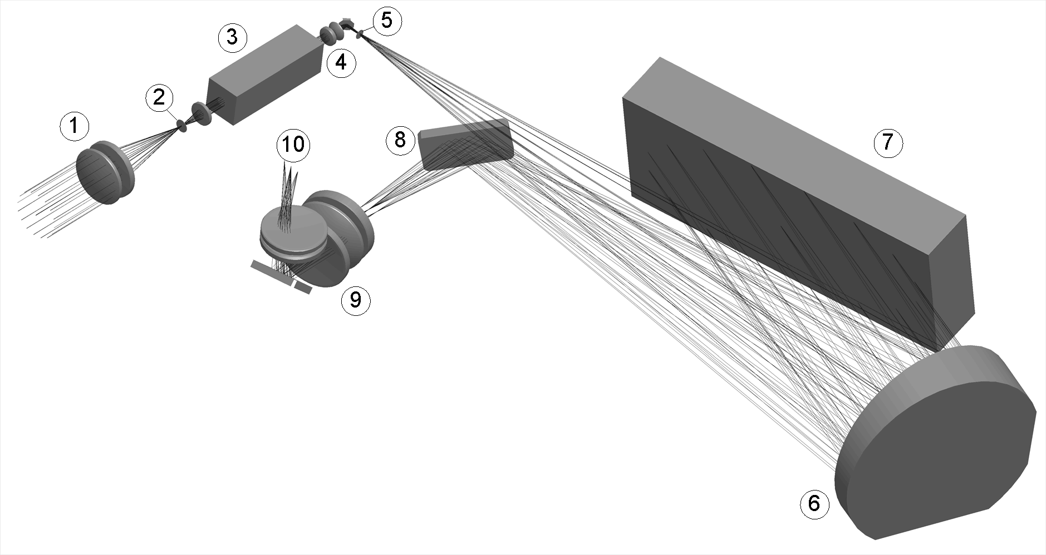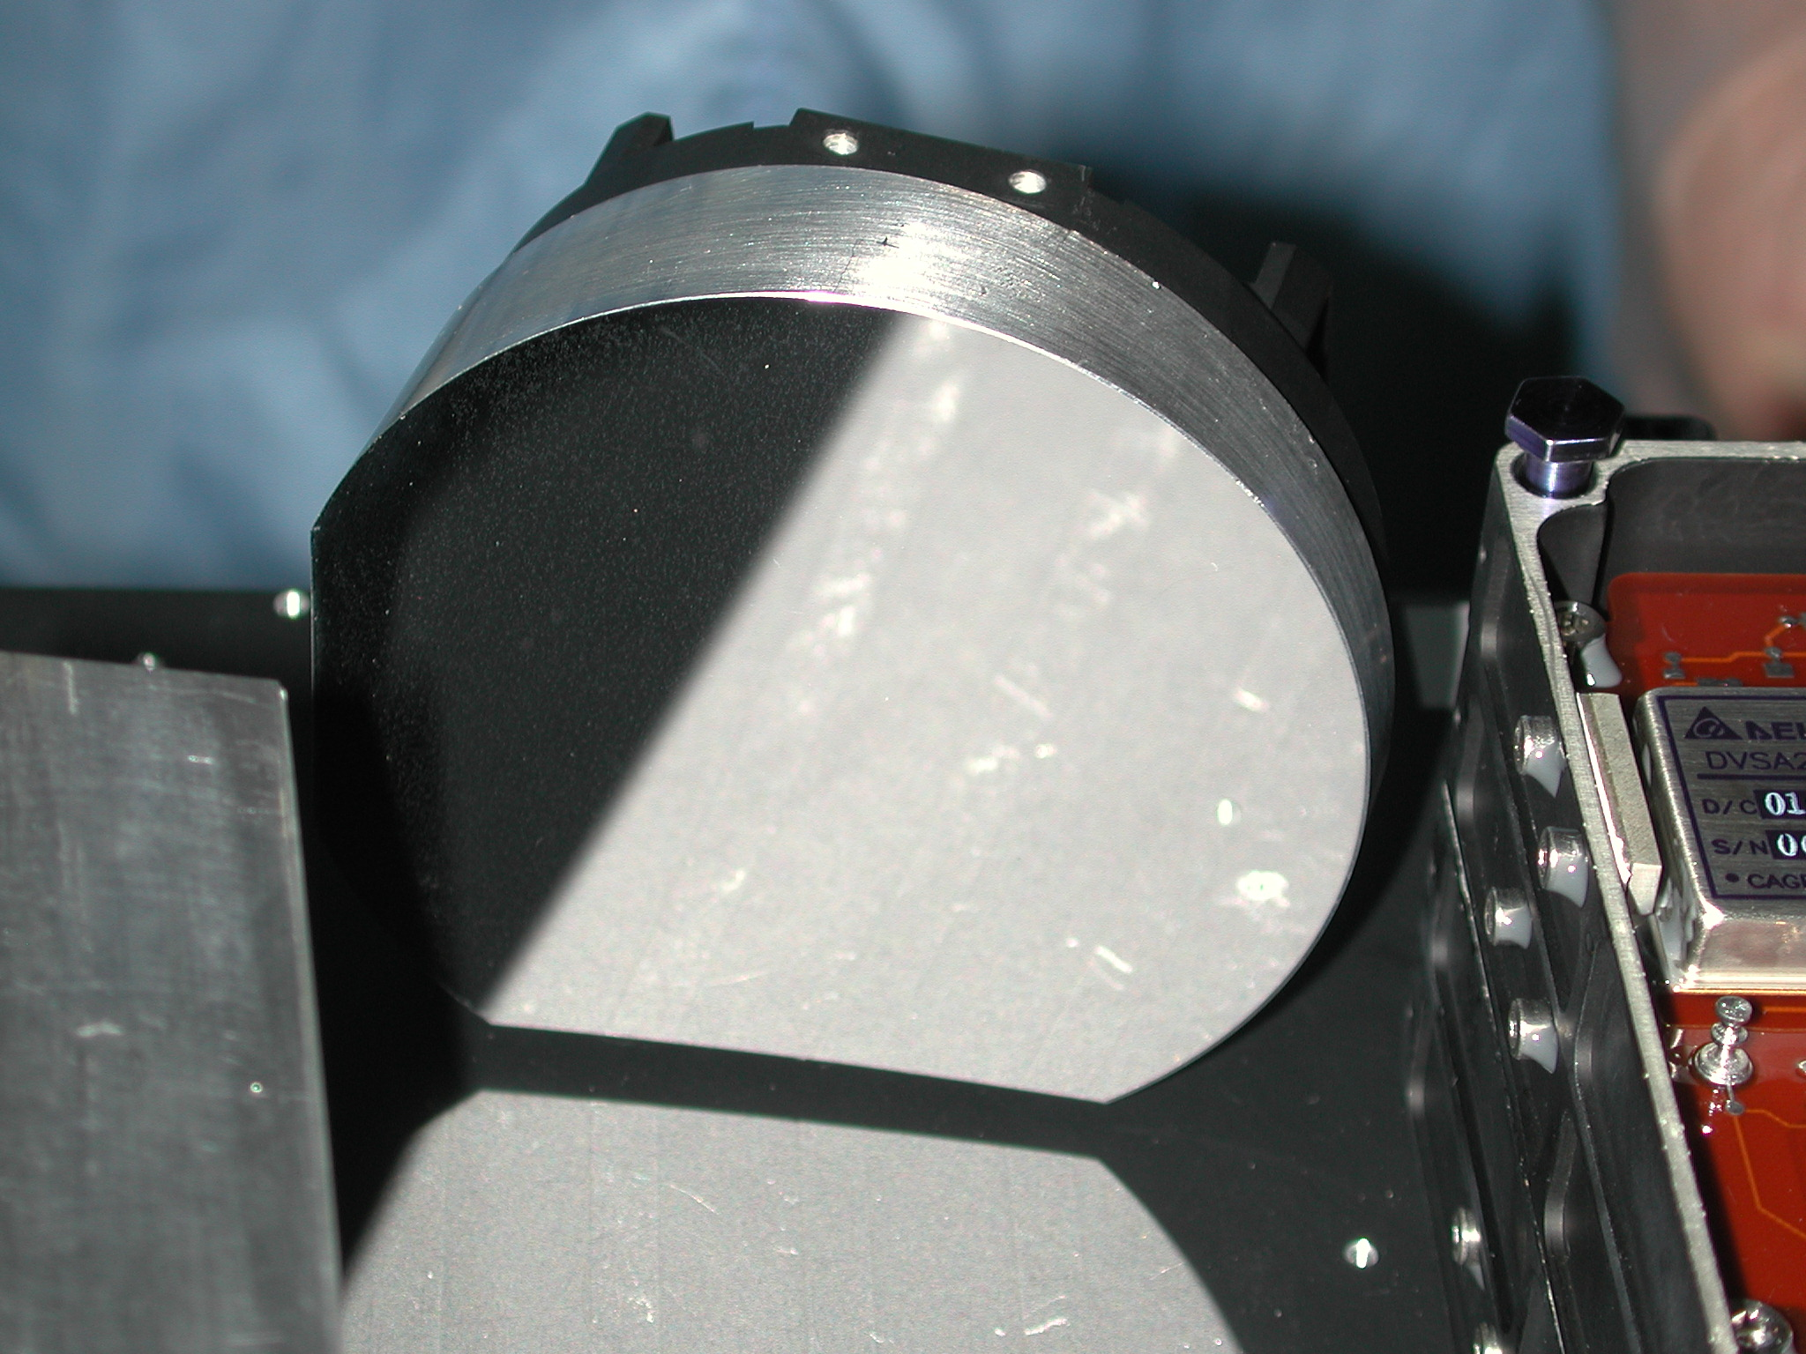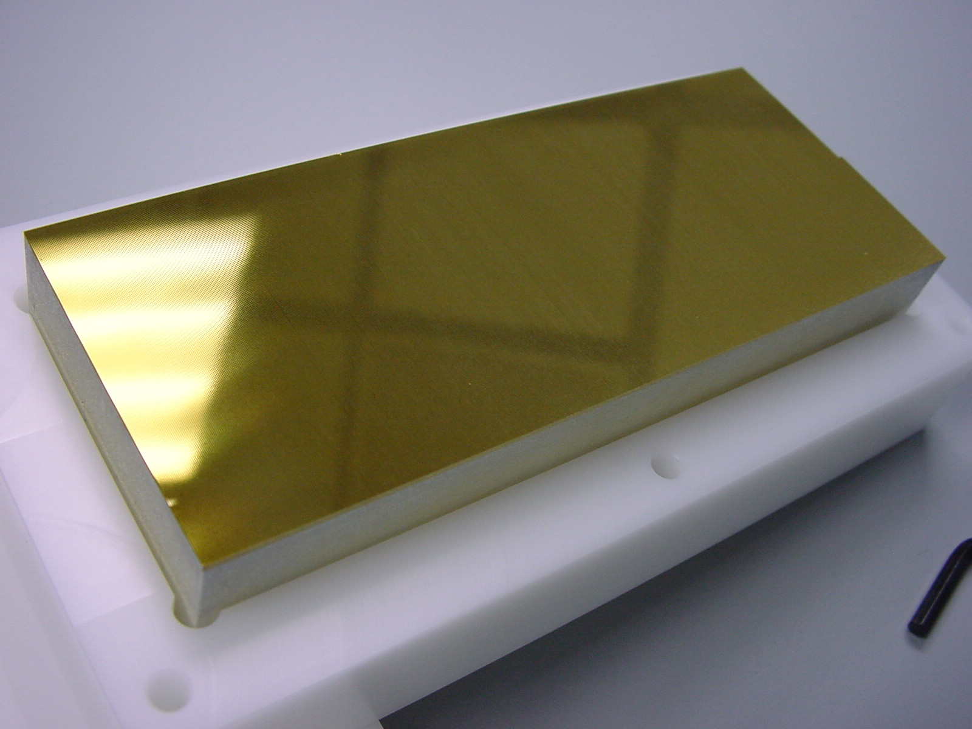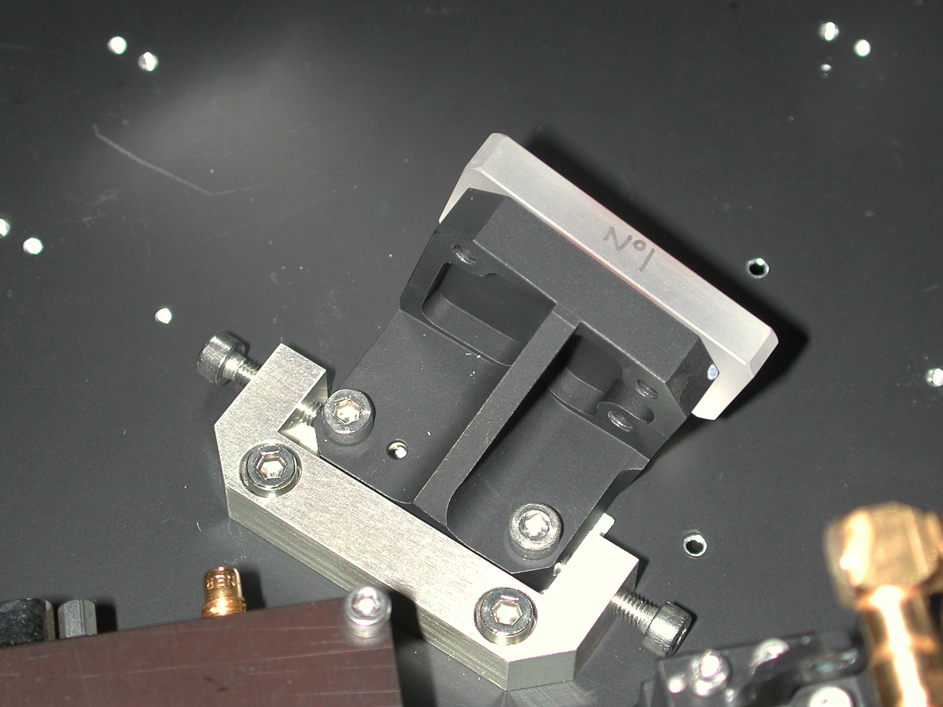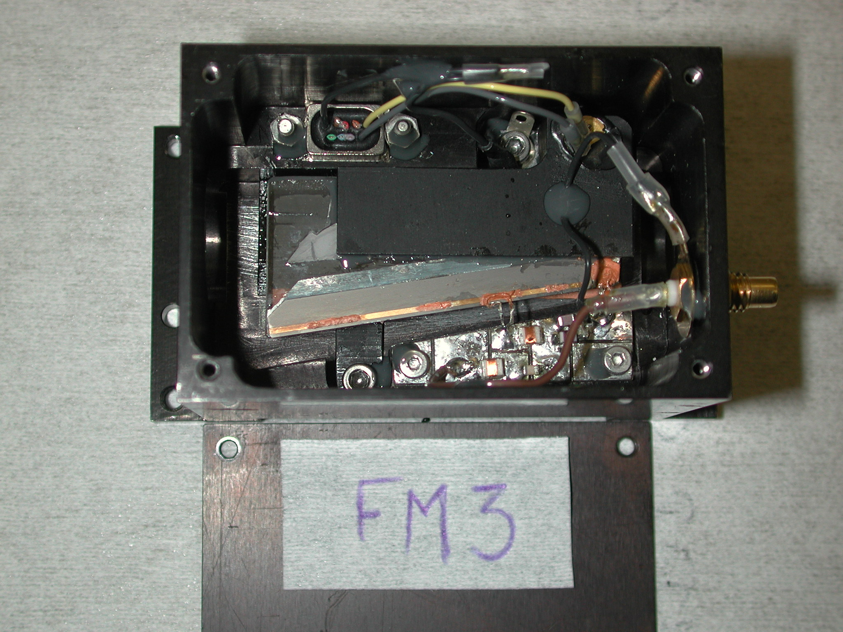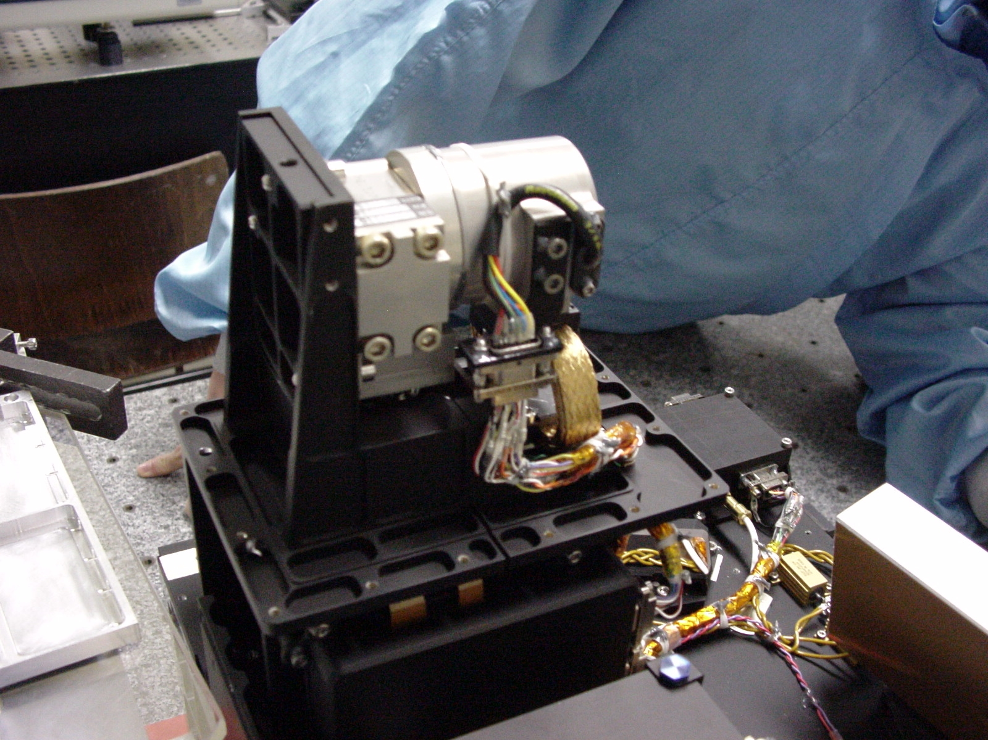

Figure 1. Optical scheme of the SOIR spectrometer. (1) AOTF entrance optics; (2) Diaphragm; (3) AOTF; (4) AOTF exit optics; (5) Spectrometer entrance slit; (6) Collimating and camera lens merged into one off-axis parabolic mirror; (7) Echelle grating; (8) Folding mirror; (9) Folded detector optics; (10) Detector assembly placed upright.

320 columns of pixels
256 rows of pixels
}
32 illuminated pixels
2 bins of 16 rows
2 bins of 12 rows
8 bins of 4 rows
4 bins of 4 rows
Ignored rows
Ignored rows
Ignored rows
Ignored rows

Figure 2. The detector is an array of 320x256 pixels. Due to the dimension of the slit, only 32 rows are illuminated. Several binning configurations have been defined: 2 bins of 16 rows, 2 bins of 12 rows, 8 bins of 4 rows, and 4 bins of 4 rows.

Figure 3: Modeled view of a solar occultation measurements (orbit 209) with (bold solid line) and without (solid line) refraction. The position of the slit on the solar disk is indicated by a rectangle. The coordinates are: the tangent altitude of the un-refracted Sun and the horizontal displacement of the solar tangent point from the point where the slit is parallel to the limb.

0
1000
2000
3000
4000
5000
6000
7000
0
50
100
150
Integration time [ms]
ADC units
ADC’
B
ADC
S
ADC’
S+B
ACU
S
ACU
S+B
Figure 4: Method for detector non-linearity correction. ADCS: ADC value available on ground, ADC'S+B, ADC'B: approximation of codes for signal plus background and background, ACUS+B, ACUB, ACUS: total, signal and background pixel charge in arbitrary units.

(a) Raw spectrum
(b) Filtered spectrum
(c) Pixel to pixel variation

Figure 5. Pixel to pixel non uniformity. (a) A spectrum where weak solar lines are present is selected, (b) high pass filtering is applied. (c) Other spectra where weak solar lines are present are selected and filtered; the global average is calculated (top panel). The percentage difference relative to the mean is shown in the bottom panel.

Figure 6. Overall sensitivity of the SOIR instrument. Top: sensitivity of bin 4 of the detector in a binning case of 8 bins of 4 rows. Bottom: sensitivity of row 150 with respect to the AOTF frequency. This row is highlighted in the top figure.

Figure 7: Measured AOTF bandpass functions at 2943.69 cm-1 (binning 4x8). The top panel presents the measurements of the intensity (bin 4 on the detector) versus the AOTF frequency and the pixel number after correction for the pixel to pixel variability and instrument sensitivity, showing the residual background level. Middle panel is obtained when this background is removed from the measurements, and finally the bottom panel shows the AOTF band pass corresponding to the 2943.69 cm-1 solar line

A
B
C

Figure 8: AOTF band pass functions for a binning of 12 for bin 1 by analyzing the solar lines situated at (a) 2583.79 cm-1, (b) 3012.03 cm-1, and (c) 4193.03 cm-1. Top panel of each figure shows the measured valued on the detector with respect to the AOTF frequency. Concerned pixel line is highlighted. Middle panel shows the measured band pass function (dashed) and fitted function (plain). Bottom panel shows the retrieved AOTF band pass function.

Figure 9. Evaluation of the FWHM of the pass band function using the dedicated mini scan.

Figure 10. Tuning relations for bins 1 and 2 of the detector. Top panel: wavenumber-frequency relation for bin 1 derived from mini scans measurements. A zoom on the right side of the fit is included. Bottom panel: wavenumber-frequency relation for bin 2 derived from mini scans measurements. On both panels, color indicates temperature of the AOTF at the time of measurement of the maximum of the band pass function.

Figure 11: Determination of the spectral resolution of the SOIR instrument. The observed solar line at 3013.7 cm-1 (dashed) measured in order 134, during orbit 227 and the fitted line (plain) are compared. The latter has been obtained by convoluting a high-resolution solar spectrum with a Gaussian function of 0.17 cm-1 FWHM.

Figure 12: Evolution of the observed FWHM of the Instrument Line Profile throughout the spectral domain

z
z

Figure 13. Evolution in time of the signal intensity (sunset September 3rd 2006). The plotted intensity is an average value over all 320 pixels (wavelenghts) for each of the recorded order. The 8 curves correspond to the 8 spectra recorded in one second (‘bin 1’ and ‘bin 2’ part of the detector for each of the 4 selected orders). First direct solar radiation is measured when the ligth path does not cross the Venusian atmosphere. During the occultation, the observed signal decreases. Finally the light path is intercepted by the cloud cover lying at 60-65 km and no ligth reaches the detector anymore. The dashed line shows the linear regression representing the solar reference spectrum. At time t, the observed signal is I(t) corresponding to an effective reference spectrum I0(t).

Order 121
Order 149
Order 171
Order 190
A
B
C
D

Figure 14. Example of spectra obtained during one occultation (sunset April 15th 2007). Each transmittance is obtained by making the ratio of the solar spectrum seen through the Venus atmosphere to the not attenuated solar spectrum measured above the atmosphere. The selection of a spectral interval is achieved through the AOT filter, tuned in this case to (A) 15809 kHz for diffraction order 121, (B) 19869 kHz for diffraction order 149, (C) 23031 kHz for diffraction order 171, (D) 25742 kHz for diffraction order 121. In these particular ranges of wavenumber, the main absorption lines are from (A) HDO, (B) CO2, (C) H2O, (D) CO.

