ESA/UPV-EHU/DADPS

Mars Express

VMC

Visual Monitoring Camera

Experiment to Archive
Interface Control Document
(EAICD)
V1.1

Contents
List of Figures 4
List of Tables 4
Acronyms 4
1. Introduction 5
1.1 Purpose and Scope 5
1.2 Contents 5
1.3 Applicable Documents 5
1.4 Reference Documents 5
2. The Visual Monitoring Camera 6
2.1 Description 6
2.2 Main Instrument Characteristics 6
2.3 Data Description 6
2.3.1 Raw Telemetry and Housekeeping data 7
2.3.2 Archive Data types 8
2.4 Science Applications 10
2.5 Opening the data 10
2.6 Known image artifacts 10
2.7 Geometry 11
3. VMC Product Generation 11
3.1 VMC Data Archive Pipeline 11
4. Archive Format and Content 12
4.1 Format and Conventions 12
4.1.1 Deliveries 12
4.1.2 Data Set ID Formation 13
4.1.3 Data Directory Naming Convention 14
4.1.4 File naming Convention 14
4.2 Standards Used in the Data Product Generation 14
4.2.1 PDS Standard 14
4.2.2 Time Standard 15
4.2.3 Reference Systems 15
4.2.4 Data Validation 15
4.2.5 Data Set 15
4.2.6 Directories 16
5. Detailed Interface Specifications 18
5.1 Data Product Design 18
5.1.1 Raw Data Products 18
5.1.2 Calibrated data products 18
5.2 Label 18
PDS version 18
File Characteristics 19
Data Object Pointers 19
Identification 19
Instrument and Detector Parameters 23
Geometry Information 23
Image Calibration, Timing and Resolution details 24
Additional information 26
Data Object Definition 27
Appendix A: Complete Data Label 29

List of Figures
Figure 1: XML Telemetry entry example 7
Figure 2: Debayering process. 8
Figure 3: Flowchart of the full VMC data pipeline used to process raw and calibrated data products, as well as browse images. 11
Figure 4: Archive folder structure. YYYY corresponds to year, MM to month, DD to day, TTTT to the start time of the observation and XXXX to the end time of the observation. 16

List of Tables
Table 1 - Mars Express Mission Phases 12

Acronyms
CMOS | Complementary Metal-Oxide-Semiconductor
DADPS  DN | Dias Almeida Data Processing and Systems  Digital Number
EAICD | Experiment to Archive Interface Control Document
ESA | European Space Agency
FOV  HK  IAU | Field Of View  HouseKeeping data  International Astronomical Union
MEX | Mars EXpress
PDS | Planetary Data System
UPV-EHU | University of the Basque Country (Spain) (Universidad del País Vasco – Euskal Herriko Unibertsitatea)
TM  VMC | TeleMetry data  Visual Monitoring Camera

Introduction

Purpose and Scope
The Experiment to Archive Interface Control Document (EAICD) serves as the companion document to the Mars Express Visual Monitoring Camera datasets. With it, the intended readers should be able to make use of these datasets for scientific purposes.

Contents
Described in this document are:
- The data itself, with information about how it evolves from the moment it is acquired to its format in the archive.
- Details of the auxiliary constructions around the data.
- The file structure, naming conventions and metadata associated with the data products.

Applicable Documents
[PDS-SR] Planetary Data System Standards Reference, v3.8. 27 February 2009.

Reference Documents
[VMC-UM] ESA VMC Flight User Manual 4.2. 2003
[VMC-DB] RE-VMC-0050-OIP/07. MEX-VMC Debayering Raw Images and Conversion to RGB images. OIP Sensor Systems. Issue 1. 2007
[VMC-OR] Ormstom, T. et al. An ordinary camera in an extraordinary location: Outreach with the Mars Webcam. Acta Astronautica 2018. https://doi.org/10.1016/j.actaastro.2011.04.015
[VMC-SLa] Sanchez-Lavega, A. et al. Limb clouds and dust on Mars from images obtained by the Visual Monitoring Camera (VMC) onboard Mars Express. 2018. https://doi.org/10.1016/j.icarus.2017.07.026
[VMC-SLb] Sanchez-Lavega, A. et al. A seasonally recurrent annular cyclone in Mars northern latitudes and observations of a companion vortex. 2018. https://doi.org/10.1029/2018JE005740

[VMC-HBa] Hernández-Bernal, J. et al. The 2018 Martian Global Dust Storm Over the South Polar Region Studied With MEx/VMC. Geophysical Research Letters 2019. https://doi.org/10.1029/2019GL084266 https://arxiv.org/abs/2102.13521
[VMC-HBb] Hernández-Bernal, J. et al. An extremely elongated cloud over Arsia Mons volcano on Mars: I. Life cycle. Journal of Geophysical Research 2021. https://doi.org/10.1029/2020JE006517 https://arxiv.org/abs/2103.03919
[VMC-HBc] Hernández-Bernal, J. et al. A Long‐Term Study of Mars Mesospheric Clouds Seen at Twilight Based on Mars Express VMC Images. Geophysical Research Letters 2021. https://doi.org/10.1029/2020GL092188 https://arxiv.org/abs/2104.02355
[VMC-HBd] Hernández-Bernal, J. et al. Looking for Meteors and Fireballs in the atmosphere of Mars from the Visual Monitoring Camera (VMC) on Mars Express. EPSC 2021. https://meetingorganizer.copernicus.org/EPSC2021/EPSC2021-515.html
[VMC-RA] Ravanis, E. et al. From engineering to science: Mars Express Visual Monitoring Camera's first science data release. EPSC, 2020.

The Visual Monitoring Camera

2.1 Description
The Visual Monitoring Camera (VMC) on board Mars Express was primarily put on the spacecraft to monitor the Beagle 2 lander release (see [VMC-UM]). It performed this task successfully, despite the failure of the Beagle 2 lander itself, and no use of the camera as a science instrument was foreseen.
In 2007, engineers from the Mars Express Flight Control Team switched VMC back on again to begin taking observations for outreach and educational purposes, whenever those observations did not interfere with the operations of science instruments (see [VMC-OR]). Since the VMC images are quite small in data volume, it was possible to acquire some images without impacting the rest of the Mars Express Payload. Finally in 2016 it was understood that there was scientific value to the VMC data (see [VMC-SLa]), and the camera was given the status of a scientific instrument on Mars Express. Science operations for the instrument has been based at the European Space Astronomy Centre in Madrid since summer 2018, and the scientific leadership is based at the University of Pais Vasco (UPV/EHU) in Bilbao, Spain. The VMC camera is able to monitor large scale atmospheric phenomena, and provides valuable context to other instruments.

2.2 Main Instrument Characteristics
The values provided here are the result of the instrument calibration performed by UPV/EHU and are updated with respect to those previously published in reference documentation. The operational values and most updated versions are maintained in the SPICE reference frame kernels (FK) and instrument kernels (IK): ftp://spiftp.esac.esa.int/data/SPICE/MARS-EXPRESS/kernels
Focal length: 12.3 mm
Focal ratio (F/#): 5
FOV: 41.38º x 31.04º.
Instantaneous FOV: 0.00112859 rads/pixel
Wavelength range: 400 - 650 nm
Detector: 640x480 pixel CMOS
Pixel pitch: 14 µm pixel pitch

2.3 Data Description
VMC has a 640 x 480 pixel array with a Bayer filter on top (see [VMC-UM], [VMC-DB] and [VMC-RA]).
For the Archive there are two main products of the VMC, these being the raw data and the calibrated data. VMC takes images by default in grayscale but colour is added using a Bayer Matrix (explained in section 2.3.2).

2.3.1 Raw Telemetry and Housekeeping data
This data is not archived, but is described here for completion. This refers to the original data obtained by the instrument and the spacecraft, which is converted into the archive products described later.

Raw Telemetry Data
The original raw telemetry data from the instrument comes as a byte stream with no header. The byte stream has the digital number (DN) intensity of each pixel in the sensor stored as 1 byte (8 bit). The sensor has a Bayer filter on top, therefore each pixel is for a different colour. The Bayer Pattern is RGGB. The byte stream is stored in a binary file produced by the European Space Operations Centre (ESOC) with a raw extension.

Housekeeping Data
In order to produce the Raw and Calibrated Data for the archive, some of the instrument and spacecraft housekeeping telemetry (HK) is used. These are produced as XML ASCII files. One XML is created for one observation (Instrument ON – Images Acquisition – Instrument OFF). The following is a sample of one of the XML entries, corresponding to one image (each file includes entries for each image acquired during one observation):
<Image>
<FileName>16-261_02.17.31_VMC_Img_No_1.raw</FileName>
<TimeStamp>16-261T02:17:31.302Z</TimeStamp>
<ExposureDurationMs>14.00</ExposureDurationMs>
<VmcInternalTempDeg>-13.0</VmcInternalTempDeg>
</Image>
Figure 1: XML Telemetry entry example
<Image> is the XML tag for the image object.
<FileName> is the file name of the ESOC produced file
The name is as follows:
YY-DOY_HH:MM:SS_VMC_Img_No_X.raw
YY- is the year
DOY – is the day of the year
HH – Hours
MM – Minutes
SS – Seconds
X – image counter of the observation
<ExposureDurationMs> is the time the sensor was exposed for the image acquisition in milliseconds.
<VmcInternalTempDeg> VMC internal temperature in degrees.

2.3.2 Archive Data types
In this section we describe how the raw and calibrated VMC data is generated and in what format.

Raw Image Data with PNG Browse file
The VMC Archive data products are in .RAW image format.
As stated in the Raw Telemetry Data section, the original data has the information of each physical pixel in a byte stream corresponding to the colour filter on top of it following the Bayer pattern. The archived raw files are codified as unsigned integers with 8 bits, which means that their values range from 0 to 255. The pixels are read row by row, starting in the top left corner of the image and finishing in the bottom right corner. In some rare cases, there are missing bytes at the end of the file, and these are drawn as black. The file size is 640 x 480 bytes, corresponding to 307200 bytes, or 300 KB.
The browse products are provided for quick-look purposes in PNG format, which is a direct conversion of the raw product into an image with the Bayer pattern solved (see [VMC-DB]). Each PNG pixel has information for Red, Green and Blue. In order to keep the scientific fidelity, the way the images are processed is that each pixel keeps its original value for the corresponding Bayer grid colour and interpolated values are calculated by averaging the available adjacent pixels of the target original colour (either 2 or 4 pixels, see also Figure 2).
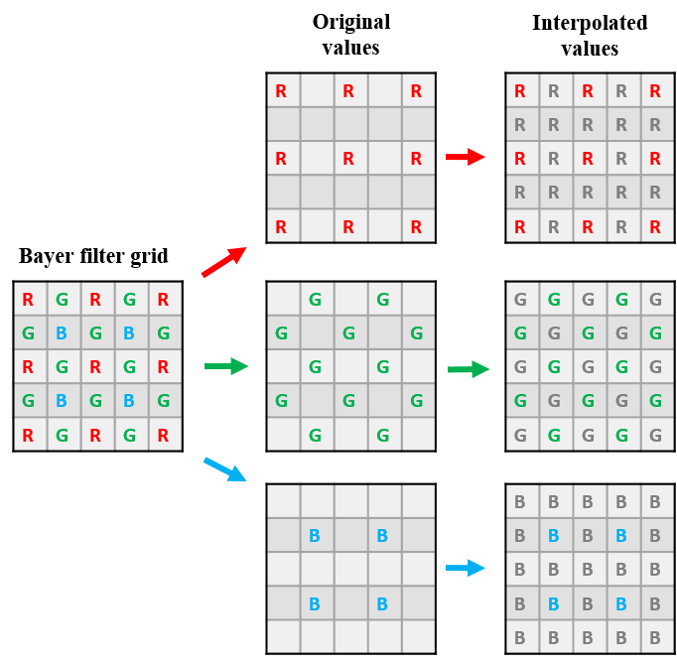
Figure 2: Debayering process. Coloured squares indicate pixels that keep their original value, grey boxes indicate where that colour channel is interpolated from the surrounding pixels.
In the Debayering process (see [VMC-DB]), each pixel keeps its original value for the corresponding colour on the Bayer filter grid, and for the other colour channels, the value is interpolated from the surrounding pixels. On the diagram in the final column, the coloured squares (red, green and blue) represents an original colour value, and the grey colour represents an interpolated value for that colour channel. This means that:
  - Red in green pixels is interpolated from only 2 available adjacent red pixels.
  - Red in blue pixels from up to 4 pixels.
  - Green in red pixels from up to 4 pixels.
  - Green in blue pixels from up to 4 pixels
  - Blue in red pixels, from up to 4 pixels.
  - Blue in green pixels, from 1 or 2 pixels.
Note that this interpolation algorithm has limitations at the borders, in particular in the 2 pixel margin around each image, which should be handled carefully and taken into account for the scientific interpretation of the images.

Calibrated FITS data with PNG Browse
No on-ground calibration exists for the VMC camera and so in-flight calibration has been performed.
The master dark current file is made from images of dark sky. The dark has a mean value of 2.4 DN, and only 0.1% of pixels have values >4 DN. Currently, the same dark current file is used for all exposures and temperatures.
The flat-field file was created using dark-corrected images of flat portions of Mars that were well and uniformly illuminated, as free as possible from large structures, and as flat as possible (e.g. taken at pericentre, in the northern plains of Mars). Sigma-clipping was performed that rejected pixels two standard deviations away from the mean value of the pixels across all the images for darker images, and 4 standard deviations away for higher pixel value images, so that images with poorer illumination had less influence on the final master flat. Once this sigma-clipping was performed, the remaining pixels were averaged across all the images and then normalised to create the master flat-field file. This was done by averaging the counts of the central portion of the images (typically the most well illuminated) to 1 and then dividing all the pixels of the master flat by that number. This flat-field calibration may be improved in future as we take more observations, but the current flat field has provided good results so far (see reference list for example publications).
In the BROWSE calibrated products, the vignetting effect produced by the camera is not corrected (though such correction is done for the DATA products using the flat-field image), as these PNGs cannot save values above 255, but the BROWSE products are not intended to be used for scientific purposes.
The process of calibration in the processing pipeline for the Level 3 DATA products is as follows: first, all saturated (=255 and above) are converted to NAN (‘Not a Number’) so that they are removed from the calibration, then the dark current file is subtracted, and the result is divided by the flat. This is illustrated later in Figure 3. Both the flat-field and dark-current file used are provided in the CALIB directory.

2.4 Science Applications
The main science applications that are envisaged focus on global climate monitoring and include the following:
- Cloud monitoring
- Dust monitoring
- Limb monitoring
- Direct wind measurements on aerosol tracers
- Dynamical phenomena
- High altitude clouds at twilight
- Surface ice coverage
- Synergies with other payloads on Mars Express.
These are made possible by the wide field of view of VMC which can therefore image large areas of Mars at once (allowing for the study of regional to global scale atmospheric phenomena) and the capability to take various images with a repetition time of less than 1 minute, allowing observations of the same area which can be used to identify and monitor dynamic atmospheric features (dust and cloud tracking, wind measurements, etc). See the reference publications for more information [VMC-OR], [VMC-SLa], [VMC-SLb], [VMC-HBa], [VMC-HBb], [VMC-HBc], [VMC-HBd], [VMC-RA].

2.5 Opening the data
FITs files are typically opened using Python. The ‘Astropy’ library is required.
DS9 is a popular free software for astronomical images which can also be used for opening VMC FITs data products. When opening the files, DS9 takes the first layer of the FITs file (the calibrated layer), and detects that it contains three dimensions (more than one colour channel). DS9 then opens a "Cube" window to handle the three dimensions. In the menu "Axes order", the user must select "2 3 1", and then the first channel (red) appears in the viewer. In the "Cube" window, it is possible to switch the channel. Once the image is in the viewer, several operations can be performed, including exporting to an image format.

2.6 Known image artifacts
We note here various artifacts that are still present in the data after the calibration process and that will hopefully be addressed in future updates of the calibration pipeline, which will be released and distributed in the PSA whenever they become available.
- The "main" artifact is in the right half of the VMC images. This is believed to be a consequence of the Beagle 2 release. It appears as a large flat-field value and those pixels cannot currently be calculated. As a result, there are sometimes white squares in the BROWSE products that are saturated values around this artifact.
- There is a horizontal "line" artifact which appears in some images. It typically appears on the top of the image, but its exact positioning changes depending on exposure. Taking the first horizontal line as 0, this artifact line is always in an odd (1,3,5,7…) number line. In most cases, the line position can be determined as: N=2.5*exposure (in milliseconds).
- There is a background "glare" in images. This glare is not present when we image dark sky. This glare does not grow linearly with exposure, and thus it is unlikely to be an internal reflection of optical origin, but instead likely has an electronic origin. This glare may be corrected in future releases, but no photometrically reliable correction has been developed so far. The typical DN of this glare is around 7, but occasionally it can reach up to DN~15.

2.7 Geometry
Only basic geometry information (latitude, longitude and distance) has been added in the PDS Labels so far. All geometry computations are based on the spacecraft ephemeris and orientation provided via the SPICE service in the web and FTP repository below:
- https://www.cosmos.esa.int/web/spice/spice-for-mex
- ftp://spiftp.esac.esa.int/data/SPICE/MARS-EXPRESS/kernels
A full geometry calibration pipeline for VMC is currently under development and it may be included in a future data release for the PSA. Some preliminary details of the geometry calibration performed so far for specific research are accessible via the reference papers Hernández‐Bernal et al. [VMC-HBa and VMC-HBb]. Note however that this is still under development and therefore some of the geometry information may differ in each of the research works.

VMC Product Generation

3.1 VMC Data Archive Pipeline
The VMC data is assembled on ground as raw data product images. These products are a bitstream of all the pixels as collected by the VMC sensor (see 2.3 Data Description).
The resulting products will be described in more detail in the following sections. In order to produce these products from the raw data, a pipeline was made that uses the raw data as well as telemetry parameters, namely the acquisition time, the exposure duration, and the VMC temperature.
The pipeline design is shown in Figure 3.
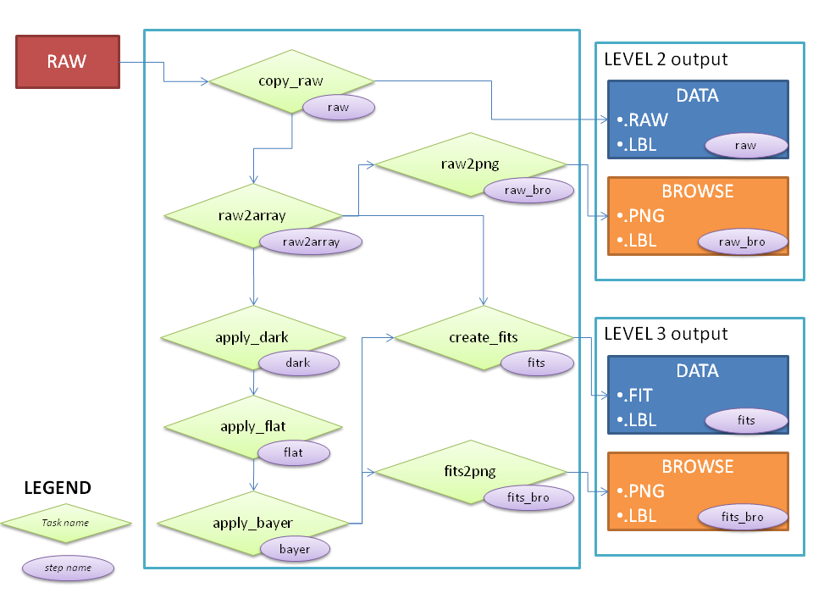
Figure 3: Flowchart of the full VMC data pipeline used to process raw and calibrated data products, as well as browse images.
Before the dark current correction is applied, the raw data products of the VMC dataset are stored, these being the level 2 outputs. The dark-corrected and flat-fielded data are the derived data products, which are the level 3 outputs.

Archive Format and Content
This chapter describes the archive structure, naming conventions for directories and data products, and a high-level description of the products. Detailed product descriptions will be found in the Section 5 Detailed Interface Specifications.

4.1 Format and Conventions

4.1.1 Deliveries
Deliveries will be done every six months for data that was acquired six months before. These datasets will correspond to a given Mars Express mission phase as shown in Table 1.
Table 1 - Mars Express Mission Phases
Mission Phase | Dates | Orbit Numbers
Nominal | 4 Jan 2004 – 30 Nov 2005 | 1 –2418
EXT1 | 1 Dec 2005 – 31 Oct 2007 | 2419 – 4918
EXT2 | 1 Nov 2007 – 30 Apr 2009 | 4919 – 6836
EXT3 | 1 May 2009 – 31 Dec 2012 | 6837 – 11453
EXT4 | 1 Jan 2013 – 31 Dec 2014 | 11454 – 13960
EXT5 | 1 Jan 2015 – 31 Dec 2016 | 13961 – 16468
EXT6 | 1 Jan 2017 – 31 Dec 2018 | 16469 – 18975
EXT7 | 1 Jan 2019 – 31 Dec 2020 | 18976 – 21487
EXT8 | 1 Jan 2021 – 31 Dec 2022 | 21488 – ongoing

4.1.2 Data Set ID Formation
This is the identification (ID) for the dataset.
The following datasets are currently envisaged:
- MEX VMC Raw Mars Data
- MEX VMC Calibrated Mars Data
The naming convention will follow the rule:
MEX-M-VMC-N-TTT-XXXX-Vn.n
Where:
  - MEX – Mars Express
  - M – Image Target Mars
  - VMC – Visual Monitoring Camera
  - N – data processing level number.
    - 2 – Raw Data – Edited data in the PDS dictionary
    - 3 – Derived Data – Calibrated data in the PDS dictionary
  - TTT – type of data.
    - EDR – Experiment Data Record (EDR) as defined in the PDS standard (AD2). It will be used for the raw data.
    - RDR – Reduced Data Record (RDR) as defined in the PDS standard (AD2). It will be used for the radiometric calibrated data.
  - XXXX – is the description of the data set. Typically the mission phase as defined by the project. For VMC it will be one of the mission extensions in the format:
    - EXT# – See Table 1
  - Vn.n – Version number of the data set, which is usually 1.0. This is updated when data needs to be reprocessed. For large updates the first number is updated. For small corrections the second number is updated. See RELEASE_ID and REVISION_ID keywords for further information.

4.1.3 Data Directory Naming Convention
There will be t levels for the data archive. The data will be separated by Year, then month, ending in observation folders.
YYYY → YYYYMM → YYYYMMDD_HHMM_hhmm
- YYYY : 4 digits denominating the data acquisition year
- MM : 2 digits denominating the month acquisition of said year
- DD : 2 digits denominating the day of acquisition of that month
- HHMM : start time of the observation (hours, minutes)
- hhmm : end time of the observation (hours, minutes)

4.1.4 File naming Convention
A unique file name identifier is used for each of the VMC images, using the following format:
VMC_TL_YYMMDD_hhmmss_ccc.PNG
- VMC – Visual Monitoring Camera
- T – Purpose of data. S stands for Science.
- L – Data type
  - E – Experiment Data Records (raw data)
  - R – Reduced Data Records (radiometrically calibrated)
  - M – Master Data Records (masters for calibration)
- YY – Year
- MM – Month
- DD – Day
- hh – hours
- mm – minutes
- ss – seconds
- ccc – counter of the image within an observation series

4.2 Standards Used in the Data Product Generation

4.2.1 PDS Standard
All files, labels, and keywords follow the PDS 3.8 standard.

4.2.2 Time Standard
The CCSDS time standard as described in the PDS standard is used.

4.2.3 Reference Systems
Mars Body Fixed frame (IAU Mars) in Earth Mean Equatorial J2000 reference system is used.

4.2.4 Data Validation
Validated using PSA PVV software and reviewed internally.

4.2.5 Data Set
Each Dataset will include an entire mission phase as shown in Table 1.

4.2.6 Directories
The directory structure envisaged for the VMC data sets is the following:
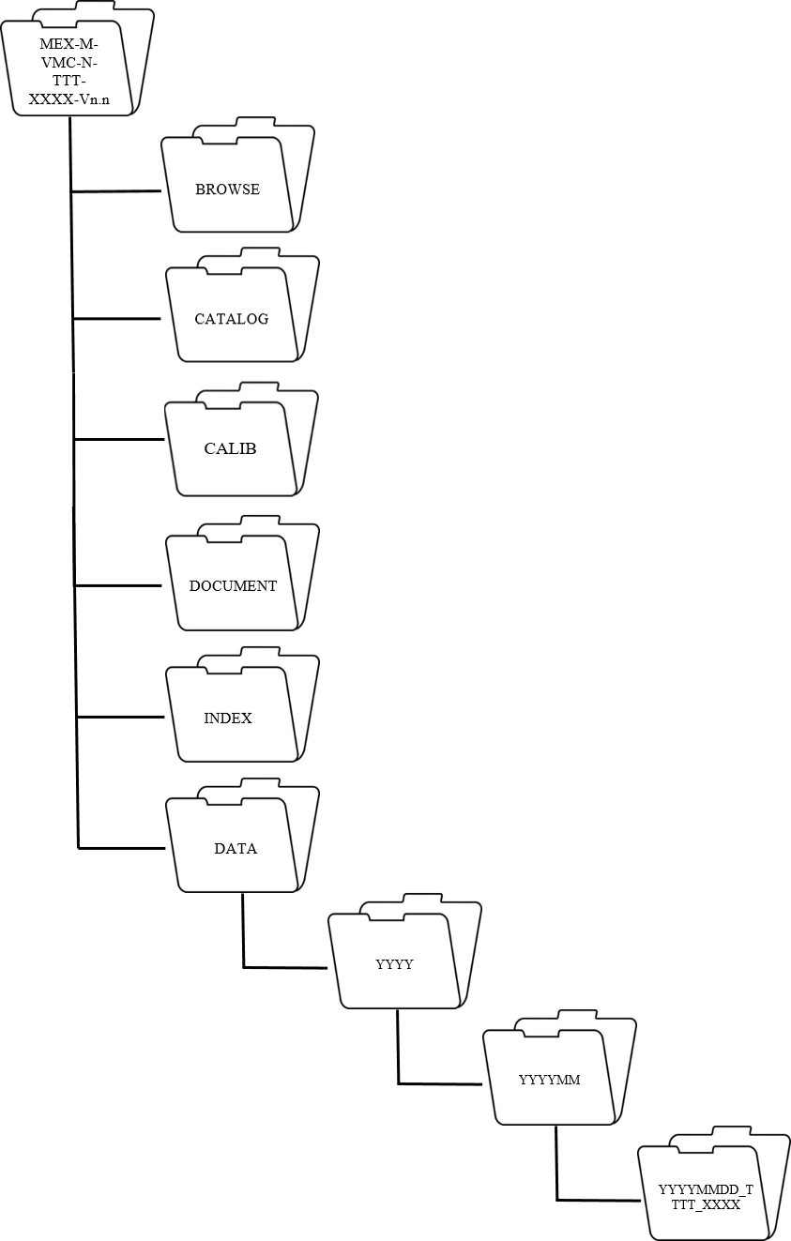
Figure 4: Archive folder structure. YYYY corresponds to year, MM to month, DD to day, TTTT to the start time of the observation and XXXX to the end time of the observation.

Root Directory
Contains a readme file explaining the dataset and the voldesc.cat catalog file, which lists all the catalogs in the volume.

Browse Directory
Contains versions of the data files used to facilitate browsing through images on the PSA (see section 5.3 SOURCE_PRODUCT_ID).

Catalog Directory
Contains the catalog files.
It includes:
- DATASET.CAT – Describes the dataset
- INST.CAT – Describes the instrument
- INSTHOST.CAT – Describes the MEX spacecraft
- MISSION.CAT – Describes the MEX mission
- PERSON.CAT – List of people involved with the instrument
- REFERENCE.CAT – Lists all publications referenced in the other catalog files
- RELEASE.CAT- Describes the individual releases that make the dataset
- SOFTWARE.CAT – Describes the software included in the dataset

Calib Directory
Contains the flat-field file and dark-current file used for the Level 3 calibration, in FITS format.

Index Directory
Contains the Dataset index file (INDEX.LBL and INDEX.TAB) that list all the files in the dataset, as well as the BROWSE index files (BROWSE_INDEX.LBL, BROWSE_INDEX.TAB).

Document Directory
Contains the Experiment to Archive Interface Control Document (EAICD) – this document, and other accompanying documents, in this case the VMC Flight User Manual and a document on the debayering technique.

Data Directory
Raw or Calibrated data depending on the Volume.

Detailed Interface Specifications

5.1 Data Product Design
Each product archived has a corresponding detached label.

5.1.1 Raw Data Products
Raw products are as described in section 2.3.2 and are archived with a detached label (see section 5.2).

5.1.2 Calibrated data products
Calibrated data products are archived as a FITS data product with extension FIT. The FITS data product consists of a header and 2 layers. The first layer includes the calibrated values, and the second layer includes the raw values. The raw layer is not debayered, instead it contains only one channel, and is codified as unsigned integers of 8 bits. The calibrated layer is debayered, it consists of 3 channels and the codification is float32. Negative values indicate saturated values. Due to a vignetting effect inherent to VMC images, which is corrected when the flat-field is applied, some values away from the centre of the image may go above 255 (but these values are photometrically correct). As mentioned before, the surrounding 2 pixel border of the images should only be used with caution for scientific purposes. Additionally, although calibrated values are stored as floating comma values, this is not the real precision of the values. There is a level of uncertainty here which is currently not calculated, however this uncertainty does not prevent the use of VMC data for scientific purposes.
The Level 3 PNGs are BROWSE products and should not be used for anything relating to photometry. The correction of the vignetting effect is undone for these BROWSE images so that the values can be stored in 8 bits (which does not allow for values above 255). These PNGs are colour-enhanced and include a sharpening filter to enhance the contrast, as well as a median filter to reduce noise. These filters may produce artefacts in some cases, and therefore these products are not intended for science (instead, the RAW and FITS products should be used).

5.2 Label
This section describes each keyword used in the label.

PDS version
PDS_VERSION_ID = PDS3

PDS_VERSION_ID
Version of PDS for the VMC data.

File Characteristics
FILE_NAME = “VMC_SR_170128_141328_003.RAW”
RECORD_TYPE = FIXED_LENGTH
RECORD_BYTES = 1920
FILE_RECORDS = 480

FILE_NAME
Name of the image data product according to the naming convention specified earlier in this document in 4.1.4 File naming Convention.

RECORD_TYPE
It is always FIXED_LENGTH.

RECORD_BYTES
Size of one line of the image in bytes. For RAW data products, this number is 640. For PNG browse products, this number is 1920. For FITS data products, this number is 6240.

FILE_RECORDS
One record for each image line. This value will always be 480.

Data Object Pointers
^IMAGE = “VMC_SR_160229_201108_0011.RAW”

^IMAGE
Location of the data/image object file. This will be the filename of the object to which the label pertains. It will be in the same directory as the label.

Identification
RELEASE_ID = 0001
REVISION_ID = 0000
DATA_SET_ID = “MEX-M-VMC-2-EDR-EXT6-V1.0”
DATA_SET_NAME = “MEX MARS VMC RAW DATA EXT6 V1.0”
PRODUCT_ID = "MEXVMC_1700400003" SOURCE_PRODUCT_ID = "MEXVMC_1700400003"
PRODUCT_CREATION_TIME = 2020-01-15T15:38:39
INSTRUMENT_HOST_ID = “MEX”
INSTRUMENT_HOST_NAME = “MARS EXPRESS”
TARGET_NAME = “MARS”
IMAGE_TIME = 2017-01-28T14:13:28.004
START_TIME = 2017-01-28T14:13:28.004
STOP_TIME = 2017-01-28T14:13:28.011
PRODUCER_ID = “ESA_UPV-EHU_DADPS”
PRODUCER_FULL_NAME = “ELENI RAVANIS AND JORGE HERNANDEZ-BERNAL”

RELEASE_ID
Release one has value 0001. Only one release is intended, however any subsequent releases will have sequential numbering if necessary.

REVISION_ID
Value from 0000 to 9999 to reflect updates to the release with updated data products or to correct mistakes.

DATA_SET_ID
To be set in accordance to the 4.1.2 Data Set ID Formation section of this document.

DATA_SET_NAME
It has two possible values:
MEX MARS VMC RAW DATA EXTX V1.x
MEX MARS VMC CALIBRATED DATA EXTX V1.x
Where EXTX indicates the mission extension number of the dataset and x represents the revision.

PRODUCT_ID
Unique identifier for each data product. This uses the following format:
MEXVMC_YYNNNNSSSS
Where:
- MEXVMC indicates the Mars Express Visual Monitoring Camera
- YY indicates the year
- NNNN indicates the observation number within that year
- SSSS indicates the image number within that observation.

SOURCE_PRODUCT_ID
For PNG BROWSE images, this refers to the source data product.

PRODUCT_CREATION_TIME
Time when the data product was created in UTC.
YYYY-MM-DDTHH:MM:SS
Where:
- YYYY – year
- MM – month
- DD – day
- T – separator, always T
- HH – hours
- MM – minutes
- SS – seconds.

INSTRUMENT_HOST_ID
It will always be “MEX”.

INSTRUMENT_HOST_NAME
It will always be “MARS_EXPRESS”.

TARGET_NAME
It will always be “MARS”. Note that some images are deliberately targeted at background stars, Phobos, Deimos, Earth or other planets for calibration purposes but these may not be specified in this keyword explicitly. There is also an observation of Beagle 2 in 2003.

IMAGE_TIME
Time when the image was acquired.
YYYY-MM-DDTHH:MM:SS.sss
Where:
- YYYY – year
- MM – month
- DD – day
- T – separator, always T
- HH – hours
- MM – minutes
- SS – seconds
- sss – milliseconds.

START_TIME
Same as the IMAGE_TIME. Both are kept in case for some reason times need to be adjusted (e.g. system latency).
YYYY-MM-DDTHH:MM:SS.sss
Where:
- YYYY – year
- MM – month
- DD – day
- T – separator, always T
- HH – hours
- MM – minutes
- SS – seconds
- sss – milliseconds.

STOP_TIME
START_TIME plus the exposure time. Start and stop time will only be different if the exposure time is longer than one second.
YYYY-MM-DDTHH:MM:SS.sss
Where:
- YYYY – year
- MM – month
- DD – day
- T – separator, always T
- HH – hours
- MM – minutes
- SS – seconds
- sss – milliseconds.

PRODUCER_ID
It will always be “ESA_UPV-EHU_DADPS”, which stands for European Space Agency, Universidad del Pais Vasco - Euskal Herriko Unibertsitatea, Dias Almeida Data Processing Systems.

PRODUCER_FULL_NAME
Producers of the datasets, e.g. “ELENI RAVANIS AND JORGE HERNANDEZ-BERNAL”

Instrument and Detector Parameters
INSTRUMENT_ID = “VMC”
INSTRUMENT_NAME = “VISUAL MONITORING CAMERA”
EXPOSURE_DURATION = 14.00
INSTRUMENT_TEMPERATURE = -13.0
INSTRUMENT_TYPE = “IMAGING CAMERA”

INSTRUMENT_ID
It will always be “VMC”.

INSTRUMENT_NAME
It will always be “VISUAL MONITORING CAMERA”.

EXPOSURE_DURATION
Exposure time in milliseconds.

INSTRUMENT_TEMPERATURE
Temperature as recorded by the instrument sensor in degrees Celsius, or ‘N/A’ when this information is not available.

INSTRUMENT_TYPE
It will always be “IMAGING CAMERA”.

Geometry Information
COORDINATE_SYSTEM_TYPE = "BODY-FIXED ROTATING"
SUB_SPACECRAFT_LONGITUDE= 103.981
SUB_SPACECRAFT_LATITUDE= -47.673
CENTRAL_BODY_DISTANCE= 13257.315

COORDINATE_SYSTEM_TYPE
This will always be “BODY-FIXED ROTATING”. In our case coordinates correspond to the IAU Mars reference frame.

SUB_SPACECRAFT_LONGITUDE
Longitude of the sub-spacecraft point. The sub-spacecraft point is that point on a body's reference surface where a line from the spacecraft centre to the body centre intersects the surface.

SUB_SPACECRAFT_LATITUDE
Latitude of the sub-spacecraft point. The sub-spacecraft point is that point on a body which lies directly beneath the spacecraft.

CENTRAL_BODY_DISTANCE
This is the distance from the spacecraft to the centre of a primary target in kilometres.

Image Calibration, Timing and Resolution details
DARK_CURRENT_CORRECTION_FLAG = “TRUE”
DARK_CURRENT_FILE_NAME = "DARK_2020.FIT"
FLAT_FIELD_CORRECTION_FLAG = “TRUE”
FLAT_FIELD_FILE_NAME = "FLAT_2020.FIT"
SOLAR_LONGITUDE = 123.4
/*MARTIAN_YEAR = 34 */
/*NADIR_RESOLUTION = 11.1
LIMB_RESOLUTION = 14.5
SEE VMC EAICD FOR DETAILS*/
DARK_CURRENT_CORRECTION_FLAG
Flag to indicate if the data is dark corrected or not. It has two possible values:
“FALSE” – Not corrected
“TRUE” – Corrected
DARK_CURRENT_FILE_NAME
Name of the dark current image file used to correct the data (or ‘N/A’ when this doesn’t apply).

FLAT_FIELD_CORRECTION_FLAG
Flag to indicate if the data is flat fielded or not. It has two possible values:
“FALSE” – Not corrected
“TRUE” – Corrected

FLAT_FIELD_FILE_NAME
Name of the flat field image file used to correct the data (or ‘N/A’ when this doesn’t apply).

SOLAR_LONGITUDE
The solar longitude of Mars (Ls) when the image was taken, to one decimal place.

/*MARTIAN_YEAR */
The Martian year that the image was taken in.

/*NADIR_RESOLUTION */
This is the pixel width in kilometres, measured at the sub-spacecraft point, that is the nadir point with emission angle zero, considering the planet as a sphere with a radius of 3390 km. Nadir resolution is simply a function of the sub-SC altitude and is independent of the camera orientation. This nadir resolution is provided as a reference of the maximum horizontal resolution that would be possible, but it may not correspond to the maximum resolution in the image, in particular if the nadir point is not within the image. The projected spatial coverage of each pixel on the planet would need to be corrected by the distance and emission angle of each pixel in the image.

/*LIMB_RESOLUTION */
This is the pixel width in kilometers, measured at the planet limb, that is in the horizon line with emission angle 90º, which is a circle considering the planet as a sphere of radius 3390 km. Limb resolution is simply computed as a function of the distance between the spacecraft and the planet limb circle, independently of the camera orientation. This limb resolution is a valid reference for all the horizon line, even if the limb may not be present in the image. This resolution provides both the pixel vertical resolution in the atmosphere, and the minimum horizontal spatial resolution in the surface, without taking into account the pixel projection on the planet due to the large emission angle (90º). Given the wide field of view of VMC, the difference between maximum (nadir) and minimum (limb) horizontal resolution in a VMC image can be considerable, and so these values provide a resolution range that can be useful for the user.

Additional information
ORBIT_NUMBER = 16474
/*OBSERVATION_ID = “170001”*/
OBSERVATION_NAME = “2017-01-02_08.35-08.47”
PRODUCT_NAME = " 17-002_08.38.03_VMC_Img_No_1 "
ORBIT NUMBER
The orbit number in which the observation was acquired. In the rare case where an observation spans 2 orbits, this will be the orbit number where the observation started.
OBSERVATION_ID
This is a unique number for each observation. This keyword is commented out, therefore not read by the PSA, but is useful for the VMC science team. It uses the following format:
YYNNNN
Where:
- YY indicates the year
- NNNN indicates the observation number within that year.
OBSERVATION NAME
This identifier contains the year, month, day, start time and end time of the observation, and also corresponds to the observations as they are uploaded to the Flickr page. It uses the following format:
YYYY-MM-DD_HH:MM-hh:mm
Where:
- YYYY – year
- MM – month
- DD – day
- HH – hour of START time of the observation
- MM –minute for the START time of the observation
- hh – hour for the STOP time of the observation
- mm – minute for the STOP time of the observation
PRODUCT NAME
This identifier contains the year, month, day, start time and end time of each image, and also corresponds to the individual images as they are uploaded to the Flickr page. It uses the following format:
YY-DOY_hh_mm_ss_Img_No_S
Where:
- YY – year
- DOY – day of the year
- hh – hour for the start time of the observation
- mm – minute for the start time of the observation
- ss – second for the start time of the observation
- S – number of the image within that observation

Data Object Definition
OBJECT = IMAGE
LINES = 480
LINE_SAMPLES = 640
BANDS = 3
BAND_SEQUENCE = “(RED,GREEN,BLUE)”
BAND_STORAGE_TYPE = BAND_SEQUENTIAL
SAMPLE_TYPE = UNSIGNED_INTEGER
SAMPLE_BITS = 8
END_OBJECT = IMAGE
OBJECT and END_OBJECT
Mark the start and end of the IMAGE Object.

LINES
Number of instances along the vertical axis of an image. It will always be 480.

LINE_SAMPLES
Number of instances along the horizontal axis of an image. It will always be 640.

BANDS
Number of bands in a single image. This is 3 for the PNG images and the calibrated data layer of the FITS products, and 1 for the RAW data and raw data layer of the FITS.

BAND_SEQUENCE
Identification of the different bands. Where this keyword appears, it will always be “(RED,GREEN,BLUE)”.

BAND_STORAGE_TYPE
It will always be BAND_SEQUENTIAL.

SAMPLE_TYPE
Data Storage representation of sample value. It will always be “UNSIGNED_INTEGER”

SAMPLE_BITS
Sample value number of bits for each band. For the RAW and PNG files this is 8, for the FITS calibrated layer this is 32.

Appendix A: Complete Data Label
PDS_VERSION_ID = PDS3

FILE_NAME = "VMC_SR_170102_083802_001.FIT"
RECORD_TYPE = FIXED_LENGTH
RECORD_BYTES = 6240
FILE_RECORDS = 480

^IMAGE = "VMC_SR_170102_083802_001.FIT"

RELEASE_ID = 0001
REVISION_ID = 0000
DATA_SET_ID = "MEX-M-VMC-3-RDR-EXT6-V1.0"
DATA_SET_NAME = "MEX MARS VMC CALIBRATED DATA EXT6 V1.0"
PROCESSING_LEVEL_ID = "3"
PRODUCT_ID = "MEXVMC_1700010001"
PRODUCT_CREATION_TIME = 2020-09-11T20:24:10
INSTRUMENT_HOST_ID = "MEX"
INSTRUMENT_HOST_NAME = "MARS EXPRESS"
TARGET_NAME = "MARS"
IMAGE_TIME = 2017-01-02T08:38:02.000
START_TIME = 2017-01-02T08:38:02.000
STOP_TIME = 2017-01-02T08:38:02.000
PRODUCER_ID = "ESA_UPV-EHU_DADPS"
PRODUCER_FULL_NAME = "ELENI RAVANIS AND
JORGE HERNANDEZ-BERNAL"

INSTRUMENT_ID = "VMC"
INSTRUMENT_NAME = "VISUAL MONITORING CAMERA"
EXPOSURE_DURATION = 14.00
INSTRUMENT_TEMPERATURE = -13.0
INSTRUMENT_TYPE = "IMAGING CAMERA"

DARK_CURRENT_CORRECTION_FLAG = "TRUE"
DARK_CURRENT_FILE_NAME = "DARK_2020.FIT"
FLAT_FIELD_CORRECTION_FLAG = "TRUE"
FLAT_FIELD_FILE_NAME = "FLAT_2020.FIT"
SOLAR_LONGITUDE = 291.7
/*MARTIAN_YEAR = 33 */
/*NADIR_RESOLUTION = 11.3
LIMB_RESOLUTION = 14.7
SEE VMC EAICD FOR DETAILS*/

COORDINATE_SYSTEM_TYPE = "BODY-FIXED ROTATING"
SUB_SPACECRAFT_LONGITUDE= 8.711
SUB_SPACECRAFT_LATITUDE= -32.722
CENTRAL_BODY_DISTANCE= 13434.808

ORBIT_NUMBER = 16474
/*OBSERVATION_ID = "170001"*/
OBSERVATION_NAME = "2017-01-02_08.35-08.47"
PRODUCT_NAME = "17-002_08.38.02_VMC_Img_No_1"

OBJECT = IMAGE
LINES = 480
LINE_SAMPLES = 640
BANDS = 3
BAND_SEQUENCE = "(RED, GREEN, BLUE)"
BAND_STORAGE_TYPE = SAMPLE_INTERLEAVED
SAMPLE_TYPE = IEEE_REAL
SAMPLE_BITS = 32
END_OBJECT = IMAGE

OBJECT = IMAGE
LINES = 480
LINE_SAMPLES = 640
BANDS = 1
BAND_STORAGE_TYPE = BAND_SEQUENTIAL
SAMPLE_TYPE = UNSIGNED_INTEGER
SAMPLE_BITS = 8
END_OBJECT = IMAGE

