CHANDRAYAAN-1-XSM

]SOXSMCIX-ICD-001TN-XX

5]ssue 1.0/Rev1 61

761120Non1vMayJan

_____________________________
Prepared by: Lauri Alha
_______________________________________

Approved by: Juhani Huovelin

Distribution List

Recipient | Organisation | Recipient
XSM science team | UH Observatory, Finland. | Lauri Alha  Juhani Huovelin
C1XS science team | RAL, UK  ISRO, India | Chris Howe  P. Shreekumar K.C.  S. Narendranath

Change Log

Date | Sections Changed | Reasons for Change
11 Nov 2009 | Minor refinements | Comments given by C. Howe
6 Jan 2011 | Minor refinements | Comments given by C. Howe

TBD ITEMS

Section | Description

TABLE OF CONTENTS

1 Introduction 7
1.1 Purpose and Scope 7
1.2 Archiving Authorities 7
1.3 Contents 7
1.4 Intended Readership 7
1.5 Scientific Objectives 7
1.6 Applicable Documents [AD] 8
1.7 Relationships to Other Interfaces 8
1.8 Acronyms and Abbreviations 8
1.9 Contact Names and Addresses 9
2 Overview of Instrument Design, Data Handling Process and Product Generation 10
2.1 Scientific Objectives 10
2.1.1 Calibration of C1XS Data 10
2.1.2 Studies of Solar Corona 10
2.1.3 Monitoring of Solar Corona in Short Time Scales 10
2.1.4 Combining with Simultaneous Observations of Solar Corona by Other Satellites 10
2.1.5 Long Term Monitoring of Solar Corona and Study of Solar-stellar Connection 10
2.1.6 Testing Stellar X-ray emission Models 11
2.2 Instrument Overview 11
2.2.1 Instrument Design 11
2.2.2 Electronics 12
2.2.3 Performance and Field Of View 13
2.3 Data Handling Process 15
2.4 Overview of Data Products 17
2.4.1 Pre-Flight Data Products 17
2.4.2 Instrument Calibrations 17
2.4.3 In-Flight Data Products 17
2.4.4 Software 17
2.4.4.1 Pipeline analysis software 17
2.4.4.2 Calibration Software: 18
2.4.4.3 Scientific Analysis Software: 18
2.4.5 Documentation 20
2.4.6 Derived and other Data Products 20
2.4.7 Ancillary Data Usage 20
3 Archive Format and Content 21
3.1 Format and Conventions 21
3.1.1 Deliveries and Archive Volume Format 21
3.1.2 Data Set ID Information 21
3.1.3 Data Directory Naming Convention 21
3.1.4 File Naming Convention 21
3.2 Standards Used in Data Product Generation 22
3.2.1 PDS Standards 22
3.2.2 Time Standards 22
3.2.3 Reference Systems 22
3.2.4 Other Applicable Standards 22
3.3 Data Validation 23
3.3.1 PDS Label and Data Set Validation 23
3.3.2 Scientific Validity of XSM Data Validation 23
3.4 Content 23
3.4.1 Volume Set 23
3.4.2 Data Set 23
3.4.3 Directories 23
3.4.3.1 Root Directory 23
3.4.3.2 Calibration Directory 24
3.4.3.3 Catalog Directory 24
3.4.3.4 Index Directory 24
3.4.3.5 Geometry Directory 24
3.4.3.6 Software Directory 25
3.4.3.7 Document Directory 25
3.4.3.8 Data Directory 26
4 Detailed Interface Specification 26
4.1 Structure and Organizational Overview 26
4.2 Data Sets, Definition and Content 26
4.3 Data Product Design 26
4.4 Data Product Design 27
5 Appendix 1: Example of Directory Listing 38
6 Appendix 2: XSM Spectrum Types 39

1.2 Archiving Authoriie1.2.1 PDS-D …

anetary Science

s

1.6 Relationships to OteIn

1.7 Contact Names and Addresse ct Generation

3.1 Format and Conventions

3.1.3 Data Directory Naming C

3.2 Standards Used in Data Pa3.2.1 PDS Standards

ms

3.3.4 Other Applicabletan3.3 Data Validation

e Set

3.4.3.1 Root Directectory

3.4.3.3 Catalog Director

3.4.3.4.1 Dataset Index edex.tab

3.4.3.4.3 other Index Files Browse Files

3.4.3.5 Geometry Directory

3.4.3.7 Gazetter Directory

3.4.3.9 Document Directo

3.4.3.11 Data Directory oducts

3.4.5 Sub-System Tests ations

3.4.7 Other Files writteng Cali

3.4.0 Software ation

3.4.11 Derived aher Da

4.1 Structure and Organization Overvi

4.3 Data Product Design sign

Data Elements

4.3.1.3 Instrument and Detector Descriptive

4.3.1.5 Data Object Definition nt

4.3.1.7 Parameters Index File Denit

4.3.2 Data Product B Design ded]

1. Appendix: Available Softwao rea

Introduction

Purpose and Scope

The purpose of this EAICD (Experimenter to (Science) Archive Interface Control Document) is two fold. First it provides users of the XSM instrument with detailed description of the product and a description of how it was generated, including data sources and destinations. Secondly, it is the official interface between XSM instrument team and the archiving authority.

Archiving Authorities
Indian Space Science Data Center (ISSDC)
ISSDC implements an online science archive, i.e. The Chandrayaan-1 Science Data Archive (CSDA)
- to support and ease data ingestion
- to offer additional services to the scientific user community and science operations teams as e.g.
  - search queries that allow searches across instruments, missions and scientific disciplines
  - several data delivery options as
    - direct download of data products, linked files and data sets
    - ftp download of data products, linked files and data sets
The CSDA aims for online ingestion of logical archive volumes and will offer the creation of physical archive volumes on request.

Contents

NASA for U.S. planetary missions, implemented by PDS
…
1.2.aeonline science archive, the PSA,
to support and ease services to the scientific user community and science operations teams as e.g.
search queries thats and scientific disciplinesseveral data delivery options as
The PSA aims for online ingestion of logical archive volumes and will offer the creation of physical archive volumes on request.

This document describes the data flow of the XSM instrument on CHANDRAYAAN-1 from the S/C until the insertion into the nd CSDAPSA for IESA. includesformation on how data were processed, formatted, labeled and uniquely identified. The document discusses general naming schemes for data volumes, data sets, data and label files. Standards used to generate the product are explained. Software that may be used to access the product is explained further on.
The design of the data set structure and the data product is given. Examples of these are given in the appendix.

Intended Readership

The staff of the archiving authority (Planetary Science Archive, ISROESA, CSDARSSD, for ESA) he Plaary Sce XSdesign team) and any potential u the XSM data.

Scientific Objectives
The XSM spectrometer is tailored to measure solar X-ray emission at the energy range 1.0 – 20 keV. Its main goal is to be a calibration instrument for the C1XS instrument. C1XS is also an X-ray spectrometer, whose main scientific objective is to determine the elemental abundances in the Moon soil by analysis. Due to the variations in the solar X-ray output, the direct solar spectra measured by XSM are required to calibrate the data obtained by C1XS.
XSM is able to do independent science by monitoring the solar coronal X-ray emission.

Applicable Documents [AD]
RD 01

  - Planetary Data Preparation Workbook, JPL, D-7669, Part 1, Version 3.1, 17 Feb 1995
- Chandrayaan-1 Archive Plan,
- Issue 1, Rev. b 10 Feb 2008, CH1-SAC-PL-001
- C1XS/XSM Flight Operations User Manual, 4 September 2008, Issue 1

- Chandrayaan-1 X-ray Spectrometer Design Specification, C1-C1X-RAL-ICD-0001, Issue1, 4/12/06
- C1XS-XSM Interface, C1-C1X-RAL-ICD-0001, Issue1, 5/12/06
- C1XS/XSM Data Handling Interface Control Document, 15 june 2009, Version 4, C1-CIX-RAL-ICD-0002

Relationships to Other Interfaces
XSM is an auxiliary detector of C1XS

and the read out electronics is located in the C1XS e-box.

This means that all XSM operation is controlled by C1XS instrument. RAL has the responsibility on

C1XS operation, hence all XSM related commands etc. go via RAL team. All the interface documentation [AD n. 4] is archived by RAL.
Changes in this document shall affect XSM data production pipeline and archive volume production and delivery system.

Acronyms and Abbreviations
ARF Ancillary Response File

cps counts per second
CSDA Chandrayaan-1 Science Data Archive
C1XS Chandrayaan-1 X-ray Spectrometer
EDR Experiment Data Record

EUV Extreme Ultra Violet
FITS Flexible Image Transfer System
FM Flight Model
FOV Field Of View
HK House Keeping
HP High Purity
IDL Interactive Data Language
ISRO Indian Space Research Organization
JPL Jet Propulsion Laboratory
keV kilo-electron-Volt

NASA National Aeronautics and Space Administration
NPO Normal Phase Operation
PIN Positive Intrinsic Negative
PSA Planetary Science Archive
QE Quantum Efficiency
RAL Rutherford Appleton Laboratory
RMF Redistribution Matrix File
SCET Spacecraft Event Time
SOHO Solar Heliospheric Observatory
S/W Soft Ware
TBW To Be Written
UH University of Helsinki
XSM X-ray Solar Monitor

Contact Names and Addresses
Lauri Alha, University of Helsinki

Data Archive Coordinator
alha@mappi.helsinki.fi, tel. +358 9 19151672

Juhani Huovelin, University of Helsinki
Principal Investigator
huovelin@mappi.helsinki.fi, tel. +358 9 19122948

n

Overview of Instrument Design, Data Handling Process and Product GenerationOverview of Instrument Design, Data Handling Process and Product Generation

Scientific Objectives

Calibration of C1XS Data
The strength and spectral distribution of the fluorescence spectrum measured by C1XS is strongly dependent on the solar X-ray irradiance at the surface of the Moon, and the primary task for the XSM is to provide solar X-ray spectra for the calibration of the fluorescence lines. For the derivation of the expected fluorescence, the incident solar spectrum shape and intensity at energies higher than the absorption edges of relevant elements are necessary. XSM will observe the solar input at 1-20 keV, which includes all important absorption edges, and a broad enough energy range above them.

Studies of Solar Corona
Being a part of the C1XS measuring system, the XSM will provide significant independent information about the solar corona.
The XSM spectral range is very sensitive to solar flare activity. During a flare the measured total spectrum will be largely dominated by the flux from the event, especially at higher energies above 2-3 keV. For example, XSM energy range (1-20 keV) covers 97% of the total flux emitted by an X1 flare. Following the total evolution of a large number of various flare events during the long observing period will yield a very useful database for general studies of flare physics and flare evolution. On the other hand, XSM is sensitive enough to see the 1-10 keV tail of the quiescent Sun spectrum at solar minimum with 10 ksec integration times.

Monitoring of Solar Corona in Short Time Scales
The mean coronal temperature and non-thermal tails can be followed with the time resolution of 16 seconds applied in the XSM. Earlier studies of solar corona suggest 1/f - type power spectral density, which may be characteristic to magnetic systems (like Tokamaks). This flickering behavior is also characteristic to the black hole candidate Cyg X-1. This indicates that magnetic flares on the disc may cause the variability and serve also as sites for the Comptonization process and soft-hard time lags. In this way, the data provided by XSM may have a much broader significance.
XSM can trace the evolution of the X-ray spectrum of solar flares during the declining phase, and for the strongest flares also along the rise of the flare. From the spectrum evolution it is possible to track the temperature evolution, and also much of the whole physical process during the flare.

Combining with Simultaneous Observations of Solar Corona by Other Satellites
Adding independent knowledge about the spatial extent and morphology of the flares from e.g. observations obtained by SOHO will provide a possibility for significant improvements of flare modeling studies. It is also important to note that XSM will extend the spectral range of SOHO data up to 20 keV, being thus a valuable complement for these data.

Long Term Monitoring of Solar Corona and Study of Solar-stellar Connection
Long term monitoring of the X-ray spectral variability of the Sun has also significance, especially in comparison with similar studies of other stars. The coronal emission is known to have a strong connection with the magnetic activity of stars, and following the behavior of the solar coronal emission together with other types of solar monitoring programs (magnetograms, radio emission monitoring, Extreme Ultra Violet – EUV – observations) will help in building a more complete picture about the connection between different aspects of the magnetic activity.

Testing Stellar X-ray emission Models
Since XSM will observe the "Sun as a star", the interpretation of the resulting data will be similar to that obtained from distant point objects by large X-ray observatories. In addition, the spectral range of XSM overlaps partly with many of the modern astronomical X-ray satellites (e.g., BeppoSAX, ASCA, XMM-Newton, Chandra), and also the spectral resolution is closely similar. Therefore it will be possible to make direct comparisons of the X-ray emission models of the Sun, which are based on the XSM observations, with the observations of other stars and astronomical objects.

Instrument Overview

Instrument Design

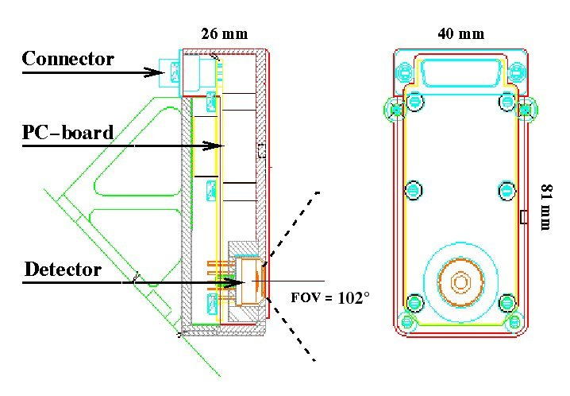
Figure 1. Illustration of Structural Layout of the XSM detector box.

The flux of the Sun in the

energy of range 0.1-20 keV, is very high (several hundred million photons/cm^2/s) and variable. The spectrum has a very steeply declining slope with increasing energy, which means that most of the photons are concentrated in the lower energies below 1 keV.
The variability, on the other hand, is concentrated in the higher energies because it is mainly caused by the changes in the high temperature components of the solar spectrum (originated in active regions and flares). This means that tuning the low energy limit for the XSM is very important to achieve reasonable count rates. Nevertheless, even by removing the mostly invariable low energy part of the flux below 1 keV, the detector will receive high photon fluxes requiring a very small active detector area.
The lower energy limit of the band pass is determined by the filter layers in front of the detector PIN and with an adjustable S/W parameter controlling the readout electronics. The optimal energy band-pass is acquired with a 13 micron Beryllium window. The standard design includes an Aluminum contact of 590 nm thickness, and the estimated Silicon dead layer is 100 nm. The co-added effects of these lead to a band pass with 10% efficiency at about 1 keV. All the XSM filter and FoV values are listed in Table 1.
The upper limit of the energy range for the High Purity Silicon (HPSi) PIN-detector depends on the thickness of the detector, which dominates the upper energy limit via the QE. The detector thickness of 0.5 mm suits well in this purpose. The range extends to about 20 keV with well sufficient QE for our purpose.
Thickness of filters and inactive layers
Beryllium | 13.00 μm
Polyimide | 0.25 μm
Aluminum filter+contact | 0.59 μm
Silicon dead layer | 0.10 μm
Silicon detector | 500.00 μm
Aperture geometry
Au-stopper diameter | 0.379 mm
Aperture diameter | 4.70 mm
Stopper-aperture distance | 2.0 mm
FoV cone radius | 52 deg

Table 1. XSM FM nominal dimensions of the detector material components.

    - Electronics
The electronics of the XSM consists of pre-amplifier stages and shaping amplifier, which are in the sensor unit box, and an electronics board in the main C1XS instrument box, which includes further stages of the signal processing electronics.
The electrical and data interfaces connect the XSM with the C1XS. There will be no direct electrical or data interfaces from the XSM to the spacecraft.
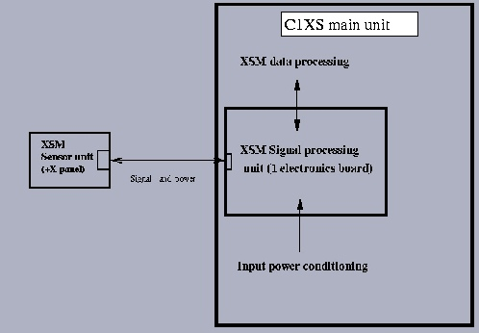

Figure2: Electrical Interface between XSM and C1XS instruments

Performance and Field Of View

The detector features will, according to simulations, yield about 1 count per second (cps) in the solar activity minimum (i.e., sunspot cycle minimum), about 200 cps in the solar maximum (i.e., average sunspot cycle maximum), and about 7000 cps during an X1 flare (a strong flare). Class X10 flares have been detected, and photon count rates above 10000 cps are therefore not ruled out, albeit very rare. From these we can set the requirement for the dynamic range of the detector. The optimization of that range should, however, be done simultaneously with that of the energy resolution, which is equally important for our science goals.
The XSM effective area when the Sun is in the middle of the FOV is shown in Fig. 3. The efficiency is defined by the filters in front of the detector PIN and the S/C attitude i.e. the position of the Sun in the XSM FOV. The efficiency decreases as a function of the increasing offaxis-angle. This angle represents the angle between the optical axis and the Sun.
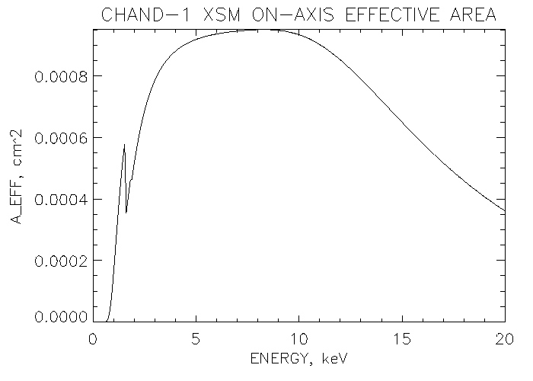

Figure 3. On-axis Sensitivity of XSM, i.e. the Sun is in the middle of the FOV.
Technically, there is a clear trade off between these goals, since high dynamic range, and capability to handle very high count rates will inevitably lead to a loss of energy resolution, and to an intolerable event pile-up. Therefore, we set the requirement for the energy resolution to be about 180 eV at 6 keV (at the PIN temperature of -20 C). This is quite sufficient for a good spectral analysis, with the capability of resolving the major spectral lines expected in the lower energy part of the spectrum (thin thermal plasma spectrum). The resolution will also be comparable to those of the instruments on the other X-ray missions (XMM-Newton and Chandra). The suitable number of equally spaced energy channels in the range 0-20 keV is 512, leading to at least 3-4 channels per resolution element.
The dynamic range is optimized by a hardware technique to compensate the detector dead time losses. This will also lead to significantly decreased amount of signal pile-up. The estimated fraction of piled up events will be about 3% at the signal level of 20000 cps.
The X-ray flux from the Sun will overwhelmingly dominate the signal in the energy range of the instrument over the sky background or any other possible source simultaneously in the FOV. In fact, the open aperture of the detector should be maximized in order to observe the Sun at different attitudes of the S/C. Thus, the instrument requires no collimation or a focusing system (telescope), and the full aperture of the detector will be used.

The XSM detector is a PIN-diode made of High Purity Silicon. Its initial energy resolution will be about 170 eV at 5.9 keV at the beginning of the Chandrayaan-1 mission. Bombardment of solar protons and cosmic particles will deteriorate the operation of the PIN-diode by degrading the energy resolution. These radiation damages will cause higher leakage current across the PIN-diode, which will be the dominant noise source in the system. The noise caused by a leakage current can be decreased by frequent annealing periods of 5 hours when required. The leakage current level will be recorded in the HK data.

Data Handling Process
The Observatory of University of Helsinki is responsible for data processing, preparation and archiving within the CSDA the XSM data products.
The following table provides the XSM data processing CODMAC levels:
Processing Level | Description
2 | XSM data that have been cleaned and merged, time ordered, and in packet format. Cleaned and merged means that duplicate data have been deleted, missing packets are padded out, and the data are organized by days. The data format is the same as the XSM telemetry packets.
3 | XSM PDS formatted data, in scientifically useful from, as data tables including science and calibration spectra, housekeeping values and attitude related information. These data are still not calibrated.
5 | High level data products generated using XSPEC fitting software tools. [This data will not be archived in the CDSA]

XSM obtains the data required to generate the CODMAC level 2 data products from:
- Raw Telemetry data (CODMAC level 1): FTP – RAL has developed an automated application that fetches the telemetry data for C1XS and XSM from ISSDC and pushes the packets to UH FTP server.
- Attitude data and related kernels are also provided using the same FTP application.
The XSM CODMAC level 2 data products are generated using the following pipe line procedure. Actually there is one specific higher level script that controls the whole pipe line run:
  - Convert Raw Telemetry data (CODMAC level 1) into FITS formatted data files. The application used to perform this conversion is smart1convert. This software requires as input the binary raw telemetry packages. The application removes the C1XS data contained in the packages and sorts out XSM data times into housekeeping and spectral data (both calibration and scientific data are considered as spectral data). smart1convert associates type 0 to housekeeping data and type 4 for spectral data for future use in the data reduction pipeline.
  - Generate FITS formatted data table containing spectral data, HK values, relevant attitude information and additional parameters required in further analysis. This is the final CODMAC level 2 data table. The application used to generate these products is DT.PRO. This application takes as inputs the type 0 and type 4 data files generated by smart1convert and also a tailored geometric file containing attitude information.
  - Finally, generate the PDS label for each of the data tables generated by DT.PRO. This is the final CODMAC level 2 data product that is archived in CSDA. The application used to generate PDS labels from the FITS table header keywords is F2P – FITS to PDS conversion tool. The data table remains unchanged in this conversion, and the result is a PDS formatted label of the data file.
Level 4/5 data products can be generated using XSPEC software. This software is freely available from:
http://heasarc.gsfc.nasa.gov/docs/xanadu/xspec/.
Although level 3 data products will not be archived in CSDA, the software tools required to generate the XSPEC compliant inputs files are archived within the data sets. The process to generate these input files is the following:
- Use RA.PRO to generate the Redistribution Matrix File (RMF) and the Ancillary Response Files (ARF). ARF files contain information on the sensitivity of the detector. The RMF contains information about the energy resolution and energy scale of the detector.
ATTENTION! THE LOWEST RELIABLE ENERGY CHANNEL IN XSM DATA VARIES DEPENDING ON THE CURRENT GAIN. HENCE, WHEN DOING SPECTRAL ANALYSIS IGNORE ALL CHANNELS LESS THAN THE CORRESPONDING LOWER TRESHOLD ENERGY! IF YOU DO SPECTRAL ANALYSIS WITH XSPEC AND YOU WILL USE THE ATTACHED RA.PRO, THEN THIS REDUCTION WILL BE PERFORMED AUTOMATICALLY. THERE IS AN ADJUSTEBLE PARAMETER CONTROLLING THE LOW ENERGY LIMIT.
- Generate XSPEC compliant data files using DG.PRO.
The figure 5 describes the XSM data flow. The boxes filled with yellow color will be archived within the level 2 data set.
ATTENTION! The DG.PRO program generates also a log file (LOG_FILE) containing a list of the number of counts in the first ch 0 (column #2), ch_1-ch_20 (#3), ch_21_510 (#4), last channel_511 (#5) and a quality flag (#6). The quality flag can have three different values 1, 0 and -1. QF equals 1 means that the data is of good quality. If QF equals 0, then there are significant amount of counts in the last channel 511 and the spectrum may contain phanto counts. If QF equals -1, do not analyze respective spectra! The first column denotes spectrum number and the second column denotes the spectral type, i.e. calibration (1), solar (0) or noise/BG (-1). -2 denotes time discontinuity between two successive spectrum, i.e. the start time difference is not 16 s as it should be during nominal operation.

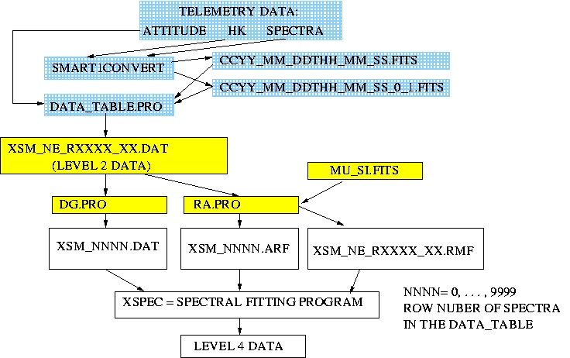
Figure 4: XSM data reduction pipeline.

Overview of Data Products

Pre-Flight Data Products
Neither

ground calibration information nor documents will be made available on the archive. The XSM team will provide and update relevant information so that the processing pipeline is up to date to reflect current situation of the XSM instrument.

Instrument Calibrations
Two different products are required to perform the spectral calibration:
- Calibration data, which is provided for each data product within the level 3 data table. Nominally, the 30 first spectra in the data table correspond to calibration data.
- Auxiliary Calibration table, called MU_SI.FITS, which contains Silicon mass attenuation factors as a function of photon energy for the nominal range of XSM. This file is archived together with the RA.PRO software, since this file is a crucial input for the application.
The calibration required previous to the generation of level 3 data products is performed by RA.PRO.

In-Flight Data Products
Raw data (at ISRO and UH)
ISRO will archive the telemetry data downloaded from Chandrayaan-1. University of Helsinki will archive all XSM telemetry data in raw binary format.

Level 2 data (at UH and CSDA)
University of Helsinki and CSDA will archive the XSM CODMAC level 2 data products in PDS format. These data products contain calibration data for each observation, the scientific data obtained in the observation, relevant attitude information, housekeeping data and some additional parameter required in the data analysis. The reason to keep all information in one table is to facilitate the usage of the data, since all the information contained in each data product is required to analyze the data product itself.
Reduced data (at UH)
Level 4 data products will be generated at UH for private usage. These data could be used in cross-instrument calibration and scientific analysis.

Software

Pipeline analysis software
The following software applications are used in the level 3 data generation pipeline:
- smart1convert: This program converts the raw telemetry data into FITS format files. There are 2 different data types for XSM that are needed for the CODMAC level 2 data set generation. Those are type 0, associated to HK, and type 4 for spectral data (be aware that both calibration and scientific data are covered by this type). The application will generate two different types of FITS files, one for housekeeping data and another for spectral data. Both files include a FITS formatted table, a primary header and an extension header.
This application will not be archived in any of the XSM data sets. It is intended to be used locally at UH to generate the data products.
The file naming scheme used for the output files is :

XSM_NE_Rxxxxx.DAT

where:
Token | Description
N | normal
E | EDR
xxxxx | Orbit number, five digits
NN | Sequence number if data on that date is split in more than one file, two digits (Otherwise NN=00)

- DT.PRO: Data Table Generator. This program generates a table containing spectral, HK, attitude data and some additional parameters related to one particular observation. The table is a FITS array made of 37 columns and variable number of rows and together with its associated label forms the level 1b data product. The total number of rows depends on the observation time. Each row represents one calibration or solar spectrum. Integration time of 16 seconds is used to acquire each single spectrum. In addition to the spectrum, each row also contains the related HK, attitude information and descriptive data quality and type parameters such as a flag indicating how the data should be used. A detailed description of the table contents and format is available in the section 4.3 Data Product Design.
This application will not be archived in any of the XSM data sets. It is intended to be used locally at UH to generate the data products.
The input file name shall follow the smart1convert output file naming scheme.
The output file name is XSM_NE_Rxxxx_00.DAT as shown in the table above.
- f2p: FITS to PDS label generator. This program generates the PDS detached data product label files to be archived in PSA. The fits table remains intact after this conversion. The software creates a PDS compliant label file from the information contained in the FITS header keywords.
This application will not be archived in any of the XSM data sets. It is intended to be used locally at UH to generate the data products.
The input file name shall follow the DT.PRO output file naming scheme.
The output file name is exactly the same as the input file name with the exception of the extension which is changed to .LBL, i.e. CCYY_MM_DDThh_mm_ss_1.LBL

Calibration Software:
Although there is no specific calibration software, RA.PRO performs calibration of the spectral data using as inputs the MU_SI.FITS file and the calibration data contained in the CODMAC level 2 data products. For further description of this application, please check the next section: Scientific Analysis Software.

Scientific Analysis Software:
The software applications used to visualize and analyze the data are non-commercial FTOOLS S/W package. None of these tools will be archived in any of the XSM data sets and can be freely download from:
http://heasarc.gsfc.nasa.gov/docs/software/ftools/ftools_menu.html
Before using refine data analysis tools, i.e. XSPEC spectra fitting program, the user shall run the following applications to obtain the required inputs:
- DG.PRO: Data Generator. This program generates the final data files to be used in XSPEC fitting program.
This application will be archived in all the XSM data sets. It is intended to be used by the XSM data user before refining the data with XSPEC.
The input file names shall follow the level 2 data product file naming scheme.
The application will generate a set of files, named XSM_nnnn.DAT, where nnnn denotes the row number, i.e. the corresponding spectrum, in the input file (nnnn = 0000, 0001, … ,9999)
When generating the XSPEC compliant data files with the DG.PRO application, both of the program and the input data must be located under the same subdirectory. The output of this process will be kept in the same directory.
- RA.PRO: RMF and ARF Files Generator. This program generates the final redistribution and ancillary response files to be used in XPESC fitting program.
This application will be archived in all the XSM data sets. It is intended to be used by the XSM data user before refining the data with XSPEC.
When running this application, the in-flight calibration is done automatically i.e. the energy versus energy channel relation is defined and the energy resolution as a function of photon energy is also determined.
The inputs to this application are the calibration spectra contained in the data products plus the MU_SI.FITS file. The application selects the calibration spectra by checking the additional parameters included in the data product not taking into account the background noise and solar spectra.
The information of channel vs. photon energy and energy resolution i.e. FWHM (Full Width at Half Maximum) are included in the corresponding RMF.
Only one RMF-file is generated for each observation as default. This IDL program generates also an extra log file for validity check, i.e. it records the channel vs. energy scale shift during the observation. The user can insert a specific spectrum number on program line 529. As a default the spectrum number is the mean value of the total number of the spectra in the data file. The log file gives a signal if the shift is greater than 20 eV between the start and the end of the observation. One can minimize the scale shift by generating several RMF’s for spectra at specific intervals if required. Each science spectra of 16 sec requires its own ARF file, hence the number of ARF files generated is equal to the number of spectra, i.e. rows, in the data table. Each ARF is a function of spacecraft attitude.
The output file naming schemes are as follows:
RMF file: XSM_NE_XXXXX_NN.RMF, where XXXX is the orbit number (Recommended file naming scheme – THE NAME OF THIS REDISTRIBUTION MATRIX FILE CAN BE TAYLORED BY THE USER!)
ARF files: XSM_nnnn.ARF, where nnnn denotes the row number, i.e. the corresponding spectrum, in the input file (nnnn = 0000, 0001, … ,9999)
When generating the ARFs and RMF with the RA.PRO application, both of the program and the input data must be located under the same subdirectory. The output of this process will be kept in the same directory.
- XSPEC: Refine Analysis Tools. This is a noncommercial S/W tool dedicated for analysis of high energy astrophysical data. Details can be found e.g. at the web address:
http://heasarc.gsfc.nasa.gov/docs/xanadu/xspec/
The input files required for this application, i.e. XSPEC compliant data files, ARFs and RMF shall be stored in the same directory.
The output of this application is refined level 3 data of solar X-ray spectra with physical units.
XSM team will not deliver this CODMAC level 3 data to the archive. The level 3 data are final scientific results. Those researchers outside XSM team willing to do refined analysis of the XSM data shall manage to do this by themselves using the delivered S/W and data described in this document.

All these above described deliverable programs and the ancillary data table – MU_SI.FITS – are archived under the software directory in the delivered data sets. All the programs can be operated under LINUX/UNIX stations. No source codes will be delivered.

Documentation

All the XSM related documents are located under the DOCUMENT subdirectory. This directory contains all the XSM documentation required to understand and analyze the archived data. The main document provided in the DOCUMENT directory is this EAICD, which contains all the relevant information on the content of the level 2 science and calibration data. This document will be archived in PDF, ASCII and DOC formats. Images and figures will be archived in this directory as JPEG files. Additional documents might be provided in any of the already mentioned formats.

Derived and other Data Products
XSM team will not deliver any derived data (level 4) data to the archive. The level 4 data are a final scientific result. Those researchers outside XSM team willing to do refined analysis of the XSM data shall manage to do this by themselves using the delivered S/W and data described in this document.
Any kind of separate in-flight calibration files will not be delivered. In nominal operation, the calibration spectra are taken at the beginning of each observation. These nominal 30 spectra consist of the 30 first rows in the data table, which will be used to generate calibrated data by running the RA.PRO.

Ancillary Data Usage
The efficiency of the XSM detector is dependent on the Sun’s position in the FOV, hence XSM needs the information of the satellite attitude at least at every 16 seconds for deriving Sun’s position in the wide circular FOV with radius of 52 deg. The accuracy of the attitude data should be less or equal to 1 degree. Two angles, OFF_AXIS and ROLL are derived from this attitude data using SPICE. These angles are needed to calculate the efficiency of the instrument during each observation. Since this information is required to analyze the data, it will be kept in the data products. These two angles are calculated by running the DT.PRO, which generates the deliverable FITS formatted data table. The time resolution in the geometric files is 5 minute, therefore when using this input the attitude data is interpolated to achieve the required time resolution of 16 sec – note that no interpolation is required if using SPICE to retrieve attitude information.
No separate attitude files will be delivered within the data set and for that reason there is no GEOMETRY directory in the data sets. All the attitude related information is included in the data products as additional columns of the data table XSM_NE_Rxxxxx.DAT.
CDSA will archive separated data sets containing all the required ancillary information for the Chandrayaan-1 mission in SPICE format. Should you require additional auxiliary data for Chandrayaan-1 or XSM, please refer to the CDSA auxiliary data sets.

Archive Format and Content

Format and Conventions

Deliveries and Archive Volume Format
XSM data is delivered within two datasets. The first data set contains the data obtained from the launch until the end of April 2009. The second data set contains the rest of the mission data.

Data Set ID Information

The name of the data set is: CH1ORB-S-C1XS-2-NPO-EDR-XSM-V1.0

Data Directory Naming Convention
The data products will be archived under the DATA directory. There will be no subdirectories under the data directory.

File Naming Convention
The naming of the data files, stored under the DATA directory, is based on the date and time of the observation. The file naming scheme is as follows:

XSM_NE_Rxxxxx.DAT

where:
Token | Description
XSM | X-ray Solar Monitor
DAT | File extension
N | normal
E | EDR
Xxxxx | Orbit number, five digits
NN | Sequence number if data on that date is split in more than one file, two digits (NN is 00, if there is only one observation made on a single orbit.)

Each of the data products contains both calibration and scientific data plus additional information required to process and analyze the data. Associated to the data files, there is a detached PDS compliant label file, with the same filename and .LBL extension.

Standards Used in Data Product Generation

PDS Standards
PDS standard for the datasets is version is v3.6 as described in document [AD. 1]

Time Standards
Three time standards are used in the XSM data products:
UTC: Coordinated Universal Time. The format used for UTC is the ISOC format:
YYYY-MM-DDThh:mm:ss.ddd
JD: Julian Date. JD represents continuous counts of days and fractions of a day starting from January 1st, 4173 BC (-4173 in the Astronomical Calendar) at Greenwich Mean Noon (12 hours UT). JD is determined from UTC.
Onboard Time (BDH Clock): seconds and fractions of a second since last reset or discontinuity in the Spacecraft Clock Time Correlation. The format followed for this time standard is the following:
p/x.y
where p is the partition number, x is the number of seconds elapsed from the last reset of the onboard clock and y is the number of fractions of a seconds. The BDH clock has a granularity of 1/ 65536th a second (corresponding to an approximate precision of 15 microseconds).
The BDH clock has to be converted to UTC using the ISRO supplied ‘.time’ files. Once the UTC time is obtained it can be used with the SPICE kernels to obtain Chandrayaan-1 attitude data.

Reference Systems
Inertial Reference Frame: The Earth Mean Equator and Equinox of Julian Date 2451545.0 (corresponding to January, 1st 2000 – Frame also referred as the J2000 system) is the standard reference frame.
Spacecraft Reference Frame: This frame, used to define the position of the Sun with respect to the Spacecraft is defined in document [TBD] as:
- +X axis is pointing to the Moon
- +Y axis is perpendicular to the launcher interface plane
- +Z axis completes the right-handed system.
- The origin of this frame is the launch vehicle interface point.

Instrument Reference Frame: This frame, used to define the position of the Sun with respect to the XSM FOV is defined as follows. Bore sight vector: X=-0.5, Y=+1/SQRT(2) and Z=+0.5.

Other Applicable Standards
FITS: Flexible Image Transport System standard. It is developed mainly for astrophysical data analysis purposes within NASA. See more details e.g. http://fits.gsfc.nasa.gov/. Fits files can be manipulated with FTOOLS S/W. (See, e.g. http://heasarc.nasa.gov/ftools/ftools_intro.html)

Data Validation

PDS Label and Data Set Validation
- PDS Label Verifier – PVV – program can be used to verify the syntax of a PDS label, including labels attached to their data file, insuring the language of the label is correct.
- PDS Table Browser – program can be used to interactively examine binary SPECTRUM data objects through the PDS label that describes the data format.
- READPDS SBN software – the program has been used to read the PDS formatted label to plot the spectral data and to read the additional information contained in the table files.

Scientific Validity of XSM Data Validation
- XSM team has done cross-calibration between XSM data and data obtained from RHESSI and GOES missions. The data from these two spacecraft are X-ray spectra and flux level measurements respectively. With that cross-calibration a first validity check of the solar spectral data is performed.

Content

Volume Set
XSM data will be split into two separate data sets. Since XSM data are delivered electronically to CSDA, there is no need to bundle several data sets into one volume set, and therefore, each data set will be contained in a volume. The number of data sets to be provided to CSDA.

Data Set
As mentioned in the previous section, both volumes contain a single data set. Therefore 2 data sets will be delivered to CSDA, by using the release and revision concept. The first data set contains data obtained from the launch to Apr 30 2009.

The data set names will be the same for each data set, with the only difference of the description. The scheme followed to create this filename is:
Instrument Host / Target Name / Instrument / Data level / Data Set type / Description / Version
The data set name is:
CHANDRAYAAN-1-ORBITER SUN C1XS 2 NPO EDR XSM V1.0

Directories

Root Directory

Files in the ROOT directory include an overview of the archive, a description of the volume for the PDS catalogue, and a list of comments about the archive. The following files are included in the ROOT directory:
File Name | File Contents
AAREADME.TXT | Contains an overview of the contents and organization of the associated volume, general instructions for its use, and contact information.
VOLDESC.CAT | Contains the VOLUME object, which gives a high level description of the contents of the volume.

Calibration Directory
There will not be CALIB directory in any of the data sets since the calibration data – calibration spectra and Silicon Mass attenuation coefficients data – are located in the data products and in the software directory respectively.

Catalog Directory
The files in the CATALOG directory provide top level understanding of the mission, spacecraft, instrument and data set. The files in this directory are created by the XSM team in cooperation with the CSDA team. The following files are located in the CATALOG directory:
File Name | File Contents
CATINFO.TXT | A description of the contents of this directory
DATASET.CAT | Data set information in PDS format. This file describes the data and peculiarities of the data set.
INSTHOST.CAT | Instrument host (spacecraft) information in PDS format. This file is generated by the PSA team to guarantee consistency between the different Chandrayaan-1 data sets.
INST.CAT | XSM Instrument description and additional information about the experiment.
MISSION.CAT | Mission information in PDS format. This file is generated by the PSA team to guarantee consistency between the different Chandrayaan-1 data sets.
SOFTWARE.CAT | Software information in PDS format. This catalogue file describes the software delivered with the data set in the SOFTWARE directory.
REFERENCE.CAT | Information about the references related to the Chandrayaan-1 mission.
RELEASE.CAT | Description, through DATA_SET_RELEASE objects, of the data products delivered to the PSA with each Release or Revision of the data set. This file is not PDS compliant.

Index Directory
Files in the INDEX Directory are provided to help the user to locate products on the archive volume. These files might be used also in a database to help to the ingestion or retrieval of the data in the system. The following files are contained in the INDEX directory:
File Name | File Contents
INDXINFO.TXT | A description of the contents of this directory
INDEX.TAB | A table listing all data products on this volume. This file is generated using the PSA PVV software application.
INDEX.LBL | A PDS detached label that describes the INDEX.TAB file. This file is generated using the PSA PVV software application.

NOTE: No geometry index files are to be provided within the data sets.

Geometry Directory
There will not be a GEOMETRY directory in any of the data sets since the geometry information required to analyze the data is contained in the data products.
CSDA will archive separated data sets containing all the required ancillary information for the Chandrayaan-1 mission in both SPICE and ISRO formats. Should you require additional auxiliary data for Chandrayaan-1 or XSM, please refer to the CSDA auxiliary data sets. The list below includes all the SPICE kernels used in generating the attitude and pointing related information are obtained from ESA/ISRO.

Software Directory
The SOFTWARE directory contains the software applications required to generate the required compliant input files for XSPEC spectral fitting software. The software packages are made of IDL programs and a data table in FITS format used by one of the applications to perform data calibration. A detailed description of the software applications and the data file is provided in sections 39.4.4.2 and 39.4.4.3. The packages are compressed with the extension of *.ZIP for the delivery. Before using the software, these files shall be uncompressed. The contents of the SOFTWARE directory are listed in the following table:

File Name | File Contents
SOFTINFO.TXT | A description of the contents of this directory
XSM_SOFT.ZIP | ZIP compressed file containing the IDL programs DG.PRO and RA.PRO. This file includes also the MU_SI.FITS auxiliary table file. This file has been compressed under LINUX by using the command tar –czvf. To uncompress the file under LINUX, please use the tar –xzvf XSM_SOFT.ZIP.
XSM_SOFT.LBL | A PDS detached label that describes the XSM_SOFT.ZIP file.

Document Directory
The DOCUMENT directory contains the required documentation to understand the data contained in the data set. XSM encourages the reading of this documentation before starting to use the data. The following files are stored in the DOCUMENT directory:
File Name | File Contents
DOCINFO.TXT | A description of the contents of this directory
XSM_EAICD.ASC | XSM Experiment to Archive interface control document in ASCII format.
XSM_EAICD.DOC | XSM Experiment to Archive interface control document in Microsoft Word format.
XSM_EAICD.PDF | XSM Experiment to Archive interface control document in PDF format.
XSM_EAICD_FIG01.JPG | Figure 1 of the XSM EAICD for the ASCII version of the document.
XSM_EAICD_FIG02.JPG | Figure 2 of the XSM EAICD for the ASCII version of the document.
XSM_EAICD_FIG03.JPG | Figure 3 of the XSM EAICD for the ASCII version of the document.
XSM_EAICD_FIG04.JPG | Figure 4 of the XSM EAICD for the ASCII version of the document.
XSM_EAICD_FIG05.JPG | Figure 5 of the XSM EAICD for the ASCII version of the document.
XSM_EAICD_FIG06.JPG | Figure 6 of the XSM EAICD for the ASCII version of the document.
XSM_EAICD.LBL | A combined PDS detached label describing the XSM_EAICD documents – All the files above this line except the DOCINFO.TXT.
XSM_PAPER001.PDF | ``The SMART-1 X-ray Solar Monitor (XSM): Calibrations for D-CIXS and independent coronal science'', Houvelin et al., Planetary and Space Science, Vol. 50/14-15, p. 1345-1353.
XSM_PAPER001.LBL | A PDS detached label describing the XSM_PAPER001.PDF document.
XSM_PAPER002.PDF | “In-flight performance of the X-ray Solar Monitor (XSM) on-board SMART-1”, L. Alha et al., NIMA Vol. 596 (2008) 317-226
XSM_PAPER002.LBL | A PDS detached label describing the XSM_PAPER002.PDF document.
XSM_PAPER003.PDF | “Ground calibration of the Chandrayaan-1 X-ray Solar Monitor (XSM)”, L. Alha et al., NIMA, Vol. 607 (2009) 544-553
XSM_PAPER003.LBL | A PDS detached label describing the XSM_PAPER003.PDF document.
XSM_CALIB_PROCEDURE.ASC | An ascii file explaining the XSM in-flight calibration method.
XSM_CALIB_PROCEDURE.LBL | A PDS detached label describing the XSM_CALIB_PROCEDURE.ASC document.

All future publications related to XSM and their label files will be archived in the document directory, after updating this document.

Data Directory
The DATA directory contains the XSM Level 3 data products. These data products are made of scientific data, calibration data to be used together with the scientific data, attitude information and some additional parameters.
There are several subdirectories under the data directory. Each subdirectory contains data obtained during circa 100 orbits. There will be only one data set delivery into the archive. Only level 3 data products will be archived in the CSDA.

Detailed Interface Specification

This chapter provides the XSM user with detailed information on the dataset, directory naming and archive design that have not been mentioned already or that are of extremely importance for the final usage of the data.

Structure and Organizational Overview
XSM data are archived in single data set covering the data obtained during the NOP. In this data set, there is one DATA directory and the DATA directory does not include any subdirectories containing data.
The archived data products contain all the data acquired in a single observation. XSM observations start with a calibration procedure during which about 30 spectra are obtained – with integration times of 16 seconds –. Once the calibration procedure is done, the instrument operates nominally, acquiring solar spectral data.

All these spectral data – calibration and scientific spectra – are archived in a single file in FITS format together with additional parameters required to analyze the data.
The filename scheme is described in detail in section 40.1.4.

Data Sets, Definition and Content
Only one data set will be produced as part of the archive of XSM Level 3 data. The Data Set ID is:
CH1ORB-X-C1XS-2-NPO-EDR-XSM-V1.0

This single release will contain data covering the whole mission phase and level 4 data will be delivered after six months the mission is terminated by the XSM team.
For further information about the data set IDs and data set names please refer to sections 40.1.2 and 40.4.2

Data Product Design

The final and archived data table containing the CODMAC level 3 data is generated by the IDL program DT.PRO.
Pre-Flight Data Products

Inputs for this program are spectral data (type 4) and HK data (type 0) files and a specially tailored attitude data (geometry file containing solar angles given with respect to the spacecraft frame etc.). The content of the data table is described below. The number of rows is variable and depends on the total observation time. The total number of columns in this data table is always constant and equal to 37.

the i

- The scheme or convention you will use for naming your directories and some cases not available. Simple keep it short or write “n/a”, if applicable.Specific and detailed information will go into a subchapter of chapter 4.3, 'Data Product A Design' etc]

ESA/PSA aims to electronic data delivery only. Experiment teams shall deliver only LOGICAL ARCHIVE VOLUMES. This can be compared to having one data set per archive volume. The size of a logical archive volume shall be the volume of a CD (<650 Mbytes) or if not feasible the size of a DVD (4.7Gbytes). The logical archive volume is an entity that can be distributed to the scientific community. For long-term archive purposes and dedicated scientific requests the PSA will generate and create physical archive volumes (as you know them from the past) on the fly on a physical media that might change over time.

Explain your volume naming scheme.

e.g. Expla

Will your team deliver pre-flight data products, e.g. ground-based observations, campaigns with the instrument model on Earth, etc.
]
Have you done any sub-system tests that might contribute to the understanding of the data? If yes, please specify and explain the tests. Refer to relevant documentation.
]
Will you archive calibration data from your flight or flight spare model. Please describe.

Is there any other information available from calibration, e.g. database on used minerals and the result of other instruments using the same minerals?
]

Give a general overview of the data obtained during the active mission.
- What are your data products? (cruise, mapping ,etc)
- Please explain what these products describe,
- why did you selected them?
- what processing level are they?
- Can they be used for cross-instrument calibration?
- Can they be used for cross-instrument scientific analysis?
- Etc
]

Give a short overview on
- calibration software
- pipeline processing software
- scientific analysis software
(not only on the software you intend to archive, but also the software your team is using in general)

- what documentation you will provide in the doc directory
- what documentation you will provide in the extras directory
- what format you will use
- how do you handle images and drawings in ASCII file, that are normally bundled in your documents? (e.g. will you create PNG files for each image in a WORD document?)

    - 1
- will you provide any other derived data (even outside of the official archiving efforts)?
- Will you provide data products that result from co-operation with other instrument teams?

Do you use orbit, attitude or event data from ESOC within your data processing chain. Please explain, for which processing you use which data.

- Detailed Interface Specifications

on the dataset, directory and filenaming, of your ]

e

S

Data Product Design

XSM data consists of one data table, which includes spectral data, HK-data and attitude data attached in the same FITS-formatted data table. The data file name is composed instrument acronyms (XSM) and mission phase marker (NE) following the respective orbit number (RXXXXX) with the end of two digits describing the observation sequence during one single orbit.
The following sections provide the description of the PDS product labels that are used in describing XSM data sets that will be supplied to the PSA. These example labels are generated from the data file having a name XSM_NE_R00300_00.DAT.

/*XSM FILE CHARACTERISTIC PDS-LABELS*/

PDS_VERSION_ID = PDS3
LABEL_REVISION_NOTE = "CH1 XSM PDS LABEL V1.1"

/* FILE CHARACTERISTICS */
FILE_NAME = "XSM_NE_R00300_00.DAT"
RECORD_TYPE = FIXED_LENGTH
RECORD_BYTES = 2880
FILE_RECORDS = 237
INTERCHANGE_FORMAT = BINARY

/* DATA OBJECT POINTERS */
^HEADER = "XSM_NE_R00300_00.DAT"
^EXTENSION_HEADER = ("XSM_NE_R00300_00.DAT", 2881<BYTES>)
^TABLE = ("XSM_NE_R00300_00.DAT", 14401<BYTES>)

/* IDENTIFICATION DATA ELEMENTS */
RELEASE_ID = 0001
REVISION_ID = 0000
DATA_SET_ID = "CH1ORB-X-C1XS-2-NPO-EDR-XSM-V1.0"
DATA_SET_NAME = "
CHANDRAYAAN-1-ORBITER SUN C1XS 2 NPO EDR XSM V1.0
"
PRODUCT_ID = "XSM_NE_R00300_00"
PRODUCT_CREATION_TIME = 2009-10-05T17:16:20
PRODUCT_TYPE = EDR
PROCESSING_LEVEL_ID = 2
PROCESSING_LEVEL_DESC = "
EDITED DATA: CORRECTED FOR TELEMETRY ERRORS. CORRESPONDS TO EDR -
EXPERIMENTAL DATA RECORDS. PSA LEVEL-1B. CODMAC LEVEL 2. THE DATA
ARE TAGGED WITH TIME AND LOCATION OF ACQUISITION.
"
MISSION_ID = CH1
MISSION_NAME = "CHANDRAYAAN-1"
MISSION_PHASE_NAME = "NORMAL PHASE OPERATIONS"
INSTRUMENT_HOST_ID = CH1ORB
INSTRUMENT_HOST_NAME = "CHANDRAYAAN-1-ORBITER"
INSTRUMENT_ID = C1XS
INSTRUMENT_NAME = "LOW ENERGY X-RAY SPECTROMETER"
INSTRUMENT_TYPE = SPECTROMETER
INSTRUMENT_MODE_ID = "CALIB/OBS"
INSTRUMENT_MODE_DESC = "
XSM HAS 2 MODES: CALIBRATION AND OBSERVATION. THE DATA PRODUCT
CONTAINS BOTH SOLAR AND CALIBRATION SPECTRA
"
TARGET_NAME = SUN
TARGET_TYPE = SUN
START_TIME = 2008-12-03T22:56:10.380
STOP_TIME = 2008-12-03T23:38:34.380
SPACECRAFT_CLOCK_START_COUNT = "0/0003702539.00000"
SPACECRAFT_CLOCK_STOP_COUNT = "0/0003705083.00000"
START_ORBIT_NUMBER = 300
STOP_ORBIT_NUMBER = 300
PRODUCER_ID = "XSM_TEAM"
PRODUCER_FULL_NAME = "LAURI ALHA"
PRODUCER_INSTITUTION_NAME = "OBSERVATORY, UNIVERSITY OF HELSINKI"

/* DESCRIPTIVE DATA ELEMENTS */
DATA_QUALITY_ID = 1
DATA_QUALITY_DESC = "1=NORMAL 2=POOR"

/* DATA OBJECT DEFINITIONS */
OBJECT = HEADER
BYTES = 2880
HEADER_TYPE = FITS
INTERCHANGE_FORMAT = BINARY
RECORDS = 1
DESCRIPTION = "
THIS PRIMARY HEADER CONTAINS THE
STANDARD KEYWORDS TO DESCRIBE A FITS-
FORMATTED DATA TABLE.
"
END_OBJECT = HEADER

OBJECT = EXTENSION_HEADER
BYTES = 11520
HEADER_TYPE = FITS
INTERCHANGE_FORMAT = BINARY
RECORDS = 4
DESCRIPTION = "
THIS SECONDARY EXTENSION HEADER CONTAINS THE
KEYWORDS REQUIRED TO DESCRIBE THE INTERNAL
STRUCTURE OF A FITS-FORMATTED DATA TABLE AND
THE AUXILIARY INFORMATION NEEDED IN FURTHER
ANALYSIS OF THE DATA.
"
END_OBJECT = EXTENSION_HEADER

OBJECT = TABLE
COLUMNS = 37
INTERCHANGE_FORMAT = BINARY
ROW_BYTES = 4266
ROWS = 156
DESCRIPTION = "
THIS TABLE IS A FITS-FORMATTED BINARY ARRAY
CONTAINING THE ARCHIVED LEVEL 2 DATA OF XSM.
PADDING WITH ZERO VALUES MAY HAVE BEEN REQUIRED
AFTER THE END OF THE TABLE OBJECT TO FIT THE
FITS PHYSICAL RECORD LENGTH OF 2880 BYTES
REQUIRED BY THE FITS STANDARD.
"

OBJECT = COLUMN
COLUMN_NUMBER = 1
NAME = SPECTRUM
BYTES = 2048
START_BYTE = 1
DATA_TYPE = MSB_INTEGER
DESCRIPTION = "
THE RAW DATA OF THE 512 CHANNEL X-RAY SPECTRUM OF THE XSM.
"
ITEMS = 512
ITEM_BYTES = 4
END_OBJECT = COLUMN

OBJECT = COLUMN
COLUMN_NUMBER = 2
NAME = FLAG
BYTES = 2
START_BYTE = 2049
DATA_TYPE = MSB_INTEGER
DESCRIPTION = "
A FLAG INDICATING THE SPECTRAL TYPE.
1=CALIBRATION
0=SOLAR SPECTRUM
-1=BACKGROUND OR NOISE
-2=TIME DISCONTINUITY
SPECTRA ARE FLAGGED WITH TIME DISCONTINUITY WHEN THE TIME
BETWEEN CONSECUTIVE SPECTRA IS OTHER THAN THE DEFAULT
INTEGRATION TIME OF 16 SECONDS. SUCH A DISCONTINUITY MAY
INDICATE AN UNCERTAIN INTEGRATION TIME CAUSED BY A BUG IN
AN EARLY VERSION OF THE FLIGHT SOFTWARE.
"
END_OBJECT = COLUMN

OBJECT = COLUMN
COLUMN_NUMBER = 3
NAME = T_UTC
BYTES = 26
START_BYTE = 2051
DATA_TYPE = CHARACTER
DESCRIPTION = "
INTEGRATION START TIME IN UTC.
"
END_OBJECT = COLUMN

OBJECT = COLUMN
COLUMN_NUMBER = 4
NAME = START_OBS
BYTES = 8
START_BYTE = 2077
DATA_TYPE = IEEE_REAL
DESCRIPTION = "
BDH CLOCK COUNT AT THE START OF INTEGRATION.
"
UNIT = SECOND
END_OBJECT = COLUMN

OBJECT = COLUMN
COLUMN_NUMBER = 5
NAME = INTEGRATION_TIME
BYTES = 4
START_BYTE = 2085
DATA_TYPE = MSB_INTEGER
DESCRIPTION = "
INTEGRATION TIME IN SECONDS.
"
UNIT = SECOND
END_OBJECT = COLUMN

OBJECT = COLUMN
COLUMN_NUMBER = 6
NAME = TOTAL_COUNTS
BYTES = 8
START_BYTE = 2089
DATA_TYPE = IEEE_REAL
DESCRIPTION = "
TOTAL COUNTS IN THE SPECTRUM.
"
END_OBJECT = COLUMN

OBJECT = COLUMN
COLUMN_NUMBER = 7
NAME = A_EFF
BYTES = 2048
START_BYTE = 2097
DATA_TYPE = IEEE_REAL
DESCRIPTION = "
THE EFFECTIVE AREA IN CM^2 FOR EACH OF THE 512 CHANNELS OF
THE XSM CORRESPONDING TO THE CURRENT INTEGRATION.
"
ITEMS = 512
ITEM_BYTES = 4
UNIT = SQUARE CENTIMETER
END_OBJECT = COLUMN

OBJECT = COLUMN
COLUMN_NUMBER = 8
NAME = PIN_TEMP
BYTES = 8
START_BYTE = 4145
DATA_TYPE = IEEE_REAL
DESCRIPTION = "
THE TEMPERATURE OF THE DETECTOR PIN IN CELSIUS. IF THE
TEMPERATURE IS GREATER THAN 0 DEGREES CELSIUS, XSM IS
SWITCHED OFF.
"
UNIT = DEGREE CELSIUS
END_OBJECT = COLUMN

OBJECT = COLUMN
COLUMN_NUMBER = 9
NAME = BOX_TEMP
BYTES = 8
START_BYTE = 4153
DATA_TYPE = IEEE_REAL
DESCRIPTION = "
TEMPERATURE OF THE XSM SENSOR BOX IN CELSIUS. THIS
TEMPERATURE VALUE DEPENDS ON THE POINTING OF THE XSM.
"
UNIT = DEGREE CELSIUS
END_OBJECT = COLUMN

OBJECT = COLUMN
COLUMN_NUMBER = 10
NAME = BIAS_HV
BYTES = 8
START_BYTE = 4161
DATA_TYPE = IEEE_REAL
DESCRIPTION = "
THE BIAS HIGH VOLTAGE. NOMINAL VALUE IS AROUND 100 VDC
WHEN XSM IS OBSERVING.
"
UNIT = VOLT
END_OBJECT = COLUMN

OBJECT = COLUMN
COLUMN_NUMBER = 11
NAME = LEAKAGE_CURRENT
BYTES = 8
START_BYTE = 4169
DATA_TYPE = IEEE_REAL
DESCRIPTION = "
THE LEAKAGE CURRENT IN PICO AMPS. THIS VALUE DEPENDS ON THE
CURRENT COUNT RATE, PIN TEMPERATURE AND LATTICE DEFECTS
CAUSED BY PARTICLE RADIATION. LEAKAGE CURRENT CAN BE
DECREASED BY ANNEALING.
"
UNIT = PICOAMPERE
END_OBJECT = COLUMN

OBJECT = COLUMN
COLUMN_NUMBER = 12
NAME = POS_5_V
BYTES = 8
START_BYTE = 4177
DATA_TYPE = IEEE_REAL
DESCRIPTION = "
THE VOLTAGE OF THE POWER SUPPLY
+5 V LINE. NOMINAL VALUE IS +5 VDC
"
UNIT = VOLT
END_OBJECT = COLUMN

OBJECT = COLUMN
COLUMN_NUMBER = 13
NAME = POS_12_V
BYTES = 8
START_BYTE = 4185
DATA_TYPE = IEEE_REAL
DESCRIPTION = "
THE VOLTAGE OF THE POWER SUPPLY
+12 V LINE. NOMINAL VALUE IS +12 VDC
"
UNIT = VOLT
END_OBJECT = COLUMN

OBJECT = COLUMN
COLUMN_NUMBER = 14
NAME = NEG_12_V
BYTES = 8
START_BYTE = 4193
DATA_TYPE = IEEE_REAL
DESCRIPTION = "
THE VOLTAGE OF THE POWER SUPPLY
-12 V LINE. NOMINAL VALUE IS -12 VDC.
"
UNIT = VOLT
END_OBJECT = COLUMN

OBJECT = COLUMN
COLUMN_NUMBER = 15
NAME = PELTIER_VOLTAGE
BYTES = 8
START_BYTE = 4201
DATA_TYPE = IEEE_REAL
DESCRIPTION = "
THE PELTIER VOLTAGE. NOMINAL VALUE DURING
COOLING IS AROUND 1.65 VDC.
"
UNIT = VOLT
END_OBJECT = COLUMN

OBJECT = COLUMN
COLUMN_NUMBER = 16
NAME = PELTIER_STATE
BYTES = 1
START_BYTE = 4209
DATA_TYPE = MSB_INTEGER
DESCRIPTION = "
THE PELTIER STATE. OFF = 0 AND COOLING = 1.
"
END_OBJECT = COLUMN

OBJECT = COLUMN
COLUMN_NUMBER = 17
NAME = FIFO_STATE
BYTES = 1
START_BYTE = 4210
DATA_TYPE = MSB_INTEGER
DESCRIPTION = "
THE FIFO STATE. 1=ACQUISITION ON 0=ACQUISITION OFF.
"
END_OBJECT = COLUMN

OBJECT = COLUMN
COLUMN_NUMBER = 18
NAME = DET_OVER_TEMP
BYTES = 1
START_BYTE = 4211
DATA_TYPE = MSB_INTEGER
DESCRIPTION = "
DETECTOR OVER TEMPERATURE FLAG. NOMINAL VALUE IS 0.
IF THE PIN TEMPERATURE EXCEEDS +0 DEGREES CELSIUS,
THIS VALUE IS 1 AND XSM IS SWITCHED OFF.
"
END_OBJECT = COLUMN

OBJECT = COLUMN
COLUMN_NUMBER = 19
NAME = XSM_STATE
BYTES = 4
START_BYTE = 4212
DATA_TYPE = MSB_INTEGER
DESCRIPTION = "
THIS COLUMN CONTAINS THE XSM STATE IN DECIMAL.
STATE NUMBER STATE NAME
0 OFF
1 STARTING
2 COOLING
3 COOL
4 CALIBRATE
5 OPENING SHUTTER
6 OPERATING
7 CLOSING SHUTTER
8 PRE-ANNEAL1
9 PRE-ANNEAL2
10 ANNEAL
11 CLOSING SHUTTER FOR CALIBRATION
"
END_OBJECT = COLUMN

OBJECT = COLUMN
COLUMN_NUMBER = 20
NAME = XSM_STATE_NAME
BYTES = 12
START_BYTE = 4216
DATA_TYPE = CHARACTER
DESCRIPTION = "
THIS COLUMN CONTAINS THE XSM STATE IN ASCII.
"
END_OBJECT = COLUMN

OBJECT = COLUMN
COLUMN_NUMBER = 21
NAME = SECOND_COUNTER
BYTES = 4
START_BYTE = 4228
DATA_TYPE = MSB_INTEGER
DESCRIPTION = "
THIS COLUMN CONTAINS THE SECOND COUNTER. THE VALUE IS THE
NUMBER OF SECONDS THE XSM HAS BEEN IN THE STATE GIVEN IN
THE XSM STATE COLUMN.
"
END_OBJECT = COLUMN

OBJECT = COLUMN
COLUMN_NUMBER = 22
NAME = RA_PNTG
BYTES = 2
START_BYTE = 4232
DATA_TYPE = MSB_INTEGER
DESCRIPTION = "
THIS COLUMN CONTAINS THE RIGHT ASCENSION OF THE XSM
POINTING IN DEGREES.
"
UNIT = DEGREE
END_OBJECT = COLUMN

OBJECT = COLUMN
COLUMN_NUMBER = 23
NAME = DEC_PNTG
BYTES = 2
START_BYTE = 4234
DATA_TYPE = MSB_INTEGER
DESCRIPTION = "
THIS COLUMN CONTAINS THE DECLINATION OF THE XSM
POINTING IN DEGREES.
"
UNIT = DEGREE
END_OBJECT = COLUMN

OBJECT = COLUMN
COLUMN_NUMBER = 24
NAME = SUN_FOV
BYTES = 1
START_BYTE = 4236
DATA_TYPE = MSB_INTEGER
DESCRIPTION = "
THIS COLUMN CONTAINS THE FLAG INDICATING THE POSITION OF THE SUN
IN RESPECT TO THE XSM FIELD OF VIEW. 1 MEANS THAT THE SUN IS INSIDE
THE FOV, I.E. OFF-AXIS ANGLE OF THE SUN IS LESS THAN OR EQUAL TO
52 DEGREES, 0 MEANS THAT THE SUN IS OUTSIDE OF FOV, I.E. IT'S
OFF-AXIS ANGLE IS GREATER THAN 52 DEGREES.
"
END_OBJECT = COLUMN

OBJECT = COLUMN
COLUMN_NUMBER = 25
NAME = RANGE_SUN
BYTES = 4
START_BYTE = 4237
DATA_TYPE = MSB_INTEGER
DESCRIPTION = "
THIS COLUMN CONTAINS THE DISTANCE TO THE CENTER OF THE SUN IN
KILOMETERS.
"
UNIT = KILOMETER
END_OBJECT = COLUMN

OBJECT = COLUMN
COLUMN_NUMBER = 26
NAME = RA_SUN
BYTES = 2
START_BYTE = 4241
DATA_TYPE = MSB_INTEGER
DESCRIPTION = "
THIS COLUMN CONTAINS THE RIGHT ASCENSION OF THE SUN
IN DEGREES.
"
UNIT = DEGREE
END_OBJECT = COLUMN

OBJECT = COLUMN
COLUMN_NUMBER = 27
NAME = DEC_SUN
BYTES = 2
START_BYTE = 4243
DATA_TYPE = MSB_INTEGER
DESCRIPTION = "
THIS COLUMN CONTAINS THE DECLINATION OF THE SUN
IN DEGREES.
"
UNIT = DEGREE
END_OBJECT = COLUMN

OBJECT = COLUMN
COLUMN_NUMBER = 28
NAME = OFF_AXIS
BYTES = 2
START_BYTE = 4245
DATA_TYPE = MSB_INTEGER
DESCRIPTION = "
THIS COLUMN CONTAINS THE OFF-AXIS ANGLE OF THE SUN IN DEGREES IN
RESPECT TO THE OPTICAL AXIS OF THE XSM (XSM +Z AXIS). THE SUN IS
OUTSIDE OF THE FOV OF XSM WHEN THE OFF-AXIS ANGLE IS GREATER
THAN 52 DEGREES.
"
UNIT = DEGREE
END_OBJECT = COLUMN

OBJECT = COLUMN
COLUMN_NUMBER = 29
NAME = ROLL
BYTES = 2
START_BYTE = 4247
DATA_TYPE = MSB_INTEGER
DESCRIPTION = "
THIS COLUMN CONTAINS THE ROLL ANGLE OF THE SUN IN DEGREES.
ROLL ANGLE IS DEFINED TO BE 0-360 DEGREES FROM THE XSM +Y AXIS
TOWARD THE XSM -X AXIS.
"
UNIT = DEGREE
END_OBJECT = COLUMN

OBJECT = COLUMN
COLUMN_NUMBER = 30
NAME = MOON_FOV
BYTES = 1
START_BYTE = 4249
DATA_TYPE = MSB_INTEGER
DESCRIPTION = "
THIS COLUMN CONTAINS THE FLAG INDICATING THE POSITION OF THE MOON
IN RESPECT TO THE XSM FIELD OF VIEW. 1 MEANS THAT THE MOON IS INSIDE
THE FOV, I.E. OFF-AXIS ANGLE OF THE MOON IS LESS THAN OR EQUAL TO
52 DEGREES, 0 MEANS THAT THE MOON IS OUTSIDE OF FOV, I.E. IT'S
OFF-AXIS ANGLE IS GREATER THAN 52 DEGREES.
"
END_OBJECT = COLUMN

OBJECT = COLUMN
COLUMN_NUMBER = 31
NAME = RANGE_MOON
BYTES = 4
START_BYTE = 4250
DATA_TYPE = MSB_INTEGER
DESCRIPTION = "
THIS COLUMN CONTAINS THE DISTANCE TO THE CENTER OF THE MOON IN
KILOMETERS.
"
UNIT = KILOMETER
END_OBJECT = COLUMN

OBJECT = COLUMN
COLUMN_NUMBER = 32
NAME = OFF_MOON
BYTES = 2
START_BYTE = 4254
DATA_TYPE = MSB_INTEGER
DESCRIPTION = "
THIS COLUMN CONTAINS THE OFF-AXIS ANGLE OF THE MOON IN DEGREES IN
RESPECT TO THE OPTICAL AXIS OF THE XSM (XSM +Z AXIS). THE SUN IS
OUTSIDE OF THE FOV OF XSM WHEN THE OFF-AXIS ANGLE IS GREATER
THAN 52 DEGREES.
"
UNIT = DEGREE
END_OBJECT = COLUMN

OBJECT = COLUMN
COLUMN_NUMBER = 33
NAME = ROLL_MOON
BYTES = 2
START_BYTE = 4256
DATA_TYPE = MSB_INTEGER
DESCRIPTION = "
THIS COLUMN CONTAINS THE ROLL ANGLE OF THE MOON IN DEGREES.
ROLL ANGLE IS DEFINED TO BE 0-360 DEGREES FROM THE XSM +Y AXIS
TOWARD THE XSM -X AXIS.
"
UNIT = DEGREE
END_OBJECT = COLUMN

OBJECT = COLUMN
COLUMN_NUMBER = 34
NAME = EARTH_FOV
BYTES = 1
START_BYTE = 4258
DATA_TYPE = MSB_INTEGER
DESCRIPTION = "
THIS COLUMN CONTAINS THE FLAG INDICATING THE POSITION OF THE EARTH
IN RESPECT TO THE XSM FIELD OF VIEW. 1 MEANS THAT THE EARTH IS INSIDE
THE FOV, I.E. OFF-AXIS ANGLE OF THE EARTH IS LESS THAN OR EQUAL TO
51.62 DEGREES, 0 MEANS THAT THE EARTH IS OUTSIDE OF FOV, I.E. IT'S
OFF-AXIS ANGLE IS GREATER THAN 51.62 DEGREES.
"
END_OBJECT = COLUMN

OBJECT = COLUMN
COLUMN_NUMBER = 35
NAME = RANGE_EARTH
BYTES = 4
START_BYTE = 4259
DATA_TYPE = MSB_INTEGER
DESCRIPTION = "
THIS COLUMN CONTAINS THE DISTANCE TO THE CENTER OF THE EARTH IN
KILOMETERS.
"
UNIT = KILOMETER
END_OBJECT = COLUMN

OBJECT = COLUMN
COLUMN_NUMBER = 36
NAME = OFF_EARTH
BYTES = 2
START_BYTE = 4263
DATA_TYPE = MSB_INTEGER
DESCRIPTION = "
THIS COLUMN CONTAINS THE OFF-AXIS ANGLE OF THE EARTH IN DEGREES IN
RESPECT TO THE OPTICAL AXIS OF THE XSM (XSM +Z AXIS). THE EARTH IS
OUTSIDE OF THE FOV WHEN THE OFF-AXIS ANGLE IS GREATER THAN 52 DEGREES.
"
UNIT = DEGREE
END_OBJECT = COLUMN

OBJECT = COLUMN
COLUMN_NUMBER = 37
NAME = ROLL_EARTH
BYTES = 2
START_BYTE = 4265
DATA_TYPE = MSB_INTEGER
DESCRIPTION = "
THIS COLUMN CONTAINS THE ROLL ANGLE OF THE EARTH IN DEGREES.
ROLL ANGLE IS DEFINED TO BE 0-360 DEGREES FROM THE XSM +Y AXIS
TOWARD THE XSM -X AXIS.
"
UNIT = DEGREE
END_OBJECT = COLUMN
END_OBJECT = TABLE
END

- Appendix 1: Example of Directory Listing

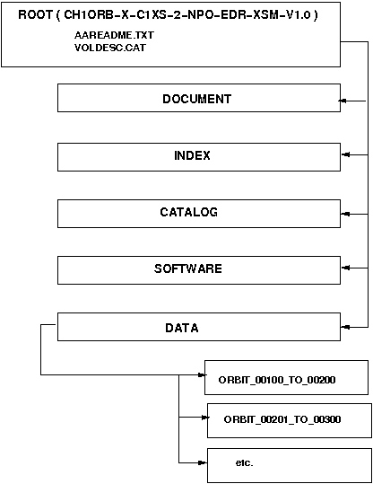

Figure 5. Data set directory structure.

You may prepare a first data set with most of the data and label files (but dummy content) on your directory structure and copy a screen-dump to this place.

Appendix 2: XSM Spectrum Types

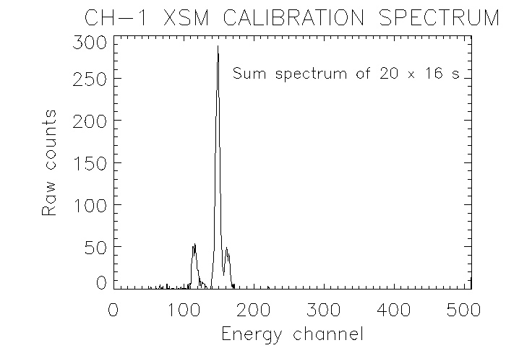

Figure 7. XSM calibration spectrum.

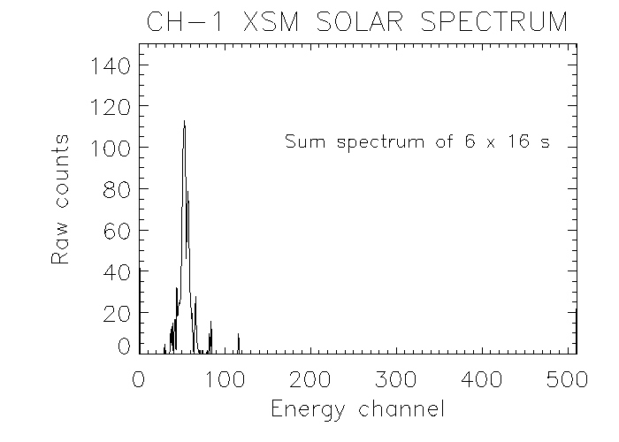
Figure 8. XSM solar spectrum.
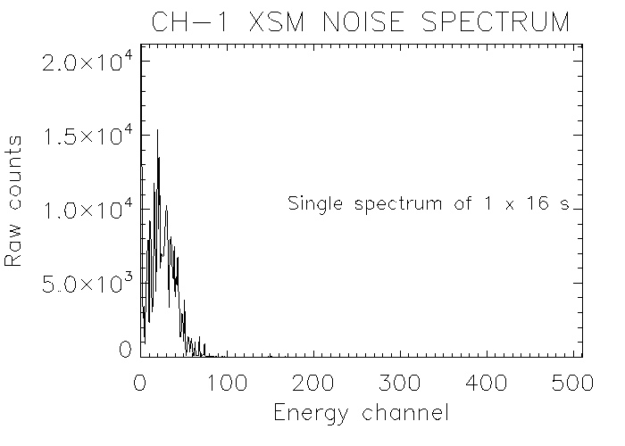
Figure 9. XSM low energy noise spectrum.

