CENTRE NATIONAL DE LA RECHERCHE SCIENTIFIQUE

SERVICE D’AERONOMIE

Huygens

Aerosol Collector Pyrolyser
( ACP )

To ESA Planetary Science Archive [or NASA PDS]

Interface Control Document
(EAICD)

ACP.CNRS.EAICD.237

Version 08

15-June-2006

______________________________
Prepared by: Jean-Francis BRUN

__________________________

Approved by: Guy ISRAEL

Distribution List

Recipient | Organisation
Lyle Huber | PDS
Joe Zender | ESA
Jean-Pierre Lebreton | ESA
Olivier Witasse | ESA
Hasso Niemann | GCMS
John Haberman | GCMS

Change Log

Date | Sections Changed | Reasons for Change
02 June 2003 | D01 Initial
09 Sept 2003 | D02 All
04 Dec 2003 | D03 | Incorporation of comments of 03.12.2003
28 May 2004 | D04 | Incorporation of comments of 28.04.2004
14 Nov. 2005 | D06 All | Incorporation of comments from 06.07.2004
March 2006 | D07 All
15 June 2006 | V08 All | Incorporation of comments from Peer Review

TBD ITEMS

Section | Description

Table Of Contents

1 Introduction 3
1.1 Purpose and Scope 3
1.2 Contents 3
1.3 Intended Readership 3
1.4 Applicable Documents 3
1.5 Reference Documents 3
1.6 Acronyms and Abbreviations 4
1.7 Contact Names and Addresses 4
2 Overview of Process and Product Generation 5
2.1 Overview of the ACP experiment 5
2.1.1 Objectives 5
2.1.2 Functional description 5
2.1.3 Measurement Strategy 8
2.1.4 Sequences During Descent 9
2.1.5 Definition of ACP instrument modes: 10
2.1.6 Interface with GCMS 11
2.2 Data flow and data processing 11
2.3 Instrument calibrations 13
2.4 In flight data products 14
2.4.1 Cruise data 14
2.4.2 Descent data 14
2.4.2.1 Instrument raw data : 14
2.4.2.2 Calibrated data 15
2.4.2.3 Science Data 15
2.5 Sub-System Tests 16
2.6 Laboratory data 16
2.7 Software 16
2.8 Documentation 16
2.9 Derived and other Data Products 16
3 Archive Format and Content 16
3.1 Format and Conventions 17
3.1.1 Deliveries and Archive Volume Format 17
3.1.2 Data Set ID Formation 17
3.1.3 Data Directory Naming Convention 17
3.1.4 Filenaming Convention 17
3.2 Standards Used in Data Product Generation 17
3.2.1 PDS Standards 18
3.2.2 Time Standards 18
3.2.3 Reference systems 18
3.2.4 Other Applicable Standards 18
3.3 Data Validation 18
3.4 Content 18
3.4.1 Overal structure 18
3.4.2 Directories 20
3.4.2.1 Root Directory 20
3.4.2.2 Calibration Directory 20
3.4.2.3 Catalog Directory 20
3.4.2.4 Index Directory 21
3.4.2.5 Browse Directory and Browse Files 21
3.4.2.6 Geometry Directory 21
3.4.2.7 Software Directory 21
3.4.2.8 Gazetter Directory 21
3.4.2.9 Label Directory 21
3.4.2.10 Document Directory 21
3.4.2.11 Extras Directory 22
3.4.2.12 Data Directory 22

Introduction

Purpose and Scope
The purpose of this EAICD (Experimenter to (Science) Archive Interface Control Document) is two fold. First it provides users of the ACP instrument with a detailed description of the product and a description of how it was generated, including data sources and destinations. Secondly, it is the official interface between the ACP instrument team and the archiving authority.

Contents
This document describes the data flow of the ACP instrument on Huygens from the s/c until insertion into the PSA and PDS. It includes information on how data were processed, formatted, labeled and uniquely identified. The document discusses general naming schemes for data volumes, data sets, data and label files. Standards used to generate the product are explained. Software that may be used to access the product are explained.
The design of the data set structure and the data product is given.

Intended Readership
The staff of archiving authority (Planetary Data System for NASA, Planetary Science Archive for ESA) design team and any potential user of the ACP data.

Applicable Documents
- Planetary Data System Preparation Workbook, February 1, 1995, Version 3.1, JPL, D-7669, Part 1
- Planetary Data System Standards Reference, October 30, 2002, Version 3.5, JPL, D-7669, Part 2
- Archive Generation, Validation and Transfer Plan, HUY-RSSD-PL-001
- ACP.JR.S/W.SUM.059, ACP Software User Manual, Version 1.8, 18.04.1996
- Huygens Detailed Data Interface Document, ESOC HMCS-ICD-DDID, Sept. 20 1996, issue 2.1

Reference Documents

- Israël et al. (1997), Huygens Probe Aerosol Collector Pyrolyser, Esa publication SP-1177, 1997, 59-84.

- Niemann et al. (1997), Huygens Probe Huygens Gas Chromatograph Mass Spectrometer,
Esa publication SP-1177, 1997, 85-107.

- Israël et al.(2002), Huygens Aerosol Collector Pyrolyser’, Space Science Review 104, 433-46

- Niemann et al.(2002), Huygens Gas Chromatograph Mass Spectrometer’, Space Science Review 104, 553-591.

- Israel et al. (2005), Complex organic matter in Titan's atmospheric aerosols from in situ pyrolysis and analysis, Nature, 438,796-799.

- Niemann et al. (2005), The abundances of constituents of Titans's atmosphere from the GCMS instrument on the Huygens probe, Nature, 438, 779-784.

- GCMS EAICD : Refer to GCMS DATASET \ DOCUMENT

Acronyms and Abbreviations

EAICD - Experimenter to (Science) Archive Interface Control Document
ACP – Aerosol Collector & Pyrolyser
CoI – Co-investigater
DDB – Descent Data broadcast
DDS – Data Delivery Server
ESOC – European Space Operations Center
GCMS – Gas Chromatograph Mass Spectrometer
HK – Housekeeping data
MS – Mass Spectrometer
N/A – Not applicable
PDS – Planetary Data System
PI – Principal Investigater
PSA – Planetary Science Archive
s/c – Spacecraft
SSR – Space Science Review
TC - Telecommand

1.7 Contact Names and Addresses

Service d’Aéronomie du CNRS, BP 91377, Verrières le Buisson, France :

Guy Israël PI 33-1 64 4743 94 israel@aerov.jussieu.fr
Michel Cabane CoI 33-1 44 27 41 75 cabane@aero.jussieu.fr
Jean -Francis Brun 33-1 64 47 42 81 brun@aerov.jussieu.fr
Cyril Pennanech 33-1 64 4743 96 pennanech@aerov.jussieu.fr

NASA – GSFC :
Hasso Neimann GCMS 1- 301 614 6x xx hasso.niemann@gsfc.nasa.gov
John Haberman GCMS 1- 301 614 68 38 john.a.haberman@nasa.gov
Jaime Demick GCMS 1- 301 614 63 97 jdemick@pop900.gsfc.nasa.gov

Overview of Process and Product Generation

Overview of the ACP experiment

Objectives

ACP’s main objectives are the chemical analysis of the aerosols of Titan’s atmosphere.
For this purpose it will sample the aerosols during the descent to Titan and prepare the collected matter (by evaporation, pyrolysis and gas products transfer) for analysis by the Huygens probe GCMS.

Functional description

ACP schematic:

The following schematic shows the instrument components, the instrument housekeeping sensors & mechanisms position status.

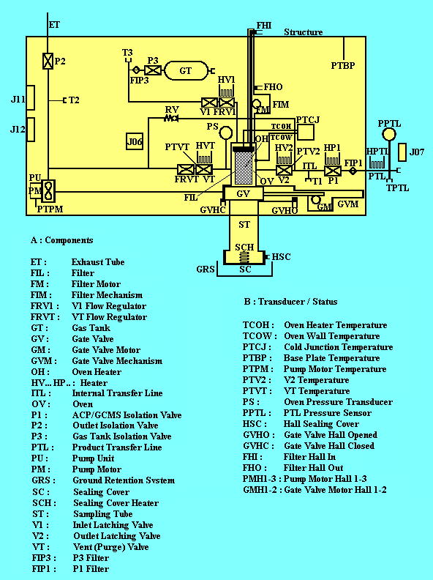

Schematic of ACP-GCMS interface:

The schematic shows the ACP data products transfer interface from ACP to GCMS.
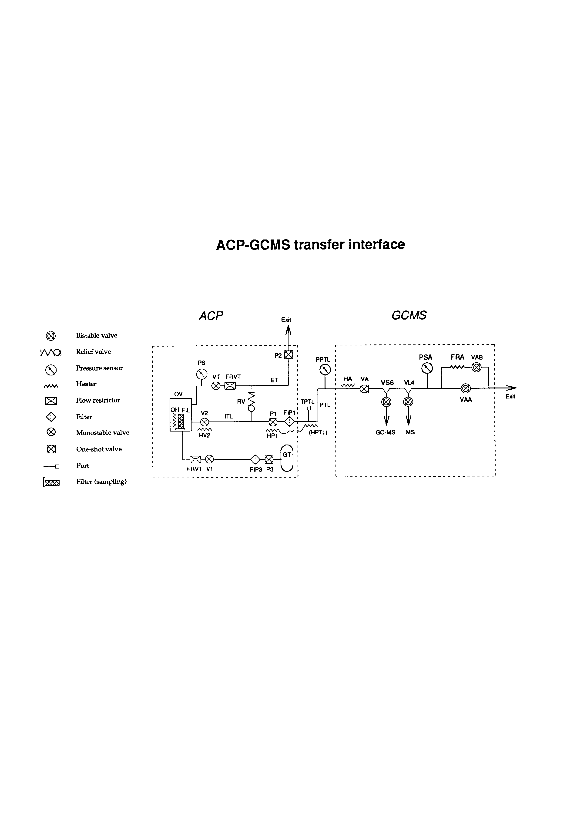

The ACP schematic and the ACP-GCMS interface schematic provide an overview of the ACP instrument. The gas products transferred from the ACP are analyzed by the GCMS . A sampling system is required for sampling the aerosols in the 135-32 km and 22-17 km altitude regions of Titan's atmosphere. These altitude ranges refer to the Probe's nominal descent profile (ESA 01/94).
Optimal sampling requires an inlet (sampling) tube (ST) extending beyond the boundary layer. This boundary layer was calculated by Aerospatiale during the Huygens Probe design and was found to be a few mm thick; the aerothermodynamic effects can be neglected since the filter’s bottom end protrudes 28 mm from the Probe's fore dome. During sampling, the collecting target's temperature must be as close as possible to that of Titan's atmosphere in order to help retain the more volatile aerosol and cloud particle components (Lefebvre and Krauss, 1992).
The target is a filter (FIL), made in stainless steel (Beckaert ST10), that can be moved along the inlet tube by a ‘filter’ mechanism (FIM). A pump unit (PU) is used to force the gas flow through the filter. In its sampling position, the filter front face extends a few mm beyond the inlet tube. This increases aerosol collection by direct impaction at high altitude, where the pump does not operate . Before descent, the filter is held in its storage position inside the oven (OV). During descent, the mechanism (FIM) can move the filter to its sampling position and return it into the oven.

The oven is a pyrolysis furnace where a heating element (OH) can heat the filter and hence the sampled aerosols to 250°C or 600°C. A motorized gate valve (GV) can be activated to close the furnace after filter retraction. Three normally-closed monostable valves (V1, V2, VT) are mounted on the oven's body. V1 supplies a labeled gas (¹⁵N₂) to carry the gas sample from the oven to the transfer lines through V2. The venting valve VT allows the oven's gas content to be drained off.

The pump unit (PU) is a drag fan which accelerates the flow of Titan's atmosphere at a rate depending on altitude. An exhaust tube (ET), with a one-shot isolation valve (P2), allows the gas to be vented into Titan's atmosphere. When it is switched off, PU acts as a flow-blocking device. The pressurization system for storing N₂ gas and controlling its flow to the oven is supplied by a gas tank (GT) at 30 bar. Oven filling is controlled by a pressure transducer (PS) associated with valve V1 . A relief valve (RV, set at 4.1 bar) in the internal gas transfer line protects the GCMS against accidental ACP overpressure.

The whole internal circuit is pressurized during ground operations and the early part of the flight to Saturn. About three years after launch, the ACP's internal circuit is evacuated by opening P2. The inlet tube end is closed by a sealing cover (SC), which will be opened at the beginning of descent. A connecting tube (Product Transfer Line, PTL) between the ACP and GCMS transfers the pyrolysis products. Valve P1 isolates the ACP internal circuit from the product transfer lines. This one-shot isolation valve is opened at the beginning of descent (To+2 min) for an initial venting of the internal (ITL) and the external (PTL) exit transfer lines. The IVA one-shot valve (see below and in the GCMS paper in this volume) isolates the PTL at its GCMS extremity. A program allows V1, V2 and VT electrovalves, P1 and PTL to be heated using special heaters. The heating of V1 is controlled by a thermostat, activated when the temperature falls below -5°C. This was shown to be necessary to prevent leakage due to the low temperatures during pumping.

Measurement Strategy

The operations sequences result from the following requirements :

1. Determining the compositions of the particle cores (non-volatile and volatile components) is conducted mainly in the lower stratosphere and down to the tropopause (above 30 km). In the higher part of the descent (above 80 km), it is expected that aerosols will be obtained by direct impaction on the filter. Below 80 km, where the pump becomes effective, the samples are obtained by filtration.
2. The second sample must be collected within the troposphere above the deep methane clouds (20 km).
3. Owing to mass constraints, the instrument is equipped with a single collector that must be used again after cleaning the oven, filter and product transfer lines.
4. The samples are analyzed by using the GCMS for a fixed portion of its life (approximately 20 min), knowing that this instrument must make at least one direct chromatographic analysis of the atmosphere's composition before surface impact.

In addition, because of the very short descent profile (120 min minimum), it was decided to make three transfers for each sample, each transfer using the direct MS mode. The transfers are done sequentially when the oven is at ambient temperature, at 250°C and at 600°C. Analysis of the aerosols using the full capacity of the GCMS and which requires about 10 min, implies the use of the three columns (NIEMANNETAL2002). It is done only for the pyrolysis sequence (600°C) after the first sampling. The gas transfer starts at To+74 min after the analysis of the content of the two gas enrichment cells programmed by the GCMS for Titan atmospheric gas analysis.

Sequences During Descent

The following sequences programmed during the descent phase are :

Sequence 1 : Initial venting and preparation for the first sampling operation between ACP initialization (at To+1min 40s) and the time when the filter reaches its sampling position (at To+6min 45s, nominal altitude 130 km).

Sequence 2 : First sampling in the low stratosphere. This period ends when the filter is retracted into the oven (GV locked) at To+60min 00s (nominal altitude 32 km).

Sequence 3 : Heating the filter (ambient, 250°C, 600°C) and gas product transfers to the GCMS at To+74min 00s (nominal altitude 24 km).

Sequence 4 : a.) Oven and transfer lines cleaning. The oven and filter are cleaned by extending the oven heating phase at 600°C. This operation is followed by flushing the different gas transfer pipes.
b.) Preparation for the second sampling operation with the filter in its sampling position at To+77min 00s (nominal altitude 22 km).

Sequence 5 : Second sampling in the upper troposphere. This period ends when the filter is retracted into the closed oven, at To+89min 00s (nominal altitude 17km).

Sequence 6 : Heating the filter (ambient, 250°C, 600°C) and gas product transfers to the GCMS ends at To+108min 00 (nominal altitude 9km).

Sequence 3 is the first analysis sequence which deals with :
1. the preparation of aerosols for producing evaporates and pyrolysis products;
2. the transfer of gas products to the ACP line (feed tube to the GCMS);
3. the proper analysis, either by the direct MS mode or by the complete mode GCMS + direct MS
(NIEMANNETAL2002).

The program for aerosol preparation and transfer consists of three phases :

Phase (a) : transfer of the gas products obtained while the filter is in the unheated oven. At the time of transfer, the filter has considerably warmed since oven closing, and the temperature gradient is sufficient to produce some evaporates.

Phase (b) : transfer of gas products obtained after heating the filter to Tf = 250°C. During the transfer time (1 min), the filter temperature is maintained by holding Tf at 250°C.

Phase (c) :transfer of the gas products obtained after heating the filter to 600°C.

In order to transfer the gas samples with minimal dilution from the effluent gas (¹⁵N₂), each injection into the GCMS is done by pressurizing the oven to 2.5 bar with N₂ (V1 controlled, V2 closed) and then rapidly depressurizing it down to 1.9 bar (fast actuation of V2 and VAB). To ensure this 'piston effect', the pressure range is controlled by the software using the oven pressure sensor signal. At injection the estimated mass flow rate is 3 to 9 mg/s at 2 bar N₂. A transfer of the sample is completed after 6 injections. The oven is then emptied in order to obtain a background analysis.

Sequence 6 is a copy of sequence 3 but during phase (c) only the MS mode is used. At the end of the transfer (phase c) of the products to the GCMS (To+108min), the ACP is prepared for being turned off until To+110min (8 km nominal altitude).

Timing sequence for ACP products transfer & analysis by GCMS :

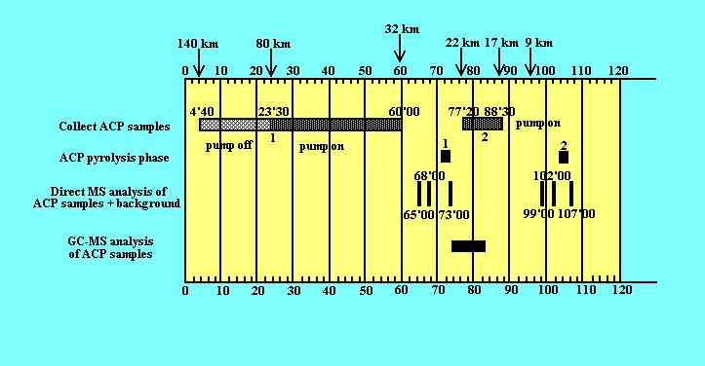

Definition of ACP instrument modes:

The ACP operating modes are defined as follows:

Descent mode (used during the descent to Titan).
In flight check-out mode (used during the Cruise phase).
Engineering mode (used during ground activities. Can also be used during Cruise with specificTCs).
Ground check-out mode (used during Ground activities).

Interface with GCMS

The ACP and GCMS run their descent operations according to time. Their internal clocks are synchronized by the DDB time information relative to the probe T0.
A precise timeline has been established for the transfer cycles of gas products from ACP to GCMS.

GCMS opens a synchro window for each transfer cycle, and ACP sends a synchro pulse to GCMS prior to every gas transfer within the transfer cycle.

Data flow and data processing

ACP Processing of ACP engineering data :

Data Process | Data Level (according to PDS) | Software | Author/Institution
Data from ESOC DDS server (raw data)  (include packet headers) | Level 2 |  | ESOC
Raw data converted to  Engineering data | Level 3 | “Trait”  “Graphic”  Data content can be displayed for each packet. Plots of analog parameters vs mission time. | Cyril Pennanech –CNRS
Sort & organize data in tables for archiving | Final form for PDS  archiving |  | Cyril Pennanech/Jean-Francis Brun –CNRS

The ACP “TRAIT” & “GRAPHIC” software convert the raw data from a data file to engineering data (packet header, packet number, packet time, decoded status, analog data to temperatures & voltages, plots vs descent time).

GCMS Processing of ACP science data :
The ACP science data :

The GCMS analyses samples from the ACP. The Data Products that are referencing the ACP are provided to the ACP Science team for analysis.

The same dataset is archived by the GCMS team.

The ACP products are sampled at determined times during the descent directly by the GCMS Ion source 2 dedicated to ACP (IS 2), and by the combination of the GC & ion sources 3/4/5 (GC-IS 3/4/5).

The ACP data consists of one GC data product, 6 stage 1 mass scan products, and 6 stage 2, and 6 stage 3 mass scan products.
For detailed information consult the GCMS EAICD and the ACP DATASET \ DATASET.CAT.

The GCMS Stage 1 ACP data is the raw data, and it is not archived.
The GCMS Stage 2 ACP data is converted from raw counts per integration period to counts per second and corrected for the counter overflow condition where this can be determined to have happened.

Stage 3 processing corrects this data for pulse pile-up, counter dead-time and other known counting system (error) conditions. These errors can become significant where the count value is large.

The files are all of the valid data from MS Ion Source #2 (the ACP data) plus the Ion Sources #3 & 4 data for Sample #3, the ACP injection to the GC Columns attached to Ion Sources #3 & 4.

As the Ion Source #5 did not work during the descent, the IS5 data files are not included.

These files are in column aligned comma delimited ASCII TEXT format.
The dataset contains the data Table files, the Label files associated with the Table files, plus the Format files referred to in the Label files.
The LBL file gives information on the file.
The FMT file gives information on the columns.

IS2_Smpl1_Stg2: Ion source 2 (MS) data at 75 eV ionization energy and unit mass resolution for ACP sample #1 in counts per second.

IS2_Smpl2_Stg2: Ion source 2 (MS) data at 75 eV ionization energy and unit mass resolution for ACP sample #2 in counts per second.
Note–Programmed low IE data is present in this block of data and not marked between times 10:18:49 – 10:19:01.

IS2_Smpl5_Stg2: Ion source 2 (MS) data at 75 eV ionization energy and unit mass resolution for ACP sample #5 in counts per second.
Note – Programmed low IE data is present in this block of data and not marked between times 10:52:48 – 10:52:55.

IS2_Stg1: Ion source 2 (ACP) full scans (mass range: 2 - 141) at unit resolution and 25 eV ionization energy.

IS2_Stg2: Ion source 2 (ACP) full scans (mass range: 2 - 141) at unit resolution and 25 eV ionization energy.

IS2_Smpl1_Stg2: Ion source 2 (MS) data at 25 eV ionization energy and unit mass resolution for ACP sample #1 in counts per second.

IS2_Smpl2_Stg2: Ion source 2 (MS) data at 25 eV ionization energy and unit mass resolution for ACP sample #2 in counts per second.

IS2_Smpl3_Stg2: Ion source 2 (MS) data at 75 eV ionization energy and unit mass resolution for ACP sample #3 in counts per second.

IS2_Smpl4_Stg2: Ion source 2 (MS) data at 75 eV ionization energy and unit mass resolution for ACP sample #4 in counts per second.

IS2_Smpl5_Stg2: Ion source 2 (MS) data at 25 eV ionization energy and unit mass resolution for ACP sample #5 in counts per second.

IS2_Smpl6_Stg2: Ion source 2 (MS) data at 75 eV ionization energy and unit mass resolution for ACP sample #6 in counts per second.

IS3_GC1_Smpl3_Stg2: Ion Source 3 (Column 1) data at 75 eV ionization energy and unit mass resolution for ACP Sample #3 as counts per second. Time relative to the injection has been determined and added to the file.

IS4_GC2_Smpl3_Stg2: Ion Source 4 (Column 2) data at 75 eV ionization energy and unit mass resolution for ACP Sample #3 as counts per second. Time relative to the injection has been determined and added to the file.

IS3_Smpl3_Stg2: IS3 (GC Column 1) sample 3 mass scans at unit resolution and 75 eV ionization energy.

IS4_Smpl3_Stg2: IS4 (GC Column 2) sample 3 mass scans at unit resolution and 75 eV ionization energy.

There is no specialized software required to view the ACP data products, and no software is provided or archived to do so.

Instrument calibrations

Transfer functions :
The ACP Software User Manual describes only the ACP on board software.
It is included in the dataset documentation as it also includes the transfer functions to convert the raw data into engineering data for the different ACP analog parameters such as temperatures, voltages, pressure, pump speed & current. It also gives information on the contents of ACP telemetry packets.

Instrument calibration :
During the instrument development phase, calibration/characterisation of the performances were conducted.
The documents and data files are archived in the ACP data base, located in Service d’Aéronomie.
We do not archive these data files in the PDS.

In flight data products

Cruise data

The Cruise Check Out data generated during the F1 to F16 C/O are not archived in the PSA.
This data could be used in case of instrument performance trouble shooting by the ACP team. It is archived in the data base, located in Service d’Aéronomie.

Descent data

The ACP Descent data consist of :
- ACP Status Word
- ACP Science packet (Housekeeping/Engineering data)
- Science data (gaseous products from ACP transferred to and analyzed by the GCMS

Instrument raw data :

The raw data is the data file in binary format which include the compilation of the telemetry packets from both telemetry channels generated by ACP during any run on the probe, delivered by ESOC with the packet headers.
ACP generates 1 telemetry packet and 1 status word every 16 sec from To to To + 10 min., and 1 telemetry packet and 1 status word every 8 sec from To + 10 min to To + 110 min.
During a Descent there are 784 packets generated on each telemetry channel (A & B). The data on B is identical to A. A data stream from the descent contains 211 ko.
The format and the contents of the telemetry packets generated by ACP are described in the ACP Software User Document.
The raw data (level 2) is processed to calibrated (engineering) data of level 3.
The raw data is preserved at ESA, and with the experment team in binary format.

Engineering calibrated data

- ACP Status : experiment status (Status Word).

- ACP Instrument housekeeping : temperatures, pressure, references voltages, DC/DC converter voltages, mechanisms position sensors.

ACP archives the following four data products of the ACP Instrument housekeeping data:

- Oven group parameters which monitor the heating and transfer phase performance; including: sampling time, oven temperature, oven wall temperature, oven pressure, and V1, V2, VT status.
- Pump group parameters which monitor the pump performance; including: sampling time, pump temperature, pump current, pump speed.
3) A temperature group parameters which monitor the different temperature sensors
located in the instrument.
4) A voltage group parameters which monitor the different DC/DC voltages, calibration
and reference voltages.
Tables of these parameters over the descent are provided in the ACP DATASET\DATA directory.

The engineering data includes only the B channel (only) data acquired from the probe by Cassini.

Science Data

The analysis of the ACP gazeous products is performed by the instrument GCMS of the Huygens probe.
The ACP products are sampled at determined times during the descent directly by the Ion source 2 (IS 2), and by the GC-IS 3/4/5.

This dataset contains the calibrated data of the ACP data products analysed by the GCMS.
The same dataset is archived by the GCMS team in the GCMSDATASET\DATA.
Detailled information is given in the ACPDATASET\DATASET.CAT.

The GCMS Stage 2 ACP data is converted from raw counts per integration period to counts per second and corrected for the counter overflow condition where this can be determined to have happened.
Stage 3 processing corrects this data for pulse pile-up, counter dead-time and other known counting system (error) conditions.

The files are all of the valid data from MS Ion Source #2 (the ACP data) plus the Ion Sources #3 & 4 data for Sample #3, the ACP injection to the GC Columns attached to Ion Sources #3 & 4.

As the Ion Source #5 did not work during the descent, the IS5 data files are not included.

The science data includes only the B channel (only) data acquired from the probe by Cassini.

Sub-System Tests

The ACP team can consult data from previous sub-system tests performed during the instrument development phase.
The main sub-systems are:
- the oven & transfer sub-system.
- the pump sub-system.
These data files are not archived in the PDS.

Laboratory data

The laboratory data consist of test data files and test reports generated during the instrument development phase. These are archived in the ACP data base at Service d’Aéronomie, and are not archived at the PDS.

Software

No software is provided. No software is necessary to interpret the ASCII data files archived.

Documentation

The documents list is described in the next section.

Derived and other Data Products

N/A

Archive Format and Content

ACP provides one volume and one data set.

Format and Conventions

3.1.1 Deliveries and Archive Volume Format

Volume naming scheme

Volume name: HUYGENS PROBE ACP DATA RECORD
Volume ID: TBD

The ACP data fits on one CD.

3.1.2 Data Set ID Formation

Data set name: HUYGENS ACP DESCENT DATA V1.0

Data set ID: HP-SSA-ACP-3-DESCENT-V1.0

3.1.3 Data Directory Naming Convention

There are no sub-directories in the /data directory.

3.1.4 Filenaming Convention

The ACP engineering data files follow the conventions:
ACP_<descriptor>_V1_0.TAB

< descriptor> can take the values: OVEN, PUMP, TEMP, VOLT.

ACP_OVEN_V1_0.TAB
ACP_PUMP_V1_0.TAB
ACP_TEMP_V1_0.TAB
ACP_VOLT_V1_0.TAB

For the science data : the GCMS files follow the GCMS filenaming convention (refer to the GCMS EAICD & GCMS DATASET).

3.2 Standards Used in Data Product Generation

3.2.1 PDS Standards

PDS Standard version 3.5 is used for the design of the ACP archive.

3.2.2 Time Standards

At the beginning of the descent trajectory, the Huygens probe timer is set to 0 and synchronizes all the Huygens instruments with this time.
ACP data times are referenced to the probe T0. ACP is synchronized every 2 seconds to the probe time information dispatched to the instruments by the DDB. The time at which the data packet is generated by ACP is included in each data packet (second column of the data tables).
The UTC time is also referenced in the label and in the table.
The corresponding value of the UTC time for T0 is : 09:10:21.675 .

3.2.3 Reference Systems
N/A.

3.2.4 Other Applicable Standards

No other applicable standards are used.

3.3 Data Validation

3 items have been validated:
- quality of the data and documentation
- completeness
- PDS compatibility.

The ACP & GCMS teams checked the first two items.
Item 3 is validated by the PDS/PSA team.

Content

Overal structure

HP-SSA-ACP-3-DESCENT-V1.0

ROOT
|
| - AAREADME.TXT
| - VOLDESC.CAT
|
| - [CATALOG]
| |
| | - CATINFO.TXT
| | - DATASET.CAT
| | - INSTRUMENT.CAT
| | - INSTRUMENT_HOST.CAT
| | - MISSION.CAT
| | - PERSONNEL.CAT
| | - REFERENCE.CAT
| | - SOFTWARE.CAT
| | - TARGET.CAT
|
| - [DOCUMENT]
| |
| | - DOCINFO.TXT
| | - ACP_EAICD (in DOC, ASCII & PDF)
| | - GCMS_EAICD (in DOC, ASCII & PDF)
| | - ACP_Soft_User_Manual (in PDF)
| | - ACP_SP-1177 (in PDF)
| | - GCMS_SP-1177 (in PDF)
| | - ACP_NATURE (in ASCII & PDF)
| | - GCMS_NATURE (in ASCII & PDF)
| | - Associated labels
|
| - [INDEX]
|
I I - INDEX.LBL
I I - INDEX.TAB
I I - INDEXINFO.TXT
I
| - [DATA]
| | - ACP_OVEN_V1_0.TAB
| | -ACP_OVEN_V1_0.LBL
| | -ACP_PUMP_V1_0.TAB
| | -ACP_PUMP_V1_0.LBL
| | -ACP_TEMP_V1_0.TAB
| | -ACP_TEMP_V1_0.LBL
| | -ACP_VOLT_V1_0.TAB
| | -ACP_VOLT_V1_0.LBL
| | -GCMS_2U_STG2.FMT
| | -GCMS_2UA_S1_STG2.LBL
| | -GCMS_2UA_S1_STG2.TAB
| | -GCMS_2UA_S2_STG2.LBL
| | -GCMS_2UA_S2_STG2.TAB
| | -GCMS_2UA_S5_STG2.LBL
| | -GCMS_2UA_S5_STG2.TAB
| | -GCMS_2UA_STG1.LBL
| | -GCMS_2UA_STG1.TAB
| | -GCMS_2UA_STG2.LBL
| | -GCMS_2UA_STG2.TAB
| | -GCMS_2US_S1_STG2.LBL
| | -GCMS_2US_S1_STG2.TAB
| | -GCMS_2US_S2_STG2.LBL
| | -GCMS_2US_S2_STG2.TAB
| | -GCMS_2US_S3_STG2.LBL
| | -GCMS_2US_S3_STG2.TAB
| | -GCMS_2US_S4_STG2.LBL
| | -GCMS_2US_S4_STG2.TAB
| | -GCMS_2US_S5_STG2.LBL
| | -GCMS_2US_S5_STG2.TAB
| | -GCMS_2US_S6_STG2.LBL
| | -GCMS_2US_S6_STG2.TAB
| | -GCMS_2US_STG1.LBL
| | -GCMS_2US_STG1.TAB
| | -GCMS_2US_STG2.LBL
| | -GCMS_2US_STG2.TAB
| | -GCMS_3U_STG2.FMT
| | -GCMS_3US_S3_STG2.LBL
| | -GCMS_3US_S3_STG2.TAB
| | -GCMS_4U_STG2.FMT
| | -GCMS_4US_S3_STG2.LBL
| | -GCMS_4US_S3_STG2.TAB
|

Directories

Root Directory

AAREADME.TXT

VOLDESC.CAT

Calibration Directory

N/A

Catalog Directory

Catalog files:

CATINFO.TXT
- DATASET.CAT
- INSTRUMENT.CAT
- INSTRUMENT_HOST.CAT
- MISSION.CAT
- PERSONNEL.CAT
- REFERENCE.CAT
- SOFTWARE.CAT
- TARGET.CAT

Index Directory

The directory contains :

INDEX.LBL

INDEX.TAB

INDEXINFO.TXT

Browse Directory and Browse Files

N/A

Geometry Directory

N/A

Software Directory

N/A

Gazetter Directory

N/A

Label Directory

N/A

Document Directory

Document

Files in this directory include:

ACP_EAICD.DOC
ACP EAICD.PDF
ACP_EAICD.TXT
GCMS_EAICD.DOC
GCMS EAICD.PDF
GCMS_EAICD.TXT
ACP_SOFT_USER_MANUAL.PDF
ACP_SP1177 .PDF
GCMS_SP1177.PDF
ACP_NATURE2005.PDF
GCMS_NATURE2005.PDF

and associated labels:

ACP_EAICD.LBL
GCMS_EAICD.LBL
ACP_SOFT_USER_MANUAL.LBL
ACP_SP1177.LBL
GCMS_SP1177.LBL
ACP_NATURE2005.LBL
GCMS_NATURE2005.LBL

Extras Directory

N/A

Data Directory

The /data directory contains the following files:

The first 8 files represent the ACP calibrated engineering data.

The 33 following files represent the ACP data analysed by the GCMS.
Further information on GCMS file naming, data processing, and data flow can be found in the GCMS DATASET.

| -ACP_OVEN_V1_0.TAB
| -ACP_OVEN_V1_0.LBL
| -ACP_PUMP_V1_0.TAB
| -ACP_PUMP_V1_0.LBL
| -ACP_TEMP_V1_0.TAB
| -ACP_TEMP_V1_0.LBL
| -ACP_VOLT_V1_0.TAB
| -ACP_VOLT_V1_0.LBL
| -GCMS_2U_STG2.FMT
| -GCMS_2UA_S1_STG2.LBL
| -GCMS_2UA_S1_STG2.TAB
| -GCMS_2UA_S2_STG2.LBL
| -GCMS_2UA_S2_STG2.TAB
| -GCMS_2UA_S5_STG2.LBL
| -GCMS_2UA_S5_STG2.TAB
| -GCMS_2UA_STG1.LBL
| -GCMS_2UA_STG1.TAB
| -GCMS_2UA_STG2.LBL
| -GCMS_2UA_STG2.TAB
| -GCMS_2US_S1_STG2.LBL
| -GCMS_2US_S1_STG2.TAB
| -GCMS_2US_S2_STG2.LBL
| -GCMS_2US_S2_STG2.TAB
| -GCMS_2US_S3_STG2.LBL
| -GCMS_2US_S3_STG2.TAB
| -GCMS_2US_S4_STG2.LBL
| -GCMS_2US_S4_STG2.TAB
| -GCMS_2US_S5_STG2.LBL
| -GCMS_2US_S5_STG2.TAB
| -GCMS_2US_S6_STG2.LBL
| -GCMS_2US_S6_STG2.TAB
| -GCMS_2US_STG1.LBL
| -GCMS_2US_STG1.TAB
| -GCMS_2US_STG2.LBL
| -GCMS_2US_STG2.TAB
| -GCMS_3U_STG2.FMT
| -GCMS_3US_S3_STG2.LBL
| -GCMS_3US_S3_STG2.TAB
| -GCMS_4U_STG2.FMT
| -GCMS_4US_S3_STG2.LBL
| -GCMS_4US_S3_STG2.TAB

