document title/ titre du document
VMC for MEX
Flight User Manual

prepared by/préparé par
reference/réference | MEX-ESA-VMC-MA-0003
issue/édition | 4
revision/révision | 2
date of issue/date d’édition | 17 January 2003
status/état
Document type/type de document | Technical Note
Distribution/distribution

A P P R O V A L

Title  titre | VMC Flight User Manaul |  |  | issue  issue | 4 | revision  revision | 0
author  auteur | David Jameux (TOS-ETD) |  |  | date  date | 07/11/02
approved by  approuvé by | HansEggel (SCI-PE) |  |  | date  date

C H A N G E L O G

reason for change /raison du changement | issue/issue | revision/revision | date/date
Timeline  Timeline  Document lay-out  ICDR RID's  ESOC (Erhardt Rabenau, TOS-OGM) comments | 1  1  1  4 | 1  2  3  0 | 19-09-00  22-09-00  13-11-00  07/11/2002

C H A N G E R E C O R D

Issue: 2Revision: 1

reason for change/raison du changement | page(s)/page(s) | paragraph(s)/paragraph(s)
Timeline  Timeline  Document lay-out  ICDR RID's | 8 - 11  10-11  all

C H A N G E R E C O R D

Issue: 4 Revision: 1

reason for change/raison du changement | page(s)/page(s) | paragraph(s)/paragraph(s)
Mistake in VMC attitude description  No action can be taken against latch-up since operations are off-line.  VMC procedures for SVT, EV, IC and Beagle2 separation were not clear  The role of the VMC “PI” was not clear  Maximal operating temperature was wrong in the definition of coloured HK checks | 9  55 and 74  65-73  75  12 | 1.4 modified  last paragraph of 5.2 moved to 8.  6.1 appended and structured  6.1.3 added  3.1

T a b l e O f C o n t e n t s

1 Introduction 10
1.1 Objectives of MEX VMC 10
1.2 Functions of the VMC 10
1.3 Description of the VMC 10
1.4 Operational principle 10
2 Reference documents 11
3 VMC Description 11
3.1 VMC Camera Configuration for Mars Express 11
3.2 Optical Design 14
3.2.1 Design description 14
3.2.2 Coatings 16
3.2.3 Image Quality 19
3.2.3.1 MTF 19
3.2.3.2 Encircled energy 22
3.2.3.3 Definition of passband filter 22
3.2.3.4 Distortion and field curvature 22
3.2.4 Thermal analysis 24
3.2.5 Straylight Analysis 26
3.2.6 Tolerance Analysis 27
3.3 Mechanical Design 29
3.3.1 MECHANICAL Design description 29
3.3.1.1 The Objective Assembly 30
3.3.1.2 The Detector Assembly 32
3.3.1.3 The Camera Assembly 34
3.3.1.4 The Baffle 37
3.4 Electrical Design For IRIS VMC 38
3.4.1 Camera Module Overview 38
3.4.2 Conventions 38
3.4.3 Electrical Interfaces 40
3.4.3.1 Power supply 40
3.4.3.1.1 Power interface 40
3.4.3.1.2 Power converter shutdown, INHIBITb function 40
3.4.3.1.3 Power supply block diagram 41
3.4.3.1.4 Power relay control 41
3.4.3.2 Data Interface 42
3.4.3.2.1 Synchronous serial command input 42
3.4.3.2.2 Synchronous serial data output 44
3.4.3.2.3 Synchronous interface compliance with [RD4] 46
3.4.3.2.4 On-board thermistor 46
3.4.3.2.5 Command/data interface connector specification 47
3.4.3.2.6 Command/data interface electrical circuit descriptions 48
3.5 EMC and PP Interface Compliance 49
3.5.1 Primary Power supply interface, electrical issues 49
3.5.2 Conducted Emissions on Primary Power, frequency domain 49
3.5.3 CE on signal lines 49
3.5.4 Radiated interference 49
3.6 VMC hardware grounding layout 50
3.7 Power Consumption Profile 50
3.8 Sensor Specifications 51
4 Camera Configurations VMC for MEX 52
4.1 System configuration 52
4.1.1 Operational mode 53
4.1.2 Default exposure time 54
4.1.3 Triggered snapshot 54
5 Functional Specification 56
5.1 Internal states, variables and default values 56
5.2 VMC start-up, system reset, initial state, sensor power monitoring 56
5.3 First image after start-up 57
5.4 Commands: format, overview, and handling 57
5.4.1 Command structure 57
5.4.2 General operation: commands, command abortion, image download 58
5.5 Reset command 59
5.6 Camera parameter setting commands 59
5.6.1 VMC-Mode setting 59
5.6.2 VMC Interactive Exposure control 60
5.7 Image acquisition commands and data formats 62
5.7.1 Image acquisition, automatic image update, image buffer readout 62
5.7.2 Image output data format 62
5.8 Transmission of the VMC data to the Ground Processing Unit. 63
6 operations procedures 64
6.1 VMC Operations Timeline on Mars Express 64
6.1.1 Task Sharing between Ground & DMS S/W 64
6.1.2 Typical Operations Scenario 66
6.1.2.1 System Validation Tests activities 66
6.1.2.2 Earth Verification activities 69
6.1.2.3 Interplanetary Cruise activities 71
6.1.2.4 Preparation activities for Beagle2 separation 74
6.1.2.5 Beagle2 separation activities 75
6.1.3 Role of the VMC “PI” 80
6.2 Operation of the VMC camera system 80
6.2.1 Commands to the vmc camera 80
7 summary of telecommand and telemetry data 85
7.1 Telecommand list 85
7.2 Telemetry list 86
8 VMC SCOE Description and Operation 87
8.1 The VMC SCOE 87
8.2 The VMC SCOE software 87
8.3 MEX VMC Ground Processing Operation 89
8.3.1 VMC Data PROCESSING 89
8.3.2 Off-line Image processing 97
9 Appendix A: mechanical layout 99
10 APPENDIX B: TRANSFER FRAMES AND VMC DATA FIELD LAY-OUT 100
10.1 Transfer Frames and VMC data field Lay-out 100
10.2 Data Field Lay-out for VMC image data 101
11 APPENDIX C: VMC circuit schematics. 102

ACRONYMS AND ABBREVIATIONS

ADC Analogue to Digital Converter
APID Application Process ID
APS Active Pixel Sensor
AR Anti Reflection coating
BMP Bitmap
CADU Channel Access Data Unit
CCD Charge Coupled Device
CCSDS Consultative Committee for Space Data Systems
CE Conducted Emissions (EMC)
CDMU Configuration and Data Management Unit
CMOS Complementary Metal Oxide Semiconductor
COG Centre of Gravity
CS Conducted Susceptibility
DDID
DMS Data Management System
EMC Electro-Magnetic Compatibility
ESA European Space Agency
F / # F- number
FF Fill Factor
FOV Field Of View
FPA Focal Plane Array
FWHM Full Width at Half Maximum
HK TLM Housekeeping Telemetry
IF Interface
IMEC Inter-university Micro-Electronics Centre
IRIS Integrated Radiation tolerant Imaging System
IRIS-1 Prototype IRIS image sensor with off-chip control logic
IRIS-2 End-product IRIS image sensor with on-chip control logic
kb/s kilo-bits per second
Kbps kilo bits per second
kilo one thousand
kps kilo pixels per second
LAN Local Area Network
LCL Latching Current Limiter to power-cycle outputs of the S/C
LSB Least Significant Bit
Mega one million
Mb/s Mega-bits per second
MB/s Mega-bytes per second
MGSE Mechanical Ground Support Equipment
ML/DS Memory Load / Data Store
Mps Mega pixels per second
MSB Most Significant Bit
MTF Modulation Transfer Function
MTL Master Time Line
NCTRS Network Control and Telemetry Routing System
OBDH On Board Data Handling subsystem
OPSLAN Operations system LAN
PCB Printed Circuit Board
PP Primary Power (from S/C)
QE Quantum Efficiency
RTU Remote Terminal Unit
S/C Spacecraft
SEU Single Event Upset
SID Structure Identifier
SNR Signal to Noise Ratio
SP Secondary Power
SSMM Solid State Mass Memory
T Temperature
TBA To Be Assessed
TBC To Be Confirmed
TC Telecommand
TM, TLM Telemetry
TBC To be confirmed
TBD To be decided
TS Trigger Signal pin selectable delay time
TSC Trigger Signal Custom hardwired delay time
TV Thermal Vacuum
VC3 Virtual Channel 3
VMC Visual Monitoring Camera
VTS Visual Telemetry System

Introduction

Objectives of MEX VMC
The Visual Monitoring Camera (VMC) is a stand-alone digital camera installed on board the Mars Express spacecraft in order to take snapshots in colour of the Mars Lander, "Beagle2", during separation and possibly later (with a view of the planet Mars if possible) for PR purposes.

Functions of the VMC
The VMC accepts image capture and exposure control commands, performs image acquisition, and can store in the baseline configuration one image in a local memory buffer to facilitate asynchronous readout at a low data rate.

Description of the VMC
The optical and mechanical parts were designed, manufactured, aligned and integrated by DSS (OIP). The detector was provided by IMEC. The electrical part was designed by IMEC and the PCB soldering and integration in the mechanical housing were done by DSS (OIP).

The Visual Monitoring Camera (VMC) is physically connected to the Mars Orbiter spacecraft, and electrically connected to the RTU by means of a ML/DS interface. The VMC can be controlled by means of separate sets of Telecommands.

Operational principle
The camera will be used during the transfer to Mars for instrument check-out and just before Beagle-separation when other payload instruments are switched off.

The location of the cameras inside the MEX Orbiter is as described in [RD3] and recalled in appendix A. The camera will look along the +Z axis (with an inclination of 19°) through an aperture in the upper panel where it has a view on the underside of the Beagle2 probe and watches it drifting away after separation. Sun illumination will determine the to-be-programmed exposure settings.

A first image (with default hardwired exposure settings) is always acquired 150 seconds after VMC Power-On. After this first image, the VMC system offers commanding capability i.e., e.g. immediately after verification of good reception of the first image, the possibility to acquire another series of images. Each image is kept in the VMC buffer until it is read out by the RTU for storage in the MEX-mass memory (for later telemetry to the ground).
Since the signal travel time to the spacecraft is in the order of 10 minutes a means must be set up to ensure image acquisition at Beagle-separation. Image acquisition and read-out must be done in a loop of a limited number of iterations to provide a sequence of images of the Beagle separating and drifting away from the spacecraft.

After downlink of these (framed) images from the on-board Solid State Mass Memory to the ground, the frames will be distributed to the VMC SCOE for image retrieval and processing.

Reference documents

[RD 1] MARS EXPRESS Space/Ground I/F. Control Doc., ME-ESC-IF-5001, issue 2, 20-12-1999.

[RD 2] Visual Monitoring Camera: DESIGN DESCRIPTION, RE-VMC-001-OIP/98, iss 4, 3-10-2000.

[RD3] Spacecraft MICD-A, MEX-MMT-IF-0349, issue 1, 30-5-2000.

[RD4] XMM Electrical Interface Requirement ,XM-IF-DOR-0001, issue 5, 26-8-97.

[RD5] VMC TM/TC ICD, MEX-MMT-RP-0221, iss 4/0, 12-12-00

[RD6] VMC for MEX EICD, MEX-ESA-VMC-IF-0001, issue 2/0, 20-12-00

[RD7] DDID

VMC Description

VMC Camera Configuration for Mars Express

The VMC camera consists of a camera objective, an array detector (called IRIS and delivered by IMEC), a camera housing and a camera mount option. An overview of the camera is shown in fig. 3.1.
The system is designed to meet the following requirements :

- Optical

focal length: 12.3 mm
F/#: 5
FOV: 40° x 31°
Wavelength range: 400 - 650 nm (colour version) / 570 - 740 nm (black & white)

- Environmental

- Mechanical : The vibration levels are summarised in table 3.1 and table 3.2

Table 3.1: Vibration levels : Sine vibration:

axis | Frequency  (Hz) | Displacement  (mm peak) | acceleration  (g) | Velocity  (mm/s)
x | 5 - 19 | 10
 | 19 - 26 |  |  | 1200
 | 26 - 100 |  | 20 g
y , z | 5 - 16 | 10
 | 16 - 100 |  | 10 g

Table 3.2: Vibration levels: Random

axis | Frequency (Hz) | Amplitude (g²/Hz) | Slope (dB/oct)
x | 20 - 80 |  | + 6 dB / oct
 | 80 - 130 | 0.5
 | 130 - 2000 |  | - 6 dB / oct
y , z | 20 - 100 |  | +6 dB / oct
 | 100 - 400 | 0.1
 | 400 - 2000 |  | -6 dB / oct

- Thermal :

operational and non - operational T range: - 50°C - + 65°C

The temperature will be checked according to the following scheme:

T < -50°C xXXREDXXx
-50°C < T < -45°C XYELLOWX
-45°C < T < +60°C xXGREENXx
+60°C < T < +65°C XYELLOWX
+65°C < T xXXREDXXx

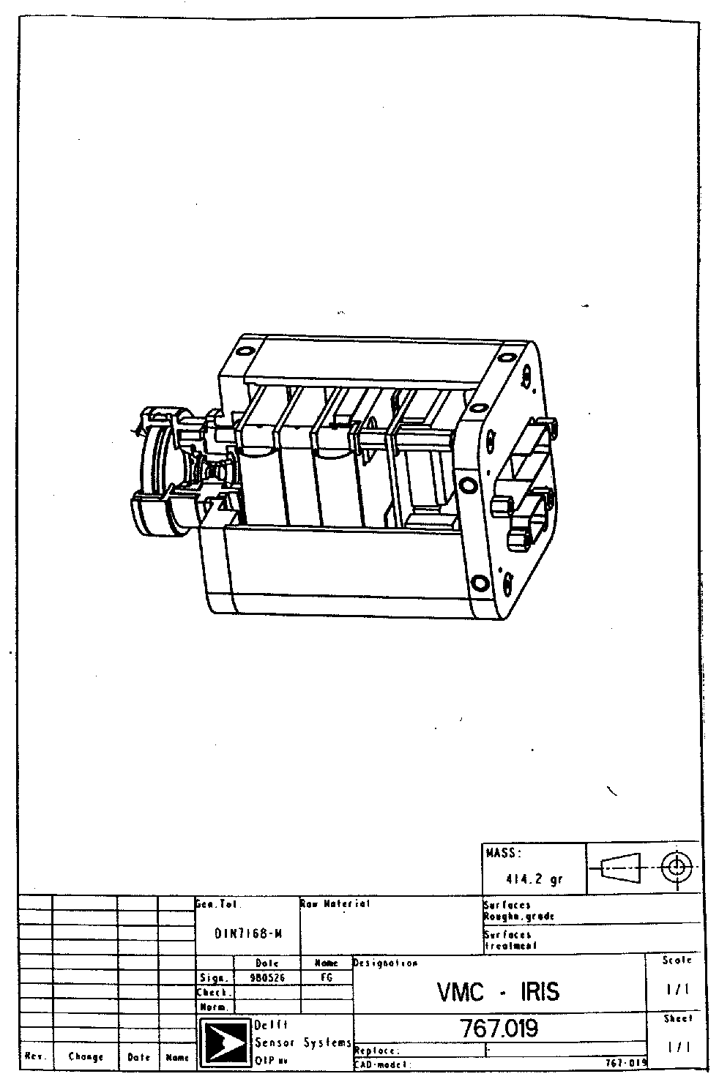

Figure 3.1.

Optical Design

Design description

The objective of the VMC camera consists of three lenses, made of suprasil 1, and a detector window, also made of suprasil. The camera objective is shown in fig. 3.2.

The system is designed to operate in the operational temperature range under vacuum conditions.

During the optical design of the system, the following important design drivers were followed:

- The spotsize should correspond as much as possible to the detector pixel size (14 x 14 µm²). The F/# of 5 corresponds to a diffraction spot having a diameter of 9 µm (first dark circle of Airy disk).

- The objective should have a large depth of focus. The large F/# makes it possible to have sharp images between 3 meter and infinity without the need to refocus the objective. For image distances smaller than 3 meter the image quality degrades slowly. At a distance of 1 meter for example, the spot size is increased to 25 x 25 µm.

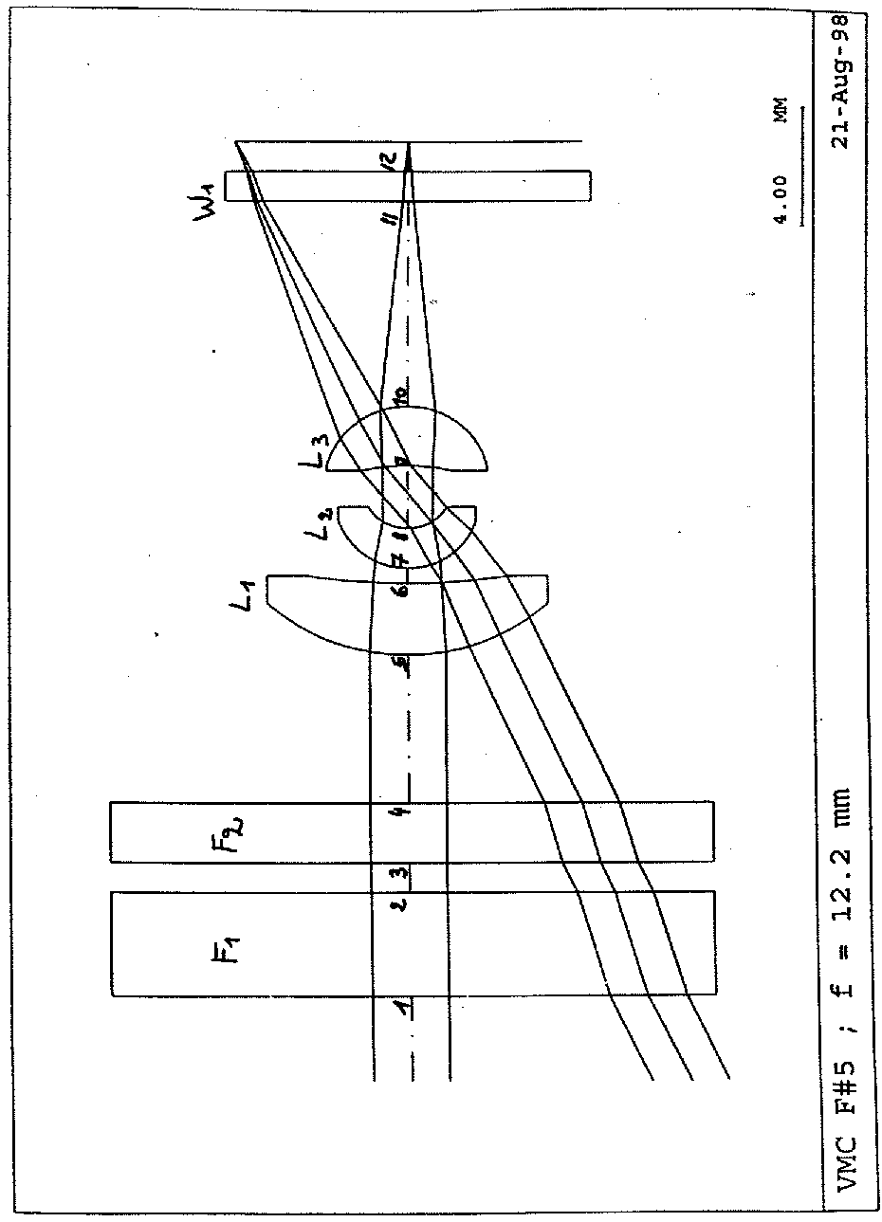

Figure 3.2

Coatings

On all the optical surfaces, except on the front surface of filter F1, an AR coating is applied (see fig. 3.2). The reflectivity of the AR coatings is smaller than 0.5 % in the spectral range of interest.

The IR blocking filter has spectral characteristics as shown in fig 3.3. It is applied at the second surface of the first window of the objective. The first surface is not coated.

The transmission of the total optical system, including the filter stack, is shown in table 3.3 and in fig. 3.4.

Table 3.3

Calculation of transmission at 400 - 740 nm
Component | Surface n° | Thickness | Glass | Bulk Absorption | Transmission Interface
F1 | 1 | 3.5 | BK7G18 | 1.000 | 0.9575
 | 2 |  |  |  | 0.9
L1 | 5 | 2.5 | Suprasil | 1.000 | 0.995
 | 6 |  |  |  | 0.995
L2 | 7 | 1.23 | Suprasil | 1.000 | 0.995
 | 8 |  |  |  | 0.995
L3 | 9 | 2.6 | Suprasil | 1.000 | 0.995
 | 10 |  |  |  | 0.995
W1 | 11 | 1 | Suprasil | 1.000 | 0.995
 | 12
 |  |  |  | TOTAL : | 0.745

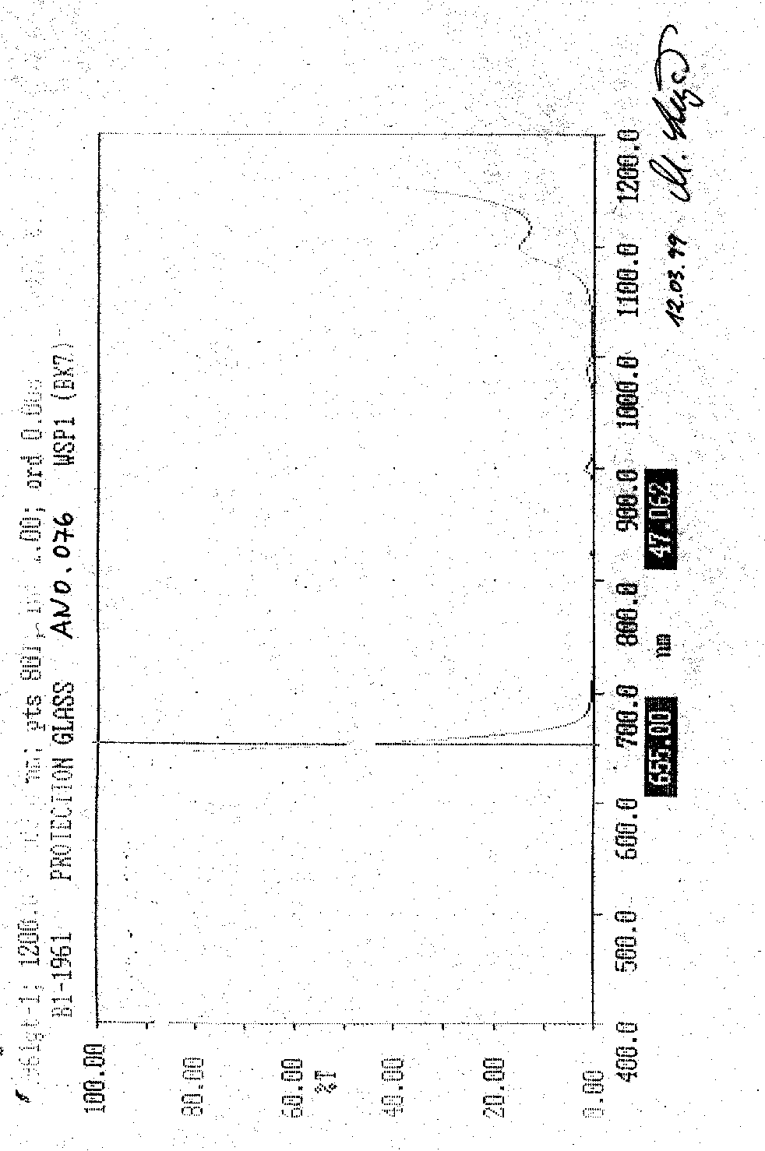

Figure 3.3

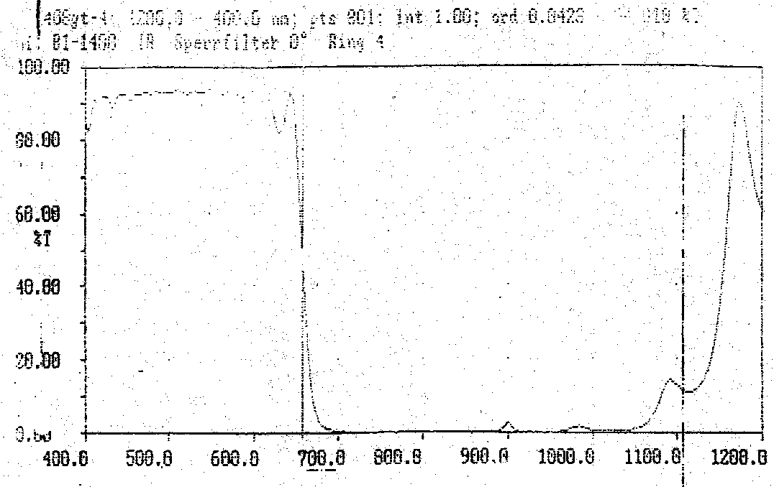

Figure 3.4 a : colour camera

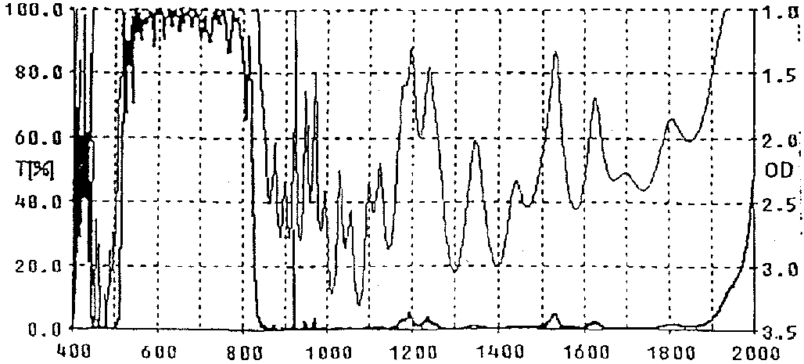

Figure 3.4 b : B&W camera

Image Quality

MTF

The MTF curves of the VMC objectives are shown in fig. 3.5 and fig. 3.6 for objects placed at a distance of 3 meter and at infinity.
MTF values for object positions at infinity are listed in table 3.4.

The MTF calculations are performed at different field values within the FOV of the camera in the wavelength range between 500 and 800 nm.

The MTF is calculated at frequencies from 0 to 40 cycles/mm, corresponding to the detector pixel dimensions.

Sharp images can be obtained for objects at 3 meter and at infinity. For this object distance range there is no need to refocus the camera.

The MTF is larger than 0.28 at 40 cycles / mm in the wavelength range between 500 and 800 nm, and in the complete FOV.

Table 3.4. MTF for objects at infinity

 | MTF
Field | RAD | TAN
0° | 0.57 | 0.57
15° | 0.52 | 0.53
20° | 0.51 | 0.44
25° | 0.47 | 0.28

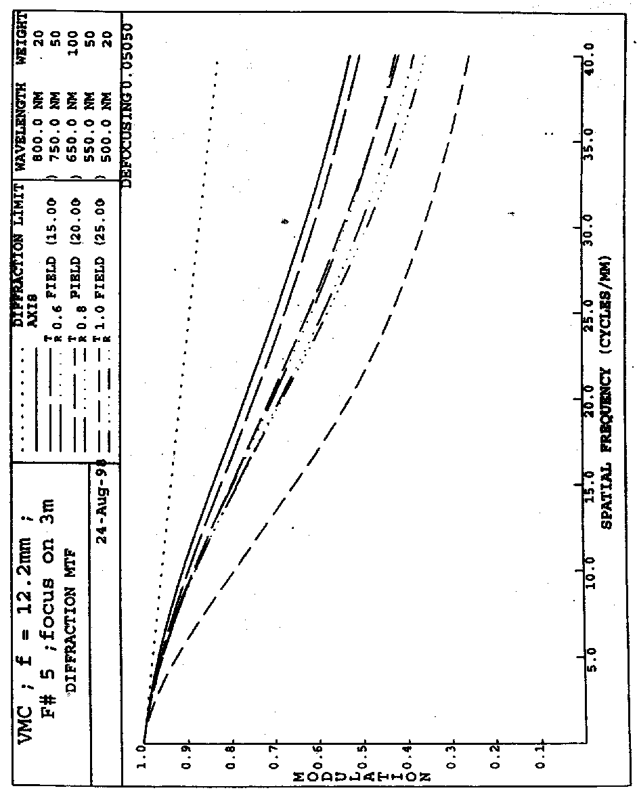

Figure 3.5

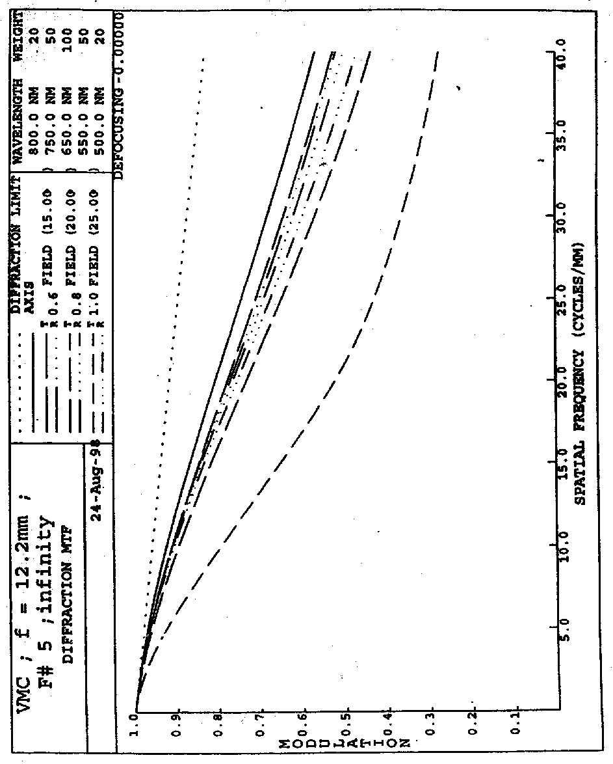

Figure 3.6

Encircled energy

The diameter of the circle that contains more than 60% of the energy is calculated.

In table 3.5 these diameters are listed at various field points. The diameter is smaller than 20 µm for all field points.

Table 3.5 : Diameter for encircled energy 60%, in the specified spectral range at different field points within the FOV of the camera.

Field | diameter(µm)
0° | 11
15° | 12
20° | 14
25° | 20

Definition of passband filter

Only in case of a black & white camera, a blocking filter is inserted with the following characteristics :
T ≥ 90 % average at 570 nm < λ < 740 nm
T ≤ 1 % absolute at 350 nm < λ < 500 nm and 800 nm < λ < 1100 nm

Distortion and field curvature

The distortion and the field curvature are shown in fig.3.7 for angles within the FOV of the camera.
The distortion of the camera is 0.4 % and the field curvature is smaller than 0.22 mm.

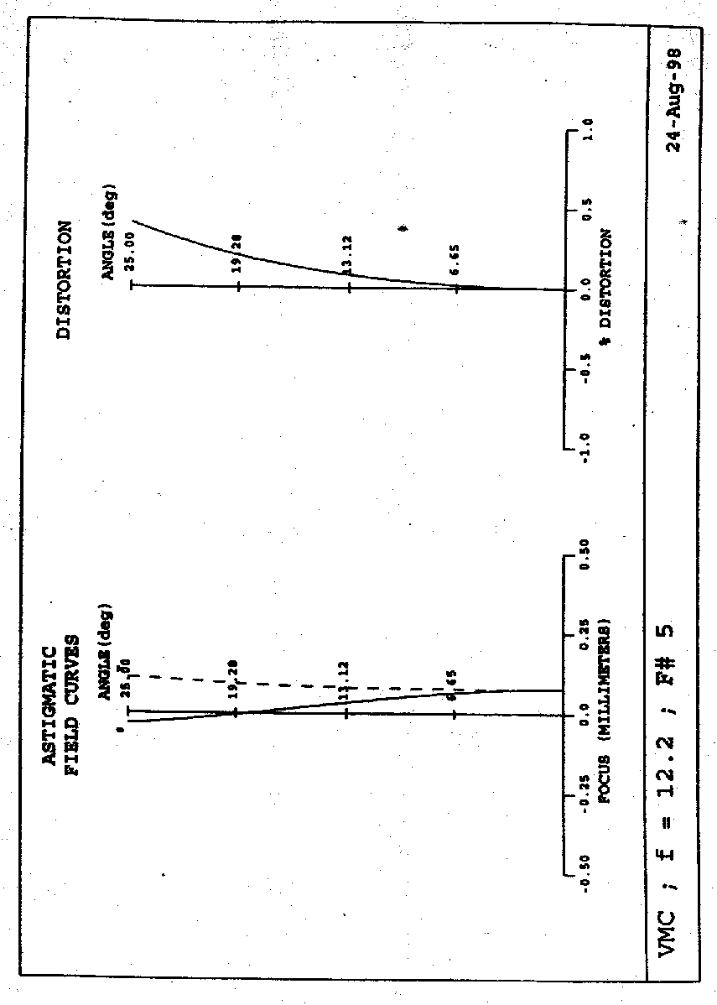

Figure 3.7

Thermal analysis

The thermal analysis is performed on the system assuming that all parts have the same temperature. The analysis is based on the following assumptions:

- nominal temperature : 20°C
- nominal pressure : vacuum
• operating temperature range: -50°C to +65°C

The following materials were used (see also chapter 3.3, mechanical design description):

The material of the objective housing is Invar (expansion coefficient =0.56 x 1E-6 /°K).
The material of the detector mount is also Invar.

The thermal behaviour is analysed at -50°C, -25°C, 0°C, 20°C, 40°C, and 65° (see tables 3.6 to 3.11). The MTF and the encircled energy almost don’t change in the specified temperature range.

When the tolerances are taken into account, an extra loss in MTF of 10% and an extra increase of the diameter of encircled energy of 4 μm must be taken into account.

Table 3.6 : Performance of the system at -50°C (at best focus position at 0° field angle)

Field angle | %MTF |  | Encircled energy (60%)(µm)
 | RAD | TAN
0° | 57 | 57 | 11
15° | 53 | 52 | 12
20° | 52 | 44 | 14
25° | 48 | 25 | 20

Table 3.7 : Performance of the system at -25°C (at best focus position at 0° field angle)

Field angle | %MTF |  | Encircled energy (60%)(µm)
 | RAD | TAN
0° | 57 | 57 | 11
15° | 52 | 53 | 12
20° | 51 | 44 | 14
25° | 47 | 25 | 20

Table 3.8 : Performance of the system at -0°C (at best focus position at 0° field angle)

Field angle | %MTF |  | Encircled energy (60%)(µm)
 | RAD | TAN
0° | 57 | 57 | 11
15° | 51 | 53 | 12
20° | 50 | 44 | 14
25° | 46 | 25 | 20

Table 3.9 : Performance of the system at 20°C (at best focus position at 0° field angle)

Field angle | %MTF |  | Encircled energy (60%)(µm)
 | RAD | TAN
0° | 57 | 57 | 11
15° | 51 | 53 | 12
20° | 58 | 44 | 14
25° | 45 | 25 | 20

Table 3.10 : Performance of the system at 40°C (at best focus position at 0° field angle)

Field angle | %MTF |  | Encircled energy (60%)(µm)
 | RAD | TAN
0° | 57 | 57 | 11
15° | 50 | 53 | 12
20° | 47 | 43 | 14
25° | 44 | 24 | 21

Table 3.11 : Performance of the system at 65°C (at best focus position at 0° field angle)

Field angle | %MTF |  | Encircled energy (60%)(µm)
 | RAD | TAN
0° | 57 | 57 | 11
15° | 48 | 53 | 12
20° | 45 | 43 | 14
25° | 42 | 24 | 21

Straylight Analysis

The ghost images, caused by specular reflections on the surfaces of the optical components and on the mechanical housing, were examined .

The following assumptions were made :

- The reflection coefficient of the filters in front of the objective is 10% (reflections at bandpass filter, IR blocking filter and uncoated protection glass).

- The reflection coefficient of the AR coatings on the lens surfaces is 0.5%

- The reflection coefficient of the detector surface is 20%

- The Invar housing (blackened) has a reflection coefficient of 2¨%

- Angles of incidence between 0° and 50° were examined.

The main sources of ghost images are the detector surface and the filters in front of the objective (uncoated front surface and bandpass filters).
The intensity of the ghost images caused by these reflections is about a factor of 13 smaller than the image of the incoming beam for field points around the axis, and decreases to a factor of 30 for field angles larger than 5°. These ghost images coincide with the image of the incoming beam.

Reflections between the detector surface and the detector window cause a ghost image with an intensity of about 500 times smaller than the image of the incoming beam. These ghost images do not coincide with the image of the incoming beam and can be disturbing.

Reflections between the detector surface and the lenses of the objective cause a ghost image with an intensity of about 1500 times smaller than the image of the incoming beam. These ghost images are smeared out over the detector surface and do not coincide with the image of the incoming beam.
All other reflections are negligible (a factor of 4000 smaller than the incoming beam) and are smeared out over the detector surface.

Since the detector has a linear response, ghost images that are a factor 100 smaller than the incoming beam will not be visible any more.

Tolerance Analysis

A tolerance analysis was performed, under the condition that the maximum allowed decrease in MTF is 15%.

In table 3.12 the most important tolerances are listed. The optical surfaces are defined in
fig. 3.2.
Most critical are the decenter and space tolerances. The manufacture of the optics will be stringent but feasible.

Table 3.12. : Optical and mechanical tolerances of the VMC design

surface nr | Glass | Fringes | Thickness |  | wedge | tilt | decenter
 |  |  | Lens | Airspace
1 | 0.001/0.80% | 5(5) | 0.1 |  | 1’
2 |  | 5(5) |  | 0.1 |  | 5’
3 | 0.001/0.80% | 5(5) | 0.01 |  | 1’
4 |  | 5(5) |  | 0.1 |  | 5’
5 | 0.001/0.80% | 20(5) | 0.1 |  | 6’ |  | 0.02
6 |  | 8(4) |  | 0.1 |  | 10’
7 | 0.001/0.80% | 8(2) | 0.03 |  |  | ref | 0.02
8 |  | 4(1.5) |  | ref
9 | 0.001/0.80% | 5(2) | 0.03 | 0.02 |  | 5’ | 0.02
10 |  | 5(3) |  |  | 5’
11 | 0.001/0.80% | 20 (10) | 0.1 |  |  | 15’
12 |  | 20(10) |  | adjustable

With these tolerances, the MTF at 20°C has been calculated and is shown in table 3.13.
In table 3.14, the diameter of encircled energy of 60% is shown. The diameter of encircled energy corresponds to about two detector pixels.

Table 3.13 : MTF at 20°C, 40 lp/mm and taking the system tolerances into account.

 | MTF
Field | RAD | TAN
0° | 52 | 51
15° | 43 | 34
20° | 41 | 26
25° | 32 | 14

Table 3.14. : Diameter of encircled energy (60%)

Field | Diameter of encircled energy(60%)(mm)
0° | 12
15° | 14
20° | 17
25° | 24

Mechanical Design

MECHANICAL Design description

A general view of the VMC camera is shown in fig. 3.1.

The mechanical structure of the VMC camera consists of the following parts:

- the mechanical housing of the objective lenses
- the detector assembly
- the camera housing
- the camera front and back plate
- the baffle

For the mechanical housing of the camera objective, Super Invar is used. The mechanical surfaces are dark chromium treated.

The other mechanical parts are made of Aluminium type AA 7075 - T 7351. The surfaces are treated with alodine 1200 according to MIL-C-5541C. Only the surfaces in the optical path are black anodised according to PSS-01-703-1.1.

The dimensions of the camera are the following:

width: 65 mm
height: 60 mm
depth: 108 mm

The camera mass estimation is 430 g. In this estimation the additional mass for the bracket and for the interface to the spacecraft is not included.

The Objective Assembly

The objective housing consists of the following parts (see fig.3.8):

- 1: lens 1
- 2: lens 2
- 3: lens 3
- 4: lens holder
- 5: spacer
- 6: Vitton o-ring
- 7: retaining ring

The position alignment of the components is assured by mechanical tolerances on the mechanical parts.

The objective lenses 2 and 3 are glued in lens holder 4 with glue type EC 22/6B/A. Lens 1 is mounted in the lens holder by means of a retainer.

The mechanical stresses originating from differences in thermal expansion between the objective housing and the optical glass is reduced in the axial direction by means of a Vitton O-ring. Care must be taken that the clamping force is sufficient to withstand vibration loads.
To avoid stresses in the radial direction, an air gap between the lens edges and the holder is provided.

To reduce scattering, the mechanical parts are black anodised or dark Chromium treated.

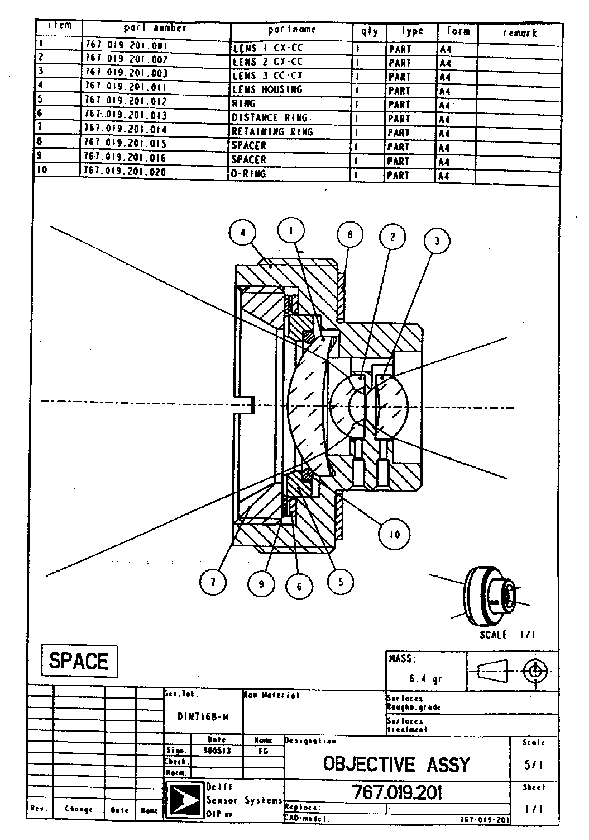

Figure 3.8

The Detector Assembly

The detector assembly consists of the following parts (fig. 3.9):

- 1: detector
- 2: detector window and fixture
- 3: window and detector holder

The detector window is glued on its holder (3) with glue type RTV 3145.

The detector, mounted on its ceramic structure, is glued on the mechanical holder 3 (glue type EC 2216). Care will be taken that the detector is centred with respect to holder 3, making use of reference marks applied at the detector housing.
The angular position of the detector is controlled within 1° with respect to the camera housing.

After assembly, the detector is soldered to the front PCB.

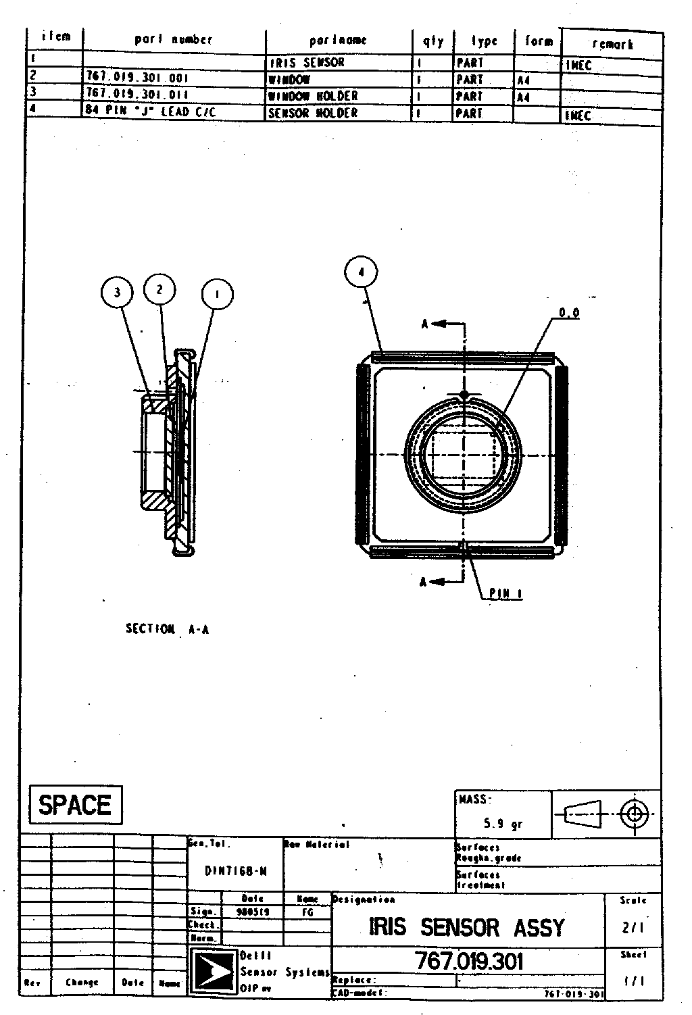

Figure 3.9

The Camera Assembly

The camera assembly consists of (see fig. 3.1):
1: the VMC premount
2: a back plate
3: the housing

- The VMC premount (fig. 3.10) consists of a front plate on which the camera objective and the electronics unit are mounted.

The 5 PCBs are interconnected by means of flexible connections, and are mounted on the camera frontplate by means of spacers and screws.

The objective is mounted to the frontplate by means of an adapter provided with screw thread. This adapter allows the integration of different detectors and objectives.

In between the camera objective and the adapter, a spacer allows a proper focusing of the camera objective on the detector surface.

- The back plate that contains the 25 pins and the 9 pins Sub-D connectors (fig. 3.11) is mounted with 4 screws, type M3x16AISI 304, to the back side of the PCB stack.

- After mounting the backplate to the PCB stack, the camera housing is clamped between the front and the back plate.

The camera is provided with 8 helicoils M4x1.5d in front and backplate for interface with the bracket (see fig. 3.11).

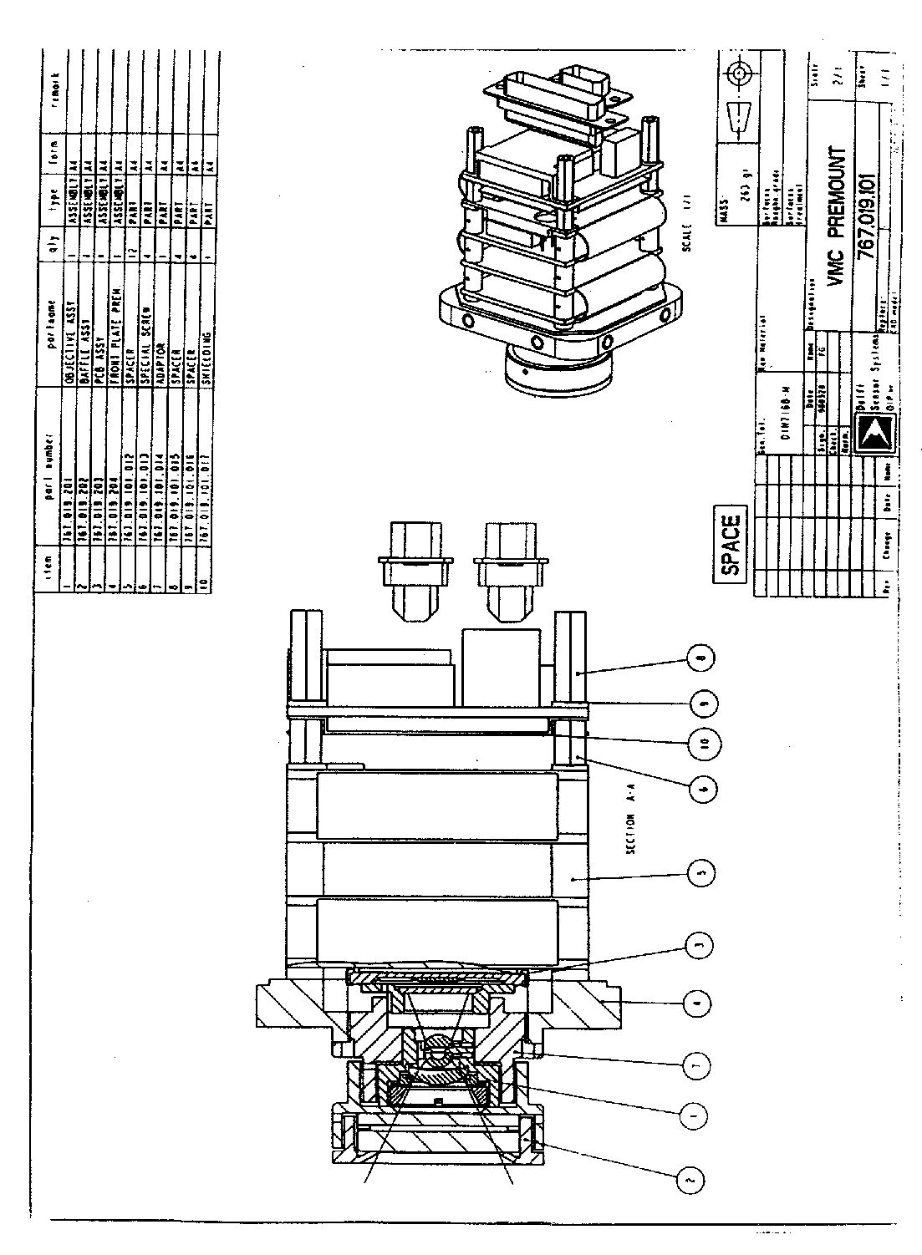

Figure 3.10

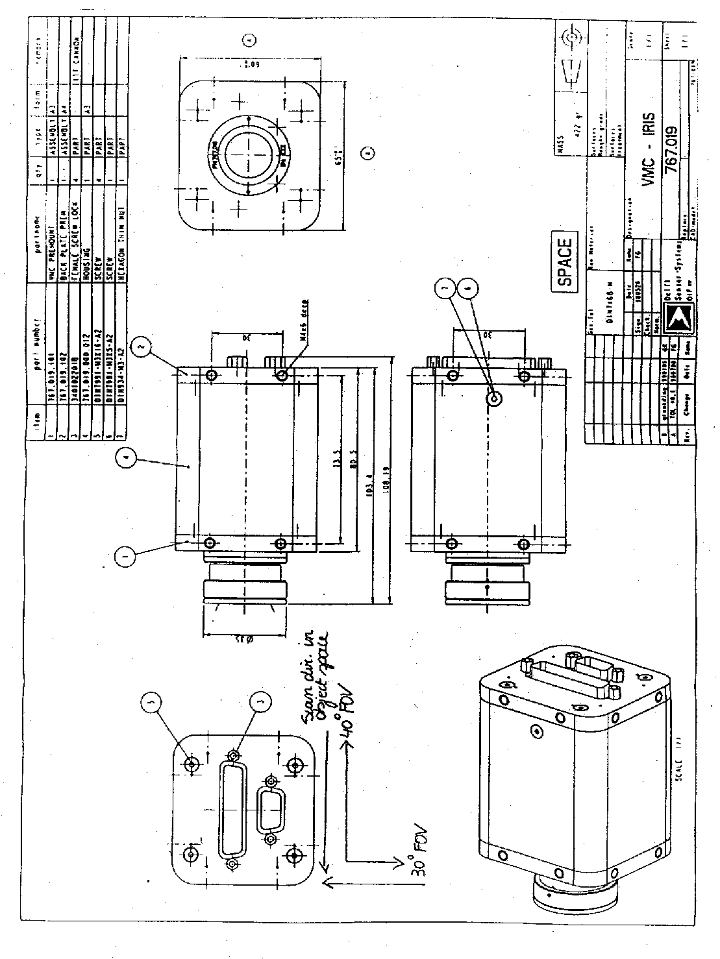

Figure 3.11

The Baffle
To prevent straylight to enter the camera objective, a baffle is mounted on the objective
(fig. 3.12). The baffle contains the IR blocking filter.
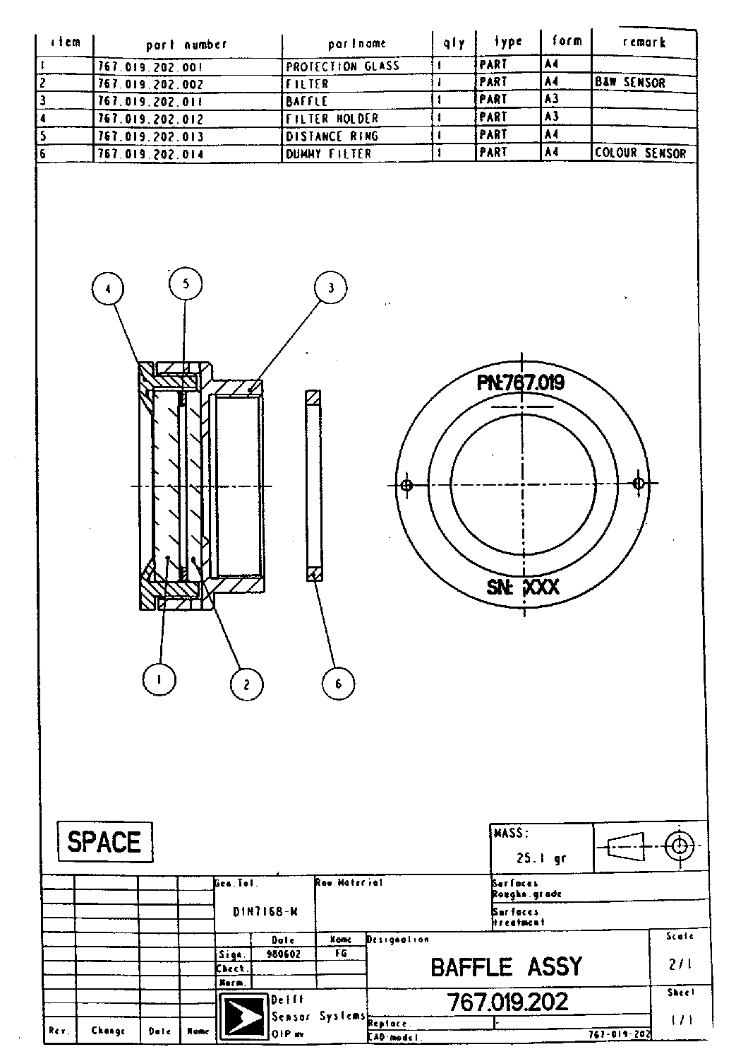

Figure 3.12

Electrical Design For IRIS VMC

Camera Module Overview
The Visual Monitoring Camera (VMC) is a stand-alone digital camera featuring a choice of sensors which can give a colour or greyscale images. It accepts image capture and exposure control commands, performs image acquisition, and stores one image in a local memory buffer to facilitate readout at a low data rate. It accepts commands from, and transmits image data to, a standard serial digital interface. An overview of the general VMC electrical characteristics are given in Table 3.15.

Conventions
Bit vector objects are denoted as “NAME[0..N]”. Here “NAME[0]” is the most significant bit.
Binary literals are denoted between double quotes, e.g. “0010”, where the leftmost bit is the most significant bit.
The ampersand (‘&’) is used as a concatenation symbol for binary objects and literals, e.g. “01”&”111” equals “01111”.
Logic signals with inverse polarity (‘active low’) are denoted as "SIGNAL\" or "SIGNALb".
The term "(image) acquisition" is used to denote the actual photo-electric process of image gathering on the sensor, possibly including an internal transfer of data from the sensor to memory.
The terms "(image) readout" and "download" are used to denote a transfer of data from internal memory to the end user or space craft.
The term "atomic" describes an operation that cannot be aborted; the term "non-atomic" describes an operation that can be aborted.

Image Sensor Type | IRIS
Sensor characteristics | IMEC IRIS-1 integrating CMOS APS.  640 x 480 pixels, linear response.  Colour: optional Bayer pattern colour mosaic on-chip.  Requires interactive control of exposure time.
Pixel pitch | 14μm
Resolution | 2 pixels
Electronic shutter | Yes
Blooming | Local
SNR | 65dB
Optical dynamic range | 2 decades linear
General
ADC | 8 bit flash, 7 bits effective resolution
Image capture speed | 200ms or slower
Image read modes | Full images
Local image buffer | One full image, SRAM-based
Interface | Synchronous serial, TTC-B-01 compatible ([RD4] ML16 version)
Power input | 28Vdc
Power consumption | <3W (average), 5W (short-term peak, <200ms duration)

Table 3.15 General VMC Electrical Characteristics

Electrical Interfaces

Power supply
The VMC internally converts a 28Vdc, <235mA supply voltage down to 12Vdc with a 550kHz switching DC/DC converter. After this, the 12V is regulated down to 5V using linear converters.

Power interface
connector type: DSUB-9, male, mounted on VMC backplate.

pin | signal name | signal type | signal function
1 | SHIELD | - | primary power line shield
2 | NC | - | -
3 | P_RTN1 | .RTN1 | primary power return line
4 | P_V1 | .SUP1 | primary power input, 28V DC, 235mA max.
5 | SHIELD | - | primary power line shield, 2
6 | NC | - | -
7 | P_RTN2 | .RTN2 | primary power return line, 2
8 | P_V2 | .SUP2 | primary power input 2
9 | NC | - | -
Tabel 3.16

The S/C PP 28Vdc has to be applied between P_V1/2 and P_RTN1/2. P_V1/2 draws up to 235mA during operation of the VMC. P_V1/2 draws <4mA when the power converter is inhibited (see section 3.4.3.1.2).
The power interface fully isolates the incoming primary supply from the camera system downstream of it.

Power converter shutdown, INHIBITb function
The DC/DC voltage converter can be enabled and disabled under control of an external logic signal, named the INHIBITb signal. This 2-wire signal resides at the data connector pins named TRIG_P and TRIG_N.
If the TRIG_P/TRIG_N pins are connected to the power supply INHIBITb port, then by shorting the pins TRIG_P and TRIG_N, where TRIG_N always is at the potential of ground P_RTN1/2, with a resistance less than 10Ω and capable of passing 4mA, the switching voltage regulator is switched off, and the camera is made inoperational. This while the primary 28V supply voltage is still applied.
When then the connection between pins TRIG_P and TRIG_N is made open, the DC/DC converter powers on and the VMC comes to action. Note that with the TRIG pins open, up to 11V can appear on pin TRIG_P.
EMC filtering: TRIG_P is shunted to TRIG_N with a 10nF or 100nF capacitor. The cable used between both pins should be a shielded twisted pair.

Power supply block diagram
Figure 3.13

Power relay control
The VMC for MEX is equipped with a power isolation relay (see configuration). This relay makes or breaks the contact between the primary power source and the VMC. The relay control signals are as follows:
- A positive pulse between ON_P and ON_N (see command/data interface connector) switches the VMC on. The pulse is to be 12V, 13ms long.
- A positive pulse between OFF_P and OFF_N (see command/data interface connector) switches the VMC off. The pulse is to be 12V, 13ms long.

Data Interface

Synchronous serial command input

General description
The synchronous serial command input employs three signals and is fully compatible with the TTC-B-01 ML16 variant as described in [RD4], page 30.

Interface signals
Signal name direction
MLS_P in Word valid sample signal, active low
MLS_N in MLS complement
TFC_P in Bit transfer clock
TFC_N in TFC complement
MLD_P in Command data, 16 bits serial
MLD_N in MLD complement

Timing diagram
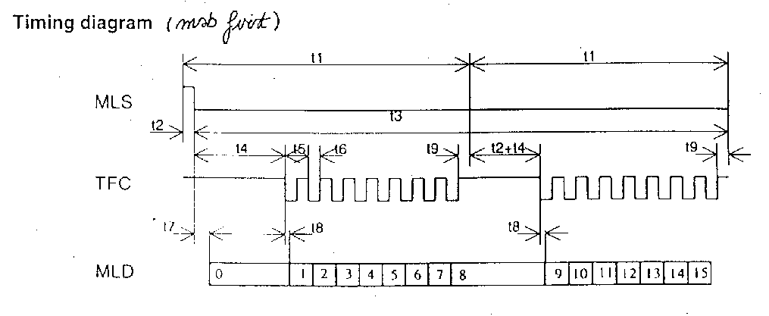

t1 -
t2 >960ns
t3 -
t4 >960ns
t5 >960ns
t6 t5/2
t7 > 480ns
t8 >160ns
t9 >0ns
maximum bit rate 1MHz (250 k Hz on the Reference VMC)
minimum bit rate 1kHz

Note : on the Reference VMC (with TTC interface), maximum input bit rate is limited to 250 kHz ; above timings should then be scaled times 4.

Electrical standard
Logic level Electrical signal level
0 MLD_P < MLD_N; 0 < MLD_P, MLD_N < 5V
1 MLD_P > MLD_N; 0 < MLD_P, MLD_N < 5V

Data rates
The interface is self-synchronising. The allowed input data rates span a range of 1kHz up to 1MHz.

Interface operation
See [RD4], page 30.
The input interface features a time-out which comes into play when any initiated command transfer stalls mid-word and is not resumed within a time of 1 millisecond.

Synchronous serial data output

Interface signals
Signal name direction
SDS_P in Word valid sample signal SDS
SDS_N in SDS complement
TFC_P in Bit transfer clock TFC (also in 3.4.3.2.1))
TFC_N in TFC complement
SDD_P out Telemetry data SDD, 16 bits
SDD_N out SDD complement

Timing diagram

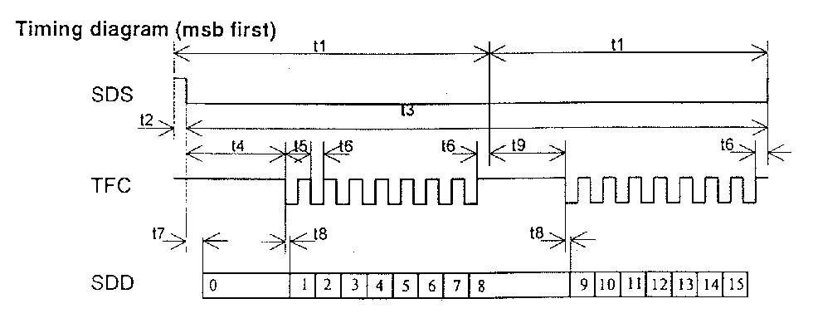

t1 -
t2 >960ns
t3 -
t4 >960ns
t5 >960ns
t6 t5/2
t7 0ns
t8 640ns
t9 > 0ns

Electrical standard
Logic level Electrical signal level
0 SDD_P < SDD_N; 0 < SDD_P, SDD_N < 5V
1 SDD_P > SDD_N; 0 < SDD_P, SDD_N < 5V

Data rates
The interface is self-synchronising to the externally applied bit transmit clock TFC. The allowed TFC input clock rate spans a range of DC up to 1MHz, with a nominal duty cycle of 50%.

Interface operation
See [RD4], page 51.

Synchronous interface compliance with [RD4]
All TTC-B-01 interface circuitry is according to [RD4], sections 3.3.2 and 3.3.7.
Note that the TM/TC interfaces are without packet formatting and without TM block formatting.
The asynchronous interfaces use the same electrical circuits and are hence not strictly compliant with e.g. the RS-422 and RS-485 standards.

On-board thermistor
The VMC features an on-board thermistor, of which both floating terminals, THER_P and THER_N, can be accessed on the command/data interface connector. The thermistor is internally thermally coupled to the VMC's circuit boards.
Part type YSI-44031 (commercial equivalent of NASA YSI-44908)
Resistance 10k at 25°C (zero-power)
Power rating 1mW max. at 125°C
Time constant 25s (max.)
EMC filtering: 1 nF to 100nF is present in shunt with the thermistor.

Command/data interface connector specification
Connector type: DSUB-25, male, mounted on VMC backplate.

Pin | pin name | pin type | pin function
1 | SDS_P | .TRUE | SDS positive phase
2 | SDS_N | .COMP | SDS negative phase
3 | SDD_SH | - | SDD shield
4 | THER_P | .SIG | thermistor positive connection
5 | THER_N | .RTN | thermistor negative connection
6 | ON_P | .SIG | camera ON relay positive phase
7 | ON_N | .RTN | camera ON relay return
8 | OFF_SH | - | camera OFF shield
9 | MLD_P | .TRUE | MLD positive phase
10 | MLD_N | .COMP | MLD negative phase
11 | MLS_SH | - | MLS shield
12 | TFC_P | .TRUE | TFC positive phase
13 | TFC_N | .COMP | TFC negative phase
14 | SDS_SH | - | SDS shield
15 | SDD_P | .TRUE | SDD positive phase
16 | SDD_N | .COMP | SDD negative phase
17 | TRIG_P | .SIG | power supply INHIBITb signal phase
18 | TRIG_N | .RTN | INHIBITb return phase, connected to P_RTN1/2
19 | ON_SH | - | camera ON shield
20 | OFF_P | .SIG | camera OFF relay positive line
21 | OFF_N | .RTN | camera OFF relay return
22 | MLD_SH | - | MLD shield
23 | MLS_P | .TRUE | MLS positive phase
24 | MLS_N | .COMP | MLS negative phase
25 | TFC_SH | - | TFC shield

Table 3.17

Command/data interface electrical circuit descriptions

The command and data interfaces comply to a specific flavour of TTC-B-01, described in [RD4], section 8.

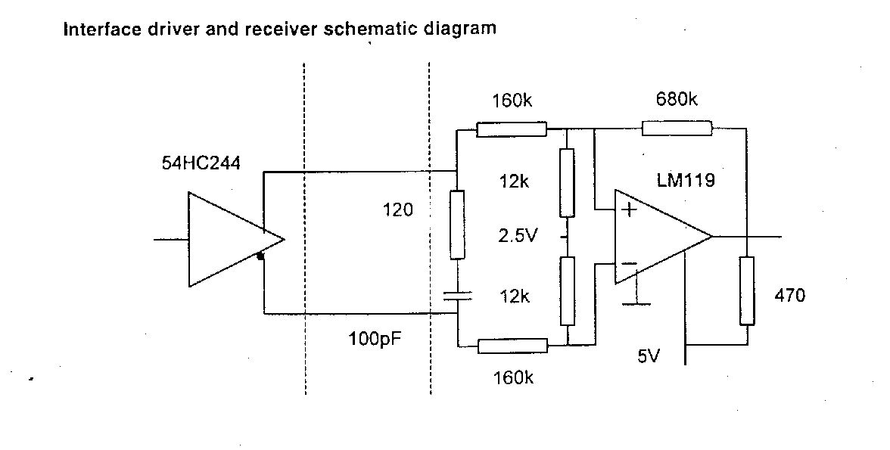

Figure 3.14

Output signals
Output signals emerge in complementary 0/5V format through standard CMOS 54HC244 buffers.

Input signals
Complementary 0/5V format input signals are converted to a single-ended format using an LM-119 comparator, fed from 5V dc and with a mid-point bias at 2.5V.
Input lines are (ac) terminated with 120 Ohms.
See [RD4] and Appendix II for full circuit details.

EMC and PP Interface Compliance
The S/C PP is interfaced to the VMC by a power isolation relay, an Interpoint FMSA-461 EMC filter and a dc isolating Interpoint MSA-2812S switching DC/DC converter, in that order. See the schematic in Appendix II, sheet 5/5, for details.

Primary Power supply interface, electrical issues
Over/under voltage tolerance: the VMC power supply interface complies with MIL-STD-704-A-D and tolerates short-term (50ms) supply line excursions on PP in the range 0 to 80V. The longterm tolerated input voltage during on-time is 16 to 40V. PP input voltage reversal is not tolerated.
The VMC's 28Vdc PP interface provides for electrical isolation between PP and Secondary Power, and between PP and VMC housing.
VMC power supply turn-on typically lasts <25ms and causes overshoot of <5V on the PP supply line, and <150mV on the SP line.

Conducted Emissions on Primary Power, frequency domain
The sole interface between S/C PP and the VMC consists of an Interpoint FMSA-461 line filter, followed by an (isolating) Interpoint MSA-2812S switching DC/CD convertor.
This combination reduces reflected ripple current on the primary power line to within US MIL-STD-461 C, Method CE03 tolerances.

CE on signal lines
Data and command interface lines: interface circuitry is according to [RD4], sections 3.3.2 and 3.3.7.
Inhibitb/trigger interface: a 10nF to 100nF shunt capacitor filters the line.
Thermistor interface: a 1 nF to 100nF shunt capacitor filters the line.
The VMC is a fully-closed non-hermetically sealed metal box, grounded at the S/C structure.

Radiated interference
To be tested post-design. The VMC is a fully-closed non-hermetically sealed metal box, grounded at the S/C structure.

VMC hardware grounding layout
DC/DC
convertor
camera circuitry
power IF
cmd
/data IF
external earth connection
DC/DC case shield
cable shields
sec. power
ground
signal
ground
Figure 3.15

Power Consumption Profile
Power dissipated during image acquisition or during fast (>1Mbs) image download: 5.0W to 6.0 W (estimated by IMEC).
Duration : < 200 ms.
Power dissipated during idling: approx. 2.8W
Image acquisitions, regardless of the chosen integration time, last 200 ms for the power calculation.
During image downloads slower than 1Mbs, the power consumption roughly equals the power used during idling.
Power profile: usually image acquisitions are followed by slow image downloads. A channel bandwidth of 64kbs results in a download time of 38s. This gives the following cyclic power profile:

Operation power duration
Image acquisition 5.0-6.0W 200 ms
Image download 2.8W 38 s
System Idling 2.8W -

Sensor Specifications

IMEC IRIS-1 integrating CMOS APS imager ([RD1])
Resolution | 640x480 pixels
Pixel size | 14μ
Fill factor | 72%
Die size | 10 x 8mm
Pixel type | 3-transistor active pixel, integrating
Electro-optical transfer | linear
Spectral response | 400-900nm
MTF | 0.18
Frame rate | 10Hz
Exposure control | user control required
Electrical SNR | 65dB (prior to ADC)
Non-uniformity | dark: 0.15% of peak signal, after on-chip CDS; lit: PRNU 10%
On-chip ADC | 8-bit flash
Access method | sequential scan
Colour | B&W and Bayer pattern-RGB available
Notes: | developed under ESA contract, chip with prototype status, requires IR-cutoff filter to minimise optical crosstalk, requires gamma correction
Table 3.18.

Camera Configurations VMC for MEX

System configuration
Prior to use and during assembly, the VMC has to be configured for specific operation modes. This configuration is hard-wired for each individual camera and has to be specified before construction. Once the VMC camera has been configured, it cannot be reconfigured. The actual configuration for MEX is defined in table 4.1.

CAMERA |  | MEX  P/N 767.019  S/N 05 | SPARE  P/N 767.019  S/N 06
Color |  | YES, RGB | NO, B&W
Sensor type |  | IRIS 1  lin. response | IRIS 1  lin. response
pixels |  | 640x480 | 640x480
Def. Exp. |  | 14ms. | 14ms.
1st image acquisition pre-defined by SNAP
SNAP |  | 10000 | 00000
TSC |  | 147s | 147s. not used
TS (delay time) |  | 147s | 0s
1st image after |  | 150s. | 3s.
Interface
I/F type |  | TTC-B-01 | TTC-B-01
Operational mode (AUTO 0 = command interactive mode)
AUTO |  | 0 | 0
Power Supply
Inh. mode |  | YES | YES
Prim. power |  | 28V DC | 28V DC
Relay |  | YES | NO
Thermistor |  | YES | YES

Table 4.1

The following list gives an overview of the VMC settings, which are hardwired on the FPGA PCB
for the IRIS S/N05 for MEX:

Name | S/N 05 setting | function
AUTO | 0 | selects autonomous or command-interactive operation of the camera. 0 = command interactive
EXP | 100 | selects default exposure time = 14 ms
SNAP, TSC | 10000 | selects method and delay for the acquisition of the first image. This setting will make use of a burned-in delay of TSC=147 seconds after power-on
INBD | 111 | selects TTC-B-01 ML16 command input interface type
OUTBD | 111 | selects TTC-B-01 TM16 data output interface type

Operational mode

AUTO | operation mode
0 | command-interactive
1 | autonomous operation after start-up

Default exposure time
The default exposure time settings for an IRIS VMC:

EXP[0..2] | Exposure time (ms)
000 | 0.5
001 | 1
010 | 2
011 | 4
100 | 14
101 | 54
110 | 200
111 | -

Triggered snapshot
The VMC can be made to acquire and store a first image in several ways. The trigger for the first image can be implicit, after system power-on, or explicit, via a trigger signal (see TRIG_P/TRIG_N pins on the electrical interface). The first image is taken a user-defined period TS after power-on or after the explicit TRIG event.
Pin SNAP[0] selects between a pin-configurable predefined delay and a custom delay time TSC which can be burned individually into each VMC during assembly.

SNAP[0] | source for delay time TS
0 | predefined delay for triggered snapshot: TS <- SNAP[2..4]
1 | burned-in delay TSC for triggered snapshot TS <- TSC
TSC is hard-programmable in a range of 0 to 255 seconds.
Pin SNAP[1] selects between a first image taken TS seconds after a trigger signal on TRIG_P/TRIG_N, or a first image taken (3+TS) seconds after power-on.

SNAP[1] | trigger event definition
1 | first image taken TS seconds after TRIG_P/TRIG_N trigger signal goes high (note: trigger has to come at least 3 seconds after VMC power-on)
0 | first image taken (3+TS) seconds after power-on

SNAP[2..4] configures the delay time TS:

SNAP[2..4] | TS (seconds) when SNAP[0]=0 | TS when SNAP[0]=1
000 | 0 | TSC
001 | 2 | TSC
010 | 4 | TSC
011 | 8 | TSC
100 | 16 | TSC
101 | 32 | TSC
110 | 64 | TSC
111 | 128 | TSC

Functional Specification

Internal states, variables and default values

The MEX-VMC holds the following variables in internal registers. The user by means of TC-commands can control these variables. The table also lists the default values for the variables after power-on or reset.

Parameter or internal allowed range of values default value Purpose
setting name

Exposure integer {0,1,2,...,239} See EXP integration time, see 5.6.2.

Nframes Integer {0,1,2,…,128} 128 Number of frames to acquire,
128 means infinity

Mode bit vector[0..7] “00000000” Operational mode settings

SystemStatus bit vector[0..7] "0000001" Read-only register, reads
"00000000" when the sensor
supply voltage sags, i.e. when
latch-up is presumed.

VMC start-up, system reset, initial state, sensor power monitoring

Upon power on, the VMC performs a reset. After this reset all internal settings and parameters take on their default values (see 5.1). During reset all output signals take on their default de-asserted values. For the output interfaces, the specific default value on an output pin may depend on the specific interface the camera has been configured for.

Then interactive mode is entered after 150 seconds, the burned-in delay time for the first image to be taken after separation. In the interval between power-on and power-on + 150 seconds any incoming command is ignored.

First image after start-up

After VMC power-on, according to the settings of SNAP/TSC, the VMC acquires one image and stores it in memory and is ready for download.

The first image can be read any number of times from the memory by subsequent TTC-B-01 TM16 interrogation cycles.

Any incoming READ_FRAMES commands (see 5.7.1) will only be serviced after the buffer has been read entirely at least once after the acquisition of the first image.

These features of operation allow the acquisition of an image (the first one after power-on), precisely triggered by an external event. It also guarantees the successful download of each image, as it resides in the memory buffer, and can be read from it as many times as needed, until a READ_FRAMES command (to acquire a new image) is received. None of these features will not used by MEX since the interactive mode is not possible due to the distance between the earth and the spacecraft. The commanding of the VMC must then be done in batch mode.

Commands: format, overview, and handling

Command structure

The camera is interactively controlled by user command words, issued to the command-input interface. The VMC command format is a 2-byte format which allows the ground to encapsulate these commands within standard SGICD TC(2,2) [RD 1]. The TCs to configure the VMC are included into the MTL and are transparent to the DMS S/W (routing to VMC only).

The generic structure of a command that will be used by the VMC cameras comprises the actual command identifier (6 bits) and command and argument parity bits (2 bits, making 1 octet in total), followed by one argument (8 bits or 1 octet). Commands that have no actual argument still require the transmission of a dummy argument, of which the contents are ignored by the camera. The MEX Ground Segment software will not make use of the parity bits; they will be ignored.

xxxxxxxxxxxxxxxxxxxxxxxxx Commandxxxxxxxxxxxxxxxxxxxxxxxxxxxxxxxxxx xxxxxxArgumentxxxxxx

Bits 0..5 Bit 6 Bit 7 Bits 0..7

Command type Odd parity over Command Odd Parity over Argument Argument value (bit
Type. Used by VMC only Used by VMC only 0 is MSB)

A command communication error occurs in the VMC when one of the command’s parity bits is faulty or when an unrecognised command is received. Faulty commands are ignored and thus cannot change the state of the VMC.

New commands overrule any older command, whether that is still pending or being executed. There are two exceptions. In case the old command comprises of image acquisition, the current image being acquired is downloaded once before the new command comes into action, e.g. a change of settings (exposure, ...) only comes into action after a new READ_FRAMES command is given. The other exception is the RESET command, which always executes immediately.

General operation: commands, command abortion, image download

The VMC is operated by sending it commands and reading its output data. Some commands upload settings for the camera. Other commands provoke image acquisition and/or image download.

The RESET command immediately interrupts any present operation while VMC returns to the default settings (see section 3.4). As such it can be used to abort any operation at will and at any time. An example could be the abortion of an image download over a slow data channel, after the first part of the image reveals that other system parameters would lead to a better picture quality. Upload of the last used parameter settings will be necessary when different from the default settings. When a RESET command has been issued, the ground software should abort the ongoing acquisition and begin to search for the synchronisation pattern, else the next image might be lost or be concatenated with the previous one.

The " READ_FRAMES " command triggers the imaging activity in the VMC. The image is stored within the VMC buffer. This delay takes 400ms + exposure time which is in the order of 20 ms. The Flight S/W should be instructed to start interrogation of the VMC buffer data only after it is guaranteed that the 1st image is completely stored in the VMC buffer.

The TCs "Read_Frames" are included into the MTL and are transparent to the DMS S/W.

The end-user controls the readout of data by means of RTU interrogation cycles, entirely asynchronous with respect to the VMC image acquisition.

Reading the buffer consists in issuing OBDH SD16 interrogation cycles that allow reading the VMC buffer by 153,605 steps of 2-byte read cycles. The size of the data buffer to be fetched by the Flight S/W is predictable, i.e., fixed to 153,605 words = 153600 words corresponding to digitised pixels + 5 words corresponding to header and trailer. It will be hard-coded in the DMS S/W (unlike the packetised P/L's for which the DMS S/W has first to read the length of the data block to be fetched from the P/L).

In an ending sequence of images, acquired by a READ_FRAMES(N) command with N < 128, the lastly acquired picture always can be downloaded any number of times by using multiple OBDH SD16 interrogation cycles.

Reset command

command name command format Argument
RESET 000001 dummy

RESET interrupts all current actions and performs a complete synchronous RESET on the device. The effect of RESET is equivalent to the hardware reset performed at power-on.

It is recommended that the value of the dummy argument is equal to the command type word for RESET.

Camera parameter setting commands

The following procedures are used to set the various internal parameters of the camera.

VMC-Mode setting

command name command format argument 1
SET_MODE 100100 Mode

The SET_MODE command influences the way of image readout. It has the following word structure. Only bit 3 applies to the MEX configuration.

Bit Name Function Default value
0
1
2
3 Exposure Mode VMC: 0=lines; 1=frames 0
4
5
6
7

The new settings in SET_MODE come into action after the download has been completed of any currently being acquired/transmitted frame.

When Exposure Mode is 0, the Exposure parameter (see section 3.7.2.1) denotes an exposure time based on a multiple of the imager line read time. When Exposure Mode is 1, Exposure denotes an exposure time based on a multiple of the image frame read time.

VMC Interactive Exposure control

Command name command format argument
SET_EXPOSURE 100001 Exposure[0..7]

The parameters Exposure, together with the Exposure Mode setting in the Modes register (see 3.7.1), and with the current readout times of pixels and lines, and the frame dimensions (640 pixels x 480 lines for IRIS) set the integration or exposure time for the IRIS sensor.

Exposure is an integer of the range 0 to 239, a range which should never be exceeded as unpredictable behaviour of the camera may result. The relation between the value of Exposure, Exposure Mode and the sensor exposure time Ti is as follows:

Ti = 0.4ms * (Exposure * 2 + 1) when Exposure Mode =0
Ti = 200ms * (Exposure * 2 + 1) when Exposure Mode =1

Resulting exposure time is the time during which the optical sensor is exposed to light.

Image acquisition time is the time that elapses between the beginning of the exposure time and the end of the write operation from sensor to internal memory.

Exposure Exposure Mode Resulting exposure time (ms) Image acquisition time (ms)
(in Set Mode) (approx.)

0 0 0.4 400+0.4
1 0 1.2 400+1.2
… … … …
239 0 200 400+200
0 1 200 200+200
1 1 600 200+600
… … … …
239 1 95800 200+95800

Note that, at room temperature, integration times of over 10 seconds result in auto-saturation by excess dark signal. Dark signal decreases with temperature.
The VMC camera has approximately the sensitivity of an ISO-50 film. Choice of setting depends on fraction of spacecraft and launcher or Earth in view, while considering that in space the intensity is twice that on Earth on a sunny day.

Image acquisition commands and data formats

Image acquisition, automatic image update, image buffer readout

command name command format Argument
READ_FRAMES 000010 N

READ_FRAMES reads (N+1) images. N is an integer of the range 0..128. When N = 128, an endless stream of frames is read. When 0 < N < 128, N+1 frames are consecutively acquired and transmitted. When eventually the (N+1)th frame is acquired, stored in the buffer, and transmitted, it remains in the buffer from which it can be retrieved again with the OBDH SD16 interrogation cycle.

When N=128, i.e. endless acquisition, is selected in combination with the TTC-B-01 output interface, then images are automatically updated in the memory buffer when a new interface interrogation cycle does not start within one second of the last image acquisition.

Issuing a new READ_FRAMES while a frame already is being read, i.e. with a previous READ_FRAMES still active, interrupts the old command. The frame currently being read is then finished and entirely output, after which the new READ_FRAMES command comes into action. Every acquired and buffered frame has to be read at least once before a new READ_FRAMES command is serviced: the acquisition and subsequent download of an image requested by a READ_FRAMES command is to be considered one atomic operation.

Image output data format
An image is output as follows:
- a 32-bit synchronization pattern is followed by a 8-bit image identifier (a cyclic ascending sequence count, unique for each image acquired, not for each image downloaded, as the same image can be downloaded many times) and a SystemStatus octet holding the alarm for sensor latch-up.

After this preamble the actual image is output as a stream of PixelValues. This stream
begins with the first pixel of the frame or line (the pixel in the top-left corner of the frame), and ends with the last pixel of the frame or line (the pixel in the bottom-right corner of the frame). N values are output if the frame or line contains N pixels. Two consecutive pixels, being 8 bit words each, are packed into one 16 bit telemetry word. The most significant byte of the TM word contains the first pixel, the least significant byte contains the second pixel. Finally, the transmission is ended with a 32-bit end marker.

Idle pattern

In case the TTC interface is used and no image data are available when the RTU interrogates the camera, an idle pattern is output. This particular case happens when
- the camera has not yet acquired and buffered an image, e.g. after power-on, or
- the camera sensor is in progress of acquiring a new image.

The idle pattern is 0x55 0xAA (e.g. 55 AA 55 AA 55 AA…)

No download abortion

Stalling of the RTU interrogation during an image download does not abort the download: it is resumed as soon as the RTU starts interrogating again. To explicitly provoke a download abort, the end-user has to employ the RESET telecommand.

Transmission of the VMC data to the Ground Processing Unit.
The telemetry consists of a continuous stream of raw images. Each image is sent line by line and every pixel is contained in 8 bits. In order to comply to TTC-B format ( 16 bits serial data), 2 pixels are grouped in one 16 bits word, the most significant byte containing the first pixel. Each image is preceded by a synch and start of image marker and followed by an end marker.

operations procedures

VMC Operations Timeline on Mars Express

After each power-on the VMC camera will take 3 seconds to wakeup and waits TSC (=147) seconds delay time for the first image acquisition.

For the image acquisition, it will take 400 ms plus the strap-programmed exposure time (= 400+14ms) before the first picture is available in the VMC buffer.

This picture is ready to be downloaded to the mass-memory using a data rate of approximately 80 kbps (=62.5% of 131 kbps). The amount of image data to be downloaded is 153600 words of 16 bits, including header it will be 153605 words of 16 bits.

Complete download of the picture is reached after exactly 153605 read cycles. This lasts for approximately 38 seconds, depending on the traffic on the OBDH bus and assuming that the VMC is the unique P/L "On & Active" during the operations herein in question. Following a complete download of the picture, the VMC will be reset and a delay of 2ms is taken before the VMC can be commanded to take the next picture using a newly command-programmed exposure time.

The next picture can be downloaded after 400ms plus the command-programmed exposure time, again at a rate of approximately 80 kbps.

Task Sharing between Ground & DMS S/W
VMC & Other Payloads
Other payloads are not foreseen to be polled together with the VMC. This allows to establish two exclusive OBDH profiles for the two intended P/L uses :
- nominal OBDH profile (Rosetta SIRS RO-DSS-IS-1001, §3.7) featuring 25% max. of bandwidth for Packet TC Users and 62.5% for TM-Block Acquisitions.
- VMC-specific OBDH profile which allocates the P/L TM bandwidth (62.5%) to the VMC buffer read. The nominal 25 % free for passing TCs to packet users is left unchanged.
- Ground disables polling of all (packetised) payloads by successive TC(16,2).
- The activation of the VMC-specific OBDH profile is implicit when the TC(130, 80) "Read_VMC_Image" is received and executed by the DMS S/W.

First Image
- Ground switches on the VMC and interface to OBDH.
- Ground sends TC(130,80) for the read-out of the VMC's 1st image (default settings).

Subsequent VMC Configuration Settings, Imaging, & Buffer Read Request
- Ground (or Master Time Line stored into on-board SSMM) issues TC(2,2)(Memory Load Commands) to configure the VMC (e.g., exposure time). DMS S/W just routes the TC.
- Ground (or MTL) issues TC(2,2) (MLC) to pass "READ_FRAMES" command to the VMC. DMS S/W just routes the TC.
- Ground (or MTL) issues TC(130,80) to DMS S/W : "READ_VMC_IMAGE". This TC is interpreted by the DMS S/W as the go-ahead for acquiring the VMC buffer data. Proper timing of the successive operations has to be ensured by the ground programming taking into account the delays inherent to the camera. This is detailed in the next section

VMC Buffer Read, Storage into SSMM, & Downlinking
- In response to the TC(130,80), the DMS S/W performs 153,605 SD16 reads (exactly counted by the DMS S/W) to download the VMC buffer data and to store it into the Mars Express mass memory (SSMM). This will take about 38 seconds (4,096 VMC OBDH interrogations/s) given the VMC is the only P/L polled at that time.
- The DMS S/W stores the VMC buffer data as a series of TM packets of 4,112 bytes (of which 4,096 bytes of VMC data) through TC(162,14) "Write Packet from DMS PM".
- It starts building the VMC TM packets in a real-time manner at a rate of two 4,112-byte TM packets/second (consistent with the 4,096 VMC OBDH interrogations/s above).
- It stores the built TM packets into the SSMM using TC(162,14) at the same rate.
- The last TM packet will include the residual data left after the generation of the 75 preceding TM packets containing 4,096 of VMC data. The length of the packet data field is provided by the packet header.
- The VMC packets will be downlinked through the TFG after ground request to the DMS S/W (TC).
- The DMS S/W can acquire a new image from the VMC every 42 seconds, taking into account the "buffer read" and the storage of TM packets into the SSMM (see figure 6.1).
- Ground (or on-board MTL) issues as many TC(130,80) as necessary to the DMS S/W to read subsequent images in case the "READ_FRAMES" command previously required the VMC to acquire several images.
- The ground (or MTL) manages the delays between the successive TC(130,80) with 1 second resolution taking into account the time to fill in the buffer with a new image (VMC-dependent), and the time taken by the DMS S/W to read the buffer and store the TM packets into the SSMM(42s).
Re-Enabling Polling of other Payloads
- Ground (or on-board MTL) re-enables the standard P/L Polling Sequence as necessary.

Typical Operations Scenario

The synchronisation of the VMC operations with the Beagle-2 separation time can be handled through the MTL since the MTL TCs are time-stamped against the on-board time (SCET). A timeline diagram is presented in figure 6.1 as an example.
The delays are implemented by programming and timely execution of TCs included into the MTL pre-loaded by the Ground. The TCs (130,80) "Acquire VMC Buffer" (triggering the VMC Buffer reads) are included in the MTL at appropriate times. They are executed by the DMS S/W.

System Validation Tests activities
Objective: last checkout of the VMC and of the VMC imaging sequence for Beagle2 ejection
Date/time: during SVT sessions, proper time to be decided by ESOC
Duration: 30 minutes minimum, up to 1 hour
The SVT checkout of the VMC must be functionally as close as possible from the critical Beagle2 separation procedures. The number of images to be acquired is still to be confirmed but 10 seems to be a minimum and 20 is a reasonable value that enables to test the impact of VMC operations on SSMM performance and TM link.
The attitude of the Mars Express spacecraft with respect to the Sun will NOT be made similar to the ejection attitude. Therefore, the exposure settings for the 20 images will cover both deep space and test room conditions to maximise the return of experience from the SVT sessions.
The Beagle2 separation image sequence will contain at least 10 pictures that require 34 steps of the following procedure. But the possibility to get more images should be kept. ESOC/operations will make the final decision during Earth Verification or Interplanetary Cruise phases. The following sequence enables the acquisition and download to ground of 20 images with different exposure times. So the steps 1 to 32 and 63 to 64 are compulsory while the execution of the steps 33 to 62 depends on the total number of images allowed.

- ground (or MTL) switches on the VMC and interface to the OBDH.
- after 150 s from 1, ground (or MTL) sends TC(130,80) for the read-out of the VMC's 1st image (default settings).
- after 42 s from 2, ground (or MTL) sends TC(2,2) for the configuration of VMC (exposure_time_01).
- ground (or MTL) sends TC(2,2) for the acquisition of 1 image ("Read_Frames (1)").
- ground (or MTL) sends TC(130,80) for the read-out of the new VMC image (picture_01) into the SSMM.
- after 42 s from 5, ground (or MTL) sends TC(2,2) for the configuration of VMC (exposure_time_02).
- ground (or MTL) sends TC(2,2) for the acquisition of 1 image ("Read_Frames (1)").
- ground (or MTL) sends TC(130,80) for the read-out of the new VMC image (picture_02) into the SSMM.
- after 42 s from 8, ground (or MTL) sends TC(2,2) for the configuration of VMC (exposure_time_03).
- ground (or MTL) sends TC(2,2) for the acquisition of 1 image ("Read_Frames (1)").
- ground (or MTL) sends TC(130,80) for the read-out of the new VMC image (picture_03) into the SSMM.
- after 42 s from 11, ground (or MTL) sends TC(2,2) for the configuration of VMC (exposure_time_04).
- ground (or MTL) sends TC(2,2) for the acquisition of 1 image ("Read_Frames (1)").
- ground (or MTL) sends TC(130,80) for the read-out of the new VMC image (picture_04) into the SSMM.
- after 42 s from 14, ground (or MTL) sends TC(2,2) for the configuration of VMC (exposure_time_05).
- ground (or MTL) sends TC(2,2) for the acquisition of 1 image ("Read_Frames (1)").
- ground (or MTL) sends TC(130,80) for the read-out of the new VMC image (picture_05) into the SSMM.
- after 42 s from 17, ground (or MTL) sends TC(2,2) for the configuration of VMC (exposure_time_06).
- ground (or MTL) sends TC(2,2) for the acquisition of 1 image ("Read_Frames (1)").
- ground (or MTL) sends TC(130,80) for the read-out of the new VMC image (picture_06) into the SSMM.
- after 42 s from 20, ground (or MTL) sends TC(2,2) for the configuration of VMC (exposure_time_07).
- ground (or MTL) sends TC(2,2) for the acquisition of 1 image ("Read_Frames (1)").
- ground (or MTL) sends TC(130,80) for the read-out of the new VMC image (picture_07) into the SSMM.
- after 42 s from 23, ground (or MTL) sends TC(2,2) for the configuration of VMC (exposure_time_08).
- ground (or MTL) sends TC(2,2) for the acquisition of 1 image ("Read_Frames (1)").
- ground (or MTL) sends TC(130,80) for the read-out of the new VMC image (picture_08) into the SSMM.
- after 42 s from 26, ground (or MTL) sends TC(2,2) for the configuration of VMC (exposure_time_09).
- ground (or MTL) sends TC(2,2) for the acquisition of 1 image ("Read_Frames (1)").
- ground (or MTL) sends TC(130,80) for the read-out of the new VMC image (picture_09) into the SSMM.
- after 42 s from 29, ground (or MTL) sends TC(2,2) for the configuration of VMC (exposure_time_10).
- ground (or MTL) sends TC(2,2) for the acquisition of 1 image ("Read_Frames (1)").
- ground (or MTL) sends TC(130,80) for the read-out of the new VMC image (picture_10) into the SSMM.
- after 42 s from 32, ground (or MTL) sends TC(2,2) for the configuration of VMC (exposure_time_11).
- ground (or MTL) sends TC(2,2) for the acquisition of 1 image ("Read_Frames (1)").
- ground (or MTL) sends TC(130,80) for the read-out of the new VMC image (picture_11) into the SSMM.
- after 42 s from 35, ground (or MTL) sends TC(2,2) for the configuration of VMC (exposure_time_12).
- ground (or MTL) sends TC(2,2) for the acquisition of 1 image ("Read_Frames (1)").
- ground (or MTL) sends TC(130,80) for the read-out of the new VMC image (picture_12) into the SSMM.
- after 42 s from 38, ground (or MTL) sends TC(2,2) for the configuration of VMC (exposure_time_13).
- ground (or MTL) sends TC(2,2) for the acquisition of 1 image ("Read_Frames (1)").
- ground (or MTL) sends TC(130,80) for the read-out of the new VMC image (picture_13) into the SSMM.
- after 42 s from 41, ground (or MTL) sends TC(2,2) for the configuration of VMC (exposure_time_14).
- ground (or MTL) sends TC(2,2) for the acquisition of 1 image ("Read_Frames (1)").
- ground (or MTL) sends TC(130,80) for the read-out of the new VMC image (picture_14) into the SSMM.
- after 42 s from 44, ground (or MTL) sends TC(2,2) for the configuration of VMC (expsure_time_105.
- ground (or MTL) sends TC(2,2) for the acquisition of 1 image ("Read_Frames (1)").
- ground (or MTL) sends TC(130,80) for the read-out of the new VMC image (picture_15) into the SSMM.
- after 42 s from 47, ground (or MTL) sends TC(2,2) for the configuration of VMC (exposure_time_16).
- ground (or MTL) sends TC(2,2) for the acquisition of 1 image ("Read_Frames (1)").
- ground (or MTL) sends TC(130,80) for the read-out of the new VMC image (picture_16) into the SSMM.
- after 42 s from 50, ground (or MTL) sends TC(2,2) for the configuration of VMC (exposure_time_17).
- ground (or MTL) sends TC(2,2) for the acquisition of 1 image ("Read_Frames (1)").
- ground (or MTL) sends TC(130,80) for the read-out of the new VMC image (picture_17) into the SSMM.
- after 42 s from 53, ground (or MTL) sends TC(2,2) for the configuration of VMC (exposure_time_18).
- ground (or MTL) sends TC(2,2) for the acquisition of 1 image ("Read_Frames (1)").
- ground (or MTL) sends TC(130,80) for the read-out of the new VMC image (picture_18) into the SSMM.
- after 42 s from 56, ground (or MTL) sends TC(2,2) for the configuration of VMC (exposure_time_19).
- ground (or MTL) sends TC(2,2) for the acquisition of 1 image ("Read_Frames (1)").
- ground (or MTL) sends TC(130,80) for the read-out of the new VMC image (picture_19) into the SSMM.
- after 42 s from 59, ground (or MTL) sends TC(2,2) for the configuration of VMC (exposure_time_20).
- ground (or MTL) sends TC(2,2) for the acquisition of 1 image ("Read_Frames (1)").
- ground (or MTL) sends TC(130,80) for the read-out of the new VMC image (picture_20) into the SSMM.
- after 42 s from 32, ground switches off VMC and interface to the OBDH.
- when appropriate, ground (or MTL) sends TC for the downlink of the 20 images from the SSMM.

Earth Verification activities
Objective: checkout of the VMC and exposure times calibration
Date/time: proper time to be decided by ESOC
Duration: 1 hour minimum, up to a complete working day
The following sequence (34 steps) enables the acquisition and download to ground of 10 images with different exposure times. These 10 images will be processed to get knowledge about the illumination conditions in space and determine the proper exposure times to use for the ejection of the Beagle2 probe. This sequence requires appreciatively 30 minutes of operations and may have to be repeated several times to tune the exposure times. Indeed, the process of computing proper exposure times will take more or less time, depending on the degree of similarity between the attitude of Mars Express spacecraft with respect to the Sun and its attitude at beagle2 ejection. It is obvious that the ideal configuration is to have similar attitudes. In any case, scaling with respect to Sun intensity will be necessary to determine adequate exposure time when at Mars-Sun distance.
The minimum number of images to acquire to get a complete sequence of the beagle2 separation will also be refined at that stage. It is set to 10 at the moment: After (Fired-but-still-attached + 500) s at 0.3 m/s, the B2 would be at 150m. But finer computation needs to be done to determine for how long the geometry allows Beagle2 to be visible (assuming that it would be illuminated and reflecting) if the SC keeps the same attitude. These calibration activities will also lead to a better definition of the proof of the Beagle2 ejection (a completely dark picture except an illuminated crescent getting smaller and smaller?).

- ground (or MTL) switches on the VMC and interface to the OBDH.
- after 150 s from 1, ground (or MTL) sends TC(130,80) for the read-out of the VMC's 1st image (default settings).
- after 42 s from 2, ground (or MTL) sends TC(2,2) for the configuration of VMC (exposure_time_01).
- ground (or MTL) sends TC(2,2) for the acquisition of 1 image ("Read_Frames (1)").
- ground (or MTL) sends TC(130,80) for the read-out of the new VMC image (picture_01) into the SSMM.
- after 42 s from 5, ground (or MTL) sends TC(2,2) for the configuration of VMC (exposure_time_02).
- ground (or MTL) sends TC(2,2) for the acquisition of 1 image ("Read_Frames (1)").
- ground (or MTL) sends TC(130,80) for the read-out of the new VMC image (picture_02) into the SSMM.
- after 42 s from 8, ground (or MTL) sends TC(2,2) for the configuration of VMC (exposure_time_03).
- ground (or MTL) sends TC(2,2) for the acquisition of 1 image ("Read_Frames (1)").
- ground (or MTL) sends TC(130,80) for the read-out of the new VMC image (picture_03) into the SSMM.
- after 42 s from 11, ground (or MTL) sends TC(2,2) for the configuration of VMC (exposure_time_04).
- ground (or MTL) sends TC(2,2) for the acquisition of 1 image ("Read_Frames (1)").
- ground (or MTL) sends TC(130,80) for the read-out of the new VMC image (picture_04) into the SSMM.
- after 42 s from 14, ground (or MTL) sends TC(2,2) for the configuration of VMC (exposure_time_05).
- ground (or MTL) sends TC(2,2) for the acquisition of 1 image ("Read_Frames (1)").
- ground (or MTL) sends TC(130,80) for the read-out of the new VMC image (picture_05) into the SSMM.
- after 42 s from 17, ground (or MTL) sends TC(2,2) for the configuration of VMC (exposure_time_06).
- ground (or MTL) sends TC(2,2) for the acquisition of 1 image ("Read_Frames (1)").
- ground (or MTL) sends TC(130,80) for the read-out of the new VMC image (picture_06) into the SSMM.
- after 42 s from 20, ground (or MTL) sends TC(2,2) for the configuration of VMC (exposure_time_07).
- ground (or MTL) sends TC(2,2) for the acquisition of 1 image ("Read_Frames (1)").
- ground (or MTL) sends TC(130,80) for the read-out of the new VMC image (picture_07) into the SSMM.
- after 42 s from 23, ground (or MTL) sends TC(2,2) for the configuration of VMC (exposure_time_08).
- ground (or MTL) sends TC(2,2) for the acquisition of 1 image ("Read_Frames (1)").
- ground (or MTL) sends TC(130,80) for the read-out of the new VMC image (picture_08) into the SSMM.
- after 42 s from 26, ground (or MTL) sends TC(2,2) for the configuration of VMC (exposure_time_09).
- ground (or MTL) sends TC(2,2) for the acquisition of 1 image ("Read_Frames (1)").
- ground (or MTL) sends TC(130,80) for the read-out of the new VMC image (picture_09) into the SSMM.
- after 42 s from 29, ground (or MTL) sends TC(2,2) for the configuration of VMC (exposure_time_10).
- ground (or MTL) sends TC(2,2) for the acquisition of 1 image ("Read_Frames (1)").
- ground (or MTL) sends TC(130,80) for the read-out of the new VMC image (picture_10) into the SSMM.
- after 42 s from 32, ground switches off VMC and interface to the OBDH.
- when appropriate, ground (or MTL) sends TC for the downlink of the 10 images from the SSMM.

Interplanetary Cruise activities
Objective: last checkout of the VMC and of the VMC imaging sequence for Beagle2 ejection
Date/time: around two months before Mars orbit insertion, exact time to be decided by ESOC
Duration: 30 minutes minimum, up to 1 hour
The last checkout of the VMC/Beagle2 separation activities should take place as late as possible during the Interplanetary Cruise but soon enough to avoid interfering with the horrendous last 10 days when all activities and manoeuvres for Mars approach take place (see Flight Dynamics Technical Note). Two months before arrival (late Oct-03) seems good enough to be confident that the VMC will work on the day of B2 ejection. If an extra late check-out is required (which is NOT recommend), it should happen at least 1 week before the Beagle2 ejection proper – actual date remaining TBC with respect to ops constraints.
Note that for this final checkout, the attitude of the Mars Express spacecraft will NOT be made similar to the ejection attitude.
The Beagle2 separation image sequence will contain at least 10 pictures that require 34 steps of the following procedure. But the possibility to get more images should be kept. ESOC/operations will make the final decision during Earth Verification or Interplanetary Cruise phases. The following sequence enables the acquisition and download to ground of 20 images with different exposure times. So the steps 1 to 32 and 63 to 64 are compulsory while the execution of the steps 33 to 62 depends on the total number of images allowed.

- ground (or MTL) switches on the VMC and interface to the OBDH.
- after 150 s from 1, ground (or MTL) sends TC(130,80) for the read-out of the VMC's 1st image (default settings).
- after 42 s from 2, ground (or MTL) sends TC(2,2) for the configuration of VMC (exposure_time_01).
- ground (or MTL) sends TC(2,2) for the acquisition of 1 image ("Read_Frames (1)").
- ground (or MTL) sends TC(130,80) for the read-out of the new VMC image (picture_01) into the SSMM.
- after 42 s from 5, ground (or MTL) sends TC(2,2) for the configuration of VMC (exposure_time_02).
- ground (or MTL) sends TC(2,2) for the acquisition of 1 image ("Read_Frames (1)").
- ground (or MTL) sends TC(130,80) for the read-out of the new VMC image (picture_02) into the SSMM.
- after 42 s from 8, ground (or MTL) sends TC(2,2) for the configuration of VMC (exposure_time_03).
- ground (or MTL) sends TC(2,2) for the acquisition of 1 image ("Read_Frames (1)").
- ground (or MTL) sends TC(130,80) for the read-out of the new VMC image (picture_03) into the SSMM.
- after 42 s from 11, ground (or MTL) sends TC(2,2) for the configuration of VMC (exposure_time_04).
- ground (or MTL) sends TC(2,2) for the acquisition of 1 image ("Read_Frames (1)").
- ground (or MTL) sends TC(130,80) for the read-out of the new VMC image (picture_04) into the SSMM.
- after 42 s from 14, ground (or MTL) sends TC(2,2) for the configuration of VMC (exposure_time_05).
- ground (or MTL) sends TC(2,2) for the acquisition of 1 image ("Read_Frames (1)").
- ground (or MTL) sends TC(130,80) for the read-out of the new VMC image (picture_05) into the SSMM.
- after 42 s from 17, ground (or MTL) sends TC(2,2) for the configuration of VMC (exposure_time_06).
- ground (or MTL) sends TC(2,2) for the acquisition of 1 image ("Read_Frames (1)").
- ground (or MTL) sends TC(130,80) for the read-out of the new VMC image (picture_06) into the SSMM.
- after 42 s from 20, ground (or MTL) sends TC(2,2) for the configuration of VMC (exposure_time_07).
- ground (or MTL) sends TC(2,2) for the acquisition of 1 image ("Read_Frames (1)").
- ground (or MTL) sends TC(130,80) for the read-out of the new VMC image (picture_07) into the SSMM.
- after 42 s from 23, ground (or MTL) sends TC(2,2) for the configuration of VMC (exposure_time_08).
- ground (or MTL) sends TC(2,2) for the acquisition of 1 image ("Read_Frames (1)").
- ground (or MTL) sends TC(130,80) for the read-out of the new VMC image (picture_08) into the SSMM.
- after 42 s from 26, ground (or MTL) sends TC(2,2) for the configuration of VMC (exposure_time_09).
- ground (or MTL) sends TC(2,2) for the acquisition of 1 image ("Read_Frames (1)").
- ground (or MTL) sends TC(130,80) for the read-out of the new VMC image (picture_09) into the SSMM.
- after 42 s from 29, ground (or MTL) sends TC(2,2) for the configuration of VMC (exposure_time_10).
- ground (or MTL) sends TC(2,2) for the acquisition of 1 image ("Read_Frames (1)").
- ground (or MTL) sends TC(130,80) for the read-out of the new VMC image (picture_10) into the SSMM.
- after 42 s from 32, ground (or MTL) sends TC(2,2) for the configuration of VMC (exposure_time_11).
- ground (or MTL) sends TC(2,2) for the acquisition of 1 image ("Read_Frames (1)").
- ground (or MTL) sends TC(130,80) for the read-out of the new VMC image (picture_11) into the SSMM.
- after 42 s from 35, ground (or MTL) sends TC(2,2) for the configuration of VMC (exposure_time_12).
- ground (or MTL) sends TC(2,2) for the acquisition of 1 image ("Read_Frames (1)").
- ground (or MTL) sends TC(130,80) for the read-out of the new VMC image (picture_12) into the SSMM.
- after 42 s from 38, ground (or MTL) sends TC(2,2) for the configuration of VMC (exposure_time_13).
- ground (or MTL) sends TC(2,2) for the acquisition of 1 image ("Read_Frames (1)").
- ground (or MTL) sends TC(130,80) for the read-out of the new VMC image (picture_13) into the SSMM.
- after 42 s from 41, ground (or MTL) sends TC(2,2) for the configuration of VMC (exposure_time_14).
- ground (or MTL) sends TC(2,2) for the acquisition of 1 image ("Read_Frames (1)").
- ground (or MTL) sends TC(130,80) for the read-out of the new VMC image (picture_14) into the SSMM.
- after 42 s from 44, ground (or MTL) sends TC(2,2) for the configuration of VMC (expsure_time_105.
- ground (or MTL) sends TC(2,2) for the acquisition of 1 image ("Read_Frames (1)").
- ground (or MTL) sends TC(130,80) for the read-out of the new VMC image (picture_15) into the SSMM.
- after 42 s from 47, ground (or MTL) sends TC(2,2) for the configuration of VMC (exposure_time_16).
- ground (or MTL) sends TC(2,2) for the acquisition of 1 image ("Read_Frames (1)").
- ground (or MTL) sends TC(130,80) for the read-out of the new VMC image (picture_16) into the SSMM.
- after 42 s from 50, ground (or MTL) sends TC(2,2) for the configuration of VMC (exposure_time_17).
- ground (or MTL) sends TC(2,2) for the acquisition of 1 image ("Read_Frames (1)").
- ground (or MTL) sends TC(130,80) for the read-out of the new VMC image (picture_17) into the SSMM.
- after 42 s from 53, ground (or MTL) sends TC(2,2) for the configuration of VMC (exposure_time_18).
- ground (or MTL) sends TC(2,2) for the acquisition of 1 image ("Read_Frames (1)").
- ground (or MTL) sends TC(130,80) for the read-out of the new VMC image (picture_18) into the SSMM.
- after 42 s from 56, ground (or MTL) sends TC(2,2) for the configuration of VMC (exposure_time_19).
- ground (or MTL) sends TC(2,2) for the acquisition of 1 image ("Read_Frames (1)").
- ground (or MTL) sends TC(130,80) for the read-out of the new VMC image (picture_19) into the SSMM.
- after 42 s from 59, ground (or MTL) sends TC(2,2) for the configuration of VMC (exposure_time_20).
- ground (or MTL) sends TC(2,2) for the acquisition of 1 image ("Read_Frames (1)").
- ground (or MTL) sends TC(130,80) for the read-out of the new VMC image (picture_20) into the SSMM.
- after 42 s from 32, ground switches off VMC and interface to the OBDH.
- when appropriate, ground (or MTL) sends TC for the downlink of the 20 images from the SSMM.

Preparation activities for Beagle2 separation
Objective: start of the imaging sequence of Beagle2 ejection
Date/time: actual date/time remaining TBC with respect to ops constraints
Duration: 10 minutes minimum, up to 20 minutes
To minimise as far as possible interleaving VMC activities and the critical Pyro sequences which lead to the Beagle2 ejection, the set-up of the VMC and acquisition/polling of the first image (with default exposure time) must take place around two hours before B2 separation (actual time TBD) when „nothing else“ happens (avoid mixing with power or AOCS TCs to turn the spacecraft). A second image (with proper exposure time) must also be acquired and stored in the SSMM as a reference picture with respect to Beagle2 separation.
This first image is then taken and read out to the SSMM (not to the Earth) when the spacecraft is still pointing Earth.

- ground (or MTL) switches on the VMC and interface to the OBDH.
- after 150 s from 1, ground (or MTL) sends TC(130,80) for the read-out of the VMC's 1st image (default settings).
- after 42 s from 2, ground (or MTL) sends TC(2,2) for the configuration of VMC (exposure_time_01).
- ground (or MTL) sends TC(2,2) for the acquisition of 1 image ("Read_Frames (1)").
- ground (or MTL) sends TC(130,80) for the read-out of the new VMC image (picture_01) into the SSMM.
- after 42 s from 5, ground (or MTL) sends TC(2,2) for the configuration of VMC (exposure_time_02).

Beagle2 separation activities
Objective: actual imaging sequence of Beagle2 ejection
Date/time: actual date/time remaining TBC with respect to ops constraints
Duration: 30 minutes minimum, up to 1 hour
At this stage, the VMC is ON and the first image (default exposure time settings) has already been acquired and transferred to the SSMM. Moreover, the exposure parameters (mode and exposure_time_01) for the first image of the sequence have already been sent to the VMC. The camera is then ready to execute the first Read_Frames command and the following sequence.
This sequence should start only when the pyro safing is finished – a couple of seconds after the ejection proper - possibly before the Beagle2 is even ejected. But so the TC interleaving would be avoided.
The Beagle2 separation image sequence will contain at least 10 pictures that require 34 steps of the following procedure. But the possibility to get more images should be kept. ESOC/operations will make the final decision during Earth Verification or Interplanetary Cruise phases. The following sequence enables the acquisition and download to ground of 20 images with different exposure times. So the steps 1 to 29 and 60 to 61 are compulsory while the execution of the steps 30 to 59 depends on the total number of images allowed.

- ground (or MTL) sends TC(2,2) for the acquisition of 1 image ("Read_Frames (1)").
- ground (or MTL) sends TC(130,80) for the read-out of the new VMC image (picture_01) into the SSMM.
- after 42 s from 5, ground (or MTL) sends TC(2,2) for the configuration of VMC (exposure_time_02).
- ground (or MTL) sends TC(2,2) for the acquisition of 1 image ("Read_Frames (1)").
- ground (or MTL) sends TC(130,80) for the read-out of the new VMC image (picture_02) into the SSMM.
- after 42 s from 8, ground (or MTL) sends TC(2,2) for the configuration of VMC (exposure_time_03).
- ground (or MTL) sends TC(2,2) for the acquisition of 1 image ("Read_Frames (1)").
- ground (or MTL) sends TC(130,80) for the read-out of the new VMC image (picture_03) into the SSMM.
- after 42 s from 11, ground (or MTL) sends TC(2,2) for the configuration of VMC (exposure_time_04).
- ground (or MTL) sends TC(2,2) for the acquisition of 1 image ("Read_Frames (1)").
- ground (or MTL) sends TC(130,80) for the read-out of the new VMC image (picture_04) into the SSMM.
- after 42 s from 14, ground (or MTL) sends TC(2,2) for the configuration of VMC (exposure_time_05).
- ground (or MTL) sends TC(2,2) for the acquisition of 1 image ("Read_Frames (1)").
- ground (or MTL) sends TC(130,80) for the read-out of the new VMC image (picture_05) into the SSMM.
- after 42 s from 17, ground (or MTL) sends TC(2,2) for the configuration of VMC (exposure_time_06).
- ground (or MTL) sends TC(2,2) for the acquisition of 1 image ("Read_Frames (1)").
- ground (or MTL) sends TC(130,80) for the read-out of the new VMC image (picture_06) into the SSMM.
- after 42 s from 20, ground (or MTL) sends TC(2,2) for the configuration of VMC (exposure_time_07).
- ground (or MTL) sends TC(2,2) for the acquisition of 1 image ("Read_Frames (1)").
- ground (or MTL) sends TC(130,80) for the read-out of the new VMC image (picture_07) into the SSMM.
- after 42 s from 23, ground (or MTL) sends TC(2,2) for the configuration of VMC (exposure_time_08).
- ground (or MTL) sends TC(2,2) for the acquisition of 1 image ("Read_Frames (1)").
- ground (or MTL) sends TC(130,80) for the read-out of the new VMC image (picture_08) into the SSMM.
- after 42 s from 26, ground (or MTL) sends TC(2,2) for the configuration of VMC (exposure_time_09).
- ground (or MTL) sends TC(2,2) for the acquisition of 1 image ("Read_Frames (1)").
- ground (or MTL) sends TC(130,80) for the read-out of the new VMC image (picture_09) into the SSMM.
- after 42 s from 29, ground (or MTL) sends TC(2,2) for the configuration of VMC (exposure_time_10).
- ground (or MTL) sends TC(2,2) for the acquisition of 1 image ("Read_Frames (1)").
- ground (or MTL) sends TC(130,80) for the read-out of the new VMC image (picture_10) into the SSMM.
- after 42 s from 32, ground (or MTL) sends TC(2,2) for the configuration of VMC (exposure_time_11).
- ground (or MTL) sends TC(2,2) for the acquisition of 1 image ("Read_Frames (1)").
- ground (or MTL) sends TC(130,80) for the read-out of the new VMC image (picture_11) into the SSMM.
- after 42 s from 35, ground (or MTL) sends TC(2,2) for the configuration of VMC (exposure_time_12).
- ground (or MTL) sends TC(2,2) for the acquisition of 1 image ("Read_Frames (1)").
- ground (or MTL) sends TC(130,80) for the read-out of the new VMC image (picture_12) into the SSMM.
- after 42 s from 38, ground (or MTL) sends TC(2,2) for the configuration of VMC (exposure_time_13).
- ground (or MTL) sends TC(2,2) for the acquisition of 1 image ("Read_Frames (1)").
- ground (or MTL) sends TC(130,80) for the read-out of the new VMC image (picture_13) into the SSMM.
- after 42 s from 41, ground (or MTL) sends TC(2,2) for the configuration of VMC (exposure_time_14).
- ground (or MTL) sends TC(2,2) for the acquisition of 1 image ("Read_Frames (1)").
- ground (or MTL) sends TC(130,80) for the read-out of the new VMC image (picture_14) into the SSMM.
- after 42 s from 44, ground (or MTL) sends TC(2,2) for the configuration of VMC (expsure_time_105.
- ground (or MTL) sends TC(2,2) for the acquisition of 1 image ("Read_Frames (1)").
- ground (or MTL) sends TC(130,80) for the read-out of the new VMC image (picture_15) into the SSMM.
- after 42 s from 47, ground (or MTL) sends TC(2,2) for the configuration of VMC (exposure_time_16).
- ground (or MTL) sends TC(2,2) for the acquisition of 1 image ("Read_Frames (1)").
- ground (or MTL) sends TC(130,80) for the read-out of the new VMC image (picture_16) into the SSMM.
- after 42 s from 50, ground (or MTL) sends TC(2,2) for the configuration of VMC (exposure_time_17).
- ground (or MTL) sends TC(2,2) for the acquisition of 1 image ("Read_Frames (1)").
- ground (or MTL) sends TC(130,80) for the read-out of the new VMC image (picture_17) into the SSMM.
- after 42 s from 53, ground (or MTL) sends TC(2,2) for the configuration of VMC (exposure_time_18).
- ground (or MTL) sends TC(2,2) for the acquisition of 1 image ("Read_Frames (1)").
- ground (or MTL) sends TC(130,80) for the read-out of the new VMC image (picture_18) into the SSMM.
- after 42 s from 56, ground (or MTL) sends TC(2,2) for the configuration of VMC (exposure_time_19).
- ground (or MTL) sends TC(2,2) for the acquisition of 1 image ("Read_Frames (1)").
- ground (or MTL) sends TC(130,80) for the read-out of the new VMC image (picture_19) into the SSMM.
- after 42 s from 59, ground (or MTL) sends TC(2,2) for the configuration of VMC (exposure_time_20).
- ground (or MTL) sends TC(2,2) for the acquisition of 1 image ("Read_Frames (1)").
- ground (or MTL) sends TC(130,80) for the read-out of the new VMC image (picture_20) into the SSMM.
- after 42 s from 32, ground switches off VMC and interface to the OBDH.
- when appropriate, ground (or MTL) sends TC for the downlink of the 20 images from the SSMM.

Role of the VMC “PI”
During each activity described in section 6.1 (System Validation Tests, Earth Validation, Interplanetary Cruise, Beagle2 separation preparation and Beagle2 ejection), a specialist of the VMC will be available on site or on line to check the prepared commands and process/interpret the downlinked data using the VMC SCOE software described in section 8.

Operation of the VMC camera system

The camera is switched ON during flight with the default parameter settings as indicated in section 5.1.

After the special RTU table for polling the VMC memories is selected by telecommand the image data of the VMC is first stored in the mass memory where it is ready to be downlinked. The first image can be read any number of times from the buffer by subsequent TTC-B-01 TM16 interrogation cycles.

The first in-flight command to the VMC cameras will only be accepted after the first image has been downloaded and correctly received by the VMC SCOE. This first command will be to acquire the next images.

Commands to the vmc camera
The command to RESET the camera is as follows:

Table 6.2.1.

Activity | TC_Command | Argument
VMC reset | 00000100 | 00000100

To command the camera to read a new image is:

Table 6.2.2.

Activity | TC_Command | Argument | Remarks
VMC Read_Frames | 0000100P_{f} | A_{f} | see table 6.2.3.

The values for P_{f} (parity bit) and A_{f} for the number of images to acquire and read one after the other can be replaced using the numbers in table 6.2.3.:

Table 6.2.3.

Activity | P_{f} | A_{f}
ReadFrames (1) | 1 | 0
ReadFrames (2) | 0 | 1
ReadFrames (3) | 0 | 2
ReadFrames (4) | 1 | 3
ReadFrames (5) | 0 | 4
ReadFrames (6) | 1 | 5
ReadFrames (7) | 1 | 6
ReadFrames (8) | 0 | 7
ReadFrames (9) | 0 | 8
ReadFrames (10) | 1 | 9
Etc.
ReadFrames (20) | 0 | 19
Etc.
ReadFrames (endless) | 0 | 128

This will command the camera to acquire a new image with the default settings and store them in the memories. The RTU takes care that the cameras are subsequently interrogated.

So if, after ground processing, new images are needed with different exposure settings then the following commands will be used:

Table 6.2.4a. VMC Exposure setting in line mode

Activity | TC_Command | Argument | Remarks
VMC reset | 00000100 | 00000100
VMC SetModeLines | 10010011 | 00000000
VMC SetExposure | 1000011P_{t} | A_{t} | see table 6.2.5a
VMC Read_Frames | 0000100 P_{f} | A_{f} | see table 6.2.3.

or

Table 6.2.4b. VMC Exposure setting in frame mode

Activity | TC_Command | Argument | Remarks
VMC reset | 00000100 | 00000100
VMC SetModeFrames | 10010010 | 00010000
VMC SetExposure | 1000011 P_{t} | A_{t} | see table 6.2.5b
VMC Read_Frames | 0000100 P_{f} | A_{f} | see table 6.2.3.

Tables 6.2.5a and b on the next pages provide the nominal values for P_{t} (parity bit) and A_{t} (raw exposure time setting) for the line mode and for the frame mode respectively.

The exposure time setting need to be given by the customer in milliseconds. The GPU shall convert it using look-up tables conform to tables 6.2.5a and b. The two relevant numbers will be given to the operator, whereupon the he shall generate the required TC_Command with its argument.

Table 6.2.5a. VMC Exposure Time for Exposure Mode = 0 (Set ModeLines).

T ms Pt At T ms Pt At T ms Pt At T ms Pt At T ms Pt At
0.4 1 0 41.2 1 51 82 1 102 122.8 1 153 163.6 1 204
1.2 0 1 42 0 52 82.8 0 103 123.6 1 154 164.4 0 205
2 0 2 42.8 1 53 83.6 0 104 124.4 0 155 165.2 0 206
2.8 1 3 43.6 1 54 84.4 1 105 125.2 1 156 166 1 207
3.6 0 4 44.4 0 55 85.2 1 106 126 0 157 166.8 0 208
4.4 1 5 45.2 0 56 86 0 107 126.8 0 158 167.6 1 209
5.2 1 6 46 1 57 86.8 1 108 127.6 1 159 168.4 1 210
6 0 7 46.8 1 58 87.6 0 109 128.4 1 160 169.2 0 211
6.8 0 8 47.6 0 59 88.4 0 110 129.2 0 161 170 1 212
7.6 1 9 48.4 1 60 89.2 1 111 130 0 162 170.8 0 213
8.4 1 10 49.2 0 61 90 0 112 130.8 1 163 171.6 0 214
9.2 0 11 50 0 62 90.8 1 113 131.6 0 164 172.4 1 215
10 1 12 50.8 1 63 91.6 1 114 132.4 1 165 173.2 1 216
10.8 0 13 51.6 0 64 92.4 0 115 133.2 1 166 174 0 217
11.6 0 14 52.4 1 65 93.2 1 116 134 0 167 174.8 0 218
12.4 1 15 53.2 1 66 94 0 117 134.8 0 168 175.6 1 219
13.2 0 16 54 0 67 94.8 0 118 135.6 1 169 176.4 0 220
14 1 17 54.8 1 68 95.6 1 119 136.4 1 170 177.2 1 221
14.8 1 18 55.6 0 69 96.4 1 120 137.2 0 171 178 1 222
15.6 0 19 56.4 0 70 97.2 0 121 138 1 172 178.8 0 223
16.4 1 20 57.2 1 71 98 0 122 138.8 0 173 179.6 0 224
17.2 0 21 58 1 72 98.8 1 123 139.6 0 174 180.4 1 225
18 0 22 58.8 0 73 99.6 0 124 140.4 1 175 181.2 1 226
18.8 1 23 59.6 0 74 100.4 1 125 141.2 0 176 182 0 227
19.6 1 24 60.4 1 75 101.2 1 126 142 1 177 182.8 1 228
20.4 0 25 61.2 0 76 102 0 127 142.8 1 178 183.6 0 229
21.2 0 26 62 1 77 102.8 0 128 143.6 0 179 184.4 0 230
22 1 27 62.8 1 78 103.6 1 129 144.4 1 180 185.2 1 231
22.8 0 28 63.6 0 79 104.4 1 130 145.2 0 181 186 1 232
23.6 1 29 64.4 1 80 105.2 0 131 146 0 182 186.8 0 233
24.4 1 30 65.2 0 81 106 1 132 146.8 1 183 187.6 0 234
25.2 0 31 66 0 82 106.8 0 133 147.6 1 184 188.4 1 235
26 0 32 66.8 1 83 107.6 0 134 148.4 0 185 189.2 0 236
26.8 1 33 67.6 0 84 108.4 1 135 149.2 0 186 190 1 237
27.6 1 34 68.4 1 85 109.2 1 136 150 1 187 190.8 1 238
28.4 0 35 69.2 1 86 110 0 137 150.8 0 188 191.6 0 239
29.2 1 36 70 0 87 110.8 0 138 151.6 1 189
30 0 37 70.8 0 88 111.6 1 139 152.4 1 190
30.8 0 38 71.6 1 89 112.4 0 140 153.2 0 191
31.6 1 39 72.4 1 90 113.2 1 141 154 1 192
32.4 1 40 73.2 0 91 114 1 142 154.8 0 193
33.2 0 41 74 1 92 114.8 0 143 155.6 0 194
34 0 42 74.8 0 93 115.6 1 144 156.4 1 195
34.8 1 43 75.6 0 94 116.4 0 145 157.2 0 196
35.6 0 44 76.4 1 95 117.2 0 146 158 1 197
36.4 1 45 77.2 1 96 118 1 147 158.8 1 198
37.2 1 46 78 0 97 118.8 0 148 159.6 0 199
38 0 47 78.8 0 98 119.6 1 149 160.4 0 200
38.8 1 48 79.6 1 99 120.4 1 150 161.2 1 201
39.6 0 49 80.4 0 100 121.2 0 151 162 1 202
40.4 0 50 81.2 1 101 122 0 152 162.8 0 203
Table 6.2.5b. VMC Exposure Time for Exposure Mode = 1 (Set ModeFrames).

T ms Pt At T ms Pt At T ms Pt At T ms Pt At T ms Pt At
200 1 0 20600 1 51 41000 1 102 61400 1 153 81800 1 204
600 0 1 21000 0 52 41400 0 103 61800 1 154 82200 0 205
1000 0 2 21400 1 53 41800 0 104 62200 0 155 82600 0 206
1400 1 3 21800 1 54 42200 1 105 62600 1 156 83000 1 207
1800 0 4 22200 0 55 42600 1 106 63000 0 157 83400 0 208
2200 1 5 22600 0 56 43000 0 107 63400 0 158 83800 1 209
2600 1 6 23000 1 57 43400 1 108 63800 1 159 84200 1 210
3000 0 7 23400 1 58 43800 0 109 64200 1 160 84600 0 211
3400 0 8 23800 0 59 44200 0 110 64600 0 161 85000 1 212
3800 1 9 24200 1 60 44600 1 111 65000 0 162 85400 0 213
4200 1 10 24600 0 61 45000 0 112 65400 1 163 85800 0 214
4600 0 11 25000 0 62 45400 1 113 65800 0 164 86200 1 215
5000 1 12 25400 1 63 45800 1 114 66200 1 165 86600 1 216
5400 0 13 25800 0 64 46200 0 115 66600 1 166 87000 0 217
5800 0 14 26200 1 65 46600 1 116 67000 0 167 87400 0 218
6200 1 15 26600 1 66 47000 0 117 67400 0 168 87800 1 219
6600 0 16 27000 0 67 47400 0 118 67800 1 169 88200 0 220
7000 1 17 27400 1 68 47800 1 119 68200 1 170 88600 1 221
7400 1 18 27800 0 69 48200 1 120 68600 0 171 89000 1 222
7800 0 19 28200 0 70 48600 0 121 69000 1 172 89400 0 223
8200 1 20 28600 1 71 49000 0 122 69400 0 173 89800 0 224
8600 0 21 29000 1 72 49400 1 123 69800 0 174 90200 1 225
9000 0 22 29400 0 73 49800 0 124 70200 1 175 90600 1 226
9400 1 23 29800 0 74 50200 1 125 70600 0 176 91000 0 227
9800 1 24 30200 1 75 50600 1 126 71000 1 177 91400 1 228
10200 0 25 30600 0 76 51000 0 127 71400 1 178 91800 0 229
10600 0 26 31000 1 77 51400 0 128 71800 0 179 92200 0 230
11000 1 27 31400 1 78 51800 1 129 72200 1 180 92600 1 231
11400 0 28 31800 0 79 52200 1 130 72600 0 181 93000 1 232
11800 1 29 32200 1 80 52600 0 131 73000 0 182 93400 0 233
12200 1 30 32600 0 81 53000 1 132 73400 1 183 93800 0 234
12600 0 31 33000 0 82 53400 0 133 73800 1 184 94200 1 235
13000 0 32 33400 1 83 53800 0 134 74200 0 185 94600 0 236
13400 1 33 33800 0 84 54200 1 135 74600 0 186 95000 1 237
13800 1 34 34200 1 85 54600 1 136 75000 1 187 95400 1 238
14200 0 35 34600 1 86 55000 0 137 75400 0 188 95800 0 239
14600 1 36 35000 0 87 55400 0 138 75800 1 189
15000 0 37 35400 0 88 55800 1 139 76200 1 190
15400 0 38 35800 1 89 56200 0 140 76600 0 191
15800 1 39 36200 1 90 56600 1 141 77000 1 192
16200 1 40 36600 0 91 57000 1 142 77400 0 193
16600 0 41 37000 1 92 57400 0 143 77800 0 194
17000 0 42 37400 0 93 57800 1 144 78200 1 195
17400 1 43 37800 0 94 58200 0 145 78600 0 196
17800 0 44 38200 1 95 58600 0 146 79000 1 197
18200 1 45 38600 1 96 59000 1 147 79400 1 198
18600 1 46 39000 0 97 59400 0 148 79800 0 199
19000 0 47 39400 0 98 59800 1 149 80200 0 200
19400 1 48 39800 1 99 60200 1 150 80600 1 201
19800 0 49 40200 0 100 60600 0 151 81000 1 202
20200 0 50 40600 1 101 61000 0 152 81400 0 203

summary of telecommand and telemetry data

Telecommand list

TELECOMMAND LIST |  |  | INSTRUMENT: VMC |  | MODEL:
ACRONYM | DESCRIPTION | APID | DATA PATTERN |  | REMARKS
ACRONYM | DESCRIPTION | APID | COMMAND | ARGUMENT | REMARKS
VMC_PWR_ON | VMC HPC ON CMD
VMCRESET | Reset all parameters to default |  | 00000100 | 00000100
VMCLINES | Set to line mode |  | 10010011 | 00000000
VMCFRAME | Set to frame mode |  | 10010010 | 00010000
VMCEXPOS | Set required exposure time |  | 1000011P_{t} | A_{t} see table 6.2.5a&b
VMCREADF | Read number of picture frames |  | 0000100 P_{f} | A_{f} see table 6.2.3.
VMC_PWR_OFF | VMC HPC OFF CMD

Telemetry list

TELEMETRY LIST |  |  | INSTRUMENT: VMC |  | MODEL:
ACRONYM | DESCRIPTION | APID | DATA PATTERN |  | REMARKS
ACRONYM | DESCRIPTION | APID | COMMAND | ARGUMENT | REMARKS
READ_VMC_IMAGE | Read VMC image buffer
PACKET_STORE_ID | Packetised VMC image report |  |  |  | 1 image is 76 TM packets
VMC_THER | VMC temperature (ANC)

VMC SCOE Description and Operation
This part is still under readjustment for Mars Express and is subject to change.

Effacé de 5.2 et à integrer quelque part dans 8.:
The VMC controller continuously monitors the 5.0Vdc supply voltage of the image sensor. When this supply drops below approximately 2.8 Vdc for more than 160 ns, the controller stops driving the sensor, and an alarm message, which will be displayed on the VMC SCOE screen, is sent with any subsequent data output requested (see SystemStatus byte in section 5.1). Such a condition would occur during latch-up of the sensor. The correct end-user reaction is then to power-cycle the VMC, i.e. the VMC operator should as soon as possible send a command to power-off and power-on the VMC (it is not known how long the VMC can survive such a latch-up protection state).

The VMC SCOE

The VMC SCOE system consists of an Intel Pentium based PC connected to the instrument LAN and running MS Windows 2000.
The VMC SCOE software has been developed in MS Visual C++ 6.0 (for MS Windows 32 bit OS).

The VMC SCOE software

The format of the VMC data is encoded according to a tailored version of the CCSDS PUS: Source Packets are not used; the data is only encapsulated in Transfer Frames. (see Appendix B and [RD 1] for a complete description).

The VMC SCOE software processes binary files containing Transfer Frames and performs consistency check discarding irrelevant and erroneous Frames. These files must be stored on the VMC SCOE hard disk drive before processing. The procedure to get these files onto the VMC SCOE hard disk drive is described in the MEX DDID ([RD7]).

When the VMC SCOE SW processes MEX data files, Transfer Frame headers and trailers are stripped off and camera data is collected. From the VMC data, the original image is then reconstructed and ancillary (image number and VMC health status) data is retrieved. VMC data start and end sync markers are checked in order to verify whether the data was correctly transmitted or to re-synchronize in case of loss of synchronisation.
The reconstructed B&W images are then displayed on the screen and automatically saved on the hard disk drive in raw format (*.RAW). Colour images can be extracted from the raw image files using an external executable (TBD) and saved as bitmap format (*.BMP).

Adobe Photoshop is installed on the VMC SCOE so that some post processing tools/filters can be applied to the images: contrast and luminosity adjustment, sharpening and smoothing, bad pixels removal (if present) and colour processing.

MEX VMC Ground Processing Operation

VMC Data PROCESSING

Step 1

Switch on the PC and login to the MS Windows 2000 OS:

User ID: vmc

Password: vmc

The Windows 2000 desktop will appear on the screen. Click on Windows Explorer. The directory tree will be displayed.

Step 2

Select and go to E:\MEX\VMC. Make a copy the folder template folder for MEX VMC data processing and rename it to the appropriate name (e.g. “MEX VMC EFVB2” or “MEX VMC Beagle2 separation”). The content of this folder should look like the following (see right part of the Explorer window):

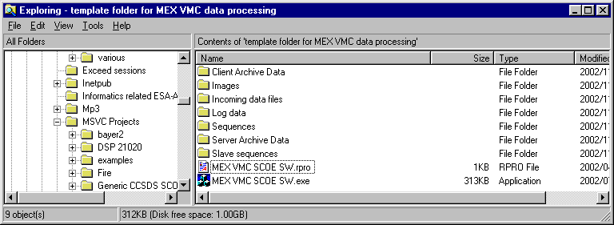

Step 3
Run the MEX VMC SCOE SW.exe executable. It should open a new document named “Document1” by default.
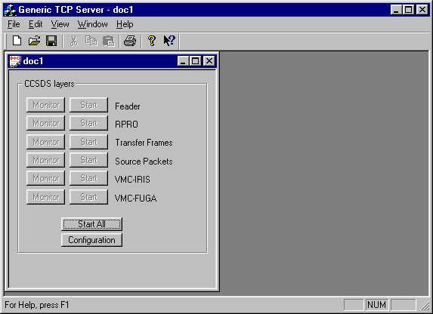

Step 4
Close the “Document1” and open the document “MEX VMC SCOE SW.rpro”:

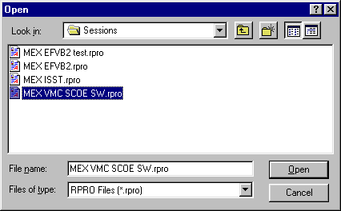

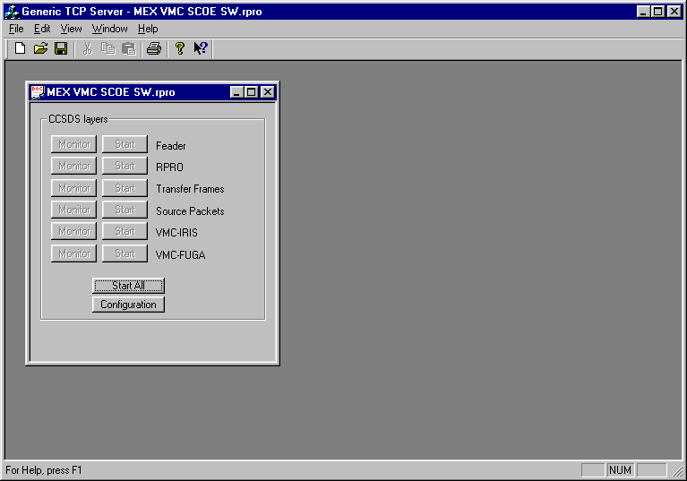

Step 5
Enlarge the document and reduce the size of the application:
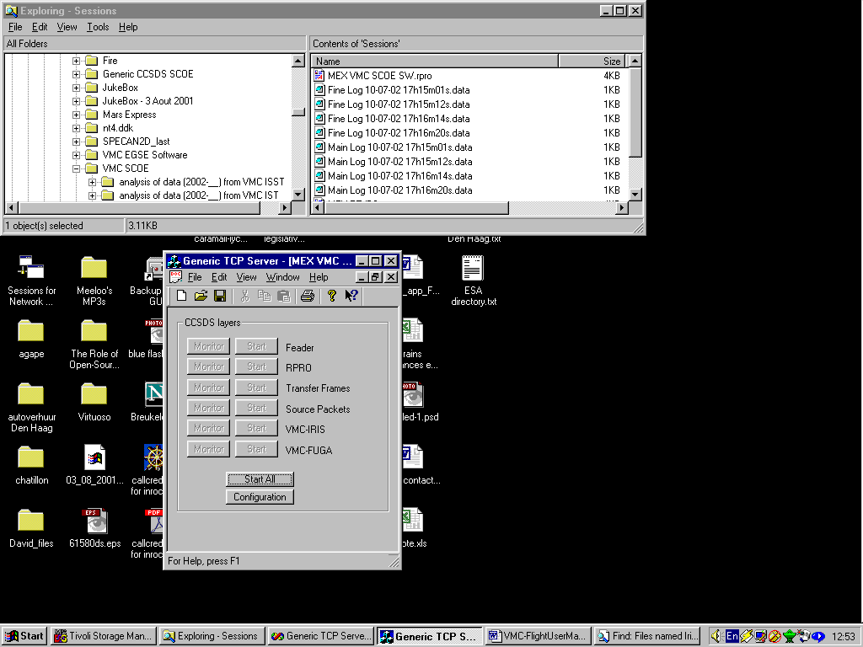

Step 6
Click on to check the configuration of the CCSDS decoder:

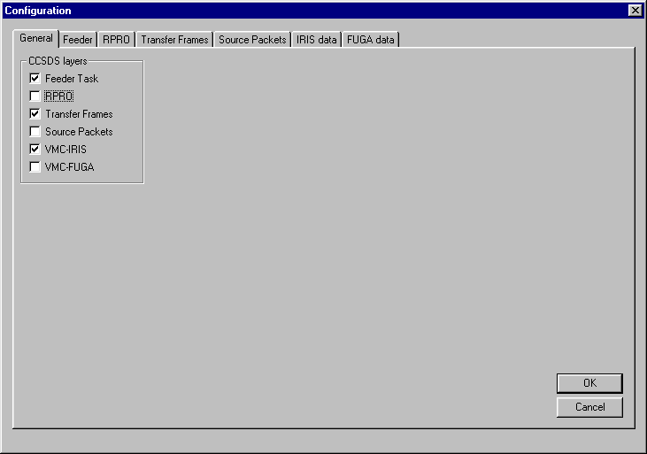

Only Feeder, Transfer Frames and VMC IRIS are selected because these are the decoding layers used to retrieve the content of VMC data from MEX.

Step 7
In the Feeder tab, fill in the box Incoming data file with the path and name of the VMC data file to process. The button allows selecting this file from a location on the hard disk drive.

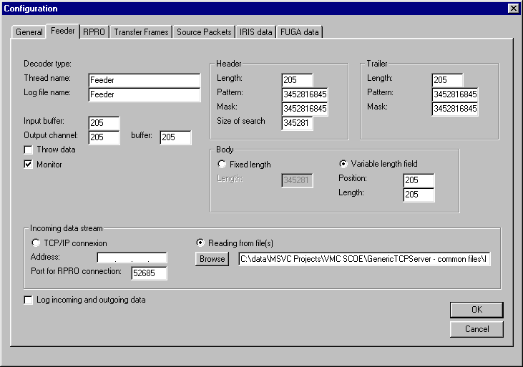

All other tabs should not be modified:

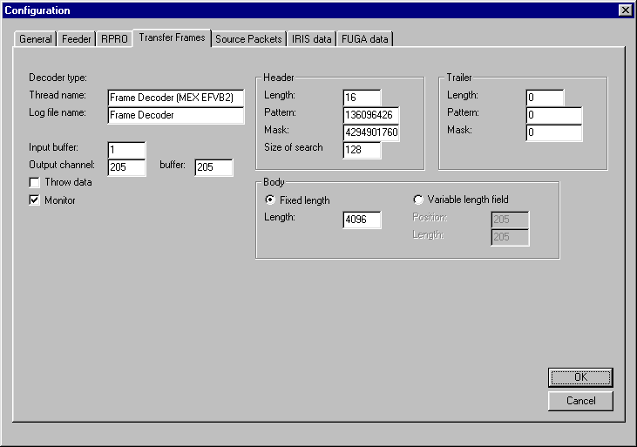

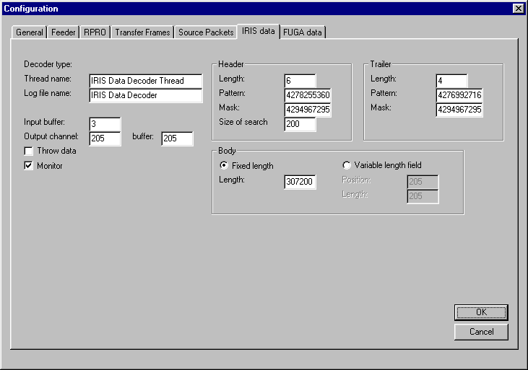

Step 8
Click on OK to load the updated configuration and get back to the main window:

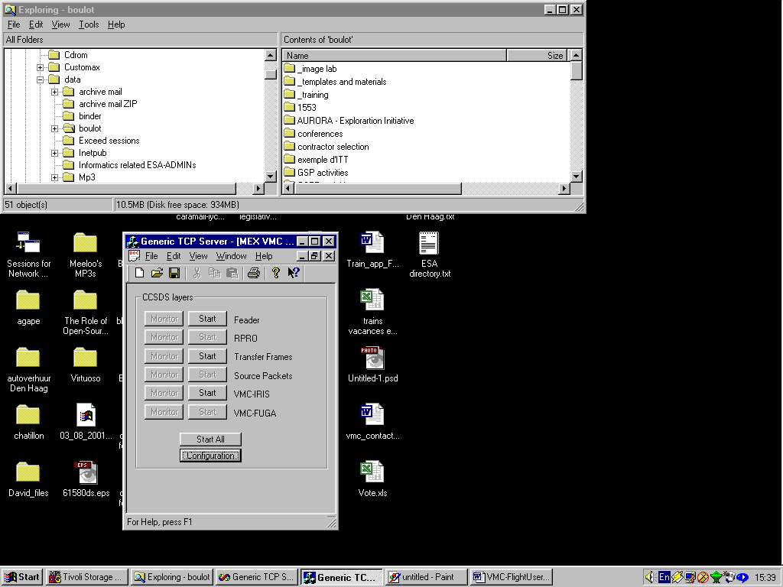

Step 9
Click on to start the decoding:

[screen shot TBA]

The monitor windows for the selected decoding layers appear on the screen:
[screen shot TBA]

The Feeder Monitor indicates the number of bytes read from the input VMC data file and the corresponding data rate.
[screen shot TBA]

The Transfer Frame Monitor shows the number of Frames decoded from the incoming byte stream.
[screen shot TBA]

The VMC IRIS Monitor shows the image being extracted from VMC data and the corresponding VMC health status but also the last complete image and the corresponding VMC health status.
[screen shot TBA]

The complete images are automatically stored in raw format (*.RAW files) in the \Images subfolder.

Step 10
When needed, click on [Stop All] to stop the processing and close all monitor windows:
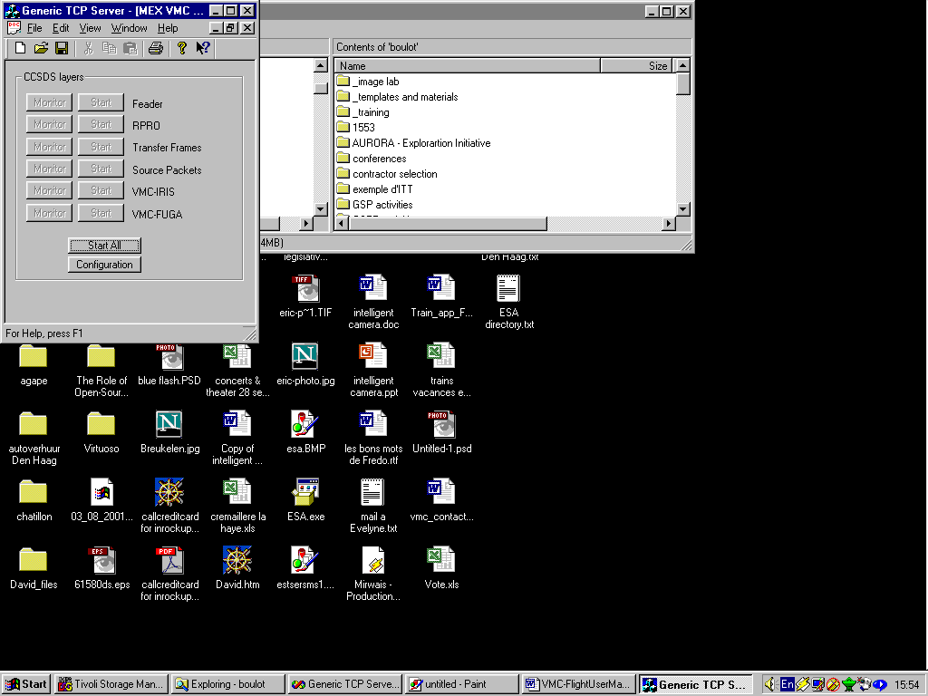

The processing can be resumed by clicking on again.

Step 10
When needed, close the application.

Off-line Image processing
The VMC is based on a linear colour sensor so VMC raw images require colour processing and gamma-correction to produce colour images. In off-line mode this can be performed using the program IrisCol.exe.

Step 1
Open a command line window and get to the subfolder \Images:

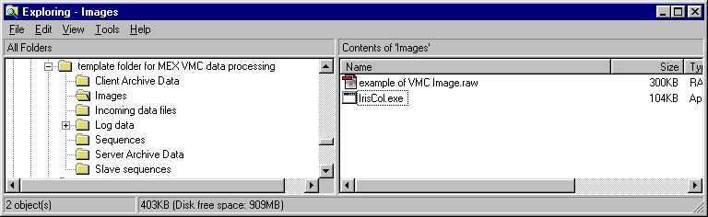

Step 2
From the command line window, run the command
IrisCol “name of the raw image file”

Note that the name of the raw file to post-process should not contain the file extension “.RAW”

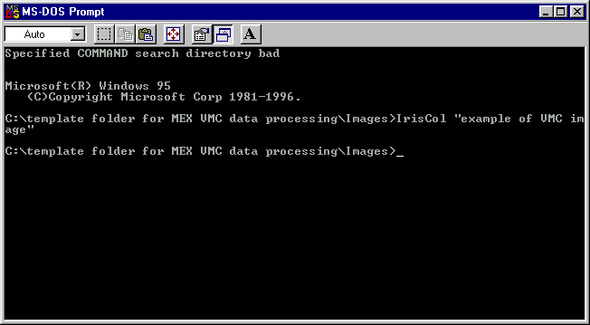

When the prompt is returned, a bitmap file (*.BMP) has been created with the same name:
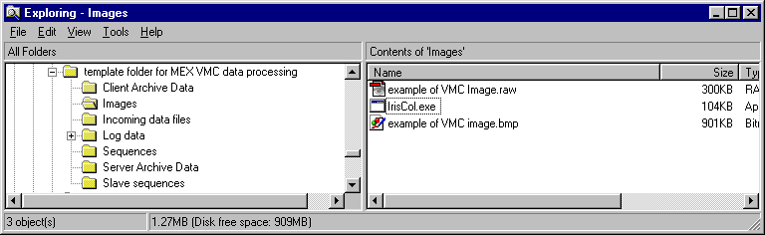

Appendix A: mechanical layout
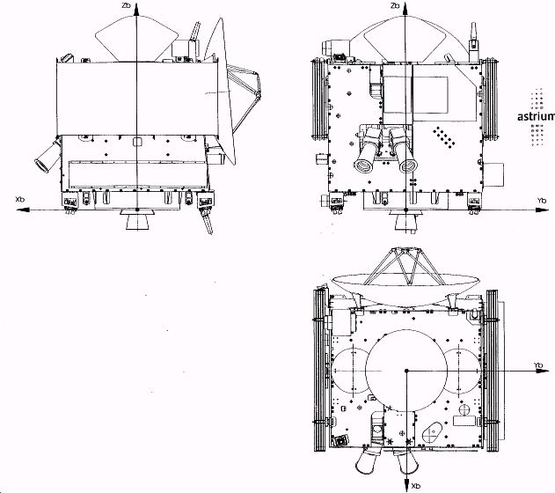
Beagle 2
VMC Field of view before B2 ejection
FOV = 30º
Inclination of axis = 19º
FOV = 40º

APPENDIX B: TRANSFER FRAMES AND VMC DATA FIELD LAY-OUT

Transfer Frames and VMC data field Lay-out

Octet nr. | nr of  bits | Content |  | Comment
Octet nr. | nr of  bits | Content | hex
0 | 2 | Version nr. | 00 | Fixed
0 | 6 | Spacecraft ID | 03 | Spacecraft ID  = MEX=037H
1 | 4 | Spacecraft ID | 7 | Spacecraft ID  = MEX=037H
1 | 3 | Virtual Channel ID | 3 | Variable
1 | 1 | Ops Ctrl Field flag | 1 | Fixed
2 |  | Master Channel Frame Counter | Nn | Counting
3 |  | Virtual Channel Frame Counter | Nn | Counting
4 |  | Frame data field status | 9F | Fixed
5 |  | Frame data field status | FF | Fixed
6 |  | Secondary Header ID | 03 | Fixed
7 |  | Secondary Header data | 00 | 24 additional bits of VC frame counter
8 |  | Secondary Header data | 00 | 24 additional bits of VC frame counter
9 |  | Secondary Header data | 01 | 24 additional bits of VC frame counter
10 |  | Data Field | data | 4096 octets of payload data
11 |  | Data Field | data | 4096 octets of payload data
12 |  | Data Field | data | 4096 octets of payload data
13 |  | Data Field | data | 4096 octets of payload data
14 |  | Data Field | data | 4096 octets of payload data
15 |  | Data Field | data | 4096 octets of payload data
--- |  | --- | data | 4096 octets of payload data
4105 |  | Data Field | data | 4096 octets of payload data
4106 |  | OCF | nn | 4 octets of Operational Control Field
--- |  | --- | --- | 4 octets of Operational Control Field
4109 |  | OCF | nn | 4 octets of Operational Control Field
4110 |  | Frame Error Control Field | nn | 2 octets
4111 |  | Frame Error Control Field | nn | 2 octets

Transfer Frame length is constant = 4112 octets.

Data Field Lay-out for VMC image data

Octet nr. | nr of  bits | Content |  | Comment
Octet nr. | nr of  bits | Content | hex
0 | 8 | Sync Marker | FF
1 | 8 | Sync Marker | 00
2 | 8 | Sync Marker | FF
3 | 8 | Sync Marker | 00
4 | 8 | Image ID | 00 - FF | 1 - 255
5 | 5 | spare | 2
5 | 2 | Timeout status | 3 | 00 = operational  01 = timeout but operational  10 = timeout and interface non-operational
5 | 1 | System status | 0 or 1 | 0 = Latch-up and 1 = OK
6 | 8 | Pixel value | 00 - FF | Pixel value is from 1 - 255
7 | 8 | Pixel value | 00 - FF | Unsigned integer
8 | 8 | Pixel value | 00 - FF | 255 = full white
 | 8
N-3 | 8 | End marker | FE
N-2 | 8 | End marker | ED
N-1 | 8 | End marker | BA
N | 8 | End marker | CC
N+1 | 8 | Sync Marker | FF | Sync header of next image
N+2 |  | Etc. | data

APPENDIX C: VMC circuit schematics.

