Author: | M. Delva, W. Zambelli
 | IWF Graz
 | Schmiedlstrasse 6
 | A-8042 Graz
Phone: | +43(316)4120-553
Fax: | +43(316)4120-590
e-mail: | magda,delva@oeaw.ac.at

VEX-MAG
IWF – INTERNAL
Science Data Processing
Description

Issue 1 Rev. 3
05 February 2009

CHANGE RECORD

Issue | Rev. | Date | Changed Para. | Remarks
1 | 0 | 11.10.2005 | All
1 | 1 | 07.06.2006 | Par 4, 5 added | Description of Data Calibration SW  V0 and V1
1 | 2 | April 2008 | Par 6, 7 added | Description of Data Calibration SW  V2 and V3
1 | 3 | Feb. 2009 | "Purpose of this document" added, p.2  In Fig. 1.2.1 CODMAC levels indicated | Relation to ESA archive CODMAC data-levels explained

PURPOSE OF THIS DOCUMENT
The purpose of this document is to describe the IWF - INTERNAL data processing pipeline of the RAW SENSOR data as received from the spacecraft, to a set of SCIENCE data which is corrected for KNOWN SENSOR EFFECTS, and called herein "calibrated" for internal reasons.

RELATION TO ESA ARCHIVE CODMAC DATA LEVEL DEFINITIONS
The outcome of the procedures "Science data Calibration" performed here leads to an IWF - INTERNAL set of ASCII files, containing a header which describes the processing done on the data, and the data itself.
The status of this IWF – INTERNAL science data-set in SC coordinates, before the removal of the SC field effects, is equivalent to the ESA archive data level CODMAC 2; only the format is different. It is the DIRECT SOURCE for the ESA archive CODMAC level 2 data-set.
The relationship to CODMAC levels is illustrated in Fig. 1.2.1

TABLE OF CONTENTS

1 Introduction 5
1.1 Overview 5
1.2 Flow Diagram 5
2 Data Processing 6
2.1 File Name Generation 6
3 VEX - MAG Science Data Transformation 7
3.1 Raw to ASCII 7
3.1.1 Input Files (in binary) 7
3.1.2 File Creation 7
3.1.3 On Board Time (OBT) Format 7
3.1.4 Output Files (in ASCII) 8
3.2 Calibration and Transformation into S/C coordinates 10
3.2.1 Input Files (in ASCII, Sensor Coordinates and OBT from T0) 10
3.2.2 File Linking to one File per Sensor, per DataRate, per Orbit 10
3.2.3 Offset Correction 10
3.2.4 Alignment Correction 10
3.2.5 Transformation into S/C Coordinates 10
3.2.6 Combination of MAGOS and MAGIS data to one file 11
3.2.7 Compute UTC Time 11
3.2.8 Output Files (in ASCII, S/C coordinates and UTC) 11
3.2.9 Header Part of the Calibrated Output File 12
3.3 Correction of S/C – Field – Effects 12
3.4 Transformation to VSO Coordinate System 12
4 Description of Calibration SW V0 (used till May 13 2006) 13
4.1 SCIENCE DATA CALIBRATION V0 13
4.1.1 INPUT DATA 13
4.1.2 Transformation of on board time (OBT) to UTC: 13
4.1.3 Correction for compensation range 13
4.1.4 Correction for orthogonality of the sensors 13
4.1.5 Correction to VEX S/C coordinate system 14
4.1.6 OUTPUT DATA 14
4.2 HOUSEKEEPING DATA: 14
5 Description of Calibration SW V1 (in use from May 14 2006) 15
5.1 SCIENCE DATA CALIBRATION V1 15
5.1.1 General differences from V0 to V1 15
5.1.2 Correction for MISALIGNMENT of the sensors 15
5.1.3 Correction for saturation effects/change of compensation range 15
5.1.4 Correction for filter effects 16
5.1.5 OUTPUT DATA files 16
5.1.6 APPLICATION to dataset 16
6 Description of Calibration SW V2 (in use from 24 Jan 2007) 17
6.1 SCIENCE DATA CALIBRATION V2 17
6.1.1 General differences from V1 to V2 17
6.1.2 OUTPUT DATA files 17
6.1.3 APPLICATION to dataset 17
7 Description of Calibration SW V3 (in use from 11 Sept 2007) 18
7.1 SCIENCE DATA CALIBRATION V3 18
7.1.1 Necessity of correction to V2: Problem in timing: 18
7.1.2 Time-difference within MAG data-sets: 19
7.1.3 General differences from V2 to V3 21
7.1.4 OUTPUT DATA files 21
7.1.5 APPLICATION to dataset 21

Introduction

Overview
The task of the “Science Data Processing” process is to transform the binary science and the HK data from the sensor coordinate system into the PDS format in Venus Orbit Coordination System (VSO).

a) The science data of the MAG instrument is transmitted to ground using the following two APIDs:
- 1644: MAGOS Science (binary in Sensor coordinates)
- 1660: MAGIS Science (binary in Sensor coordinates)

b) For the HK information the following 3 APIDs are reserved:
- 1620: DPU HK (binary)
- 1636: MAGOS HK (binary)
- 1652: MAGIS HK(binary)

- The time information is given in the Time Correlation Packets, which can be downloaded from the DDS server.

- The Mission Phase information (Commissioning / Orbit number) TBD.

Concerning the science data processing task only the temperature information from the MAGOS HK and the MAGIS HK are relevant.

Flow Diagram
For the transformation of the raw data into VSO data several transformation steps must be performed.

~ CODMAC level 2
~ CODMAC level 3

Fig. 1.2-1 Data Processing flow diagram and relation to ESA archiving CODMAC data-levels

Data Processing

File Name Generation

The Filename is composed of the Sensor, the DataRate, the Mode, the DataLevel and the Time Information.

Very important Notes:
- The “RAW to ASCII” software packet uses the S/C Event Time (SCET) of the first vector to generate the file names.
- The output files of the “Calibration and Transformation” software packet uses the measurement time in UTC of the first vector.

FileName: Bs_CCYY-MM-DDTHH-MM-SS-sss_Mc_Dn_i_l.dat

CCYYMMDD assigns the date
HHMMSSsss assigns the time (milli sec. resolution)
s assigns sensor (OS / IS)
c assigns Mode (ST / C1 / C2 / C3 / C4 / C5 / HK)
n assigns DataRate (001Hz, 002Hz, 032Hz, 064Hz, 128Hz)
I assigns counter (1 digit) (if a new file has to be generated within the same transmission frame)
l assigns DataLevel

Note: only capitals and numbers are allowed in the file name.

Example for science file name:
BOS_2005-10-11T22-12-45-788_MST_D032_2_RAW.dat

Example for HK file name:
BOS_2005-10-11T22-12-45-788_MHK_D032_0_RAW.dat

VEX - MAG Science Data Transformation

Raw to ASCII
The conversion from the binary raw file to the ASCII raw file is performed by the SW packet “VEX MAG PacketValidator” (written by Gerhard Berghofer).

Input Files (in binary)
- MAGOS HK (1636.dat, in binary)
- MAGIS HK (1652.dat, in binary)
- MAGOS Science (1644.dat, in binary)
- MAGIS Science (1660.dat, in binary)

File Creation
The file name generator uses the S/C Event Time (SCET in UTC). The SCET is afterwards not used anymore and therefore not content of the output files. All internal time applications use the measurement time within the MAG telemetry packets.

A new science file is generated if
- a Mode change occurred
- a Range change occurred
- a DataRate change occurred
- the time interval between two science packets is not within a certain limit (manually adjustable)
There are only two HK files for each orbit; one for MAGOS and one for MAGIS. The generation interval of the HK packets has to be estimated by the S/C clock OBT time stamps.

On Board Time (OBT) Format
The format of the time stamp within the MAG TM packets is a 32 bit (unsigned) binary second counter (coarse time) and a 16 bit (unsigned) binary Tic counter (fine time). The Tic counter counts not in milliseconds but in 1 / 65535 [s].

Fig. 3.1-2 Time Format of the MAG OBT.

The Time Stamp Format within the ASCII Raw files is given in DDDD-HH:MM:SS.ttttt
DDDD number of days (4 digits)
HH hour (2 digits)
MM minute of the day (2 digits)
SS second of the day (2 digits)
ttttt Tics (5 digits) (counter from 0…65535)

Output Files (in ASCII)
- MAGOS HK (in ASCII)
- MAGIS HK (in ASCII)
- MAGOS Science (in ASCII)
- MAGIS Science (in ASCII)

NOTE: The number of science output files depends from the number of Mode changes; Range change, DataRate changes and the gap between the time stamps of the vectors (see 3.1.2). For one Venus orbit there are at least 5 science output files for each sensor foreseen. (1Hz, 32Hz, 128Hz, 32Hz, 1Hz). Please not that there can be more output files and that the number of files can be different for each sensor.

Science File
The science file contains the “Header” part and the “Science Data” part.

a) Header Part
#File = Name
#Sensor= OS / IS
#Mode = Std / Cal1 / Cal2 / Cal3 / Cal4 / Cal5 / HK
#DataRate = 1Hz / 2Hz / 32Hz / 64Hz /128Hz
#Range = 32nT / 64nT / 128nT / 256nT / 512nT/ 1024nT /…/ 8192nT
#MissionPhase = Com1 / Com2 / Orbit 1 / Orbit 2 / ….
#CoordinateSystem = SensorCoordinates / SCCoordinates / VSOCoordinates
#DataLevel = RAW
#CompensationBx = xxxx nT
#CompensationBy = xxxx nT
#CompensationBz = xxxx nT
#StartTime = DDDD-HH:MM:SS.ttttt (S/C clock OBT from T0)
#StopTime = DDDD-HH:MM:SS.ttttt (S/C clock OBT from T0)
#TimeInterval = DDDD-HH:MM:SS. ttttt (StopTime-StartTime)
#DataLines = xxxxxx
#FirstFrameTime = CCYY-MM-DDTHH:MM:SS.ssssss (SCET of first TM Packet )
#LastFrameTime = CCYY-MM-DDTHH:MM:SS.ssssss (SCET of last TM Packet)
#Columns: OBT Bx By Bz

b) Science Data Part
1. column: Time string (OBT) (DDDD-HH:MM:SS.ttttt)
2. column: Bx (x.ppp)
3. column: By (x.ppp)
4. column: Bz (x.ppp)

HK File
The HK file contains the “Header” part and the “HK Data” part.

a) Header Part
#File = Name
#Sensor= OS / IS
#Mode = Std / Cal1 / Cal2 / Cal3 / Cal4 / Cal5 / HK
#DataRate = 1Hz / 2Hz / 32Hz / 64Hz /128Hz
#Range = 32nT / 64nT / 128nT / 256nT / 512nT/ 1024nT /…/ 8192nT
#MissionPhase = Commisioning1 / Commisioning2 / Orbit 1 / Orbit 2 / ….
#DataLevel = RAW
#StartTime = DDDD-HH:MM:SS.ttttt (S/C clock OBT from T0)
#StopTime = DDDD-HH:MM:SS.ttttt (S/C clock OBT from T0)
#TimeInterval = DDDD-HH:MM:SS.ttttt (StopTime-StartTime)
#DataLines = xxxxxx
#FirstFrameTime = CCYY-MM-DDTHH:MM:SS.ssssss (SCET of first TM Packet)
#LastFrameTime = CCYY-MM-DDTHH:MM:SS.ssssss (SCET of last TM Packet)
#Columns: OBT Temp1 Temp2 Temp E +5Vd +8Vd +8Va -8Va

b) HK Data:
1. column: Time string (OBT) (DDDD-HH:MM:SS.ttttt)
2. column: Sensor Temp. 1 (xxx.pp)
3. column: Sensor Temp. 2 (xxx.pp)
4. column: Sensor Electronic Temp (xxx.pp)
5.column: +5V Digital (x.pp)
6.column: +8V Digital (x.pp)
7.column: +8V Analog (x.pp)
8.column: -8V Analog (x.pp)

Calibration and Transformation into S/C coordinates

Input Files (in ASCII, Sensor Coordinates and OBT from T0)
- MAGOS HK (ASCII)
- MAGIS HK (ASCII)
- MAGOS Science (ASCII, in Sensor coordinates)
- MAGIS Science (ASCII, in Sensor coordinates)
- Time correlation Packets (download from DDS Server)
- Mission Phase Information (TBD)

File Linking to one File per Sensor, per DataRate, per Orbit
In this procedure all science data input files of the same sensor and the same DataRate of one orbit are linked together. Also the temperature information from the HK files is linked to this science data.

Offset Correction
The offset correction is done by subtracting the offset vector from each collected science vector. This offset is caused by the sensor itself and by the sensor electronic. The offset correction is done separately for each sensor.

The default offset vector is set to O = (0; 0; 0)

Alignment Correction
The alignment correction is the transformation of the science data from the non orthogonal sensor coordinate system to an orthogonal coordinate system. To transform the science data into an orthogonal system each vector has to be multiplied by the Alignment Rotation Matrix. This correction is done separately for each sensor.

The default Alignment Rotation Matrix is set to$A=\left(\begin{matrix}1 & 0 & 0 \\ 0 & 1 & 0 \\ 0 & 0 & 1\end{matrix}\right)$

Transformation into S/C Coordinates
It is important that the data of both sensors has the same direction. To satisfy this requirement the data of both sensors is transformed into the S/C coordinate system. Each vector has to be multiplied by the S/C Coordinates Rotation Matrix. This transformation is done separately for each sensor.
The default Alignment Rotation Matrix is set to$B=\left(\begin{matrix}1 & 0 & 0 \\ 0 & 1 & 0 \\ 0 & 0 & 1\end{matrix}\right)$

Combination of MAGOS and MAGIS data to one file
Here the science data of one orbit and of the same DataRate of MAGOS and MAGIS are combined together.

Compute UTC Time
In this procedure the time stamp of the science frames in transformed into a UTC time using the “Time correlation Packets”.
The Output Format is CCYY-MM-DDTHH:MM:SS.sss

CC century (2 digits)
YY year (2 digits)
MM month (2 digits)
DD day (2 digits)
HH hour (2 digits)
MM minute of the day (2 digits)
SS second of the day (2 digits)
sss milliseconds (3 digits)

Output Files (in ASCII, S/C coordinates and UTC)
There is one file per mode, per orbit containg the calibrated data of both sensors.

- Science 1Hz (ASCII, in S/C coordinates and UTC)
- Science 2Hz (ASCII, in S/C coordinates and UTC)
- Science 32Hz (ASCII, in S/C coordinates and UTC)
- Science 64Hz (ASCII, in S/C coordinates and UTC)
- Science 128Hz (ASCII, in S/C coordinates and UTC)

Each science file contains the calibrated science data in S/C coordinates of MAGOS and MAGIS. Also the temperature of both sensors is given in these files.

Header Part of the Calibrated Output File
#File = Name
#Sensor = MAGOS and MAGIS
#Mode = Std / Cal1 / Cal2 / Cal3 / Cal4 / Cal5 / HK
#DataRate = 1Hz / 2Hz / 32Hz / 64Hz /128Hz
#Range = 32nT / 64nT / 128nT / 256nT / 512nT/ 1024nT /…/ 8192nT
#MissionPhase = Com1 / Com2 / Orbit 1 / Orbit 2 / ….
#CoordinateSystem = SCCoordinates
#DataLevel = Calibrated
#StartTime (UTC) = CCYY-MM-DDTHH:MM:SS.sss
#StopTime (UTC) = CCYY-MM-DDTHH:MM:SS.sss
#TimeInterval = DDDDTHH:MM:SS.sss (StopTime-StartTime)
#DataLines = xxxxxx
#FirstFrameTime = CCYY-MM-DDTHH:MM:SS.ssssss (SCET of first TM Packet)
#LastFrameTime = CCYY-MM-DDTHH:MM:SS.ssssss (SCET of last TM Packet)
#Columns: UTC B_{x/OS} B_{y/OS} B_{z/OS} B_{T/OS} B_{x/IS} B_{y/IS} B_{z/IS} B_{T/IS} Temp_{OS} Temp_{IS}

Science Part of the Calibrated Oputput File
1. column: Time string (UTC) (CCYY-MM-DDTHH:MM:SS.sss)
2. column: B_{x / OS} (x.ppp) [nT]
3. column: B_{y / OS} (x.ppp) [nT]
4. column: B_{z / OS} (x.ppp) [nT]
5. column: B_{T / OS} (x.ppp) [nT]
6. column: B_{x / IS} (x.ppp) [nT]
7. column: B_{y / IS} (x.ppp) [nT]
8. column: B_{z / IS} (x.ppp) [nT]
9. column: B_{T / IS} (x.ppp) [nT]
10 column: Temp_{OS} (x.ppp) [°C]
11. column: Temp_{IS} (x.ppp) [°C]

Correction of S/C – Field – Effects
This task will be performed by our colleges from slowakia.

Transformation to VSO Coordinate System
To transform the corrected science data into the VSO coordinate system the attitude and position files of the S/C are necessary.
TBD.

Description of Calibration SW V0 (used till May 13 2006)
The SW –package V0 corrects for the following effects in the data:

SCIENCE DATA CALIBRATION V0

INPUT DATA
The Calibration SW uses the RAWASCII files for the SCIENCE data and for the housekeeping data.

Transformation of on board time (OBT) to UTC:
This is done using the SPICE SCLK-files from

JPL/NAIF-server:
naif.jpl.nasa.gov
username: anonymous
passwd: anonymous
remote dir: /pub/naif/VEX/kernels/sc

Get the latest file with filetype= VEX_060515_STEP.TSC
Here, “060515” is the data of issue of the file; be sure to always use the LATEST file-version!!

Correction for compensation range
The values of the compensation are added to the values on the raw files.

Correction for orthogonality of the sensors
The correction for orthogonality is done INDEPENDENT from the sensor-temperature
-> DEFAULT CALIBRATION.

The following matrices are applied to the vector-components.
From

Doc. Title: VEX-MAG FM Instrument Calibration Issue: 1
Doc. Ref. : VE-MAG-TR-0029 Rev. : 1
Date : 19.10.05 Page : 6

%------------------------------------------------
Matrix_OS_ortho_row1 = [ 1 0 0 ];
Matrix_OS_ortho_row2 = [ -0.00369 1 0 ];
Matrix_OS_ortho_row3 = [-0.00109 0.00259 1 ];
%
Matrix_IS_ortho_row1 = [ 1 0 0 ];
Matrix_IS_ortho_row2 = [ 0.00778 1 0 ];
Matrix_IS_ortho_row3 = [-0.00372 0.00384 1 ];

The elements of the mis-alignment matrices above correspond with the following mis-alignment angles within the sensors:

Axis | ma angles [°] | delta90° [°]
OS-YX | 89.79 | -0.21
OS-ZX | 89.94 | -0.06
OS-ZY | 90.15 | 0.15
IS-YX | 90.45 | 0.45
IS-ZX | 89.79 | -0.21
IS-ZY | 90.22 | 0.22
Tab. 4-1 Mis-alignment angles
%------------------------------------------------------------

Correction to VEX S/C coordinate system
MAGIS is always MASTER, MAGOS is always SLAVE.

- MAGIS is aligned with the VEX S/C coordiante system
- MAGOS:
- Before boom deploýment, MAGOS is not aligend to the VEX S/C coordinate system:
boomdeployment time: UTC
Deploy_time = 2005-11-18T17-07

the following matrix transformation is applied on the MAGOS data:

Matrix_OS2IS_row1 = 0.041876 0 -0.999123
Matrix_OS2IS_row2 = 0 1 0
Matrix_OS2IS_row3 = 0.999123 0 0.041876

- After boom-deployment time, the MAGOS data are in VEX S/C cosys and
NO correction is performed.

OUTPUT DATA
Calibrated files are generated, default is one file per day of year or per orbit (for the S/C in the final orbit)

HOUSEKEEPING DATA:
For the housekeeping data, only the times are transformed from OBT to UTC.

The RAW HK files are attached to each other, to build: default one file per day of year or per orbit (for the S/C in the final orbit)
Only the OBT is transformed to UTC.

Description of Calibration SW V1 (in use from May 14 2006)

SCIENCE DATA CALIBRATION V1

General differences from V0 to V1
The V1 version corrects for ALL the SENSOR ARTEFACTS in the data, known until 1 June 2006 by the VEX-MAG team.

The science Science Data Calibration V1 is different from V0 in the following points:

  - The orthogonality-correction was done WRONGLY in V0 due to a SW error;
however, the orthogonality matrices are correct.
V1 now does the transformation in a correct way!!

  - Correction for MISALIGNMENT of the sensors is applied

  - Correction for saturation effects in the data is applied (data are flagged)

  - Correction for filter effects in the data is applied (data are skipped)

Correction for MISALIGNMENT of the sensors

MAGIS is the master, MAGOS is the slave:

% MATRIX for ALIGNING OS to IS Sensorcosystem
%----------------------------------------------------
% rotate OS about Zos back to Xis over angle alfa

Align_OS2IS_row1 = 1.0 0.028 0.0
Align_OS2IS_row2 = -0.028 1.0 0.0
Align_OS2IS_row3 = 0.0 0.0 1.0

Correction for saturation effects/change of compensation range
Automatic change of the compensation range occurs only, if a minimum number of subsequent vector components are in saturation:
The saturated data-values are detected BEFORE the compensation range correction is performed.

Saturation treshold value: 520 nT; larger components are FLAGGED.

For the different datarates, the following number of vectors are required to trigger a change of the compensation range (of at least 4.5 nT)

1Hz: 1*64samples (X=1 full frame)
2Hz: 1*64samples (X=1 full frame)
32Hz: 5*64samples (X=5 full frames)
64Hz: 10*64samples (X=10 full frames)
128 Hz: 20*64samples (X=20 full frames)

The saturated values/blocks are detected automatically and the values are FLAGGED.

Beforer each block of saturated values, a fixed number of vectors is to be flagged additionally, depending on the datarate:

[ 1, 2, 32, 64, 128]; % DATA-rates in Hz
[15, 15, 20, 20, 20]; % nr. of previous samples to be ADDITIONALLY flagged

Correction for filter effects
Filter effects occurr in the data of BOTH sensors at each:
- Change of data-rate at one of the sensors
- Change of compensation range at one of the sensors

The filter effect generates in the first data-sets NON-REAL variations in the data until the filter is in good action
Therefore, at each switch on of the filter, a fixed number of lines is to be skipped in the data:

DEFAULT: 15 data-lines are skipped, (same value for all data – rates)

OUTPUT DATA files
Output calibrated files of V1 now have the version extension:

_1_SCC

The HEADER description in the file contains the line:
#DataLevel = V1-CALIBRATED

APPLICATION to dataset
The Calibration V1 was applied to all data from START of the mission and initial switch-on of MAG:

i.e. for all data after
2005-11-20T00-00-32
till
2007-01-11

Description of Calibration SW V2 (in use from 24 Jan 2007)

SCIENCE DATA CALIBRATION V2

General differences from V1 to V2
The V2 FLAGS more data-lines before and after a saturation block.

Beforer each block of saturated values, a fixed number of vectors is to be flagged additionally, depending on the datarate:

[ 1, 2, 32, 64, 128]; % DATA-rates
[30, 20, 20, 20, 20]; % nr. of previous samples to be ADDITIONALLY flagged

OUTPUT DATA files
Output calibrated files of V2 now have the version extension:

_2_SCC

The HEADER description in the file contains the line:
#DataLevel = V2-CALIBRATED

APPLICATION to dataset
The Calibration V2 was applied to all data from ARRIVAL of the SC at Venus:

i.e. for all data after
2006-04-12T07-56-08
till
2007-09-01

Description of Calibration SW V3 (in use from 11 Sept 2007)

SCIENCE DATA CALIBRATION V3

Necessity of correction to V2: Problem in timing:
A time-delay due to filtering was detected in the V2 calibration (and is existent also in all previous versions):

Problem detected through comparison with ASPERA data:
VEXMAG (1Hz data, 4 sec averaged data) seems to lag ~ 6 secs behind ASPERA-data

Example:
VEXMAG (4 sec averaged data from 1Hz data) lag ~ 6 secs behind ASPERA-data
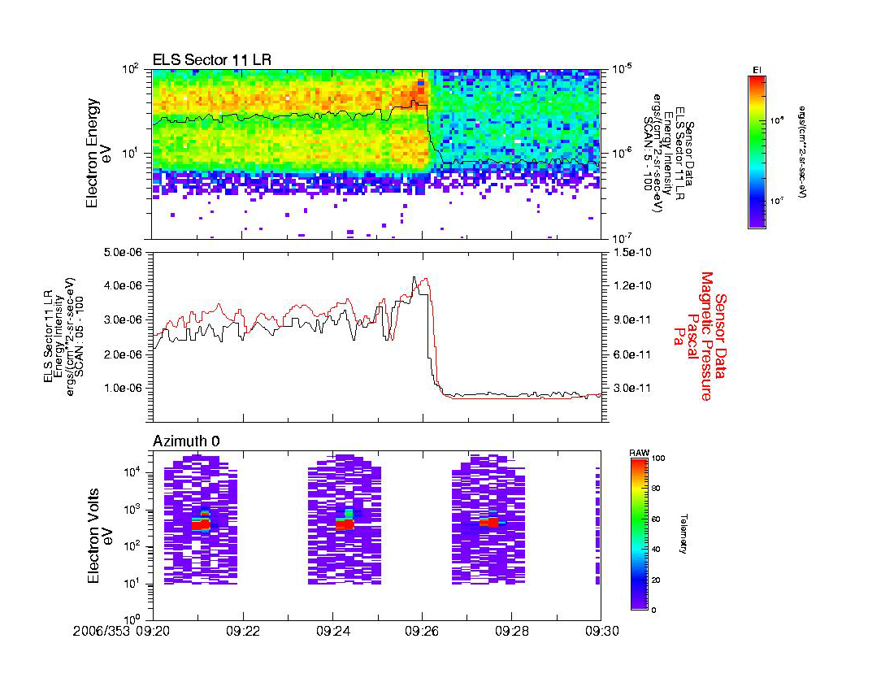
Fig. 1 Timely comparison ASPERA - MAG

Time-difference within MAG data-sets:
MAG Problem:
There is a ~ 6 secs TIME_DIFFERENCE between MAG 32 Hz and MAG 1 Hz data-sets (see example in following figure).

Onboard:
MAG instrument samples normally with 128 Hz:
In normal solar wind mode (22 hrs per orbit) :
ALL data are digitally down-filtered to a 1 Hz data-rate
In 32 Hz data –rate mode (1hr before and after pericenter):
ALL data are digitally down-filtered to a 1 Hz data-rate.
(and also 2 mins of data in 128 HZ around pericenter)

On ground:
To get a FULL orbit with 1 Hz data-rate, we digitally down-filter the 32 Hz data to 1Hz; so for all files with 32 Hz data-rate, we have the same data-set also in 1Hz.

The FIR digital filter used on ground is exactly the same as the one onboard.

The effect of the FIR filtering from 32Hz to 1 Hz causes a specific event in the data-set to be seen after the filtering at a time ~ 6 SECS later in the 1Hz data than in the 32Hz data.

Conclusion:
There is always a CONSTANT ~ 6 secs time-difference between the MAG 32Hz data-set and the MAG 1Hz data-set, due to digital filtering, where the 1Hz data are lagging behind the 32Hz data., see MAG example in Fig. below.

Example: same MAG data-set in 32Hz resp. 1Hz: time-diff ~ 6 secs.
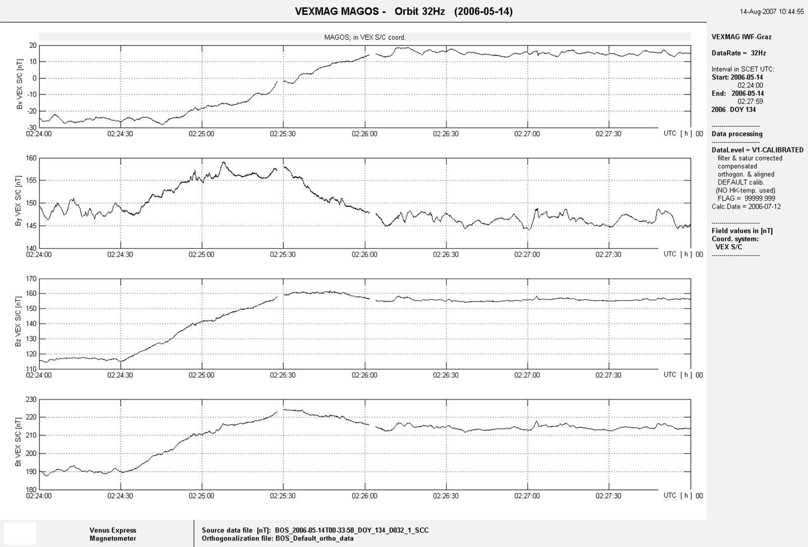
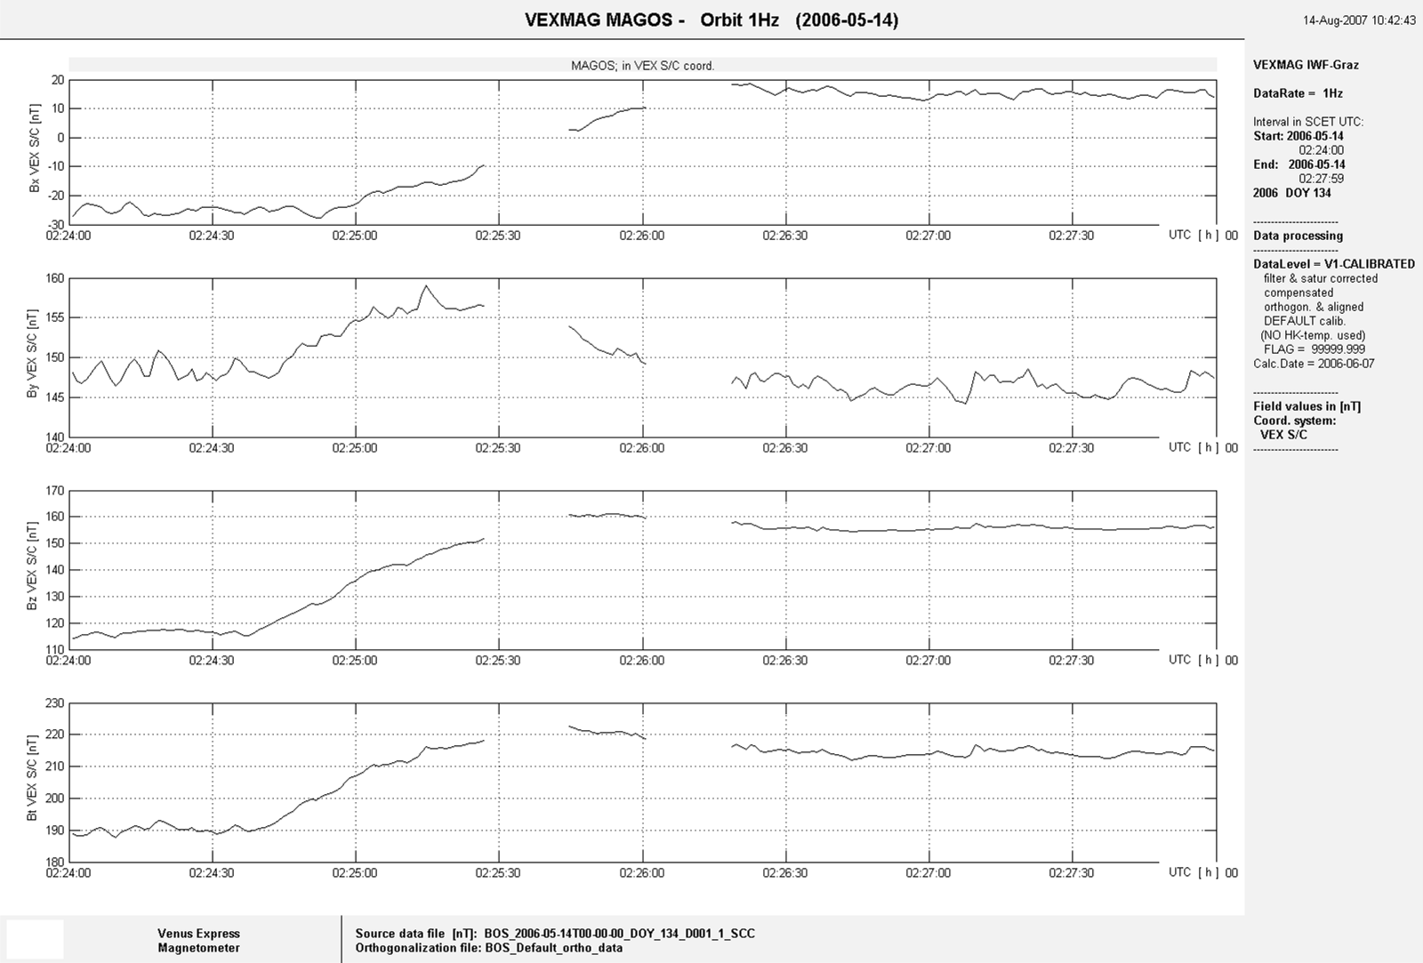
Fig. 2 MAG timely comparison 32Hz data (top 4 panels) to 1 Hz data (lower 4 panels)

General differences from V2 to V3
Time-difference is corrected, i.e. all UTC times in V3 files are diminished by ~ 6 secs.
This results in NEW start times of the daily files and some data-lines being attributed now to the PREVIOUS day.

OUTPUT DATA files
Output calibrated files of V2 now have the version extension:

_3_SCC

The HEADER description in the file contains the line:
#DataLevel = V3-CALIBRATED

APPLICATION to dataset
The Calibration V3 was applied to all data from ARRIVAL of the SC at Venus:

i.e. for all data after
2006-04-12T07-56-08
till present
2008-04-04.

