Mars Express Bistatic Radar Experiment
Operations Plan and Report - Supplement
10 February 2010

This report summarizes calibration results at DSS 14 for the MEX bistatic radar experiment conducted on 2010/041. The DSS 14 S-LCP system temperature anomaly seems to have been cured. But there is a puzzling polarization-dependent modulation of up to 5 dB on the radiated power from the MEX spacecraft.

DSS 14 System Temperature:

X-Band system temperature was higher than normal and more variable. But weather was unsettled, and that may explain the values. During ground pre-calibration, the X-Band Y-factors were about 8.5 dB (Figures 1 and 2); during the post-calibration, they were about 6.5 dB. For comparison, the pre-calibration Y-factors during the last experiment (2009/291) were 12.5 and 11.5 dB for X-RCP and X-LCP, respectively.
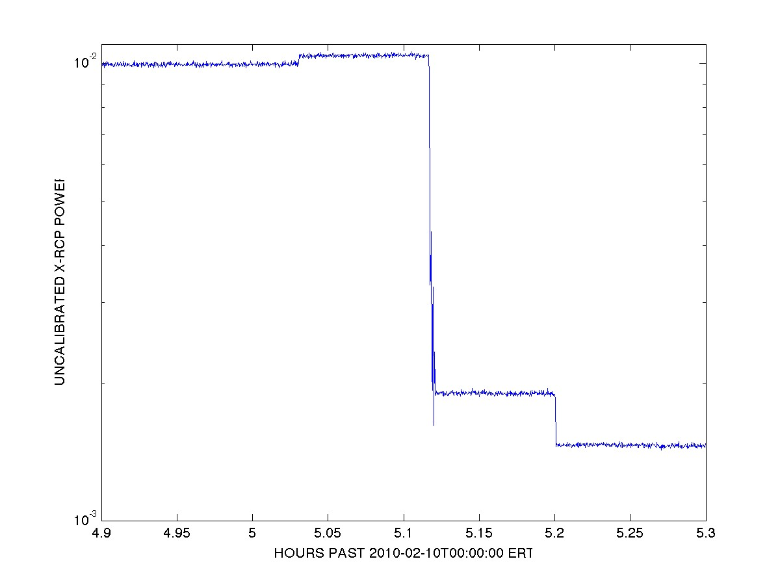

Figure 1. X-RCP pre-calibration power levels. Starting at t=4.90, the receiver was connected to the ambient load. At t=5.03 the 12.5K noise diode was turned on. At t=5.12 the ambient load was disconnected and the receiver was connected to the antenna, which was aimed at zenith. At t=5.20 the noise diode was turned off. Y-factor is the ratio of powers (in dB) in the first and fourth states.

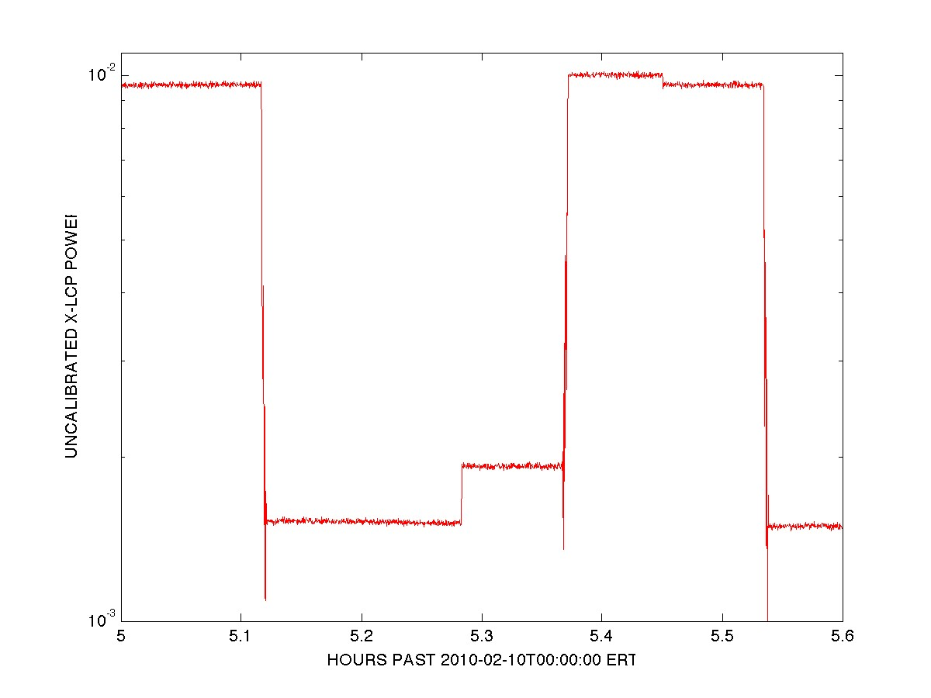
Figure 2. X-LCP pre-calibration power levels. Until t=5.11 the receiver was connected to the ambient load. At t=5.11 the ambient load was disconnected and the receiver was connected to the antenna, which was aimed at cold sky (zenith). At t=5.29 the noise diode was turned on. At t=5.37 the ambient load was reconnected. At t=5.45 the noise diode was turned off. At t=5.54 the ambient load was disconnected and the receiver was reconnected to the antenna (looking at cold sky). Y-factor is the ratio of powers (in dB) in the first and second states (or fifth and sixth states).

Of more concern, was the system temperature for S-LCP, which had been characterized by Y-factors on the order of 4.7 dB for all experiments between 2009/226 and 2009/291. During tests on 2010/021, normal Y-factors were obtained (about 10.5 dB). During the current experiment, S-LCP Y-factors were about 10.5 dB during both the pre-calibration (Figure 3) and post-calibration. The S-LCP problems have apparently been resolved.

S-RCP had behaved normally during the experiments from 2009/226 through 209/291; but the S-RCP maser was inoperative for the experiment on 2010/041 and no S-RCP data were acquired.

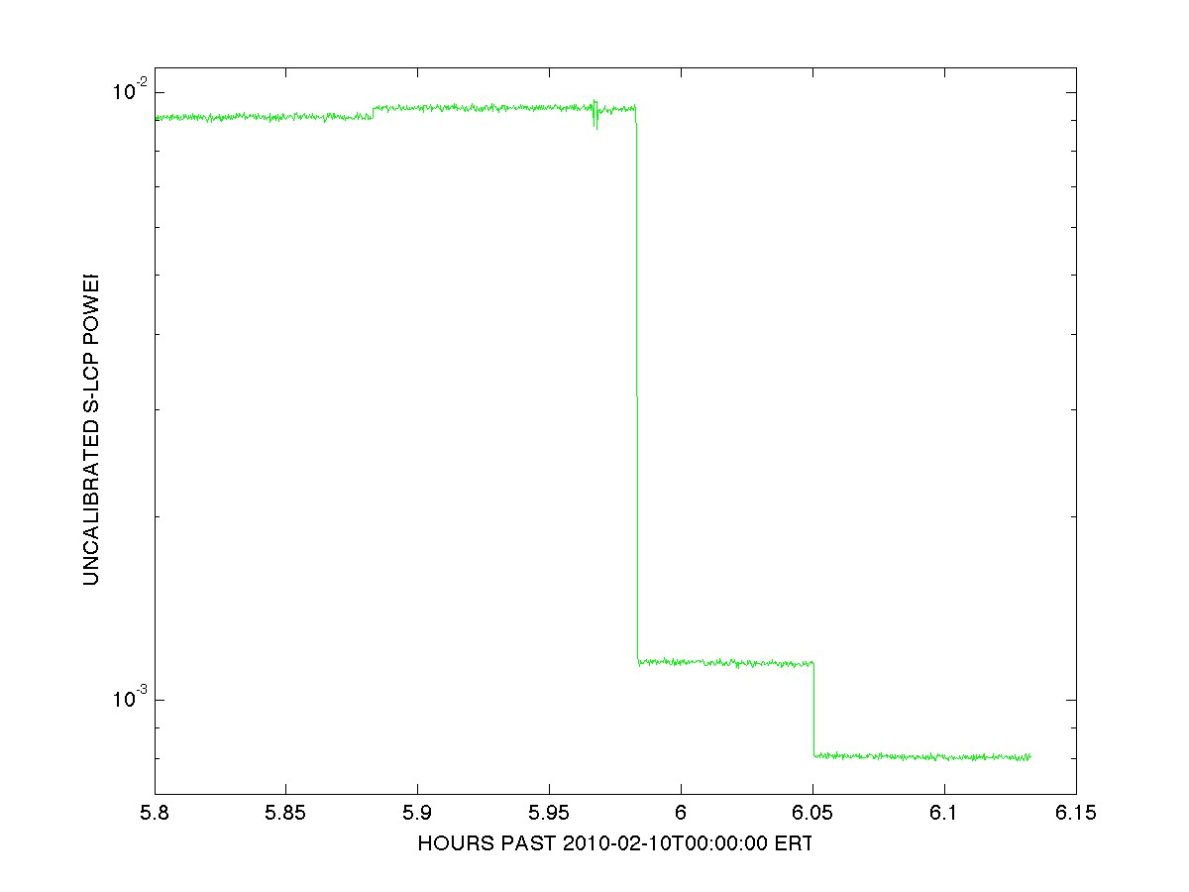
Figure 3. S-LCP pre-calibration power levels. Starting at t=5.80, the receiver was connected to the ambient load. At t=5.88 the 12.5K noise diode was turned on. At t=5.98 the ambient load was disconnected and the receiver was connected to the antenna, which was aimed at zenith. At t=6.05 the noise diode was turned off. Y-factor is the ratio of powers (in dB) in the first and fourth states.

MEX Carrier Modulation:

After the ground pre-calibration had been completed, the DSS 14 antenna was pointed toward Mars and a spacecraft calibration was carried out. At t=6.875 X-Band telemetry and ranging modulation were turned off and carrier power increased about 5 dB (Figure 4).

Approximately once every 85 seconds, there is a drop of 2-5 dB in the X-RCP carrier level -- with reduced power of some amount lasting up to 50 seconds. The drops in X-RCP are matched by increases of up to 2 dB in the X-LCP level. The drops also occurred before modulation was turned off (t=6.851); and the same behavior can be seen in the powers during the post-BSR spacecraft calibration (Figure 5).

The X-LCP carrier power is a measure of imperfect isolation between RCP and LCP in the transmitting and receiving antenna systems. If this phenomenon is caused by fluctuations in spacecraft transmitter output, decreases in X-RCP carrier power should be mimicked by decreases in X-LCP; that is not observed.

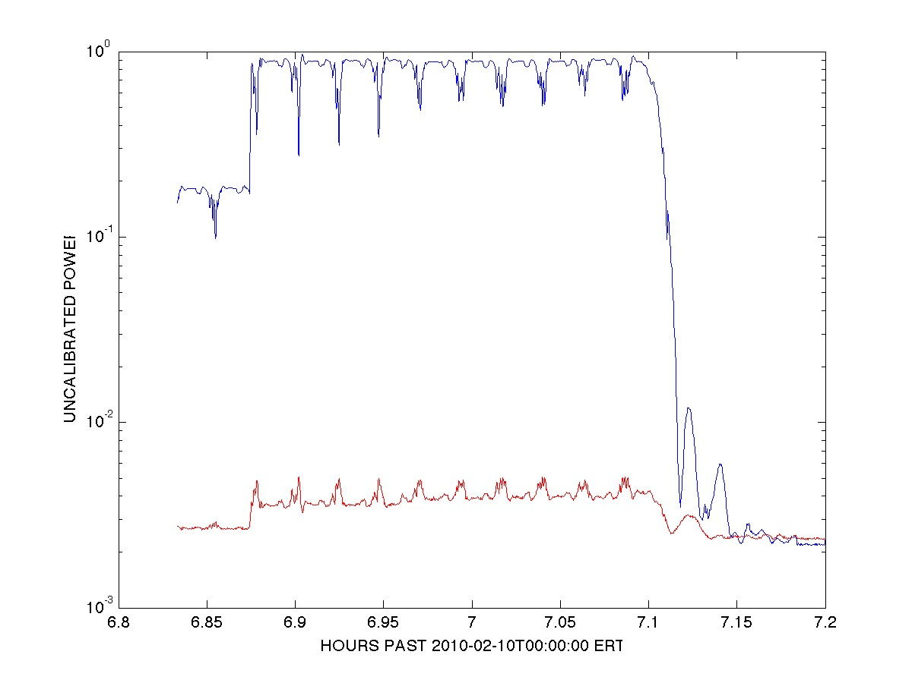
Figure 4. X-Band carrier power during the first (pre-BSR) spacecraft calibration. At t=6.875 telemetry and ranging modulation were turned off. At t=7.1 the spacecraft began to slew toward the initial attitude for surface observations. The upper curve (blue) is X-RCP; the lower curve (red) is X-LCP. The drop-outs in X-RCP and surges in X-LCP are unexplained.

Alternative explanations include the possibility that spacecraft attitude is oscillating. Oscillations which reduce the X-RCP carrier power by 5 dB would mean the HGA pointing is drifting 0.8 degrees to either side of boresight; this should cause 0.6 dB changes in the S-RCP carrier level and might lead to increases in X-LCP radiated power when the HGA was not correctly aimed toward Earth. We see no evidence for increased X-LCP power during the slews to or from the BSR attitude, however (t=7.1 in Figure 4 and t=8.82 in Figure 5).

Another possibility is that a switch in the X-Band microwave path is malfunctioning with a period of 85 seconds and letting X-LCP be radiated. We are not aware of any designed X-LCP radiation capability on MEX, however.
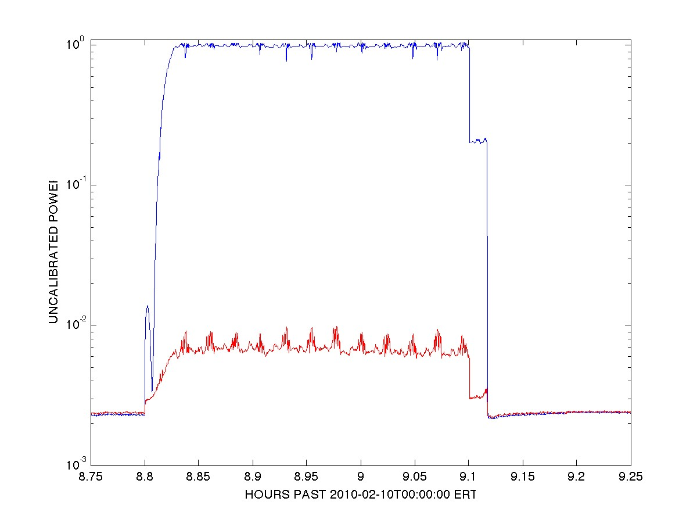
Figure 5. X-Band carrier power during the second (post-BSR) spacecraft calibration. By t=8.83 the spacecraft antenna had slewed back to Earth point. At t=9.1 telemetry and ranging modulation were turned on. At t=9.11 spacecraft tracking ended and the ground antenna was moved to zenith. The upper curve (blue) is X-RCP; the lower curve (red) is X-LCP. The drop-outs in X-RCP and surges in X-LCP are unexplained. Note that the X-RCP analog-to-digital converter reached saturation during this calibration and the strongest signals were slightly clipped.

For additional interest we also show measurements of echo power during the surface observations (Figure 6). As expected, both X-RCP and X-LCP show drops in power every 85 seconds since the surface echoes are produced by X-RCP (only) illumination.

Conclusions:

The S-LCP system temperature anomaly that plagued DSS 14 observations from 2009/226 through 2009/291 seems to have been corrected (Y-factor ~4.7 dB). The S-LCP Y-factor for these observations was about 10.5 dB, which is in the expected range.

X-Band Y-factors were about 8.5 dB during the pre-calibration and 6.5 dB during the post-calibration. These are much worse than the 12 dB normally expected; but weather may have been a factor at X-Band.

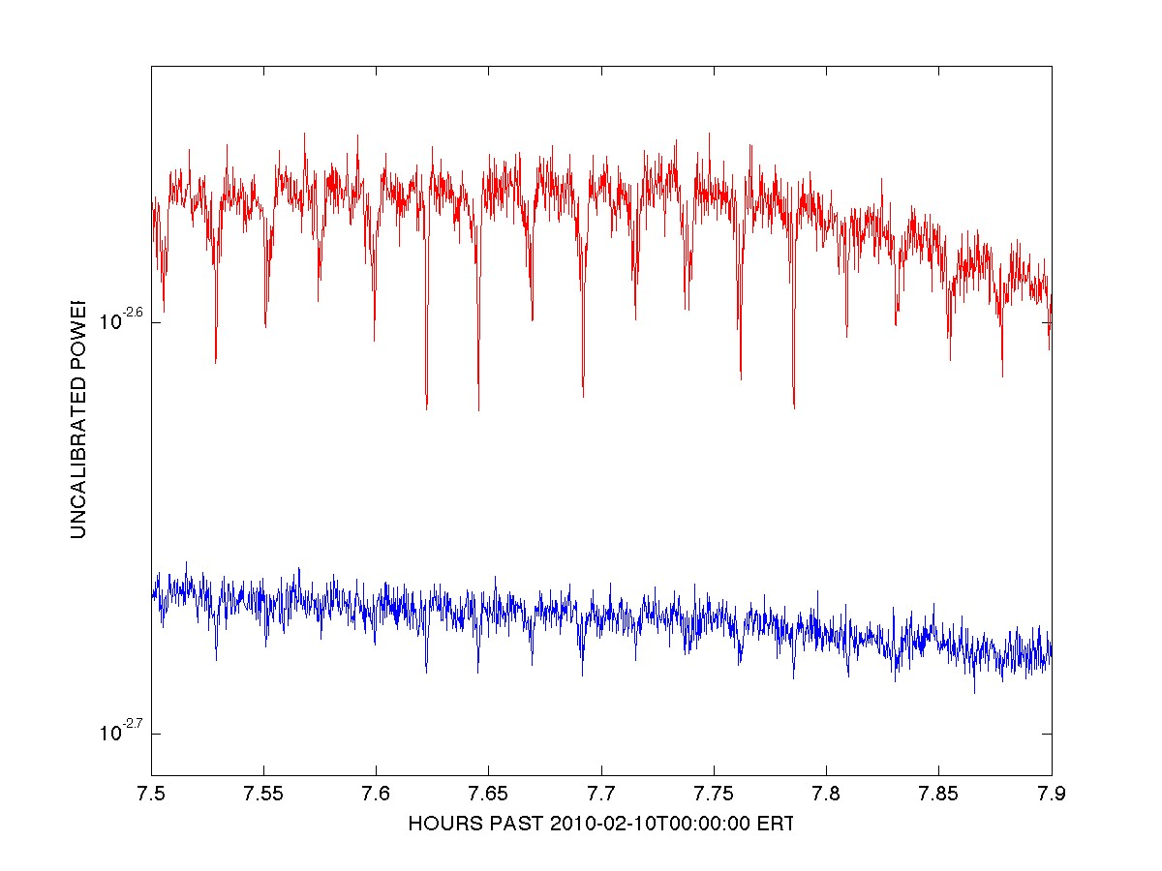
Figure 6. X-RCP (blue, lower) and X-LCP (red, upper) echo powers during the Mars surface observations. Since X-RCP illuminates the surface, both echo components should show power dropouts at approximately 85 second spacings if the modulation seen in Figures 4 and 5 continues during the surface measurements.

The 85-second modulation on both X-RCP and X-LCP (decreasing the former by up to 5 dB, while increasing the latter by up to 2 dB) remains unexplained and should be investigated by MEX personnel. Since the modulation affects both echo components in equal proportion, it should have no net effect on science in the bistatic radar measurements.

Note:

All power measurements reported here were calculated using the full 25 kHz bandwidth of the sampled data. Later, after amplitude calibration and filtering, it should be possible to derive more accurate estimates of carrier and echo powers using narrower bandwidths.

Original (Dick Simpson): 2010-02-12
Corrected Figure 2 caption (Simpson): 2011-03-28

