ROSETTA

FLIGHT REPORTS
of RPC-MAG

RO-IGEP-TR0013

Issue:1 Revision:0

November 10, 2004

Mission Commissioning Results Review
MCRR

Andrea Diedrich
Karl-Heinz Glassmeier
Ingo Richter

Institut für Geophysik und extraterrestrische Physik
Technische Universität Braunschweig
Mendelssohnstraße 3, 38106 Braunschweig
Germany

Introduction

This document describes the results of the commissioning and interference campaign concerning the RPC MAG experiment. The tests were executed from March 17. - October 14, 2004.
Details and an overview of the measured data can be found in:
RO--IGEP--TR0006: Report of the Commissioning PART 1, March 17. -- March 19, 2004
RO--IGEP--TR0008: Report of the Commissioning PART 2, May 05. -- May 10, 2004
RO--IGEP--TR0010: Report of the Commissioning PART 3, September 6. -- September 10, 2004
RO--IGEP--TR0011: Report of the Interference Campaign, September 20. -- October 14, 2004
RO--IGEP--TR0012: Investigation of the impact of ROSETTA's Reaction wheels on the Magnetic Field measurements.

These documents can be found on :
ftp-server: ftp.geophys.nat.tu-bs.de
user: anonymous
directory: /pub/rosetta/docs

A copy is also available on the RPC server at the Imperial College.

Activities during CVP

Functional Tests

- RPCMAG could be switched on successfully every time and worked as expected.

- RPCMAG was tested in all modes successfully.

- Both RPCMAG sensors are working nominally.

- Sensor temperatures: - 120°C ... -45°C

Boom Deployment

The MAG Boom deployment was successfully performed on March 19th, 2004.

- The s/c generated Residual field before Deployment was
~200 nT at the IB sensor
~740 nT at the OB sensor

- The s/c generated Residual field after Deployment was
~ 250 nT at the IB sensor
~100 nT at the OB sensor

- The noise level after the boom deployment was about a factor of ten lower than before the deployment.

All measurements were taken at a sensor temperature of about T = -88°C.

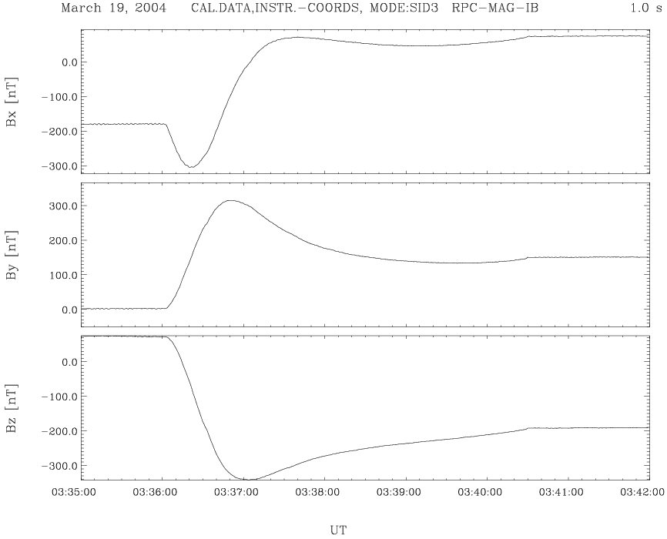

Figure 1:The magnetic Field at the IB sensor during the boom deployment

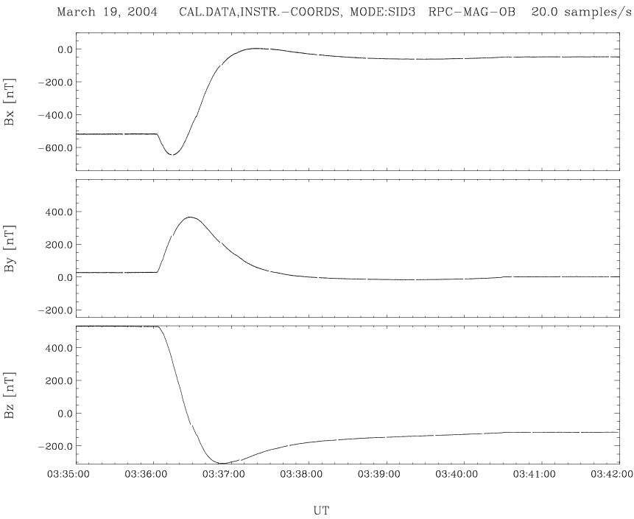

Figure 2: The magnetic Field at the IB sensor during the boom deployment

Cognitions from CVP

DC Analysis - Temperature Behaviour

- S/C generated Residual field after Deployment
~ 250 nT @ IB ~100 nT @ OB

RPCMAG readings vary with temperature

Temperature dependence of RPCMAG offset
deviates from GND CAL results.
The most likely reason for this is that the ground calibration was only be performed down to –60°C, the observed temperatures in space, however, are going down to –125 °C.

➔
A New temperature model has to be applied

The old Temperature Model
The quality of the ground calibration based temperature model of the sensors was checked using the following
Procedure:

- Long term investigation: May – September 2004
All available commissioning data were taken
- Averages were built on a 10 minute base

Result:
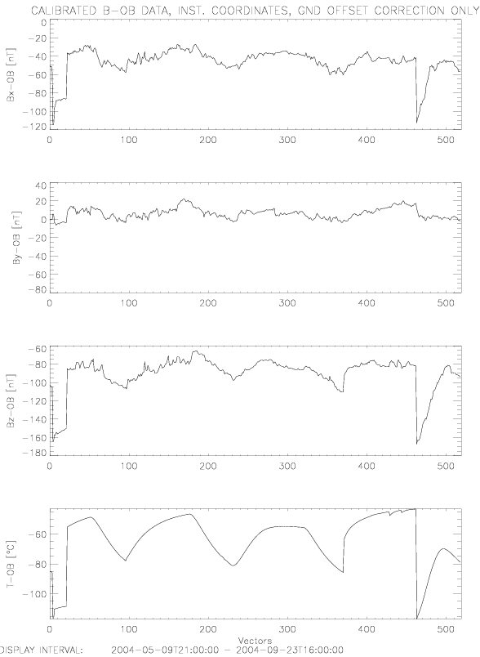

Figure 3: 600s average OB Magnetometer readings, calibrated with ground calibration results, versus sensor temperature.

It is obvious that a strong correlation between the sensor temperature and the MAG sensor readings occurs. Therefore, a better temperature model has to be developed.

The new Temperature Model
To get an idea of the real dependence between the MAG sensor readings and the sensor temperature the 10 minute averaged MAG data were plotted versus the temperature.
Refer to Figure 4. As a result it turned out, that a cubic
Temperature model (solid line) like

Bi*(t) =Bi(t) - P3i(T(t))

Describes the sensor behaviour in a convenient was. The original ground based model was just a pure linear model.

The successful application of the new model to the data can be seen in Figure 5.

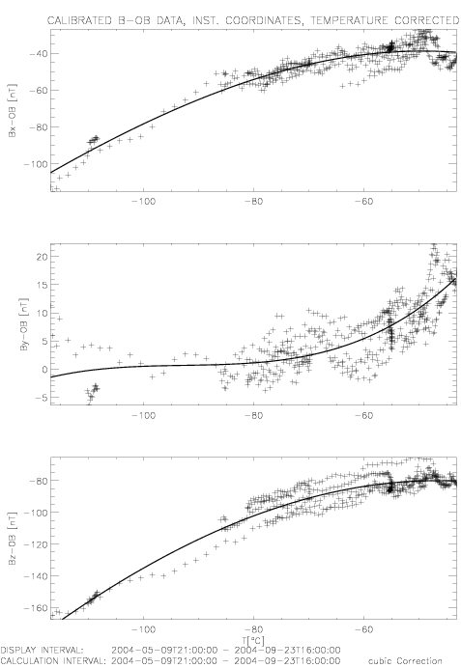

Figure 4: 600s average OB Magnetometer readings versus sensor temperature.

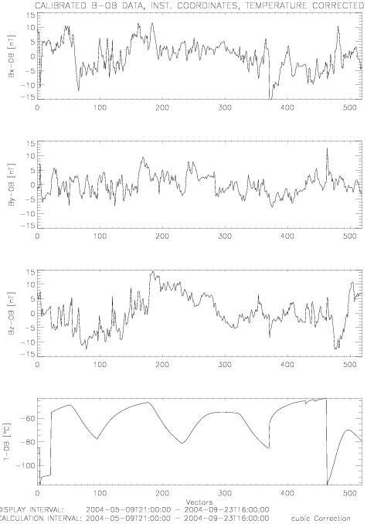

Figure 5: 600s average OB Magnetometer readings, calibrated with the new temperature model, versus sensor temperature.

AC-Analysis: Impact of the Reaction wheels

The signal analysis revealed that

- there is always a sinusoidal disturbance in the order of 1nTpp with slow varying frequencies.
- The observed frequencies of the disturbers are different for different modes. ➔ Aliasing effect
- Disturbance can be seen on OB, IB & ROMAP
This behaviour is displayed on the following diagrams.

Typical Timeseries

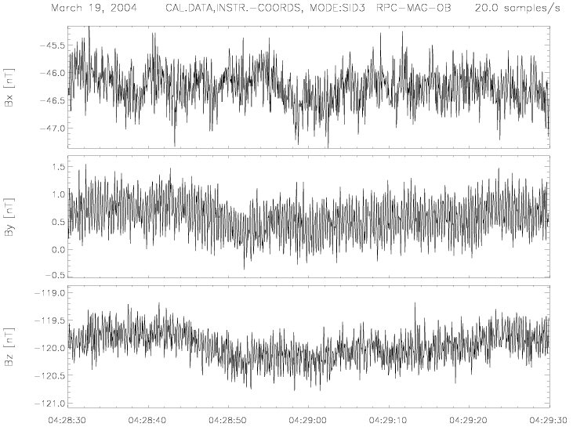

Figure 6: Typical timeseries of OB burst mode data.
Data were zoomed in a 1 minute interval. The DC level is quite stable, the noise is in the order of 0.7 nTpp.

Typical Powerspectra

The power spectra reveal discrete, monofrequent signals in the order of a few Hertz if the MAG signal is sampled with 20 Hz.

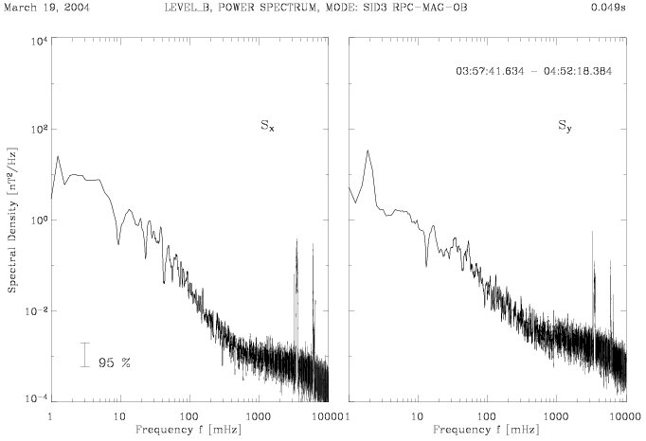

Figure 7: Typical Power spectra. Data of the OB sensor in Burst mode. X and Y component in s/c coordinates is plotted.

Typical Dynamical Spectra

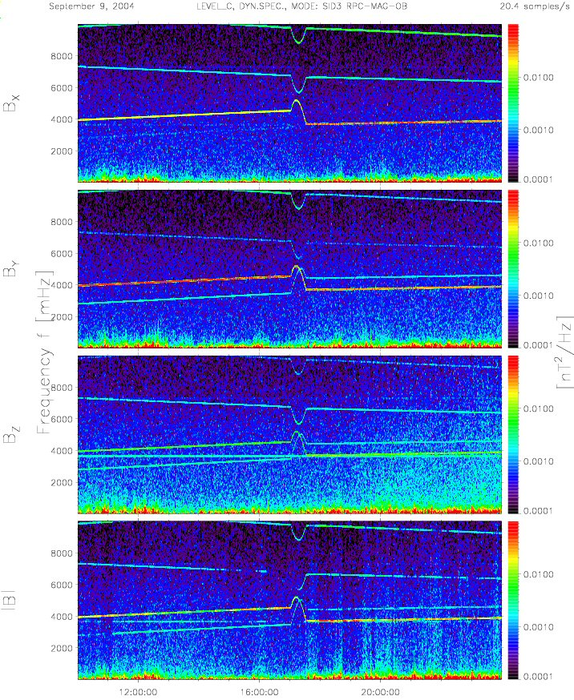

Figure 8: Typical Dynamic spectra. Data of the OB sensor in Burst mode (20 Hz sampling) in s/c coordinates is plotted.

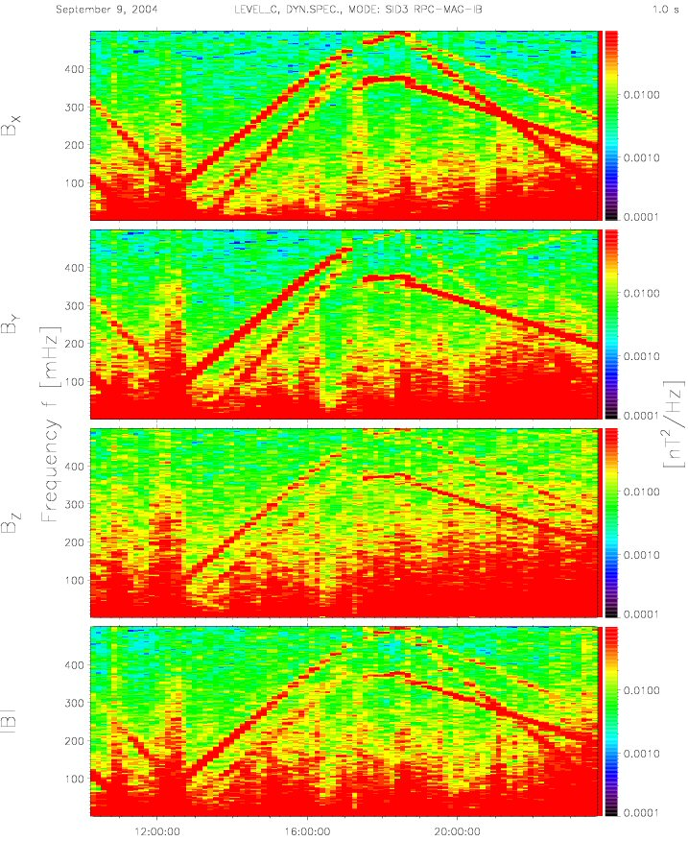

Figure 9: Typical Dynamic spectra. Data of the IB sensor in Burst mode (1Hz sampling) in s/c coordinates is plotted.
The dynamic spectra show various spectral lines beside the “real magnetic field data”. These line vary slowly with the time and show specific structures. The shape of these disturbance lines is specific to the sampling frequency of the MAG sensosrs. All these criteria lead to the guess, that the disturbance might be an Aliasing effect and might be dependent of ROSETTAs four reaction wheels.

The Reaction Wheels

The next figure show the speeds of the reaction wheels in rpm. The data are taken from the DDS. The panels show the timeseries of the parameters

- NAAD60014
- NAAD6024
- NAAD6034
- NAAD6044
The parameters have been calibrated using the DDS calibration value 0.50813.
Figure 12 shows the same data but in the unit of Hertz rather than Rpm.
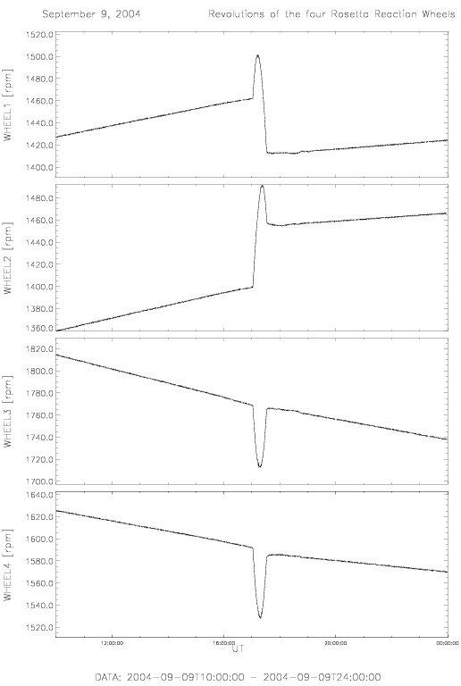

Figure 10: Revolutions of all 4 Rosetta Reaction wheels in rpm.
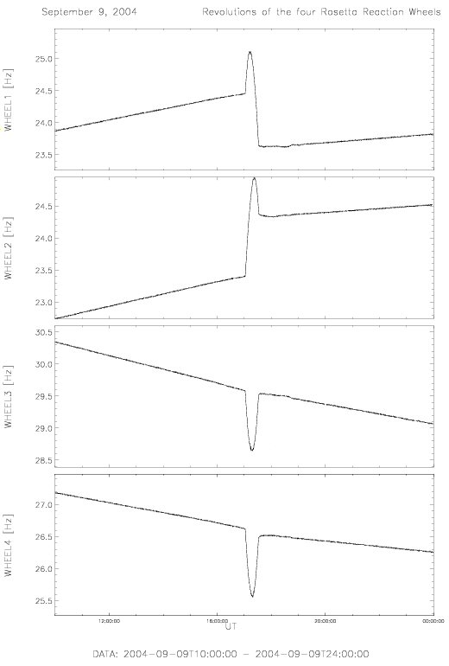

Figure 11: Revolutions of all 4 Rosetta Reaction wheels in Hertz.

Reaction Wheels - Seen from the MAG sensors

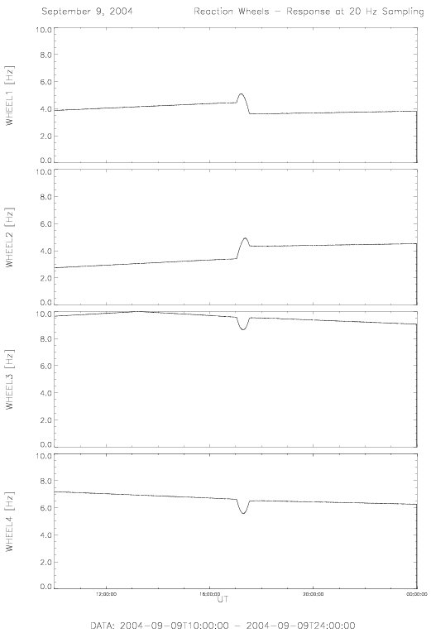

Figure 12: Magnetic signature of the 4 Reaction wheels seen by a sensor which is sampled with 20 Hertz.

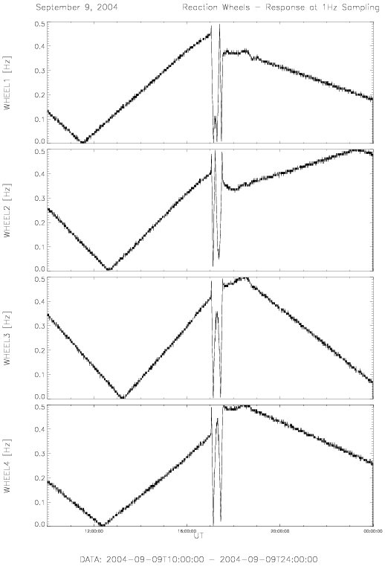

Figure 13: Magnetic signature of the 4 Reaction wheels seen by a sensor which is sampled with 1 Hertz.
To get an idea how the “high frequent” reation wheel speeds would appear on sensor which is only sampled with 20 Hz or 1Hz the wheel data have been shifted and folded down to the
Nyquist frequency interval according the sampling theorem.
The result can be seen in Figures 13 and 14.

AC-ANALYSIS : Results

- RPCMAG clearly identifies the signatures of the 4 Reaction wheels
The comparison of the dynamic spectra of the magnetic field data and the reaction wheel frequencies from the DDS parameters reveals a nearly perfect accordance.

➔ Dynamic frequency reduction model to be developed
to get rid of the reaction wheel impact

- Spin –Off:
Analysis of OB, IB and - independently - ROMAP revealed a slightly wrong reaction wheel calibration factor (1.00335 ~ 4 rpm)

➔ DDS HK Calibration Parameters to be updated.

Comparison with ROMAP

3.3.1 Power Spectra
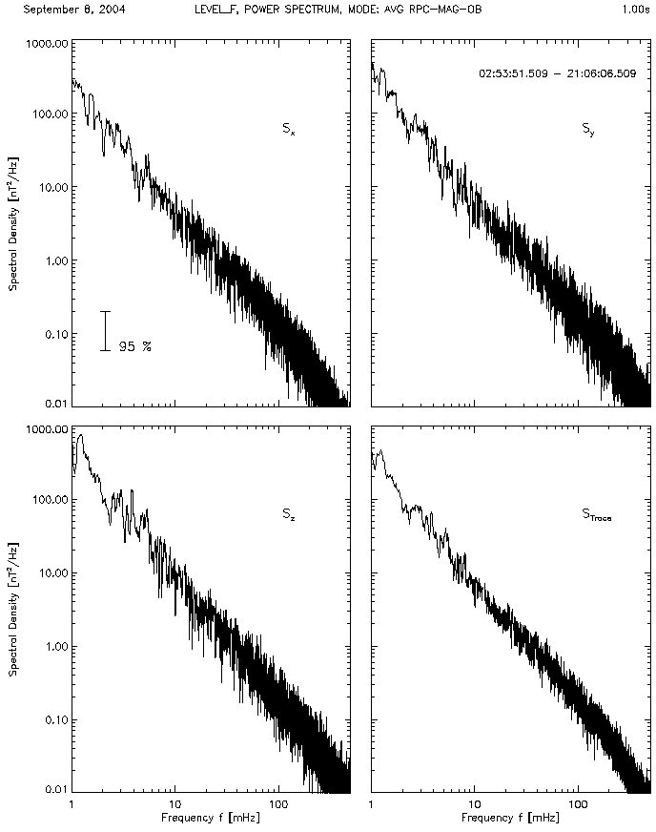
Figure 14: Power Spectra of the RPC_MAG OB sensor.
1 s average data in s/c coordinates.

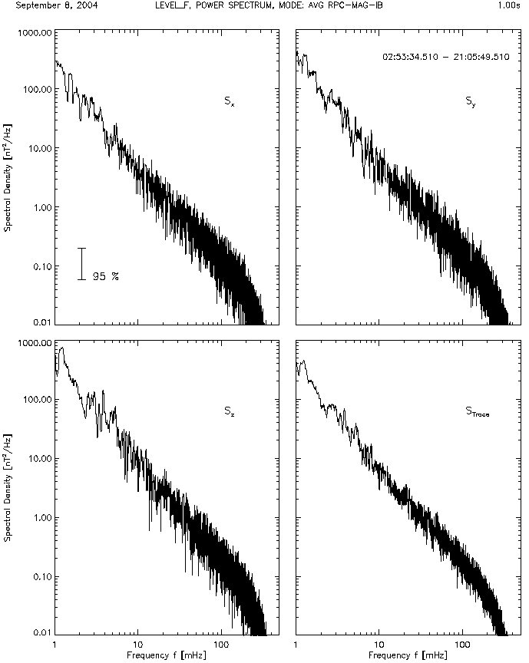
Figure 15: Power Spectra of the RPC_MAG IB sensor.
1 s average data in s/c coordinates.

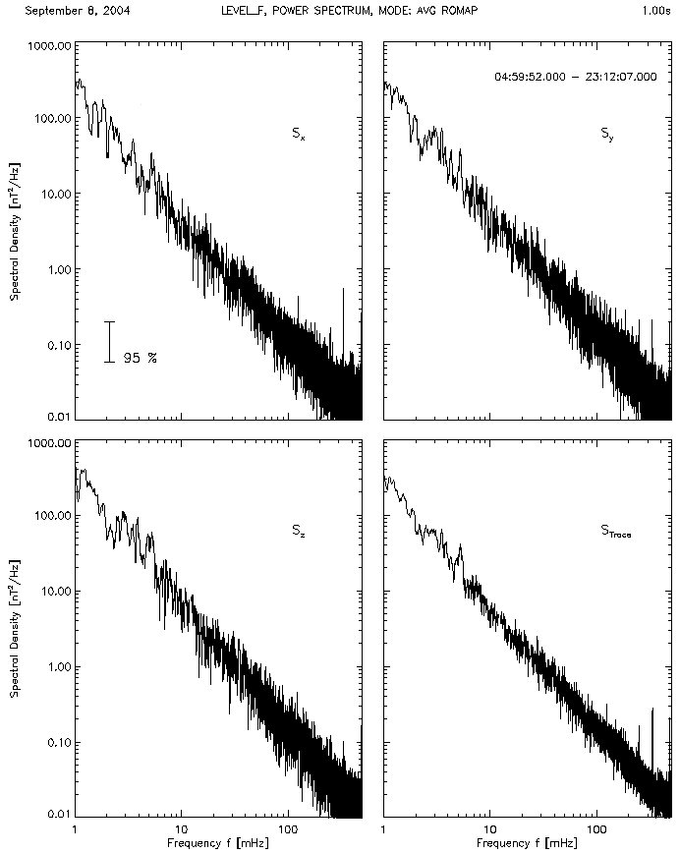

Figure 16: Power Spectra of the ROMAP sensor.
1 s average data in s/c coordinates.

The Figures 15 – 17 show the Power spectra for of the RPCMAG OB, RPCMAG IB, and the Lander Magnetometer ROMAP. Data were taken in a 1 Hz mode.
As result it can be stated, that all three sensors have quasi the same dynamic properties. The noise level of the RPCMAG sensors seem to be slightly better in the higher freuquent part of the spectrum.

3.3.2 Dynamic Spectra
As a last point of the investigation also the dynamic spectra for RPCMAG and ROMAP are shown in Figures 18 – 20. All there sensor sho the impact ot the reaction wheels. The slightly different pictures are caused by different sampling modes.

- RPCMAG OB was sampled with 20 Hz. The data were averaged later to 1s mean values.
- RPCMAG IB was sampled with 1Hz. No additional averaging was done. The “low activity” areas in the spectrum are caused by a mode switching to a low smapling mode on the IB sensor.
- ROMAP was sampled with 1Hz. No additional averaging was done.

Therefore, these data show different behaviour concerning the response of the reaction wheel speeds.
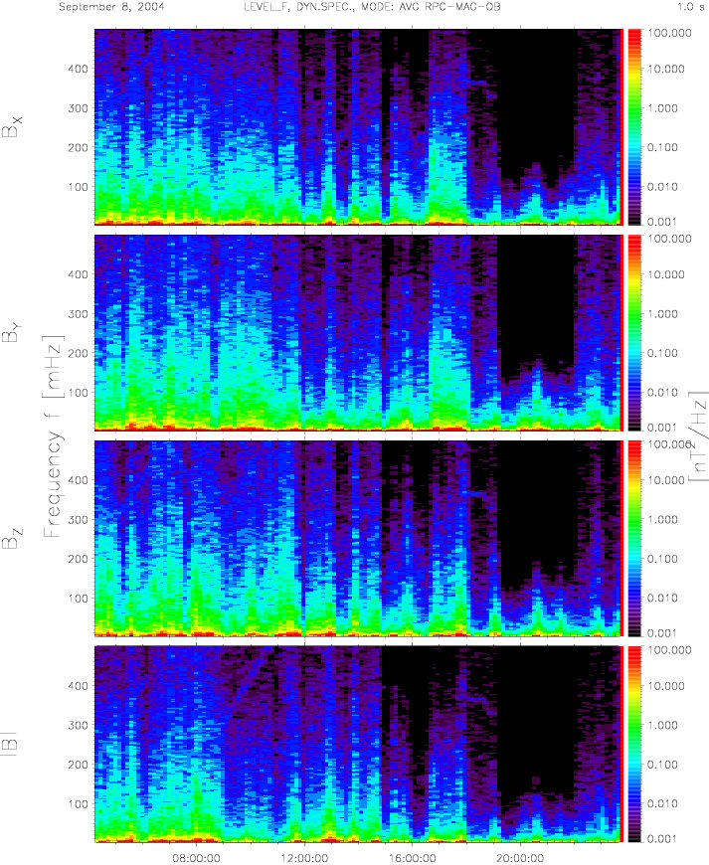
Figure 17: Dynamic Spectra of the RPC-MAG OB sensor. 1 s average data in s/c coordinates.

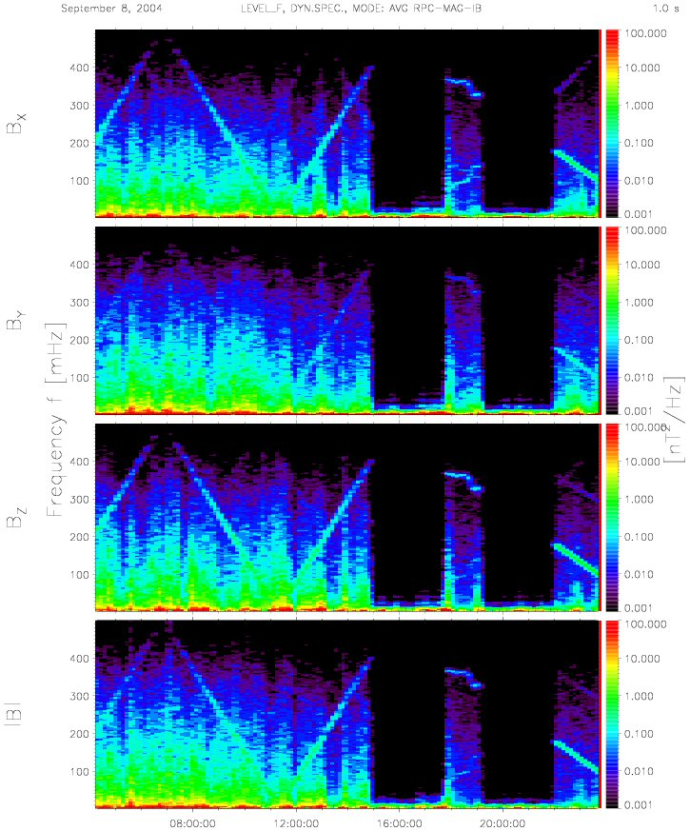
Figure 18: Dynamic Spectra of the RPC-MAG IB sensor.
1 s average data in s/c coordinates.

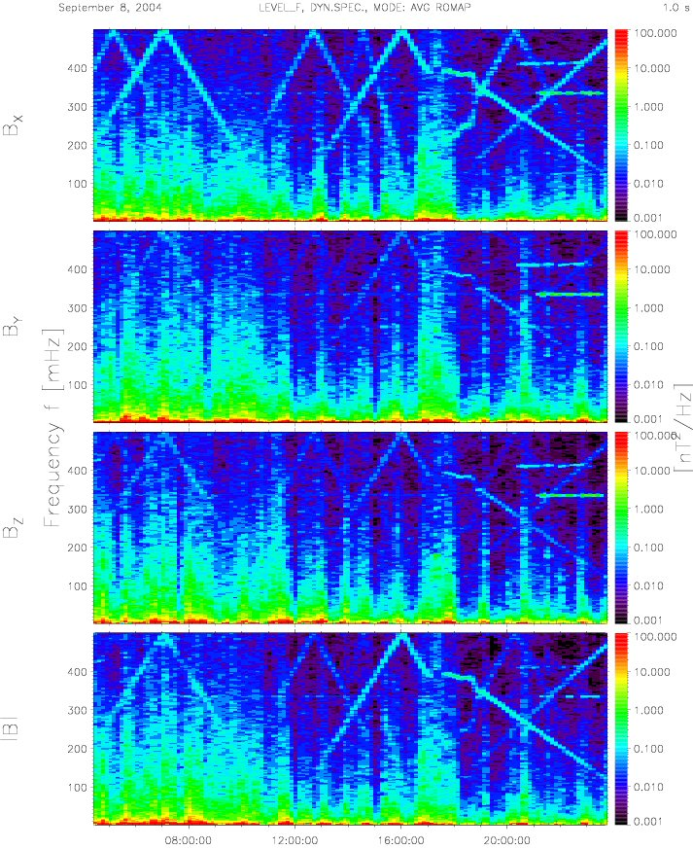
Figure 19: Dynamic Spectra of the ROMAP sensor.
1 s average data in s/c coordinates.

Interference Campaign
The analysis of the interference campaign did not show remarkable interference effects rather than the reaction wheels. A detailed analysis could be performed if a detailed list of activities on the s/c (Time, event) would be available. A coarse overall first view analysis, however, did not show any further problems.

Instrument Status

RPCMAG is fully operable!

Archiving S/W Status

For the archiving of the data an IDL s/w package called
DDS2PDS has been developed. This is a day based
Data processing tool which
- gets data from the ftp sever
- converts binary to ASCII data
- calibrates the data
- generates plots and PDS compliant files

This s/w is working but always under improvement.

Improvements:
- New Temperature model already implemented
- Dynamic frequency elimination to be implemented

According to this, the RPCMAG EAICD is kept up to date.

