European Space Agency

Research and Science Support Department

Planetary Missions Division

[Huygens]-[Probe Engineering Data]

To Planetary Science Archive Interface Control Document

HUY-RSSD-ICD-001

Issue 2.0

10 July 2006

______________________________

Prepared by: O. Witasse, M. Perez Ayucar and Joe Wheadon
__________________________

Approved by: Jean-Pierre Lebreton and Claudio Sollazo

Distribution List

Recipient/Organisation
Jean-Pierre Lebreton
Claudio Sollazzo
Thierry Blancquaert
Anne-Marie Schipper
Patrice Couzin
Huygens DAWG members

Change Log

Date | Sections Changed | Reasons for Change

1 Introduction 3
1.1 Purpose and Scope 3
1.2 Archiving Authorities 3
1.3 Contents 3
1.4 Intended Readership 4
1.5 Scientific Objectives 4
1.6 Applicable Documents 4
1.7 Reference Documents 4
1.8 Relationships to Other Interfaces 4
1.9 Acronyms and Abbreviations 4
1.10 Contact Names and Addresses 4
2 Overview of Huygens Probe design, Data Handling process and Product Generation 5
2.1 Overview of Probe Design 5
Figure 1: Huygens subsystems 7
2.2 Product Generation 7
2.3 Overview of Data Products 9
2.3.1 Engineering Data Calibrations 9
2.3.2 In-Flight Data Products 10
2.3.3 Software 10
2.3.4 Documentation 10
2.3.5 Derived and other Data Products 11
3 Archive Format and Content 11
3.1 Format and Conventions 11
3.1.1 Data Set ID Formation 11
3.1.2 Data Directory Naming Convention 11
3.1.3 Filenaming Convention 11
3.2 Standards Used in Data Product Generation 12
3.2.1 PDS Standards 12
3.2.2 Time Standards 12
3.2.3 Reference Systems 12
3.3 Data Validation 13
3.4 Content 13
3.4.1 Directories 13
3.4.2 Root Directory 13
3.4.3 Calibration Directory 13
3.4.4 Catalog Directory 13
3.4.4.1 Index Directory 14
3.4.4.2 Browse Directory 14
3.4.4.3 Geometry Directory 14
3.4.4.4 Software Directory 14
3.4.4.5 Gazetter Directory 14
3.4.4.6 Label Directory 14
3.4.4.7 Document Directory 14
3.4.4.8 Extras Directory 14
3.4.4.9 Data Directory 15

Introduction

Purpose and Scope

The purpose of this EAICD (Experimenter to (Science) Archive Interface Control Document) is two fold. First it provides users of the Huygens probe engineering data with detailed description of the product and a description of how it was generated, including data sources and destinations. Secondly, it is the official interface between the Huygens probe engineering data team and the archiving authority.

Archiving Authorities

The Planetary Data System Standard is used as archiving standard by
- NASA for U.S. planetary missions, implemented by PDS
- ESA for European planetary missions, implemented by the Research and Scientific Support Department (RSSD) of ESA

ESA implements an online science archive, the PSA,
- to support and ease data ingestion
- to offer additional services to the scientific user community and science operations teams as e.g.
  - search queries that allow searches across instruments, missions and scientific disciplines
  - several data delivery options as
    - direct download of data products, linked files and data sets
    - ftp download of data products, linked files and data sets
The PSA aims for online ingestion of logical archive volumes and will offer the creation of physical archive volumes on request.

Contents
This document describes the data flow of the Huygens Probe engineering data from the s/c until the insertion into the PSA for ESA. It includes information on how data were processed, formatted, labeled and uniquely identified. The document discusses general naming schemes for data volumes, data sets, data and label files. Standards used to generate the product are explained.
The design of the data set structure and the data product is given..

Intended Readership
The staff of the archiving authority (Planetary Science Archive, ESA, RSSD) and any potential user of the Huygens Probe Engineering data.

Scientific Objectives
The probe engineering data are not considered as pure scientific data. Nevertheless, these data can support some science investigations (like the radar and the accelerometer sensors).

Applicable Documents

[AD1] Archive Generation, Validation and Transfer Plan, HUY-RSSD-PL-001, Sept 1, 2004.

Reference Documents

[RD1] Clausen et al., The Huygens Probe System Design, Space Science Review, 104, 155, 2002.
[RD2] The Huygens Probe System Design, ESA-SP 1177, 1997.

Relationships to Other Interfaces

N/A

Acronyms and Abbreviations

A complete list of acronyms related to the Cassini-Huygens mission is part of the archive.

Contact Names and Addresses

Olivier Witasse
ESA ESTEC
PO BOX 299
Noordwijk 2200 AG
The Netherlands
Olivier.Witasse@esa.int

Miguel Perez-Ayucar
ESA ESTEC
PO BOX 299
Noordwijk 2200 AG
The Netherlands
mperez@rssd.esa.int

Jean-Pierre Lebreton
ESA ESTEC
PO BOX 299
Noordwijk 2200 AG
The Netherlands
Jean-Pierre.Lebreton@esa.int

Joe Wheadon
ESA ESOC
Robert-Bosch Str. 5
64293 Darmstadt
Germany
Joe.Wheadon@esa.int

Claudio Sollazo
ESA ESOC
Robert-Bosch Str. 5
64293 Darmstadt
Germany
Claudio.Sollazzo@esa.int

Overview of Huygens Probe design, Data Handling process and Product Generation

Overview of Probe Design

An overview is given here. More details may be found in [RD1].
Huygens consists of two main elements: the Huygens Probe itself that will detach from the CASSINI Orbiter and the Probe Support Equipment (PSE) that will remain attached to the Orbiter after separation. The PSE will provide the radio link relay functions with the Probe.
The subsystem breakdown is the following:
- Front Shield Subsystem (FRSS)
- Back Cover Subsystem (BCSS)
- Descent Control Subsystem (DCSS)
- Separation Subsystem (SEPS)
- Inner Structure Subsystem (ISTS)
- Thermal Subsystem (THSS)
- Electrical Power Subsystem (EPSS)
- Command and Data Management Subsystem (CDMS)
- Probe Data Relay Subsystem (PDRS)

Fig 1 illustrates the subsystem breakdown, with a little more details. All these subsystems are described in [RD1].
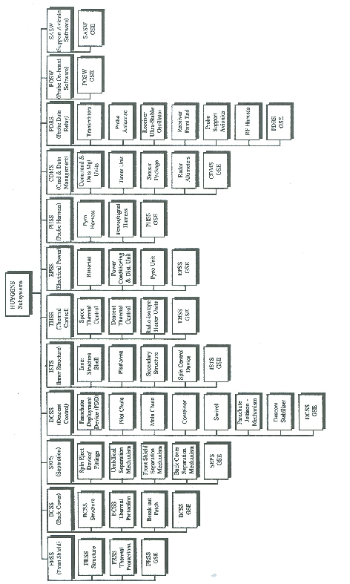

Figure 1: Huygens subsystems

Product Generation

Fig.2 summarizes all the processes involved in the data flow from the Huygens probe to the ESA Planetary Science Archive.
First, the telemetry data coming from the spacecraft are transferred by the JPL-SPOC to HPOC via a secure line. These data are then processed by the operating system called HMCS (Handling Management Control System). Table 1 lists the different operations that are performed by HMCS.

Step | Operation | Data | Comments
1 | Reception of the TM | Streams, binary
2 | Dump files
3 | RS on the Probe superpackets
4 | Packets extraction, conversion to SCOS packets including datation, filing the history files, send the HK packets to the cache
5 | Creation of RS log file |  | Necessary step to evaluate of the completeness of the packets.
6 | Distribution of the data to the TM monitoring clients | Parameters values: calibrated and raw | Use of the calibration database
7 | HK ASCII files generation from the cache | ASCII raw and calibrated data | Use of the calibration database
8 | Experiment packets distribution on the DDS server | Binary files | Can be done before step #7

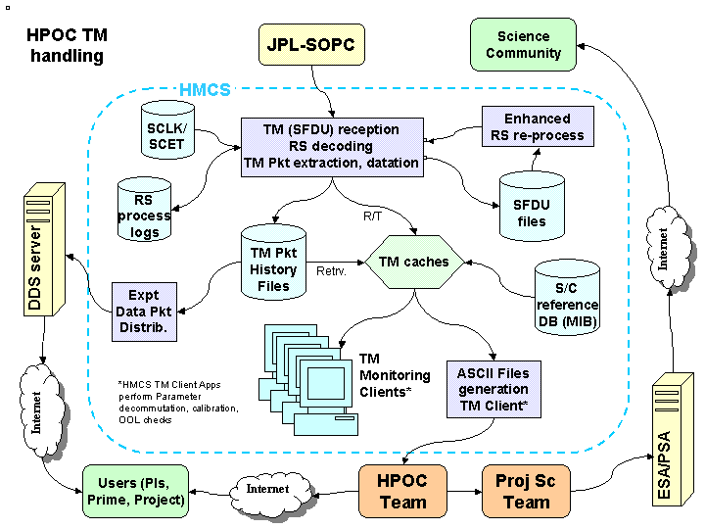
Figure 2: Overview of the data product generation

Overview of Data Products

Engineering Data Calibrations

The calibration data is archived in the ‘CALIB’ directory. For each probe engineering data we provide one of the following calibration type:
- the calibration curve (type 1)
- the polynomial coefficients (type 2)
- the text calibration (type 3)
- No calibration (type 4)

In-Flight Data Products

The In-flight data includes the probe checkouts, and the mission data.
Regarding the checkouts, only the reports provided by Alcatel Space are archived.
Regarding the mission phase, the PDS archive contains 214 housekeeping parameters. The data products are split amongst the following directories, which correspond to the probe subsystems and to the science experiments:
CDMS: Command and Data Management Subsystems
SASW: Support Avionics Software
POSW: Probe Onboard Software
PDRS: Probe Data Relay Subsystem
EPSS: Electrical Power Subsystem
EXP: Experiments
The data products are tables (ext: .TAB) with three columns: Time (UTC), raw data, engineering data. There is one table per parameter.
An overview of the archived HK parameters is given in the document OVERVIEW.TXT, available in the DOCUMENT directory. The document provides the following information:
- Parameter name (e.g. D4002F)
- Description (e.g. PRX SNS B/R ALT)
- Additional comment (Radar B altitude on the redundant chain)
- Num/Status (N or S)
- Engineering unit (e.g. m)
- Sampling rate (e.g. 125 ms)
- Calibration type
- Path/Filename (*.TAB)

Software

The software used in the HMCS to process the data at ESOC is not archived.

Documentation

The following documentation will be provided, in order to support the data analysis:
- The EAICD (WORDS, ASCII and PDF format): this document.
- OVERVIEW.TXT (ASCII format)
- Huygens glossary (ASCII format)
- Probe design (SP1177 paper) in PDF and ASCII format
- Probe design (Space Science Review) in PDF format
- The Huygens overview Nature article in PDF format
- The Huygens probe User Manuel (PDF format)
- The radar design report (PDF format)
- Mission phase: Flight Control Team report (PDF format)
- TM/TC data table (PDF format)
- A document on the location of the temperature sensors (PDF format)
- The probe checkouts reports written by Alcatel (PDF format)
- Two engineering analysis reports by Alcatel (PDF format)
- Documentation on the Huygens aerodynamical database (PDF format and ASCII files)
- Three proceedings of the Planetary Probe Workshop 3 (June 2005) on the analysis of engineering parameters (PDF format).

Derived and other Data Products

The data set contains raw and calibrated data. In addition, it contains the two derived products: the spin profile reconstructed from different sensors; the corrected radar altitudes.

Archive Format and Content

Format and Conventions

Data Set ID Formation

The HouseKeeping parameters are archived in one dataset.
Dataset name: HUYGENS PROBE ENGINEERING DATA V1.0
Dataset ID: HP-SSA-HK-2/3-V1.0

Data Directory Naming Convention

The subdirectories in the /DATA directory are directly related to the Huygens probe subsystems.
The names usually are the same as the subsystem acronyms.

Filenaming Convention

Under /DATA, the filename convention is the following:

HK_<subsystem>_<subsubsystem>_<parameter name>.TAB

<subsystem> and <subsubsystem> are defined as follows:

<subsystem> can be:
CDMS: Command and Data Management Subsystems
SASW: Support Avionics Software
POSW: Probe Onboard Software
PDRS: Probe Data Relay Subsystem
EPSS: Electrical Power Subsystem
EXP: Experiments

<subsubsystem> can be:
CDMUB: Command and Data Management Unit Chain B
CASU: Central Acceleration Sensor Unit
RASU: Radial Acceleration Sensor Unit
PSAB: Probe Support Avionics Chain B
DISR: Descent Imager Spectral Radiometer
HASI: Huygens Atmospheric Structure Instrument
ACP: Aerosol Collector Pyroliser
SSP: Surface Science Package
GCMS: Gas Chromatograph and Mass Spectrometer
TUSO: Transmitter Ultra Stable Oscillator
RUSO: Receiver Ultra Stable Oscillator
PROXSENSORA: Proximity Sensor (radar) Chain A
PROXSENSORB: Proximity Sensor (radar) Chain B
TIMER: Huygens timers
TEMP: Temperature sensors
PCDU:Power Conditioning & Distribution Unit
LNAA: Low Noise Amplifiers Chain A
TXB:Transmitter Chain B.

Standards Used in Data Product Generation

PDS Standards

PDS 3.5 is used.

Time Standards

The time standard is defined in the Data Archive Plan [AD1]. UTC is used.

Reference Systems

The reference system (for the probe) is defined in the Data Archive Plan [AD1].

Data Validation

HPOC provided a report on the telemetry after the mission phase. This report is available in the archive.
Before release to the science community and to the public, the data have been peer reviewed.

Content

Directories

Here is the overview of the structure of the dataset

HP-SSA-HK-2/3-V1.0
|
|- [DOCUMENT]
|- [CALIB]
|- [CATALOG]
|- [EXTRAS]
|- [INDEX]
|- [DATA]

Root Directory

AAREADME.TXT
VOLDESC.CAT

Calibration Directory

The directory contains:
- a calibration report on the Huygens radar altitude.
- 4 files describing the calibration of the engineering parameters.

Catalog Directory

It contains the following required files:
- MISSION.CAT
- MISSION_HOST.CAT
- DATASET.CAT
- SOFT.CAT
- INSTRUMENT.CAT
- REF.CAT
- PERSONNEL.CAT
- CATINFO.TXT

Index Directory

It contains the following files:

- INDXINFO.TXT
- INDEX.LBL
- INDEX.TAB

Browse Directory

N/A

Geometry Directory

N/A

Software Directory

N/A

Gazetter Directory

N/A

Label Directory

N/A

Document Directory

It contains the following folders and files:
DOCINFO.TXT: gives the content of the directory.
OVERVIEW.TXT: gives the list of engineering parameters and some useful information.
HUYGENS_GLOSSARY.TXT: list of acronyms.
The EAICD folder contains the Experiment-to-Archive Interface Control Document (EAICD), ASCII and PDF formats.
The USERMANUAL folder contains the Huygens user manual (PDF format) and the radar design report.
The INDUSTRY_DOCUMENTS folder contains the TM/TC data table, the engineering reports and the Probe checkouts reports (PDF format)
The HPOC folder contains the Flight Control Team final report (PDF format)
The PUBLICATION folder contains the documents [RD1] and [RD2], the Huygens overview Nature article, and three proceedings on the engineering data analysis.
The TEMPERATURE_SENSORS folder contains a document on the sensors locations.

Extras Directory

It contains the engineering parameters in the format MVDA, as well as a PDF documents describing the format of the file.

Data Directory
The directory contains the data.

