DISR Solar Aureole Polarization Measurements.

1.0 Introduction

This paper describes the polarization tests that were performed on the DISR 02 Instrument. Polarization measurements were taken at 11 distributed points in the field of view of each of the 4 Solar Aureole (SA) DISR camera's.

The test were performed at the University of Arizona's Lunar and Planetary Lab cleanroom (room 222c) between the 4th of September 2002 and the 25th of March, 2003.

Polarization measurements were made in both the 'Red' (935 nm) and 'Blue' (500 nm) wavelengths.

2.0 Approach

The general approach was to take DISR SA measurements with light polarized from -30 to 210 degrees relative to the horizontal. These measurements were taken at 11 different places in the SA field of view for each camera, (three along the column nearest the shadow bar, five down the center, and three along the column furthest from the shadow bar). The intensity and polarization of the beam was also be measured, so that the DISR measurements could be normalized to the incident light.

In order to minimize the incident beam polarization the optics in the test setup were kept to a minimum. The High Intensity (HI) white lamp source was used to create the beam, which impinged directly on the DISR (or detector) after passing thorough the polarizer. Masks or baffles were used to collect stray light.

To determine the intensity and polarization of the beam, the monochrometer's Silicon detector was placed between the polarizer and the DISR Sensor Head (SH) prior to the measurements, and readings were taken at the same polarization angles as were used for the DISR measurements. A bandpass filter, with pass characteristics similar to those in the DISR SH, was placed over the detector to minimize wavelength effects.

2.0 Test Setup

The tests were performed on the DISR optical bench in room 222c of the Lunar and Planetary Lab. See Figures 2.1 & 2.2.

The High Intensity Lamp was used as the white light source. Its output was directed through a polarizing filter, and impinged on either the monochrometer's silicon detector, or DISR sensor head, depending on the measurement being taken. A bandpass filter was attached to the front of the Si detector. A filter holder and baffle were also placed in front of the polarizer to reduce the stray light contamination. For the IR measurements it was necessary to put an ND2 filter in this filter holder to reduce the IR light.

A HeNe laser was used to align the lamp, filter holders, polarizer, detector mount and DISR sensor head. The SH was mounted on the Alt-Az mount to allow alignment with individual pixels, and the Solar Aureole Camera was placed at its center of rotation.

Figure 2.1, Test Setup Schematic.

HI
Lamp

Si Detector
Polarizer

DISR Sensor Head

Figure 2.2, Pictures of the Test Setup

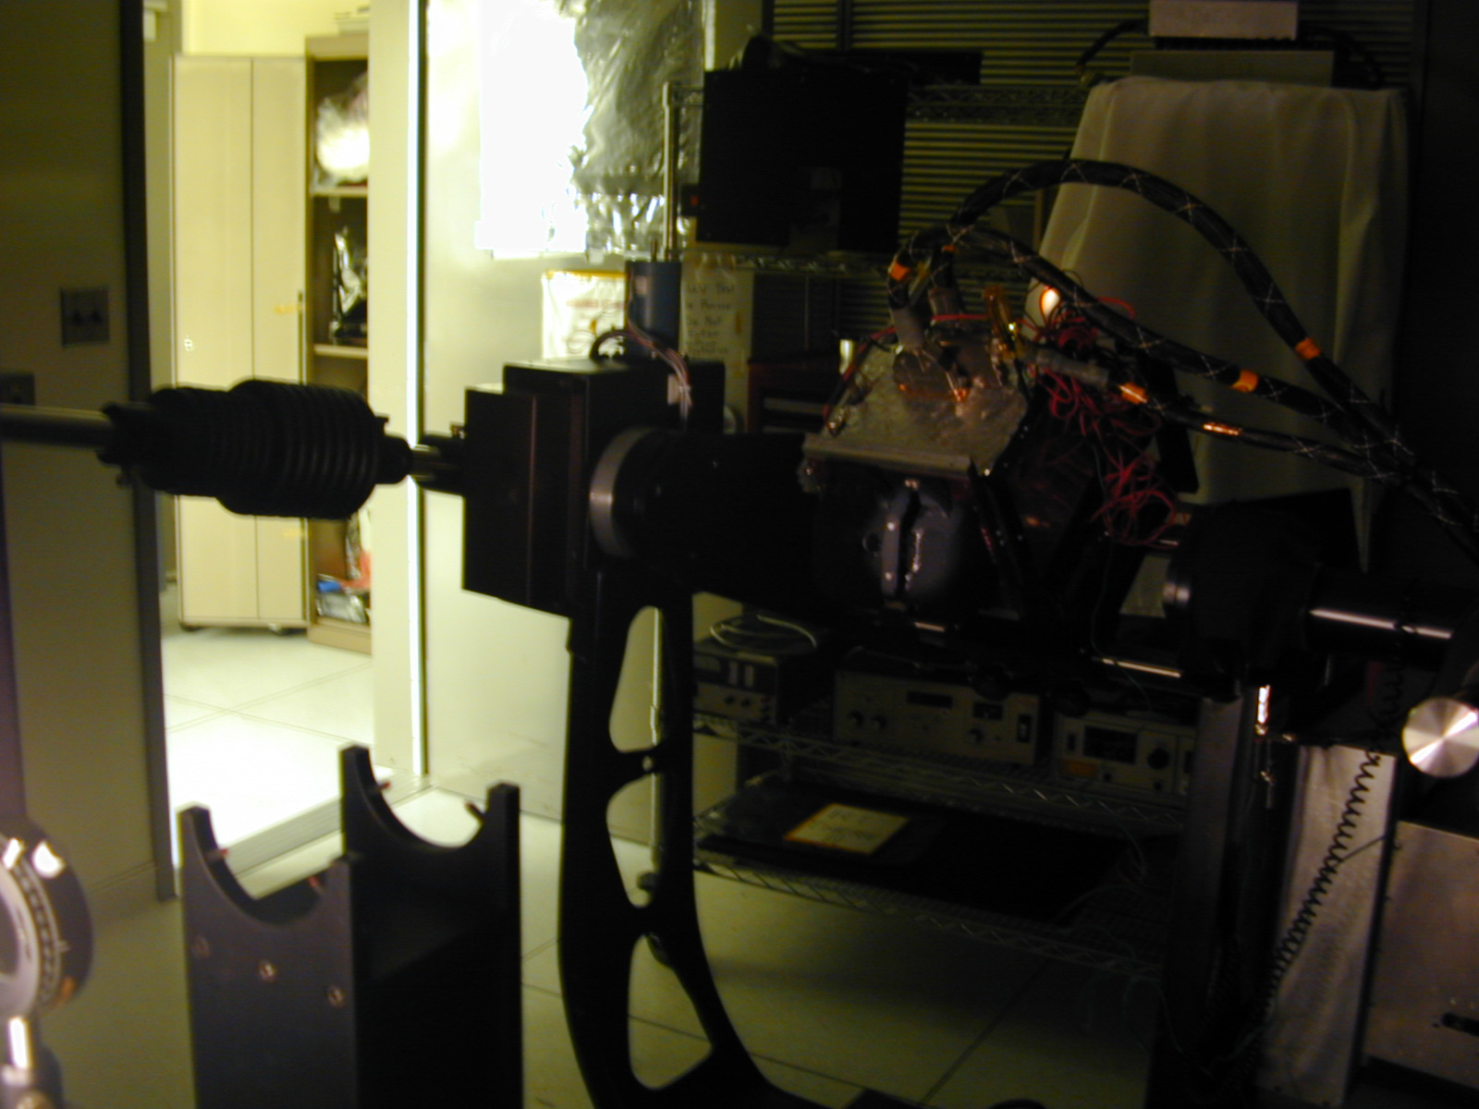

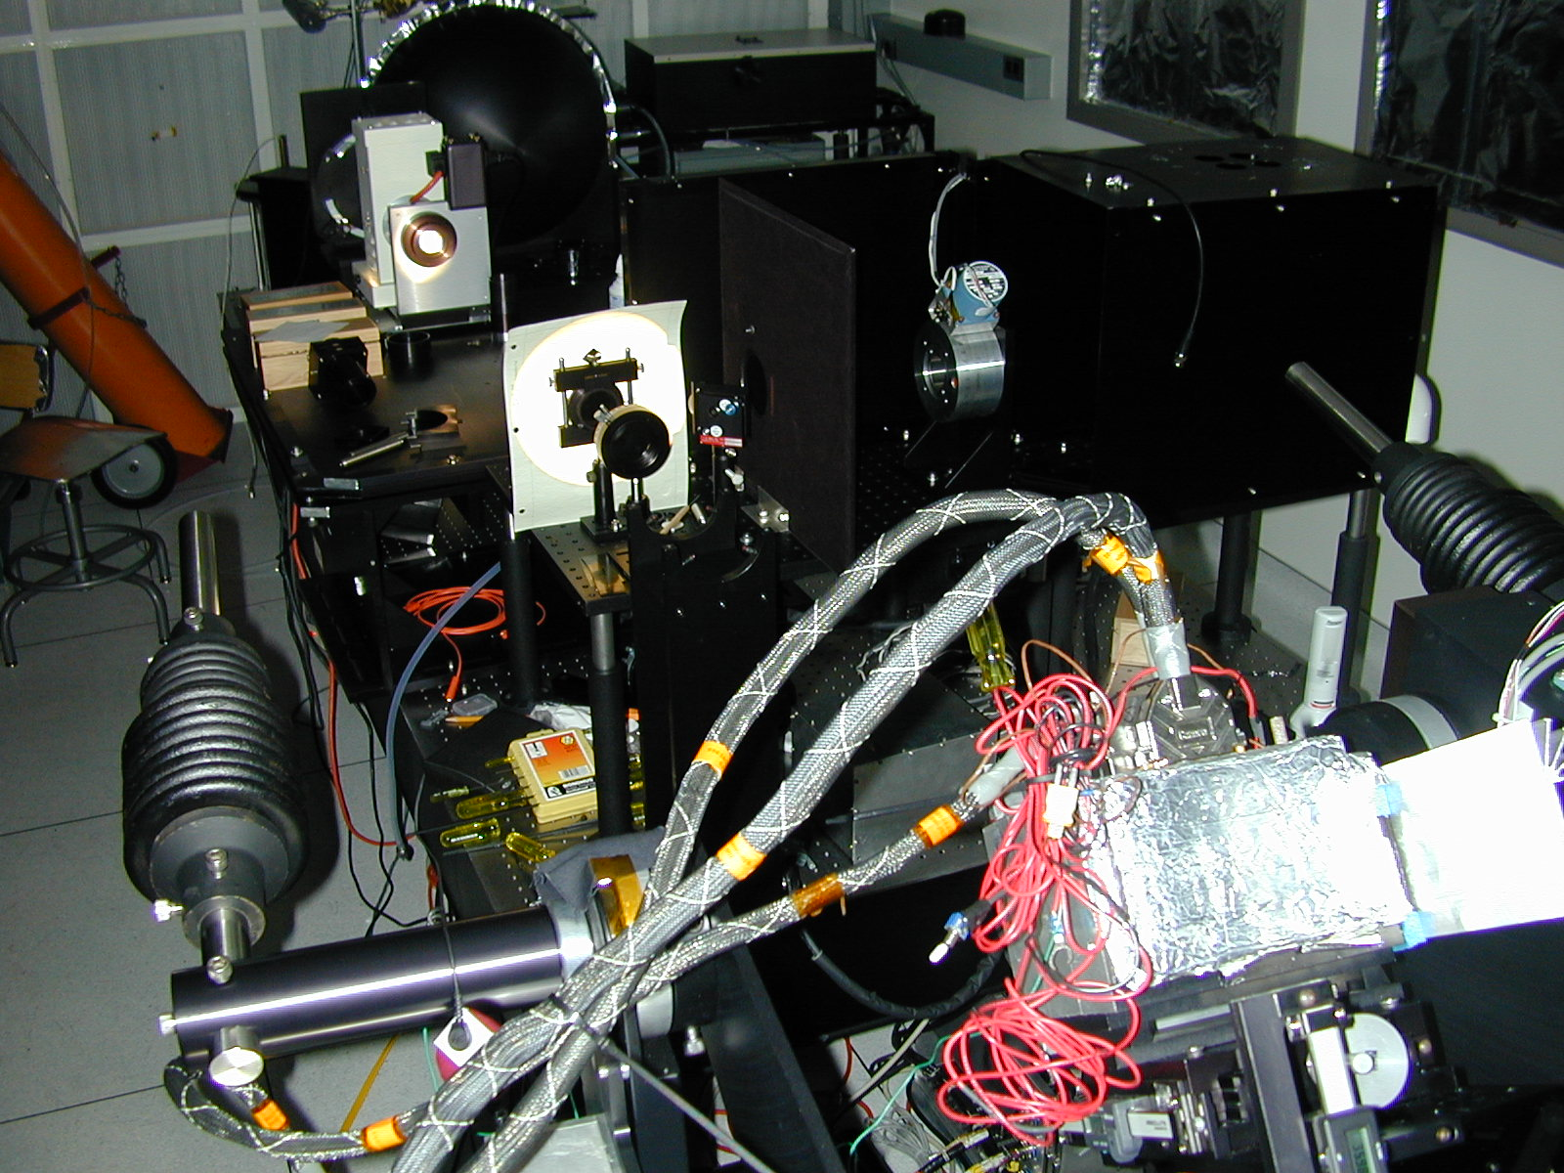

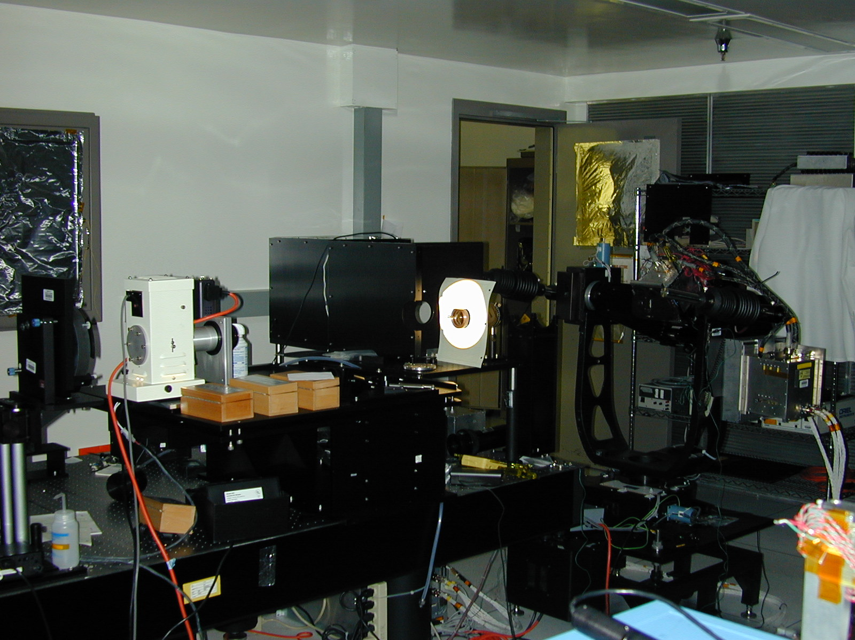

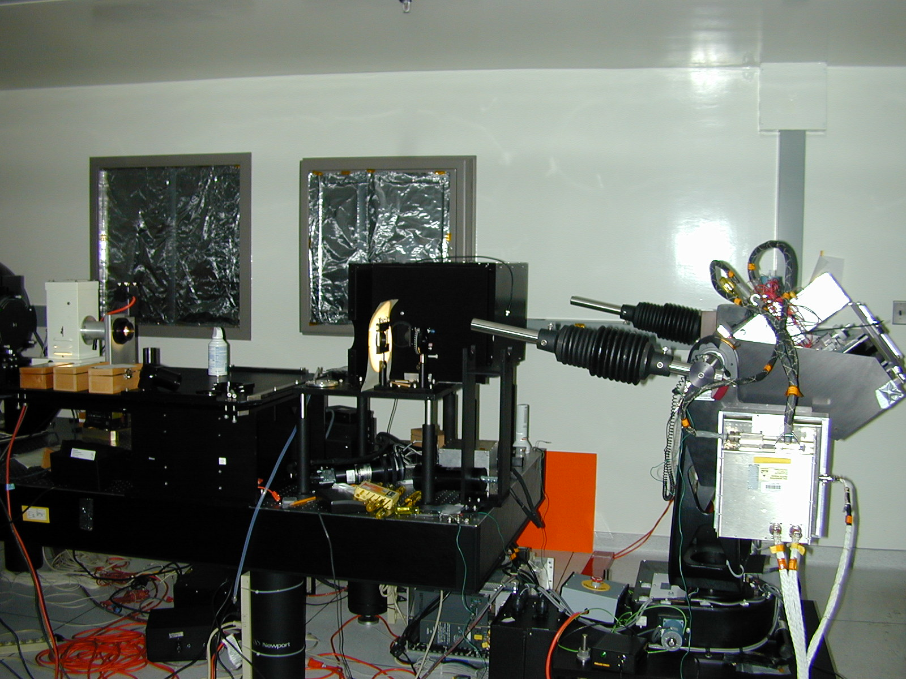

3.0 Measurements

DISR measurements were taken with polarization angles of -30 to 210 degrees, in 10 degree increments. The polarizer was fixed to the optical bench, therefore the polarization angle remain relative to the horizontal and vertical, not to the DISR coordinates as the instrument moves. Thus it is necessary to make the normal coordinate transformation from DISR coordinates to Titan coordinates when considering the polarization angles. With DISR setting on the bench, the polarization angle zero corresponds to the -Y axis of the instrument, and the incident beam is along the -Z axis, as shown below:

Positive
Polarization Angle
Y
x

*
Z

The measurements were taken in three steps:

1) The beam intensity was measured with the polarizer removed by placing the Si detector (and its attached bandpass filter) in the beam.
2) The polarization of the beam was measured by installing the polarizer and taking readings on the Si detector at the same angles anticipated for the DISR measurements.
3) DISR polarization measurements were then made by removing the Si detector, aligning the beam with the appropriate pixel, and taking exposures at each polarizer orientation.

The DISR exposure time was adjusted to get a peak signal (on the appropriate pixel) between 1000 and 2100 dN.

Two sets of dark exposures were taken at the end of each session with 1) an opaque square placed in the beam, and 2) the lamp shutter closed. It was hoped that in this way stray light contamination and dark current could be compensated for.

These measurements were made on eleven pixels in each Solar Aureole camera. The general idea was to have one at each extreme of the field of view, and a few down the center. Because of the limited number of pixels, the point spread function, the spreading of the beam, and interference from the shadow bar, it was not always possible to make measurements with the perfect pixel. The following table shows which pixels were used for each measurement, and on the next page is a graphic depicting which rows and columns it was foreseen to take DISR polarization data.

Definitions:
Wavelength | Blue | Blue | Red | Red
Orientation | Horizontal | Vertical | Vertical | Horizontal
Designation | SA1 | SA2 | SA3 | SA4
Column Numbers | 0-5 | 6-11 | 12-17 | 18-23
Pixels Used:
 | SA1 |  | SA2 |  | SA3 |  | SA4
 | column | row | column | row | column | row | column | row
Left, Top | 0 | 2 | 7 | 2 | 12 | 2 | 19 | 2
Left, Middle | 0 | 24 | 6 | 24 | 12 | 24 | 18 | 24
Left, Bottom | 0 | 46 | 7 | 46 | 12 | 47 | 18 | 47
Center, Top | 3 | 2 | 9 | 2 | 15 | 2 | 21 | 2
Center, st2 | 3 | 13 | 9 | 13 | 15 | 13 | 21 | 13
Center, Middle | 3 | 24 | 9 | 24 | 15 | 24 | 21 | 24
Center, st4 | 3 | 35 | 9 | 35 | 15 | 35 | 21 | 35
Center, Bottom | 3 | 47 | 9 | 47 | 15 | 47 | 21 | 47
Right, Top | 5 | 2 | 11 | 2 | 17 | 2 | 23 | 2
Right, Middle | 5 | 24 | 11 | 24 | 17 | 24 | 23 | 24
Right, Bottom | 5 | 47 | 10 | 47 | 17 | 47 | 23 | 47

Typical Measurement Locations (pixels)
The following table shows in which rows and column's it was foreseen to take data.
 | 0 | 1 | 2 | 3 | 4 | 5 | 6 | 7 | 8 | 9 | 10 | 11 | 12 | 13 | 14 | 15 | 16 | 17 | 18 | 19 | 20 | 21 | 22 | 23
0
1
2 | X |  |  | X |  | X | X |  |  | X |  | X | X |  |  | X |  | X | X |  |  | X |  | X
3
4
5
6
7
8
9
10
11
12
13 |  |  |  | X |  |  |  |  |  | X |  |  |  |  |  | X |  |  |  |  |  | X
14
15
16
17
18
19
20
21
22
23
24 | X |  |  | X |  | X | X |  |  | X |  | X | X |  |  | X |  | X | X |  |  | X |  | X
25
26
27
28
29
30
31
32
33
34
35 |  |  |  | X |  |  |  |  |  | X |  |  |  |  |  | X |  |  |  |  |  | X
36
37
38
39
40
41
42
43
44
45
46
47 | X |  |  | X |  | X | X |  |  | X |  | X | X |  |  | X |  | X | X |  |  | X |  | X
48
49

4.0 Data Reduction

I1
I2
Polarizer
DISR
SH
*

The data reduction proceeded in 6 steps:

1) Curve fit of normalized incident beam data as: T = (I2/|I1|) = A*Cos²(CФ+D)+B
2) Dark subtraction of DISR SA data
3) Curve fit dark subtracted data as: R = A1*Cos²(C1Ф+D1)+B1
4) Normalize the data to the incident beam, & curve fit Ratio R/T = A2*Cos²(C2Ф+D2)+B2
5) Calculate % polarization as the percent of signal extinction: %polar = 100*A2/(A2+B2)
6) Calculate the polarization angle as the angle of maximum transmittance, or maximum of R/T, (i.e. where Cos²(C2Ф+D2)=1): Polar_angle = -D2/C2 (or (180-D2)/C2 )

These calculations are performed in the spreadsheets labeled: SA_color_orientation_polar_column2.xls. There is one such spreadsheet for each column, so there are 12 of them in total.

5.0 Other supporting data

The raw data is collected by an IDL program (sa_polar.pro) and placed in a file named sa_table.out. There is one of these for each test Log. A summary of the data collected in each test log is presented below:

Date Data Collected
16 Sep 02 - SA1, Center, Middle (point 2,3)
18 Sep 02 - SA1, Center, Top & Bottom (points 2,1 & 2,5)
23 Oct 02 - SA1, Left, points 1,1; 1,3 & 1,5
24 Oct 02 - SA1, Right, points 3,1; 3,3 & 3,5
29 Oct 02 - Redo SA1, Right, point 3,5
24 Jan 03 - SA1, points 2,2; 2,5
13 Feb 03 - SA2, points 1,1 - 1,3 - 1,5 (left side)
06 Mar 03 - SA2, points 3,1; 3,2;, 3,3 (right side)
20 Mar 03 - SA2, points 2,1 thru 2,5 (center)
21 Mar 03 - SA3, points 2,1 thru 2,5 (center) (smudged ND2?)
24 Mar 03 - SA3, points 1,1 thru 1.5 (left) & SA3, points 3,1 thru 3,5 (right) & SA4, points 1,1 thru 1,5 (left)
25 MAR 03 - SA4, center and right.

The data from the sa_table.out files was loaded into Excel spreadsheets and combined with the polarization angle data from the notes file for each log. Then erroneous or redundant data was removed before being incorporated into the final analysis spreadsheet. These intermediate files are named sa_table.xls, and there is one for every test log.

There is also filter data available in my public directory:
Homer\\ C:\My Documents\Public\sa_polar\Filter Specifications

In fact all of the data is copied to:
Homer\\ C:\My Documents\Public\sa_polar

6.0 Results.

The results are presented in the following two tables and graphics. The polarization effects are more pronounced in the blue channels than in the red. In all cases the polarization vectors rotate in the positive sense to the top of the FOV (toward zenith) and in the negative sense toward the bottom of the array (toward nadir). The variation is fairly linear and symmetric about the center of the FOV.

The leakage at the center of the FOV is minimal (something like 0.2%), but at the edges of the chip it can be as high as 12%. Again the effect is significantly more pronounced in the blue channels.

 | Polarization Angle - Degrees from Horizontal (-Y DISR axis)
 | Blue |  |  |  |  |  | Red
 | SA1 |  |  | SA2 |  |  | SA3 |  |  | SA4
 | Horizontal (perpendicular) |  |  | Vertical (parallel) |  |  | Vertical (parallel) |  |  | Horizontal (perpendicular)
Row | Left | Center | Right | Left | Center | Right | Left | Center | Right | Left | Center | Right
2 | 15.80 | 17.50 | 18.75 | 99.68 | 99.97 | 101.41 | 93.95 | 94.30 | 93.40 | 7.75 | 8.20 | 8.90
13 |  | 7.50 |  |  | 93.60 |  |  | 92.42 |  |  | 4.80
24 | 0.20 | 0.03 | 0.18 | 88.35 | 88.15 | 88.44 | 90.60 | 91.00 | 90.57 | 1.65 | 1.80 | 1.90
35 |  | -7.25 |  |  | 82.50 |  |  | 89.42 |  |  | -1.35
47 | -17.10 | -18.65 | -20.62 | 75.40 | 74.55 | 73.82 | 86.92 | 87.59 | 87.85 | -4.70 | -5.85 | -6.70

 | Percent Polarization - Maximum Extinction (%)
 | Blue |  |  |  |  |  | Red
 | SA1 |  |  | SA2 |  |  | SA3 |  |  | SA4
 | Horizontal (perpendicular) |  |  | Vertical (parallel) |  |  | Vertical (parallel) |  |  | Horizontal (perpendicular)
Row | Left | Center | Right | Left | Center | Right | Left | Center | Right | Left | Center | Right
2 | 95.47 | 97.08 | 98.58 | 95.53 | 95.23 | 94.62 | 99.61 | 99.53 | 99.80 | 99.38 | 98.87 | 99.16
13 |  | 99.30 |  |  | 99.07 |  |  | 100.00 |  |  | 100.00
24 | 100.00 | 100.00 | 99.83 | 100.00 | 100.00 | 100.00 | 100.00 | 100.00 | 100.00 | 100.00 | 100.00 | 100.00
35 |  | 99.49 |  |  | 98.72 |  |  | 100.00 |  |  | 99.75
47 | 94.80 | 97.08 | 97.82 | 94.43 | 95.23 | 94.29 | 98.97 | 99.53 | 99.40 | 97.43 | 98.87 | 98.38

