Assembly / Subsystem |  | PEM |  |  |  | Phone |  | Section |  | Date
SPIRE |  | Martin Herman |  |  |  | (818) 354-8541 |  | 386 |  | 3 February, 2005
Drawing/ Part No. | Dwg. Rev. | Nomenclature |  |  |  | Serial No. | Model | Type | Final IR No. | Mass (Meas. / Req.)
10209750-1 | B | JFET Module |  |  |  | 012 | FLIGHT | N/A | 923845 | 275.8 gm / 305 gm
Check applicable answer and provide explanation in remarks column |  | YES | NO | N  A | R e m a r k s |  |  | Data Attachments |  | Signature & Date
1. Are all drawings and specifications complete, approved, released and frozen? |  | X |  |  |  |  |  | 14. Latest Top Assembly drawings  Attached None |  | Cognizant Engineer
2. Do the released drawings and specifications reflect all approved changes? |  | X |  |  |  |  |  | 15. List of open ECRs  Attached None |  | PEM
3. Is hardware identical to other hardware delivered? If no, provide difference list. |  | X |  |  |  |  |  | 16. Waivers (RFW request for waiver)  Attached None |  | QA Engineer
4. Does the hardware meet its functional requirements, specifications, waivers, ICDs? |  | X |  |  | EIDP attached.  Also see item # 8 attachments. |  |  | 17. Open MRB  Attached None |  | Environments/Reliability
5. Are all IR and MRB dispositioned and concurred by QA? |  | X |  |  |  |  |  | 18. Open PFR on this H/W  Attached None |  | Mission Assurance Mgr.
6. Is complete as-built list information included in the build book? |  | X |  |  |  |  |  | 19. Open PFR on similar H/W  Attached None |  | Project Office
7. Have all required environmental tests & analyses been completed? |  | X |  |  | ETAS attached |  |  | 20. Handling Document →See Item 11  Attached None |  | P I
8. Is all required assembly and/or subsystem level functional testing complete? |  | X |  |  | Performance Test Data Attached.  Also see EIDP in item # 4. |  |  | 21. Shortage List  Attached None
9. Have all piece parts, processes and materials been approved by JPL? |  | X |  |  |  |  |  | 22. Requirements Verification Matrix  Attached (See #4, #7, #8) None
10. Does this hardware meet all contamination control requirements? |  | X |  |  | Parts, processes and MIUL met all contamination control and out-gassing requirements. |  |  | 23. Qualification Status  Attached None
11. Are all shipping containers, shipping and special handling procedures ready? |  | X |  |  | See Attached Document D-26790 |  |  | 24. Mate / Demate Record  Attached None
12. Is additional work required to bring this hardware to flight readiness? |  |  | X |  |  |  |  | 25. Operating Log  Attached (See Item # 24) None
13. Is this hardware acceptable for flight? |  | X |  |  |  |  |  | 26. MICD  Attached None

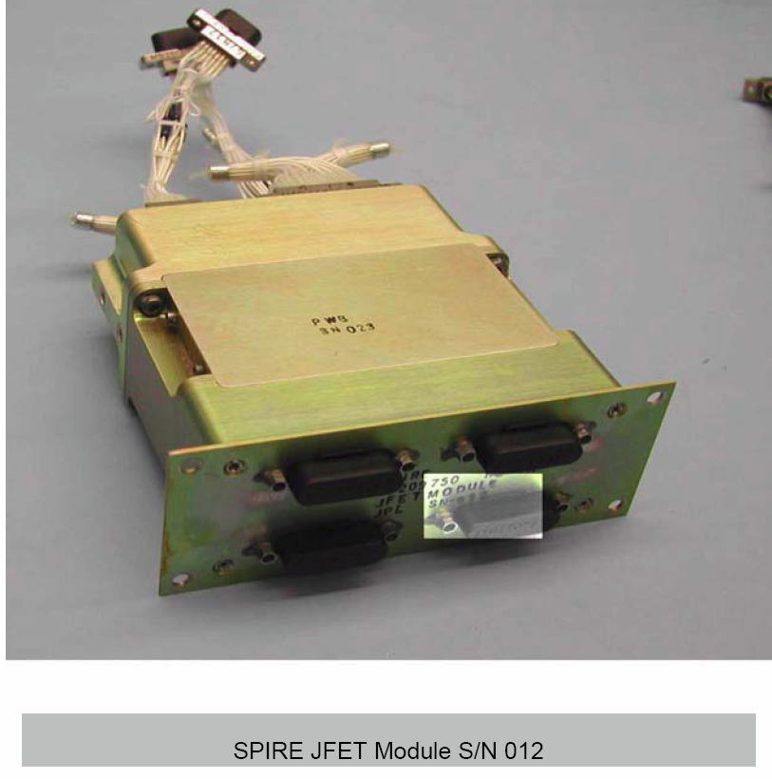
RAL EIDP Table of Contents Versus JPL HRCR Check List Item Numbers

RAL EIDP  Section Number | RAL EIDP Title | JPL HRCR Check List Item Number | Notes
1 | Shipping Documents |  | Shipper and Final IR
2 | Transportation, Packing, Handling  & Integration Procedures | 11 | Special Handling Document D-26790
3 | Certificate of Conformance /  Delivery Review Board MOM |  | HRCR book is the C of C
4 | As Built Configuration Status List | 1 & 2 | Assembly Drawings
5 | List of Waivers | 4 | RFW (request for waiver) Attached
6 | Copies of Waivers | 4 & 7 | RFW (request for waiver) Attached
7 | List of Non-Conformance Reports |  | See RFW in 4 & 7
8 | Copies of Non-Conformance Reports |  | See RFW in 4 & 7
9 | Cleanliness Statement |  | Final IR QA Inspection
10 | Operational Manual |  | NA
11 | Top Level Drawings (inc. Family Tree) | 14 | Top Assembly Drawing
12 | Interface Drawings | 26 | MICD Drawing
13 | Functional, Block & Mechanical Drawings |  | NA
14 | Electrical Circuit Drawings |  | NA
15 | Serialized Components List |  | In build books – not shipped
16 | Mass Properties/ Power Budget | HRCR Check List Page 1 | Mass listed in HRCR check list
17 | Qualification Status List / Test Matrix | 23 | Qualification Unit Test Matrix
18 | Test Reports | 4, 7, 8, 23
19 | Open Work / Deferred Work / Open Tests |  | NA
20 | Calibration Data |  | NA
21 | Historical Record | 23 | Qualification Unit Test Matrix
22 | Manufacturing Logbook(s) |  | In build books – not shipped
23 | Operating Time / Cycle Record | 25
24 | Connector Mating Record | 24
25 | Age Sensitive Items Record |  | NA
26 | Pressure Vessels – History/Test Record |  | NA
27 | Temporary Installation Record |  | NA
28 | Reference List of EIDPs (Lower level) |  | NA
29 | Other Useful Information |  | NA

JPL Hardware Requirements
Certification Review (HRCR)

Junction Field Effect Transistor (JFET)
Flight Module

10209750-1 S/N 012

SPIRE Element
Herschel Space Observatory Project

February 3, 2005

Configuration of Module, Boards & Membranes

Module 10209750-1 | S/N 12 | S/N 12
PWB 10209760-1 | S/N 22 | S/N 23
Membrane 10209758-1 | J5.6.2 | J5.6.3

Attachment of HRCR Items #1
Drawing Release Status

ALL ASSEMBLY & PARTS DRAWINGS ARE RELEASED IN PDMS

Released Drawings:

10209719-1 assembly built per released Rev. A drawing (studlock)

10209722-1 assembly built per released Rev. B drawing (interface drawing)

10209750-1 assembly built per released Rev. B drawing (module assy)

10209751-1 assembly built per released Rev. B drawing (chassis 1)

10209752-1 assembly built per released Rev. A drawing (chassis 2)

10209753-1 assembly built per released Rev. A drawing (chassis 3)

10209754-1 assembly built per released Rev. C drawing (mount)

10209756-1 assembly built per released Rev. B drawing (chassis lid)

10209757-1 assembly built per released Rev. A drawing (membrane)

10209758-1 assembly built per released Rev. A drawing (membrane assy)

10209759-1,-2,-4 redlined Rev. B drawing (gasket)

10209760-1 assembly built per released Rev. C drawing (board assembly)

10209761-1 assembly built per released Rev. C drawing (solder connector)

10209769-1 assembly built per released Rev. A drawing (stiffener)

10209777-1 assembly built per released Rev. B drawing (board)

10209858-2 assembly built per released Rev. A drawing (special fastener)

10217636-1 assembly built per released Rev. A drawing (clip)
Attachment of HRCR Item #4: EIDP

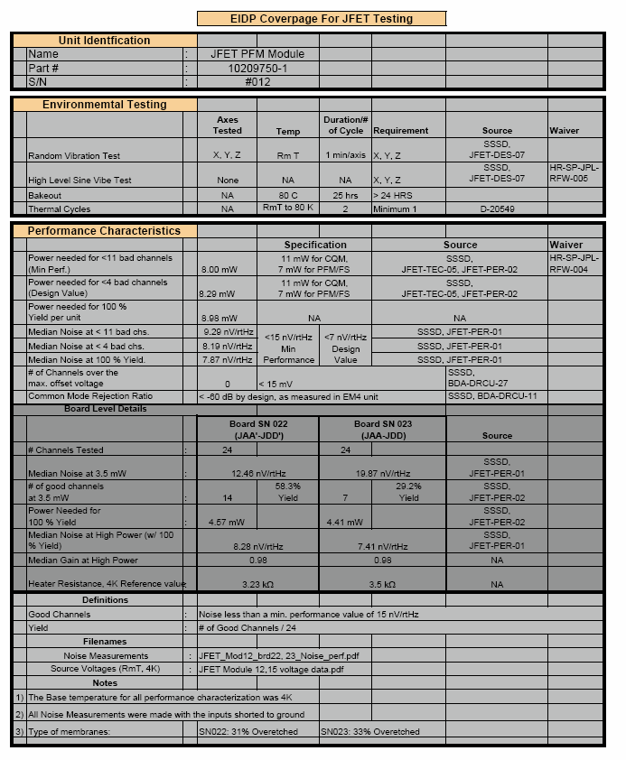
Attachment of HRCR Item # 4: RFW (request for waiver)

 |  |  |  | RFW/RFD Number: |  |  |  |  | HR-SP-JPL-RFW-013
Spacecraft / Project | Herschel |  |  | Originator’s Name |  |  |  | Steve Tseng
System / Experiment / Model | SPIRE |  |  | Signature / Date
Sub-System | detectors |  |  | Request Type  (Highlight applicable request) |  |  |  | Waiver (RFW) |  |  |  | Deviation (RFD)
Assembly | JFET modules |  |  | Organisation |  |  |  | Jet Propulsion Laboratory
Sub-Assembly |  |  |  | Ref. Doc. / Drwg No. |  |  |  | SPIRE-JPL-PRJ-000456
Item |  |  |  | References
Serial No.
RFW/RFD Title | JFET Power Dissipation s/n 012
End Items(s) Affected (Hardware, Software)
Name |  |  | CI-Number |  |  |  |  | Model(s)
JFET Module p/n 10209750 s/n 012 |  |  |  |  |  |  |  | PFM
Requirement / Interface Documents Affected
Specification/Drawing Title |  | Number |  |  | Issue |  | Date |  |  | App. Paragraph
BDA-SSSD |  | SPIRE-JPL-PRJ-0004456 |  |  | 3.2 |  | 7/1/03 |  |  | JFET-PER-01  JFET-PER-02  JFET-TEC-05
Description of Deviation / Discrepancy / Non-Conformance
Requirement states that dissipation of photometer JFETs is to be less than 7 mW average, while supplying 90% of channels with voltage noise < 15 nV/rtHz according to BDA-SSSD JFET-PER-01, JFET-PER-02, JFET-TEC-05.
Measured JFET performance of the JFETs indicates that 8.98 mW of power dissipation will be required to meet the specified yield and noise performance specifications.

Other Items or Requirements (Potentially) Affected
Overall sensitivity of the bolometer sub-system is affected by JFET noise performance. JFET power dissipation impacts the heat sink temperature of the 3He refrigerator and may in turn increase the base detector temperature.
Dissipation of JFETs affects power dissipation on cryostat.
Need for RFW/RFD and Rationale for Acceptance
Measured JFET performance of JFETs indicates that 10.30 mW of power dissipation will be required to meet the specified yield and noise performance specifications. JPL is unable to significantly alter the JFET fabrication process in order to meet the power specification without undue risk to the stated PFM/FS delivery dates. Furthermore, JPL requests a full system optimisation to revisit the noise and power requirements on the JFETs. The JFET modules can meet the noise design value with 100 % yield at higher dissipation.

 | Approved |  | Rejected |  |  | Name |  |  |  |  | Date
Engineering:
Product Assurance:
CCB-Chairman:
Principal Investigator
Product Assurance:
Co-Investigator
Prime Contractor
ESA Project Office

Attachment of HRCR Item #7: RFW (request for waiver)
 |  |  |  | RFW/RFD Number: |  |  |  |  | HR-SP-JPL-RFW-005
Spacecraft / Project | Herschel |  |  |  | Originator’s Name |  |  |  |  | Kalyani Sukhatme
System / Experiment / Model | SPIRE |  |  |  | Signature / Date
Sub-System | detectors |  |  |  | Request Type  (Highlight applicable request) |  |  |  |  | Waiver (RFW) |  |  | Deviation (RFD)
Assembly |  |  |  |  | Organisation |  |  |  |  | Jet Propulsion Laboratory
Sub-Assembly |  |  |  |  | Ref. Doc. / Drwg No. |  |  |  |  | SPIRE-JPL-PRJ-000456
Item |  |  |  |  | References
Serial No.
RFW/RFD Title | BDA and JFET module sine test deletion
End Items(s) Affected (Hardware, Software)
Name |  |  | CI-Number |  |  |  |  |  |  | Model(s)
Bolometric Detector Assemblies  JFET Modules |  |  |  |  |  |  |  |  |  | CQM, PFM, FS  CQM, PFM, FS
Requirement / Interface Documents Affected
Specification/Drawing Title |  | Number |  |  |  | Issue |  | Date |  |  | App. Paragraph
BDA-SSSD (SPIRE-JPL-PRJ-000456) |  |  |  |  |  | 3.2 |  | Jan 7, 2003 |  |  | BDA-DES-10, JFET-DES-07
Description of Deviation / Discrepancy / Non-Conformance
High Level Sine- Vibe Test is not performed on these units

Other Items or Requirements (Potentially) Affected
Need for RFW/RFD and Rationale for Acceptance
The hardware has to be qualified under a cold vibration test and is installed in the cold vibration facility for the purpose of the test. The high level sine vibration test configuration will put the hardware and the personnel at risk since the cold vibration facility is not structurally capable of withstanding the high levels. Obtaining additional resources (cost and schedule) for developing a new set-up is not feasible at this time.
 | Approved |  | Rejected |  |  |  | Name |  |  |  |  | Date
JPL Engineering:
JPL Product Assurance:
CCB-Chairman:
Principal Investigator
Product Assurance:
Co-Investigator
Prime Contractor
ESA Project Office
Attachment of HRCR Item #7: ETAS (environmental test summary)

Attachment of HRCR Item #7: ETAS (environmental test summary)
Attachment of HRCR Item #7: ETAS (environmental test summary)

Attachment of HRCR Item # 8: Test Data - Source Voltage & Noise
For Module 12
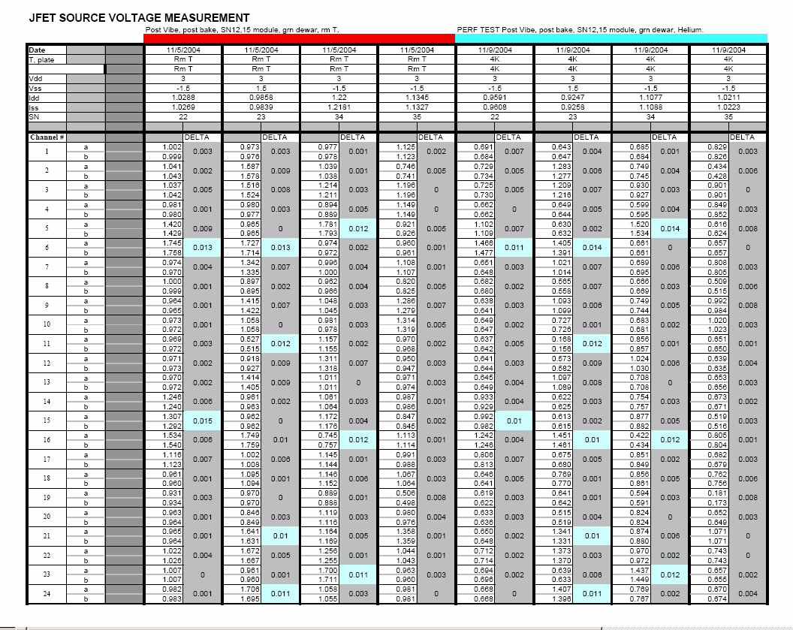
Attachment of HRCR Item # 8: Test Data - Source Voltage & Noise

Board S/N 022 in Module S/N 012
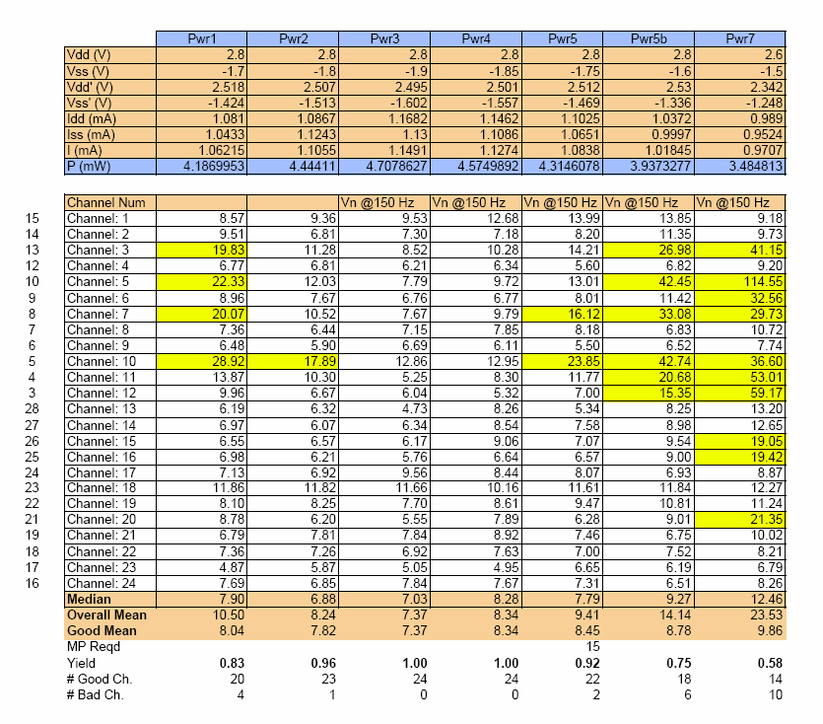
Attachment of HRCR Item # 8: Test Data - Source Voltage & Noise

Board S/N 023 in Module S/N 012
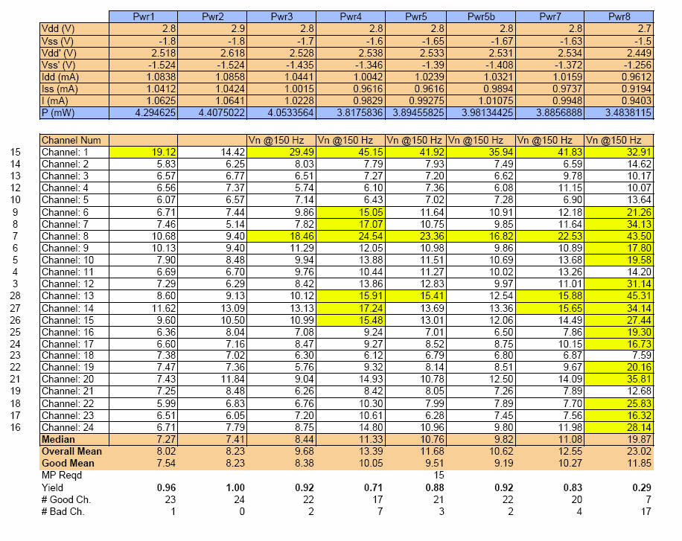

Attachment of HRCR Item # 9: SPIRE MIUL Cover Page

MIUL = Material Identification & Utilization List

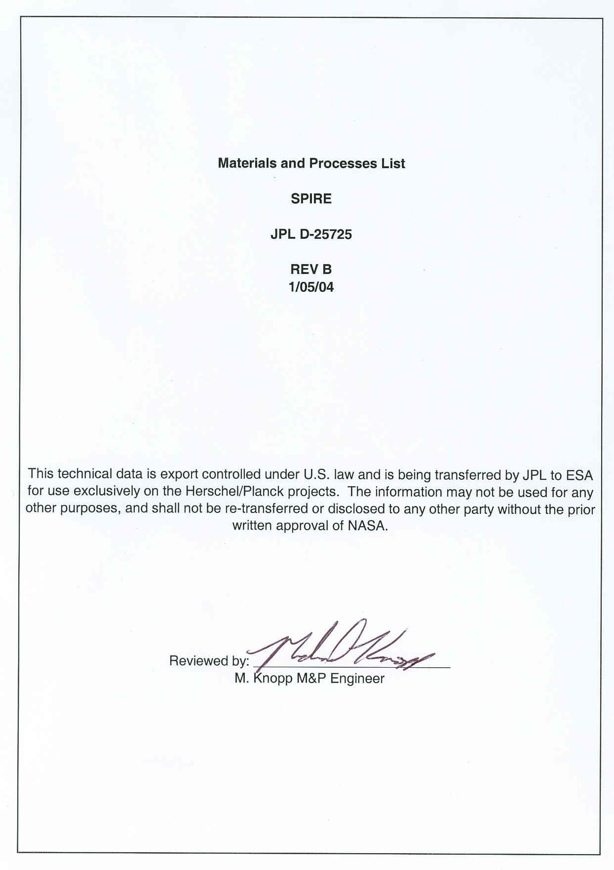

Attachment of HRCR Item # 11:

See End of This HRCR Package for
“JFET Module Handling Document”

Attachment of HRCR Item # 14: JFET Module Top Assembly Drawing 10209750-1
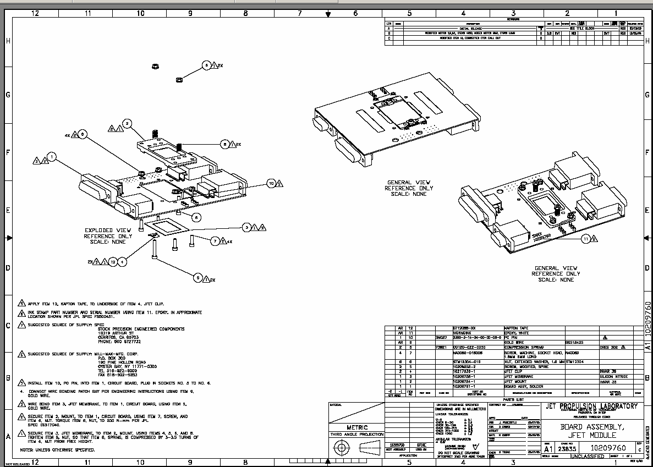
Attachment of HRCR Item # 23: Qualification Compliance Test

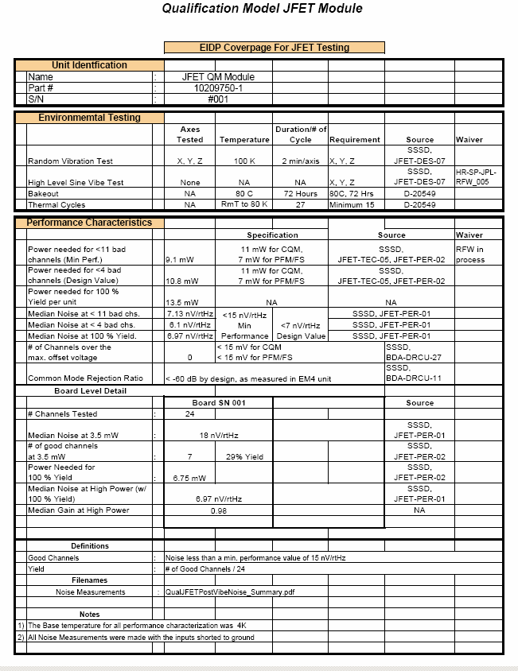
Attachment of HRCR Item # 24 & #25: Mate/Demate & Operation Logs

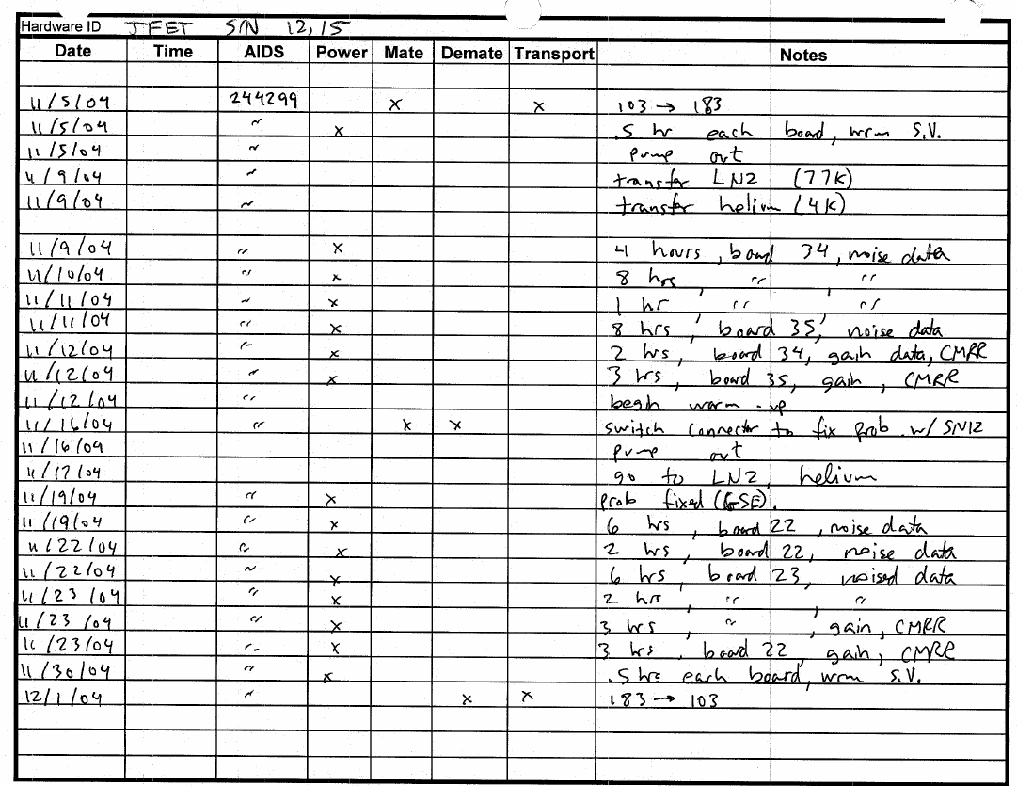
Attachment of HRCR Item # 24 & #25: Mate/Demate & Operation Logs (continued)

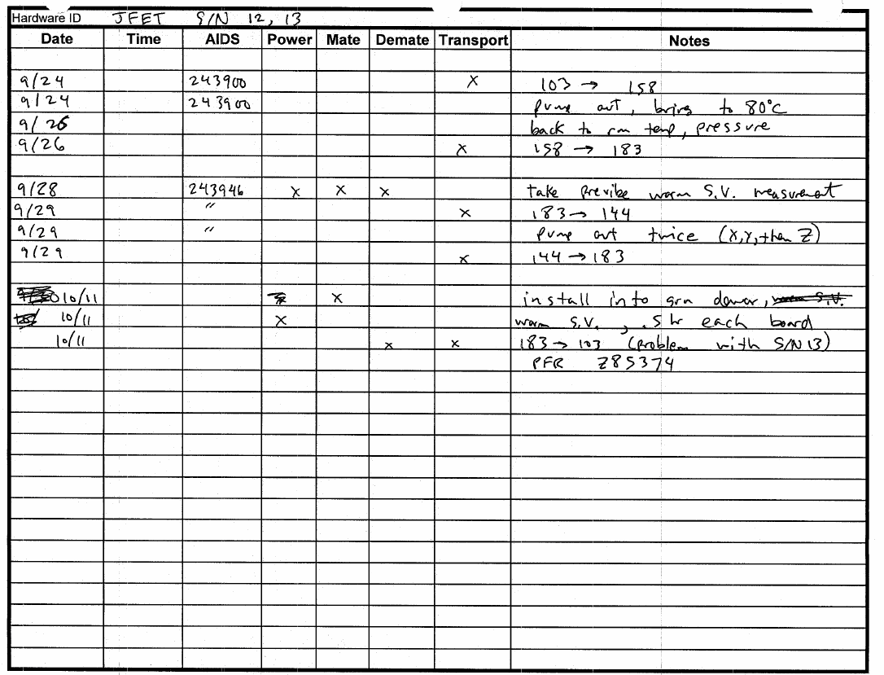
Attachment of HRCR Items # 24 & # 25: Mate/Demate & Operation Logs (PWB S/N 022)
Attachment of HRCR Items # 24 & # 25: Mate/Demate & Operation Logs (PWB S/N 023)
Attachment of HRCR Item # 26: MICD - JFET Interface Drawing 10209722 (p 1 of 2)

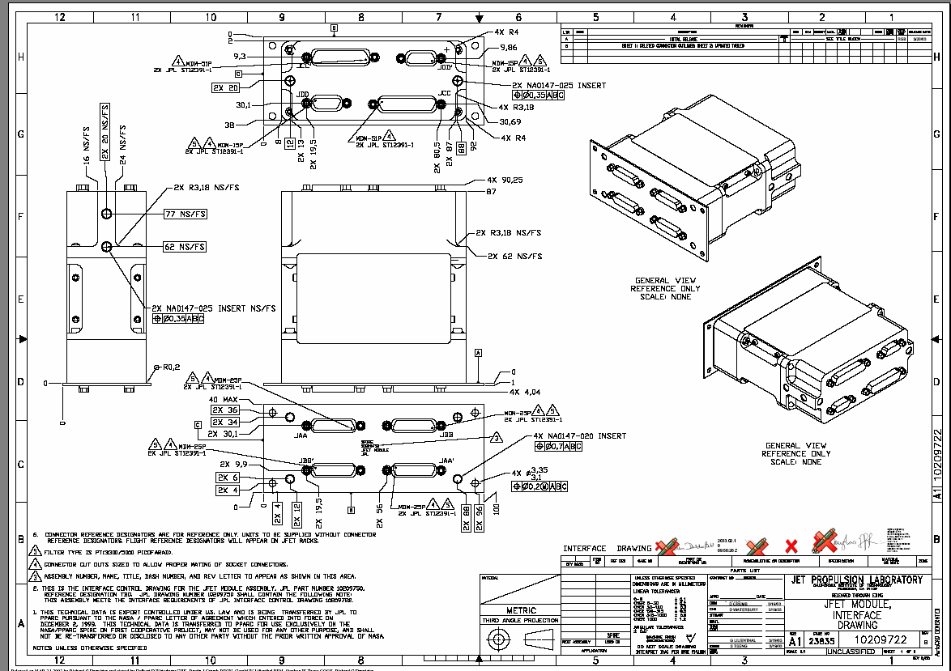
Attachment of HRCR Item # 26: MICD - JFET Interface Drawing 10209722 (p 2 of 2)

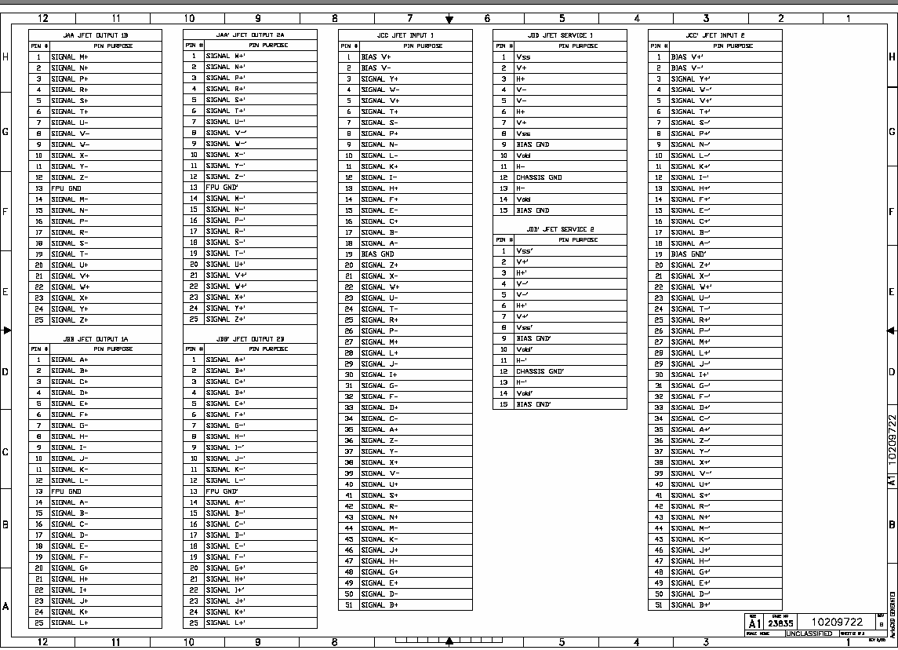

Attachment of HRCR Item # 11:

SPIRE

Handling Document

Field Effect Transistor (JFET) Module

10209750-1

Prepared by: Kalyani Sukhatme

10 September, 2003

Hardware Handling Guidelines

Contamination: Open shipment suitcase in a FED-STD-209 Class 10,000 clean room (ISO 14644-1 class 7) or better. Handle hardware with gloves.

ESD: Handle with grounding straps, ESD-safe gloves and ESD smocks at an ESD-safe workstation. Maintain shorting plugs on the unit whenever ESD is a concern. Refer to attached electrical handling document for other important safety precautions.

Fragile: Do not drop or otherwise shock the hardware including the shipping suitcase and container.

Humidity Sensitive: Place hardware in a humidity controlled Class 10,000 clean room. Maintain humidity level at 35%-50% RH typical, for ESD safety.

SPIRE JFET Electrical Handling Document

1 Introduction 1
1.1 Hardware Description 1
2 Handling 2
3 Power ON Procedure 2
4 Electrical Check-out Test: Characteristic Offset Voltage Measurement 3

1. Introduction
This document provides guidelines for electrical handling for the SPIRE JFET Module.

1.1 Hardware Description

Each JFET module has two sets of 24 JFET channels. The JFET channels are populated on 1.0 micron thick Silicon Nitride membranes which provides thermal isolation. The operating temperature for these JFETs is ~120 K. The process of powering up the JFETs dissipates heat into the membrane resulting in a temperature increase with respect to the base temperature (4K to 10 K). Higher the power dissipation, higher is the temperature of the JFETs.

Each JFET channel consists of a matched pair of FETs (Figure 1.1-1) with a requirement for the offset voltage of less than 15 mV between the matched pair. [The characteristic offset voltage is the difference between the source voltages (V_{sa} and V_{sb} with respect to ground) of the two FETs.]
R_{ss}
Input_{a}
V_{dd}
V_{ss}
Output_{a}
R_{d}
Input_{b}
Output_{b}

(V_{sb})
(V_{sa})

Figure 1.1-1
The Gates of the JFETs are the ‘Inputs’ of the circuit and the Sources (V_{sa} and V_{sb}) of the JFETs are the outputs, as marked in Figure 1.1-1. Vdd and Vss are the power lines for the circuit.

Handling

- The JFET Module is Contamination Sensitive: Handle the unit with Gloves only in a FED-STD-209 Class 100000 clean room (ISO 14644-1 class 7) or better.

- The JFET Module is ESD Sensitive: Please handle with appropriate ESD hardware handling procedures. Handle with grounding straps, ESD-safe gloves, ESD smocks at an ESD-safe workstation.

- The JFET Module is Fragile: Please do not drop or otherwise shock the unit. Please DO NOT remove the cover of the JFET Module.

Power ON Procedure

- The JFET Module should be powered on WITH the shorting plugs (JPL Supplied Protection connectors) in place and with the inputs shorted to ground. Pins #9 and #15 on the 15-pin MDM connectors on the JFET Module are the bias grounds on the module. These pins should also be shorted to the power supply ground. The unit may be powered up without the shorting plug only when the inputs are connected to the detector system.

Under no circumstances the unit should be powered up without the inputs shorted to ground either via the shorting plug (JPL Supplied) or via the detector system.

- Do not exceed a voltage of +5 V for the Vdd line and –5 V for the Vss line of the JFET Module.

- When removing the shorting plugs from the unit for installation into the instrument, please use standard ESD precautions including grounding straps, ESD-safe gloves, ESD smocks at an ESD-safe workstation.

Electrical Check-out Test: Characteristic Offset Voltage Measurement

- Verify that the gates of the JFET channels (Inputs) are shorted together and grounded.
- Apply the power supply ground to the bias ground pins on the unit (Pins 9 and 15 on the 15-pin MDM connectors)
- Power on the JFET modules with Vdd = +3 V and Vss = -1.5 V
- Verify that the handheld multimeter is in calibration.
- Connect one side of the handheld multimeter to ground (Power supply ground).
- And measure the voltage with respect to ground of each side (V_{sa} and V_{sb}) of each channel.
- Calculate the characteristic offset voltage (V_{offset}) for each channel (V_{offset}= V_{sa}-V_{sb})
- Compare the values for each of the channels with the specific datasheet provided with the unit.
The datasheets accompanying the unit also provides the values for the drain and source currents for a similar test performed at JPL.

REFER TO MEASURED SOURCE VOLTAGE DATA FOR ACTUAL HARDWARE. Here is an example of the source voltage values and the drain and the source currents obtained for such a test at room temperature are given in the Table 4-1

T, JFET | rm T
Vdd | 3 V
Vss | -1.5 V
Idd | 1.564 mA
Iss | 1.5686 mA
Channel # | (V) | DELTA (V)
1 | 1.130 | 0
1 | 1.130 | 0
2 | 1.075 | 0.001
2 | 1.074 | 0.001
3 | 0.781 | 0.001
3 | 0.780 | 0.001
4 | 1.088 | 0.005
4 | 1.093 | 0.005
5 | 0.834 | 0.001
5 | 0.833 | 0.001
6 | 1.012 | 0.003
6 | 1.015 | 0.003
7 | 0.785 | 0.002
7 | 0.787 | 0.002
8 | 1.148 | 0.004
8 | 1.144 | 0.004
9 | 0.753 | 0
9 | 0.753 | 0
10 | 0.693 | 0.008
10 | 0.701 | 0.008
11 | 1.110 | 0.004
11 | 1.114 | 0.004
12 | 0.758 | 0.001
12 | 0.759 | 0.001
13 | 0.832 | 0.002
13 | 0.830 | 0.002
14 | 1.264 | 0.001
14 | 1.265 | 0.001
15 | 1.206 | 0
15 | 1.206 | 0
16 | 0.818 | 0.001
16 | 0.819 | 0.001
17 | 0.526 | 0.005
17 | 0.521 | 0.005
18 | 1.423 | 0
18 | 1.423 | 0
19 | 0.773 | 0.002
19 | 0.775 | 0.002
20 | 0.873 | 0.004
20 | 0.877 | 0.004
21 | 1.387 | 0.006
21 | 1.393 | 0.006
22 | 1.417 | 0.003
22 | 1.420 | 0.003
23 | 0.887 | 0.002
23 | 0.889 | 0.002
24 | 0.888 | 0.003
24 | 0.891 | 0.003

- END OF -
Attachment of HRCR Item # 11:
JFET Module Handling Document

END OF

HRCR PACKAGE

