Assembly / Subsystem |  | PEM |  |  |  | Phone |  | Section |  | Date
SPIRE |  | Martin Herman |  |  |  | (818) 354-8541 |  | 385 |  | 10 June, 2005
Drawing/ Part No. | Dwg. Rev. | Nomenclature |  |  |  | Serial No. | Model | Type | Final IR No. | Mass (Meas. / Req.)
10209750-1 | B | JFET Module |  |  |  | 019 | FLT-Spare | N/A | 926200 | 276 gm / 305 gm
Check applicable answer and provide explanation in remarks column |  | YES | NO | N  A | R e m a r k s |  |  | Data Attachments |  | Signature & Date
1. Are all drawings and specifications complete, approved, released and frozen? |  | X |  |  |  |  |  | 14. Latest Top Assembly drawings  Attached None |  | Cognizant Engineer
2. Do the released drawings and specifications reflect all approved changes? |  | X |  |  |  |  |  | 15. List of open ECRs  Attached None |  | PEM
3. Is hardware identical to other hardware delivered? If no, provide difference list. |  | X |  |  |  |  |  | 16. Waivers (RFW request for waiver)  Attached None |  | QA Engineer
4. Does the hardware meet its functional requirements, specifications, waivers, ICDs? |  | X |  |  | EIDP attached.  Also see item # 8 attachments. |  |  | 17. Open MRB  Attached None |  | Environments/Reliability
5. Are all IR and MRB dispositioned and concurred by QA? |  | X |  |  |  |  |  | 18. Open PFR on this H/W  Attached None |  | Mission Assurance Mgr.
6. Is complete as-built list information included in the build book? |  | X |  |  |  |  |  | 19. Open PFR on similar H/W  Attached None |  | Project Office
7. Have all required environmental tests & analyses been completed? |  | X |  |  | ETAS attached |  |  | 20. Handling Document →See Item 11  Attached None |  | P I
8. Is all required assembly and/or subsystem level functional testing complete? |  | X |  |  | Performance Test Data Attached.  Also see EIDP in item # 4. |  |  | 21. Shortage List  Attached None
9. Have all piece parts, processes and materials been approved by JPL? |  | X |  |  |  |  |  | 22. Requirements Verification Matrix  Attached (See #4, #7, #8) None
10. Does this hardware meet all contamination control requirements? |  | X |  |  | Parts, processes and MIUL met all contamination control and out-gassing requirements. |  |  | 23. Qualification Status  Attached None
11. Are all shipping containers, shipping and special handling procedures ready? |  | X |  |  | See Attached Document D-26790 |  |  | 24. Mate / Demate Record  Attached None
12. Is additional work required to bring this hardware to flight (flight-spare) readiness? |  |  | X |  |  |  |  | 25. Operating Log  Attached (See Item # 24) None
13. Is this hardware acceptable for flight? |  | X |  |  |  |  |  | 26. MICD  Attached None

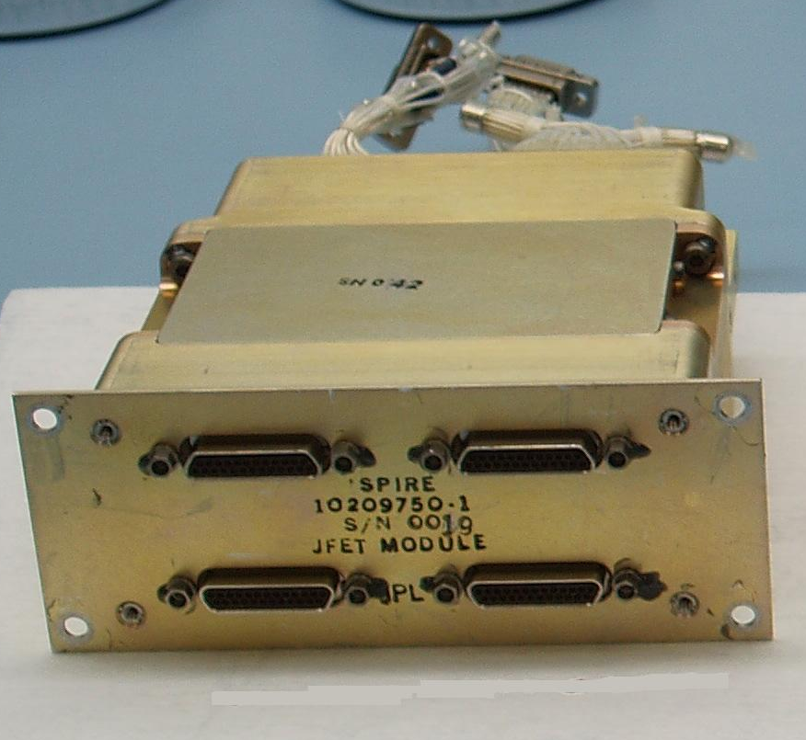

RAL EIDP Table of Contents Versus JPL HRCR Check List Item Numbers

RAL EIDP  Section Number | RAL EIDP Title | JPL HRCR Check List Item Number | Notes
1 | Shipping Documents |  | Shipper and Final IR
2 | Transportation, Packing, Handling  & Integration Procedures | 11 | Special Handling Document D-26790
3 | Certificate of Conformance /  Delivery Review Board MOM |  | HRCR book is the C of C
4 | As Built Configuration Status List | 1 & 2 | Assembly Drawings
5 | List of Waivers | 4 | RFW (request for waiver) Attached
6 | Copies of Waivers | 4 & 7 | RFW (request for waiver) Attached
7 | List of Non-Conformance Reports |  | See RFW in 4 & 7
8 | Copies of Non-Conformance Reports |  | See RFW in 4 & 7
9 | Cleanliness Statement |  | Final IR QA Inspection
10 | Operational Manual |  | NA
11 | Top Level Drawings (inc. Family Tree) | 14 | Top Assembly Drawing
12 | Interface Drawings | 26 | MICD Drawing
13 | Functional, Block & Mechanical Drawings |  | NA
14 | Electrical Circuit Drawings |  | NA
15 | Serialized Components List |  | In build books – not shipped
16 | Mass Properties/ Power Budget | HRCR Check List Page 1 | Mass listed in HRCR check list
17 | Qualification Status List / Test Matrix | 23 | Qualification Unit Test Matrix
18 | Test Reports | 4, 7, 8, 23
19 | Open Work / Deferred Work / Open Tests |  | NA
20 | Calibration Data |  | NA
21 | Historical Record | 23 | Qualification Unit Test Matrix
22 | Manufacturing Logbook(s) |  | In build books – not shipped
23 | Operating Time / Cycle Record | 25
24 | Connector Mating Record | 24
25 | Age Sensitive Items Record |  | NA
26 | Pressure Vessels – History/Test Record |  | NA
27 | Temporary Installation Record |  | NA
28 | Reference List of EIDPs (Lower level) |  | NA
29 | Other Useful Information |  | NA

JPL Hardware Requirements
Certification Review (HRCR)

Junction Field Effect Transistor (JFET)
Flight Module

10209750-1 S/N 019

SPIRE Element
Herschel Space Observatory Project

June 10, 2005

Configuration of Module, Boards & Membranes

Module 10209750-1 | S/N 19 | S/N 19
PWB 10209760-1 | S/N 42 | S/N 44
Membrane 10209758-1 | J6.15.6 | J6.11.1

Attachment of HRCR Items #1
Drawing Release Status

ALL ASSEMBLY & PARTS DRAWINGS ARE RELEASED IN PDMS

Released Drawings:

10209719-1 assembly built per released Rev. A drawing (studlock)

10209722-1 assembly built per released Rev. B drawing (interface drawing)

10209750-1 assembly built per released Rev. B drawing (module assy)

10209751-1 assembly built per released Rev. B drawing (chassis 1)

10209752-1 assembly built per released Rev. A drawing (chassis 2)

10209753-1 assembly built per released Rev. A drawing (chassis 3)

10209754-1 assembly built per released Rev. C drawing (mount)

10209756-1 assembly built per released Rev. B drawing (chassis lid)

10209757-1 assembly built per released Rev. A drawing (membrane)

10209758-1 assembly built per released Rev. A drawing (membrane assy)

10209759-1,-2,-4 redlined Rev. B drawing (gasket)

10209760-1 assembly built per released Rev. C drawing (board assembly)

10209761-1 assembly built per released Rev. C drawing (solder connector)

10209769-1 assembly built per released Rev. A drawing (stiffener)

10209777-1 assembly built per released Rev. B drawing (board)

10209858-2 assembly built per released Rev. A drawing (special fastener)

10217636-1 assembly built per released Rev. A drawing (clip)
Attachment of HRCR Item #4: EIDP (End Item Data Package)

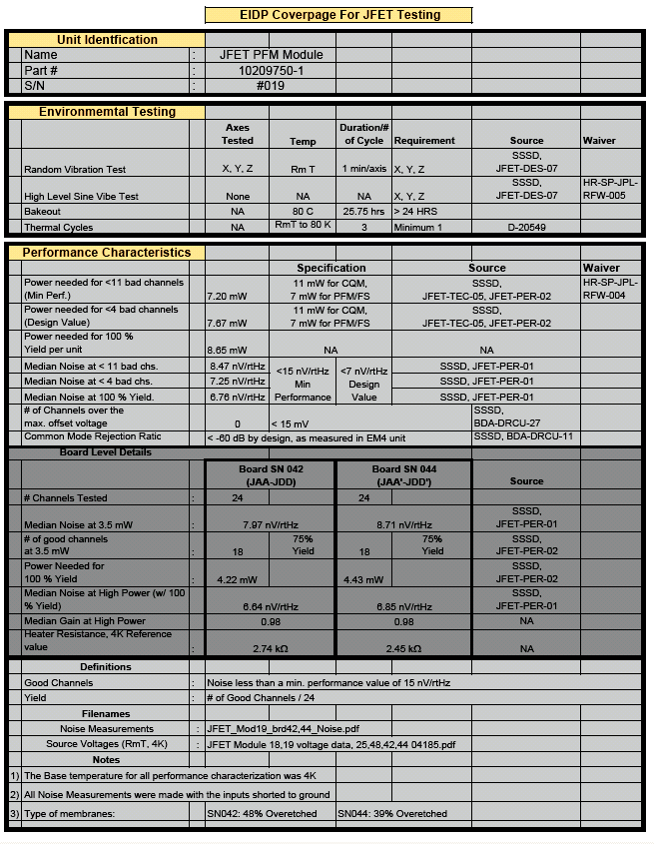
Attachment of HRCR Item # 4: RFW (Request For Waiver)

 |  |  |  | RFW/RFD Number: |  |  |  |  | HR-SP-JPL-RFW-21
Spacecraft / Project | Herschel |  |  | Originator’s Name |  |  |  | Steve Tseng
System / Experiment / Model | SPIRE |  |  | Signature / Date
Sub-System | detectors |  |  | Request Type  (Highlight applicable request) |  |  |  | Waiver (RFW) |  |  |  | Deviation (RFD)
Assembly | JFET modules |  |  | Organisation |  |  |  | Jet Propulsion Laboratory
Sub-Assembly |  |  |  | Ref. Doc. / Drwg No. |  |  |  | SPIRE-JPL-PRJ-000456
Item |  |  |  | References
Serial No.
RFW/RFD Title | JFET Power Dissipation s/n 019
End Items(s) Affected (Hardware, Software)
Name |  |  | CI-Number |  |  |  |  | Model(s)
JFET Module p/n 10209750 s/n 019 |  |  |  |  |  |  |  | PFM
Requirement / Interface Documents Affected
Specification/Drawing Title |  | Number |  |  | Issue |  | Date |  |  | App. Paragraph
BDA-SSSD |  | SPIRE-JPL-PRJ-0004456 |  |  | 3.2 |  | 7/1/03 |  |  | JFET-PER-01  JFET-PER-02  JFET-TEC-05
Description of Deviation / Discrepancy / Non-Conformance
Requirement states that dissipation of photometer JFETs is to be less than 7 mW average, while supplying 90% of channels with voltage noise < 15 nV/rtHz according to BDA-SSSD JFET-PER-01, JFET-PER-02, JFET-TEC-05.
Measured JFET performance of the JFETs indicates that 7.20 mW of power dissipation will be required to meet the specified yield and noise performance specifications.

Other Items or Requirements (Potentially) Affected
Overall sensitivity of the bolometer sub-system is affected by JFET noise performance. JFET power dissipation impacts the heat sink temperature of the 3He refrigerator and may in turn increase the base detector temperature.
Dissipation of JFETs affects power dissipation on cryostat.
Need for RFW/RFD and Rationale for Acceptance
Measured JFET performance of JFETs indicates that 7.20 mW of power dissipation will be required to meet the specified yield and noise performance specifications. JPL is unable to significantly alter the JFET fabrication process in order to meet the power specification without undue risk to the stated PFM/FS delivery dates. Furthermore, JPL requests a full system optimisation to revisit the noise and power requirements on the JFETs. The JFET modules can meet the noise design value with 100 % yield at 8.65 mW.

 | Approved |  | Rejected |  |  | Name |  |  |  |  | Date
Engineering:
Product Assurance:
CCB-Chairman:
Principal Investigator
Product Assurance:
Co-Investigator
Prime Contractor
ESA Project Office

Attachment of HRCR Item #7: RFW (Request For Waiver)

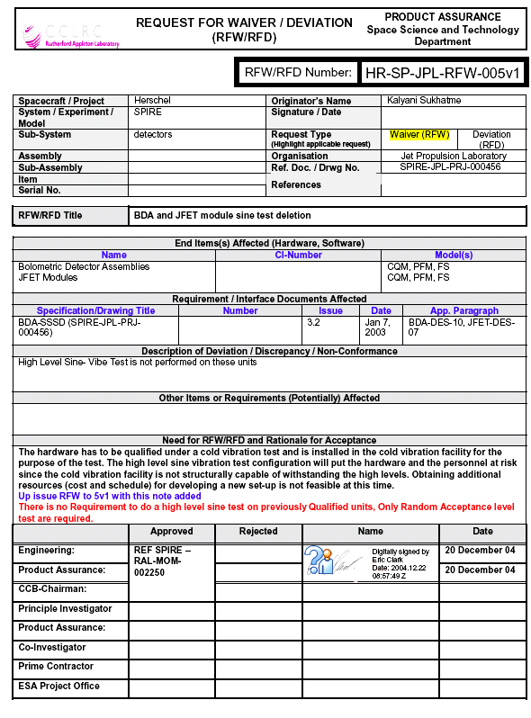
Attachment of HRCR Item #7: ETAS (Environmental Test Summary)
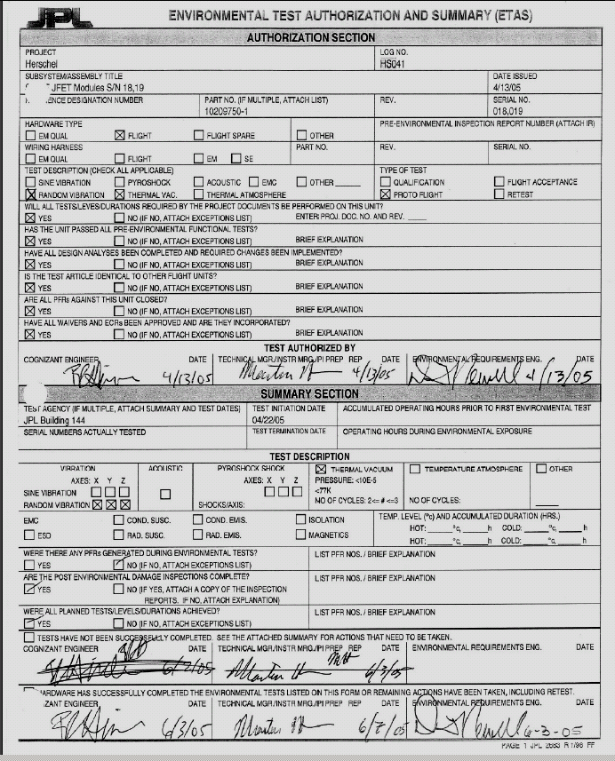
Attachment of HRCR Item #7: ETAS (Environmental Test Summary)
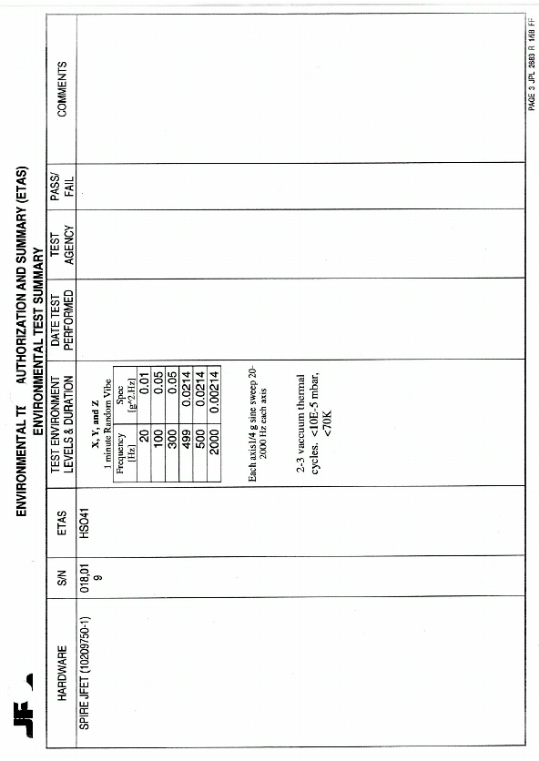
Attachment of HRCR Item #7: ETAS (Environmental Test Summary)
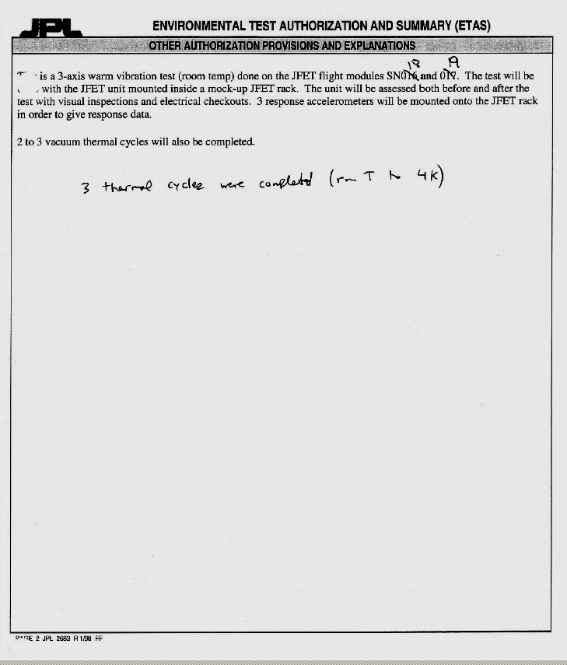
Attachment of HRCR Item # 8: Test Data - Source Voltage Data

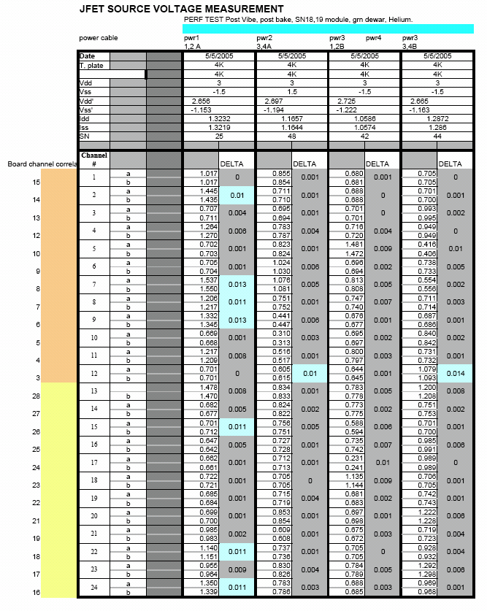
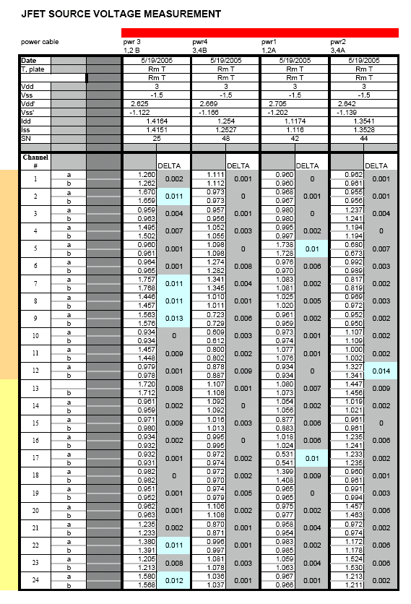
Attachment of HRCR Item # 8: Noise Test Data
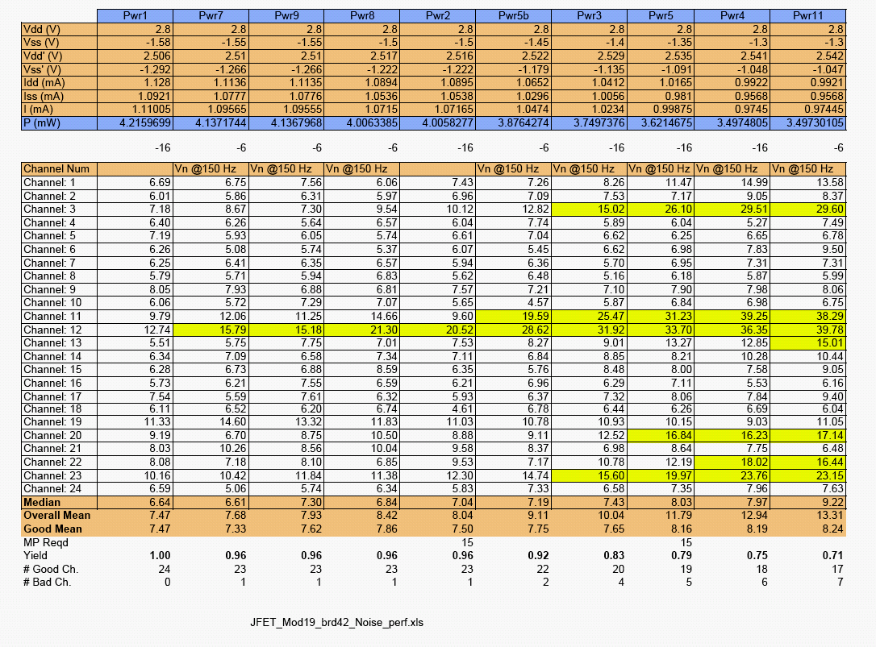

Attachment of HRCR Item # 8: Test Data - Source Voltage & Noise

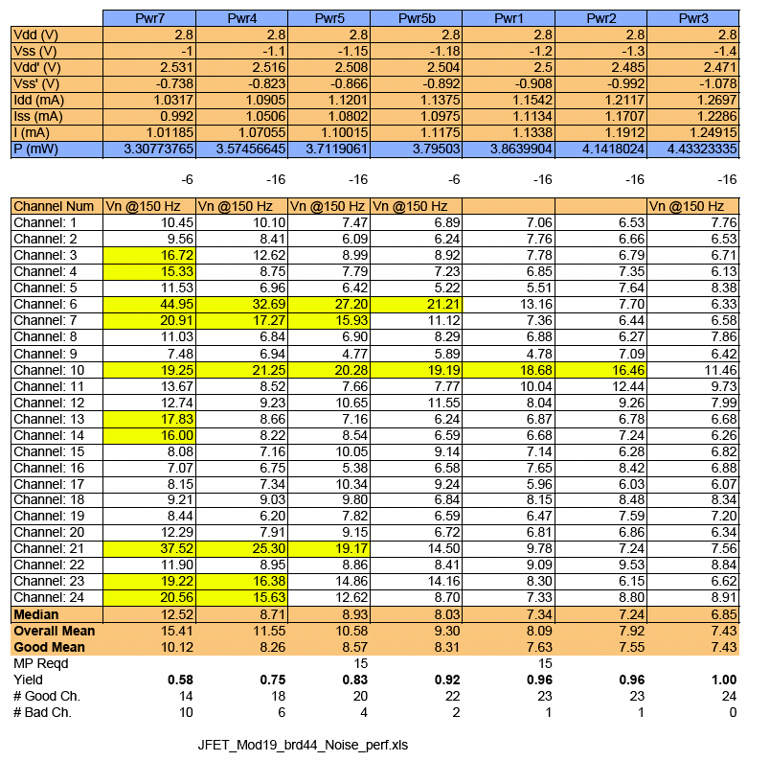

Attachment of HRCR Item # 9: SPIRE MIUL Cover Page
MIUL = Material Identification & Utilization List
Declared Materials List's and Processes List are not included in this HRCR

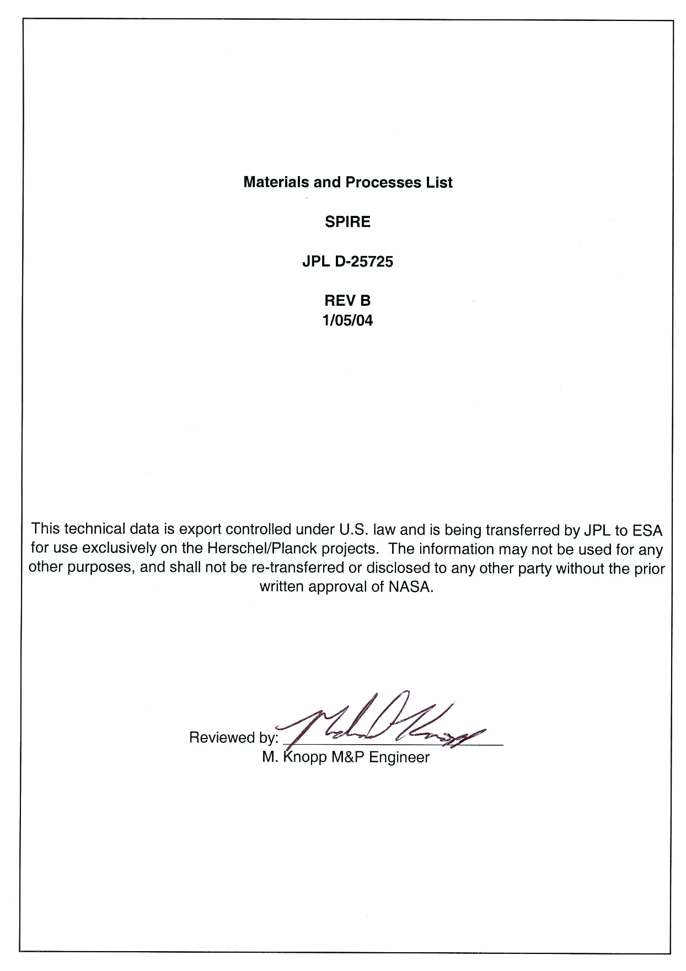

Attachment of HRCR Item # 11:

See End of This HRCR Package for
“JFET Module Handling Document”

Attachment of HRCR Item # 14: JFET Module Top Assembly Drawing 10209750-1
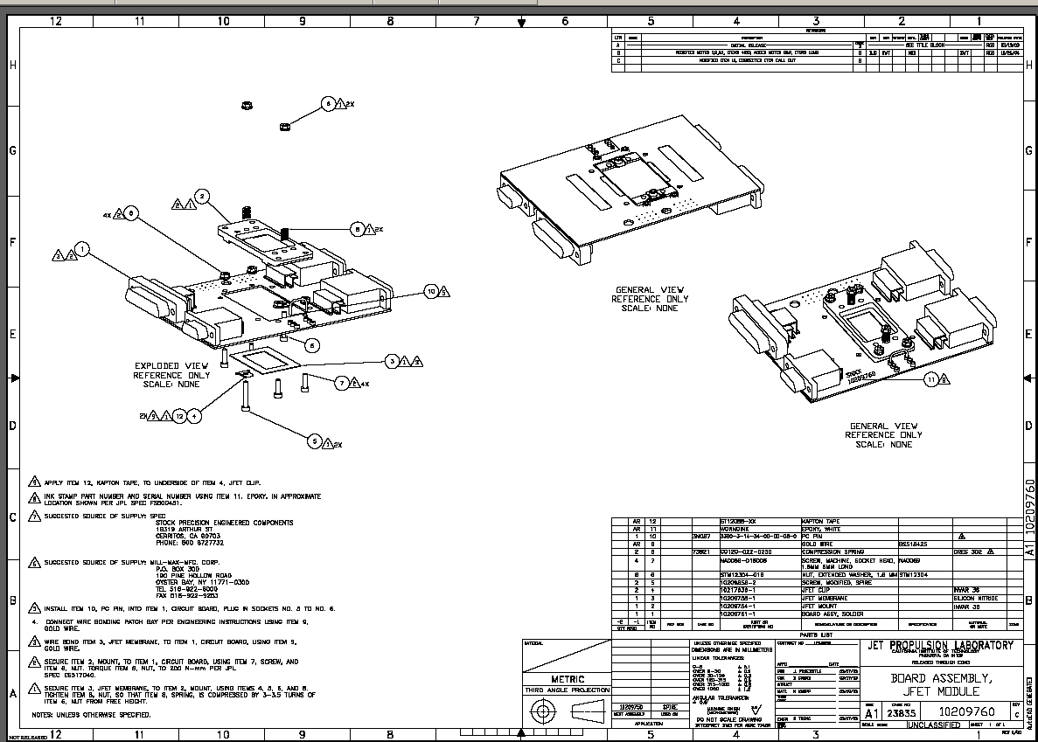
Attachment of HRCR Item # 23: Qualification Compliance Test

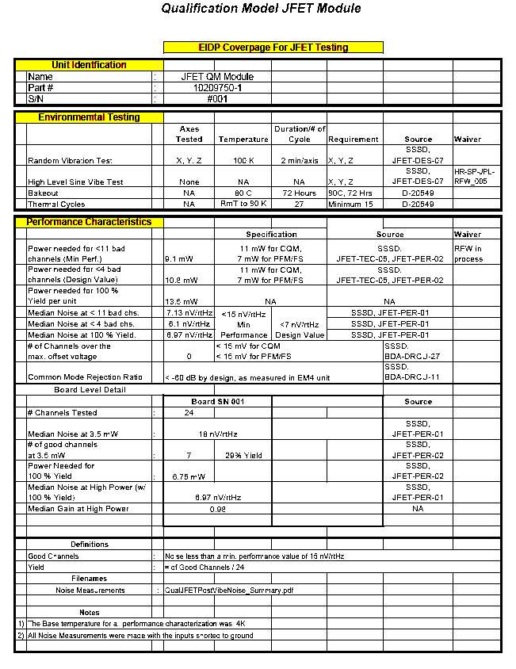
Attachment of HRCR Item # 24 & #25: Mate/Demate & Operation Logs

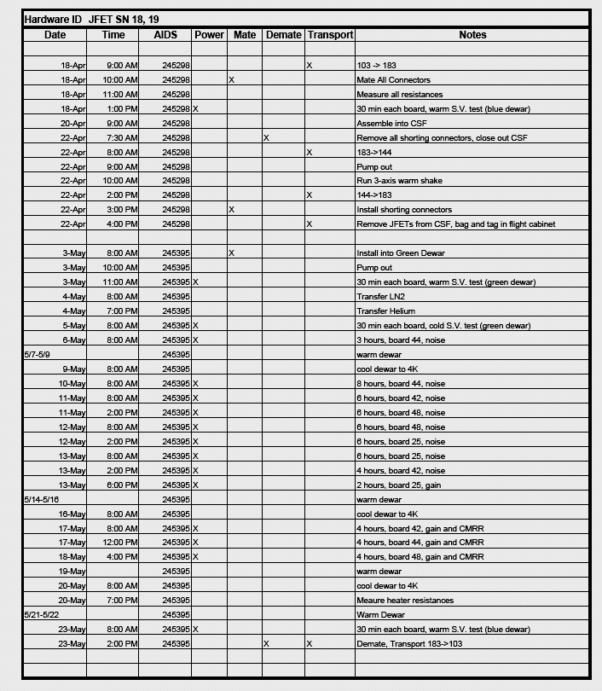
Attachment of HRCR Item # 24 & #25: Mate/Demate & Operation Logs (continued)

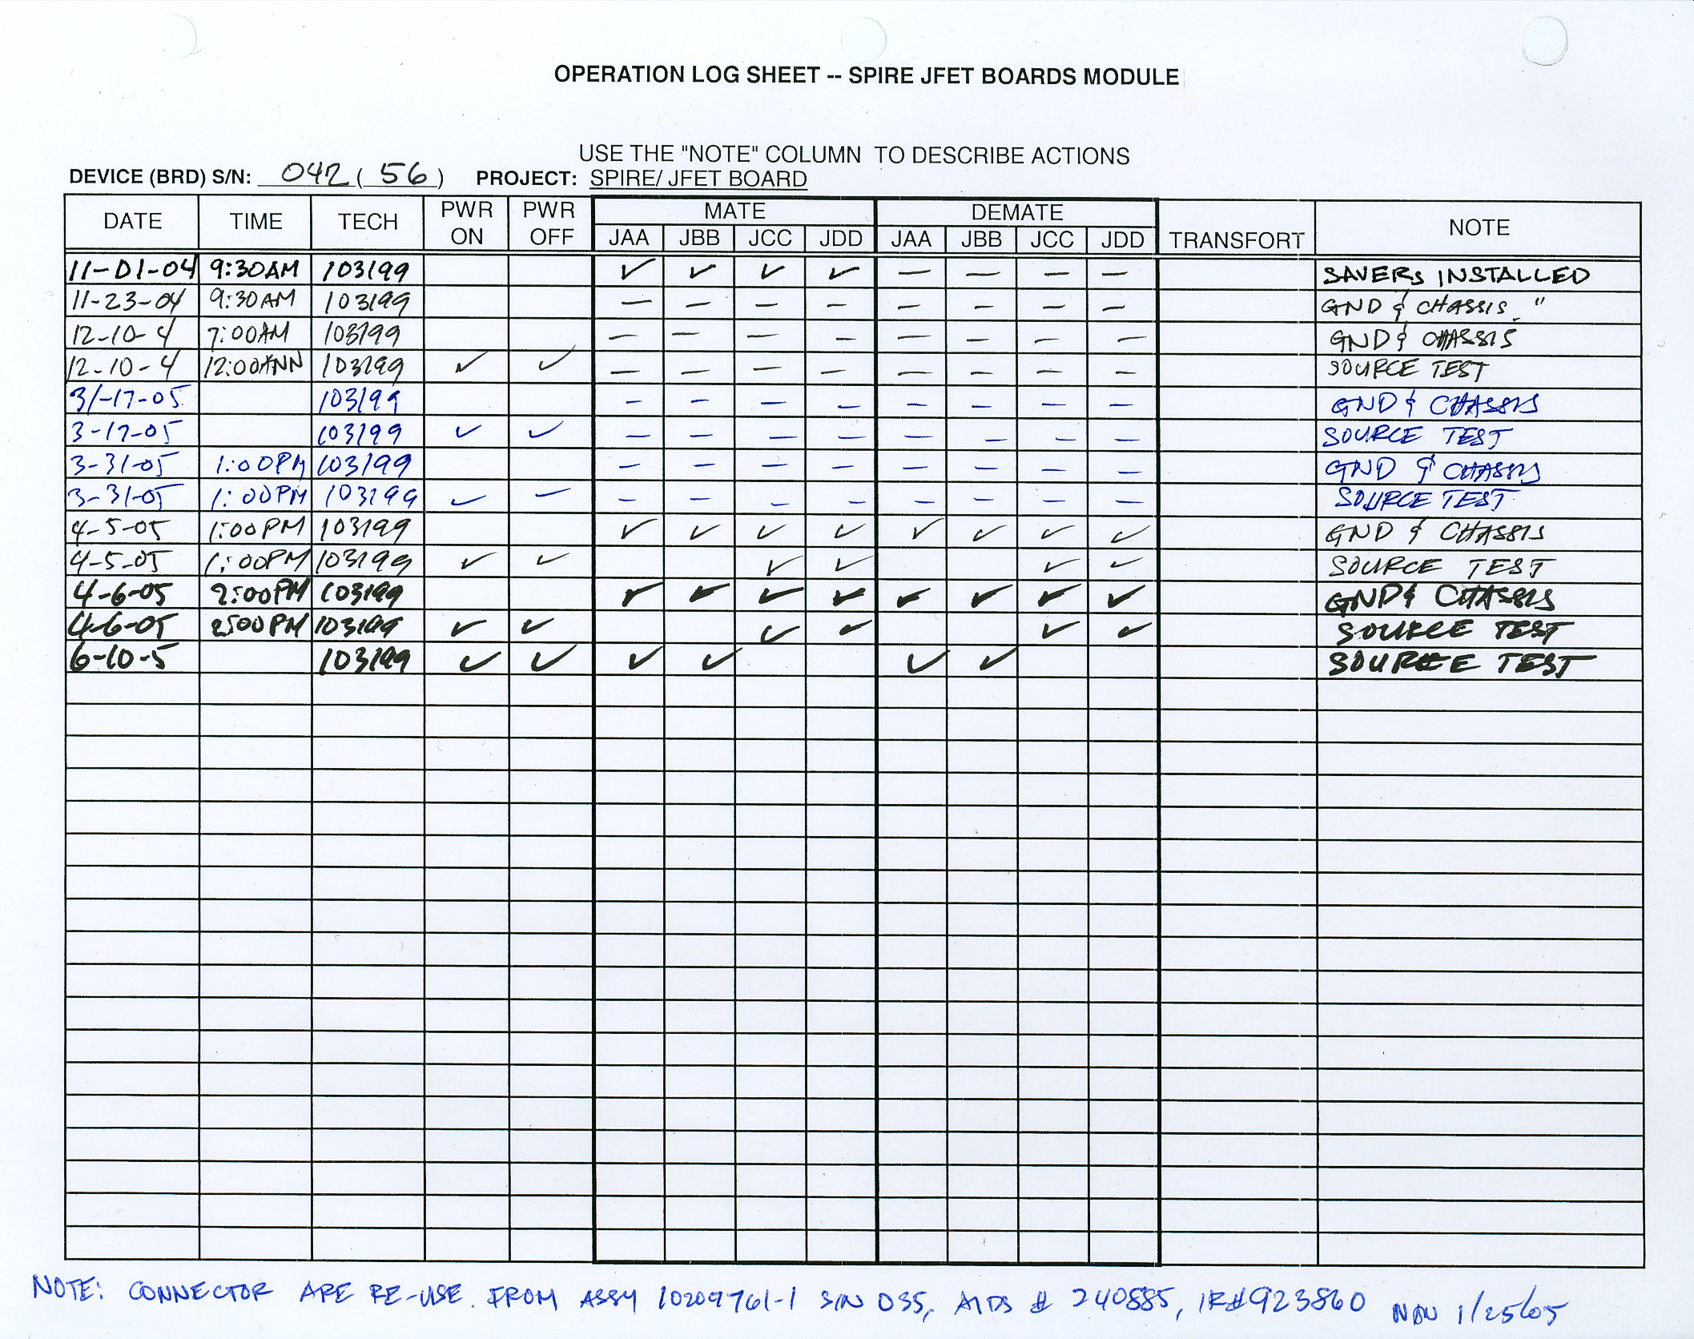
Attachment of HRCR Items # 24 & # 25: Mate/Demate & Operation Logs
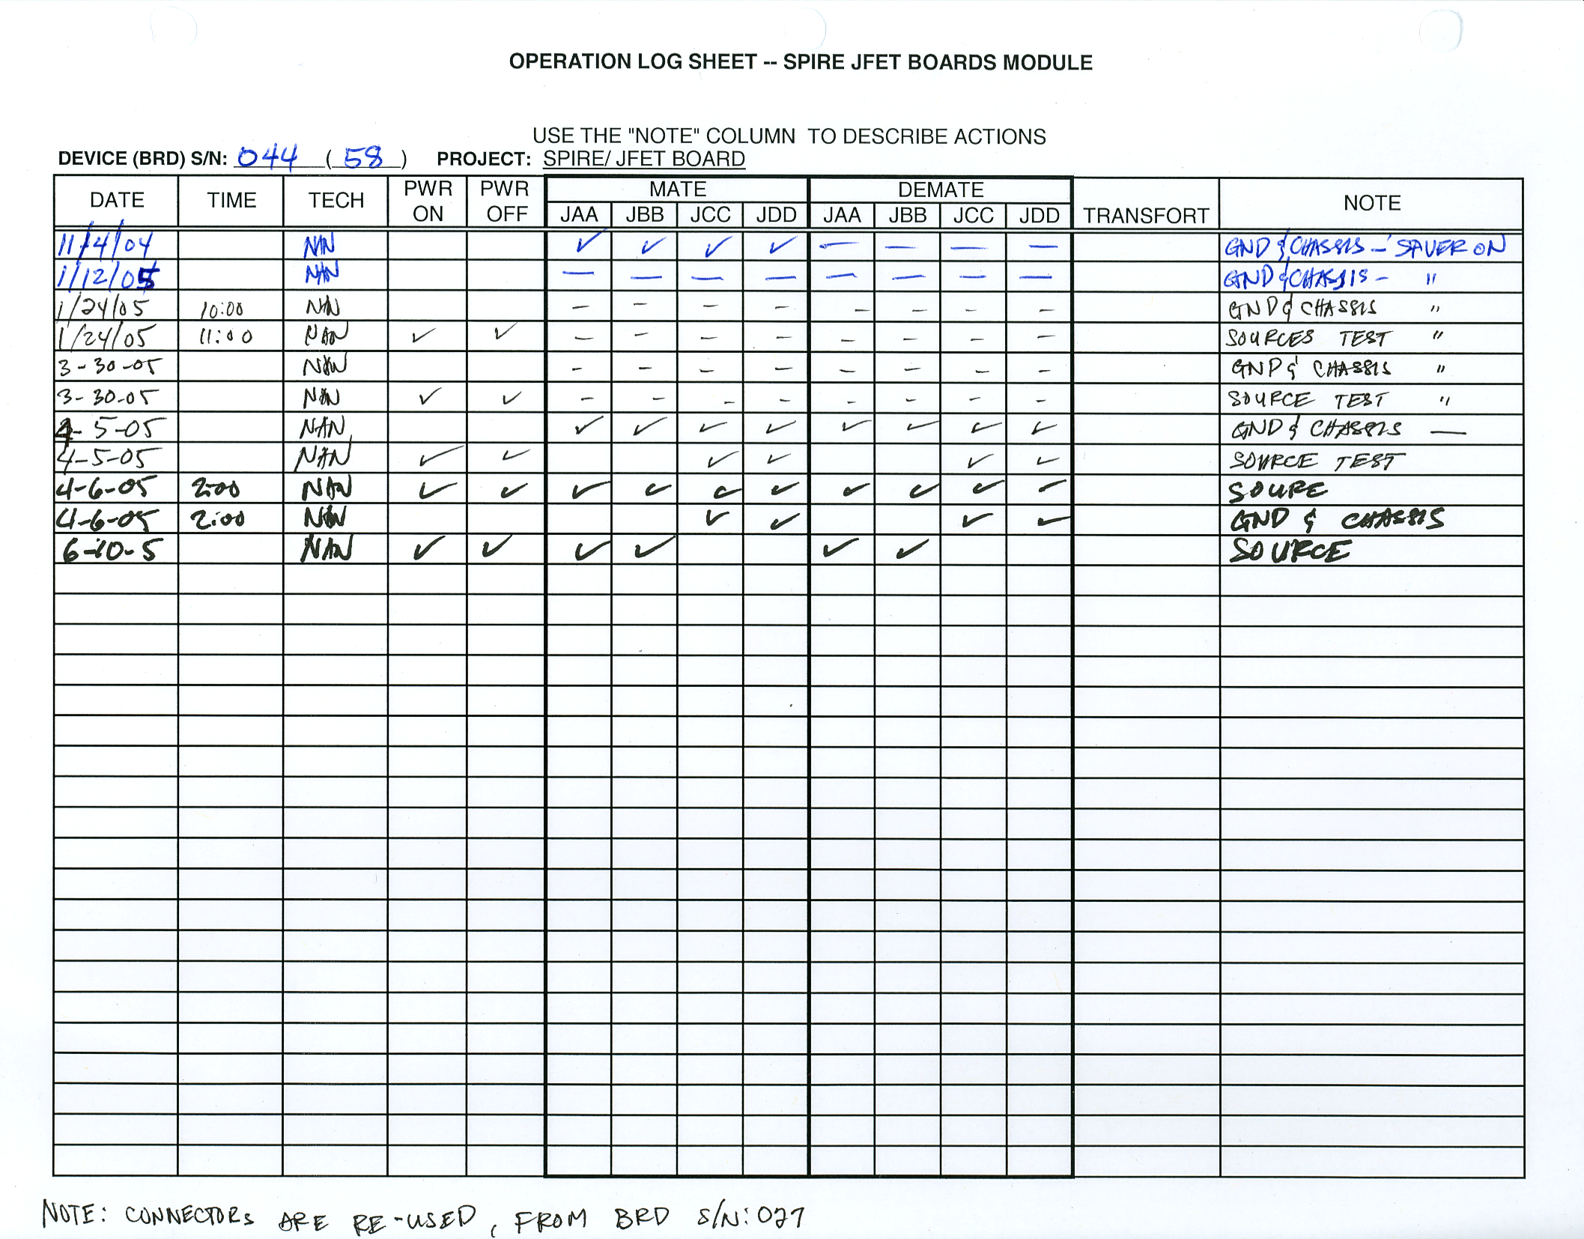
Attachment of HRCR Item # 26: MICD - JFET Interface Drawing 10209722 (p 1 of 2)

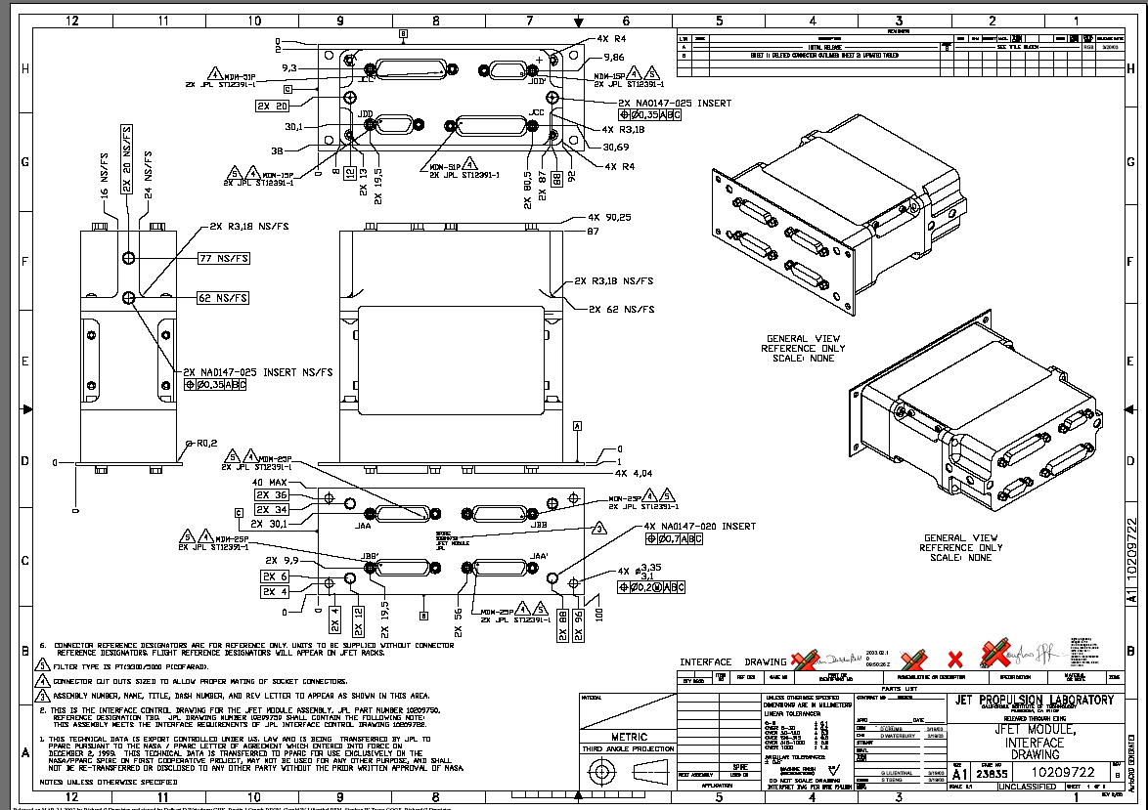
Attachment of HRCR Item # 26: MICD - JFET Interface Drawing 10209722 (p 2 of 2)

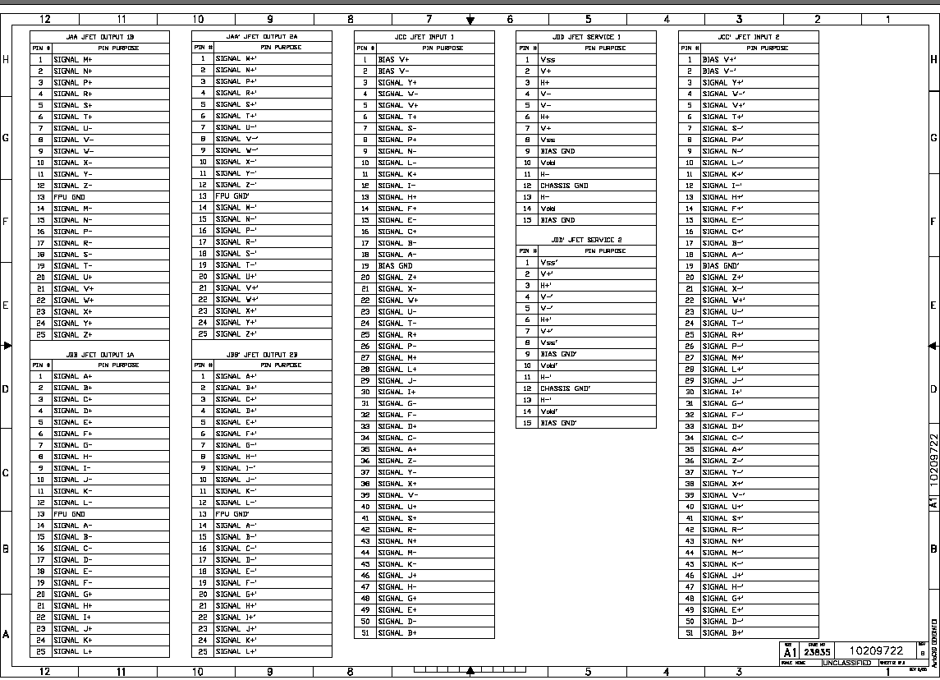

Attachment of HRCR Item # 11:

JFET Module

Handling Document D-26790

Field Effect Transistor (JFET) Module 10209750-1

Prepared by: Kalyani Sukhatme 10 September, 2003

Revised by: Roger Welker & Steve Tseng 15 June, 2005
D-26790

1. Introduction
This document provides guidelines for electrical handling for the SPIRE JFET Module.

1.1 Hardware Description

Each JFET module has two sets of 24 JFET channels. The JFET channels are populated on 1.0 micron thick Silicon Nitride membranes which provides thermal isolation. The operating temperature for these JFETs is ~120 K. The process of powering up the JFETs dissipates heat into the membrane resulting in a temperature increase with respect to the base temperature (4K to 10 K). Higher the power dissipation, higher is the temperature of the JFETs.

Each JFET channel consists of a matched pair of FETs (Figure 1.1-1) with a requirement for the offset voltage of less than 15 mV between the matched pair. [The characteristic offset voltage is the difference between the source voltages (V_{sa} and V_{sb} with respect to ground) of the two FETs.]
R_{ss}
Input_{a}
V_{dd}
V_{ss}
Output_{a}
R_{d}
Input_{b}
Output_{b}

(V_{sb})
(V_{sa})

Figure 1.1-1
The Gates of the JFETs are the ‘Inputs’ of the circuit and the Sources (V_{sa} and V_{sb}) of the JFETs are the outputs, as marked in Figure 1.1-1. Vdd and Vss are the power lines for the circuit.

2. Handling

- The JFET Module is Contamination Sensitive: Open shipment suitcase in an ISO 14644 Class 7 (FED-STD-209 Class 10,000) or cleaner cleanroom. Handle hardware with approved nitrile or polyurethane ESD safe cleanroom gloves.

D-26790
- The JFET Module is ESD Sensitive:

Please handle with appropriate ESD hardware handling procedures. Handle with grounding straps, ESD-safe gloves, ESD smocks at an ESD-safe workstation.

ESD: Handle with approved wrist straps, ESD-safe gloves and ESD smocks at an approved ESD protected workstation. All personnel within 1 meter of unprotected ESD sensitive hardware shall be certified for ESD awareness. Maintain shorting plugs on the unit at all times, except when the unit is installed in the final assembly of the SPIRE instrument. JFET modules are shipped with two shorting plugs for ESD protection. Refer to attached electrical handling document for other important safety precautions. Follow all instructions for the use of wrist straps, ESD smocks, static protected work areas, ionizers, packing/unpacking and cable handling per JPL standard D-1348, rev. F (This document is available through the public domain by the following URL: http://acquisition.jpl.nasa.gov/rfp/miri/dewar/DL-2671-584331/JPL_D-1348.pdf).

ESD - Ionizer: Prior to mate or demate of any connector, turn on an ionizer approved for ESD sensitive components in clean room environment at least 5 minutes in advance and place/hold both sides of the connections in front of the ionized air stream for a minimum of 10 seconds before mating/demating operation. Position the ionizer near the hardware within the required distance per manufacturer’s manual. Different makes and models of ionizers have different positioning requirements. During the mating/demating operations, it is necessary to follow the requirements for handling ESD sensitive hardware.

ESD - Connection to GSE: It is essential to ensure that all signal and bias lines of the GSE are grounded prior to mating the JFET hardware to the GSE. A save-to-mate check must be performed prior to connecting the JFET to the GSE. No excessive voltages and currents on all signal and bias lines shall be observed while the hardware is connected.
QA Oversight: Quality Assurance personnel should witness all handling, electrical testing, operation and integration of JFET flight hardware. At a minimum, a "two person" rule should be invoked at all times, where oversight by an independent party is provided to ensure hardware safety during handling, test and integration operations.

Humidity Sensitive: Place hardware in a humidity controlled ISO 14644 Class 7 (FED-STD 209 Class 10,000) cleanroom. Maintain humidity level at 35%-50% RH typical, for ESD safety.

- The JFET Module is Fragile: Please do not drop or otherwise shock the unit including the shipping suitcase and container. Do not remove the cover of the JFET Module.

D-26790

3. Power ON Procedure

- The JFET Module should be powered on WITH the shorting plugs (JPL Supplied Protection connectors) in place and with the inputs shorted to ground. Pins #9 and #15 on the 15-pin MDM connectors on the JFET Module are the bias grounds on the module. These pins should also be shorted to the power supply ground. The unit may be powered up without the shorting plug only when the inputs are connected to the detector system.

Under no circumstances the unit should be powered up without the inputs shorted to ground either via the shorting plug (JPL Supplied) or via the detector system.

- Do not exceed a voltage of +5 V for the Vdd line and –5 V for the Vss line of the JFET Module.

- When removing the shorting plugs from the unit for installation into the instrument, please use standard ESD precautions including grounding straps, ESD-safe gloves, ESD smocks at an ESD-safe workstation.

4. Electrical Check-out Test: Characteristic Offset Voltage Measurement

- Verify that the gates of the JFET channels (Inputs) are shorted together and grounded.
- Apply the power supply ground to the bias ground pins on the unit (Pins 9 and 15 on the 15-pin MDM connectors)
- Power on the JFET modules with Vdd = +3 V and Vss = -1.5 V
- Verify that the handheld multimeter is in calibration.
- Connect one side of the handheld multimeter to ground (Power supply ground).
- And measure the voltage with respect to ground of each side (V_{sa} and V_{sb}) of each channel.
- Calculate the characteristic offset voltage (V_{offset}) for each channel (V_{offset}= V_{sa}-V_{sb})
- Compare the values for each of the channels with the specific datasheet provided with the unit.
The datasheets accompanying the unit also provides the values for the drain and source currents for a similar test performed at JPL.

REFER TO MEASURED SOURCE VOLTAGE DATA FOR ACTUAL HARDWARE. Here is an example of the source voltage values and the drain and the source currents obtained for such a test at room temperature are given in the Table 4-1

T, JFET | rm T
Vdd | 3 V
Vss | -1.5 V
Idd | 1.564 mA
Iss | 1.5686 mA
Channel # | (V) | DELTA (V)
1 | 1.130 | 0
1 | 1.130 | 0
2 | 1.075 | 0.001
2 | 1.074 | 0.001
3 | 0.781 | 0.001
3 | 0.780 | 0.001
4 | 1.088 | 0.005
4 | 1.093 | 0.005
5 | 0.834 | 0.001
5 | 0.833 | 0.001
6 | 1.012 | 0.003
6 | 1.015 | 0.003
7 | 0.785 | 0.002
7 | 0.787 | 0.002
8 | 1.148 | 0.004
8 | 1.144 | 0.004
9 | 0.753 | 0
9 | 0.753 | 0
10 | 0.693 | 0.008
10 | 0.701 | 0.008
11 | 1.110 | 0.004
11 | 1.114 | 0.004
12 | 0.758 | 0.001
12 | 0.759 | 0.001
13 | 0.832 | 0.002
13 | 0.830 | 0.002
14 | 1.264 | 0.001
14 | 1.265 | 0.001
15 | 1.206 | 0
15 | 1.206 | 0
16 | 0.818 | 0.001
16 | 0.819 | 0.001
17 | 0.526 | 0.005
17 | 0.521 | 0.005
18 | 1.423 | 0
18 | 1.423 | 0
19 | 0.773 | 0.002
19 | 0.775 | 0.002
20 | 0.873 | 0.004
20 | 0.877 | 0.004
21 | 1.387 | 0.006
21 | 1.393 | 0.006
22 | 1.417 | 0.003
22 | 1.420 | 0.003
23 | 0.887 | 0.002
23 | 0.889 | 0.002
24 | 0.888 | 0.003
24 | 0.891 | 0.003
- END OF -
Attachment of HRCR Item # 11:
“JFET Module Handling Document D-26790”

END OF

HRCR PACKAGE

JPL approved ESD safe cleanroom gloves are: Nitrile: Ansell-Edmont Nitrilite http://www.ansellpro.com/ce/products3.asp?pid=87 Ansell-Edmont Nitrilite Silky http://www.ansellpro.com/ce/products3.asp?pid=149 Ansell-Edmont Silky Ultra-Clean http://www.ansellpro.com/ce/products3.asp?pid=150 Safeskin Critical (white) http://www.safeskin.com/crit_nt_glv.asp Polyurethane: Wilshire Technology DuraCLEAN call in US, 323-259-6469 for ordering information
JPL approved wrist straps are: Speidel Twist-o-Flex ™ brand metal expansion bracelet wrist straps 3M model 4600 adjustable molded thermoplastic wrist straps
All work areas shall be certified and operated in compliance with the requirements of the following subsections sections of JPL-STD D-1348 rev. F section 2.3: subsections: 6, 8-11, 14-19, 21, 23 – 27, 29 – 36, 38 – 43 and 45.
All personnel shall be trained and certified to the requirements of section 2.3.3 of JPL STD_D-1348 rev. F.
The ionizer performance shall be verified to comply with the requirements of JPL-STD-D-1348 rev. F, Table 1 for devices with human body model ESD sensitivity less than 50 volts. The ionizer shall discharge from ± 1000 volts to less than ± 20 volts in less than 20 seconds and have a float potential of less than ± 20 volts.

