Scope
The SPIRE Spectrometer Short Wavelength JFET unit 1 (SSW JFET1) failed to switch on normally during the Integrated System TV/TB test on the 30th November 2008. Subsequently the heater fitted to the membrane was used and the unit responded, although with a much higher noise figure. This note describes the problem that occurred and relates this to the previous history of the unit operation from the delivery of SPIRE for integration onto the satellite.

Reference documents
RD 1 IST_FM_Warm_FT_Report_20Sep2007
RD 2 IST_FM_Prime Warm_FT_Report_002991_23Oct2007_Issue1.1
RD 3 IST Prime_Cold_FT_Report_ 07March2008_003088_Issue1.0
RD 4 IST Prime_Cold_FT_DetectorCheck_Report_ 17June2008_003147_Draft1
RD5 IST Prime_Cold_FT_and_CommissioningTest_Report_ 30July2008_003149_Draft1

Background information

Overview
The SSW array uses two 24 channel JFET units to condition the bolometer signals. These are mounted close to the FPU with two instrument harnesses: one – the “backharness” - to feed the bias supplies from the SPIRE DRCU warm electronics to the membranes and the other – the JFET-BDA harness – to feed the signals from the BDA mounted inside the FPU to the JFET unit. Figure 1 shows photographs of the FPU integrated onto the HOB with the harnesses labelled.

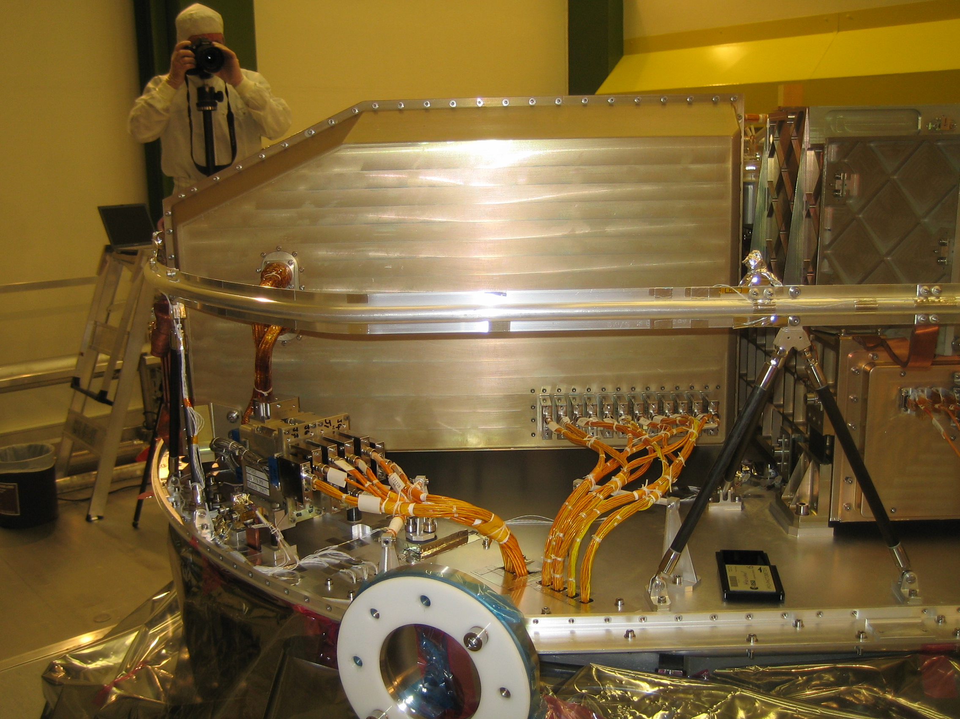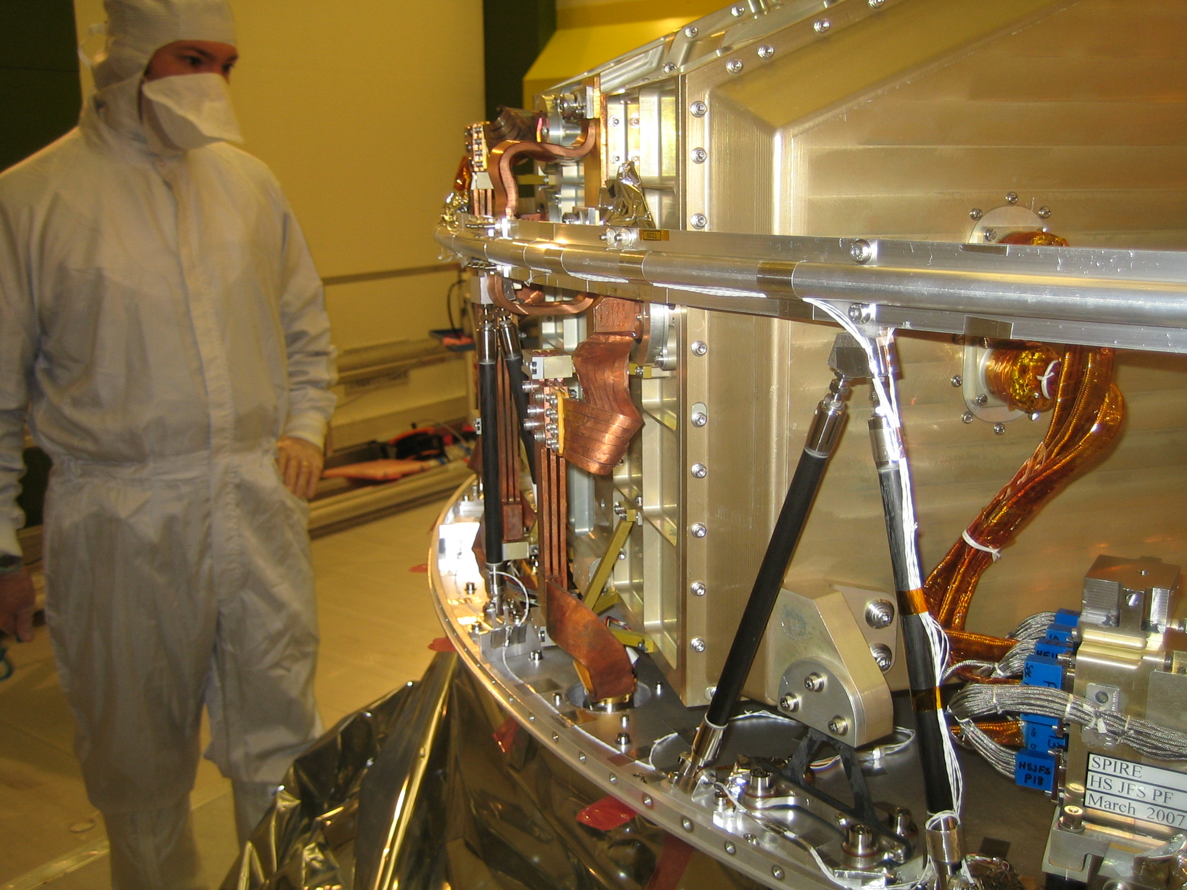
Spectrometer
JFET
Spacecraft harness
JFET
Backharness
JFET-BDA
harness

Figure 1: SPIRE integrated onto the Herschel Optical Bench (HOB) showing the relationship between the JFET unit and FPU and the three harnesses used to connect the BDA/JFET and warm electronics.

Two JFET “modules” are used for the SPIRE spectrometer (see RD1). Each consists of two membranes or units that have 24 individual amplifiers on each. Each membrane has its own bias supply and a heater designed to warm up the membrane to operating temperature. The JFETs require an operating temperature of >70 K. During instrument level testing it was found that under normal circumstances the start up heater was not required as sufficient current was drawn through the units on switch on to warm the membranes up sufficiently to allow the JFETs to “start” – i.e. get above the freeze out point. This method of operation was used for all of the instrument level testing and, apart from circumstances described below, for all of the integrated system tests until the switch on failure seen during TV/TB. All photometer units switched on normally each time they were operated. The SLW unit also operated normally each time it was operated, however both SSW units showed anomalous behaviour during IST (Integrated System Tests) as described below.

Unit identification
We are only concerned from hereon with the units that showed anomalous behaviour at any point during IST and the unit that failed to switch on during TV/TB. Table 1 gives the identification of the pixels addressed by each unit and the connector and cable identifications for these units. The physical location in the FoV of the pixels addressed by the unit showing the anomalous behaviour is show in figure 2.

Table 1: Interface information for the SSW JFET Module. The JFS_S1 unit is the one that exhibited anomalous behaviour during TV/TB

Pixel |  | BDA  Conn |  | +pin |  | -pin |  | Co-ax |  | JFET  Conn |  | JFET |  | Mod SerNo |  | Memb  SerNo
R1 |  | J05 |  | 1 |  | 26 |  | F13-12ax-A1 |  | J11 |  | JFS_S1 |  | SN024 |  | SN059
A4 |  | J05 |  | 2 |  | 27 |  | F13-12ax-A2 |  | J11 |  | JFS_S1 |  | SN024 |  | SN059
A3 |  | J05 |  | 3 |  | 28 |  | F13-12ax-A3 |  | J11 |  | JFS_S1 |  | SN024 |  | SN059
A2 |  | J05 |  | 4 |  | 29 |  | F13-12ax-A4 |  | J11 |  | JFS_S1 |  | SN024 |  | SN059
A1 |  | J05 |  | 5 |  | 30 |  | F13-12ax-B1 |  | J11 |  | JFS_S1 |  | SN024 |  | SN059
DP1 |  | J05 |  | 6 |  | 31 |  | F13-12ax-B2 |  | J11 |  | JFS_S1 |  | SN024 |  | SN059
B3 |  | J05 |  | 7 |  | 32 |  | F13-12ax-B3 |  | J11 |  | JFS_S1 |  | SN024 |  | SN059
B2 |  | J05 |  | 8 |  | 33 |  | F13-12ax-B4 |  | J11 |  | JFS_S1 |  | SN024 |  | SN059
B1 |  | J05 |  | 9 |  | 34 |  | F13-12ax-C1 |  | J11 |  | JFS_S1 |  | SN024 |  | SN059
C3 |  | J05 |  | 10 |  | 35 |  | F13-12ax-C2 |  | J11 |  | JFS_S1 |  | SN024 |  | SN059
C2 |  | J05 |  | 11 |  | 36 |  | F13-12ax-C3 |  | J11 |  | JFS_S1 |  | SN024 |  | SN059
C1 |  | J05 |  | 12 |  | 37 |  | F13-12ax-C4 |  | J11 |  | JFS_S1 |  | SN024 |  | SN059
D3 |  | J05 |  | 13 |  | 38 |  | F13-12ax-D1 |  | J11 |  | JFS_S1 |  | SN024 |  | SN059
D2 |  | J05 |  | 14 |  | 39 |  | F13-12ax-D2 |  | J11 |  | JFS_S1 |  | SN024 |  | SN059
D1 |  | J05 |  | 15 |  | 40 |  | F13-12ax-D3 |  | J11 |  | JFS_S1 |  | SN024 |  | SN059
E3 |  | J05 |  | 16 |  | 41 |  | F13-12ax-D4 |  | J11 |  | JFS_S1 |  | SN024 |  | SN059
E2 |  | J05 |  | 17 |  | 42 |  | F13-12ax-E1 |  | J11 |  | JFS_S1 |  | SN024 |  | SN059
E1 |  | J05 |  | 18 |  | 43 |  | F13-12ax-E2 |  | J11 |  | JFS_S1 |  | SN024 |  | SN059
F3 |  | J05 |  | 19 |  | 44 |  | F13-12ax-E3 |  | J11 |  | JFS_S1 |  | SN024 |  | SN059
F2 |  | J05 |  | 20 |  | 45 |  | F13-12ax-E4 |  | J11 |  | JFS_S1 |  | SN024 |  | SN059
F1 |  | J05 |  | 21 |  | 46 |  | F13-12ax-F1 |  | J11 |  | JFS_S1 |  | SN024 |  | SN059
G1 |  | J05 |  | 22 |  | 47 |  | F13-12ax-F2 |  | J11 |  | JFS_S1 |  | SN024 |  | SN059
T1 |  | J05 |  | 23 |  | 48 |  | F13-12ax-F3 |  | J11 |  | JFS_S1 |  | SN024 |  | SN059
G2 |  | J05 |  | 24 |  | 49 |  | F13-12ax-F4 |  | J11 |  | JFS_S1 |  | SN024 |  | SN059
Pixel | BDA  Conn |  | +pin |  | -pin |  | Co-ax |  | JFET  Conn |  | JFET |  | Mod SerNo |  | Memb  SerNo
G3 | J06 |  | 7 |  | 32 |  | F14-12ax-B3 |  | J12 |  | JFS_S2 |  | SN024 |  | SN060
G4 | J06 |  | 8 |  | 33 |  | F14-12ax-B4 |  | J12 |  | JFS_S2 |  | SN024 |  | SN060
DP2 | J06 |  | 9 |  | 34 |  | F14-12ax-C1 |  | J12 |  | JFS_S2 |  | SN024 |  | SN060
F5 | J06 |  | 10 |  | 35 |  | F14-12ax-C2 |  | J12 |  | JFS_S2 |  | SN024 |  | SN060
F4 | J06 |  | 11 |  | 36 |  | F14-12ax-C3 |  | J12 |  | JFS_S2 |  | SN024 |  | SN060
E6 | J06 |  | 12 |  | 37 |  | F14-12ax-C4 |  | J12 |  | JFS_S2 |  | SN024 |  | SN060
E5 | J06 |  | 13 |  | 38 |  | F14-12ax-D1 |  | J12 |  | JFS_S2 |  | SN024 |  | SN060
E4 | J06 |  | 14 |  | 39 |  | F14-12ax-D2 |  | J12 |  | JFS_S2 |  | SN024 |  | SN060
D7 | J06 |  | 15 |  | 40 |  | F14-12ax-D3 |  | J12 |  | JFS_S2 |  | SN024 |  | SN060
D6 | J06 |  | 16 |  | 41 |  | F14-12ax-D4 |  | J12 |  | JFS_S2 |  | SN024 |  | SN060
D5 | J06 |  | 17 |  | 42 |  | F14-12ax-E1 |  | J12 |  | JFS_S2 |  | SN024 |  | SN060
D4 | J06 |  | 18 |  | 43 |  | F14-12ax-E2 |  | J12 |  | JFS_S2 |  | SN024 |  | SN060
C6 | J06 |  | 19 |  | 44 |  | F14-12ax-E3 |  | J12 |  | JFS_S2 |  | SN024 |  | SN060
C5 | J06 |  | 20 |  | 45 |  | F14-12ax-E4 |  | J12 |  | JFS_S2 |  | SN024 |  | SN060
C4 | J06 |  | 21 |  | 46 |  | F14-12ax-F1 |  | J12 |  | JFS_S2 |  | SN024 |  | SN060
B5 | J06 |  | 22 |  | 47 |  | F14-12ax-F2 |  | J12 |  | JFS_S2 |  | SN024 |  | SN060
B4 | J06 |  | 23 |  | 48 |  | F14-12ax-F3 |  | J12 |  | JFS_S2 |  | SN024 |  | SN060
T2 | J06 |  | 24 |  | 49 |  | F14-12ax-F4 |  | J12 |  | JFS_S2 |  | SN024 |  | SN060

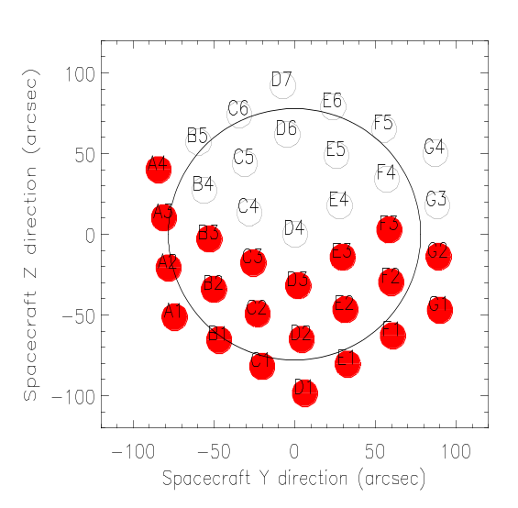
Figure 2: The physical positions of the SSW pixels as projected at the SPIRE field in S/C co-ordinates

History of the SSW JFET operation following delivery of the FPU to the Satellite
Table below shows the history of the operation of the JFET following delivery to the satellite (April 2007) up to the TV/TB test in November 2008. I’ve given some relevant temperatures where I have them. The results of the tests are recored

Table 2: Test History
Date | Test Name/Description | P/R | Temp | Result | Section  /report
? September 2007 | Harness integrity verification | P | Room | Voltages applied on prime side and measured on redundant.  I_{ss} and I_{dd} measured directly – compatible with expectations | 5.1
26th September 2007 | Initial warm functional test | P+R | Room | JFETs switched on (R1 seen to respond)  No BDA integrity check as phase=0  Both sides the same | RD1
23rd/24th October 2007 | Warm functional Test horizontal | P+R | Room | Repeat of September test – behaviour as expected – both sides operational. | RD2
7th March 2008 | HeI Cold Functional Test | P | L0 - ~4.3 K  L1 - ~7.5 K  L3 - ~11 K  TS1 ~ 37 K  TS2 ~ 100 K  TS3 ~ 175 K  CVV shell -room | First cold test – SSW JFET membranes 1 and 2 did not switch on at -1.49 V on Vss. “Vss Test” then carried out and both switched on at -2.4 V | RD3  and §5.2
17th June 2008 | HeI Cold Function Test post environmental testing | P+R | L0 - ~4.3 K  L1 - ~7.5 K  L3 - <10 K?  CVV shell -room | Used higher switch on voltage (-2.6 V). Both JFET membranes switched on normally on both sides | RD4  and §5.3
30 July 2008 | HeII Cold Functional and Commissioning Test | P+R (no noise test on R) | L0 - ~2 K  L1 - ~8-9 K  L3 ~?  CVV shell - room | Used higher switch on voltage (-2.6 V). Both JFET membranes switched on normally on both sides. | RD5
20-23 August 2008 | SPT | P | L0 - ~ 1.89 K  L1 ~ 8.9 K  L3 ~ 8.9  TS1 ~ 10 K  TS2 ~ 16 K  TS3 ~ 50 K  CVV shell - room | Used higher switch on voltage (-2.6 V). Both JFET membranes switched on normally. | §5.4
30 November 2008 | TV/TB | P | L0 – ~1.82 K  L1 - ~ 3.8 K  L3 - ~ 6.2 K  TS1 ~ 23 K  TS2 ~ 36 K  TS3 ~ 54 K  CVV Shell – 94 K | Used higher switch on voltage (-2.6 V). JFET membrane 1 did not switched on. JFET membrane 2 switched on normally. | §5.5

Test Results

Interface Checks Friedrichshafen September 2007
This was an extensive test design the verify the spacecraft harness configuration, the voltage drop down the harness and the current drawn by each unit. The voltage drops observed on the V_{dd} (2.5V) were on average:

10 mV for all the photometer JFETS
54 mV for SLW
81 mV for SSW

And for the -1.5 V V_{ss} were:

5 mV for all the photometer JFETS
46 mV for SLW
74 mV for SSW

The measured I_{dd} and I_{ss} were as given in figure 3 – V_{ss} was -1.5 V for all measurements. From these figures we derive the spectrometer JFET power dissipation to be SLW 6.31 mW, SSW 1 5.87 mW and SSW 2 5.09 mW.
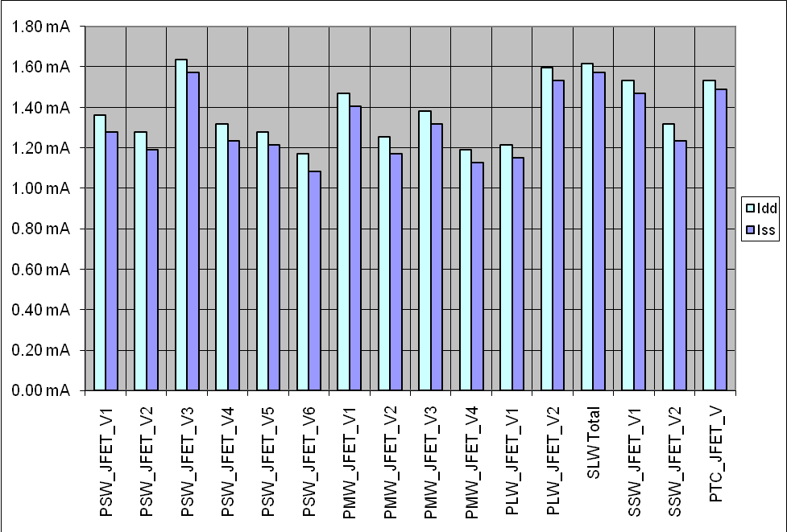
Figure 3: Measured I_{dd} and I_{ss} during SPIRE integration into satellite for V_{ss}=-1.5 V.

HeI Cold Functional Test 7th March 2008
Once the units had been switched on using the higher switch on voltage a noise versus V_{ss} voltage test was carried out. Following this test the switch on and operating voltages were set as:

JFET Switch-on Vss Optimum Vss

SLW-V1 1.47 1.59
SSW-V1 2.59 1.59
SSW-V2 2.59 1.97

In section 5.2.1 I give the tables from Jamie used to establish these values and in section 5.2.2 the temperatures observed on the JFET interfaces during the test.

Noise Values
Jamie Bock reports the noise versus Vss setting as follows (noise reported in nV/rt(Hz)):

SSW Unit 1
V_{ss} (V) | -1.37264 | -1.58531 | -1.77864 | -1.97197 | -2.1653 | -2.35863 | -2.57129
Median noise | 8.079 | 7.952 | 7.904 | 8.011 | 8.251 | 8.856 | 10.477
SSWR1 | 27.01 | 25.26 | 27.51 | 30.86 | 33.16 | 34.51 | 37.28
SSWA4 | 8.21 | 8.18 | 8.31 | 8.31 | 8.57 | 8.6 | 9.48
SSWA3 | 14.69 | 13.61 | 12.06 | 9.76 | 8.95 | 9.14 | 9.8
SSWA2 | 7.48 | 7.31 | 7.48 | 7.31 | 7.68 | 8.33 | 10.01
SSWA1 | 7.85 | 7.63 | 7.51 | 7.6 | 7.81 | 8.62 | 10.12
SSWDP1 | 7.6 | 7.3 | 7.51 | 7.56 | 7.93 | 8.57 | 9.94
SSWB3 | 11.4 | 10.64 | 10.99 | 8.97 | 7.88 | 7.76 | 8.19
SSWB2 | 8.54 | 8.17 | 8.13 | 8.24 | 8.42 | 9.04 | 10.18
SSWB1 | 9.31 | 8.77 | 8.29 | 8.32 | 7.81 | 7.69 | 8.44
SSWC3 | 7.82 | 7.81 | 7.86 | 8 | 8.29 | 9.07 | 10.57
SSWC2 | 8.08 | 7.86 | 7.99 | 8.14 | 8.72 | 9.25 | 10.87
SSWC1 | 7.68 | 7.36 | 7.46 | 7.58 | 8.07 | 8.75 | 10.49
SSWD3 | 8.52 | 8.65 | 8.63 | 8.63 | 9.02 | 9.81 | 11.4
SSWD2 | 8.76 | 9.31 | 9.66 | 9.3 | 8.77 | 9.3 | 10.5
SSWD1 | 7.81 | 7.61 | 7.65 | 7.64 | 8.18 | 9.05 | 10.85
SSWE3 | 8.37 | 7.98 | 7.97 | 7.99 | 8.25 | 8.86 | 10.48
SSWE2 | 8.37 | 8.29 | 8.3 | 8.33 | 8.73 | 9.95 | 11.8
SSWE1 | 7.82 | 7.95 | 7.85 | 8.15 | 8.43 | 9.45 | 11.18
SSWF3 | 7.92 | 7.87 | 7.83 | 8.01 | 8.49 | 9.5 | 11.46
SSWF2 | 7.75 | 7.4 | 7.39 | 7.51 | 7.42 | 7.93 | 8.59
SSWF1 | 8.52 | 8.93 | 9.44 | 9.02 | 8.75 | 9.35 | 10.8
SSWG1 | 7.71 | 7.52 | 7.35 | 7.64 | 8.03 | 8.79 | 10.93
SSWT1 | 8.34 | 8.2 | 7.9 | 7.83 | 8.02 | 8.35 | 8.91
SSWG2 | 7.61 | 7.55 | 7.52 | 7.45 | 7.7 | 8.22 | 9.09

SSW Unit 2
V_{ss} [V] | -1.37264 | -1.58531 | -1.77864 | -1.97197 | -2.1653 | -2.35863 | -2.57129
Median noise | 7.809 | 7.759 | 8.034 | 8.827 | 10.368 | 12.395 | 13.648
SSWE5 | 7.74 | 7.67 | 8.18 | 9.27 | 11.28 | 13.86 | 14.68
SSWE4 | 7.64 | 7.59 | 7.9 | 8.9 | 10.88 | 13.04 | 13.66
SSWD7 | 7.81 | 7.84 | 8.03 | 8.83 | 10.57 | 12.94 | 13.41
SSWD6 | 8.56 | 8.3 | 8.28 | 8.91 | 10.33 | 12 | 12.75
SSWD5 | 62.38 | 115.66 | 130.68 | 138.23 | 139.21 | 138.91 | 148.02
SSWD4 | 7.53 | 7.47 | 7.7 | 8.53 | 10.05 | 12.16 | 13.12
SSWC6 | 9.49 | 9.25 | 9.11 | 9.65 | 10.96 | 12.89 | 13.94
SSWC5 | 7.69 | 7.76 | 8.16 | 9.21 | 10.96 | 13.39 | 15.14
SSWC4 | 7.91 | 7.63 | 7.84 | 8.58 | 9.93 | 12.21 | 14.4
SSWB5 | 7.48 | 7.57 | 7.72 | 8.44 | 9.83 | 11.84 | 13.65
SSWB4 | 8.02 | 7.95 | 7.84 | 8.24 | 8.64 | 9.69 | 11.19
SSWT2 | 7.59 | 7.46 | 7.48 | 7.8 | 8.31 | 9.4 | 11.31
SSWG3 | 7.62 | 7.46 | 7.83 | 8.59 | 9.98 | 12.08 | 13.38
SSWG4 | 8.56 | 8.55 | 8.27 | 7.92 | 8.17 | 8.98 | 9.99
SSWDP2 | 7.86 | 7.82 | 8.11 | 9 | 11.06 | 13.16 | 14.55
SSWF5 | 7.49 | 7.44 | 7.78 | 8.72 | 10.37 | 12.39 | 13.29
SSWF4 | 8.43 | 8.5 | 8.85 | 9.9 | 12.22 | 14.93 | 16.23
SSWE6 | 8.04 | 8.03 | 8.31 | 9.65 | 11.81 | 14.18 | 15.2

Temperatures during test
The flow rate appears set to ~34 mg/s from the CVSE-004 data. Figure 4 shows the overall situation with the shields etc. Figure 5 shows a close up with the L3 and L1 temperatures. The switch off of the photometer and the switch on of the spectrometer on seen in the L3 temperature profiles but not as clearly as during TV/TB (see later).

Thermal shield temperatures are as follows (see appendix for the key to where the thermistors are located):

TS1 (T421) ~ 37.5 K
TS2 (T441) ~ 100 K
TS3 (T461) ~ 175 K

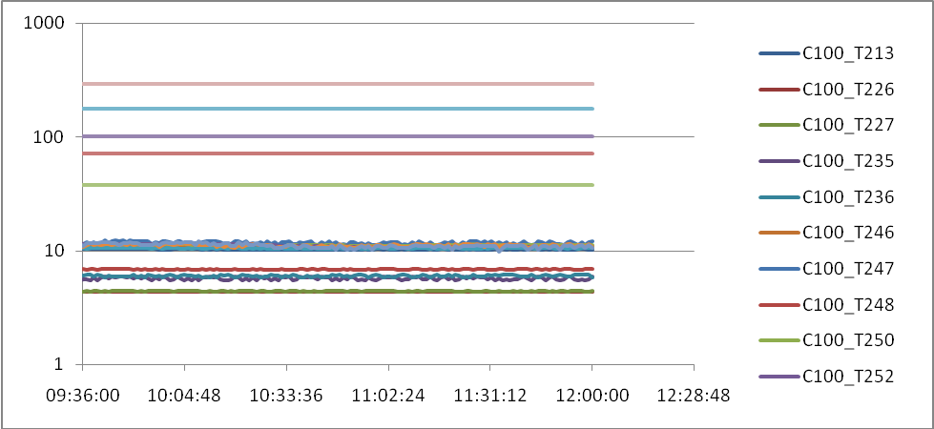
Figure 4: Relevant temperatures during switch on during CFT 7 March 2008

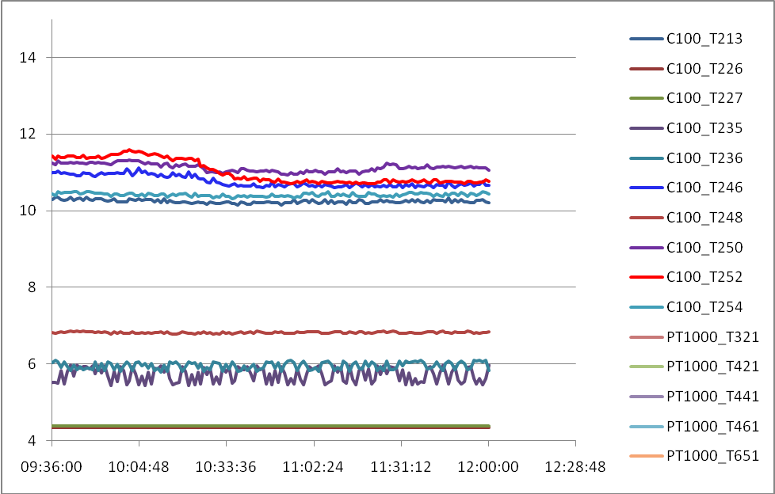
SDET_ON
PDET_OFF
VSS Test
Figure 5: Close up on L3 temperatures during switch on during CFT 7 March 2008

Detector Checks Post Acoustic Test 17th June 2008
We give here some additional analysis of the data from the 17th June cold functional test. The Vss test wasn’t done but we can look at the voltage across the resistor and the channel noise as the JFET switched on using the data from the “DCU-11” functional test carried out on prime and redundant side. During this test a small bias voltage is applied to the BDAs so that we can observe the behaviour of the JFETs. This is most evidient by observing the resistor channels on SSW and SLW. The voltage measured across the resistor is plotted versus time in Figure 1.

Figure 6. Measured voltage across the SSW resistor and SSW JFET 1 Vss during switch on (upper two plots) and SLW resistor voltage and SLW JFET Vss (lower two plots). The dashed line is to give the approximate time of the application of Vss in the two membranes (slightly later for SLW). Note there appears to be a difference in the time it takes for the SLW membrane to actually start.

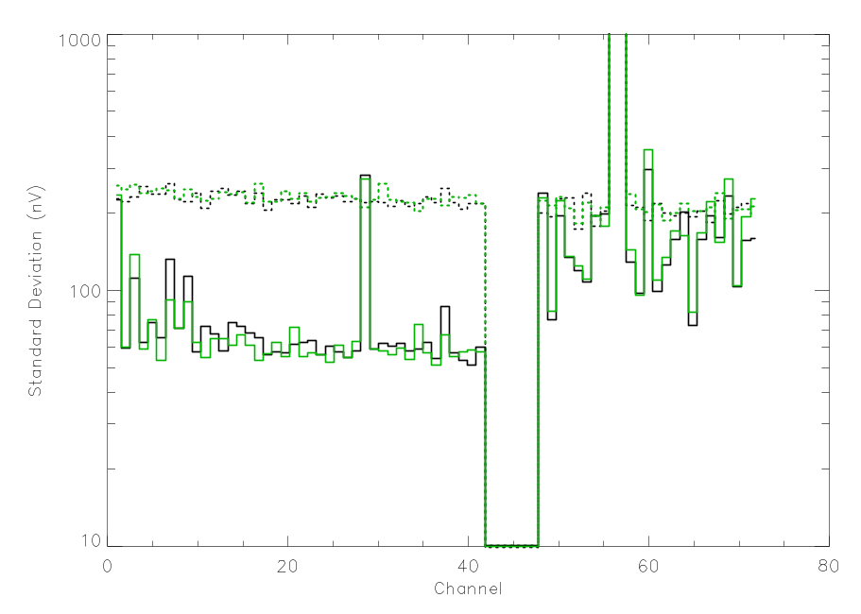
Figure 7. This is the time series noise per channel just before switch on (dashed lines) – i.e. open source LIA noise – and ~20 sec after switch on (solid lines). The prime side is plotted in black and the redundant side is plotted in green.

To check whether there was any time dependence, the noise per channel is plotted in approximately ten second intervals in the next plot.
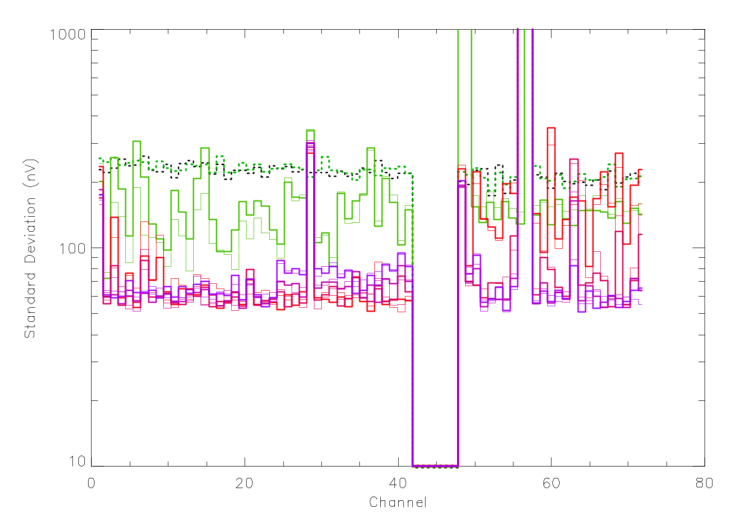
Figure 8. This plot is the same as above with the colors now indicating the time interval from green (earliest) through red to purple (latest in data set). The thin lines are now prime and the thick lines redundant. The dashed lines are the LIA open source noise as before.

We can plot the time evolution more explicitly….

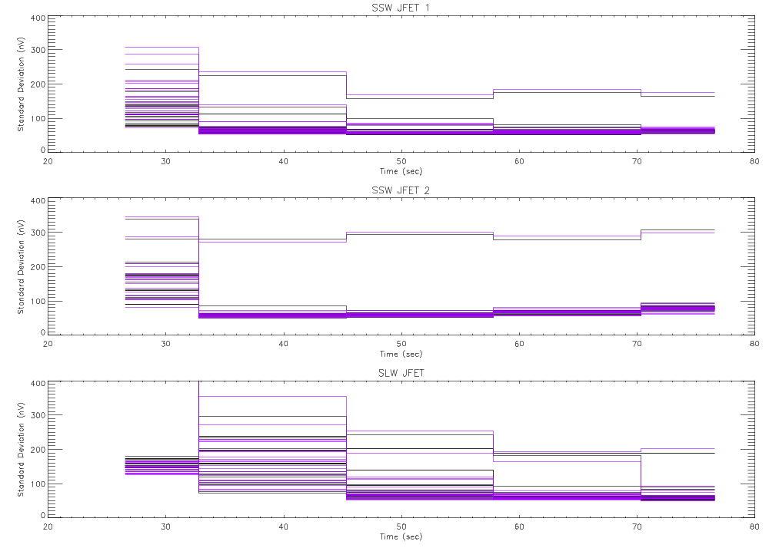

Figure 9.This plot shows the evolution of the noise in each channel as a function of time from the beginning of the data set (see Fig X above). I have broken out the three membranes to look for a difference in behaviour. The prime side is in black and the redundant in purple. There are clear differences in the settling times here between SLW and SSW possibly due to the difference Vss voltage applied. The fact there is no discernable difference between prime and redundant is a strong indicator that the voltages applied are the same.

SPT 22nd August 2008
There was a high flow rate used during the spectrometer part of the test during the switch on of the JFETs only the CVSE-008 flow meter appeared to register anything sensible and indicated a flow rate of ~420 mg/s. I have contacted Bernard Collaudin to check whether this is sensible. Figure SPT-1 shows the overall situation with shields etc. For some reason some of the SPIRE interface thermistors were non-operational and I have replaced these with others close to the same location as follows.

T212 for T213 on the OB shield
T234 (PACS L1 interface ) for T235
T442 for T441 on thermal shield 2
Added T464 on Thermal shield 3 as there is a larger discrepancy here

Thermal shield temperatures are as follows:

TS1 (T421) ~ 10 K
TS2 (T442) ~ 16 K
TS3 (T461/T464) ~ 46-54 K

Figure SPT-2 shows a close up of the L3 temperatures – there is clearly a rise when the spectrometer is switched on but a simple calculation of the power required given the reported flow rate does not seem to give a sensible answer for the JFET dissipation.

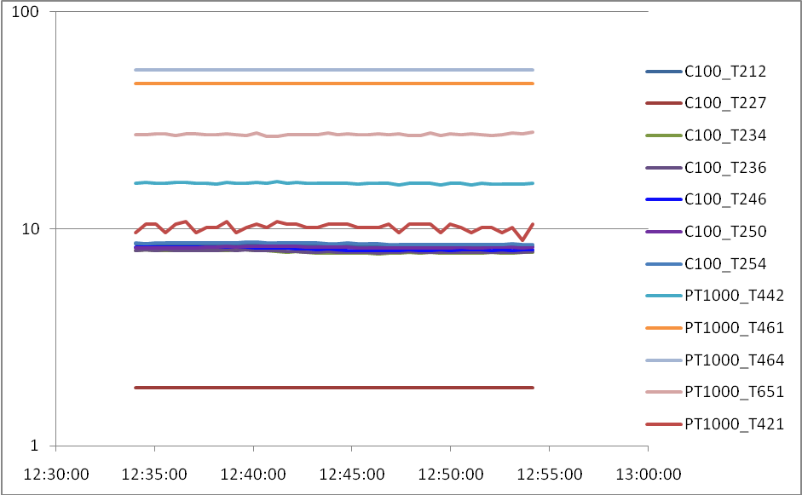

Figure 10: Relevant temperatures during switch on during SPT 22 August 2008

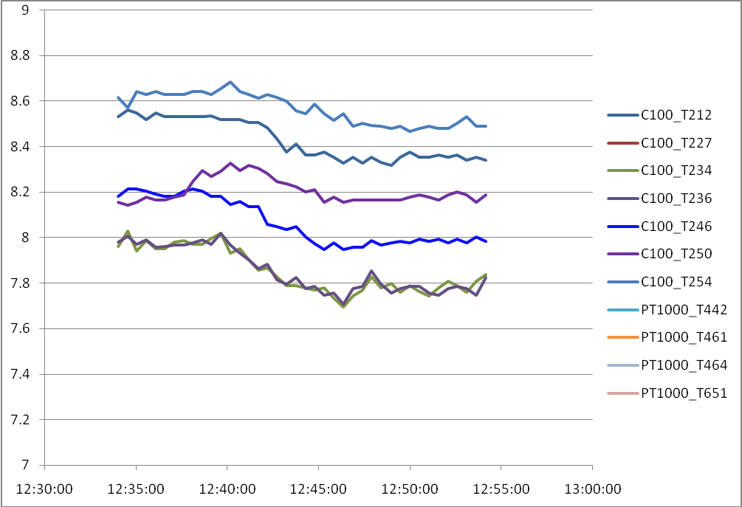
SDET_ON

Figure 11: L3 Temperatures as spectrometer JFETs were switched on. Note that the system temperatures were changing at the same time as switch on.

Thermal Vacuum test 30th November

Thermal Data from First Attempt to Switch on
The flow rates during TB/TV test appear to be much better monitored and the lowest range value (most accurate?) flow meter is used (CVSE-006). This gave a flow rate of ~ 7 mg/s during the two switch on attempts. Figure 12 shows the overall temperatures during the first (failed) switch on attempt.
The thermal shield temperatures were as follows:

TS1 (T421) ~ 23 K
TS2 (T441) ~ 36 K
TS3 (T461) ~ 54 K

Figure 13 shows a close up of the L3 temperatures. The temperature variation on L3 now reflects the JFET power dissipation much more closely than seen in previous tests with higher flow rate.

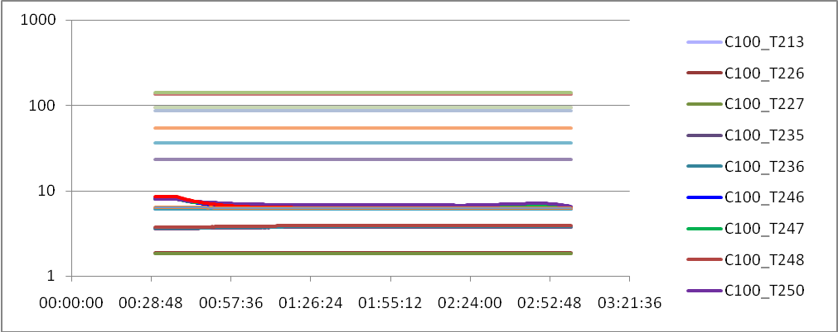

Figure 12: Temperatures on 30th November during first attempt to switch on Spec JFETs – all relevant thermistors – Log scale

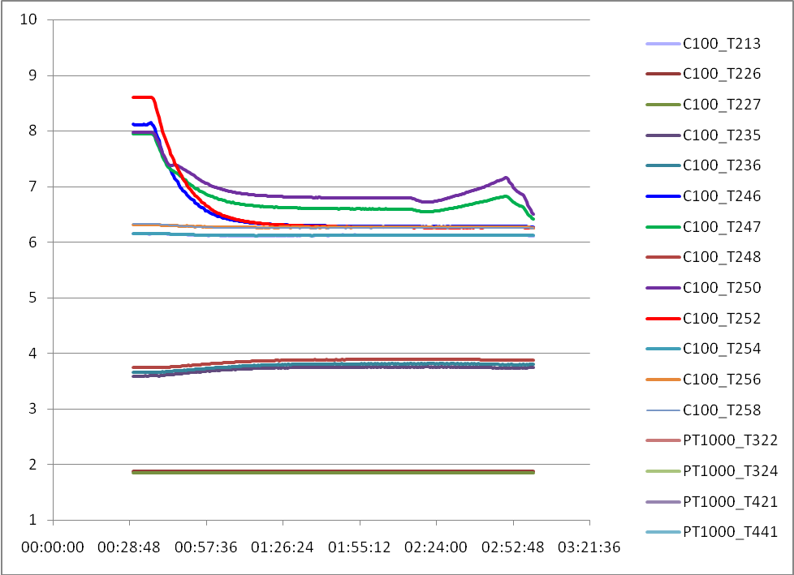
SDET_ON
PDET_OFF
VSS Test

Figure 13: Temperatures on 30th November during first attempt to switch on Spec JFETs – close up on L0, L1 and L3

Thermal data during second attempt to switch on
The flow rate remained at ~ 7 mg/s and the thermal shield temperatures had not changed during the second attempt to switch on. Figure 14 shows a close up of the L3 temperatures. The temperature variation on L3 again follows the JFET power dissipation closely and I have attempted to calculate the power dissipation using this, the flow rate and a thermal capacity of the Helium gas of 5.2 J/g/K. The estimated dissipation is as shown in figure 15. I used the measured rise in temperature of the cooling strap (T250) for the spectrometer JFET L3 interface to estimate the dissipation in the JFET unit. I’ve also plotted the result for the T247 thermistor that is described as being mounted on the pipework downstream of the spectrometer L3 interface. There is a fairly large difference in the answers - not sure why? Anyway, according to the DCU design document the JFET heater provides 5 mA – at -2.5V this should be ~12.5 mW. This looks about right for the period when only the JFET heater was switched on – circled in red. This power dissipation is the total for all three membranes giving an average of ~4 mW per membrane – however compare this with Jamie’s estimation from an e-mail of 12 January 2009

“Note the JFET heaters are 2.89 kOhms and 2.644 kOhms, so max power was 2.3 mW per membrane.”

Compared to the dissipation required to keep the memebranes at operating temperature (~8 mW) we can see that this was too low and probably explains the poor noise performance and the weird behaviour when we tried the heater variation test.

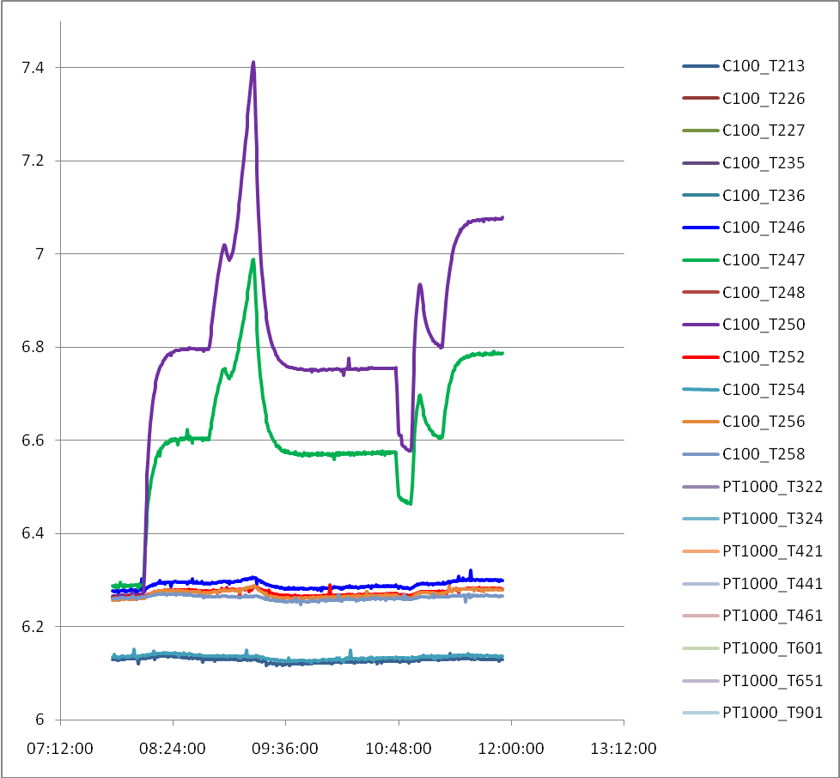
VSS Test
test stopped at -2.4 V
SDET_ON
VSS Test
from -2 to -3.6 V
VSS reset

SDET_OFF
JFET Heater on -2.5V
SDET_ON
JFET Heater off
JFET Heater back on
Figure 14: Temperatures on 30th November during second attempt to switch on Spec JFETs with heater close up on L3 thermistors.
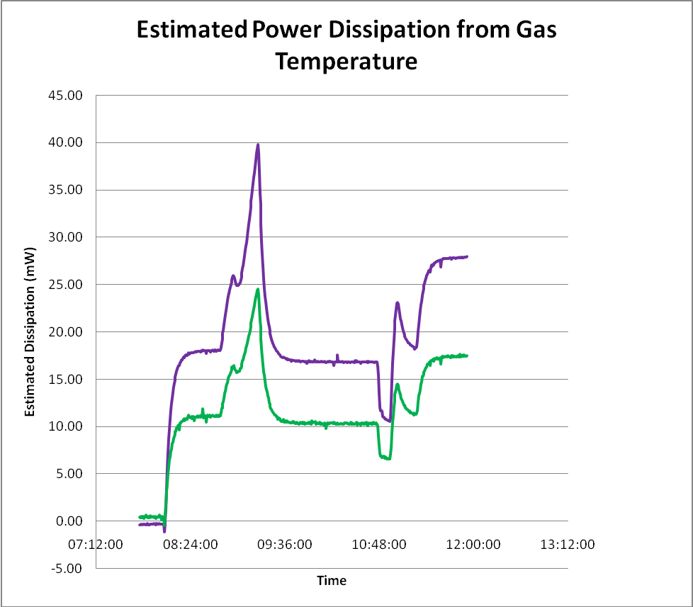
VSS Test
test stopped at -2.4 V
SDET_ON
VSS Test
from -2 to -3.6 V
VSS reset

SDET_OFF
JFET Heater on -2.5V
SDET_ON
JFET Heater off
JFET Heater back on
Figure 15: Estimated power dissipation calculated by taking the observed temperature rise on L3; the specific heat of helium gas (5.2 J/g/K) and the measured flow rate (6.9±0.2 mg/s). Two cases are calculated using the temperature of the cooling strap (T250 spectrometer JFET L3 interface) and that of the “pipework downstream of L3 interface” (T247). Not sure why there is such a large difference? The JFET heater provides ~12.5 mW. This looks about right on the purple curve for the period when only the JFET heater was switched on – circled in red.

Appendix 1: Thermistor lookup table
This table relates the names of the spacecraft conditioned thermistors and flow rate meters to to their location.

C100_T213 | OB Shield +x, close to SPIRE | OBA
C100_T226 | L0; on cooling strap to "SPIRE Cooler Pump HS" | OBA
C100_T227 | L0; on cooling strap to "SPIRE Cooler Evaporator HS" | OBA
C100_T235 | L1; on Ventline upstream cooling strap to "SPIRE Optical Bench" | OBA
C100_T236 | L1; on Ventline downstream cooling strap to "SPIRE Optical Bench" | OBA
C100_T246 | L3; on Ventline downstream cooling to 6-JFET (JFET-Phot) | OBA
C100_T247 | L3; on Ventline downstream cooling strap to 2-JFET (JFET-Spec) | OBA
C100_T248 | L1; on cooling strap to "SPIRE Optical Bench" , on FPU side | OBA
PT1000_T249 | L3; on cooling strap on Spire 2-JFET (JFET-Spec), on FPU side | OBA
C100_T250 | L3; on cooling strap on Spire 2-JFET (JFET-Spec), on FPU side | OBA
PT1000_T251 | L3; on cooling strap on Spire 6-JFET (JFET-Phot), on FPU side | OBA
C100_T252 | L3; on cooling strap on Spire 6-JFET (JFET-Phot), on FPU side | OBA
C100_T254 | OB Plate near SPIRE foot; center | OBA
C100_T256 | OB Plate near SPIRE foot; -z+y | OBA
C100_T258 | OB Plate near SPIRE foot; -y-z | OBA
PT1000_T322 | SVM Shield; on top +y-z | SVM Shield
PT1000_T324 | SVM Shield; on top -y | SVM Shield
PT1000_T421 | Thermalshield 1, outside on lower bulkhead under MLI, in +x+y plane | Thermal Shield
PT1000_T441 | Thermalshield 2, outside on lower bulkhead under MLI, in +x+y plane | Thermal Shield
PT1000_T461 | Thermalshield 3, outside on lower bulkhead under MLI, in +x+y plane | Thermal Shield
PT1000_T601 | on Cover Heat Shield (CHS) | Cover
PT1000_T651 | On Baffle; cylinder outside; -z | Cryostat Baffle
PT1000_T901 | CVV outside upper bulkhead, on upper plane; -z | CVV Outside
CVSE_006 | Flowmeter LMF 0-16.6 mg/s | CVSE

