SPIRE Science Verification Review - 3
Stockholm

October 29-30, 2007
SPIRE ILT Report:
Instrument Optical Performances

Document Number: SPIRE-RAL-REP-002963 1.3

Marc Ferlet (RAL)

Contents

1. Introduction and scope 2
2. List of requirements that the test programme was designed to evaluate 2
3. Test results and conclusions 4
3.1 List of tests carried out and tests still to be done 4
3.2 Subsystem requirements tested at instrument level and their verification status 4
3.3 Instrument-level requirements and their verification status. 8
4. Open issues and anomalies 11
5. Discussion on previous recommendations (data analysis and tests) and related optical performances results 13
5.1 Previously recommended data analysis 13
5.2 Previously recommended tests 14
5.3 Further optical characterisation 16
6. References 22
6.1 Applicable documents 22
6.2 Reference documents 22

Introduction and scope

This document summarises the present status of the verification of the SPIRE instrument optical performances. List of the relevant requirements is given in section 2. Section 3 gives a summary of the main results obtained with respect to individual optical subsystem level and optics-related instrument level requirements. A few anomalies found are reported in section 4. Some discussion on previous recommendations for priority data analysis and future tests are discussed in section 5 as well as the results from the associated tests. Finally, references for the background technical documentation are to be found in section 6.

The document template and content are identical to the first SVR document with additional targeted updates highlighted in colour. Update after SVR-2 is added in green, re-using the format and template of AD2 where relevant. It is based on the last ILT test campaign which included optical tests i.e. PFM4. No results from ILT PFM5 test campaign more relevant to detector, thermal, etc characterisation are discussed here.

List of requirements that the test programme was designed to evaluate

The optics-related requirements to be evaluated are listed in the table below; along side the relevant SPIRE model which has allowed/will allow their partial or complete verification. The requirement identifiers are taken from AD1.

Requirement Name | Description | Verification Method | Model | Test ID | Upper Links
IRD-OPTP-R00 | Compatibility with Herschel telescope | Design analysis Instrument level alignment verification Instrument level performance tests | AM  CQM | ILT_ALIGN  ILT_PERF | IID-A-SECT4.3.1
IRD-OPTP-R01 | Nominal final focal ratio | Design analysis | N/A | N/A
IRD-OPTP-R02 | Variation in focal ratio | Design analysis Instrument level alignment verification Instrument level performance tests | AM  CQM  PFMI, PFMII, PFMIIII, PFMIV | ILT_ALIGN  ILT_PERF | IRD-PHOT-R10
IRD-OPTP-R03 | Distortion | Design analysis Instrument level alignment verification Instrument level performance tests | AM  CQM  PFMI, PFMII, PFMIIII, PFMIV | ILT_ALIGN  ILT_PERF | IRD-PHOT-R10
IRD-OPTP-R04 | Anamorphism | Design analysis Instrument level alignment verification Instrument level performance tests | AM  CQM  PFMI, PFMII, PFMIIII, PFMIV | ILT_ALIGN  ILT_PERF | IRD-PHOT-R03
IRD-OPTP-R06 | Image quality | Design analysis Instrument level alignment verification Instrument level performance tests | AM  CQM  PFMI, PFMII, PFMIIII, PFMIV | ILT_ALIGN  ILT_PERF | IRD-PHOT-R03 IRD-PHOT-R04  IRD-PHOT-R05
IRD-OPTP-R08 | In-band straylight | Design analysis Instrument level performance tests | CQM  PFMI, PFMII, PFMIIII, PFMIV | ILT_PERF | IRD-PHOT-R04
IRD-OPTS-R01 | Nominal final focal ratio | Design analysis | N/A | N/A
IRD-OPTS-R02 | Variation in focal ratio | Design analysis Instrument level alignment verification Instrument level performance tests | AM  CQM  PFMI, PFMIIII, PFMIV | ILT_ALIGN ILT_PERF
IRD-OPTS-R03 | Distortion | Design analysis Instrument level alignment verification Instrument level performance tests | AM  CQM  PFMI, PFMIIII, PFMIV | ILT_ALIGN ILT_PERF
IRD-OPTS-R04 | Anamorphism | Design analysis Instrument level alignment verification Instrument level performance tests | AM  CQM  PFMI, PFMIIII, PFMIV | ILT_ALIGN ILT_PERF | IRD-SPEC-R05
IRD-OPTS-R06 | Image quality | Design analysis Instrument level alignment verification Instrument level performance tests | AM  CQM  PFMI, PFMIIII, PFMIV | ILT_ALIGN ILT_PERF | IRD-SPEC-R05  IRD-SPEC-R06 IRD-SPEC-R07
IRD-DETS-R07 | Detector angular response | Design analysis Subsystem acceptance data package | N/A | N/A | IRD-SPEC-R05
IRD-DETP-R07 | Detector angular response | Design analysis Subsystem acceptance data package | N/A | N/A | IRD-PHOT-R06
IRD-STRC-R01 | Alignment of the instrument w.r.t. the FIRST optical axis | Design analysis Instrument alignment verification | AM  CQM | ILT_ALIGN | IID-A-SECT5.3.2.1
IRD-STRC-R04 | Optics and associated sub-system alignment | Design analysis Instrument alignment verification | AM  CQM | ILT_ALIGN
IRD-STRC-R08 | Attenuation of radiation from cryostat environment | Design analysis Instrument level performance tests | CQM | ILT_PERF | IRD-PHOT-R04  IRD-PHOT-R05  IRD-SPEC-R17
IRD-STRP-R02 | Optics and filters alignment | Design analysis Instrument alignment verification | AM  CQM | ILT_ALIGN
IRD-STRP-R03 | Array module alignment | Design analysis Instrument alignment verification | AM  CQM | ILT_ALIGN | IRD-PHOT-R16
IRD-STRP-R06 | Attenuation of radiation from common structure environment | Design analysis Instrument level performance tests | CQM | ILT_PERF | IRD-PHOT-R04 IRD-PHOT-R05
IRD-STRS-R02 | Optics alignment requirements | Design analysis Instrument alignment verification | AM  CQM | ILT_ALIGN
IRD-STRS-R03 | Array module alignment | Design analysis Instrument alignment verification | AM  CQM | ILT_ALIGN
IRD-STRS-R06 | Attenuation of radiation from 4-K environment | Design analysis Instrument level performance tests | CQM | ILT_PERF | IRD-SPEC-R17
IRD-PHOT-R02 | FoV | Design analysis Instrument level alignment verification Instrument level performance tests | CQM  PFMI, PFMII, PFMIIII, PFMIV | ILT_ALIGN  ILT_PERF | SRD R7
IRD-PHOT-R03 | Beam FWHM | Design analysis Instrument level Instrument level performance tests | CQM  PFMII, PFMIIII, PFMIV | ILT_PERF | SRD R1
IRD-PHOT-R10 | Field distortion | Design analysis Instrument level alignment verification Instrument level performance tests | AM  CQM  PFMI, PFMII, PFMIIII, PFMIV | ILT_ALIGN  ILT_PERF | SRD R6
IRD-PHOT-R16 | Co-alignment | Design analysis Instrument level alignment verification Instrument level performance tests | AM  PFMI, PFMII, PFMIIII, PFMIV | ILT_ALIGN  ILT_PERF | SRD R15
IRD-SPEC-R04 | FoV | Design analysis Instrument level performance tests | PFMI, PFMIIII, PFMIV | ILT_PERF | SRD R16
IRD-SPEC-R05 | Beam FWHM | Design analysis Instrument level performance tests | PFMI, PFMIIII, PFMIV | ILT_PERF | SRD R16

Test results and conclusions

List of tests carried out and tests still to be done

Tests relevant to optical alignment (ILT_ALIGN in table above), mostly for AM and CQM models are discussed in RD1 and RD2. A summary of optical alignment results for all SPIRE FPU models including PFM, and more recently FS, can be found in RD6.
Test relevant to in-band optical performances (ILT_PERF in table above) test on CQM and PFM are discussed in RD4, RD5 and RD7 with support from the specific characteristics of the optical set-up of the SPIRE test facility, described in RD3.

More details on the SPIRE test campaign details (plan, test data, intermediate reports, …) on the can be found at the following link: HThttp://scott1.bnsc.rl.ac.uk:8080/hcss/test_area/index.htmTH .

Subsystem requirements tested at instrument level and their verification status
The table below summarised the optics subsystem requirements and their present status.
Updates from PFM4 have been put again in green where relevant.

Requirement Name | Description | Verification status
IRD-OPTP-R00 | Compatibility with Herschel telescope | Nominally by design HSO telescope taken  HSO axis and pupil simulated during AM warm and cold alignment activities as reference for pupil alignment (internal/external).
IRD-OPTP-R01 | Nominal final focal ratio | Taken as F/5 by design.  Not derived (yet) from measurement.  - Update from PFM3: preliminary derived value for Phot arrays is ~4.9+/-0.25. Refined value and reduction of uncertainty from future cross-check with other datasets.  - Update from PFM4: F~4.9+/-0.25 is confirmed
IRD-OPTP-R02 | Variation in focal ratio | Ok by design.  To be derived from future Phot full FoV mapping and PSF measurements  - Update from PFM3: see above. Presently compliant and to be refined.  - Update from PFM4: confirmation of <+/-0.25 or 5% max relative change
IRD-OPTP-R03 | Distortion | Ok by design.  To be derived from future Phot full FoV mapping measurement  - Update from PFM3: preliminary derived value for Phot arrays is <8+2/-5%. Refined value and reduction of uncertainty from future cross-check with other datasets.  - Update from PFM4: confirmed max level of <8(+2/-5)%, also in-line with the relative variation of f-number.
IRD-OPTP-R04 | Anamorphism | Ratio of axes length in assumed generally elliptical beam pattern found <~10% for PLW from CQM (at FoV centre) so compliant to the 6/5 max ratio ; to be confirmed by PFM2 PLW measured beam data.  To be analysed for PSW. PMW affected by the anomaly during PFM2 so possibly not relevant.  - Update from PFM3 (& PFM2): data analysis on PLW confirmed the compliance at <10% level. Value <15% for PSW and ~5% for PMW. Obtained by max ellipticity of pixel spatial response for in-band broadband point source on a sample set of pixels.  - Update from PFM4: confirmed ellipticipty/anamorphism values of <10% for PLW, <15% for PSW and ~5% for PMW. Upper limits more often reach at FoV edge or corners.
IRD-OPTP-R06 | Image quality | Strehl ratio >99% at 250um over full Phot FoV; derived from measurement during AM warm alignment.  Not derived (yet) from in-band measurement (through-focus).  - Update from PFM3: derivation of in-band Strehl ratios from spectral measurements of spatial pixel response and modelling of low Fresnel number optical effect. Values ~98+/-2% for PSW, 96+/-2% for PMW and 94+/-3% for PLW have been obtained so compliant with the >0.9 spec. Apparent anomaly of the decrease with wavelength explained by optical diffractive effect involved and measurement performed at best focus for individual wavelength. Refined values to be obtained by cross-checking with other test set (see recommended tests for PFM4) and alternative analysis method.  - Update from PFM4: confirmed Strehl values of ~98+/-2% for PSW, 96+/-2% for PMW and 94+/-3% for PLW; although in highly diffraction–limited low Fresnel number systems, Strehl is somewhat ill-defined/not perfectly adapted. Illustration of the model based (with ILT data constraints) Strehl retrieval for PMW is shown below.  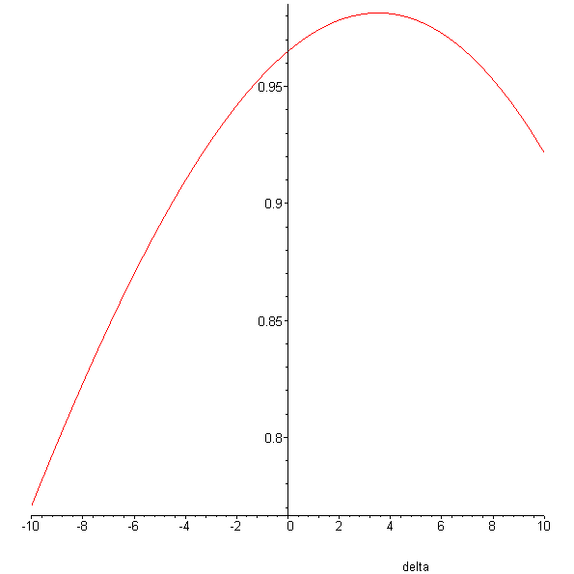
IRD-OPTP-R08 | In-band straylight | To be discussed in the spectral & throughput performances document.  - Analysis of waveguide cut-off and from filter/dichroics explained the measured spatial response beyond the nominal band edges of PMW and PSW in PFM2. Qualitative appearance of ghost images in PFM3 data when external point source used in the measurement but can not separated from the ones induced by extra test cryostat filter, so final status of Phot in-field in-band straylight to be obtained by re-analysis. Out-of-field in-band strayligh can only be commented in the throughput and photometry document as not appearing in optical data set (no source modulation).  - Update from PFM4: same conclusion; spectral variations around waveguide cut-off now implemented in spectral band definition; SPIRE only ghost simulated (example through illustration below) and confirming that ghosts in Phot ILT data are likely due to cryostat filters and/or detector cross-talks.  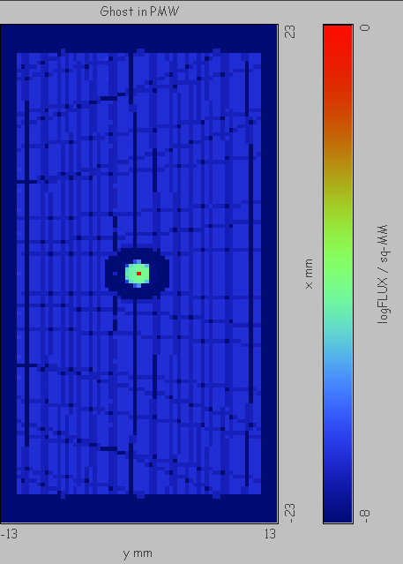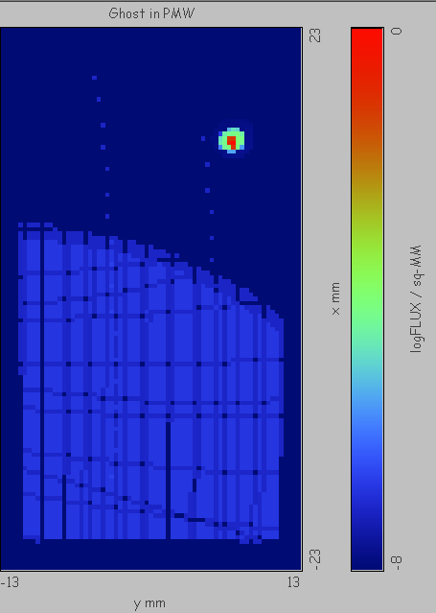  Log-scale irradiance map of PMW focal plane with point source illumination (centre of Fov, left; corner of Fov, right) and including in-field ghost; spatial sampling is F.λ/8.
IRD-OPTS-R01 | Nominal final focal ratio | Taken initially as ~F/5 but final design gives ~4.85+/-0.1 for SLW and 4.35+/-0.1 for SSW  (uncertainty is variation across FoV). From PFM1: measured to be between 4.5 and 5 for SLW; measured to be between 4 and 5 for SSW.  - No update from PFM3 due to reduced/partial coverage of SSW FoV only (half not accessible as not working); pixel characterisation of SLW only not FoV.  - Update from PFM4: confirmed initial values of ~4.85+/-0.15 for SLW and 4.35+/-0.15 for SSW
IRD-OPTS-R02 | Variation in focal ratio | From above: Ok by design and ok as derived from PFM measurements.  - See IRD-OPTS-R02 above  - Update from PFM4: confirmation of ~5% max relative change
IRD-OPTS-R03 | Distortion | Ok by design; estimated to <~5% from field mapping.  - See IRD-OPTS-R02 above  - Update from PFM4: confirmed of < ~5%
IRD-OPTS-R04 | Anamorphism | From PFM1: found <~10% for the all pixels tested in SSW and SLW. Some uncertainty remains due to test source fluctuations and shape at different wavelengths.  - Update from PFM3: value from PFM1 confirmed. Slight dependence over the FoV noticed for SLW (lower anamorphism closer to FoV centre); not clearly the case for SSW.  - Update from PFM4: confirmed with max spatial response ellipticity/anamorphism found <10%, for broadband point source as narrow band test sources (i.e. laser, photomixer) affected by strong polarisation orientation and/or modal non-circular behaviour
IRD-OPTS-R06 | Image quality | Strehl ratio >95% at 250um at FoV centre; derived from measurement during AM warm alignment. Improved to >97% after astigmatism correction in Spec optical train for PFM.  Not derived (yet) from in-band measurement (through-focus).  - No update from PFM3 as no through-focus data set for Spectro but same phenomenon as in IRD-OPTP-R06 expected (but more difficult to extract separately from the pixel response more dominated by detector modal behaviour in the Spectro).  - Update from PFM4: no update, model based retrieval as in Phot case less suited here due to multiple overlapping of effect; estimates from through-focus data (shown in section 5) in-line with alignment based value above.
IRD-DETS-R07 | Detector angular response | By design in Spec BDAs EIDP  Modal content to be further investigated (see section 5.2) at different wavelengths and correlated with spectral bandpass measurement  - Update from PFM3: quasi single-mode behaviour retrieved and confirmed for SSW; quasi single mode for SLW for λ>580um and multi-moded between 300um and ~450um; obtained from experimental derivation of in-band etendue (radiometric; in agreement with geometric so optics/detector interface) at set of measured in-band wavelength.  - Update from PFM4: confirmed, and summarised below via plot of the in-band etendue A.Ω, followed by retrieved spectral mode contents N=A.Ω/λP^{2P} and comparison with waveguide theory applied to Spectro detector geometry.  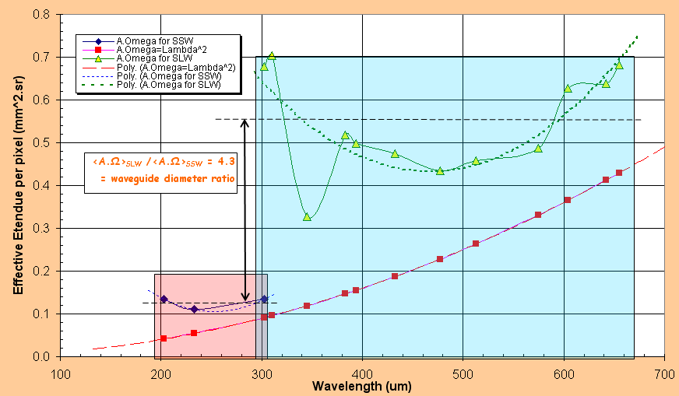  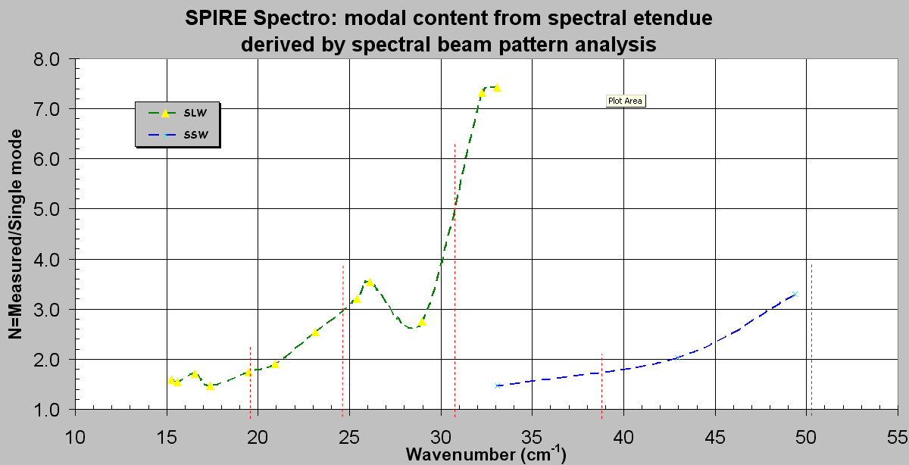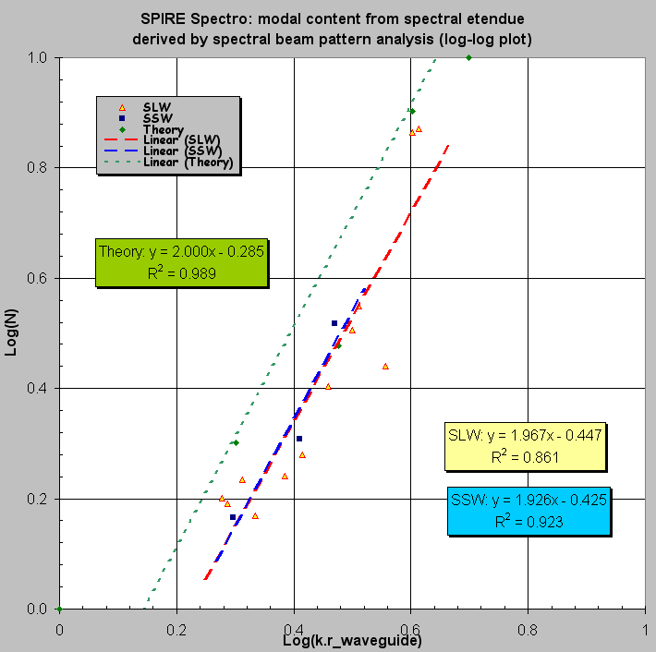
IRD-DETP-R07 | Detector angular response | By design in Phot BDAs EIDP  Modal content to be further investigated (see section 5.2) at different wavelengths and correlated with spectral bandpass measurement  - Update from PFM3: near single-mode behaviour retrieved and confirmed from experimental derivation of in-band etendue at set of measured in-band wavelength.  - Update from PFM4: confirmed, and summarised below via plot of the in-band etendue in Phot bands  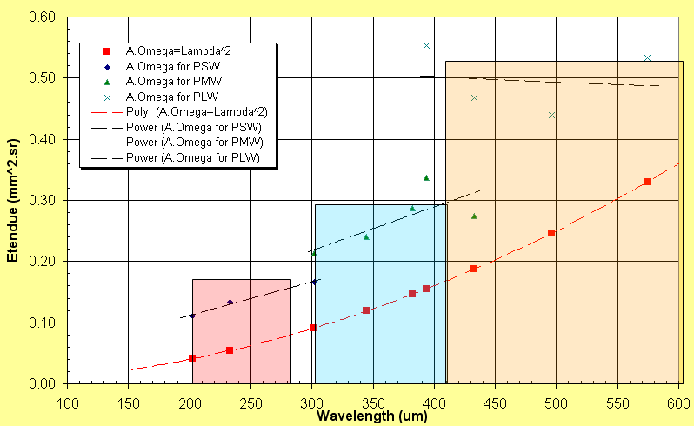  and due to increased in PLW spectral bandwidth (high frequency shift of PDIC2 cut-on edge), a larger relative portion of the band is now including the second detector mode (TM01 on top of the fundamental TE11) which broaden slightly the pattern against classical optical diffraction at short wavelength in-band leading, for a given cold stop-defining solid angle, to a larger etendue in the shortwave part of the newly extended PLW spectral band.  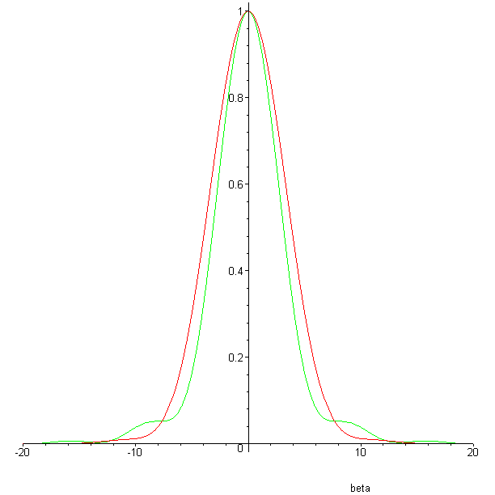  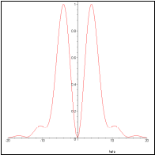  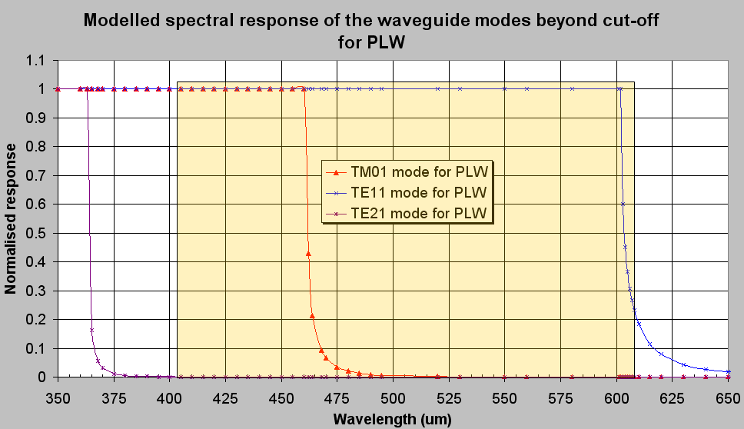  TM01  TE11
IRD-STRC-R01 | Alignment of the instrument w.r.t. the FIRST optical axis | By FPU structure design & characteristics
IRD-STRC-R04 | Optics and associated sub-system alignment | Test on AM warm and cold for pupil alignment (after vibrations) + warm CQM => ok within spec. Test warm on PFM (before vibrations) -> ok well within spec, and ambient test on FS (based on the CQM optics + structure)  No filters, BDAs, or BSM (OGSE flat mirror CM4 used during AM & CQM model test then used as reference for mounting flight BSM).
IRD-STRC-R08 | Attenuation of radiation from cryostat environment | See FPU structure design & justification
IRD-STRP-R02 | Optics and filters alignment | Test on AM warm and cold for pupil alignment (after vibrations) + warm CQM => ok within spec. Test warm on PFM (before vibrations) -> ok well within spec, and ambient test on FS (based on the CQM optics + structure)  No filters, BDAs, or BSM (OGSE flat mirror CM4 used during AM & CQM model test then used as reference for mounting flight BSM). BDA alignment covered by BDA metrology fed into design of interface plates at detector box/BDA interfaces.
IRD-STRP-R03 | Array module alignment
IRD-STRP-R06 | Attenuation of radiation from common structure environment | See FPU structure design & justification
IRD-STRS-R02 | Optics alignment requirements | Test on AM warm and cold for pupil alignment (after vibrations) => ok within spec.  Test warm on PFM (before vibrations) => ok well within spec, and ambient test on FS (based on the CQM optics + structure)  No filters, BDAs, or BSM (OGSE flat mirror CM4 used during AM & CQM model test then used as reference for mounting flight BSM). BDA alignment covered by BDA metrology fed into design of interface plates at detector box/BDA interfaces.
IRD-STRS-R03 | Array module alignment
IRD-STRS-R06 | Attenuation of radiation from 4-K environment | See FPU structure design & justification

Instrument-level requirements and their verification status.
The table below summarised the higher level relevant requirements and their present status.
Updates from PFM4 have been put again in green where relevant.

Requirement Name | Description | Verification Status
IRD-PHOT-R02 | FoV | 4x8arcminP^{2P} nominal from design.  Used as-is during AM activities but not quantitatively assessed.  Not assessed in-band (yet).  - Update from PFM3: FoV found to be ~4x8arcminP^{2 P}for all Phot bands for spatial mapping of Fov via peak-ups  - Update after PFM4: nominal FoV extent size found is ~4x8arcminP^{2P}  NB: effective final value on-sky of FoV will depend on HSO telescope as-built parameters and position of SPIRE FPU in telescope focal plane.
IRD-PHOT-R03 | Beam FWHM | PSW: TBC (measured during PFM2 but final value not yet derived)  - Update from PFM3 (and PFM2): 19.2+/-2.0arcsec when illumination with broadband thermal point source but extra refined value and relative uncertainty reduction when all PSW dataset taken into account in analysis  - 18+/-1.4arcsec at 250um from the spectral average of response to wavelength-varying in-band source  PMW: TBC but potential discrepancy due to PMW anomaly (see section 4)  - Update from PFM3: 22.3+/-2.1arcsec when illumination with broadband thermal point source but extra refined value and relative uncertainty reduction when all PMW dataset taken into account in analysis  - 23.5+/-1.6arcsec at 350um from the spectral average of response to wavelength-varying in-band source  PLW: 30+/-4.8arcsec at 432um (measured during CQM2 tests), equivalent to 34.7+/-5.5 at 500um. Uncertainty to be reduced by analysis of PFM2 data. A priori, compliant wrt spec: 36arcsec at 500um  - Update: PFM2 -> 35.0+/-2.0arcsec // PFM3 -> 36.5+0.5/-1.3arcsec when illumination with broadband thermal point source  - 32.2+/-1.8arcsec at 500um from the spectral average of response to wavelength-varying in-band source  - Update after PFM4: final summary from all PFM test data (broadband and spectral) summarised in plot below  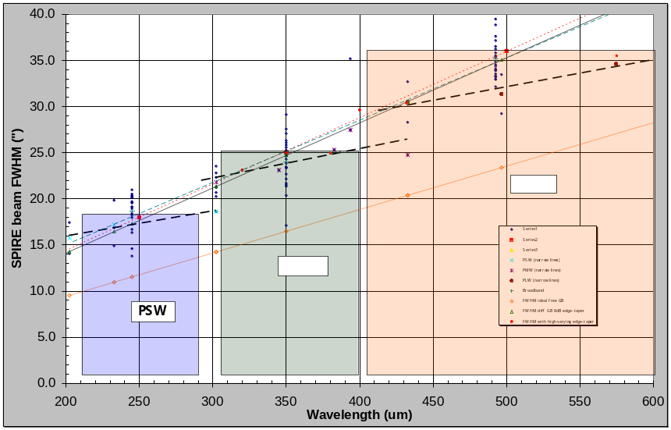  Proposed final beamsize values and Phot beam patterns reconstructed on 2” grid from optical model under constraints/matching ILT test data (see RD7):  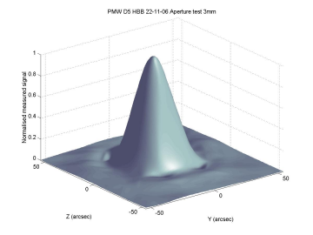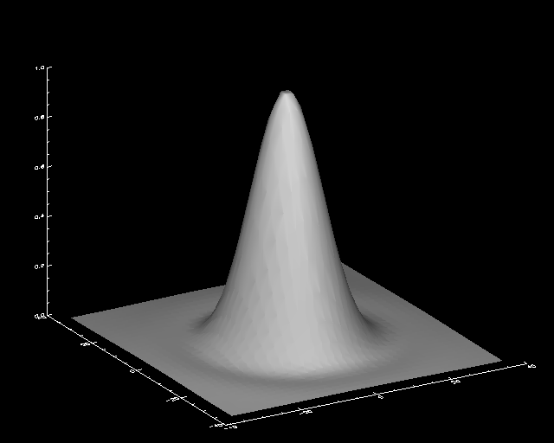  PFM4 ILT results for PMW D5 with quasi point-source (diameter ~F.λ) and HBB (left), ASAP model results final PMW beam pattern (right).
  Reconstructed broadband beam profiles | PSW | PMW | PLW
  FWHM in case of flat spectrum | 18.8” | 24.6” | 35.6”
  FWHM in case of RJ spectrum | 18.5” | 24.3” | 34.9”
IRD-PHOT-R10 | Field distortion | To be derived from future Phot full-Fov measurement.  - Update from PFM3: found <10% (compliant) for all Phot bands for spatial mapping of Fov via peak-ups  - Update from PFM4: confirmed value of <10%
IRD-PHOT-R16 | Co-alignment | Not directly measured during AM activities as BDAs and filter not present.  Used as design guideline in BDA/Phot detector box alignment hardware design (see SPIRE-RAL-NOT-002344 issue 1.0 (15/03/05)).  Good general alignment (quantitatively TBC) found between PLW and PSW. PMW appeared not perfectly co-aligned during PFM2, likely due to the anomaly (see section 4).  - SUpdate from PFM3: found <10% (compliant) for all Phot bands for spatial mapping of Fov via peak-ups  - Update from PFM4: co-alignment between PLW and PMW is found <2+/-1arcsec, co-alignment between PSW and PMW is found <4+/-2.5arcsec. Limitations from the spatial/angular sampling during test do not allow retrieval at 1arcsec or better level. Verification of compliance may done but from other tests/methods (eg BSM data)
IRD-SPEC-R04 | FoV | 2.6arcmin diameter nominal from design.  Not used or assessed during AM activities (on-axis use only) + not present in CQM.  Spec field mapping during PFM indicate FoV is at least 2.6arcmin (although small continuous vignetting occur right from the FoV centre) for both SSW and SLW.  - No special update as PFM3 coverage of Spectro Fov was only partial  - Update from PFM4: Previous conclusion confirmed via more mapping of pixel in Spectro FoV during PFM4; the design and verified F-number being <5, the FoV increases compare to nominal.  NB: effective final value on-sky of FoV will depend on HSO telescope as-built parameters and position of SPIRE FPU in telescope focal plane.
IRD-SPEC-R05 | Beam FWHM | SSW: 16+/-2arcsec at 250um (extrapolated from value derived from PFM1 measurement)  So compliance with spec of 18arcsec at 250um.  - Update from PFM3: 13.8+/-1.1arcsec when illumination with broadband thermal point source  - From the spectral average of response to wavelength-varying in-band source: variation from 17.4arsec at ~200um down to 15.6arsec at ~240um and back up to 17.3arsec at 300um  SLW: measured during PFM1 >40arcsec below ~310um and <30arcsec above 500um  So not compliant with the spec of 25arcsec at 350um but the spec does not take into account the multi-modal behaviour of the detector+coupling optics (broadband waveguide + feedhorn).  - Update from PFM3: 24.2+/-1.3 arcsec when illumination with broadband thermal point source  - From the spectral average of response to wavelength-varying in-band source: variation from nearly 40arsec at 300um down to ~31arsec near 450/500um and back up to 35-40arsec above 600um + high fluctuations of the value in the 300-450um region due to dominant multi-moded behaviour of the detector (feedhorn+waveguide+cavity)  - Update after PFM4: same trend as before for both SSW and SLW confirmed and graphically summarised in following plot  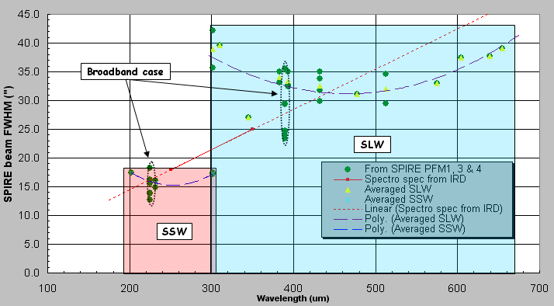

Important remark: any value in arcsec on arcmin (eg pixel beamsize, FoV, …) in the above table on-sky is extrapolated from experimentally derived data by assuming nominal baseline HSO telescope characteristics. Also the values mentioned at specific wavelength or for special source type have been measured at best respective focus (i.e. where best coupling via maximal signal from detector after centration of the point source on the given pixel).

Open issues and anomalies

- Spatial response of PMW array:
During PFM2 test campaign, it was observed a different spatial response. It acted as PMW channel was affected by field dependent aberrations inducing change in shape of the PSF from pixel to pixel alongside an estimated longer in-band relative depth-of-focus and relatively large (in fraction of pixel) misalignment wrt PSW and PLW arrays.
After inspection after the test campaign, a bent/curved dichroic (in reflection for PMW) was found. The design expects a flat reflecting surface while a possible powered element was present during the PFM2 tests in front of PMW BDA. This can qualitatively explain the effects seen.
More quantitative estimations (comparison measured data/optical simulations) will be performed to assure that no other PMW BDA specific effects are to be the cause. Meanwhile the dichroic in question has been replaced by a flat one at ambient.
- Completed (analysis and replacement of PDIC2) before start of PFM3 test campaign. PMW data from PFM3 test shows normal behaviour (spatial response) i.e. the cause of the PFM2 PMW anomaly has been understood and corrected (see the note “Summary of optical investigation into SPIRE PFM2 “PMW anomaly” v1.1, Marc Ferlet, RAL/SSTD – 09/03/06”). Impact on Phot spectral bands size and location (shift) is further discussed in SVR-3 doc nP^{oP}9 on Instrument throughput.

- Global illumination of the Phot and Spectro arrays by on-board calibration sources:
A non-uniform illumination pattern of the Phot arrays has been found. The issue under investigations in an attempt to discriminate the possible cause: individual detector response, test source field flatness, extra misalignment at operating conditions or internal vignetting of Phot optical path at FoV edge not previously found.
- Analysis via optical models of SCAL source illumination of the Spectro arrays has been performed and indicate non-uniform illumination pattern in qualitative agreement with test results. PCAL illumination of Phot array under investigation with optical models. Anomalous (non-uniform and shifted) array illumination by the CBB during PFM3 qualitatively traced to a tilt of the CBB assembly at FPU aperture interface: improved mounting of CBB assembly at FPU interface will be implemented for PFM4 test campaign.
- Simulations of SCAL illumination (illustration below from the note “SPIRE Testing: focal plane illumination by the calibration sources, Marc Ferlet, RAL/SSTD, v1.1”) indicate an expected none uniform illumination with ~15+/-5% gradient (SMEC position independent) oriented at 45deg wrt the main axes.
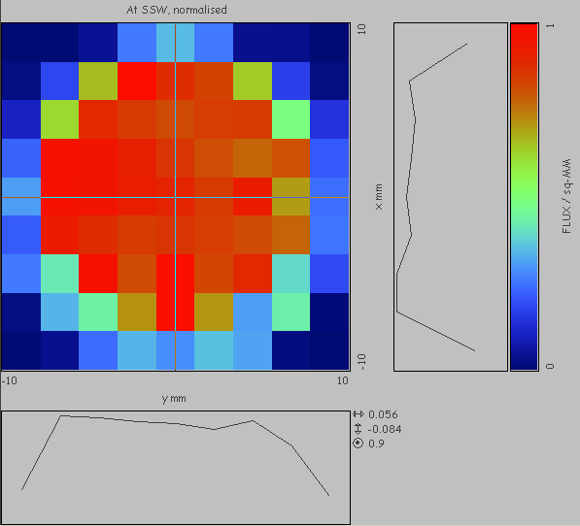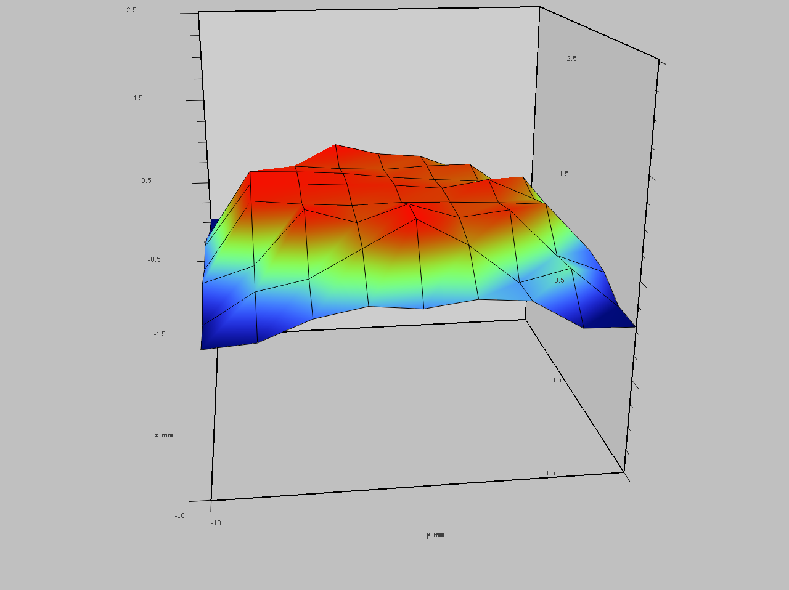

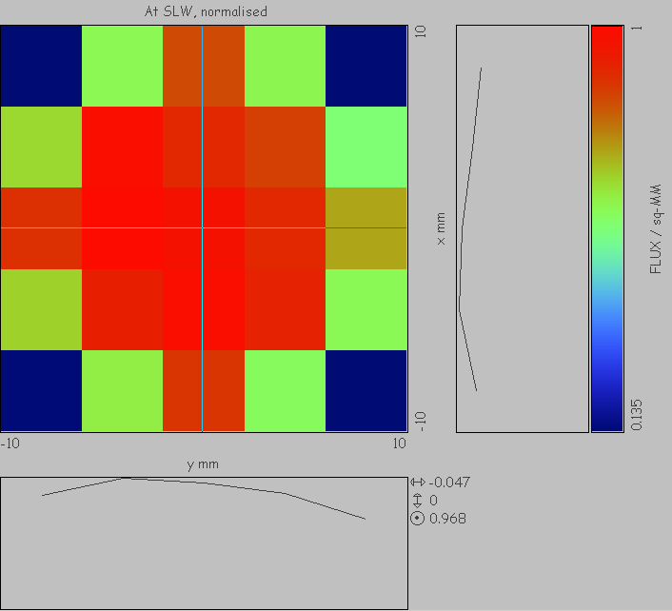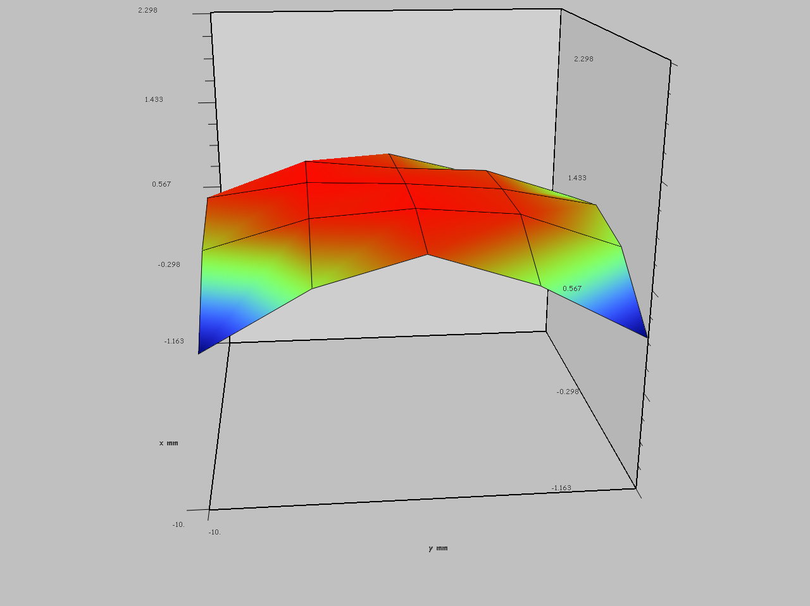
Figure 1: Optical simulation of Spectro arrays illumination (SSW top, SLW bottom) from SCAL
Generalisation of model to PCAL possible when source radiant intensity distribution available.

- Spec Channel fringing:
The presence of low and high frequency channel fringing in the Spec SSW and SLW interferogram signals was detected during PFM1 testing. It seems to appear when looking at cold, spatially and spectrally broad source (not found when bright monochromatic point sources are used).
In-field ghost images were expected and simulated in both SSW and SLW in particular due to the presence of the additional field lenses in front of both BDAs and could lead to some channel fringing. And modelling of some Spec characteristics have led to good matching of other features of Spec interferogram signal such as the baseline variation and decentring (from internal apodisation, vignetting and SMEC localised small decentre and tilt).
But here the exact source of the different channel fringing effects is not entirely clear: supplementary reflections detector/lens, OPD-dependent out-of-field stray (internal ?) path are among the alternative explanations.
Corrective action such as the development and use of an AR coating on the Spec field lenses will reduce the magnitude of the spatially overlapping ghost images and therefore reduce the effect of the channel fringing.
- New AR coating on Spectro lens for PFM3. Noticeable reduction in low frequency channel fringe indicating the effect of the new coating but appearance of new non-predicted ghost across Spectro FoV when external test source used: qualitatively linked to the presence of extra cryostat filter (for room background/load reduction).
- High frequency channel fringing still present so possible causes listed above still valid. Important note: SMEC has been replaced by the flight item after PFM3 campaign; a possible link between remaining channel fringing and SMEC configuration could then be further identified in during PFM4.
- Still in-field straylight through ghost found in PFM4 Spectro data when source external to cryostat are used so still strong possibility of being caused by increasing number (and untilted) of filters along the cryostat optical port; leading to appearance of channel fringing features in the interferograms. Further discussed in SVR-3 doc nP^{oP}11 on SMEC and Spectrometer performances.
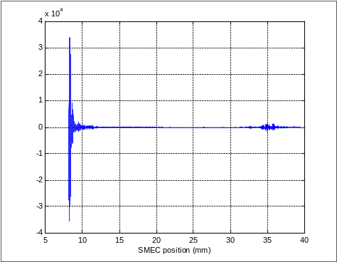
Figure 2: Example of Spectro interferogram with external source (lab background here)

Discussion on previous recommendations (data analysis and tests) and related optical performances results

Previously recommended data analysis

- PFM2 spatial data:
Most point source beam scans and peak-ups, monochromatic and broadband, as well as pupil scan profiles at different wavelength are to be analysed in order to characterise the individual pixel spatial response (PSF shape for derivation of FHWM, anamorphism, etendue).
NB: The Phot arrays were only partially active so distortion and variation at the Phot FoV scale can not be retrieved from PFM2 test data set.
- Completed during PFM3 test campaign. Analysis procedure further applied to the measured PFM3 dataset.
- Dataset further completed during PFM4 leading to confirmation of broadband results and complementary narrow line response at same and also different wavelengths

- Through-focus beam scans:
Further analysis of this data set could be used to retrieve any eventual residual in-band relative defocus between arrays (i.e. longitudinal co-alignment), within Phot and Spec respectively, as well as in-band Strehl ratio (instead of the wavelength scaling technique used at the moment from Warm Alignment image quality test in the VNIR), including filter and detectors, from the axial variations of measured focal plane irradiance.
NB: Optical phase retrieval (including the effect of the coupling detector-feeding optics) could be performed but not expected to give high due to large depth-of-focus and natural long-wavelength blurring
- Only one Phot focus test performed during PFM3, none on Spectro (see below recommended tests for PFM4). Strehl ratio derived by alternative method from spectral measurement of spatial pixel response at best focus and compared to axial irradiance model. Phase retrieval from dataset (based on focus diverse phase diversity or else) as an independent assessment to be developed.
- Through-focus on co-aligned Phot pixels done with broadband point source during PFM4; waiting for completion of data reduction.

- Merging of pupil scans and beam scans data:
When measured with same calibration source at same wavelength, substracting the measured focal plane pixel beam pattern back projected on the external pupil from the pupil scan data in order to obtain an estimate of the telescope pupil illumination.
NB: This is limited for the moment to a reduced number of wavelengths (1 for Spec during PFM1, 2 for Phot during PFM2).
- Has been done for the one measured on Spectro (SSW). Alternative derivation of effective edge taper as function of wavelength has been derived from PFM3-measured spatial pixel response at different in-band wavelength for the specific case of PLW. Extension to PSW and PMW on-going.

Previously recommended tests
First, a brief review of the tests recommended at previous SVRs is performed, with complement from PFM4 results.

- Systematic mapping of the Phot FoV:
The availability of the complete live Phot arrays for PFM3 performance test campaign would allow the Phot FoV mapping (extent, distortion). This would be performed by systematic series (along chop and jiggle axes as well as FoV corners) of point source peak-ups, moved by/from external test set-up with recording of the source pointing.
NB: for Spec, this was done nearly completely during PFM1 performance test campaign.
- Completed during PFM3 test campaign.
- Done again partially during PFM4 as post-vibration verification.

- Extension of the spatial characterisation tests (beam scans & peak-up):
Extension of the standard spatial beam scan test with monochromatic point source to more wavelengths in-band for Phot and Spec would allow a more spectrally continuous derivation of the main characteristics (PSF width and shape) in each band and compared to alternative derivation of the wavelength-dependent throughput (e.g. from spectral bandpass measurement).
This needs the use of several wavelengths per Spec or Phot bands when available by the calibration source (FIR laser). The use of low power but detectable spectrally tunable photomixing source, tested during PFM2, can complement the FIR laser at the longer wavelength regions (in PLW and SLW bands).
- This is mainly a modification of an existing test to allow higher information, wrt pixel spatial response, to be recorded. During PFM3, more type II beamscans were performed and the use of type III (see Calibration and Test Plan) as sampling/duration trade-offs for peak-ups.
- Not implemented. Same trade-off approach as in PFM3 used during PFM4.

- Extension of the pupil scan:
The pupil scan test is at the moment performed by scanning a simulated point source at the SPIRE external exit pupil (matching HSO telescope secondary) only in one direction (along ZB_{esaB}), horizontal in the test configuration. In order to extend the verification the illumination of this circular external pupil for both Spec and Phot, it is recommended to perform the test as well the pupil scan in the orthogonal direction (YB_{esaB}). A simple scheme for the implementation of this manual test in the present test set-up is being investigated.
- This is mainly an extension of an existing test to allow higher information wrt effective external pupil illumination, to be recorded. Not performed during PFM3.
- Extension to the Y axis and to Phot array not performed but 1D pupil scan done on SLW.

- Polarisation response:
To avoid spurious effect from source already polarised such as the FIR laser and supplementary polarisation rotation induced by the test set-up optics, it is recommended to perform the polarisation test with the broadband calibration source (HBB), typically in point source mode towards co-aligned Spec or Phot pixels. Implementation and procedure have already been developed accordingly.
NB: This is not directly called by any optics or instrument level requirements but its interest lies in the potentiality that a change in response as function of the polarisation angle could inducing some modulation (eventually spatially-dependent) in in-band throughput.
- Although not directly linked with/called by IRD spec, this is a baselined test. Not performed during PFM3, so recommended for PFM4 (see below).
- Test performed twice on each side (Spectro and Phot) during PFM4 and discussed below.

A final set of recommended optical tests for the PFM4 test campaign is listed in the table below. Note that most of them are labelled medium or low priority as they are intended for further characterisation and not direct evaluation of compliance with IRD. This is has been submitted for inclusion in the PFM4 test plan.
Additional column has been added to show which recommended tests where actually performed during PFM4 campaign. More details regarding the results of the further SPIRE PFM optical characterisation thanks to these tests is discussed after the table.

Recommended tests | Purpose and Justification | Outline of procedure | Priority for PFM4 test campaign | Performed during PFM4 ?
Post-vibration verification test | Quick estimation of eventual post-vibrations optical performances degradation by comparison with PFM1,2 and 3 datasets | reduced sets of peak-up with HBB on a few pixels for each bands Phot and Spectro + max 1 beamscan type II per band with HBB or laser or photonic mixer | Medium/high priority | Yes, see summary below
Pupil scan | In-band verification of external/internal pupil alignment (optical dataset quality & validity)  + complementary information wrt pupil illumination (edge taper) at given wavelength | 1 in SLW and 1 in PMW but some issue with lack of stable FIR laser line available in PMW band as only doable with strong source (= laser); with 2P^{ndP} dimension extension (slice along Y axis) | Low priority | Yes for Spectro side only (and no extension to 2D), see summary below
Spatial focus test | Through-focus characterisation;  Inter-band relative defocus assessment;  Database of spatial response wrt defocus | with HBB on at least co-aligned Phot and co-aligned Spectro pixels with range beyond respective nominal depth-of-focus  + same with 1 line (laser or photomixer) per band | Medium priority  Low priority | Yes for Phot (under data reduction) and Spectro (summary, see below)  No
Spectral focus test | Characterisation of defocus effect on Spectrometer pixel response (coupling, spectral shift, …) | SMEC scans with HBB (and/or photomixer) at co-aligned central Spectro pixels with different defocus in TelSim.  NB: needs effective SCAL nulling of room background | Medium/Low priority | No
Polarisation test | Assessment of instrument polarisation response impact on photometry and eventually the second order vector effects | with HBB on co-aligned near FoV centre pixels for Phot and Spectro | Medium/Low priority | Yes for Phot and Spectro, see summary below
Spectro 3D characterisation test | Characterisation of spatial/spectral crossed effects by generation of a spatially-oriented 3D data cube | beam scans on Spectro at different OPD/SMEC positions: could take between ~5h min to ~20h depending on OPD step size + open question if to be done with HBB on co-aligned or with less stable laser lines (trade-off is 1 with HBB and 1 with photomixer)  NB: needs effective SCAL nulling of room background | Medium/Low priority | Yes
Aperture test | Characterisation of in-band pixel coupling vs source size from quasi-point source to quasi-extended source | TelSim pointed at central co-aligned Phot and then Spectro pixels with HBB source (with laser and photomixer possible, just need strong source): object aperture size is varied from quasi close to wide open, simulating coherent point source to extended source for all bands | Low priority | Yes for Phot and Spectro, see summary below

Further optical characterisation
In more details, the recommended tests (relevant to general SPIRE optical characterisation even if not related directly to IRD, and not possible in flight) performed during PFM4 led to the following results:

- Post-vibration verification tests

Example of comparison between PFM3 (before) and PFM4 (after last FPU vibrations) Phot spatial responses, with broadband quasi-point source on PMW D5 and associated co-aligned detectors. Beam size of SPIRE comparable to 1-2 arcsec in all bands. Good stability of the ellipticity value and consistency of the results for other compared co-aligned detectors along the chop axis (eg PMW D11).
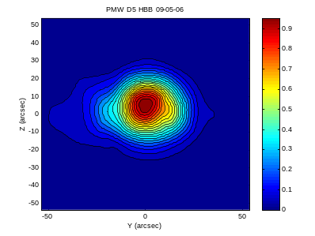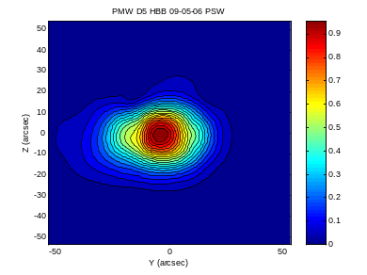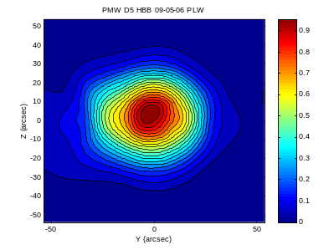
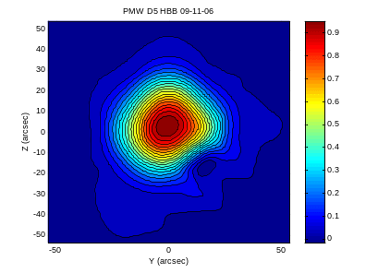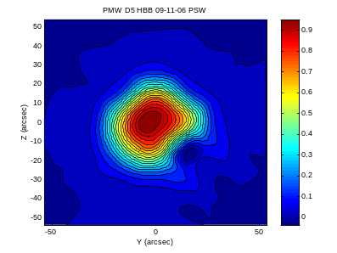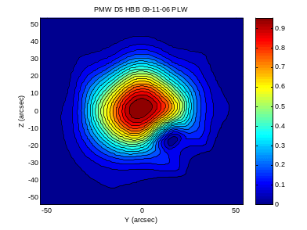
Figure 3: Beam scan on PMW D5 from FPM3 (Upper plots) and from PFM4 (lower plots). Central and Right columns are for the PSW and PLW co-aligned pixel respectively.

- Pupil scan

Relatively good agreement & reproducibility with general test set-up model and in agreement with previous pupil 1D (Z axis) scan on SSW during PFM1
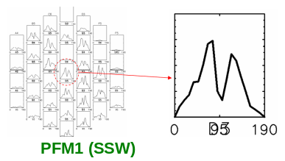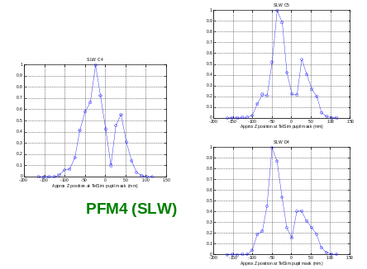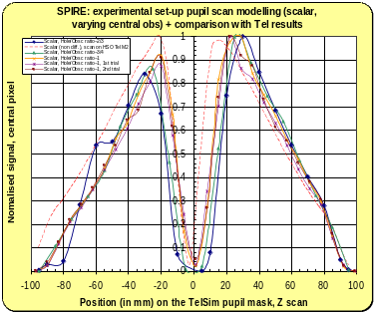
Figure 4: Results of the PFM1 SSW pupil scan (left), pupil scan result during PFM4 through a few illuminated SLW pixels (centre), results of end-to-end simulation of the test (right)

- Focus test (Spectro only)

Broadband small source size on Spectro FoV centre, scanned in focus at SPIRE FPU optical interface (entrance focal plane).

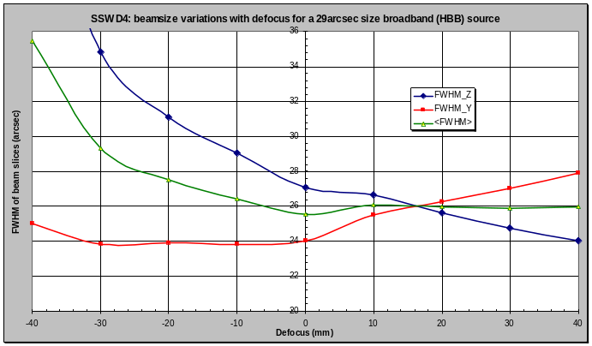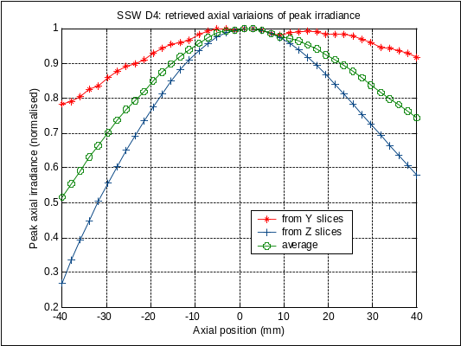

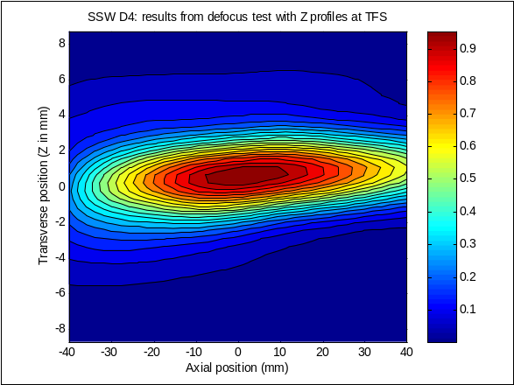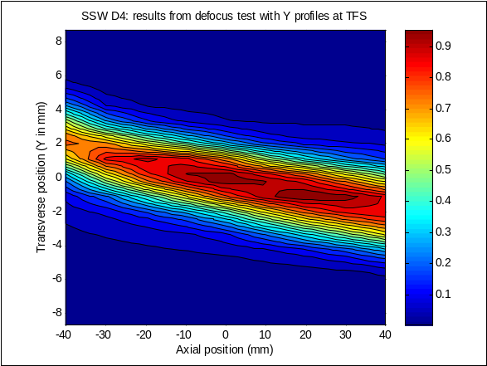
Figure 5: Focus test results for SSW D4
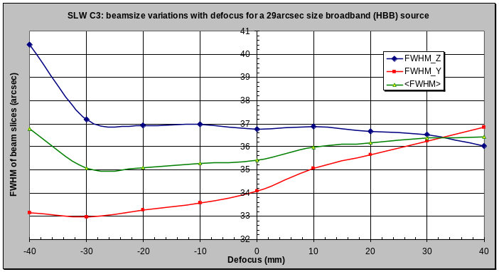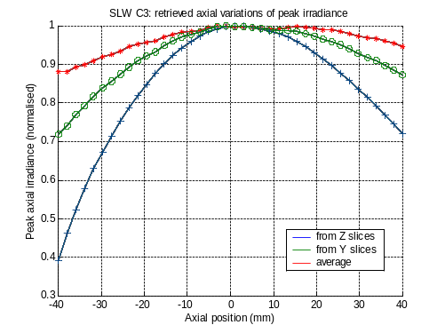
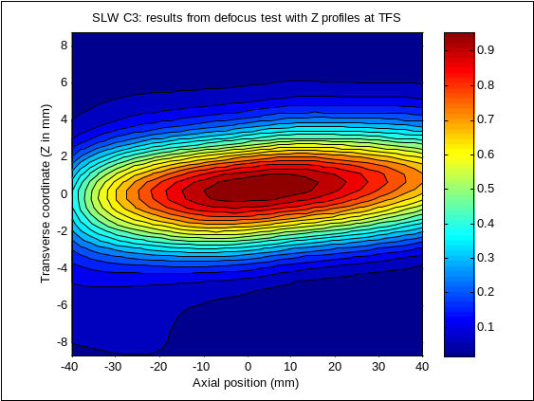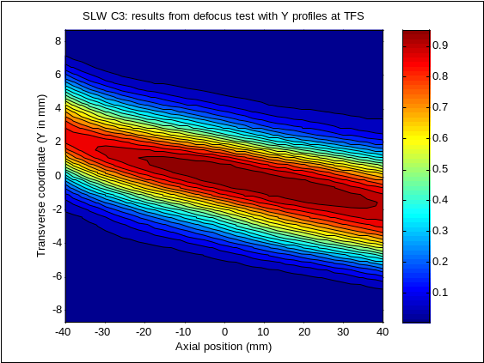
Figure 6: Focus test results for SLW C3

Variations of FWHM and peak irradiance as expected; angular tilts/distorsion effect due to limits of the experimental set-up at large magnitude defocus.

- Polarisation

Rotating polariser (wire grid) inserted in the path of the source while pointing towards co-aligned Phot and Spectro pixel. Test repeated for assessment of reproducibility.

Photometer side:

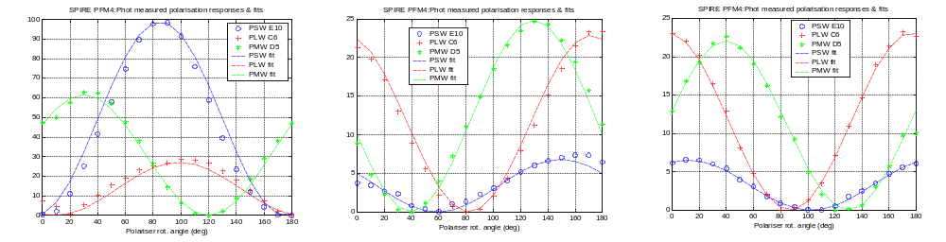
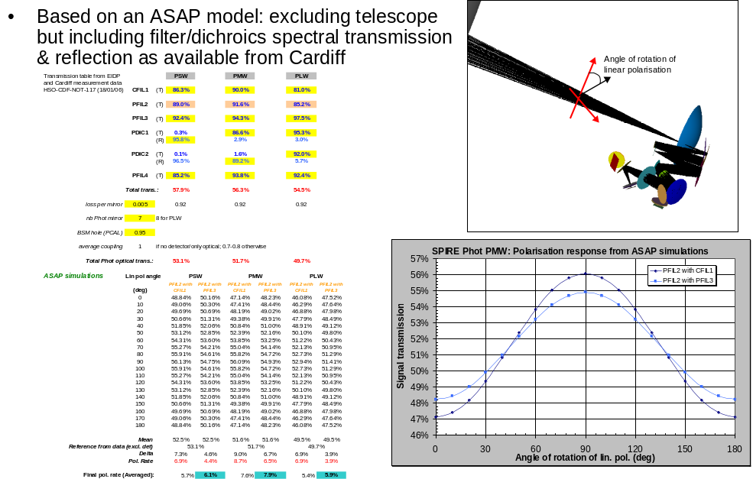

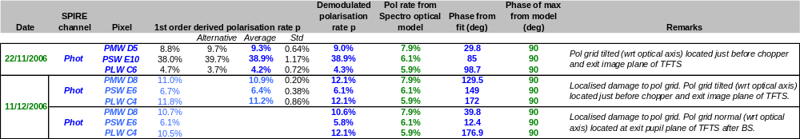
Figure 7: Phot side polarisation: experimental results & fits for co-aligned Phot pixels (top), optical simulation of polarisation response (middle), summary of results and comparison (bottom)
PMW and PLW polarisation rate in agreement with model for 1st test, PSW in the 2nd test but difference in test set-up prevents concluding on any FoV dependence. Phase only matches model for PSW and PLW in 1st test; specific dichroics phase effect (not in model) and exact geometry test set-up drive the large differences elsewhere.

Spectrometer side:

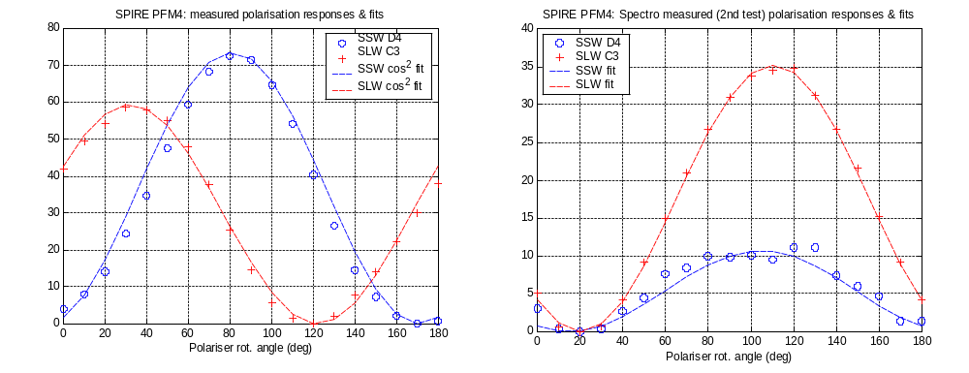
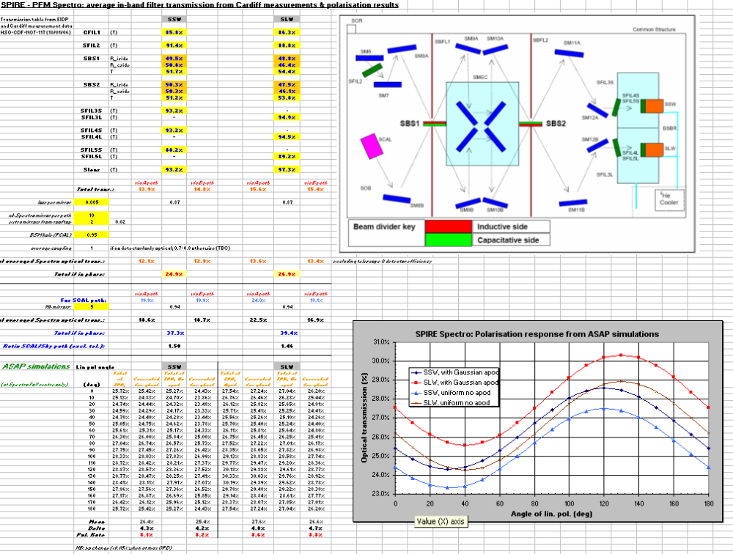

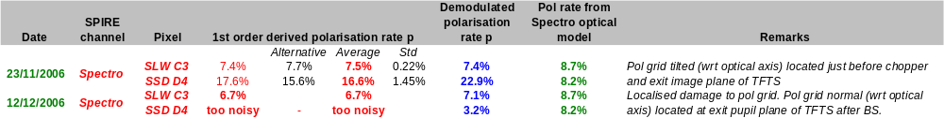
Figure 8: Spectro side polarisation: experimental results & fits for co-aligned Spectro pixels (top), optical simulation of polarisation response based on component characteristics (middle), and summary of results (bottom)
Relatively good agreement for SLW; SSW affected by grating behaviour of polariser, incident angular beam spread and damage to polariser in second test. Phase shifts matching very well model in the 2nd test case. Note that from the model, SSW is expected to have relative phase shift after recombination due to unbalanced beamsplitters in RR and TT configuration.

- Aperture test

Broadband source pointed at co-aligned pixel around Phot and Spectro FoV centre. Source size d is varied in size from sub-pixel size to larger than 1 pixel and spatial pixel response measured for each position d; all other parameters fixed/constant. Dependence of resulting quantities is expressed in reduced source size (area) (d/dB_{oB})P^{2P} where dB_{oB}=2.F.λB_{oB} is the focal plane pixel size (feedhorn aperture) for each respective band.

Photometer side:

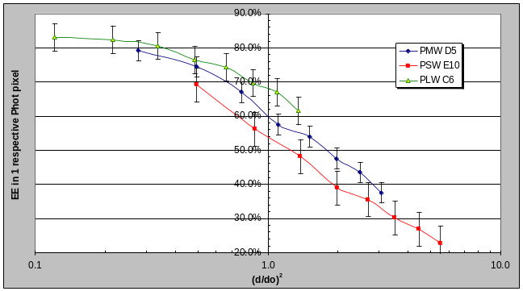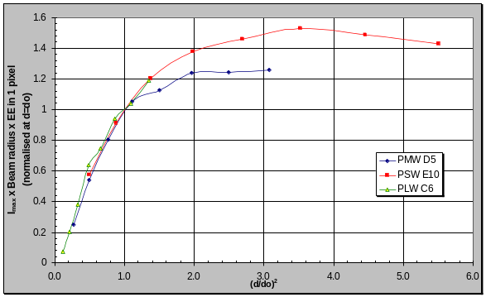
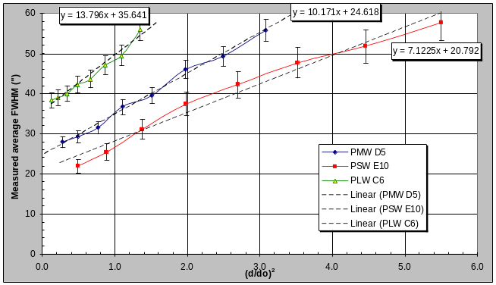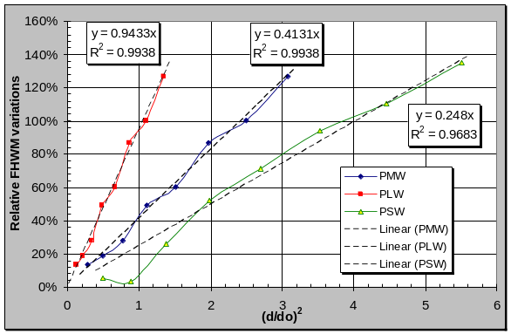
Figure 9: EE in a respective focal plane pixel (upper left), reconstructed total signal per pixel (upper right), measured beamsize in terms of FWHM (lower left), and derived relative FWHM variations (lower right)
Results consistent with PFM3 and other PFM4 spatial response tests (in terms of coupling per pixel, beamsize but here without deconvolution i.e. when d<<dB_{oB}). So measured variations of beamsize vs relative source size ok and independently confirmed.
Relative beamsize variations (FWHM(d)-FWHMB_{oB})/FWHMB_{oB} vs source size (actually surface area), where FWHMB_{oB}=FWHM(d→0) is the beam size for unresolved spatially coherent point source), can be then generally expressed for all Phot bands as:
ΔFWHM/FWHMB_{oB} = (d/K)P^{2P}

where d is source size and K a coefficient independent of the wavelength (and therefore bands), with K=8.87mm if at TFP, or K=64.2” if on-sky assuming telescope fB_{effB}=28.5m.

NB: the last result is general but applicability will depend on source spectrum; uncertainty on final result found <5%

Spectrometer side:

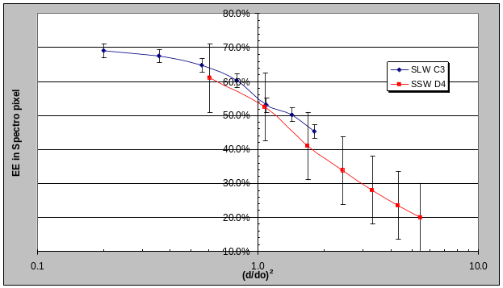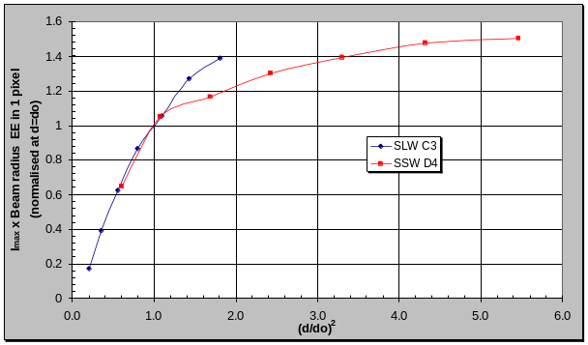
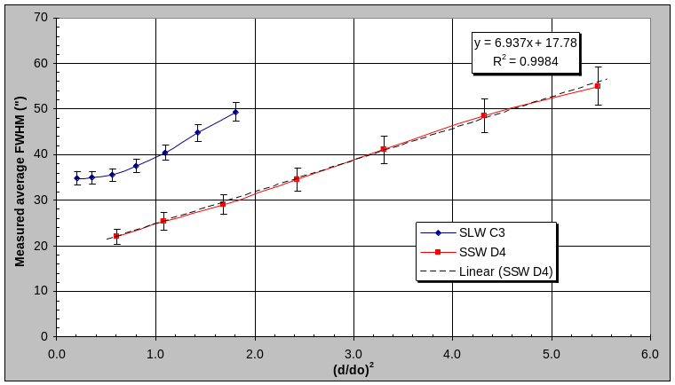
Figure 10: EE in a respective focal plane pixel (upper left), reconstructed total signal per pixel (upper right), measured beamsize in terms of FWHM (lower)

Same thing here but with some of the Spectro-specific features including the more detector-dominant, i.e. less optical-dominant like in the Phot case, specially for SLW (SSW found closer to Phot behaviour as expected and previously measured in PFM1&3). Some residual issue with the small source size response of SLW: large variations between tests (from 25arcsec to 35arcsec typically) indicating a specific sensitivity to small (point source and quasi-point source sized) broadband source.

References

Applicable documents

AD1 SPIRE IRD, SPIRE-RAL-PRJ-00034 issue 1.3 (14/07/05)

AD2 SPIRE SVR-2 Optical Performances, SPIRE-RAL-REP-002572 issue 2.0 (15/09/06)

Reference documents

RD1 SPIRE STM alignment test campaign: Phot Hartmann test, Spec Hartmann test, cold stop alignment verification (05/03) + SPIE vol 5487 pp448-459 (06/04)

RD2 SPIRE-RAL-NOT-001807 issue 2.0 (07/07/04)

RD3 SPIRE-RAL-NOT-002006 issue 3.0 (25/08/06)

RD4 SPIRE-RAL-NOT-002211 draft 0.3 (23/02/05)

RD5 SPIRE-RAL-NOT-002460 issue 3.0 (21/09/07)

RD6 SPIRE-RAL-NOT-002876 issue 1.1 (28/03/07)

RD7 SPIRE-RAL-NOT-002949 issue 1.0 (25/07/07)

