TITLE: FS ambient alignment verification test: summary report

By: Marc Ferlet (RAL)

DISTRIBUTION

- RAL/SSTD - SPIRE Project Team:
For info:
E Sawyer (RAL)
D Griffin (RAL)
B Swinyard (RAL)

For Project database/archive:
J Long (RAL)

change record

ISSUE DATE SECTION REASON FOR CHANGE

1.0 16/07/07 All First issue of the document

CONTENTS

- Introduction

- Photometer side

- Spectrometer side

- Appendix

Applicable and reference documents

AD1 Herschel-SPIRE Optical Alignment Plan, LAM.OPT.SPI.PRC-031203_01 (18/05/2004)

RD1 Herschel-SPIRE FS AIV logbook (July 5th, July 6th, July 9th, July 10th; RAL SSTD, 2007)

RD2 SPIRE-RAL-NOT-001807 issue 2 (07/07/2004)

1. Introduction

This note reports on the Herschel SPIRE Flight Spare (FS) model ambient alignment verification test. It follows procedure as described in AD1 based on early optical alignment plan and update from feedback of the STM alignment campaign. These formed the baseline approach for the PFM alignment campaign in 2004 and were re-used here.

Step by step activities were performed in the tunnel area of cleanroom RAL-SSTD/R25-G56 and are recorded in daily FS AIV electronic logbook RD1.

The FS model is made of the original STM structure which became the CQM and the STM optics. The STM optics was characterised at ambient and cold during STM test campaign. Exchange of mirror (noticeably CM3) occurred at the end of STM campaign when it became the CQM. So the last optical ambient characterisation of the optical alignment occurred at this period and was reported in RD2, and this gives the baseline of ambient alignment verification activity for this time.

To allow end-to-end optical verification in the visible, filters, dichroics and beamsplitters are all removed (as not transparent in the visible) and replaced by set of dummy ones specially made by Cardiff University - AIG. The initial sets of dummy Phot dichroics made for the STM test campaign were too reflective (90/10 typical) and then replaced by ones closer to 50/50 separation level for PFM. This second set was used here again in order to allow minimum signal to be detected in/out of PLW, through dummy PDIC1 and dummy PDCI2.
The BSM subsystem, including the flat mirror CM4, is also replaced by a dummy/GSE BSM with no central hole.

2. Photometer side

2.1 Alignment set-up
The main set-up configuration is the following: FPU is attached to MSSL rotisserie and rotated so that the FPU main optical bench (SOB) is horizontal. The FPU+rotisserie are on the HOB simulator plate, itself attached to the transfer white trolley, the rotation of the latter is blocked.
To get more stability from the blocked wheels of the white trolley, the entire system is raised with no longer contact of wheels with the floor. At the same time, it is levelled with monitoring with a precision spirit level. This device is left as a set-up stability monitoring device during the entire alignment process. This replaces the previously used theodolite on a temporary mounted optical reference on SOB.

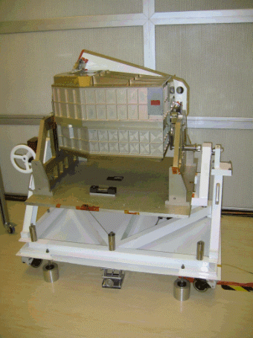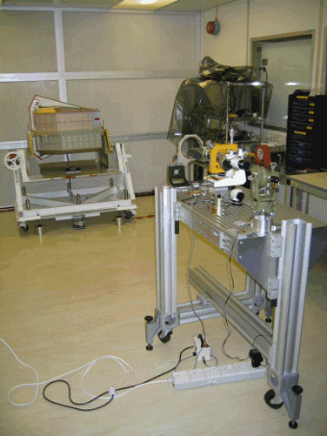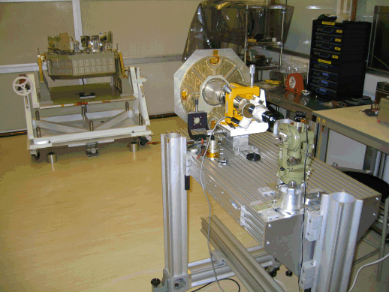
Figure 1: SPIRE FS FPU in the ambient alignment set-up (left), with the LAM M2 OGSE bench being aligned to the simulated Herschel axis optical reference (centre), and with Phot cover open and LAM M2 bench with M2 tool in position (right).
The lightweight HOB simulator plate equipped with optical reference simulating the location and orientation of Herschel telescope optical axis is mounted on the FS FPU feet. The external LAM M2 bench is then levelled, positioned axially and aligned angularly wrt this reference. This allows the location of the M2 tool wrt FS FPU, simulating Herschel M2 the external SPIRE pupil.

2.2 Internal alignment tools
Measure of the pupil mismatch and instrument LOS towards M2 is performed via back-illumination of a structured pattern at the internal image of the pupil (cold stop location). Following feedback from STM test campaign, a new Phot CS tool was defined and used for PFM test campaign (see note “New definition of PCS tool”, KD, 20/05/2003). This is the one used again here and mounted in place of the cold stop in the Phot detector box entrance aperture.

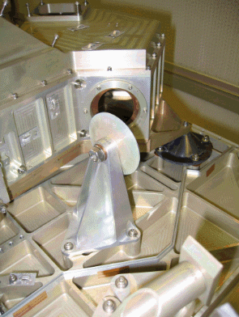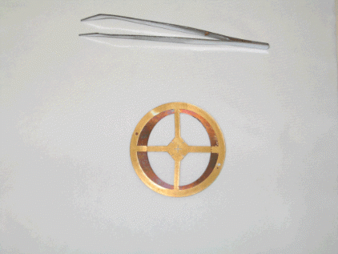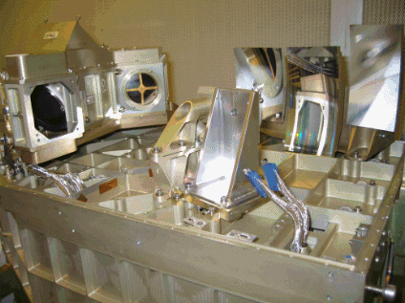
Figure 2: FS FPU with open Phot cover, cold stop present (left); the cold stop and the Phot CS tool superposed in the right orientation (centre); the Phot CS in place in Phot detector box (right) with PM8 temporary removed for accessibility.
Ambiguity of mounting orientation is solved by the position of the dowel pin and matching the internal ovoid shape of the cold stop aperture.

The BSM OGSE was used most of the time because of the absence of central obscuration. This central obscuration once magnified by CM3 at the M2 plane is approximately matching the MAT optics aperture, making it useless for checking focus along the set nominal chief ray beyond CM3.

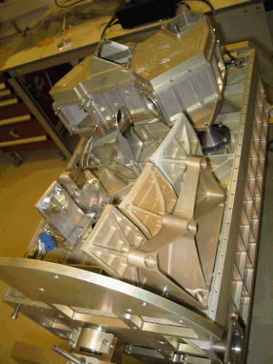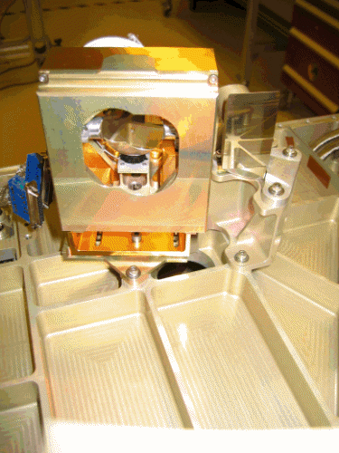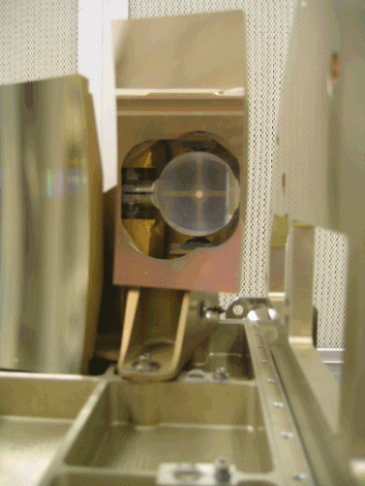
Figure 3: FS FPU Phot side with OGSE BSM (left), FS BSM mounted on SOB (centre), and view of the BSM, superimposed (with image of CS tool) through reflection in CM3 (right).
The OGSE BSM was nevertheless swapped for the FS BSM in order to assess any differences and in order to test a mirror chain more representative of the final FS model.

2.3 Results
The M2 tool after alignment becomes the reference. Pupil shifts are measured by comparing the local image (Phot CS back illuminated projected onto M2 via SPIRE optics) with reference fiducials on M2 tools.
The measurements translated into the telescope coordinate system gave: ΔZ= -11.5mm, ΔY= 16mm. It was checked that this is stable when the source (fibre D-tool) is moved from one Phot BDA position to another (i.e. in place of PSW BDA, PMW and PLW) so that there is no effect from the optics (dummy dichroics, PM9 and flats PM10 & PM11). Uncertainty on these values are estimated at ~+/-2.5mm but further discussed below.

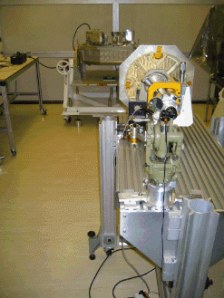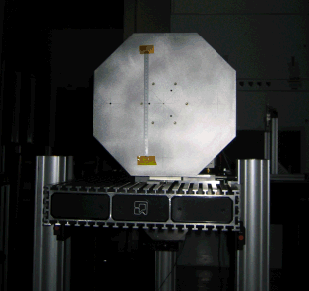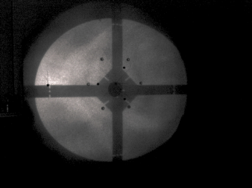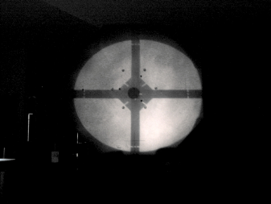
+Y_{loc}
+X_{loc}
+Z_{ESA}
+Y_{ESA}
Figure 4: Set-up with fibre D-tool here in PSW position (left), M2 tool with local and telescope coordinate systems (centre), and projection of back illuminated Phot CS tool pattern onto M2 tool (right) with the central hole of the FS BSM overlapping.
Variations across the pupil have been found as follows:
- top edge: ΔZ= -14.5mm, ΔY= 17mm
- bottom edge: ΔZ= -9mm, ΔY= 15mm
- left edge: ΔZ= -13mm, ΔY= 11mm
- right edge: ΔZ= -12.5mm, ΔY= 18mm
This indicates a low residual ellipticity of the pupil image and low level of distortion showing good image quality transfer by the SPIRE Phot optical chain between CM3 and PM8 inclusive. An azimuthal rotation about the chief ray/projection line of sight was found to be <1.2+/-0.4deg.
After swapping the OGSE BSM for the FS BSM, the following results were obtained:
- centre of projected FS BSM obscuration: ΔZ= 1mm, ΔY= 13.5mm
- centre of projected Phot CS tool image: ΔZ= -3.5mm, ΔY= 16.5mm
The differences lead to an equivalent relative lateral shift ~0.5mm (or ~2% in ΔR/R) in Z and Y between Cold Stop and image of CM4 at the Cold Stop plane. This is possibly due to the FS BSM design itself to a small extent and the change of the interface of the Phot detector box with SOB (A-frames & cone legs).
It is interesting to note that the FS BSM is correcting for the general nominal deviation in Z. Intuitively, because the BSM brings CM4 close to a pupil image, no change should occurs but the composite of CM4 orientation and position (along Z so in the plane of the SOB) slightly away from the real image of the pupil induces a possible effect seen here.
The remaining values along Y are close for the BSM obscuration image and CS tool image and this can be the indication that the pupil shift offset in Y is generated by CM3 and to a small extent the sub-bench supporting CM3, CM5 and PM7.
By comparison, CM3 is not shimmed as it is in the PFM and from RD2, measurement on the CQM indicated as well a major shift along +Y. The magnitude here is larger but an offset is particularly expected along Y due to stability of the set-up, weaker for rotation around Z as was pointed out in RD2 and AD1 (with potential temporary and non quantified solution involving extra weight on the HOB for compensation). So that on top of the measurement uncertainty, there is an offset from the set-up itself which transfers directly to the measurement. This is also on top of the test for reproducibility
This means that these measurements are consistent with previous tests on CQM (see RD2). Residual differences (equivalent to < ~0.6mm at the cold stop) maybe explained by the change of Phot box feet.
A total pupil shift is measured to be ΔR/R~6.5% which is in-line with previous values from the CQM, higher than the values found for a different model (PFM structure and optics), although still at the edge (no margin) of the acceptable level set by the SPIRE alignment error budget.

As in RD2, focus check was performed with the MAT on M2 tool bench nominally aligned on the chief ray and the LED D-tool. This can only be qualitative due to the very slow beam to/from the MAT (large distance and small aperture). It was checked that for PLW, the only one with D-tool nominally at the geometric (i.e. short wavelength limit) focus, this is in focus (within estimated +/-2mm from the MAT depth-of-focus and focus control accuracy in this configuration).

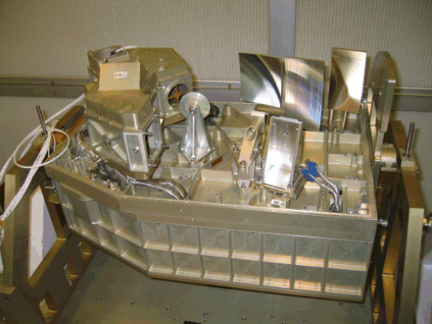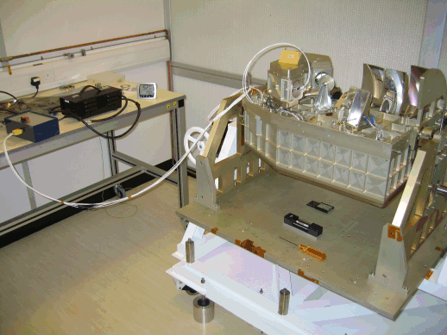

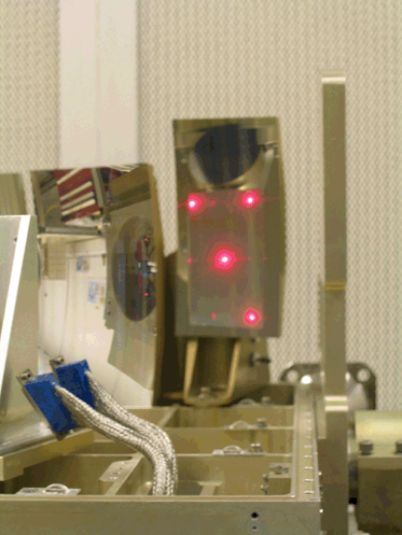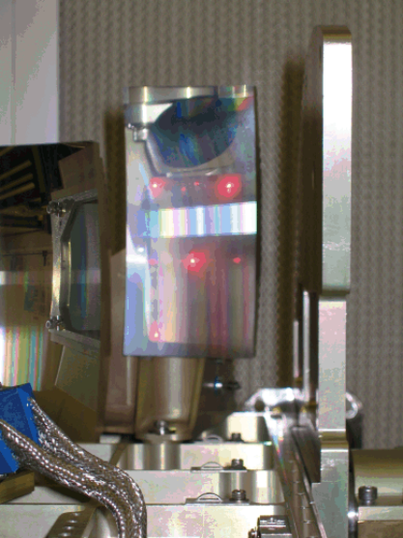
Figure 5: the open FS FPU with LED D-tool in place of PSW (left) and PLW (right), with at the bottom, the respective full field view through the entire Phot optics chain.

Changing position for the LED D-tool from PLW to PMW and PSW allow a qualitative check of the array co-alignment and this was found better than a single magnified image of the LED, which is much smaller than even a PSW pixel; although this is only qualitative because of non perfect uniformity of the LED spatial illumination and potentially less relevant as more affected by the (dummy) dichroics.

3. Spectrometer side

3.1 Alignment set-up and specific tools
After rotating the FPU by 180deg with the MSSL rotisserie, the same set-up approach as in the case of Phot side is used. This is illustrated for the Spectro side in figure 6 below by comparison with figure 1 in section 2. This time the possible residual rotation of the set-up has been a bit more constrained in order to limit the introduction of systematic offset in Y.

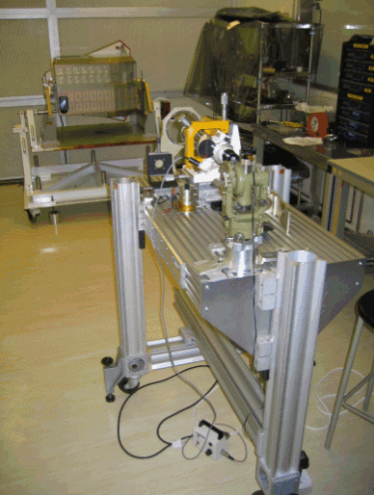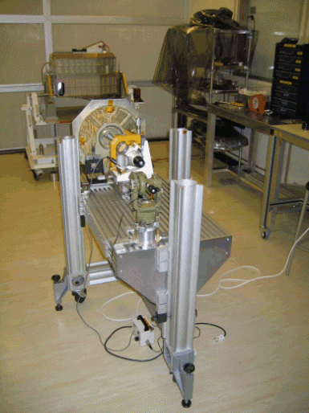
Figure 6: SPIRE FS FPU in alignment set-up on the Spectro side with LAM M2 bench, being aligned to LAM HOB reference (left) and with M2 tool set in position (right)
Extra alignment tools are the replacement beamsplitters SBS1 and SBS2 used together or sequentially in order to probe the different arms of the interferometer from the different arrays (SLW or SSW).
The SMEC, is replaced by a set of back to back non-moving roof top visible light-compliant mirrors (see figure 7 left below), in nominal position in the interferometer optics.
As in the case of the Phot, a special cold stop tool, Spectro CS tool, is added (see figure 10 right). This is the same as used for PFM alignment activity and follow modification for feedback of the STM test campaign (see the note “New definition of SCS tool”, KD, 17/12/2003 which was used to constrain the SCS tool mounting orientation ambiguity).

3.2 Results
The displacements for nominal centring of the imaged pupil on simulated M2 are as follows:
- SSW & interfero arm A: ΔZ= 11mm, ΔY= 3mm
- SSW & interfero arm B: ΔZ= 11mm, ΔY= 3mm
- SLW & interfero arm A: ΔZ= 5mm, ΔY= 0mm
- SLW & interfero arm B: ΔZ= 5mm, ΔY= 0mm
This indicates that the interferometer optics appears geometrically well balanced. The difference between the 2 bands in Y is of the order of the uncertainty but larger in Z. The main hardware differences between the 2 bands are different SM12s and SM11s. SM12s are symmetric flats at a pupil stop so that SM11s, although symmetric as well, may induce the residual difference. Note also that the beamsplitter are used differently for SSW and SLW (i.e. to get the RR/TT or RT/TR behaviour) and there are close to an image of the array (i.e. the source with fibre D-tool here) so that they could induce by small angular tilts the seen in-plane offset. An average pupil shift for the Spectro can be taken as: ΔZ= 8mm, ΔY= 1.5mm, leading to a nominal geometric ΔR/R~5.4%. Contrary to the Phot, there is no CQM alignment verification data available and nothing can be inferred from CQM Performances tests as no Spectro arrays were present.

It should be noticed that this value could vary (potential in-plane, i.e. along Z, if like the Phot case) by further effect from the FS BSM. The OGSE BSM was in place during the measurement on the Spectro side and it was not then accessible for any exchange with the FS BSM so that the effect of the FS BSM CM4 mirror was not experimentally assessed. In extrapolation with the case of the Phot discussed in section 2, a final value would be ΔR/R~5.4+/-5% to indicate the possibility of further increasing or compensating in-plane the nominal pupil shift by the FS BSM depending on CM4 position & orientation wrt the image of the Spectro pupil.

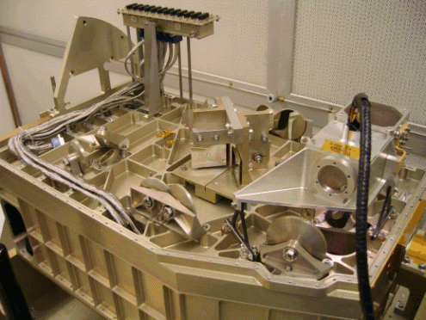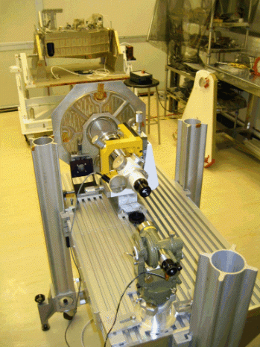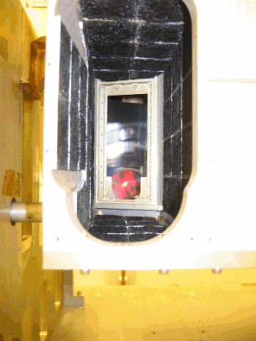
Figure 7: FS FPU open on the Spectro side with fibre D-tool attached (left), idem but with LED D-tool (centre), and view of the imaged D-tools through instrument entrance aperture (right)

The LED D-tools were also used to verify the co-alignment at Spectro Fov centre. Qualitatively it was found well overlapping after being image up to entrance focal plane so that any geometric difference in Spectro FoV centre transverse misalignment is expected lower that the image of the LEDs which here as well is much smaller that a SSW pixel. Note this does not guarantee the final co-alignment (due to all additional elements such as BDAs and associated interface plates) but demonstrate no noticeable relative deviations between the respective array chief rays as defined by the Spectro optical chain(s).
4. Appendix

As sideline to the main alignment verification activity, it was possible to probe qualitatively some other issues and this is reported here.

4.1 Phot straylight path
As previously found during CQM ambient alignment verification (see RD2), there is a possible stray path for PSW. It was checked by moving the fibre D-tool that, as before, PMW does not seem to be affected and PLW is not.
By adding the Phot cover, it can be seen that the PFIL2 aperture in the baffle wall between PM8 and PM7 is blocking only partially.

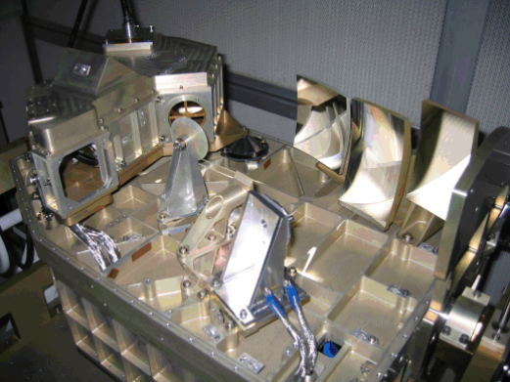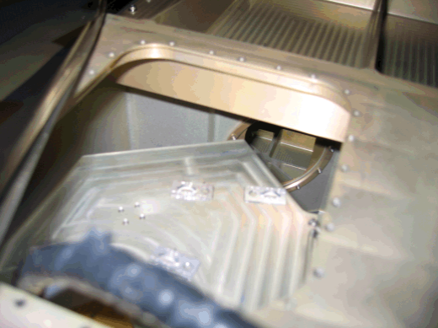
Stray path from PM8 to CM5
Nominal path from PM8 to PM7
Figure 8: Visualisation of the possible stray path for PSW with no cover (left), with the cover and view onto the PFIL2 aperture in the main baffle wall (right)
The high incidence on CM5 leads to illumination of the entrance cavity features. The +Z edge region of the CFIL1 aperture is illuminated as well as some of the +Z wall black tiles. Only a small fraction of stray path can hit the metal zone uncovered by black tiles just above the CFIL1 aperture edge, so that it is unlikely able to exit the entrance cavity or only with small efficiency/view factor.

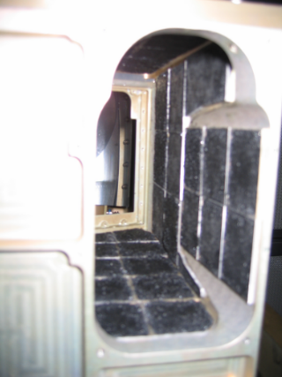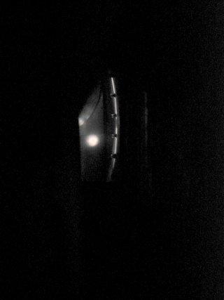
Figure 9: Looking through the FPU entrance aperture with external light to show the present geometry and features (left), and with just the back illumination from PSW position (right) to identify the stray illuminated parts

4.2 BSM shoe and Spectro beam path

The hole in the SOB to allow for the Spectro beam to go through it between SM6 and SM7 is quite oversized wrt the full FoV beam footprint. But from the Phot side, when the BSM is in place, its shoe appears covering part of this hole.
Taking the opportunity on the Spectro side to get view access through the Spectro cold stop and the hole in SOB, it can be noticed that the edge of the BSM shoe is blocking view to the edge of SM6. This is flagged here just as a possibility for slight vignetting at the operating (long) wavelength beam of some of the SSW and SLW edge pixels. This is neither occurring at an image plane nor at a pupil so it may occur more as a small graded reduction in flux and/or source of spreading by diffraction of the light from bright source in this edge part of the Spectro FoV.

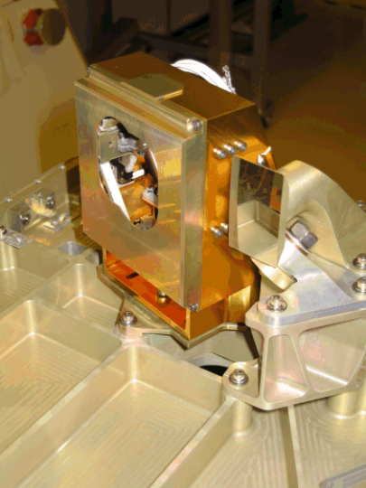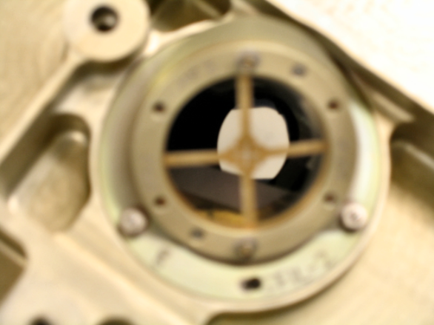
Figure 10: BSM on the Phot side of the SOB next to PM6 and SM6 (left), looking through the SCS mount (with Spectro CS tool mounted) and SOB towards SM6 from Spectro side with SM7 removed (right)

