TITLE: SPIRE Spacecraft-Instrument Alignment Matrix (SIAM)

By: Marc Ferlet (RAL)

DISTRIBUTION

- Herschel Science Centre (ESTEC & ESAC)

- Mission Operations Centre (ESOC)

- SPIRE Project Team:
S Sidher (RAL)
S Leeks (RAL)
M Pohlen (Cardiff University)

For info:
K King (RAL)
B Swinyard (RAL)
E Sawyer (RAL)
D Griffin (RAL)
T Lim (RAL)
E Polehampton (RAL)

For Project database/archive:
J Porter (RAL)

change record

ISSUE DATE SECTION REASON FOR CHANGE

0.1 28/03/07 All First draft, not released

1.0 23/05/07 All First release

1.1 24/05/07 All Typo corrected, added references

1.2 30/05/07 All Aperture S55 is now assigned to
parallel mode.

1.3 18/07/07 4 Addition of SIAM file data for the Parallel Mode

1.4 30/07/07 2 & Appendix 1 Correction to SSW E5 found similar to SSW C5 due to typo in source code generating LOS

1.5 11/09/07 4 Reference to PACS document added

2.0 25/07/08 1,2,3 & 4 + Appendix 1 General update after new generation of SIAM based on updated model including ground alignment results and flight telescope optical prescription data

3.0 19/12/08 1,2,3 & 4 + Appendix 1 Final update based on updated model including all ground alignment measurement data (from new reference RD6)

CONTENTS

- General description

- SIAM file data

- Additional SIAM file data (SLW)

- Parallel Mode

Appendix 1 SPIRE Pixel Tables and SIAM Apertures

Appendix 2 SPIRE Aperture Identifiers

Appendix 3 DCM Generation Code

ATTACHMENT: text file “SPIRE SIAM v3.0.txt”

Applicable and reference documents

AD1 “ICD: Herschel Spacecraft / Instrument Alignment History”, PT-HMOC-FD-ICD-2111-OPS-GFT issue 1.3 (07/02/06)

AD2 IID-B Herschel/Planck Instrument Interface Document – Part B Instrument “SPIRE”, SCI-PT-IIDB/SPIRE-02124, issue 3.3 (21/06/04)

RD1 SPIRE Design Description, SPIRE-RAL-PRJ-000620 issue 2.0 (15/05/03)

RD2 SPIRE PACS Parallel Mode Observers’ Manual, HERSCHEL-HSC-DOC-0883 v1.0 (01/02/07)

RD3 Herschel instrument alignment wrt CVV – Test Report, HP-2-ASED-TR-0219 issue 1.0 (19/10/07)

RD4 SPIRE alignment data summary, SPIRE-RAL-NOT-002876 issue 1.1 (28/03/07)

RD5 Optical Interface Control Document, HER.NT-0167.T.ASTR issue 06 Rev 00 (06/12/2006)

RD6 Herschel Instruments / Telescope Alignment Test Report, HP-2-ASED-TR-0260 issue 2 (10/10/2008)

This note reports on the generation of the Spacecraft-Instrument Alignment Matrix (SIAM) file data, as defined in AD1, for the Herschel/SPIRE instrument. This new issue includes update of the model used to generate the SIAM file data. The model has been locally modified to take into account the updated HSO telescope optical prescription and the results of the ground alignment at instrument and CVV level.

1. General description

The main components in the SIAM file are the Direction Cosine Matrices (DCM) for the individual pixels or “apertures”. The following scheme, in a bottom-up approach, is used for their generation:

* Step 1:
The arrangement (relative geometric location) of SPIRE detectors of different bands listed as relevant “apertures” for the SIAM file are taken from the relevant SPIRE BDA EIDP and implemented at the relevant detector focal planes of the official (configuration control) optical models (BOLSP509 and BOLPHOT155 respectively) for SPIRE Spectrometer and Photometer channels (see RD1).

* Step 2:
Backward raytraces are performed in order to find the intercept of each relevant “apertures” with the telescope focal surface at SPIRE entrance focal plane. This is done in the official ESA coordinate system (as defined by the optical interface, see the ICDs in AD2). These are reported in details in Appendix 1.
This approach allows finding what each detector actually see and therefore points towards rather than what they are expected to receive/collect and allows taking into account the second order effect (non perfect telecentricity, residual field distortion) compared to a linear first-order plate-scale-based approach.
Figure 1: From detector layout at focal plane to optical interface plane with telescope

* Step 3:
Coordinates intercepts are then checked with measured data during ILT (PFM4 test campaign) when available for the relevant “apertures”. ILT tests are bound to be performed in same coordinate system by the constraint of the set optical interface. The ESA coordinate system for the telescope is actually similar in axis orientation with the Herschel Spacecraft coordinate system as defined in AD1.

* Step 4:
Instrument tilts and lateral shifts as measured during the ground alignment campaign at CVV level and reported in RD3 are used as input to define respectively translation and rotation of the instrument model compared to its nominal position and orientation. In more details, from RD3 table 6-7, the rotation about Y and Z are respectively of -5.56’ and -2.84’, although there is an ambiguity with the sign of the equivalent pupil shift in Y direction compared to the text around table 6-7 in RD3.
Additionally the tilts of the internal chief ray as measured at instrument level for all SPIRE models (see RD4) adds the following rotations (about same assumed centre of rotation as above): 0.92’ about Y and -2.23’ about Z. This is also reported in RD3 table 6-9 but for the sake of generating the total pupil mismatch table 6-11 which is not relevant for the pointing.
The reported measured lateral shift of SPIRE (-1.21mm in Y and +0.26mm in Z from table 6-8 in RD3) are applied to the instrument model here. Defocus or variations along X are not applied as small/negligible in front of the telescope focus uncertainty and being dominantly along X, have very low impact on the on-sky pointing.
Finally last deviations from nominal, now included in the model, are lateral optical bench displacement effect from cooldown (strap re-tensioning, …) of 0.71mm in Y as well as actual telescope position from measurements (0.9mm in Y and 1.5mm in Z so equivalent to same magnitude but opposite sign) reported in RD6.

* Step 5:
Confirmed intercepts are then further raytrace backward through the HSO telescope, up to far-field object-space of the telescope (on-sky region) where the geometric centroid of the individual “apertures” beam is now defined in term of direction cosine vector, representing the “apertures” line-of-sight (LOS).
These are reported in details in Appendix 1. The HSO telescope optical model used now is based on the data related to the flight configuration as defined under the “Flight 70K” label in the telescope OICD (see RD5) and includes variations in lateral position of M2 and TFS, curvature of M1, M2 and TFS, conic constant of M2, separation M1-M2 and M1-TFS compared to the nominal design values previously used.
NB: all variations/displacements are made comparatively to M1 whose surface normal at vertex is maintained as the reference spacecraft X axis.

* Step 6:
A Cartesian system based on right-handed orthonormal vector triad (u,v,w) is generated around the LOS for each aperture. The vector u is given by the respective direction cosine vector of the “aperture”. The vectors v and w are obtained via the orthonormalisation procedure given in section 1.2.2 of AD1. The DCM is then generated first through individual coefficients as expressed in section 7.1.2 of AD1 and checked by an alternative more direct method.
A Matlab script, user-fed by the LOS for each “aperture”, performing these computations is given in Appendix 3, along side its standard output on an example. Multiple verification of (u,v,w) orthonormality and of DCM orthonormality as a 3x3 rotation matrix is also performed by the script.

This completes the process of generating the main data, i.e. the DCM, for each “aperture”.

2. SIAM file data

This section used to be a place-holder for the listing of the SIAM field data, in the format defined by AD1, for the nominal detector list in Appendix 2.
After discussion with ESA, the SIAM file data are now delivered as a single external separate text file containing all the matrix values for all SPIRE “apertures” an in the defined format. Attached to the previous of this note was text file “SPIRE SIAM v1.5.txt” in consistence with the note history version. It is now the text file labelled “SPIRE SIAM v2.0.txt” for issue 2.0 of this note. Issue 3.0 is associated with external data text file “SPIRE SIAM v3.0.txt”.

3. Additional SIAM file data (SLW)

Initially only the SSW detectors may have been thought to be relevant for the SPIRE Spectrometer channel because some SSW detectors were originally co-aligned with SLW ones. Actually since the inclusion of the field lenses in the Spectrometer optics (see RD1), the detector plane focal ratio changed and is now different between SLW and SSW, leading to non-perfect co-alignment of most detectors between these 2 bands except the central ones. So while SLW-C3 and SSW-D4 still share the same SPIRE aperture (viz. S24), there is a possible need for the SIAM file data to take into account the remaining SLW detectors as well.
AD1 (in its Annex A) allows up to 75 different elements to be included. From Appendix 2, it can be seen that nominally only 54 are used so that additional 18 for SLW detectors will still fit in the total allocation of the SIAM file for SPIRE. The same procedure as described in section 1 was applied and resulting SIAM file data for these “apertures” (link with SPIRE SLW detectors can be found from table at the end of Appendix 1 with completed look-up table detector label/SIAM file number in Appendix 2) are included in the same, now external, text file “SPIRE SIAM v3.0.txt”.

4. Parallel Mode

In the Parallel Mode, PACS and SPIRE are operating in photometry mode simultaneously by definition (see RD2). The nominal LOS is logically at the centre/middle of the respective SPIRE and PACS Photometer FoV. For SPIRE, “aperture” PSW E8 at the centre of the SPIRE Photometer FoV, is used as reference. Its SIAM matrix data is under label S14 above. For PACS, aperture P01_0 (Photometer centre of field) is taken delta_x=202.0 mm, delta_y=-0.26 mm, delta_z=84.49 mm, as defined by ESA (see email from Miguel Sanchez ESA/SCI-OPS, 12/07/2008).

Using the updated telescope model, the LOS of PACS reference aperture is found: [0.9999961, 2.20E-04, -2.77E-03]. And this is averaged with the vector LOS (see Appendix 1, Table 1) defining the pointing on-sky of PSW E8 for SPIRE, leading to the “middle” LSO pointing vector [0.999999916, 0.000232084, 0.000337186]. This latter one is then fed into step 6 of the procedure described in section 1 in order to generate the resulting DCM.

The SIAM file data to be used for the Parallel Mode aperture S55 has also been included in “SPIRE SIAM v3.0.txt”.

Appendix 1 SPIRE Pixel Tables and SIAM Apertures

Below are given tables linking the pixel labelling as per PFM4 (last ILT performance test campaign on flight model including optical test data that can be used in relation to pixel location) and the SPIRE SIAM “aperture” list, given in Appendix 2, for the relevant SPIRE spectral bands (PSW, SSW and SLW). Illustration of the pixel labelling and related position in respective array and at telescope focal plane is also given.

- PSW band: only the 17 detectors listed in the SPIRE SIAM “aperture” list are reported here

+Y
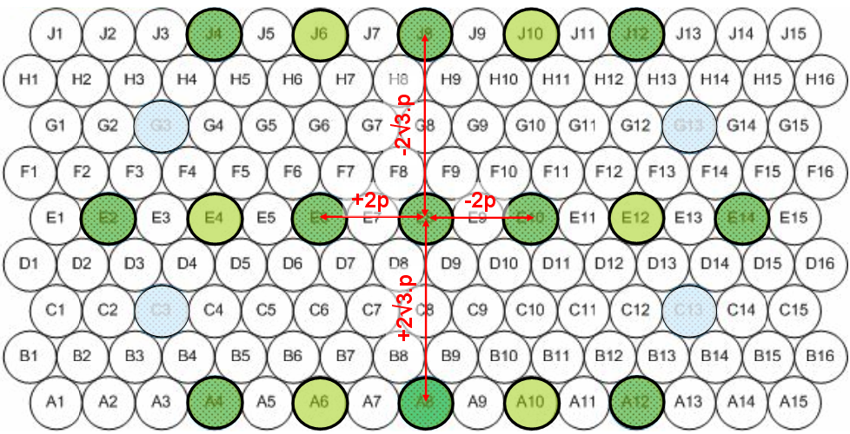
+Z
Figure 2: Left: Layout of PSW detector arrangement and labels as used in ILT. The bold circled ones are the one relevant for the SIAM file. Right: Image of their centres (seen from M2) at the telescope focal plane in the official coordinate system.

Table 1: Summary of the Telescope focal plane intercepts (in mm in ESA coordinate system) and the direction cosine vector coordinates for PSW detectors. The SIAM file identifier is added to allow link and traceability with respective relevant detector.

- SSW band: all 37 detectors are included

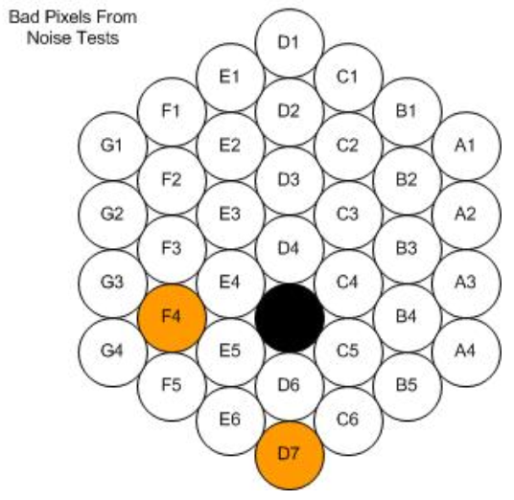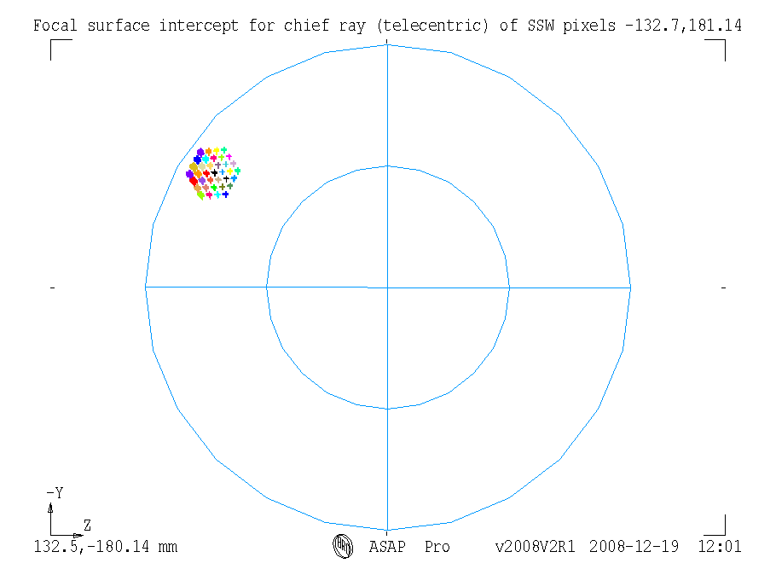
+Y
+Z
Figure 3: Left: Layout of SSW detector arrangement and labels as used in ILT. Right: Image of their centres (seen from M2) at the telescope focal plane in the official coordinate system

Table 2: Summary of the Telescope focal plane intercepts (in mm in ESA coordinate system) and the direction cosine vector coordinates for SSW detectors. The SIAM file identifier is added to allow link and traceability with respective relevant detector.

- SLW band: all detectors are included (see section 3 for justification)

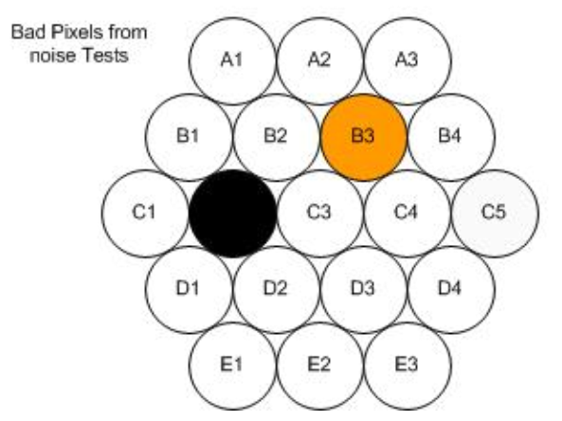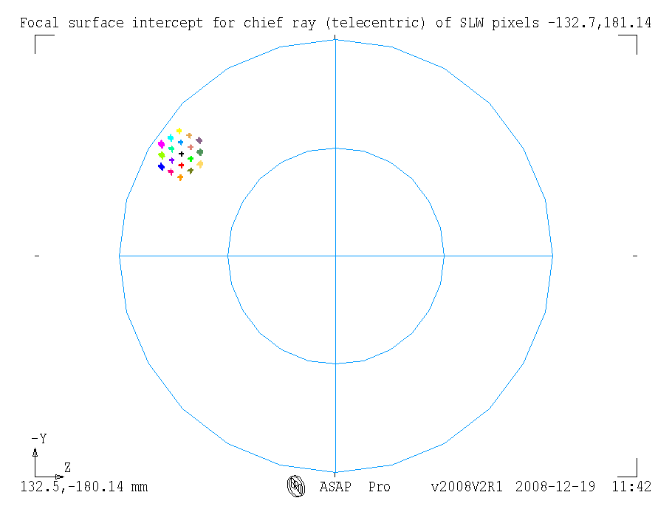
+Y
+Z
Figure 4: Left: Layout of SLW detector arrangement and labels as used in ILT. Right: Image of their centres (seen from M2) at the telescope focal plane in the official coordinate system

Table 3: Summary of the Telescope focal plane intercepts (in mm in ESA coordinate system) and the direction cosine vector coordinates for SLW detectors. The SIAM file identifier is added to allow link and traceability with respective relevant detector.
Appendix 2 SPIRE Aperture Identifiers

Nominal list of SIAM aperture identifiers are listed below with their SPIRE detector counterparts. The additional SLW aperture identifiers are highlighted in yellow.

Aperture Description

S01_s PSW Array: Bolometer A4 Co-aligned
S02_s PSW Array: Bolometer A8 Co-aligned
S03_s PSW Array: Bolometer A12 Co-aligned
S04_s PSW Array: Bolometer E2 Co-aligned
S05_s PSW Array: Bolometer E6 Co-aligned
S06_s PSW Array: Bolometer E10 Co-aligned
S07_s PSW Array: Bolometer E14 Co-aligned
S08_s PSW Array: Bolometer J4 Co-aligned
S09_s PSW Array: Bolometer J8 Co-aligned
S10_s PSW Array: Bolometer J12 Co-aligned
S11_s PSW Array: Bolometer A6
S12_s PSW Array: Bolometer A10
S13_s PSW Array: Bolometer E4
S14_s PSW Array: Bolometer E8
S15_s PSW Array: Bolometer E12
S16_s PSW Array: Bolometer J6
S17_s PSW Array: Bolometer J10
S18_s SSW Array: Bolometer D1 Co-aligned
S19_s SSW Array: Bolometer G1 Co-aligned
S20_s SSW Array: Bolometer E2 Co-aligned
S21_s SSW Array: Bolometer C2 Co-aligned
S22_s SSW Array: Bolometer A1 Co-aligned
S23_s SSW Array: Bolometer F3 Co-aligned
S24_s SSW Array: Bolometer D4 Co-aligned
S25_s SSW Array: Bolometer B3 Co-aligned
S26_s SSW Array: Bolometer G4 Co-aligned
S27_s SSW Array: Bolometer E5 Co-aligned
S28_s SSW Array: Bolometer C5 Co-aligned
S29_s SSW Array: Bolometer A4 Co-aligned
S30_s SSW Array: Bolometer D7 Co-aligned
S31_s SSW Array: Bolometer E1
S32_s SSW Array: Bolometer C1
S33_s SSW Array: Bolometer F1
S34_s SSW Array: Bolometer D2
S35_s SSW Array: Bolometer B1
S36_s SSW Array: Bolometer F2
S37_s SSW Array: Bolometer D3
S38_s SSW Array: Bolometer B2
S39_s SSW Array: Bolometer G2
S40_s SSW Array: Bolometer E3
S41_s SSW Array: Bolometer C3
S42_s SSW Array: Bolometer A2
S43_s SSW Array: Bolometer G3
S44_s SSW Array: Bolometer E4
S45_s SSW Array: Bolometer C4
S46_s SSW Array: Bolometer A3
S47_s SSW Array: Bolometer F4
S48_s SSW Array: Bolometer D5
S49_s SSW Array: Bolometer B4
S50_s SSW Array: Bolometer F5
S51_s SSW Array: Bolometer D6
S52_s SSW Array: Bolometer B5
S53_s SSW Array: Bolometer E6
S54_s SSW Array: Bolometer C6

S55_s SPIRE Parallel Mode

S56_s SLW Array: Bolometer C2
S57_s SLW Array: Bolometer C4
S58_s SLW Array: Bolometer C1
S59_s SLW Array: Bolometer C5
S60_s SLW Array: Bolometer D2
S61_s SLW Array: Bolometer D3
S62_s SLW Array: Bolometer D1
S63_s SLW Array: Bolometer D4
S64_s SLW Array: Bolometer E2
S65_s SLW Array: Bolometer E1
S66_s SLW Array: Bolometer E3
S67_s SLW Array: Bolometer B2
S68_s SLW Array: Bolometer B3
S69_s SLW Array: Bolometer B1
S70_s SLW Array: Bolometer B4
S71_s SLW Array: Bolometer A2
S72_s SLW Array: Bolometer A1
S73_s SLW Array: Bolometer A3

Appendix 3 DCM Generation Code

Below is given the Matlab script used to generate DCM from and its screen output (in the case of PSW E8).

%
% SPIRE_SIAM_generator.m
% Matlab script to generate matrix of SIAM file
% Marc Ferlet, RAL/SSTD, March 07
%

% initialisation
clear all
close all

DCM=zeros(3);

x=[1;0;0]; % X_SCA reference vector
y=[0;1;0]; % Y_SCA reference vector
z=[0;0;1]; % Z_SCA reference vector

disp(' ');
disp('**********************************************************************');
disp('* SPIRE SIAM file generator *');
disp('* Marc Ferlet, STFC-RAL/SSTD, March 07 *');
disp('**********************************************************************');
disp(' ');

% generation of the orthonormal INS vectors, based on LOS for a given aperture
disp(' ');
u=input('-> Enter the aperture LOS: '); % Dir cos of pixel LOS from ASAP model; example of PSWE8 is [0.999994 0 0.0031855]

u=u.'; % transposition for ease of handling below
u=u/norm(u); % normalisation (not necessary as already done by definition of dir cos vector)

v=y-sum(u.*y)*u; % orthogonalisation of y wrt u=LOS
v=v/norm(v); % normalisation

w=cross(u,v); % generation of last orthogonal vector of the INS right-hand triedre (u,v,w)

% manual (i.e. not vectorised) generation of the DCM
% by generation of the matrix element through individual vector scalar products
DCM(1,1)=sum(u.*x);
DCM(2,1)=sum(v.*x);
DCM(3,1)=sum(w.*x);

DCM(1,2)=sum(u.*y);
DCM(2,2)=sum(v.*y);
DCM(3,2)=sum(w.*y);

DCM(1,3)=sum(u.*z);
DCM(2,3)=sum(v.*z);
DCM(3,3)=sum(w.*z);

format +;format long e

disp(' ');disp(' And the Direction Cosine Matrix is: ');
DCM % print the matrix in long format

% for verification/validation of orthonormalisation procedure
format
disp(' ');disp('-> Verification of :');disp(' ');
disp(' => Dot products on INS=(u,v,w) basis vectors (should be 0): ');
sum(u.*v)
sum(u.*w)
sum(v.*w)
disp(' ');disp(' => Cross-products in INS=(u,v,w) basis (should be [0 0 0]): ');
(cross(u,v)-w).'
(cross(v,w)-u).'
(cross(w,u)-v).'
disp(' '); disp(' => Determinant of DCM (should be 1): ');det(DCM)
disp(' '); disp(' => Orthogonality of DCM (should be I_3 matrix): ');DCM*DCM.'
disp(' '); disp(' => Transfer from INS=(u,v,w) to SCA=(x,y,z) (should be [0 0 0]): ');
(DCM*u-x).'
(DCM*v-y).'
(DCM*w-z).'
disp(' '); disp(' => Transfer from SCA=(x,y,z) to INS=(u,v,w) (should be [0 0 0]): ');
(DCM.'*x-u).'
(DCM.'*y-v).'
(DCM.'*z-w).'
disp(' ');disp(' -> Alternative (more direct/vectorised) way to generate the DCM: ');
format long e;DCM_altern=[u.'/x(1);v.'/y(2);w.'/z(3)]
disp(' ');
format long;DCM-DCM_altern % this should be 0 / verification that the 2 methods give the same result

return;
______________________________________________________________________________

**********************************************************************
* SPIRE SIAM file generator *
* Marc Ferlet, STFC-RAL/SSTD, March 07 *
**********************************************************************

-> Enter the aperture LOS: [0.999994 0 0.0031855]

And the Direction Cosine Matrix is:

DCM =
9.999949262726043e-001 0 3.185502950659085e-003
0 1.000000000000000e+000 0
-3.185502950659085e-003 0 9.999949262726043e-001

-> Verification of :

=> Dot products on INS=(u,v,w) basis vectors (should be 0):

ans =
0

ans =
0

ans =
0

=> Cross-products in INS=(u,v,w) basis (should be [0 0 0]):

ans =
0 0 0

ans =
0 0 0

ans =
0 0 0

=> Determinant of DCM (should be 1):

ans =
1

=> Orthogonality of DCM (should be I_3 matrix):

ans =
1 0 0
0 1 0
0 0 1

=> Transfer from INS=(u,v,w) to SCA=(x,y,z):

ans =
0 0 0

ans =
0 0 0

ans =
0 0 0

=> Transfer from SCA=(x,y,z) to INS=(u,v,w) (should be [0 0 0]):

ans =
0 0 0

ans =
0 0 0

ans =
0 0 0

-> Alternative (more direct/vectorised) way to generate the DCM:

DCM_altern =
9.999949262726043e-001 0 3.185502950659085e-003
0 1.000000000000000e+000 0
-3.185502950659085e-003 0 9.999949262726043e-001

verif =

0 0 0
0 0 0
0 0 0

the location of the centre of rotation is not mentioned and as it is applied in RD3 as a direct pupil shear, it is assumed that this rotation centre is at the optical interface surface i.e. the nominal telescope focal surface and at the FoV centre/reference taken here as the nominal design location of PSW E8.
This value is probably wrong as we expect more ~220mm but being along X this is not important as discussed in section 1 step 4.

