JFET/DCU gain check carried out 10 October 2006
Photometer JFET gains were measured stand alone during the instrument integration testing before the start of PFM4. This note reports on the photometer side JFET gains and confirmation of system gain.

Datasets used:
70 Hz ILT_PERF_DAB_P_SinglePhase_300000F5_
130 Hz ILT_PERF_DAB_P_SinglePhase_300000F6_
189 Hz ILT_PERF_DAB_P_SinglePhase_300000F7_

Set up:
Warm JFETs connected to the FM warm electronics via RAL cryoharness.
No FPU present and bias fed directly to JFET inputs through test connectors and the FM backharness.
Electronics driven through standard instrument GSE and test scripts.
Measurements were taken as “standard loadcurves” (ILT_PERF_DAB_P) with fixed phase
Three bias frequencies were used namely 70, 130 and 189 Hz
At each frequency the phase was optimised:
70 Hz phase 163.76416
130 Hz phase 183.52880
189 Hz phase 196.23464

Example of processing:
Bias converted to rms by dividing converted housekeeping values by sqrt(2). Gains applied as per DCU design description. No phase correction applied. Residual gain derived by fitted first order (only) fit to data before saturation and extracting slope. See figure 1 for an example.

Results:
The results for each array are summarised in figures 2,3 and 4. The are also given in handy ascii format at the end of the note.

As a cross check I looked at the value of the resistor during the warm functional checks (FUNC-DCU-13-PHOT_30011021_) and during an arbitrary cold load curve (ILT_PERF_DAB_P_SinglePhase_30011394_). The values returned using the same derivation procedure as for the gains were (in MΩ)

 | EIDP | Warm | Cold
PSW | 5.04986 | 4.94752 | 5.31180
PMW | 5.36000 | 4.71816 | 5.06183
PLW | 4.92089 | 4.84059 | 5.19588

PMW warm value looks anomalous here (12% deviation from EIDP?) otherwise the values are with 2-6% of expected. Why there is a variation at all is a good question perhaps? A quick check with another cold loadcurve showed that there is no variation from day to day.

Conclusions:
Basically the results are as expected for the JFET gain – nominal ~0.96 – with some small variation from membrane to membrane and channel to channel. There is a slight, no more than 2-3%, overall gain variation with frequency. This is probably due to the phase not being set absolutely precisely but it is hard to tell. The comparison with the fixed resistor is a little strange but (apart from PMW warm measurement) the reported value is always within 6% of the expectation. Final conclusion is that the default gains for the DCU are certainly correct to within 6% absolute and probably better than this.
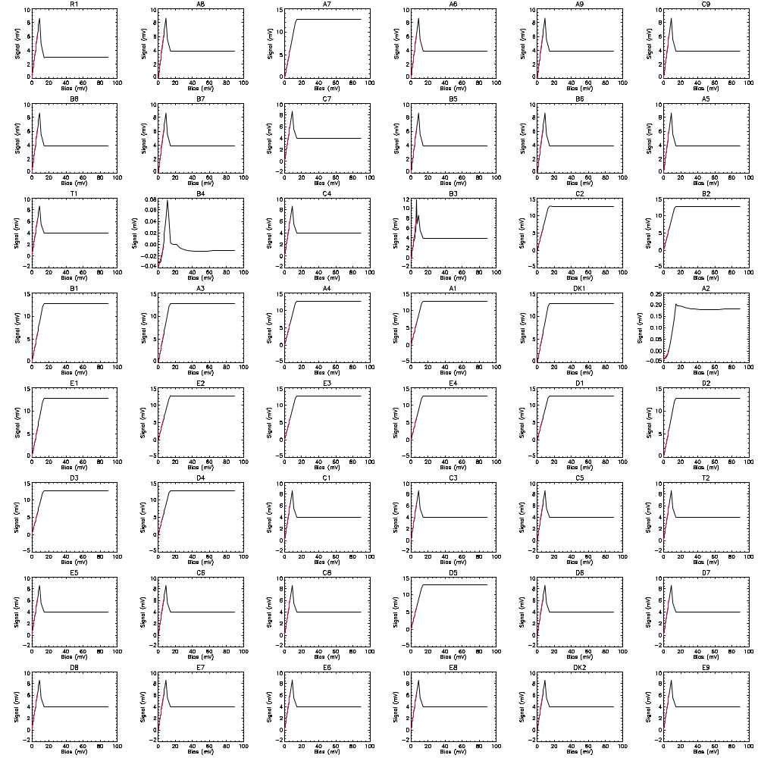
Figure 1: Example of slope fitting for gain determination. This is for PLW. The black line is the measured voltage versus applied bias after gain correction and addition of offsets; the red line is a first order fit to the data. The slope of the fit is taken as the residual gain.

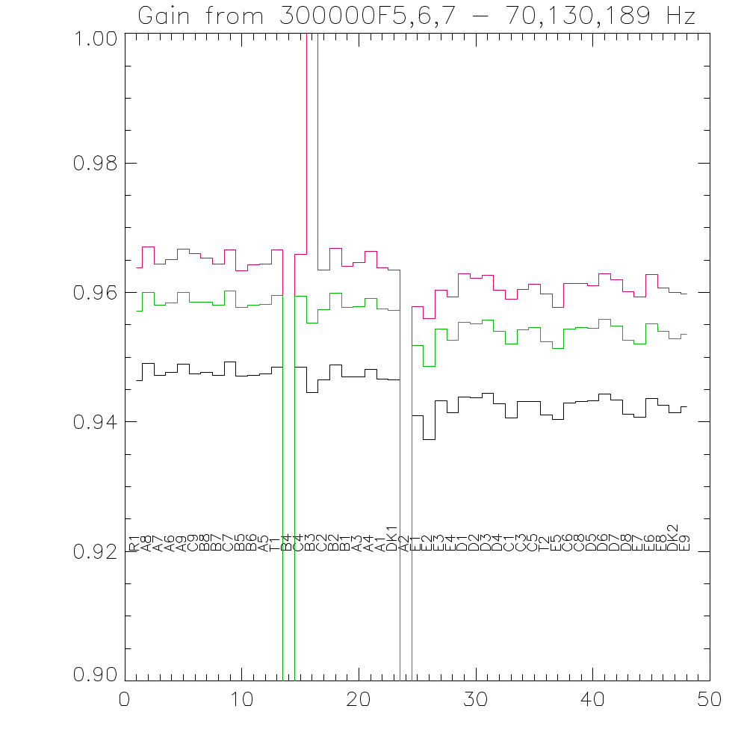
Figure 2: PLW JFET gains at 70 (red) 130 (green) and 189 Hz (black) versus channel number.

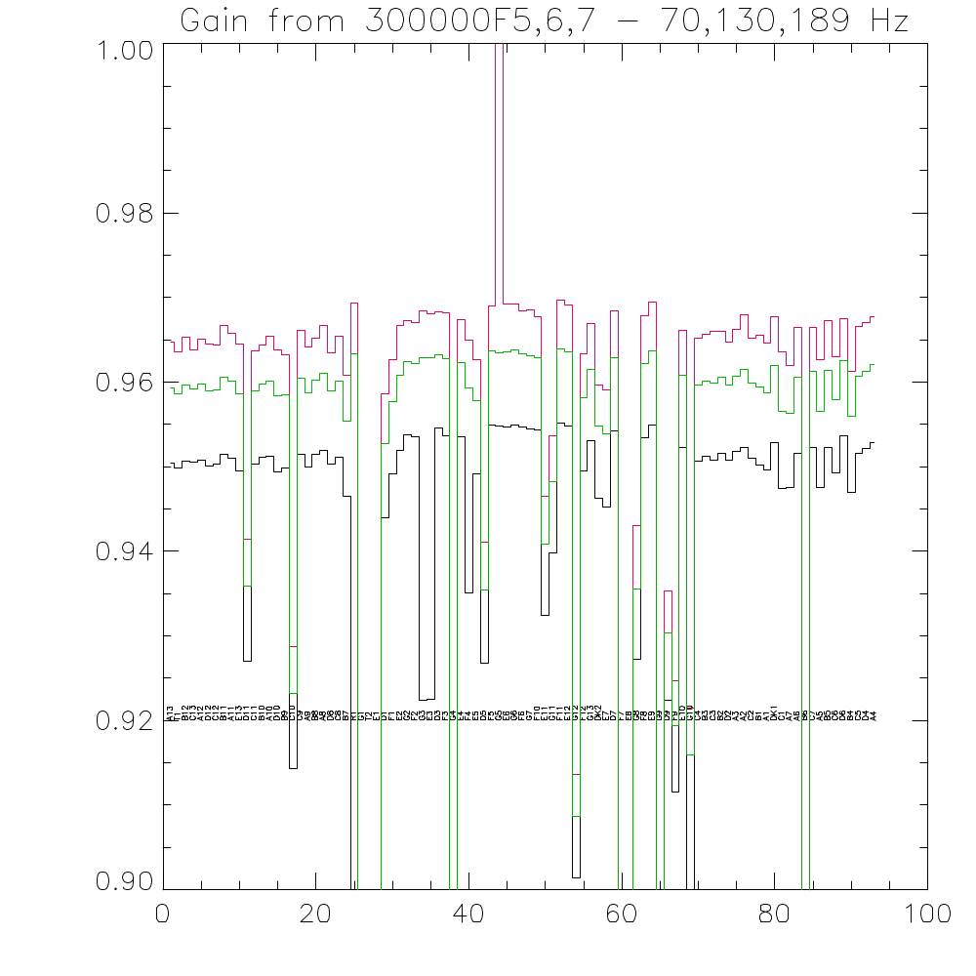
Figure 3: PMW JFET gains at 70 (red) 130 (green) and 189 Hz (black) versus channel number.

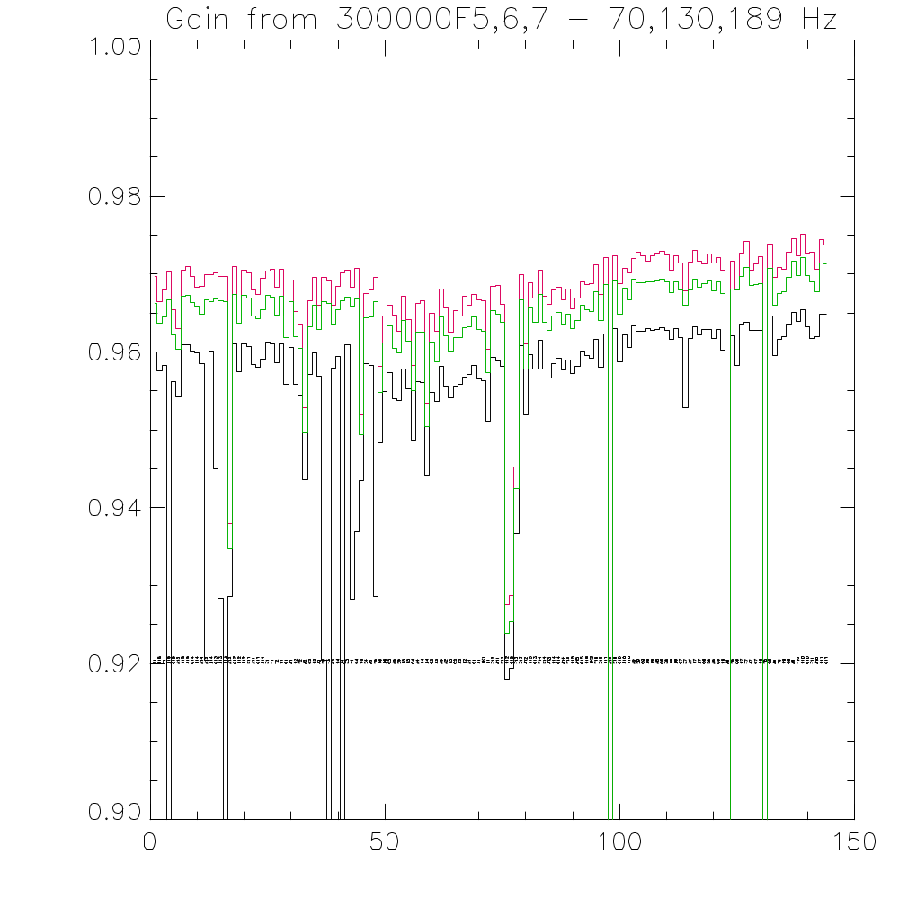
Figure 4: PSW JFET gains at 70 (red) 130 (green) and 189 Hz (black) versus channel number.
PLW JFET Gain versus Channel

Chan 70 Hz 130Hz 189 Hz
R1 0.963823 0.957106 0.946430
A8 0.967006 0.960047 0.948999
A7 0.964439 0.957997 0.947228
A6 0.965074 0.958440 0.947720
A9 0.966671 0.959980 0.948990
C9 0.965987 0.958503 0.947432
B8 0.965280 0.958498 0.947672
B7 0.964449 0.958060 0.947234
C7 0.966583 0.960193 0.949279
B5 0.963405 0.957715 0.947130
B6 0.964272 0.958001 0.947237
A5 0.964346 0.958164 0.947463
T1 0.966633 0.959566 0.948499
B4 0.00551464 0.006087 0.006062953
C4 0.965858 0.959429 0.948467
B3 1.33970 0.955295 0.944495
C2 0.963473 0.957327 0.946543
B2 0.966800 0.959841 0.948786
B1 0.963993 0.957756 0.947025
A3 0.964576 0.957813 0.946931
A4 0.966400 0.959106 0.948141
A1 0.963814 0.957416 0.946670
DK1 0.963415 0.957271 0.9465578
A2 0.005961 0.0065688 0.006498414
E1 0.957806 0.951848 0.940983
E2 0.956032 0.948545 0.937317
E3 0.960357 0.954380 0.943274
E4 0.959328 0.952660 0.941445
D1 0.962919 0.955422 0.943883
D2 0.962182 0.955152 0.943743
D3 0.962672 0.955765 0.944480
D4 0.960373 0.954043 0.942842
C1 0.958948 0.952056 0.940622
C3 0.960445 0.954281 0.943117
C5 0.961304 0.954570 0.943222
T2 0.959724 0.952455 0.941105
E5 0.957652 0.951372 0.940420
C6 0.961450 0.954405 0.942977
C8 0.961451 0.954552 0.943190
D5 0.961009 0.954515 0.943321
D6 0.962938 0.955806 0.944361
D7 0.961991 0.954827 0.943451
D8 0.960134 0.952599 0.941205
E7 0.959375 0.952083 0.940740
E6 0.962739 0.955214 0.943668
E8 0.960714 0.954008 0.942629
DK2 0.959971 0.952812 0.9414675
E9 0.959821 0.953570 0.942371

PMW JFET Gain versus Channel

Chan 70 Hz 130 Hz 189 Hz
A13 0.964795 0.959312 0.950434
T1 0.963550 0.958653 0.949820
B12 0.965344 0.959719 0.950672
C13 0.963876 0.959155 0.950523
A12 0.965037 0.959800 0.950795
D12 0.964528 0.959032 0.950072
C12 0.964389 0.959065 0.950278
B11 0.966732 0.960635 0.951461
A11 0.965829 0.960113 0.951012
E13 0.964547 0.958658 0.949475
D11 0.941484 0.935952 0.927010
C11 0.963684 0.959014 0.950304
B10 0.964430 0.959815 0.951071
A10 0.965426 0.960169 0.951223
D10 0.963864 0.958358 0.949370
B9 0.963240 0.958471 0.949843
C10 0.928729 0.923259 0.914357
C9 0.966133 0.960467 0.951477
A9 0.964187 0.958738 0.949923
B8 0.965205 0.960290 0.951517
A8 0.966679 0.961028 0.951950
D8 0.963504 0.958985 0.950281
C8 0.965400 0.960123 0.951132
B7 0.960831 0.955390 0.946466
R1 0.969395 0.963378 0.890225
G1 0.00708896 0.00822181 0.00856990
T2 2.65234e-009 -2.12504e-009 -2.16947e-009
E1 -0.000276926 -0.000225974 -0.00019518
D1 0.958637 0.952747 0.944016
F1 0.962675 0.957646 0.949146
E2 0.966707 0.960770 0.951955
G2 0.967297 0.962419 0.953727
F2 0.967000 0.962200 0.953586
G3 0.968446 0.962895 0.922382
E3 0.968034 0.962927 0.922507
D3 0.968264 0.963219 0.954569
F3 0.968236 0.962830 0.953716
G4 0.00600036 0.00644764 0.00646342
E4 0.967365 0.962274 0.953581
F4 0.964999 0.959305 0.935137
E5 0.962652 0.957817 0.949128
D5 0.941142 0.935477 0.926765
F5 0.969004 0.963684 0.954963
G5 1.01823 0.963453 0.954824
E6 0.969202 0.963535 0.954706
G6 0.969289 0.963790 0.954977
F6 0.968448 0.963389 0.954745
G7 0.968547 0.963165 0.954464
F10 0.967761 0.962879 0.954395
E11 0.946503 0.940895 0.932465
G11 0.953715 0.948264 0.939769
F11 0.969688 0.963897 0.955127
E12 0.969144 0.963580 0.954860
G12 0.913682 0.908713 0.901373
F12 0.963323 0.958148 0.949566
G13 0.966972 0.961567 0.953085
DK2 0.959696 0.954784 0.946262
E7 0.959064 0.953855 0.945262
D7 0.968461 0.962870 0.954216
F7 -0.0126811 -0.0118012 -0.0116634
E8 0.891568 0.887566 0.881205
G8 0.943106 0.935504 0.927282
F8 0.967900 0.962154 0.953440
E9 0.969442 0.963672 0.954973
G9 0.00469866 0.00497541 0.00484126
D9 0.935344 0.930394 0.922454
F9 0.924749 0.919380 0.911588
E10 0.966084 0.960846 0.952300
G10 0.921479 0.915897 0.677865
C4 0.965211 0.959681 0.950644
B3 0.965701 0.960157 0.951260
C3 0.965968 0.959923 0.950769
B2 0.966059 0.960628 0.951577
D2 0.964783 0.959630 0.950761
A3 0.966296 0.960733 0.951816
A2 0.968014 0.961553 0.952291
C2 0.965183 0.959865 0.950998
B1 0.965588 0.959434 0.950200
A1 0.964626 0.958762 0.949582
DK1 0.967768 0.962022 0.952908
C1 0.963542 0.956521 0.947398
A7 0.961984 0.956375 0.947533
A6 0.966522 0.960537 0.951537
B6 0.00685332 0.00746575 0.00732472
C7 0.966477 0.961246 0.952333
A5 0.962690 0.956571 0.947584
B5 0.967316 0.961354 0.952244
C6 0.962953 0.957907 0.949319
D6 0.967566 0.962528 0.953635
B4 0.961243 0.955976 0.947015
C5 0.966631 0.960699 0.951537
D4 0.967070 0.961239 0.952207
A4 0.967728 0.962066 0.952911

PSW JFET Gain versus Channel

Chan 70 Hz 130 Hz 189 Hz
R1 0.969681 0.966282 0.959973
D16 0.966425 0.963690 0.957631
T1 0.968021 0.964498 0.958267
B16 0.970253 0.966660 0.863046
C15 0.965442 0.962253 0.956230
A15 0.963050 0.960371 0.954252
D15 0.970512 0.967118 0.960882
B15 0.971019 0.967274 0.960950
C14 0.969729 0.966411 0.960152
D14 0.968268 0.965871 0.959853
A14 0.968408 0.964845 0.958559
A13 0.969879 0.966750 0.920487
B14 0.969952 0.966427 0.960119
C13 0.970161 0.966850 0.945039
B13 0.969735 0.966596 0.928444
D13 0.969658 0.966442 0.895592
A12 0.938018 0.934758 0.928582
C12 0.970940 0.967357 0.961069
D12 0.966895 0.963662 0.957465
B12 0.970561 0.967316 0.961076
E11 0.970106 0.966949 0.960720
A11 0.968009 0.964608 0.958394
C11 0.967399 0.964238 0.958043
B11 0.969512 0.965460 0.959050
E1 0.970424 0.967308 0.961294
F1 0.970607 0.967092 0.961046
T2 0.968352 0.964764 0.958628
H1 0.970618 0.967130 0.961089
G1 0.964640 0.961825 0.955858
J1 0.969245 0.966447 0.960607
H2 0.965219 0.961926 0.955871
F2 0.963572 0.960495 0.954506
J2 0.952909 0.949619 0.943636
G2 0.966576 0.963251 0.957186
H3 0.969578 0.966015 0.959941
J3 0.966008 0.962901 0.956873
E2 0.969629 0.966492 0.920447
F3 0.969070 0.966205 0.887530
G3 0.966020 0.963637 0.957921
H4 0.968372 0.965388 0.959429
J4 0.970152 0.966560 0.895831
E3 0.970520 0.967000 0.960911
F4 0.968353 0.965943 0.928249
G4 0.970752 0.966855 0.936925
H5 0.951901 0.949380 0.943557
E4 0.967463 0.964401 0.958466
J5 0.967930 0.964463 0.958299
F5 0.969553 0.966488 0.928598
D6 0.958146 0.954837 0.948358
B6 0.964669 0.961222 0.954935
C5 0.965954 0.963405 0.957319
A5 0.964681 0.960513 0.953997
E5 0.962637 0.959908 0.953766
B5 0.967195 0.964048 0.957784
D5 0.964133 0.961343 0.955283
C4 0.958281 0.955080 0.948759
A4 0.966277 0.962594 0.956248
D4 0.966606 0.962601 0.956086
B4 0.953482 0.950481 0.944243
C3 0.964931 0.961260 0.954857
B3 0.962636 0.958796 0.953722
A3 0.968082 0.964565 0.958193
A2 0.965645 0.962048 0.955633
D3 0.962529 0.960185 0.954110
C2 0.965277 0.961831 0.955665
B2 0.964587 0.961897 0.955835
D2 0.967221 0.963165 0.956801
A1 0.966016 0.963284 0.957171
C1 0.967434 0.964527 0.958321
B1 0.966646 0.962917 0.956529
DK1 0.966536 0.962680 0.956299
D1 0.960302 0.957341 0.951166
F12 0.968427 0.965305 0.959375
J11 0.968588 0.964859 0.958821
E12 0.966081 0.963848 0.958166
H12 0.927559 0.923918 0.918025
G12 0.928742 0.925365 0.919455
F13 0.945218 0.942459 0.936705
E13 0.969902 0.966694 0.960776
J12 0.961052 0.957869 0.951918
H13 0.968849 0.965629 0.959673
G13 0.966951 0.963774 0.957830
F14 0.970466 0.967404 0.961473
E14 0.967121 0.963835 0.957841
J13 0.966093 0.962730 0.956664
H14 0.967951 0.964618 0.958567
G14 0.968287 0.965074 0.959176
J14 0.966655 0.963599 0.957704
F15 0.968046 0.964884 0.958935
H15 0.965595 0.962971 0.957188
J15 0.966987 0.964035 0.958148
G15 0.969037 0.966059 0.960147
H16 0.968719 0.965488 0.959503
DK2 0.968815 0.965265 0.959237
F16 0.971151 0.967681 0.961630
E15 0.967408 0.964040 0.958073
D11 0.972181 0.968669 0.962362
A10 0.0057588 0.00635890 0.006366835
E10 0.972404 0.969119 0.962980
C10 0.968753 0.964888 0.958708
B10 0.970738 0.968212 0.962245
D10 0.970124 0.966671 0.960593
A9 0.971986 0.969313 0.963351
E9 0.972860 0.968903 0.962612
C9 0.972388 0.968877 0.962698
B9 0.971713 0.969016 0.963044
D9 0.972339 0.968969 0.962817
A8 0.972721 0.969121 0.962880
C8 0.972940 0.969411 0.963184
E8 0.972417 0.968961 0.962790
D8 0.970484 0.967653 0.961599
B8 0.972320 0.969067 0.962968
C7 0.971440 0.967998 0.961814
E7 0.967875 0.966006 0.952849
A7 0.971568 0.967921 0.961687
D7 0.972993 0.969398 0.963197
B7 0.971650 0.968309 0.962186
C6 0.971348 0.968811 0.962841
E6 0.972604 0.969090 0.962901
A6 0.971449 0.967868 0.961710
G5 0.972115 0.969004 0.962884
H6 0.970557 0.967557 0.960197
J6 0.00607183 0.729912 0.00680532
F6 0.971682 0.968108 0.962085
G6 0.967976 0.967987 0.958291
H7 0.972668 0.969709 0.963607
F7 0.974254 0.970866 0.963863
J7 0.970491 0.968603 0.962821
G7 0.971355 0.968646 0.962781
H8 0.972223 0.968817 0.962796
F8 0.00608885 0.00678184 0.00681399
G8 0.973908 0.970782 0.964673
J8 0.969631 0.966063 0.959529
F9 0.970890 0.967556 0.961614
H9 0.970626 0.967773 0.961984
G9 0.972868 0.969592 0.963551
J9 0.974554 0.971710 0.965112
F10 0.972347 0.969841 0.963879
H10 0.975106 0.972085 0.965425
G10 0.972714 0.969793 0.963239
F11 0.972827 0.969007 0.961767
J10 0.970592 0.967716 0.961920
H11 0.974378 0.971478 0.964873
G11 0.973726 0.971370 0.964862

