SPIRE Flight Thermal Performance
Predictions

THERMAL ENGINEERING GROUP
PREPARED BY | A.S. GOIZEL | (RAL) | 20-03-07 | pp
CHECKED BY | B. SHAUGHNESSY | (RAL)
SPIRE PROJECT
APPROVED BY | E. SAWYER | (RAL)

“Page intentionally left blank”

CHANGE RECORD

Issue | Date | Section | Change
Draft A | 14/03/07 | - | New Document.
Issue 1 | 20/03/07 | - | First Issue

Acronyms

Acronym | Definition
AD | Applicable Document
BDA | Bolometer Detector Arrays
BSM | Beam Steering Mechanism
CBB | Cold Black Body
CQM | Cryogenic Qualification Model
DRCU | Digital Readout Control Unit
DTMM | Detailed Thermal Mathematical Model
EGSE | Electronic Ground Support Equipment
FM | Flight Model
FPU | Focal Plane Unit
FS | Flight Spare
HCSS | Herschel Common Science System
HeI | Helium I
HeII | Helium II
HOB | Herschel Optical Bench
I/F | Interface
IIDB | Instrument Interface Document Part B
IRD | Instrument Requirement Document
ILT | Instrument Level Testing
JFET | Junction Field Effect Transistor
L0 | Level-0
L1 | Level-1
L2 | Level-2
L3 | Level-3
LN2 | Liquid Nitrogen
MGSE | Mechanical Ground Support Equipment
PFM | Proto Flight Model
RD | Reference Document
SMEC | Spectrometer Mechanism
SCU | Subsystem Control Unit
SOB | SPIRE Optical Bench
SPIRE | Spectral and Photometric Imaging Receiver
TBT | Thermal Balance Test

CONTENTS

1 Introduction 7
1.1 Scope 7
1.2 Documents 7
1.2.1 Applicable Documents 7
1.2.2 Reference Documents 7
2 Analysis 8
2.1 SPIRE High Level Thermal Requirements 8
2.2 SPIRE Thermal Testing and Verification 8
2.3 SPIRE Flight Thermal Model 9
2.4 Instrument Power Dissipations 10
2.4.1 Photometer Mode and Power Budget 10
2.4.2 Spectrometer Mode and Power Budget 11
2.4.3 Power Dissipation References 12
2.5 Cooler Recycling 13
2.6 SPIRE Photometer Mode – Steady-State Analysis 14
2.6.1 Power Dissipation in Worse Case Photometer Mode 14
2.6.2 Heat Loads in Worse Case Photometer Mode 15
2.6.3 Temperatures in Worse Case Photometer Mode 16
2.7 SPIRE Spectrometer Mode – Steady-State Analysis 17
2.7.1 Power Dissipation in Worse Case Spectrometer Mode 17
2.7.2 Heat Loads in Worse Case Spectrometer Mode 18
2.7.3 Temperatures in Worse Case Spectrometer Mode 19
2.8 SPIRE Steady-State Average Performance during Mission 20
2.8.1 Average Power Dissipation during Mission 20
2.8.2 Average Heat Loads during Mission 21

LIST OF TableS

Table 1-1- Applicable Documents 7
Table 1-2 - Reference Documents 7
Table 2-1 –SPIRE High Level Thermal Requirements 8
Table 2-2 – SPIRE Flight Thermal Model Correlation Factors Summary 9
Table 2-3 - Photometer Observatory Functions (SPIRE-RAL-DOC-000320, Issue 3) 10
Table 2-4 – SPIRE Mechanisms and Calibration Sources Dissipations in Photometer Mode 11
Table 2-5 – Spectrometer Observatory Functions (SPIRE-RAL-DOC-000320, Issue 3) 11
Table 2-6 – SPIRE Mechanisms and Calibration Sources Dissipations in Spectrometer Mode 12
Table 2-8 – Worse Case Power Dissipation in Photometer Mode 14
Table 2-9 – SPIRE Heat Load Performance in Worse Case Photometer Mode 15
Table 2-9 – Herschel Interface Temperature in Worse Case Photometer Mode 16
Table 2-10 - SPIRE Temperature in Worse Case Photometer Mode 16
Table 2-12 – Worse Case Power Dissipation in Spectrometer Mode 17
Table 2-13 – SPIRE Heat Load Performance in Worse Case Spectrometer Mode 18
Table 2-13 – Herschel Interface Temperature in Worse Case Spectrometer Mode 19
Table 2-14 - SPIRE Temperature in Worse Case Spectrometer Mode 19
Table 2-16 - Average SPIRE Dissipation during Mission 20
Table 2-17 – Average SPIRE Heat Loads During Mission 21

LIST OF FIGUReS

Figure 3-1 – Cooler Pump Heater Dissipation Profile during Nominal Automated Cooler Recycling 13

Introduction

Scope

This report presents the results from the SPIRE flight thermal performance prediction analysis. These predictions have been carried out with the SPIRE detailed thermal mathematical model (correlated against test data gathered during the instrument and its subsystems test campaigns) integrated in the Herschel detailed thermal mathematical model Issue 4.6 delivered by ESA in September 2006 (which has been correlated against test data gathered during the cryostat STM1 test campaign).

Documents

Applicable Documents

ID | Title | Number
AD1 | SPIRE Thermal Design Requirements | SPIRE-RAL-PJR-002075
AD2 | SPIRE Instrument Interface Document Part B (IIDB) | SPIRE-ESA-DOC-000275

Table 1-1- Applicable Documents

Reference Documents

ID | Title | Number
RD1 | SPIRE Flight Thermal Model Correlation Report | SPIRE-RAL-REP-002723
RD2 | SPIRE CQM1/2 Thermal Test Balance Report | SPIRE-RAL-REP-002078
RD3 | SPIRE PFM2 Thermal Balance Test Report | SPIRE-RAL-REP-002534
RD4 | SPIRE PFM3 Thermal Balance Test Report | SPIRE-RAL-REP-002684
RD5 | SPIRE PFM4/PFM5 Thermal Balance Test Report | SPIRE-RAL-REP-002784
RD6 | SPIRE Verification Science Review Thermal Performance | SPIRE-RAL-REP-002557

Table 1-2 - Reference Documents

Analysis

SPIRE High Level Thermal Requirements

Requirements applicable to the SPIRE thermal design can be found in [AD1] and [AD2]. The main SPIRE high level requirements are summarised in Table 2-3 hereafter.

Parameter | Reqt | Goal
Minimum Cooler Hold Time [hr] | 46 | 46
Maximum Detector Absolute Temperature [mK] | 310 | 310
Maximum L0 Enclosure Heat Load [mW] | 4 | 1
Maximum L0 Pump Heat Load [mW] | 2 | 2
Maximum L1 Heat Load [mW] | 15 | 13
Maximum PJFET L3 Heat Load [mW] | 50 | 50
Maximum SJFET L3 Heat Load [mW] | 25 | 25

Table 2-3 –SPIRE High Level Thermal Requirements

Important notes:

- The heat load requirements guarantee a maximum interface temperature at the various Herschel temperature stages. These have been defined such that SPIRE meets its 46hr holdtime.

- Should the SPIRE operating loads at one/several of these interfaces be higher than required, the Herschel interface temperatures will increase and this could compromise the instrument overall performance. It is therefore important that the SPIRE thermal design ensures that operating heat loads remain within the requirements at all times.

- The heat load requirements also represent the maximum allowable average operating heat loads for SPIRE over the whole mission lifetime. It is important that the SPIRE average loads do not exceed the requirements in order for the Herschel cryostat to meet its 3.5 years mission lifetime.

SPIRE Thermal Testing and Verification

The SPIRE instrument underwent a total of 6 thermal balance test campaigns (as part of the instrument level testing) and a number of reports have been produced (RD2 to RD5), each summarising the outcome and results from the tests carried out during each of the test campaign.

The “SPIRE Verification Science Review Thermal Performance” (RD6) summarises the outcome of each test campaign and also contains the Thermal Requirement Verification Matrix.

SPIRE Flight Thermal Model

The SPIRE detailed thermal model has been correlated against test data gathered at unit and instrument level testing. A summary of the main correlation factors is given in Table 2-4 hereafter. Additional details about the thermal model correlation can be found in RD1.

Parameter | Correlation  Factors
JFET Isolation Supports Conductance | 1.1
L3 Isolation Interface Conductance | 0.3
JFET Chassis Conductance | 0.333
FPU Isolation Joint | 0.14
Cooler Heat Switches OFF Conductance | 1.3795
Cooler Shunt to Evaporator Titanium Tube Conductance | 0.8
L0 Straps Cu/Cu Bolted Interface Conductance | 0.588
Support CFRP Thermal Conductivity | 2
PLW Feedhorn to Cover Interface Conductance | 1.2
PMW Feedhorn to Cover Interface Conductance | 0.93
PSW Feedhorn to Cover Interface Conductance | 1.83
SLW Feedhorn to Cover Interface Conductance | 1.07
SSW Feedhorn to Cover Interface Conductance | 1.15
PSW Kapton Harness Conductance | 1
PMW Kapton Harness Conductance | 0.55
PLW Kapton Harness Conductance | 0.87
SSW Kapton Harness Conductance | 0.87
SLW Kapton Harness Conductance | 3.51
Cooler Cold tip Absolute Temperature | -10mK

Table 2-4 – SPIRE Flight Thermal Model Correlation Factors Summary

The SPIRE thermal model which has been used for this analysis can be found on the Thermal_Models network drive at the Rutherford Appleton Laboratory under:

\\Thermal_Models\TD-01-02-SPIRE\DTMM\SPIRE_TMM_FM_3-1\SPIRE_TMM_FM_3-1.d

The thermal model logfile can be found at:
\\Thermal_Models\TD-01-02-SPIRE\DTMM\ SPIRE_TMM_FM_Logfile.xls

Note: Issue 4.6 of the correlated Herschel cryostat detailed thermal model (delivered by ESA in September 2006) has been used in conjunction with SPIRE_TMM_FM_3-1 for this analysis.

Instrument Power Dissipations

This section summarises all power dissipated in SPIRE at L1 and L3 for the photometer and spectrometer observation modes.

Photometer Mode and Power Budget

Table 2-5 describes the various operations mode of SPIRE when in photometer observation mode.

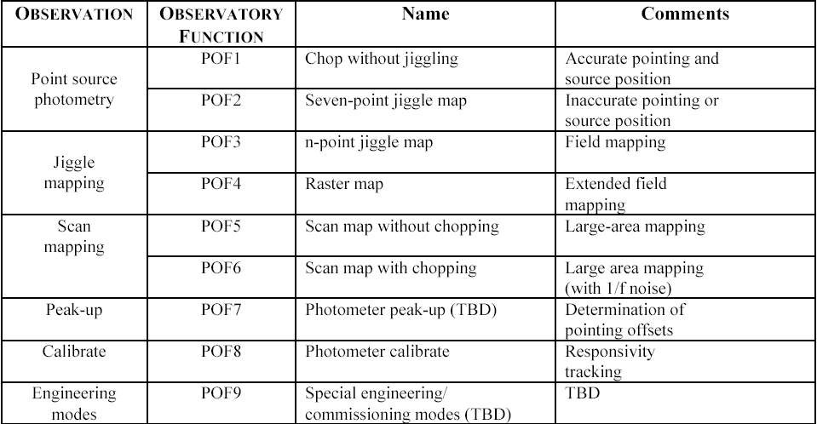

Table 2-5 - Photometer Observatory Functions (SPIRE-RAL-DOC-000320, Issue 3)

Observations in photometer mode consist mainly of POF1, POF2, POF3, POF5 and POF8.

Table 2-6 hereafter describes the power dissipated by the SPIRE PCAL, BSM and PJFET when operating in photometer mode. The dissipations represent the “average power” dissipated during a given mode of observation i.e. the power dissipated by the BSM at the various chop/jiggle positions of the 7pt jiggle map varies between 0mW and 0.7mW, the 0.3mW given in the table represents the average dissipation for all positions for a single map. The duty cycle gives an indication of the amount of time which will be allocated to the various operation modes for a nominal observation period of 46hr i.e. the chopping mode is to be used for only a quarter of the overall 46hr period.

Mechanisms | Ref | Average Dissipation [mW] | Duty Cycle [%] (*)
BSM – POF8 – Calibration with PCAL | 2 | 0.0243 | 100
BSM Sensors | 1 | 0.8 | 100
BSM Motor - POF1 – Chopping (+/-63”) | 1 | 0.548 | 25
BSM Motor - POF2 – 7pt Jiggle Map | 1 | 0.3 | 25
BSM Motor - POF3 – 64pt Jiggle Map | 1 | 1.55 | 25
BSM Motor – POF5 – Scan | 1 | 0.0 | 25
Extra power component during BSM dynamic switching | 1 | 0.25 | 100
Photometer JFETs | 3 | 56.64 | 100
(*) Over a nominal 46hr observation period in photometer mode.

Table 2-6 – SPIRE Mechanisms and Calibration Sources Dissipations in Photometer Mode

Notes:
- It is currently assumed that POF1, POF2, POF3 and POF5 will be equally used. This will depend on the scientific community needs.

- The 64pt Jiggle Map is currently the worse case power dissipation for the steady-state analysis.

- The reference given in the table can be found in section 2.4.3.

Spectrometer Mode and Power Budget

Table 2-7 describes the various operations mode of SPIRE when in spectrometer observation mode.

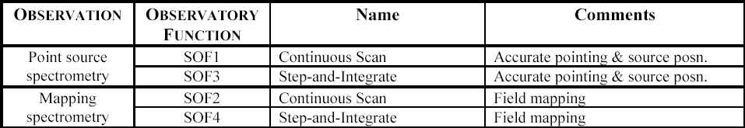
Table 2-7 – Spectrometer Observatory Functions (SPIRE-RAL-DOC-000320, Issue 3)

Table 2-8 hereafter describes the power dissipated by the SPIRE SMEC, SCAL, BSM, PCAL and SJFET when operating in spectrometer mode. The dissipations represent the “average power” dissipated during a given mode of observation i.e. the power dissipated by the SMEC actuator during a high resolution scan varies quadratically between 0 and ~17mW. The 3.56mW given in the table represents the integrated power dissipation of the actuator over the full scan range. The duty cycle gives an indication of the amount of time which will be allocated to the various observation modes for a nominal observation period of 46hr i.e. the SMEC HI resolution mode is to be used half the time of the overall 46hr period.

Mechanisms | Ref | Average  Dissipation [mW] | Duty Cycle [mW] (*)
SCAL2 at 80K | 2 | 2 | 100
Extra power component during SCAL dynamic switching | 2 | 0.87 | 50
SMEC Actuator R1000 (HI Resolution) | 4 | 3.56 | 50
SMEC Actuator R100 (MED Resolution) | 4 | 0.46 | 25
SMEC Actuator R10 (L0 Resolution) | 4 | 0.43 | 25
SMEC Encoder (Level 2) | 4, 5 | 1.2 | 100
SMEC LVDT | 5 | 0.112 | 100
BSM Sensors | 1 | 0.8 | 100
BSM Motor – POF3 – 64pt Jiggle Map | 1,6,7 | 1.55 | 50
Extra power component during BSM dynamic switching | 1, 6 | 0.25 | 50
BSM Calibrator (PCAL) | 2 | 0.0243 | 100
Spectrometer JFETs | 3 | 15.17 | 100
(*) Over a nominal 46hr operation period in Spectrometer mode.

Table 2-8 – SPIRE Mechanisms and Calibration Sources Dissipations in Spectrometer Mode

Notes:
- The High Scan Resolution map is currently the worse case power dissipation for the steady-state analysis.

- The reference given in the table can be found in section 2.4.3.

Power Dissipation References

[1] – Measured at unit level on PFM unit, please refer to Bryan Stobie’s email on 09/02/04.

[2] – Measured as part of instrument PFM3 test campaign, please refer to PFM3 Thermal Test Report, section 4.8.1.

[3] – Measured as part of instrument PFM3 test campaign, please refer to HR-SP-RAL-RFW-005v1.

[4] – Measured as part of instrument PFM4 test campaign, please refer to PFM4 Thermal Test Report (including short section on latest PFM5 test results).

[5] – Measured at unit level on CQM unit, please refer to SMEC CQM Cryogenic Test Results (LAM.ELE.SPI.PRV.040731_01).

[6] – Emails from Bruce Swinyard on 05/12/05.

[7] – SPIRE Operating Modes Document (SPIRE-RAL-DOC-000320, Issue 3).

Cooler Recycling

Figure 2-1 describes the cooler pump heater power dissipation during a nominal automated cooler recycling.

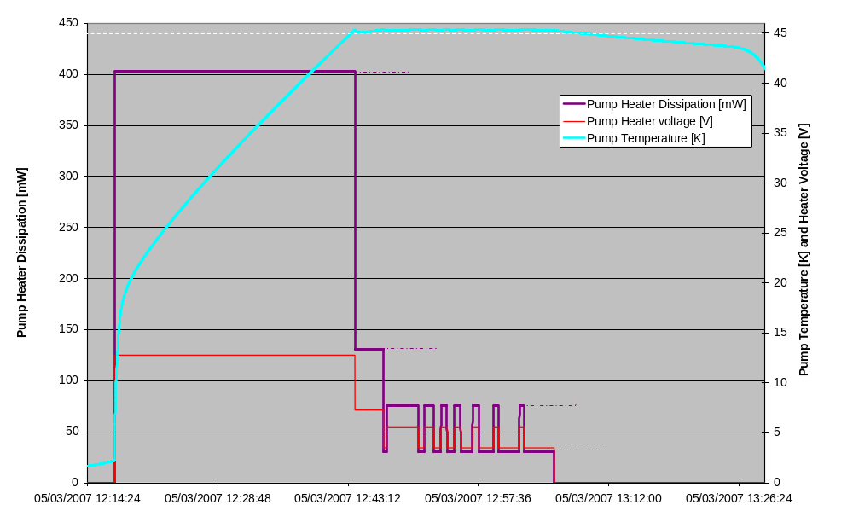
Figure 2-1 – Cooler Pump Heater Dissipation Profile during Nominal Automated Cooler Recycling

SPIRE Photometer Mode – Steady-State Analysis

Power Dissipation in Worse Case Photometer Mode

The table below summarises the power dissipation for the SPIRE mechanisms, calibration source and electronic boxes, including their duty cycle for the worse case operating mode when in photometer mode.

BSM – POF8 – Calibration with PCAL | [mW] | 0.024 | 100% | 0.024
SCAL2 at 80K | [mW] | 2.000 | 0% | 0.000
Extra power component  during SCAL dynamic switching | [mW] | 0.870 | 0% | 0.000
SMEC Actuator – R10 | [mW] | 0.430 | 0% | 0.000
SMEC Actuator – R100 | [mW] | 0.460 | 0% | 0.000
SMEC Actuator – R1000 | [mW] | 3.560 | 0% | 0.000
SMEC Encoder (Level 2) | [mW] | 1.200 | 0% | 0.000
SMEC LVDT | [mW] | 0.112 | 0% | 0.000
BSM Sensors | [mW] | 0.800 | 100% | 0.800
BSM Motor – POF1 – Chopping (+/-63”) | [mW] | 0.548 | 0% | 0.000
BSM Motor – POF2 – 7pt Jiggle Map | [mW] | 0.300 | 0% | 0.000
BSM Motor – POF3 – 64pt Jiggle Map | [mW] | 1.550 | 100% | 1.550
BSM Motor – POF5 – Scan | [mW] | 0.000 | 0% | 0.000
Extra power component  during BSM dynamic switching | [mW] | 0.250 | 100% | 0.250
Total L1 Dissipation | [mW] | - | - | 2.624
PJFET Dissipation | [mW] | 56.64 | 100.0% | 56.64
SJFET Dissipation | [mW] | 15.17 | 0.0% | 0.000

Table 2-9 – Worse Case Power Dissipation in Photometer Mode

Heat Loads in Worse Case Photometer Mode

The table below summarises the SPIRE heat loads at the various interfaces for the worse case operating mode in photometer mode.

 |  | Performance | Reqt | Goal
Cooler Total Load | [uW] | 29.4 (*) | 30 | 30
Cooler Hold Time | [hr] | 49.4 | 46 | 46
L0 Evaporator Heat Load | [mW] | 0.44 | - | -
L0 Pump Heat Load | [mW] | 2.3 | 2 | 2
L0 Enclosure Heat Load | [mW] | 0.7 | 4 | 1
L1 PJFET Harness Parasitic | [mW] | 2.17 | - | -
L1 SJFET Harness Parasitic | [mW] | 0.29 | - | -
L1 Isolation Supports | [mW] | 7.97 | - | -
L1 Housekeeping Harness | [mW] | 1.62 | - | -
L1 Radiation Load | [mW] | 3.64 | - | -
L1 Dissipation | [mW] | 2.64 | - | -
Total L1 Heat Load | [mW] | 16.75 | 15 | 13
L3 PJFET Heat Load | [mW] | 41.96 | 50 | 50
L3 SJFET Heat Load | [mW] | -5.34 | 25 | 25

Table 2-10 – SPIRE Heat Load Performance in Worse Case Photometer Mode

Notes:

- Please note that the Herschel L0 HeII interface temperature is assumed to be at 1.65K.

- The cooler total heat load includes a 1uW (*) for PTC operation.

- The results presented do not include any margin.

Observations:

- The heat load at the pump L0 interface exceeds the 2mW requirement but the heat loads from the L0 Enclosure is much lower than the requirement.

- The total L1 heat load exceeds the 15mW requirement in this case but the instrument still meets its hold time requirements.

Temperatures in Worse Case Photometer Mode

Table 2-11 summarises the temperatures experienced at the various Herschel interfaces (for the operating heat loads described in section 2.6.2) while Table 2-12 gives an overview of the instrument temperatures.

Herschel Interface Temperature [K] | Photometer  Mode
PJFET L3 IF | 15.532
SJFET L3 IF | 14.944
HOB - 371 | 12.098
HOB - 372 | 11.842
HOB - 373 | 12.08
HOB - 374 | 12.1
HOB - 375 | 12.094
HOB - 376 [-> SPIRE Cone] | 12.097
HOB - 377 | 12.177
HOB - 378 | 12.308
HOB - 379 | 12.176
HOB - 380 | 12.193
HOB - 381 [-> SPIRE A-Frames] | 12.173
L1 Strap IF #1 | 4.481
L1 Strap IF #2 | 4.567
HeII Tank | 1.65

Table 2-11 – Herschel Interface Temperature in Worse Case Photometer Mode

SPIRE Temperature [K] (*) | Photometer  Mode
Cold Tip (adjusted for self-heating on sensor) | 0.28
PLW BDA Detector | 296
PMW BDA Detector | 298
PSW BDA Detector | 299
SLW BDA Detector | 301
SSW BDA Detector | 294
Cooler Pump | 1.851
Cooler Shunt | 1.656
L0 Photometer Enclosure | 1.68
L0 Spectrometer Enclosure | 1.67
SOB | 4.8
PJFET Chassis | 16.75
SJFET Chassis | 14.85
(*) Mean temperature for enclosures

Table 2-12 - SPIRE Temperature in Worse Case Photometer Mode

Observations:

- All detectors are within the required 310mK absolute temperature.

SPIRE Spectrometer Mode – Steady-State Analysis

Power Dissipation in Worse Case Spectrometer Mode

The table below summarises the power dissipation for the SPIRE mechanisms, calibration source and electronic boxes, including their duty cycle for the worse case operating mode when in spectrometer mode.

BSM – POF8 – Calibration with PCAL | [mW] | 0.024 | 100% | 0.024
SCAL2 at 80K | [mW] | 2.000 | 100% | 2.000
Extra power component  during SCAL dynamic switching | [mW] | 0.870 | 50% | 0.435
SMEC Actuator – R10 | [mW] | 0.430 | 0% | 0.000
SMEC Actuator – R100 | [mW] | 0.460 | 0% | 0.000
SMEC Actuator – R1000 | [mW] | 3.560 | 100% | 3.560
SMEC Encoder (Level 2) | [mW] | 1.200 | 100% | 1.200
SMEC LVDT | [mW] | 0.112 | 100% | 0.112
BSM Sensors | [mW] | 0.800 | 100% | 0.800
BSM Motor – POF1 – Chopping (+/-63”) | [mW] | 0.548 | 0% | 0.000
BSM Motor – POF2 – 7pt Jiggle Map | [mW] | 0.300 | 0% | 0.000
BSM Motor – POF3 – 64pt Jiggle Map | [mW] | 1.550 | 50% | 0.775
BSM Motor – POF5 – Scan | [mW] | 0.000 | 0% | 0.000
Extra power component  during BSM dynamic switching | [mW] | 0.250 | 50% | 0.125
Total L1 Dissipation | [mW] | - | - | 9.031
PJFET Dissipation | [mW] | 56.64 | 0.0% | 0.000
SJFET Dissipation | [mW] | 15.17 | 100.0% | 15.170

Table 2-13 – Worse Case Power Dissipation in Spectrometer Mode

Heat Loads in Worse Case Spectrometer Mode

The table below summarises the SPIRE heat loads at the various interfaces for the worse case operating mode in spectrometer mode.

 |  | Performance | Reqt | Goal
Cooler Total Load | [uW] | 29.1 | 30 | 30
Cooler Hold Time | [hr] | 49.9 | 46 | 46
L0 Evaporator Heat Load | [mW] | 0.53 | - | -
L0 Pump Heat Load | [mW] | 2.38 | 2 | 2
L0 Enclosure Heat Load | [mW] | 0.86 | 4 | 1
L1 PJFET Harness Parasitic | [mW] | 0.91 | - | -
L1 SJFET Harness Parasitic | [mW] | 0.21 | - | -
L1 Isolation Supports | [mW] | 6.66 | - | -
L1 Housekeeping Harness | [mW] | 2.42 | - | -
L1 Radiation Load | [mW] | 3.65 | - | -
L1 Dissipation | [mW] | 9.05 | - | -
Total L1 Heat Load | [mW] | 20.91 | 15 | 13
L3 PJFET Heat Load | [mW] | 0.48 | 50 | 50
L3 SJFET Heat Load | [mW] | 12.63 | 25 | 25

Table 2-14 – SPIRE Heat Load Performance in Worse Case Spectrometer Mode

Notes:

- Please note that the Herschel L0 HeII interface temperature is assumed to be at 1.65K.

- The results presented do not include any margin.

Observations:

- The heat load at the pump L0 interface exceeds the 2mW requirement but the heat loads from the L0 Enclosure is much lower than the requirement.

- The total L1 heat load exceeds the 15mW requirement in this case but the instrument still meets its hold time requirements.

Temperatures in Worse Case Spectrometer Mode

Table 2-15 summarises the temperatures experienced at the various Herschel interfaces (for the operating heat loads described in section 2.7.2) while Table 2-16 gives an overview of the instrument temperatures.

Herschel Interface Temperature [K] | Spectrometer  Mode
PJFET_L3 IF | 11.785
SJFET_L3 IF | 12.687
HOB - 371 | 11.492
HOB - 372 | 11.273
HOB - 373 | 11.475
HOB - 374 | 11.494
HOB - 375 | 11.482
HOB - 376 [-> SPIRE Cone] | 11.485
HOB - 377 | 11.565
HOB - 378 | 11.64
HOB - 379 | 11.539
HOB - 380 | 11.581
HOB - 381 [-> SPIRE A-Frames] | 11.535
L1 Strap IF #1 | 4.885
L1 Strap IF #2 | 4.985
HeII Tank | 1.65

Table 2-15 – Herschel Interface Temperature in Worse Case Spectrometer Mode

SPIRE Temperature [K] (*) | Spectrometer  Mode
Cold Tip (adjusted for self-heating on sensor) | 0.28
PLW BDA Detector | 296
PMW BDA Detector | 298
PSW BDA Detector | 300
SLW BDA Detector | 301
SSW BDA Detector | 294
Cooler Pump | 1.86
Cooler Shunt | 1.66
L0 Photometer Enclosure | 1.70
L0 Spectrometer Enclosure | 1.68
SOB | 5.4
PJFET Chassis | 11.8
SJFET Chassis | 13
(*) Mean temperature for enclosures

Table 2-16 - SPIRE Temperature in Worse Case Spectrometer Mode

Observations:

- All detectors are within the required 310mK absolute temperature.

SPIRE Steady-State Average Performance during Mission

Average Power Dissipation during Mission

The table below summarises the power dissipations for the SPIRE mechanisms, calibration source and electronic boxes, including their duty cycle for all operating modes during the mission lifetime.

PACS Mode | - | - | ON  Spectro | ON  Photo | OFF | OFF | OFF | OFF | OFF
HIFI Mode | - | - | OFF | OFF | ON | OFF | OFF | OFF | OFF
SPIRE Mode | - | - | OFF | OFF | OFF | ON Photo |  | ON Spectro
BSM – POF8 – Calibration with PCAL | [mW] | 0.024 | 0 | 0 | 0 | 100% | 0.024 | 100% | 0.024
SCAL2 at 80K | [mW] | 2.000 | 0 | 0 | 0 | 0% | 0 | 100% | 2.000
Extra power component  during SCAL dynamic switching | [mW] | 0.870 | 0 | 0 | 0 | 0% | 0 | 50% | 0.435
SMEC Actuator – R10 | [mW] | 0.430 | 0 | 0 | 0 | 0% | 0 | 25% | 0.108
SMEC Actuator – R100 | [mW] | 0.460 | 0 | 0 | 0 | 0% | 0 | 25% | 0.115
SMEC Actuator – R1000 | [mW] | 3.560 | 0 | 0 | 0 | 0% | 0 | 50% | 1.780
SMEC Encoder (Level 2) | [mW] | 1.200 | 0 | 0 | 0 | 0% | 0 | 100% | 1.200
SMEC LVDT | [mW] | 0.112 | 0 | 0 | 0 | 0% | 0 | 100% | 0.112
BSM Sensors | [mW] | 0.800 | 0 | 0 | 0 | 100% | 0.800 | 100% | 0.800
BSM Motor – POF1 – Chopping (+/-63”) | [mW] | 0.548 | 0 | 0 | 0 | 25% | 0.137 | 0% | 0.000
BSM Motor – POF2 – 7pt Jiggle Map | [mW] | 0.300 | 0 | 0 | 0 | 25% | 0.075 | 0% | 0.000
BSM Motor – POF3 – 64pt Jiggle Map | [mW] | 1.550 | 0 | 0 | 0 | 25% | 0.388 | 50% | 0.775
BSM Motor – POF5 – Scan | [mW] | 0.000 | 0 | 0 | 0 | 25% | 0.000 | 0% | 0.000
Extra power component  during BSM dynamic switching | [mW] | 0.250 | 0 | 0 | 0 | 100% | 0.250 | 50% | 0.125
Total L1 Dissipation | [mW] | - | 0 | 0 | 0 | - | 1.674 | - | 7.474
PJFET Dissipation | [mW] | 56.64 | 0 | 0 | 0 | 100% | 56.64 | 0% | 0
SJFET Dissipation | [mW] | 15.17 | 0 | 0 | 0 | 0% | 0 | 100% | 15.17

Table 2-17 - Average SPIRE Dissipation during Mission

Observations:

- One can see that in this case the average power dissipation at L1 in photometer mode is 1.67mW versus 2.62mW for the worse case power dissipation.

- One can see that in this case the average power dissipation at L1 in spectrometer mode is 7.47mW versus 9.03mW for the worse case power dissipation.

Average Heat Loads during Mission

PACS Mode | - | ON  Spectro | ON  Photo | OFF | OFF | OFF
HIFI Mode | - | OFF | OFF | ON | OFF | OFF
SPIRE Mode | - | OFF | OFF | OFF | ON  Photo | ON  Spectro
Mission Duty Cycle | [%] | 16.65 | 16.65 | 33.3 | 16.65 | 16.65 | Mission  Average | Reqt | Goal
L0 Evaporator Heat Load | [mW] | 0.62 | 0.37 | 0.48 | 0.44 | 0.53 | 0.49 | - | -
L0 Pump Heat Load | [mW] | 0.61 | 0.37 | 0.47 | 2.3 | 2.38 | 1.10 | 2 | 2
L0 Enclosure Heat Load | [mW] | 1.00 | 0.59 | 0.78 | 0.7 | 0.86 | 0.79 | 4 | 1
L1 PJFET Harness Parasitic | [mW] | 1.00 | 0.83 | 1.36 | 2.17 | 0.91 | - | - | -
L1 SJFET Harness Parasitic | [mW] | 0.18 | 0.15 | 0.24 | 0.29 | 0.21 | - | - | -
L1 Isolation Supports | [mW] | 7.89 | 6.3 | 11.01 | 7.97 | 6.66 | - | - | -
L1 Housekeeping Harness | [mW] | 1.38 | 1.4 | 1.85 | 1.62 | 2.42 | - | - | -
Radiation Load | [mW] | 3.65 | 3.58 | 3.76 | 3.64 | 3.65 | - | - | -
Total L1 Dissipation | [mW] | 0.00 | 0.00 | 0.00 | 1.67 | 7.47 | - | - | -
Total L1 Heat Load | [mW] | 11.84 | 10.62 | 16.45 | 16.75 | 20.91 | 15.5 | 15 | 13
L3 PJFET Heat Load | [mW] | -0.04 | 0.12 | -0.318 | 41.96 | 0.48 | 6.98 | 50 | 50
L3 SJFET Heat Load | [mW] | 0.06 | 0.08 | 0.033 | -5.34 | 12.63 | 1.25 | 25 | 25

Table 2-18 – Average SPIRE Heat Loads During Mission

Notes:

- Please note that the Herschel L0 HeII interface temperature is assumed to be at 1.65K.

- The results presented do not include any margin.

Observations:

- One can see that the SPIRE L1 heat load exceeds the 15mW requirement by 0.5mW.

