Introduction
This document reports on the WARM FUNCTIONAL TESTS carried out on the SPIRE Flight Instrument Model at the start of the PFM5 ILT tests campaign to verify the correct functioning of each of its subsystems prior to cool down. The test cryostat chamber was fully pumped down.

Scope
To judge the success or failure of a warm functional test by checking that:

- The telecommand sequence generated for a particular functional test is correctly received and executed on board by the SPIRE DPU.
- No error/event reports or command failures are generated during the execution of these commands.
- Telemetry is generated by the instrument as a result of telemetry requests to its different subunits.
- Particular telemetry parameters for each functional test change in an expected manner.
- A particular success criterion/criteria (specified in this document) is/are met.

Reference Documents
Ref | Document | Name | Version/Issue Nb.
RD01 | SPIRE-RAL-DOC-001652 | SPIRE Functional Tests Specification | Issue 1.4
RD02 | SPIRE-RAL-DOC-001630 | SPIRE EGSE-ILT Start-Up Procedures | Issue 0.7
RD03 | SPIRE-RAL-PRC-002222 | DRCU Switch ON Procedure | Issue 1.0
RD04 | SPIRE-RAL-PRJ-001078 | SPIRE Data ICD | Issue 2.0
RD05 | Sap-SPIRE-CCa-076-02 | DRCU/DPU Interface Control Document | Issue 1.2
RD06 | LAM.PJT.SPI.NOT.011011 | MCU/DPU Command List ICD | Issue 5.0
RD07 | SPIRE-IFS-PRJ-001391 | SPIRE OBS User Manual | Issue 2.2
RD08 | SPIRE-IFS-PRJ-000650 | SPIRE DPU Interface Control Document | Issue 1.1

Change Record
Document | Change date | Changes
Issue 1.0 | 3rd January 2007 | First version of the document created.

Table of Contents
1. Introduction 1
1.1 Scope 1
1.2 Reference Documents 1
1.3 Change Record 1
2. Functional Tests Configuration 4
2.1 SPIRE Instrument Configuration (REDUNDANT) 4
2.2 Software Configuration (REDUNDANT) 4
2.3 EGSE Configuration Checks 5
3. Test procedure 7
3.1 General Pass/Fail Criteria 7
3.2 General Test Sequence 7
4. Detailed Test Results on REDUNDANT instrument. 9
4.1 FUNC-SCU-01 9
4.2 FUNC-SCU-03 11
4.3 FUNC-SCU-06 13
4.4 FUNC-SCU-02 15
4.5 FUNC-SCU-08 17
4.6 FUNC-SCU-04 19
4.7 FUNC-SCU-05 20
4.8 FUNC-SCU-07 21
4.9 FUNC-MCU-01 22
4.10 FUNC-MCU-02 24
4.11 FUNC-MCU-03 26
4.12 FUNC-MCU-04 28
4.13 FUNC-BSM-01 30
4.14 FUNC-BSM-02c 32
4.15 FUNC-BSM-02j 32
4.16 FUNC-BSM-03 34
4.17 FUNC-BSM-06 36
4.18 36
4.19 FUNC-SMEC-03 39
4.20 FUNC-SMEC-01 41
4.21 FUNC-SMEC-04a 43
4.22 FUNC-SMEC-02A/B 45
4.23 FUNC-SMEC-09 46
4.24 FUNC-SMEC-07 48
4.25 FUNC-SMEC-04B 50
4.26 FUNC-DCU-01 52
4.27 FUNC-DCU-02 55
4.28 FUNC-DCU-03 56
4.29 FUNC-DCU-04P 57
4.30 FUNC-DCU-11P 59
4.31 FUNC-DCU-13P 61
4.32 ILT_PERF_DNA_P 63
4.33 FUNC-DCU-04S 65
4.34 FUNC-DCU-11S 67
4.35 FUNC-DCU-13S 69
4.36 ILT_PERF_DNA_S 71
5. Annexe1 (Instrument nominal configuration/modes) 72
6. Annexe 2 (Results of Load Curves) 73

Functional Tests Configuration

SPIRE Instrument Configuration (REDUNDANT)

SPIRE FPU:

- FPU In Tank.
- DRCU to Cryostat harnesses connected (Grounding pins not connected)
- Cryostat open
- Cryo-harness connected to FPU

SPIRE FM DPU:

- DPU Power supply connected on DPU Power REDUNDANT (J01) connector (DPU side).
- 1553 Mil Bus connected on REDUNDANT Connector Bus A (J03) connector (DPU side).
- DPU-DRCU REDUDANT interfaces connected:

SPIRE FM DRCU:

- DRCU Power supply connected on DRCU Power REDUNDA NT (J05) connector (DRCU side on FCU) via the external DRCU switch box.
- FCU to DCU REDUNDAN T power connector J7 (FCU) to J03 (DCU) via the external DPU switch box.

Software Configuration (REDUNDANT)
The current EGSE software configuration for the REDUNDANT side tests:

EGSE component | Version/Build number | Comment
SCOS2000 | SCOS2.3e Patch 5 | SCOS archives PFM4_TEST3_PRIME under /spired/hfiles and /spired/TMD  SCOS MIB is PFM4_Issue2.2.D1_Redundant
CDMS Simulator | v2.5
HCSS | v0.3.6 Build #1043
QLA | 3.2.3 Build #438
QLA scripts | ?
Test Control scripts | Create TAGS
CUS Scripts | Create TAGS
Versant | 7.0.0.1
TFCS | MIB v1.9  Code
TFTS | MIB v1.6  Server code v1.6

EGSE Configuration Checks
To check for the success of failure of a functional test, the real time telemetry of the instrument has to be monitored. The following applications must be running to do so. Before the test sequence starts, make the following checks:

Workstation | EGSE component | Status | Check | Comments
Lichfield | EGSE router | Started | ✓ | Running in the background – no dedicated console on lichfield
Lichfield | EGSE Gateway | Started | ✓ | Running in the background – no dedicated console on lichfield
Lichfield | Telemetry Ingestion | Started | ✓ | Running
Lichfield | Packet Display | Started | ✓ | Running
Lincoln | SCOS2000 | Started | ✓ | Running
Lincoln | EXIF + TOPE | Started | ✓ | Running
Lincoln | Manual Stack | Started | ✓ | Running
Gordon | CDMS Simulator | Started | ✓ | Running
Lichfield | Test Control Server | Started | ✓ | Running

The following checks were performed to verify the correct initial instrument configuration for the tests.

Step# | Action | Comments | Check
1 | In SCOS open  DPU_AND_OBS_PARAMETERS display  Check if :  TM2N is incrementing by one @1Hz.  TM1N is incrementing by one @0.5Hz.  - If they are, go to step 5.  - If they are not, go to step 2. | Both TM1N and TM2N are incrementing at their nominal rates.  Will go to step 5. | ✓
2 | Check if the DPU is powered ON:  - If ON, the DPU power supply LCD will show ~ 28V and 0.40A, go to step 4.  - If not ON, power ON DPU see comments on the right, then go to step 3.
3 | In SCOS open  Boot_ROM_Memory_Check display and check no errors are reported:  - If no errors are reported, execute DPU_ON from HCSS Test Procedures. Then repeat step 1.  - If the (5,1) contains errors:  Check the error code in RD07. Then switch OFF the DPU and repeat step 2
4 | Execute define_new_HK_report.tcl HCSS Test procedure.
5 | In SCOS open  SCU_PARAMETERS display  - If SCUP5V/P9V/M9V are jittering and  BIAS_PARAMETERS display  - If BIASTEMP  show ambient temperature, the DRCU is ON.Go to step 6.  - If DRCU is not ON, refer to RD03 on how to start up the DRCU. | ALL SCU VOLTAGES LOOKING GOOD.  SCUP5V = 5.22V  SCUP9V =9.09V  SCUM9V = -9.10V  ALL BIAS VOLTAGES LOOKING GOOD.  BIASP5V = 5.10V  BIASP9V = 9.00V  BIASM9V= -9.06V | ✓
6 | In SCOS open  DPU_AND_OBS_PARAMETERS display and check that the MODE housekeeping parameter is DRCU_ON. | MODE (RAW)= 0x100  MODE (ENG) = DRCU_ON | ✓
Table 1. Initial configuration check

Test procedure
The following two sections describe general pass/fail criteria (Section 3.1), the general test procedure layout (Section 3.1) and the detailed procedure for each functional test (Section 3.2).

General Pass/Fail Criteria
The general criterion for declaring a single test failed is the repeated failure of 2 consecutive runs of this test. In that case the functional test procedure should be aborted and the overall functional testing declared FAILED.
In the case of a ‘first run’ failure followed by a successful execution a third run of the same test should be performed and in the unlikely event of this third run being a failure the test procedure should be also aborted and the overall functional testing declared FAILED, as this would imply a not reliable operability of the instrument.
As a general remark ANY failure should be closely analyzed.

Note: If the functional test is declared FAILED refer to section 4.1 for instrument switch OFF.

General Test Sequence
The table below shows the general WFT as it was performed.

Step | Subsystem tested | Test Id | Test Purpose
1 | SCU | FUNC-SCU-01 | SCU Nominal Science Generation Check
2 |  | FUNC-SCU-03 | FPU DC Thermometry Check
3 |  | FUNC-SCU-06 | FPU AC Thermometry Check
4 |  | FUNC-SCU-02 | SCU Nominal Science Contents Check
5 |  | FUNC-SCU-08 | SCU Test Pattern Check
6 |  | FUNC-SCU-07 | Sorption Cooler Check
7 |  | FUNC-SCU-04 | Photometer Calibrator Check
8 |  | FUNC-SCU-05 | Spectrometer Calibrators Check
9 | MCU | FUNC-MCU-01 | MCU Boot Check
10 |  | FUNC-MCU-02 | MCU Nominal Science Generation Check
11 |  | FUNC-MCU-03 | MCU Nominal Science Contents Check
12 |  | FUNC-MCU-04 | MCU Test Pattern Check
13 | BSMm | FUNC-BSM-01 | BSM Switch ON Check
14 |  | FUNC-BSM-02c | BSM Chop Sensor Polarity Check
15 |  | FUNC-BSM-02j | BSM Jiggle Sensor Polarity Check
16 |  | FUNC-BSM-03 | BSM Open Loop dynamics Check
17 |  | BSM_INIT | Close loop on chop/jiggle axis.
18 |  | FUNC-BSM-06 | BSM Operational Mode Check
19 | DCU | FUNC-DCU-01 | DCU Nominal Science Generation Check
20 |  | FUNC-DCU-02 | DCU Nominal Science Contents Check
21 |  | FUNC-DCU-03 | DCU Test Pattern Check
22 | Photometer LIAs | FUNC-DCU-04P | Photometer LIAs Check
23 |  | FUNC-DCU-05P | Photometer Manual Offset Setting Check
24 |  | FUNC-DCU-11P | Photometer Detectors Switch ON Check
25 | Photometer BDAs | FUNC-DCU-013P | Photometer Detectors Check
26 | Spectrometer LIAs | FUNC-DCU-04S | Spectrometer LIAs Check
27 |  | FUNC-DCU-05S | Spectrometer Manual Offset Setting Check
28 |  | FUNC-DCU-11S | Spectrometer Detectors Switch ON Check
29 | Spectrometer BDAs | FUNC-DCU-013S | Spectrometer Detectors Check
18 | SMECm | FUNC-SMEC-02A | SMEC Launch Latch Open/Close Check
19 |  | FUNC-SMEC-01 | SMECm Switch ON Check
20 |  | FUNC-SMEC-03 | SMEC LED Optical Encoder LED Check
21 |  | FUNC-SMEC-04 | SMEC Positioning Test (Open Loop)
Table 2. General WFT sequence

Detailed Test Results on REDUNDANT instrument.
The following is a detailed (test by test) procedure including the steps performed on each test and the results obtained.

Step# | Action | Comments
0 | Open SCU_PARAMETERS display on SCOS Alpha Numeric Displays.

FUNC-SCU-01
Test Id: | FUNC-SCU-01
Initial Configuration: | DRCU_ON
Final Configuration: | DRCU_ON
Success Criteria: | Test passed if :  - Two SCU Nominal Science Report telemetry packets are received on QLA with the following characteristics:  - The frame time difference between consecutive SCU frames within these packets corresponds to the sampling rate. Nominal SCU sampling rate is 80Hz ➔ Δt = 12.5 ms  - The SPIRE HK parameter SCUFRAMECNT increments by 31.  - No events are generated during the frame generation.  QLA to give go ahead.
  APID | Type | Subtype | SID | FrameID | Frame length
  0x509 | 21 | 1 | 0xA20 | 0x20 | 0x1E

Test Procedure:
Step# | Action | Comments
1 | Write the initial value of SCUFRAMECNT parameter located in SCU_PARAMETERS display and the initial value of TM1N located in DPU_AND-OBS_PARAMETERS display. | SCUFRAMCNT = 0
2 | Run QLA script FUNC-SCU-01.py on QLA console.
3 | Run FUNC-SCU-01 test procedure from the HCSS Test Procedure window on TOPE
4 | Write the final value of SCUFRAMECNT and TM1N. | SCUFRAMCNT = 31
5 | Contingency:  If test fails repeat steps 1 to 4.

Test Log:
Test Id | Key Parameter(s) | Expected Value Before/After | Actual Value  Before/After | Nb. of frames received | Test Result
FUNC-SCU-01 | SCUFRAMECNT  TM5N | n/ n+ 31  0x3FFF/1 | 0/ 31  0x3FFF/1 | 31 | Success
Start time @: 12:29
End time @: 12: 29
OBSID: 0x30011A8D
Comments:

QLA script was run in playback:

*************************************************************************
SCU: OBSID = 30011A8D, BBTYPE = 0x8000, APID = 0x509, SID = 0xa20
_________________________________________________________________________
Parameter Initial Final Increment Expect Incre. Packet Chars.

SCUFRAMECNT 0 31 31 31 Packet type = 0x15
TM5N 16383 1 49153 2 subtype = 0x1
FrameTime 12.4960 12.4960 Frame ID = 0x20
Frame Len = 0x1E
STATISTICS ON TIME BETWEEN RECEPTION OF 2 CONSECUTIVE FRAMES:
mean = 12.49792 ms
sigma = 0.00160 ms

FUNC-SCU-03
Test Id: | FUNC-SCU-03
Initial Configuration: | DRCU_ON
Final Configuration: | DRCU_ON + DC thermometry ON
Success Criteria: | Test passed if all FPU DC thermometry sensors show temperature values indicating a correct functioning of the sensor, not open/short-circuited. If ANY reading is anomalous check RAW sensor reading.  Open Circuit Criterion:  RAW reading in the range [0, -100]  Short Circuit Criterion:  RAW reading of -32768  Note: For some parameters the calibration curve above 75K has only 2 points, thus the linearly interpolated temperature reading given by SCOS is usually not correct at T > 75K.

Test Procedure:
Step# | Action | Comments
1 | Run FUNC-SCU-03 test procedure from the HCSS Test Procedure window on TOPE
2 | When the test is finished Write the current value of SCUTEMPSTAT and the RAW/converted values of the 16 FPU temperatures located in SCU_PARAMETERS display.
3 | Contingency:  If test fails execute SCU_OFF procedure from HCSS Test Procedure window on TOPE and then repeat steps 1 and 2.

Test Log:
Test Id | Key Parameter(s) | Expected Value Before/After | Actual Value  Before/After | Nb. of frames received | Test Result
FUNC-SCU-03 | SCUTEMPSTAT | 0/0xFFFF | 0/0xffff | N/A | Success
Start time @: 12:31
End time @: 12: 31
OBSID:0x30011A8E
Comments:

SCU-03 Thermometry Check
OBSID = 0x30011a8e

PUMPHTRTEMP 50.09 32768
PUMPHSTEMP 36.42 32768
EVAPHSTMP 39.25 32768
SHUNTTEMP 18.05 32768
EMCFILTMP 284.27 35977
SL0TEMP 19.89 32768
PL0TEMP 22.52 32768
OPTTEMP 141.72 32768
BAFTEMP 160.50 32768
BSMIFTEMP 110.81 32768
SCAL2TEMP 166.07 32768
SCAL4TEMP 141.47 32768
SCALTEMP 83.15 32768
SMECIFTEMP 133.33 32768
SMECTEMP 27.28 32768
BSMTEMP 13.13 32768

The actual SCOS display readings are -32768. Error on QLA script?

FUNC-SCU-06
Test Id: | FUNC-SCU-06
Initial Configuration: | DRCU_ON + DC thermometry ON
Final Configuration: | DRCU_ON + AC/DC thermometry ON
Success Criteria: | Test passed if SUBKSTAT parameter went from 0 to 1.  Open Circuit Criterion:  RAW reading in the range 0 -100  Short Circuit Criterion:  RAW reading of -32768

Test Procedure:
Step# | Action | Comments
1 | Run FUNC-SCU-06 test procedure from the HCSS Test Procedure window on TOPE.
2 | When the test is finished Write the current value of SUBKSTAT located in SCU_PARAMETERS display. Also write down the RAW value of the SUBKTEMP parameter.
3 | Contingency:  If test fails :  Send manual command:  SEND_DRCU_COMMAND  Parameter1 = 0xA0860000  Parameter2 = 0  Then repeat steps 1 and 2.

Test Log:
Test Id | Key Parameter(s) | Expected Value Before/After | Actual Value  Before/After | Nb. of frames received | Test Result
FUNC-SCU-06 | SUBKSTAT | 0/1 | 0/1 | N/A | Success
Start time @: 12:43
End time @: 12:43
OBSID:0x30011A8F
Comments:

SUBKTEMP:
Before: RAW = 32767
After : RAW = 32767

No change (as it happened) on PFM4 but the channel is actually working.

FUNC-SCU-02
Test Id: | FUNC-SCU-02
Initial Configuration: | DRCU_ON + AC/DC thermometry ON
Final Configuration: | DRCU_ON + AC/DC thermometry ON
Success Criteria: | Test passed if :  - Parameters in the SCU Nominal science packets and the same parameters in the Nominal HK packet have similar RAW/converted values to within 10%.  - The SPIRE HK parameter SCUFRAMECNT located in SCU_PARAMETERS display increments by 31.  - No events are generated during the frame generation.  QLA to give the go ahead.

Test Procedure:
Step# | Action | Comments
1 | Write the current value of SCUFRAMECNT located in SCU_PARAMETERS display.
2 | Run QLA script FUNC-SCU-02.py on QLA console.
3 | Run FUNC-SCU-02 test procedure from the HCSS Test Procedure window on TOPE
4 | When the test is finished Write the current value of SCUFRAMCNT.
5 | Contingency:  If test fails repeat steps 1 to 4.

Test Log:
Test Id | Key Parameter(s) | Expected Value Before/After | Actual Value  Before/After | Nb. of frames received | Test Result
FUNC-SCU-02 | SCUFRAMECNT  TM5N | n+31/n+62  1/3 | 31/62  1/3 | 31 | Success
Start time @: 12:45
End time @: 12: 46
OBSID: 0x30011A90

Comments:

QLA script was run in playback:

FUNC-SCU-02 version: 1.4

Housekeeping @ Fri Jan 26 12:45:41 GMT 2007
SCU Science @ Fri Jan 26 12:45:35 GMT 2007

Name HSK value SCU value Equal (within 10%)?
TCHTRV 18.0 20.0 False
PCALCURR 9.0 10.0 False
SCAL4CURR 10.0 11.0 True
SCAL2CURR 10.0 10.0 True
PCALV 13.0 13.0 True
SCAL4V 11.0 10.0 True
SCAL2V 10.0 10.0 True
PUMPHTRTEMP 32768.0 32768.0 True
PUMPHSTEMP 32768.0 32768.0 True
EVAPHSTEMP 32768.0 32768.0 True
SHUNTTEMP 32768.0 32768.0 True
EMCFILTEMP 35978.0 35974.0 True
SL0TEMP 32768.0 32768.0 True
PL0TEMP 32768.0 32768.0 True
OPTTEMP 32768.0 32768.0 True
BAFTEMP 32768.0 32768.0 True
BSMIFTEMP 32768.0 32768.0 True
SCAL2TEMP 32768.0 32768.0 True
SCAL4TEMP 32768.0 32768.0 True
SCALTEMP 32768.0 32768.0 True
SMECIFTEMP 32768.0 32768.0 True
SMECTEMP 32768.0 32768.0 True
BSMTEMP 32768.0 32768.0 True
SUBKTEMP 32767.0 32767.0 True

FUNC-SCU-08
Test Id: | FUNC-SCU-08
Initial Configuration: | DRCU_ON + AC/DC thermometry ON
Final Configuration: | DRCU_ON + AC/DC thermometry ON
Success Criteria: | Test passed if :  - Two SCU Diagnostic Science Report telemetry packets are received with the following characteristics:  - The SCU Test Pattern agrees with the reference test pattern.  QLA to give go ahead.
  APID | Type | Subtype | SID | FrameID | Frame length
  0x509 | 21 | 3 | 0x1121 | 0x21 | 0x1E

Test Procedure:
Step# | Action | Comments
1 | Write the current values of SCUFRAMECNT located in SCU_PARAMETERS display.
2 | Run QLA script FUNC-SCU-08.py on QLA console.
3 | Run FUNC-SCU-08 test procedure from the HCSS Test Procedure window on TOPE
4 | When the test is finished Write the current value of SCUFRAMCNT.
5 | Contingency:  If test fails repeat steps 1 to 4.

Test Log:
Test Id | Key Parameter(s) | Expected Value Before/After | Actual Value  Before/After | Nb. of frames received | Test Result
FUNC-SCU-08 | SCUFRAMECNT and SCU test pattern frame parameters | n+62/n+93 | 62/93  93/124 | 31  31 | Success
Start time @: 12:47
End time @: 12:48
OBSID:0x30011A91

Comments:

QLA produced the following file:

SCU Test Pattern @ Fri Jan 26 12:47:15 GMT 2007
..compared with data from SCU Test Pattern @ Thu Jan 25 13:59:59 GMT 2007, OBSID=0x30011A58

Name New Value[0] New Value[20] Comp Value[0] Comp Value[20]
SCUTSTOBSID 8.05378705E8 0.0 8.05378648E8 <--BAD 0.0 --> OK
SCUTSTBBID 2.315714561E9 0.0 2.315714561E9 --> OK 0.0 --> OK
SCUTSTBLKLEN 30.0 30.0 30.0 --> OK 30.0 --> OK
SCUTSTFRAMEID 33.0 33.0 33.0 --> OK 33.0 --> OK
SCUTST001 43690.0 31181.0 43690.0 --> OK 31181.0 --> OK
SCUTST002 21844.0 62363.0 21844.0 --> OK 62363.0 --> OK
SCUTST003 43688.0 59190.0 43688.0 --> OK 59190.0 --> OK
SCUTST004 21840.0 52844.0 21840.0 --> OK 52844.0 --> OK
SCUTST005 43680.0 40153.0 43680.0 --> OK 40153.0 --> OK
SCUTST006 21825.0 14771.0 21825.0 --> OK 14771.0 --> OK
SCUTST007 43650.0 29543.0 43650.0 --> OK 29543.0 --> OK
SCUTST008 21765.0 59086.0 21765.0 --> OK 59086.0 --> OK
SCUTST009 43530.0 52637.0 43530.0 --> OK 52637.0 --> OK
SCUTST010 21524.0 39739.0 21524.0 --> OK 39739.0 --> OK
SCUTST011 43048.0 13943.0 43048.0 --> OK 13943.0 --> OK
SCUTST012 20560.0 27887.0 20560.0 --> OK 27887.0 --> OK
SCUTST013 41120.0 55774.0 41120.0 --> OK 55774.0 --> OK
SCUTST014 16705.0 46012.0 16705.0 --> OK 46012.0 --> OK
SCUTST015 33411.0 26489.0 33411.0 --> OK 26489.0 --> OK
SCUTST016 1287.0 52978.0 1287.0 --> OK 52978.0 --> OK
SCUTST017 2574.0 40420.0 2574.0 --> OK 40420.0 --> OK
SCUTST018 5149.0 15304.0 5149.0 --> OK 15304.0 --> OK
SCUTST019 10298.0 30608.0 10298.0 --> OK 30608.0 --> OK
SCUTST020 20597.0 61216.0 20597.0 --> OK 61216.0 --> OK
SCUTST021 41194.0 56896.0 41194.0 --> OK 56896.0 --> OK
SCUTST022 16852.0 48257.0 16852.0 --> OK 48257.0 --> OK
SCUTST023 33705.0 30978.0 33705.0 --> OK 30978.0 --> OK
SCUTST024 1874.0 61956.0 1874.0 --> OK 61956.0 --> OK
SCUTSTADCFLGS 0.0 0.0 0.0 --> OK 0.0 --> OK
SCUTSTFRAMETIME 4228657.0 4306769.0 4228894.0 <--BAD 4307006.0 <--BAD
SCUTSTCHECKWORD 58804.0 15468.0 58523.0 <--BAD 13059.0 <--BAD

FUNC-SCU-04
Test Id: | FUNC-SCU-04
Initial Configuration: | DRCU_ON + AC/DC thermometry ON
Final Configuration: | DRCU_ON + AC/DC thermometry ON
Success Criteria: | Test passed if PCALCURR/PCALV SCU HK parameters show the following values:  - PCALCURR HK parameter which shows the measured PCAL current is ~ 0.1 mA.  - PCALV HK parameter which shows the measured PCAL voltage is ~ 0.02V

Test Procedure:
Step# | Action | Comments
1 | Write the current value of PCALV and PCALCURR located in SCU_PARAMETERS display.
2 | Run FUNC-SCU-04 test procedure from the HCSS Test Procedure window on TOPE
3 | While the test is running Write the values of PCALV and PCALCURR.
4 | Contingency:  If test fails repeat steps 1 to 3.

Test Log:
Test Id | Key Parameter(s) | Expected Value Before/During test | Actual Value  Before/After | Nb. of frames received | Test Result
FUNC-SCU-04 | PCALCURR  PCALV | 0/0.1mA  0/0.02V | 0 / 0.101 mA  0 / 0.0200 V | N/A | Success
Start time @: 12:48
End time @: 12: 48
OBSID: 0x30011A92
Comments:

Test Successful

FUNC-SCU-05
Test Id: | FUNC-SCU-05
Initial Configuration: | DRCU_ON + AC/DC thermometry ON
Final Configuration: | DRCU_ON + AC/DC thermometry ON
Success Criteria: | Test passed if :  - SCAL2CURR ,SCAL4CURR HK parameters which show the measured current read ~ 0.1 mA  - SCAL2V,SCAL4V parameters which show the measured voltage read ~ 0.05V.

Test Procedure
Step# | Action | Comments
1 | Write the current value of SCAL2V ,SCAL2CURR,SCAL4V,SCAL4CURR located in SCU_PARAMETERS display.
2 | Run FUNC-SCU-05 test procedure from the HCSS Test Procedure window on TOPE
3 | While the test is running write the values of SCAL2V ,SCAL2CURR,SCAL4V,SCAL4CURR.
4 | Contingency:  If test fails repeat steps 1 to 3.

Test Log:
Test Id | Key Parameter(s) | Expected Value Before/During test | Actual Value  Before/After | Nb. of frames received | Test Result
FUNC-SCU-05 | SCAL4CURR  SCAL4V  SCAL2CURR  SCAL2V | 0/0.1mA  0/0.05V  0/0.1mA  0/0.05V | 0 / 0.1017 mA  0 / 0.0508 V  0 / 0.1000 mA  0 / 0.0498 V | N/A | Success
Start time @: 12:49
End time @: 12: 52
OBSID:0x30011A93
Comments:

The same command (parameter 0x4e) should be sent to both SCAL2/4

Test Successful

FUNC-SCU-07
Test Id: | FUNC-SCU-07
Initial Configuration: | DRCU_ON + AC/DC thermometry ON
Final Configuration: | DRCU_ON + AC/DC thermometry ON
Success Criteria: | Test passed if during the execution of the test the following SCU HK parameters give correspondent readings of:
  SCU HK parameter | RAW | Converted
  SPHSV | ~12715 | ~323mV
  EVHSV | ~12715 | ~323mV
  SPHTRV | ~14390 | ~ 8 V

Test Procedure:
Step# | Action | Comments
1 | Run FUNC-SCU-07 test procedure from the HCSS Test Procedure window on TOPE. | Pending
2 | While the test is running Write the values of current values of SPHSV, EVHSV, SPHTRV located in SCU_PARAMETERS display. (RAW and CONVERTED)
3 | Contingency:  If test fails repeat steps 1 and 2.

Test Log:
Test Id | Key Parameter(s) | Expected Value Before/During test | Actual Value  Before/After | Nb. of frames received | Test Result
FUNC-SCU-07 | SPHSV  EVHSV  SPHTRV | 0/ ~ 323 mV  0/ ~ 323 mV  0/ ~ 8 V | ~ 0 mV / 324.21 mV  ~ 0 mV / 325.27 mV  ~ 0 V / 8.85 V | N/A | Success
Start time @: 12:53
End time @: 12:56
OBSID:0x30011A94

Comments:

Test Successful

Step# | Action | Comments
0 | Open MCU_PARAMETERS display on SCOS Alpha Numeric Displays.

FUNC-MCU-01
Test Id: | FUNC-MCU-01
Initial Configuration: | DRCU_ON + AC/DC thermometry ON
Final Configuration: | DRCU_ON + AC/DC thermometry ON +MCU ON
Success Criteria: | Test passed if:  - MCU boots.  - MCU voltages show expected values.  - MAC, SMEC and BSM board temperatures shows ambient temperature.

Test Procedure:
Step# | Action | Comments
1 | Run FUNC-MCU-01 test procedure from the HCSS Test Procedure window on TOPE
2 | When procedure is finished Write the values of the MCU voltages.
3 | Contingency:  If test fails repeat steps 1 and 2.

Test Log:
Test Id | Key Parameter(s) | Expected Value Before/After | Actual Value  Before/After | Nb. of frames received | Test Result
FUNC-MCU-01 | MCUP5V  MCUP15V  MCUP14V  MCUM14V  MCUM15V  MCUMACTEMP  MCUSMECTEMP  MCUBSMTEMP | N/A/ ~ 5V  N/A / ~15V  N/A / ~ 14V  N/A / ~ -14V  N/A / ~ -15V  N/A / ~ 300K  N/A / ~ 300K  N/A / ~ 300K | - / 5.00V  - / 15.50V  - / 14.12V  - / -14.49 V  - / -15.60 V  - / 291.32K  - / 295.60K  - / 295.00K | N/A | Success
Start time @: 12:56
End time @: 14:35
OBSID:0x30011A95

Comments:

SCUDCDCSTAT went from 0 to 4 as expected

DRCU Power Supply LCD reading = ( I = 0.87 A )

Test Successful

FUNC-MCU-02
Test Id: | FUNC-MCU-02
Initial Configuration: | DRCU_ON + AC/DC thermometry ON +MCU ON
Final Configuration: | DRCU_ON + AC/DC thermometry ON +MCU ON
Success Criteria: | Test passed if :  - MCU produces each type of the frames requested and with the following characteristics.  - No events are generated during the different frames generation.
  Frame | APID | Type | Subtype | SID | FrameID | Frame length
  Eng. | 0x509 | 21 | 3 | 0x814 | 0x14 | 0x15
  BSM | 0x509 | 21 | 1 | 0x612 | 0x12 | 0xD
  SMEC | 0x509 | 21 | 1 | 0x410 | 0x10 | 0xC
  BSM +SMEC

Test Procedure:
Step# | Action | Comments
1 | Write the current value of MCUFRAMECNT located in MCU_PARAMETERS display
2 | Run QLA script FUNC-MCU-02.py on QLA console.
3 | Run FUNC-MCU-02 test procedure from the HCSS Test Procedure window on TOPE
4 | When test is finished Write the current value of MCUFRAMECNT.
5 | Contingency:  If test fails repeat steps 1 to 4.

Test Log:
Test Id | Key Parameter(s) | Expected Value Before/After | Actual Value  Before/After | Nb. of frames received | Test Result
FUNC-MCU-02 | MCUFRAMECNT | 0/ ~ 6600 | 0 / 6493 |  | Success
Start time @: 12:58
End time @: 13:01
OBSID:0x30011A96
Comments:

QLA produced the following file:

*************************************************************************
MCUENG: OBSID = 30011A96, BBTYPE = 0x8901, APID = 0x509, SID = 0x814
_________________________________________________________________________
Parameter Initial Final Increment Expect Incre. Packet Chars.

MCUFRAMECNT 0 609 609 609 Packet type = 0x15
TM5N 5 32 27 27 subtype = 0x3
FrameTime 16.4223 16.4225 Frame ID = 0x14
Frame Len = 0x15
STATISTICS ON TIME BETWEEN RECEPTION OF 2 CONSECUTIVE FRAMES:
mean = 16.42260 ms
sigma = 0.00115 ms

*************************************************************************
BSM: OBSID = 30011A96, BBTYPE = 0x8903, APID = 0x509, SID = 0x612
_________________________________________________________________________
Parameter Initial Final Increment Expect Incre. Packet Chars.

MCUFRAMECNT 609 1250 641 609 Packet type = 0x15
TM5N 32 49 17 17 subtype = 0x1
FrameTime 15.5809 15.5809 Frame ID = 0x12
Frame Len = 0xD
STATISTICS ON TIME BETWEEN RECEPTION OF 2 CONSECUTIVE FRAMES:
mean = 15.58042 ms
sigma = 0.00104 ms

*************************************************************************
SMEC: OBSID = 30011A96, BBTYPE = 0x8902, APID = 0x509, SID = 0x410
_________________________________________________________________________
Parameter Initial Final Increment Expect Incre. Packet Chars.

MCUFRAMECNT 1250 3624 2374 2375 Packet type = 0x15
TM5N 49 107 58 58 subtype = 0x1
FrameTime 4.2112 4.2114 Frame ID = 0x10
Frame Len = 0xC
STATISTICS ON TIME BETWEEN RECEPTION OF 2 CONSECUTIVE FRAMES:
mean = 4.21092 ms
sigma = 0.00090 ms

*************************************************************************
SMEC+BSM: OBSID = 30011A96, BBTYPE = 0x8904, APID = 0x509, SID = 0x612
_________________________________________________________________________
Parameter Initial Final Increment Expect Incre. Packet Chars.

MCUFRAMECNT 3624 6493 2869 2850 Packet type = 0x15
TM5N 107 178 71 71 subtype = 0x1
FrameTime SMEC 4.2112 4.2112 Frame ID = 0x10, Len = 0xC
FrameTime BSM 20.2143 20.2143 Frame ID = 0x12, Len = 0xD

STATISTICS ON TIME BETWEEN RECEPTION OF 2 CONSECUTIVE FRAMES:
mean = 4.21093 ms (SMEC), 20.21245 ms (BSM)
sigma = 0.00090 ms (SMEC), 0.00157 ms (BSM)

FUNC-MCU-03
Test Id: | FUNC-MCU-03
Initial Configuration: | DRCU_ON + AC/DC thermometry ON +MCU ON
Final Configuration: | DRCU_ON + AC/DC thermometry ON +MCU ON
Success Criteria: | Test passed if :  - MCU produces 99 frames of each type of frames requested with the following characteristics:  - No events are generated during the different frames generation.  - QLA analysis results are correct.  QLA to give go ahead.
  Frame | APID | Type | Subtype | SID | FrameID | Frame length
  Eng. | 0x508 | 21 | 3 | 0x814 | 0x14 | 0x15
  BSM | 0x508 | 21 | 1 | 0x612 | 0x12 | 0xD
  SMEC | 0x508 | 21 | 1 | 0x410 | 0x10 | 0xC
  BSM +SMEC

Test Procedure:
Step# | Action | Comments
1 | Write the current value of MCUFRAMECNT located MCU_PARAMETERS display.
2 | Run QLA script FUNC-MCU-03.py on QLA console.
3 | Run FUNC-MCU-03 test procedure from the HCSS Test Procedure window on TOPE
4 | When test is finished Write the current value of MCUFRAMECNT
5 | Contingency:  If test fails repeat steps 1 to 4.

Test Log:
Test Id | Key Parameter(s) | Expected Value Before/After | Actual Value  Before/After | Nb. of frames received | Test Result
FUNC-MCU-03 | MCUFRAMECNT | n/ n+297  n~6600 | 6493 / 6790 |  | Success
Start time @: 13:01
End time @: 13:03
OBSID:0x30011A97

FUNC-MCU-04
Test Id: | FUNC-MCU-04
Initial Configuration: | DRCU_ON + AC/DC thermometry ON +MCU ON
Final Configuration: | DRCU_ON + AC/DC thermometry ON +MCU ON
Success Criteria: | Test passed if:  - MCU produces 100 frames of Test Pattern with the following characteristics:  - MCU Test pattern produced is the same as the previous time this test was run.  QLA to give go ahead.
  Frame | APID | Type | Subtype | SID | FrameID | Frame length
  Test | 0x509 | 21 | 3 | 0x915 | 0x15 | 0x15

Test Procedure:
Step# | Action | Comments
1 | Write the current value of MCUFRAMECNT located in MCU_PARAMETERS display.
2 | Run QLA script FUNC-MCU-04.py on QLA console.
3 | On Lincoln run FUNC-MCU-04 test procedure from the HCSS Test Procedure window on TOPE
4 | When test is finished Write the current value of MCUFRAMECNT
5 | Contingency:  If test fails repeat steps 1 to 4.

Test Log:
Test Id | Key Parameter(s) | Expected Value Before/After | Actual Value  Before/After | Nb. of frames received | Test Result
FUNC-MCU-04 | MCUFRAMECNT | m/ m+99  m~6600 | 6790/ 6889 |  | Success
Start time @: 13:03
End time @: 13:04
OBSID: 0x30011A98

Comments:

QLA produced the following file:

MCU Test Pattern @ Fri Jan 26 13:03:37 GMT 2007
..compared with data from MCU Test Pattern @ Thu Jan 25 14:47:41 GMT 2007, OBSID=0x30011A5F

Name New Value[0] New Value[20] Comp Value[0] Comp Value[20]
MCUTSTBBID 2.298806273E9 0.0 2.298806273E9 --> OK 0.0 --> OK
MCUTSTBLKLEN 21.0 21.0 21.0 --> OK 21.0 --> OK
MCUTSTFRAMEID 21.0 21.0 21.0 --> OK 21.0 --> OK
MCUTST001 21845.0 21845.0 21845.0 --> OK 21845.0 --> OK
MCUTST002 43690.0 43690.0 43690.0 --> OK 43690.0 --> OK
MCUTST003 21844.0 21844.0 21844.0 --> OK 21844.0 --> OK
MCUTST004 43688.0 43688.0 43688.0 --> OK 43688.0 --> OK
MCUTST005 21840.0 21840.0 21840.0 --> OK 21840.0 --> OK
MCUTST006 43680.0 43680.0 43680.0 --> OK 43680.0 --> OK
MCUTST007 21825.0 21825.0 21825.0 --> OK 21825.0 --> OK
MCUTST008 43650.0 43650.0 43650.0 --> OK 43650.0 --> OK
MCUTST009 21765.0 21765.0 21765.0 --> OK 21765.0 --> OK
MCUTST010 43530.0 43530.0 43530.0 --> OK 43530.0 --> OK
MCUTST011 21524.0 21524.0 21524.0 --> OK 21524.0 --> OK
MCUTST012 43048.0 43048.0 43048.0 --> OK 43048.0 --> OK
MCUTST013 20560.0 20560.0 20560.0 --> OK 20560.0 --> OK
MCUTST014 41120.0 41120.0 41120.0 --> OK 41120.0 --> OK

Step# | Action | Comments
0 | Open CHOP PARAMETERS display on SCOS Alpha Numeric Displays.

FUNC-BSM-01
Test Id: | FUNC-BSM-01
Initial Configuration: | DRCU_ON + AC/DC thermometry ON +MCU ON
Final Configuration: | DRCU_ON + AC/DC thermometry ON +MCU ON + BSM ON (open loop)
Success Criteria: | Test passed if:  - CHOPSENSPWR HK parameter goes from 0 to 1  - CHOPDACVAL HK parameter goes from 0 to 0x8000  - CHOPSENSIG HK parameter shows variation from off to on  - JIGGSENSPWR HK parameter goes from 0 to 1  - JIGGDACVAL parameter goes from 0 to 0x8000  - JIGGSENSSIG HK parameter shows variation from off to on

Test Procedure
Step# | Action | Comments
1 | On QLA bring up a time series display of the following HK parameters:  CHOPSENSPWR  CHOPDACVAL  CHOPSENSIG  JIGGSENSPWR  JIGGDACVAL  JIGGSENSSIG
2 | Run FUNC-BSM-01 test procedure from the HCSS Test Procedure window on TOPE
3 | When the test is finished record all the Key parameters noted bellow
Contingency:
If test fails repeat steps 1 and 2.

Test Log:
Test Id | Key Parameter(s) | Expected Value Before/After | Actual Value  Before/After | Nb. of frames received | Test Result
FUNC-BSM-01 | CHOPSENSPWR  CHOPLOOPMODE  CHOPDACVAL  CHOPFFGAIN  CHOPSENSSIG  JIGGSENSPWR  JIGGLOOPMODE  JIGGDACVAL  JIGGFFGAIN  JIGGSENSSIG | 0/1  3/3  0x8000/0x8000  0xBEB/0xBEB  ~0x8000/?  0/1  3/3  0x8000/0x8000  0xBEB/0xBEB  ~0x8000/? | 0/1  3/3  0x8000/0x8000  0xBEB/0x770  0x7FFD/0x94B2  0/1  3/3  0x8000/0x8000  0xBEB/0xF6E  0x7FF2/ ~ 0x8CB6 | N/A | Success
Start time @: 14:39
End time @: 14:40
OBSID: 0x30011A99
Comments:

The BSM was switched ON correctly. The highlighted Chop and Jiggle FF gains are consistent with the latest BSMNominalSettings.txt table in the CUS.

FUNC-BSM-02c
Test Id: | FUNC-BSM-02c
Initial Configuration: | DRCU_ON + AC/DC thermometry ON +MCU ON + BSM ON (open loop)
Final Configuration: | DRCU_ON + AC/DC thermometry ON +MCU ON + BSM ON (open loop)
Success Criteria: | Test passed if the chop sensor signal evolves in the same way as the positions set.(i.e if (pos1 > pos2 ➔ sig1 > sig2)

Test Procedure:
Step# | Action | Comments
1 | On QLA open up a time series display of HK parameter CHOPDACVAL and CHOPSENSSIG
2 | Run FUNC-BSM-02c test procedure from the HCSS Test Procedure window on TOPE
3 | Contingency:  If test fails repeat steps 1.

Test Log:
Test Id | Key Parameter(s) | Expected Value Before/After | Actual Value  Before/After | Nb. of frames received | Test Result
FUNC-BSM-02c | CHOPDACVAL  CHOPSENSSIG |  | See below | N/A | Success
Start time @: 14:42
End time @: 14:43
OBSID: 0x30011A9A

Comments:

The BSM moved along the chop axis in the same direction as expected.

Insert QLA picture

FUNC-BSM-02j
Test Id: | FUNC-BSM-02j
Initial Configuration: | DRCU_ON + AC/DC thermometry ON +MCU ON + BSM ON (open loop)
Final Configuration: | DRCU_ON + AC/DC thermometry ON +MCU ON + BSM ON (open loop)
Success Criteria: | Test passed if the jiggle sensor signal evolves in the same way as the positions set.(i.e if (pos1 > pos2 ➔ sig1 > sig2)

Test Procedure:
Step# | Action | Comments
1 | On QLA open up a time series display of HK parameter JIGGDACVAL and JIGGSENSSIG
2 | Run FUNC-BSM-02j test procedure from the HCSS Test Procedure window on TOPE
3 | Contingency:  If test fails repeat steps 1.

Test Log:
Test Id | Key Parameter(s) | Expected Value Before/After | Actual Value  Before/After | Nb. of frames received | Test Result
FUNC-BSM-02j | JIGGDACVAL  JIGGSENSSIG |  | See below | N/A | Success
Start time @: 14:44
End time @: 14:46
OBSID: 0x30011A9B
Comments:

The BSM moved along the jiggle axis in the same direction as expected.

Insert QLA picture

FUNC-BSM-03
Test Id: | FUNC-BSM-03
Initial Configuration: | DRCU_ON + AC/DC thermometry ON +MCU ON + BSM ON (open loop)
Final Configuration: | DRCU_ON + AC/DC thermometry ON +MCU ON + BSM ON (open loop)
Success Criteria: | Test passed if the chop sensor signal evolves in the same way as the positions set.(i.e if (pos1 > pos2 ➔ sig1 > sig2) for each jiggle position.  Note: During warm tests the voltages on both chop and jiggle motors are likely to be saturated (CHOP/JIGGMOTORVOLT RAW values of ~ 0xFFFF) due to the high resistance of the motor coil at ambient temperature.

Test Procedure
Step# | Action | Comments
1 | On QLA open up a time series display of HK parameters:  CHOPPOSN  CHOPDACVAL  CHOPMOTORCURR  CHOPSENSSIG  CHOPMOTORVOLT  JIGGPOSN  JIGGDACVAL  JIGGMOTORCURR  JIGGSENSSIG  JIGGMOTORVOLT
2 | Run FUNC-BSM-03 test procedure from the HCSS Test Procedure window on TOPE
3 | Contingency:  If test fails repeat step 2.

Test Log:
Test Id | Key Parameter(s) | Expected Value Before/After | Actual Value  Before/After | Nb. of frames received | Test Result
FUNC-BSM-03 |  |  |  | N/A | Success

Start time @: 14:48
End time @: 14: 52
OBSID:0x30011A9C

Comments:
Ran TOPE script with input parameters:
Jiggle Start = 0x4000
Jiggle End = 0xC000
Jiggle Step = 0x4000
Chop Start = 0x3000
Chop End = 0xF000
Chop Step = 0x1000

3 seconds per step

Insert QLA picture

Jiggle position as given by senssig shows going to position then coming back as the chop position is stepped. This is due to the coupling between the axis.

Insert QLA picture

FUNC-BSM-06
Step# | Action | Comments
0 | Execute BSM_INIT from HCSS Test Procedures | Started at 16:52  OBSID: 0x30011A9D

Test Id: | FUNC-BSM-06
Initial Configuration: | DRCU_ON + AC/DC thermometry ON +MCU ON + BSM ON (open loop)
Final Configuration: | DRCU_ON + AC/DC thermometry ON +MCU ON + BSM ON (open loop)
Success Criteria: | Note:  The purpose of this test is to check the correctness of the BSM close loop initialisation procedure and the default PID parameters  If the dynamical behaviour of the BSM during chopping with these PID parameters is close or within requirements this indicates that the PID parameters used can be applied to cold testing with certain adjustment.  If NOT these indicates that the PID parameters need further tuning BUT NOT TO BE DONE DURING THESE TEST.  In any case the success/fail criteria are NOT applicable for this test.

Test Procedure
Step# | Action | Comments
1 | On QLA open up a time series display of HK parameters:  BSMCHOPSENSSIG  BSMCHOPMOTORCURR  BSMCHOPMOTORVOLT  BSMJIGGSENSSIG  BSMJIGGMOTORCURR  BSMJIGGMOTORVOLT
2 | Run FUNC-BSM-06 test procedure from the HCSS Test Procedure window on TOPE
3 | Contingency:  None contemplated.

Test Log:
Test Id | Key Parameter(s) | Expected Value Before/After | Actual Value  Before/After | Nb. of frames received | Test Result
FUNC-BSM-06 | CHOPSENSSIG  CHOPMOTORCURR  CHOPDACVAL | ?/?  ?/?  ?/? |  | N/A | N/A
Start time @: 14:56
End time @: 15:02
OBSID:0x30011AA0
Comments:
Ran TOPE script with default values that the input parameters have:
Input Parameter | Value
Frame rate | 125 Hz
On source chop | 0x5279
On source jiggle | 0x8D00
Off source chop | 0xAD87
Off source chop | 0x8D00
Number of cycles | 50
Chop cycle period | 500000 (us)
DCU frame type | 0
Number of DCU frame per half cycle | 4
DCU delay to start sampling | 34959 (us)
Number of BSM samples | 65535 = continuous sampling

Had to run LoadCommandList procedure from TOPE as apparently the BSM CHOP command list had not been uploaded correctly due to the initial CDMS Sim Bus problem.
Repeated the functional test then the BSM chopped.

Second Attempt behaviour:

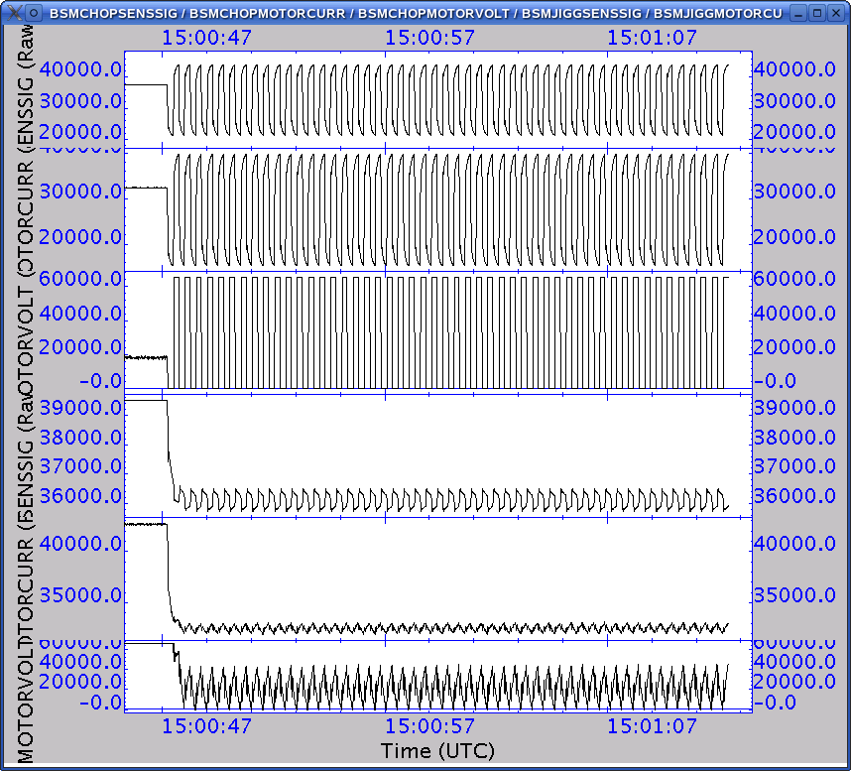

Note: Although both sensor signals show clear signs of not correct PID settings and the jiggle motor current is very irregular the purpose of this test is to prove that we can operate the BSM in its nominal operational mode PID chopping.

Step# | Action | Comments
4 | Execute BSM_OFF from HCSS Test Procedures | Switched OFF the BSM @ 15:08  Obsid: 0x30011AA1

Manually set the MODE HK parameter to REDY: SET_OBS_MODE(0x200)

FUNC-SMEC-03
Test Id: | FUNC-SMEC-03
Initial Configuration: | DRCU_ON + AC/DC thermometry ON +MCU ON+ SMEC ON (open loop)
Final Configuration: | DRCU_ON + AC/DC thermometry ON +MCU ON+ SMEC ON (open loop)
Success Criteria: | Test passed if:  SMEC encoder signals 1 and 2 show a variation on their amplitudes from one LED illumination level to another.

Test Procedure:
Step# | Action | Comments
1 | On QLA bring up a time series display of the following Nominal HK parameters:  SMECENCSIGAMP1  SMECENCSIGAMP2
2 | Run FUNC-SMEC-03 test procedure from the HCSS Test Procedure window on TOPE
3 | Contingency:  If test fails repeat steps 1 and 2.

Test Log:
Test Id | Key Parameter(s) | Expected Value Before/After | Actual Value  Before/After | Nb. of frames received | Test Result
FUNC-SMEC-03 | SMECENCSIG1  SMECENCSIG2 |  |  |  | Success
Start time @: 15:12
End time @: 15:13
OBSID: 0x30011AA2

Comments:
Using input parameters:
Start level = 3
End level = 6
Step level = 1
5 seconds at each
Also plotted SMECENCPWR.
The level of the encoder signals 1 and 2 changed as the level of the power changed staying in range throughout the sequence.

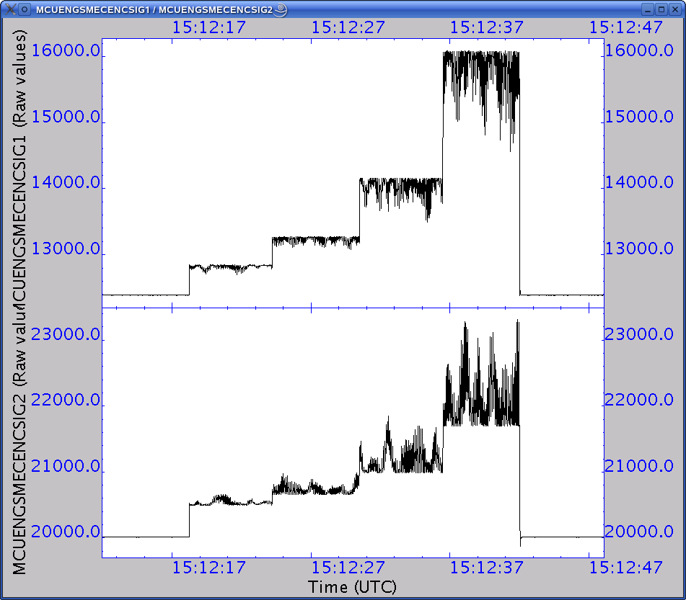

Note: Procedure should be change to plot the QLA MCU ENG frames rather than the HK values which have a much lower resolution.

FUNC-SMEC-01
Test Id: | FUNC-SMEC-01
Initial Configuration: | DRCU_ON + AC/DC thermometry ON +MCU ON+ SMEC ON (open loop)
Final Configuration: | DRCU_ON + AC/DC thermometry ON +MCU ON+ SMEC ON (open loop)
Success Criteria: | Test passed if :  - SMECENCPWR HK parameter changes from 0 to 6.  - SMEC encoder signals 1 and 2 amplitude show variation when encoder is switched ON.  - SMEC LVDT is switched ON.  - SMEC LVDT DC and AC signals show variation when LVDT is switched ON.

Test Procedure:

Step# | Action | Comments
0 | Open SMEC PARAMETERS display on SCOS Alpha Numeric Displays.
1 | On QLA bring up a display of the following HK parameters:  SMECENCPWR  SMECENCSIG1AMP  SMECENCSIG2AMP  SMECLVDTDCSIG  SMECLVDTACSIG
2 | Run FUNC-SMEC-01 test procedure from the HCSS Test Procedure window on TOPE
Contingency:
If test fails repeat steps 1.

Test Log:
Test Id | Key Parameter(s) | Expected Value Before/  After | Actual Value  Before/After | Nb. of frames received | Test Result
FUNC-SMEC-01 | SMECENCPWR  SMECLVDTPWR  SMECENCSIG1  SMECENCSIG1AMP  SMECENCSIG1OFF  SMECENCSIG2  SMECENCSIG2AMP  SMECENCSIG2OFF |  | 0/6  0/1  not relevant/ ~ 0x3C00  0xCE20/0xDEA8  not relevant/~0x5400  0xCE20/0xAFC8 | N/A
Start time @: 15:17
End time @: 15:18
OBSID: 0x30011AA2
Comments:
Procedure still asks from encoder signal amplitudes when it should only ask for encoder signals

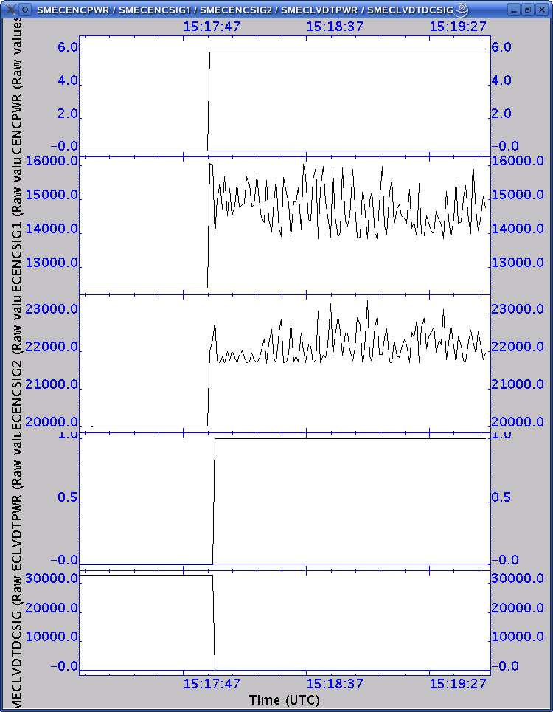

FUNC-SMEC-04a
Test Id: | FUNC-SMEC-04a
Initial Configuration: | DRCU_ON + AC/DC thermometry ON+MCU ON+ SMEC ON (open loop) UNLATCHED
Final Configuration: | DRCU_ON + AC/DC thermometry ON+MCU ON+ SMEC ON (open loop) UNLATCHED
Success Criteria: | Test passed if only the SMECMOTORCURR shows a variation meaning that the mechanism has not moved.

Test Procedure:
Step# | Action | Comments
1 | On QLA bring up a time series display of the following Nominal HK parameters:  SMECENCSIG1  SMECENCSIG2  SMECLVDTDCSIG  SMECLVDTACSIG  SMECMOTORCURR
2 | Run FUNC-SMEC-04a test procedure from the HCSS Test Procedure window on TOPE
3 | Contingency:  If test fails repeat steps 1.

Test Log:
Test Id | Key Parameter(s) | Expected Value Before/After | Actual Value  Before/After | Nb. of frames received | Test Result
FUNC-SMEC-04a | SMECLVDTDCSIG |  | 13A4/
Start time @: 15:30
End time @: 15:33
OBSID:0x30011AA3
Comments:
Used the following input parameters to the TOPE script:
Scan Start = 1000 um
Scan End = 15000 um
Scan Step = 1000 um
Scan F speed = 500 um/s
Scan R speed = 1000 um/s
Time at each position = 5 s
The test procedure specifies HK parameters should be displayed when the SMEC science parameters are needed.

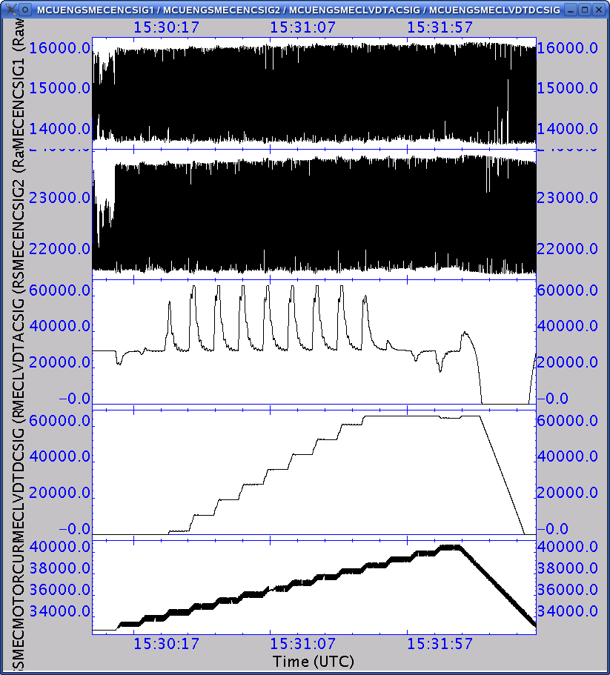

FUNC-SMEC-02A/B
Test Id: | FUNC-SMEC-02A/B
Initial Configuration: | DRCU_ON + AC/DC thermometry ON +MCU ON + SMEC ON  If WFT prior to cooldown : Smec Latched  If WFT after warm up : Smec Unlatched
Final Configuration: | DRCU_ON + AC/DC thermometry ON +MCU ON + SMEC ON  If WFT prior to cooldown : Smec Unlatched  If WFT after warm up : Smec Latched
Success Criteria: | Test passed if :  Prior to un-latching the resistance across pins 7 and 8 of the launch latch is ~ 368 Ohms. After un-latching the resistance is 483 Ohms.  Note: These resistance values were recorded for the CQM SMEC model, for the flight SMEC, these values are expected to vary.

Step# | Action | Comments
1 | Measure the resistance across pins 7 and 8 of the launch latch. | This step is not applicable anymore
2 | If WFT prior to cooldown:  Run FUNC-SMEC-02A test procedure from the HCSS Test Procedure window on TOPE  If WFT after warm up:  Run FUNC-SMEC-02B test procedure from the HCSS Test Procedure window on TOPE
3 | Measure the resistance across pins 7 and 8 of the launch latch.
4 | Contingency:  If test fails repeat steps 1.

Test Id | Key Parameter(s) | Expected Value Before/After | Actual Value  Before/After | Nb. of frames received | Test Result
FUNC-SMEC-02A/B |  |  |  | N/A | Passed
Start time:
End time :
OBSID:
Test not performed as the SMEC is already unlatched and will be left unlatched for the cooldown.

FUNC-SMEC-09
Test Id: | FUNC-SMEC-09
Test Purpose: | SMEC Open Loop Scan Test.
Initial Configuration: | DRCU_ON + AC/DC thermometry ON+MCU ON+ SMEC ON (open loop)
Final Configuration: | DRCU_ON + AC/DC thermometry ON+MCU ON+ SMEC ON (open loop)
Success Criteria: | Test passed if SMECLVDTDCSIG parameter shows a variation according to the different position of the SMEC along the scan.

Test Procedure:
Step# | Action
1 | On QLA bring up a time series display of the following SMEC nominal science parameters:  SMECENCSIG1  SMECENCSIG2  SMECLVDTDCSIG  SMECLVDTACSIG  SMECMOTORCURR
2 | Run FUNC-SMEC-09 test procedure from the HCSS Test Procedure window on TOPE
3 | Contingency:  If test fails repeat steps 1.

Test Log:
Test Id | Key Parameter(s) | Expected Value Before/After | Actual Value  Before/After | No. of frames received | Test Result
FUNC-SMEC-09 | All above mentioned in step 2 | N/A | N/A | N/A | Success
Start time @: 16:08
End time @: 16;20
OBSID: 0x30011AA5
Comments:

ALL SMEC FUNCTIONAL TESTS PRODUCE ENGINEERING FRAMES NOT SMEC SCIENCE AND THIS SHOULD BE NOTED IN THE PROCEDURES

Manually set the encoder signal 1/2 offsets to :
SMECEMCSIGOFF1 = 14500 (0x38A4)
SMECEMCSIGOFF2 = 22500 (0x57E4)
as the SMEC_ON script still does not incorporate a PRIME/REDUNDANT switch

Start point = 1 mm,
End point = 38 mm
Forward speed = 0.5 mm/s
Reverse speed = 0.5 mm/s
Number of scan = 4

Encoder not counting

Reset manually
SMECEMCSIGOFF1 = 15000
SMECEMCSIGOFF2 = 23000

Repeated SCAN: OBSID: 0x30011AA6

Start point = 1 mm,
End point = 15 mm
Forward speed = 0.2 mm/s
Reverse speed = 0.2 mm/s
Number of scan = 2

Encoder now counting

See next test for a comparison with the open to close loop performance

Step# | Action | Comments
0 | Execute SMEC_INIT from HCSS Test Procedures | Obsid: 0x30011AA7

FUNC-SMEC-07
Test Id: | FUNC-SMEC-07
Test Purpose: | SMEC Close Loop Scan Test.
Initial Configuration: | DRCU_ON + AC/DC thermometry ON+MCU ON+ SMEC ON (close loop)
Final Configuration: | DRCU_ON + AC/DC thermometry ON+MCU ON+ SMEC ON (close loop)
Success Criteria: | Test passed if:  SMECENCPOS HK parameter shows identical values as those of the SMECTRAJPOSN HK parameter during the scan.

Test Procedure:
Step# | Action
1 | On QLA bring up a time series display of the following SMEC nominal science parameters:  SMECENCSIG1  SMECENCSIG2  SMECLVDTDCSIG  SMECLVDTACSIG  SMECMOTORCURR
2 | Run FUNC-SMEC-07 test procedure from the HCSS Test Procedure window on TOPE
3 | Contingency:  If test fails repeat steps 1.

Test Log:
Test Id | Key Parameter(s) | Expected Value Before/After | Actual Value  Before/After | No. of frames received | Test Result
FUNC-SMEC-07 | All above mentioned in step 1 | N/A | N/A | N/A | Success
Start time @: 16:26
End time @: 16:30
OBSID: 0x30011AA8
Comments:

Start point = 1 mm,
End point = 15 mm
Forward speed = 0.2 mm/s
Reverse speed = 0.2 mm/s
Number of scan = 2

The loop remained closed through out the scan but note the much larger scatter on the SMEC motor current during the close loop scan which most probably indicates a wrong set of PID parameters for redundant SMEC warm operation. Nevertheless this test proves that the redundant SMEC CAN be operated in close loop.

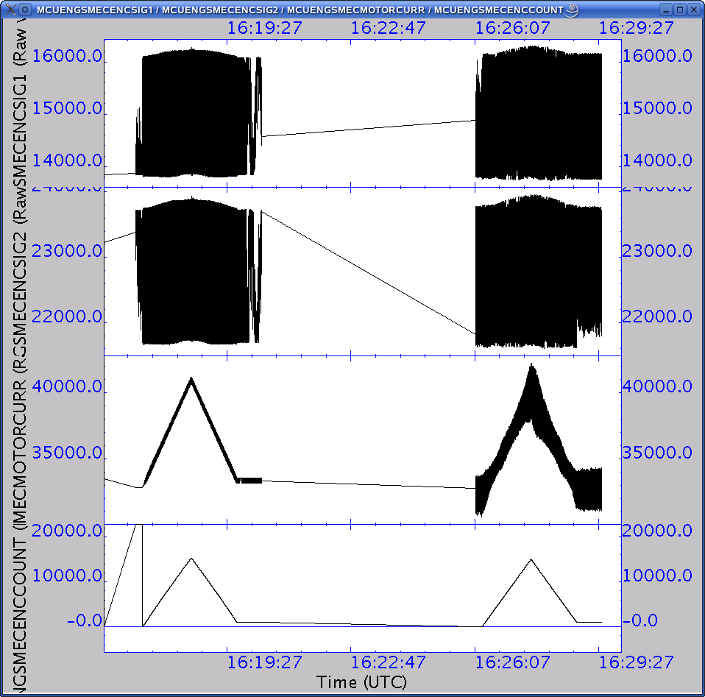

FUNC-SMEC-04B
Test Id: | FUNC-SMEC-04B
Test Purpose: | SMEC Close Loop Position Test. SMEC close loop operation check.
Initial Configuration: | DRCU_ON + AC/DC thermometry ON+MCU ON+ SMEC ON (open loop)
Final Configuration: | DRCU_ON + AC/DC thermometry ON+MCU ON+ SMEC ON (open loop)
Success Criteria: | Test passed if :  SMECENCPOS HK parameter shows identical values as those of the SMECTRAJPOSN HK parameter for the different commanded SMEC positions.( 1mm to 25mm in steps of 1mm)

Test Procedure:
Step# | Action
1 | On QLA bring up 2 time series displays:  Display 1 of the following MCU Engineering block parameters:  MCUENGSMECENCSIG1  MCUENGSMECENCSIG2  MCUENGSMECLVDTDCSIG  MCUENGSMECLVDTACSIG  MCUENGSMECMOTORCURR  Display 1 of the following SMEC HK parameters:  SMECENCPOSN  SMECTRAJPOSN
2 | Run FUNC-SMEC-04B test procedure from the HCSS Test Procedure window on TOPE
3 | Contingency:  If test fails repeat steps 1.

Test Log:
Test Id | Key Parameter(s) | Expected Value Before/After | Actual Value  Before/After | No. of frames received | Test Result
FUNC-SMEC-04B | All above mentioned in step 1 | N/A | N/A | N/A | Not done
Start time @: 16:37
End time @: 16:41
OBSID: 0x30011AA9
Comments:

Start point = 1 mm
End point = 15 mm
Steps = 1 mm
Forward speed = 0.5 mm/s
Reverse speed = 1.0 mm/s

Step# | Action | Comments
4 | Execute SMEC_OFF from HCSS Test Procedures | Done at 16:49; Obsid:0x30011AAA

Step# | Action | Comments
0 | Open DCU PARAMETERS SCOS Alpha Numeric Display

FUNC-DCU-01
Test Id: | FUNC-DCU-01
Initial Configuration: | DRCU_ON + AC/DC thermometry ON+MCU ON
Final Configuration: | DRCU_ON + AC/DC thermometry ON+MCU ON
Success Criteria: | Test passed if:  - DCU produces each type of DCU nominal science frame with the following characteristics.  - The frame time difference between consecutive DCU frames of each type corresponds to the sampling rate.  Photometer Sampling rate is 15.3Hz → Δt ~ 65.5 ms  Spectrometer Sampling rate is 80Hz → Δt = 12.5 ms  - The SPIRE HK parameter DCUFRAMECNT increments by 700.  - No events are generated during the frames generation.
  APID | Type | S.type | SID | Frame  ID | Frame type | Nb. Of frames | Nb. of pkts.
  0x505 | 21 | 1 | 0x200 | 0 | PF | 100 | 100
  0x507 | 21 | 1 | 0x201 | 1 | SF | 100 | 17
  0x505 | 21 | 2 | 0x102 | 2 | PSW | 100 | 34
  0x505 | 21 | 2 | 0x103 | 3 | PMW | 100 | 25
  0x505 | 21 | 2 | 0x104 | 4 | PLW | 100 | 12
  0x507 | 21 | 2 | 0x105 | 5 | SSW | 100 | 12
  0x507 | 21 | 2 | 0x106 | 6 | SLW | 100 | 7

Test Procedure:
Step# | Action | Comments
1 | Write the current value of DCUFRAMECNT located d in DCU PARAMETERS AND
2 | Run FUNC-DCU-01 test procedure from the HCSS Test Procedure window on TOPE
3 | Write the current value of DCUFRAMECNT located d in DCU PARAMETERS AND
4 | Contingency:  If test fails repeat steps 1 to 3.

Test Log:
Test Id | Key Parameter(s) | Expected Value Before/After | Actual Value  Before/After | Nb. of frames received | Test Result
FUNC-DCU-01 | DCUFRAMECNT | n/n+700  n depends on the BSM chop operations on FUNC-BSM-06 | 0 / 700 | 700
Start time @: 29/01/2007 - 14:19
End time @: 29/01/2007 - 14:22

OBSID: 0x30011AB9

Comments: Test run out of sequence

Ran TOPE script with default values

QLA created file QLA-DCU-01_30011AB9.txt:

*************************************************************************
PHOTF: OBSID = 30011AB9, BBTYPE = 0x8800, APID = 0x505, SID = 0x200
_________________________________________________________________________
Parameter Initial Final Increment Expect Incre. Packet Chars.

DCUFRAMECNT 0 100 100 100 Packet type = 0x15
TM3N 16383 99 49251 100 subtype = 0x1
FrameTime 53.7568 53.7568 Frame ID = 0x0
Frame Len = 0x126
STATISTICS ON TIME BETWEEN RECEPTION OF 2 CONSECUTIVE FRAMES:
mean = 53.75887 ms
sigma = 0.00154 ms

*************************************************************************
PHOTSW: OBSID = 30011AB9, BBTYPE = 0x8802, APID = 0x505, SID = 0x102
_________________________________________________________________________
Parameter Initial Final Increment Expect Incre. Packet Chars.

DCUFRAMECNT 100 200 100 100 Packet type = 0x15
TM3N 99 133 34 34 subtype = 0x2
FrameTime 53.7568 53.7600 Frame ID = 0x2
Frame Len = 0x96
STATISTICS ON TIME BETWEEN RECEPTION OF 2 CONSECUTIVE FRAMES:
mean = 53.75890 ms
sigma = 0.00154 ms

*************************************************************************
PHOTMW: OBSID = 30011AB9, BBTYPE = 0x8803, APID = 0x505, SID = 0x103
_________________________________________________________________________
Parameter Initial Final Increment Expect Incre. Packet Chars.

DCUFRAMECNT 200 300 100 100 Packet type = 0x15
TM3N 133 158 25 25 subtype = 0x2
FrameTime 53.7600 53.7600 Frame ID = 0x3
Frame Len = 0x66
STATISTICS ON TIME BETWEEN RECEPTION OF 2 CONSECUTIVE FRAMES:
mean = 53.75890 ms
sigma = 0.00152 ms

*************************************************************************
PHOTLW: OBSID = 30011AB9, BBTYPE = 0x8804, APID = 0x505, SID = 0x104
_________________________________________________________________________
Parameter Initial Final Increment Expect Incre. Packet Chars.

DCUFRAMECNT 300 400 100 100 Packet type = 0x15
TM3N 158 170 12 12 subtype = 0x2
FrameTime 53.7600 53.7600 Frame ID = 0x4
Frame Len = 0x36
STATISTICS ON TIME BETWEEN RECEPTION OF 2 CONSECUTIVE FRAMES:
mean = 53.75890 ms
sigma = 0.00152 ms

*************************************************************************
SPECF: OBSID = 30011AB9, BBTYPE = 0x8801, APID = 0x507, SID = 0x201
_________________________________________________________________________
Parameter Initial Final Increment Expect Incre. Packet Chars.

DCUFRAMECNT 400 500 100 100 Packet type = 0x15
TM4N 16383 16 49168 17 subtype = 0x1
FrameTime 12.4928 12.4928 Frame ID = 0x1
Frame Len = 0x4E
STATISTICS ON TIME BETWEEN RECEPTION OF 2 CONSECUTIVE FRAMES:
mean = 12.49254 ms
sigma = 0.00089 ms

*************************************************************************
SPECSW: OBSID = 30011AB9, BBTYPE = 0x8805, APID = 0x507, SID = 0x105
_________________________________________________________________________
Parameter Initial Final Increment Expect Incre. Packet Chars.

DCUFRAMECNT 500 600 100 100 Packet type = 0x15
TM4N 16 28 12 12 subtype = 0x2
FrameTime 12.4928 12.4896 Frame ID = 0x5
Frame Len = 0x36
STATISTICS ON TIME BETWEEN RECEPTION OF 2 CONSECUTIVE FRAMES:
mean = 12.49254 ms
sigma = 0.00089 ms

*************************************************************************
SPECLW: OBSID = 30011AB9, BBTYPE = 0x8806, APID = 0x507, SID = 0x106
_________________________________________________________________________
Parameter Initial Final Increment Expect Incre. Packet Chars.

DCUFRAMECNT 600 700 100 100 Packet type = 0x15
TM4N 28 35 7 7 subtype = 0x2
FrameTime 12.4928 12.4928 Frame ID = 0x6
Frame Len = 0x1E
STATISTICS ON TIME BETWEEN RECEPTION OF 2 CONSECUTIVE FRAMES:
mean = 12.49254 ms
sigma = 0.00088 ms

FUNC-DCU-02
Test Id: | FUNC-DCU-02
Initial Configuration: | DRCU_ON + AC/DC thermometry ON+MCU ON
Final Configuration: | DRCU_ON + AC/DC thermometry ON+MCU ON
Success Criteria: | Test passed if DCUFRAMECNT goes from 700 to 1400 and the frametime difference between consecutive frames computed by QLA script is in agreement with the expected differences based on commanded sampling rate:  - Photometer Sampling rate is 15.3Hz → Δt ~ 65.5 ms  - Spectrometer Sampling rate is 80Hz → Δt = 12.5 ms

Test Procedure:
Step# | Action | Comments
1 | Write the current value of DCUFRAMECNT located d in DCU PARAMETERS AND
2 | Run QLA script FUNC-DCU-02.py on QLA console.
3 | Run FUNC-DCU-02 test procedure from the HCSS Test Procedure window on TOPE
4 | Write the current value of DCUFRAMECNT located d in DCU PARAMETERS AND
5 | Contingency:  If test fails repeat steps 1 to 4.

Test Log:
Test Id | Key Parameter(s) | Expected Value Before/After | Actual Value  Before/After | Nb. of frames received | Test Result
FUNC-DCU-02 | DCUFRAMECNT | m/m+1400 | 700 / 1400 | 700 | Success
Start time @: 29/01/2007 - 14:26
End time @: 29/01/2007 - 14:29
OBSID: 0x30011ABA

Comments: Test run out of sequence

Contents of QLA created files show sampling times to be consistent with input parameters entered for sampling frequencies of photometer 18Hz (Δt ~ 53.3 ms) and spectrometer 80Hz Δt ~ 12.5 ms.

FUNC-DCU-03

Test Id: | FUNC-DCU-03
Initial Configuration: | DRCU_ON + AC/DC thermometry ON+MCU ON
Final Configuration: | DRCU_ON + AC/DC thermometry ON+MCU ON
Success Criteria: | Test passed if :  - DCU produces 100 frames of Full Photometer Test Pattern and 100 frame of Full Spectrometer Test Pattern test.  - QLA analysis shows that phot/spec test patterns are the same as the reference phot/spec test patterns.

Test Procedure:
Step# | Action | Comments
1 | Write the current value of DCUFRAMECNT located d in DCU PARAMETERS AND
2 | Run QLA script FUNC-DCU-03.py on QLA console.
3 | Run FUNC-DCU-03 test procedure from the HCSS Test Procedure window on TOPE
4 | Write the current value of DCUFRAMECNT located d in DCU PARAMETERS AND
5 | Contingency:  If test fails repeat steps 1 to 4.

Test Log:
Test Id | Key Parameter(s) | Expected Value Before/After | Actual Value  Before/After | Nb. of frames received | Test Result
FUNC-DCU-03 | DCUFRAMECNT | j/j+200 | 1400 / 1600 | 200
Start time @: 29/01/2007 - 14:29
End time @: 29/01/2007 - 14:32
OBSID: 0x30011ABB

Comments: Test run out of sequence

Files produced by QLA:
QLA-DCU-03_30011ABB_8807.txt
QLA-DCU-03_30011ABB_8808.txt
Test pattern files show agreement with reference DCU test pattern files from OBSID 0x30011A6A (25/01/2007).

FUNC-DCU-04P
Test Id: | FUNC-DCU-04P
Initial Configuration: | DRCU_ON + AC/DC thermometry ON+MCU ON
Final Configuration: | DRCU_ON + AC/DC thermometry ON+MCU ON + Photometer LIAs ON
Success Criteria: | Test passed if :  - SCUDCDCSTAT parameter goes from 4 to 5.  - Photometer LIA card voltages are showing correct readings of +5V,+9V,-9V.  - Photometer LIA temperatures show an increase indicating that they are ON.

Test Procedure:
Step# | Action | Comments
1 | On QLA bring up a time series display of the HK parameters:  PLIAP5V  PLIAP9V  PLIAM9V  LIAP1/2/3/4/5/6/7/8/9TEMP
2 | Run FUNC-DCU-04P test procedure from the HCSS Test Procedure window on TOPE
5 | Contingency:  If test fails repeat steps 1 and 2.

Test Log:
Test Id | Key Parameter(s) | Expected Value Before/After | Actual Value  Before/After | Nb. of frames received | Test Result
FUNC-DCU-04-P | SCUDCDCSTAT  PLIAP5V  PLIAP9V  PLIAM9V  LIAP1TEMP to LIAP9TEMP | 4/5  0/~ +5V  0/~+11V  0/~-11V  N/A/ [290-300]K | 4/5  0/+5.18V  0/+11.53V  0/-11.53V  ~294/warming up |  | Success
Start time @: 16:53
End time @: 16:54
OBSID: 0x30011AAB
Comments:
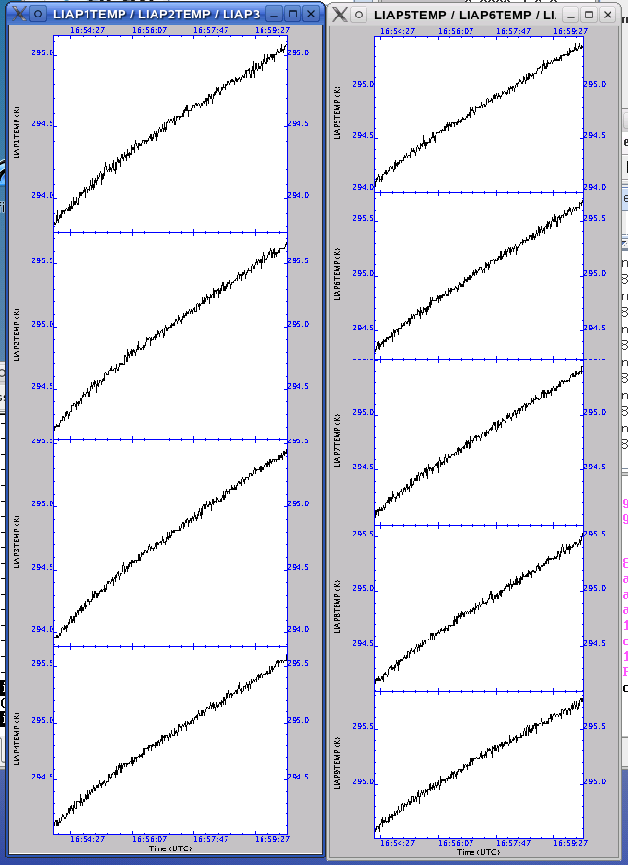

FUNC-DCU-11P
Test Id: | FUNC-DCU-11P
Initial Configuration: | DRCU_ON + AC/DC thermometry ON+MCU ON+ Photometer LIAs ON
Final Configuration: | DRCU_ON + AC/DC thermometry ON+MCU ON+ Photometer LIAs ON + Photometer BIAS ON +Photometer JFETs ON
Success Criteria: | Test passed if Photometer JFET source and drain voltages are correct:  - PSWJFETVSS1/2/3/4/5/6 (RAW: 0x4C CONVERTED ~ -1.5V).  - PMLWJFETVSS1/2/3/4 (RAW: 0x4C CONVERTED ~ -1.5V).  - PSWJFETSTAT = 0x3F  - PMLWJFETSTAT = 0x1F

Test Procedure:
Step# | Action | Comments
1 | Run FUNC-DCU-11P test procedure from the HCSS Test Procedure window on TOPE
2 | After the test Write the values RAW and converted values of:  PSWJFETSTAT,PMLWJFETSTAT,  PSWJFET1/2/3/4/5/6V  PMWJFET1/2/3/4V  PLWJFET1/2V  located in DCU PARAMETERS AND
3 | Contingency:  If test fails repeat steps 1 and 2.

Test Log:
Test Id | Key Parameter(s) | Expected Value Before/After | Actual Value  Before/After | Nb. of frames received | Test Result
FUNC-DCU-11P | PSWJFETSTAT  PMLWJFETSTAT  PSWJFET1/2/3/4/5/6V  PMWJFET1/2/3/4V  PLWJFET1/2V | 0/0x3f  0/0x7f  0V/-1.5V  0V/-1.5V  0V/-1.5V | 0/0x03f  0/0x07f  See comments | N/A | Success
Start time @: 17:05
End time @: 17: 06
OBSID: 0x30011AAC

Comments:

The Vss values for the JFETs were the same as for the PFM4 cold test campaign, i.e.

PSWJFET1V: -1.68V
PSWJFET2V: -1.59V
PSWJFET3V: -1.37V
PSWJFET4V: -1.59V
PSWJFET5V: -1.78V
PSWJFET6V: -1.59V

PMWJFET1V: -1.68V
PMWJFET2V: -1.59V
PMWJFET3V: -1.59V
PMWJFET4V: -1.88V

PLWJFET1V: -1.59V
PLWJFET2V: -1.37V

PSW:

G8 and C12 have a relatively higher output (~ 45000 ADUs against ~ 16500) than the rest
G13 appears to be dead (no signal before or after, only during the JFET switch on did it show a spike).

PMW:

D7, C8 , DP1 , T2 are flat at 0 ADUs

PLW:

All good

FUNC-DCU-13P
Test Id: | FUNC-DCU-13P
Initial Configuration: | DRCU_ON + AC/DC thermometry ON+MCU ON+ Photometer LIAs ON + Photometer BIAS ON +Photometer JFETs ON
Final Configuration: | DRCU_ON + AC/DC thermometry ON+MCU ON+ Photometer LIAs ON + Photometer BIAS ON +Photometer JFETs ON
Success Criteria: | Test passed if :  The photometer detectors show a small linear variation on the output voltage when different bias is applied through the load curve.

Test Procedure:
Step# | Action | Comments
1 | On QLA bring up a time series display of a couple of pixels on each of the photometer BDAs
2 | Run FUNC-DCU-13P test procedure from the HCSS Test Procedure window on TOPE
3 | Contingency:  If test fails repeat step 1 and 2.

Test Log:
Test Id | Key Parameter(s) | Expected Value Before/After | Actual Value  Before/After | Nb. of frames received | Test Result
FUNC-DCU-13P |  |  |  | N/A | Success
Start time @: 17: 12
End time @: 17: 24
OBSID: 0x30011AAD
Comments:
Parameter for LC:
Array: PF
Bias frequency: 130 Hz
Sampling frequency: 18 Hz
PSW phase: 180.71 deg
PMW phase: 180.71 deg
PLW phase: 180.71 deg
Time at each level: 5 s

See Annex 2 for detailed plots for each pixel

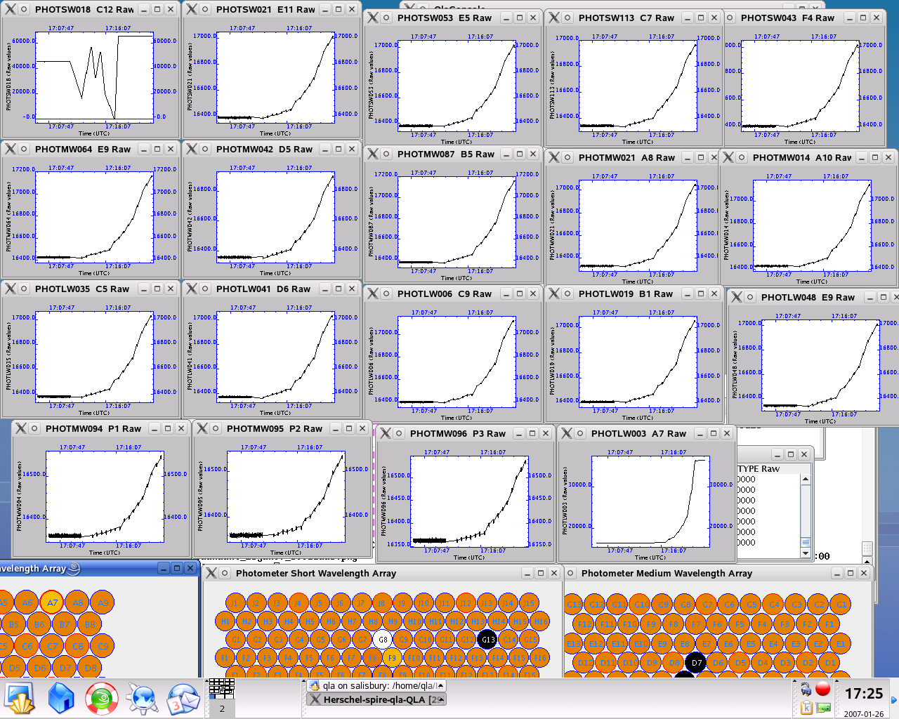

ILT_PERF_DNA_P
Test Id:
Initial Configuration: | DRCU_ON + AC/DC thermometry ON+MCU ON + Photometer LIAs ON + Photometer BIAS ON + Photometer JFETs ON
Final Configuration: | DRCU_ON + AC/DC thermometry ON+MCU ON + Photometer LIAs ON + Photometer BIAS ON + Photometer JFETs ON
Success Criteria: | Test passed if :  The Photometer detectors don’t show excess noise.

Test Procedure:
Step# | Action | Comments
1 | Run ILT-PERF-DAN-P test procedure from the HCSS Test Procedure window on TOPE
2 | Contingency:  If test fails repeat step 1.

Test Log:
Test Id | Key Parameter(s) | Expected Value Before/After | Actual Value  Before/After | Nb. of frames received | Test Result
ILT_PERF_DNA_P |  |  |  | N/A
Start time @: 17: 30
End time @: 17: 35
OBSID: 0x30011AAE

Comments:

Detectors settings:
Bias frequency: 130 Hz
Sampling frequency: 18 Hz
PSW phase: 180.71 deg
PMW phase: 180.71 deg
PLW phase: 180.71 deg
PSW bias : ~ 31mV
PMW bias : ~ 31mV
PLW bias : ~ 31mV
TC bias : ~ 62 mV

Duration of test: 5 minutes

Step# | Action | Comments
1 | From TOPE HCSS Test Procedures run PDET-OFF | Executed @ 17:36  OBSID 0x30011AAF

FUNC-DCU-04S
Test Id: | FUNC-DCU-04S
Initial Configuration: | DRCU_ON + AC/DC thermometry ON+MCU ON
Final Configuration: | DRCU_ON + AC/DC thermometry ON+MCU ON + Spectrometer LIAs ON
Success Criteria: | Test passed if :  - SCUDCDCSTAT parameter goes from 4 to 6.  - Spectrometer LIA card voltages are showing correct readings of +5V,+9V,-9V.  - Spectrometer LIA temperatures show an increase indicating that they are ON.

Test Procedure:
Step# | Action | Comments
1 | On QLA bring up a time series display of the HK parameters:  SLIAP5V  SLIAP9V  SLIAM9V  LIAS1/2/3TEMP
2 | Run FUNC-DCU-04S test procedure from the HCSS Test Procedure window on TOPE
5 | Contingency:  If test fails repeat steps 1 and 2.

Test Log:
Test Id | Key Parameter(s) | Expected Value Before/After | Actual Value  Before/After | Nb. of frames received | Test Result
FUNC-DCU-04S | SCUDCDCSTAT  SLIAP5V  SLIAP9V  SLIAM9V  LIA1/2/3TEMP | 4/6  0/~ +5V  0/~+11V  0/~-11V  N/A/ [290-300]K | 4/6  0.17 / 5.23  0.003/ 11.57  0.003/-11.55  /~295Kwarming up |  | Success
Start time @: 17:43
End time @: 17:44
OBSID: 0x30011AB0
Comments:
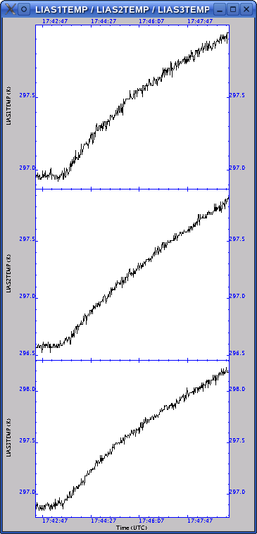

Spectrometer LIAs switched ON correctly

FUNC-DCU-11S
Test Id: | FUNC-DCU-11S
Initial Configuration: | DRCU_ON + AC/DC thermometry ON+MCU ON + Spectrometer LIAs ON
Final Configuration: | DRCU_ON + AC/DC thermometry ON+MCU ON + Spectrometer LIAs ON + Spectrometer BIAS ON + Spectrometer JFETs ON
Success Criteria: | Test passed if SCUDCDCSTAT goes from 4 to 6, Spectrometer LIAs voltages are correct and SJFET voltages are also correct.

Test Procedure:
Step# | Action | Comments
1 | Run FUNC-DCU-11S test procedure from the HCSS Test Procedure window on TOPE
2 | After the test Write the values RAW and converted values of:  LIASTAT  SLIAP5V, SLIAP9V, SLIAN9V,  SSWJFETSTAT,SLWJFETSTAT,  SSWJFET1V,SLWJFET2V  located in DCU PARAMETERS AND
3 | Contingency:  If test fails repeat steps 1 and 2.

Test Log:
Test Id | Key Parameter(s) | Expected Value Before/After | Actual Value  Before/After | Nb. of frames received | Test Result
FUNC-DCU-11S | SCUDCDCSTAT  LIASTAT  SLIAP5V  SLIAP9V  SLIAM9V  SPECJFETSTAT  SSWJFET1/2V  SLWJFET1/2V | 6/6  0/0  0V/ ~ 5V  0V/~11V  0V/-11V  0/7  0V/-1.5V  0V/-1.5V | 6/6  0/0  /5.23  /11.57  /-11.55  0/0x7  See comments below | N/A | Success
Start time @: 17:51
End time @: 17:52
OBSID: 0x30011AB1

Comments:
The Vss values for the JFETs were the same as for the PFM4 cold test campaign, i.e.
SSWJFET1V: -2.07V
SSWJFET2V: -1.59V
SLWJFET1V: -1.68V

SSW:
D7 shows a higher output ( ~ 35000 ADUs against ~ 16500 ADUs) then the rest of the array.
SLW:
DP1, DP2 not responsive after switch on, they jump to zero. T2 remains at zero.
C2, C4 and B3 showing previous (PFM4) anomalous behaviour. C4 behaviour corrected itself during cooldown.

FUNC-DCU-13S
Test Id: | FUNC-DCU-13S
Initial Configuration: | DRCU_ON + AC/DC thermometry ON+MCU ON + Spectrometer LIAs ON + Spectrometer BIAS ON + Spectrometer JFETs ON
Final Configuration: | DRCU_ON + AC/DC thermometry ON+MCU ON + Spectrometer LIAs ON + Spectrometer BIAS ON + Spectrometer JFETs ON
Success Criteria: | Test passed if :  The spectrometer detectors show a small linear variation on the output voltage when different bias is applied through the load curve.

Test Procedure:
Step# | Action | Comments
1 | Run FUNC-DCU-13S test procedure from the HCSS Test Procedure window on TOPE
2 | Contingency:  If test fails repeat step 1.

Test Log:
Test Id | Key Parameter(s) | Expected Value Before/After | Actual Value  Before/After | Nb. of frames received | Test Result
FUNC-DCU-13S |  |  |  | N/A | Success
Start time @: 17:56
End time @: 18:10
OBSID: 0x30011AB2

Comments:
Array: SF
Bias frequency: 160 Hz
Sampling frequency: 80 Hz
SSW phase shift: 180.71deg
SLW phase shift: 179.295 deg
Time at each level: 5 s

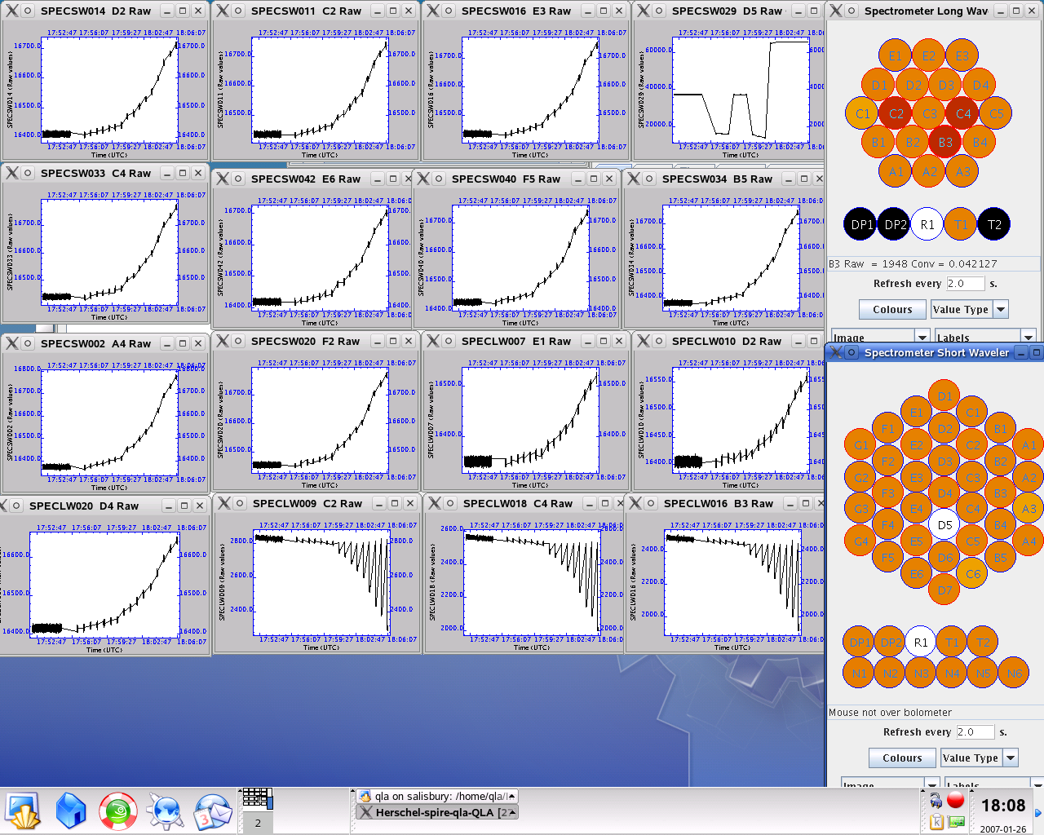

SSW D5 shows different behaviour than the rest of the pixels as in PFM4.
Generally all (SSW/SLW) pixels looking responsive (TBC) except SSW C2,C4,B3 (the three bottom last ones).

See Annex 2 for detailed plots for every pixel.

ILT_PERF_DNA_S
Test Id: | FUNC-DCU-13S
Initial Configuration: | DRCU_ON + AC/DC thermometry ON+MCU ON + Spectrometer LIAs ON + Spectrometer BIAS ON + Spectrometer JFETs ON
Final Configuration: | DRCU_ON + AC/DC thermometry ON+MCU ON + Spectrometer LIAs ON + Spectrometer BIAS ON + Spectrometer JFETs ON
Success Criteria: | Test passed if :  The spectrometer detectors show a signal with some noise.

Test Procedure:
Step# | Action | Comments
1 | Run FUNC-DCU-13S test procedure from the HCSS Test Procedure window on TOPE
2 | Contingency:  If test fails repeat step 1.

Test Log:
Test Id |  | Key Parameter(s) | Expected Value Before/After |  | Actual Value  Before/After | Nb. of frames received | Test Result
ILT_PERF_DNA_S |  |  |  |  |  | N/A
Start time @: 18:11
End time @: 18:16
OBSID: 0x30011AB3

Comments:
Test run in order to collect noise data at nominal spectrometer settings:
Array: SF
Bias frequency: 160 Hz
Sampling frequency: 80 Hz
SSW phase shift: 180.71deg
SLW phase shift: 179.29 deg

Duration of test: 5 minutes

QLA script needed to report the RMS values for all Spectrometer detectors.

Step# | Action |  |  | Comments
1 | From TOPE HCSS Test Procedures run SDET_OFF |  |  | 18:45  OBSID 0x30011A74

SWITCH OFF sequence:

Execute MCU_OFF
Execute DRCU_OFF

Power OFF DRCU
Power OFF DPU

Annexe1 (Instrument nominal configuration/modes)

 | OFF | INIT | DPU_ON | DRCU_ON | REDY | PHOT STBY | SPEC STBY | CREC | SAFE
DPU |  | ON | ON | ON | ON | ON | ON | ON | ON
Essential Hsk packets |  |  | 0.5Hz | 0.5Hz | 0.5Hz | 0.5Hz | 0.5Hz | 0.5Hz | 0.5Hz
Normal Hsk packets |  |  | 1.0Hz | 1.0Hz | 0.25Hz | 0.25Hz | 0.25Hz | 1.0Hz | 0.25Hz
TC Acceptance |  | TBC | Yes | Yes | Yes | Yes | Yes | Yes | Yes
Event packets |  | Yes | Yes | Yes | Yes | Yes | Yes | Yes | Yes
Science packets
VM |  |  |  |  |  |  |  | Cooler_Recycle
VM1 |  |  |  |  |  | Det_Temp_Ctrl
VM2
VM3
MODE |  |  | 0x0000 | 0x0100 | 0x0200 | 0x0300 | 0x0400 | 0x0600 | 0x0900
DRCU |  |  | ON | ON | ON | ON | ON | ON
SCU
Temp Channels powered |  |  |  |  | Yes | Yes | Yes | Yes
SubK Channel powered |  |  |  |  | Yes | Yes | Yes | Yes
PCAL source powered
SCAL sources powered |  |  |  |  |  |  | TBD
TC Heater powered |  |  |  |  |  | Yes
Cooler SP Heater powered |  |  |  |  |  |  |  | Yes
Cooler EV HS powered |  |  |  |  |  |  |  | Yes
Cooler SP HS powered |  |  |  |  | Yes | Yes | Yes | Yes
DCU
Photometer BIAS |  |  |  |  |  | Yes
Photometer JFETS |  |  |  |  |  | Yes
Photometer LIAs |  |  |  |  |  | Yes
TC BIAS |  |  |  |  |  | Yes
TC JFETS |  |  |  |  |  | Yes
TC LIAs |  |  |  |  |  | Yes
Spectrometer BIAS |  |  |  |  |  |  | Yes
Spectrometer JFETS |  |  |  |  |  |  | Yes
Spectrometer LIAs |  |  |  |  |  |  | Yes
MCU
DSP |  |  |  |  | On | On | On | On
BSM |  |  |  |  |  | Hold | Hold
SMEC |  |  |  |  |  |  | Hold

Annexe 2 (Results of Load Curves)
The following graphs (1-12) show the response of the 288 Photometer detectors to the input voltage during the Load Curve (FUNC-DCU-13). The graph (13) shows the response of the 3 PTC channels to the input voltage during the Load Curve. The graphs (14-16) show the spectrometer 78 detectors output voltage during the load curve performed on the spectrometer side. These plots are for OBSIDs 30011AAD (phot) and 30011AB2 (spec).

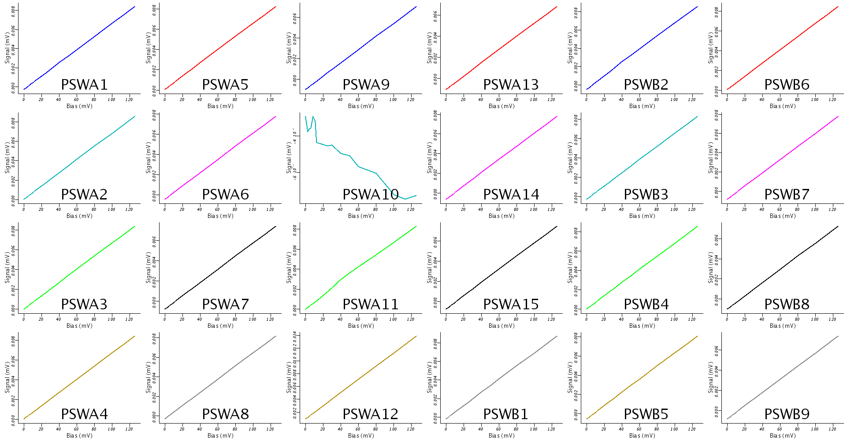
Figure 1. PSW Detectors (1)
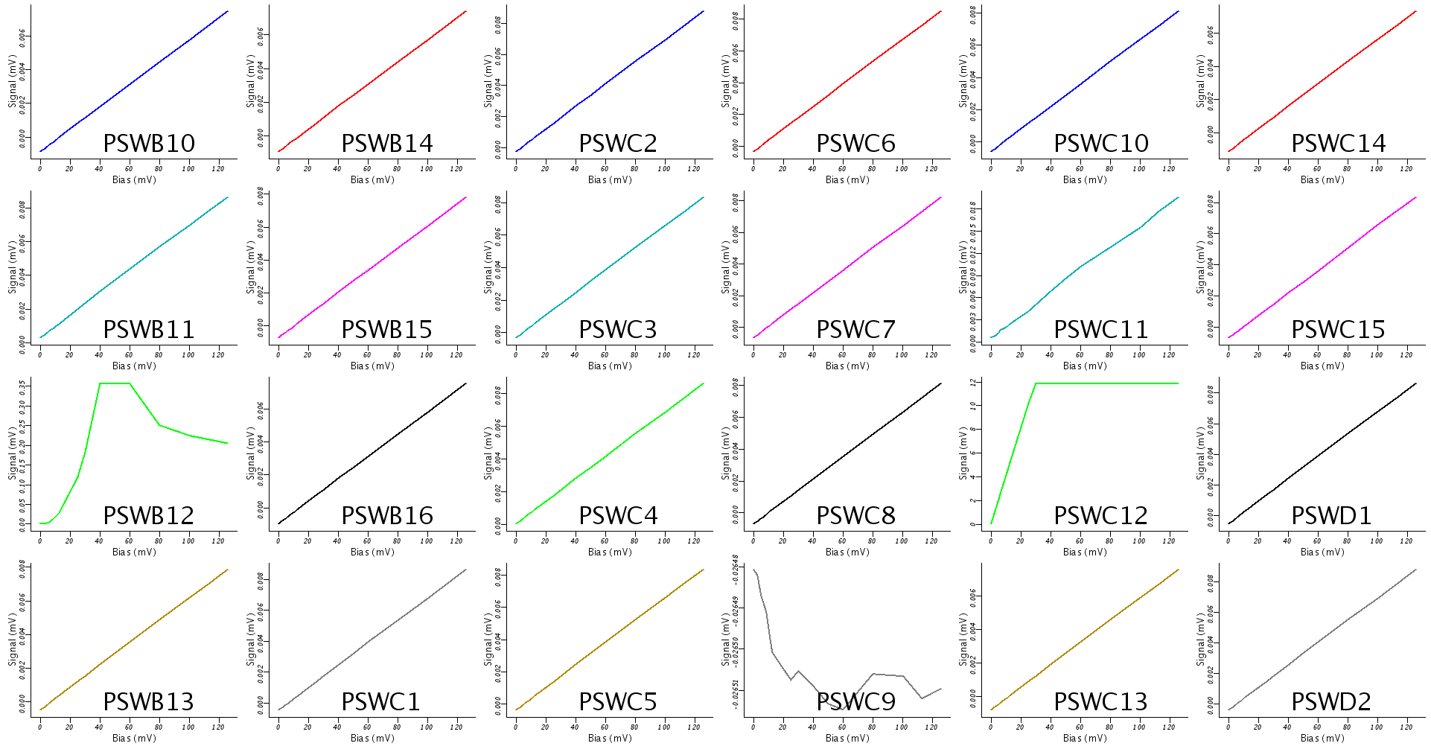
Figure 2. PSW Detectors (2)
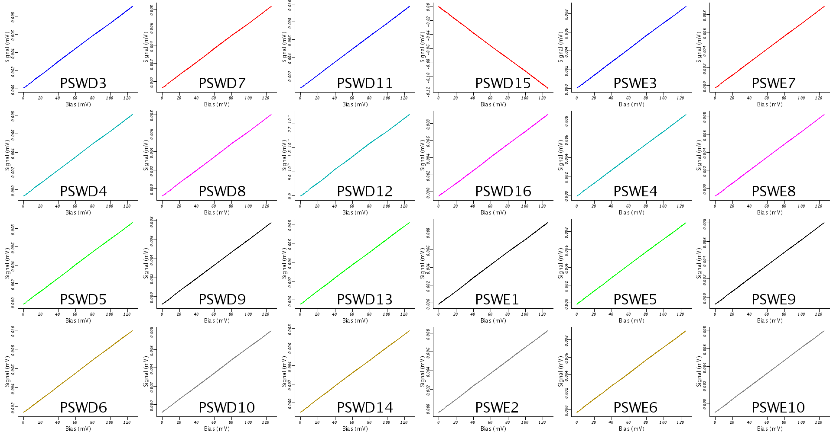
Figure 3. PSW Detectors (3)

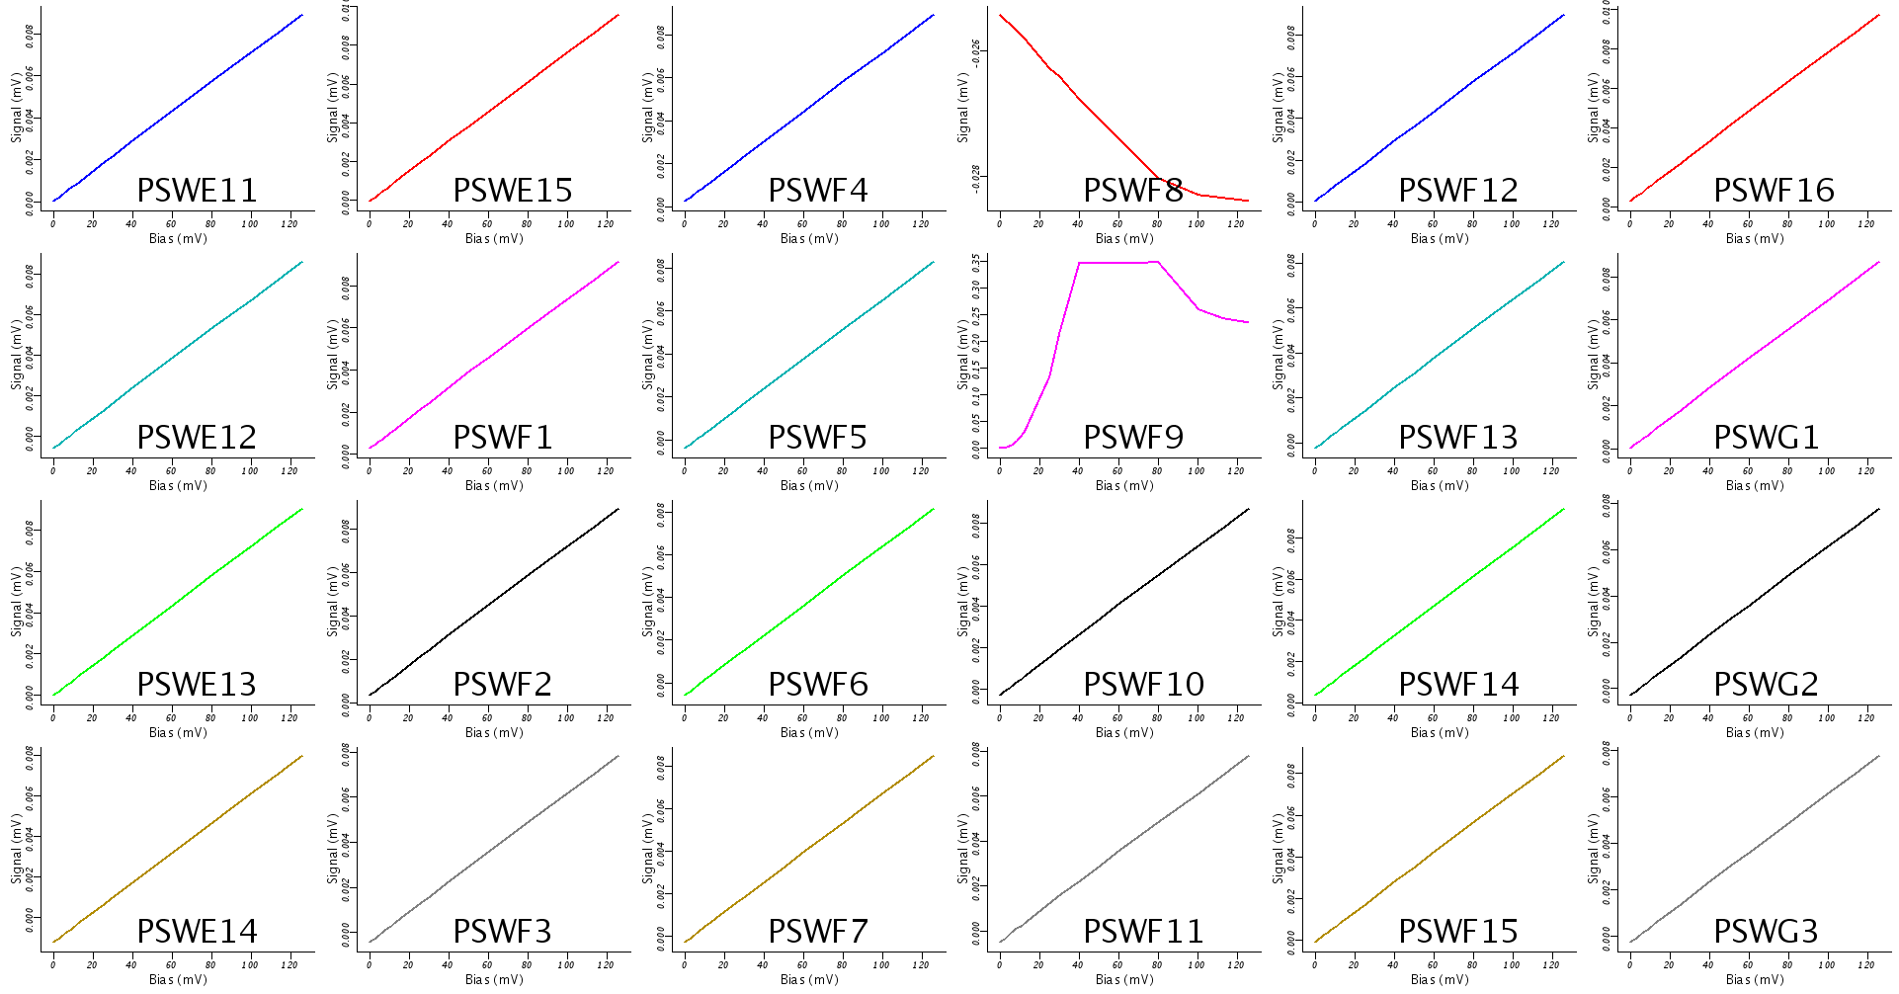
Figure 4. PSW Detectors (4)

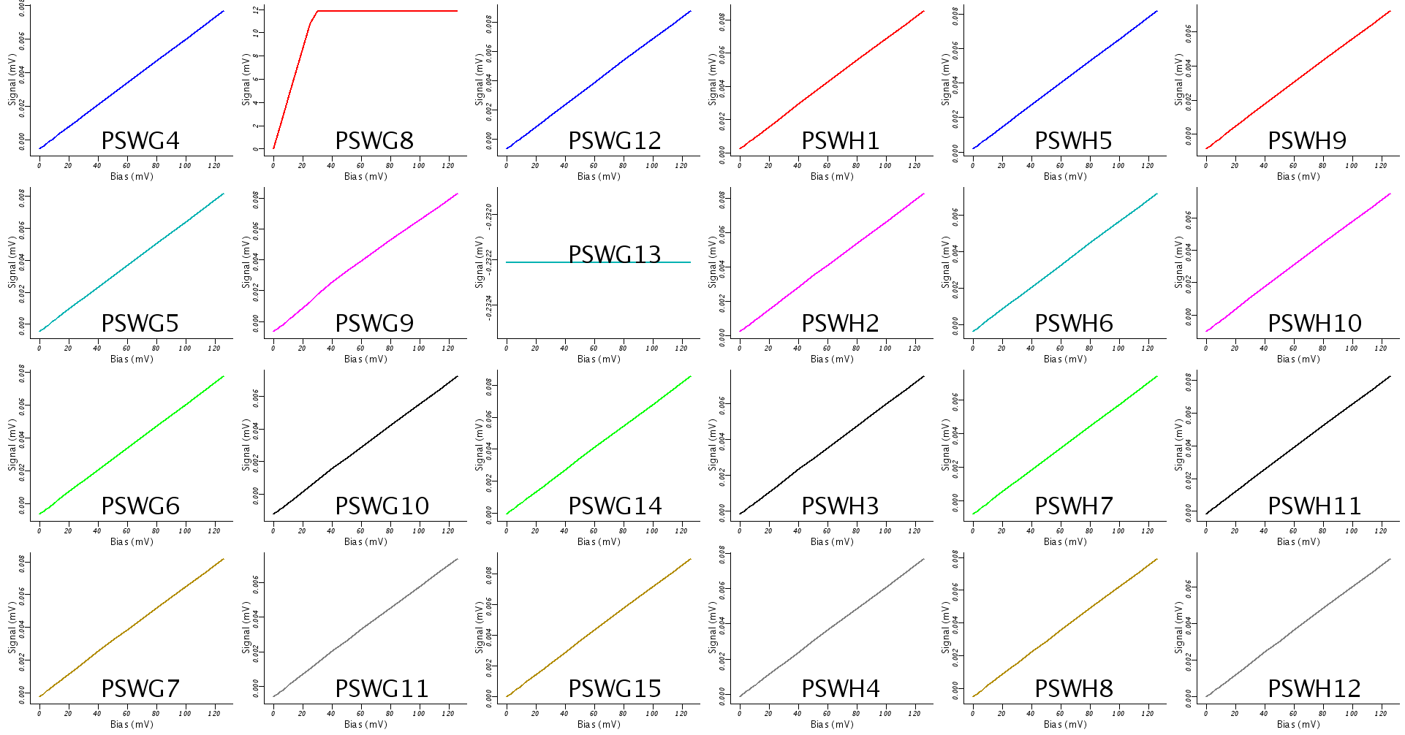
Figure 5. PSW Detectors (5)

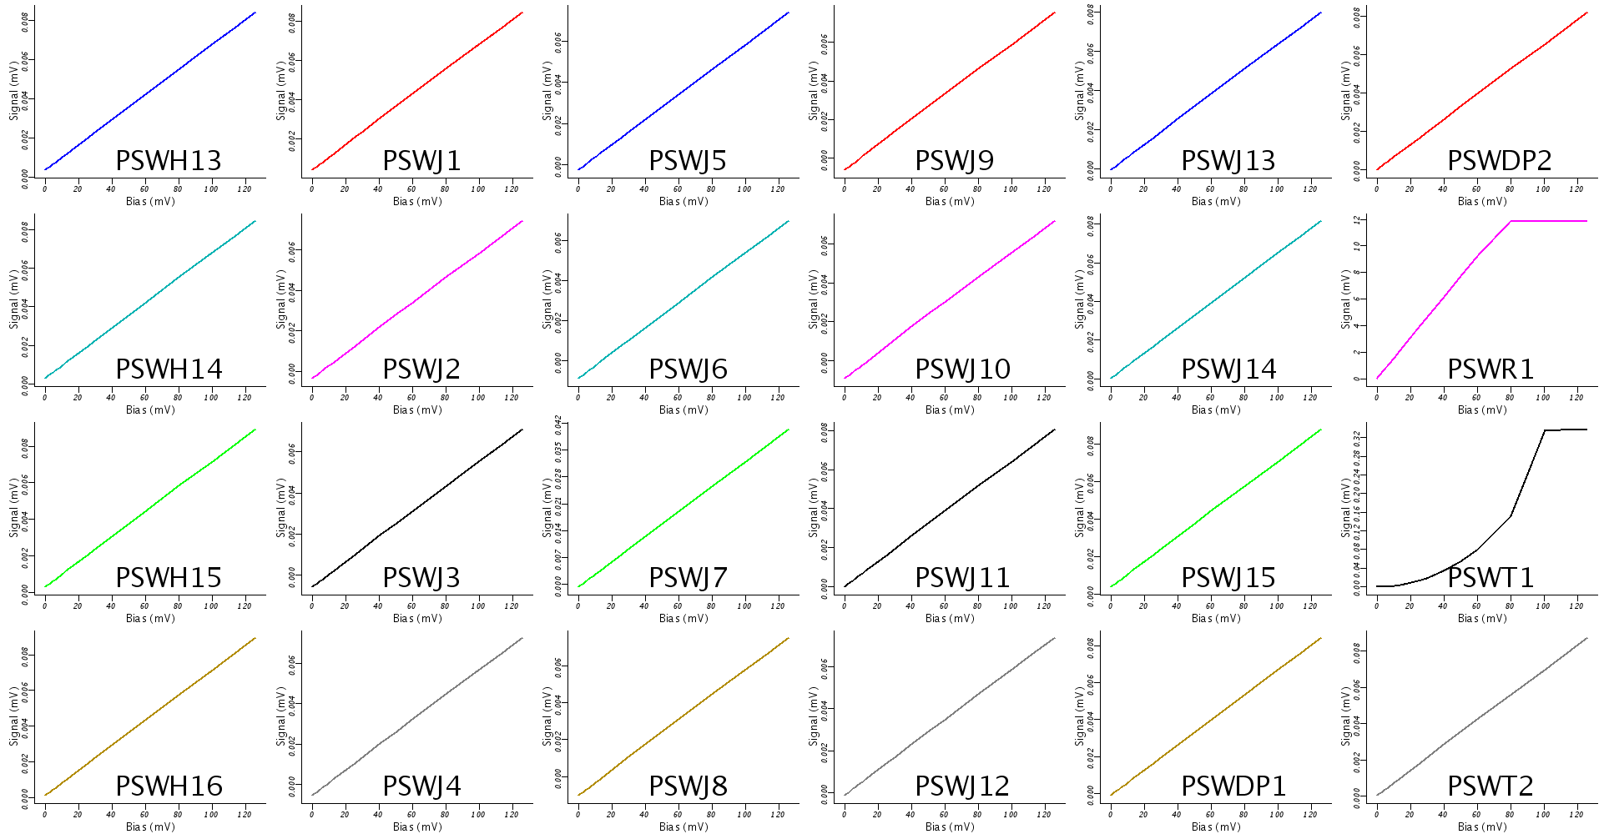
Figure 6. PSW Detectors (6)

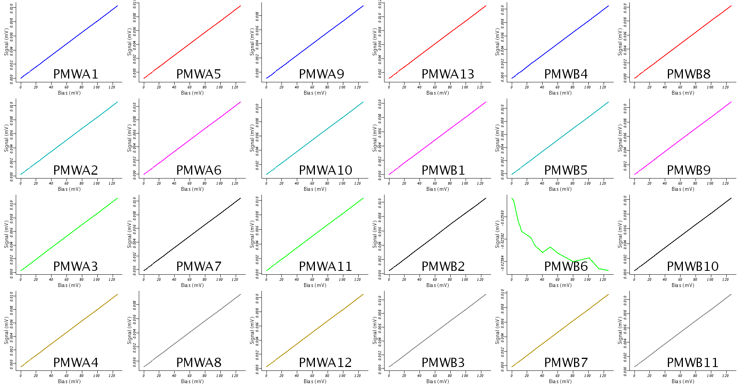
Figure 7. PMW Detectors (1)

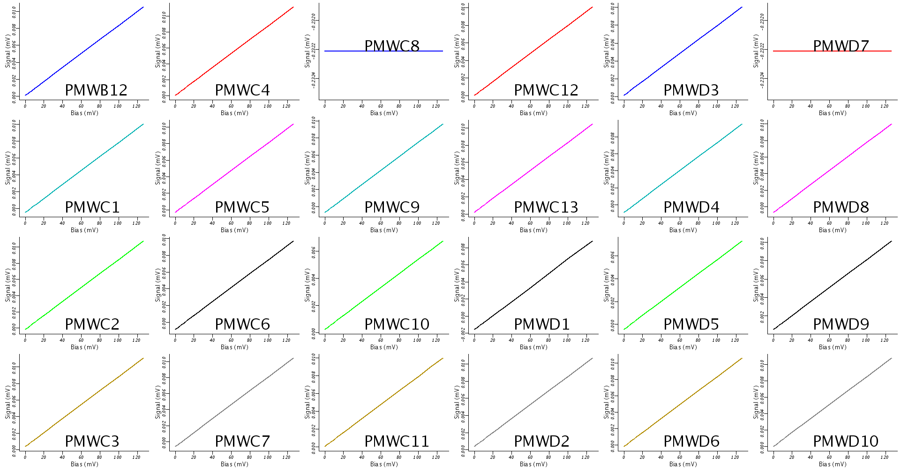
Figure 8. PMW Detectors (2)

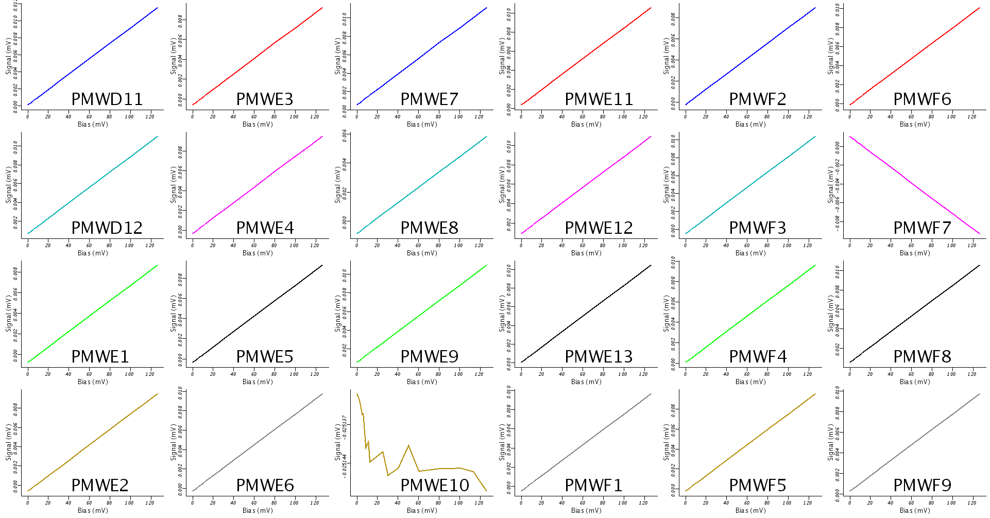
Figure 9. PMW Detectors (3)

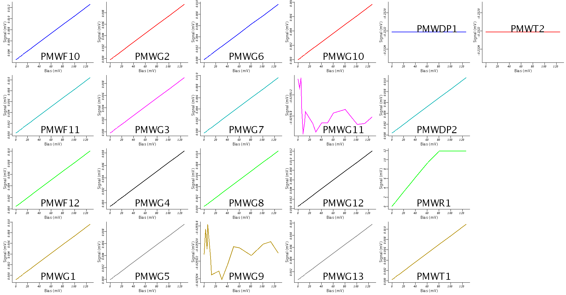
Figure 10. PMW Detectors (4)
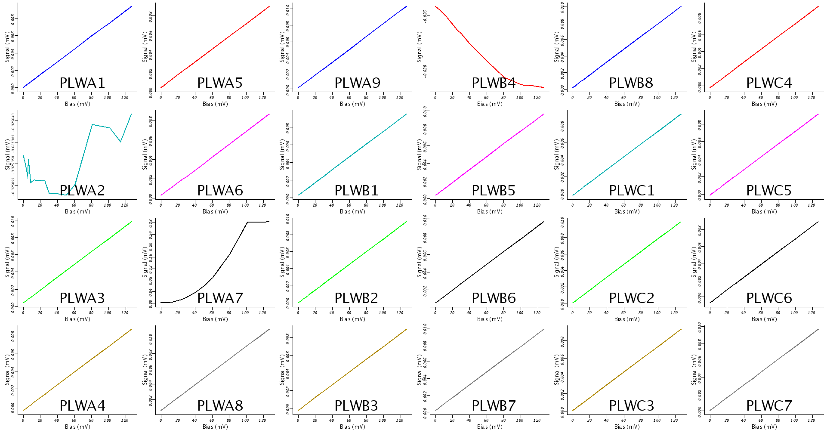

Figure 11. PLW Detectors (1)

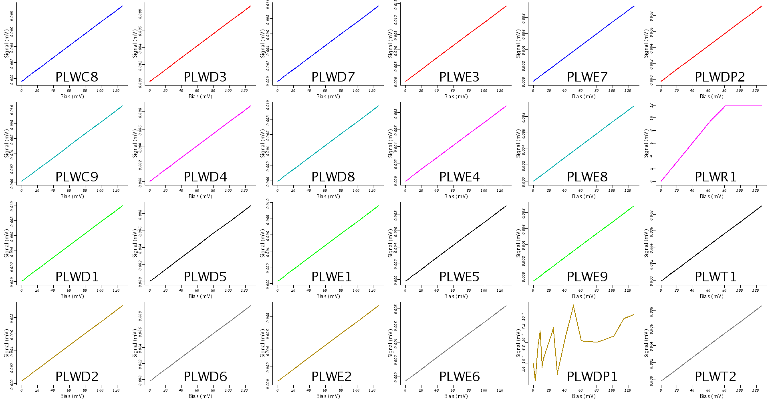
Figure 12. PLW Detectors (2)
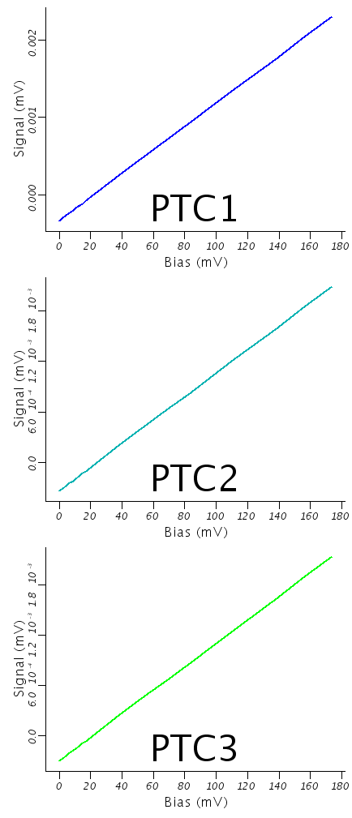
Figure 13. PTC Detectors (1)

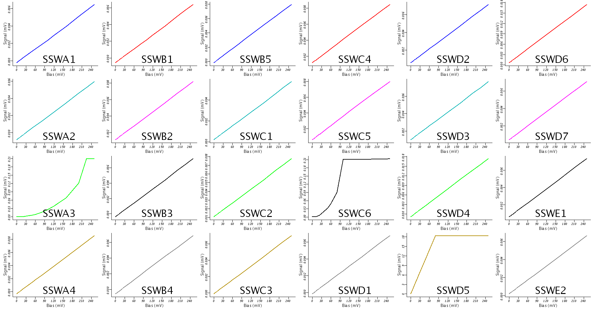
Figure 14. SSW Detectors (1)

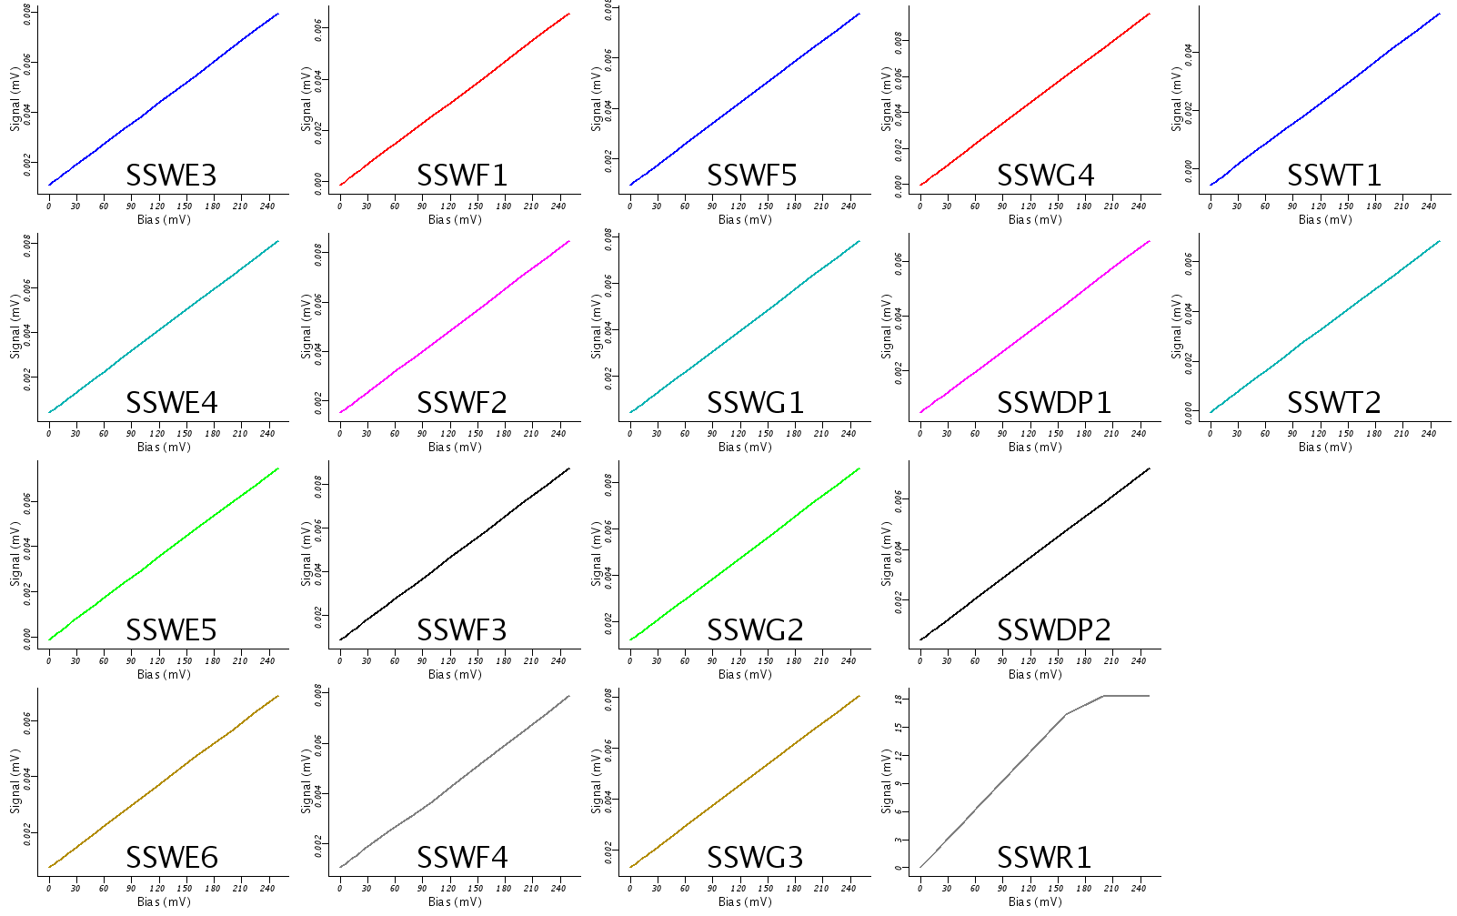
Figure 135. SSW Detectors (2)

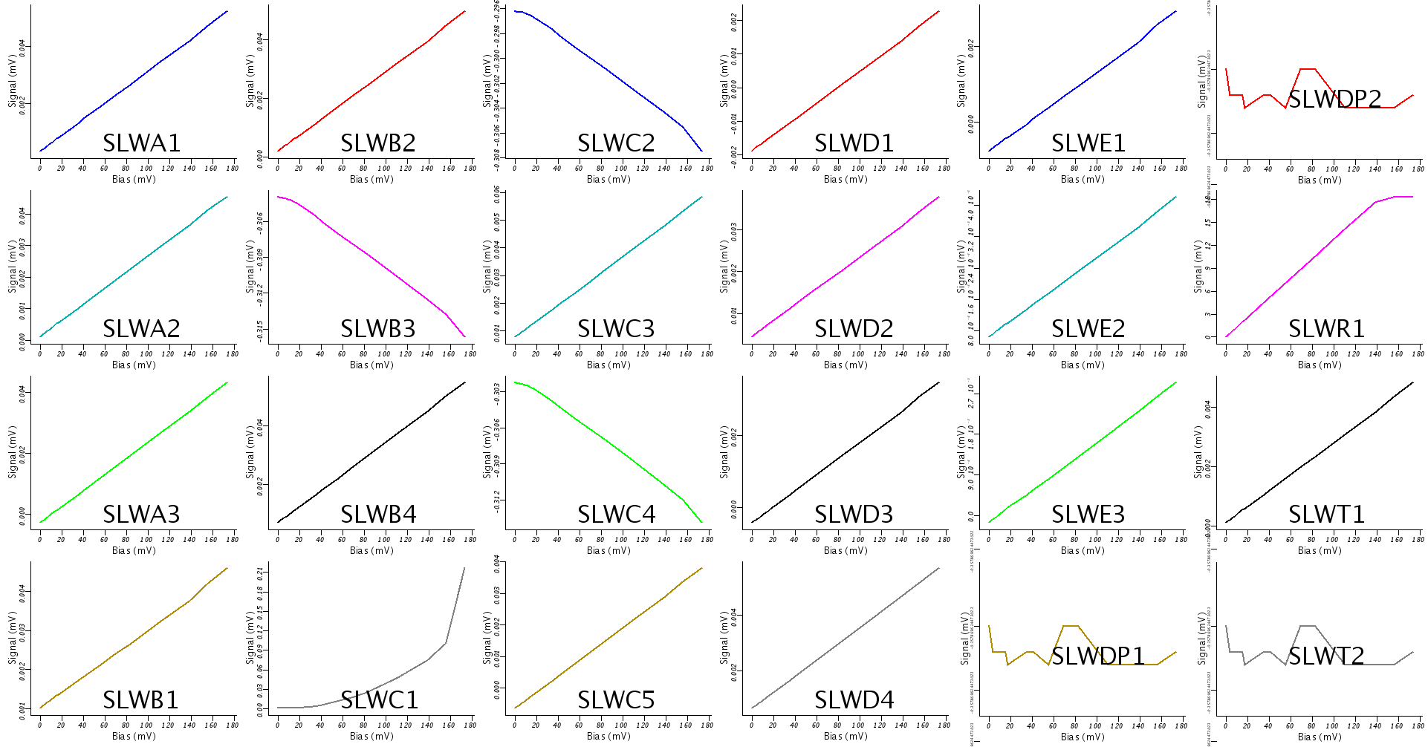
Figure 146. SLW Detectors (1)

