 | HERSCHEL  SPIRE | Ref: SPIRE-RAL-PRC-002816  Author: D.L. Smith | Issue: 1.0  Date:31-Jan-2007

PFM5 Cold Test – Master Procedure

Prepared by:
 | D.L. Smith (RAL) | Date
Checked:
 | B.J. Swinyard (RAL) | Date
Approval:
 | E. Sawyer (RAL) | Date

Distribution
RAL | Eric Sawyer
 | Eric Clark
 | Alan Pearce
 | Anne Sophie Goizel
 | Marc Ferlet
 | Bruce Swinyard
 | Doug Griffin
 | Tanya Lim
 | Ken King
 | Sunil Sidher
UOL | Asier Aramburu
 | Peter Davies Imhof
UCW | Matt Griffin
 | Peter Hargrave
 | Tim Waskett
LAM | Dominique Pouliquen
ATC | Phil Parr-Burman
 | Brian Stobie
IC | Dave Clements
 | Davide Rizzo

Host system | Windows 2000 SP2
Word Processor | Microsoft Word 2000 SR1
File | 0000.doc

Document Change Record

Date | Index | Affected Pages | Changes
31-Jan-2007 | 1.0 | All

Scope of Document

This procedure describes the activities to be performed during the PFM-4 cold thermal test campaign, which is a key inspection point (AD 1). The details of the instrument integration and cryostat operations are given in AD 7 and AD 8 respectively. The sequence of the performance testing is a an overview based on the SPIRE FM Calibration and Performance Test Plan (AD 3) which defines the flow and detailed procedures. The aim of this document is to ensure that the test objectives are achieved.

Documents

Applicable Documents
 | Title | Author | Reference | Date
AD 1 | SPIRE AIV Plan | B.J. Swinyard | SPIRE-RAL-DOC-000410 Issue 3 | May 2003
AD 2 | As Built Configuration List | Eric Sawyer | SPIRE-RAL-DOC-002326 Issue 2.8 | Oct 2006
AD 3 | SPIRE FM Calibration and Performance Test Plan | T. Lim | SPIRE-RAL-DOC-002535 Draft 0.2 | 15-Sep-2006
AD 4 | Functional Test Specification | S. Ronayette Asier Abreu | SPIRE-RAL-NOT-1652 Issue 1.4 | 10-Dec-2004
AD 5 | PFM2 Thermal Balance Test Specification | A.S. Goizel | SPIRE-RAL-DOC-002435 Issue 1 | Dec 2005
AD 6 | Input to SPIRE PFM3 Thermal Test Specification | A.S. Goizel | SPIRE-RAL-MEM-002563 Draft A | Feb 06
AD 7 | SPIRE Harness Integration Procedures | D.L. Smith | SPIRE-RAL-PRC-2122 Issue 0.4D | Dec 2004
AD 8 | SPIRE Cryostat Operating Procedures | D.L. Smith | SPIRE-RAL-DOC-001556 Issue 1.0 | 12-Jan-2005
AD 9 | SPIRE Cryolab Risk Assesment | D.L. Smith | SPIRE-RAL-DOC-002103 Issue 2.0 | 28-July-2004
AD 10 | SPIRE Instrument Operations Procedures | S. Sidher
AD 11 | SPIRE EGSE ILT Startup Procedures | S. Sidher and M. Requena | SPIRE-RAL-DOC-001630 | 24-Jun-2003
AD 12 | DRCU Switch On Procedure | A. Aramburu | SPIRE-RAL-NOT-002222
AD 13 | SPIRE Cleanliness Plan | B.J. Swinyard | SPIRE-RAL-DOC-001070 Issue 1.0 | 9-Jan-2002
AD 14 | RAL Safety Codes | CCLRC | http://www-internal.clrc.ac.uk/staff/notices/clrc_safety_codes/sc2.html | July-2003

Test Objectives

The PFM-5 test campaign is an additional test of the SPIRE PFM instrument to evaluate the stray light performance under dark conditions.

Test Configuration

Instrument Build
The model to be tested consists of the full flight model configuration of the FPU, DPU and DRCU. The table below provides a summary of the build standard of the PFM-4 instrument for information only. A more detailed breakdown of the components is given in the as built configuration list AD 2.

Unit  /component | Build Standard
HSFPU
Structure/baffles/standoffs etc | PFM
L0 straps | MGSE – New for PFM-4 with flight like flexible interface and light trap.
Mirrors | PFM
Filters | CFIL-1 – PFM  SFIL2 – PFM  SBS1 – PFM  SBS2 - PFM  SFIL3 to 5S – PFM  SFIL3 to 5L – PFM  CFIL1 - PFM  PFIL-2 - PFM  PFIL-3 - PFM  PDIC-1 – PFM  PDIC-2 – PFM  PFIL-4S - PFM  PFIL-5S - PFM  PFIL-4M - PFM  PFIL-5M - PFM  PFIL-4L - PFM  PFIL-5L - PFM  PFIL-6L - PFM
Beam steering mirror | PFM
3He Cooler | PFM
300 mK thermal straps and supports | PFM
300 mK Thermal control system | PFM
Photometer LW array | PFM
Photometer MW array | PFM
Photometer SW array | PFM
SMEC | PFM
Spectrometer SW array | PFM
Spectrometer LW array | PFM
Photometer Calibrator | PFM
Spectrometer Calibrator | PFM – with 2% and 4% source  redundant side disconnected for phot box GSE heater
FPU RF Filters | PFM
Thermometry | PFM
FPU internal harnesses | Spectrometer side – PFM  Photometer side - PFM
HSJFP
JFET Structure | PFM
JFET Modules | PFM – except one non flight but functional module
JFET box RF filter modules | PFM
JFET Backharness | PFM
JFET/FPU Harness | PFM
HSJFS
JFET Structure | PFM
JFET Modules | PFM
JFET box RF filter modules | PFM
JFET Backharness | PFM
JFET/FPU Harness | PFM

Subsystem  /component | Requirement
HSDCU
DCU Structure | FM
Electrical Interfaces | Flight
Functionality | Full functionality
Electrical Component Level | Flight
HSFCU
FCU Structure | FM
MCU | FM
Electrical Interfaces | Flight
Functionality | Full functionality
Electrical Component Level | Flight
SCU | FM
Electrical Interfaces | Flight
Functionality | Full functionality
Electrical Component Level | Flight
PSU | FM
Electrical Interfaces | Flight
Functionality | Full functionality
Electrical Component Level | Flight
HSDPU | FM
DPU Structure | Flight
Electrical Interfaces | Flight
Functionality | Full functionality
Electrical Component Level | Flight
On Board Software
Functionality | Full functionality but no autonomy required  Refer to table in section 4.4 for version numbers and patches
HSWIH
Length/Connector type | Test harness
Electrical Interfaces | Form; fit; function
Functionality | Full functionality on prime side only
Electrical Component Level | Commercial

Cryostat

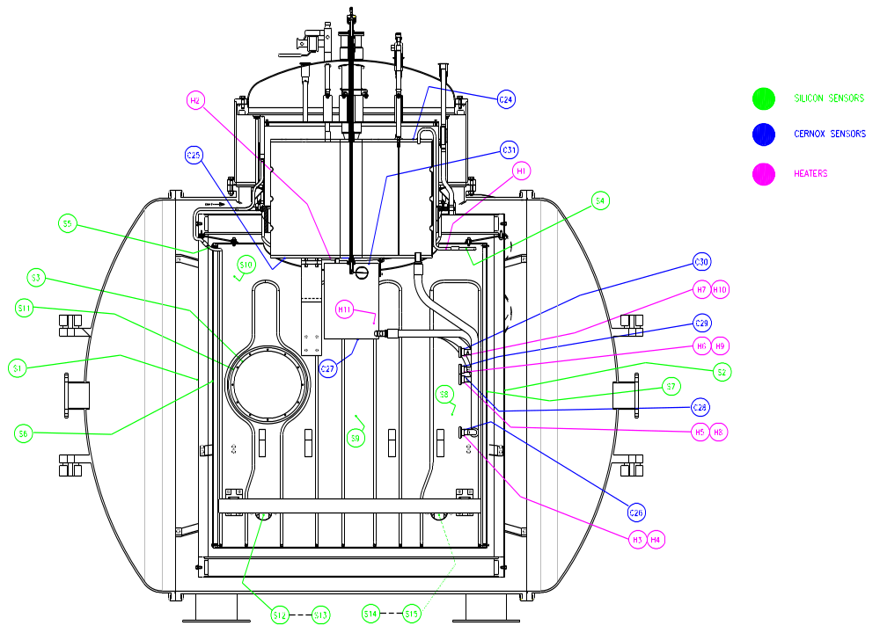
4.2K He Vessel
1.7K He Pot
10K Radiation Shield
77K LN2 Vessel

Figure 1: Cross section of SPIRE test cryostat showing the different temperature stages and thermometer locations.

The SPIRE Calibration Cryostat has four stages of cooling, an outer liquid nitrogen cooled vessel at 77K, a 10K radiation shield, a 4.2K liquid He vessel and a 1.7K pumped liquid He pot, Figure 1. A more detailed description of the cryostat and its operation is given in AD 8

OGSE
No optical equipment will be used for this test campaign as the entrance aperture of the instrument will be covered.

EGSE Configuration

The following table gives the build standard of the EGSE software at the start of the test campaign.

System | Version | Updated
SCOS-2000 | 2.3E patch 5
HCSS | Build 1106 (Version 0.4.1)
QLA | 3.3
MIB | PFM5
OBS | 2.2G
TFCS | 2.8 | Nov-2006
TFTS server | 1.6 | 25-Nov-2006

Constraints

Safety
All personnel working in the SPIRE test facility must read the facility risk assessment, especially as there are particular hazards associated with the cryostat and laser.

Great care should be taken when handling liquid nitrogen and helium. The main hazards associated with liquid Nitrogen and Helium are:

- Cold "burns" to the person.
- Explosions due to the vaporization of the liquefied gas into an enclosed space.
- Asphyxiation due to exclusion of oxygen.
- Spillage onto structural materials, which can cause thermal contraction of the metal, say steelwork, with resultant cracking.

All people working with the cryostat should have instruction on the safe handling of cryogenic liquids and familiarise themselves with the laboratory safety code CCLRC Safety Code 2 which can be found on http://www-internal.clrc.ac.uk/staff/notices/clrc_safety_codes/sc2.html The safety code must be followed at all times when handling cryogenic liquids. A risk assessment shall be performed before operating the cryostat.

The personal oxygen monitors provided must be used when entering the lab when the cryostat is cold. These are calibrated every 6 months by the manufacturers (Crowcon in Abingdon).

When the oxygen monitor alarm sounds leave the room immediately and call ext 5996. DO NOT attempt to enter the room afterwards until the all clear has been given.

The gloves provided shall be worn when transferring liquid helium and nitrogen into the tank.

Any dewars with worn or damaged castors or which are difficult to wheel safely should be taken out of service and returned to stores immediately for repair or maintenance.

Cleanliness
To minimise the level of contamination, the FPU should remain covered until the particulate count is below that for a class 6 (old class 1000) clean room. The maximum concentration limits as specified by ISO EN 14644-1 1999 Standard (particles per m³ of air) for particles greater than the considered sizes are
Size | Specification
0.1µm | 1000000
0.2µm | 237000
0.3µm | 102000
0.5µm | 35200
1.0µm | 8320
5.0µm | 293

The following clothing shall be worn at all times when working in the clean room to avoid contamination of the instrument or surfaces that the instrument will come into contact with.

Facemasks
Hats
Coats
Overshoes
Gloves – to prevent cross contamination via tools and test equipment

Personnel working in the clean room must first attend the RAL SSTD training session on clean room practice.

Where possible, personnel should work downstream of the instrument from the air-filters.

As space is extremely limited, only essential personnel are permitted to work in the clean room.

Tools for use in the clean room must first be cleaned using IPA wipes.

ESD Precautions

The SPIRE FPU, JFETS, DRCU and DPU are sensitive to electrostatic discharge. To prevent accidental damage to sensitive components, the units shall be grounded via a suitable earth strap while work is being performed. The earth straps may only be removed once the electronics have been connected together in accordance with the harness integration procedure. ESD wrist straps shall be worn at all times when working either directly or within 1m of the instrument.

All personnel who are working on or in the vicinity of the instrument must have attended the RAL SSTD training session on ESD.

Organisation

Once cold the typical daily plan for the test campaign is shown as follows

07:30-08:30 (2 people)
Top up He vessels

08:30-10:30 (2 people)
Top up LN2 vessel
Allow temperatures to stabilise
Recycle cooler if necessary
Switch on test equipment (laser) and allow temperatures to stabilise
Order Helium for next day

10:30-15:00
Instrument Testing – Team A (3 people, SCOS driver, QLA driver, Equipment driver)

15:00-15:30
Daily planning meeting
Full team required
report on previous 24 hours
highlight major issues
plan next 24 hours activities

15:30-22:00
Instrument Testing – Team B (3 people)

22:00-23:00 – Team B
Prepare to store instrument for night

23:00-07:30
Thermal balance tests
Quiet Performance Tests (e.g. TFTS scans, noise tests)

Procedure Flowchart

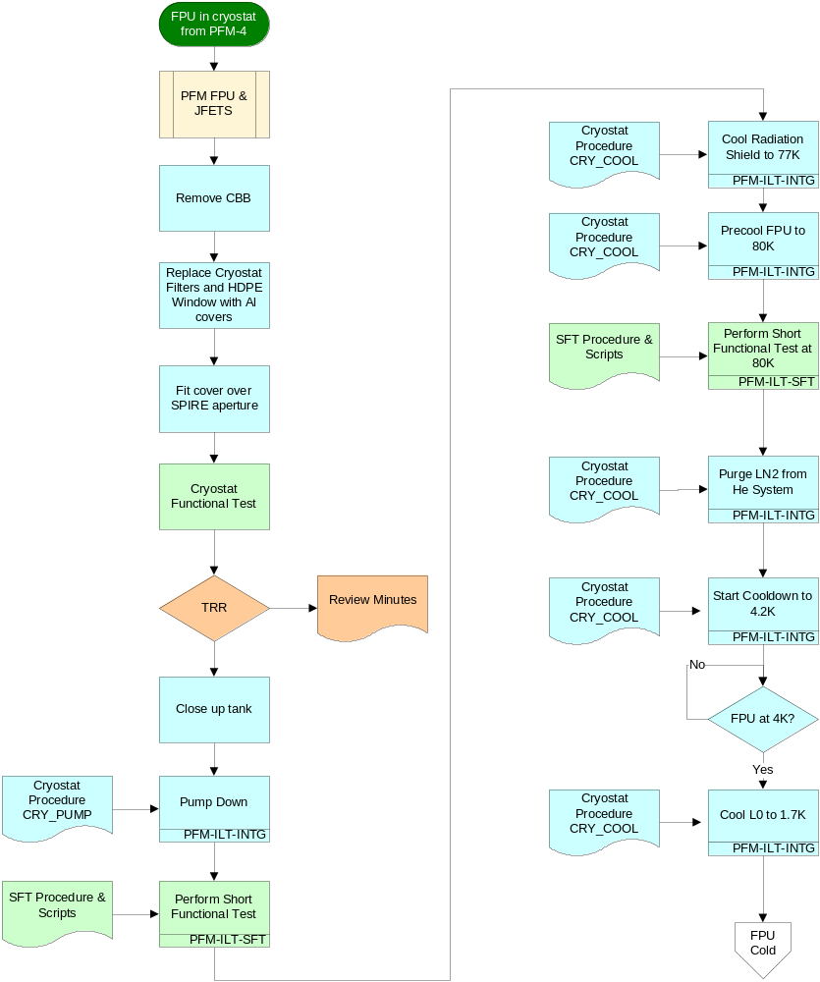
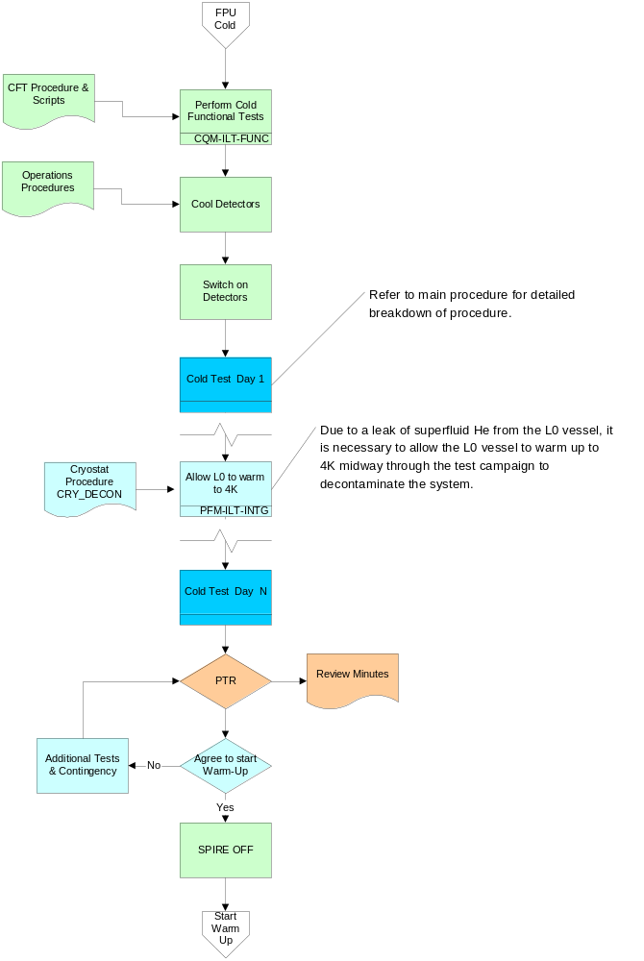

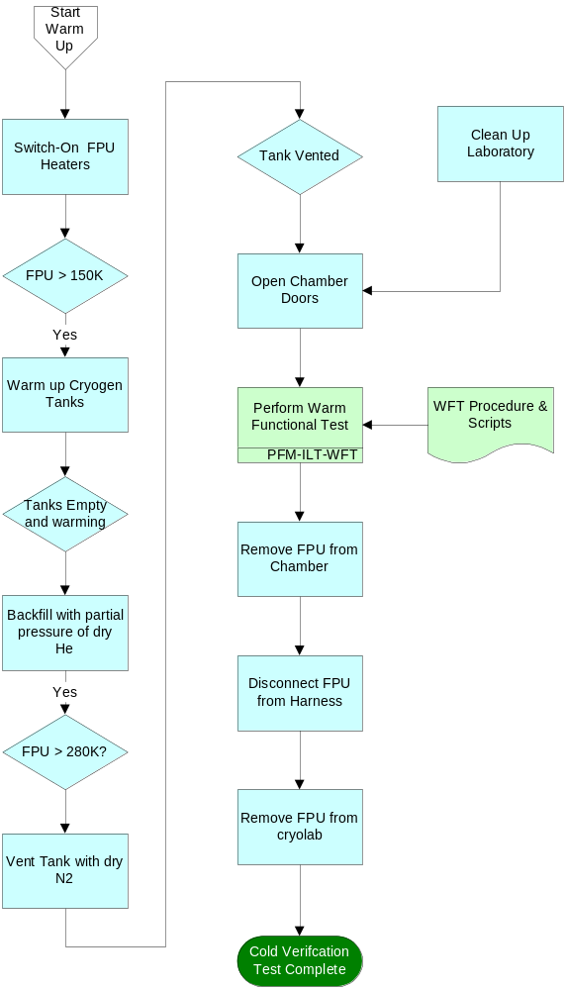

Test Procedure

Objectives: | See section 3  This is a key inspection point.
Initial Conditions: | SPIRE PFM  Chamber at Atmospheric Pressure (~1000mbar)  FPU in cryostat  Vacuum system control electronics OFF  Turbo Pump fan unit power OFF  N2 supply closed  3 Phase supply OFF  EGSE ILT OFF
Final Conditions: | FPU Removed from Cryolab
Constraints: | Pumping must not start until a test readiness review has been held and authorisation to proceed has been given.  Grounding straps provided must be worn at all times when working on FPU and WE
Total Duration: | 5 weeks

Step. | Action | Comments | Task Complete
1 | Hold Test Readiness Review
1.1 | Required Personnel  Instrument Manager – Eric Sawyer  AIV Manager – Dave Smith  PA Manager – Eric Clark  System Engineer – Doug Griffin  Thermal Engineer – Anne Sophie Goizel  Calibration Scientist – Tanya Lim  Instrument Specialist – Sunil Sidher  Instrument Scientist – Bruce Swinyard
2 | Reconfigure Instrument from PFM-4 campaign
2.1 | Remove cold blackbody
2.2 | Replace filters with Aluminium blanks
2.3 | Replace HDPE window with Metal vacuum plate
2.3 | Fit aperture cover to SPIRE
3 | Cryostat Functional Tests
3.1 | Verify operation of cryostat instrumentation using procedure CRY_CHECK (ref AD 8)
3.1 | Verify correct operation of Pump System
3.2 | Verify thermometer connections
3.3 | Verfiy cryostat heater operations
4 | Close Cryostat
4.1 | Replace 10K end-cap at west end of cryostat
4.2 | Connect thermometer harness and check function
4.3 | Replace 77K end-cap at west end of cryostat
4.4 | Connect thermometer harness and check function
4.5 | Replace 10K end-cap at east end of cryostat
4.6 | Connect thermometer harness and check function
4.7 | Clamp instrument cryoharness to 10K shield and verify electrical isolation
4.8 | Replace cowl on 10K end plate
4.9 | Replace 77K end-cap at east end of cryostat
4.10 | Place loose harness between MLI and 77K shield – ensuring that electrical isolation is maintained.
4.11 | Close doors of vacuum chamber and fasten clamps.
5 | Pump-Down Cryostat
5.1 | Start cryostat pump-down using procedure CRY_PUMP (ref AD 8)
6 | Perform Short Functional Test – PFM-ILT-SFT
6.1 | Vacuum chamber at 10⁻⁵mbar?
6.2 | Perform Short Functional Test | Refer to document SPIRE-RAL-PRC-002322
6.3 | Leave SCU DC thermometry on for cooldown | Done as part of SPIRE-RAL-PRC-002322
7 | Purge He Vessels
7.1 | Purge He vessels with dry N2 gas according to procedure CRY_COOL (ref AD 8)
8 | Cool LN2 Radiation Shield
8.1 | Fill LN2 Radiation shield according to procedure CRY_COOL (ref AD 8)
9 | Pre-cool FPU to 80K
10.1 | Cool SPIRE FPU to 80K using procedure CRY_COOL (ref AD 8) – NOTE This procedure will take several days to complete
10.2 | Once FPU has reached 80K remove liquid nitrogen from 1.7K and 4K vessels using step 4 of the cryostat operating procedure CRY_COOL (ref AD 8)
10.3 | Confirm that all liquid nitrogen has been removed from 1.7K and 4K vessels.  Do not proceed with pump/purge cycle without signing off this step!
10.4 | Purge He vessels with He gas according to step 5 of cryostat operating procedure CRY_COOL (ref AD 8)
11 | Perform Short Functional Test Before Filling with He – PFM-ILT-SFT
11.1 | FPU thermometers below 100K?
11.2 | Perform Cool Functional Test | Refer to document SPIRE-RAL-PRC-002322
11.3 | Leave SCU DC Thermometry Running | Done as part of SPIRE-RAL-PRC-002322
12 | Cool instrument to 4.2K
12.1 | Cool SPIRE to 4.2K using procedure CRY_COOL (ref AD 8)
12.2 | Allow temperatures to stabilise
12.3 | Measure steady state temperatures and check thermometry
13 | Perform Cold Full Functional Tests - Part 1
13.1 | FPU Below 5K?
13.2 | Perform SPIRE Cold Functional Tests – step 1 to X inclusive | Refer to document SPIRE-RAL-PRC-002322
14 | Cool to 2K
14.1 | FPU below 5K?
14.2 | Cool L0 interface to 2K using procedure CRY_COOL (ref AD 8)
14.3 | If FPU L0 at 2K proceed to step 19
15 | Perform Cold Full Functional Tests - Part 2
15.1 | All L0 temperatures at 2K and stable?
15.2 | Recycle cooler holding L0 vessel at 2K
15.3 | When evaporator temperature at 300mK, lower L0 vessel temperature to 1.7K.
15.4 | Continue cold functional tests from step X+1 | Refer to document SPIRE-RAL-PRC-002322
16 | Start Cold Test Activities
The following is a rough outline of the main activities to be performed for the first two weeks of the test campaign. The eventual flow of the test campaign will depend on schedule and the availability of key personell.
A spreadsheet with a detailed step-by-step sequence to be followed by the test team will be produced on a daily basis.
Day 1
Phase up for photometer
Overnight load curves
Day 2
PTC optimisation
Overnight photometer load curves at higher temp
Day 3
PTC optimisation
Overnight noise test
Day 4
EMC
Overnight photometer load curves at higher temp
Day 5
EMC
Overnight photometer load curves at higher temp
Day 6
Phase up Spectrometer
Overnight spectrometer load curves
Day 7
Phase up Spectrometer
Load Curves
Overnight noise tests
Day 8
SMEC Operations
Overnight load curves at higher temp
Day 9
SMEC Step and look tuning
Day 10
Microphonics
Overnight load curves at higher temp

17 | Post Test Review
17.1 | Hold test review to assess need for additional/repeat tests before warming up.
18 | Switch OFF SPIRE
18.1 | Switch OFF SPIRE, leaving SCU DC thermometry running.
18 | Warm Up
18.1 | Warm SPIRE to ambient using procedure CRY_WARM (ref AD 8)
19 | Let Up to Atmosphere
19.1 | Let up chamber to atmospheric pressure using procedure CRY_LETUP (ref AD 8)
20 | Perform Warm Functional Test
20.1 | Chamber at atmospheric pressure?
20.2 | Perform warm functional test | Refer to document SPIRE-RAL-PRC-002322
20.3 | Check that all SPIRE subsystems have been switched OFF | Done as part of SPIRE-RAL-PRC-002322
21 | Open Cryostat
21.1 | Return MGSE from G56 clean room
21.2 | Connect MGSE to facility ground
21.3 | Monitor Particulate levels in laboratory
21.4 | Particulate levels for class 6 clean room (old class 1000)  Maximum concentration limits (particles per m³ of air) for particles > than the  considered sizes below.
Size | Specification | Measured
0.1µm | 1000000
0.2µm | 237000
0.3µm | 102000
0.5µm | 35200
1.0µm | 8320
5.0µm | 293

21.5 | Open cryostat doors – ensure that Oxygen monitor is on person at all times during this procedure as the chamber will be full of nitrogen gas – allow oxygen levels to recover before returning to lab
21.6 | Remove 77K end caps and store in cryostat doors
21.7 | Remove cowl from 10K shield
21.8 | Unclamp instrument harness from 10K shield
21.9 | Remove 10K end-caps
22 | Remove FPU from Cryostat
22.1 | Remove CBB from cryostat – bag and return to G56 clean room
22.2 | Replace aperture cover
22.3 | Disconnect cryostat flexibles from the FPU and move out of way
22.4 | Unclamp and lower the FPU and HOB frame onto wheels
22.5 | Connect MGSE trolley rails to cryostat rails
22.6 | Move FPU out of cryostat onto MGSE trolley.
22.7 | Secure FPU and HOB assembly onto MGSE
22.8 | Connect FPU to HOB plate using grounding strap
22.9 | Disconnect Cryo-Harness to FPU according to integration procedure ref ILT_INTG_HARN (AD 7)
22.10 | Replace covers on FPU
22.11 | Disconnect MGSE from facility ground
22.12 | Return FPU to G56 clean room

Schedule

The following schedule is based on the pump-down starting on 23-Jan-2007.



