Table of Contents
Change Log 1
1. Scope 2
2. Reference Documents 2
3. Channels monitored during testing 2
4. Injection calibration 3
5. Test results 4
5.1 8-20MHz Band 4
5.1.1 Test conditions 4
5.1.2 Channel susceptibilities 5
5.2 20-120MHz Band: 1.2V/m + 6dB 9
5.2.1 Test conditions 9
5.3 20-120MHz Band: 1.2V/m + 0dB 9
5.3.1 Test conditions 9
5.3.2 Manual search for Peak Susceptibilities 14
5.4 Test conditions 21
5.5 Susceptibility Threshold at 30.9 MHz 22
5.5.1 Channels 1-12 22
5.5.2 Channels 13-24 24
5.5.3 Channels 25-36 26
5.5.4 Channels 37-48 28
6. Comparison STM2 and EQM susceptibility thresholds 30
7. Load curve analysis 30
8. Appendix 1 – Susceptibility threshold during EQM Test Campaign 32
9. Appendix 2: Length of cryoharness and λ/2 resonance 33

Change Log
Date | Issue | Change
18 November 2006 | 0.1 | Initial drafting of document
27 November 2006 | 0.11 | Circulate for comment
12 Jan 2007 | 0.2 | Some changes
16 March 2007 | 0.3 | More updates for PFM DRB summary

- Scope

This document reports and documents the RS susceptibility tests carried out at ESTEC on the SPIRE CQM instrument in the PFM Cryostat within the scope of the satellite STM2 test campaign during the period 16-Oct-2006 to 21-Oct-2006.

- Reference Documents

RD1: ‘’PLM EQM EMC Test Procedure, HP-2-ASED-PR-0033, dated 21.09.05
RD2: “SPIRE EQM EMC Test Procedure” SPIRE-RAL-PRC-002545, Issue: 2.0 pre-release
- Channels monitored during testing

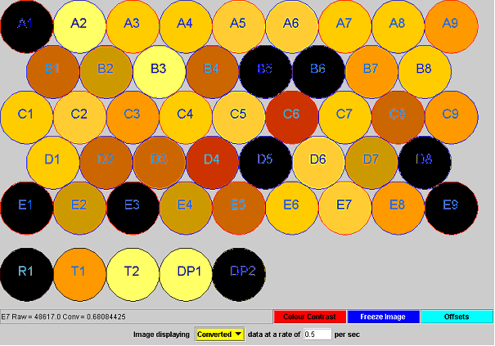
Figure 1 - PLW Array pixel map – bad channels are identified by black colouring.

Figure 1 shows the physical mapping of the various detector channels onto the array. The channels prefixed by the letters A-E are normal optical pixels. Channel R1 is designated as a resistor channel which is intended to have a similar impedance to a normal working pixel, but with a static impedance independent of the bias current or temperature. Channels T1 and T2 are mounted on the 300-mK bath and are intended to monitor the base temperature of the bolometers. They have a strong thermal coupling to the 300-mK bath and should therefore show a weak correlation between thermal loading and temperature rise. Channels DP1 and DP2 are physically similar to the normal optical pixels except that they are enclosed inside a dark cavity and should show no optical response.
The channel yield for the CQM array is 38/48 (79.2%) and the following channels are listed as being out of specification and are therefore excluded from the EMC analysis.
R1
B5
B6
A1
E1
E3
D5
D8
DP2
E9
Table 1 – Bad channels in the SPIRE CQM array

It was noted that the response (ΔV) of pixel C5 to P-Cal flashes was approximately 5 times higher than comparable neighbouring pixels.

- Injection calibration

The E-Field generated by the combination of the antenna, RF amplifier and signal synthesizer was calibrated in the ESTEC Maxwell anechoic facility. The E-Field was measured with a calibrated probe, 1 m from the radiating antenna. A calibration file was generated which was stored in the signal synthesizer to achieve the correct field strength in the clean room.

Test results
  - 8-20MHz Band
    - Test conditions

Test type | Frequency Sweep
Signal | Sinusoidal
Amplitude Modulation | 100% Amplitude  1 Hz  80% duty cycle (800ms on: 200ms off)
ObsID | 0xB000003E
Injection Amplitude | 1.2V/m + 6dB = 2.4V/m
Start Frequency | 8MHz
End Frequency | 20MHz
Frequency Step | 1% (Log-linear)
Step Dwell | 5 sec
EMI Countermeasures | None
Antenna | Monopole, ~ 1m from cryostat
Time and date | 17-Oct-2006 12:03 to 12:37
Counter measures | None

    - Channel susceptibilities
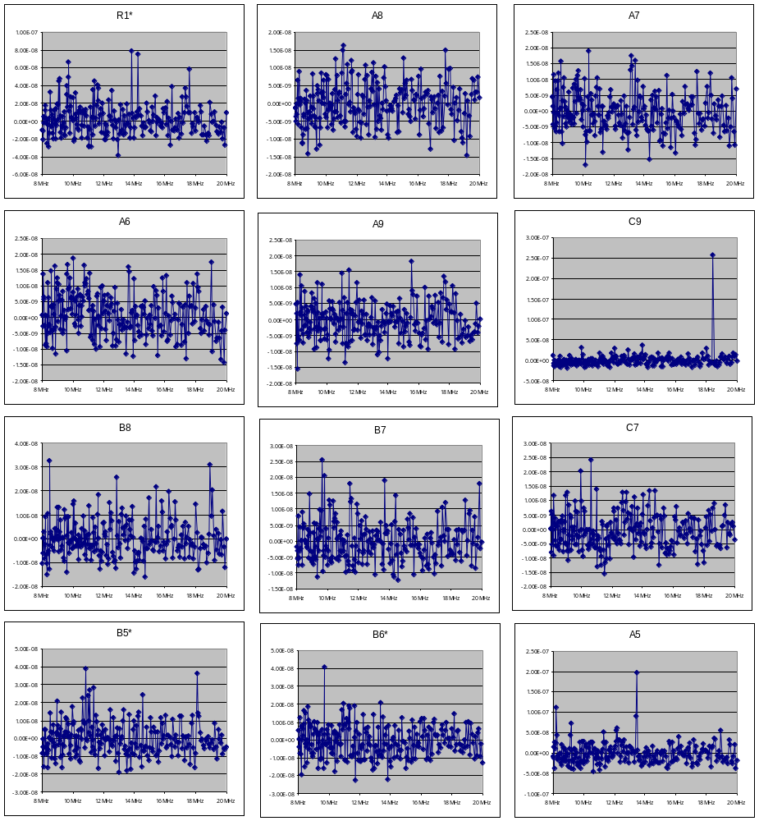
Figure 2 - 8-20MHz sweep channel 1-12 response

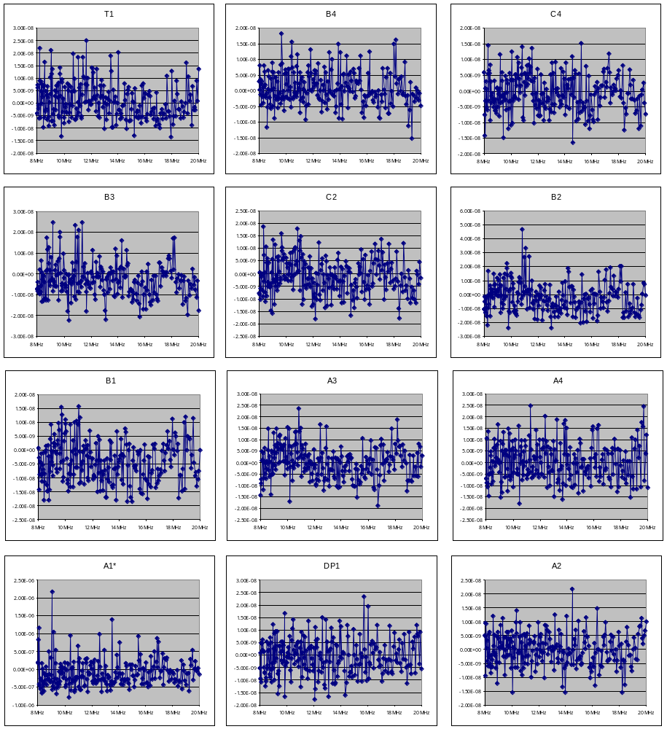
Figure 3 - 8-20MHz sweep channel 13-24 response

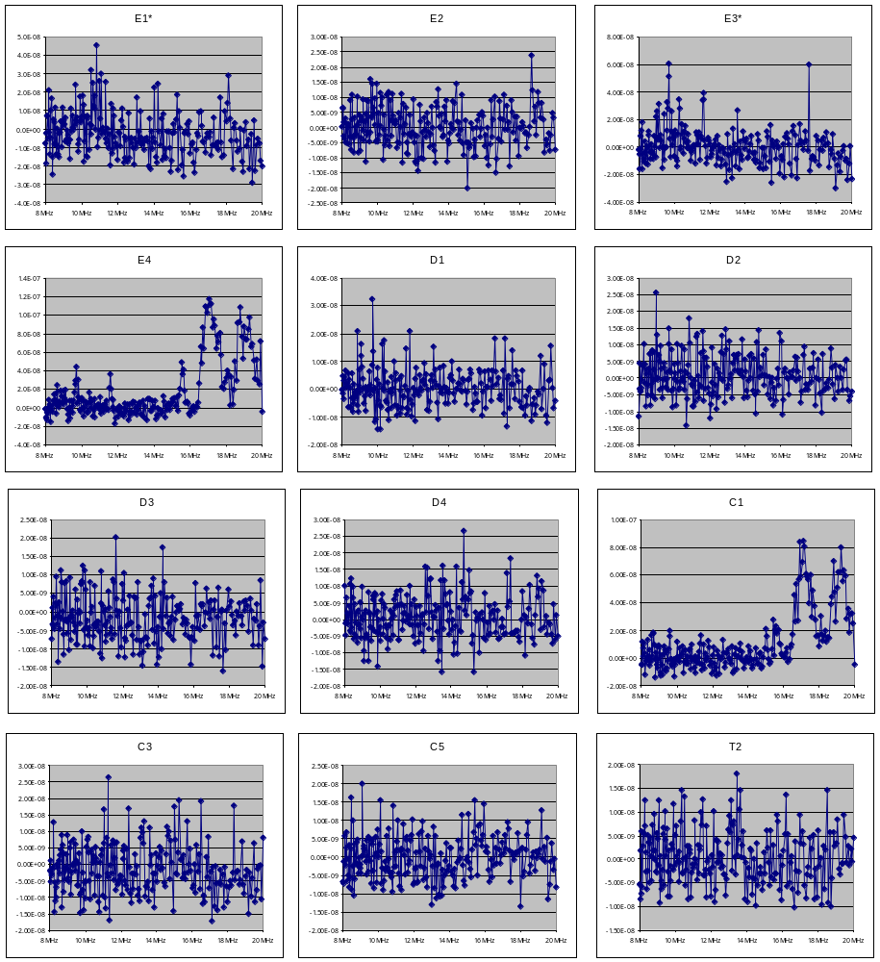
Figure 4 - 8-20MHz sweep channel 25-36 response
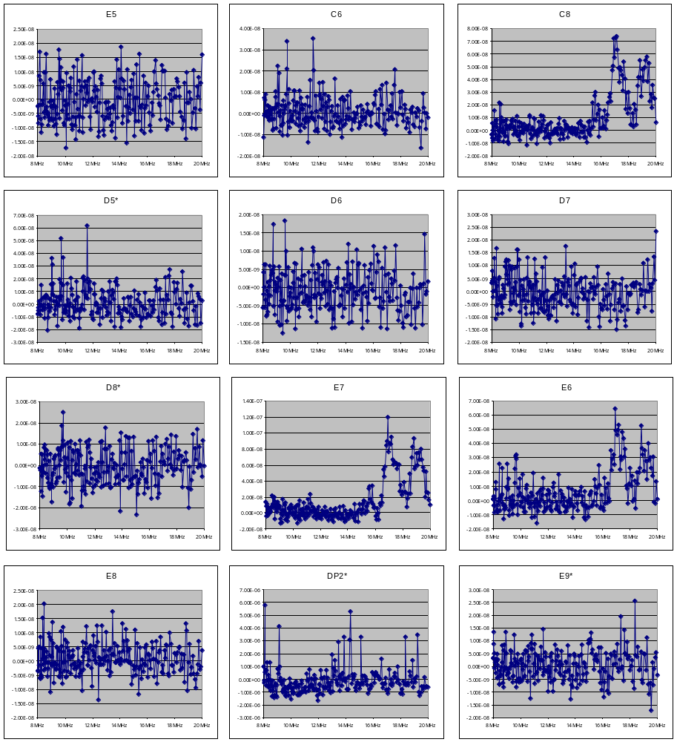
Figure 5 - 8-20MHz sweep channel 25-36 response

20-120MHz Band: 1.2V/m + 6dB
    - Test conditions

Test type | Frequency Sweep
Signal | Sinusoidal
Amplitude Modulation | 100% Amplitude  1 Hz  80% duty cycle (800ms on: 200ms off)
ObsID | 0xB0000040
Injection Amplitude | 1.2V/m + 6dB = 2.4V/m
Start Frequency | 20MHz
End Frequency | 120MHz
Frequency Step | 1% (Log-linear)
Step Dwell | 5 sec
EMI Countermeasures | None
Antenna | Biconic, ~ 1m from cryostat
Time | 17-10-2006 12:38

Susceptibilities were on QLA during this test, so it was decided to repeat this portion of the spectrum at 1.2V/m.
  - 20-120MHz Band: 1.2V/m + 0dB
    - Test conditions

Test type | Frequency Sweep
Signal | Sinusoidal
Amplitude Modulation | 100% Amplitude  1 Hz  80% duty cycle (800ms on: 200ms off)
ObsID | 0xB0000042
Injection Amplitude | 1.2V/m + 6dB = 2.4V/m
Start Frequency | 20MHz
End Frequency | 120MHz
Frequency Step | 1% (Log-linear)
Step Dwell | 5 sec
EMI Countermeasures | None
Antenna | Biconic, ~ 1m from cryostat

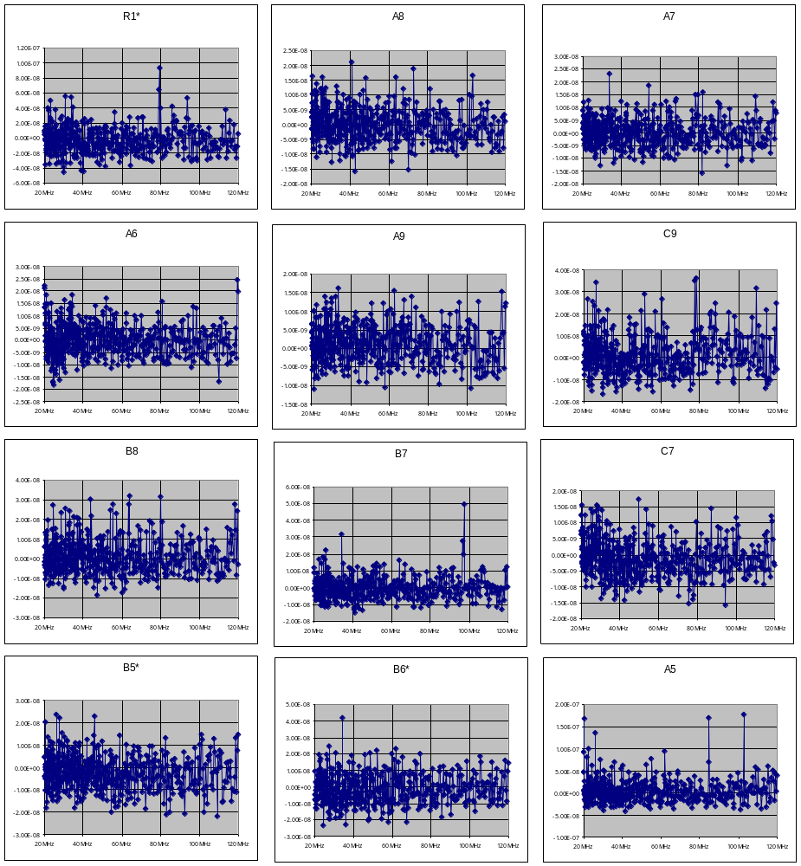
Figure 6

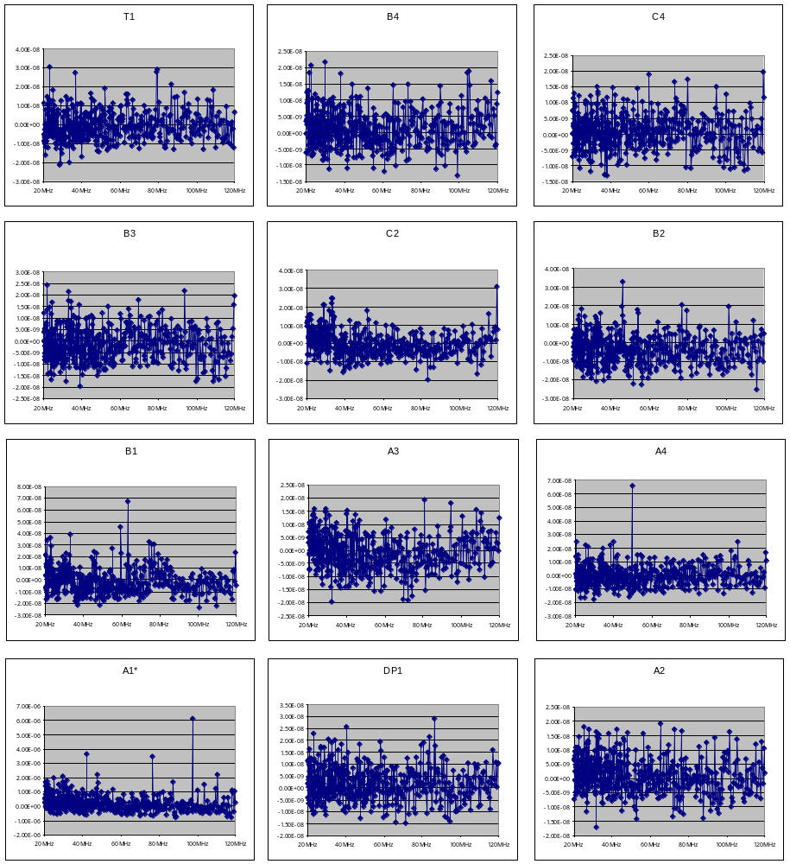
Figure 7
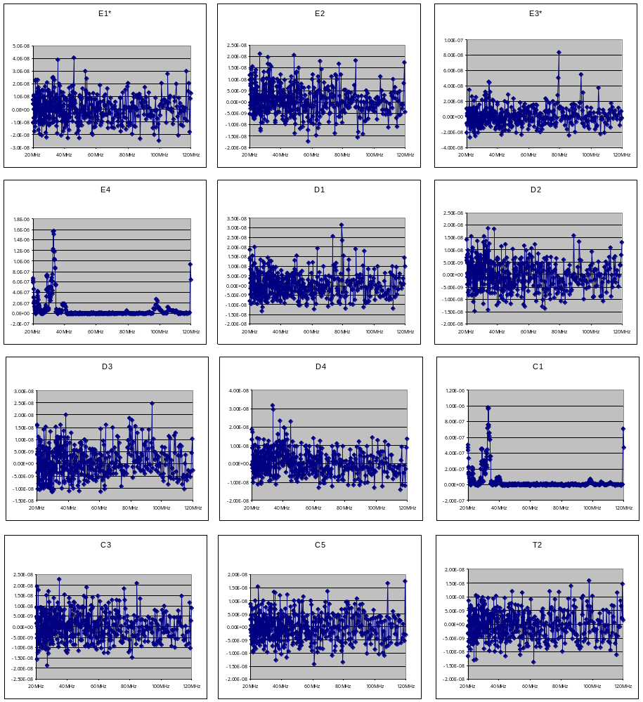
Figure 8
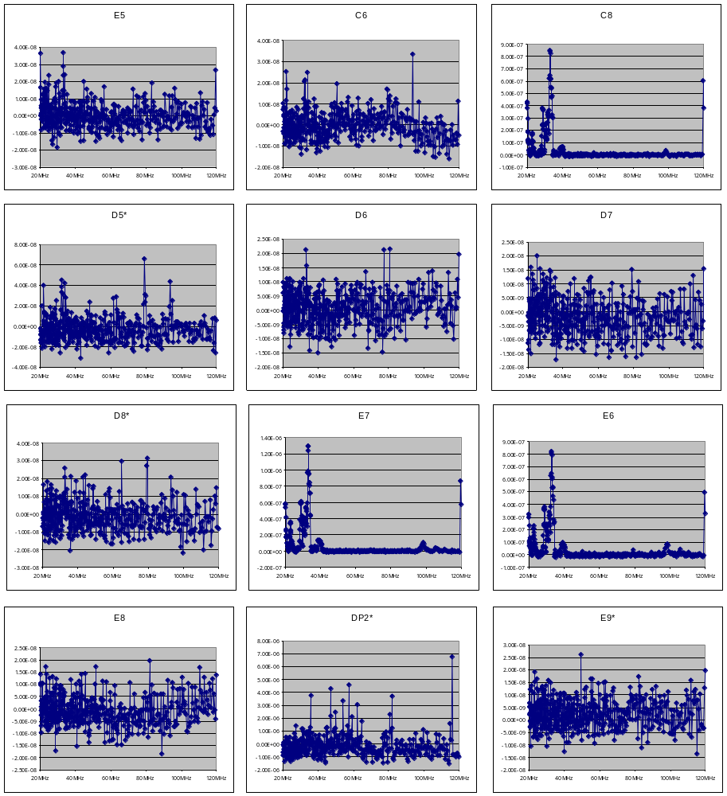
Figure 9

Manual search for Peak Susceptibilities

Test carried out by setting the function generator to an initial frequency known to be lower than the peak susceptibility and manually stepping the frequency up in small increments. At each step, the magnitude of the EMI is recoded as being better or worse. The assumption is that there is only one global peak susceptibility in the range of frequencies selected.

32.56697
32.89264 | Worse
33.22156 | Worst
33.55378 | Better

22.5365
22.76187 | Worse
22.98948 | Worst
23.21938 | Better
23.45157 | Better

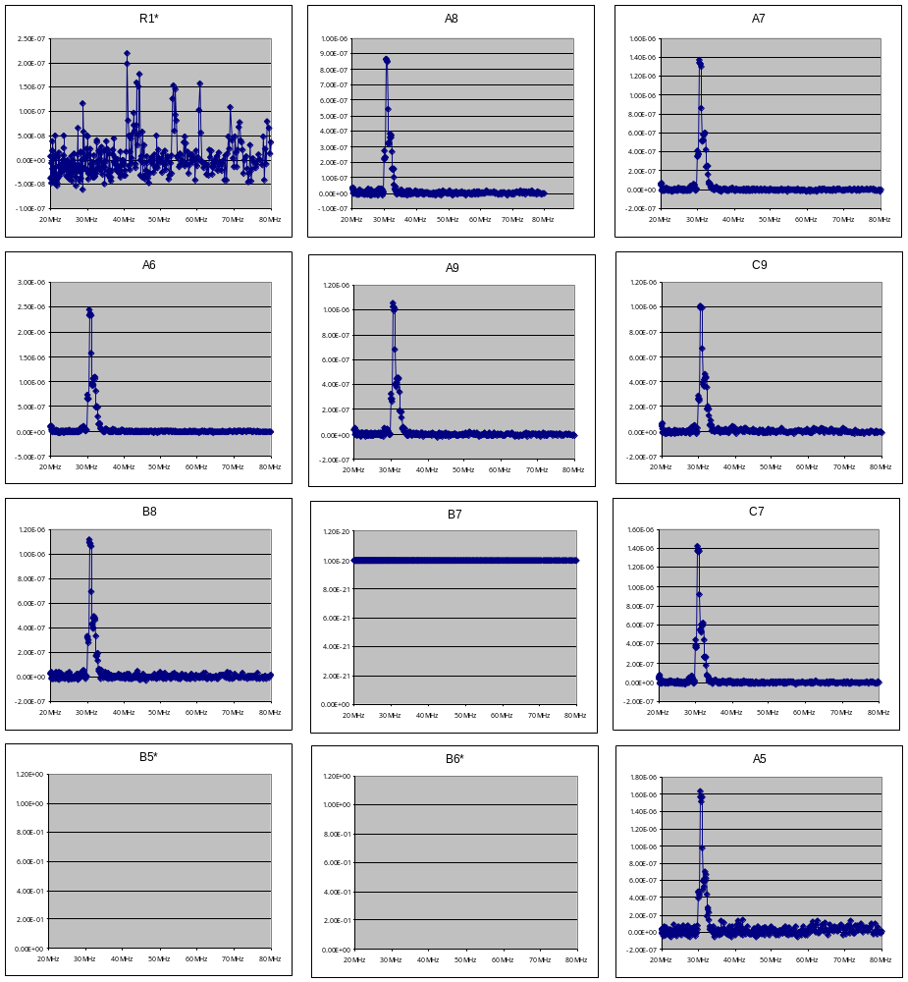
Figure 10
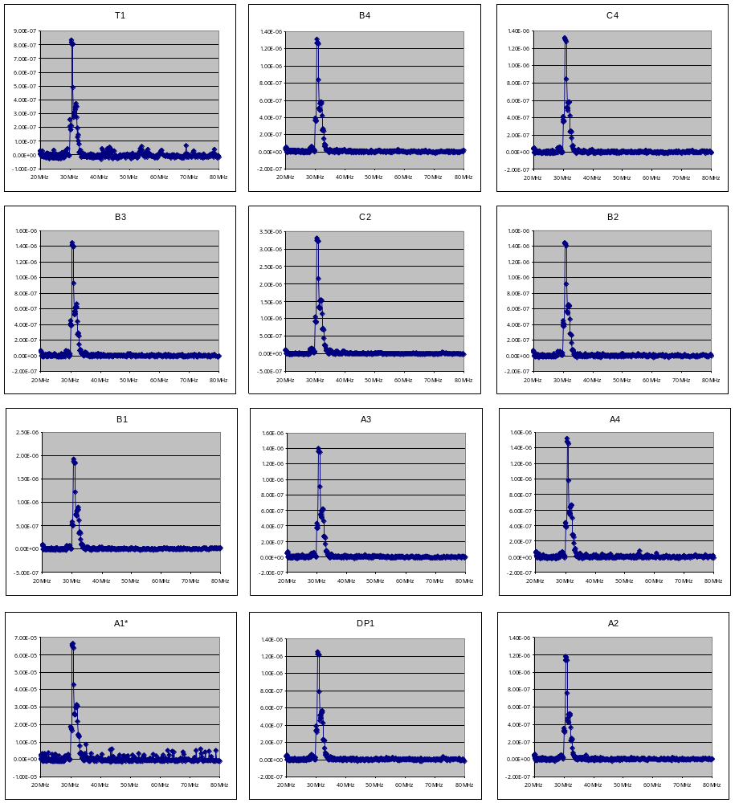
Figure 11

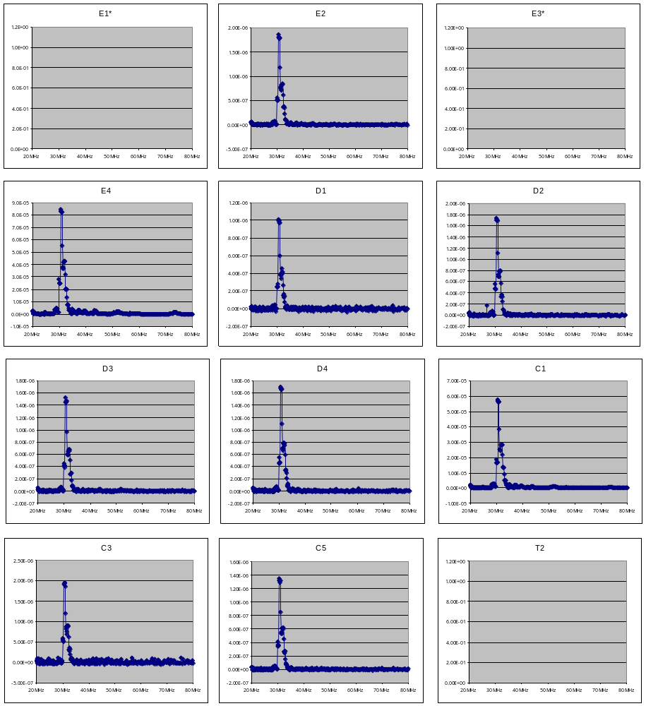
Figure 12
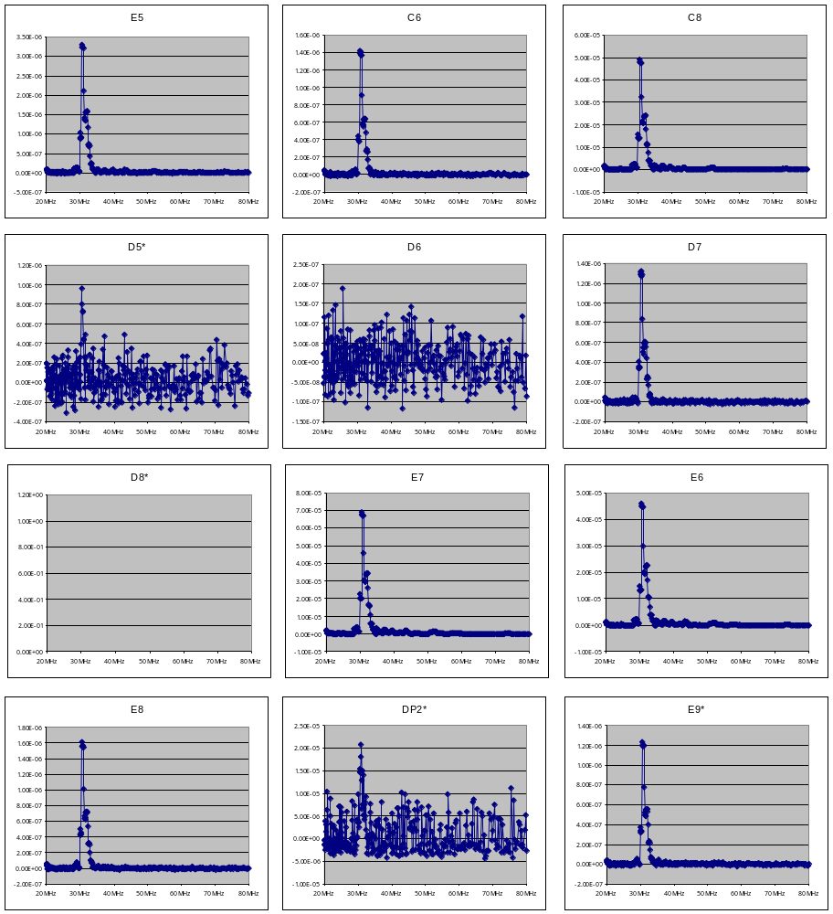
Figure 13
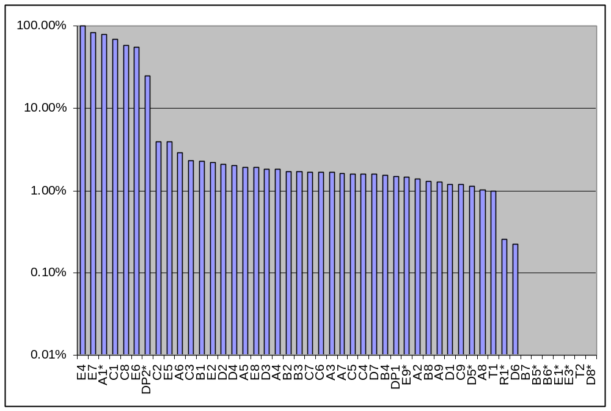
Figure 14 – Normalised susceptibilities (wrt E4 which showed highest susceptibility in this sweep)
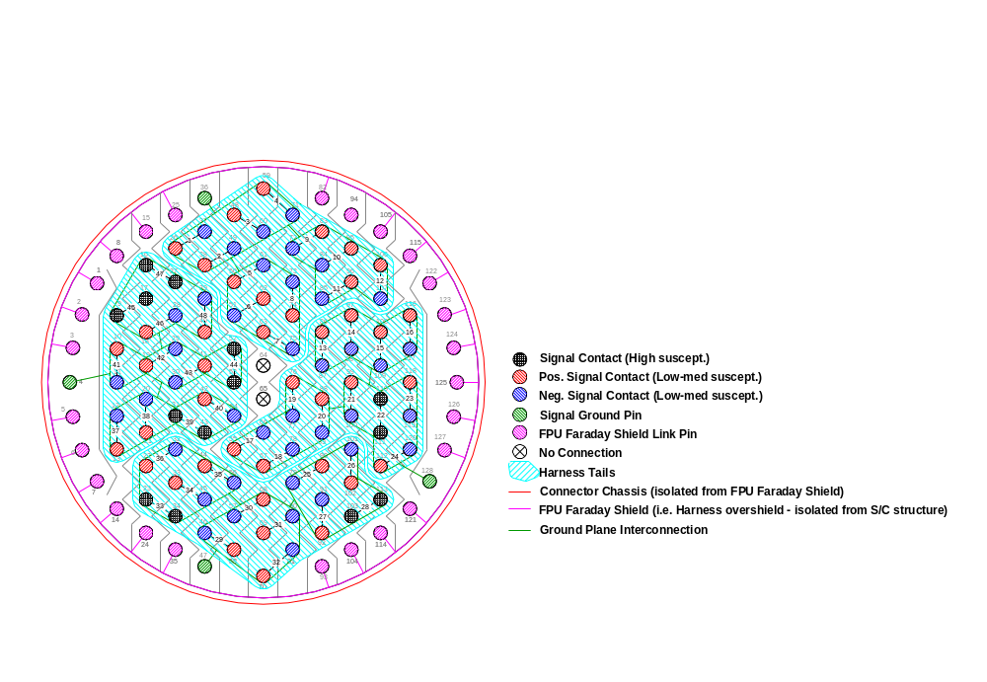
Figure 15 - Schematic view of contact arrangement/allocation on PLW vacuum feedthru. The seven most susceptible channels are cross hatched in black ink.
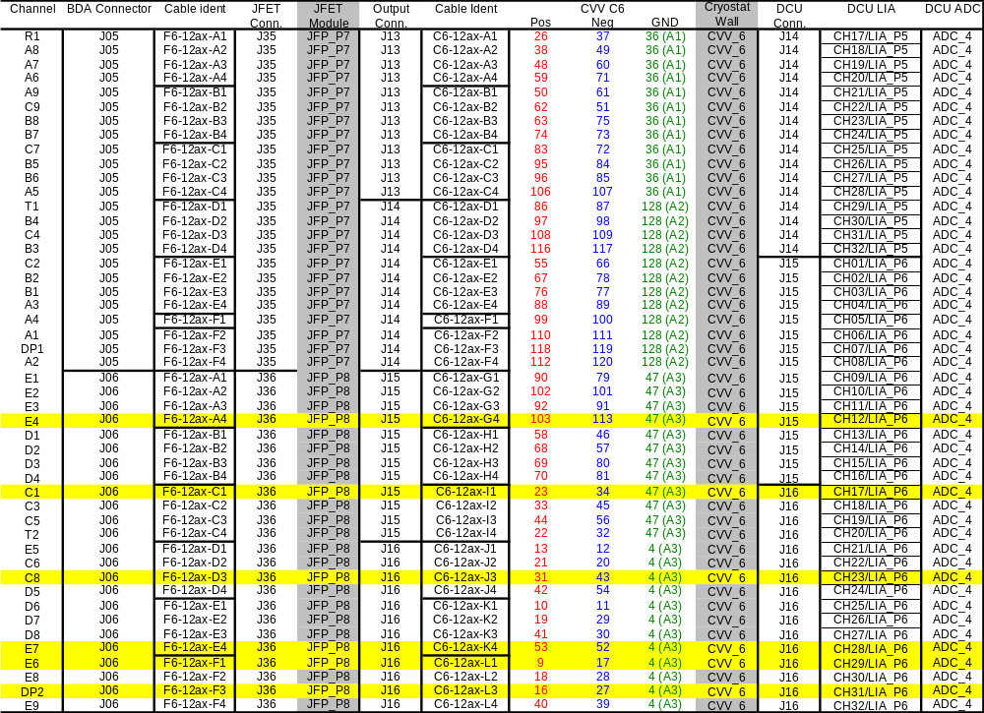
Figure 16 - Detector channel system table. Yellow highlighted rows correspond to nominally functional channels with large susceptibility

Test conditions

Test type | Frequency Sweep
Signal | Sinusoidal
Amplitude Modulation | 100% Amplitude  1 Hz  80% duty cycle (800ms on: 200ms off)
ObsID | 0xB000007E
Injection Amplitude | 1.2V/m + 6dB = 2.4V/m
Start Frequency | 20MHz
End Frequency | 80MHz
Frequency Step | 2% (Log-linear)
Step Dwell | 10 sec
EMI Countermeasures | 6 Ferrites on each harness
Antenna | Biconic, ~ 3m from cryostat

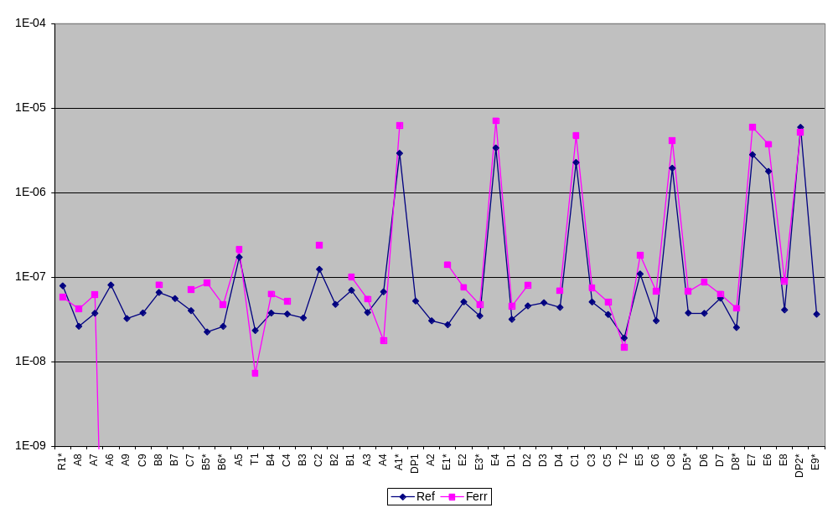
Figure 17 - Comparison between peak susceptibility in the 20-80MHz range with Ferrite to the peak without a Ferrite
Figure 18

  - Susceptibility Threshold at 30.9 MHz
    - Channels 1-12

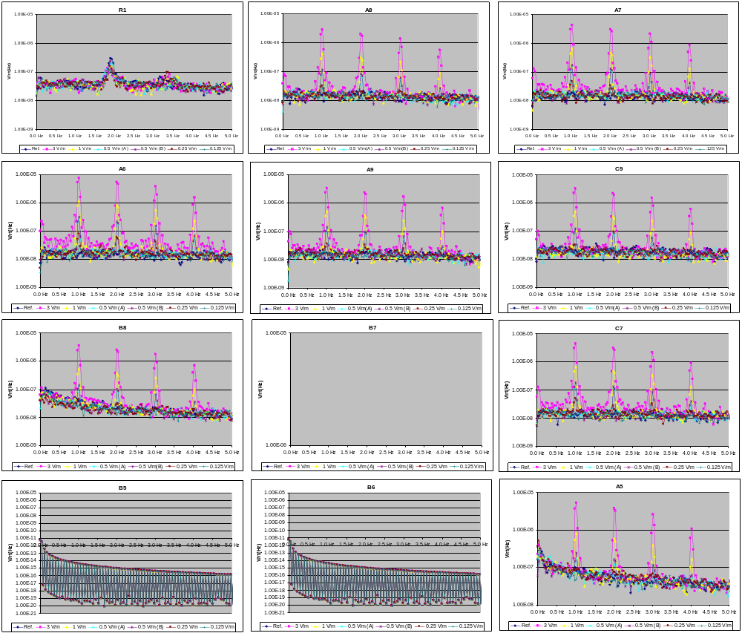
Figure 19
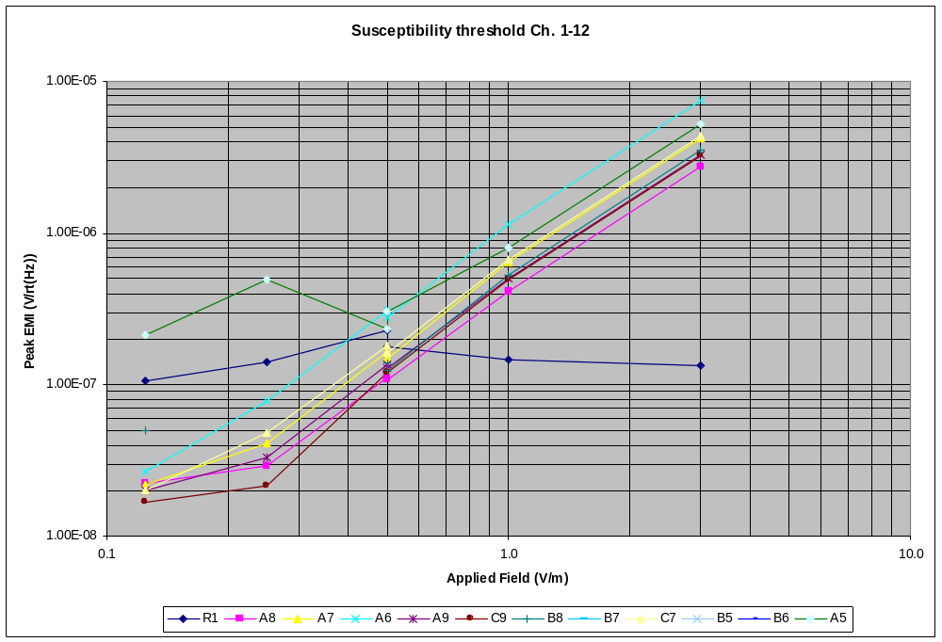
Figure 20

    - Channels 13-24

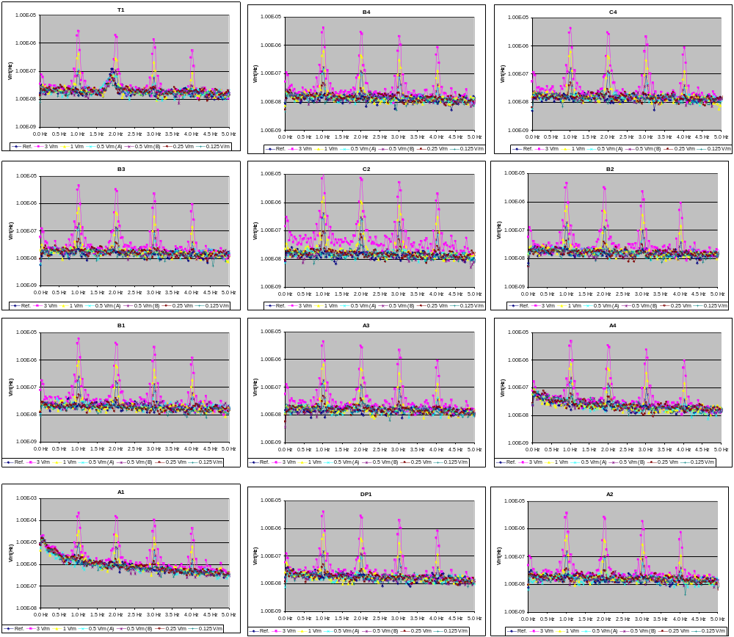
Figure 21

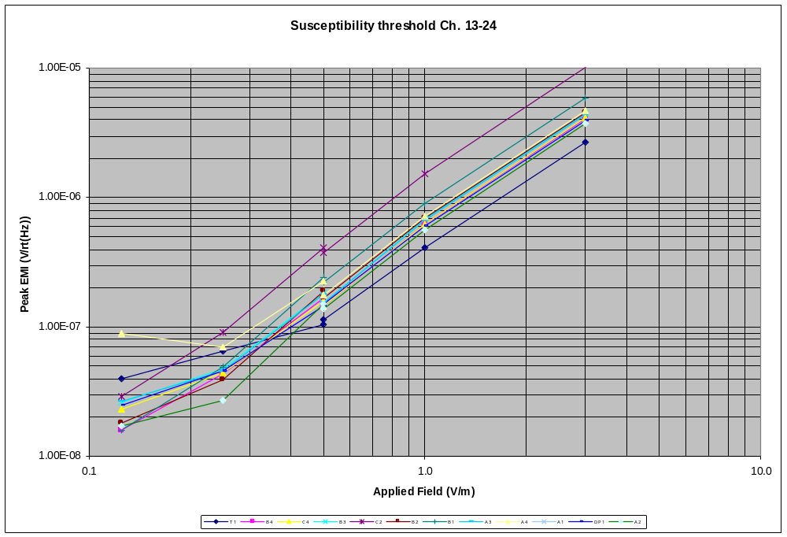
Figure 22

    - Channels 25-36

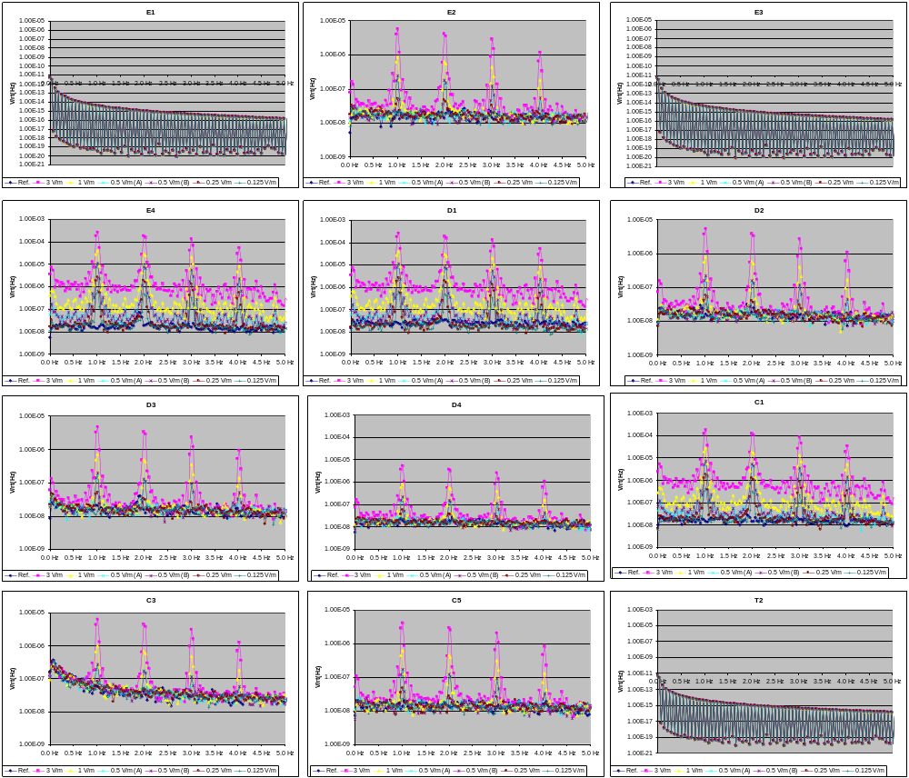
Figure 23 – Channels E1
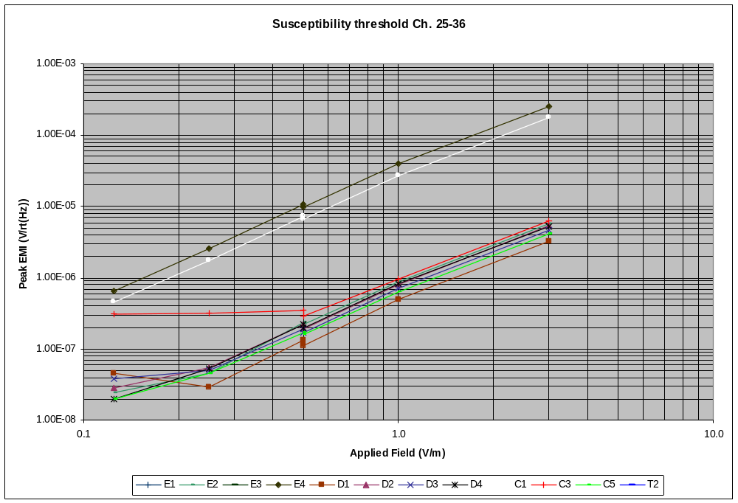
Figure 24

    - Channels 37-48
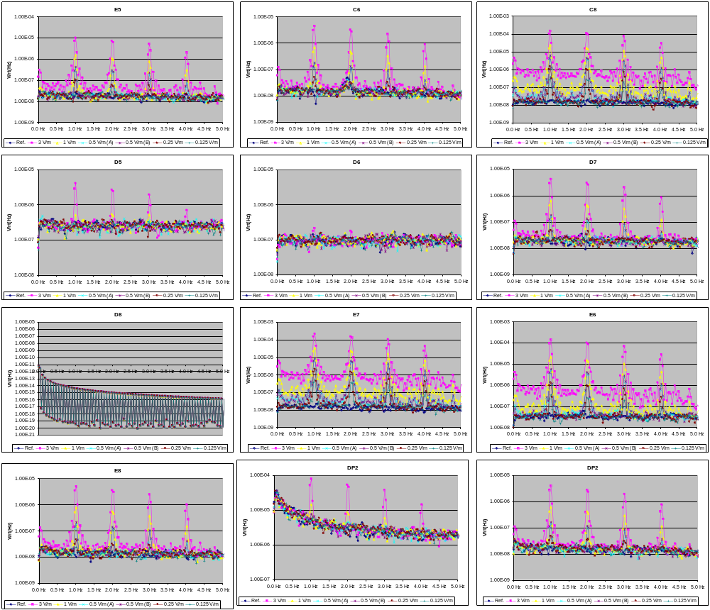
Figure 25

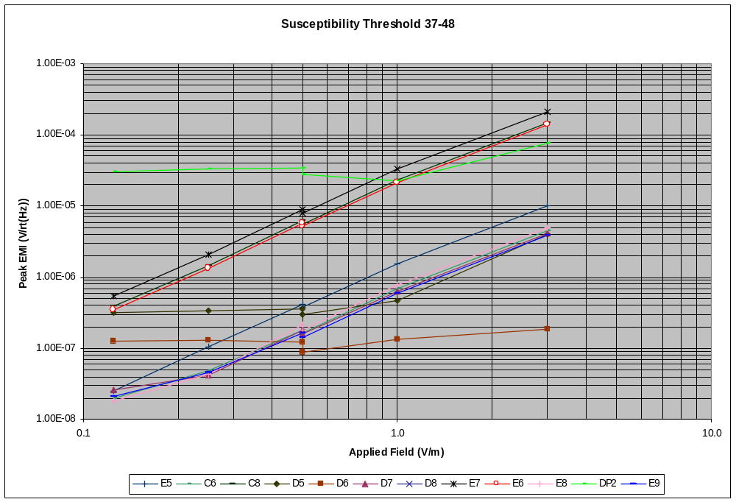
Figure 26

- Comparison STM2 and EQM susceptibility thresholds
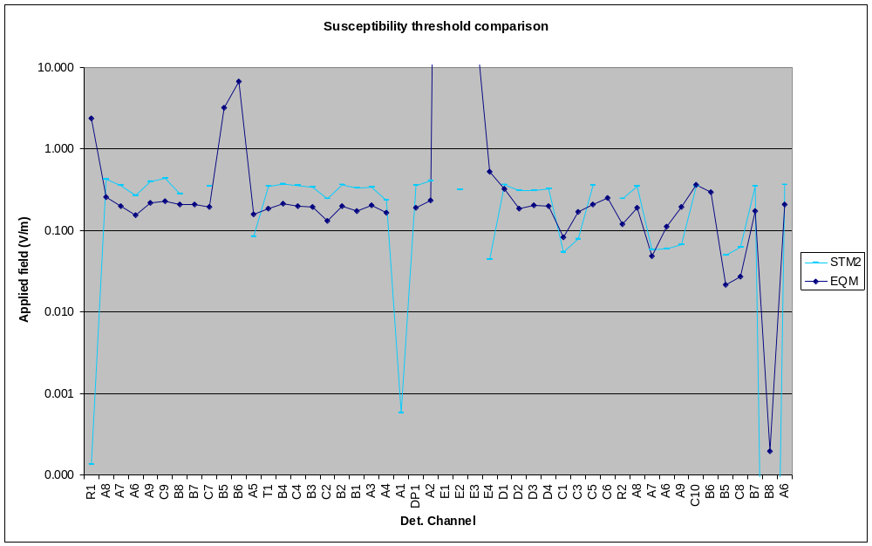
Figure 27 - Comparison between susceptibility threshold found during EQM and STM2 tests. Plots indicate the field which induces a peak noise PSD of 100nV/rt(Hz)

- Load curve analysis
Estimated power and noise for 30 MHz EMC test during STM2 testing.

Upper plot is estimated absorbed power measured two different ways – comparison to dark loadcurve (red) and comparison to internal thermistor (purple)

Lower plot is estimated voltage noise for dark loadcurve (black) and during EMC irradiation (purple)

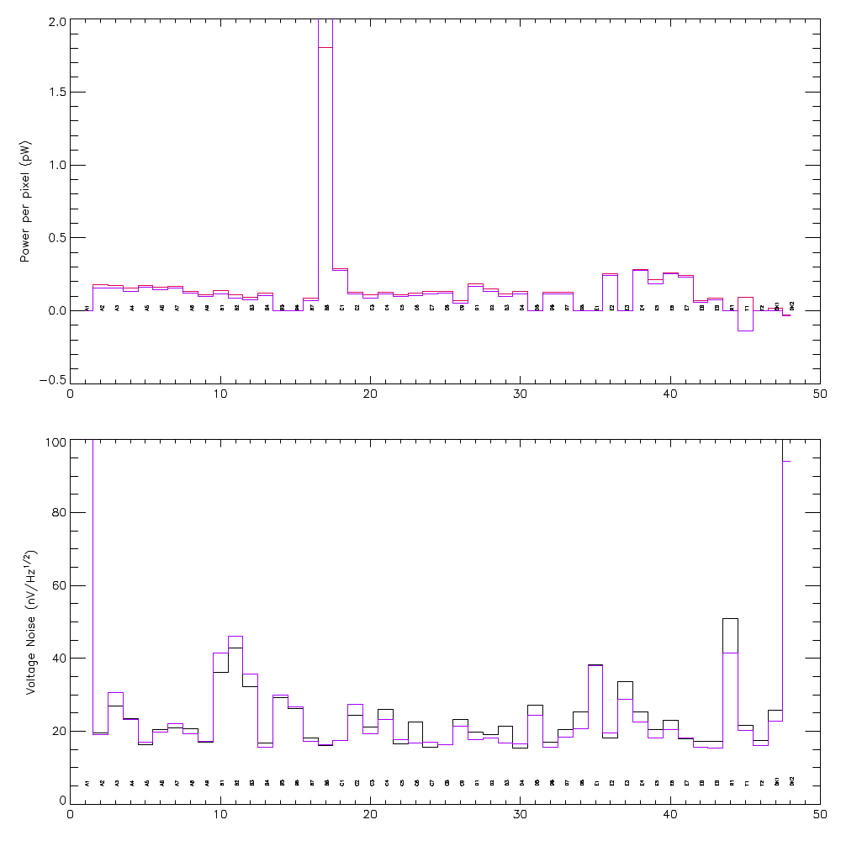
Figure 28 - Load curve analysis

Appendix 1 – Susceptibility threshold during EQM Test Campaign

Appendix 2: Length of cryoharness and λ/2 resonance
Function | Harness | CS | IS | SS | Total | Half wave resonant frequency
Spect Bias | SIH-01 | 1350 mm | 2455 mm | 1245 mm | 5.05 m | 29.7 MHz
SSW | SIH-02 | 1315 mm | 2816 mm | 1206 mm | 5.34 m | 28.1 MHz
Phot Bias | SIH-03 | 1270 mm | 2136 mm | 1547 mm | 4.95 m | 30.3 MHz
PMW | SIH-04 | 1280 mm | 2816 mm | 1556 mm | 5.65 m | 26.5 MHz
PMW | SIH-05 | 1200 mm | 2816 mm | 1728 mm | 5.74 m | 26.1 MHz
PLW | SIH-06 | 1165 mm | 2816 mm | 1265 mm | 5.25 m | 28.6 MHz
PSW | SIH-07 | 1035 mm | 2365 mm | 1242 mm | 4.64 m | 32.3 MHz
PSW | SIH-08 | 1245 mm | 1905 mm | 1279 mm | 4.43 m | 33.8 MHz
PSW | SIH-09 | 1295 mm | 2816 mm | 1252 mm | 5.36 m | 28.0 MHz
S/S Prime | SIH-10 | 1790 mm | 2024 mm | 1784 mm | 5.60 m | 26.8 MHz
S/S Prime | SIH-11 | 1710 mm | 1843 mm | 1858 mm | 5.41 m | 27.7 MHz
S/S Red. | SIH-12 | 1630 mm | 1896 mm | 1717 mm | 5.24 m | 28.6 MHz
S/S Red. | SIH-13 | 1790 mm | 1748 mm | 2015 mm | 5.55 m | 27.0 MHz
Table 2
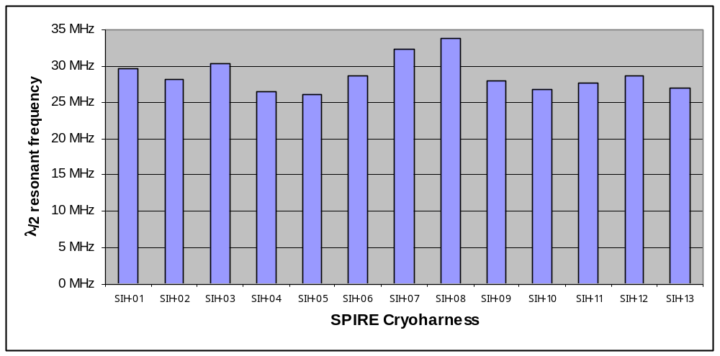
Figure 29

