SPIRE flight model deliverables

Cold vibration qualification report – HSO-CDF-RP-078
P. Hargrave. 5th October 2004

Introduction
This document records the warm and cold vibration qualification tests carried out on the following hardware deliverables for SPIRE:-
- 300mK strap supports and light baffles LTS-DM-100, LTS-DM-300 – flight design.
- SCal reduced power version – SCAL-FS-000. Note that this item has since been accepted as the actual flight model unit.
- Pcal DM – this unit is the Pcal lifetest source mounted in the DM structure. This test was performed after the lifetest cycle had been successfully completed.
- Two additional Pcal sources in sealed chambers – one mica-based device, and one sapphire-based unit. The sapphire unit is a flight-replica design.
- Beam divider unit in CQM mount – flight design.
- Sample of blackened tile – flight design

Test configuration

300mK strap support components
The 300mK strap support components were mounted in the configuration shown in Figure 1. A bus-bar replica was manufactured, with an accelerometer mounted at the apex, to replicate the mechanical loading expected on the Kevlar-suspended 300mK parts of the system.

SCal unit
This unit, at the time of the test, was designated the flight spare unit. It was built to a revised design to the already qualified flight model unit, following a change request from the project to reduce power dissipation.
It was mounted on a bracket off the shaker plate as shown in Figure 2. The unit was sealed with vented bags for cleanliness.

Pcal unit
The Pcal unit comprised the lifetest source (HB-27) mounted in the DM structure. This vibration test was performed after HB-27 had successfully completed the lifetest qualification tests. The unit was mounted on a bracket off the shaker plate as shown in Figure 3.

Additional PCal sources
Two additional PCal sources were mounted as shown in Figure 4.
These sources were HB-21 (sapphire – flight type) and HB-25 (mica – non-flight design).

Beam divider unit
A flight replica beam divider unit was mounted off the shaker plate in a flight-design (CQM) mount, as shown in Figure 5. This component was bagged for cleanliness, as the mount was from the CQM instrument.

Blackened tile sample
An aluminium tile was manufactured and blackened according to the flight design and procedure. It was mounted according to the RAL procedure to an aluminium box, as shown in Figure 6. The tile sample was bagged so that if any particles were dislodged during the shake, they would be contained.

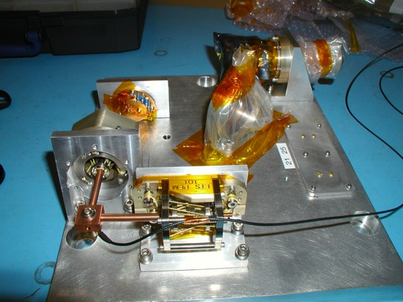
Light baffle unit
Photometer bus-bar support
Bus-bar replica with accelerometer at apex
Figure 1 Configuration used for vibration testing of 300mK strap support components. Note the accelerometer mounted on the suspended copper bus-bar replica.

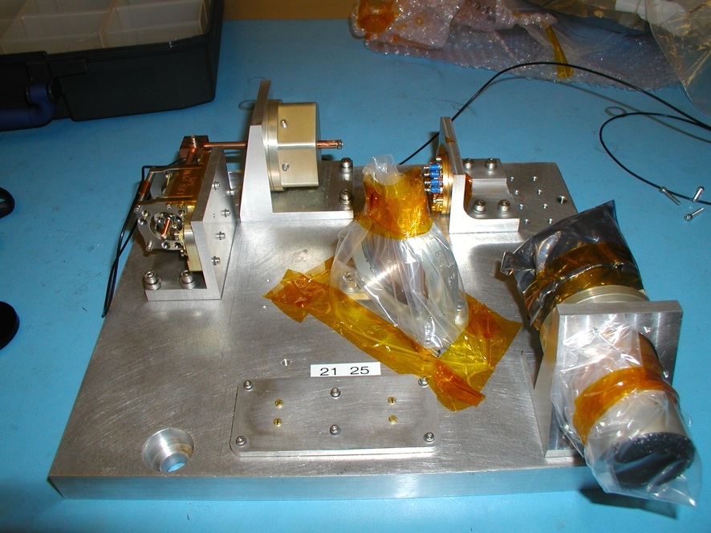
SCal flight spare unit
Figure 2 SCal flight spare model on shaker plate.
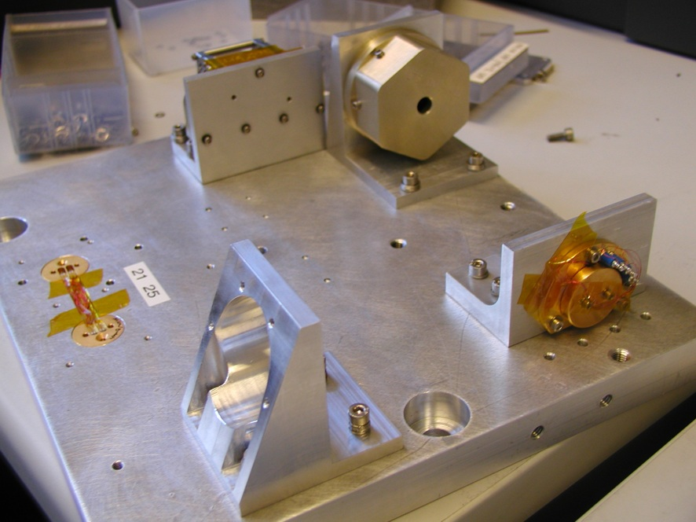
PCal DM unit
Figure 3 PCal DM in mounting bracket.
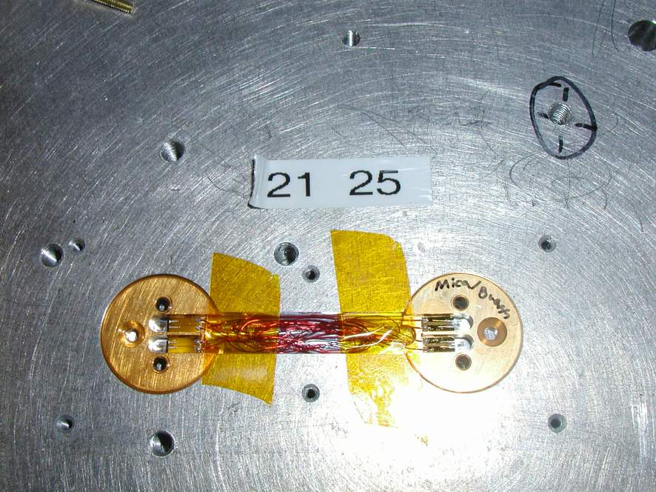
Figure 4 Additional PCal-type sources, prior to covering with aluminium plate.
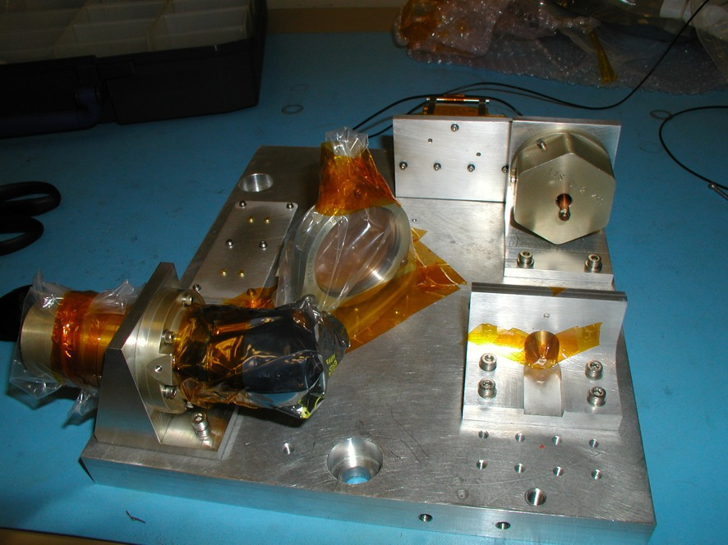
Beam divider in CQM mount
Figure 5 Beam divider in CQM mount.
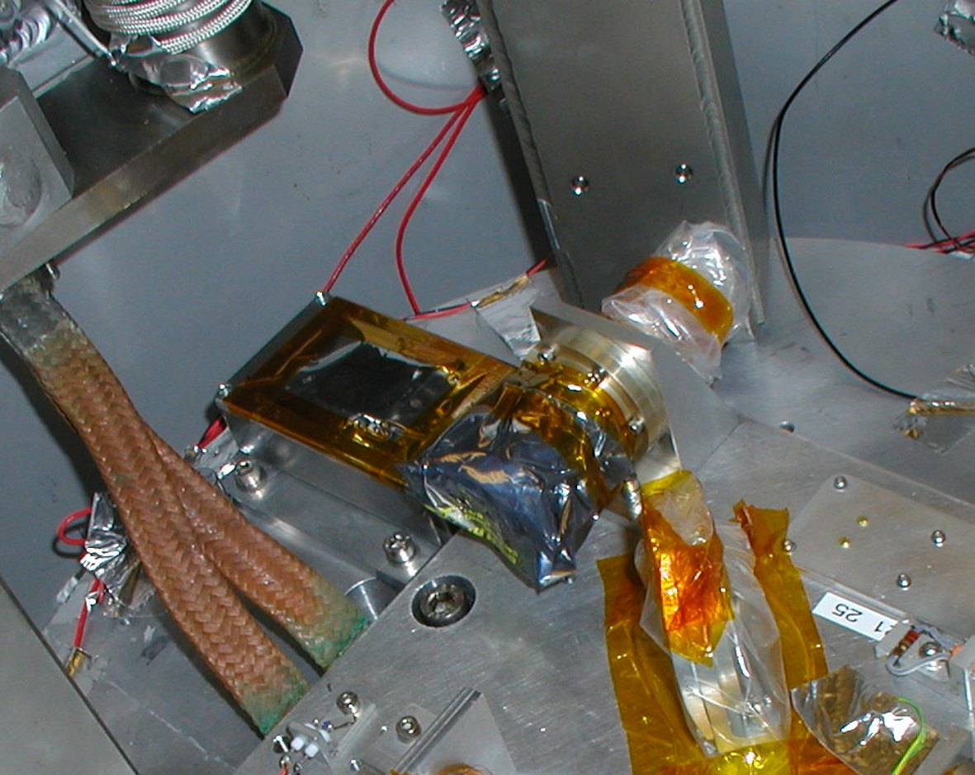
Blackened tile sample
Figure 6 Tile mounted on aluminium box – bagged for cleanliness and for capture of any particles which may be dislodged.

Test report
Full details of the warm and cold vibration test are contained in the RAL vibration test report, AIV-2003-091-VIB, attached to this document as Appendix A.

Post-test inspections

300mK strap support components
Following removal of the shaker plate from the cold vibration test facility, the 300mK strap support components were examined for any sign of damage or movement. The location of the bus-bar apex with respect to the supports and the shaker plate had not changed following the shake. Therefore the bus-bar replica was removed and the support and light baffle were examined individually. There were no signs of Kevlar distress on either unit, nor any sign of particulate contamination from e.g. the black coating on the light baffle. No movement of the suspended hubs was discernable for either unit, as the alignment caps fitted each unit perfectly both before and after the shake.

SCal unit
Visual inspection of the unit revealed no visible damage.
The unit was subsequently re-calibrated at Cardiff, and no difference was observed in its’ performance compared to the equivalent test before vibration.

Pcal unit
Visual inspection of the unit revealed no visible damage.
The unit was subsequently re-calibrated at Cardiff, and no difference was observed in its’ performance compared to the equivalent test before vibration.

Additional PCal sources
Visual inspection of the sources revealed no visible damage.
The sources were subsequently re-calibrated at Cardiff, and no difference was observed in their performance compared to the equivalent test before vibration.

Beam divider unit
Visual inspection revealed no damage.
The beam divider was measured spectrally following the vibration test and showed identical performance to the pre-shake measurements.

Blackened tile sample
The bag containing the tile sample was carefully removed, and no debris was noted.
Careful microscopic examination of the tile sample shows no sign of cracking.

