HBI-8 life test

(Results)
25 October 2004

Document Ref.: HSO-CDF-RP-091
Issue: 1.0

Prepared by: Iris Didschuns
Last Modified on: 15 March 2005

Distribution list
Table of Content
HBI-8 life test 1
(Results) 1
1. Introduction 3
2. Characterization before the life test 4
2.1 Dark current 4
2.2 Raw data 6
2.3 Time constant 6
2.4 Power 8
3. Life test 9
3.1 Prime Source 9
4. Characterization after the life test 12
4.1 Dark current 12
4.2 Raw data 13
4.3 Time constants 13
4.4 Power 15
5. Summary 16

Introduction
The life test was carried out to show that the internal SPIRE photometer calibrator (PCAL) is capable of 250000 operational cycles (IRD SPIRE-RAL-PRJ-000034) during the mission lifetime without failure. The actual number of cycles in the life test was increased by a margin factor of 1.5 (375000 operational cycles) ensuring reliable performance well above the requirement.
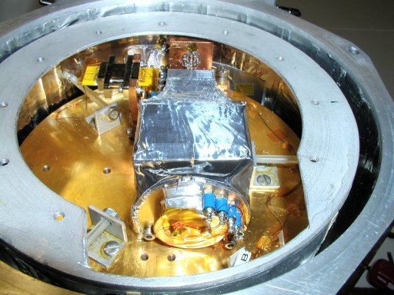
Figure 1: PCAL HBI-8 source mounted onto the cold plate of the test cryostat.
Both Pcal sources were NiCr film deposited onto sapphire substrate suspended as by brass wires that also provided the electrical connections. The brass wires are connected to the sapphire substrate and mount via indium solder. The indium solder connection was then covered by a layer of silver epoxy to strengthen the connection. The source is labelled as HBI-8 (Figure 2) that indicates it is a Haller-Beeman source with Indium contacts and "8" is identification number.

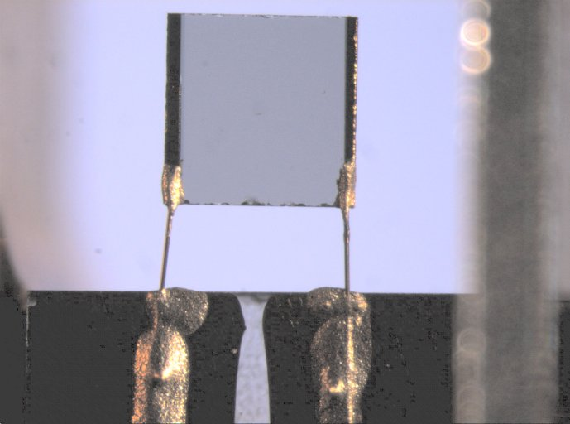
Figure 2: Close-up of HBI-8 primary source
The life test had to be repeated because the difference in the way the brass wires was connected to the source. Previously an impedance change was observed during thermal cycles with bare silver epoxy connection in place.
During the first characterisation test the redundant source showed a short and a drastically impedance change. The cause of the change is not yet determine, however the short was fixed but the impedance was permanent. Therefore the life test was only carry out with the primary source of HBI-8. Nevertheless this has no influence running the life test because both sources are identically. So it is only necessary to show that one source survives the life test without failure or changes in the properties.
The Pcal source resistances were determined with as a 4-wire measurement using an ac resistance bridge (AVS-47) with the excitation set at 300 μV (Table 1).

 | Resistance (Ω)
 | 300 K | 77 K | 4.2 K
Primary source | 192.9 | 182.97 | 183.37
Table 1: HBI-8 primary source resistance determined with 4-wire measurement at different temperature.
The test was carried out from 26.10.2004 to 29.10.2004 and the data can be found in \\Darkstar\Astroworld\Projects\Spire\Cardiff_workpackages\PCAL\life test\.
A detailed description of the test set-up can be found in \\Darkstar\Astroworld\Projects\Spire\Cardiff_workpackages\PCAL\Assembly&test\PFM\Experimental Set-up version2.doc and of the test procedure an in \\Darkstar\Astroworld\Projects\Spire\Cardiff_workpackages\PCAL\Assembly&test\PFM\life test\HBI-8\Test procedure and record-HBI-8.doc.
The PCAL source was characterised by applying a constant power to it and simultaneously measuring the voltage across the photodetector. The power level was determined by measuring the voltage across a control resistor (R_{control}=909 Ω), connected in series with the HBI-8 illuminator, and the voltage across the illuminator. The control resistor was located outside the cryostat allowing an accurate current calculation and, therefore, a precise determination of the power applied to the Pcal source.

Characterization before the life test

Dark current
The dark current of the detector (Figure 3) was measured to ensure that no light leaks between the detector and the illuminator exists. A voltage bias of 250 mV for the photodetector amplifier was chosen because the voltage offset (caused by light leaks and/or different base temperature) is reasonable small and at the same time noise of the detector, voltage is small as well.
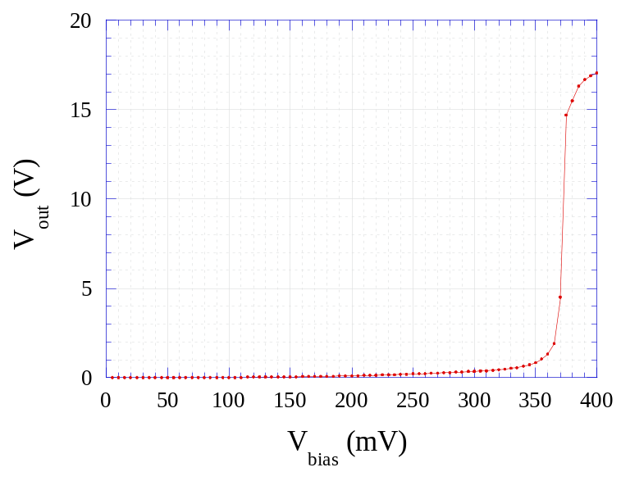
Figure 3: Detector voltage during the dark current measurement of photodetector by un-powered HBI-8 illuminator.

The detector darkcurrent and resistance can be calculated by knowing the value of the feedback resistor R_{F} (R_{F}=2.8*10⁹ Ω accordingly to GP measurement from 28/3/01):
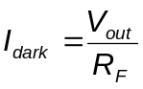; 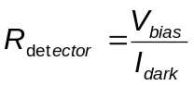
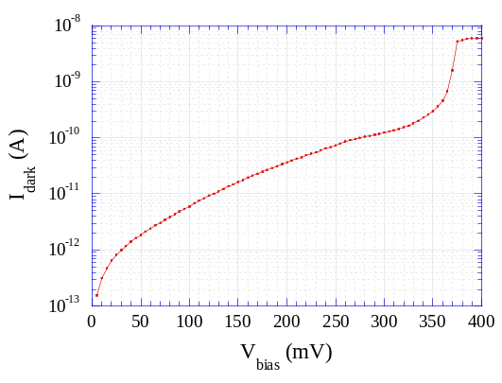 | 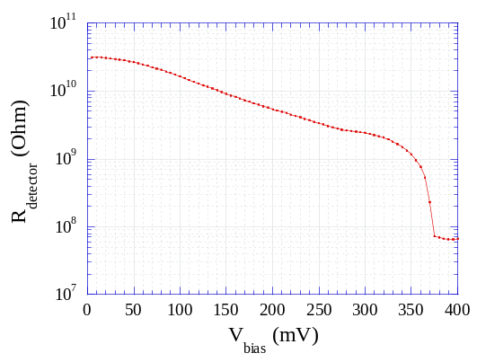
Figure 4: Dark current and Detector resistance of photodetector by un-powered HBI-8 illuminator with comparison to HB1.
V_{bias} (mV) | V_{out} (V) HBI-8 | V_{out} (V) HB1 | I_{dark} (A) HBI-8 | I_{dark} (A) HB1 | R_{det} (Ω) HBI-8 | R_{det} (Ω) HB1
250 | 0.20771 | 0.19908 | 7.4183·10⁻¹¹ | 7.11·10⁻¹¹ | 3.37·10⁺⁰⁹ | 3.5162·10⁺⁰⁹

The dark current measurement (Figure 4) showed HBI-8 has no light leak. The detector signal of HBI-8 at Vbias=250 mV is 4% higher then HB1 which could be explained by a higher temperature of the sample mount. This cannot be verified because the temperature was not monitored during the HBI-8 dark current measurement.

Raw data
The data file names having following structure:
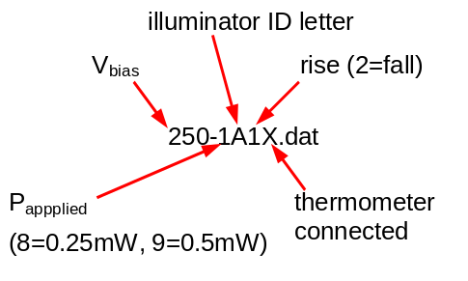
The Data were in stored in the HP SDF-format and been converted with \\Darkstar\Astroworld\Projects\Spire\Cardiff_workpackages\PCAL\Assembly&test\PFM\conversion program\SdfToAsc32.exe. This conversion program inverts the detector voltages and so the first step in the analysis is to invert back the detector voltage. Furthermore was the detector voltage offset subtracted from every detector voltage curves for each power level. As well, the time was normalized to allow an easy comparison between each power level. Figure 5 shows the normalised data during powering up (left side) and powering down (right side) for different power levels of the prime source.
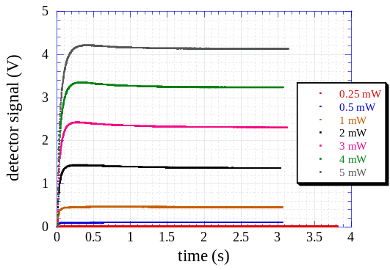 | 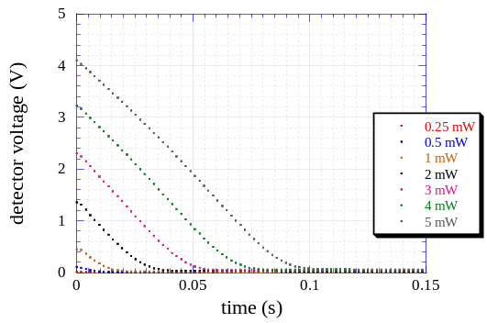
Figure 5: Detector voltage of the prime source during powering on (left side) and powering off (right side) for the various power levels measured.

Time constant
The rise time constants were defined as the time until the detector voltage reach 90% of its maximum value. The fall time constants were determined defined as the time taken for the detector voltage to drop 90% from the maximum once the power was switched off. Figure 6 and Figure 7 show the measured time constants (rise and fall) as a function of the illuminator power with the voltage bias on the amplifier set to V_{bias}=250mW. The data points are given in Table 2. The rise time constants are longer than the fall time constants in agreement with modelling.

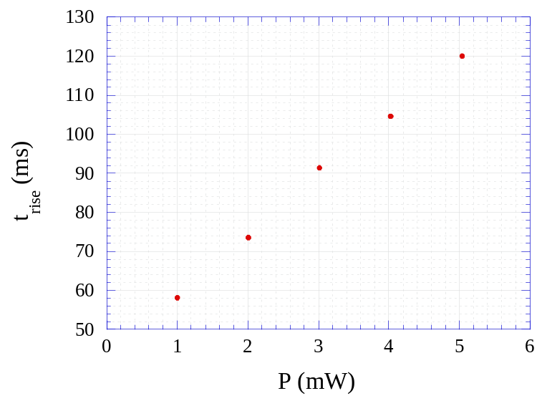
Figure 6: Rise time constants for the primary source (V_{BIAS}=250mV).
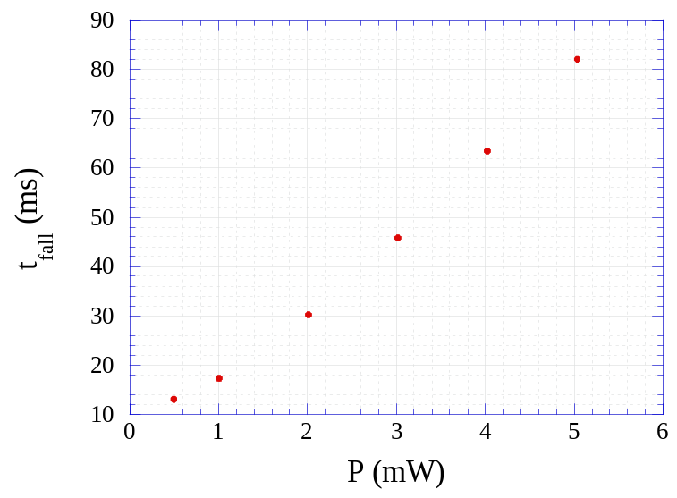
Figure 7: Fall time constants for the primary source (V_{BIAS}=250mV).

Primary source
P (mW) | t_{rise} (ms) | t_{fall} (ms)
0.502 |  | 13.09
1.004 | 58.12 | 17.27
2.010 | 73.48 | 30.21
3.017 | 91.39 | 45.75
4.025 | 104.61 | 63.47
5.037 | 120.04 | 82.09
Table 2: Rise and fall times for the primary source at given values of power input.

Power
The maximum detector voltage was determined by taking the maximum of the detector voltage after the illuminator was switch off. Figure 8 shows the maximum detector voltage measured as a function of illuminator power for the primary source with V_{bias}=250mV. The data points are given in Table 3.
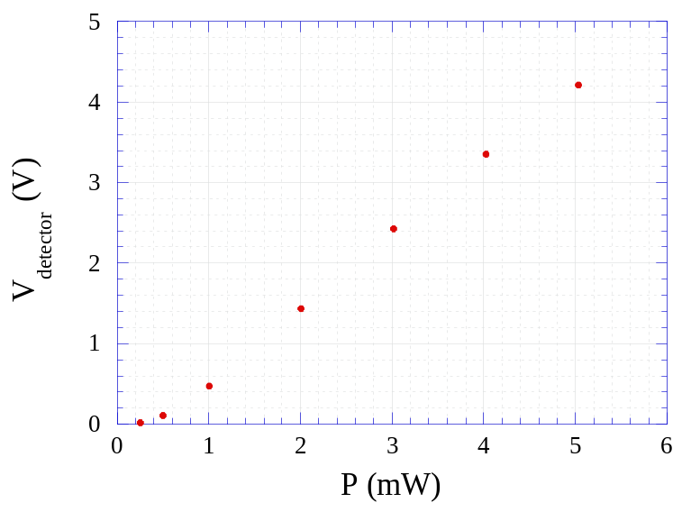
Figure 8: Detector voltage for the primary source measured (V_{BIAS}=250mV).

Primary source
P (mW) | V_{detector} (V)
0.251 | 0.016
0.502 | 0.107
1.004 | 0.469
2.010 | 1.434
3.017 | 2.428
4.025 | 3.350
5.037 | 4.213
Table 3: Maximum detector voltage measured at given values of power input.

Life test
The life tests were carried out by applying a continuous series of on/off pulses with constant excitation (P_{applied}=5mW) and equal width (300ms) to the PCAL sources. The life test was done only with the primary source due to above described reasons. To reduce the size of data file only every 100th cycle the time, V_{PCAL}, V_{drop}, V_{detector}, T_{CX25830} and the cycles number was recorded. The life test was split into three parts (125000 cycles) because the constant measurement of the detector voltage made it necessary to change the batteries in the pre-amplifier every day. Additional the detector signal V_{detector} of 10 cycles was then measured & recorded at the beginning, the middle and the end of the life tests in order to prove that the PCAL sources were still functional.

Prime Source
Figure 9 shows the dark current measurements measured during the life test of the HBI-8 primary source. There was no obvious change in the dark current during the life test. It may be conducted therefore, that any change in the detector voltage was not caused by the dark current.
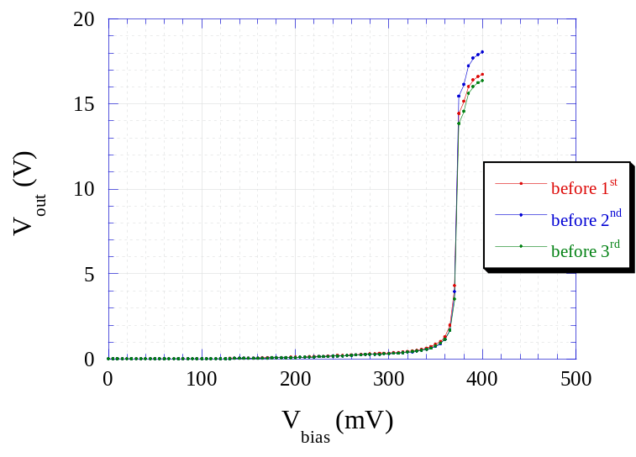
Figure 9: Dark current measurement during the life test of primary source.
Figure 10 shows the measured voltage of the primary HBI-8 source during its life test. The digitisation of the voltage is due to the resolution of the DAQ card and so it can be concluded the source did not change its resistance during the life test.
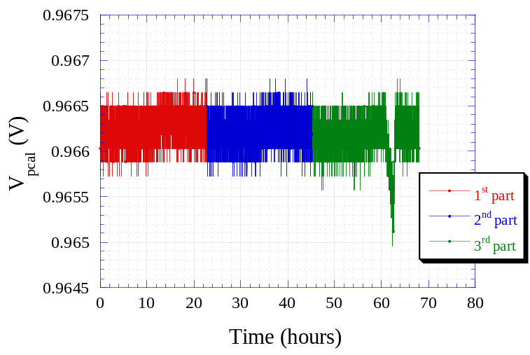
Figure 10: Measured voltage from HBI-8 prime source during the life test
The measured peaks/drops in the PCAL voltage correspond to changes in the temperature of the structure within which the detector and the PCAL source were mounted (Figure 11). This can be explained due to the effect that the resistance is increasing with decreasing temperature by the “Kondo Effect”. The Kondo effect describes the resistance increase with decrease temperature in metals due to magnetic elements or impurities inside the metal. The temperature dependence of the resistance was measured on a similar PCAL source (HB26) and an increase in the resistance with decreasing temperature around 10K can be observed.
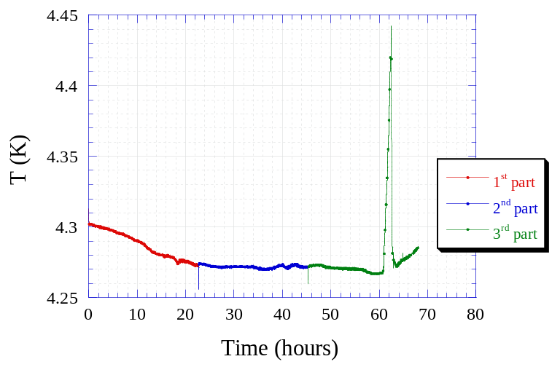
Figure 11: Measured temperature of the body structure housing the detector and the PCAL source.
The detector voltage for 10 cycles was measured at the beginning, the middle and the end of the life test (Figure 12) to prove that the PCAL source was still functional at these times. The measurements in Figure 12 were implemented using a LabVIEW program, where time responds was not as good as that of the spectrum analyser used previously (2.2). Nevertheless, this measurement showed that the PCAL source was working during the life test with no change in the detector voltage and, therefore no change in the PCAL source power output.
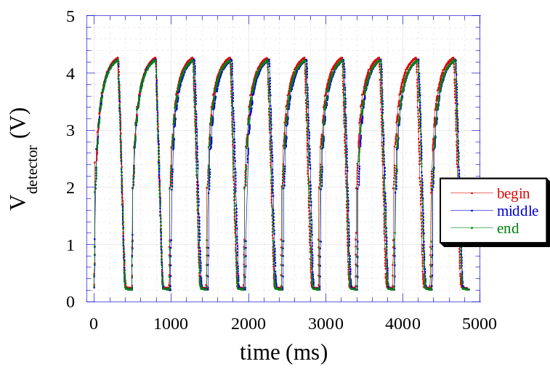
Figure 12: Detector voltage for 10 cycles was measured at the beginning, the middle and the end of the life test in order to prove that the PCAL primary source was still functional.

Characterization after the life test
The PCAL HBI-8 source was again characterized after the life test was carried out to find any changes caused by the constant used during the life test. This characterization was done in the exact same way then the previous one before the life test. The results can be seen below.

Dark current
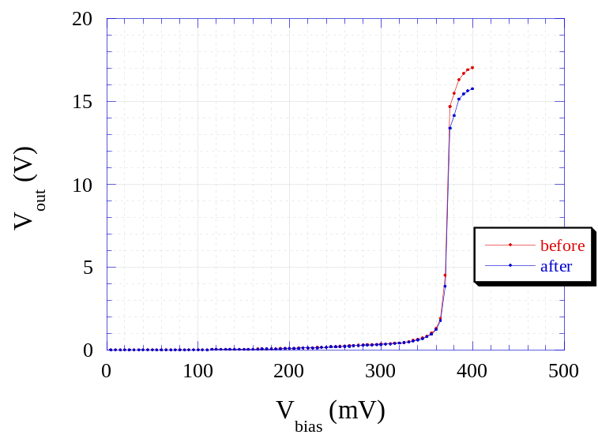
Figure 13: Detector voltage during the dark current measurement of photodetector by un-powered HBI-8 illuminator before and after the life test.

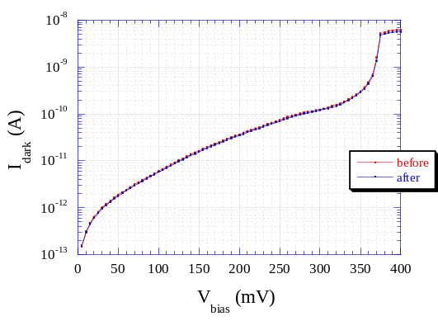 | 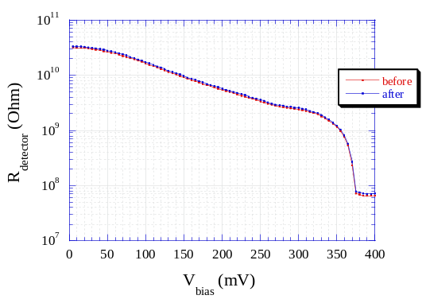
Figure 14: Dark current (left side) and Detector resistance (right side) of photodetector by un-powered HBI-8 illuminator before and after the life test.

 | V_{bias} (V) | V_{off-set} (V) | V_{detector} (V) | I_{dark} (A) | R_{detector} (Ω)
Before LT | 250 | 0.0020742 | 0.20771 | 7.4183·10⁻¹¹ | 3.37·10⁺⁰⁹
After LT | 250 | 0.0021546 | 0.19652 | 7.0185·10⁻¹¹ | 3.562·10⁺⁰⁹
Difference | 0 | +3.9% | -5.4% | -5.4% | +5.7%
Table 4: Parameter at V_{bias}=250 mV obtained from dark current measurement before and after the life test.

Raw data
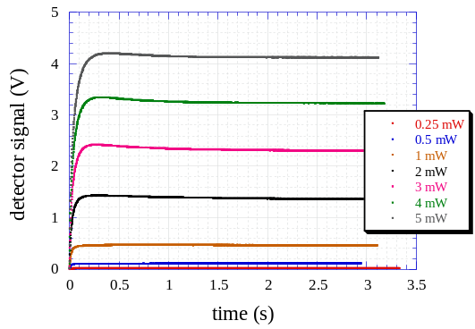 | 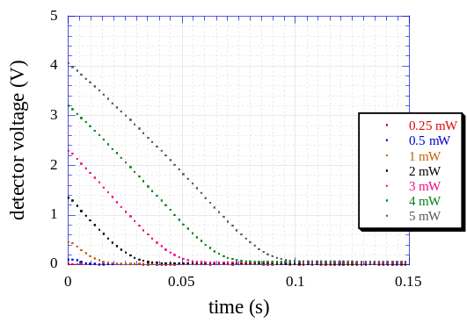

Figure 15: Detector voltage of the prime source during powering on (left side) and powering off (right side) for the various power levels measured.

Time constants
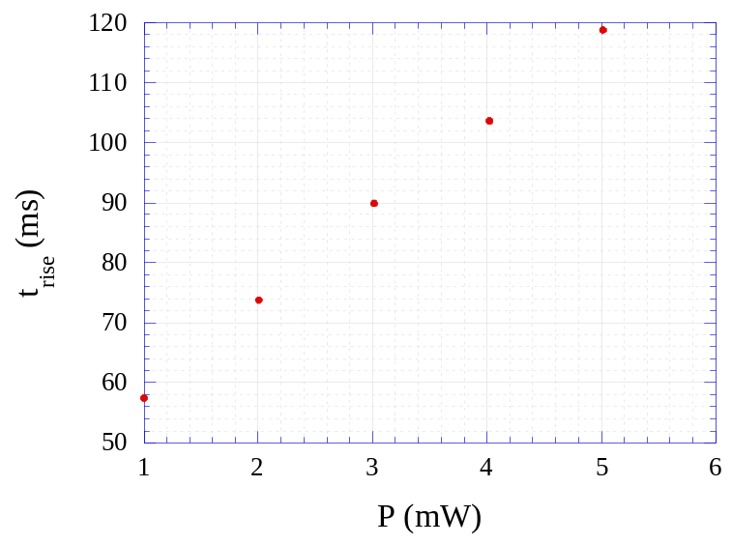
Figure 16: Rise time constants for the primary sources (V_{BIAS}=250mV).
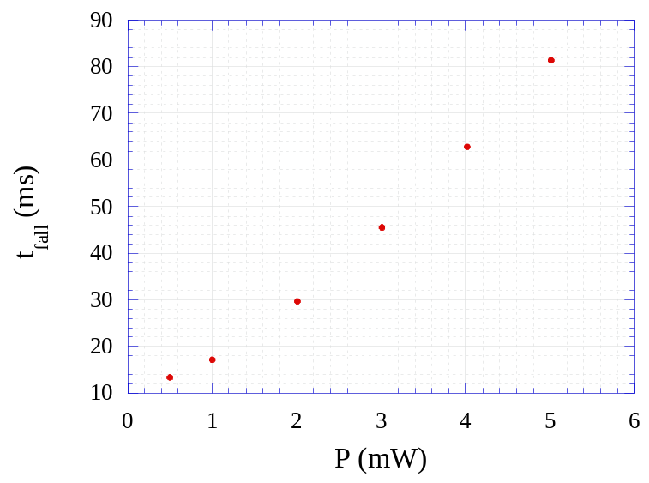
Figure 17: Fall time constants for the primary sources (V_{BIAS}=250mV).

Primary source
P (mW) | t_{rise} (ms) | t_{fall} (ms)
0.501 |  | 13.281
1.003 | 57.45 | 17.21
2.007 | 73.75 | 29.69
3.014 | 89.88 | 45.49
4.022 | 103.63 | 62.88
5.014 | 118.76 | 81.33
Table 5: Rise and fall time constants for the primary sources at given values of power input.

Power
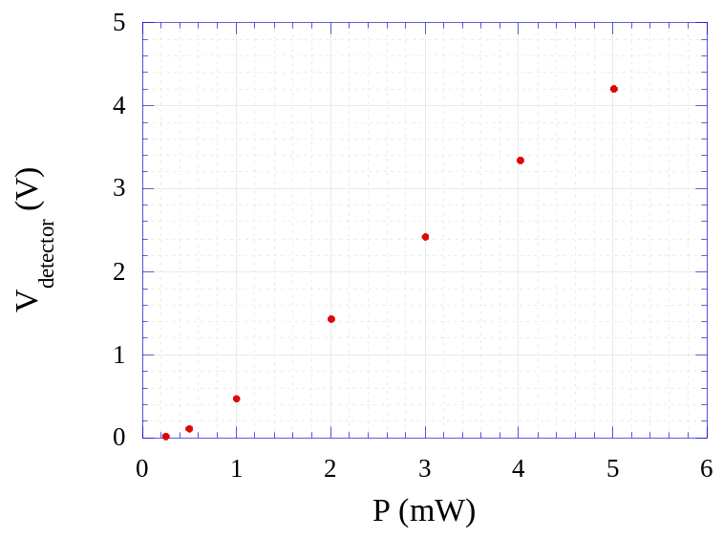
Figure 18: Maximum detector voltage measured when applying power to the primary sources (V_{BIAS}=250mV).

Primary source
P (mW) | V_{detector} (V)
0.250 | 0.016
0.501 | 0.108
1.003 | 0.471
2.007 | 1.433
3.014 | 2.421
4.022 | 3.342
5.014 | 4.201
Table 6:Maximum detector voltage obtained at given values of power input.

Summary
There are two main conclusions to be drawn from those results:
Firstly, HBI-8 primary source completed the life test without failure. Secondly, there was no change in the PCAL radiant power output observed, which can be concluded from the measured detector voltage before and after the life test (Figure 19).
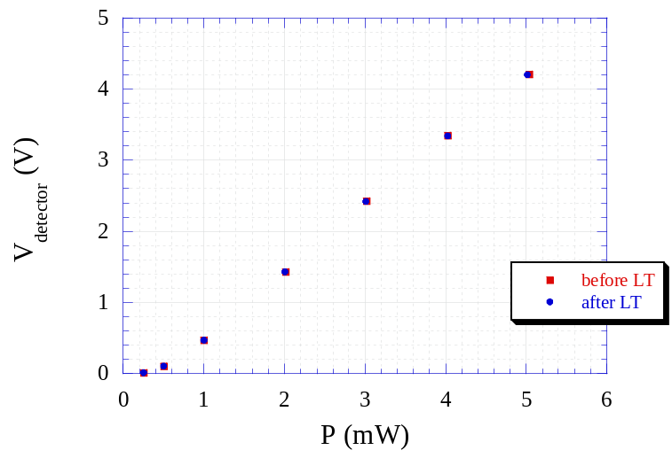
Figure 19: Comparison between the detector voltage before and after the life test
Figure 20 shows the rise time constants before and after the life test for the primary source. The slightly different values for some power levels are probably a results of the way the data was determined and do not represent a real change in sources themselves because the fall time constants do not show the same changes (Figure 21).
To do so, both the time and detector voltage were normalised. The detector voltage was normalised by subtracting the detector offset. This offset can be difficult to define and may be the cause of the observed difference in the time constants before and after the life test.
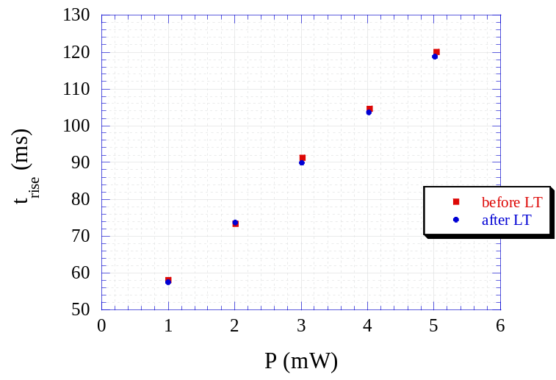
Figure 20: Comparison between the rise time constants before and after the life test
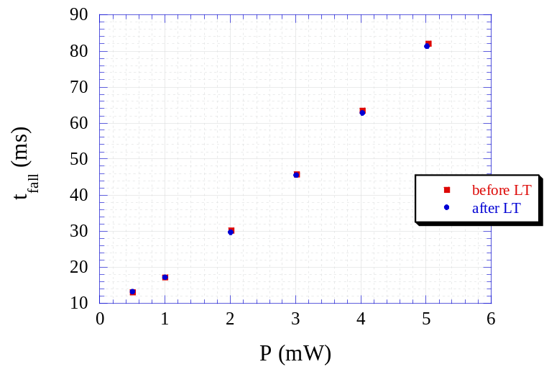
Figure 21: Comparison between the fall time constants before and after the life test

