Table of Contents
Change Log 1
1. Scope 1

Change Log
Date | Issue | Change
Monday, 20 November 2006 | 1.0 | Initial drafting of document

- Scope

This report documents the measurements of the dissipation in the JFET modules and the measurements carried out on the pixels to investigate unexplained bad detector channels.

- Reference Document

RD 1: PFM4 JFET Power and Pixel Diagnostic Test Procedure SPIRE-RAL-PRC-002777, 20-Nov-2006

- JFET Power Measurement Test

  - Idd and Iss measurement description

The impedance of the wires bias the JFET modules is ~ 140Ohm in the RAL ILT configuration. The only exception is the SLW array which is robustly wired and therefore has approximately half this impedance.

A breakout box was inserted between the cryoharness and the DCU with inline resistors in the Vss and Vdd lines.

When the instrument was set up in the nominal PDET_STBY or SDET_STBY mode, the Idd and the Iss currents flow through these resistors and is quantified by measuring the voltage drop across the resistor. The resistor is selected so that an accurate measure of the current can be made without unduly influencing the test.

The voltage at the output of the DCU is measured, so a comparison between the commanded and actual voltages can be made

  - Vdd and Vss measurement description

The second phase of the test is completed by inserting a break out box between the redundant bias connector of the cryoharness and the DCU. This allows the voltage at the terminals of the JFET power rails in the modules to be made without the effect of the voltage drop in the prime harness.

  - Test results

Figure 1 reports the measurements carried out during the test. The assumption prior to carrying out the tests was that Idd would approximately equal Iss and therefore cold power dissipation could be calculated by measuring the voltage drop across the devices times the current. This assumption was found in practice not to be valid. In general, there was a discrepancy between the two. For the majority of the measurements, Idd was higher than Iss by ~2-7%. In three cases, there was a much greater discrepancy between the two current measurements ranging from 23% to 89% higher Idd than Iss. The source of this discrepancy is unknown (see Figure 2).

One consequence of this is that the computation of the cold dissipation becomes ambiguous depending on whether the dissipation is calculated by using Idd or Iss. Both calculations are shown in Figure 3. If the higher values are used, then the dissipation in the modules is very much higher than the instrument budget values.

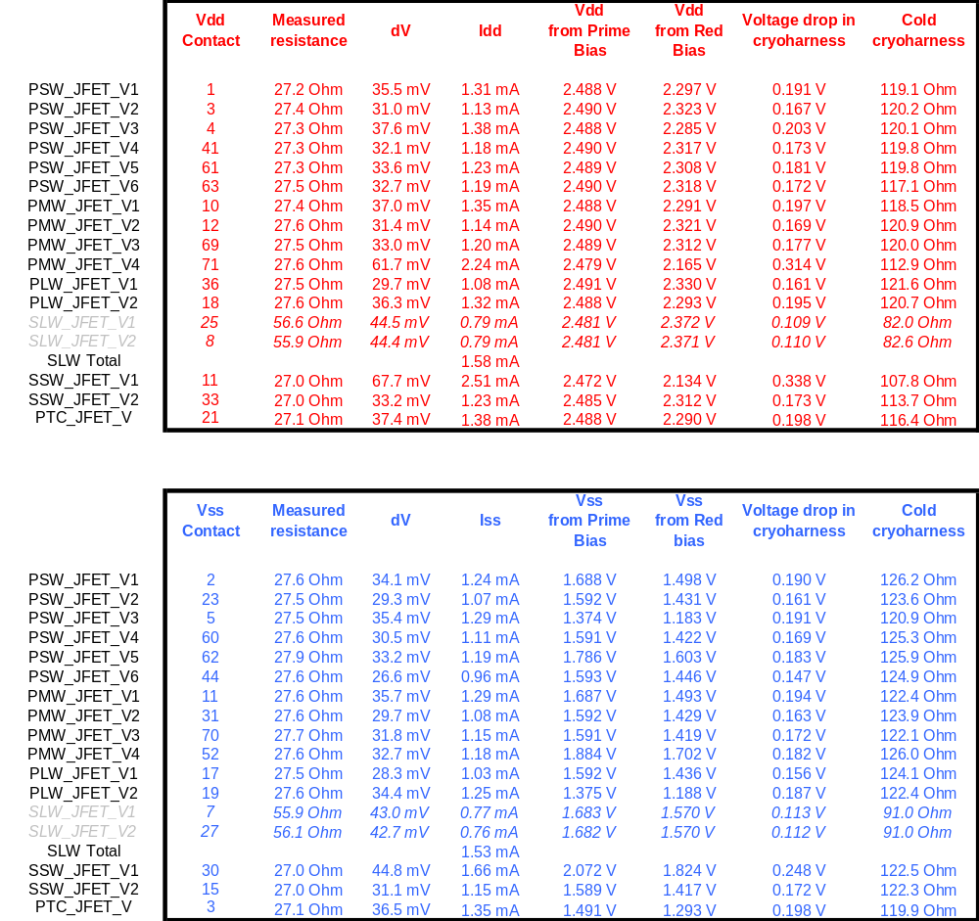
Figure 1 – Measurements on the JFET power dissipation

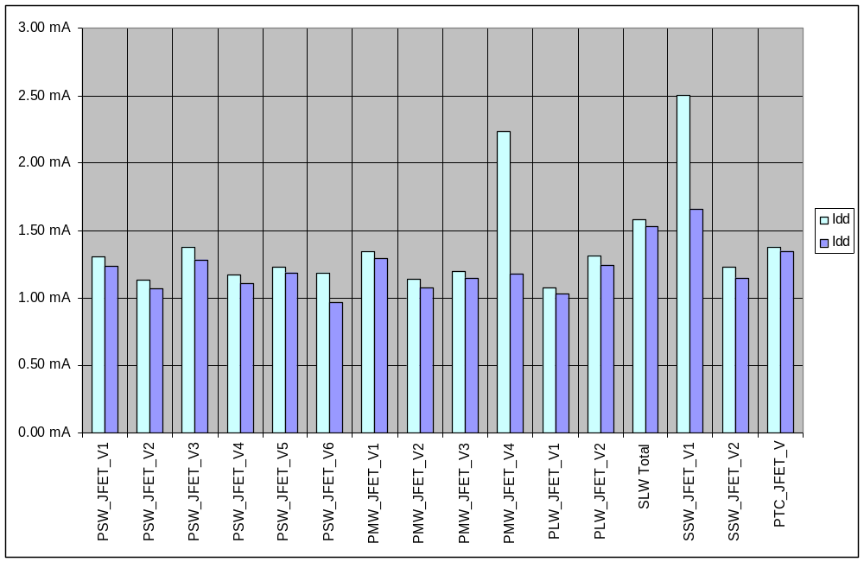
Figure 2 – Idd and Iss measurements
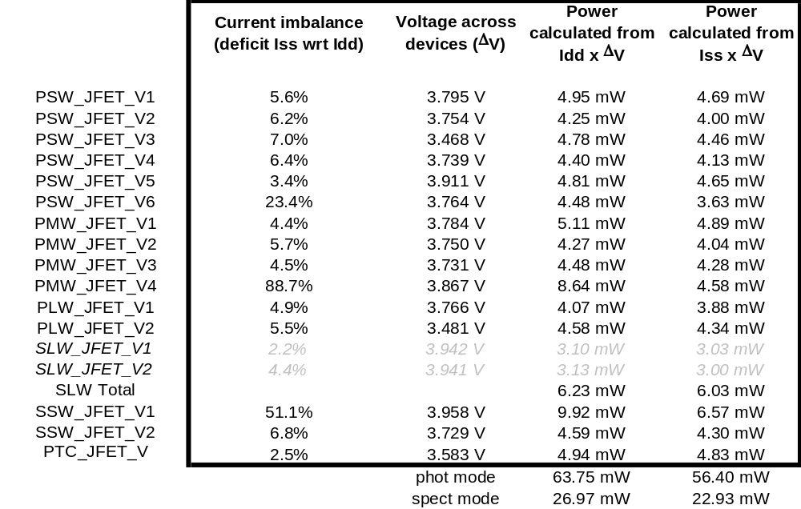
Figure 3 – Power measurements

Anomalous channel investigations
  - Test description
The impedance between the signal and the ground (chassis) was measured when the instrument was unpowered. After this measurement, the instrument was switched on and set up in the appropriate mode (PDET_STBY or SDET_STBY) and the voltage measured between the signal and ground.

The time required to shut down then instrument and change break out boxes precluded testing all anomalous channels.

Measurements were carried out on both nominal and non-working channels.

Anomalous impedances and voltages were measured on all non-working channels sampled. Two distinct failures are indicated. One where one of the offsets goes to zero and the other where the offsets between the channels is out of specification.

  - Test results

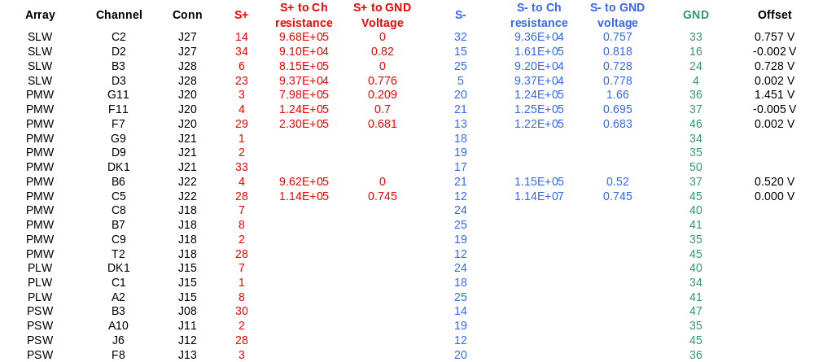
Figure 4

