Reported temperatures of spectrometer BDAs for “Dark” loadcurve conditions.

Usual stuff for deriving the temperatures except now we have the advantage of having measured the spectrometer JFET gains warm (see appendix).

Table 1 gives the measurements made taken from the log description of “dark” loadcurves. Actually one of these was with the window open but I have included it anyway as the thermistors and dark bolometers did not significantly change temperature. The absolute accuracy of the results is somewhat dubious as we can see from the table and more from the plots in figures 1 (only truly dark measurements on blown up y-axis) and figure 2 (three dark measurements and the room background on larger y-axis scale). The scatter is too large from bolometer to bolometer to be explained by gain variation and there is a clear need to make some fundamental correction the JPL calibration values for these detectors.

Table 1: Measurement data and reported temperatures.
OBSID | File Prefix | Description of measurement | Date/Time | SubK Temp | SSW T1 | SSW  DK1 | SLW T1 | SLW DK1
0x3000E22C | ILT_PERF_DAB_S_SinglePhase_3000E22C_ | Dark | 10 May 2006 18:37 | 289.3 | 300 | 290.5 | 275 | 301
0x3000E232 | ILT_PERF_DAB_S_SinglePhase_3000E232_ | Dark; different bias phase | 10 May 2006 19:25 | 289.6 | 299 | 290 | 266 | 298
0x3000E4D1 | ILT_PERF_DAB_S_SinglePhase_3000E4D1_ | Dark | 6 June 2006 10:09 | 288.5 | 302 | 290 | 283 | 305
0x3000E559 | ILT_PERF_DAB_S_SinglePhase_3000E559_ | Room background | 7 June 2006 20:23 | 288.5 | 302 | 291 | 282 | 308
0x3000E562 | ILT_PERF_DAB_S_SinglePhase_3000E562_ | Dark | 8 June 2006 08:22 | 288.6 | 302.5 | 290.5 | 283 | 306

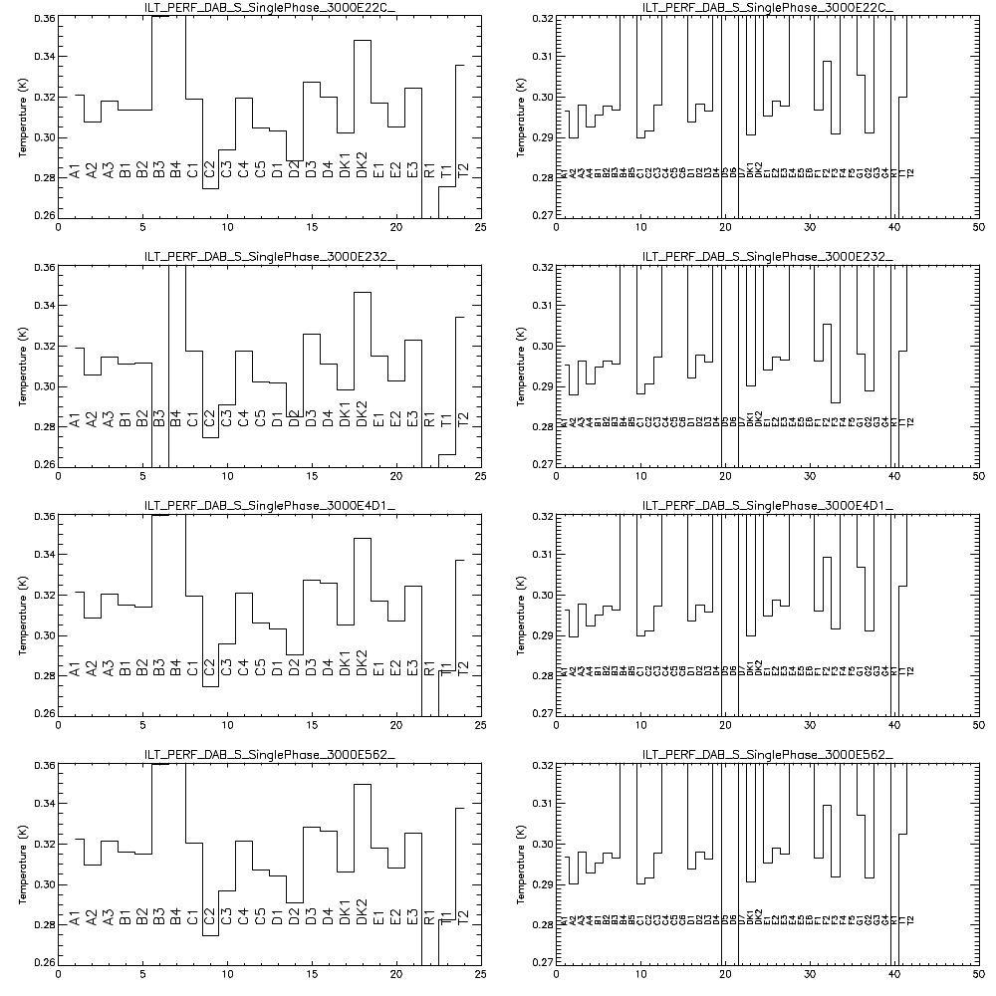
Figure 1: True dark temperatures per detector. Left column SLW; right SSW.
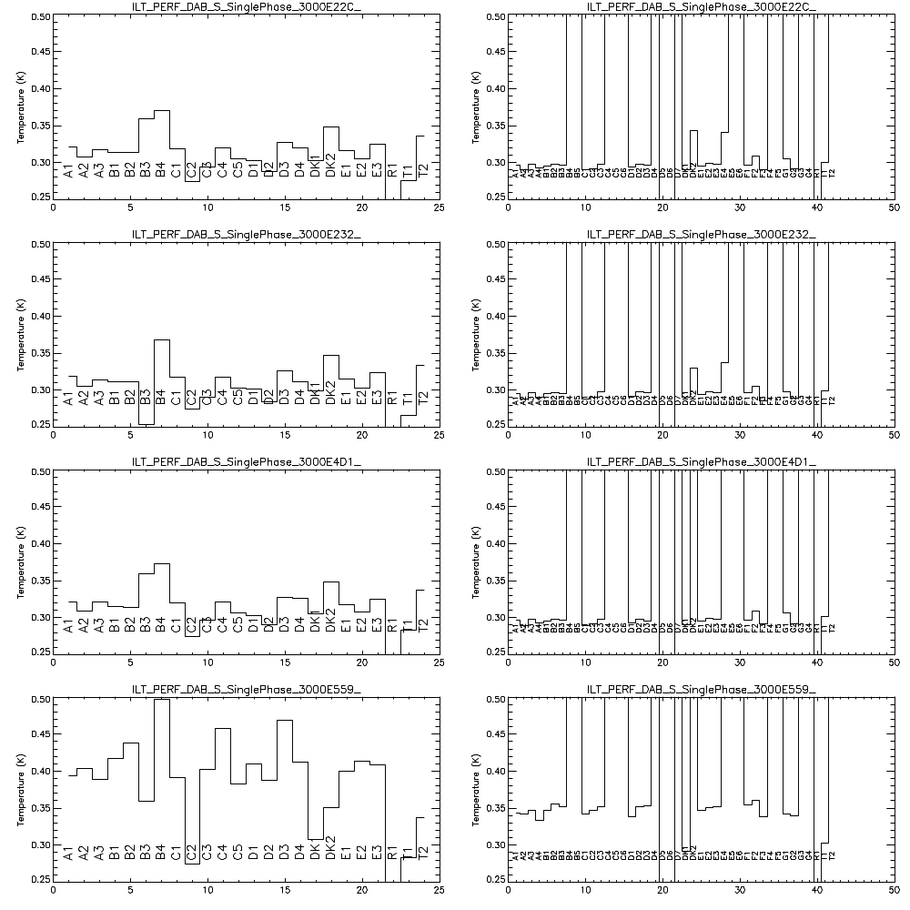
Figure 2: First three rows are dark as figure 1; last is room background.

Appendix: Spectrometer JFET Gain Calibration
A standard loadcurve was taken with the spectrometer JFETs attached to the QM2 electronics but with “safe” connectors attached that result in the bias being directly applied to the JFET inputs. Thus the bias is measured directly through the entire electronics chain allowing the gain of the system to be verified independently of any affects due to the presence of the bolometers or other resistance. The net gain, after rmovel of known DRCU gains, are given in the following table. The VSS applied during the measurement was -1.49 V at the output of the DRCU – there is an approximate 0.2 V along the harness to the JFETs.

SLW  ModuleSN022 Board SN055 |  | SSW  ModuleSN023 Board SN057 |  | SSW  ModuleSN023 Board SN054
Channel Name | Measured JFET Gain | Channel Name | Measured JFET Gain | Channel Name | Measured JFET Gain
R1 | 0.972902 | R1 | 0.966490 | N /C
T1 | 0.970925 | A4 | 0.966567 | N /C
C1 | 0.972505 | A3 | 0.965276 | N /C
DK1 | 0.965534 | A2 | 0.966791 | N /C
B1 | 0.972177 | A1 | 0.962773 | N /C
D1 | 0.971274 | DK1 | 0.963910 | N /C
E1 | 0.972679 | B3 | 0.964738 | E5 | 0.966475
A1 | 0.970774 | B2 | 0.966812 | E4 | 0.965099
C2 | 0.00301509 | B1 | 0.964809 | D7 | 0.964490
D2 | 0.972847 | C3 | 0.966335 | D6 | 0.965323
B2 | 0.969908 | C2 | 0.966602 | D5 | 0.965093
E2 | 0.972830 | C1 | 0.964377 | D4 | 0.965260
A2 | 0.971082 | D3 | 0.965462 | C6 | 0.965458
C3 | 0.970206 | D2 | 0.966996 | C5 | 0.966806
D3 | 0.971067 | D1 | 0.965709 | C4 | 0.964972
B3 | 0.972613 | E3 | 0.965862 | B5 | 0.965687
E3 | 0.970979 | E2 | 0.964826 | B4 | 0.960917
C4 | 0.970189 | E1 | 0.967200 | T2 | 0.936779
DK2 | 0.970992 | F3 | 0.965943 | G3 | 0.966101
D4 | 0.970738 | F2 | 0.966602 | G4 | 0.963477
C5 | 0.972466 | F1 | 0.965880 | DK2 | 0.965119
B4 | 0.970875 | G1 | 0.966546 | F5 | 0.966096
A3 | 0.970286 | T1 | 0.966471 | F4 | 0.966267
T2 | 0.972189 | G2 | 0.965001 | E6 | 0.962968

