TITLE: Integration of Photometer FS BDAs: alignment issues

By: Marc Ferlet (RAL)

DISTRIBUTION

- RAL/SSTD & MSSL - SPIRE Project Team:
For action:
C Brockley-Blatt (MSSL)
D Griffin (RAL)
A Pearce (RAL)

For info:
E Sawyer (RAL)
B Swinyard (RAL)
D Smith (RAL)

For Project database/archive:
J Long (RAL)

change record

ISSUE DATE SECTION REASON FOR CHANGE

1.0 25/05/2006 All First issue

CONTENTS

1. Defocus and lateral shift
1.1 Case of PMW
1.2 Case of PSW & PLW
1.3 Conclusion

2. Tilt and rotation
2.1 Case of PMW
2.2 Case of PSW & PLW
2.3 Conclusion

3. Conclusion and proposed corrective actions on respective interface plates

Applicable and reference documents

RD1 Alignment Measurement Summary for FS PMW BDA 10209800-2 SN019, Mark Weilert (JPL – 02-Oct 05), as part of the delivered EIDP

RD2 Alignment Measurement Summary for FS PSW BDA 10209800-3 SN017, Mark Weilert (JPL – 14 May 06), added in the delivered EIDP

RD3 Alignment Requirements of detector arrays in SPIRE, SPIRE-RAL-NOT-000912 v0.3, Bruce Swinyard & Tony Richards (RAL, 17-Oct-2001)

RD4 Alignment Measurement Summary for FS PLW BDA 10209800-1 SN018, Mark Weilert (JPL – 14 May 06), added in the delivered EIDP

This note briefly assesses the impact of the alignment measurements performed on FS PSW, PMW and PLW BDAs (see RD1 & RD2 and RD4) wrt the integration of the respective BDAs into the SPIRE FS FPU sub-assembly (Photometer detector box).

This note comes in parallel with a similar assessment performed for the Spectrometer FS BDAs in SPIRE-RAL-NOT-002661 (issue 1.0, 21/03/06).

- Defocus and lateral shift

From RD1, the local coordinates system is reproduced below (originally from ICD). The local z axis is out-of-the plane of the figure.
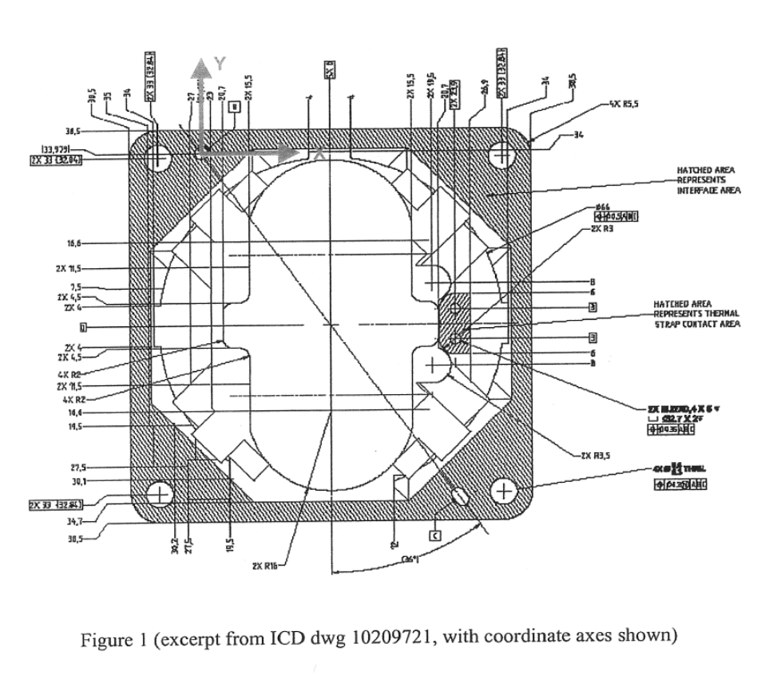
  - Case of PMW

The deviation found (total i.e. ambient and cold measurement from RD1) from the nominal plane along the local z axis is ~0.05mm. This will translates into a very small defocus of the PMW BDA in operation wrt the nominal best focal plane, well within the +/-0.5mm allowed margin in RD3. This is therefore acceptable as it’s a very small value when compared to the ~F/5 depth-of-focus at PMW wavelengths.

NB: this is assumed to be the residual after the correction of the initial defocus issue discussed in the note “Assessment of defocus tolerance and margin on SPIRE PMW BDA”, Marc Ferlet, 19/05/04.

The lateral in-plane shift of the BDA centre wrt to nominal centre is found to be (total i.e. ambient and cold measurement):
- along X: - 0.347+/-0.05mm
- along Y: +0.389+/-0.05mm
so that the max displacement from centre is sqrt(dx²+dy²)~0.521+/-0.100mm. This represents ~15.8% of the PMW pixel size and, at the entrance focal plane (CFIL1 location), is equivalent to 0.910+/-0.175mm displacement which is within the oversize (wrt FoV) of the shaped aperture at CFIL1. Nevertheless this means that the centre of the PMW FoV is shifted on sky by ~6.6+/-1.26arcsec wrt the nominal location in the Herschel coordinates system but this does not affect directly the performances of the PMW channel.

  - Case of PSW

The deviation found (total i.e. ambient and cold measurement from RD1) from the nominal plane along the local z axis is 0.20+/-0.05mm. This will translates into a small defocus of the PMW BDA in operation wrt the nominal best focal plane, well within the +/-0.5mm allowed margin in RD3, even if uncertainty is included. This is therefore acceptable as it’s a small value when compared to the ~F/5 depth-of-focus at PSW wavelengths.

NB: this is assumed to be the residual after the correction of the initial defocus issue discussed in the note “Assessment of defocus tolerance and margin on SPIRE PMW BDA”, Marc Ferlet, 19/05/04 (which applies to PSW as well).

The lateral in-plane shift of the BDA centre wrt to nominal centre is found to be (total i.e. ambient and cold measurement):
- along X: - 0.087+/-0.05mm
- along Y: +0.209+/-0.05mm
so that the max displacement from centre is sqrt(dx²+dy²)~0.226+/-0.100mm. This represents ~9% of the PSW pixel size and, at the entrance focal plane (CFIL1 location), is equivalent to 0.158+/-0.175mm displacement which is within the oversize (wrt FoV) of the shaped aperture at CFIL1. Nevertheless this means that the centre of the PSW FoV is shifted on sky by ~1.4+/-1.3arcsec wrt the nominal location in the Herschel coordinates system but this does not affect directly the performances of the PSW channel.

  - Case of PLW

The deviation found (total i.e. ambient and cold measurement from RD1) from the nominal plane along the local z axis is -0.047+/-0.05mm. This will translates into a very small defocus of the PMW BDA in operation wrt the nominal best focal plane, well within the +/-0.5mm allowed margin in RD3, even if uncertainty is included. This is therefore acceptable as it’s a very small value when compared to the ~F/5 depth-of-focus at PLW wavelengths.

The lateral in-plane shift of the BDA centre wrt to nominal centre is found to be (total i.e. ambient and cold measurement):
- along X: - 0.287+/-0.05mm
- along Y: +0.319+/-0.05mm
so that the max displacement from centre is sqrt(dx²+dy²)~0.429+/-0.100mm. This represents ~8.6% of the PLW pixel size and, at the entrance focal plane (CFIL1 location), is equivalent to 0.750+/-0.175mm displacement which is within the oversize (wrt FoV) of the shaped aperture at CFIL1. Nevertheless this means that the centre of the PLW FoV is shifted on sky by ~5.4+/-1.3arcsec wrt the nominal location in the Herschel coordinates system but this does not affect directly the performances of the PSW channel.

  - Conclusion

The amount of cold to ambient induced defocus of all Phot FS BDAs wrt their respective structure is found sufficiently small (with margin) so no correction to be applied.

There is no direct requirement in RD3 wrt the in-plane lateral shift but a need to maintain co-alignment with PSW centre to within 120μm. Below is the illustrated summary of the BDAs centres lateral shift as-measured and reported in RD1 (axes orientation are as per figure above). The separation (black arrows) between PSW and PMW centres and PSW and PLW centres is 228±50μm and 316±50μm respectively .

x
(x_{nominal}, y_{nominal})=(0;0)
y_{measured}=389um
x_{measured}=
-347um
Legend:
Blue are PMW data
Red are PSW data
Green are PLW data
y_{measured}=209um
x_{measured}=
-87um
y_{measured}=319um
x_{measured}=
-287um
y
Figure 2: Distribution of the measured FS BDAs centre positions in the focal plane wrt nominal

It is therefore suggested to compensate at respective interface plate level:
- the PMW centre by 200μm along –y and 250μm along +x,
- the PLW centre by 100μm along –y and 200μm along +x.

- Tilt and rotation

  - Case of PMW

The measured tilt of the as-built x-y plane compared to the nominal one is found at ambient to be 0.645deg wrt the local z axis. Although this measurement is at ambient only, this is at the limit of the +/-30arcmin=+/-0.5deg acceptable tolerance around the gut ray which nominally is aligned with the local z axis at the centre of the array. The cryo data indicates supplementary hysteretic effect (in rotation about x) which is equivalent to uncertainty in the range of +/-0.03deg on the above value.
This tilt wrt z axis will reduce the coupling from science beam into BDA PMW feedhorns. A correction is desirable and experience with SSW BDA shows the possibility of having a wedge shape interface plate to correct even smaller amount of tilt deg.
x
y
z
0.645 deg
126.5 deg
y
x
0.35 deg

The in-plane rotation has been found (ambient + cold) to be -0.35deg which is larger than the allowed +/-0.233deg (=+/-14 arcmin stated in RD3) but the impact may (or not) be acceptable depending on the respective value for in-plane rotation for PLW and PSW as PSW chop axis being the main reference.

Because there seems to be in-plane rotation of the PSW array of ~+0.38deg in the opposite azimuthal direction, the angular difference between PSW and PMW is 0.73deg specified so that to maintain the best common the nominal chop axis for PMW & PSW, a correction/compensation in-plane would be necessary.

  - Case of PSW

The measured tilt of the as-built x-y plane compared to the nominal one is found at ambient to be 0.41deg wrt the local z axis. Although this measurement is at ambient only, this is slightly lower than the limit of the +/-30arcmin=+/-0.5deg acceptable tolerance around the gut ray which nominally is aligned with the local z axis at the centre of the array. Extra uncertainty from the cryo data mentioned still lead to just worst case below the specification.
x
y
z
0.41 deg
141 deg
y
x
0.38 deg

The in-plane rotation has been found (ambient + cold) to be 0.38deg which is larger than the allowed +/-0.233deg (=+/-14 arcmin stated in RD3) which would need correction/compensation.

  - Case of PLW

The measured tilt of the as-built x-y plane compared to the nominal one is found at ambient to be 0.32deg wrt the local z axis with additional 0.1deg uncertainty from cryo measurement (put as uncertainty as not reproducible).Although this measurement is at ambient mainly, this is slightly lower than the limit of the +/-30arcmin=+/-0.5deg acceptable tolerance around the gut ray which nominally is aligned with the local z axis at the centre of the array.
x
y
z
0.32deg
135 deg
y
x
0.06 deg

The in-plane rotation has been found (ambient + cold) to be smaller than 0.06deg which is much lower than the allowed +/-0.233deg (=+/-14 arcmin stated in RD3) so no problem for this DoF.

  - Conclusion

PSW is the reference array but adding a in-pane rotation to PLW to bring it in line with PSW will lead to both arrays being beyond the +/-14arcmin from nominal axis orientation i.e. they could be angularly co-aligned wrt each other but not with nominal chop axis (BSM-related).
Similar correction in the opposite direction is needed for PMW on top of which in-plane decentring compensation is needed to bring it better co-aligned with the reference array PSW. Further out-of-plane tilts for PSW and PMW need correction for best coupling of individual pixel. A simple form of correction is to use slightly wedge-shape interface plates.
PLW is then suggested to be corrected only for in-plane decentring.

- Conclusion and proposed corrective actions on respective interface plates

For all Phot BDAs, the defocus is ok but decentring and in-plane rotation needs compensation. More precisely for each array and respective interface plate:

- PSW interface: only the in-plane (x-y) rotation needs a correction by a rotation of the centres of mounting and reference points (dashed blue in sketch below) wrt overall plate about the nominal plate centre. Rotation angle is 0.35deg (negative i.e. clockwise or from y to x) which at mounting point approximately located radially 33*1.414=46.67mm away from centre the local tangential displacement needed is 46.67*tan(0.35)~285μm.
Direction of the PSW rotation from nominal positions
Centre of the rotation
Angle: 0.35deg=21arcmin

- PMW interface: the in-plane (x-y) rotation needs a correction by a rotation of the centres of mounting and reference points (dashed blue in sketch below) wrt overall plate about the nominal plate centre. Rotation angle is 0.35deg (positive i.e. counterclockwise or from x to y) which at a typical corner mounting point approximately located radially 33*1.414=46.67mm away from centre the local tangential displacement (of its centre wrt nominal) needed is 46.67*tan(0.35)~285μm.

Direction of the PMW rotation from nominal positions
Centre of the rotation
Angle: 0.35deg = 21arcmin

More the in-plane (local x-y) lateral shift needs to be corrected, by shift of the mounting holes in the interface plate with detector box in the following way:
Displacement of the mounting and reference points in the SLW interface plate wrt their nominal position by: (250)μm in x and (-200)μm in y (axes x and y), as sketched below (red arrows).

- PLW interface: Only the in-plane (local x-y) lateral shift needs to be corrected, by shift of the mounting holes in the interface plate with detector box in the following way:
Displacement of the mounting and reference points in the SLW interface plate wrt their nominal position by: (200)μm in x and (-100)μm in y (axes x and y), as sketched below (red arrows).
For the tilt of the feedhorn array plane wrt local z axis, all BDAs except PLW indicate a value (dominated by a rotation about the local x axis) which is at the edge of beyond the allowed requirement and therefore a correction for this measured tilt on the BDAs is strongly suggested.

- Consequences for interface plates on the case of PSW, PMW: from the above considerations, it is suggested to machine the interface plates (for PMW and PSW) in a wedge shape for the schematic below.
0.4deg=24arcmin (tolerance: <0.05deg)
z
y
x
Nominal interface plate thickness
(tolerance: +0.2 / -0.0 max)
Phot detector box side
BDA side

NB: the removal of material from the nominal constant thickness interface plate will produce an axial shift along +z which is estimated to be of the order of +200-250μm max (suggested tolerance above tuned to minimise this). Added to the above nominal expected BDA internal defocus along z, the net result will still be well within the allocated +/-0.5mm.

The correction for PLW would be typically half of the one above (not directly needed as globally in spec for the tilt wrt the local z axis), leading to a very small slope more difficult to be machined accurately so that it is not recommended here.

This is again assuming that the issue in the note “Assessment of defocus tolerance and margin on SPIRE PMW BDA”, Marc Ferlet, 19/05/04 (which applies to PSW as well) has been dealt with separately.

