Title: |  | PLM EQM EMC Test Procedure  AS – RUN - PROCDURE
CI-No:
Prepared by: |  | Clemens Kalde | Date: | 05.10.05
Checked by: |  | Christian Schlosser
Product Assurance: |  | René Stritter
Configuration Control: |  | Walter Wietbrock
Project Management: |  | Wolfgang Fricke
Distribution: |  | See Distribution List (last page)
 | Copying of this document, and giving it to others and the use or communication of the contents there-of, are forbidden without express authority. Offenders are liable to the payment of damages. All rights are reserved in the event of the grant of a patent or the registration of a utility model or design.

Issue | Date | Sheet |  | Description of Change | Release
1 | 05.10.05 |  | First formal issue

Table of Content
1 Scope 7
1.1 Objective 7
1.2 Flow 7
2 Documents/Drawings 8
2.1 Applicable Documents 8
2.2 Reference Documents 8
3 Configuration 10
3.1 PLM EQM Configuration 10
3.2 GSE Configuration 10
3.3 Facility 12
4 Conditions 13
4.1 General Requirements 13
4.2 Environmental Conditions 13
4.3 Measurement Accuracies 13
4.3.1 Receiver Accuracies 13
4.4 General Precautions and Safety 14
4.4.1 General Safety Requirements 14
4.4.2 ESD constraints 14
4.5 Activities Management 14
4.5.1 Pre-Test Activities 14
4.5.2 Procedure Variation 14
4.5.3 Criteria for Failure 15
4.5.4 Test Completion and Post-Test Activities 15
4.6 PA Requirements 16
4.7 Personnel 17
5 Test Requirements 18
5.1 Radiated Susceptibility H-field 18
5.1.1 HIFI Instrument Setting 18
5.1.2 PACS Instrument Setting 18
5.1.3 SPIRE Instrument Setting 18
5.2 Radiated Susceptibility E-field 19
5.2.1 HIFI Instrument Setting 20
5.2.2 PACS Instrument Setting 20
5.2.3 SPIRE Instrument Setting 20
5.3 HIFI Optional CE/CS Testing 21
6 Activities Flow 22
7 Step by Step Procedure 25
7.1 HIFI EMC Test 25
7.2 HIFI ADDITIONAL EMC Test 29
7.3 PACS EMC Test 40
7.4 SPIRE EMC Test 47
7.5 Pre- and Post Test Activities 53
8 RS Frequency Control Tables 54
8.1 HIFI Frequency Control Tables H-field 54
8.2 HIFI Frequency Control Tables E-field 55
8.3 HIFI Control Tables Conducted Susceptibility Power Lines 65
8.4 HIFI Control Tables Conducted Susceptibility on Instrument Cryo Harness Bundles 66
8.5 PACS Frequency Control Tables H-field 67
8.6 PACS Frequency Control Tables E-field 82
8.7 SPIRE Frequency Control Tables H-field 100
8.8 SPIRE Frequency Control Tables E-field 103
9 Facility Report 116
9.1 Calibration Data 116
9.2 Grounding Diagram of EQM Test 116
10 Summary Sheets 118
10.1 Procedure Variation Summary 118
10.2 Non Conformance Report (NCR) Summary 119
10.3 Sign-off Sheet 119

Table of Figures

Figure 1.2-1: PLM EQM RS Test Flow 7
Figure 3.1-1: Principle PLM EQM Configuration 10
Figure 3.3-1: Set-up in Astrium Clean Room 12

List of Tables

Table 3.2-1: Test Equipment List 11
Table 4.3-1: Receiver Measurement Bandwidth 13
Table 4.7-1: Personel 17
Table 5.2-1: RS Notches 19
Table 9.1-1: Procedure Variation Sheet 116
Table 9.2-1: Non-Conformance Record Sheet 117

Scope

Objective
This procedure describes the activities to be carried out for the Radiated Susceptibility (RS) test of the three instruments HIFI, PACS and SPIRE on PLM EQM level as specified in the Instrument PLM EQM Level Test Procedure, AD11. In addition a CS test is planned for HIFI as far as it fits in the 5 days allocated for this instrument.

Flow
Due to the total allocated testing time of 20 working days the complete test is subdivided in 4 parts allowing each instrument to allocate 5 working days for their dedicated RS testing and performance evaluation activities, plus extra 5 days, allocated as contingency.
The test flow shall consider the offline evaluation time needed to decide whether susceptibility has been detected and the evaluation of its criticality with ASPI and ESA. This is in order to have sufficient time to decide whether additional testing is necessary at the end of the first 15 days or not.
Although Astrium baseline is to perform only RS tests, the test flow considers the wish of HIFI to add some instrument level CS tests to the nominal RS testing program as far as this allows to keep the window of 5 working days. Then, in parallel to the additional HIFI CS testing activities (ref. HIFI-CR 0128 v.1) the HIFI offline characterisation could be performed.
PACS Ref.
Test
PACS RS
H-field
PACS RS
E-field
PACS
Off-line
Agreement between Intruments, ESA/ASPI and Astrium
Complementary Tests if any
SPIRE Ref.
Test
SPIRE RS
H-field
SPIRE RS
E-field
SPIRE
Off-line
HIFI Ref.
Tests
HIFI RS
H-field
HIFI RS
E-field
HIFI
Off-line
HIFI CS
Figure 1.2-1: PLM EQM RS Test Flow

Documents/Drawings

Applicable Documents
The following documents in their latest issue are applicable to this procedure:

AD1 | HP-2-ASED-PL-00007 | Herschel PA Plan | Issue 2.1
AD2 | HP-2-ASED-PL-0023 | Herschel Contamination Control Plan | Issue 2
AD3 | SCI-PT-IIDA-04624 | Herschel/Planck Instrument Interface Document, IID Part A | Issue 3.3
AD4 | SCI-PT-IIDB/HIFI-02125 | Instrument Interface Control Document Part B, Instrument HIFI | Issue 3.2
AD5 | SCI-PT-IIDB/SPIRE-02124 | Instrument Interface Control Document Part B, Instrument SPIRE | Issue 3.3
AD6 | SCI-PT-IIDB/PACS-02126 | Instrument Interface Control Document Part B, Instrument PACS | Issue 3.3
AD7 | HP-2-ASED-PL-0021 | Herschel PLM EQM AIT Plan | Issue 2.2
AD8 | HP-2-ASED-PR-0012 | Herschel PLM/EQM General AIT Procedure | Issue 1
AD9 | H-P-1-ASPI-SP-0037 | HERSCHEL/PLANCK EMC Specification | Issue 4
AD10 | H-P-1-ASPI-PL-0038 | HERSCHEL/PLANCK EMC/ESD Control Plan | Issue 3
AD11 | HP-2-ASED-PR-0051 | Instrument PLM EQM Level Test Procedure | Issue 1.1
AD12 | HP-2-ASED-PL-0037 | EMC Test Plan | Issue 2

Reference Documents
In this section all documents are given which either
- could serve as reference for the PLM EQM RS test as well as for complementary tests, or
- may be referred in the test report for clarification/justification of an outcome (result) of the test.

RH1 | SRON-U/HIFI/PR/2004-001 | HIFI EMC Test Specification | Issue 1.3
RH2 | SRON-G/HIFI/PR/2005-101 | HIFI EQM IST & EMC Test Procedure | Issue 1.4
RH3 | SRON-U/HIFI/SP/2005-003 | HIFI EQM Grounding Configuration | Issue 1.0
RP1 | PACS-ME-PL-015 | PACS EMC/ ESD Control Plan and Procedure | Issue 1.2
RP2 | PACS-ME-TP-021 | PACS Integrated Module Test Procedure | Issue 1.2
RS1 | Spire EMC Test Sequence for EQM Testing | SPIRE-RAL-NOT-002402 | Issue 1.0
RS2 | Spire Cooler Recycling SCOS Procedure | SPIRE –RAL-PRC-002267 | Issue 1.0

Configuration

PLM EQM Configuration
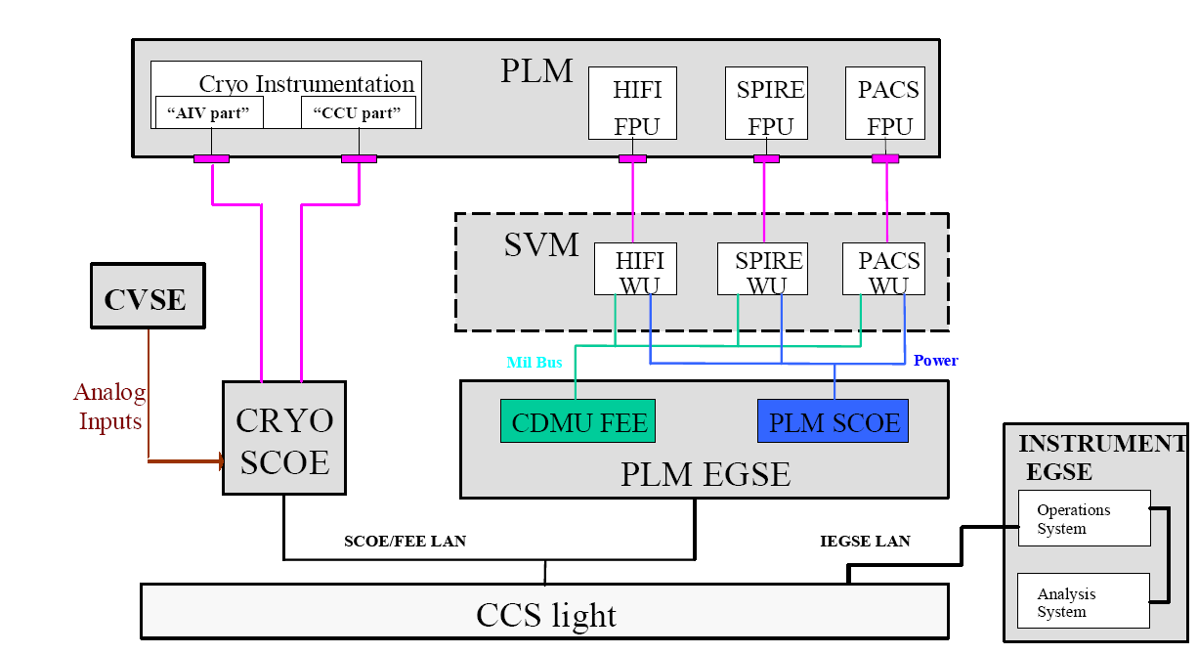
Figure 3.1-2: Principle PLM EQM Configuration

The configuration is the fully Integrated EQM Cryostat in combination with the EGSE and SCOE in accordance to the figure 3.1-1. A detailed description of the configuration can be found in the Instrument PLM EQM Level Test Procedure, AD11.
The actual hardware and software configuration of the GSE shall be validated at the TRR and reported in the test report.

GSE Configuration
A detailed description of the configuration can be found in the Instrument PLM EQM Level Test Procedure, AD11.
In addition there are some antennas cabling etc. and electrical test equipment necessary from the EMC facility in order to generate and measure the EMI levels. All test hardware shall be calibrated and shall be within the calibration period during the test time.
The test equipment list shall be completed during the test included in the test report.

Test Equipment List
Item | Manuf. | Model No. | SN No. | Invent No. | Next Calib.
Table 3-1: Test Equipment List

Facility
The activities detailed in this procedure shall be carried out in the EADS Astrium clean room in Ottobrunn.
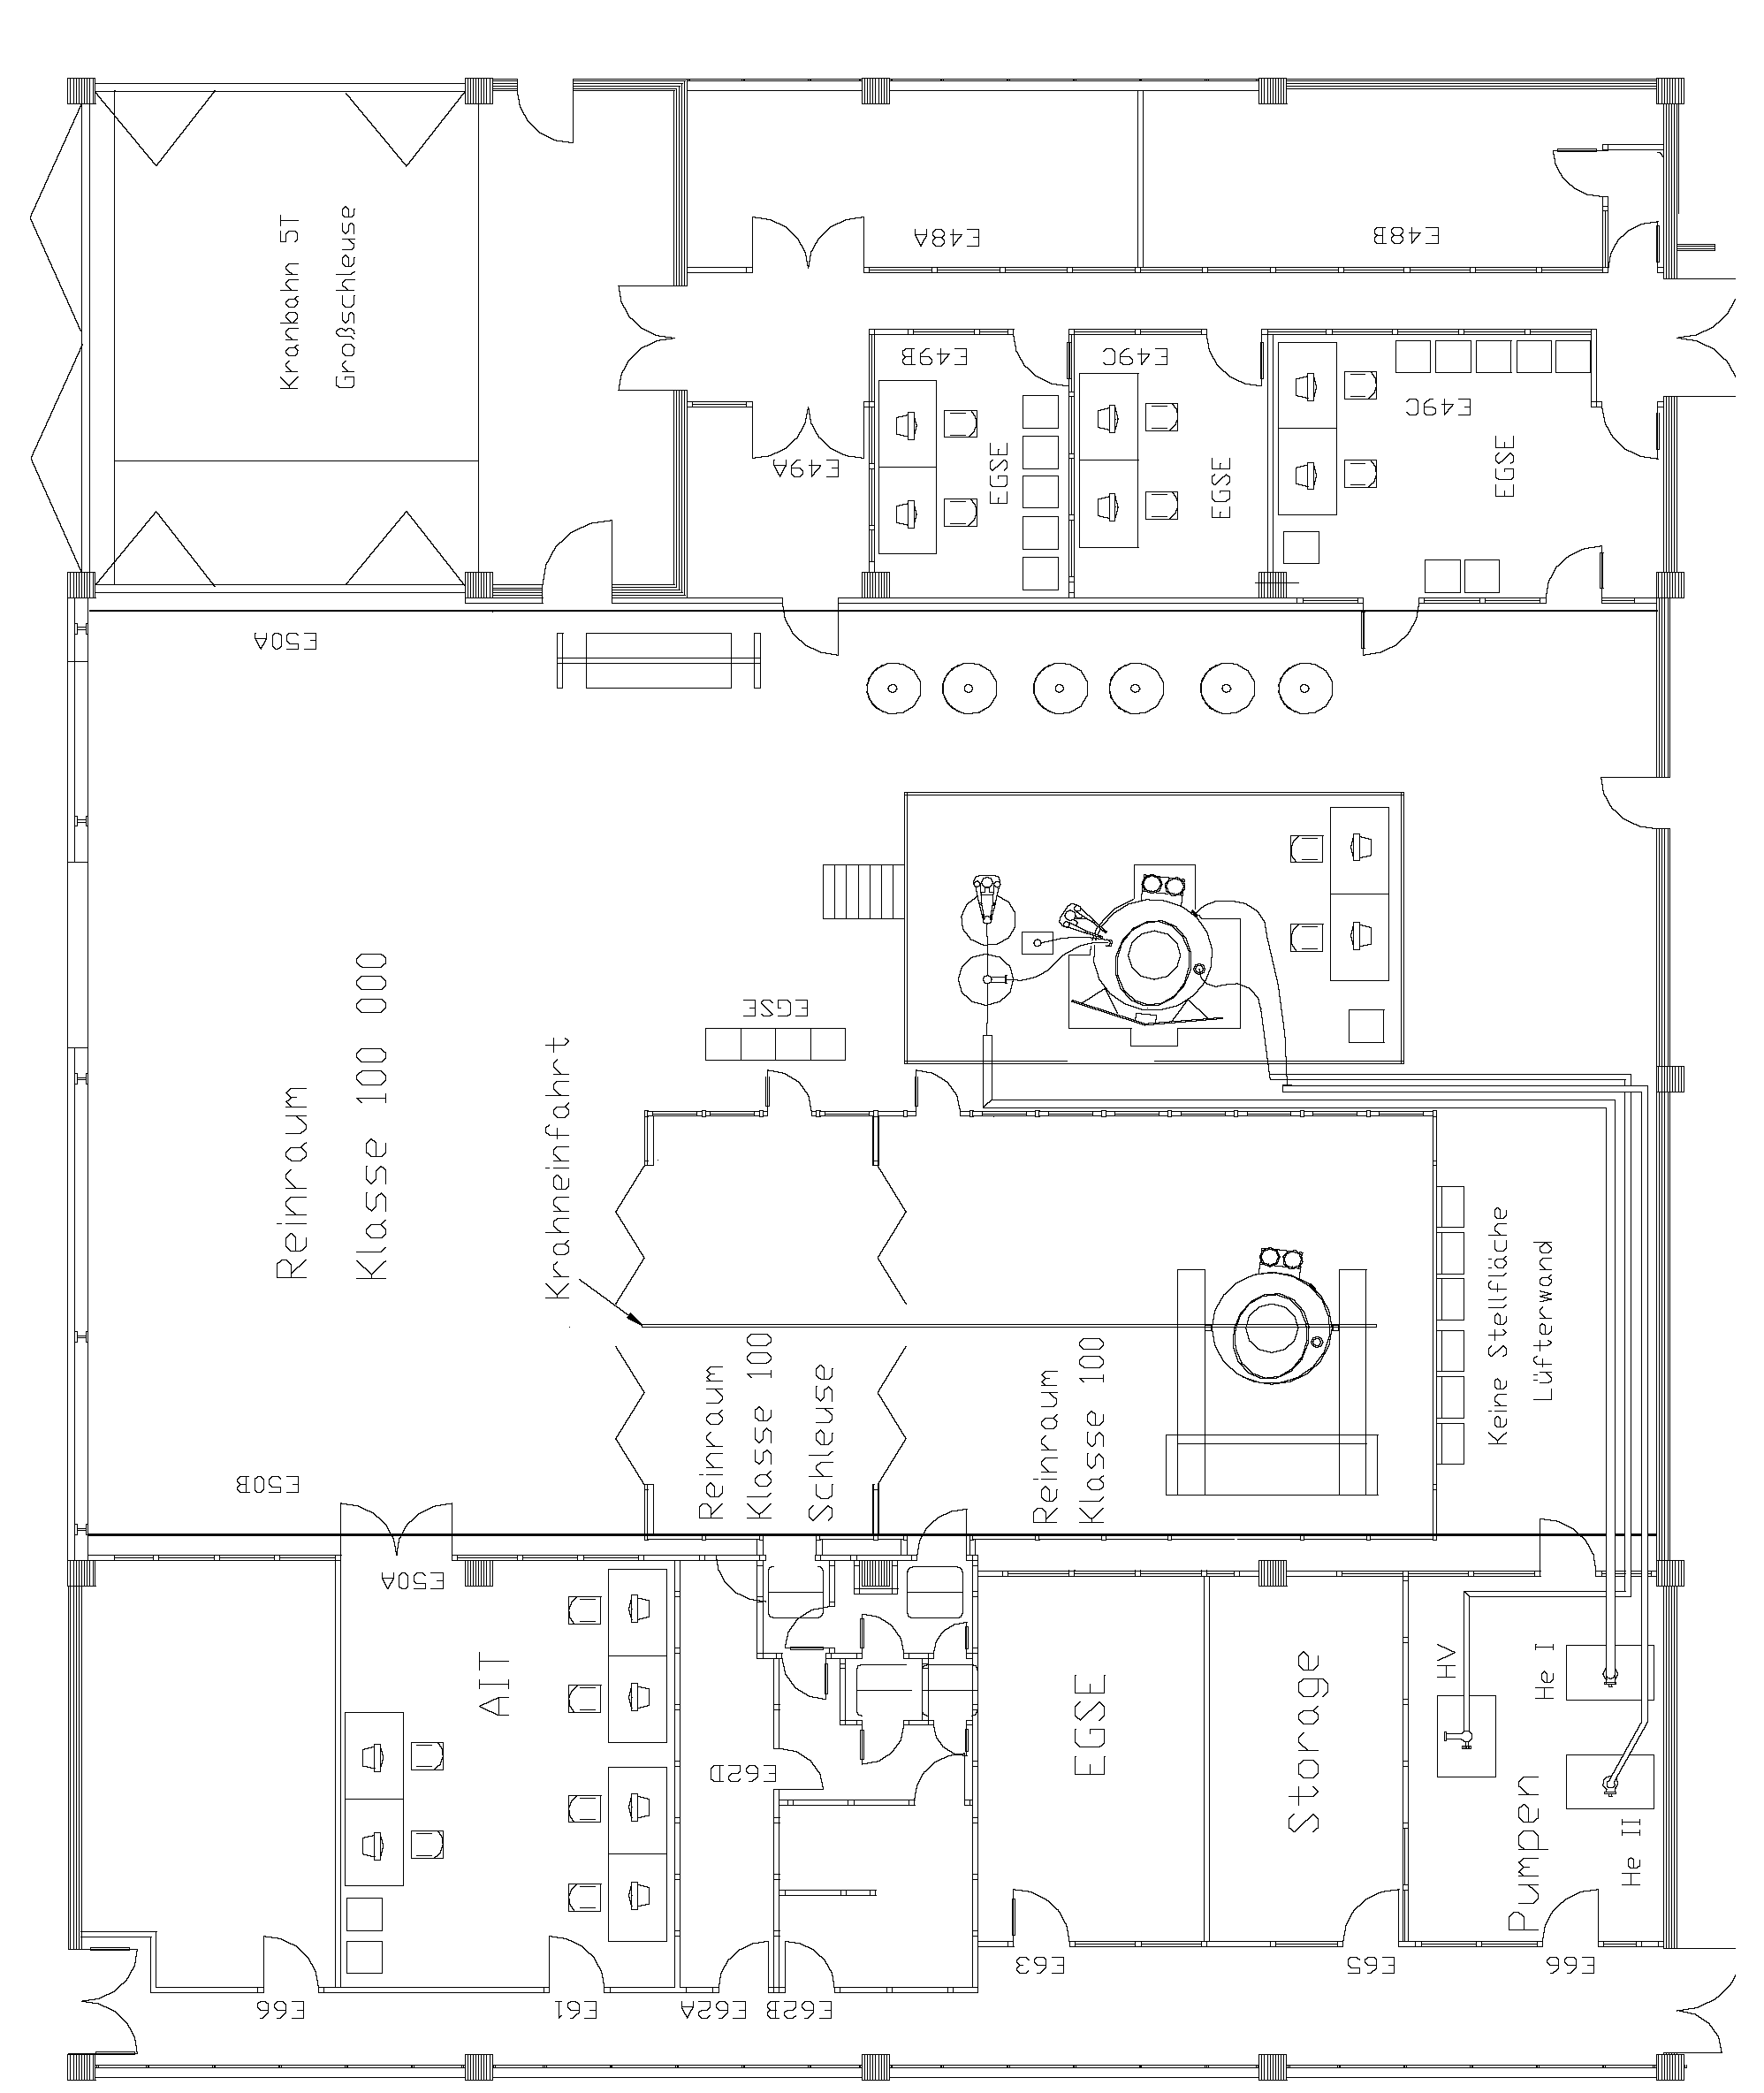
Figure 3.3-3: Set-up in Astrium Clean Room

Conditions

General Requirements
General instructions are given in the Herschel PLM EQM General AIT Procedure, AD8, and have to be respected accordingly.
In addition, the temperature of the lid must be stabilised before each test and set to a certain value (to be defined by the instruments before start of test). The temperature adjustment can be done by varying the He flow rate through the lid.

Environmental Conditions
All activities specified in the procedure have to be performed in a clean room class 100 000.
Temperature: 22°C +/- 3°C
Relative Humidity: 40% to 55%
The cleanliness requirements will be observed throughout the activities, and the overall contamination control requirements identified in the Herschel Contamination Control Plan, AD2, will be observed.

Measurement Accuracies

Receiver Accuracies
Table 4.3.1-1 gives a guideline for receiver measuring bandwidths. The actual bandwidth of the test equipment shall be provided by the facility personnel during the EMC tests.
Frequency Range | Proposed | Actual | Comment
30 Hz - 2.5 kHz | 10 Hz
2.5 kHz - 5 kHz | 30 Hz
5 kHz - 50 kHz | 100 Hz
50 kHz - 1 MHz | 1 kHz
1 MHz - 100 MHz | 3 kHz
100 MHz - 1 GHz | 10 kHz
1 GHz - 18 GHz | 100 kHz
Frequency Accuracy | ± 2 %
Amplitude Accuracy | ± 2 dB
Table 4-2: Receiver Measurement Bandwidth

General Precautions and Safety

General Safety Requirements
No special hazards are expected. The application of the standard technical rules for mechanical and electrical integration and test activities is sufficient.
Lower level procedures called up by this procedure may define their own safety requirement in the relevant chapters which must be respected accordingly

ESD constraints
In order to prevent ESD sensitive H/W from any possible damages by accidental electrostatic discharges an ESD protected area must be defined and setup during ESD sensitive activities:
- Floor and test bench of the ESD protected area has to be covered with anti-static mats
- During all handling activities (as transport, mounting, mating/de-mating of connectors, measurements with individual measurement devices, etc.) the operator has to work on anti static mats with correct clothing and personal grounding-straps
- Adequate ESD clothing is required:
- Anti static coat
- Anti static gloves
- Anti static boots
- Transportation of ESD sensitive H/W will be made only in ESD protective bag or box.

Activities Management

Pre-Test Activities
At least the following tasks have to be successfully completed before start of integration and test activities according this procedure:
- This procedure released and accepted
- Formal release to start given by the board following review of relevant test procedures and test configurations.

Procedure Variation
Major activities deviating from the approved test procedure require the agreement of Project, AIV and PA responsible, and shall be documented via Activity Control Sheets (ACS). All ACS's generated in the frame of the execution of this procedure shall be listed in the ACS Summary Sheet in section 9.1 of this procedure.

Criteria for Failure
If the results of any test performed using this procedure or a lower level procedure which this procedure refers to yields a value which lies outside the specified limits, it shall be considered as a non-conformance. Initial analysis of the result will be applied to establish whether the result is due to measurement error or incorrect specification limits. A NCR will then be raised to report the non-conformance. Depending on the magnitude of the non-conformance, and its impact, either a minor or a major NCR will be raised. In case of major NCR the test shall be continued only upon written or verbal authorisation of Customer (Alcatel and ESA). All NCR's raised in the frame of the execution of this procedure shall be listed in the NCR Summary Sheet in section 9.2 of this procedure.
The NCR process is described in the Herschel PA Plan, AD1.

Test Completion and Post-Test Activities
All data that has been recorded during the test activities specified in this procedure shall be collected and retained in a centralised reference volume, and will include:
- EQM PLM logbook
- Relevant CCS logs
- Photographs and plots
- Filled out test procedure
- Activity Control Sheets (ACS), if any
- Copies of NCR's, if any

All these test data shall be available for presentation at the Test Review Board (TRB) which will finally conclude on the test.
A test report shall be produced in accordance to the AIT Plan, AD7, whose contents shall be as follows:
- Brief summary of the test results
- PLM and instrument build standard summary
- "As-run" test procedure as an annex (this includes housekeeping data, temperature curves, etc.).
- List of NCR's raised
- List of ACS's generated.
- Relevant meeting minutes (e. g. TRR, TRB)
- Filled out Sign-off Sheet (see section 9.3 of this procedure).
- Evaluation of test results (might be in separate document)

PA Requirements
Quality Assurance shall monitor all operations (handling, transportation, disassembly, installation and test) as necessary to assure compliance with this procedure and the applicable requirements of the Herschel PA Plan, AD1.
In the course of this procedure PA shall pay particular attention to:
- the application of adequate protections to critical surfaces
- the records in the log-sheet
- the recording of the serial number of the test equipment used
- ensure that the test equipment used is within actual calibration cycle
PA has to make sure that NCR’s are raised when applicable and treated by NRB procedure as defined in the Herschel PA Plan, AD1.
After the conclusion that an activity is successfully completed, this activity has to be signed by the responsible AIT- and PA engineer in the step by step procedure. Also relevant log sheets have to be filled out and signed.

Personnel
Title | Function | Name*)
Test Director | Overall responsible | Siegmund Idler
Test Conductor | EMC Test Responsibility | Clemens Kalde
EGSE Operator | Operate EGSE (CCS, PLM SCOE, CDMU DFE, Cryo SCOE) | S. Ilsen
EGSE Expert (Alcatel) | Support EGSE operator and EMC | André Luc,  Guy Doubrovik
EMC Test Performance (IABG) | Responsible for the EMC facility and operations | Ulf Hülsenbusch
Mech. Operator(s) | All mech. Integration activities, handles the PLM during testing (e.g. tilting of PLM), supports instrument test team
Cryo Operators | Operate the cryostat during testing and maintain the required temperatures
ESA Support | Support and supervison of test activities | Filippo Marliani,  Astrid Heske,  Carsten Scharmberg,  Walter Pinter-Krainer
HIFI Engineers | Support test activities and evaluate/analyse instrument data | Bert Joost v. Leeuwen,  Nick Whyborn,  Norbert Brüning,  Albert Naber,  Toni Marston
PACS Engineers | Support test activities and evaluate/analyse instrument data | Helmut Feuchtgruber  Michael. Leininger
SPIRE Engineers | Support test activities and evaluate/analyse instrument data | Doug Griffin
PA Representative | To ensure PA requirements | Dave Hendry
*) Names to be registered prior to start of test activities
Table 4-3: Personnel

Test Requirements

Radiated Susceptibility H-field
The set-up and performance of the radiated H-field susceptibility.
- Frequency Range: 30 Hz to 50 kHz, IABG Loop Antenna
- 2 antenna positions for HIFI, one for SPIRE, 2 or 3 respectively for PACS (depending on mode) and different for each instrument, to be selected at start of test. Instrument harness should be illuminated. The irradiating antenna shall be placed at a test distance of 1 metre towards the satellite structure.
- Sufficient clearance of the CVV from other metallic structure has to be granted in order to avoid effects from standing waves, refer to the EMC Test Plan AD12, chapter 4.3.
- Level 120 dBpT up to 20 kHz, 110 dBpT from 20 kHz to 50 kHz. The level will be calibrated according to the frequency tables within the anechoic chamber at IABG before RS test in the cleanroom of EADS Astrium. Herewith, we have clear reference, repeatable adjustment of the right disturbance level and no impacts from satellite and EGSE structure. During the RS test at EADS Astrium, a field probe will be installed in the vicinity of the CVV for monitoring and, if possible, reporting of the field level in the frequency control tables or in annex of the test report.
➔ The particular detailed conductance of the RS test is for every instrument different defined and described in the EMC Test Plan, AD12. This is reflected in the step-by-step procedure.
If necessary, susceptibility threshold shall be predicted:
- Adjust the frequency/frequency range at which the susceptibilities occurred.
- Repeat the RS test manually for these frequencies and reduce the noise level until no susceptibility occurs.
- Record the susceptibility threshold.

HIFI Instrument Setting
As for RS E-field tests. Please refer also to RH1. The HIFI configuration is not fully representative due to the absence of the LSU which is substituted by a LSU simulator. For the grounding configuration see RH3.

PACS Instrument Setting
As for RS E-field tests.

SPIRE Instrument Setting
As for RS E-field tests.

Radiated Susceptibility E-field
The set-up and performance of the radiated E-field susceptibility Test shall be in is accordance to the MIL Std, 461 E, RS 103.
General Frequency Range: 14 kHz to 18 GHz:
14 kHz - 30 MHz, SML-01 generator, SMX-100 amp, At-3000 antenna, V- pol
30 MHz - 1 GHz, SML-01 generator SMX-100 amp., BDLP antenna, V- and H- poll
1 GHz - 6 GHz, WILTRON generator, no ampl., RGA-180 antenna, , V- and H- pol
6 GHz - 18 GHz, WILTRON generator + 1 W amplifier, RGA 180 antenna, , V- and H- pol
8 GHz Notch (ref. Table 5-1):
8.45 - 8.5 GHz, WILTRON generator + 1 W amplifier, SGH antenna, V- and H- pol

3 antenna positions for HIFI, 2 for SPIRE, and 2 for PACS and different for each instrument, to be selected at start of test. Instrument harness needs to be illuminated. The irradiating antenna shall be placed at a test distance of 1 metre towards the satellite structure.
- Sufficient clearance of the CVV from other metallic structure has to be granted in order to avoid effects from standing waves, refer to the EMC Test Plan AD12, chapter 4.3.
- Level 2 V/m (126 dBµV/m) over the applicable frequency range except for some notches where the level shall be in accordance to the table 5-1. The level will be calibrated according to the frequency tables within the anechoic chamber at IABG before RS test in the cleanroom of EADS Astrium. Herewith, we have clear reference, repeatable adjustment of the right disturbance level and no impacts from satellite and EGSE structure. During the RS test at EADS Astrium, a field probe will be installed in the vicinity of the CVV for monitoring and, if possible, reporting of the field level in the frequency control tables or in annex of the test report.
- The E-field level shall be 30% amplitude modulated (AM) with 1 kHz square wave.

Frequency Range | RS Level | Comment
8.45 GHz to 8.5 GHz in 10 MHz steps | 10 V/m | Spacecraft TM
Table 5-4: RS Notches

➔ The particular detailed conductance of the RS test is for every instrument different defined and described in the EMC Test Plan, AD12. This is reflected in the step-by-step procedure.
If necessary, susceptibility threshold shall be predicted:
- Adjust the frequency/frequency range at which the susceptibilities occurred.
- Repeat the RS test manually for these frequencies and reduce the RS level until no susceptibility occurs.
- Record the susceptibility threshold.

HIFI Instrument Setting
The HIFI configuration is not fully representative due to the absence of the LSU which is substituted by a LSU simulator. Please refer also to RH1. The HIFI instrument setting can be found in RH2, section 11.
Susceptibility tests shall be performed with:
- The reference signal switched on.
- Continuous observation during EMI stimuli. Synchronisation by operators call.
- Instrument settings
HIFI mode: Primary
LO band: 3a
LO Frequency: 807 GHz
HRS mode: High Resolution
HRS band centre frequency: 6.6 GHz
WBS: on
Observing mode: Total Power
Integration time: 1sec.
Chopper: Cold source
For the grounding configuration see RH3.

PACS Instrument Setting
The mode applicable for PACS has been described in the PACS Integrated Module Test Procedure, RP2.

SPIRE Instrument Setting
The mode applicable for SPIRE has been described in the ‘’Spire EQM Test Sequence’’, RS 1.

HIFI Optional CE/CS Testing
Conducted emission and susceptibility testing shall be performed on the nominal primary power lines of the HIFI LCU and ICU as well as on selected signal lines of the Cryo Harness.
FHICU Power:
Bracket DB05, J05 PIN 2 = PLUS
PIN 4 = RTN
FHLCU Power:
Bracket DB06, J01 PIN 2,7 = PLUS
PIN 4,9 = RTN

FPU Signal Lines:
FP Cryo-H location: View from -Y, Bracket 311100
FP Cryo-H bundles: SIH-IH-01, J03
SIH-IH-02, J01
SIH-IH-05, J02

LOU Signal Lines:
LO Cryo-H location: View from -Y
LO Cryo-H bundles: SIH-IH-07, Bracket 311300, J03

For the test requirements it shall be referred to RH1
The HIFI configuration is not fully representative due to the absence of the LSU which is substituted by a LSU simulator. For the grounding configuration see RH3. The HIFI instrument setting can be found in RH2, section 11.

Activities Flow
The following table depicts the flow of the activities described in this procedure. The Radiated Susceptibility test for the three instruments is embedded in the overall PLM EQM integration and test flow (refer to the Instrument PLM EQM Level Test Procedure, AD11).

No | Activity | Remark
1 | HIFI EMC Test | See para. 7.1
1.1 | Initialise LSU simulator
1.2 | Restart instrument if has been powered down
1.3 | Perform functional test
1.4 | Configure for EMC test
1.5 | Perform RS H-field test (2 positions)
1.6 | Perform RS E-field test (3 antenna positions, each with 2 polarisations)
1.7 | Perform off-line performance evaluation via QLA
2 | HIFI ADDITIONAL TESTS (acc. to HIFI-CR 0128) | See para. 7.2
2.1 | Prepare for CS test
2.2 | Perform CS DM steady state on ICU power lines to 50 KHz
2.3 | Perform CS DM steady state on LCU power lines to 50 KHz
2.4 | Perform CS DM steady state on ICU power lines up to 50 MHz
2.5 | Perform CS DM steady state on LCU power lines to 50 MHz
2.6 | Perform CS CM steady state on ICU power lines to 50 MHz
2.7 | Perform CS CM steady state on LCU power lines to 50 MHz
2.8 | Perform CS DM Transients test on ICU power lines
2.9 | Perform CS DM Transients test on LCU power lines
2.10 | Perform CS CM Transients test on ICU power lines
2.11 | Perform CS CM Transients test on LCU power lines
2.12 | Perform CE/CS signal bundle test for SIH-IH-01, 02 and 05
2.13 | Perform CE/CS signal bundle test for SIH-IH-07
3. | PACS EMC Test | See para. 7.3
3.1 | Set-up instrument to safe mode
3.2 | Perform PACS Cooler Recycle during the night before for every testing day in photometer mode
3.3 | Perform cover flushing every morning.
3.4 | Set PACS in photometer mode and perform reference tests
3.5 | Perform RS H-field test in photometer mode (3 antenna positions). Specific threshold tests with about 30 frequencies for each antenna position are to be considered in photometer mode and shall be performed at the beginning of each an automated test session.
3.6 | Set PACS in spectrometer mode and perform reference tests
3.7 | Perform RS H-field test in spectrometer mode (2 antenna positions)
3.8 | Perform PACS Cooler Recycle during the night before for every testing day in photometer mode
3.9 | Perform cover flushing every morning.
3.10 | Set PACS in photometer mode and perform reference tests
3.11 | Perform E-field test in photometer mode (2 antenna positions x 2 polarisations)
3.12 | Set PACS in spectrometer mode and perform reference tests
3.13 | Perform E-field test in spectrometer mode (2 antenna positions x 2 polarisations)
3.14 | Perform off-line performance evaluation via QLA
4 | SPIRE EMC Test | See para. 7.4
4.1 | Set-up instrument into REDY mode
4.2 | Perform Cooler Recycle in the evening before each testing day
4.3 | Facility setting, measurements and SPIRE health check every morning, before test
4.4 | Set SPIRE in nominal mode.
4.5 | Perform H-field test in nominal mode (1 antenna position), SWEEP case. Repeat reference as necessary.
4.6 | Perform H-field test in nominal mode (1 antenna position), SPOT case. Repeat reference as necessary.
4.7 | Perform E-field test in nominal mode (2 antenna positions each with two polarisations), SWEEP case. Repeat reference as necessary.
4.8 | Perform E-field test in nominal mode (2 antenna positions each with two polarisations), SPOT case. Repeat reference as necessary.
5 | Pre-and Post Test Activities | See para. 7.5
 | Describing all activities to be done at the beginning of the day before test start prepare for CS test
 | Describing all activities to be done at the end of the test day before test switching Instruments OFF.
Table 6-5: Test Activities Flow

Step by Step Procedure

HIFI EMC Test
Step-No. | Integration-Step-Description | OP / EMC | Nom  Val | Tol. | Act.  Val. | Comment | P | N
7.1.1 | Initialise LSU simulator for 807 GHz operation
7.1.1.1 | Refer to RH2, para 11.4.1 | OP |  |  | OK | Done previously, 14/11/05 | X
7.1.2 | Restart Instrument if has been powered down
7.1.2.1 | Refer to RH2, para 11.4.2 | OP |  |  |  | N/A
7.1.3 | Perform functional test
7.1.3.1 | Perform functional test pumped (Refer to RH2, para 11.4.4.1) | OP |  |  | OK | LO tune @ 63%, 15:11.2005 | X
7.1.3.2 | Perform functional test unpumped (refer to RH2, para 11.4.4.2 | OP |  |  | OK |  | X
7.1.4 | Configure for EMC test
7.1.4.1 | Configure HIFI for EMC test (refer to RH2, para. 11.4.4.3) | OP |  |  | OK | LO tune at 63 %. The HYB versions of the TCL scripts were run. | X
7.1.5 | Perform RS H-field test in for the frequencies and antenna positions according to the frequency control tables in para. 8.
7.1.5.1 | Prepare EMC set-up for a test session which shall not last longer than 15 minutes. Refer to RH2 para 11.4.4.4 | EMC/OP |  |  | OK |  | X
7.1.5.2 | The frequencies shall be applied as ‘’stepwise sweep’’ into two . sessions of 10 minutes (10 seconds script).  - Application of one frequency: 10.0 sec  - f2 = 1.1 x fprev from 30 Hz to 50 kHz | EMC |  |  | OK | Done 15.11.2005 | X
7.1.5.3 | Let OP confirm application of the correct SCRIPT file (refer to RH2) (susceptibility setting), data acquisition to be started | EMC |  |  | OK |  | X
7.1.5.4 | After OP request start immediately the stepwise-sweep and inform OP. | EMC |  |  | OK |  | X
7.1.5.5 | Tell EMC the time tag for notification in the frequency control table and wait for end of the session (about 10 minutes) | OP |  |  | OK |  | X
7.1.5.6 | Notify the time tag provided by OP immediately in the frequency control table together with the applied frequency range (to be filled into the control table) | EMC |  |  | OK |  | X
7.1.5.7 | After the session (end of sweep) inform OP immediately. | EMC |  |  | OK |  | X
7.1.5.8 | Give to EMC the corresponding time tag to be filled in the table and store the session data with identification of  - Field type (H field)  - Antenna position  - Polarisation  - Frequency range | OP |  |  | OK |  | X
7.1.5.9 | Note the time tag in the frequency control table and prepare the next session until the complete frequency range, and all antenna positions/ polarisations in accordance to the frequency control table are covered. | EMC |  |  | OK | H-field test finished the morning of 15.11.2005 | X
7.1.6 | Perform RS E-field test for the frequencies and antenna positions according to the frequency control tables in para. 8.
7.1.6.1 | Prepare EMC set-up for a test session which shall not last longer than 15 minutes. Refer to RH2 para 11.4.4.4 | EMC/OP |  |  | OK |  | X
7.1.6.2 | The frequencies shall be applied as ‘’stepwise sweep’’ over a number of test sessions  - Application of one frequency: 10.0 sec  - f = 1.1 x fprev from 14 kHz to 2.5 GHz  - f = 1.05 x fprev from 2.5 GHz to 8.5 GHz  - f = 1.1 x fprev from 8.5 GHz to 18 GHz | EMC |  |  | NOK | Done in accordance to the required set-ups between 15.11 ans 16.11. See frequency control table.  See NCR ‘’ASED-NC-1733’’ (HIFI radiated susceptibility in range 3.9 GHz to 8.1 GHz) |  | X
7.1.6.3 | Let OP confirm application of the correct SCRIPT file (refer to RH2) (susceptibility setting), data acquisition to be started | EMC |  |  | OK |  | X
7.1.6.4 | After OP request start immediately the stepwise-sweep and inform OP. | EMC |  |  | OK |  | X
7.1.6.5 | Tell EMC the time tag for notification in the frequency control table and wait for end of the session (about 10 minutes) | OP |  |  | OK |  | X
7.1.6.6 | Notify the time tag provided by OP immediately in the frequency control table together with the applied frequency range (to be filled into the control table) | EMC |  |  | OK |  | X
7.1.6.7 | After the session (end of sweep) inform OP immediately. | EMC |  |  | OK |  | X
7.1.6.8 | Give to EMC the corresponding time tag to be filled in the table and store the session data with identification of  - Field type (E-field)  - Antenna position  - Polarisation  - Frequency range | OP |  |  | OK |  | X
7.1.6.9 | Note the time tag in the frequency control table and prepare the next session until the complete frequency range, and all antenna positions/ polarisations in accordance to the frequency control table are covered. | EMC |  |  | OK |  | X

HIFI ADDITIONAL EMC Test
Step-No. | Integration-Step-Description | OP / EMC | Nom  Val | Tol. | Act.  Val. | Comment | P | N
7.2.1 | Prepare HIFI for Conducted Susceptibility test power lines
7.2.1.1 | Switch off HIFI  RH2 procedure 11.4.5.5: Configure HIFI to standby  RH2 procedure 2.4.4: Power-off HIFI | OP |  |  | OK |  | X
7.2.1.2 | Install power supplies and LISN’s for the primary power lines FHICU, FHLCU, FHHRH and FHWEH | EMC |  |  | OK |  | X
7.2.1.3 | Connect break-out boxes to the nominal power lines of the ICU and the LCU, test connector:  FHICU Power:  Bracket DB05, J05 PIN 2 = PLUS  PIN 4 = RTN  FHLCU Power:  Bracket DB06, J01 PIN 2,7 = PLUS  PIN 4,9 = RTN |  |  |  | OK |  | X
7.2.1.4 | Install T-adapters in the Cryo harness in order to enable CE/CS measurements on the FPU signal lines:  FPU Signal Lines:  FP Cryo-H location: View from -Y, Bracket 311100  FP Cryo-H bundles: SIH-IH-01, J03  SIH-IH-02, J01  SIH-IH-05, J02 |  |  |  | OK |  | X
7.2.1.5 | Install T-adapters in the Cryo harness in order to enable CE/CS measurements on the LOU signal lines:  LOU Signal Lines:  LO Cryo-H location: View from -Y  LO Cryo-H bundles: SIH-IH-07, Bracket 311300, J03 |  |  |  | OK |  | X
7.2.1.6 | RH2 procedure 11.4.1: Initialise LSU simulator for 807 GHz | OP |  |  | OK |  | X
7.2.1.7 | Switch-on ICU power and inform OP  Check voltage and current | EMC |  |  | OK |  | X
7.2.1.8 | RH2 procedure 2.4.2.1: Power on ICU  RH2 procedure 2.4.2.2: Check ICU HK  RH2 procedure 2.4.2.3: Check FCU HK | OP |  |  | OK | PDU power switching to be omitted | X
7.2.1.9 | Switch-on HRH power and inform OP  Check voltage and current | EMC |  |  | OK |  | X
7.2.1.10 | RH2 procedure 2.4.2.4: Power-on HRH | OP |  |  | OK | PDU power switching to be omitted | X
7.2.1.11 | Switch-on WEH power and inform OP  Check voltage and current | EMC |  |  | OK |  | X
7.2.1.12 | RH2 procedure 2.4.2.5: Power-on WEH | OP |  |  | OK | PDU power switching to be omitted | X
7.2.1.13 | Switch-on LCU power and inform OP  Check voltage and current | EMC |  |  | OK |  | X
7.2.1.14 | RH2 procedure 2.4.2.6: Power-on LCU | OP |  |  | OK | PDU power switching to be omitted | X
7.2.1.15 | RH2 procedure 11.4.1: Initialise LSU simulator | OP |  |  | OK |  | X
7.2.1.16 | RH2 procedure 11.4.2: Restart HIFI | OP |  |  | OK |  | X
7.2.1.17 | RH2 procedure 11.4.3.1: Perform Functional test pumped | OP |  |  | OK |  | X
7.2.1.18 | RH2 procedure 11.4.3.2: Perform Functional test unpumped | OP |  |  | OK |  | X
7.2.1.19 | RH2 procedure 11.4.3.3: Configure HIFI for EMC test | OP |  |  | OK |  | X
7.2.2 | Perform CS Power Lines test for the ICU,  DM, Steady State, Frequency range 30 Hz to 50 kHz
7.2.2.1 | Install the test set-up for the ICU primary power lines,  according to RH1, section 5.4.1.2.1 | EMC |  |  | OK |  | X
7.2.2.2 | Prepare EMC set-up  The frequencies shall be applied as ‘’step-wise-sweep’’ over two sessions of 10 minutes (10 seconds script).  - Application of one frequency: 10.0 sec  - f2 = 1.1 x f1 f3 = 1.1 x f2  Frequency range 30 Hz to 50 kHz | EMC |  |  | OK | Total 79 steps | X
7.2.2.3 | RH2 procedure 11.4.3.4: EMC susceptibility test for the 10 minutes script file | OP |  |  | OK |  | X
7.2.2.4 | One minute after start of script in previous step:  Inform EMC to start EMC source sweep | OP |  |  | OK |  | X
7.2.2.5 | Start the stepwise-sweep and inform OP. | EMC |  |  | OK |  | X
7.2.2.6 | Tell EMC the time tag for notification in the frequency control table and wait for end of the session | OP |  |  | OK |  | X
7.2.2.7 | Notify the time tag provided by OP immediately in the frequency control table together with the applied frequency range (to be filled into the control table) | EMC |  |  | OK |  | X
7.2.2.8 | After the session (end of sweep) inform OP immediately. | EMC |  |  | OK |  | X
7.2.2.9 | Give to EMC the corresponding time tag to be filled in the table and store the session data with identification of  - CS Power Lines DM  - Frequency range | OP |  |  | OK |  | X
7.2.2.10 | Note the time tag in the frequency control table. | EMC |  |  | OK |  | X
7.2.3 | Perform CS Power Lines test for the LCU,  DM, Steady State, Frequency range 30 Hz to 50 kHz
7.2.3.1 | Install the test set-up for the LCU primary power lines,  according to RH1, section 5.4.1.2.1 | EMC |  |  | OK |  | X
7.2.3.2 | Remaining test procedure as above |  |  |  | OK |  | X
7.2.4 | Perform CS Power Lines test for the ICU,  DM, Steady, Frequency range 50 kHz to 50 MHz
7.2.4.1 | Install the test set-up for the ICU primary power lines,  according to RH1, section 5.4.1.2.2 | EMC |  |  | OK |  | X
7.2.4.2 | Prepare EMC set-up according to RH1, section 5.4.1.2.2  The frequencies shall be applied as ‘’step-wise-sweep’’ over two sessions of 10 minutes (10 seconds script).  - Application of one frequency: 10.0 sec  - f2 = 1.1 x f1 f3 = 1.1 x f2 | EMC |  |  | OK | Total 12 steps | X
7.2.4.3 | RH2 procedure 11.4.3.4: EMC susceptibility test for 10 minutes | OP |  |  | OK |  | X
7.2.4.4 | One minute after start of script in previous step:  Inform EMC to start EMC source sweep | OP |  |  | OK |  | X
7.2.4.5 | Start the stepwise-sweep and inform OP. | EMC |  |  | OK |  | X
7.2.4.6 | Tell EMC the time tag for notification in the frequency control table and wait for end of the session (about 10 minutes) | OP |  |  | OK |  | X
7.2.4.7 | Notify the time tag provided by OP immediately in the frequency control table together with the applied frequency range (to be filled into the control table) | EMC |  |  | OK |  | X
7.2.4.8 | After the session (end of sweep) inform OP immediately. | EMC |  |  | OK |  | X
7.2.4.9 | Give to EMC the corresponding time tag to be filled in the table and store the session data with identification of  - CS Power Lines DM ICU  - Frequency range | OP |  |  | OK |  | X
7.2.4.10 | Note the time tag in the frequency control table.  Prepare the next session according to RH1, section 5.4.1.2.2.  Continue from step 7.2.4.3. | EMC |  |  | OK |  | X
7.2.4.11 | Deleted | EMC |  |  |  | Total 8 steps
7.2.4.12 | Deleted | OP
7.2.4.13 | Deleted | EMC/OP
7.2.4.14 | Deleted | EMC |  |  |  | Total 55 steps
7.2.4.15 | Deleted | OP
 | Repeat steps 7.2.4.4 to 7.2.4.10 | EMC/OP |  |  | OK |  | X
7.2.5 | Perform CS Power Lines test for the LCU,  DM, Steady State, Frequency range 50 kHz to 50 MHz
7.2.5.1 | Install the test set-up for the LCU primary power lines,  according to RH1, section 5.4.1.2.2 | EMC |  |  | OK |  | X
7.2.5.2 | Remaining test procedure as above |  |  |  | OK |  | X
7.2.6 | Perform CS Power Lines test for the ICU,  CM, Steady State, Frequency range 10 kHz to 50 MHz
7.2.6.1 | Install the test set-up for the ICU primary power lines,  according to RH1, section 5.4.2.2 | EMC |  |  | OK |  | X
7.2.6.2 | Prepare EMC set-up, according to RH1, section 5.4.2.2  The frequencies shall be applied as ‘’step-wise-sweep’’ over a session of 5 minutes (5 minutes script) and two sessionsof 10 minutes (10 seconds script).  - Application of one frequency: 10.0 sec  - f2 = 1.1 x f1 f3 = 1.1 x f2 | EMC |  |  | OK | Total 79 steps | X
7.2.6.3 | RH2 procedure 11.4.3.4: EMC susceptibility test. | OP |  |  | OK |  | X
7.2.6.4 | One minute after start of script in previous step:  Inform EMC to start EMC source sweep | OP |  |  | OK |  | X
7.2.6.5 | Start the stepwise-sweep and inform OP. | EMC |  |  | OK |  | X
7.2.6.6 | Tell EMC the time tag for notification in the frequency control table and wait for end of the session | OP |  |  | OK |  | X
7.2.6.7 | Notify the time tag provided by OP immediately in the frequency control table together with the applied frequency range (to be filled into the control table) | EMC |  |  | OK |  | X
7.2.6.8 | After the session (end of sweep) inform OP immediately. | EMC |  |  | OK |  | X
7.2.6.9 | Give to EMC the corresponding time tag to be filled in the table and store the session data with identification of  - CS Power Lines CM  - Frequency range | OP |  |  | OK |  | X
7.2.6.10 | Note the time tag in the frequency control table.  Prepare the next session according to RH1 section 5.4.2.2  Continue from step 7.2.6.3 | EMC |  |  | OK |  | X
7.2.7 | Perform CS Power Lines test for the LCU,  CM, Steady State, Frequency range 10 kHz to 50 MHz
7.2.7.1 | Install the test set-up for the LCU primary power lines,  according to RH1, section 5.4.2.2 | EMC |  |  | OK |  | X
7.2.7.2 | Remaining test procedure as above |  |  |  | OK |  | X
7.2.8 | Perform CS Power Lines test for the ICU,  DM, Transients
7.2.8.1 | Install the test set-up for the ICU primary power lines,  according to RH1, section 5.4.3 | EMC |  |  | OK |  | X
7.2.8.2 | Prepare EMC set-up, according to RH1, section 5.4.3 | EMC |  |  | OK |  | X
7.2.8.3 | RH2 procedure 11.4.3.4: EMC susceptibility test for 5 minutes | OP |  |  | OK |  | X
7.2.8.4 | One minute after start of script in previous step:  Inform EMC to start EMC injection | OP |  |  | OK |  | X
7.2.8.5 | Start the EMC injection and inform OP | EMC |  |  | OK |  | X
7.2.8.6 | After the session inform OP immediately. | EMC |  |  | OK |  | X
7.2.8.7 | Give to EMC the corresponding time tag to be filled in the table and store the session data with identification of  - CS Power Lines DM Transients | OP |  |  | OK |  | X
7.2.9 | Perform CS Power Lines test for the LCU,  DM, Transients
7.2.9.1 | Install the test set-up for the LCU primary power lines,  according to RH1, section 5.4.3 | EMC |  |  | OK |  | X
7.2.9.2 | Remaining test procedure as above |  |  |  | OK |  | X
7.2.10 | Perform CS Power Lines test for the ICU,  CM, Transients
7.2.10.1 | Install the test set-up for the ICU primary power lines,  according to RH1, section 5.4.4 | EMC |  |  | OK |  | X
7.2.10.2 | Prepare EMC set-up, according to RH1, section 5.4.4 | EMC |  |  | OK |  | X
7.2.10.3 | RH2 procedure 11.4.3.4: EMC susceptibility test for 5 minutes | OP |  |  | OK |  | X
7.2.10.4 | One minute after start of script in previous step:  Inform EMC to start EMC injection | OP |  |  | OK |  | X
7.2.10.5 | Start the EMC injection and inform OP | EMC |  |  | OK |  | X
7.2.10.6 | After the session inform OP immediately. | EMC |  |  | OK |  | X
7.2.10.7 | Give to EMC the corresponding time tag to be filled in the table and store the session data with identification of  - CS Power Lines CM Transients | OP |  |  | OK |  | X
7.2.11 | Perform CS Power Lines test for the LCU,  CM, Transients
7.2.11.1 | Install the test set-up for the LCU primary power lines,  according to RH1 section 5.4.4 | EMC |  |  | OK |  | X
7.2.11.2 | Remaining test procedure as above |  |  |  | OK |  | X
 |  |  |  |  |  | CE/CS Steps not performed due to time schedule constraints |  | X
 |  | EMC
7.2.12.3 |  | OP |  |  |  | EMC test source may remain on, as it will not influence the emission test.
7.2.12.4 |  | OP
7.2.12.5 |  | EMC
7.2.12.6 |  | EMC
7.2.12.7 |  | EMC |  |  |  | Only for frequencies and levels found in previous step, otherwise skip steps
7.2.12.8 |  | OP
7.2.12.9 |  | OP
7.2.12.10 |  | EMC
7.2.12.11 |  | EMC
7.2.12.12
7.2.12.13 |  | EMC/  OP
7.2.12.14 |  | OP
7.2.12.15 |  | EMC/  OP
 |  |  |  |  |  | CE/CS Steps not performed due to time schedule constraints |  | X
 |  | EMC

PACS EMC Test
It follows the step by step procedure for the PACS EMC test. Because the test will last more that oneday after the testing day the procedure shall be started from the beginning every start of the testing day in order to continue with the EMC test where it was interrupted the day before. The frequency control tables as shown in para. 8 shall be filled in during the test and will provide the correlation between the testing time and the achieved progress of the EMC test

Step-No. | Integration-Step-Description | OP / EMC | Nom  Val | Tol. | Act.  Val. | Comment | P | N
7.3.1 | At the beginning of the day start up instrument and set-up PACS instrument into safe mode
7.3.1.1 | Command ‘’PACS_Switch_On_CCS.tcl’’ | OP | SAFE |  | OK | Refer to RP2 | X
7.3.2 | Perform PACS Cooler Recycle (required every day provided that the instrument has to be set in photometer mode)
7.3.2.1 | Refer to RP2 | OP | SAFE |  | OK | Refer to RP2 | X
7.3.3 | Perform flushing every morning
7.3.4 | Set PACS in photometer mode and perform reference tests
7.3.4.1 | Command ‘’PHOT_setup_OBS_shell.tcl’’ | OP | PHOT |  | OK | Refer to RP2 | X
 | Command ‘’Chop_mov_abs_obs_shell.tcl’’ | OP | PHOT |  | OK | Refer to RP2. Check that science packets are generated and being displayed on QLA grating position 500000 and chopper target =25000. | X
7.3.5 | Perform RS H-field test in photometer mode for the frequencies and antenna positions according to the frequency control tables in para. 8.
7.3.5.1 | Prepare EMC set-up | OP / EMC |  |  | OK |  | X
7.3.5.2 | Let OP confirm photometer mode | EMC |  |  | OK |  | X
7.3.5.3 | Perform threshold measurements on a predefined set of frequencies directly before set-up change in accordance to the normal frequency list from the frequency control table. | EMC |  |  | OK |  | X
7.3.5.4 | Apply the calibrated frequency according to frequency control table, switch it ON, note the CCS time and inform OP. | EMC |  |  | OK |  | X
7.3.5.5 | START DATA ACQUISITION and tell EMC the time tag for notification in the frequency control table and wait 50 sec. (DWELL time). | OP |  |  | OK |  | X
 |  |  |  |  |  | DELETED
7.3.5.7 | After the about 50 sec (DWELL time) STOP DATA | OP |  |  | OK |  | X
7.3.5.8 | Store data and give emc the corresponding file name. | EMC |  |  | OK |  | X
7.3.5.9 | Switch RS frequency OFF, note the stop time and set to the next frequency step | EMC |  |  | OK |  | X
7.3.5.10 | Apply the next frequency according to frequency control table and repeat the above steps until the complete H-field is tested (3 antenna positions). A reference test shall be included in between as far as necessary (about every 90 min.). | OP/ EMC |  |  | OK |  | X
7.3.5.11 | Return to SAFE mode by commanding ‘’ENTER_SAFE_Model_Shell.tcl’’ | OP | SAFE |  | OK |  | X
7.3.6 | Set PACS in spectrometer mode and perform reference tests
7.3.6.1 | Command ‘’SetupSpectroscopyEQMIMT_Shell.tcl’’’ | OP | SPEC |  | OK | Refer to RP2 | X
 | Command ‘’SPEC_Prepare_EMC_Shell.tcl’’ | OP | PHOT |  | OK | Refer to RP2. Check that science packets are generated and being displayed on QLA grating position 500000 and chopper target =25000. | X
7.3.7 | Perform RS H-field test in spectrometer mode for the frequencies and antenna positions according to the frequency control tables in para. 8.
7.3.7.1 | Prepare EMC set-up | OP / EMC |  |  | OK |  | X
7.3.7.2 | Let OP confirm spectrometer mode | EMC |  |  | OK |  | X
7.3.7.3 | Apply the calibrated frequency according to frequency control table, switch it ON, note the CCS time and inform OP. | EMC |  |  | OK |  | X
7.3.7.4 | START DATA ACQUISITION and tell EMC the time tag for notification in the frequency control table and wait 50 sec. (DWELL time). | OP |  |  | OK |  | X
 |  |  |  |  |  | DELETED
7.3.7.6 | After the about 50 sec (DWELL time) STOP DATA acquisition. | OP |  |  | OK |  | X
7.3.7.7 | Store data and give emc the corresponding file name. | EMC |  |  | OK |  | X
7.3.7.8 | Switch RS frequency OFF, note the corresponding CCS time and set to the next frequency step | EMC |  |  | OK |  | X
7.3.7.9 | Apply the next frequency according to frequency control table and repeat the above steps until the complete H-field is tested (2 antenna positions). A reference test shall be included in between as far as necessary (abput every 90 min.). | OP/ EMC |  |  | OK | The H-field RS tests in spectrometer mode have been performed 22.11.05. | X
7.3.7.10 | Return to SAFE mode by commanding ‘’ENTER_SAFE_Model_Shell.tcl’’ | OP | SAFE |  | OK |  | X
7.3.8 | Perform PACS Cooler Recycle (required every day provided that the instrument has to be set in photometer mode)
7.3.8.1 | Refer to RP2 | OP | SAFE |  | OK | Refer to RP2. Cooler recycle performed at the end of day 22.11.05. | X
7.3.9 | Perform flushing every morning
7.3.10 | Set PACS in photometer mode and perform reference tests
7.3.10.1 | Command ‘’PHOT_setup_OBS_shell.tcl’’ | OP | PHOT |  | OK | Refer to RP2 | X
7.3.10.2 | Command ‘’Chop_mov_abs_obs_shell.tcl’’ | OP | PHOT |  | OK | Refer to RP2. Check that science packets are generated and being displayed on QLA grating position 500000 and chopper target =25000. | X
7.3.11 | Perform RS E-field test in photometer mode for the frequencies and antenna positions according to the frequency control tables in para. 8.
7.3.11.1 | Prepare EMC set-up | OP / EMC |  |  | OK |  | X
7.3.11.2 | Let OP confirm photometer mode | EMC |  |  | OK |  | X
7.3.11.3 | Apply the calibrated frequency according to frequency control table, note the CCS time and switch it ON and inform OP. | EMC |  |  | OK |  | X
7.3.11.4 | START DATA ACQUISITION and tell EMC the time tag for notification in the frequency control table and wait 50 sec. (DWELL time). | OP |  |  | OK |  | X
 |  |  |  |  |  | DELETED
7.3.11.6 | After the about 50 sec (DWELL time) STOP DATA AQUISITION. | OP |  |  | OK |  | X
7.3.11.7 | Store data and give emc the corresponding file name. | EMC |  |  | OK |  | X
7.3.11.8 | Switch RS frequency OFF, note the CCS time and set to the next frequency step | EMC |  |  | OK |  | X
7.3.11.9 | Apply the next frequency according to frequency control table and repeat the above steps until the complete E-field is tested (2 antenna positions). A reference test shall be included in between as far as necessary (about every 90 min.). | OP/ EMC |  |  | OK |  | X
7.3.11.10 | Return to SAFE mode by commanding ‘’ENTER_SAFE_Model_Shell.tcl’’ | OP | SAFE |  | OK |  | X
7.3.12 | Set PACS in spectrometer mode and perform reference tests
7.3.12.1 | Command ‘’SetupSpectroscopyEQMIMT_Shell.tcl’’’ | OP | SPEC |  | OK | Refer to RP2 | X
 | Command ‘’SPEC_Prepare_EMC_Shell.tcl’’ | OP | PHOT |  | OK | Refer to RP2. Check that science packets are generated and being displayed on QLA grating position 500000 and chopper target =25000.
7.3.13 | Perform RS E-field test in spectrometer mode for the frequencies and antenna positions according to the frequency control tables in para. 8.
7.3.13.1 | Prepare EMC set-up | OP / EMC |  |  | OK |  | X
7.3.13.2 | Let OP confirm spectrometer mode | EMC |  |  | OK |  | X
7.3.13.3 | Apply the calibrated frequency according to frequency control table,switch it ON, note the CCS time and inform OP. | EMC |  |  | OK |  | X
7.3.13.4 | START DATA ACQUISITION and tell EMC the time tag for notification in the frequency control table and wait 50 sec. (DWELL time). | OP |  |  | OK |  | X
 |  |  |  |  |  | DELETED
7.3.13.6 | After the about 50 sec (DWELL time) STOP DATA AQUISITION. | OP |  |  | OK |  | X
7.3.13.7 | Store data and give emc the corresponding file name. | EMC |  |  | OK |  | X
7.3.13.8 | Switch RS frequency OFF, note the CCS time and set to the next frequency step | EMC |  |  | OK |  | X
7.3.13.9 | Apply the next frequency according to frequency control table and repeat the above steps until the complete E-field is tested (2 antenna positions). A reference test shall be included in between as far as necessary (every 90 min. TBC). | OP/ EMC |  |  | OK |  | X
7.3.13.10 | Return to SAFE mode by commanding ‘’ENTER_SAFE_Model_Shell.tcl’’ | OP | SAFE |  | OK |  | X
7.3.14 | Perform offline evaluation. | OP

SPIRE EMC Test
It follows the step by step procedure for the SPIRE RS test. Because the test will last more that one day, after a testing day the procedure shall be started from the beginning every start of the testing day in order to continue with the EMC test where it was interrupted the day before. The frequency control tables as shown in para. 8 shall be filled in during the test and will provide the correlation between the testing time and the achieved progress of the EMC test.

Step-No. | Integration-Step-Description | OP / EMC | Nom  Val | Tol. | Act.  Val. | Comment | P | N
7.4.1 | Start up SPIRE and set-up instrument into REDY mode
7.4.1.1 | Refer to RS2 | OP | REDY |  | REDY |  | X
7.4.2 | Perform cooler recycle at the evening of each testing day
7.4.2.1 | Refer to RS2 | OP |  |  | OK |  | X
7.4.3 | Perform facility measurements and SPIRE health check and the beginning of each testing day
7.4.3.1 | Refer to RS2 | OP |  |  | OK |  | X
7.4.4 | Set SPIRE into nominal mode
7.4.4.1 | Refer to RS2 | OP |  |  | OK |  | X
 |  | OP |  |  | OK |  | X
7.4.5 | Perform H-field test in nominal mode SWEEP
7.4.5.1 | Perform SPIRE REFERENCE TEST (necessary about every 90 min on OP request), refer to RS2. | OP |  |  | OK |  | X
7.4.5.2 | Prepare RS H-field set-up with calibrated EMI values.  Use the frequency tables for the definition of the respective sweep start and end frequency.  The sweep shall be a step-wise sweep in accordance to the law:  f = fprev. x 1.05 (i.e. 5 %) The sweep shall be 100 % amplitude modulated with 140 ms OFF and 800 ms ON time, i.e. with a repetition frequency of 1 second.DWELL time shall be 10 seconds.  The particular single frequencies of each sweep subset will be presented by the facility personnel at test. | EMC |  |  | OK |  | X
7.4.5.3 | Start SWEEP SCRIPT file for the sweep  SPIRE-CCS-EMC-SWEEP.tcl  and the same time the EMC sweep and note the corresponding CCS time in the frequency table, both EMC and OP. | OP/  EMC |  |  | OK |  | X
7.4.5.4 | Stop SWEEP SCRIPT file simultaneously with the end of the EMC sweep and  1. Note the corresponding CCS time, both OP and EMC.  2. Note the STEP Number of the SWEEP, both OP and EMC. | EMC/OP |  |  | OK |  | X
7.4.5.5 | Generate ASCI file with the QLA routines | OP |  |  | OK |  | X
7.4.5.6 | After a certain number of SWEEPs a reference test in accordance to RS 2 have to be performed.  If all sweeps from the frequency table are performed go to the next step below. | OP/  EMC |  |  | OK |  | X
7.4.6 | Perform H-field test in nominal mode, SPOT
7.4.6.1 | The frequency table shall be completed by OP in order to show maximum 30 SPOTS as result of this sweep test analysis. | OP |  |  | OK |  | X
7.4.6.2 | Perform SPIRE REFERENCE TEST in accordance to RS2. | EMC |  |  | OK |  | X
7.4.6.4 | Start SPOT SCRIPT file for the SPOT  SPIRE-CCS-EMC-SPOT.tcl  simultaneously with the start of the EMC SPOT application and note the corresponding CCS time in the frequency table, both OP and EMC. The H-field shall be 100 % amplitude modulated with 140 ms OFF and 800 ms ON time duration. | OP |  |  | OK |  | X
7.4.6.5 | Stop SPOT SCRIPT file simultaneously with the EMC SPOT after 3 minutes and  1. Note the corresponding CCS time, both OP and EMC  2. Note the STEP Number of the SPOT, both OP and EMC. | OP/  EMC |  |  | OK |  | X
7.4.6.6 | Generate ASCI file with the QLA | OP |  |  | OK |  | X
7.4.6.7 | After a certain number of SPOTs a reference test in accordance to RS 2 have to be performed.  If all SPOTs from the frequency table are performed go to the next step below. | EMC / OP |  |  | OK |  | X
7.4.6.8 | If all applicable EMC set-ups have been performed the test is completed, otherwise go back to step 7.4.5 for a sweep with the other EMC set-up, in accordance to the frequency table in chapter 8. | EMC/OP |  |  | OK |  | X
7.4.7 | Perform E-field test in nominal mode, SWEEP
7.4.7.1 | Perform SPIRE REFERENCE TEST (necessary about every 90 min on OP request), refer to RS2. | EMC |  |  | OK |  | X
7.4.7.2 | Prepare RS E-field set-up for this antenna position with calibrated EMI values.  Use the frequency tables for the definition of the respective sweep start and end frequency.  The sweep shall be a step-wise sweep wih the parameters defined in the frequency control tables (annexed).  In addition to the standard modulation the E-field shall be 100% amplitude modulated (ON – OFF), as reported in the frequency control sheets.  The particular single frequencies of each sweep subset will be presented by the facility personnel at test. | OP |  |  | OK |  | X
7.4.7.3 | Start SWEEP SCRIPT file for the sweep  SPIRE-CCS-EMC-SWEEP.tcl  simultaneously with the EMC sweep and note the corresponding CCS time in the frequency table, both EMC and OP. | OP/  EMC |  |  | OK |  | X
7.4.7.4 | Stop SWEEP SCRIPT file simultaneously with the end of the EMC sweep and  1. Note the corresponding CCS time, both OP and EMC.  2. Note the STEP Number of the SWEEP, both OP and EMC. | EMC/OP |  |  | OK |  | X
7.4.7.5 | Generate ASCI file with the QLA |  |  |  | OK |  | X
7.4.7.6 | After a certain number of SWEEPs a reference test in accordance to RS 2 have to be performed.  If all sweeps from the frequency table for a given EMC set-up are performed go to the next step below. | OP/  EMC |  |  | OK |  | X
7.4.8 | Perform E-field test in nominal mode, SPOT
7.4.8.1 | The frequency table shall be completed by OP in order to show maximum 30 SPOTS as result of this sweep test analysis. | OP |  |  | OK |  | X
7.4.8.2 | Perform SPIRE REFERENCE TEST in accordance to RS2. | EMC |  |  | OK |  | X
7.4.8.3 | Start SPOT SCRIPT file for the SPOT  SPIRE-CCS-EMC-SPOT.tcl  simultaneously with the start of the EMC SPOT application and note the corresponding CCS time in the frequency table, both OP and EMC. In addition to the standard modulation the E-field shall be 100% amplitude modulated (ON – OFF), as reported in the frequency control sheets. | OP |  |  | OK |  | X
7.4.8.4 | Stop SPOT SCRIPT file simultaneously after 3 minutes and  1. Note the corresponding CCS time, both OP and EMC.  2. Note the STEP Number of the SPOT, both OP and EMC | OP |  |  | OK |  | X
7.4.8.5 | Generate ASCI file with the QLA routines | OP |  |  | OK |  | X
7.4.8.6 | After a certain number of SPOTs a reference test in accordance to RS 2 have to be performed.  If all SPOTs from the frequency table are performed go to the next step below. | EMC / OP |  |  | OK |  | X
7.4.8.7 | If all antenna positions with the applicable EMC set-up or polarisation have been performed the test is completed, otherwise go back to step 7.4.7 for a sweep with the other EMC set-up or antenna position/polarisation, in accordance to the frequency table in chapter 8. | EMC/OP |  |  | OK |  | X

Pre- and Post Test Activities
Step-No. | Integration-Step-Description | OP / EMC | Nom  Val | Tol. | Act.  Val. | Comment | P | N
7.5.1 | Pre- Test activities
7.5.1.1 | Confirm that every instrument is switched OFF. | OP / EMC |  |  | OK | Only for fist start up, else instruments are already in standby | X
7.5.1.2 | Switch all instruments into Standby mode. | OP / EMC |  |  | OK | dito | X
7.5.1.3 | Hold Pointer meeting in order to clarify the steps to be performed this day (max. 30 min) | OP / EMC |  |  | OK |  | X
7.5.2 | Post- Test activities
7.5.2.1 | Confirm operational mode for the instrument under test. | OP / EMC |  |  | OK |  | X
7.5.2.2 | Confirm Standby mode for the instruments not under test. | OP / EMC |  |  | OK |  | X
7.5.2.3 | Confirm that all tests data are available and well stored, respectively available as paper copy or photo. | OP / EMC |  |  | OK |  | X
7.5.2.4 | Switch all instruments into standby | OP / EMC |  |  | OK |  | X
7.5.2.5 | Switch-all instruments OFF except if cooler recycling is required. In this case the recycled instrument shall be left in standby or safe mode respectively. | OP / EMC |  |  | OK |  | X
7.5.2.6 | Hold wash-up meeting (max 60 min):  1. status  2. tasks to be done next day in parallel to the normal test activities. | OP / EMC |  |  | OK |  | X

RS Frequency Control Tables

HIFI Frequency Control Tables H-field
HIFI RS H-Field, Antenna Position 1
i | Frequency Range | Date | CCS Sweep Start Time | CCS Sweep Stop Time | Script File | Session Name  OBS ID | Sensor | Observations
1 | 30 Hz – 1.23 kHz (< 7 min) | 15.11.05 | 8:59:27 | 9:6:31 | 10 min | 19378 |  | See (1)
2 | 1.23 kHz - 50 kHz (< 7 min) | 15.11.05 | 9:12:05 | 9:19:08 | 10 min | 19379 |  | See (1)
3 | Reference Measurement | 15.11.05 | 8:51 | 8:52 | 10 min | 19377 |  | Reference Measurement
Table 8.1-1: HIFI @ Susceptibility Mode // H-field // 1st Antenna Position (1)
(1): Antenna position is in front of the LOU, illumenating the middle of the cryostat

HIFI RS H-Field, Antenna Position 2
i | Frequency Range | Date | CCS Start Time | CCS Stop Time | Script File | Session Name | Sensor | Observations
1 | 30 Hz – 1.23 kHz (< 7 min)
2 | 1.23 kHz - 50 kHz (< 7 min)
Table 8.1-2: HIFI @ Susceptibility Mode // H-field // 2nd Antenna Position

HIFI Frequency Control Tables E-field
HIFI RS E-Field, Antenna Position 1 (High), Horizontal Polarization
i | Frequency Range | Date | CCS Sweep Start Time | CCS Sweep Stop Time | Script File | Session Name  OBS ID | Sensor  [V/m] | Observations
1 | 30 MHz – 1 GHz (< 7 min) | 15.11.05 | 14:28:22 | 14:36:47 | 10 min | 19393 | 2.2 | Antenna position as fig. 8.2-1 (High)
2 | 1 GHz – 6 GHz ( < 5 min) | 15.11.05 | 17:58:00 | 18:04:15 | 10 min | 19401 | 2.9 – 3.4 | Antenna position as fig. 8.2-4 (High)
3 | 6 GHz – 18 GHz (< 3 min) | 16.11.05 | 13:03:03 | 13:06:30 | 5 min | 19453 | 1.6 – 0.7 | Antenna position as fig. 8.2-4 (High)
4 | 8.45 GHz – 8.5 GHz (in steps of 10 MHz) | 16.11.05 | 14:21:56 | 14:23:16 | 5 min | 19465 |  | Antenna position as fig. 8.2-4 (High)
3a | 6.05 GHz – 18 GHz | 16.11.05 | 13:13:50 | 13:17:09 | 5 min | 19454 | 1.8 – 2.3 | Antenna position as fig. 8.2-4 (High)  Offset 2.5 %
Table 8.2-1: HIFI @ Susceptibility Mode // E-field // 1st Antenna Position, Horizontal Polarization

HIFI RS E-Field, Antenna Position 1 (High/Low), Vertical Polarization
i | Frequency Range | Date | CCS Start Time | CCS Stop Time | Script File | Session Name  OBS ID | Sensor  [V/m] | Observations
1 | 14 kHz – 600 kHz (< 8 min) | 15.11.05 | 10:27:11 | 10:35:56 | 10 min | 19381 | 8 - 4 | Antenna position as fig. 8.2-1, (High)
2 | 600 kHz – 30 MHz (< 7 min) | Dito | 10:56:63 | 10:05:23 | 15 min | 19383 | 4 - 2 | Antenna position as fig. 8.2-1, (High)
3 | 30 MHz – 1 GHz (< 7 min) | Dito | 14:13:35 | 14:21:50 | 10 min | 19392 | 1.6 - | Antenna position as fig. 8.2-1, (High)
4 | 1 GHz – 6 GHz ( < 5 min) | Dito | 17:47:09 | 17:53:29 | 10 min | 19400 | 3.3 – 1.9 | Antenna position as fig. 8.2-3, (Low)
5 | 6 GHz – 18 GHz (< 3 min) | 16.11.05 | 12:56:?? | 12:59:42 | 5 min | 19452 | 3.1 - | Antenna position as fig. 8.2-3, (Low)
6 | 8.45 GHz – 8.5 GHz (in steps of 10 MHz) | Dito | 14;49:30 | 14:5051 | 5 min | 19467
1a | 14 kHz – 600 kHz | Dito | 10:40:36 | 10:49:27 | 15 min | 19382 |  | Repetition of step 1
Table 8.2-2: HIFI @ Susceptibility Mode // E-field // 1st Antenna Position, Vertical Polarization

HIFI RS E-Field, Antenna Position 2 (Low), Horizontal Polarization
i | Frequency Range | Date | CCS Start Time | CCS Stop Time | Script File | Session Name  OBS ID | Sensor | Observations
1 | 30 MHz – 1 GHz (< 7 min) | 15.11.05 | 15:41:54 | 15:50:05 | 10 min | 19395 | 2.4 – 6.0 | Antenna position as fig. 8.2-2 (Low)
2 | 1 GHz – 6 GHz ( < 5 min) | Dito | 17:33:33 | 17:39:55 | 10 min | 19399 | 2.3 – 1.8 | Antenna position as fig. 8.2-4 (Low)
3 | 6 GHz – 18 GHz (< 3 min) | 16.11.05 | 12:48:50 | 12:52:09 | 5 min | 19451 | 0.9 – 1.5 | Antenna position as fig. 8.2-4 (Low)
4 | 8.45 GHz – 8.5 GHz (in steps of 10 MHz) | Dito | 14:16:16 | 14:17:34 | 5 min | 19464
Table 8.2-3: HIFI @ Susceptibility Mode // E-field // 2nd Antenna Position, Horizontal Polarization

HIFI RS E-Field, Antenna Position 2 (Low), Vertical Polarization
i | Frequency Range | Date | CCS Start Time | CCS Stop Time | Script File | Session Name  OBS ID | Sensor  [V/m] | Observations
1 | 14 kHz – 600 kHz (< 8 min | 15.11.05 | 13:08:50 | 13:17:27 | 15 min | 19388 | 2.4 – 2.3 | Antenna position as fig. 8.2-2 (Low)
2 | 600 kHz – 30 MHz (< 7 min) | Dito | 13:25:12 | 13:34:24 | 15 min | 19389 | 2.5 – 2.9 | Antenna position as fig. 8.2-2 (Low)
3 | 30 MHz – 1 GHz (< 7 min) | Dito | 15:27:33 | 15:35:58 | 10 min | 19394 | 2.0 – 5.5 | Antenna position as fig. 8.2-2 (Low)
4 | 1 GHz – 6 GHz ( < 5 min) | Dito | 17:22:54 | 17:29:15 | 10 min | 19398 | 3.5 – 1.4 | Antenna position as fig. 8.2-4 (Low)  (Session 19397 aborted, wrong stepsize)
5 | 6 GHz – 18 GHz (< 3 min) | 16.11.05 | 12:41:03 | 12:44:32 | 5 min | 19450 | 0.8 – 2.5 | Antenna position as fig. 8.2-4 (Low)
6 | 8.45 GHz – 8.5 GHz (in steps of 10 MHz) | Dito | 14:43:40 | 14:44:56 | 5 min | 19466
Table 8.2-4: HIFI @ Susceptibility Mode // E-field // 2nd Antenna Position, Vertical Polarization

HIFI RS E-Field, Antenna Position 3 Horizontal Polarization
i | Frequency Range | Date | CCS Start Time | CCS Stop Time | Script File | Session Name | Sensor | Observations
1 | 30 MHz – 1 GHz (< 7 min)
2 | 1 GHz – 6 GHz ( < 5 min)
3 | 6 GHz – 18 GHz (< 3 min)
4 | 8.45 GHz – 8.5 GHz (in steps of 10 MHz)
Table 8.2-5: HIFI @ Susceptibility Mode // E-field // 3rd Antenna Position, Horizontal Polarization

HIFI RS E-Field, Antenna Position 3 (SVM internal), Vertical Polarization
i | Frequency Range | Date | CCS Start Time | CCS Stop Time | Script File | Session Name  OBS ID | Sensor | Observations
1 | 14 kHz – 600 kHz (< 8 min)
2 | 600 kHz – 30 MHz (< 7 min)
3 | 30 MHz – 1 GHz (< 7 min)
4 | 1 GHz – 6 GHz ( < 5 min) | 16.11.05 | 11:03:04 | 11:09:29 | 10 min | 19448 |  | Antenna position according to fig. 8.2-5 (SVM)
5 | 6 GHz – 18 GHz (< 3 min) | Dito | 11:25:51 | 11:28:50 | 10 min | 19449 |  | Antenna position according to fig. 8.2-5 (SVM)
Table 8.2-6: HIFI @ Susceptibility Mode // E-field // 3rd Antenna Position, Vertical Polarization

HIFI RS E-Field, Susceptibility Analysis
i | Frequency | Date | CCS Start Time | CCS Stop Time | Antenna Position | Session Name | E_field | Comments
1 | 5.253 GHz | 16.11.05 | 8:30:30 |  | High (fig. 8.2-4); Hor. | 19413 | 2 V/m
2 |  | 16.11.05 | 8:33:20 |  | High (fig. 8.2-4); Hor. | 19414 | 500 mV/m
3 |  | 16.11.05 | 8:36:15 |  | High (fig. 8.2-4); Hor. | 19415 | 1000 nV/m
4 |  | 16.11.05 | 8:37:50 |  | High (fig. 8.2-4); Hor. | 19416 | 250 mV/m
5 |  | 16.11.05 | 8:42:10 |  | High (fig. 8.2-4); Hor. |  | 150 mV/m | No observation
6 |  | 16.11.05 | 8:44:20 |  | High (fig. 8.2-4); Hor. | 19417 | 50 mV/m
7 |  | 16.11.05 | 8:45:50 |  | High (fig. 8.2-4); Hor. | 19418 | 100 mV/m
8 |  | 16.11.05 |  | 8:45:50 | High (fig. 8.2-4); Hor. | 19419 | 100 mV/m | 5 min scan, OFF at ½ scan
9 | 4.765 GHz | 16.11.05 | 9:00:40 |  | High (fig. 8.2-4); Hor. | 19420 | 2 V/m
10 |  | 16.11.05 |  | 9:09:15 | High (fig. 8.2-4); Hor. | 19421 | 2 V/m | 5 min scan, OFF at ½ scan
11 |  | 16.11.05 | 9:10:10 |  | High (fig. 8.2-4); Hor. | 19422 | 0 | LO RF OFF, EMC OFF
12 |  | 16.11.05 | 9:12:50 |  | High (fig. 8.2-4); Hor. | 19423 | 0 | LO ON, EMC OFF
13 |  | 16.11.05 | 9:15:50 | 9:19:27 | High (fig. 8.2-4); Hor. | 19424 | 500 mV/s | 40 se. scan, OFF at 1/ scan
14 |  | 16.11.05 | 9:20:00 |  | High (fig. 8.2-4); Hor. | 19425 | 250 mV/m | As above
15 |  | 16.11.05 | 9:24:00 | 9:25:00 | High (fig. 8.2-4); Hor. | 19426 | 100 mV/m | As above
16 |  | 16.11.05 | 9:26:00 |  | High (fig. 8.2-4); Hor. | 19427 | 50 mV/m | As above
17 | 5.560 GHz | 16.11.05 | 9:31 |  | High (fig. 8.2-4); Hor. | 19428 | 2 V/m | As above
18 |  | 16.11.05 | 9:33 |  | High (fig. 8.2-4); Hor. | 19429 | 500 mV/m | As above
19 |  | 16.11.05 | 9:37 |  | High (fig. 8.2-4); Hor. | 19430 | 250 mV/m | As above
20 |  | 16.11.05 | 9:39 |  | High (fig. 8.2-4); Hor. | 19431 | 100 mV/m | As above
21 | 3.920 GHt | 16.11.05 | 9:45 |  | Low (fig. 8.2-3), Vertical | 19432 | 2 V/m | As above
22 |  | 16.11.05 |  |  | Low (fig. 8.2-3), Vertical | 19433 | 500 mV/m | As above
23 |  | 16.11.05 | 9:52 |  | Low (fig. 8.2-3), Vertical | 19434 | 2 V/m | 40 se. scan, OFF at ½ scan
24 | 4.765 GHz | 16.11.05 | 10:03 |  | Low (fig. 8.2-3), Vertical | 19435 | 2 V/m | as above
25 |  | 16.11.05 | 10:05 |  | Low (fig. 8.2-3), Vertical | 19436 | 500 mV/m | as above
26 |  | 16.11.05 | 10:09 |  | Low (fig. 8.2-3), Vertical | 19437 | 250 mV/m | as above
27 |  | 16.11.05 | 10:12 |  | Low (fig. 8.2-3), Vertical | 1438 | 100 mV/m | as above
28 |  | 16.11.05 | 10:23 |  | Low (fig. 8.2-3), Vertical | 1439 | 500 mV/m | as above
29 |  | 16.11.05 | -- |  | Low (fig. 8.2-3), Vertical | 19440 | 500 mV/m | short scan
30 |  | 16.11.05 | 10:32 |  | Low (fig. 8.2-3), Vertical | 19441 | 2 V/m | 40 sec. scan
31 |  | 16.11.05 | -- |  | Low (fig. 8.2-3), Vertical | 19442 | 2 V/m | 40 sec. scan  LO RF OFF at ½ scan
32 |  | 16.11.05 | 1038 |  | Low (fig. 8.2-3), Vertical | 19444 | 2 V/m | 40 sec. scan  LO RF ON, Band 0
33 |  | 16.11.05 | 13:24 |  | High (fig. 8.2-4); Ver. | I19455 | 500 mV/m | 40 sec. scan, LO RF OFF at ½ scan
34 |  | 16.11.05 | 13:27 |  | High (fig. 8.2-4); Ver. | 19456 | 100 mV/m | 40 sec. scan, LO RF OFF at ½ scan
35 |  | 16.11.05 | 13:35 |  | High (fig. 8.2-4); Ver. | 19457 | 25 mV/m | 40 sec. scan, LO RF OFF at ½ scan
37 |  | 16.11.05 | 13:39 |  | High (fig. 8.2-4); Ver. | 19458 | 500 mV/m | 40 sec. scan, LO RF OFF at ½ scan
Table 8.2-7: Susceptibility Analysis Table

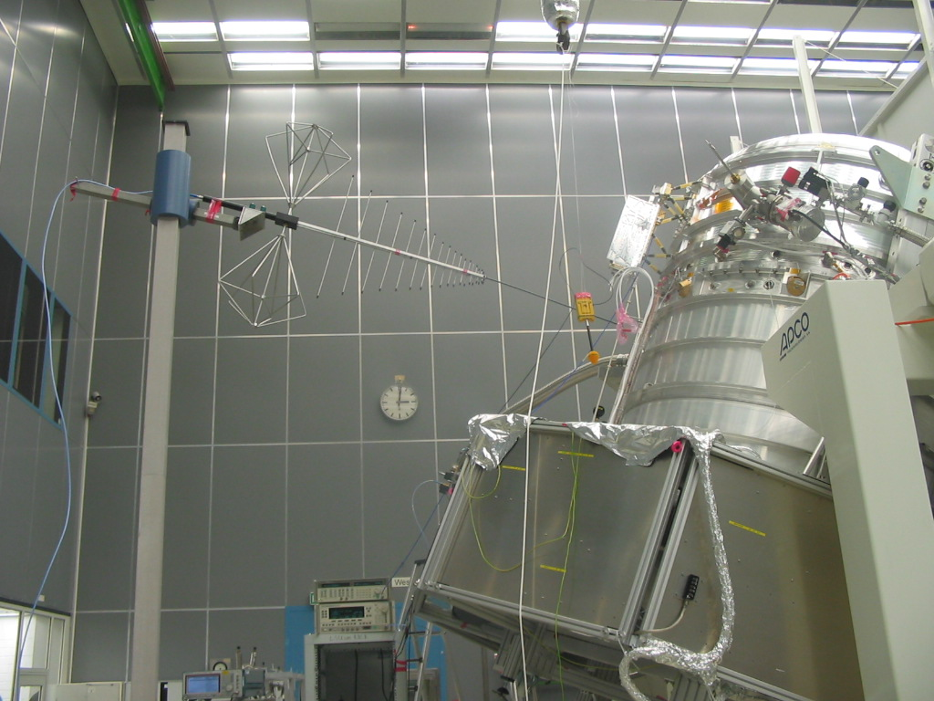
Fig. 8.2-1: Antenna Upper Position in Front of the LOU for < 1 GHz

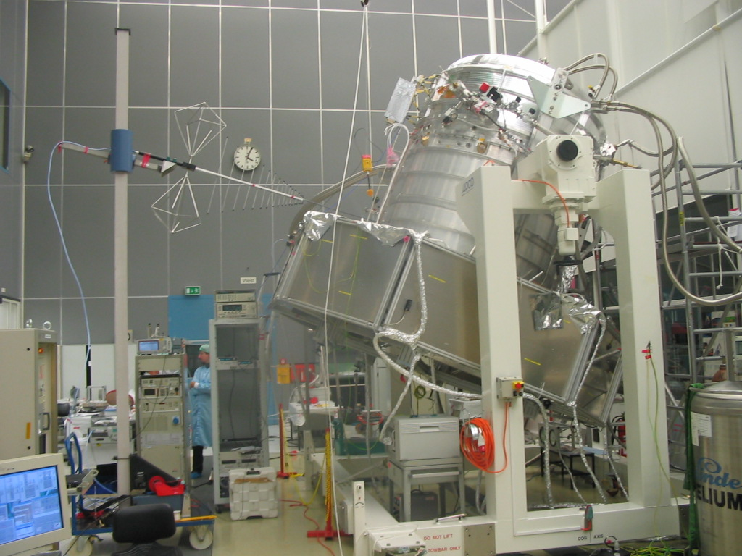
Fig. 8.2-2: Antenna Lower Position in Front of the LOU for < 1 GHz

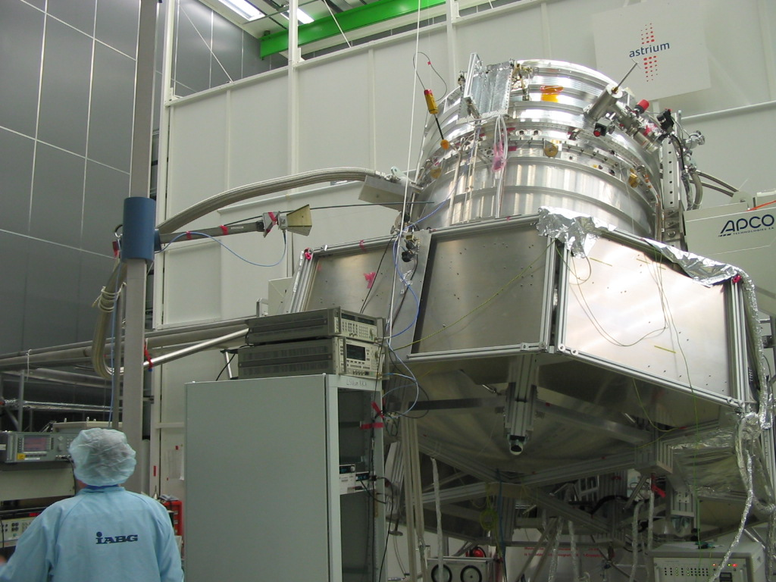
Fig. 8.2-3: Antenna Lower Position for HIFI Biasing Harness

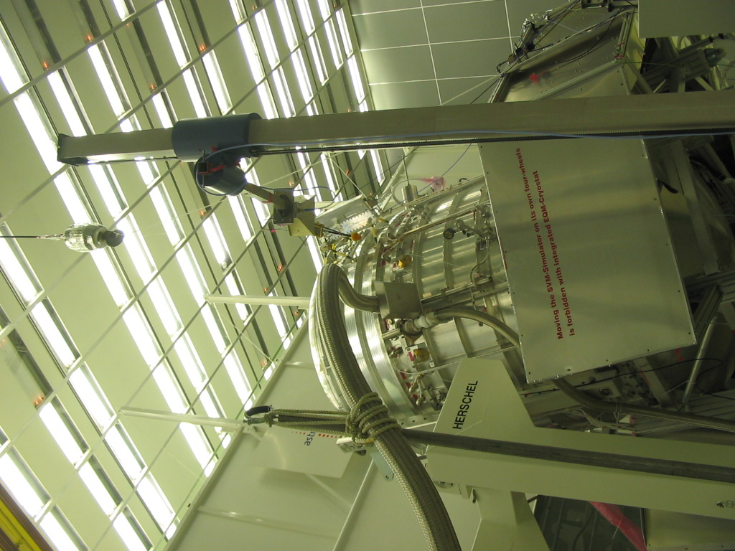
Fig. 8.2-4: Antenna Higher Position for HIFI Biasing Harness and Optical Window

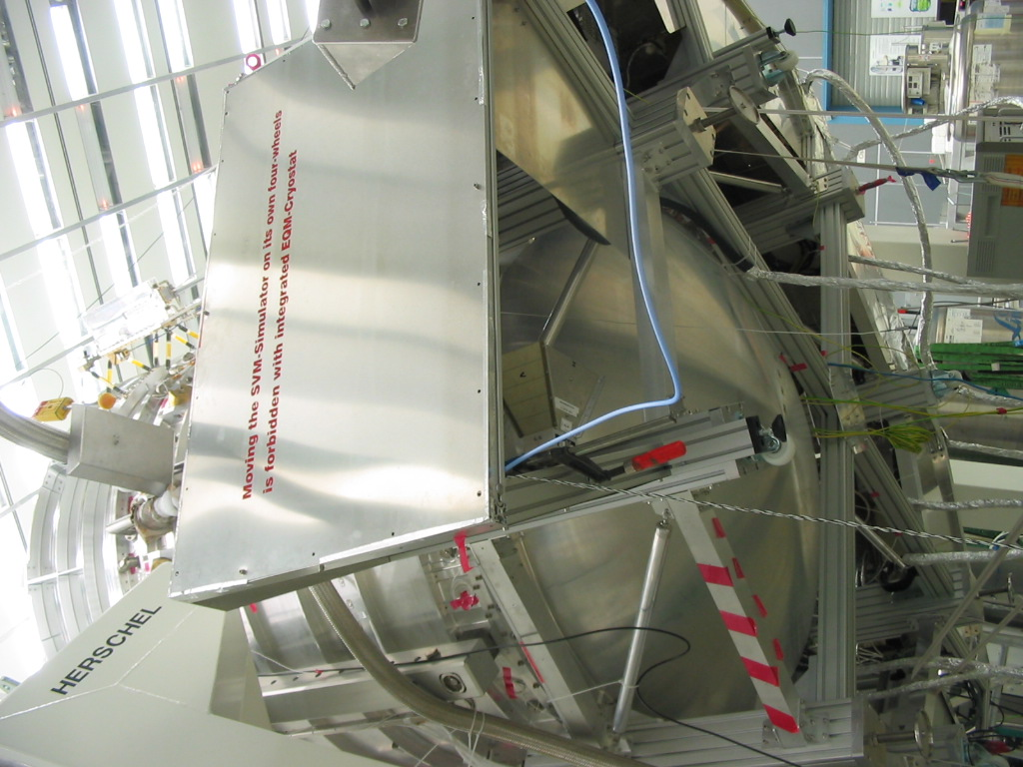
Fig. 8.2-5: Antenna Position for SVM Internal Illumination of HIFI Warm Electronics

HIFI Control Tables Conducted Susceptibility Power Lines
HIFI CS Test ICU Power Lines
i | Frequency Range | Date | CCS Start Time | CCS Stop Time | Script File | Session Name  OBS ID | Sensor | Observations
1 | 30 Hz – 50 kHz, DM | 17:11:05 | 07:55:44 | 08:30:00 |  | 2415919488
2 | 50 kHz – 50 MHz, DM | Dito | 09:52:10 | 10:13:38 |  | 19493
3 | 10 kHz – 50 MHz, DM | Dito | 11:05:30 | 11:11:23 |  | 19495 |  | Wrong steps. Wait 10 secf at low value
4 | 50 kHz – 50 MHz, DM | Dito | 13:53:49 | 13:59:00 |  | 19497 |  | Abortet. calibration from 2 was too low
5 | 50 kHz – 50 MHz, DM | Dito | 14:06:23 | 14:19:16 |  | 19500 |  | Calibration from 2 is used, increased with V2 correction.
6 | CS CM Transient ‘’+’’ | Dito | 14:49:00 | 16:54:10 |  | 19510 |  | Pulse level adjusted in pre-run
7 | CS CM Transient ‘’-’’ | Dito | 16:57:00 | 17:03:10 |  | 19511 |  | Pulse level adjusted in pre-run
8 | CS DM Transient ‘’+’’ | 18.11:00 | 10:48:32 | 10:53:23 |  | 19522
9 | CS DM Transient ‘’-’’ | Dito | 10:37:00 | 10:41:40 |  | 19520 |  | 30 seconds reference at the end
Table 8.3-1: HIFI @ Susceptibility Mode // CS ICU Power Lines

HIFI CS Test LCU Power Lines
i | Frequency Range | Date | CCS Start Time | CCS Stop Time | Script File | Session Name  OBS ID | Sensor | Observations
1 | 30 Hz – 50 kHz, DM | 17:11:05 | 09:36:00 | 09:05:26 |  | 19489
2 | 50 kHz – 50 MHz, DM | Dito | 10:29:54 | 10:50:04 |  | 19494
3 | 10 kHz – 50 MHz, DM | Dito | 13:18:13 | 13:23:19 |  | 19496
4 | 50 kHz – 50 MHz, DM | Dito | 14:29:06 | 14:42:39 |  | 19501 |  | Calibration from 2 is used with correction
5 | 10 kHz – 50 MHz, CM | Dito | 15:05:50 |  |  | 19502 |  | Calibration run before actual measurement. Measurement abortet.
6 | 10 kHz – 50 MHz, CM | Dito | 15:11:31 | 15:27:25 |  | 19502 |  | Re-run of 5
7 | CS CM Transient ‘’+’’ | Dito | 17:08:00 | 17:13:10 |  | 19512 |  | Pulse level adjusted during previous measurement
8 | CS CM Transient ‘’-’’ | Dito | 17:14:10 | 17:19:20 |  | 19513 |  | Pulse level adjusted in pre-run
9 | CS DM Transient ‘’+’’ | 18.11:00 | 11:00:10 | 11:05:12 |  | 19523
10 | CS DM Transient ‘’-’’ | Dito | 11:08:38 | 11:13:10 |  | 19524
Table 8.3-2: HIFI @ Susceptibility Mode // CS LCU Power Lines

HIFI Control Tables Conducted Susceptibility on Instrument Cryo Harness Bundles
Corresponding tables and figures to be prepared during the test because they would be specific (the CS value has to be adjusted 6 dB above the value measured at every particular frequency at given instrument Cryo Harness bundle).

PACS Frequency Control Tables H-field
PACS RS H-field Photometer Mode 1st Position
i | Frequency | Date | CCS Step Start Time | CCS Step Stop Time | Data file  imt_emc20051121_h1_ | Level  [dBpT) | Sensor | Comments
1 | 30 Hz | 22.11.05 | 12:06:34 | 12:08:34 | 30H0 | 120
2 | 40 Hz | Dito | 12:09:42 | 12:10:50 | 40H0 | 120
3 | 50 Hz | Dito | 12:11:22 | 12:14:06 | 50H0 | 120
4 | 64 Hz | Dito | 12:15:02 | 1216:10 | 64H0 | 120
5 | 80 Hz | Dito | 12:16:22 | 12:17:41 | 80H0 | 120
6 | 100 Hz | Dito | 12:18:03 | 12:19:10 | 100H0 | 120
7 | 125 Hz | Dito | 12:19:20 | 12:20:32 | 125H0 | 120
8 | 256 Hz | Dito | 12:20:410 | 12:21:50 | 256H0 | 120
9 | 350 Hz | Dito | 12:22:04 | 12:23:14 | 350H0 | 120
10 | 500 Hz | Dito | 12:23:14 | 12:25:03 | 500H0 | 120
11 | 750 Hz | Dito | 12:25:20 | 12:26:25 | 750H0 | 120
12 | 1 kHz | Dito | 12:26:30 | 12:29:04 | 1K0 | 120
13 | 1.5 kHz | Dito | 12:29:23 | 12:30:37 | 1K5 | 120
14 | 2 kHz | Dito | 12:30:45 | 12:32:14 | 2K0 | 120
 | --- | --- | --- | --- | --- | --- |  | Waiting time to recover stability
15 | 2.5 kHz | Dito | 12:37:08 | 12:38:59 | 2K5 | 120
16 | 3 kHz | Dito | 12:39:08 | 12:40:20 | 3K0 | 120
17 | 3.5 kHz | Dito | 12:40:32 | 12:41:47 | 3K5 | 120
18 | 4 kHz | Dito | 12:41:52 | 12:43:52 | 4K0 | 120
19 | 4.5 kHz | Dito | 12:44:09 | 12:45:50 | 4K5 | 120
20 | 5 kHz | Dito | 12:45:58 | 12:47:47 | 5K0 | 120
21 | 5.5 kHz | Dito | 12:47:57 | 12:49:17 | 5K5 | 120
22 | 6 kHz | Dito | 12:49:25 | 12:50:43 | 6K0 | 120
23 | 6.5 kHz | Dito | 12:50:55 | 12:52:11 | 6K5 | 120
24 | 7 kHz | Dito | 12:52:20 | 12:53:30 | 7K0 | 120
25 | 7.5 kHz | Dito | 12:53:36 | 12:54:53 | 7K5 | 120
26 | 8 kHz | Dito | 12:55:00 | 12:56:16 | 8K0 | 120
27 | 8.5 kHz | Dito | 12:56:22 | 12:57:40 | 8K5 | 120
28 | 9 kHz | Dito | 12:57:40 | 12:58:59 | 9K0 | 120
29 | 9.5 kHz | Dito | 12:59:08 | 13:00:12 | 9K5 | 120
31 | 10 kHz | Dito | 13:00:22 | 13:01:48 | 10K0 | 120
31 | 11.47 Khz |  | 13:06:50 | 13:09:47 | 11K47 | 120 | 1.5 mT
32 | 15.6 kHz | Dito | 13:10:18 | 13:11:24 | 15K6 | 120 | 1.2 mT | Probe measurement in addition
33 | 17.0 kHz | Dito | 13:11:42 | 13:12:52 | 17K0 | 120
34 | 20.0 kHz | Dito | 13:13:03 | 13:14:14 | 20K0 | 110
35 | 25.0 kHz | Dito | 13:14:20 | 13:15:32 | 25K0 | 110
36 | 30 kHz | Dito | 13:15:40 | 13:16:55 | 30K0 | 110
37 | 35 kHz | Dito | 13:17:00 | 13:18:15 | 35K0 | 110
38 | 40 kHz | Dito | 13:18:22 | 13:19:29 | 40K0 | 110
39 | 45.8 kHz | Dito | 13:19:34 | 13:20:47 | 48K8 | 110
40 | 50 kHz | Dito | 13:20:52 | 13:22:05 | 50K0 | 110
12-1 | 1 kHz | Dito | 14:19:17 | 14:20:46 | th_1K0_1_m0 | 120 |  | Threshold prediction
12-2 | 1 kHz | Dito | 14:23:07 | 14:26:41 | th_1K0_2_m0 | 120 |  | Threshold prediction
12-3 | 1 kHz | Dito | 14:27:55 | 14:36:33 | th_1K0_20_m20 | 120-20 dB |  | Threshold prediction
13-1 | 1.5 kHz | Dito | 14:37:25 | 14:40:41 | th_1K5_10_m10 | 120-10 dB |  | Threshold prediction
13-2 | 1.5 kHz | Dito | 14:41:00 | 14:54:02 | th_1K5_2_m20 | 120-20 dB |  | Threshold prediction
13-3 | 1.5 kHz | Dito | 14:45:19 | 14:54:02 | th_1K5_3_m30 | 120-30 dB |  | Threshold prediction
14-1 | 2 kHz | Dito | 14:47:45 | 14:50:53 | th_2K0_1_m10 | 120-10 dB |  | Threshold prediction
14-2 | 2 kHz | Dito | 14:51:10 | 14:54:15 | th_2K0_2_m20 | 120-20 dB |  | Threshold prediction
--- | --- | -- | 14:54 … | 15:58 | --- | --- |  | Reference measurement with EMC amps OFF
14-3 | 2 kHz | Dito | 14:58:42 | 15:02:45 | th_2K0_3_m30 | 120-30 dB |  | Threshold prediction
15-1 | 2.5 kHz | Dito | 15:03:10 | 15:04:42 | th_2K5_1_m10 | 120-10 dB |  | Threshold prediction
15-2 | 2.5 kHz | Dito | 15:05:03 | 15:07:13 | th_2K5_2_m20 | 120-20 dB |  | Threshold prediction
15-3 | 2.5 kHz | Dito | 15:07:24 | 15:09:18 | th_2K5_3_m30 | 120-30 dB |  | Threshold prediction
16-1 | 3 kHz | Dito | 15:09:27 | 15:12:18 | th_3K0_1_m10 | 120-10 dB |  | Threshold prediction
16-2 | 3 kHz | Dito | 15:12:18 | 15:14:54 | th_3K0_2_m20 | 120-20 dB |  | Threshold prediction
16-3 | 3 kHz | Dito | 15:14:54 | 15:16:56 | th_3K0_3_30 | 120-30 dB |  | Threshold prediction
18-1 | 4 kHz | Dito | 15:17:30 | 15:19:31 | th_4K0_1_10 | 120-10 dB |  | Threshold prediction
18-2 | 4 kHz | Dito | 15:19:31 | 15:21:57 | th_4K0_2_m20 | 120-20 dB |  | Threshold prediction
20-1 | 5 kHz | Dito | 15:22:18 | 15:24:03 | th_5K0_1_m10 | 120-10 dB |  | Threshold prediction
20-2 | 5 kHz | Dito | 15:24:03 | 15:26:30 | th_5K0_2_m20 | 120-20 dB |  | Threshold prediction
31-1 | 11.57 kHz | Dito | 15:27:25 | 15:29:25 | th_11K57_1_m0 | 120 |  | Threshold prediction
31-2 | 12.00 kHz | Dito | 15:29:46 | 15:31:32 | th_12K00_1_m0 | 120 |  | Threshold prediction
31-2 | 12.00 kHz | Dito | 15:31:32 | 15:33:17 | th_12K00_2_m10 | 120-10 dB |  | Threshold prediction
31-3 | 12.00 kHz | Dito | 15:33:17 | 15:35:08 | th_12K00_3_m20 | 120-20 dB |  | Threshold prediction
31-4 | 12.00 kHz | Dito | 15:35:08 | 15:38:19 | th_12K00_4_m30 | 120-30 dB |  | Threshold prediction
34-1 | 20.0 kHz | Dito | 15:41:20 | 15:43:10 | th_20K0_1_m10 | 110-10dB |  | Threshold prediction
34-2 | 20.0 kHz | Dito | 15:43:10 | 15:46:12 | th_20K0_2_m20 | 110-20dB |  | Threshold prediction
34-3 | 20.0 kHz | Dito | 15:46:12 | 15:48:03 | th_20K0_3_m30 | 110-30dB |  | Threshold prediction
39-1 | 45.8 kHz | Dito | 15:48:15 | 15:50:21 | th_48K8_1_m10 | 110-10dB |  | Threshold prediction
39-2 | 45.8 kHz | Dito | 15:50:21 | 14:51:51 | th_48K8_2_m20 | 110-20dB |  | Threshold prediction
39-2 | 45.8 kHz | Dito | 14:51:51 | 15:55:29 | th_48K8_3_m30 | 110-30dB |  | Threshold prediction
41 | 40 Hz | Dito |  |  |  |  |  | . Replaced, see above thresholds
42 | 100 Hz | Dito |  |  |  |  |  | Replaced, see above thresholds
43 | 350 Hz | Dito |  |  |  |  |  | Replaced, see above thresholds
44 | 1 kHz | Dito |  |  |  |  |  | Replaced, see above thresholds
45 | 2.5 kHz | Dito |  |  |  |  |  | Replaced, see above thresholds
46 | 3.5 kHz | Dito |  |  |  |  |  | Replaced, see above thresholds
47 | 6 kHz | Dito |  |  |  |  |  | Replaced, see above thresholds
48 | 8 kHz | Dito |  |  |  |  |  | Replaced, see above thresholds
49 | 20 kHz | Dito |  |  |  |  |  | Replaced, see above thresholds
50 | 30 kHz | Dito |  |  |  |  |  | Replaced, see above thresholds
Table 8.5-1: PACS @ Photometer Mode // H-field // 1st Antenna Position (upper part of cryostat in order to illuminate the detectors)

PACS RS H-field Photometer Mode 2nd Position
I | Frequency | Date | CCS Step Start Time | CCS Step Stop Time | Data file  imt_emc200511DAY_h2_ | Level  [dBpT) | Sensor | Observations
1 | 30 Hz | 21.11.05 | 16:37:50 | 16:39:20 | 30H0 | 120
2 | 40 Hz | Dito | 16:39:29 | 16:40:51 | 40H0 | 120
3 | 50 Hz | Dito | 16:41:09 | 16:42:35 | 50H0 | 120
4 | 64 Hz | Dito | 16:42:41 | 16:44:08 | 64H0 | 120
5 | 80 Hz | Dito | 16:44:12 | 16:45:35 | 80H0 | 120
6 | 100 Hz | Dito | 16:45:35 | 16:47:01 | 100H0 | 120
7 | 125 Hz | Dito | 16:47:01 | 16:49:16 | 125H0 | 120
8 | 256 Hz | Dito | 16:49:16 | 16:50:35 | 256H0 | 120
9 | 350 Hz | Dito | 16:50:35 | 16:51:58 | 350H0 | 120
 | --- | --- | --- | --- | --- | --- | --- | Reference test
10 | 500 Hz | Dito | 16:53:39 | 16:54:55 | 500H0 | 120
11 | 750 Hz | Dito | 16:54:55 | 16:56:22 | 750H0 | 120
 | --- | --- | --- | --- | --- | --- | --- | Reference test
12 | 1 kHz | Dito | 16:59:21 | 17:00:58 | 1K0 | 120
13 | 1.5 kHz | Dito | 17:00:58 | 17:02:21 | 1K5 | 120
14 | 2 kHz | Dito | 17:02:21 | 17:03:40 | 2K0 | 120
15 | 2.5 kHz | Dito | 17:03:40 | 17:05:06 | 2K5 | 120
16 | 3 kHz | Dito | 17:05:06 | 17:06:25 | 3K0 | 120
17 | 3.5 kHz | Dito | 17:06:25 | 17:07:45 | 3K5 | 120
18 | 4 kHz | Dito | 17:07:45 | 17:09:07 | 4K0 | 120
19 | 4.5 kHz | Dito | 17:09:07 | 17:10:20 | 4K5 | 120
20 | 5 kHz | Dito | 17:10:20 | 17:11:44 | 5K0 | 120
21 | 5.5 kHz | Dito | 17:11:44 | 17:13:22 | 5K5 | 120
22 | 6 kHz | Dito | 17:13:22 | 17:14:39 | 6K0 | 120
23 | 6.5 kHz | Dito | 17:14:39 | 17:15:47 | 6K5 | 120
24 | 7 kHz | Dito | 17:15:47 | 17:17:02 | 7K0 | 120
25 | 7.5 kHz | Dito | 17:17:02 | 17:18:12 | 7K5 | 120
26 | 8 kHz | Dito | 17:18:12 | 17:19:38 | 8K0 | 120
27 | 8.5 kHz | Dito | 17:19:38 | 17:20:50 | 8K5 | 120
28 | 9 kHz | Dito | 17:20:50 | 17:22:03 | 9K0 | 120
29 | 9.5 kHz | Dito | 17:22:03 | 17:23:14 | 9K5 | 120
31 | 10 kHz | Dito | 17:23:14 | 17:24:30 | 10K0 | 120
31 | 11.47 kHz | Dito | 17:24:30 | 17:25:55 | 11K47 | 120
32 | 15.6 kHz | Dito | 17:25:55 | 17:27:08 | 15K6 | 120
33 | 17.0 kHz | Dito | 17:27:08 | 17:28:25 | 17K0 | 120
34 | 20.0 kHz | Dito | 17:31:10 | 17:32:29 | 20K0 | 110
35 | 25.0 kHz | Dito | 17:29:37 | 17:30:47 | 25K0 | 110
36 | 30 kHz | Dito | 17:32:38 | 17:34:02 | 30K0 | 110
37 | 35 kHz | Dito | 17:34:02 | 17:35:21 | 35K0 | 110
38 | 40 kHz | Dito | 17:35:21 | 17:36:32 | 40K0 | 110
39 | 45.8 kHz | Dito | 17:36:32 | 17:37:45 | 48K8 | 110
40 | 50 kHz | Dito | 17:37:45 | 17:38:56 | 50K0 | 110
 | --- | --- | --- | --- | --- | --- | --- | Reference test
12-1 | 1 kHz | 22.11.05 | 08:16:20 | 08:17:46 | th_1k0_1_m0 | 120 |  | Threshold measurement
12-2 | 1 kHz | Dito | 08:17:46 | 08:19:04 | th_1k0_2_m10 | 120-10 dB |  | Threshold measurement
12-3 | 1 kHz | Dito | 08:19:04 | 08:20:32 | th_1k0_3_m20 | 120-20 dB |  | Threshold measurement
12-4 | 1 kHz | Dito | 08:20:32 | 08:22_18 | th_1k0_4_m30 | 120-30 dB |  | Threshold measurement
13-1 | 1.5 kHz | Dito | 08:22_18 | 08:23:41 | th_1k5_1_m0 | 120 |  | Threshold measurement
13-2 | 1.5 kHz | Dito |  |  | th_1k5_2_m10 | 120.10 dB |  | Threshold measurement
13-3 | 1.5 kHz | Dito |  | 08:26:51 | th_2k0_3_m20 | 120-20 dB |  | Threshold measurement
13-4 | 1.5 kHz | Dito | 08:26:51 | 08:28:16 | th_2k0_4_m30 | 120-30 dB |  | Threshold measurement
14-1 | 2 kHz | Dito | 08:28:16 | 08:29:32 | th_2k0_1_m0 | 120 |  | Threshold measurement
14-2 | 2 kHz | Dito | 08:29:32 | 08:30:58 | th_2k0_2_m10 | 120-10 dB |  | Threshold measurement
14-3 | 2 kHz | Dito | 08:30:58 | 08:32:21 | th_2k5_3_m20 | 120-20 dB |  | Threshold measurement
14-4 | 2 kHz | Dito | 08:32:21 | 08:33:43 | th_2k5_4_m30 | 120-30 dB |  | Threshold measurement
15-1 | 2.5 kHz | Dito | 08:33:43 | 08:35:01 | th_2k5_1_m0 | 120 |  | Threshold measurement
15-2 | 2.5 kHz | Dito | 08:35:01 | 08:36:22 | th_2k5_2_m10 | 120-10 dB |  | Threshold measurement
15-3 | 2.5 kHz | Dito | 08:36:22 | 08:37:40 | th_2k5_3_m20 | 120-20 dB |  | Threshold measurement
15-4 | 2.5 kHz | Dito | 08:37:40 | 08:38:57 | th_2k5_4_m30 | 120-30 dB |  | Threshold measurement
16-1 | 3 kHz | Dito | 08:38:57 | 08:40:48 | th_3k0_1_m0 | 120 |  | Threshold measurement
16-2 | 3 kHz | Dito | 08:40:48 | 08:42:06 | th_3k0_2_m10 | 120-10 dB |  | Threshold measurement
16-3 | 3 kHz | Dito | 08:42:06 | 08:43:23 | th_3k0_3_m20 | 120-20 dB |  | Threshold measurement
16-4 | 3 kHz | Dito | 08:43:23 | 08:44:57 | th_3k0_4_m30 | 120-30 dB |  | Threshold measurement
18-1 | 4 kHz | Dito | 08:44:57 | 08:46:25 | th_4k0_1_m0 | 120 |  | Threshold measurement
18-2 | 4 kHz | Dito | 08:46:25 | 08:47:40 | th_4k0_2_m10 | 120-10 dB |  | Threshold measurement
18-3 | 4 kHz | Dito | 08:47:40 | 08:48:55 | th_4k0_3_m20 | 120-20 dB |  | Threshold measurement
18-4 | 4 kHz | Dito | 08:48:55 | 08:50:27 | th_4k0_3_m30 | 120-30 dB |  | Threshold measurement
20-1 | 5 kHz | Dito | 08:50:27 | 08:51:40 | th_5k0_1_m0 | 120 |  | Threshold measurement
20-2 | 5 kHz | Dito | 08:51:40 | 08:52:52 | th_5k0_2_m10 | 120-10 dB |  | Threshold measurement
20-3 | 5 kHz | Dito | 08:52:52 | 08.54:06 | th_5k0_2_m20 | 120-20 dB |  | Threshold measurement
20-4 | 5 kHz | Dito | 08.54:06 | 08:56:00 | th_5k0_2_m30 | 120-30 dB |  | Threshold measurement
31-1 | 11.57 kHz | Dito | 08:56:43 | 08:58:08 | th_11k57_1_m0 | 120 |  | Threshold measurement
31-2 | 12.00 kHz | Dito | 08:58:36 | 08:59:53 | th_12k0_2_m0 | 120 |  | Threshold measurement
31-2 | 12.00 kHz | Dito | 08:59:53 | 09:01:15 | th_12k0_3_m10 | 120-10 dB |  | Threshold measurement
31-3 | 12.00 kHz | Dito | 09:01:15 | 09:02:35 | th_12k0_4_m20 | 120-20 dB |  | Threshold measurement
31-4 | 12.00 kHz | Dito | 09:02:35 | 09:04:07 | th_12k0_5_m30 | 120-30 dB |  | Threshold measurement
34-1 | 20.0 kHz | Dito | 09:04:07 | 09:06:01 | th_20k0_1_m0 | 110 |  | Threshold measurement
34-2 | 20.0 kHz | Dito | 09:06:01 | 09:07:27 | th_20k0_2_m10 | 110-10 dB |  | Threshold measurement
34-3 | 20.0 kHz | Dito | 09:07:27 | 09:08:48 | th_20k0_3_m20 | 110-20 dB |  | Threshold measurement
34-4 | 20.0 kHz | Dito | 09:08:48 | 09:10:04 | th_20k0_4_m30 | 110-30 dB |  | Threshold measurement
34-5 | 20.0 kHz | Dito | 09:10:04 | 09:11:41 | th_20k0_5_m0 | 110 |  | Threshold measurement
39-2 | 45.8 kHz | Dito | 09:13:10 | 09:14:29 | th_45k8_2_m10 | 110-10 dB |  | Threshold measurement
39-3 | 45.8 kHz | Dito | 09:14:29 | 09:15:48 | th_45k8_3_m20 | 110-20 dB |  | Threshold measurement
39-4 | 45.8 kHz | Dito | 09:15:48 | 09:17:03 | th_45k8_3_m30 | 110-30 dB |  | Threshold measurement
41 | 40 Hz | Dito |  |  |  |  |  | Replaced by thresholds measurements above
42 | 100 Hz | Dito |  |  |  |  |  | Replaced by thresholds measurements above
43 | 350 Hz | Dito |  |  |  |  |  | Replaced by thresholds measurements above
44 | 1 kHz | Dito |  |  |  |  |  | Replaced by thresholds measurements above
45 | 2.5 kHz | Dito |  |  |  |  |  | Replaced by thresholds measurements above
46 | 3.5 kHz | Dito |  |  |  |  |  | Replaced by thresholds measurements above
47 | 6 kHz | Dito |  |  |  |  |  | Replaced by thresholds measurements above
48 | 8 kHz | Dito |  |  |  |  |  | Replaced by thresholds measurements above
49 | 20 kHz | Dito |  |  |  |  |  | Replaced by thresholds measurements above
50 | 30 kHz | Dito |  |  |  |  |  | Replaced by thresholds measurements above
Table 8.5-2: PACS @ Photometer Mode // H-field // 2nd Antenna Position

PACS RS H-field Photometer Mode 3rd Position
i | Frequency | Date | CCS Step Start Time | CCS Step Stop Time | Data file  imt_emc20051122_h3_ | Level  [dBpT] | Sensor | Observations
1 | 30 Hz |  |  |  |  |  |  | Not performed
2 | 40 Hz |  |  |  |  |  |  | Not performed
3 | 50 Hz |  |  |  |  |  |  | Not performed
4 | 64 Hz |  |  |  |  |  |  | Not performed
5 | 80 Hz |  |  |  |  |  |  | Not performed
6 | 100 Hz |  |  |  |  |  |  | Not performed
7 | 125 Hz |  |  |  |  |  |  | Not performed
8 | 256 Hz |  |  |  |  |  |  | Not performed
9 | 350 Hz |  |  |  |  |  |  | Not performed
10 | 500 Hz |  |  |  |  |  |  | Not performed
11 | 750 Hz |  |  |  |  |  |  | Not performed
12 | 1 kHz |  |  |  |  |  |  | Not performed
13 | 1.5 kHz |  |  |  |  |  |  | Not performed
14 | 2 kHz |  |  |  |  |  |  | Not performed
15 | 2.5 kHz |  |  |  |  |  |  | Not performed
16 | 3 kHz |  |  |  |  |  |  | Not performed
17 | 3.5 kHz |  |  |  |  |  |  | Not performed
18 | 4 kHz |  |  |  |  |  |  | Not performed
19 | 4.5 kHz |  |  |  |  |  |  | Not performed
20 | 5 kHz |  |  |  |  |  |  | Not performed
21 | 5.5 kHz |  |  |  |  |  |  | Not performed
22 | 6 kHz |  |  |  |  |  |  | Not performed
23 | 6.5 kHz |  |  |  |  |  |  | Not performed
24 | 7 kHz |  |  |  |  |  |  | Not performed
25 | 7.5 kHz |  |  |  |  |  |  | Not performed
26 | 8 kHz |  |  |  |  |  |  | Not performed
27 | 8.5 kHz |  |  |  |  |  |  | Not performed
28 | 9 kHz |  |  |  |  |  |  | Not performed
29 | 9.5 kHz |  |  |  |  |  |  | Not performed
31 | 10 kHz |  |  |  |  |  |  | Not performed
31 | 11.47 kHz |  |  |  |  |  |  | Not performed
32 | 15.6 kHz |  |  |  |  |  |  | Not performed
33 | 17.0 kHz |  |  |  |  |  |  | Not performed
34 | 20.0 kHz |  |  |  |  |  |  | Not performed
35 | 25.0 kHz |  |  |  |  |  |  | Not performed
36 | 30 kHz |  |  |  |  |  |  | Not performed
37 | 35 kHz |  |  |  |  |  |  | Not performed
38 | 40 kHz |  |  |  |  |  |  | Not performed
39 | 45.8 kHz |  |  |  |  |  |  | Not performed
40 | 50 kHz |  |  |  |  |  |  | Not performed
51-1 | 3.5 kHz | 22.11.05 | 9:45:00 | 9:56:11 | 3K0_1_m0 | 120 |  | Threshold measurements
51-2 | 3.5 kHz | Dito | 9:56:11 | 9:57:32 | 3K0_2_m10 | 120-10 dB |  | Threshold measurements
51-3 | 3.5 kHz | Dito | 9:57:32 | 9:57:40 | 3K0_3_m20 | 120-20 dB |  | Threshold measurements
51-4 | 3.5 kHz | Dito | 9:57:40 | 10:00:10 | 3K0_3_m30 | 120-30 dB |  | Threshold measurements
52-1 | 4.5 kHz | Dito | 10:00:10 | 10:01:27 | 4K5_1_m0 | 120 |  | Threshold measurements
51-2 | 4.5 kHz | Dito | 10:01:27 | 10:02:50 | 4K5_2_m10 | 120-10 dB |  | Threshold measurements
52-3 | 4.5 kHz | Dito | 10:02:50 | 10:04:11 | 4K5_3_m20 | 120-20 dB |  | Threshold measurements
52-4 | 4.5 kHz | Dito | 10:04:11 | 10:05:34 | 4K5_4_m30 | 120-30 dB |  | Threshold measurements
53-1 | 6.0 kHz | Dito | 10:05:45 | 10:06:52 | 6K0_1_m0 | 120 |  | Threshold measurements
53-2 | 6.0 kHz | Dito | 10:08:08 | 10:09:18 | 6K0_2_m10 | 120-10 dB |  | Threshold measurements
53-3 | 6.0 kHz | Dito | 10:09:18 | 10:10:36 | 6K0_3_m20 | 120-20 dB |  | Threshold measurements
53-4 | 6.0 kHz | Dito | 10:10:36 | 10:12:07 | 6K0_4_m30 | 120-30 dB |  | Threshold measurements
54-1 | 7.0 kHz | Dito | 10:12:18 | 10:13:32 | 7K0_1_m0 | 120 |  | Threshold measurements
54-2 | 7.0 kHz | Dito | 10:13:32 | 10:15:10 | 7K0_2_m10 | 120-10 dB |  | Threshold measurements
54-3 | 7.0 kHz | Dito | 10:15:10 | 10:16:32 | 7K0_3_m20 | 120-20 dB |  | Threshold measurements
54-4 | 7.0 kHz | Dito | 10:16:40 | 10:17:57 | 7K0_4_m30 | 120-30 dB |  | Threshold measurements
55-1 | 8.0 kHz | Dito | 10:18:04 | 10:19:15 | 8K0_1_m0 | 120 |  | Threshold measurements
55-2 | 8.0 kHz | Dito | 10:19:15 | 10:19:20 | 8K0_2_m10 | 120-10 dB |  | Threshold measurements
55-3 | 8.0 kHz | Dito | 10:19:20 | 10:21:53 | 8K0_3_m20 | 120-20 dB |  | Threshold measurements
55-4 | 8.0 kHz | Dito | 10:21:53 | 10:23:10 | 8K0_4_m30 | 120-30 dB |  | Threshold measurements
56-1 | 9.0 kHz | Dito | 10:23:10 | 10:24:34 | 9K0_1_m0 | 120 |  | Threshold measurements
56-2 | 9.0 kHz | Dito | 10:24:34 | 10:25:35 | 9K0_2_m10 | 120-10 dB |  | Threshold measurements
56-3 | 9.0 kHz | Dito | 10:25:35 | 10:27:08 | 9K0_3_m20 | 120-20 dB |  | Threshold measurements
56-4 | 9.0 kHz | Dito | 10:27:08 | 10:28:40 | 9K0_4_m30 | 120-30 dB |  | Threshold measurements
57-1 | 10.0 kHz | Dito | 10:28:40 | 10:30:07 | 10K0_1_m0 | 120 |  | Threshold measurements
57-2 | 10.0 kHz | Dito | 10:30:07 | 10:31:19 | 10K0_2_m10 | 120-10 dB |  | Threshold measurements
57-3 | 10.0 kHz | Dito | 10:31:19 | 10:32:38 | 10K0_3_m20 | 120-20 dB |  | Threshold measurements
57-4 | 10.0 kHz | Dito | 10:32:38 | 10:33:58 | 10K0_4_m30 | 120-30 dB |  | Threshold measurements
58-1 | 30.0 kHz | Dito | 10:34:05 | 10:38:05 | 30K0_1_m0 | 110 |  | Threshold measurements
59-1 | 40.0 kHz | Dito | 10:38:05 | 10:41:02 | 40K0_1_m0 | 110 |  | Threshold measurements
59-2 | 40.0 kHz | Dito | 10:41:15 | 10:43:31 | 40K0_2_m10 | 110-10 dB |  | Threshold measurements
59-3 | 40.0 kHz | Dito | 10:43:31 | 10:44:45 | 40K0_3_m20 | 110-20 dB |  | Threshold measurements
60-1 | 50.0 kHz | Dito | 10:44:55 | 10:45:28 | 50K0_1_m0 | 110 |  | Threshold measurements
60-2 | 50.0 kHz | Dito | 10:45:28 | 10:47:47 | 50K0_2_m10 | 110-10 dB |  | Threshold measurements
60-3 | 50.0 kHz | Dito | 10:47:47 | 10:49:49 | 50K0_3_m20 | 110-20 dB |  | Threshold measurements
60-4 | 50.0 kHz | Dito | 10:49:49 | 10:51:19 | 50K0_4_m30 | 110-30 dB
61-1 | 25 kHz | Dito | 10:52:00 | 10:53:14 | 25K0_1_m0 | 110 |  | Threshold measurements
62-1 | 20.0 kHz | Dito | 10:53:45 | 10:55:04 | 20K0_1_m0 | 120 |  | Threshold measurements
62-2 | 20.0 kHz | Dito | 10:55:20 | 10:56:44 | 20K0_2_m10 | 120-10 dB |  | Threshold measurements
62-3 | 20.0 kHz | Dito | 10:56:44 | 10:48:13 | 20K0_3_m20 | 120-20 dB |  | Threshold measurements
62-4 | 20.0 kHz | Dito | 10:58:20 | 11:00:02 | 20K0_4_m10 | 120-10 dB |  | Threshold measurements
63-1 | 45.8 kHz | Dito | 11:01:08 | 11:01:36 | 45K8_1_m0 | 110 |  | Threshold measurements
63-2 | 45.8 kHz | Dito | 11:01:36 | 11:02:55 | 45K8_2_m10 | 110-10 dB |  | Threshold measurements
63-3 | 45.8 kHz | Dito | 11:02:55 | 11:04:35 | 45K8_3_m20 | 110-20 dB |  | Threshold measurements
41 | 40 Hz | Dito |  |  |  |  |  | Replaced by thresholds measurements above
42 | 100 Hz | Dito |  |  |  |  |  | Replaced by thresholds measurements above
43 | 350 Hz | Dito |  |  |  |  |  | Replaced by thresholds measurements above
44 | 1 kHz | Dito |  |  |  |  |  | Replaced by thresholds measurements above
45 | 2.5 kHz | Dito |  |  |  |  |  | Replaced by thresholds measurements above
46 | 3.5 kHz | Dito |  |  |  |  |  | Replaced by thresholds measurements above
47 | 6 kHz | Dito |  |  |  |  |  | Replaced by thresholds measurements above
48 | 8 kHz | Dito |  |  |  |  |  | Replaced by thresholds measurements above
49 | 20 kHz | Dito |  |  |  |  |  | Replaced by thresholds measurements above
50 | 30 kHz | Dito |  |  |  |  |  | Replaced by thresholds measurements above
Table 8.5-3: PACS @ Photometer Mode // H-field // 3rd^{t} Antenna Position

PACS RS H-field Spectrometer Mode 1st Position
i | Frequency | Date | CCS Step Start Time | CCS Step Stop Time | Data file  imt_emc20051122_s_h1_ | Level  [dBpT] | Sensor | Observations
1 | 30 Hz | 21.11.05 | 12:49:53 | 12:51:04 | 30H0 | 120
2 | 40 Hz | Dito | 12:51:04 | 12:52:14 | 40H0 | 120
3 | 50 Hz | Dito | 12:52:14 | 12:53:30 | 50H0 | 120
4 | 64 Hz | Dito | 12:53:30 | 12:54:40 | 64H0 | 120
5 | 80 Hz | Dito | 12:54:40 | 12:56:00 | 80H0 | 120
6 | 100 Hz | Dito | 12:56:00 | 12:57:20 | 100H0 | 120
7 | 125 Hz | Dito | 12:57:20 | 12:58:36 | 125H0 | 120
8 | 256 Hz | Dito | 12:58:36 | 12:59:58 | 256H0 | 120
9 | 350 Hz | Dito | 12:59:58 | 13:01:09 | 350H0 | 120
10 | 500 Hz | Dito | 13:01:09 | 13:02:37 | 500H0 | 120
11 | 750 Hz | Dito | 13:02:37 | 13:03:49 | 750H0 | 120
12 | 1 kHz | Dito | 13:03:49 | 13:05:05 | 1K0 | 120
13 | 1.5 kHz | Dito | 13:05:05 | 13:06:23 | 1K5 | 120
14 | 2 kHz | Dito | 13:06:23 | 13:07:36 | 2K0 | 120
15 | 2.5 kHz | Dito | 13:07:36 | 13:11:12 | 2K5 | 120
16 | 3 kHz | Dito | 13:11:12 | 13:12:22 | 3K0 | 120
17 | 3.5 kHz | Dito | 13:12:22 | 13:13:37 | 3K5 | 120
18 | 4 kHz | Dito | 13:13:37 | 13:14:55 | 4K0 | 120
19 | 4.5 kHz | Dito | 13:14:55 | 13:16:09 | 4K5 | 120
20 | 5 kHz | Dito | 13:16:09 | 13:17:25 | 5K0 | 120
21 | 5.5 kHz | Dito | 13:17:25 | 13:18:36 | 5K5 | 120
22 | 6 kHz | Dito | 13:18:36 | 13:19:52 | 6K0 | 120
23 | 6.5 kHz | Dito | 13:19:52 | 13:20:55 | 6K5 | 120
24 | 7 kHz | Dito | 13:20:55 | 13:22:02 | 7K0 | 120
25 | 7.5 kHz | Dito | 13:22:02 | 13:23:13 | 7K5 | 120
26 | 8 kHz | Dito | 13:23:13 | 13:24:28 | 8K0 | 120
27 | 8.5 kHz | Dito | 13:24:28 | 13:25:41 | 8K5 | 120
28 | 9 kHz | Dito | 13:25:41 | 13:27:00 | 9K0 | 120
29 | 9.5 kHz | Dito | 13:27:00 | 13:28:48 | 9K5 | 120
31 | 10 kHz | Dito | 13:28:48 | 13:30:00 | 10K0 | 120
31 | 11.47 kHz | Dito | 13:30:00 | 13:31:32 | 11K47 | 120
32 | 15.6 kHz | Dito | 13:31:32 | 13:32:41 | 15K6 | 120
33 | 17.0 kHz | Dito | 13:32:41 | 13:33:56 | 17K0 | 120
34 | 20.0 kHz | Dito | 13:33:56 | 13:35:17 | 20K0 | 120
35 | 25.0 kHz | Dito | 13:35:17 | 13:36:28 | 25K0 | 110
36 | 30 kHz | Dito | 13:36:28 | 13:37:42 | 30K0 | 110
37 | 35 kHz | Dito | 13:37:42 | 13:39:00 | 35K0 | 110
38 | 40 kHz | Dito | 13:39:00 | 13:40:18 | 40K0 | 110
39 | 45.8 kHz | Dito | 13:40:18 | 13:41:35 | 45K8 | 110
40 | 50 kHz | Dito | 13:41:35 | 13:43:04 | 50K0 | 110
Table 8.5-1: PACS @ Spectrometer Mode // H-field // 1st Antenna Position

PACS RS H-field Spectrometer Mode 2nd Position
i | Frequency | Date | CCS Step Start Time | CCS Step Stop Time | Data file  imt_emc20051122_s_h2_ | Level  [dBpT] | Sensor | Observations
1 | 30 Hz | 21.11.05 | 14:05:35 | 14:06:48 | 30H0 | 120
2 | 40 Hz | Dito | 14:06:48 | 14:08:01 | 40H0 | 120
3 | 50 Hz | Dito | 14:08:01 | 14:09:17 | 50H0 | 120
4 | 64 Hz | Dito | 14:09:17 | 14:10:38 | 64H0 | 120
5 | 80 Hz | Dito | 14:10:38 | 14:11:47 | 80H0 | 120
6 | 100 Hz | Dito | 14:11:47 | 14:13:00 | 100H0 | 120
7 | 125 Hz | Dito | 14:13:00 | 14:14:30 | 125H0 | 120
8 | 256 Hz | Dito | 14:14:30 | 14:15:43 | 256H0 | 120
9 | 350 Hz | Dito | 14:15:43 | 14:16:55 | 350H0 | 120
10 | 500 Hz | Dito | 14:16:55 | 14:18:08 | 500H0 | 120
11 | 750 Hz | Dito | 14:18:08 | 14:19:22 | 750H0 | 120
12 | 1 kHz | Dito | 14:19:22 | 14:20:38 | 1K0 | 120
13 | 1.5 kHz | Dito | 14:20:38 | 14:21:52 | 1K5 | 120
14 | 2 kHz | Dito | 14:21:52 | 14:23:04 | 2K0 | 120
15 | 2.5 kHz | Dito | 14:23:04 | 14:24:21 | 2K5 | 120
16 | 3 kHz | Dito | 14:24:21 | 14:25:29 | 3K0 | 120
17 | 3.5 kHz | Dito | 14:25:29 | 14:26:40 | 3K5 | 120
18 | 4 kHz | Dito | 14:26:40 | 14:27:52 | 4K0 | 120
19 | 4.5 kHz | Dito | 14:27:52 | 14:29:00 | 4K5 | 120
20 | 5 kHz | Dito | 14:29:00 | 14:30:14 | 5K0 | 120
21 | 5.5 kHz | Dito | 14:30:14 | 14:31:25 | 5K5 | 120
22 | 6 kHz | Dito | 14:31:25 | 14:32:32 | 6K0 | 120
23 | 6.5 kHz | Dito | 14:32:32 | 14:33:42 | 6K5 | 120
24 | 7 kHz | Dito | 14:33:42 | 14:34:56 | 7K0 | 120
25 | 7.5 kHz | Dito | 14:34:56 | 14:36:06 | 7K5 | 120
26 | 8 kHz | Dito | 14:36:06 | 14:37:19 | 8K0 | 120
27 | 8.5 kHz | Dito | 14:37:19 | 14:39:00 | 8K5 | 120
28 | 9 kHz | Dito | 14:39:00 | 14:40:20 | 9K0 | 120
29 | 9.5 kHz | Dito | 14:40:20 | 14:41:33 | 9K5 | 120
31 | 10 kHz | Dito | 14:41:33 | 14:42:36 | 10K0 | 120
31 | 11.47 kHz | Dito | 14:42:36 | 14:43:58 | 11K47 | 120
32 | 15.6 kHz | Dito | 14:43:58 | 14:45:05 | 15K6 | 120
33 | 17.0 kHz | Dito | 14:45:05 | 14:46:21 | 17K0 | 120
34 | 20.0 kHz | Dito | 14:46:21 | 14:47:31 | 20K0 | 120
35 | 25.0 kHz | Dito | 14:47:31 | 14:48:49 | 25K0 | 110
36 | 30 kHz | Dito | 14:48:49 | 14:50:16 | 30K0 | 110
37 | 35 kHz | Dito | 14:50:16 | 14:51:21 | 35K0 | 110
38 | 40 kHz | Dito | 14:51:21 | 14:52:37 | 40K0 | 110
39 | 45.8 kHz | Dito | 14:52:37 | 14:53:48 | 45K8 | 110
40 | 50 kHz | Dito | 14:53:48 | 14:55:09 | 50K0 | 110
Table 8.5-2: PACS @ Spectrometer Mode // H-field // 2nd Antenna Position

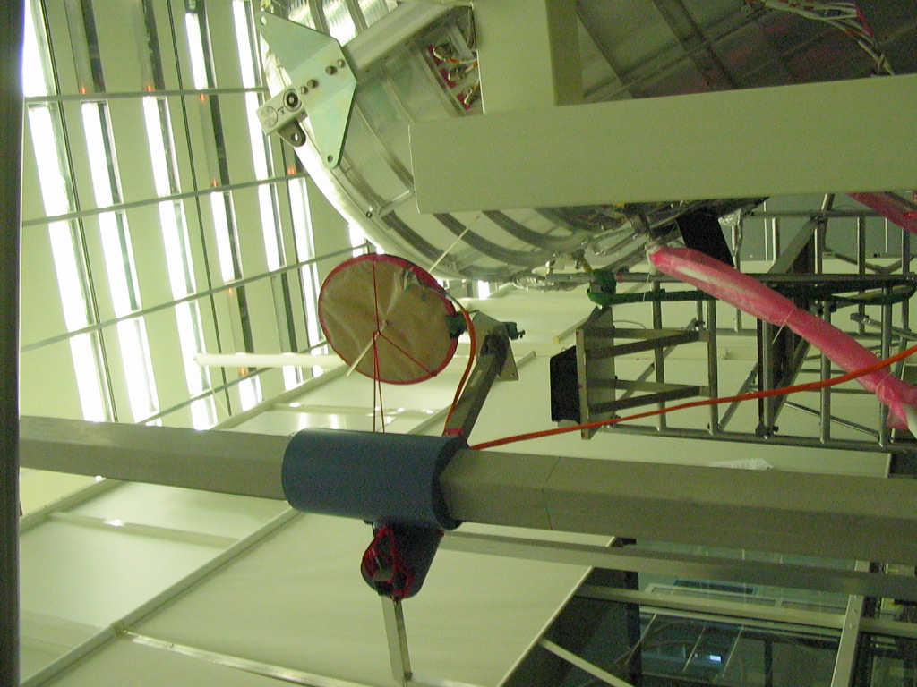
Figure 8.5-1: First Antenna Position for the H-field (direction optical bench and feedthrough connectors for signal cable bundles)

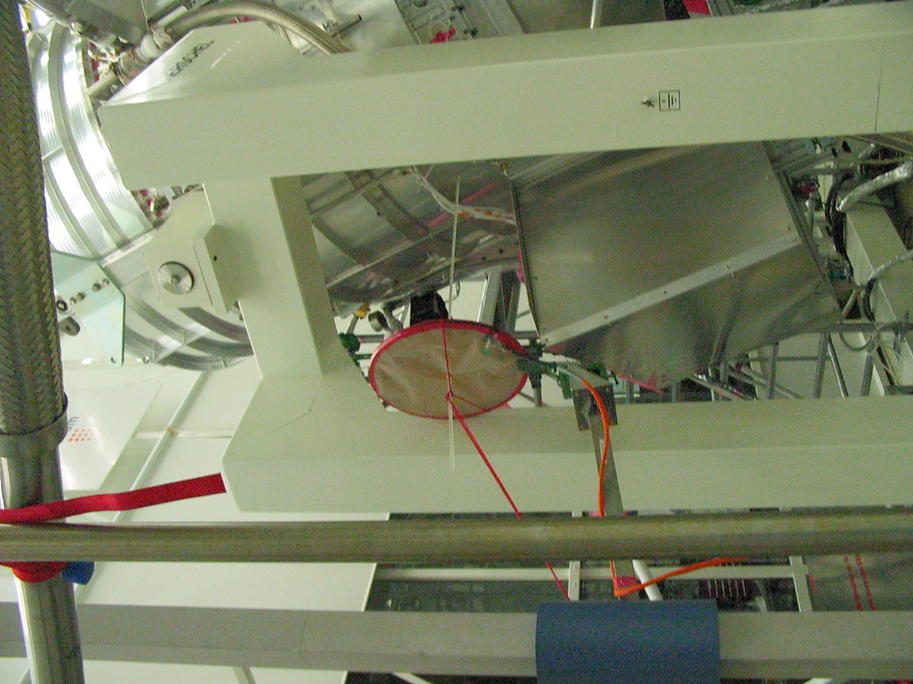
Figure 8.5-2: Second Antenna Position for the H-field (direction bias harness biggest loop areas)

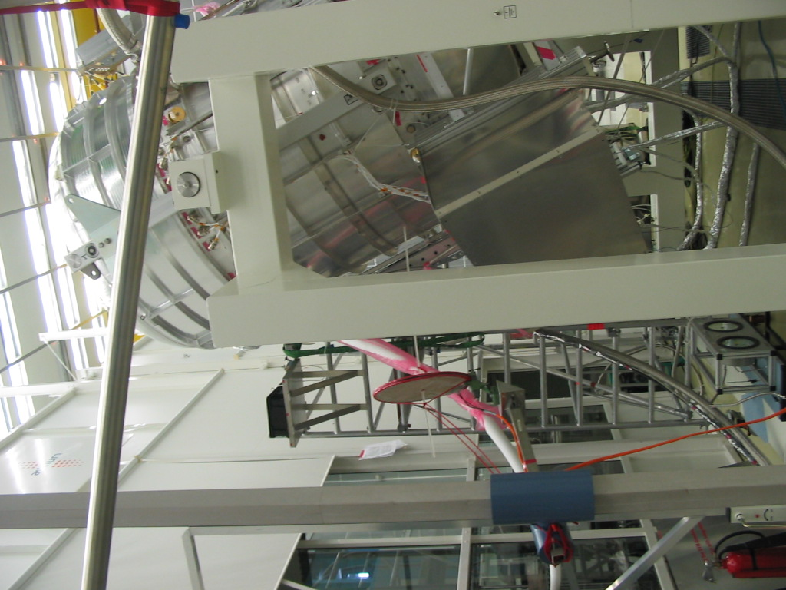
Figure 8.5-3: Third Antenna Position for the H-field (lower than 1st antenna position to illuminate especially PACS signal cables)

PACS Frequency Control Tables E-field
PACS Photometer Mode // E-field // 1st Antenna Position
I | Frequency | Pol. | Date | CCS Step Time Start | CCS Step Time Stop | Data file  imt_emc200511DAY_e1_ | Level  [V/m] | Sensor | Comment
1 | 0.1 MHz | V | 23:11.05 | 08:51:25 | 08:52:43 | V_0M1 |  |  | See fig.8.6-1 for antenna position on the crane
2 | 0.131 MHz | V | Dito | 08:52:43 | 08:53:51 | V_0M131
3 | 0.18 MHz | V | Dito | 08:53:51 | 08:55:17 | V_0M18
4 | 0.2 MHz | V | Dito | 08:55:17 | 08.56:32 | V_0M2
4a | dito | dito | Dito | 09:04:29 | 08:05:38 | V_0M2_2
5 | 0.22 MHz | V | Dito | 08:05:38 | 08:06:58 | V_0M22
6 | 0.312 MHz | V | Dito | 08:06:58 | 08:08:17 | V_0M312
6a | Dito | V | Dito | 08:10:03 | 9:11:23 | V_0M312_2
7 | 0.5 MHz | V | Dito | 9:11:23 | 09:12:14 | V_0M5
8 | 1 MHz | V | Dito | 09:12:14 | 09:13:59 | V_1M5
9 | 2 MHz | V | Dito | 09:13:59 | 09:15:17 | V_2M0
10 | 4 MHz | V | Dito | 09:15:17 | 09:16:32 | V_4M0
11 | 6.88 MHz | V | Dito | 09:16:32 | 09:17:45 | V_6M88
12 | 9.623 MHz | V | Dito | 09:17:45 | 09:19:03 | V_10M623
13 | 10 MHz | V | Dito | 09:19:03 | 09:20:15 | V_10M0
14 | 12 MHz | V | Dito | 09:20:15 | 09:21:38 | V_12M0
15 | 12.8 MHz | V | Dito | 09:24:07 | 09:25:25 | V_12M8
16z | 14 MHz | V | Dito | 09:25:25 | 09:26:51 | V_14M0
17 | 16 MHz | V | Dito | 09:26:51 | 09:27:59 | V_16M0
18 | 17.28 MHz | V | Dito | 09:27:59 | 09:29:24 | V_17M28
18a | Dito | V | Dito | 09:30:30 | 09:32:42 | V_17M28_2
19 | 19.246 MHz | V | Dito | 09:32:42 | 09:34:07 | V_19M246
19a | Dito | V | Dito | 09:37:05 | 09:38:20 | V_19M246_2
20 | 20 MHz | V | Dito | 09:38:20 | 09:39:37 | V_20M0
21 | 20.6478 MHz | V | Dito | 09:39:37 | 09:41:11 | V_20M6478
 | CHANGE |  |  |  |  |  |  |  | SETUP CHANGE
22 | 36 MHz | V | 23.11.05 | 14:24:03 | 14:25:38 | V_36M0
22a | Dito | V | Dito | 14:26:57 | 14:29:24 | V_36M0_2
23 | 38.49 MHz | V | Dito | 14:29:24 | 14:30:44 | V_38M49
24 | 40 MHz | V | Dito | 14:30:44 | 14:32:35 | V_40M0
24a | Dito | V | Dito | 14:34:10 | 14:35:20 | V_40M0_2
25 | 48 MHz | V | Dito | 14:35:20 | 14:36:38 | V_48M0
25a | Dito | V | Dito | 14:38:11 | 14:39:41 | V_48M0_2
26 | 60 MHz | V | Dito | 14:39:41 | 14:40:55 | V_60M0
27 | 80 MHz | V | Dito | 14:40:55 | 14:42:14 | V_80M0
28 | 100 MHz | V | Dito | 14:42:14 | 14:43:56 | V_100M0
29 | 200 Mhz | V | Dito | 14:43:56 | 14:45:07 | V_200M0
30 | 300 MHz | V | Dito | 14:45:28 | 14:46:40 | V_30M0
31 | 384.93 MHz | V | Dito | 14:46:40 | 14:47:57 | V_384M93
32 | 481 MHz | V | Dito | 14:47:57 | 14:49:22 | V_481M0
33 | 550 MHz | V | Dito | 14:49:22 | 14:50:40 | V_550M0
34 | 577.38 MHz | V | Dito | 14:50:40 | 14:52:00 | V_577M38
35 | 673.61 MHz | V | Dito | 14:52:00 | 14:53:20 | V_673M61
36 | 769.86 MHz | V | Dito | 14:53:20 | 14:54:39 | V_769M86
 | CHANGE |  |  |  |  |  |  |  | SETUP CHANGE
37 | 1.1 GHz | V | 24.11.05 | 16:17:06 | 16:18:28 | V_1G1
38 | 1.25 GHz | V | Dito | 16:18:28 | 16:20:02 | V_1G25
38b | Dito | V | Dito | 16:21:23 | 16:22:58 | V_1G25_2
39 | 2.30959 GHz | V | Dito | 16:22:58 | 16:24:59 | V_2G30956
40 | 4 GHz | V | Dito | 16:24:59 | 16:26:42 | V_4G
40a | Dito | V | Dito | 16:28:12 | 16:29:26 | V_4G_2
41 | 5 GHz | V | Dito | 16:29:26 | 16:30:44 | V_5G
42 | 6.15891 GHz | V | Dito | 16:30:44 | 16:32:14 | V_6G15891
42a | Dito | V | Dito | 16:33:49 | 16:35:10 | V_6G15891_2
 | CHANGE |  |  |  |  |  |  |  | SETUP CHANGE
43 | 6.600 GHz | V | 24.11.05 | 15:49:48 | 15:51:20 | V_6G6
44 | 7.600 GHz | V | Dito | 15:51:20 | 15:52:37 | V_7G6
45 | 8.4685 GHz | V | Dito | 15:52:37 | 15:58:30 | V_8G4685
45a | Dito | V | Dito | 16:00:09 | 16:01:36 | V_8G4685_2
46 | 8.600 GHz | V | Dito | 16:01:36 | 16:03:00 | V_8G6
47 | 9.600 GHz | V | Dito | 16:03:00 | 16:04:20 | V_9G6
48 | 10.36375 GHz | V | Dito | 16:04:20 | 16:05:45 | V_10G36375
49 | 15.173565 GHz | V | Dito | 16:05:45 | 16:07:11 | V_15G173565
50 | 16.690921 GHz | V | Dito | 16:07:11 | 16:08:30 | V_16G690921
 | CHANGE |  |  |  |  |  |  |  | SETUP CHANGE
51 | 8.45 GHz | V | 24:1:04 | 17:50:16 | 17:51:18 | V_8G45 |  |  | TX Notch
52 | 8.475 GHz | V | Dito | 17:51:18 | 17:52:36 | V_8G475 |  |  | TX Notch
53 | 8.5 GHz | V | Dito | 17:52:36 | 17:53:59 | V_8G5 |  |  | TX Notch
1 | 36 MHz | H | 23:11:05 | 16:11:01 | 16:12:17 | H_36M0
2 | 38.49 MHz | H | Dito | 16:12:17 | 16:13:25 | H_38M49
3 | 40 MHz | H | Dito | 16:13:25 | 16:14:52 | H_40M0
4 | 48 MHz | H | Dito | 16:14:52 | 16:16:03 | H_48M0
5 | 60 MHz | H | Dito | 16:16:03 | 16:17:25 | H_60M0
6 | 80 MHz | H | Dito | 16:17:25 | 16:18:36 | H_80M0
7 | 100 MHz | H | Dito | 16:18:36 | 16:19:43 | H_100M0
8 | 200 Mhz | H | Dito | 16:19:43 | 16:20:53 | H_200M0
9 | 300 MHz | H | Dito | 16:21:06 | 16:22:19 | H_30M0
10 | 384.93 MHz | H | Dito | 16:22:19 | 16:23:36 | H_384M93
11 | 481 MHz | H | Dito | 16:23:36 | 16:24:49 | H_481M0
12 | 550 MHz | H | Dito | 16:24:49 | 16:26:06 | H_550M0
13 | 577.38 MHz | H | Dito | 16:26:06 | 16:27:31 | H_577M38
14 | 673.61 MHz | H | Dito | 16:27:31 | 16:28:27 | H_673M61
15 | 769.86 MHz | H | Dito | 16:28:27 | 16:29:45 | H_769M86
 | CHANGE |  |  |  |  |  |  |  | SETUP CHANGE
16 | 1.1 GHz | H | 24.11.05 | 16:38:52 | 16:40:08 | H_1G1
17 | 1.25 GHz | H | Dito | 16:40:08 | 16:41:26 | H_1G25
18 | 2.30959 GHz | H | Dito | 16:41:26 | 16:42:51 | H_2G30956
19 | 4 GHz | H | Dito | 16:42:51 | 16:44:10 | H_4G
19a | Dito | H | Dito | 16:45:44 | 16:47:16 | H_4G-2
20 | 5 GHz | H | Dito | 16:47:16 | 16:48:39 | H_5G
21 | 6.15891 GHz | H | Dito | 16:48:39 | 16:50:00 | H_6G15891 |  | 0.84 v/m
 | CHANGE |  |  |  |  |  |  |  | SETUP CHANGE
22 | 6.600 GHz | H | 24.11.05 | 15:31:20 | 15:32:42 | H_6G6
23 | 7.600 GHz | H | Dito | 15:32:42 | 15:34:12 | H_7G6
24 | 8.4685 GHz | H | Dito | 15:34:12 | 15:35:37 | H_8G4685
24a | Dito | H | Dito | 15:37:05 | 15:38:28 | H_8G4685_2
25 | 8.600 GHz | H | Dito | 15:38:28 | 15:39:46 | H_8G6
26 | 9.600 GHz | H | Dito | 15:39:46 | 15:41:07 | H_9G6
27 | 10.36375 GHz | H | Dito | 15:41:07 | 15:42:30 | H_10G36375
28 | 15.173565 GHz | H | Dito | 15:42:30 | 15:44:01 | H_15G173565
29 | 16.690921 GHz | H | Dito | 15:44:01 | 15:45:20 | H_16G690921
 | CHANGE |  |  |  |  |  |  |  | SETUP CHANGE
30 | 8.45 GHz | H | 24.11.05 | 18:12:39 | 18:14:00 | H_8G45 |  |  | TX Notch
31 | 8.475 GHz | H | Dito | 18:14:00 | 18:15:31 | H_8G475 |  |  | TX Notch
32 | 8.5 GHz | H | Dito | 18:15:31 | 18:17:05 | H_8G5 |  |  | TX Notch
Table 8.6-1 : PACS @ Photometer Mode// E-field // 1st Antenna Position

PACS Photometer Mode // E-field // 2nd Antenna Position
i | Frequency | Pol. | Date | CCS Step Time Start | CCS Step Time Stop | Data file  imt_emc200511DAY_e2_ | Level  [V/m] | Sensor | Comment
1 | 0.1 MHz | V | 23.11.05 | 09:58:46 | 10:00:00 | V_0M1 |  |  | See fig.8.6-2 for antenna position on the crane
2 | 0.131 MHz | V | Dito | 10:00:00 | 10:01:29 | V_0M131
3 | 0.18 MHz | V | Dito | 10:05:09 | 10:06:30 | V_0M18
4 | 0.2 MHz | V | Dito | 10:08:10 | 10:09:24 | V_0M2
5 | 0.22 MHz | V | Dito | 10:09:24 | 10:11:04 | V_0M22
6 | 0.312 MHz | V | Dito | 10:11:04 | 10:12:21 | V_0M312
7 | 0.5 MHz | V | Dito | 10:12:21 | 10:13:37 | V_0M5
8 | 1 MHz | V | Dito | 10:13:37 | 10:14:58 | V_1M0
9 | 2 MHz | V | Dito | 10:14:58 | 10:16:18 | V_2M0
9a | Dito | V | Dito | 10:22:22 | 10:25:17 | V_2M0_2
10 | 4 MHz | V | Dito | 10:25:17 | 10:28:40 | V_4M0
11 | 6.88 MHz | V | Dito | 10:28:40 | 10:27:50 | V_6M88
11a | Dito | V | Dito | 10:30:35 | 10:32:00 | V_6M88_2
12 | 9.623 MHz | V | Dito | 10:32:00 | 10:33:27 | V_10M623
12a | Dito | V | Dito | 10:34:56 | 10:39:22 | V_10M623_2
13 | 10 MHz | V | Dito | 10:39:22 | 10:41:10 | V_10M0
14 | 12 MHz | V | Dito | 10:41:10 | 10:42:24 | V_12M0
14a | Dito | V | Dito | 10:39:55 | 10:40 | V_12M0_2
15 | 12.8 MHz | V | Dito | 10:44:54 | 10:46:21 | V_12M8
16z | 14 MHz | V | Dito | 10:46:21 | 18:47:55 | V_14M0
17 | 16 MHz | V | Dito | 18:47:55 | 10:48:56 | V_16M0
18 | 17.28 MHz | V | Dito | 10:48:56 | 10:50:11 | V_17M28
18a | Dito | V | Dito | 10:51:38 | 10:52:58 | V_17M28_2
19 | 19.246 MHz | V | Dito | 10:52:58 | 10:54:17 | V_19M246
20 | 20 MHz | V | Dito | 10:54:17 | 10:55:41 | V_20M0
21 | 20.6478 MHz | V | Dito | 10:55:41 | 10:56:55 | V_20M6478
21a | Dito | V | Dito | 10:58:30 | 10:59:39 | V_20M6478_2
 | CHANGE |  |  |  |  |  |  |  | SETUP CHANGE
22 | 36 MHz | V | 23.11.05 | 15:02:03 | 15:03:39 | V_36M0
23 | 38.49 MHz | V | Dito | 15:03:39 | 15:04:50 | V_38M49
24 | 40 MHz | V | Dito | 15:04:50 | 15:06:08 | V_40M0
24a | Dito | V | Dito | 15:07:36 | 15:08:40 | V_40M0_2
25 | 48 MHz | V | Dito | 15:08:40 | 15:10:00 | V_48M0
26 | 60 MHz | V | Dito | 15:10:00 | 15:11:14 | V_60M0
27 | 80 MHz | V | Dito | 15:11:14 | 15:12:24 | V_80M0
28 | 100 MHz | V | Dito | 15:12:24 | 15:13:44 | V_100M0
29 | 200 Mhz | V | Dito | 15:13:44 | 15:14:58 | V_200M0
30 | 300 MHz | V | Dito | 15:15:18 | 15:16:37 | V_30M0
30a | Dito | V | Dito | 15:17:50 | 15:19:21 | V_30M0_2
31 | 384.93 MHz | V | Dito | 15:19:21 | 15:20:45 | V_384M93
32 | 481 MHz | V | Dito | 15:20:45 | 15:22:17 | V_481M0
33 | 550 MHz | V | Dito | 15:22:17 | 15:23:34 | V_550M0
34 | 577.38 MHz | V | Dito | 15:23:34 | 15:24:56 | V_577M38 |  | 1.3 V/m
35 | 673.61 MHz | V | Dito | 15:24:56 | 15:26:11 | V_673M61
35a | Dito | V | Dito | 15:27:48 | 15:29:04 | V_673M61_2
36 | 769.86 MHz | V | Dito | 15:29:04 | 15:31:10 | V_769M86
 | CHANGE |  |  |  |  |  |  |  | SETUP CHANGE
37 | 1.1 GHz | V | 24.11.05 | 17:15:33 | 17:16:55 | V_1G1
38 | 1.25 GHz | V | Dito | 17:16:55 | 17:18:16 | V_1G25
39 | 2.30959 GHz | V | Dito | 17:18:16 | 17:19:41 | V_2G30956
39a | Dito | V | Dito | 17:21:14 | 17:22:26 | V_2G30956_2
40 | 4 GHz | V | Dito | 17:22:26 | 17:24:20 | V_4G
41 | 5 GHz | V | Dito | 17:24:20 | 17:25:45 | V_5G
42 | 6.15891 GHz | V | Dito | 17:25:45 | 17:27:10 | V_6G15891
 | CHANGE |  |  |  |  |  |  |  | SETUP CHANGE
43 | 6.600 GHz | V | 24.11.05 | 14:50:35 | 14:52:02 | V_6G6
44 | 7.600 GHz | V | Dito | 14:52:02 | 14:53:19 | V_7G6
45 | 8.4685 GHz | V | Dito | 14:53:19 | 14:54:59 | V_8G4685
46 | 8.600 GHz | V | Dito | 14:54:59 | 14:56:23 | V_8G6
46a | Dito | V | Dito | 14:57:57 | 14:59:18 | V_8G6_2
47 | 9.600 GHz | V | Dito | 15:00:48 | 15:03:10 | V_9G6
48 | 10.36375 GHz | V | Dito | 15:03:10 | 15:04:30 | V_10G36375
49 | 15.173565 GHz | V | Dito | 15:04:30 | 15:05:57 | V_15G173565
50 | 16.690921 GHz | V | Dito | 15:05:57 | 15:07:45 | V_16G690921
 | CHANGE |  |  |  |  |  |  |  | SETUP CHANGE
51 | 8.45 GHz | V | 24.11.05 | 17:37:45 | 17:39:12 | V_8G45 |  |  | TX Notch
52 | 8.475 GHz | V | Dito | 17:39:15 | 17:40:50 | V_8G475 |  |  | TX Notch
52a | Dito | V | Dito | 17:42:12 | 17:43:28 | V_8G475_2 |  |  | TX Notch
53 | 8.5 GHz | V | Dito | 17:43:28 | 17:44:13 | V_8G5 |  |  | TX Notch
1 | 36 MHz | H | 23.11.05 | 15:43:42 | 15:47:17 | H_36M0
2 | 38.49 MHz | H | Dito | 15:47:17 | 15:48:40 | H_38M49
3 | 40 MHz | H | Dito | 15:48:40 | 15:49:57 | H_40M0
4 | 48 MHz | H | Dito | 15:49:57 | 15:51:12 | H_48M0
5 | 60 MHz | H | Dito | 15:51:12 | 15:52:36 | H_60M0
6 | 80 MHz | H | Dito | 15:52:36 | 15:54:01 | H_80M0
7 | 100 MHz | H | Dito | 15:54:01 | 15:55:11 | H_100M0
8 | 200 Mhz | H | Dito | 15:55:11 | 15:56:35 | H_200M0
9 | 300 MHz | H | Dito | 15:56:35 | 15:57:57 | H_30M0
10 | 384.93 MHz | H | Dito | 15:57:57 | 15:59:14 | H_384M93
11 | 481 MHz | H | Dito | 15:59:14 | 16:00:40 | H_481M0
12 | 550 MHz | H | Dito | 16:00:40 | 16:01:49 | H_550M0
13 | 577.38 MHz | H | Dito | 16:01:49 | 15:03:07 | H_577M38
14 | 673.61 MHz | H | Dito | 15:03:07 | 15:04:27 | H_673M61
15 | 769.86 MHz | H | Dito | 15:04:27 | 15:05:46 | H_769M86
 | CHANGE |  |  |  |  |  |  |  | SETUP CHANGE
16 | 1.1 GHz | H | 24.11.05 | 16:56:54 | 16:58:02 | H_1G1
16a | Dito | H | Dito | 16:59:30 | 17:00:43 | H_1G1_2
17 | 1.25 GHz | H | Dito | 17:00:43 | 17:02:15 | H_1G25
18 | 2.30959 GHz | H | Dito | 17:02:15 | 17:03:44 | H_2G30956 |  | 3.5 V/m
18a | Dito | H | Dito | 17:06:44 | 17:08:07 | H_2G30956_2
19 | 4 GHz | H | Dito | 17:08:07 | 17:09:40 | H_4G
20 | 5 GHz | H | Dito | 17:09:40 | 17:11:09 | H_5G
21 | 6.15891 GHz | H | Dito | 17:11:09 | 17:12:21 | H_6G15891
 | CHANGE |  |  |  |  |  |  |  | SETUP CHANGE
22 | 6.600 GHz | H | 24.11.05 | 15:13:55 | 15:15:24 | H_6G6
23 | 7.600 GHz | H | Dito | 15:15:24 | 15:16:50 | H_7G6
24 | 8.4685 GHz | H | Dito | 15:16:50 | 15:18:14 | H_8G4685
25 | 8.600 GHz | H | Dito | 15:18:14 | 15:19:40 | H_8G6
26 | 9.600 GHz | H | Dito | 15:19:40 | 15:21:01 | H_9G6
27 | 10.36375 GHz | H | Dito | 15:21:01 | 15:22:26 | H_10G36375
28 | 15.173565 GHz | H | Dito | 15:22:26 | 15:23:50 | H_15G173565
29 | 16.690921 GHz | H | Dito | 15:23:50 | 15:25:10 | H_16G690921
 | CHANGE |  |  |  |  |  |  |  | SETUP CHANGE
30 | 8.45 GHz | H | 24.11:05 | 17:58:40 | 18:00:00 | H_8G45 |  |  | TX Notch
30a | Dito | H | Dito | 18:01:24 | 18:02:50 | H_8G452 |  |  | TX Notch
31 | 8.475 GHz | H | Dito | 18:02:50 | 18:04:09 | H_8G475 |  |  | TX Notch
32 | 8.5 GHz | H | Dito | 18:04:09 | 18:05:20 | H_8G5 |  |  | TX Notch
Table 8.6-2 : PACS @ Photometer Mode// E-field // 2nd Antenna Position

PACS Spectrometer Mode // E-field // 1st Antenna Position
i | Frequency | Pol. | Date | CCS Step Time Start | CCS Step Time Stop | Data file  imt_emc200511_s_DAY_e1_ | Level  [V/m] | Sensor | Comment
1 | 0.1 MHz | V | 23.11.05 | 13:18:37 | 13:19:55 | V_0M1
2 | 0.131 MHz | V | Dito | 13:19:55 | 13:21:54 | V_0M131
3 | 0.18 MHz | V | Dito | 13:21:54 | 13:23:35 | V_0M18
4 | 0.2 MHz | V | Dito | 13:23:35 | 13:24:47 | V_0M2
5 | 0.22 MHz | V | Dito | 13:24:47 | 13:26:00 | V_0M22
6 | 0.312 MHz | V | Dito | 13:26:00 | 13:27:23 | V_0M312
7 | 0.5 MHz | V | Dito | 13:27:23 | 13:28:31 | V_0M5
8 | 1 MHz | V | Dito | 13:28:31 | 13:29:40 | V_1M0
9 | 2 MHz | V | Dito | 13:29:40 | 13:30:55 | V_2M0
10 | 4 MHz | V | Dito | 13:30:55 | 13:32:10 | V_4M0
11 | 6.88 MHz | V | Dito | 13:32:10 | 13:33:25 | V_6M88
12 | 9.623 MHz | V | Dito | 13:33:25 | 13:34:39 | V_10M623
13 | 10 MHz | V | Dito | 13:34:39 | 13:35:50 | V_10M0
14 | 12 MHz | V | Dito | 13:35:50 | 13:37:08 | V_12M0
15 | 12.8 MHz | V | Dito | 13:37:08 | 13:38:22 | V_12M8
16z | 14 MHz | V | Dito | 13:38:22 | 13:39:33 | V_14M0
17 | 16 MHz | V | Dito | 13:39:33 | 13:40:50 | V_16M0
18 | 17.28 MHz | V | Dito | 13:40:50 | 13:42:09 | V_17M28
19 | 19.246 MHz | V | Dito | 13:42:09 | 13:43:07 | V_19M246
20 | 20 MHz |  | Dito | 13:43:07 | 13:44:24 | V_20M0
21 | 20.6478 MHz | V | Dito | 13:44:24 | 13:45:42 | V_20M6478
 | CHANGE |  |  |  |  |  |  |  | SETUP CHANGE
22 | 36 MHz | V | 24.11.05 | 08:45:50 | 08:51:55 | V_36M0
23 | 38.49 MHz | V | Dito | 08:51:55 | 08:53:25 | V_38M49
24 | 40 MHz | V | Dito | 08:53:25 | 08:54:58 | V_40M0
25 | 48 MHz | V | Dito | 08:54:58 | 08:56:38 | V_48M0
26 | 60 MHz | V | Dito | 08:56:38 | 08:57:08 | V_60M0
27 | 80 MHz | V | Dito | 08:57:08 | 08:59:29 | V_80M0
28 | 100 MHz | V | Dito | 08:59:29 | 09:00:50 | V_100M0
29 | 200 Mhz | V | Dito | 09:00:50 | 09:02:27 | V_200M0
30 | 300 MHz | V | Dito | 09:02:27 | 09:03:51 | V_30M0
31 | 384.93 MHz | V | Dito | 09:03:51 | 09:05:34 | V_384M93
32 | 481 MHz | V | Dito | 09:05:34 | 09:06:54 | V_481M0
33 | 550 MHz | V | Dito | 09:06:54 | 09:08:15 | V_550M0
34 | 577.38 MHz | V | Dito | 09:08:15 | 09:09:44 | V_577M38
35 | 673.61 MHz | V | Dito | 09:09:44 | 09:11:11 | V_673M61
36 | 769.86 MHz | V | Dito | 09:11:11 | 09:12:40 | V_769M86
 | CHANGE |  |  |  |  |  |  |  | SETUP CHANGE
37 | 1.1 GHz | V | 24.11.05 | 10:34:40 | 10:35:57 | V_1G1
38 | 1.25 GHz | V | Dito | 10:35:57 | 10:37:20 | V_1G25
39 | 2.30959 GHz | V | Dito | 10:37:20 | 10:38:38 | V_2G30956
40 | 4 GHz | V | Dito | 10:38:38 | 10:39:58 | V_4G
41 | 5 GHz | V | Dito | 10:39:58 | 10:41:10 | V_5G
42 | 6.15891 GHz | V | Dito | 10:41:10 | 16:42:36 | V_6G15891
 | CHANGE |  |  |  |  |  |  |  | SETUP CHANGE
43 | 6.600 GHz | V | 24.11.01 | 10:51:29 | 10:52:50 | V_6G6
44 | 7.600 GHz | V | Dito | 10:52:50 | 10:54:18 | V_7G6
45 | 8.4685 GHz | V | Dito | 10:54:18 | 10:55:51 | V_8G4685
46 | 8.600 GHz | V | Dito | 10:55:51 | 10:57:08 | V_8G6
47 | 9.600 GHz | V | Dito | 10:57:08 | 10:58:25 | V_9G6
48 | 10.36375 GHz | V | Dito | 10:58:25 | 11:00:00 | V_10G36375
49 | 15.173565 GHz | V | Dito | 11:00:00 | 11:01:31 | V_15G173565
50 | 16.690921 GHz | V | Dito | 11:01:31 | 11:02:52 | V_16G690921
 | CHANGE |  |  |  |  |  |  |  | SETUP CHANGE
51 | 8.45 GHz | V | 25-11-05 | 08:58:38 | 08:59:55 | V_8G45 |  |  | TX Notch
52 | 8.475 GHz | V | Dito | 09:00:25 | 09:01:35 | V_8G475 |  |  | TX Notch
53 | 8.5 GHz | V | Dito | 09:01:35 | 09:02:48 | V_8G5 |  |  | TX Notch
 |  |  | Dito
1 | 36 MHz | H | 23.11.05 | 16:48:10 | 16:49:46 | H_36M0
2 | 38.49 MHz | H | Dito | 16:49:46 | 16:50:50 | H_38M49
3 | 40 MHz | H | Dito | 16:50:50 | 16:52:09 | H_40M0
4 | 48 MHz | H | Dito | 16:52:09 | 16:53:28 | H_48M0
5 | 60 MHz | H | Dito | 16:53:28 | 16:54:36 | H_60M0
6 | 80 MHz | H | Dito | 16:54:36 | 16:56:01 | H_80M0
7 | 100 MHz | H | Dito | 16:56:01 | 16:57:10 | H_100M0
8 | 200 Mhz | H | Dito | 16:57:10 | 16:58:22 | H_200M0
9 | 300 MHz | H | Dito | 16:58:28 | 16:59:37 | H_30M0
10 | 384.93 MHz | H | Dito | 16:59:37 | 17:00:50 | H_384M93
11 | 481 MHz | H | Dito | 17:00:50 | 17:02:04 | H_481M0
12 | 550 MHz | H | Dito | 17:02:04 | 17:03:20 | H_550M0
13 | 577.38 MHz | H | Dito | 17:03:20 | 17:04:32 | H_577M38
14 | 673.61 MHz | H | Dito | 17:04:32 | 17:05:47 | H_673M61
15 | 769.86 MHz | H | Dito | 17:05:47 | 17:07:00 | H_769M86
 | CHANGE |  |  |  |  |  |  |  | SETUP CHANGE
16 | 1.1 GHz | H | 24.11.05 | 10:23:01 | 10:24:30 | H_1G1
17 | 1.25 GHz | H | Dito | 10:24:30 | 10:25:50 | H_1G25
18 | 2.30959 GHz | H | Dito | 10:25:50 | 10:27:16 | H_2G30956
19 | 4 GHz | H | Dito | 10:27:16 | 10:28:32 | H_4G
20 | 5 GHz | H | Dito | 10:28:32 | 10:29:48 | H_5G
21 | 6.15891 GHz | H | Dito | 10:29:48 | 10:31:10 | H_6G15891
 | CHANGE |  |  |  |  |  |  |  | SETUP CHANGE
22 | 6.600 GHz | H | 24.11.05 | 11:06:37 | 11:07:59 | H_6G6
23 | 7.600 GHz | H | Dito | 11:07:59 | 11:09:09 | H_7G6
24 | 8.4685 GHz | H | Dito | 11:09:09 | 11:10:47 | H_8G4685
25 | 8.600 GHz | H | Dito | 11:10:47 | 11:12:22 | H_8G6
26 | 9.600 GHz | H | Dito | 11:12:22 | 11:14:00 | H_9G6
27 | 10.36375 GHz | H | Dito | 11:14:00 | 11:15:16 | H_10G36375
28 | 15.173565 GHz | H | Dito | 11:15:16 | 11:16:39 | H_15G173565
29 | 16.690921 GHz | H | Dito | 11:16:39 | 11:17:59 | H_16G690921
29a | Dito | H | Dito | 11:19:24 | 11:20:40 | H_16G690921_2
 | CHANGE |  |  |  |  |  |  |  | SETUP CHANGE
30 | 8.45 GHz | H | 25.11.05 | 08:37:10 | 08:38:32 | H_8G45 |  |  | TX Notch
31 | 8.475 GHz | H | Dito | 08:38:32 | 08:39:58 | H_8G475 |  |  | TX Notch
32 | 8.5 GHz | H | Dito | 08:39:58 | 08:41:08 | H_8G5 |  |  | TX Notch
32a | Dito | H | Dito | 08:42:30 | 08:43 | H_8G5_2
Table 8.6-3 : PACS @ Spectrometer Mode // E-field // 1st Antenna Position

PACS @ Spectrometer Mode // E-field // 2nd Antenna Position
i | Frequency | Pol. | Date | CCS Step Time Start | CCS Step Time Stop | Data file  imt_emc200511_s_DAY_e2_ | Level  [V/m] | Sensor | Comment
1 | 0.1 MHz | V | 23:11:05 | 12:39:20 | 12:40:29 | V_0M1 |  |  | See figure 8.6-1 for antenna position
2 | 0.131 MHz | V | Dito | 12:40:29 | 12:41:43 | V_0M131
3 | 0.18 MHz | V | Dito | 12:41:43 | 12:43:30 | V_0M18
4 | 0.2 MHz | V | Dito | 12:43:30 | 12:44:44 | V_0M2
5 | 0.22 MHz | V | Dito | 12:44:44 | 12:46:05 | V_0M22
6 | 0.312 MHz | V | Dito | 12:46:05 | 12:47:23 | V_0M312
7 | 0.5 MHz | V | Dito | 12:47:23 | 12:48:40 | V_0M5
8 | 1 MHz | V | Dito | 12:48:40 | 12:49:57 | V_1M0
9 | 2 MHz | V | Dito | 12:49:57 | 12:51:06 | V_2M0
10 | 4 MHz | V | Dito | 12:51:06 | 12:52:23 | V_4M0
11 | 6.88 MHz | V | Dito | 12:52:23 | 12:53:40 | V_6M88
12 | 9.623 MHz | V | Dito | 12:53:40 | 12:54:54 | V_10M623
13 | 10 MHz | V | Dito | 12:54:54 | 12:56:04 | V_10M0
14 | 12 MHz | V | Dito | 12:56:04 | 12:57:20 | V_12M0
15 | 12.8 MHz | V | Dito | 12:57:20 | 12:58:35 | V_12M8
16z | 14 MHz | V | Dito | 12:58:35 | 12:59:54 | V_14M0
17 | 16 MHz | V | Dito | 12:59:54 | 13:01:08 | V_16M0
18 | 17.28 MHz | V | Dito | 13:01:08 | 13:02:28 | V_17M28
19 | 19.246 MHz | V | Dito | 13:02:28 | 13:03:50 | V_19M246
20 | 20 MHz | V | Dito | 13:03:50 | 13:04:59 | V_20M0
21 | 20.6478 MHz | V | Dito | 13:04:59 | 13:06:25 | V_20M6478
 | CHANGE |  |  |  |  |  |  |  | SETUP CHANGE
22 | 36 MHz | V | 25.11.04 | 08:10:02 | 08:12:25: | V_36M0
23 | 38.49 MHz | V | Dito | 08:12:25: | 08:13:50 | V_38M49
24 | 40 MHz | V | Dito | 08:13:50 | 08:15:21 | V_40M0
25 | 48 MHz | V | Dito | 08:15:21 | 08:16:40 | V_48M0
26 | 60 MHz | V | Dito | 08:16:40 | 08:17:59 | V_60M0
27 | 80 MHz | V | Dito | 08:17:59 | 08:19:25 | V_80M0
28 | 100 MHz | V | Dito | 08:19:25 | 08:20:45 | V_100M0
29 | 200 Mhz | V | Dito | 08:20:45 | 08:22:02 | V_200M0
30 | 300 MHz | V | Dito | 08:22:02 | 08:23:24 | V_30M0
31 | 384.93 MHz | V | Dito | 08:23:24 | 08:24:55 | V_384M93
32 | 481 MHz | V | Dito | 08:24:55 | 08:26:39 | V_481M0
33 | 550 MHz | V | Dito | 08:26:39 | 08:27:57 | V_550M0
34 | 577.38 MHz | V | Dito | 08:27:57 | 08:29:28 | V_577M38
35 | 673.61 MHz | V | Dito | 08:29:28 | 08:30:55 | V_673M61
36 | 769.86 MHz | V | Dito | 08:30:55 | 08:32:19 | V_769M86
 | CHANGE |  |  |  |  |  |  |  | SETUP CHANGE
37 | 1.1 GHz | V | 24.11.05 | ?? | done | V_1G1
38 | 1.25 GHz | V | Dito | ?? | done | V_1G25
39 | 2.30959 GHz | V | Dito | ?? | done | V_2G30956
40 | 4 GHz | V | Dito | ?? | done | V_4G
41 | 5 GHz | V | Dito | ?? | done | V_5G
42 | 6.15891 GHz | V | Dito | ?? | done | V_6G15891
 | CHANGE |  |  | ?? |  |  |  |  | SETUP CHANGE
43 | 6.600 GHz | V | 24:11.05 | 11:42:14 | 11:43:24 | V_6G6
44 | 7.600 GHz | V | Dito | 11:43:24 | 11:45:08 | V_7G6
44a | Dito | V |  | 11:46:45 | 11:48:00 | V_7G6_2
45 | 8.4685 GHz | V | Dito | 11:48:00 | 11:49:25 | V_8G4685
46 | 8.600 GHz | V | Dito | 11:49:25 | 11:50:54 | V_8G6
47 | 9.600 GHz | V | Dito | 11:50:54 | 11:52:08 | V_9G6
48 | 10.36375 GHz | V | Dito | 11:52:08 | 11:53:41 | V_10G36375
48a | Dito | V | Dito | 11:55:03 | 11:56:18 | V_10G36375_2
49 | 15.173565 GHz | V | Dito | 11:56:18 | 11:57:45 | V_15G173565
50 | 16.690921 GHz | V | Dito | 11:57:45 | 11:59:10 | V_16G690921
 | CHANGE |  |  |  |  |  |  |  | SETUP CHANGE
51 | 8.45 GHz | V | 25.11.04 | 08:47:12 | 08:48:20 | V_8G45 |  |  | TX Notch
52 | 8.475 GHz | V | Dito | 08:48:20 | 08:49:30 | V_8G475 |  |  | TX Notch
52a | Dito | V | Dito | 08:51:00 | 08:52:10 | V_8G475_2 |  |  | TX Notch
53 | 8.5 GHz | V | Dito | 08:52:10 | 08:53:34 | V_8G5 |  |  | TX Notch
53a | D | V | Dito | 08:54:50 | 08:55: | V_8G5_2 |  |  | TX Notch
1 | 36 MHz | H | 23.11.2005 | 17:17:37 | 17:18:56 | H_36M0
2 | 38.49 MHz | H | Dito | 17:18:56 | 17:20:07 | H_38M49
3 | 40 MHz | H | Dito | 17:20:07 | 17:21:21 | H_40M0
4 | 48 MHz | H | Dito | 17:21:21 | 17:22:27 | H_48M0
5 | 60 MHz | H | Dito | 17:22:27 | 17:23:38 | H_60M0
6 | 80 MHz | H | Dito | 17:23:38 | 17:24:48 | H_80M0
7 | 100 MHz | H | Dito | 17:24:48 | 17:25:58 | H_100M0
8 | 200 Mhz | H | Dito | 17:25:58 | 17:27:11 | H_200M0
9 | 300 MHz | H | Dito | 17:27:18 | 17:28:20 | H_30M0
10 | 384.93 MHz | H | Dito | 17:28:20 | 17:29:38 | H_384M93
11 | 481 MHz | H | Dito | 17:29:38 | 17:30:49 | H_481M0
12 | 550 MHz | H | Dito | 17:30:49 | 17:31:57 | H_550M0
13 | 577.38 MHz | H | Dito | 17:31:57 | 17:33:11 | H_577M38
14 | 673.61 MHz | H | Dito | 17:33:11 | 17:34:58 | H_673M61
15 | 769.86 MHz | H | Dito | ?? | ?? | H_769M86
 | CHANGE |  |  |  |  |  |  |  | SETUP CHANGE
16 | 1.1 GHz | H | Dito | 09:42:07 | 09:43:46 | H_1G1
17 | 1.25 GHz | H | Dito | 09:43:46 | 09:45:12 | H_1G125
18 | 2.30959 GHz | H | Dito | 09:45:12 | 09:47:08 | H_2G30959
19 | 4 GHz | H | Dito | 09:47:08 | 09:10:58 | H_4G0
20 | 5 GHz | H | Dito | 09:10:58 | 09:12:40 | H_5G0
21 | 6.15891 GHz | H | Dito | 09:12:40 | 9:13:59 | H_6G15891
 | CHANGE |  |  |  |  |  |  |  | SETUP CHANGE
22 | 6.600 GHz | H | 24.11.05 | 11:23:50 | 11:25:40 | H_6G6
22a | Dito | H | Dito | 11:26:56 | 11:28:20 | H_6G6_2
23 | 7.600 GHz | H | Dito | 11:28:20 | 11:29:41 | H_7G6
24 | 8.4685 GHz | H | Dito | 11:29:41 | 11:31:03 | H_8G4685
25 | 8.600 GHz | H | Dito | 11:31:03 | 11:32:20 | H_8G6
26 | 9.600 GHz | H | Dito | 11:32:20 | 11:33:39 | H_9G6
27 | 10.36375 GHz | H | Dito | 11:33:39 | 11:35:28 | H_10G36375
28 | 15.173565 GHz | H | Dito | 11:35:28 | 11:36:40 | H_15G173565
29 | 16.690921 GHz | H | Dito | 11:36:40 | 11:37:54 | H_16G6909
 | CHANGE |  |  |  |  |  |  |  | SETUP CHANGE
30 | 8.45 GHz | H | 25.11.05 | 08:30:32 | 08:31:40 | H_8G45 |  |  | TX Notch
31 | 8.475 GHz | H |  | 08:31:40 | 08:33:02 | H_8G475 |  |  | TX Notch
32 | 8.5 GHz | H |  | 08:33:02 | 08:34:18 | H_8G5 |  |  | TX Notch
Table 8.6-4 : PACS @ Spectrometer Mode // E-field // 2nd Antenna Position

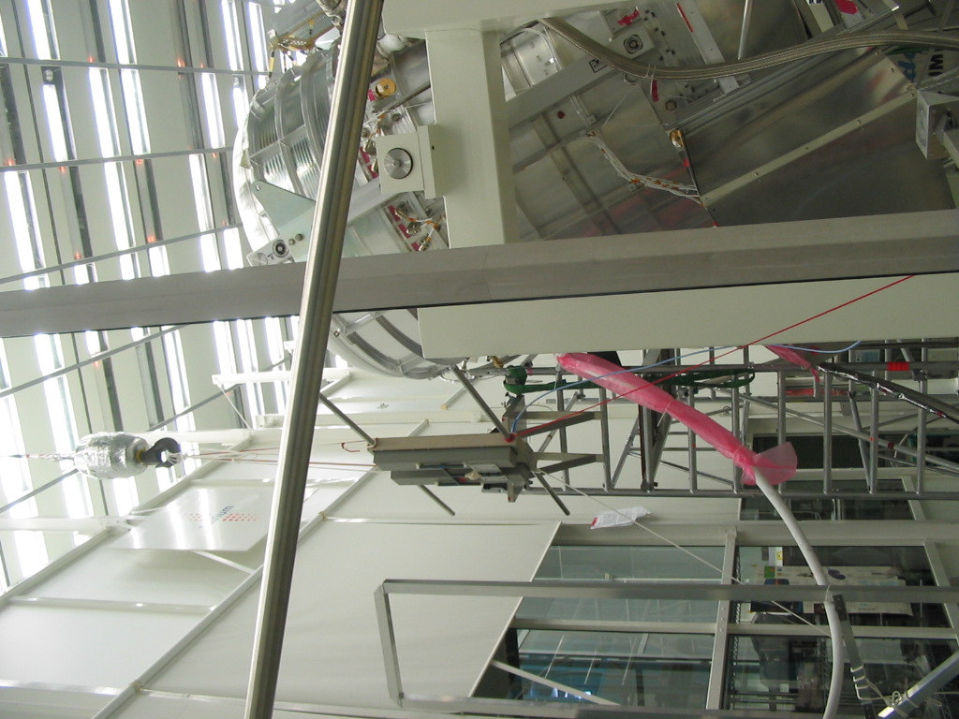
Figure 8.6-1: Antenna on the Crane for RS E-field, 1st Position, Vertical Pol., Range up to 30 MHz (direction for feed-through connectors and signal cables)

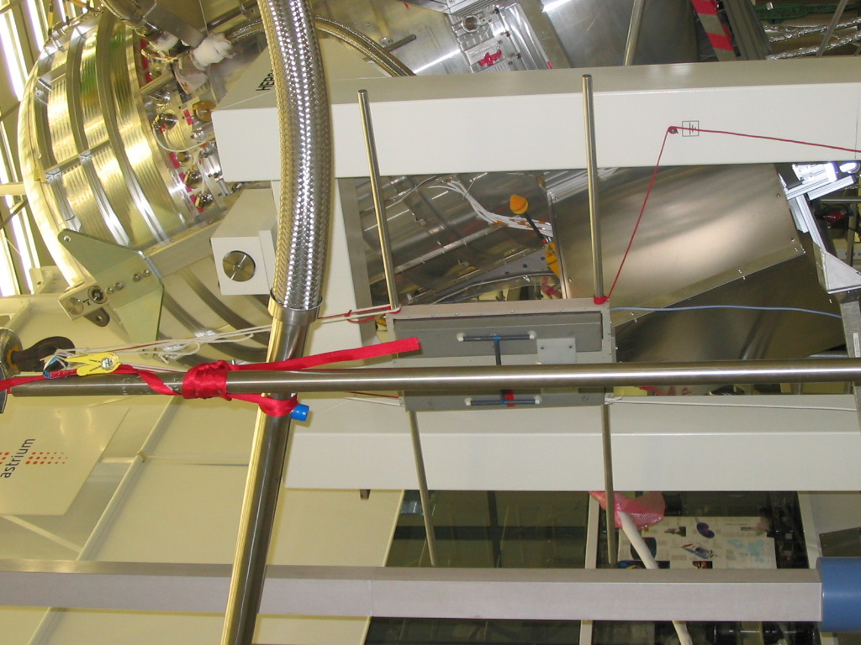
Figure 8.6-2: Antenna on the Crane for RS E-field 2st Position, Vertical Pol., Range up to 30 MHz (direction PACS bias cables)

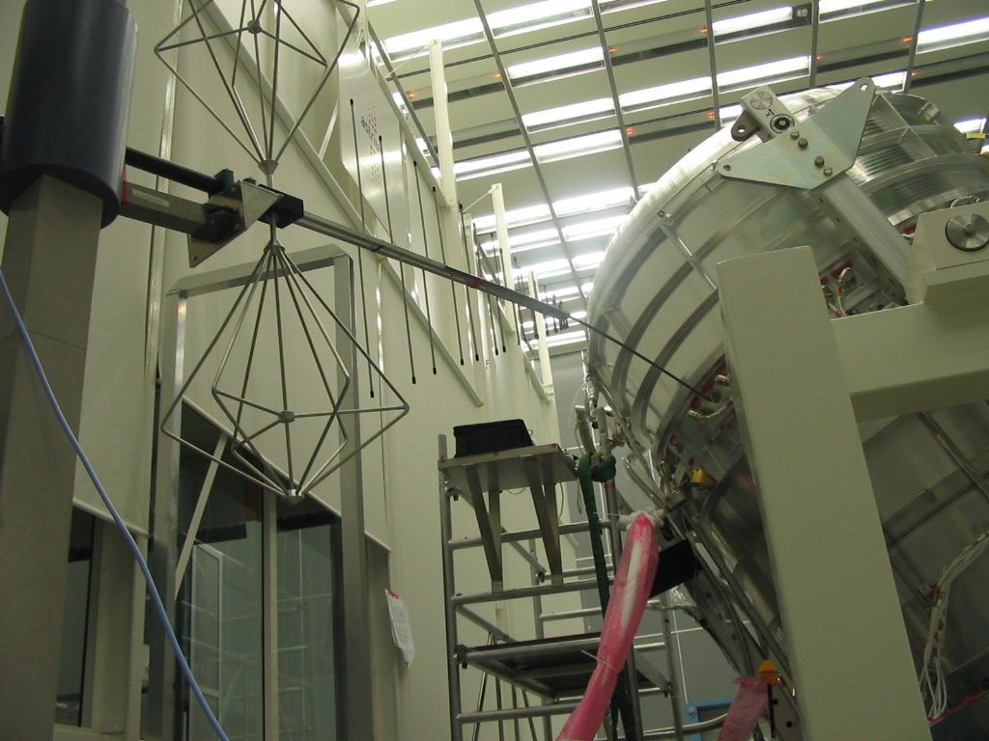
Figure 8.6-3: First Antenna Position for Frequencies > 30 MHz (direction feedthrough connectors and signal cable bundles)

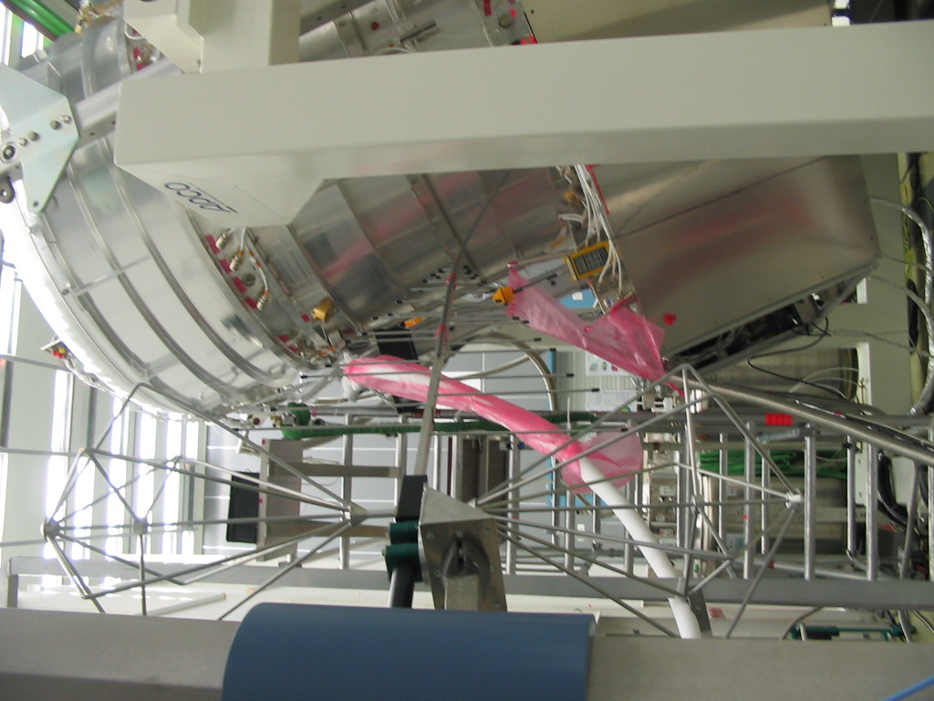
Figure 8.6-4: Second Antenna Position for Frequencies > 30 MHz to 1 GHz (direction PACS biasing harness in general)

SPIRE Frequency Control Tables H-field
SPIRE RS H-field, File: SPIRE-EQM-EMC-’’QLA / STEP’’.txt
i | Frequency | Date | CCS Start Time | CCS Stop Time | Script | QLA / STEP | Sensor | Observations
1 | 30 Hz – 50 kHz | 28.11.05 | 16:00:20 | 16:26:52 |  | N/A |  | 5 % Sweep, 10 sec DWELL time, 100% AM with 140 ms OFF, 800 ms ON
3 | 30 Hz – 50 kHz | 29.11.05 | 09:15:14 | 09:41:46 |  | N/A |  | Dito
4 | 247.96 Hz | Dito | ?? |  |  | SPOTB000002F_8764_2 |  | 100% AM with 140 ms OFF, 800 ms ON
5 | 260.36 Hz | Dito | ?? |  |  | SPOTB000002F_8764_3 |  | Dito
6 | 273.38 Hz | Dito | ?? |  |  | SPOTB000002F_8764_4 |  | Dito
7 | 348.91 Hz | Dito | 10:41:59 |  |  | SPOTB000002F_8764_5 |  | Dito
8 | 366.36 Hz | Dito | 10:45:11 |  |  | SPOTB000002F_8764_6 |  | Dito
9 | 384.67 Hz | Dito | 10:48:25 |  |  | SPOTB000002F_8764_7 |  | Dito
10 | 445.31 Hz | Dito | 10:51:40 |  |  | SPOTB000002F_8764_8 |  | Dito
11 | 467.57 Hz | Dito | 10:55:00 |  |  | SPOTB000002F_8764_9 |  | Dito
12 | 490.95 Hz | Dito | 10:48:00 | 11:02:19 |  | SPOTB000002F_8764_10 |  | Dito
13 | 1.020 kHz | Dito | 11:06:30 |  |  | SPOTB000002F_8764_12 |  | Dito
14 | 1.071 kHz | Dito | 11:09:58 |  |  | SPOTB000002F_8764_13 |  | Dito
15 | 1.125 kHz | Dito | 11:13:30 |  |  | SPOTB000002F_8764_14 |  | Dito
16 | 1.368 kHz | Dito | 11:16:50 |  |  | SPOTB000002F_8764_15 |  | Dito
17 | 1.437 kHz | Dito | 11:20:05 |  |  | SPOTB000002F_8764_16 |  | Dito
18 | 1.508 kHz | Dito | 11:23:33 |  |  | SPOTB000002F_8764_17 |  | Dito
19 | 2.020 kHz | Dito | 11:27:12 |  |  | SPOTB000002F_8764_18 |  | Dito
20 | 2.985 kHz | Dito | 11:30:30 |  |  | SPOTB000002F_8764_19 |  | Dito
21 | 4.632 kHz | Dito | 11:34:01 |  |  | SPOTB000002F_8764_20 |  | Dito
22 | 4.863 kHz | Dito | 11:37:16 |  |  | SPOTB000002F_8764_21 |  | Dito
23 | 5.107 kHz | Dito | 11:40:29 | 11:43:46 |  | SPOTB000002F_8764_22 |  | Dito
24 | 19.065 kHz | Dito | 11:47:05 |  |  | SPOTB000002F_8764_24 |  | Dito
25 | 20.018 kHz | Dito | 11:50:50 |  |  | SPOTB000002F_8764_25 |  | Dito
26 | 21.019 kHz | Dito | 11:54:20 |  |  | SPOTB000002F_8764_26 |  | Dito
27 | 45.882 kHz | Dito | 11:58:00 |  |  | SPOTB000002F_8764_27 |  | Dito
28 | 48.176 kHz | Dito | 12:01:01 |  |  | SPOTB000002F_8764_28 |  | Dito
29 | 50.000 kHz | Dito | 12:04:20 |  |  | SPOTB000002F_8764_29 |  | Dito
27a | 45.882 kHz | Dito | 12:08:10 | 12:11:20 |  | SPOTB000002F_8764_30 |  | Dito
30 | 657.9 kHz | Dito | 12:14:35 |  |  | SPOTB000002F_8764_32 |  | Dito
31 | 690.8 Hz | Dito | 12:17:39 | 12:20:50 |  | SPOTB000002F_8764_33 |  | Dito
Table 8.7-1: SPIRE RS H-field

SPIRE RS H-field Thresholds, File: SPIRE-EQM-EMC-’’QLA / STEP’’.txt
i | Frequency | Date | CCS Start Time | CCS Stop Time | Script | QLA / STEP | Sensor | Observations
1 | 260 Hz high level | 29.11.05 | 12:47:30 |  |  | SPOTB0000035_8764_1 |  | 100% AM with 140 ms OFF, 800 ms ON
 | 260 Hz -10 dB | Dito |  |  |  | SPOTB0000035_8764_2 |  | Dito
 | 384 Hz, high level | Dito | 12:59:43 |  |  | SPOTB0000035_8764_3 |  | Dito
 | 384 Hz -10 dB | Dito | 13:06:40 |  |  | SPOTB0000035_8764_5 |  | Dito
 | 1.436 kHz, high level | Dito | 13:10:10 |  |  | SPOTB0000035_8764_6 |  | Dito
 | 1.436 kHz – 10 dB | Dito | 13:14:00 |  |  | SPOTB0000035_8764_8 |  | Dito
 | 657 Hz, high level | Dito | 13:17:28 |  |  | SPOTB0000035_8764_9 |  | Dito
 | 657 Hz – 10 dB | Dito | 13:21:00 |  |  | SPOTB0000035_8764_10 |  | Dito
 | 1.986 kHz, high level | Dito | 13:24:34 |  |  | SPOTB0000035_8764_11 |  | Dito
 | 1.986 kHz – 10 dB | Dito | 13:28:00 |  |  | SPOTB0000035_8764_12 |  | Dito
 | 48.176 kHz, high level | Dito | 13:31:33 |  |  | SPOTB0000035_8764_13 |  | Dito
 | 48.176 kHz – 10 dB | Dito | 13:36:00 |  |  | SPOTB0000035_8764_14 |  | Dito
 | 50 kHz, high level | Dito | 13:29:35 |  |  | SPOTB0000035_8764_15 |  | Dito
 | 50 kHz – 10 dB | Dito | 13:42:52 | 13:46:10 |  | SPOTB0000035_8764_16 |  | Dito
 | 260 Hz high level | Dito | 14:00:48 | 14:12:00 |  | SPOTB0000035_8764_18 |  | Dito
 | 384 Hz high level | Dito | 14:06:50 |  |  | SPOTB0000035_8764_19 |  | Dito
 | 657, high level | Dito | 14:10.20 |  |  | SPOTB0000035_8764_20 |  | Dito
 | 1.436 kHz, high level | Dito | 14:13:55 |  |  | SPOTB0000035_8764_21 |  | Dito
 | 2.986 k | Dito | 14:17:27 |  |  | SPOTB0000035_8764_22 |  | Dito
 | 48.1 kHz, high level | Dito | 14:21:00 |  |  | SPOTB0000035_8764_23 |  | Dito
 | 50 kHz, high level | Dito | 14:24:06 |  |  | SPOTB0000035_8764_24 |  | Dito
Table 8.7-2: SPIRE RS H-field, Threshold Measurements

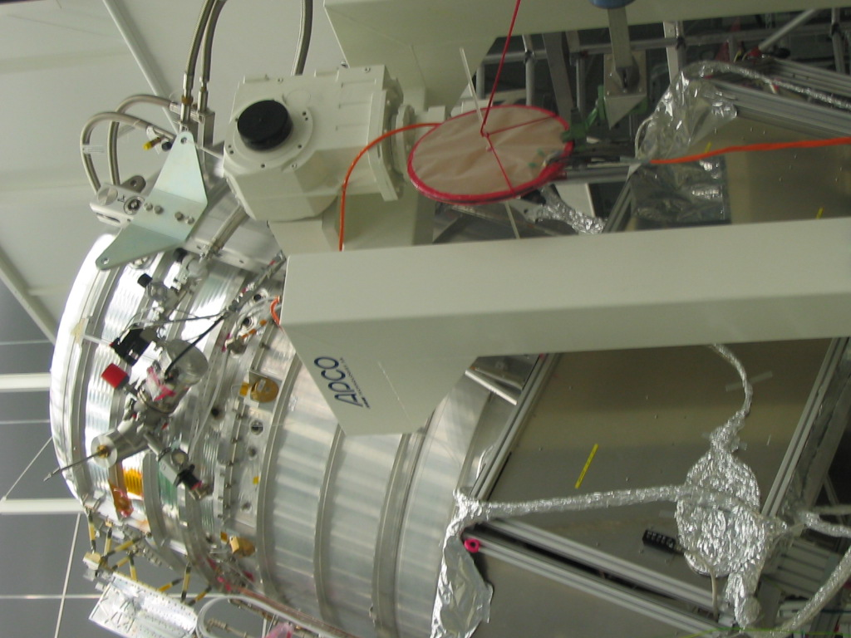
Fig. 8.7-1: Antenna Position for theSPIRE H-field RS Test

SPIRE Frequency Control Tables E-field
SPIRE RS E-Field, Antenna Position 1 Horizontal Polarization, File: SPIRE-EQM-EMC-‘’QLA/STEP’’.txt
i | Frequency | Date | CCS Start Time | CCS Stop Time | Script | QLA/STEP | Sensor | Observations
1 | 30 MHz – 1 GHz | 29.11.05 | 15:45:49 | 16:34:20 |  | N/A |  | 30% AM +: 10 sec. DWELL, 10 % step, 200 ms OFF 800 ms ON
1a | 30 MHz – 40 MHz, | 30.11.05 | 14:17:32:40 | 15:04:41 |  | SWEEPB0000057_8764_2 |  | 30% AM +: 30 sec. DWELL, 0.5 % step, 200 ms OFF 800 ms ON
1b | 200 MHz – 400 MHz | Dito | 16:23:51 | 16:28:00 |  | SPOTB000005E_8764_13 ABORTED- |  | 30% AM +: 30 sec. DWELL, 10 % step, 200 ms OFF 800 ms ON
1c | 200 MHz – 600 MHz | Dito | 16:30:34 | 16:53:01 |  | SPOTB000005E_8764_14 |  | 30% AM +:30 sec. DWELL, 10 % step, 200 ms OFF 800 ms ON
2 | 1 GHz – 6 GHz | 12.12.05 | 12:54:40 | 13:29:10 |  | SWEEPB0000BE_8764_2 |  | 30% AM +: 20 sec. DWELL, 2 % step, 140 ms OFF 800 ms ON
3 | 6 GHz – 18 GHz | 13.12.05 | 09:28:06 | 09:42:47 |  | SWEEPB0000F7_8764_2 |  | 30% AM +: 20 sec. DWELL, 3 % step, 140 ms OFF 800 ms ON
 | 8.475 GHz – 25 MHz | 13.12.05 | 11:48:25 | 11:53:29 |  | SPOTB0000FB_8764_18
 | 8.475 GHz – 12.5 MHz | Dito | 11:53:29 |  |  | SPOTB0000FB_8764_19
 | 8.475 GHz | Dito |  | 11:58:40 |  | SPOTB0000FB_8764_20
 | 8.475 GHz + 12.5 MHz | Dito | 11:58:40 | 12:03:58 |  | SPOTB0000FB_8764_21
 | 8.475 GHz + 25 MHz | Dito | 12:03:58 | 12:09:17 |  | SPOTB0000FB_8764_23
Table 8.8-1: SPIRE @ RS E-field // Antenna Position 1, Horizontal Polarization

SPIRE RS E-Field, Antenna Position 1, Vertical Polarization, File: ‘’SPIRE-EQM-EMC-QLA/STEP’’.txt
I | Frequency | Date | CCS Start Time | CCS Stop Time | Script | QLA/STEP | Sensor | Observations
1 | 14 kHz – 30 MHz | 02.12.05 | 07:36:32 | 08:48:01 |  | SWEEP0000099_8764_3 |  | 30% AM +: 10 sec. DWELL, 2 % step, 200 ms OFF 800 ms ON
3 | 30 MHz – 1 GHz | 29.11.05 | 17:06::05 | 17:51:27 |  | N/A |  | 30% AM +: 20 sec. DWELL, 0.5 % step, 200 ms OFF 800 ms ON
3a | 30 MHz – 40 MHz | 30.11.05 | 17:06:09 | 17:28:08 |  | SWEEP0000062_8764_2 |  | 30% AM +: 20 sec. DWELL, 0.5 % step, 200 ms OFF 800 ms ON
4 | 1 GHz – 6 GHz | 12.12.05 | 11:10:23 | 11:45:42 |  | SWEEPB0000B7_8764_2 |  | 30% AM +: 20 sec. DWELL, 2 % step, 140 ms OFF 800 ms ON
5 | 6 GHz – 18 GHz | 13.12.05 | 08:23:36 | 08:38:22 |  | SWEEPB0000EF_8764_2 |  | 30% AM +: 20 sec. DWELL, 3 % step, 140 ms OFF 800 ms ON
 | 8.475 GHz – 25 MHz | Dito | 10:06:48 | 10:13:05 |  | SPOTB0000FB_8764_3
 | 8.475 GHz – 12.5 MHz | Dito | 10:13:05 | 10:19:30 |  | SPOTB0000FB_8764_4
 | 8.475 GHz | Dito | 10:19:30 | 10:24:18 |  | SPOTB0000FB_8764_5
 | 8.475 GHz + 12.5 MHz | Dito | 10:24:18 | 10:30:47 |  | SPOTB0000FB_8764_6
 | 8.475 GHz + 25 MHz | Dito | 10:30:47 | 10:36:20 |  | SPOTB0000FB_8764_7
Table 8.8-2: SPIRE @ RS E-field // Antenna Position 1, Vertical Polarization

SPIRE RS E-Field, Antenna Position 2 Horizontal Polarization, File: ‘’SPIRE-EQM-EMC-QLA/STEP’’.txt
i | Frequency | Date | CCS Start Time | CCS Stop Time | Script | QLA/STEP | Sensor | Observations
2 | 1 GHz – 6 GHz | 12.12:05 | 13:38:36 | 14:13:00 |  | SWEEPB0000C2_8764_2 |  | 30% AM +: 20 sec. DWELL, 2 % step, 140 ms OFF 800 ms ON
3 | 6 GHz – 18 GHz | Dito | 16:51:39 | 17:05:00 |  | SWEEPB0000D2_8764_2 |  | 30% AM +: 20 sec. DWELL, 3 % step, 140 ms OFF 800 ms ON
 | 8.475 GHz – 25 MHz | Dito | 11:14:40 | 11:20 |  | SPOTB0000FB_8764_13
 | 8.475 GHz – 12.5 MHz | Dito | 11:20 | 11:25:44 |  | SPOTB0000FB_8764_14
 | 8.475 GHz | Dito | 11:25:44 | 11:30 |  | SPOTB0000FB_8764_15
 | 8.475 GHz + 12.5 MHz | Dito | 11:30 | 11:36:15 |  | SPOTB0000FB_8764_16
 | 8.475 GHz + 25 MHz | Dito | 11:36:15 | 11:41:51 |  | SPOTB0000FB_8764_17
Table 8.8-3: SPIRE @ RS E-field // Antenna Position 2, Horizontal Polarization

SPIRE RS E-Field, Antenna Position 2, Vertical Polarization, File: ‘’SPIRE-EQM-EMC-QLA/STEP’’.txt
I | Frequency Range | Date | CCS Start Time | CCS Stop Time | Script | QLA/STEP | Sensor | Observations
4 | 1 GHz – 6 GHz | 12.12.05 | 15:21:03 | 15:55:18 |  | SWEEPB0000CA_8764_2 |  | 30% AM +: 20 sec. DWELL, 2 % step, 140 ms OFF 800 ms ON
5 | 6 GHz – 18 GHz | Dito | 16:27:48 | 16:42:30 |  | SWEEPB0000CE_8764_3 |  | 30% AM +: 20 sec. DWELL, 3 % step, 140 ms OFF 800 ms ON
 | 8.475 GHz – 25 MHz | 13:12:05 | 10:39:30 | 10:45:30 |  | SPOTB0000FB_8764_8
 | 8.475 GHz – 12.5 MHz | Dito | 10:45:30 |  |  | SPOTB0000FB_8764_9
 | 8.475 GHz | Dito | 10:57:20 |  |  | SPOTB0000FB_8764_10
 | 8.475 GHz + 12.5 MHz | Dito |  | 11:03:37 |  | SPOTB0000FB_8764_11
 | 8.475 GHz + 25 MHz | Dito | 11:03:37 |  |  | SPOTB0000FB_8764_12
Table 8.8-4: SPIRE @ RS E-field // Antenna Position 2, Vertical Polarization

SPIRE RS E-field Thresholds, 30 MHz – 1 GHz, Horizontal, File: SPIRE-EQM-EMC-”QLA/STEP’’.txt
I | Frequency | Date | CCS Start Time | CCS Stop Time | Script | QLA/ STEP | Sensor | Observations
1 | 34.2 MHz, high level | 30.11.05 | 08:55:56 | 08:58:15 |  | SPOTB0000051_8764_2
1a | 34.2 MHz, 0.5 V/m | Dito | 08:49:15 | 09:02:18 |  | SPOTB0000051_8764_3
1b | 34.2 MHz, 0.1 V/m | Dito | 09:06:52 | 09:10:21 |  | SPOTB0000051_8764_4
1c | 34.2 MHz, 0.2 V/m | Dito | 09:10:21 | 09:15:10 |  | SPOTB0000051_8764_5 | 0.6 V/m
2 | 34.5 MHz, high level | Dito | 09:15:10 |  |  | SPOTB0000051_8764_6
2a | 34.5 MHz, 1 V/m | Dito | 09:17:00 |  |  | SPOTB0000051_8764_7
2b | 34.5 MHz, 0.5 V/m | Dito | 09:18:16 |  |  | SPOTB0000051_8764_8
2c | 34.5 MHz, 0.2 V/m | Dito | 09:19:50 |  |  | SPOTB0000051_8764_9
2e | 34.5 MHz, 0.1 V/m | Dito | 09:45:42 |  |  | SPOTB0000051_8764_11 | 0.3 V/m
2f | 34.5 MHz, 0.5 V/m | Dito | 10:00:00 | 10:03:50 |  | SPOTB0000051_8764_12
2g | 34.5 MHz, 0.25 V/m | Dito | 10:06:52 |  |  | SPOTB0000051_8764_13
2h | 34.5 MHz, 1 V/m | Dito | 10:10:43 | 10:15:15 |  | SPOTB0000051_8764_14
2i | 34.5 MHz, 0.05 V/m | Dito | 10:29:01 |  |  | SPOTB0000051_8764_16
3 | 30 MHz, 0.5 V/m | Dito | 10:43:50 |  |  | SPOTB0000051_8764_17
3a | 30 MHz, 1 V/m | Dito | 10:48:00 |  |  | SPOTB0000051_8764_18
3b | 30 MHz, 0.2 V/m | Dito | 10:51:50 |  |  | SPOTB0000051_8764_19
3c | 30 MHz, 0.1 V/m | Dito | 10:56:06 |  |  | SPOTB0000051_8764_20
4 | 30.35 MHz, 0.1 V/m | Dito | 11:01:05 |  |  | SPOTB0000051_8764_21
4a | 30.35 MHz, 0.2 V/m | Dito | 11:04:43 |  |  | SPOTB0000051_8764_22
4b | 30.35 MHz, 0.5 V/m | Dito | 11:03:03 |  |  | SPOTB0000051_8764_23
5 | 30.65 MHz, 0.5 V/m | Dito | 11:11:48 |  |  | SPOTB0000051_8764_24
5a | 30.65 MHz, 0.2 V/m | Dito | 11:15:35 |  |  | SPOTB0000051_8764_25
5b | 30.65 MHz, 0.1 V/m | Dito | 11:19:21 |  |  | SPOTB0000051_8764_26
6 | 30.96 MHz, 0.1 V/m | Dito | 11:23:21 |  |  | SPOTB0000051_8764_27
6a | 30.96 MHz, 0.2 V/m | Dito | 11:26:55 |  |  | SPOTB0000051_8764_8
6b | 30.96 MHz, 0.5 V/m | Dito | 11:30:25 |  |  | SPOTB0000051_8764_29
7 | 31.58 MHz, 0.5 V/m | Dito | 11:34:34 |  |  | SPOTB0000051_8764_30
7a | 31.58 MHz, 0.2 V/m | Dito | 11:38:00 |  |  | SPOTB0000051_8764_31
7b | 31.58 MHz, 0.1 V/m | Dito | 11:41:39 | 11:44:58 |  | SPOTB0000051_8764_32
8 | 32.22 MHz, 0.1 V/m | Dito | 12:52:56 |  |  | SPOTB0000053_8764_2
8a | 32.22 MHz, 0.2 V/m | Dito | 12:56:27 |  |  | SPOTB0000053_8764_3
8b | 32.22 MHz, 0.5 V/m | Dito | 13:00:02 |  |  | SPOTB0000053_8764_4
9 | 32.87 MHz, 0.5 V/m | Dito | 13:03:48 |  |  | SPOTB0000053_8764_5
9a | 32.87 MHz, 0.2 V/m | Dito | 13:07:12 |  |  | SPOTB0000053_8764_6
9b | 32.87 MHz, 0.1 V/m | Dito | 13:10:41 |  |  | SPOTB0000053_8764_7
10 | 33.53 MHz, 0.1 V/m | Dito | 13:14:05 |  |  | SPOTB0000053_8764_8
10a | 33.53 MHz, 0.2 V/m | Dito | 13:18:01 |  |  | SPOTB0000053_8764_9
10b | 33.53 MHz, 0.5 V/m | Dito | 13:21:20 |  |  | SPOTB0000053_8764_10
11 | 35.24 MHz, 0.5 V/m | Dito | 13:24:59 |  |  | SPOTB0000053_8764_11
11a | 35.24 MHz, 0.2 V/m | Dito | 13:28:22 |  |  | SPOTB0000053_8764_12
11b | 35.24 MHz, 0.1 V/m | Dito | 13:31:48 |  |  | SPOTB0000053_8764_13
12 | 35.94 MHz, 0.1 V/m | Dito | 13:36:12 |  |  | SPOTB0000053_8764_14
12a | 35.94 MHz, 0.2 V/m | Dito | 13:39:13 |  |  | SPOTB0000053_8764_15
12b | 35.94 MHz, 0.5 V/m | Dito | 13:42:56 |  |  | SPOTB0000053_8764_16
13 | 36.67 MHz, 0.5 V/m | Dito | 13:47:09 |  |  | SPOTB0000053_8764_17
13a | 36.67 MHz, 0.2 V/m | Dito | 13:50:51 |  |  | SPOTB0000053_8764_18
13b | 36.67 MHz, 0.1 V/m | Dito | 13:54:14 | 13:57:20 |  | SPOTB0000053_8764_19
14 | 37.4 MHz, 0.1 V/m | Dito | 14:01:40 |  |  | SPOTB0000053_8764_21
14a | 37.4 MHz, 0.2 V/m | Dito | 14:05:01 |  |  | SPOTB0000053_8764_22
14b | 37.4 MHz, 0.5 V/m | Dito | 14:08:27 |  |  | SPOTB0000053_8764_23
15 | 38.17 MHz, 0.5 V/m | Dito | 14:11:57 |  |  | SPOTB0000053_8764_24
15a | 38.17 MHz, 0.2 V/m | Dito | 14:15:24 |  |  | SPOTB0000053_8764_25
15b | 38.17 MHz, 0.1 V/m | Dito | 14:18:30 | 14:22:50 |  | SPOTB0000053_8764_26
16 | 502.17 MHz | Dito | 15:35:40 |  |  | SPOTB000005E_8764_2
17 | 507.20 MHz | Dito | 15:39:10 |  |  | SPOTB000005E_8764_3
18 | 512.27 MHz | Dito | 15:42:30 |  |  | SPOTB000005E_8764_4
19 | 517.39 MHz | Dito | 15:45:36 |  |  | SPOTB000005E_8764_5
20 | 522.56 MHz | Dito | 15:49:10 |  |  | SPOTB000005E_8764_6
21 | 527.79 MHz | Dito | 15:53:08 |  |  | SPOTB000005E_8764_7
22 | 600.68 MHz | Dito | 16:06:20 |  |  | SPOTB000005E_8764_9
23 | 704.34 | Dito | 16:10:00 |  |  | SPOTB000005E_8764_10
24 | 903.27 | Dito | 16:13:17 |  |  | SPOTB000005E_8764_11
25 | 1 GHz | Dito | 16:16:37 | 16:19:00 |  | SPOTB000005E_8764_12
Table 8.8-5: SPIRE RS E-field, Threshold Measurements 30 MHz – 1 GHz, Horizontal Polarisation

SPIRE RS E-Field Thresholds, 14 kHz - 30 MHz, Vertical, File SPIRE-EQM-EMC-‘’QLA/STEP’’.txt
I | Frequency | Date | CCS Start Time | CCS Stop Time | Script | QLA/ STEP | Sensor | Observations
2 | 15.99 MHz, 0.1 V/m | 02.12.05 | 09:23:25 |  |  | SPOTB000009D_8764_2
2 | 15.99 MHz, 0.2 V/m | Dito | 09:27:05 |  |  | SPOTB000009D_8764_3
3 | 15.99 MHz, 0.05 V/m | Dito | 09:30:39 |  |  | SPOTB000009D_8764_4
4 | 15.99 MHz, 1 V/m | Dito | 09:34:50 | 09:45:56 |  | SPOTB000009D_8764_5
Table 8.8-6: SPIRE RS E-field, Threshold Measurements 14 kHz - 30 MHz, Vertical Polarisation

SPIRE RS E-Field Thresholds, 30 MHz – 1 GHz, Vertical, File: SPIRE-EQM-EMC-‘’QLA/STEP’’.txt
I | Frequency | Date | CCS Start Time | CCS Stop Time | Script | QLA/ STEP | Sensor | Observations
1 | 20 MHz – 40 MHz, high level  31.38 MHz  31.7 MHz  32.01 MHz  32.34 MHz  32.66 MHz  32.66 MHz  32.99 MHz  33.32 MHz  33.64 MHz  33.99 MHz  34.33 MHz  34.67 MHz  35.02 MHz  35.37 MHz | 30.11.05 | 17:38:26 | 17:43:14 |  | SWEEPB0000066_8764_2 |  | 30% AM +: 20 sec. DWELL, 0.5 % step, 200 ms OFF 800 ms ON  Measurement to identify the frequencies of main interest for the threshold measurement.
1a | 20 MHz – 40 MHz (steps as above), 0.1 V/m | 01.12.05 | 10:13:35 | 10:18:08 |  | SPOTB0000073_8764_1 |  | 30% AM +: 20 sec. DWELL, 0.5 % step, 200 ms OFF 800 ms ON
1b | 20 MHz – 40 MHz (steps as above), 0.2 V/m | Dito | 10:18:55 | 10:23:41 |  | SPOTB0000073_8764_2 |  | Dito
1c | 20 MHz – 40 MHz (steps as above), 0.5 V/m | Dito | 10:24:12 | 10:28:52 |  | SPOTB0000073_8764_3 |  | Dito
1d | 20 MHz – 40 MHz (steps as above), 1 V/m | Dito | 10:30:12 | 10:34:47 |  | SPOTB0000073_8764_4 |  | Dito
2 | 33.32 MHz, 0.025 V/m | Dito | 12:16:56 |  |  | SPOTB0000077_8764_2
2a | 33.32 MHz, 0.1 V/m | Dito | 12:20:20 | 12:23:42 |  | SPOTB0000077_8764_3
2b | 33.32 MHz, 0.05 V/m | Dito | 12:24:04 |  |  | SPOTB0000077_8764_4
2c | 33.32 MHz, 0.2 V/m | Dito | 12:28:21 |  |  | SPOTB0000077_8764_5
3 | 33.64 MHz, 0.025 V/m | Dito | 12:49:11 |  |  | SPOTB0000077_8764_8
3a | 33.64 MHz, 0.05 V/m | Dito | 12:52:44 |  |  | SPOTB0000077_8764_9
3b | 33.64 MHz, 0.1 V/m | Dito | 12:56:25 |  |  | SPOTB0000077_8764_10
3c | 33.64 MHz, 0.2 V/m | Dito | 13:00:00 |  |  | SPOTB0000077_8764_11
4 | 32.99 MHz, 0.025 V/m | Dito | 13:04:09 |  |  | SPOTB0000077_8764_12
4a | repetition | Dito |  |  |  | SPOTB0000077_8764_13
4b | 32.99 MHz, 0.05 V/m | Dito | 13:10:29 | 13:13:38 |  | SPOTB0000077_8764_14
4c | 32.99 MHz, 0.1 V/m | Dito | 13:50:30 |  |  | SPOTB0000077_8764_15
4d | 32.99 MHz, 0.2 V/m | Dito | 13:54:06 |  |  | SPOTB0000077_8764_16
4e | 33.99 MHz, 0.025 V/m | Dito | 13:57:55 |  |  | SPOTB0000077_8764_17
4f | 33.99 MHz, 0.05 V/m | Dito | 14:01:20 |  |  | SPOTB0000077_8764_18
4g | 33.99 MHz, 0.1 V/m | Dito | 14:01:20 |  |  | SPOTB0000077_8764_19
4h | 33.99 MHz, 0.2 V/m | Dito | 14:08:34 |  |  | SPOTB0000077_8764_20
5 | 32.66 MHz, 0.025 V/m | Dito | 14:12:20 |  |  | SPOTB0000077_8764_21
5a | 32.66 MHz, 0.05 V/m | Dito | 14:16:10 |  |  | SPOTB0000077_8764_22
5b | 32.66 MHz, 0.1 V/m | Dito | 14:19:36 |  |  | SPOTB0000077_8764_23
5c | repetition | Dito | 15:23:03 |  |  | SPOTB0000077_8764_24
6 | 60 MHz - 90 MHz, high level | Dito | 15:31:27 |  |  | SPOTB0000077_8764_25 |  | 30% AM +: 20 sec. DWELL, 0.5 % step, 200 ms OFF 800 ms ON
Table 8.8-7: SPIRE RS E-field, Threshold Measurements 30 MHz – 1 GHz, Vertical Polarisation

SPIRE RS E-Field Thresholds, 1 GHz - 18 MHz, 1st Position, File: SPIRE-EQM-EMC-‘’QLA/STEP’’.txt
I | Frequency | Date | CCS Start Time | CCS Stop Time | Script | QLA/ STEP | Sensor | Observations
1 | Reference | 12.12.2005 | 11:50:56 | 11:56:20 |  | SPOTB00000BA_8764_1 |  | 30% AM +: 20 sec. DWELL, 0.5 % step, 140 ms OFF 800 ms ON
2 | Missed test | Dito |  |  |  | SPOTB00000BA_8764_2 |  | Missed test
3 | 1.25 GHz, vertical | Dito | 12:01:48 | 12:06: |  | SPOTB00000BA_8764_3 | 2V/m | 30% AM +: 20 sec. DWELL, 0.5 % step, 140 ms OFF 800 ms ON
4 | 2.309 GHz, vertical | Dito | 12:08:50 | 12:13:53 |  | SPOTB00000BA_8764_4 | 2V/m | Dito
5 | 6.158 GHz, vertical | Dito | 12:15:00 | 12:20:06 |  | SPOTB00000BA_8764_5 | 2V/m | Ditp
6 | 1.25 GHz, horizontal | Dito | 12:23:52 | 12:28:28 |  | SPOTB00000BA_8764_6 | 2V/m | Dio
7 | 2.309 GHz, horizontal | Dito | 12:29:27 | 12:35:15 |  | SPOTB00000BA_8764_7 | 2V/m | Dito
8 | 6.158 GHz, horizontal | Dito | 12:35:32 | 12:40:48 |  | SPOTB00000BA_8764_8 | 2V/m | Dito
9 | 7.6 GHz, vertical | 13:12:2005 | 08:50:38 | 08:56:22 |  | SPOTB00000F3_8764_2
10 | 15.17 GHz, vertical | Dito | 08:56:32 | 09:03:03 |  | SPOTB00000F3_8764_3
11 | 15.17 GHz, horizontal | Dito | 09:05:00 | 09:11:02 |  | SPOTB00000F3_8764_4
12 | 7.6 GHz, horizontal | Dito | 09:11:02 | 09:16:50 |  | SPOTB00000F3_8764_5
Table 8.8-8: SPIRE RS E-field, Threshold Measurements 1 GHz - 18 GHz, First Antenna Position

SPIRE RS E-Field Thresholds, 1 GHz - 18 MHz, 2nd Position, File: SPIRE-EQM-EMC-‘’QLA/STEP’’.txt
I | Frequency | Date | CCS Start Time | CCS Stop Time | Script | QLA/ STEP | Sensor | Observations
1 | 1.25 GHz, horizontal | 12.12.2005 | 14:29:52 | 14:36:52 |  | SPOTB00000C6_8764_2 |  | 30% AM +: 20 sec. DWELL, 0.5 % step, 140 ms OFF 800 ms ON
2 | 2.309 GHz, horizontal | Dito | 14:37:22 | 14:44:18 |  | SPOTB00000C6_8764_3 |  | Dito
3 | 6.158 GHz, horizontal | Dito | 14:44:30 | 14:51:00 |  | SPOTB00000C6_8764_4 |  | Dito
4 | 6.158 GHz, vertical | Dito | 14:52:04 | 14:57:42 |  | SPOTB00000C6_8764_5 |  | Dito
5 | 2.309 GHz, vertical | Dito | 14:57:57 | 15:03:25 |  | SPOTB00000C6_8764_6 |  | Dito
6 | 1.25 GHz, vertical | Dito | 15:03:36 | 15:9:44 |  | SPOTB00000C6_8764_7 |  | Dito
7 | 7.6 GHz, horizontal | 13.12.2005 | 07:46:32 | 07:52:12 |  | SPOTB00000EB_8764_2 |  | Dito
8 | 15.17 GHz, horizontal | Dito | 07:52:45 | 07:58:16 |  | SPOTB00000EB_8764_3 |  | Dito
9 | 15.17 GHz, vertical | Dito | 08:00:04 | 08:04:55 |  | SPOTB00000EB_8764_4 |  | Dito
10 | 7.6 GHz, vertical | Dito | 08:05:16 | 08:12:06 |  | SPOTB00000EB_8764_5 |  | Dito
Table 8.8-9: SPIRE RS E-field, Threshold Measurements 1 GHz - 18 GHz, Second Antenna Position

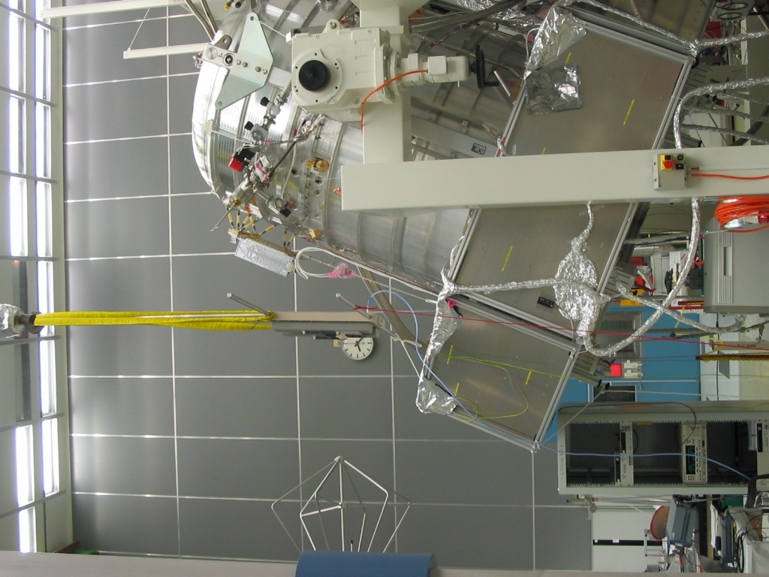
Fig. 8.8-1: Antenna Position for the SPIRE E-field RS Test, 14 kHz to 30 MHz

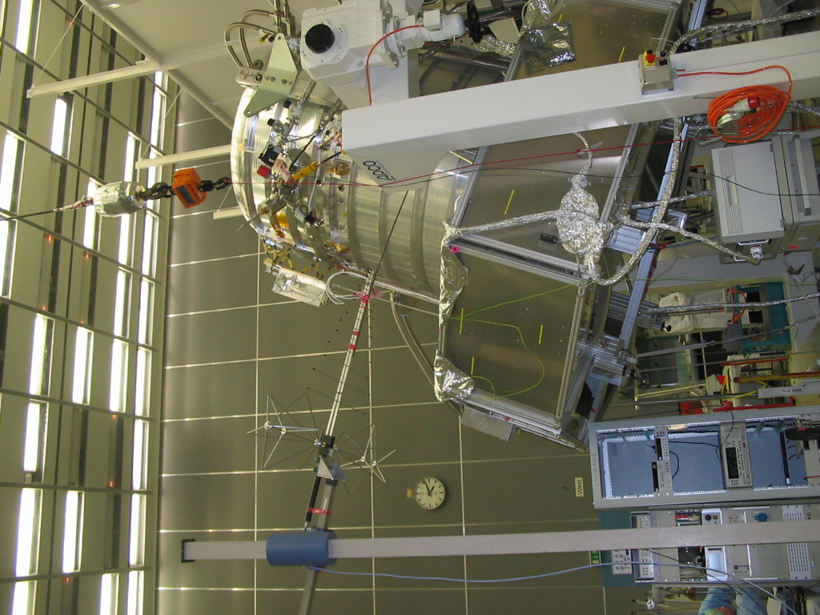
Fig. 8.8-2: Antenna Position for the SPIRE E-field RS Test, 30 MHz to 1 GHz

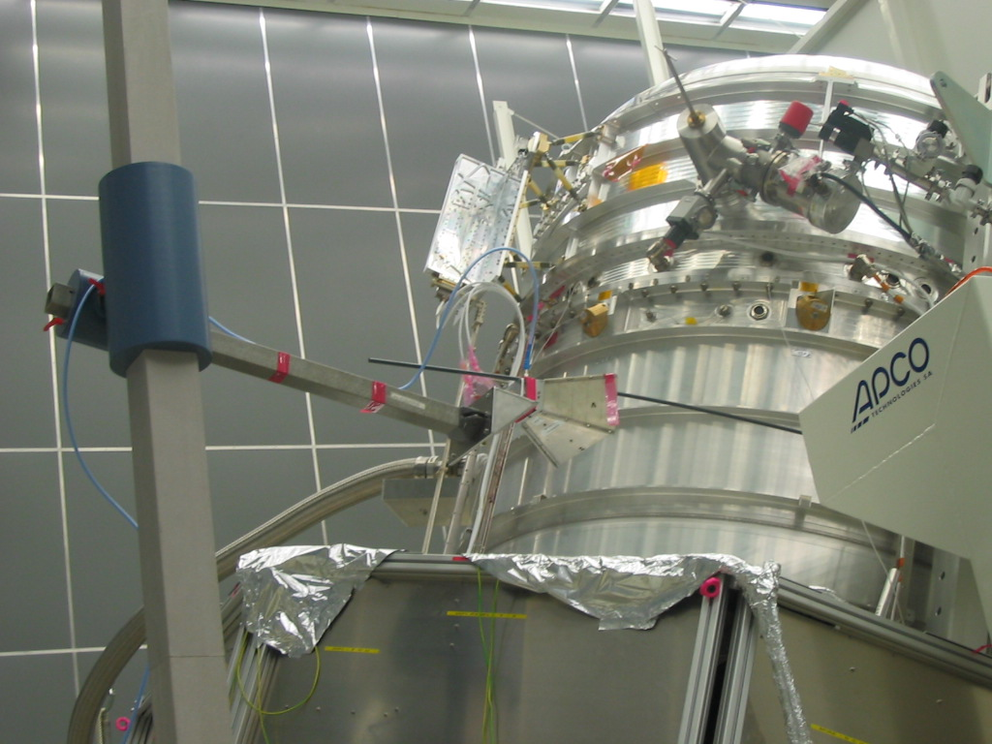
Fig. 8.8-3: First Antenna Position for the SPIRE E-field RS Test, 1 GHz to 18 GHz

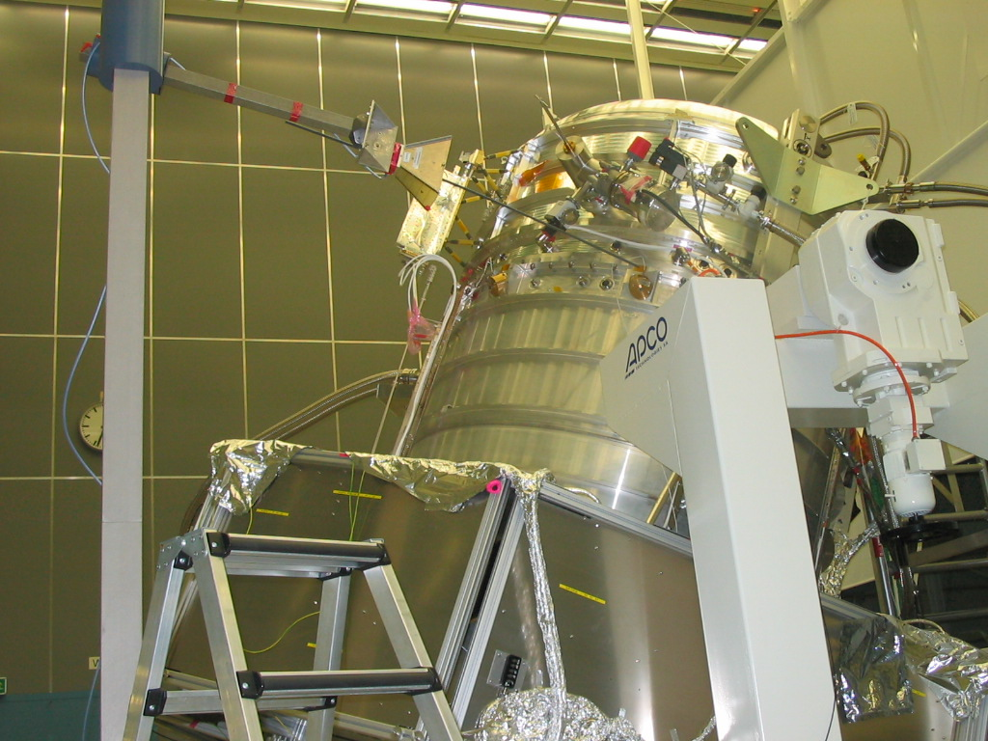
Fig. 8.8-4: Second Antenna Position for the SPIRE E-field RS Test, 1 GHz to 18 GHz

Facility Report

Calibration Data

To be included

Grounding Diagram of EQM Test

Summary Sheets

Procedure Variation Summary
 | Test Change |  |  | Curr. No.:  Date: 15.12.2005  Page 1 of 1
Test designation  Herschel PLM EQM EMC Test |  |  | Test Procedure  HP-2-ASED-PR-0033 | Issue  1, dated 05.10.05 | Rev.
Test step changed  7.2.12 |  |  | Reason for Change  No CE/CS tests on Signal Cable Bundles as this is covered already by RS tests
Test step changed  7.3.5 & 7.3.7 |  |  | Reason for Change  Some precisements necessary for PACS RS H-field test (see red-lined as-run procedure)
Test step changed  7.3.11 & 7.3.13 |  |  | Reason for Change  Some precisements necessary for PACS RS E-field test (see red-lined as-run procedure)
Test step changed  7.4.5 - 7.4.8 |  |  | Reason for Change  Precisements and modifications for stepsize, modulation, DWELL time, synchronisation EMC/OP (see red-lined as-run procedure).
Prepared by:  Clemens Kalde |  | Resp. Test Leader |  | Project Engineer
PA/QA |  | Prime |  | Customer
Table 10-6: Procedure Variation Sheet

Non Conformance Report (NCR) Summary

NCR - No. | NCR - Title | Date | Open  Closed | PA  sig.
Table 10-7: Non-Conformance Record Sheet

Sign-off Sheet

 | Date | Signature
Test Manager
Operator
PA Responsible
ESA Representative

 | Name | Dep./Comp. |  | Name | Dep./Comp.
 | Alberti von Mathias Dr. | AOE22 |  | Schmidt Rudolf | FAE22
 | Barlage Bernhard | AED11 |  | Schweickert Gunn | AOE22
 | Bayer Thomas | AOA52 |  | Sonn Nico | AOE51
 | Brune Holger | AOA55 |  | Steininger Eric | AED32
 | Fehringer Alexander | AOE13 | x | Stritter Rene | AED11
 | Fricke Wolfgang Dr. | AED 65 |  | Thörmer Klaus-Horst Dr. | OTN/AED65
 | Geiger Hermann | AOA52 |  | Wagner Klaus | AOE22
 | Gerner Willi | AED11 | x | Wietbrock Walter | AET12
 | Grasl Andreas | OTN/AOA54 |  | Wöhler Hans | AOE22
 | Grasshoff Brigitte | AET12 |  | Wössner Ulrich | ASE442
 | Hauser Armin | AOE22
 | Hendry David | Terma Resid.
 | Hengstler Reinhold | AOA 5 | x | Alcatel | ASP
 | Hinger Jürgen | AOE22 | x | ESA/ESTEC | ESA
 | Hofmann Rolf | ASE442 |  | Instruments:
 | Hohn Rüdiger | AED65 | x | MPE (PACS) | MPE
 | Huber Johann | AOA52 | x | RAL (SPIRE) | RAL
 | Hund Walter | ASE442 | x | SRON (HIFI) | SRON
x | Idler Siegmund | AED312 |  | Subcontractors:
x | Ilsen Stijn | Terma Resid. |  | Air Liquide, Space Department | AIR
 | Ivády von András | FAE22 |  | Air Liquide, Space Department | AIRS
 | Jahn Gerd Dr. | AOE22 |  | Air Liquide, Orbital System | AIRT
x | Kalde Clemens | APE3 |  | Alcatel Bell Space | ABSP
x | Kameter Rudolf | OTN/AOA54 |  | Astrium Sub-Subsyst. & Equipment | ASSE
 | Kettner Bernhard | AET42 |  | Austrian Aerospace | AAE
x | Knoblauch August | AET32 |  | Austrian Aerospace | AAEM
 | Koelle Markus | AOA53 |  | APCO Technologies S. A. | APCO
x | Kroeker Jürgen | AED65 |  | Bieri Engineering B. V. | BIER
 | Kunz Oliver Dr. | AOE22 |  | BOC Edwards | BOCE
 | Lamprecht Ernst | OTN/ASI21 |  | Dutch Space Solar Arrays | DSSA
 | Lang Jürgen | ASE442 |  | EADS CASA Espacio | CASA
 | Langenstein Rolf | AED15 |  | EADS CASA Espacio | ECAS
 | Langfermann Michael | AOA51 |  | EADS Space Transportation | ASIP
 | Mack Paul | OTN/AOA54 |  | Eurocopter | ECD
 | Müller Jörg | AOA52 |  | European Test Services | ETS
 | Müller Martin | AOA53 |  | HTS AG Zürich | HTSZ
 | Müller Ralf | FAE22 |  | Linde | LIND
 | Peltz Heinz-Willi | AOE13 |  | Patria New Technologies Oy | PANT
 | Pietroboni Karin | AED65 |  | Phoenix, Volkmarsen | PHOE
 | Platzer Wilhelm | AED22 |  | Prototech AS | PROT
 | Reichle Konrad | AOA52 |  | QMC Instruments Ltd. | QMC
 | Reuß Friedhelm | AED62 |  | Rembe, Brilon | REMB
 | Rühe Wolfgang | AED65 |  | Rosemount Aerospace GmbH | ROSE
 | Runge Axel | OTN/AOA54 |  | RYMSA, Radiación y Microondas S.A. | RYM
 | Sachsse Bernt | AED21 |  | SENER Ingenieria SA | SEN
x | Schink Dietmar | AED44 |  | Stöhr, Königsbrunn | STOE
x | Schlosser Christian | OTN/AOA54 |  | Terma A/S, Herlev | TER

