SPIRE-UCF-PRJ-002607

SPIRE PFM Filter Configuration
Summary of filter, beam divider, dichroic & lens configuration, and calibration curve index

SPIRE Ref.:
Cardiff Ref.: HSO-CDF-NOT-117

Issue 1.0
18 January 2006

Prepared by: Peter Hargrave

Scope
This note defines and summarises the filters, beam dividers, dichroics & lenses used for all aspects of the SPIRE FM campaign.
- The actual FM instrument configuration is detailed in section .
- The configuration used for PFM1 and PFM2 testing is detailed in section 2
- Test facility filters are detailed in section 3.
- Flight calibration data, and photometer channel calibration curves are presented and indexed in section 6.
- PFM2 test campaign calibration data are presented and indexed in section 7.

For all test data, the calibration curves to be used have been extracted from the as-delivered Microsoft Excel spreadsheets and placed on the accompanying CD-ROM. These curves are standard ASCII text files, where the first column is wavenumbers, and the second column is transmission. All data have been re-binned to a common wavenumber scale, with 0.1 cm⁻¹ resolution.

This release does not provide the recommended transmission for the spectrometer detectors, but does provide the index and calibration curves for all components in the spectrometer channels.
The next release will include recommended photometer channel calibration curves for use in situations where the SPIRE detectors are viewing the AIV test laboratory through the AIV cryostat filters and window. At the time of this release, data for the window transmission was not available, although calibration files for the individual AIV filters are provided.

SPIRE FM instrument filters, beam dividers and dichroics
This section details the FM configuration, used from the PFM3 campaign onwards, and reflects the current configuration as at 18th January 2006.

FM instrument filters
Filter | Reference | Data file | Notes
CFIL1 | B723 FILT-PFM-101 | pfm-cfil1.txt
PFIL2 | B745 FILT-PFM-102 | pfm-pfil2.txt
PFIL3 | W879 FILT-PFM-103 | pfm-pfil3.txt | A/R coated component
SFIL2 | B705 FILT-PFM-113 | pfm-sfil2.txt
SFIL3S | B655 FILT-PFM-116 | pfm-sfil3s.txt
SFIL3L | B731 FILT-PFM-120 | pfm-sfil3l.txt
PLW 300mK filters | B730 FILT-PFM-230 | pfm-plw-stack.txt | 300mK PLW filter in mount. Single PFIL4L blocker.
PMW 300mK filters | B734 FILT-PFM-240 | pfm-pmw-stack.txt | 300mK PMW filter in mount. Single PFIL4M blocker.
PSW 300mK filters | W859, W857, FILT-PFM-250 | pfm-psw-stack.txt | 300mK PSW filters in mount.  W859 – blocker  W857 – edge definer  Data file is transmission of assembled stack.
SFIL4L | B683#2 FILT-PFM3-214 | pfm3-sfil4l.txt | 300mK SLW blocker. This component was originally delivered as the flight-spare unit, which was later upgraded to FM once at RAL.
SFIL5L | B675#1 FILT-PFM3-215 | pfm3-sfil5l.txt | 300mK SLW edge definer. This component was originally delivered as the flight-spare unit, which was later upgraded to FM once at RAL.
SFIL4S | B679#2 FILT-PFM3-224 | pfm3-sfil4s.txt | 300mK SSW blocker. This component was originally delivered as the flight-spare unit, which was later upgraded to FM once at RAL.
SFIL5S | B650#2 FILT-PFM3-225 | pfm3-sfil5s.txt | 300mK SSW edge definer. This component was originally delivered as the flight-spare unit, which was later upgraded to FM once at RAL.
SLW Lens | FILT-PFM3-213 | pfm3-slw-arc-flight-lens.txt | Note that this lens is an A/R coated upgrade. It was NOT used for campaigns prior to PFM3.  The transmission is measured only through the planar part of the lens.
SSW Lens | FILT-PFM3-223 | pfm3-ssw-arc-flight-lens.txt | Note that this lens is an A/R coated upgrade. It was NOT used for campaigns prior to PFM3.  The transmission is measured only through the planar part of the lens.

Dichroics
Filter | Reference | Data file | Notes
PDIC1 | 1489 FILT-PFM3-310 | pfm3-pdic1-flight-T.txt | Transmission data. Note – this component was not used prior to PFM3 testing.
PDIC1 | 1489 FILT-PFM3-310 | pfm3-pdic1-flight-R.txt | Reflection data. Note – this component was not used prior to PFM3 testing.
PDIC2 | 1487 FILT-PFM3-320 | pfm3-pdic2-flight-T.txt | Transmission data. Note – this component was not used prior to PFM3 testing.
PDIC2 | 1487 FILT-PFM3-320 | pfm3-pdic2-flight-R.txt | Reflection data. Note – this component was not used prior to PFM3 testing.

Beam dividers
Filter | Reference | Data file | Notes
SBS1 | FILT-PFM-410 | pfm-sbs1-c.txt | Reflection off capacitative grid, 10-140cm⁻¹, 0.1cm⁻¹ resolution
SBS1 | FILT-PFM-410 | pfm-sbs1-i.txt | Reflection off inductive grid, 10-140cm⁻¹, 0.1cm⁻¹ resolution
SBS1 | FILT-PFM-410 | pfm-sbs1-t.txt | Transmission, 10-140cm⁻¹, 0.1cm⁻¹ resolution
SBS2 | FILT-PFM-420 | pfm-sbs2-c.txt | Reflection off capacitative grid, 10-140cm⁻¹, 0.1cm⁻¹ resolution
SBS2 | FILT-PFM-420 | pfm-sbs2-i.txt | Reflection off inductive grid, 10-140cm⁻¹, 0.1cm⁻¹ resolution
SBS2 | FILT-PFM-420 | pfm-sbs2-t.txt | Transmission, 10-140cm⁻¹, 0.1cm⁻¹ resolution

SPIRE PFM1 and PFM2 instrument filters, beam dividers and dichroics – NON-FLIGHT CONFIGURATION
This section details the configuration, used for the PFM1 and PFM2 test campaigns. While the majority of components are the same flight components, there were a few non-flight, temporary components, or components that were subsequently upgraded for flight. These components are highlighted in boldface.

PFM1/2 instrument filters
Filter | Reference | Data file | Notes
CFIL1 | B723 FILT-PFM-101 | pfm-cfil1.txt
PFIL2 | B745 FILT-PFM-102 | pfm-pfil2.txt
PFIL3 | W879 FILT-PFM-103 | pfm-pfil3.txt | A/R coated component
SFIL2 | B705 FILT-PFM-113 | pfm-sfil2.txt
SFIL3S | B655 FILT-PFM-116 | pfm-sfil3l.txt
SFIL3L | B731 FILT-PFM-120 | pfm-sfil3s.txt
PLW 300mK filters | B730 FILT-PFM-230 | pfm-plw-stack.txt | 300mK PLW filter in mount. Single PFIL4L blocker.
PMW 300mK filters | B734 FILT-PFM-240 | pfm-pmw-stack.txt | 300mK PMW filter in mount. Single PFIL4M blocker.
PSW 300mK filters | W859, W857, FILT-PFM-250 | pfm-psw-stack.txt | 300mK PSW filters in mount.  W859 – blocker  W857 – edge definer  Data file is transmission of assembled stack.
SFIL4L | B488 FILT-PFM-214 | pfm-sfil4l.txt | These filters were present in the PFM1 and PFM2 builds, but for calculations of total spectrometer band transmission, the transmission curves below should be used, which are the total measured 300mK filter and lens stack transmissions.
SFIL5L | B476 FILT-PFM-215 | pfm-sfil5l.txt
SFIL4S | B679 FILT-PFM-224 | pfm-sfil4s.txt
SFIL5S | B650 FILT-PFM-225 | pfm-sfil5s.txt
SLW 300mK Lens & filter stack | FILT-PFM-210 | pfm12-slw-stack.txt | This is the total transmission of the 300mK SLW filter and lens assembly.  The transmission is measured only through the planar part of the lens.  HDPE lens – non-flight.
SSW 300mK Lens & filter stack | FILT-PFM-220 | pfm12-ssw-stack.txt | This is the total transmission of the 300mK SSW filter and lens assembly.  The transmission is measured only through the planar part of the lens.  HDPE lens – non-flight.

Dichroics
Filter | Reference | Data file | Notes
PDIC1 | 1338 FILT-PFM-310 | gse-pfm2-pdic1-T.txt | Transmission data. Note – this component was only used for PFM2 testing.
PDIC1 | 1338 FILT-PFM-310 | gse-pfm2-pdic1-R.txt | Reflection data. Note – this component was only used for PFM2 testing.
PDIC2 | 1459 FILT-PFM-320 | gse-pfm2-pdic2-T.txt | Transmission data. Note – this component was only used for PFM2 testing.
PDIC2 | 1459 FILT-PFM-320 | gse-pfm2-pdic2-R.txt | Reflection data. Note – this component was only used for PFM2 testing.

Beam dividers
Filter | Reference | Data file | Notes
SBS1 | FILT-PFM-410 | pfm-sbs1-c-w-10-140-1.txt | Reflection off capacitative grid, 10-140cm⁻¹, 0.1cm⁻¹ resolution
SBS1 | FILT-PFM-410 | pfm-sbs1-i-w-10-140-1.txt | Reflection off inductive grid, 10-140cm⁻¹, 0.1cm⁻¹ resolution
SBS1 | FILT-PFM-410 | pfm-sbs1-t-w-10-140-1.txt | Transmission, 10-140cm⁻¹, 0.1cm⁻¹ resolution
SBS2 | FILT-PFM-420 | pfm-sbs2-c-w-1-140-1.txt | Reflection off capacitative grid, 10-140cm⁻¹, 0.1cm⁻¹ resolution
SBS2 | FILT-PFM-420 | pfm-sbs2-i-w-1-140-1.txt | Reflection off inductive grid, 10-140cm⁻¹, 0.1cm⁻¹ resolution
SBS2 | FILT-PFM-420 | pfm-sbs2-t-w-1-140-1.txt | Transmission, 10-140cm⁻¹, 0.1cm⁻¹ resolution

Test facility filters – GSE – NON-FLIGHT
Filter | Reference | Data file | Notes
AIV77K | B648 | AIV77.txt
AIV10K | B635 | AIV10.txt
ND09 | ND09 | ND09.txt | 9.5% ND filter. Uniformity data in CBB data pack (AIV_ND_uniformity.xls).
ND04 | ND04 | ND04.txt | 3.8% ND filter. Uniformity data in CBB data pack (AIV_ND_uniformity.xls).

SPIRE filter topology
The general topology of SPIRE optical components is illustrated in Figure 1 and Figure 2. Filters, dichroics and beam-splitters are shown in green.
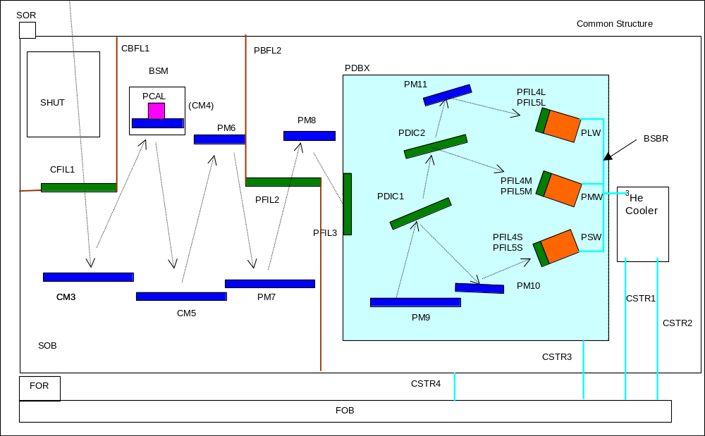
Figure 1 Photometer filter topology
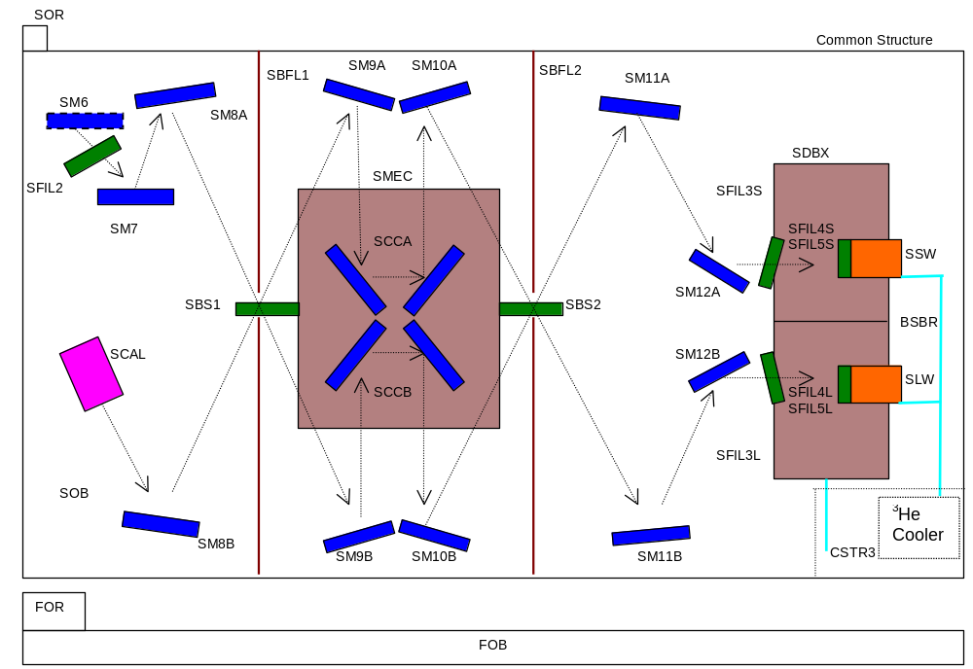
Figure 2 Spectrometer filter topology

Beam divider configuration
The beam dividers each consist of two grids, separated by a dielectric layer. There is a capacitative grid pattern on one side, with an inductive grid pattern on the other. The beam dividers are mounted in the instrument such that the capacitative and inductive grids are in opposition, as shown in Figure 3.
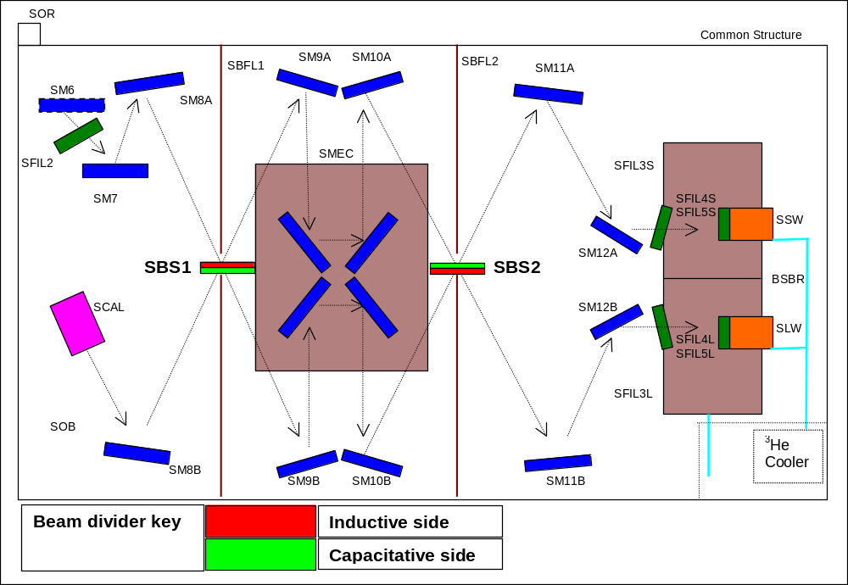
Figure 3 Beam divider mounting guide.

Photometer bands – flight configuration

PSW Channel
Filter configuration for this channel:-
CFIL1 | pfm-cfil1.txt | Flight item
PFIL2 | pfm-pfil2.txt | Flight item
PFIL3 | pfm-pfil3.txt | Flight item
PDIC1R | pfm3-pdic1-flight-R.txt | Flight dichroic – PFM3 tests onwards. Seen by this channel in reflection.
PSWSTACK | pfm-psw-stack.txt | Flight 300mK PSW filter stack.

The recommended calibration file for the PSW channel pass-band is:-
pfm3-psw-channel-calibration.txt
This file includes the waveguide cut-off data for this channel. The value for the cut-off is 34.282 cm⁻¹ (291.7 μm), and comes from the PSW BDA EIDP. The cut-off is modelled in these data as a hard cut-off to zero transmission for frequencies below the cut-off value. These data are shown in Figure 4.

The calibration file to be used for the transmission of all flight filters alone is:-
pfm3-psw-channel-filters-only.txt
This file is the transmission of the filters alone, and does not include the waveguide cut-off.
These data are shown, together with the individual filter traces, in Figure 5.
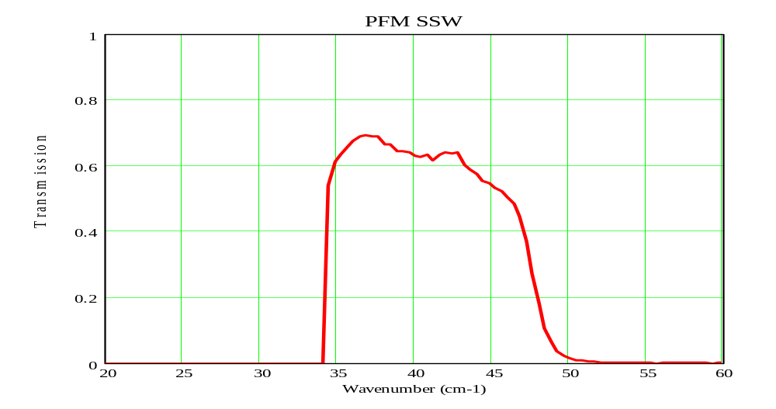
PFM PSW
Figure 4 PSW channel calibration data. These data include the waveguide cut-off.
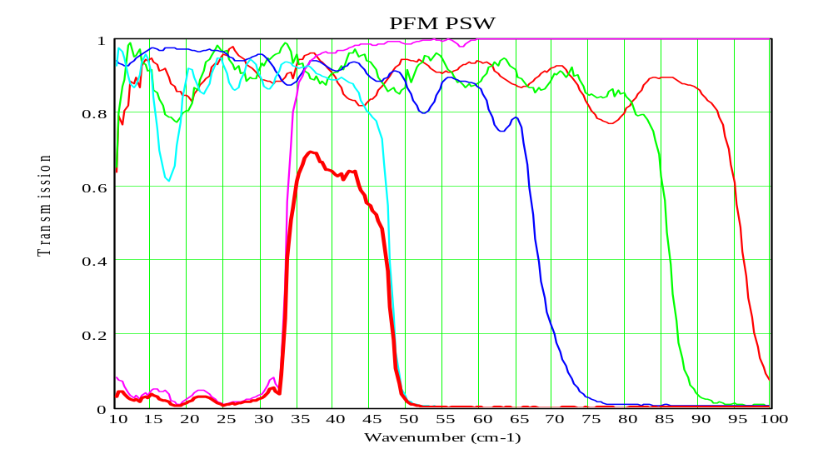
Figure 5 PSW channel filter calibration data. Bold red trace is summation of all components, and is the overall PSW filter transmission function.

PSW PFM3 ground-test calibration data
Need window transmission from Bruce……

PMW Channel
Filter configuration for this channel:-
CFIL1 | pfm-cfil1.txt | Flight item
PFIL2 | pfm-pfil2.txt | Flight item
PFIL3 | pfm-pfil3.txt | Flight item
PDIC1T | pfm3-pdic1-flight-T.txt | Flight dichroic – PFM3 tests onwards. Seen by this channel in transmission.
PDIC2R | pfm3-pdic2-flight-R.txt | Flight dichroic – PFM3 tests onwards. Seen by this channel in reflection.
PMWSTACK | pfm-pmw-stack.txt | Flight 300mK PMW filter stack.

The recommended calibration file for the PMW channel pass-band is:-
pfm3-pmw-channel-calibration.txt
This file includes the waveguide cut-off data for this channel. The value for the cut-off is 23.81 cm⁻¹ (420 μm), and comes from the PMW BDA EIDP. The cut-off is modelled in these data as a hard cut-off to zero transmission for frequencies below the cut-off value. These data are shown in Figure 6.

The calibration file to be used for the transmission of all flight filters alone is:-
pfm3-pmw-channel-filters-only.txt
This file is the transmission of the filters alone, and does not include the waveguide cut-off.
These data are shown, together with the individual filter traces, in Figure 7.
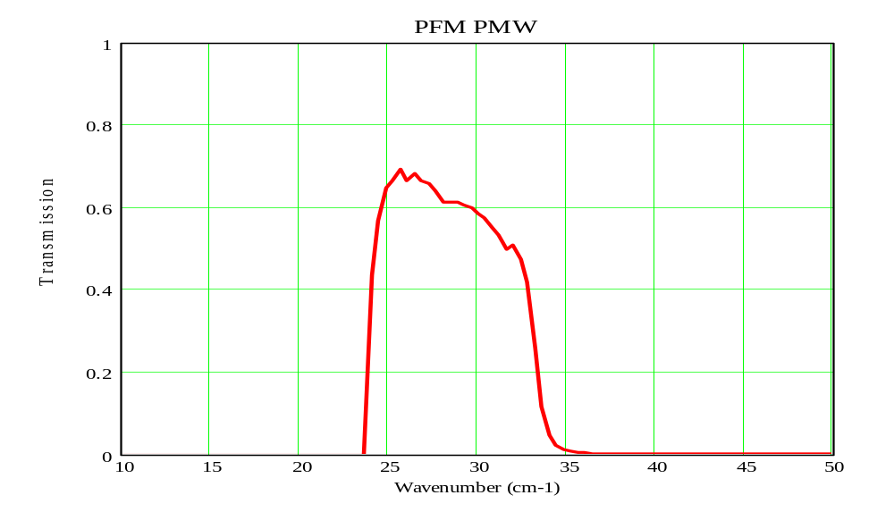
Figure 6 PMW channel calibration data. These data include the waveguide cut-off.
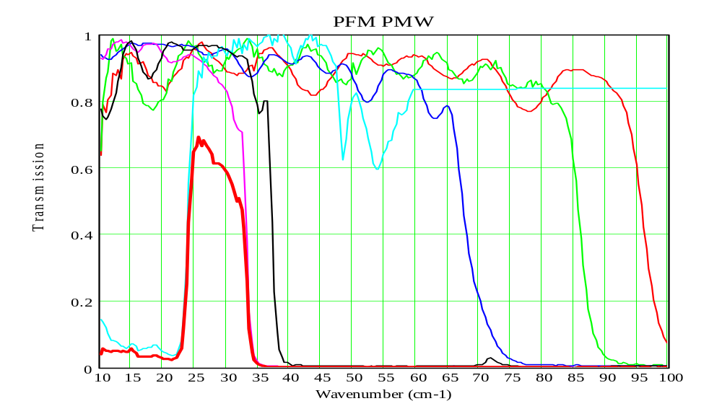
Figure 7 PMW channel filter calibration data. Bold red trace is summation of all components, and is the overall PMW filter transmission function.

PLW Channel
Filter configuration for this channel:-
CFIL1 | pfm-cfil1.txt | Flight item
PFIL2 | pfm-pfil2.txt | Flight item
PFIL3 | pfm-pfil3.txt | Flight item
PDIC1T | pfm3-pdic1-flight-T.txt | Flight dichroic – PFM3 tests onwards. Seen by this channel in transmission.
PDIC2T | pfm3-pdic2-flight-T.txt | Flight dichroic – PFM3 tests onwards. Seen by this channel in transmission.
PLWSTACK | pfm-plw-stack.txt | Flight 300mK PLW filter stack.

The recommended calibration file for the PLW channel pass-band is:-
pfm3-plw-channel-calibration.txt
This file includes the waveguide cut-off data for this channel. The value for the cut-off is 16.58 cm⁻¹ (603.2 μm), and comes from the PLW BDA EIDP. The cut-off is modelled in these data as a hard cut-off to zero transmission for frequencies below the cut-off value. These data are shown in Figure 8.

The calibration file to be used for the transmission of all flight filters alone is:-
pfm3-plw-channel-filters-only.txt
This file is the transmission of the filters alone, and does not include the waveguide cut-off.
These data are shown, together with the individual filter traces, in Figure 9.
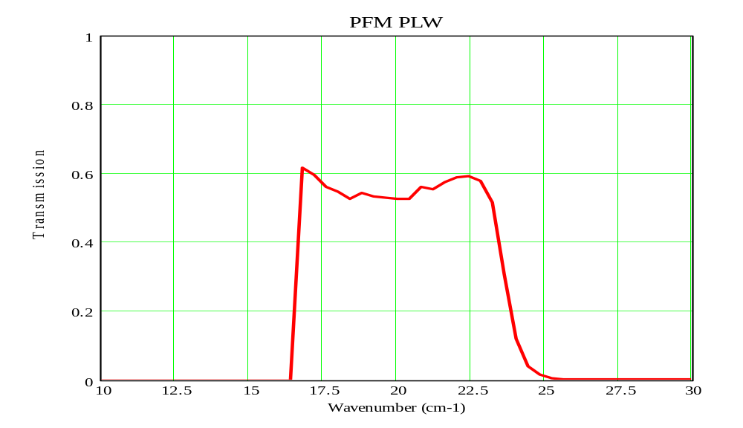
Figure 8 PLW channel calibration data. These data include the waveguide cut-off.
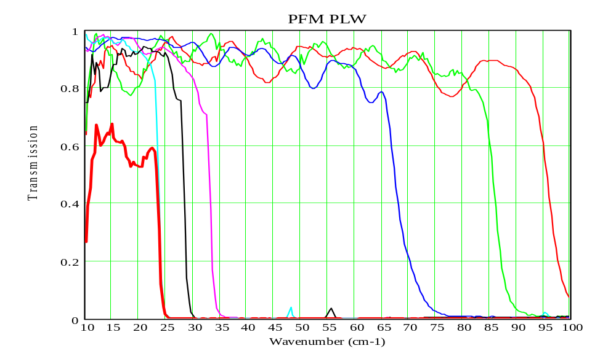
Figure 9 PLW channel filter calibration data. Bold red trace is summation of all components, and is the overall PMW filter transmission function.

Photometer bands – PFM2 testing configuration.
The calibration data presented in this section should be used for analysis of data from the PFM2 test campaign ONLY. This test campaign used temporary, non-flight dichroics, which were replaced following this campaign, prior to the PFM3 campaign.

PSW PFM2 Channel – non-flight
Filter configuration for this channel:-
CFIL1 | pfm-cfil1.txt | Flight item
PFIL2 | pfm-pfil2.txt | Flight item
PFIL3 | pfm-pfil3.txt | Flight item
PDIC1R | gse-pfm2-pdic1-R.txt | Non-flight, temporary dichroic – PFM2 tests only. Seen by this channel in reflection.
PSWSTACK | pfm-psw-stack.txt | Flight 300mK PSW filter stack.

The recommended calibration file for the PSW channel pass-band is:-
pfm2-psw-channel-calibration.txt
This file includes the waveguide cut-off data for this channel. The value for the cut-off is 34.282 cm⁻¹ (291.7 μm), and comes from the PSW BDA EIDP. The cut-off is modelled in these data as a hard cut-off to zero transmission for frequencies below the cut-off value. These data are shown in Figure 10.

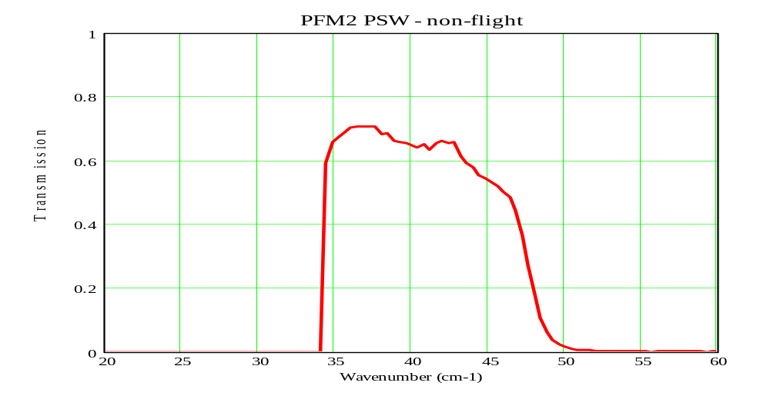
Figure 10 PSW channel calibration data for PFM2 test campaign only. A non-flight dichroic was used for these tests.

PMW PFM2 Channel – non-flight
Filter configuration for this channel:-
CFIL1 | pfm-cfil1.txt | Flight item
PFIL2 | pfm-pfil2.txt | Flight item
PFIL3 | pfm-pfil3.txt | Flight item
GSEPDIC1T | gse-pfm2-pdic1-T.txt | Non-flight, temporary dichroic – PFM2 tests only. Seen by this channel in transmission.
GSEPDIC2R | gse-pfm2-pdic2-R.txt | Non-flight, temporary dichroic – PFM2 tests only. Seen by this channel in reflection.
PMWSTACK | pfm-pmw-stack.txt | Flight 300mK PMW filter stack.

The recommended calibration file for the PMW channel pass-band is:-
pfm2-pmw-channel-calibration.txt
This file includes the waveguide cut-off data for this channel. The value for the cut-off is 23.81 cm⁻¹ (420 μm) and comes from the PMW BDA EIDP. The cut-off is modelled in these data as a hard cut-off to zero transmission for frequencies below the cut-off value. These data are shown in Figure 11.

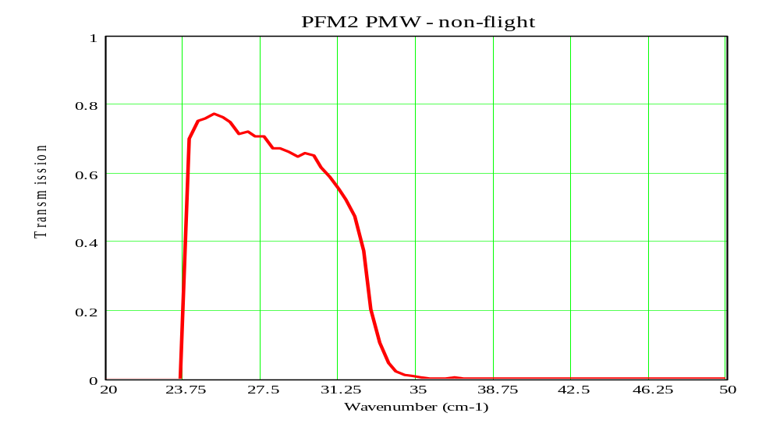
Figure 11 PMW channel calibration data for PFM2 test campaign only. Non-flight dichroics were used for these tests.

PLW PFM2 Channel – non-flight
Filter configuration for this channel:-
CFIL1 | pfm-cfil1.txt | Flight item
PFIL2 | pfm-pfil2.txt | Flight item
PFIL3 | pfm-pfil3.txt | Flight item
GSEPDIC1T | gse-pfm2-pdic1-T.txt | Non-flight, temporary dichroic – PFM2 tests only. Seen by this channel in transmission.
GSEPDIC2T | gse-pfm2-pdic2-T.txt | Non-flight, temporary dichroic – PFM2 tests only. Seen by this channel in transmission.
PLWSTACK | pfm-plw-stack.txt | Flight 300mK PLW filter stack.

The recommended calibration file for the PLW channel pass-band is:-
pfm2-plw-channel-calibration.txt
This file includes the waveguide cut-off data for this channel. The value for the cut-off is 16.58 cm⁻¹ (603.2 μm), and comes from the PLW BDA EIDP. The cut-off is modelled in these data as a hard cut-off to zero transmission for frequencies below the cut-off value. These data are shown in Figure 12.

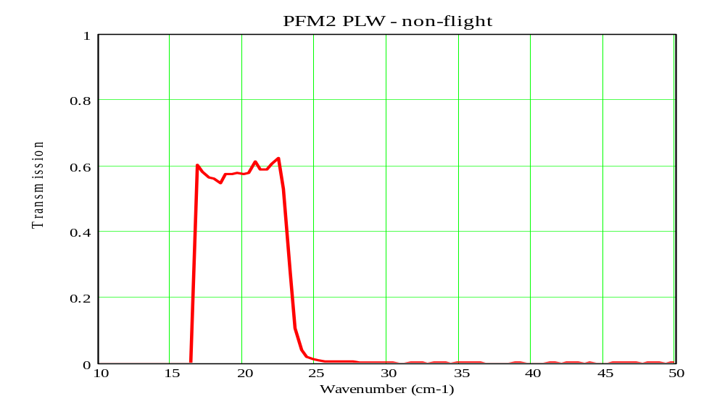
Figure 12 PLW channel calibration data for PFM2 test campaign only. Non-flight dichroics were used for these tests.

