Analysis of SPIRE Thermal Performances
With Hybrid FPU Supports

THERMAL ENGINEERING GROUP
PREPARED BY | A.S. GOIZEL | (RAL) | 07/12/05
CHECKED BY | B. SHAUGHNESSY | (RAL)
SPIRE PROJECT
APPROVED BY | E. SAWYER | (RAL)

- Background

During the SPIRE PFM2 vibration testing at CSL, a sudden change in frequency was observed. Further investigations suggested that the instrument FPU CFRP cone support might have been damaged and therefore requires:

  - To be redesigned – such activity would however have serious impacts on the project.

  - Or to be replaced with the original stainless steel version of the support.

- Scope

Replacing the CFRP support with its stainless steel counterpart would impact the overall instrument thermal performances. The thermal analyses summarised in this technical note have been carried out to assess any degradation in the instrument thermal performance and the results have been used as an input to the decision process.

- Thermal Models and Assumptions

Thermal analyses are usually performed with the “stand-alone” version of the SPIRE instrument thermal model. In this model, the instrument/cryostat thermal interface temperatures are fixed boundaries derived either from the requirement or the goal interface temperatures defined in the IIDB. This approach provides a worst case scenario and ensures that the instrument thermal performances will meet the heat loads budgets for the defined thermal environments.

Given that there is only a limited scope for redesigning a support at such a late stage in the project, it was thought preferable to use a more realistic thermal environment to perform this thermal analysis. The full version of the Herschel Cryostat thermal model (Issue 4) has therefore been used in conjunction with the SPIRE thermal model to run this analysis.

The following assumptions are applicable to this analysis:

  - The SPIRE thermal model “SPIRE_TMM_FM-2-2” has been used for this analysis. Please note that this model has not yet been correlated and that the same applies to the Herschel thermal model.

  - All the SPIRE mechanisms internal power dissipations have been updated with the most recent inputs from the sub-systems. Worst case average dissipations were used for each mechanism.

  - A nominal 6 litres cooler has been used for this analysis.

  - A 0.25 factor has been applied to the original L1 and L0 stainless steel supports to model the instrument CFRP supports conductance.

  - The analysis has been carried out in spectrometer mode as this currently represents the worst case scenario in terms of cooler hold time.

- Thermal Analysis Results Summary

Table 1 below summarises the instrument thermal performances for:

  - Baseline – all L1 and L0 supports are CFRP supports,

  - Baseline with L1 cone support changed from CFRP to stainless steel,

  - Baseline with all L1 supports changed from CFRP to stainless steel (sensitivity study only).

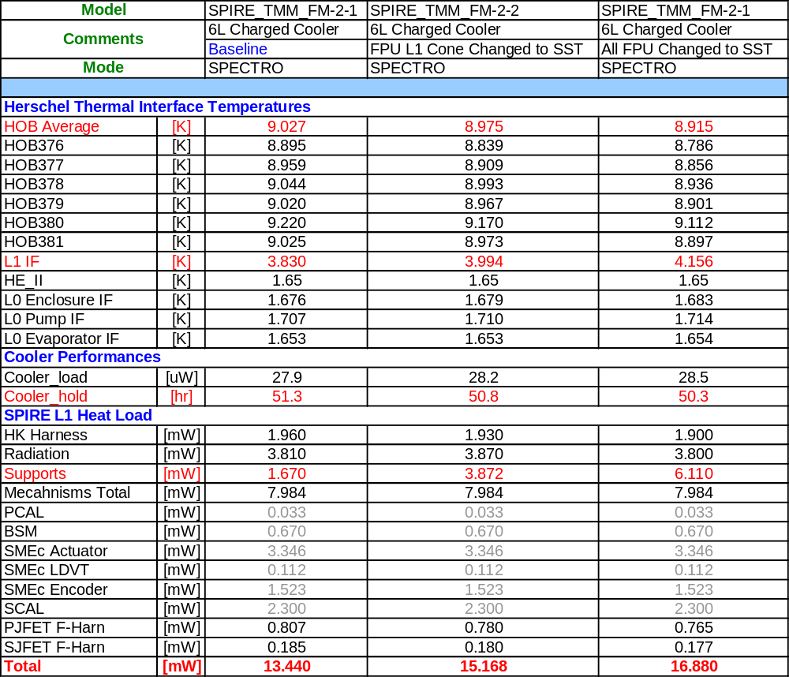

Table 1 – Summary of Thermal Analysis Results

- Discussion

The analysis showed that changing the L1 cone support back to stainless steel increased the total load to L1 from 13.44 mW to 15.168 mW (due to the increase in L1 supports parasitic from 1.67 mW to 3.872 mW). The instrument maximum heat load requirement at L1 is 15mW. Changing to stainless steel would bring the instrument L1 heat load in excess of the specification by 0.168mW.

The increase in L1 heat load also impacts the SPIRE L1 interface temperature which increased from 3.83K to 3.99K (0.16K increase). This meant a reduction in cooler hold time of 0.5 hr.

It is worth keeping the following points in mind however:

- The L0 interface temperatures currently obtained with the Herschel model are quite low (they are based on a 1.65K HeII base temperature) in comparison with the one agreed in the IIDB. Should these temperatures be higher while in flight, the impact of an increased L1 load on the cooler hold time would be even more important.

- The predicted HOB average temperature is about 9K for this analysis against 12K in the IIDB. Should the HOB temperature be closer to 12K in flight, the increase in L1 heat load would be 1.6 times larger than the currently predicted one, i.e. the total L1 heat load would increase from 15.17 mW to ~17.49mW, well in excess of the L1 heat load requirement (15mW).

In addition, any change in JFETs internal power dissipation and/or their isolation support conductance (with respect to the one currently used in the model) would affect the HOB temperature. For this reason, additional sensitivity analyses on these parameters were carried out to anticipate the impact such changes would have with the new baseline (stainless steel L1 cone, CFRP L1 A-frames and all L0 supports in CFRP). While the instrument spectrometer mode was used in the previous analysis, the photometer mode will be used in this case as this is the case with the highest JFET internal power dissipation. The following cases were considered:

- New baseline in spectrometer mode,

- New baseline in photometer mode,

- New baseline in photometer mode with reduced JFET isolation support conductance (by a 1.18 factor),

- New baseline in photometer mode with reduced JFET isolation support conductance (by a 1.18 factor) and an increase in PJFET internal power dissipation from 42mW to 66mW.

The results of this analysis are summarised in Table 2.

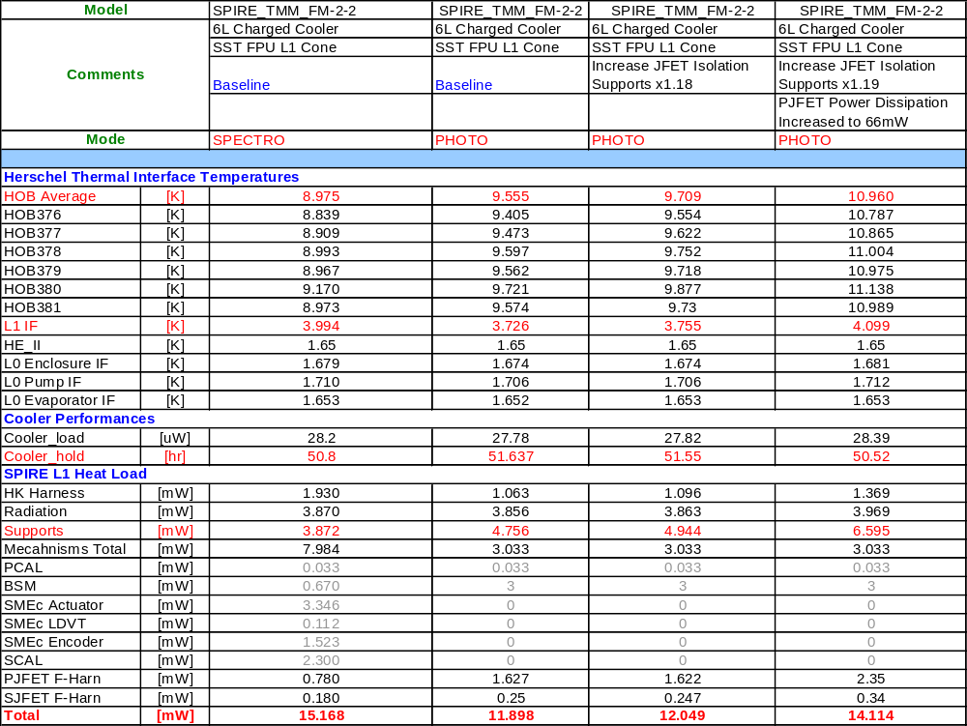

Table 2 – Summary of Sensitivity Analysis Result
Observations:

- From the results, one can see that the photometer mode has an impact on the HOB temperature and that the L1 support parasitic load for the new baseline in this case would increase further from 3.872 mW (when in spectrometer mode) to 4.756 mW.

- As the instrument mechanisms power dissipation is lower in photometer mode than for the spectrometer mode (3.033mW against 7.98 mW), the overall increase in instrument L1 heat load is minimised however.

- This analysis emphasises that an increase in the JFET isolation supports conductance and/or internal power dissipation would increase the HOB temperature from 9.5K to almost 11K. This means that the L1 supports parasitic load could increase from 4.7mW to 6.6mW. Despite this increase, the total L1 heat load would remain within the 15mW specification.

Additional Notes:

- Please note that the load from the PTC when used in photometer mode has not been included in this analysis. An additional 1 uW should be added to the total cooler load when the PTC is used.

- Please also note that the instrument mechanism power dissipation should to be reviewed for the photometer case depending on which observation mode will most likely be used in flight.

- Conclusion

This analysis demonstrated that changing the SPIRE L1 cone support from CFRP to stainless steel would have a minimal impact on the instrument hold time performance (overall reduction of 0.5hr).

This change however increased the instrument L1 heat load from 13.44mW to 15.17mW in spectrometer mode, in excess of the agreed 15mW maximum heat load in the IIDB. The SPIRE RAL team agreed however that this excess load could be mitigated in flight by using some of the mechanisms for shorter period of times.

Based on these results, the SPIRE RAL team concluded that changing to a stainless steel cone support was the most viable option and that the impact on the cooler hold time was acceptable [see minutes of RAL meeting, 06/12/05]. The SPIRE L1 supports flight hardware baseline now consists of a stainless steel cone and two CFRP A-frames. The L0 supports remain unchanged (all made of CFRP).

Further analyses were carried out to assess how sensitive the new instrument baseline would be to change in JFET performances. The results did not anticipate any major degradation of the overall instrument thermal performances.

