Scope:
This is a report from the SPIRE verification control database (VCD) giving the cross matrix between the requirements in the IID-B – labelled as HP-SPIRE-REQ-#### - and the corresponding requirements in the SPIRE Instrument Requirements Document SPIRE-RAL-PRJ-000034 v1.3

Cross Reference Table:
The table below is an image from the SPIRE Access database pivot query “HP-SPIRE to IRD pivot”.

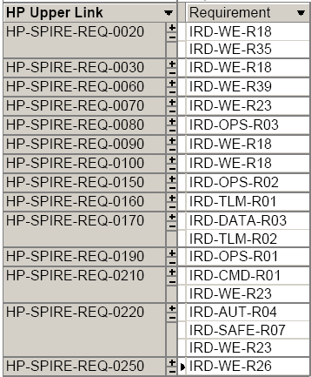

Only those requirements in the IID-B that directly relate to SPIRE are listed.

The full database is available for inspection on request. It should be noted that this is not intended for public consumption and is very much a working tool. The database does not generate forms or automatic reports.

