Scope

This note is intended only to clarify the implementation of the shielding/grounding in the SPIRE instrument test cryoharness and the spacecraft cryoharness.

Applicability:

This note is applicable to the SPIRE Cryoharnesses related to the detector signals; specifically SIH-CS-01 to SIH-CS-09 inclusive.

Description:

In the following sketches, the following colour scheme is followed:
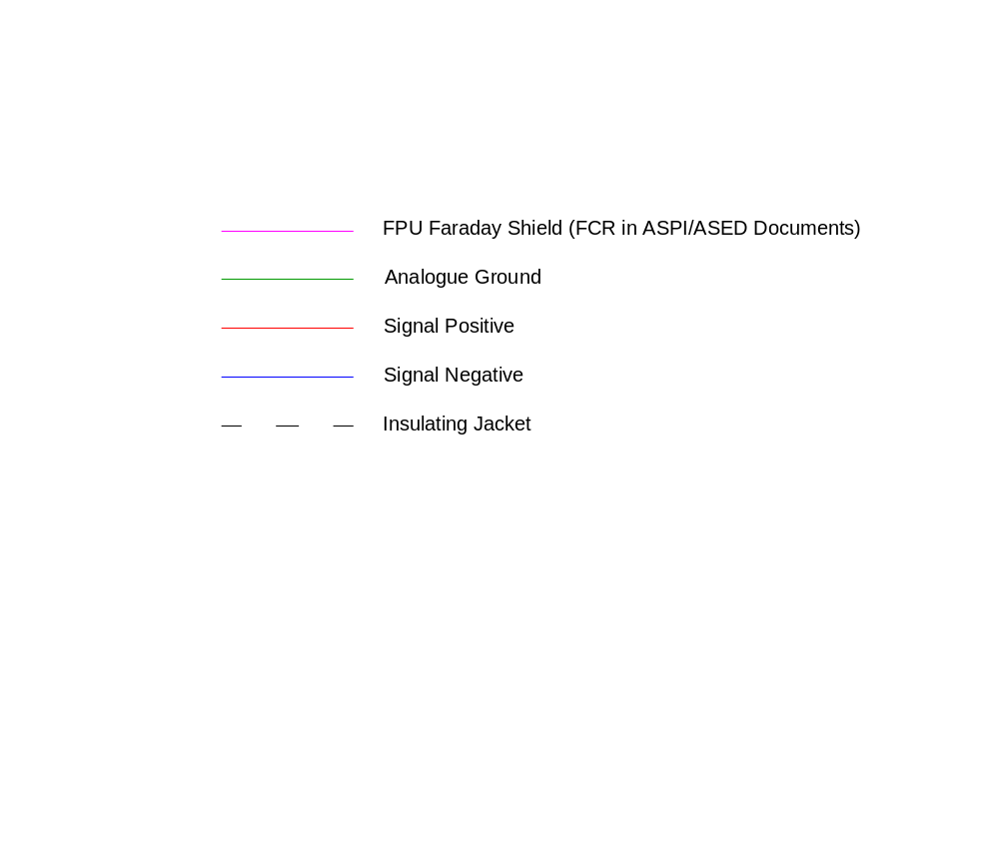
Figure 1 schematically represents detector bias connectors showing (1) the implementation in the instrument test harness (ILT Test Harness), (2) the current implantation in the EQM and PFM harnesses with the Analogue Ground wire left unshielded (i.e. outside the FPU Faraday Shield) and (3) the proposed solution with the Ground Wires shielded.

Figure 2 schematically represents detector signal connectors in the instrument test harness configuration and the current implementation. This figure is included for completeness and as an extra cross-check.

Doug Griffin
Thursday, 07 April 2005
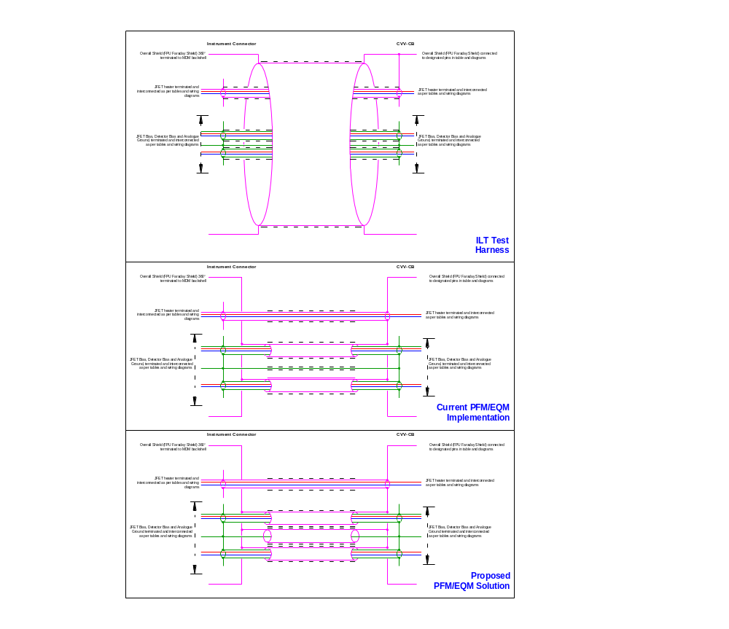
Figure 1 – Internal cryoharness grounding implementation for detector bias connectors. (JFS P09/P10 and JFP P25/P26/P27 and P28). In the Current Implementation, the Analogue Ground Wire is exposed to EMI.
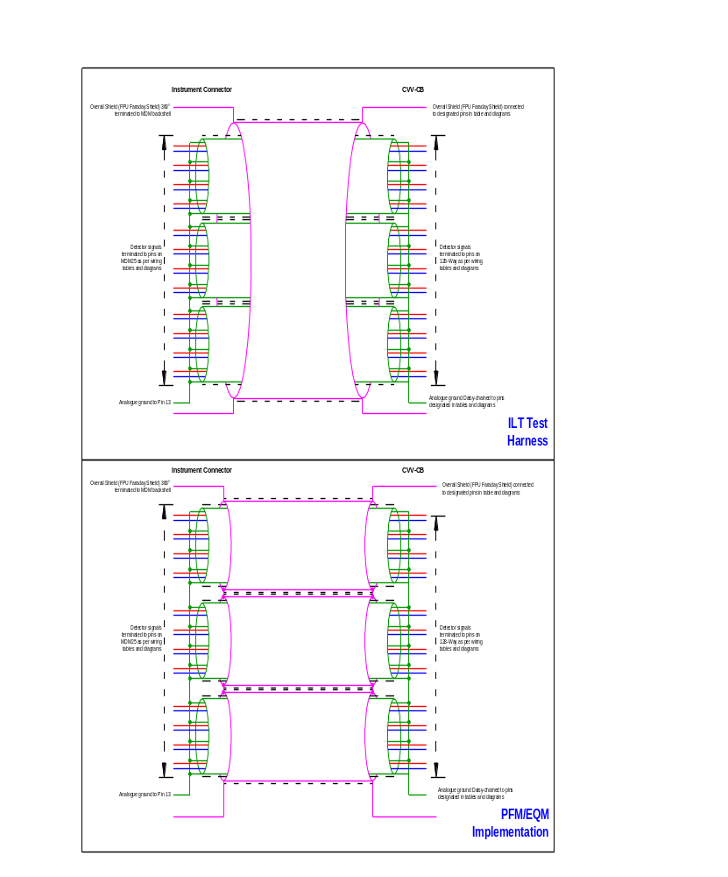
Figure 2 - Internal cryoharness grounding implementation for detector signal connectors. (JFS P01 to P07 and JFP P01 to P24)

