

SUBJECT: | SPIRE Instrument User Manual
PREPARED BY: | K.J. King & S.J. Leeks
DOCUMENT No: | SPIRE-RAL-PRJ-002395
ISSUE: | Issue 1.4 | Date: | 6th October 2008

APPROVED BY:

Project Manager
(K.J. King)

System Engineer
(D. Griffin)

Instrument Scientist
(B.M. Swinyard)

Distribution

C. Scharmberg | ESTEC
M. Schmidt | ESOC
J. Porter | RAL
Herschel Science Operations Working Group
I. Valtchanov | ESAC
L Conversi | ESAC
A. Dowell | RAL
M. Pohlen | Cardiff
L. Lucas | ESOC
R. Biggins | ESOC
M. Krassenberg | ESTEC
P. Collins | ESTEC

Change Record

ISSUE | DATE | Changes
1.0 | 20th April 2005 | First issue, with CQM delivery
1.1 | 10th April 2006 | Update to include nominal procedures for system-level testing
1.2 | 28th August 2007 | Several updates:  - Mode transition diagram in Figure 7-1 replaced by two separate diagrams, one for switching from OFF to PHOTSTBY/STBY and the other from switch from PHOTSTBY/SPECSTBY to OFF.  - Tables in sections 11.2.3 and 11.2.4 updated.  - Replaced SOBTEMP with EMCFILTTEMP in sections 7.2.5.7, 7.2.6.7, 7.2.7.7 and 7.2.8.7  - Nominal procedures added as annex A
1.3 | 9th November 2007 | - Updated Observing Modes Definitions  - Included OBS upload procedures  - Included Contingency Procedures
1.4 | 6th October 2008 | Updated for the IFAR  - Updated distribution list  - Filled in Operating Principles section 2.4  - Included information in Section 6  - Updated Reference Document List  - Added/referred to Recovery Procedures (in section 12.3.5)  - Updated Section 12.1 on Instrument Operations Procedures for Commissioning.  - Replaced TBDs in Sections 10.3.2 and 10.3.3  - Updated 7.1.8 in line with RD03  - New section 7.3 added on Skeleton Operational days.  - Minor changes such as typos and adding references  - Minor updates to Chapter 13.  - Updated section 8.1 on instrument failures  - Updated Contents, Figure and Table lists  - ACRONYMS list updated

Table of Contents

1. Introduction 17
1.1 Scope 17
1.2 Structure of Document 17
1.3 Documents 17
1.3.1 Applicable Documents 17
1.3.2 Reference Documents 17
2. Instrument Description 19
2.1 SPIRE Scientific Purpose 19
2.2 SPIRE Instrument Overview 19
2.2.1 Photometer design drivers 19
2.2.2 Spectrometer design drivers 20
2.2.3 Instrument functional block diagram 20
2.2.4 Imaging photometer 23
2.2.5 Fourier transform spectrometer 26
2.2.6 Helium-3 cooler 29
2.3 Instrument System Design 30
2.3.1 SPIRE subsystems 30
2.3.2 The SPIRE instrument as a system 38
2.3.3 Structural design and FPU integration 42
2.3.4 Optical Design 43
2.3.5 Straylight control 50
2.3.6 Thermal design 58
2.3.7 EMC 60
2.3.8 System-level criticality 67
2.3.9 Redundancy scheme 68
2.4 Operating Principles 69
3. Instrument Configuration 71
3.1 Hierarchical Configuration 71
3.1.1 Instrument Units: 71
3.1.2 Subsystems 72
3.2 Physical Configuration 73
3.3 Configuration Drawings 74
4. Instrument Functions 75
4.1 Warm Electronics 75
4.1.1 Digital Processing Unit (HSDPU) 76
4.2 Detector Readout and Control Unit (HSDRCU) 83
4.2.1 Detector Control Unit (DCU) 84
4.2.2 Mechanisms Control Unit MCU 87
4.2.3 Subsystems Control Unit (SCU) 89
4.3 RF Filters 91
4.3.1 Subsystem Filters 91
4.3.2 Detector and Bias Filters 91
4.4 Bolometric Detector Arrays 92
4.4.1 Principle of semiconductor bolometers 92
4.4.2 SPIRE bolometer performance requirements 93
4.4.3 SPIRE bolometer design and specifications 94
4.4.4 Bolometer readout electronics 94
4.4.5 Feedhorns and bolometer cavities 95
4.4.6 Bolometer array thermal-mechanical design 97
4.5 JFET units 98
4.6 Mirrors 102
4.7 Filters and beam splitters 107
4.7.1 Photometer filtering scheme 107
4.7.2 Spectrometer filtering scheme 109
4.8 Internal calibrators 110
4.8.1 Photometer calibrator (PCAL) 110
4.8.2 Spectrometer calibrator (SCAL) 112
4.9 Beam Steering Mechanism (BSM) 114
4.10 Spectrometer Mechanism 119
4.10.1 Requirements on the mirror mechanism 120
4.10.2 Control System and Readout 122
4.10.3 The cryogenic mechanism (SMECm) 123
4.10.4 Position measurement 123
4.10.5 The preamplifier (SMECp) 123
4.11 FPU structure 124
4.11.1 Mechanical Requirements 126
4.11.2 Thermal Isolation Requirements 126
4.11.3 Stray light and RF shielding 128
4.11.4 Alignment requirements 129
4.11.5 Thermometry 130
4.12 Helium-3 Cooler 131
4.12.1 Introduction 131
4.12.2 Cooler components 132
4.12.3 Cooler construction and thermo-mechanical design 133
4.12.4 Heat switch operation 134
4.12.5 Cooler operation 134
4.12.6 Cooler redundancy 135
4.13 Thermal straps 137
4.13.1 Level-0 137
4.13.2 300-mK Thermal Straps 138
4.14 Harnesses and Connectors 141
4.14.1 Passive thermal load 142
4.14.2 Ohmic dissipation 142
4.14.3 EMC, ESD and Signal Integrity Considerations 142
4.14.4 Noise Budget Allocation 144
4.14.5 Harness Reliability 144
4.14.6 Detector harnesses 145
4.14.7 Connectors 145
5. Instrument Interfaces 148
5.1 External Interfaces 148
5.1.1 Power Interface 148
5.1.2 Mechanical Interface 148
5.1.3 Thermal Interface 148
5.1.4 Electrical Interface 148
5.1.5 Control/Data Interfaces 148
5.2 Internal Interfaces 148
5.2.1 Power Interface 148
5.2.2 Mechanical Interface 148
5.2.3 Thermal Interface 148
5.2.4 Electrical Interface 148
5.2.5 Control/Data Interfaces 148
6. Instrument performance 149
6.1 Thermal constraints for external temperature monitoring 149
6.2 Internal temperature range 149
6.3 Heat dissipation 151
6.3.1 Power Dissipation Outside the Cryostat 151
6.3.2 Power Dissipation Inside the Cryostat 152
6.4 Nominal power consumption for different modes/configurations 153
6.5 Constraints for power consumption 153
7. Instrument Operations Modes 154
7.1 Overview of Operating Modes 154
7.1.1 OFF 154
7.1.2 INIT 154
7.1.3 DPU_ON 154
7.1.4 REDY 154
7.1.5 Standby Modes 154
7.1.6 CREC 155
7.1.7 SAFE 155
7.1.8 Observing Modes 155
7.1.9 Mode Transitions 156
7.1.10 Summary of Mode Configurations 159
7.2 Mode descriptions 162
7.2.1 OFF 162
7.2.2 DPU_ON 163
7.2.3 DRCU_ON 164
7.2.4 REDY 165
7.2.5 PHOT_STBY 168
7.2.6 SPEC_STBY 171
7.2.7 CREC 174
7.2.8 SAFE 176
7.2.9 Photometer Observing Modes 177
7.2.10 Spectrometer Observing Modes 180
7.3 Skeleton Operational Days 182
7.3.1 A Cooler Recycle Day 182
7.3.2 Day without a Cooler Recycle being run 182
7.3.3 Others items 182
8. Instrument Failures 184
8.1 Instrument fault management and redundancy provisions 184
8.2 Failure identification 184
9. Instrument On-Board Software 185
9.1 Functional description 185
9.2 Physical description 185
9.3 Memory addressing information 185
9.4 Instrument on-board software operations 185
10. Summary of Instrument HK Telemetry Data 186
10.1 Critical Housekeeping Report 186
10.1.1 Packet definition 186
10.1.2 Packet Contents 186
10.2 Nominal Housekeeping Report 186
10.2.1 Packet definition 186
10.2.2 Packet Contents 186
10.3 Event Reports 186
10.3.1 Events 186
10.3.2 Exceptions 187
10.3.3 Error/Alarms 188
10.4 Definition of On-ground Limit Check information for parameters 189
11. Summary of Instrument Telecommand Data 190
11.1 Summary of TC Packets 190
11.2 Reflection of telecommands in TM 191
11.2.1 TM paramter(s) reflecting the telecommand echo 191
11.2.2 TM parameter(s) reflecting telecommand counters 191
11.2.3 Table of affected TM parameters per telecommand 191
11.2.4 DRCU Parameters in Telecommands 195
11.3 Definition of Telecommand Sequences 203
12. Instrument Operations Procedures 204
12.1 Instrument Operations Procedures for Commissioning 204
12.1.1 Cold Functional Test Procedures 204
12.1.2 Peak-Up Procedure 207
12.1.3 BSM PID Tuning Procedure 207
12.1.4 SMEC PID Tuning Procedure 207
12.1.5 SMEC LVDT Backup Procedure 207
12.1.6 Spectrometer Calibrator (SCAL2 and SCAL4) PID Tuning Procedure 207
12.1.7 Manual Cooler Recycle Procedure 207
12.1.8 Photometer Thermal Control PID Tuning Procedure 207
12.1.9 SPIRE Instrument Apertures Determination Procedure 207
12.1.10 SPIRE Straylight Test Procedure 207
12.2 Instrument Operations Procedures for Normal Operations 208
12.2.1 DPU_ON 208
12.2.2 DPU_OFF 208
12.2.3 DPU_START 208
12.2.4 DRCU_ON 209
12.2.5 DRCU_OFF 209
12.2.6 SCU_ON 209
12.2.7 SCU_OFF 209
12.2.8 MCU_ON 209
12.2.9 MCU_OFF 210
12.2.10 BSM_ON 210
12.2.11 BSM_INIT 210
12.2.12 BSM_OFF 210
12.2.13 PDET_ON 210
12.2.14 PDET_OFF 210
12.2.15 SMEC_ON 211
12.2.16 SMEC_INIT 211
12.2.17 SMEC_OFF 211
12.2.18 SDET_ON 211
12.2.19 SDET_OFF 211
12.2.20 CREC 212
12.3 Instrument Operations Procedures Contingency Recovery Operations 213
12.3.1 Exception Events 213
12.3.2 Alarm Events 213
12.3.3 Limit Check Failures 214
12.3.4 Telecommand Verification Failures 215
12.3.5 Recovery Procedures 215
12.4 OBS Upload Procedures 216
12.4.1 LOAD_OBS_BSW: Procedure to Upload OBS from the Boot Software 216
12.4.2 LOAD_OBS_ASW_01: Procedure to Upload Complete OBS from the Application Software 218
12.4.3 Procedure LOAD_OBS_ASW_02: 221
12.4.4 WRITE_OBS_EEPROM: Write the OBS into EEPROM 224
13. Instrument Budgets 225
13.1 Power 225
13.2 Data 225
13.3 Mass 225
13.4 Error and Alignment 225
13.5 Timing 225
14. Instrument Science Data Definition 226
14.1 DCU Science Packets 226
14.1.1 Photometer Full Array 226
14.1.2 Spectrometer Full Array 230
14.2 SCU Science Packet 232
14.3 MCU Science Packets 234
14.3.1 BSM Science Packet 234
14.3.2 SMEC Science Packet 235
14.4 Packet Generation 236

Figures
Figure 2-1 - Block diagram of the SPIRE instrument 21
Figure 2-2 Location of the SPIRE FPU with respect to the other instruments on the Herschel Optical Bench 22
Figure 2-3 Perspective view of SPIRE and the other Herschel instruments on the Herschel Optical Bench 22
Figure 2-4 Solid model of the SPIRE photometer (4-K cover not shown) 23
Figure 2-5 Imaging photometer optical design 24
Figure 2-6 (a) layout of the three photometer arrays; (b) photograph of array mechanical prototype. 25
Figure 2-7 Overlaid photometer arrays and summary of photometer observing modes 26
Figure 2-8 Physical layout of the spectrometer 27
Figure 2-9 Optical design of the spectrometer 27
Figure 2-10 Layout of spectrometer detector arrays 28
Figure 2-11 View of a prototype SPIRE cooler 30
Figure 2-12 Schematic diagram of the sub systems of SPIRE contained within the Herschel CVV 32
Figure 2-13 Schematic diagram of the sub-systems of SPIRE contained on the Herschel SVM 33
Figure 2-14 View of photometer side of the instrument. The photometer cover is shown rotated to expose the photometer components 34
Figure 2-15 View of the spectrometer side of the FPU. The cover is shown rotated to expose the components house beneath the cover. 35
Figure 2-16 Simplified view of the SPIRE instrument as broken into “systems.” 38
Figure 2-17 Conceptual design of the SPIRE instrument structure. Once the 4-K covers are integrated the instrument box forms a straylight and RF shield 42
Figure 2-18 Ray diagram of the Herschel telescope with the SPIRE optics to the same scale. The primary mirror has a diameter of 3.5 m and the SPIRE FPU is about 500 mm wide. 44
Figure 2-19 Ray diagram of the SPIRE photometer showing the ray paths for three points in the tangential plane, centre and extremes of the FOV (2 arc minutes). Also shown here are the locations of the straylight baffles and optical bandpass filters. 45
Figure 2-20 The beam folding within the photometer detector box. The dichroics are low pass devices so PSW is the shortest wavelength array; PMW the medium wavelength array and PLW the long wavelength array. 46
Figure 2-21 Geometric spot diagrams across the 4 x 8 SPIRE photometer FOV. The spots are plotted in their actual positions and to scale. The concentric circles around the central spot have diameters 3.0, 4.3, and 6.1 mm and indicate the Airy disk size at 250, 350µm. A slight distortion is observed, corresponding to 6′ or 1.1% of the FOV diagonal. The average focal ratio is f/4.9. 46
Figure 2-22 Three possible interferometer concepts for the SPIRE spectrometer: (a) Martin-Puplett polarising interferometer, (b) classical Michelson interferometer, and (c) Mach-Zehnder type dual beam interferometer. BB: blackbody source, RT: roof-top mirror, P: polariser, F: filter, D: detector, CC: corner-cube reflector (could also me mirrors or roof-tops), BS: beamsplitter, Dic: dichroic beam splitter, M: mirror, BCC: back-to-back corner cubes (or roof-tops). 47
Figure 2-23 Raytracing diagram of the upper half of the SPIRE spectrometer. The symmetrical lower half is generated by reflection about the plane containing the two beam splitters. The location of the cold stop and the bandpass filters are also indicated. Note: this is for the corner-cube option - there is no significant difference for the roof-top option 49
Figure 2-24 - Geometric spot diagrams at the centre, half field, and full field of the 2.6′ diameter spectrometer FOV. The spots are plotted in their actual positions and to scale. The concentric circles around the central spot have diameters 3.7 and 6.7 mm indicating the Airy disk size at 300 and 550 µm, respectively. With a maximum RMS wavefront error of 6.6 µm, the theoretical Strehl ratio is better than 0.97 anywhere in the FOV at 250 µm. Distortion corresponding to 9′′ or 6% of the FOV diameter is observed. The average focal ratio is f/4.9. Note: this is for the corner-cube option - for the roof-top option, there is no field rotation. 49
Figure 2-25 - Sketch of the final optical beams onto the spectrometer focal planes. There is a real pupil image of ~20 mm at about 119 mm from the focal plane which has a physical diameter of 23.8 mm. Off axis images therefore come onto the array at an angle of up to 3.5º – shown by the dark dashed line. The detectors themselves, because of the feedhorns, can only accept a certain range on input angles and, as they are configured to stare straight ahead, they only partially illuminate the pupil – shown in pink. Whilst this only causes a small loss of signal at the centre of the FTS mirror movement, at large mirror displacements the pupil images from the two interferometer arms shear past each other and the loss in fringe contrast will be greater. To counter this a lens is introduced at the location of the cold filter on the detector structure itself that tilts the beam pattern from the detectors to more nearly match the illumination of the pupil image. 50
Figure 2-26 - Example showing the definition of a 350 micron photometer channel using real filters. The passband (λ/Δλ) in this case is ~3. 51
Figure 2-27 - Chopped and jiggled footprints of the photometer and spectrometer arrays at the focal plane of the Herschel telescope. The solid line shows the boundary used to define the physical stop that will be placed at the entrance to the SPIRE FPU. 52
Figure 2-28 - Overview of the straylight baffling scheme for the photometer 53
Figure 2-29 - Possible baffling scheme for the spectrometer. 53
Figure 2-30 - Pupil spot diagrams obtained by tracing rays from 15 positions in the FOV through 16 points along the rim of the telescope pupil to the cold stop 54
Figure 2-31 - PLW channel at λ = 500 μm, smooth-wall horn. The two profiles shown are principal sections of the response. Airy disc radius = 0.55 arcmin. 56
Figure 2-32 PMW channel at  = 35 m, smooth-wall horn. The two profiles shown are principal sections of the response. Airy disc radius = 0.38 arcmin. 56
Figure 2-33 - PSW channel at λ = 250 μm, corrugated horn (smooth-wall case TBC). 2 profiles shown are principal sections of the response. Airy disc radius = 0.27 arcmin. 57
Figure 2-34 - Illustration of the 20% oversize rule and the comparison between component margin and instantaneous beam footprint. 57
Figure 2-35 - Summary of the thermal analysis model for the subsystems within the CVV. 59
Figure 2-36 - Schematic representation of the SPIRE signal chain showing the noise sources and gains through the system 63
Figure 2-37 - Outline grounding diagram for the SPIRE instrument – this is subject to change and is shown for illustrative purposes only. 64
Figure 2-38 – SPICE model of the detector drive electronics used for EMC analysis. 65
Figure 2-39 – SPICE model of detectors, Herschel structure and detector harnesses used in the SPICE EMC analysis. 66
Figure 2-40 DPU interfaces between SPIRE and the spacecraft. 69
Figure 2-41 Command Interface Diagram 70
Figure 3-1 SPIRE Instrument Block Diagram 71
Figure 4-1 - Schematic representation of the Warm Electronics. 75
Figure 4-2 - Layout of the DPU showing interfaces with the DRCU and the Spacecraft. 76
Figure 4-3 – Block diagram of the DPU I/F Board. 78
Figure 4-4 – Fast Science Data Link architecture. 79
Figure 4-5 – Architecture of the Low Speed Link of the DPU. 80
Figure 4-6 – CPU board block diagram. 81
Figure 4-7 - Conceptual diagram showing the flow of information within the DPU. 82
Figure 4-8 - SPIRE DPU On Board Software Context Diagram. 82
Figure 4-9 - Schematic block diagram of the DRCU including the interfaces to the DPU and the FPU. 84
Figure 4-10 - Schematic representation of the DCU including it's interfaces with the FPU, DPU and FCU. 85
Figure 4-11 - Back plane connections to the photometer LIA cards. The spectrometer LIA boards are conceptually indentical. 86
Figure 4-12 - Architecture of the MCU. 88
Figure 4-13 - SMEC Scan characteristics. 89
Figure 4-14 - Block diagram of the SCU. 90
Figure 4-15 – Attenuation curves for the MDM filtered connectors used in SPIRE. The detectors use type ‘T’ while the subsystems use type ‘M’. 92
Figure 4-16 - Principles of bolometer operation. 93
Figure 4-17 - Left: Photograph of part of a SPIRE P/LW (520-μm) array wafer, showing individual spider-web bolometers and lithographed electrical connections. Right: close-up of an individual bolometer. The dark rectangle is the 100x300-μm NTD thermometer. 94
Figure 4-18 - Bolometer bias and cold readout circuit. 95
Figure 4-19 - Left: feedhorn eedhorn and cavity design. Right: photograph of SPIRE P/LW (500-μm) feedhorn array. 96
Figure 4-20 A 16-point “jiggle pattern” is needed to achieve a fully sampled map with 2Fλ feedhorns (for hexagonal packing the jiggle pattern is slightly different but 16 steps are still required). 96
Figure 4-21 - Left: Bolometer Detector Array module design (not incorporating some superficial modifications to the design that have been recently been introduced). Right: photograph of a prototype P/LW BDA (without the array filter). 97
Figure 4-22 - Front view of Photometer JFET rack. (JFP). 99
Figure 4-23 - Rear view of Photometer JFET Rack (JFP) including details of the routing of the back harness. 100
Figure 4-24 - Exploded view of a single JFET module. 101
Figure 4-25 - View showing assembled JFET modules. 101
Figure 4-26 – Example of mirror mounts. 102
Figure 4-27 - Engineering drawing of CM5 103
Figure 4-28 – Drawing of the Mirror/Mirror Mount mechanical interface. 104
Figure 4-29 – Nomenclature for the SPIRE common and photometer mirrors, filters, beam splitters and dichroics. 106
Figure 4-30 - Nomenclature for the SPIRE spectrometer mirrors, filters, beam splitters and dichroics. 106
Figure 4-31 - Transmission characteristics of prototype 350-μm photometer filter chain. 108
Figure 4-32 - Performance of a prototype 15-cm-1 dichroic (red: reflection; blue: transmission). 109
Figure 4-33 Measured efficiency of FTS beam splitter prototype. 110
Figure 4-34 - Photograph of PCAL prototype and schematic diagram of PCAL design. 111
Figure 4-35 - Schematic diagram of PCAL source unit. 112
Figure 4-36 - Model of SCAL assembly showing prime and redundant sources and baffle. 113
Figure 4-37 - General view of the Beam Steering Mechanism with the stray light baffle removed to illustrate the interior components. 115
Figure 4-38 - Chop (shown in grey) and Jiggles stages of the BSM. 116
Figure 4-39 - Prototype BSM motor. 117
Figure 4-40 – Schematic drawing of the Infineon magneto-resistive position sensor. 117
Figure 4-41 - View of the BSM with the stray light baffle covering the electrical components. 118
Figure 4-42 - Mechanical interface drawing between the BSM and the SPIRE optical bench. 119
Figure 4-43 - CAD drawing of the link mechanism used for the SMEC. 120
Figure 4-44 - Solid model of the SPIRE FTS Mechanism. 120
Figure 4-45 - Views of the engineering model of the SMEC. 121
Figure 4-46 - Definition of a typical scan trajectory for the SMEC. 122
Figure 4-47 - Simulated spectrum of the 80 K telescope seen through the SPIRE FTS with representation optical filtering. The black line is before applying the frequency response of the detectors the red line after. Note the much larger rate of change of the sign 124
Figure 4-48 - General view of the FPU and the Herschel coordinate system. Only one A-Frame Support can be seen in this view. The second A-Frame is located in a similar position on the Spectrometer Cover. 125
Figure 4-49- FPU/HOB interface A-Frame and Cone Supports. 127
Figure 4-50 - Thermal isolation between Level-1 (SOB) and Level-0 (Detector Box). 127
Figure 4-51 - RF and stray light tight joint design used in the FPU. 129
Figure 4-52 - Details of the mounting of the enclosure for the filtered MDM connectors. 130
Figure 4-53 - View of the Lakeshore, Cernox SD hermetically sealed RTD thermometers. 130
Figure 4-54 - Illustration of the 2-K cooler without cooler to SPIRE optical bench mounting structure. 132
Figure 4-55 - Schematic representation of the gas gap heat switch. 134
Figure 4-56 - Operation of the 3He cooler during recycle, (A and B) and normal operation (C). 135
Figure 4-57 - ³He Cooler cryogenic redundancy scheme. 136
Figure 4-58 – Conceptual design of the stray light baffle on the 2-K straps entering the FPU. 137
Figure 4-59 Position of the Level-0 straps on the exterior of the FPU. 137
Figure 4-60 – Solid model of the 300-mK thermal isolation supports. These supports use Kevlar cord to mechanically support and thermally isolate the 300-mK copper strap from the Level-0 Photometer Detector Box structure. 139
Figure 4-61 - Section view of the detector box stray-light baffle. 140
Figure 4-62 - Routing of the 300-mK strap inside the photometer detector box. 140
Figure 4-63 - Routing of the 300-mK strap through the Spectrometer Detector Box to the BDAs 141
Figure 4-64 – SPIRE harnessing inside FPU. 146
Figure 4-65 - SPIRE harnesses outside the FPU. 147
Figure 7-1 SPIRE Instrument Operating Mode Transitions: From OFF to PHOTSTBY or SPECSTBY. The transition to and from cooler recycle mode is also shown. The DPU INIT mode can be used for loading OBS from the boot software. 157
Figure 7-2 SPIRE Instrument Operating Mode Transitions: From PHOTSTBY or SPECSTBY to OFF. The transition to and from cooler recycle mode is not shown here (see previous transition diagram). 158
Figure 14-1 PSW Detector Pixel Locations 227
Figure 14-2 PMW Detector Pixel Locations 228
Figure 14-3 PLW Detector Pixel Locations 229
Figure 14-4 SSW Detector Pixel Locations 231
Figure 14-5 SLW Detector Pixel Locations 232

Tables
Table 2-1 List of the SPIRE sub-systems. 37
Table 2-2 Description of the SPIRE systems 41
Table 2-3 Alignment of the SPIRE photometer and spectrometer gut rays w.r.t. the Herschel bore sight. 43
Table 3-1 Instrument Units 72
Table 4-1 - Specifications on the power output from the DC/DC board of the DPU. 77
Table 4-2 – Detector driver electronics specifications. 86
Table 4-3 - Main design and performance parameters for the SPIRE detectors. 98
Table 4-4 – General mirror specifications. The locations of these mirrors are illustrated in Figure 4-29 and Figure 4-30. 105
Table 4-5 Photometer filtering scheme. 107
Table 4-6 Spectrometer filtering scheme. 109
Table 4-7 - Key specifications of the BSM. 114
Table 4-8 - General interface acceleration loads for the FPU and JFET Boxes. Taken from the IID-A for information only. 126
Table 4-9 - Thermal budget allocations to the structure taken from SPIRE Thermal Configuration Control Document for information only. 126
Table 4-10- Location and details of the FPU thermometry. 131
Table 4-11 - Principal cooler design characteristics. 131
Table 4-12 SPIRE harnesses. 141
Table 4-13 - Layout of harnessing between the FPU and the Warm Electronics on the SVM. 143
Table 4-14 - Schematic reprsentation of the bulkhead connectors on the wall of the CVV. 144
Table 6-1 SPIRE Instrument Temperature Sensors. 150
Table 6-2 SPIRE Satellite Temperature Sensors. 151
Table 7-1 Non-Operating Modes 160
Table 7-2 Photometer Observing Modes 160
Table 7-3 Spectrometer Observing Modes 161

Glossary

AIV | Integration and Verification Assembly
APART | Arizona's Program for the Analysis of Radiation Transfer
ASAP | Advanced Systems Analysis Program
AVM | Avionics Model
BDA | Bolometer Detector Array
BFL | Back Focal Length
BOL | Beginning of Life
BRO | Breault Research Organization
BSM | Beam Steering Mirror
CDMS | Command and Data Management System
CDMU | Command and Data Management Unit
CPU | Central Processing Unit
CVV | Cryostat Vacuum Vessel
DAC | Digital to Analogue Converter
DAQ | Data Acquisition
DPU | Digital Processing Unit = HSDPU
DQE | Detective Quantum Efficiency
DRCU | Detector Readout and Control Unit
DSP | Digital Signal Processor
EGSE | Electrical Ground Support Equipment
EMC | Electro-magnetic Compatibility
EMI | Electro-magnetic Interference
FCU | FPU Control Unit = HSFCU
FIR | Far Infrared
FIRST | Far Infrared and Submillimetre Telescope
FOV | Field of View
F-P | Fabry-Perot
FPGA | Field Programmable Gate Array
FPU | Focal Plane Unit
FSDL | Fast Science Data Link. Used to transfer scientific data from the DRCU to the DPU
FTS | Fourier Transform Spectrometer
FWHM | Full Width Half maximum
HIFI | Heterodyne Instrument for FIRST
HK | House Keeping
HOB | Herschel Optical Bench
HPDU | Herschel Power Distribution Unit
HSDCU | Herschel-SPIRE Detector Control Unit
HSDPU | Herschel-SPIRE Digital Processing Unit
HSFCU | Herschel-SPIRE FPU Control Unit
IID-A | Instrument Interface Document - Part A
IID-B | Instrument Interface Document - Part B
IRTS | Infrared Telescope in Space
ISO | Infrared Space Observatory
JFET | Junction Field Effect Transistor
JFP | Photometer JFET Unit
JFS | Spectrometer JFET Unit
LCL | Latching Current Limiter
LIA | Lock-In Amplifier
LSL | Low Speed Link. Used for TC link between the DRCU and the DPU
LVDT | Linear Variable Differential Transformer
LWS | Long Wavelength Spectrometer
MAC | Multi Axis Controller
MCU | Mechanism Control Unit = HSMCU
M-P | Martin-Puplett
NEP | Noise Equivalent Power
NTD | Neutron Transmutation Doped
OBS | On-Board Software
OPD | Optical Path Difference
PACS | Photodetector Array Camera and Spectrometer
PCAL | Photometer Calibration source
PID | Proportional, Integral and Differential
PLW | Photometer, Long Wavelength
PMW | Photometer, Medium Wavelength
POF | Photometer Observatory Function
PROM | Programmable Read Only Memory
PSW | Photometer, Short Wavelength
RMS | Root Mean Squared
SCAL | Spectrometer Calibration Source
SED | Spectral Energy Distribution
SMEC | Spectrometer Mechanics
SMPS | Switch Mode Power Supply
SOB | SPIRE Optical Bench
SOF | Spectrometer Observatory Function
SPIRE | Spectral and Photometric Imaging Receiver
SSSD | SubSystem Specification Document
STP | Standard Temperature and Pressure
SVM | Service Module
TBC | To Be Confirmed
TBD | To Be Determined
TBI | To Be Implemented
TC | Telecommand
UV | Ultra Violet
WE | Warm Electronics
ZPD | Zero Path Difference

Introduction

Scope
This document describes the use of the SPIRE instrument from an operational point of view. It is meant to conform to the required format as defined in AD01.

Structure of Document
AD01 provides a table of contents for the Herschel Satellite User Manual of which one section is allocated to each of Herschel instruments. This document corresponds to the SPIRE section (numbered 5.3) and each section is numbered following AD01.

Some information is better detailed in already existing documents and these are referred to throughout this document and listed in section 1.3.2. The documents themselves will be attached as Annexes to this document.

Documents

Applicable Documents

AD01 | System Operation and FDIR Requirements (H-P-1-ASP-SP-0209), October 2003  Appendix 1: 1553 Bus FDIR
AD02 | Herschel/Planck Packet Structure Interface Control Document.  (SCI-PT-ICD-07527) Issue 3.0
AD03 | Herschel/Planck Operations Interface Requirements Document (SCI-PT-RS-07360), Issue 2.0
AD04 | SPIRE Commissioning Phase Plan (SPIRE-RAL-PRJ-003018)

Reference Documents

RD01 |  | SPIRE proposal to ESA, M.G.Griffin et al, 1998
RD02 |  | SPIRE Design Description, (SPIRE-RAL-PRJ-000620)
RD03 |  | Operating Modes for the SPIRE Instrument, (SPIRE-RAL-DOC-000320)
RD04 |  | Instrument Interface Document Part B –SPIRE (SCI-PT-IIDB/SPIRE-02124)
RD05 | (Annex A) | SPIRE Failure Detection Isolation and Recovery (SPIRE-RAL_PRJ-001978)
RD06 |  | Hardware/Software Interaction Analysis (SPIRE-RAL-NOT-001719)
RD07 | (Annex B) | SPIRE Data ICD (SPIRE_RAL_PRJ-001078)
RD08 |  | DRCU/DPU Interface Control Document (SPIRE-SAP-PRJ-001324)
RD09 |  | SPIRE Product Tree (SPIRE-RAL-DOC-000030)
RD10 |  | Detector Readout & Control Unit Interface Control Document  (SPIRE-SAP-PRJ-000451)
RD11 |  | DPU Interface Control Document (SPIRE-IFS-PRJ-000650)
RD12 |  | DPU OBS Software Specification Document (SPIRE-IFS-PRJ-001036)
RD13 |  | SPIRE Sensitivity Models (SPIRE-QMW-NOT-000642)
RD14 |  | SPIRE PFM Power Dissipation Summary (SPIRE-RAL-Rep-002781)
RD15 |  | Packet Telemetry Standard (ESA PSS-04-106), Issue 1, 1998
RD16 |  | Packet Telecommand Standard (ESA PSS-04-107), Issue 2, 1992
RD17 |  | Telemetry and Telecommand Packet Utilisation Standard (ECSS-E-70/41) Draft 04, April 1999
RD18 |  | SPIRE OBS User Manual
RD19 |  | the SPIRE Optical Error Budgets

Instrument Description
A complete description of the instrument from a design point of view is available in the SPIRE Design Description document (RD02), some of which is reproduced here.

SPIRE Scientific Purpose
SPIRE (the Spectral and Photometric Imaging REceiver) is one of three cryogenic focal plane instruments for ESA’s Herschel mission. Its main scientific goals are the investigation of the statistics and physics of galaxy and structure formation at high red shift and the study of the earliest stages of star formation, when the protostar is still coupled to the interstellar medium. These studies require the capabilities to carry out large-area (many tens of square degrees) deep photometric imaging surveys at far-infrared and sub millimetre wavelengths, and to follow up these systematic survey observations with spectroscopy of selected sources. SPIRE will exploit the advantages of Herschel: its large-aperture, cold, low-emissivity telescope; the complete lack of atmospheric emission and attenuation giving access to the poorly explored 200-700-μm range, and the large amount of high quality observing time. Because of these advantages, SPIRE will have unmatched sensitivity for deep imaging photometry and moderate-resolution spectroscopy.

These high priority programmes for Herschel require sensitive continuum imaging in several bands to carry out surveys, and a low-resolution spectroscopic mode to obtain detailed SEDs of selected objects and measure key spectral lines. Although SPIRE has been optimised for these two main scientific programmes, it will offer the astronomical community a powerful tool for many other astrophysical studies: giant planets, comets, the galactic interstellar medium, nearby galaxies, ultra luminous infrared galaxies, and active galactic nuclei. Its capabilities will remain unchallenged by the ground-based and the airborne observatories which are planned to come into operation over the next decade.

The scientific case for SPIRE is described in more detail in the SPIRE proposal to ESA (RD01).

SPIRE Instrument Overview
SPIRE contains a three-band imaging photometer and an imaging Fourier Transform Spectrometer (FTS), both of which use 0.3-K feedhorn-coupled “spider-web” NTD germanium bolometers cooled by a ³He refrigerator. The photometer and spectrometer are not designed to operate simultaneously. The field of view of the photometer is 4 x 8 arc minutes, the largest that can be achieved given the location of the SPIRE field of view in the Herschel focal plane and the size of the telescope unvignetted field of view. Three bolometer arrays provide broad-band photometry (λ/Δλ ~ 3) in wavelength bands centred at approximately 250, 360 and 520 μm. (For historical reasons, these are sometimes referred to as the 250-, 350- and 500-μm bands. The field of view is observed simultaneously in all three bands through the use of fixed Dichroics beam-splitters. Spatial modulation can be provided either by a Beam Steering Mirror (BSM) in the instrument or by scanning the telescope across the sky, depending on the type of observation. An internal thermal calibration source is available to provide a repeatable calibration signal for the detectors. The FTS uses novel broadband intensity beam splitter, and combines high efficiency with spatially separated input ports. One input port covers a 2.6-arcminute diameter field of view on the sky and the other is fed by an on-board calibration source. Two bolometer arrays are located at the output ports, covering two overlapping spectal bands, 200-325 μm and 315-670 μm. The spectral resolution, as determined by the maximum optical path difference, will be adjustable between 0.04 and 2 cm⁻¹ (corresponding to λ/Δλ = 1000 - 20 at 250 μm wavelength. The FTS can be operated in continuous scan mode, with the path difference between the two arms of the interferometer being varied by a constant-speed mirror drive mechanism or in step-and-integrate mode in which the scan-mirror is sequentially positioned at a range of positions with the interferogram built up from individual measurements at each step. In this mode, signal modulation will be provided by the BSM.

Photometer design drivers

The basic design of the photometer was dictated by the following consideration:

- the major scientific priorities for SPIRE require an instrument which is capable of deep mapping of large areas of sky efficiently with full spatial sampling and multi-wavelength coverage;
- observations of point and compact sources should also be possible with good efficiency;
- the instrument should be as simple as possible for affordability, reliability and ease of operation;
- the wavelength coverage should complement that of the PACS instrument on board Herschel and ground-based facilities operating at near-millimetre wavelengths;

These considerations led to the choice of a system with fixed Dichroics beam splitters allowing simultaneous observation of a large field of view in the three chosen sub millimetre bands, with the inclusion of a beam steering mirror to allow point source observations and small maps to be carried out efficiently.

Spectrometer design drivers

Fabry-Perot and grating spectrometer designs were also studied for SPIRE (Griffin, 1997; Griffin et al. 1998b). The FTS was chosen for a number of reasons:

- it allows for two-dimensional imaging spectroscopy, which is not possible with the grating instrument;
- the spectral resolution can easily be adjusted and tailored to the scientific requirements of the observation;
- the detectors can be operated at 300 mK because the photon noise limited NEP is higher for the FTS, whose detectors observe broad-band, than for grating or Fabry-Perot spectrometers in which they observe in narrow-band mode - this allowed a ³He sorption cooler to be adopted for SPIRE - a considerable simplification over the 100-mK dilution cooler that would have been needed for a grating or F-P instrument;
- whilst the grating is more sensitive, at least in principle, for observations of known spectral lines, there is little difference in the sensitivities of the two options for spectral survey observations, which are of greater scientific priority for SPIRE;
- the FTS is less vulnerable to degradation in performance arising from stray light and out-of-band leaks which can be problematic with a low-background grating instrument;
- practical implementation of either a grating or an F-P instrument within the constraints of the Herschel system would have posed serious accommodation problems (grating) or risk of FPU failure due to having multiple mechanisms in series (F-P).

Instrument functional block diagram

Figure 2-1 shows a functional block diagram of the SPIRE instrument. The subsystems are prefixed HS standing for Herschel-SPIRE. The focal plane unit is mounted on the Herschel Optical Bench as shown in Figure 2-2 and Figure 2-3. It is approximately 690 x 410 x 410 mm in size, and has three separate temperature stages at nominal temperatures of 4 K (Herschel cryostat Level-1), 2 K (cryostat Level-0) and 300 mK (provided by SPIRE's internal cooler). The main Level-1 structural element of the FPU is an optical bench panel which is isostatically mounted on the cryostat optical bench (Level-2, approx. 10 K) by two stainless steel blade mounts and a single stainless steel cone mount. The photometer and spectrometer are located on either side of this panel. The majority of the optics are at Level-1, but the detector arrays and final optics are contained within Level-0 enclosures. The ³He refrigerator cools all of the five detector arrays to 0.3 K. Two JFET preamplifier boxes (one for the photometer and one for the spectrometer) are attached to the Level-2 optical bench close to the Level-1 enclosure. The two JFET units are heated internally to their optimum operating temperature of ~ 120 K.

The SPIRE warm electronics consist of a Detector Readout Unit (DCU), a FPU Control Unit (FCU) and a Digital Processing Unit (DPU). The DCU provides bias and signal conditioning for the arrays and cold readout electronics and reads out the detector signals; the FCU controls the FPU mechanisms, the ³He cooler and the internal calibrators, and housekeeping thermometers. The DPU acts as the interface to the spacecraft, including instrument commanding, and formats science and housekeeping data for telemetry to the ground.

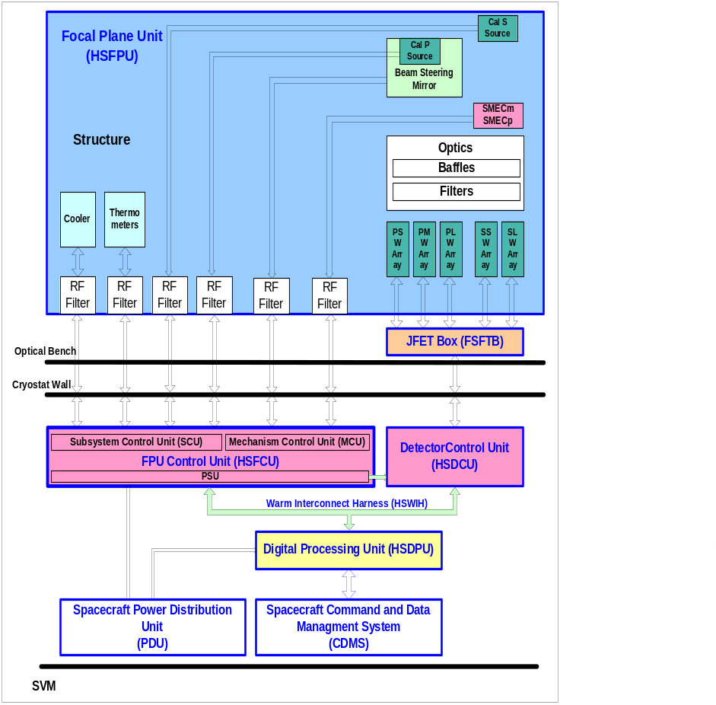
Figure 2-1 - Block diagram of the SPIRE instrument
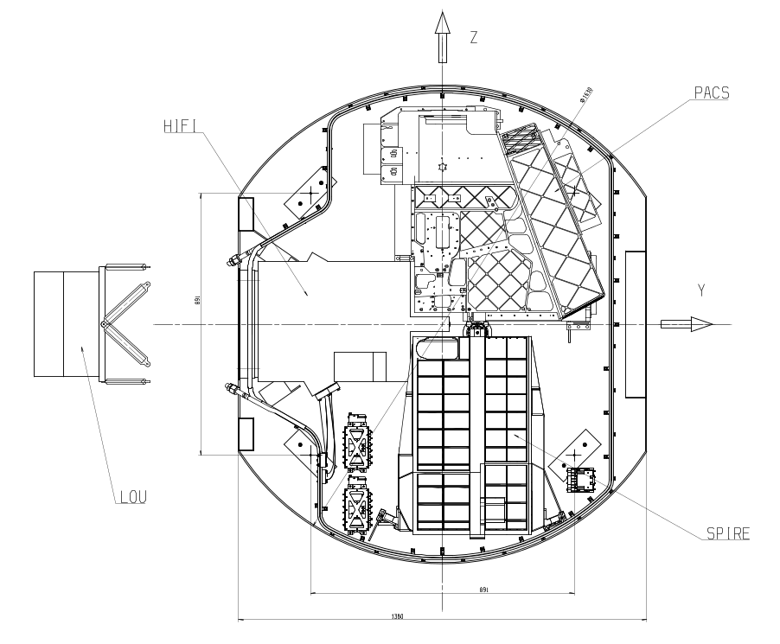
Figure 2-2 Location of the SPIRE FPU with respect to the other instruments on the Herschel Optical Bench
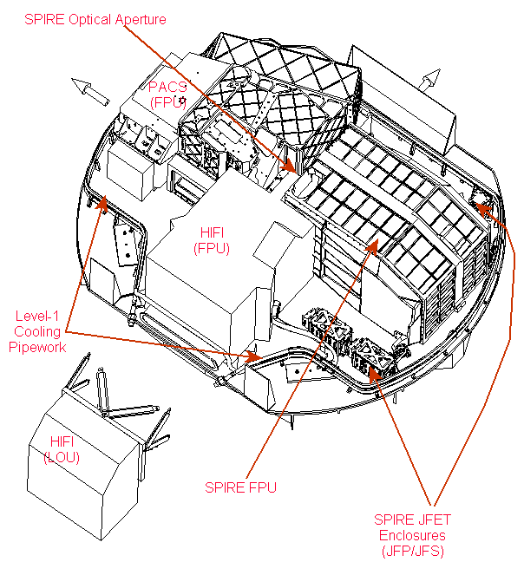
Figure 2-3 Perspective view of SPIRE and the other Herschel instruments on the Herschel Optical Bench

Imaging photometer

Optical Design and FPU layout
The photometer layout is shown in Fig. 2.3. The Level-1 optical elements are mounted directly on the SPIRE Optical Bench (SOB). The Level-0 Photometer Detector Box is also supported on the SOB by stainless steel blades, and contains the Bolometer Detector Arrays (BDAs), Dichroics, and fold mirrors. The three BDAs are bolted to the outside wall of the Level-0 box. Within each module, the detector arrays, feed horns and the final filter are thermally isolated from the Level-0 structure by Kevlar wires, and are cooled by a thermal strap to the ³He refrigerator. The photometer input optics are shared with the spectrometer. The separate spectrometer field of view is directed to the other side of the optical bench panel by a pick-off mirror.

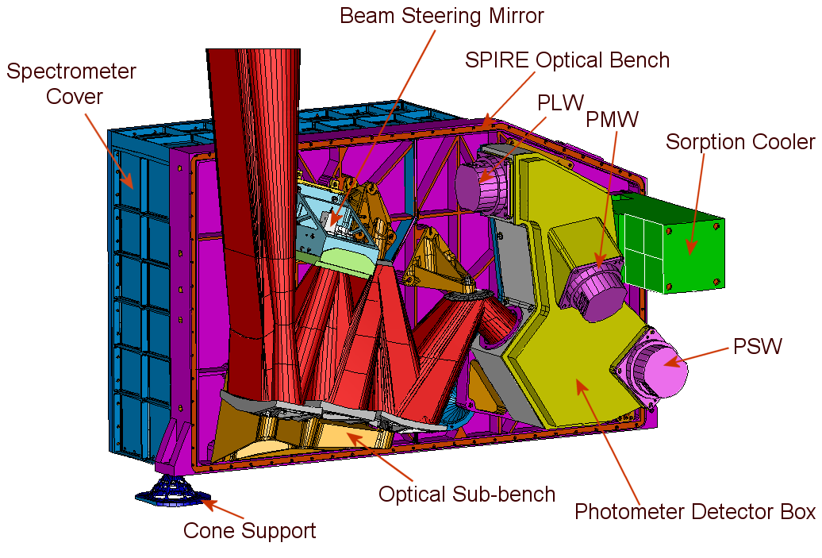
Figure 2-4 Solid model of the SPIRE photometer (4-K cover not shown)

The photometer optical design is shown in Figure 2-5, and is described in more detail by Dohlen et al. (2000) .. It is an all-reflective system except for two Dichroics beam splitters used to direct the three wavelength bands onto different bolometer arrays, and various Tran missive band-pass and edge filters used to reject out-of-band radiation. It is optimised to give close to diffraction-limited imaging across the whole 4 x 8 arc minute field of view. The SPIRE field of view is offset by 11 arc minutes from the centre of the Herschel telescope's highly curved focal surface. Mirror M3, which lies below the focus, receives the f/8.68 beam from the telescope and forms a pupil image of the telescope secondary at the flat beam steering mirror, M4. Mirror M5 converts the focal ratio to f/5 and provides an intermediate focus at the next mirror, M6, which re-images the aperture stop at M4 to a cold stop located at the entrance to a Level-0 enclosure. M7, M8 and M9 constitute a one-to-one optical relay to bring the M6 focus to the three detector arrays. The beams for the three bands are directed onto the arrays at f/5 by a combination of flat folding mirrors and fixed Dichroics set at 25º to the beam axis. M3 - M8 are at Level-1 and the cold stop and all subsequent optics are at Level-0.
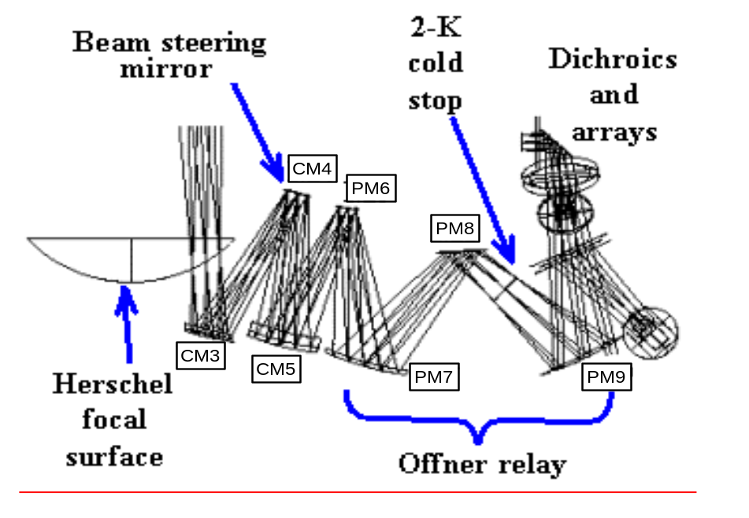
Figure 2-5 Imaging photometer optical design

Initially, it was envisaged that a shutter at the entrance aperture of the instrument (just above the telescope focus) would be used to block the beam during ground testing. This piece of hardware has been removed and provision has been made in the satellite ground test cryostat (and to an extent in the flight cryostat) for the provision of a low background in the three Herschel instruments’ field-of-views.

An internal calibration source provides a repeatable signal for the bolometer arrays. It radiates through a 2.8-mm hole in the centre of the beam steering mirror, M4. As this is at a pupil image, the illumination is close to uniform over the arrays. The source will be modulated at frequencies of a few Hz, and will provide a high instantaneous S/N with peak power dissipation < 2 mW. The beam steering mirror is capable of chopping ±2 arc minutes along the long axis of the 4 x 8 arc minute field of view, at frequencies up to 2 Hz with an efficiency of 90% and power dissipation < 4 mW. It can operate at higher frequencies with reduced efficiency and increased power dissipation. The beam steering mechanism can simultaneously chop at up to 1 Hz in the orthogonal direction by up to 30 arc seconds. Two axis motion allows "jiggling" of the pointing to create a fully sampled image of the sky with the feed horn-coupled detectors whose diffraction-limited beams on the sky are separated by approximately twice the beam FWHM.

The SPIRE filtering scheme is designed to provide precise definition of the spectral pass bands with high out-of-band rejection and maximum in-band transmission, and also to minimise the thermal loading on the 4-K, 2-K and 0.3-K stages by reflecting short-wavelength radiation. To achieve complete rejection out to UV wavelengths, four blocking filters are needed in the chain in addition to high-pass and low-pass edge filters which define the band.

Photometer Bolometer Detector Arrays
SPIRE will use spider-web bolometers with NTD germanium thermometers (Bock et al. 1998, Turner et al. 2002). The bolometers are coupled to the telescope by hexagonally close-packed single-mode conical feed horns, providing diffraction limited beams. The horn diameters are 2Fλ where F is the focal ratio of the final optics and λ is the wavelength: this provides a diffraction-limited beam with maximum coupling efficiency of the detector to a point source. The feed horn centre-centre spacings are defined at wavelengths of 250, 333, and 500 μm. The value of 333 μm is selected to provide exact overlap between a significantly large set of detectors in all three of the arrays. The numbers of detectors in the three arrays are 139, 88, and 43 for 250, 350 and 500 μm respectively, making a total of 270 detectors for the photometer. The detector arrays are shown schematically in Figure 2-6a and Figure 2-6b is a photograph of a prototype array module. Modelling of the complete optical train predicts FWHM beam widths of 17.1, 24.4 and 34.6 arc seconds at 250, 350 and 500 μm, respectively Each array unit has an interface to the Level-0 box, with a thermal strap from the ³He cooler to the 0.3-K stage, which is supported by Kevlar strings from Level-0. The electrical connections to the detectors are made with Kapton ribbon cables within the array modules and with woven manganin cables between the array modules and the JFET units. The bolometers are excited by an AC bias at a frequency of approximately 100 Hz, which eliminates 1/f noise from the JFETs, giving a 1/f knee for the system of less than 100 mHz.

Photometer observing modes
The photometer will have three principal observing modes, as illustrated in Figure 2-7 and described below. These modes are described in greater detail in RD03.
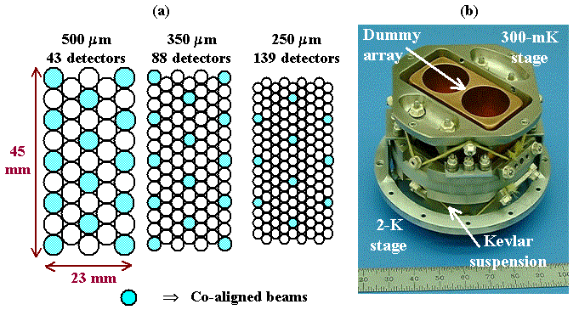
Figure 2-6 (a) layout of the three photometer arrays; (b) photograph of array mechanical prototype.
Point source photometry: For photometric observations of point or compact sources, chopping will be used. There are several sets of three detectors for which the beams at the three wavelengths are exactly co-aligned on the sky, indicated by the shaded circles in Figure 2-7. By chopping through the appropriate angle (approx. 126 arc seconds), 3-band photometric observations can be carried out simultaneously with maximum efficiency. To account for the possibility of positional errors due to telescope pointing inaccuracy or imperfect knowledge of the source position, the beam steering mirror can be used to implement a seven-point mapping routine in this mode. Assuming an angular offset of 6" for the seven-point, the loss in S/N for a given integration time varies between 6% at 500 μm and 20% at 250 μm, which is a small penalty to pay for assurance that telescope pointing or source position errors do not result in an underestimate of the source flux density.

Field mapping: For mapping of regions a few arc minutes in extent, the beam steering mirror will be used to carry out a jiggle map, similar to the mode of operation of the SCUBA bolometer camera on the JCMT (Holland et al. 1999). A 64-point jiggle pattern is needed to achieve full spatial sampling in all bands simultaneously, with a step size of 9 arc seconds (half-beam spacing at 250 μm). A maximum field size of 4 x 4 arc minutes is available in this mode as the 2-arcminute regions at each end of the array will be chopped outside the field of view admitted by the photometer optics.

Scan mapping: This mode will be used for mapping large areas of sky (much bigger than the SPIRE field of view), including deep survey observations. The telescope will be scanned across the sky (at up to 1 arc minute per second, the maximum rate that the spacecraft can provide). Because of the excellent 1/f stability of the NTD detectors, the beam steering mirror does not need to be operated - signal modulation is provided by the telescope motion. To provide the necessary beam overlap for full spatial sampling over the strip defined by a single scan, the scan angle must be 14.5º with respect to one of the array axes.

The available Herschel telemetry rate (at least 100 kbs, perhaps up to 140 kbs) allows all of the 270 photometer detectors to be sampled with 16-bit resolution at up to 28 Hz. This data is stored in Hershel bulk memory and telemetered directly during ground contact periods with no on-board processing.

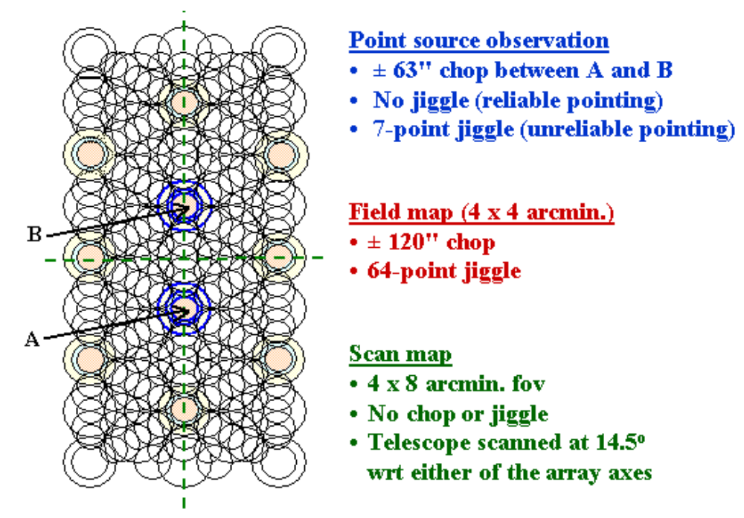
Figure 2-7 Overlaid photometer arrays and summary of photometer observing modes

Fourier transform spectrometer

Optical design and FPU layout
The layout of the FTS and its optical scheme are shown in Figure 2-8 and Figure 2-9 respectively. The main design features of the FTS are described in Swinyard et al. (2000) and in §2.3.4.2 below. It uses two broadband, high-efficiency, intensity beam splitters in a Mach-Zehnder configuration rather than the traditional polarising beam splitters. This configuration has the advantage that all four ports are separately accessible, as in the classical Martin Puplett (M-P) polarising FTS (Martin, 1982). But the throughput is a factor of two higher than for the M-P as none of the incoming radiation is rejected. This design is also insensitive to the polarisation of the incident radiation. The performance of the beam splitters and of a bench-top implementation of this design has been demonstrated (Ade et al. 1999). A thermal calibrator (P-Cal) is located at a pupil image in the second input port of the FTS, and provides a thermal input that mimics the dilute 80-K black body emission of the telescope. This allows the large telescope background to be nulled, thereby reducing the dynamic range requirements for the detector sampling. Two band-limited detector arrays are placed in the two output ports, covering 200-325 μm and 315-670 μm. These bands are referred to as the S/SW and S/LW bands, respectively. A single back-to-back moving rooftop mechanism serves both arms of the interferometer, with a frictionless carriage mechanism using double parallelogram linkage and flex pivots. The pick-off mirror (on the photometer side of the optical bench panel and located at the intermediate field image) directs the spectrometer field of view through a hole in the optical bench panel into the FTS side of the instrument. A 4-K pupil stop is located between the pick-off mirror and the input fold mirror. The input relay mirror focuses the beam to an intermediate image plane located just after the first beam splitter, after which the beam is collimated and sent to the moving rooftop mirror assembly. The rooftop mirror shifts the beam and sends it towards the camera mirror, which produces an image plane just before the output beam splitter. The output relay mirror focuses the beam onto the detector arrays. A pupil image is located near the final fold mirror, making this a convenient location for the entrance aperture to the Spectrometer Detector Box. As this pupil moves when the optical path difference changes, it is not a good place for a limiting cold stop. Instead, the limiting aperture is located at the 4-K pupil plane between the pick-off mirror and the input fold mirror.

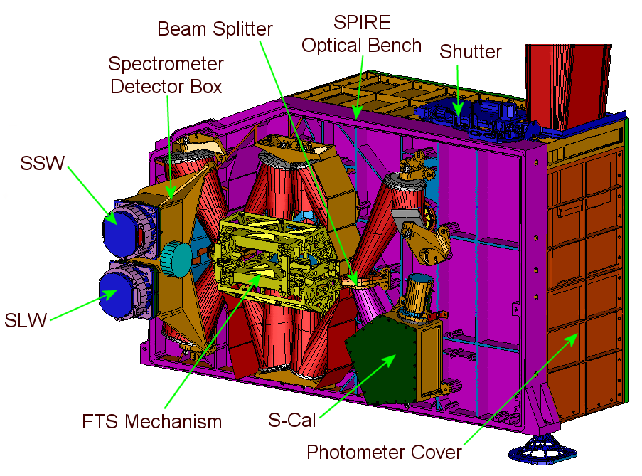
Figure 2-8 Physical layout of the spectrometer

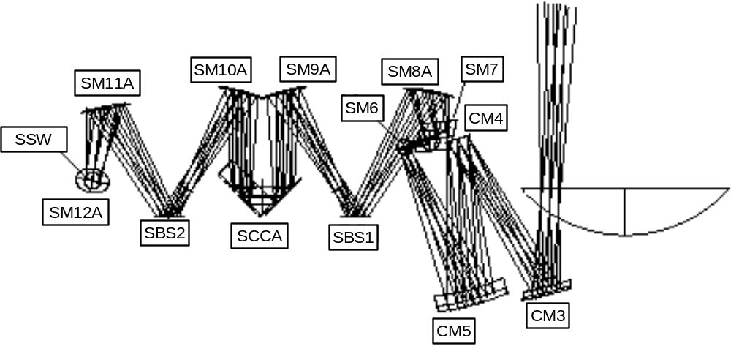
Figure 2-9 Optical design of the spectrometer

The FTS design is optimised for the 200-450 μm band. The wavelength coverage is extended to 15 cm⁻¹ (670 μm) to give access to the astrophysically important 609-μm line of CI in our own and nearby galaxies, and to increase the range over which the spectral energy distribution of sources can be measured in the FTS low-resolution mode. A filtering scheme similar to the one employed for the photometer channel is used to restrict the pass band of the instrument. Filters on the bolometer arrays themselves define the pass band for each array.

Spectrometer Bolometer Detector Arrays
The field of view of the FTS is approximately 2.6 arc minutes in diameter, and is covered by 37 hexagonally close-packed detectors in a short-wavelength array and 19 in a long-wavelength array. The detector modules will be similar to those used for the photometer, with a mechanical interface to the wall of the Spectrometer Detector Box.

The detectors and feed horns for the S/SW band are similar to those for the photometer 250-μm BDAs. The S/LW feed horn and detector designs are optimised for the shorter-wavelength part of the range, up to approximately 450 μm. At longer wavelengths there is a degradation in point source coupling efficiency at wavelengths due to the decreasing aperture size relative to the wavelength and the non-optimal design of the horn and detector cavity. The waveguide coupling the horn to the bolometer must also have a diameter large enough to transmit at 670-μm, and so is overmoded at the shorter wavelengths within the band. This results in an increase in background radiation on the detectors and a broadening of the beam by about 20% compared to the diffraction limit at the lower end of the band (Caldwell et al. 2000).

The layout of the FTS arrays is shown in Figure 2-10. The detectors on the periphery of the arrays are partly vignetted by the 2.6-arcminute field of view admitted by the instrument optics (indicated by the large circles in Figure 2-10.). The short-wavelength array feed horns are sized to give 2Fλ pixels at 225 μm and the long-wavelength horns to give 2Fλ pixels at 389 μm. This arrangement, although slightly non-optimal from the point of view of point source sensitivity at the central wavelengths of the two arrays, has the advantage that there are numerous co-aligned pixels in the combined field of view. This maximises the observing efficiency for measuring a point source spectrum together with its surrounding sky background and also provides redundancy to the spectrometer in the case of failure of a single pixel within one array.

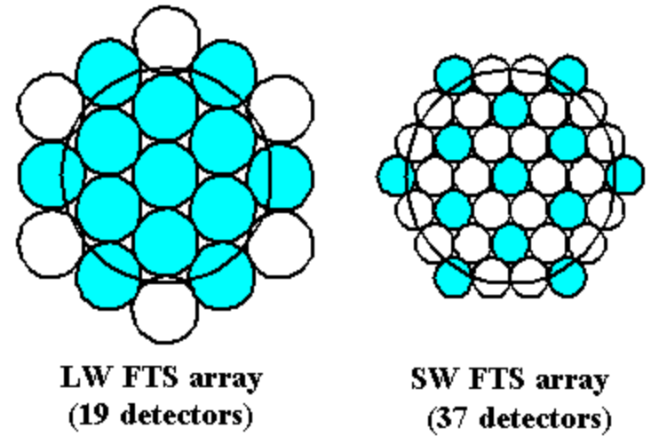
Figure 2-10 Layout of spectrometer detector arrays

Spectrometer observing modes
The modes are described in greater detail in RD03. The FTS will be operated in continuous scan mode with the mirrors moving at a constant speed of up to 0.1 cm s⁻¹, corresponding to a signal frequency range of 6 - 20 Hz. The spectral resolution can be adjusted between 0.04 and 2 cm⁻¹ (λ/Δλ = 20 - 1000 at 250 μm). The maximum scan length is 3.5 cm (taking 35 seconds or more and giving an optical path difference of 14 cm). To ensure that mechanism jitter noise is well below the photon noise level, a relative accuracy of 0.1 μm is required for the mirror position. The FTS calibration source will be on continuously while the spectrometer is operating, with a peak power of no more than 5 mW. For spectral mapping of extended sources, the beam steering mirror will be used to provide the necessary pointing changes between scans. The scanning mirror control system uses a digital feedback loop to provide a constant speed over the scan length, with an accuracy requirement of 1% (goal 0.5%). The position readout uses a Heidenhain Moiré fringe sensing system. The detectors are read out asynchronously with the samples time-stamped to match them to the corresponding mirror locations. No on-board processing will be done - the raw interferograms will be telemetered to the ground. The number of detectors and the available telemetry rate are compatible with an over sampling factor of two with respect to the Nyquist sampling rate of 40 Hz (sampling at approx. 80 Hz per detector). An over sampling factor somewhat greater than this is desirable - options to achieve this include increasing the data rate, decreasing the mirror speed, sampling only a fraction of the detectors in some cases (e.g., point source observations), or a combination of these.

Helium-3 cooler

The ³He cooler (Duband 1997) uses porous material to adsorb or release a gas when cooled or heated. This type of refrigerator is well-suited to a space environment. Gas-gap heat switches (Duband 1995) are used the control the refrigerator and there are no moving parts. It can be recycled indefinitely with over 95% duty cycle efficiency and the lifetime is only limited by that of the cold stage from which it is run (in this case, the lifetime of the Herschel cryostat). The evaporation of ³He naturally provides a very stable operating temperature under constant heat load over the entire cycle. The cooler requires no mechanical or vacuum connections and only low-current electrical leads for its operation, making the mechanical and electrical interfaces very simple. For operation in a zero-g environment two aspects of the design of a ³He refrigerator have been addressed: the liquid confinement and the structural strength required for the launch. The confinement within the evaporator is provided by a porous material which holds the liquid by capillary attraction. For the thermal isolation and structural support of the refrigerator elements, a suspension system using Kevlar wires has been designed to support the cooler firmly during launch whilst minimising the parasitic heat load on the system. The base-line SPIRE cooler contains 6 STP litres of ³He, fits in a 200 x 100 x 100 mm envelope and weighs about 1.6 kg. Its performance has been analysed using the same methods that successfully predicted the performance of the IRTS cooler on orbit. When operated from a 1.8-K heat sink it achieves a temperature of 287 mK at the evaporator with a 10 μW heat load, a hold time of at least 46 hours and a duty cycle efficiency of 96%. The energy input to the helium tank during recycling of the fridge is about 700 Joules. The ³He cooler is a potential single point failure for the instrument. Various options for redundancy have been considered. The chosen option is to implement a single cooler with non-redundant heats switches. The critical heaters and thermisters on the heat switches and on the pump are fully redundant and double-wired where appropriate. The reliability and redundancy have been analyzed (Collerias, 2001), and the results are satisfactory. Figure 2-11 is a photograph of a development model cooler which is similar to the SPIRE design.

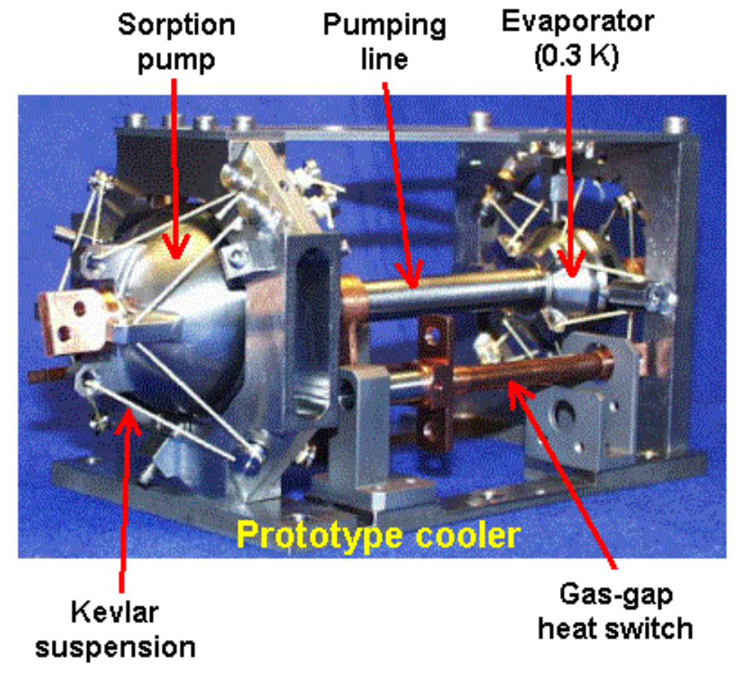
Figure 2-11 View of a prototype SPIRE cooler

Instrument System Design

In this section the SPIRE instrument is described in terms of its systems level implementation. First an overview is given of the SPIRE instrument subsystem implementation, then the instrument is described as a number interacting systems. Finally a more detailed description is given of the systems design approach taken in the critical areas of structural design; optical design; thermal design; electrical design and EMI protection.

SPIRE subsystems

The SPIRE instrument can be divided into two separate sections, the cryogenic subsystems located on the Herschel Optical Bench (HOB) inside the Cryostat Vacuum Vessel (CVV) and the Warm Electronics (WE) which are located outside the CVV on the Herschel Service Module SVM below the CVV. A schematic diagram of the SPIRE subsystems inside the CVV is shown in Figure 2-12. The following features are illustrated in this Figure.

- The Herschel Optical Bench (HOB) upon which SPIRE, PACS and HIFI are mounted is shown with black hatching.
- The thermal straps between the various stages of the cryostat, cryocooler and the detector boxes are shown as blue hatching
- The Photometer and Spectrometer Detector Boxes which are kept at 2 K are shown are indicated by blue crosses.
- The 4-K FPU is indicated by green crosshatching. This unit is sealed to prevent the ingress of EMI and/or stray light. .
- Internal stay light baffles are indicated by black hatching.
- Indicative harness routing is shown by magenta.
- The light rays from the telescope is shown by red lines.

The only interface between the SPIRE subsystems inside the CVV and the WE on the SVM is via the bulk-head connectors (and associated harnesses) shown at the top of Figure 2-12. The SPIRE harnesses that connect the outside of the CVV to the WE are shown on the left hand side of Figure 2-13.This schematic shows the Detector Readout and Control Unit (DRCU), which consists of two sub-units; the Focal-Plane Control Unit (FCU) and the Digital Control Unit (DCU), together with the electrical interfaces to the Herschel spacecraft.

Figure 2-14 and Figure 2-15 show views of the photometer and the spectrometer with the physical locations of the various subsystems. Table 2-1 lists and describes the sub-systems and gives the unit names used in the IID-B. A detailed description of the design of all the SPIRE subsystems is given in RD02.

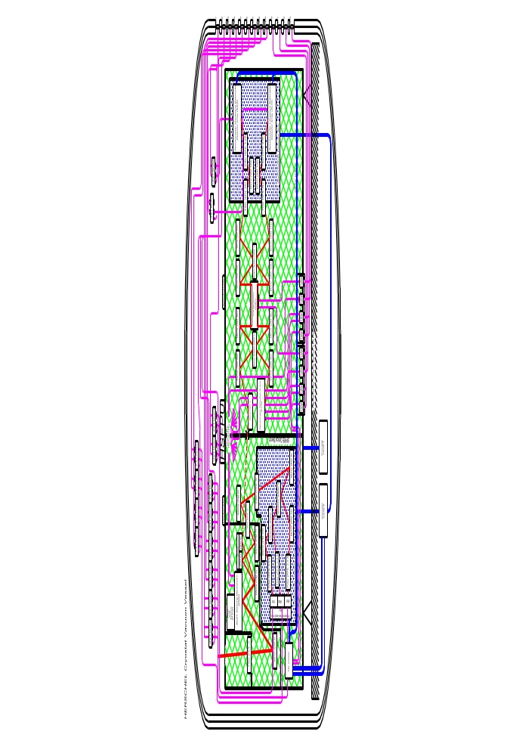
Figure 2-12 Schematic diagram of the sub systems of SPIRE contained within the Herschel CVV
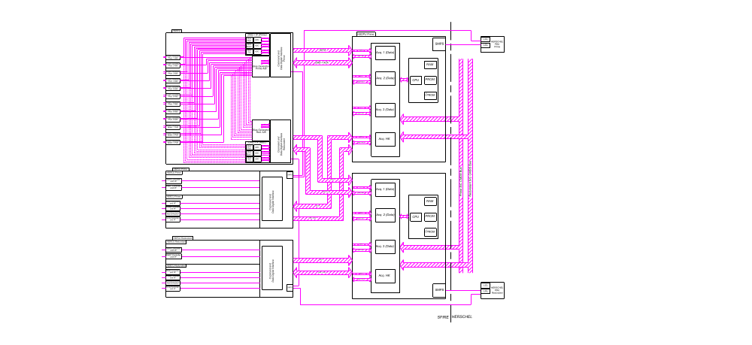
Figure 2-13 Schematic diagram of the sub-systems of SPIRE contained on the Herschel SVM

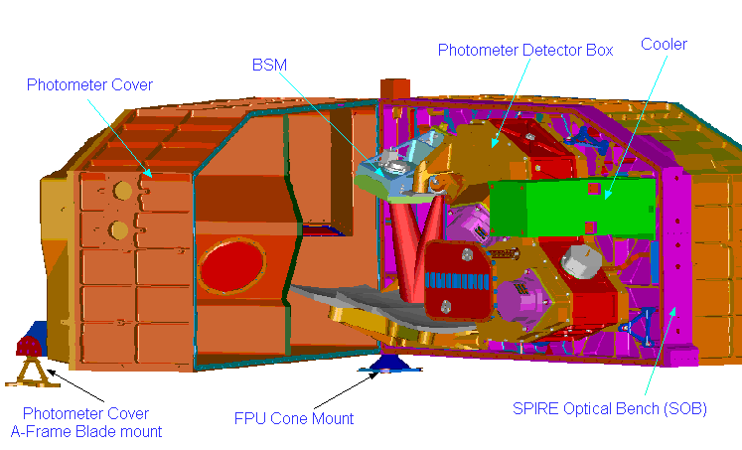
Figure 2-14 View of photometer side of the instrument. The photometer cover is shown rotated to expose the photometer components

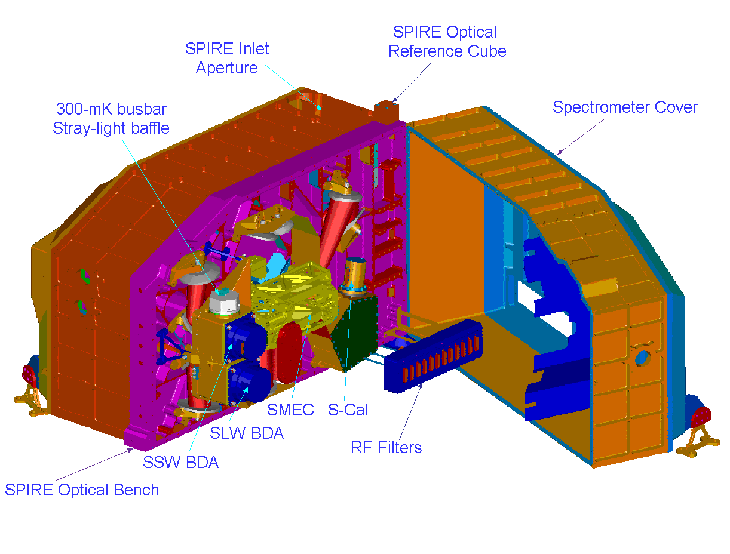
Figure 2-15 View of the spectrometer side of the FPU. The cover is shown rotated to expose the components house beneath the cover.

The following table lists the subsystems within SPIRE

Subsystem Name | Description | Unit | Redundancy
Structure | Focal plane unit structure to hold all cold sub-systems in the focal unit. This includes all thermometers necessary to monitor the instrument during cool down and operation. | HSFPU | No redundancy
Optics | All mirrors for the photometer and spectrometer channels | HSFPU | No redundancy
Filters | All filters; beam splitters and Dichroics for the photometer and spectrometer channels  The requirements on these are included with those for the optics. | HSFPU | No redundancy
Baffles | Straylight control baffles for the photometer and spectrometer channels | HSFPU | No redundancy
Cooler | ³He cooler unit cools the photometer and spectrometer detector arrays to 300 mK | HSFPU | No redundancy on hardware, full redundancy on control system and harnessing
Bolometer Detector Arrays (BDAs) | Bolometer array modules for the photometer and spectrometer | HSFPU | No redundancy. Loss of a single bolometer element is a soft failure mechanism but several hard failure mechanisms exist
Beam Steering Mechanism (BSM) | This mechanism allows the photometer and spectrometer fields of view to be stepped or chopped across the sky. | HSFPU | No redundancy in the structure, mirror or flexure pivots. Redundancy in instrumentation, actuation and harnessing.
FTS Mechanism  (SMECm) | The FTS moving mirrors drive mechanism and position measurement system. SMECm designates the mechanism and position encoder | HSFPU | No redundancy in the structure, mirror or flexure pivots. Redundancy in instrumentation, actuation and harnessing.
FTS encoder amplifier  (SMECp) | SMECp the cold pre-amplifier for the position encoder detectors. | HSFPU | Fully redundant
Shutter Mechanism | A shutter is required in the instrument for ground test to allow the detectors to see the correct radiation environment. | HSFPU | No redundancy as not a flight item.
Photometer Calibration Source | Calibration source for photometer | HSFPU | No redundancy on light guide and reference source. Full redundancy on electronics and harnesses.
Spectrometer Calibration Source (SCAL) | Calibration source for the spectrometer | HSFPU | Redundancy on reference source heater and thermometer. Full redundancy on electronics, heater and harnesses.
RF Filter Modules | Each sub-system harness into the cold FPU must have an electrical RF filter to prevent EMI problems with the bolometers. These will be mounted in standard RF filter modules on the wall of the FPU box. | HSFPU | Fully redundant
Photometer JFET Box | JFET pre-amplifiers for photometer NTD germanium bolometers. | HSFTBp | No redundancy. Failure of single JFET amplifier is a soft failure mechanism
Spectrometer JFET Box | JFET pre-amplifiers for spectrometer NTD germanium bolometers. | HSFTBs | No redundancy. Loss of a single JFET amplifier is a soft failure mechanism
Detector Read-out & Control Unit (DRCU) | Detector amplifier and digitisation chain and instrument control electronics. Conceptually this is a single unit however for accommodation reasons it will be split into two physical units | HSDRC | See below
FPU Control Unit (FCU) | Contains the electronics for the power conversion and distribution to the DRCU; for the control and read-out of the thermometers; cooler; calibration sources and the cold mechanisms | HSFCU | Full redundancy
Detector Control Unit (DCU) | Contains the bias conditioning electronics for the bolometers arrays and JFET units and the lock in amplifiers and readout electronics for all the detector arrays. | HSDCU | No redundancy on the Lock-in Amplifiers. Full redundancy on DAQ. Full redundancy on Bias Generators
Digital Processing Unit (DPU) | Instrument on board computer – forms interface to CDMS | HSDPU | Full redundancy
Warm Interconnect Harness | Harnesses between warm boxes | HSWIH | Full redundancy
On Board Software (OBS) | All on board software that controls the function of the instrument. This is all contained in the DPU | HSOBS | N.A.
FPU Simulator | A set of electronic components, either passive or active, that mimics the analogue response of the FPU sub-systems to the warm electronics. | HSFPS | No redundancy as not a flight item
DRCU Simulator | A set of interface hardware and computer software that mimics the response of the DRCU and FPU to the DPU and on board software. | HSDRS | No redundancy as not a flight item
Table 2-1 List of the SPIRE sub-systems.

The SPIRE instrument as a system

SPIRE can be viewed not just as a series of physical sub-systems but also as a series of interacting systems. Figure 2-16 is a system topology of the SPIRE instrument that attempts to divide it into a number of systems areas with over lapping areas of interest. Table 2-2 expands on Figure 2-16 and gives details of what each system area represents; the issues to be addressed under each system area; the physical components that can be associated with each system and what methods of analysis and verification we intend using to ensure that each area is properly considered in the implementation of the instrument

Although Figure 2-16 and Table 2-2 are a very much-simplified view of the systems interactions in the instrument, they do serve to illustrate some important points about the system level design of SPIRE:

The Radiation Detection System – going from the cold detector arrays through to the digitised signals from the DRCU, is at the very heart of the instrument. All systems issues ultimately come back to ensuring that the detection system can operate correctly and without undue interference.

The Electrical System and Structure System can be seen as the “glue” that bonds the instrument together into a single unit.

The EMC/EMI Protection System touches on virtually every aspect of the instrument design. The issues raised by consideration of the EMC/EMI must always be taken into account in design and implementation of virtually every physical sub-system in the instrument
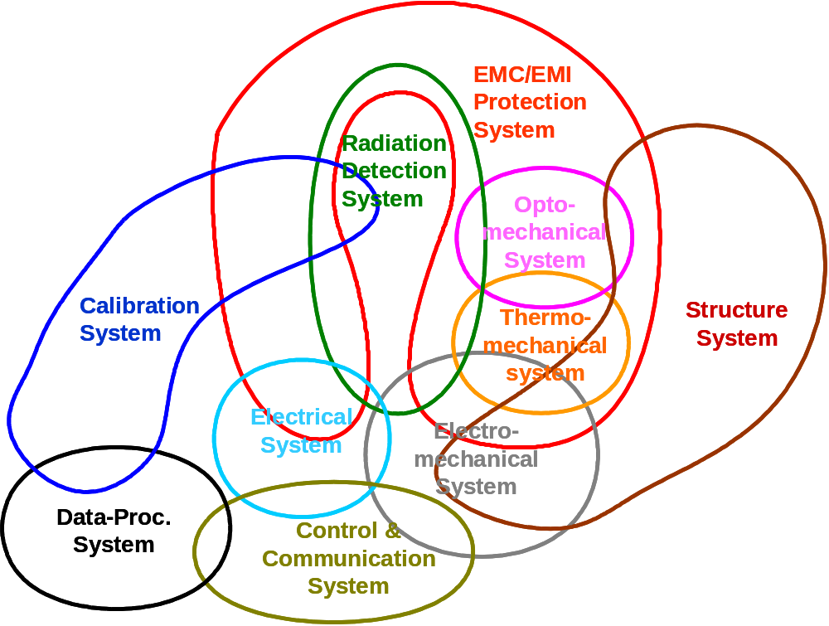
Figure 2-16 Simplified view of the SPIRE instrument as broken into “systems.”

System | Description/Issues | Sub-systems | Design analysis Tools | Design verification methods
Structural | To ensure that the SPIRE instrument is mechanically compatible with the Herschel system and capable of withstanding the launch environment  Mechanical frequency response  Ability to withstand launch environment  Mechanical interface with Herschel system  Instrument level integration  Sub-system mechanical interfaces | Primarily instrument Structure and JFET enclosures  Interfaces to all cold FPU sub-systems | CAD  FEM | Prototype material testing  STM/CQM instrument model vibration tests  CQM system level integration
Opto-mechanical | To ensure that only the legitimate optical radiation reaches the radiation detection system and does so in a manner that fulfils the instrument requirements  Optical design  Optical interface to Herschel system  Straylight  Instrument optical performance  Integration and alignment  Sub-system optical interfaces | Structure  Optics  Filters  Calibration Sources  Detector Arrays  Baffles  SMEC  BSM | Synopsis  ASAP  APART  Feed horn model (Gaussian Mode analysis; HFSS) | Component testing (filters etc)  Optical alignment  Instrument level tests
Thermo-mechanical | To ensure that the different parts of the instrument run at the correct temperature and that the instrument functions at the correct temperature according to requirements for all defined instrument operating and environmental conditions  Thermal performance under all operating conditions  Thermal interface to Herschel system  Sub-system thermal interfaces  Sub-system thermal control | Structure  Cooler  Thermometry  Temperature Control  JFET Amplifiers  JFET Enclosure  Filters  Thermal straps  SCU | ESATAN model  Other computer models | Prototype sub-system tests (cooler; cooler plus strap etc)  STM/CQM sub-system cold tests  Instrument level STM cold tests  Instrument level CQM cold tests  System level CQM cold tests
Electro-mechanical | To ensure that the moving parts of the instrument meet the instrument requirements; do not unduly influence the operation of other parts of the instrument and that the instrument can operate according to requirements in the micro-vibration environment expected in the Herschel satellite  Micro-vibration environment  Mechanism control  Harness mechanical frequency response and routing | FPU Harnesses  Detector arrays  SMEC  BSM  JFET Amplifiers  Cryostat cold harness  Cryostat warm harness  MCU | Dynamical analysis model (DSPACE?) at sub-system level only | Prototype sub-system tests  Instrument level STM cold tests  Instrument level CQM cold tests  System level CQM cold tests
Radiation Detection | To ensure that the radiation transmitted by the opto-mechanical system is efficiently detected and converted into digital signals without excess noise or contamination from other electrical signals.  Detector performance versus environment  (temperature; photon background; micro-vibration; EMC)  JFET Amplifier performance versus environment (ditto)  Harness performance  Detector sub-system interface compatibility – thermal; electrical; mechanical  End-to-end system performance | Detector Arrays  Thermal Straps Temperature Control  Cooler  FPU Harnesses  RF Filters  JFET Amplifiers  Cryostat cold harness  Cryostat warm Harness  DCU | MathCAD Models  System analysis | Prototype cold units in representative environment with representative electronics  STM sub-system cold units for thermal and environmental test  CQM sub-system end to end test  CQM instrument level end to end test  CQM system level end to end test
EMI/EMC protection | To ensure that no radiofrequency EM radiation enters the radiation detection system from any source within the Herschel system. Also that the SPIRE instrument does not emit any radiofrequency EM radiation that might influence the operation of any part of the Herschel system  EMC susceptibility and emission – radiated/conducted  Electrical grounding  Faraday cage integrity and performance  RF filter performance  Harness performance  Power supply cleanliness  Digital/analogue separation | Structure  FPU Harness  RF Filters  JFET Box (FSFTB)  Cryostat cold harness  Cryostat warm harness  DRCU (FSDRC) | Systems Analysis  SPICE model | EM and QM electronics units as sub-system with simulator and EMC tested  CQM instrument level testing  CQM system level testing
Electrical | To ensure that the SPIRE instrument is electrically compatible with the Herschel system and that the different parts of the instrument are mutually electrically consistent with each other  Electrical interface to Herschel system  Power supply distribution and control  Sub-system electrical interfaces  Wiring tables  Analogue to digital interfaces  Digital to digital interfaces | DRCU (FSDRC)  SPIRE Warm harness (FSWIH)  DPU (FSDPU)  S/C PDU  S/C Warm harness  DRCU Simulator  FPU Simulator | Systems analysis | EM and QM electronics units tested as sub-system with simulator(s)  CQM Instrument level testing  AVM and CQM system level testing
Instrument  control and communication | To ensure that the SPIRE instrument communicates with the Herschel system; that the different parts of the SPIRE instrument are mutually consistent with the operations concept and that the instrument operates safely and to requirements in all operational modes  Data interface to Herschel system  Operating mode definition  Instrument commanding definition  On board software definition  Sub-system operational and control interfaces  Sub-system data interfaces | DRCU (FSDRC)  SPIRE warm harness (FSWIH)  DPU (FSDPU)  S/C CDMS  FPU Simulator  DRCU Simulator | Systems analysis  Software simulators | EM and QM electronics units tested as sub-system with simulator(s)  CQM Instrument level testing  AVM and CQM system level testing
Instrument  data processing | To ensure that the data produced by the SPIRE instrument are compatible with the requirements of the Herschel system and are processed into the required data products  Interfaces to the ICC  Data product definition  Data processing definition  Sub-system data processing interfaces  Observing mode data processing interfaces | DPU (FSDPU)  DRCU Simulator  FPU Simulator  ICC | Systems analysis  Software simulators | Data sets produced by simulators EM and QM electronics units tested as sub-system with simulator(s) produces data sets  Instrument level CQM tests for observation verification and producing data sets  System level AVM and CQM tests for end to end verification
Calibration | To ensure that the data produced by the instrument can be converted into meaningful physical units to allow the correct operation of the instrument in all modes and the processing of the instrument data into the required data products  Observing mode calibration definition  Ground commissioning and calibration plan  Flight commissioning and calibration plan  Instrument to ground facility interfaces  Ground facility definition  Ground based observing programme definition | Photometer Calibrator  Spectrometer Calibrator  DPU (FSDPU)  ICC | Systems analysis  Instrument performance models | Prototype sub-system tests  CQM instrument level performance verification  Ground based observing programme
Table 2-2 Description of the SPIRE systems

Structural design and FPU integration

We have already discussed the need to have various temperature zones with the SPIRE FPU. This, combined with the need for two essentially separate instruments in the SPIRE instrument, has dictated the design approach to be taken for the SPIRE structural design. Figure 2-17 shows the conceptual design of the FPU structure. A single stiff optical bench is used to mount all the subsystems and optical components, including two detector boxes that are thermally isolated from the optical bench on stiff space frames. On one side of the bench the components for the common entrance optics and the photometer channel are mounted, and on the other the components for the spectrometer channel. Each side of the optical bench has a cover that forms a structural “monocoque” element in the design. The integrated instrument box is mounted from the Herschel optical bench via three thermally isolating supports. One of these is directly mounted from the SPIRE optical bench and forms a fixed reference point, the other two are mounted from the two covers and are bipods with flexibility in one direction to allow for any differential thermal contraction during system cool down.

The FPU covers also form both a Straylight shield to protect the instrument from the ambient thermal radiation environment in the Herschel cryostat and an RF shield to protect the detectors from any radiated EMI. All sub-system wiring entering the instrument box must pass through passive RF filters mounted in boxes from the SPIRE Optical Bench on the spectrometer side. When the cover is integrated with the optical bench the RF filter boxes will be sealed to the cover. The exception to this are the harnesses for the detectors themselves that connect the bolometer arrays to the externally mounted JFET units. These are filtered within the JFET units and then pass to the instrument box via a drilled plate hard mounted to the SPIRE Optical Bench. The wiring harnesses therefore form part of the RF shield therefore and careful attention must be paid their electrical shielding.

In addition to sealing the instrument box against RF, it must also be sealed against the possibility of stray optical radiation entering via routs other than the legitimate path defined by the telescope and SPIRE optical elements. To this end the thermal straps that must broach the covers to connect the sorption cooler and the detector boxes directly to the Herschel helium tank at 1.7 K must pass through light baffles.

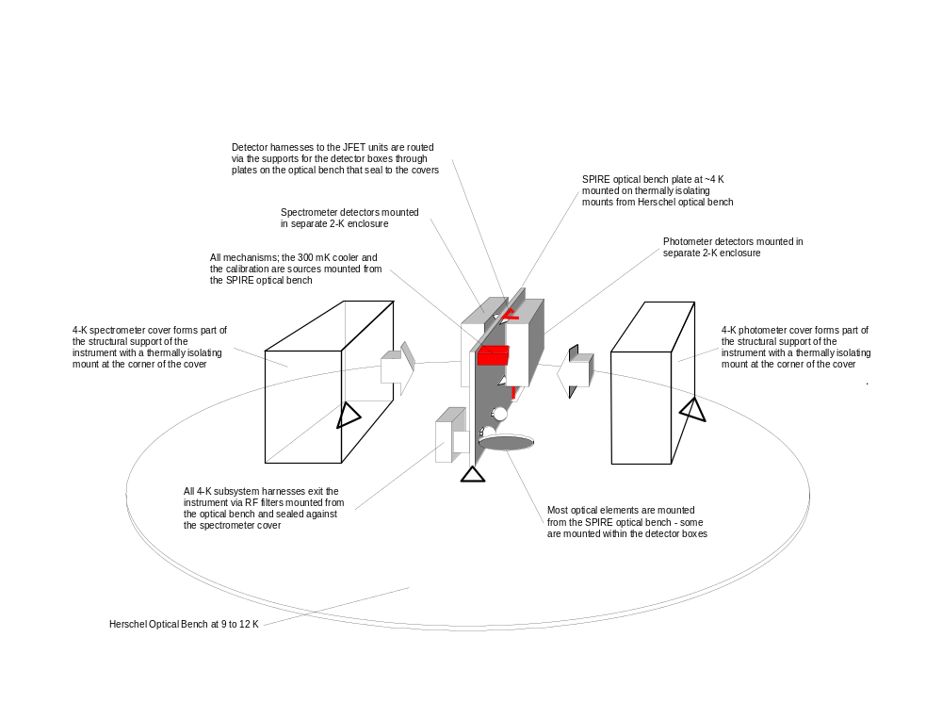
Figure 2-17 Conceptual design of the SPIRE instrument structure. Once the 4-K covers are integrated the instrument box forms a straylight and RF shield

Optical Design

Common optics and photometer optics

The 3.5 m Herschel telescope will be either a Cassegrain or Richey- Chrétien system. In either case it will provide a well-corrected image at a focal ratio of f/8.68 (IID-A). The low focal ratio of the primary mirror (f/0.5) causes the telescope focal surface to be highly curved. SPIRE uses an off-axis part of the telescope FOV and its object surface is therefore tilted with respect to the central (gut) ray. Figure 2-18shows a scaled drawing of the telescope and SPIRE photometer.

 | x-y plane | x-z plane
Photometer | 0º 0’ 0” | 0º 10’ 59”
Spectrometer | 0º 7’ 23” | 0º 10’ 59”
Table 2-3 Alignment of the SPIRE photometer and spectrometer gut rays w.r.t. the Herschel bore sight.
At an early stage in the design process several decisions were taken on the system design of the instrument that were to be design drivers for the optical design:

- The spectrometer and photometer are not to be operated simultaneously;
- the spectrometer and photometer are to have separate fields of view on the sky and no beam switching mechanism is to be used;
- the largest possible field of view available to SPIRE should be used for the photometer;
- whatever is conveniently left should be available for the spectrometer;
- a mechanism to steer the beam around the sky to allow chopping and spatial sub-sampling is required;
- the beam steering mechanism is to be available for both the photometer and spectrometer channels and so must be placed ahead of any division of the fields into the separate instrument channels;
- the secondary mirror of the telescope is to be used as the final exit pupil of the instrument and a cold aperture stop close to the detectors is required;
- no compromise is to be made in the photometer optical design to accommodate the spectrometer channel;
- imaging in the spectrometer is not a key requirement; the primary science driver is for point sources viewed on axis.

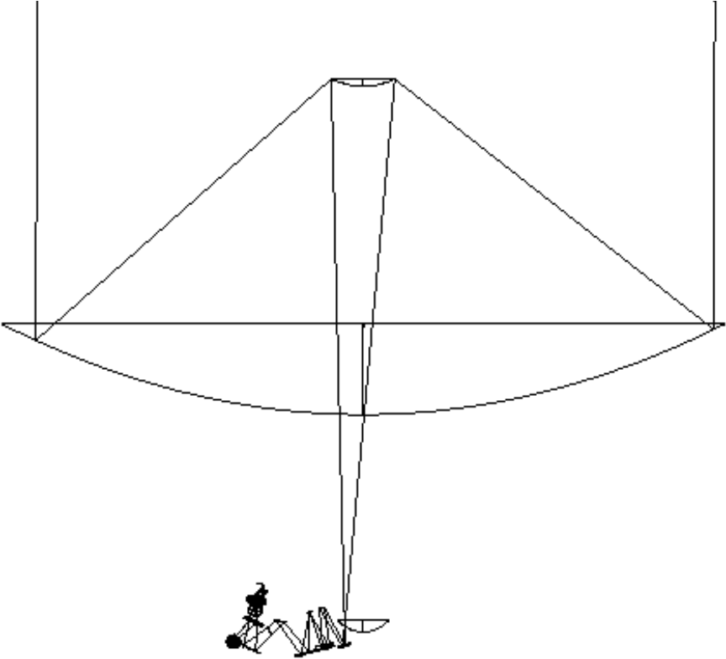
Figure 2-18 Ray diagram of the Herschel telescope with the SPIRE optics to the same scale. The primary mirror has a diameter of 3.5 m and the SPIRE FPU is about 500 mm wide.

The SPIRE optics are divided into a common portion followed by the photometer and spectrometer optical chains. The common optics form an image of the secondary at the location of the beam steering mirror and provide a well corrected intermediate focus to allow the separation of the spectrometer and photometer beams into different parts of the instrument box

In addition, the combination of the common optics and the rest of the photometer optical train has to provide:
- a well-corrected, flat focal surface, perpendicular to the gut ray, at f/5 at the proposed location of the detector arrays – i.e. correction for the highly tilted focal plane of the telescope;
- sufficient back-focal length (BFL) to allow separation of the photometer beam into three spectral bands using dichroics;
- a non-aberrated image of the telescope secondary at a physical location as close to the photometer detectors as possible and physically accessible to allow a real stop to be placed there.

All these functions are assured by the SPIRE common optics and photometer optical design as shown in Figure 2-19. CM3 is an off-axis ellipsoid projecting an image of the telescope secondary (CM2) onto CM4. This image is well-corrected and in focus at the centre of the CM4 so that the pupil image at the cold stop stays fixed during chopping and beam steering. CM4 is a flat mirror whose orientation is adjustable in flight to permit ±2 arcminutes chopping in the sagittal plane, allowing off-field chopping for a 4 x 4 arcminute sub-field, and ±30 arcminutes beam steering motion in both the tangential and sagittal planes to obtain fully Nyquist sampled images. The toric CM5 mirror reimages the focal plane onto PM6 and converts the focal ratio of the beam from f/8.68 to f/5. While CM3 and CM4 are common for both photometer and spectrometer, the two systems separate at PM6. The photometer PM6 is toric and sends the beam into an Offner-type relay system consisting of three spherical mirrors: PM7 (concave), PM8 (convex), and PM9 (concave). The tilt angles, separations and curvatures of these mirrors provide enough free variables to satisfy the need for well corrected flat image planes; a long back focal length and an image of the telescope secondary mirror close to the detectors. In particular, an easily accessible pupil image is provided between PM8 and PM9 in which the cold stop is located. The physical separation between the 4-K cavity and the 2-K cavity (detector box) into which the detectors are mounted, is made here so that the entrance to the cold environment containing the detectors is as small as possible to restrict the possibility of straylight hitting the detector arrays.

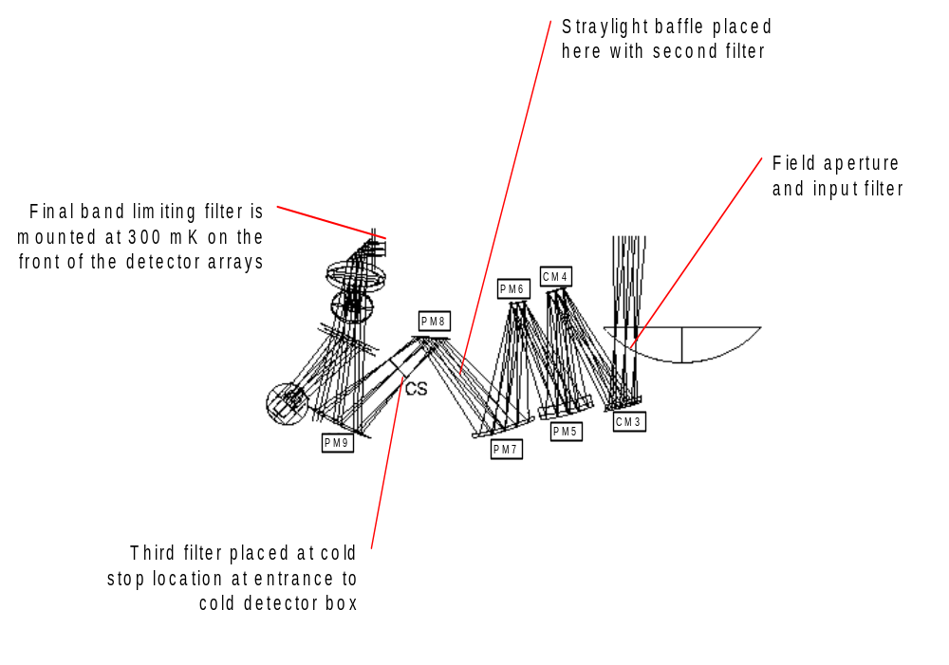
Figure 2-19 Ray diagram of the SPIRE photometer showing the ray paths for three points in the tangential plane, centre and extremes of the FOV (2 arc minutes). Also shown here are the locations of the straylight baffles and optical bandpass filters.

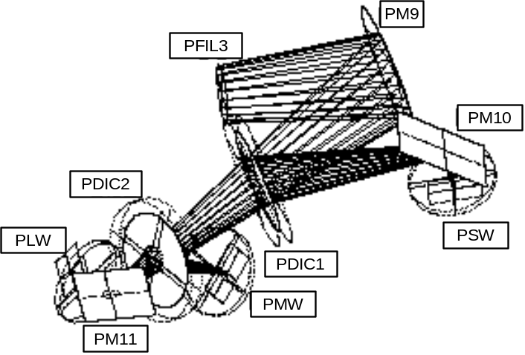
Figure 2-20 The beam folding within the photometer detector box. The dichroics are low pass devices so PSW is the shortest wavelength array; PMW the medium wavelength array and PLW the long wavelength array.

The detector box contains PM9, the last powered mirror of the optical train, and dichroics and beam folding mirrors distributing the light between three detector arrays. An edge filter at the cold stop minimizes stray radiation entering the cold box and band-pass filters in front of each detector array ensures the spectral limitation of each band. Figure 2-20 shows a 3-D view of the photometer detector box optics.

Figure 2-21shows geometrical spot diagrams across the photometer FOV. The final focal surface is flat and perpendicular to the gut ray, and the exit pupil is close to telecentric. With a theoretical Strehl ratio better than 0.986 at 250 µm, the system leaves headroom for manufacturing tolerances, and the field distortion is below 1.1%.

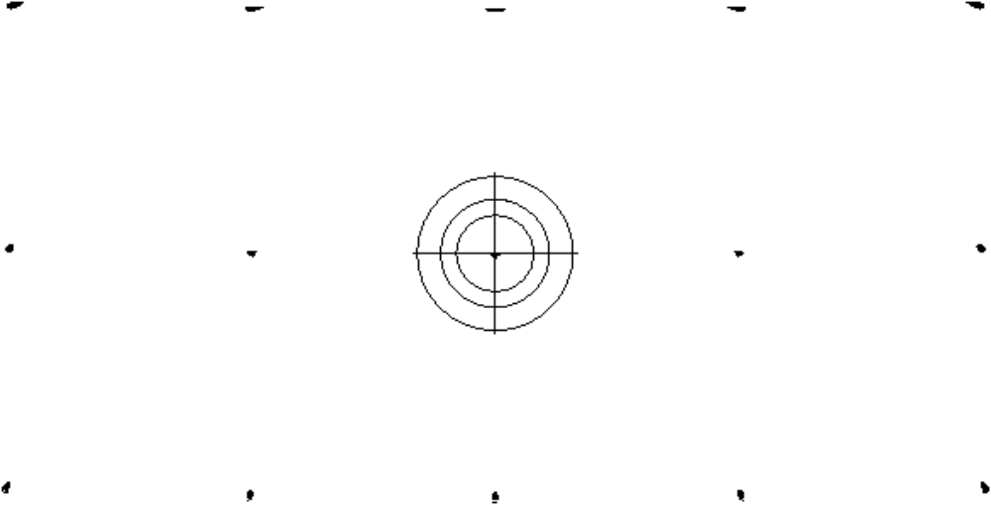
Figure 2-21 Geometric spot diagrams across the 4 x 8 SPIRE photometer FOV. The spots are plotted in their actual positions and to scale. The concentric circles around the central spot have diameters 3.0, 4.3, and 6.1 mm and indicate the Airy disk size at 250, 350µm. A slight distortion is observed, corresponding to 6′ or 1.1% of the FOV diagonal. The average focal ratio is f/4.9.

Spectrometer optical design

An imaging FTS has been chosen for SPIRE rather than a grating-based solution because of its superior imaging capability, lower stray-light sensitivity, and variable spectral resolution. Among a large number of possible interferometer concepts, three were chosen for a final comparison, see Figure 2-22. In each case, two separate, band-limited detector arrays are required to divide the 200-670 µm band into two sub-bands: 200-315 µm, and 315-670 µm. Covering the entire spectrum with a single array would be too constraining with respect to spatial sampling and detection efficiency.

The Martin-Puplett interferometer (Figure 2-22a) offers a good and robust solution to this problem. Based on the use of three polarisers, components which can provide excellent efficiency over a broad band in the far infrared region, and roof-top mirrors, it provides two input and two output ports with a minimum of complexity. When the polarisers are properly oriented, the roof-top mirrors switch the polarisation of the beams so that 100% of the light incident upon P2 is transmitted towards the detectors. One polarisation of the incident light is lost at P1 however, reducing the optimal efficiency of this concept to 50%. P3 is required to analyse the interfering beams, sending complementary interferograms towards the two detectors. Usually, both detectors would see the entire band, hence detecting all the light incident onto P3, but in our case the spectrum would have to be divided into two by band-pass filtering each detector. This loses another 50%, reducing the theoretical efficiency to 25%.

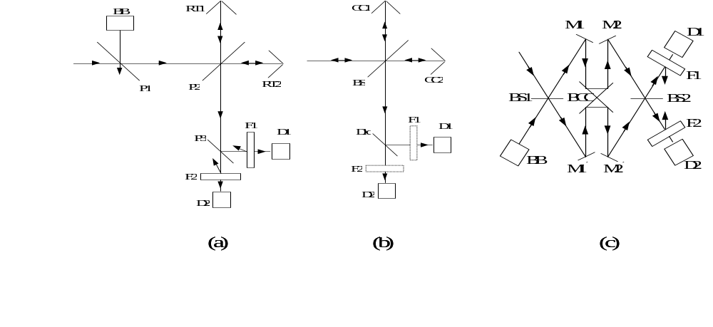
Figure 2-22 Three possible interferometer concepts for the SPIRE spectrometer: (a) Martin-Puplett polarising interferometer, (b) classical Michelson interferometer, and (c) Mach-Zehnder type dual beam interferometer. BB: blackbody source, RT: roof-top mirror, P: polariser, F: filter, D: detector, CC: corner-cube reflector (could also me mirrors or roof-tops), BS: beamsplitter, Dic: dichroic beam splitter, M: mirror, BCC: back-to-back corner cubes (or roof-tops).

As a second option, we considered a simple Michelson interferometer as shown in Figure 2-22b. This option was made possible thanks to a new development of 50/50 beamsplitters, (Ade et. al. 1999), providing greater than 90% efficiency (4RT) over the entire SPIRE band. No output polariser is required in this case and it can be replaced with a dichroic beam splitter, offering a theoretically loss-less channel separation. There is of course a 50% loss at the beamsplitter since half the incident radiation is sent back out through the telescope. This configuration is still twice as efficient as the previous one. Its main drawback is the lack of a second input port, required for balancing off the telescope background radiation.

The preferred solution is shown in Figure 2-22c, with roof-top mirrors used in preference to corner-cubes because this does not produce image-rotation at the detectors as happens with the corner-cube option. The beam-shear due to out-of-pane motion of the scan mechanism when using roof-tops has been shown to be acceptable. Rather more complex than the others, option (c) provides both a second input ports and a 50% theoretical efficiency. The concept is based on a Mach-Zehnder interferometer with its arms folded in order to avoid beam shearing during scanning of the optical path difference (OPD) and uses two 50/50 beamsplitters. If the detectors could be used over the entire spectral range, this concept would provide 100% efficiency, but the requirement for two separate bands imposes a 50% channel separation loss as in the Martin-Puplett case. The folding allows the optical path of both arms to be changed simultaneously with a single scanning mechanism, hence doubling the available resolving power for a given mirror-moving mechanism. A resolving power of 1000 at 250 µm, requiring a maximum OPD of 125 mm, is therefore obtained with a lopsided movement from -3 mm to +31 mm. The lowest resolving power, R = 20, is achieved using a double sided scanning of ±0.6 mm.

One of the difficulties encountered in the optical design of the interferometer concept of Figure 2-22c was the long distance between separation (at BS1) and recombination (at BS2) of the beams. Due to the FOV dependent beam spread, the size of the beam splitters and collimating and camera optics became prohibitive. Also, it was difficult to find space for the scanning mechanism. To improve the situation it was decided to move collimator and camera optics to within the interferometer by making the four mirrors M1, M2, M1′, and M2′ of Figure 2-22c powered. This is not without disadvantages, since at non-zero OPD, the two arms do not see the same optical system. A differential aberration analysis is therefore necessary. Keeping to a strict scheme of symmetry ensures minimal aberrations in the system, and the only residual aberration of some concern is differential distortion giving a lateral separation between the images of a point source at the edge of the FOV. The induced contrast reduction is not negligible but small compared with other sources, notably alignment tolerances.

Figure 2-23 shows the ray diagram of the upper half of the spectrometer. The lower half has the same optical design. After reflection from the common mirrors CM3, CM4, and CM5, the spectrometer beam is picked off by the toric SM6 and sent out of the plane of the photometer system. The flat SM7 redirects it into a parallel plane, separated by 170 mm from the photometer plane. The input relay mirror (SM8) focuses the beam to an intermediate image plane located just after the first beam splitter, after which the beam is collimated (SM9) and sent vertically towards the corner cube assembly. The corner cube, modelled by non-sequential raytracing, shifts the beam and sends it up towards the camera mirror (SM10). Symmetrical with the collimator, the camera focuses the beam to an image plane just before the output beam splitter. The output relay mirror (SM11) focuses the beam onto the detector arrays. To accommodate the components within the available volume, a fold mirror is needed to take the beam out of the plane again. The input and output relays are toric in order to control astigmatism and image anamorphism. A slight asymmetry in the input and output relays is introduced in order to adjust the final focal ratio. The collimator and camera mirrors are spherical.

A pupil image is located near the final fold mirror, making this a convenient place for the entrance hole in the 2-K enclosure. This pupil moves as the OPD changes, however, so it is not appropriate for a limiting cold stop. Instead, a limiting aperture is placed in another pupil image at Level-1 located between SM6 and SM7.

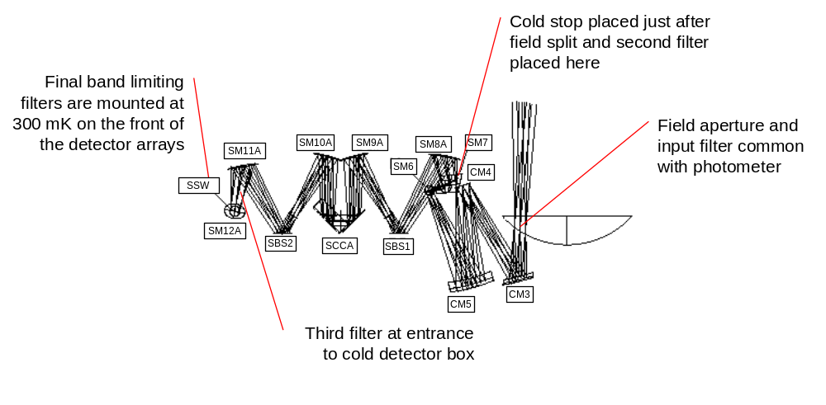
Figure 2-23 Raytracing diagram of the upper half of the SPIRE spectrometer. The symmetrical lower half is generated by reflection about the plane containing the two beam splitters. The location of the cold stop and the bandpass filters are also indicated. Note: this is for the corner-cube option - there is no significant difference for the roof-top option
Figure 2-24 shows spot diagrams for the spectrometer. Clearly the imaging performance is not quite as good as that of the photometer, the spots reflect the image quality in the intermediate focal plane at SM6. Since the planar symmetry is lost, it is very difficult to improve on this. However, the astigmatism has been brought to zero at the centre of the FOV and a good balance of aberrations over the rest of the FOV has been achieved by introducing a 3.8° rotation of the output relay mirror around its normal. The worst RMS wavefront error is 6.6 μm, giving a Strehl ratio at 250µm of 0.97. Apart from a slight rotation, the image suffers from a distortion of up to 9′′, corresponding to 6% of the FOV diameter.
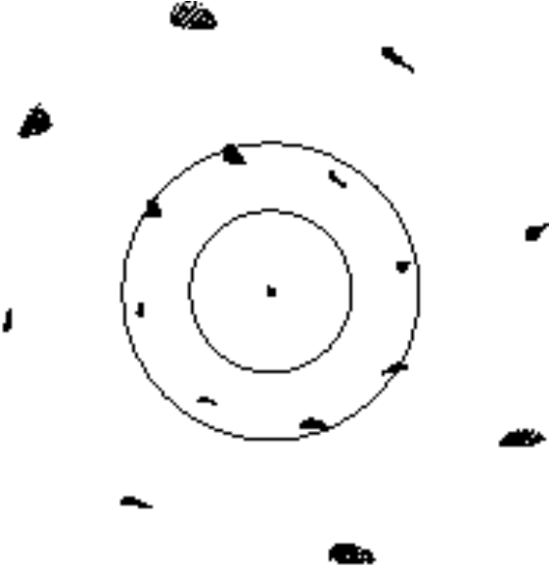
Figure 2-24 - Geometric spot diagrams at the centre, half field, and full field of the 2.6′ diameter spectrometer FOV. The spots are plotted in their actual positions and to scale. The concentric circles around the central spot have diameters 3.7 and 6.7 mm indicating the Airy disk size at 300 and 550 µm, respectively. With a maximum RMS wavefront error of 6.6 µm, the theoretical Strehl ratio is better than 0.97 anywhere in the FOV at 250 µm. Distortion corresponding to 9′′ or 6% of the FOV diameter is observed. The average focal ratio is f/4.9. Note: this is for the corner-cube option - for the roof-top option, there is no field rotation.

One feature of the optical design of the spectrometer is that the final re-imaging optics are non-telecentric – that is the beams at different parts of the field of view are not parallel (or nearly so), unlike in the photometer design. This feature is forced by the lack of physical space available to the instrument. Whilst with most detection systems this would not make very much impact, with the feedhorn arrays this causes some loss of signal as the detector “beams” only illuminate a portion of the pupil for off-axis detectors. To correct for the non-telecentricity a lens has been introduced into the optical train just ahead of the final focal plane. The lens will be made from Low Density Polyethylene and one will be mounted on each detector array at the same location as the final cold filter. Figure 2-25 illustrates the situation. In the short wavelength channel the lens is mounted some distance form actual geometric focal plane. This causes a slight degradation in classical Strehl ratio for this channel at some points in the FOV. The on-axis pixel is unaffected. The loss in Strehl ratio is more than compensated for by the increase in overall efficiency due to the much better illumination of the pupil stop.

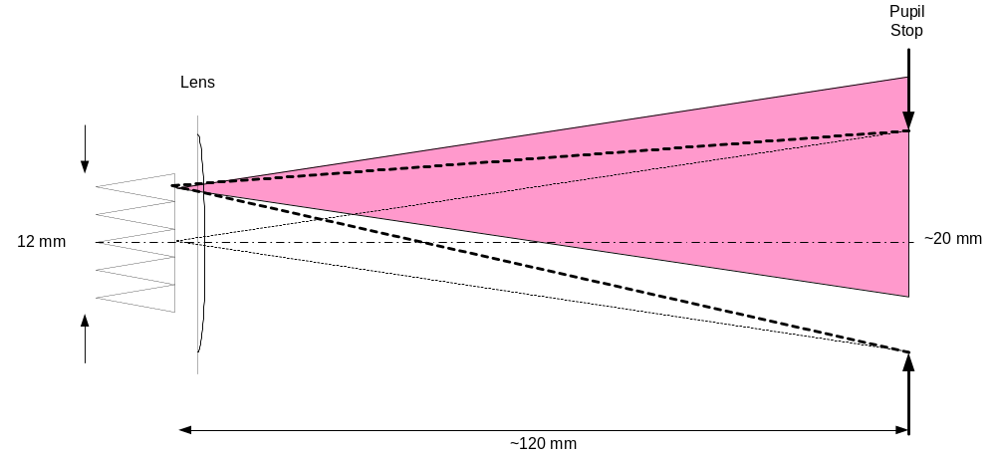
Figure 2-25 - Sketch of the final optical beams onto the spectrometer focal planes. There is a real pupil image of ~20 mm at about 119 mm from the focal plane which has a physical diameter of 23.8 mm. Off axis images therefore come onto the array at an angle of up to 3.5º – shown by the dark dashed line. The detectors themselves, because of the feedhorns, can only accept a certain range on input angles and, as they are configured to stare straight ahead, they only partially illuminate the pupil – shown in pink. Whilst this only causes a small loss of signal at the centre of the FTS mirror movement, at large mirror displacements the pupil images from the two interferometer arms shear past each other and the loss in fringe contrast will be greater. To counter this a lens is introduced at the location of the cold filter on the detector structure itself that tilts the beam pattern from the detectors to more nearly match the illumination of the pupil image.

Straylight control

Straylight control is defined as the reduction of any unwanted radiant power falling on the detectors in an instrument to such a low level that it has a negligible effect on the instrument performance. This includes both the removal of out-of- band power and the removal of in-band power from sources outside of the field of view. These might be radiating surfaces within the structure of the instrument or satellite directly viewed by the detectors or seen via reflection or diffraction from other parts of the optical chain and structure.

Bandpass filtering

Any surface with a temperature greater than ~10-15 K will emit radiation in the detection band of the SPIRE instrument. The Herschel telescope will be at a temperature of about 70-80 K with a (highly uncertain) effective emissivity of a few %. There will, therefore, be a relatively large photon flux falling on the SPIRE instrument entrance aperture from the telescope alone. Bolometric detectors are sensitive to radiant power at all wavelengths - therefore the first task in managing the amount of unwanted radiant power falling on the detectors themselves is to limit the spectral band of the incident radiation. This is achieved by a series of submillimetre filters as described in the SPIRE Filter Subsystem Specification Document. In practice a single band-pass filter does not have enough out-of-band rejection on its own, and four filters are used, strategically placed along the optical path, to reduce the out-of-band radiation entering each part of the instrument structure. The overall passband provided by these filters for the case of a prototype 350-μm filter chain is shown in Figure 2-26. The physical locations of the SPIRE filters are shown in Figure 2-19 and Figure 2-23 above.

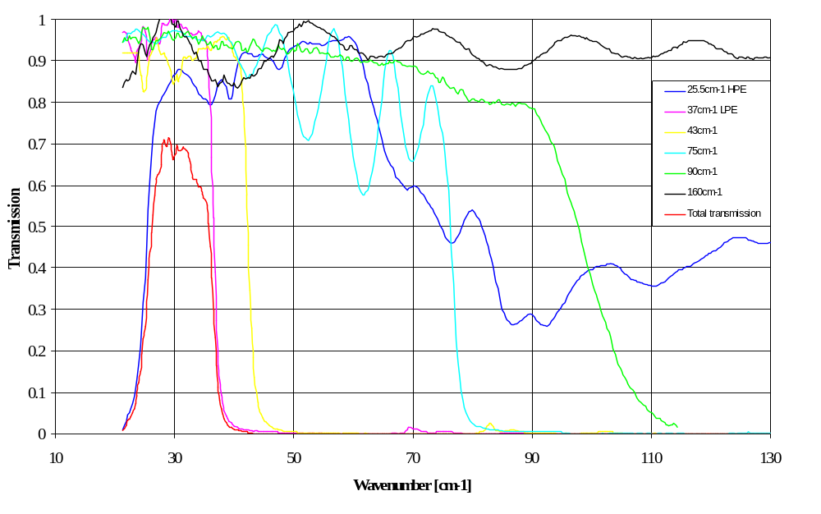
Figure 2-26 - Example showing the definition of a 350 micron photometer channel using real filters. The passband (λ/Δλ) in this case is ~3.

Baffling

Controlling unwanted radiant power that is in the spectral band of the detectors is effected in the SPIRE instrument by having a series of compartments within the instrument separated by physical barriers or baffles. The overall concept for the photometer is shown in Figure 2-28 and for the spectrometer in Figure 2-29. The optical design, as described above, is arranged so that the entrance to the instrument itself is at the field plane of the Herschel telescope and a physical aperture plate is placed here together with an optical filter that rejects most of the out-of-band radiation. The aperture plate is made just large enough to allow the beams generated by the detectors to pass out of the instrument with the minimum vignetting. In fact the beams will be chopped and jiggled around the sky so the aperture plate is slightly oversized compared to the detector footprint on-axis – Figure 2-27 (also see Definition of a combined focal plane plate for the SPIRE instruments).

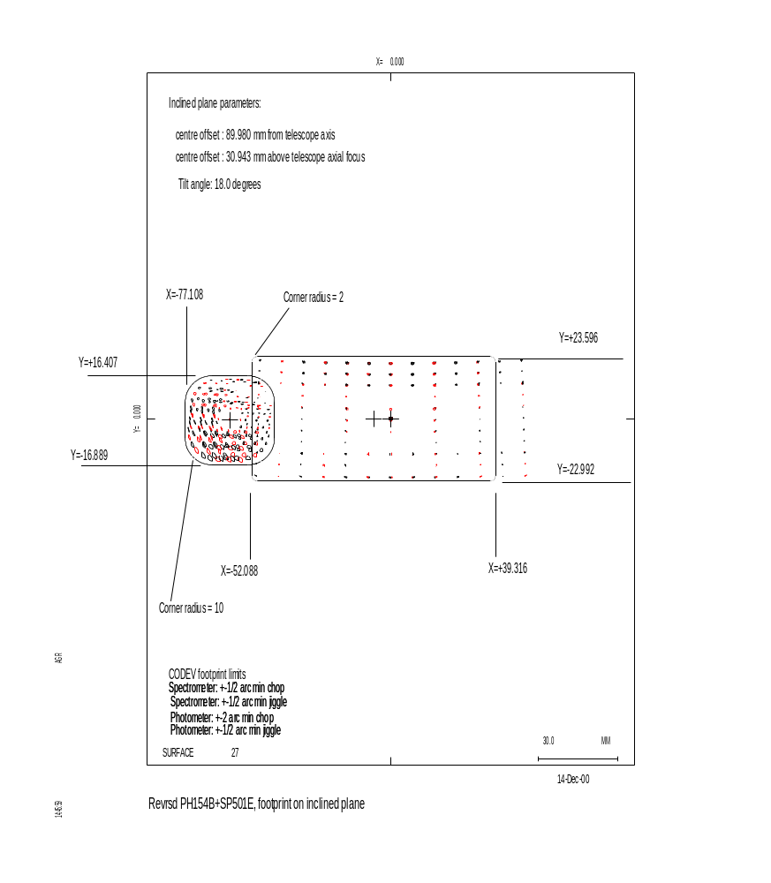
Figure 2-27 - Chopped and jiggled footprints of the photometer and spectrometer arrays at the focal plane of the Herschel telescope. The solid line shows the boundary used to define the physical stop that will be placed at the entrance to the SPIRE FPU.

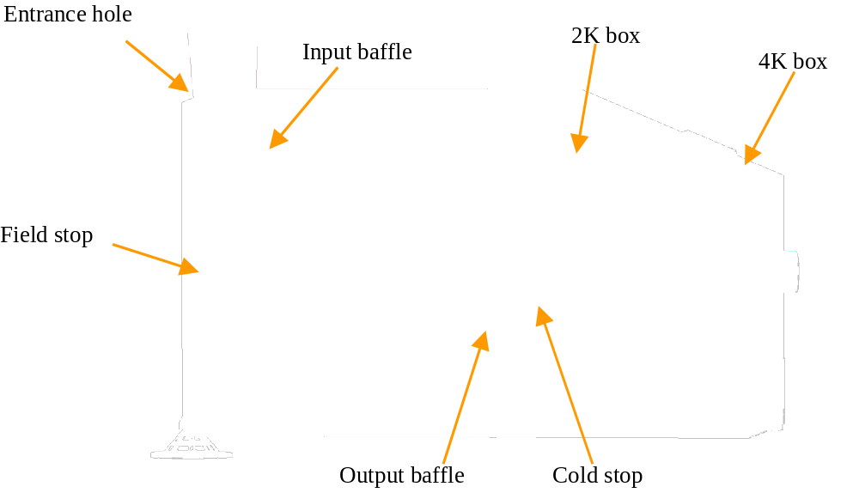
Figure 2-28 - Overview of the straylight baffling scheme for the photometer

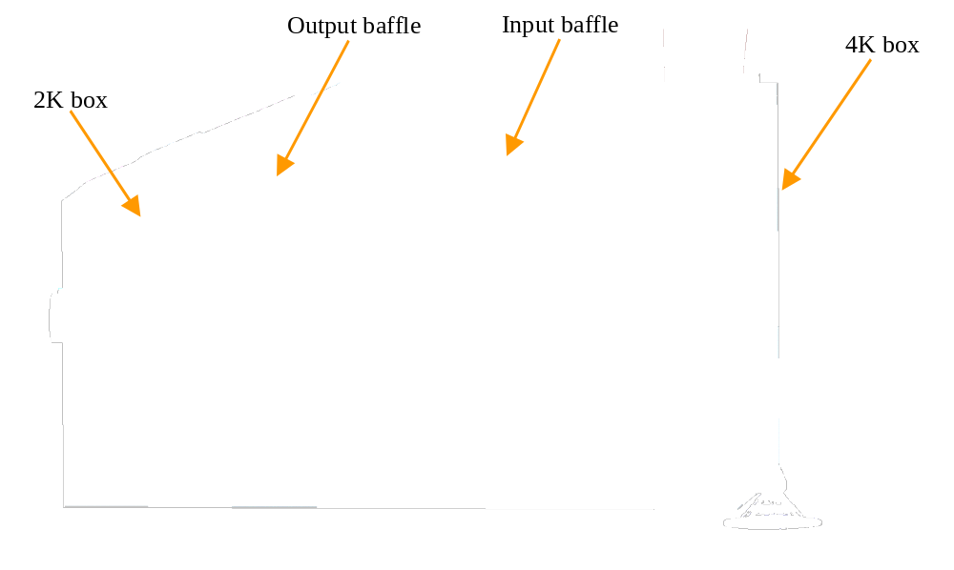
Figure 2-29 - Possible baffling scheme for the spectrometer.

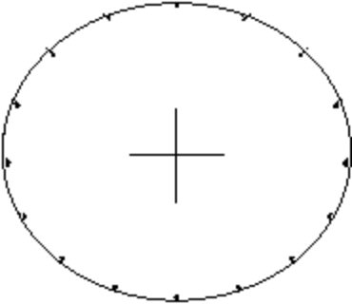 | 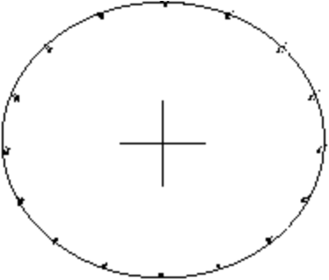
(a) | (b)
Figure 2-30 - Pupil spot diagrams obtained by tracing rays from 15 positions in the FOV through 16 points along the rim of the telescope pupil to the cold stop

The photometer detectors are mounted to a sealed box that is kept below 2 K by directly strapping the detector box to the Herschel helium tank (Level 0). An image of the secondary mirror of the telescope is made at the entrance to this box and a physical aperture placed around at exactly the size of the image – see Figure 2-30. In Figure 2-30a the M4 beam-steering mirror is in its neutral position, in Figure 2-30b it is tilted by 2.17°, changing the instrument pointing by 2′ in the sagittal plane. Assuming the nominal M2 image to run through the centre of gravity of each spot, we may measure the radial pupil error ΔR for each point in the FOV at each point along the pupil edge. A useful measure of pupil aberration is relative pupil displacement ΔR/R, found to be less than 5% both in the chopped and unchopped configuration. The good control of the geometric image of the telescope secondary means that the primary source of unwanted radiation from sources outside of the field of view from any part of the Herschel cryostat; telescope or sunshade is that passing into the instrument via reflection or diffraction from the telescope secondary mirror. Control of the straylight from such sources must carried out by the system level straylight control design. A further baffle is implemented in the photometer optical path between M7 and M8 to prevent the direct illumination of the cold box aperture by sources within the instrument box itself. The second bandpass filter is mounted at this point.

The straylight control within the spectrometer is more problematic than in the photometer as the motion of the scan mirror means that the final image of the telescope secondary mirror moves both laterally and along the optical axis. Instead of placing the pupil at the entrance to the cold detector box, therefore, it is placed at an image of the secondary made by the Fabry mirror SM6 at the field plane where the spectrometer and photometer fields are separated. A physical stop is placed at this pupil image, which is at Level 1. A filter is also placed at that position. As this stop is only ~25 mm diameter and, apart from holes for cables and thermal straps is the only aperture in the optical bench, the spectrometer part of the instrument box is very well baffled against radiation entering the instrument through the common entrance aperture. Two other baffles will be placed in spectrometer; one to prevent stray radiation from the calibrator reaching the detectors and one to prevent radiation from the mirror mechanism reaching the detectors – no filters will be placed on these baffles. The final baffle in the spectrometer is at the two entrances to the cold detector box where another filter will be placed as in the photometer.

The straylight model of the instrument has been constructed using the BRO APART code. A “reversed” Code V model has also been constructed to generate the optical paths from the detectors out through the system to space. These are the solid model beams shown in the general views of the instrument. By reversing the optical model one can determine more easily what it is possible for each part of the field of view to directly “see” within the Herschel system. The APART code is used to determine which straylight paths reach to detectors via multiple scattering and diffraction and what level of radiation falls onto the detectors from those paths given the physical construction; temperatures and scattering properties of the real system.

Diffraction limited optical analysis

One final aspect of the optical design that influences both the amount of straylight falling onto the detectors and the optical performance of the instrument in terms of both throughput and image quality, is the diffraction-limited nature of the SPIRE optics. For SPIRE the sizes of the optical elements and stops within the system are significant compared to the longest wavelength radiation that has to pass through the system – λ ~ 0.7 mm compared to optical stops of 20-25 mm in some cases. Use of the feedhorns over the detectors makes the diffraction-limited optics design somewhat more tractable as the feedhorns act as spatial filters and reduce sidelobes to a minimum. However, great care must still be exercised in the optical design to ensure that truncation of the beam from the detectors only occurs at the desired apertures: we need to limit the effective throughput of the instrument only at the telescope secondary and its image within the instrument optical train. Some truncation at the edges of the field of view is nevertheless inevitable at the field stop. All other optical components in the SPIRE instrument must be sufficiently oversized to allow the beams from the detectors to pass un-truncated at each and every point in the field of view.

The most basic rule of thumb that can be employed in taking into account the diffraction limited beam is to oversize all components by 20% of the geometrical footprint of the beam at the location of the element (see Figure 2-34). This is complicated by having a wide field of view as all beams from each detector must be amalgamated to make a single “instrument beam” before the oversizing is determined. This has been successfully done for all elements in the photometer optical train. In the spectrometer the situation is more difficult due to the moving mirror. The spectrometer components have been oversized to the physical limits possible but some truncation will still occur for some parts of the field of view at the limits of the mirror travel.

The BRO ASAP program has been used to ensure that the “20% rule” is indeed sufficient given the real Gaussian modes generated by the feedhorns and to determine what influence the truncation of the Gaussian modes has on the point spread function. Figure 2-31, Figure 2-32and Figure 2-33 show the angular responses on the sky (i.e., the calculated point spread functions) for the long-wave (PLW), medium-wave (PMW) and short-wave (PSW) photometer detectors at the channel centre wavelengths. The following assumptions were made:
- the telescope mirrors is the JPL design which was the nominal design at the time of the SPIRE IIDR (note that the changes to telescope design which have been made since then have no significant impact on the results presented here);
- the plots are calculated at the centre of the SPIRE FOV.

There is excellent agreement between these traces and the theoretical Airy disc radii for the Herschel telescope.

One further aspect of the diffraction limited design of the SPIRE optics is the change in optimum detector focal position with wavelength. This can be analysed using the ASAP code (Caldwell 2000) and the optimum detector positions found with respect to those given by the geometrical optical design. The detectors will be displaced along the optical axis at the position that gives the best coupling between the radiation field from the telescope and optics and the Gaussian mode generated by the feedhorns.
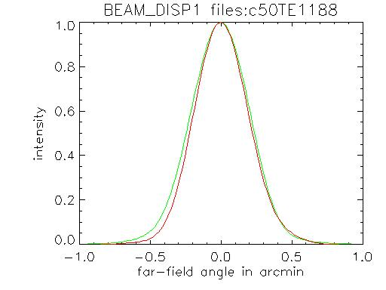
Figure 2-31 - PLW channel at λ = 500 μm, smooth-wall horn. The two profiles shown are principal sections of the response. Airy disc radius = 0.55 arcmin.

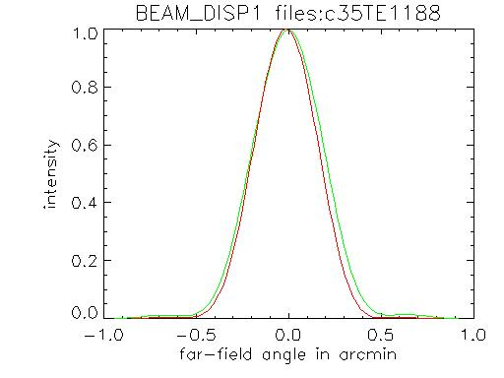
Figure 2-32 PMW channel at  = 35 m, smooth-wall horn. The two profiles shown are principal sections of the response. Airy disc radius = 0.38 arcmin.

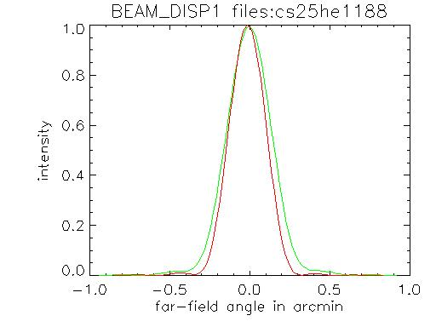
Figure 2-33 - PSW channel at λ = 250 μm, corrugated horn (smooth-wall case TBC). 2 profiles shown are principal sections of the response. Airy disc radius = 0.27 arcmin.

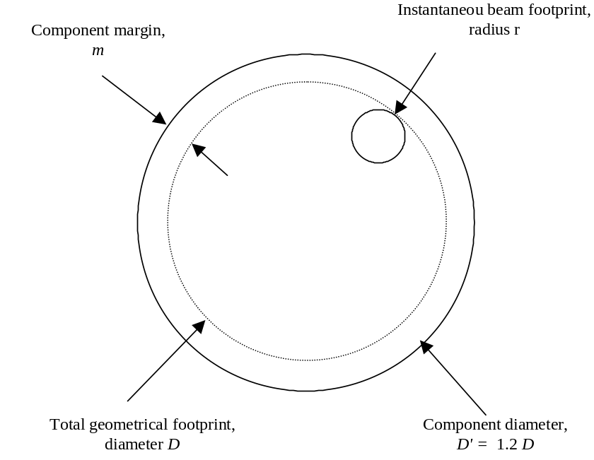
Figure 2-34 - Illustration of the 20% oversize rule and the comparison between component margin and instantaneous beam footprint.

Optical alignment

Alignment of the SPIRE FPU will be performed using a method based on high-precision machining and pre-assembly 3-D measurements and a programme of optical alignment checks during and after assembly. Nominally no adjustments will be needed but, if a serious misalignment is detected, its compensation will be possible by re-machining of the M6 mirror stand. Alignment of the instrument with respect to the telescope axis and pupil will be performed using a Herschel optical bench simulator consisting of a set of reference mirrors accurately located with respect to the instrument interface points. Verification of image quality and internal alignment stability will be effectuated using a set of alignment tools (sources, reticules, theodolites etc) mounted in strategic positions in the optical train (object plane, cold stop, image plane). The detailed alignment procedures are described in the SPIRE Alignment Plan. Details of the calculation of the optical alignment budget are given in the SPIRE Optical Error Budgets document, here we give an overview of the requirements on the alignment.

An optical sensitivity study shows that with an alignment tolerance of 0.1 mm and 1′ applied to all the mirrors in the photometer, the alignment-related relative pupil displacement will be less than ΔR/R_{I} = 4.1%. This compares favourably with the contribution from telescope alignment errors, budgeted to ΔR/R_{T} = 6%, and the theoretical design contribution of ΔR/R_{D} = 5%. The total instrument budget is estimated by square-summing of the random alignment errors and summing of the deterministic design error:

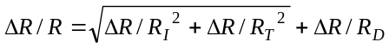,

giving a total of 12.3%. For an exactly sized pupil this gives a loss of 8% in telescope transmission factor.

For the spectrometer, the predominant alignment criterion is interferometer contrast, calculated from the misalignment-induced lateral separation of the interfering images using the van Cittert-Zernike theorem. Note that this only concerns mounting tolerances of the fixed optical components within the interferometer (beamsplitters and collimator/camera mirrors) since the interferometer design with its back-to-back corner cube reflector leaves the interferogram contrast insensitive to errors in the scanning movement. Again, tolerances of 0.1 mm and 1′ have been found appropriate, offering a contrast in the interferogram of 87%. Including mirror surface quality and differential aberrations a total contrast greater than 80% is expected.

Thermal design

The thermal design of the SPIRE instrument is dictated by the following requirements:

- to maintain the temperature of the structure, mechanisms, and optics at a low enough temperature that their thermal radiation is insignificant compared with that from the telescope;
- to achieve a bolometer temperature close to 300 mK, and to maintain this temperature in a stable manner for all instrument observing modes;
- to minimise the thermal load on the Herschel cryostat to maximise the mission lifetime.

Instrument temperature levels

Given these drivers and the structural layout of the SPIRE instrument, three basic temperature levels have been defined within the SPIRE FPU. The various optical components (mirrors, filters, beam splitters etc.) and other instrument sub-systems (structure, mechanisms, harnesses etc.) must not be allowed to radiate significant submillimetre power. The temperature of all components that can either directly or indirectly (i.e. via multiple reflections) irradiate the detectors must therefore be below around 6 K. The main structure of the instrument and most of the optics are therefore held at 5 K or less (Level-1 of the cryostat); the structure that houses the detectors is held at around 2 K (Level-0), and, in order to achieve a sensitivity matched to the photon noise limit from the telescope thermal background, the detectors must be close to 300 mK – this temperature is generated internally by the sorption cooler which is mounted from the Level-1 optical bench. The detector JFET amplifiers must run at a temperature of ~120 K so they are mounted on silicon nitride membranes which isolate them thermally from the surrounding structure. These membranes are then housed in a JFET units that is hard mounted to the Herschel optical bench at the cryostat Level-2 temperature of between 9 and 12 K.

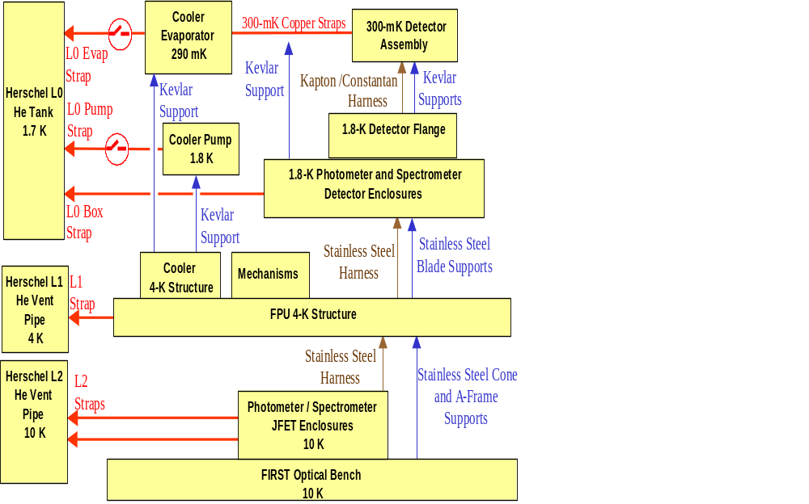

Figure 2-35 - Summary of the thermal analysis model for the subsystems within the CVV.

Cryogenic heat loads

To maximise the lifetime of the mission and therefore the quantity of science data, the rate of consumption of helium must be minimised. This is done by (i) minimising the power dissipated in the various sections of the instrument, and (ii) minimising the flow of heat from warmer stages to stages requiring lower operating temperatures. Stringent thermal budgets have been applied to all dissipating elements in the focal plane, and to the mechanical mounts that support the FPU from the Herschel optical bench; the mechanical mounts for detector cold boxes from the SPIRE optical bench and the support system for the various elements that have to be maintained at 300 mK. The electrical harnesses for the mechanisms and the detectors also contribute significantly to the thermal loads and these will have to be carefully designed to ensure that they meet both the electrical and thermal requirements placed upon them. The heat flows within the instrument are represented in an ESATAN model and shown schematically in Figure 2-35. A detailed description of the SPIRE thermal mathematical model is found in the SPIRE Thermal Configuration Control Document.

Temperature stability

The output voltage of a bolometer depends on its operating temperature, so the temperature of the bolometric detectors must be highly stable to achieve the required sensitivity. In addition, noise due to fluctuations in the background power incident on the detector caused by temperature variations in the instrument or telescope must be limited. A detailed analysis of the effects of temperature fluctuations on the sensitivity of the instrument in various operating modes has been conducted. The detector temperature must have a stability of 0.7 μKHz^{-1/2} in the signal band, dictated by the SLW channel (see Bock, 2001). The allowable drift rate for the detector temperature is determined by the need to extract point sources from scan map data and is 0.06 mK hr⁻¹.

For the various temperature stages seen by the detectors, the following maximum thermal drift rates are derived for the case of scan-map observations in Griffin (Griffin, 2002):

Level-0 temperature: 20 mK s⁻¹ 
Level-1 temperature (assumed 5 K): 290 mK hr⁻¹
Telescope (assumed 80 K with 4% emissivity): 180 mK hr⁻¹

EMC

Bolometric detectors are sensitive to any form of power input to the device. Unwanted electromagnetic radiation (from any part of the spectrum) absorbed by the detector will generate a spurious signal. Over and above this, any spurious RF power reaching the detector through conduction along the bias or signal wires will be dissipated through ohmic heating of the thermometer element, generating a spurious signal. It is critical therefore that bolometers be protected from EMI via an effective RF shield and a grounding scheme that prevents ground loops and protects the sensitive parts of the system from injected EMI. The system design and verification approach to EMC is described in the SPIRE EMC Control Plan.

Signal quality

The signal, gain and noise figures expected at each portion of the detection chain are shown schematically in Figure 2-36. The basic voltage level at the detectors and, after buffering by the JFETs, is of order of a few mV. The noise voltage spectral density at the detectors is of order 25 nV.Hz^{-1/2}, and all amplification and digitisation stages must contribute insignificant noise compared to this. The value of the basic detection noise also represents the sensitivity of the system to injected EMI.

Grounding and RF shield
In order to maintain the very low noise required at the detector it is necessary to create an RF shielded environment around the detectors and to filter all wiring entering the enclosure. In the SPIRE FPU, the RF shielded enclosure is created using the FPU box itself and the JFET boxes together with harnesses running between them – this is shown in yellow in . The only significant aperture in the RF shield will be the optical entrance aperture of the instrument itself. The RF rejection performance of real enclosures is difficult to model and predict as it is very sensitive to the detailed physical implementation and the necessary electromagnetic modelling is complex and computer-intensive. Whether there is sufficient attenuation of RF frequencies by the apertures along the optical path of the instrument remains to be seen. If tests prove that that further attenuation is required, a “chicken wire” type RF filter will be fitted to the instrument entrance aperture. At this location, the optical beam is defocused and the presence of a fine wire mesh in the beam would not cause significant distortion to the final image at the detector plane.

The grounding of the SPIRE electrical system is complex, even more complex than shown in the simplified scheme basic grounding scheme treats the two halves of the instrument, the photometer and spectrometer, as entirely separate electrical systems with their own power supplies and grounding. The analogue grounds of the two systems can be brought to a unipoint connection to the system ground through the thermal straps to the cooler – as shown in. However, there is a separate ground and power supply for the digital part of the detector control electronics (not shown in) which also has to be connected to system ground. There is some concern that this may lead to injection of noise into the analogue system via the system ground. Another possibility therefore is to isolate the RF shield at the cold end and connect to system ground in the warm electronics. Both these possibilities are open to us providing the mechanical structure of the FPU is electrically isolated from the cryostat. This will be implemented by electrical isolation washers on the feet of the FPU mounts and sapphire plates on the thermal straps between SPIRE and the Herschel cryostat.

In order to study the relative effects of various noise injection and signal cross talk, a SPICE equivalent circuit of the detectors and the read out and AC biasing electronics has been developed. This model can be seen in Figure 2-38.

The only significant aperture in the RF shield will be the optical entrance aperture of the instrument itself. The RF rejection performance of real enclosures is difficult to model and predict as it is very sensitive to the detailed physical implementation and the necessary electromagnetic modelling is complex and computer-intensive. Whether there is sufficient attenuation of RF frequencies by the apertures along the optical path of the instrument remains to be seen. If tests prove that that further attenuation is required, a “chicken wire” type RF filter will be fitted to the instrument entrance aperture. At this location, the optical beam is defocused and the presence of a fine wire mesh in the beam would not cause significant distortion to the final image at the detector plane.

The grounding of the SPIRE electrical system is complex, even more complex than shown in the simplified scheme basic grounding scheme treats the two halves of the instrument, the photometer and spectrometer, as entirely separate electrical systems with their own power supplies and grounding. The analogue grounds of the two systems can be brought to a unipoint connection to the system ground through the thermal straps to the cooler – as shown in. However, there is a separate ground and power supply for the digital part of the detector control electronics (not shown in) which also has to be connected to system ground. There is some concern that this may lead to injection of noise into the analogue system via the system ground. Another possibility therefore is to isolate the RF shield at the cold end and connect to system ground in the warm electronics. Both these possibilities are open to us providing the mechanical structure of the FPU is electrically isolated from the cryostat. This will be implemented by electrical isolation washers on the feet of the FPU mounts and sapphire plates on the thermal straps between SPIRE and the Herschel cryostat.

In order to study the relative effects of various noise injection and signal cross talk, a SPICE equivalent circuit of the detectors and the read out and AC biasing electronics has been developed. This model can be seen in Figure 2-38.

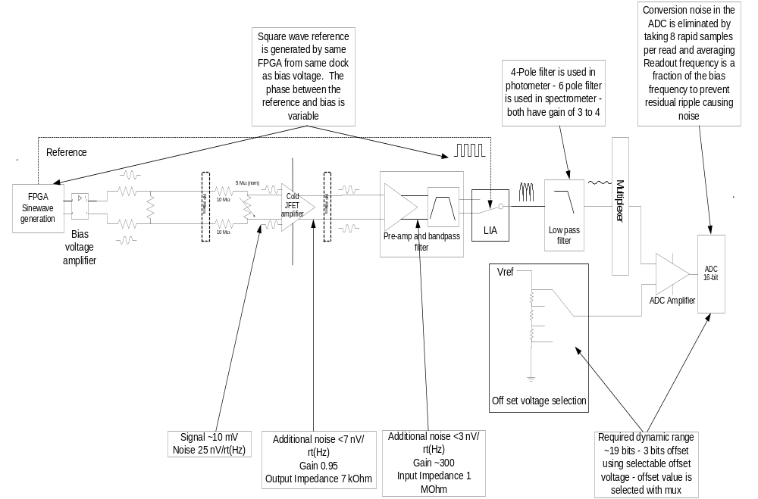
Figure 2-36 - Schematic representation of the SPIRE signal chain showing the noise sources and gains through the system

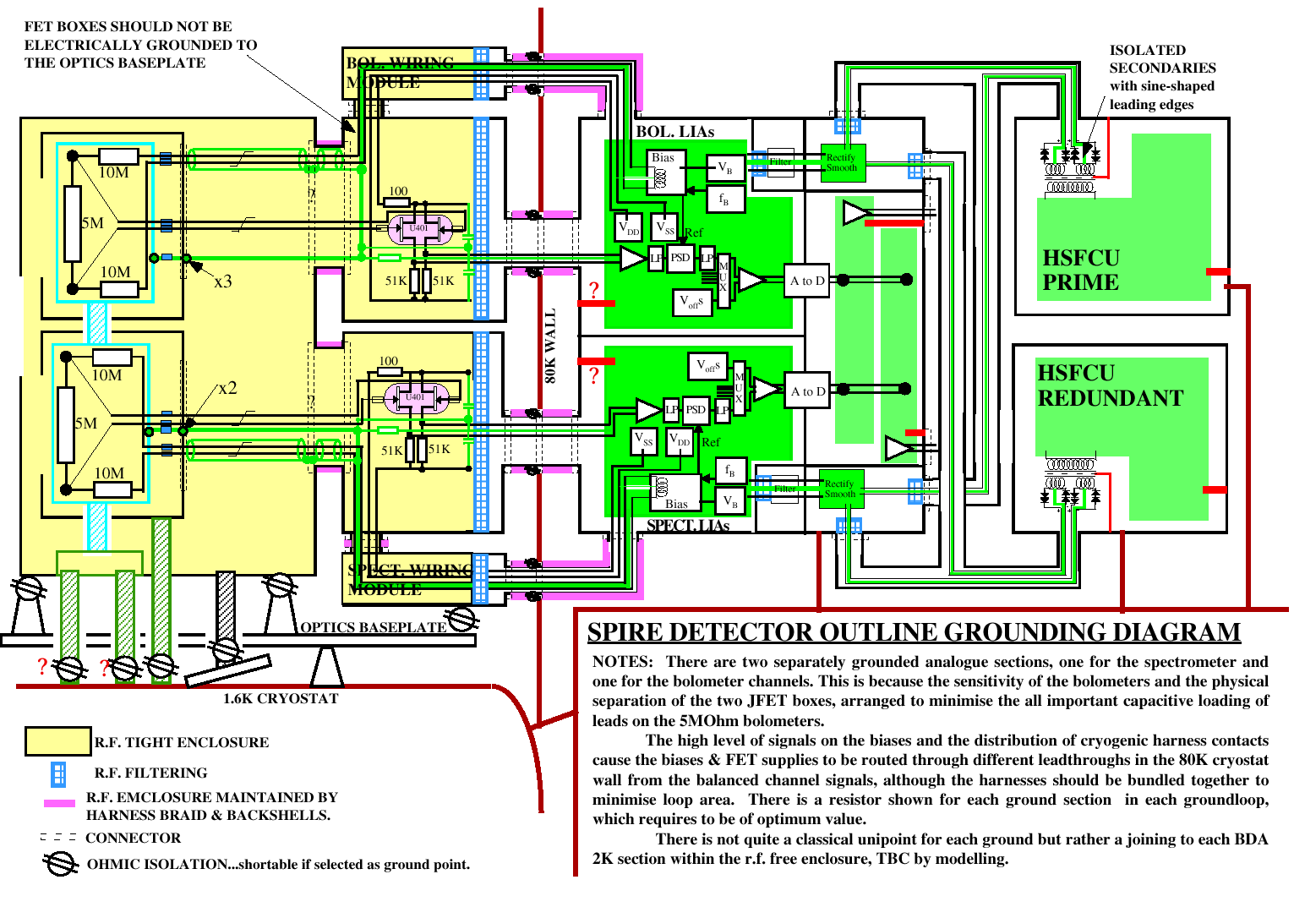
Figure 2-37 - Outline grounding diagram for the SPIRE instrument – this is subject to change and is shown for illustrative purposes only.

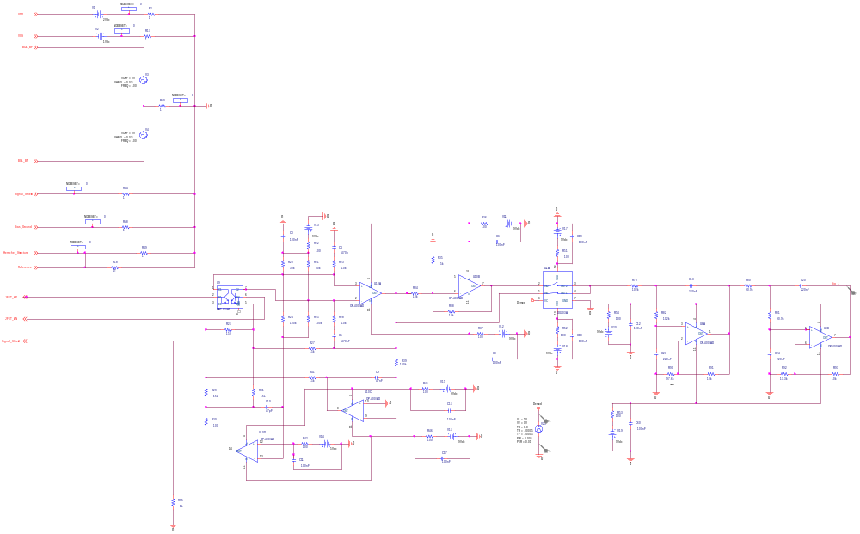
Figure 2-38 – SPICE model of the detector drive electronics used for EMC analysis.

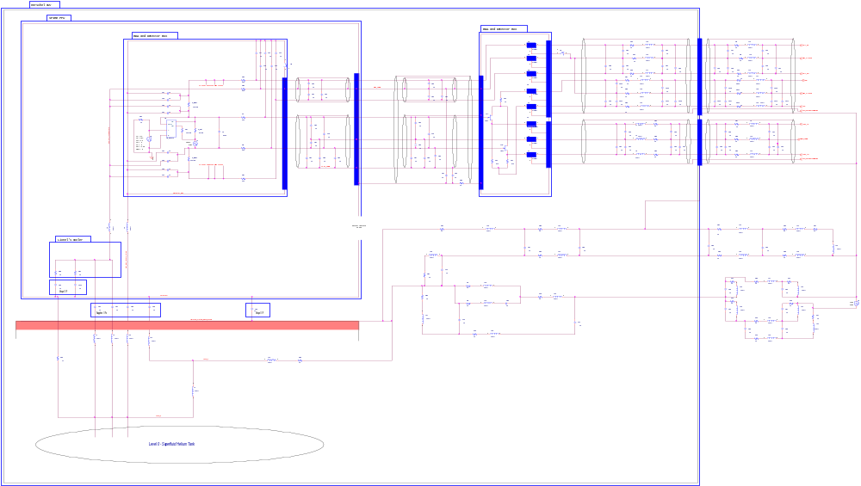
Figure 2-39 – SPICE model of detectors, Herschel structure and detector harnesses used in the SPICE EMC analysis.

Microphonics

The impedances of the NTD bolometer elements are on the order of 5 MΩ. This represents a compromise between high responsivity (which requires high impedance) and immunity to EMI and microphonic disturbance, which require a lower impedance). The JFETs located outside the FPU convert the impedance of the detection circuit to approximately 7 kΩ.

So-called microphonic effects are due to the physical motion of the detector wiring that result in either capacitative or inductive injection of voltages into the signal lines. The magnitude of microphonic induced noise increases with the magnitude of vibration of the harness and the support structure. With the low signal levels to be detected, very small vibrations of the wires cause a serious problem. Microphonic effects can be strongly suppressed by use of differential wiring. However, charge can build up due to the physical solicitation of asperities on the conductor and insulator interface.

As the harness connecting the bolometer elements to the JFET units represents the most vulnerable part of the detection system, it will be strapped down to the structure to give a minimum resonant frequency of any part of the harness of 1 kHz. In practice this means running the harnesses via the cold detector box supports, onto the optical bench and along the FPU covers. The harnesses will be strapped to the structure at intervals of approximately 1 cm. This routing is not optimum for the electrical requirements as the capacitance of the harness will be near to 100 pF, meaning that the bias frequency may have to be lower than initially desired to prevent roll off. However, the need to prevent induced noise from microphonics is felt to be an overriding concern as the bias frequency can be varied sufficiently in the electronics to optimise the performance of the detection system.

The spectrometer scan mechanism is also sensitive to microvibrations when operating in continuous scan mode. Microvibrations can add jitter noise to the scan mirror velocity, which is in turn translated into errors in the spectrum derived from the interferogram. This will only have a significant impact for low-resolution observations (for which the spectral information is encoded in the steep central maximum of the interferogram). Current estimates of the level of vibration from the spacecraft gyros and the allowable levels for the FTS mechanism indicate that the goal resolution can be achieved with some margin on the microvibration level. However, this issue will be kept under continual review, as the uncertainties in these estimates are large. In the event of a microvibration problem with the FTS mechanism, the low-resolution observations will be carried out in step-and-integrate mode.

System-level criticality

A top-level analysis has been conducted into the effects of a failure or partial failure of one of the SPIRE subsystems (Assessment of System Level Failure Effects for SPIRE, Swinyard). In this analysis the following failures are shown to be mission critical – i.e. a failure of one of these sub-systems will cause major loss of scientific capability for the SPIRE instrument:

- total loss of the cooler;
- Structural failure in the 300-mK system leading to thermal short;
- total loss of the photometer long wavelength array;
- total loss of either spectrometer array;
- total loss of the FTS mirror mechanism.

All other sub-system failures will lead to a greater or lesser degree of loss of performance and difficulty of operation, but they do not lead to a total failure of either the photometer or spectrometer scientific goals. The redundancy and reliability of these sub-systems will be addressed as a first priority.

For most sub-systems, cold redundancy can be provided to ensure a high probability of avoiding total failure in any part of the sub-system implementation. However in some cases this is not possible: for instance there will not be multiple detector arrays and only a single cooler will be fitted. In the case of the detectors, reliability is achieved by having many pixels arranged in blocks for the purposes of power supplies and multiplexing into ADCs etc. In the case of the cooler, and the 300-mK thermal architecture, large safety margins will be implemented backed up by testing, and “soft” failure modes will be considered to prevent dead thermal shorts in the event of structural failure.

An additional method of providing operational reliability is to define backup operational modes for the sub-systems and instrument. The following instrument backup operating modes are required in event of sub-system or system failure:

- more frequent cooler recycling including the possibility of autonomous recycling under control of the DPU alone;
- slow chop mode in the event of partial BSM failure;
- open loop BSM control using commanded current to the actuators;
- single axis BSM operation;
- slow scanning of FTS mirrors;
- step-and-integrate operation of the FTS in conjunction with the BSM;
- open-loop operation of the FTS mechanism by commanding the current to the actuator;
- DC operation of photometer calibrator this will allow V-I’s on detectors under different loadings for calibration;
- selection of smaller numbers of detectors from photometer arrays in event of telemetry bandwidth or FPU thermal dissipation problems;

selection of smaller number of spectrometer detectors in event of problems with telemetry bandwidth, FPU thermal dissipation, and/or loss of spectrometer calibrator.

Redundancy scheme

The general design philosophy of the instrument, as far as is possible, is that the total failure of a single sub-system will does not lead to the total loss of instrument operations. In order to achieve this, SPIRE has been designed with both a prime and a redundant side to the instrument. There is no electrical cross strapping between these two sides of the instrument, except at the SPIRE/Herschel data interface where both the Prime and Redundant HSDPU subsystems are each connected to the Prime and the Redundant Herschel MIL-STD-1553 data buses. Normally, to switch between the prime and redundant sides of the instrument, the spacecraft sends appropriate commands on the MIL-STD-1553 bus to the HSDPU to firstly shut down the HSFCU and then to prepare itself for shut down. Once the HSDPU is ready, the two prime spacecraft level LCLs in the HPDU that power the HSDPU and HSMCU are unlatched and the Prime side is then shut down. The two redundant LCLs are then latched and the Redundant HSDPU and HSFCU are powered up. Due to impracticalities, some systems (for example, the ³He Cooler) are not duplicated. In these cases, either the Prime or Redundant side of the instrument can control them. Importantly, in the signal detection subsystems, there is no redundancy in the detectors, the JFETs and the Lock-in Amplifiers. The specific redundancy scheme adopted for each sub-system is described in Table 2-1. Figure 2-13 illustrates the redundancy in the Warm Electronics. Figure 2-12 shows the redundancy in the FPU subsystems. It can be seen that the cryogenic bulkhead connectors J10 and J11 on the CVV wall are harnessed to the prime Filter Boxes (and from there the prime subsystems) Connectors J12 and J13 are connected to the redundant Filter Boxes and the redundant subsystems.

Operating Principles
The DPU (Digital Processing Unit) provides the interfaces between SPIRE and the spacecraft as shown in Figure 2-40.

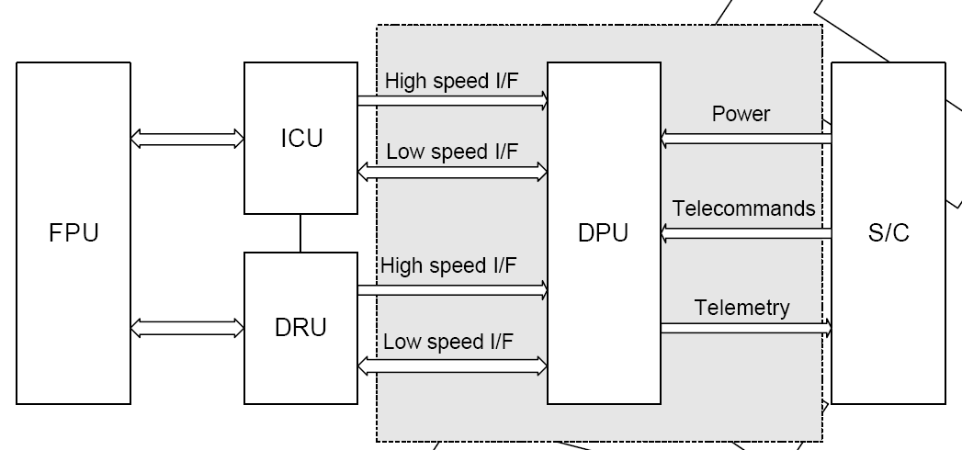

DRCU

Figure 2-40 DPU interfaces between SPIRE and the spacecraft.
Control of the SPIRE instrument is handled by the DPU part of the instrument electronics, which contains the On-Board Software (OBS). This unit is mounted on the spacecraft Service Module (SVM) and interfaces directly to the CDMS bus of the Herschel spacecraft for the purpose of transferring commands to, and collection of telemetry data from the instrument. All data passing between the instrument and the spacecraft is transferred in the form of telemetry and telecommand packets conforming to the ESA packet standards (RD15 and RD16). The ESA Packet Utilisation Standard (RD17) defines the types of service that may be provided by units on board ESA spacecraft, but the set of supported packet types within the Herschel project is restricted. This restricted set is defined in the Herschel Packet Structure ICD (AD02) and is the minimum set necessary to meet the satellite operational requirements given in AD03.

The DRCU (Detector Readout and Control Unit) contains the DCU (Detector Control Unit) and the FCU (Focal Plane Control Unit). The FCU contains the SCU (Sub-systems Control Unit), the MCU (Mechanisms Control Unit) and the PSU (Power Supply Unit). The DRCU (Detector Readout and Control Unit) has two kinds of interface with the DPU: one is devoted to low level command transmission (to the DRCU) for H/W configuration and housekeeping/status parameters reporting while the second is in turn devoted to data transfer from the DRCU to the DPU for further packing activities. While the low-level command interface is slow (312.5 kps), bi-directional with word-based protocol the data transfer interface is fast (between 1.25 Mbps and 2.5 Mbps depending on the subsystem (S/S)) unidirectional with frame-based protocol.

The command interface goal is manifold:
• Passing of commands from the DPU to the DRCU subsystems.
• Setting of DRCU Subsystems parameters.
• DRCU Subsystems synchronisation.

Physically it consists of 3 sets of bi-directional point-to-point links between the DPU and the DRCU (one link per DRCU subsystem except PSU: i.e. one for each of the DCU, MCU & SCU). The protocol is master-slave based, the DPU being the master.
It allows operating independently the 3 DRCU sub-units, all commands being sent simultaneously to the 3 DRCU subsystems with each subsystem recognising its own commands by means of an address inserted into the command word. In addition a broadcast address allows sending the same (broadcast) command simultaneously to the 3 DRCU sub-units.
The command format is fixed and consists of a 32-bit word with 3 fields:
• a DRCU sub-unit address field,
• a command identifier field,
• a parameter field.

DRCU subsystems, if addressed individually (with SYN0=0) reply with a response word with the following format:
• a field for reporting interface error (in place of the sub-unit address),
• a field echoing the command identifier,
• a data field which contains, either the echo of the command parameter, or a data requested by the command (housekeeping parameter).

In the case of broadcast command, no acknowledgement is sent back by the DRCU subsystems. If the DPU requires acknowledgement it has to be carried out by sending successive acknowledgement request (specific command) to the DRCU sub-units.

The Command Interface diagram is given in Figure 2-41: main and redundant interfaces are shown.

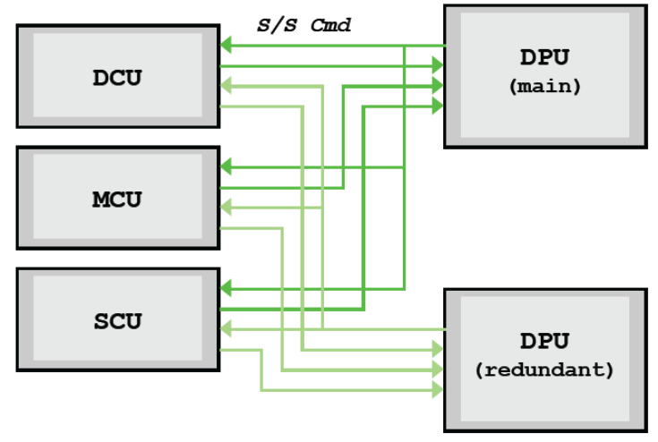
Figure 2-41 Command Interface Diagram

Instrument Configuration
Figure 3-42 shows a block diagram of the SPIRE instrument indicating the instrument units and the subsystems contained within them.

Figure 3-42 SPIRE Instrument Block Diagram

Hierarchical Configuration

Instrument Units:
The SPIRE instrument consists of several “units” as defined in RD04 and recapitulated in Table 3-4 together with brief descriptions of their functions and their locations on the Herschel satellite.

Instrument unit | Function | ESA code | Location
Cold Focal Plane Unit (FPU) | Contains the optics; mechanisms and detectors. | HSFPU | On Herschel optical bench inside cryostat
Focal plane JFET boxes (JFP and JFS) | These units contains the cold read-out electronics for the NTD germanium bolometers. There will be one each for the spectrometer (JFS) and photometer channels (JFP) in the SPIRE instrument | HSJFP  FSJFS | On Herschel optical bench inside cryostat
Detector Read-out and Control Unit (DRCU) | These warm electronics units contains the circuitry necessary to read-out the detectors; control the various mechanisms and provide instrument control and data handling functions. The FCU contains the power supply unit; mechanism control unit and the sub-system control unit which conditions thermistors and heaters. The DCU contains the electronics to drive the detectors and JFETS and condition the detector signals. | HSFCU  HSDCU | On spacecraft service module (SVM)
Digital Processing Unit (DPU) | This warm electronics unit provides the instrument interface to the S/C CDMS sub-system; receives and interprets instrument commands and formats the instrument data for telemetry to the ground | HSDPU | On SVM
Warm interconnect harnesses (HARNESS) | This connects the warm electronics units. | HSWIH | On SVM
Table 3-4 Instrument Units

Subsystems
Within each unit is contained one or more subsystems of the instrument according to the following decomposition (Partially taken from RD09).

ID | Product Item | Description
AA | HSFPU | Cold Focal Plane Unit
AA0_11 | Structure | ‘15K’, ‘4K’ and ‘2K’ boxes;  Thermal Straps ;  300mK subsystem  Structure Thermistors;
AA0_21 | Optics | Photometer mirrors and their mounts;  Spectrometer mirrors and their mounts;  Optical baffling, including baffle mounts;
AA0_22 | Filters | Passband filters;  Fore-optics filters;  Dichroics;  Polarising Grids;  Filter, Grids and Dichroics mounts (excluding detector filters);
AA0_41 | Photometer Arrays | PSW, PMW and PLW Photometer Bolometer arrays, including feed optics, cold readout electronics and  focal plane structure (including filter mounts and thermal strap);  Cold harness and connector(s);
AA0_42 | Spectrometer Arrays | SSW and SLW Spectrometer Bolometer arrays, including feed optics, cold readout electronics and focal plane structure (including filter mounts and thermal strap);  Cold harness and connector(s);
AA0_51 | Cooler | ³He Cooler Unit, including mechanical interface structure and cold finger interface structure;  Cooler cold harness and connectors;
AA0_61 | BSM | BSM, including mechanical interface structure  Cold harness and connector;
AA0_71 | Spectrometer | Spectrometer Mechanism (SMEC), including moving mirror support structure, spectrometer actuator, mirror movement measurement system, mechanical interface structure;  Cold harness and connector;
AA0_81 | Photometer calibration source | Temperature controlled radiation source, including mechanical interface structure;  Cold harness and connector;
AA0_82 | Spectrometer calibration source | Temperature controlled radiation source, including mechanical interface structure;  Cold harness and connector;
AB | HSJFP | Photometer JFET Box
AB0_10 | JFET Module | JFETs and associated components;  RF Filters and associated components;  Box and mechanical interface structure;  Cold harness and connectors;
AC | HSJFS | Spectrometer JFET Box
AC0_10 | JFET Module | JFETs and associated components;  RF Filters and associated components;  Box and mechanical interface structure;  Cold harness and connectors;
BA | HSFCU | Focal Plane Control Unit
BA0_10 | Power Supply Unit
BA0_20 | Mechanism Control Unit
BA0_30 | Subsystem Control Unit
CA | HSDPU | Digital Processing Unit
CA0_10 | Digital Processing Unit (including Power Supply);
CA0_20 | On Board Software
DA | HSWIH | Warm Interconnect Harness
DA0_10 | DPU to DRCU harness;

Physical Configuration
This may be found in RD04

Configuration Drawings
These may be found in RD04

Instrument Functions

Warm Electronics

The Warm Electronics are physically located on the Herschel SVM below the Cryostat Vacuum Vessel. The temperature of the SVM is conditioned to remain between -15°C and +45°C during operation of the instrument. The principal function of these subsystems is to (i) act as the back end for the instrumentation contained in the CVV, and (ii) to interface SPIRE with the Herschel spacecraft. This is illustrated in Figure 4-43.

=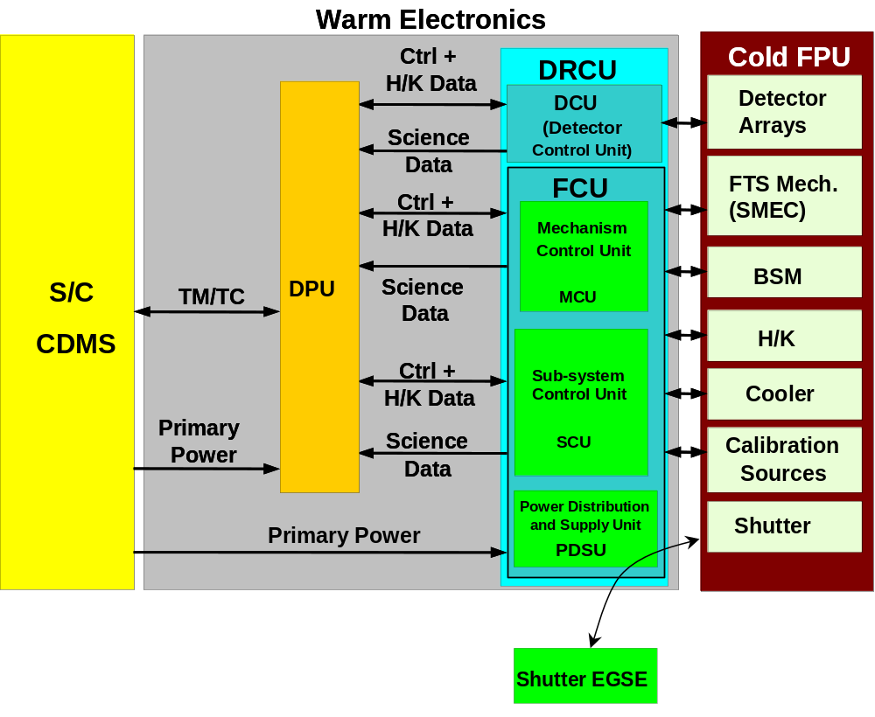
Figure 4-43 - Schematic representation of the Warm Electronics.

The Warm Electronics is composed of the DPU (Digital Processing Unit) and the DRCU (Detector Readout and Control Unit). The DPU acts as the digital data interface between the instrument and the spacecraft. The DRCU receives low level digital commands from the DPU and carries out the appropriate control function or data acquisition function. Data acquired by the DRCU is digitized and transferred to the DPU.

The DPU is housed in a single enclosure mounted on the SVM. The DRCU is split into two physical enclosures. The first of these contains the DCU (Detector Control Unit) electronics. The second of these boxes contains the FCU (Focal Plane Control Unit) which contains the SCU (Sub-systems Control Unit), the MCU (Mechanisms Control Unit) and the PSU (Power Supply Unit).

Digital Processing Unit (HSDPU)

The DPU interfaces with the Detector readout and Control Unit subsystem (DRCU) on the instrument side and with the spacecraft Command and Data Management System (CDMS) and the spacecraft PDU. is a high-level block diagram showing the electric and data interfaces of the DPU to the spacecraft and the DRCU. There are two types of data interface between the DPU and the DRCU: (a) high-speed, mono directional, serial data links for the transmission of science data (the FSDL) and (b) low speed, bi-directional serial links for command transmission (the LSL). The MCU, the DCU and the SCU each have one FSDL and one LSL with the DPU.

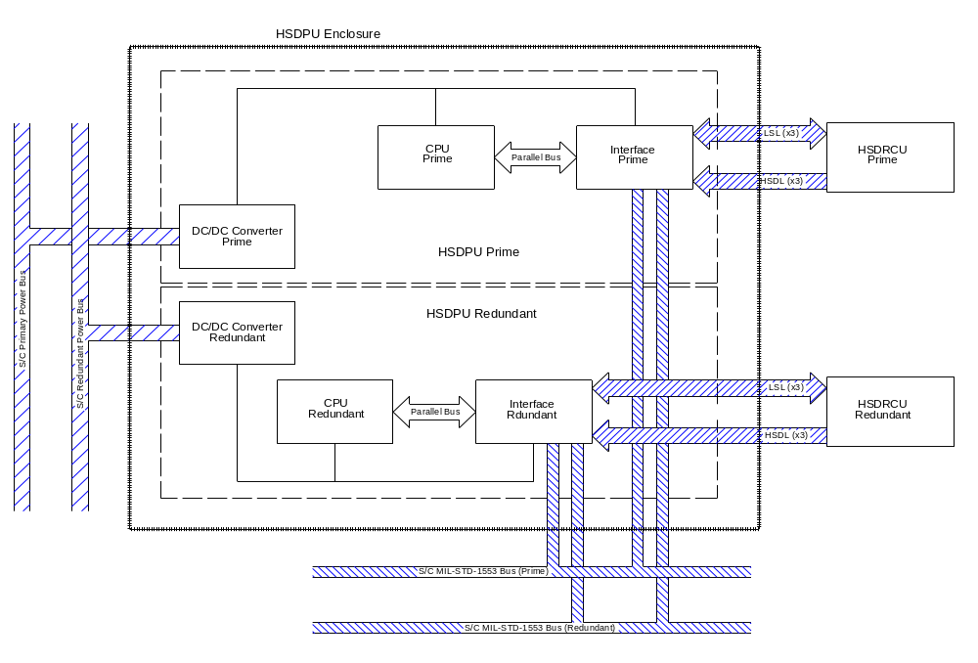
Figure 4-44 - Layout of the DPU showing interfaces with the DRCU and the Spacecraft.

The interface with the spacecraft has a baseline average 24 hour data rate of 100 kbps, with burst mode transmission rates of up to 350 kbps. This interface is compliant with the MIL-STD-1553B standard. The DPU acts as a remote terminal and the spacecraft CDMS acts as the bus controller.

There are four separate printed circuit boards used in the DPU: the Motherboard, the Interface Board, the CPU Board and the Power Supply board. A single Motherboard is used for both the prime and redundant functions while the other boards are implemented in a completely redundant configuration. These boards are discussed more fully below.

The mass of the DPU is estimated to be 6.621 kg ± 10%. The largest contribution to this is the mass of the aluminium alloy, RF tight box.

Motherboard: The motherboard is mounted inside the DPU enclosure and provides the back-plane interconnections between the prime CPU, Interface and DC/DC Boards along with the interconnections between the corresponding redundant boards. The wires from the external connectors are wired to the motherboard. The single motherboard is separated into two sections that contain the prime and the redundant boards. Each card (double euro) mounted on the motherboard has two 96 pin, DIN 41612 connectors. The connections between the various boards include power rails, a 32-bit system bus, serial digital interfaces and analogue signals.

DC/DC Board:
This board is mounted on the motherboard of the DPU. It is responsible for providing power to the digital electronics at the correct voltage. Power is supplied to the PDU at between 26 and 29V according to the IID-A requirements. The board supplies the internal electronics with ±15V, +5V, +2.5V and local Ground. The DC/DC SMPS converter runs at 131.072 kHz and has a conversion efficiency of greater than 70%. The maximum power output of the board is 23W (±20%).

The IID-A conducted EMC requirements on susceptibility and emissions apply to the power interface with the satellite. These requirements are fulfilled through the correct design of the input filter to the power switching circuit. The specifications on the quality of the output from the board are specified below in Table 4-5

Output | Vmin  [V] | Vmax  [V] | Imin  [mA] | Imax  [mA] | Ripple  [mVPP] | Spikes  [mVPP]
+5VD | 4.75 | 5.25 | 1000 | 3500 | 200 | 100
+15VA | 14.25 | 15.75 | TBD | 100 | 400 | 200
-15VA | -15.75 | -14.25 | TBD | 250 | 400 | 200
+2.5V | 2.375 | 2.625 | TBD | 200 | 200 | 100
Table 4-5 - Specifications on the power output from the DC/DC board of the DPU.
Over current protection is used on the outputs of the board. This automatically shuts the board down if any of the power outputs exceeds a preset maximum.

Interface board: A schematic diagram describing the functionality of the interface board is shown below in Figure 4-45. It identifies the different data interfaces managed by the board. The first interface shown in the top left corner is a serial Mil-Std-1553B interface with the S/C CDMU. It is managed by a BU-61582 chip acting in remote terminal mode. This chip is also connected to the 32-bit DPU system bus. The second interface type is shown by the three boxes in the top right hand corner labelled FSDL (Fast Science Data Link). These three data links upload serial science data from the DCU, the MCU and the SCU. The architecture of these three links is shown in Figure 4-46.

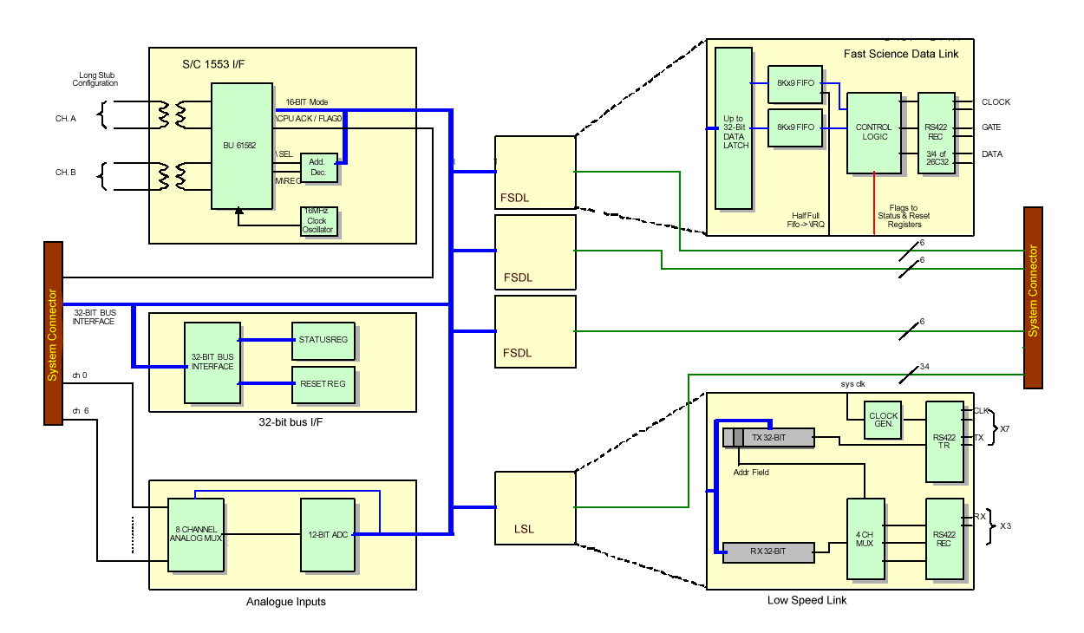
Figure 4-45 – Block diagram of the DPU I/F Board.

A 1 MHz clock pulse is generated inside the DCRU and is received by a RS-422 line receiver. This is gated by a signal indicating the transmission of a 16-bit word on the data line-pair. The data is sent by the DRCU as soon as it is ready. Therefore, the DPU must always be ready to receive data from the DRCU. An 8k FIFO buffer between the serial to parallel converter and the system bus temporarily holds the science data until it is commanded to be placed on the system bus. An interrupt is generated when the buffer is half-full indicating that the buffer needs to be readout onto the system bus. The interrupt handler ensures that no science data is lost.

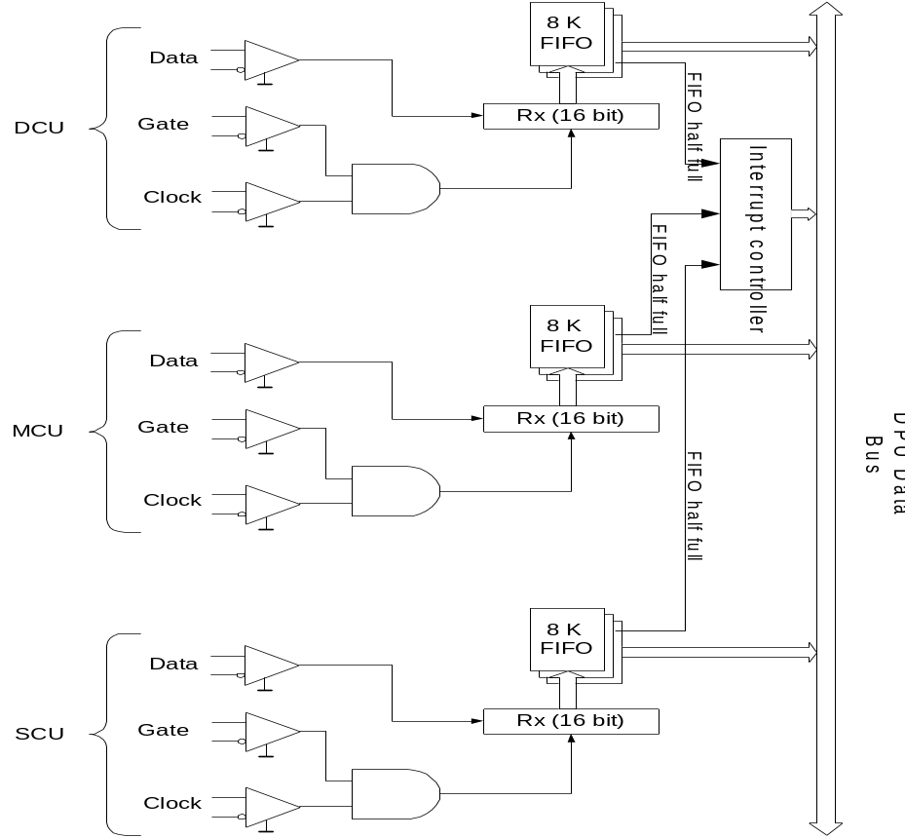
Figure 4-46 – Fast Science Data Link architecture.

The third interface shown on Figure 4-45 is the Low Speed Link (LSL). This is a bi-directional serial interface between the DPU and the DRCU. The architecture of this link is illustrated Figure 4-47. This link is used to send commands to the DCU, MCU and SCU and to receive housekeeping information from these boards. The Interface Board in the DPU board acts as the controller for this interface with the DRCU boards acting as slaves. Data is transmitted to the individual boards from the system bus. An addressing scheme is used to select the boards intended to receive the commands. A handshake protocol is used to ensure that commands have been received correctly. As the DPU is acting as bus controller, no buffer is required to receive the data sent by the DRCU.

The fourth interface shown on Figure 4-45 is the Analogue Inputs. This is used to readout the analogue signals from current and temperatures sensors within the DPU. They are converted to a 12-bit digital values by an ADC chip then placed on the system bus by a FPGA.

The fifth interface is to the system Data Bus. The bus has 24 address lines, 32 data lines, 7 chip select lines, read and write lines, clock (20 MHz) and a reset line.

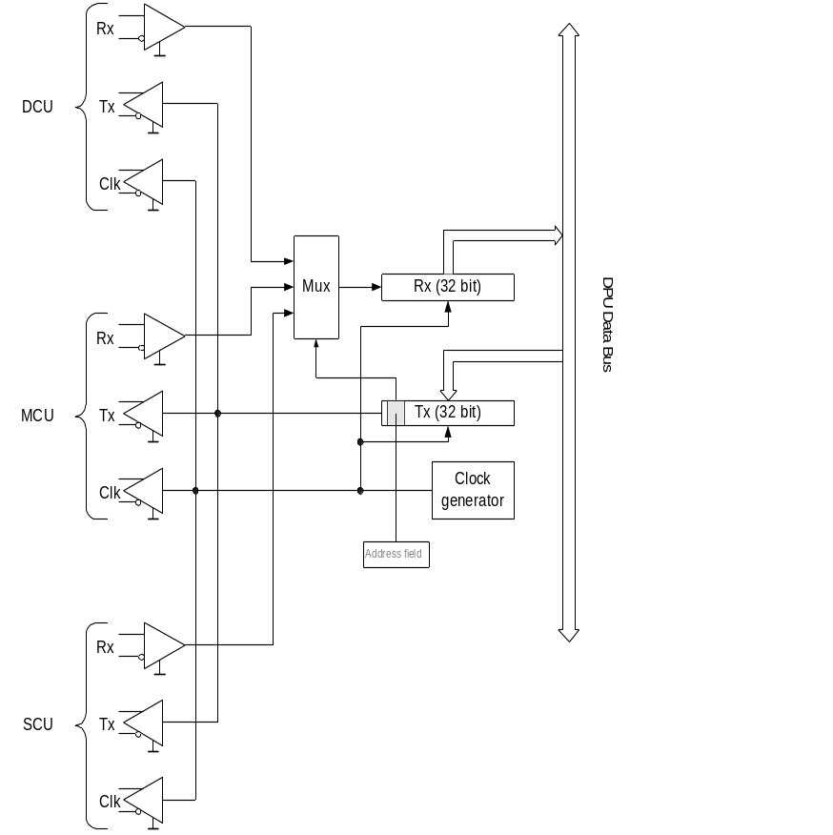
Figure 4-47 – Architecture of the Low Speed Link of the DPU.

CPU Board: A block diagram showing the main components of the CPU board is shown in Figure 4-48. A mezzanine board mounted on the main CPU board accommodates some of the components. The microprocessor is a TEMIC TSC 21020 which is the Analog Devices 21020 Digital Signal Processor (DPS) adapted for space applications. The DSP runs at 20 MHz and is capable of peak computational rates of 20 MIPS and 66Mflops and has provision for four hardware interrupts. There is 512k of 48-bit program memory and 512k of 32-bit data memory. A Control FPGA chip is used to provide the following services:
- a system bus control and management,
- a local peripheral timing adjustment,
- a mezzanine interface, (used to increase the number of available interrupts to eight)
- boot logic,
- an interrupt manager,
- a system watchdog (used to detect lockup of the DPU),
- an interval timer.
A 256k 32-bit EEPROM chip is used to store the program. The program is transferred from the EEPROM into the program by the DSP.

A schematic representation of the information flow within the DPU is shown in Figure 4-49. On the top left hand side of the Figure, the DPU “Command-handling” electronics receives and interprets commands from the CDMS. Upon successful receipt of these commands, a handshake/acknowledge message is sent back to the bus. The high level commands from the CDMS are processed by the DPU to provide digital driver commands to the DRCU (which acts as the analogue drive/read out electronics for the cryogenic part of the instrument) and are executed in real time. It is the task of the spacecraft to determine the sequence and absolute timing of the commands to be passed to SPIRE. These commands are passed to the DRCU via the “Commanding” block in the lower left hand corner of Figure 4-49. Science frames and housekeeping data from the instrument are passed to the “Data Collection” block via the high-speed data interfaces with the DRCU. The housekeeping data (such as instrument temperature, control currents etc.) are monitored by the “Autonomy” block. In the event of a fault condition in the DRCU or in the cryogenic section of the instrument, commands are passed to the DRCU to put the instrument into safe mode. Notification of a fault condition is also passed to the CDMS via the “Packetisation Block” in the top right corner of Figure 4-49. The CDMS then determines if the instrument should be turned off and unlatches the LCL for the DRCU and the DPU as necessary. All data passed from the DPU to the CDMS is formatted according to the ESA Packet Utilisation Standard.
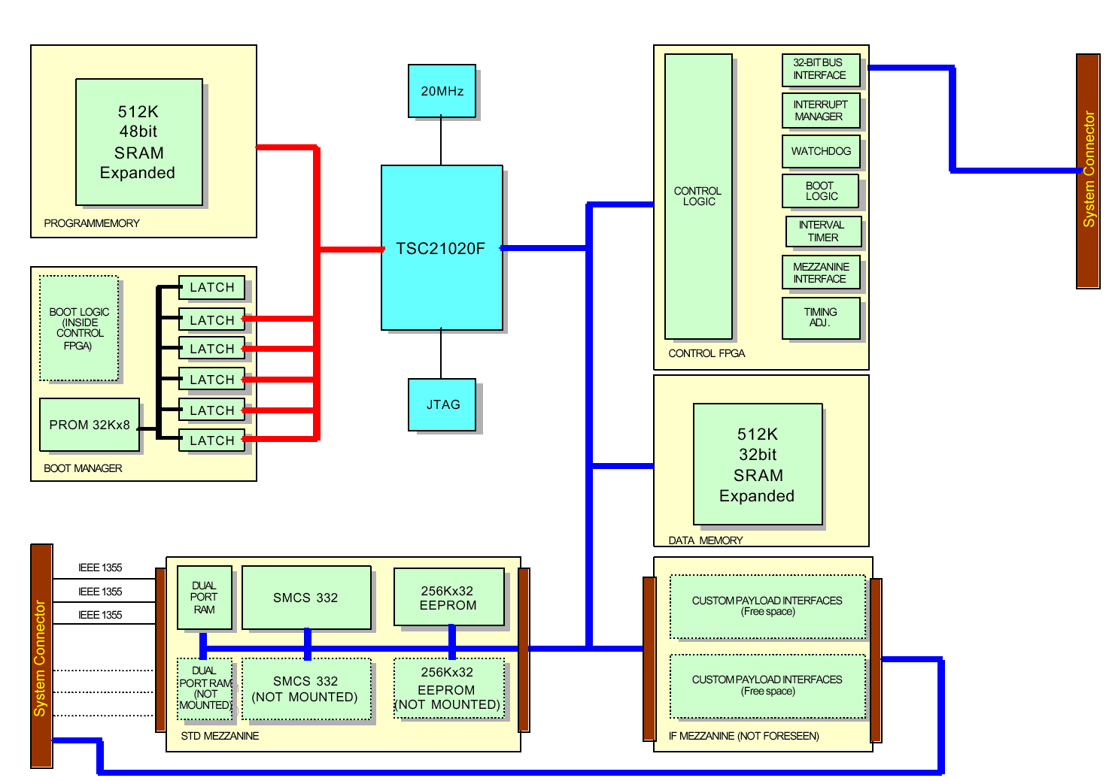
Figure 4-48 – CPU board block diagram.

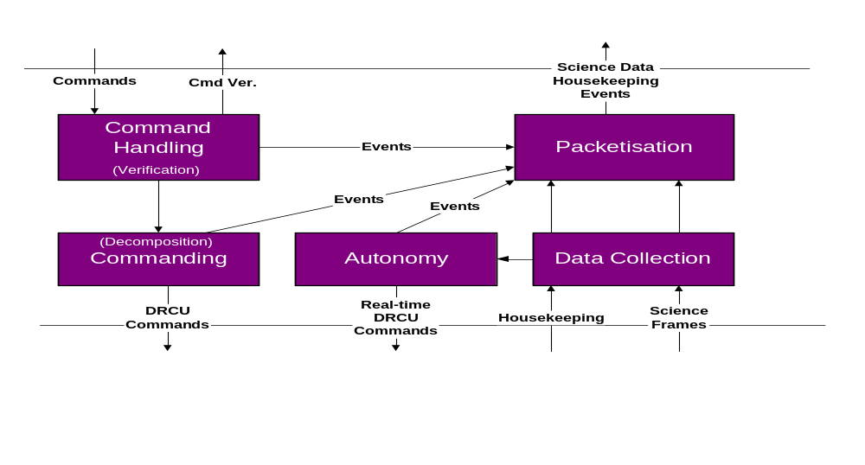
Figure 4-49 - Conceptual diagram showing the flow of information within the DPU.

Onboard Software
The CPU board carries in the PROM the basic software to drive and control the DPU. The tasks the OBS carries out are schematically shown in Figure 4-50.

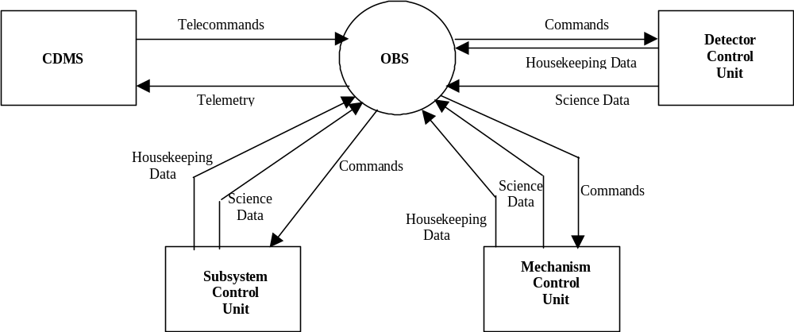
Figure 4-50 - SPIRE DPU On Board Software Context Diagram.

The main functions of the OBS are the:
- acceptance of instrument commands from CDMS;
- execution of predefined commanding sequences;
- instrument health/status monitoring;
- implementation of pre-defined procedures on detection of instrument anomalies. When an anomaly occurs, the OBS either (i) adjusts the instrument operation parameters, and/or (ii) switches the operating mode and/or (iii) activates subsystem redundancy;
- science data acquisition and packetisation;
- HK data packetisation;
- transmission of data (science, HK, events and telecommand verification) from the instrument to the CDMS.

In addition, the OBS shall provide the following software oriented functions:
- the ability to load, via telecommands, replacement and/or additional software (patches, tables, command sequences);
- self-test and software verification facilities;
- the possibility to load and dump part of DPU/DCU memory;
- the possibility to write and check EEPROM;
- the possibility to inhibit these functions during flight operations.

Detector Readout and Control Unit (HSDRCU)

The DRC is an electronic unit housed into two boxes: the FCU and the DCU, located between the FPU and the DPU. The DRCU includes the front-end electronics of the following sub-systems:
- BDAs,
- SMEC,
- Beam Steering Mirror,
- Cooler,
- PCAL and SCAL,
- Thermometry & Analogue Housekeeping,

The DRCU comprises 4 physical sub-units:
- the DCU which includes the detector control, biasing, readout and digitization electronics;
- the MCU includes the mechanisms’ (FTS+BSM) control electronics;
- the SCU includes the sub-system control electronics; and
- the PSU which takes power from the spacecraft power bus and converts it to the required voltage for the other sub-units of the DRCU.

These components are schematically represented in Figure 4-51.

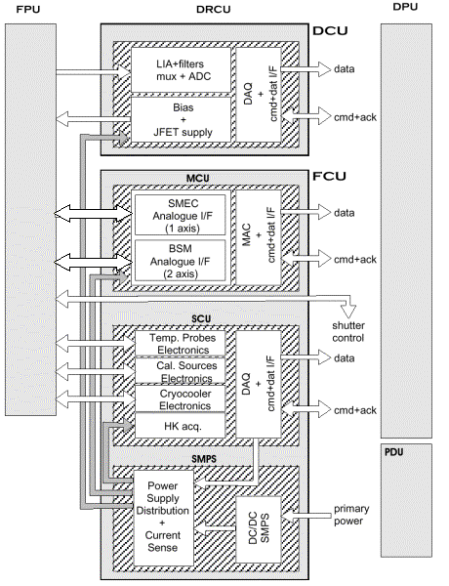
Figure 4-51 - Schematic block diagram of the DRCU including the interfaces to the DPU and the FPU.

Detector Control Unit (DCU)
The DCU acts as the interface between the analogue signals from the detectors and the digital DPU. A schematic drawing of the DCU together with the detector train components in the FPU and the interfaces with the DPU and FCU is shown in Figure 4-52. There are three basic board types used in the DCU; the Lock-in Amplifier (LIA) boards, the Bias Boards and the Data Acquisition and Interface (DAQ + I/F) boards. They are all connected by the motherboard, which forms the back plane for the other boards.

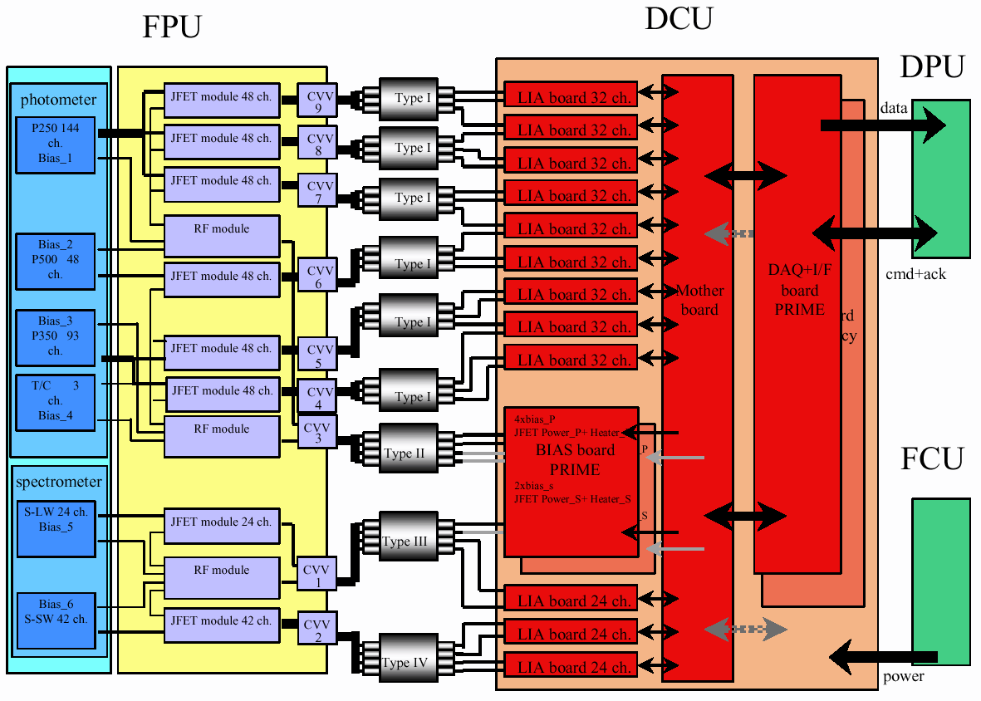
Figure 4-52 - Schematic representation of the DCU including it's interfaces with the FPU, DPU and FCU.

Bias Boards: Three different biases are provided by the Bias Board, as listed below.
- DC biasing of the JFET modules,
- DC biasing of the JFET heaters, and
- AC Biasing of the Photometer BDAs, Spectrometer BDAs and the 300-mK Thermal Control System.

Detector Bias Generators: The detectors are differentially biased with an AC voltage, which is provided by the Bias Generator board. Separate generators are used for Due to the criticality of this component of the detector read out electronics, there is both a prime and redundant board for the bias signals. The amplitude, frequency and phase of the bias signals are all software commandable with the XC-4010-200 FPGA chip on the DAQ + I/F board. This FPGA generates a series of 12-bit words, which correspond to the amplitude of the bias signal. These words are loaded into Analog Devices AD7475A, 12-bit DAC chips that generate the analogue bias signal. These signal are then amplified to the required amplitude with Analog Devices OP-400 operational amplifiers. The characteristics of the bias signal are summarized in Table 4-6.

Number of channels | 48  96  144  24  48 | PLW BDA  PMW BDA  PSW BDA  SLW BDA  SSW BDA
Signal AC amplitude | 10 mV | Dark condition
Signal DC level | 5 mV | JFET V_{Osmax}
Common mode offset | 1 V | DC
Noise allocation | 7 nV/Hz^{1/2}  0.64 pA/Hz^{1/2} | 0.05 to 25 Hz
Input capacitance | < 100 pF
Input impedance | > 1 M
Base band signal bandwidth | 0.03 to 5 Hz  0.03 to 25 Hz  5 Hz | Photometer  Spectrometer  Thermometry
Input noise impedance | > 7kΩ
Common mode rejection | - 60 dB | 30–300 Hz
Table 4-6 – Detector driver electronics specifications.

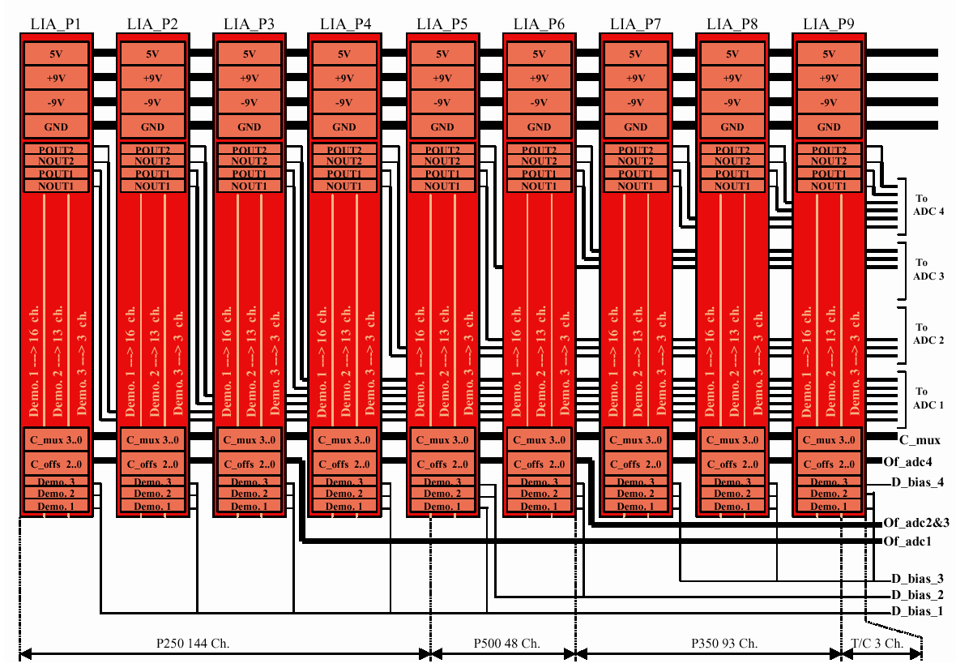
Figure 4-53 - Back plane connections to the photometer LIA cards. The spectrometer LIA boards are conceptually indentical.

LIA Amplifiers: The Lock-in Amplifiers are used to read out the AC signals from the detectors and convert them into DC. Each bolometer has a dedicated amplifier. The amplifiers are grouped together in groups of 32 on each LIA board. Figure 4-53 shows the interconnection between the LIA boards on the motherboard. The analogue output from each of the amplifiers is placed on a bus connected to the DAQ + I/F board.

Each individual amplifier has;
- a differential input pre-amplifer circuit that uses Analog Devices OP-400 operational amplifier;
- an Intersil, DG303A digital switch. This takes the pre-amplified AC signal from the bolometer and full wave rectifies it using the signal from the bias generators. The switching is signal is phase commandable to compensate for any signal phase change that occurs between the detector and the digital switch in order to maximize the output from the switch;
- an active post low pass filtering circuit that removes the bias frequency and bias harmonic components from the rectified signal. The low pass filter circuit uses two Analog Devices OP-400 operational amplifiers.

These three components are illustrated in Figure 2-36. There are a total of 12 LIA boards; with nine being used for the photometer and three used for the spectrometer.

The DAQ + I/F boards: The analogue signals from the 288 photometer channels and the 72 spectrometer channels need to be converted into digital values. To get the required precision, the signals are digitised into at least 19-bit precision. Firstly, the DC offset is removed from the analogue signal. This offset is the three most significant bits of the digitisation. The signals are then passed into an analogue multiplexer before being passed to a 16-bit Analogue-to-Digital converter chip. The conversion of all the photometer channels is performed in less than 6.2 ms; the spectrometer channels in less than 1.2 mS. The digitised signals are then passed to the DPU via the HSDL. The board also manages the LSL link and the commanding of the DCU.

Mechanisms Control Unit MCU
The MCU controls and monitors the two mechanisms of the SPIRE instrument, viz.:
- the Spectrometer Mechanism (SMEC). The control is typically based on a scan at a configurable speed, but can be set-up on the basis of a step position control in case on use of the step and integrate mode of the instrument;
- the chopper and jiggle axis of the Beam Steering Mirror subsystem . The control is a position step control pattern.

The position and rate control of the 3 axes is performed by an Analog Devices 21020 DSP chip using PID control architecture. The MCU software is based on a master scheduler using the principle of time sharing without a specific multi tasking kernel. The tasks to be performed shall be called on the basis of a software interrupt generated by the inner DSP timer. The software interrupt defines the global sampling time (ie the computation cycle) of the DSP tasks at a programmable rate of between 100 and 300 μs. During each cycle, the following tasks are performed :
- the SMEC control loop task
- the BSM chop control loop task,
- the BSM jiggle control loop task,
- the communication with the command line and other various internal DSP tasks.

The scan parameters are put in memory for configuration purpose with a command bi-directional serial line.

The MCU receives commands from the DPU via a 32-bit, bi-directional serial interface. The MCU also sends three types of data back to the DPU:
- H/K Data: which consists of the readout of single variables read by the command line at a rate of about 1 Hz. The H/K variables readout by a get-parameter command from the DPU. The delay between transmission of a H/K readout request and the response is about 500 μs. Typical H/K variables include, mean SMEC scan speed, SMEC control status, SMEC encoder status, Chopper mean position, Jiggle mean position etc.
- Trace Data: The trace data is a buffer in the DSP memory which contains a long data acquisition. The number of trace variables, the sampling time, the length of the data buffer are programmable. This buffer can be read off-line, i.e. when the DPU sends a dedicated command for each variable. Typically, the trace data mode shall be used for the scanning of large number of samples for engineering purposes;
- Telemetry Data: The telemetry data is the SMEC time counts between two encoder 2 micron positions and the BSM chop and jiggle positions The telemetry data is transmitted on a fast 16-bit, 1 MHz serial line. The telemetry line is independent of the DSP control and monitoring and is used for the delivery of data related to the detector signals , with a high level of synchronisation.

Physically, the MCU is composed of a motherboard which acts as the back-plane for the with two MAC (Multi-axis Controller) boards, the two SMEC boards a the single BSM board. All these boards have a prime and redundant side. Figure 4-54 shows the schematic block diagram for these boards. The MAC interfaces via two digital interfaces with the DPU. The first link is a bi-directional 32-bit serial interface for the transmission of telecommands from the DPU and the retransmission of acknowledge words back to the DPU. This interface is controlled by a FPGA chip. The commands are then passed to the DSP chip. During normal operation, the DSP cycles at a frequency between 10 kHz and 3.33 kHz through the following sequence:
- the SMEC digital PID control algorithm is updated;
- the chop stage BSM digital PID control algorithm is updated;
- the jiggle stage BSM digital PID control algorithm is updated;
- the trace table is updated;
- any commands from the DPU are uploaded from the FPGA and the acknowledge reply is sent.

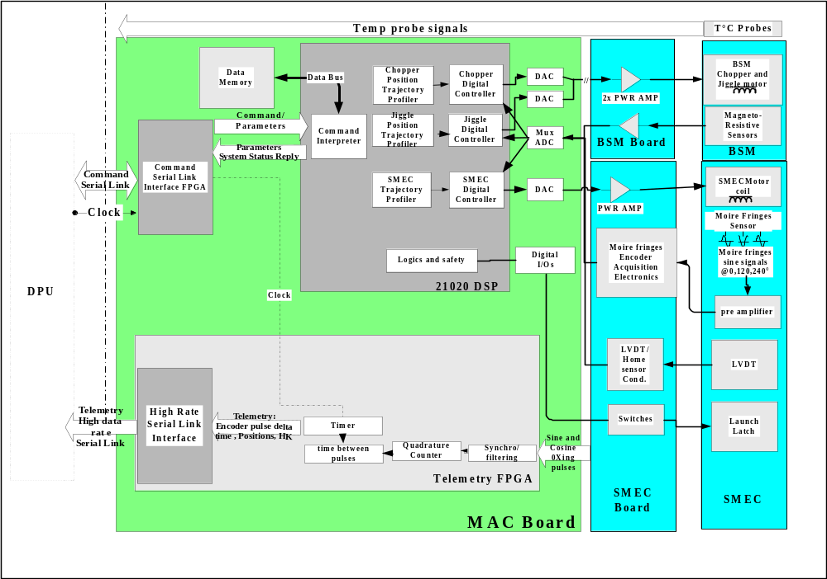
Figure 4-54 - Architecture of the MCU.

The PID algorithm is implemented in software using standard 21020 assembly language without the use of a specific off-the-shelf real time operating kernel. The assembly language is chosen because Analog Devices provides directly specific libraries to produce PID, filtering, arctan computation with a high efficiency and readability.

The SMEC is typically required follow a saw-tooth position profile as shown in Figure 4-55. The scan nominally starts from 3 mm before the Zero Path Difference (ZPD) position, through to 32 mm. The absolute position of the mirrors vs. time is required in order to be able to obtain a spectrum from the detector signals. This is done in a two step procedure.

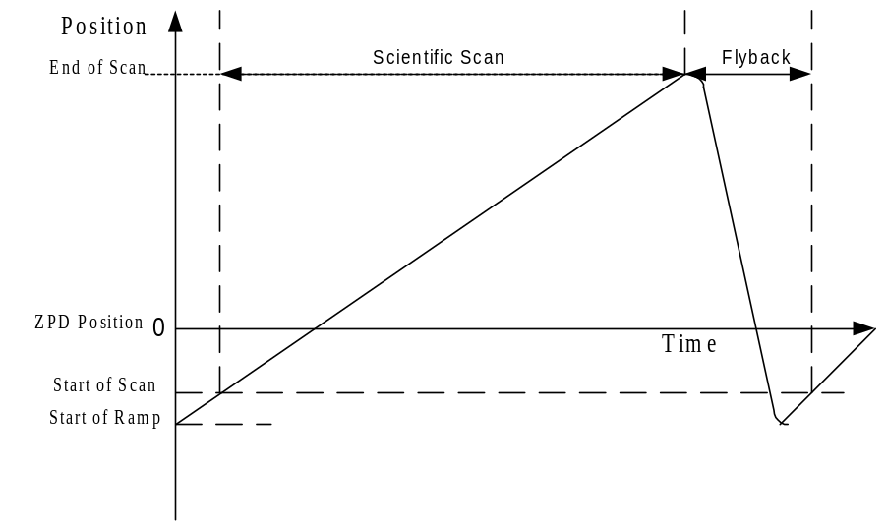
Figure 4-55 - SMEC Scan characteristics.
BSM position sensing: The position of the BSM chop and jiggle stages is monitored via coil inductance. Along with magneto resistive sensing elements.

Subsystems Control Unit (SCU)
The SCU carries out the following analogue functions:

- Biasing of the sorption cooler recycle heater,
- Biasing of the sorption cooler gas switches heaters,
- Biasing of the heater on the cooler cold tip
- Biasing of the calibrators black bodies,
- Measurement and readout of the calibrators temperature
- Measurement and readout of cold instrument temperature channels,
- Measurement and readout of analogue housekeeping channels,
- The switching (on/off) of sub-unit power supplies.

It also carries out the following digital functions:
- The decoding of low level commands from the DPU,
- Provide response to low level commands,
- The generation of relative timestamps on Telemetry,
- Digitization of housekeeping parameters,
- Transmission of digitized data (data + hsk + relative timestamp) to the DPU

A block diagram showing the architecture of the SCU is shown in Figure 4-56.
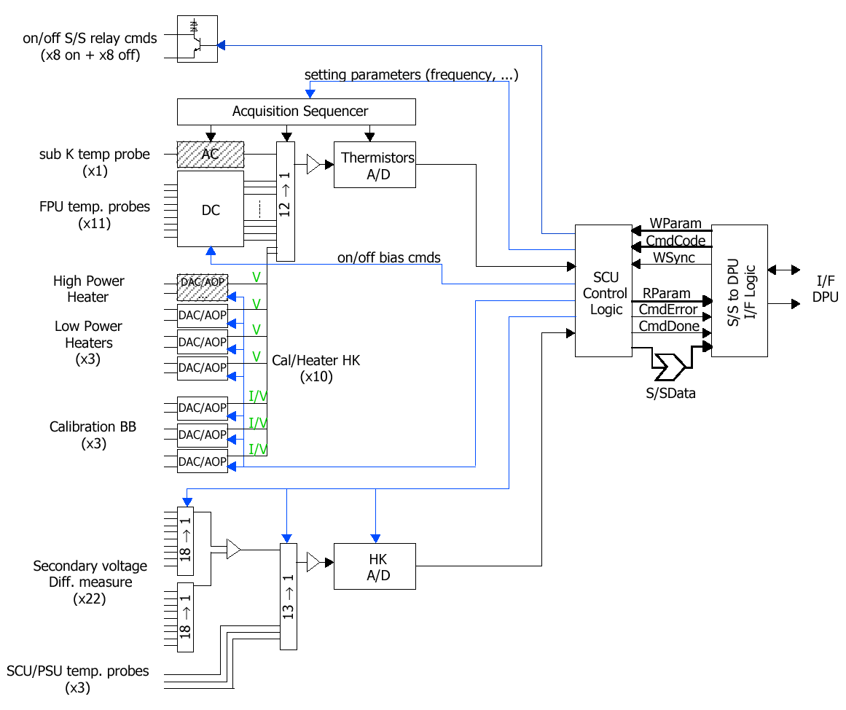
Figure 4-56 - Block diagram of the SCU.

RF Filters

The bolometer detectors in the spectrometer and the photometer are sensitive to all frequencies of electromagnetic radiation. Although the BDA feedhorns act as effective high pass filters, it is essential that emissions from within the FPU unit be minimised to eliminate spurious sources of signal. The harnesses that pass from the WE on the SVM to the FPU can act as receiving antennas. The voltages received by the harnesses outside the cryostat could then possibly retransmit EM radiation within the FPU and corrupt the signals from the BDA.

To eliminate this possible source of noise on the detector signal, low pass filtered connectors are used for all harnesses passing into the FPU. Three basic types of harnesses pass into the FPU; (i) bolometer signal wires, (ii) bolometer bias wires, and (iii) FPU sub-system drive and instrumentation wires (eg. Coil drive current wires, thermistor readout signals etc.). These three types of harnesses can be identified on the SPIRE system diagram, Figure 2-12.

Subsystem Filters

Six filter boxes for the subsystems are located on the spectrometer side of the FPU (see Figure 2-15). They have two 37-way filtered MDM socket connectors on the WE side of the box connected to two 37 way MDM plug connectors on the subsystems side of the box. Type-T Cristek filtered MDM connectors are used for the subsystem. The filter units are attached to the SPIRE optical bench by a blade support structure as shown in Figure 4-93. As the spectrometer cover is placed over the SPIRE optical bench, the outer cover meets with the filter units. The filter boxes are then screwed tightly to the outer cover with a 30 mm bolt spacing and become a part of the RF tight FPU enclosure. The required mechanical rigidity of the filter boxes come from the bolts attaching them to the outer cover. The first natural frequency of the filter boxes is above the required 200 Hz.

Detector and Bias Filters

The requirement on the filtering of the detectors is that frequencies from 500 MHz to 10 GHz be rejected to 60 dB. Cristek filtered MDM connectors,l Type M are used for this. The filtering occurs within the connectors in the JFET enclosures. The insertion losses for the Cristek filtered MDM connectors at room temperature and with a 50Ω source and load impedance is shown in Figure 4-57.
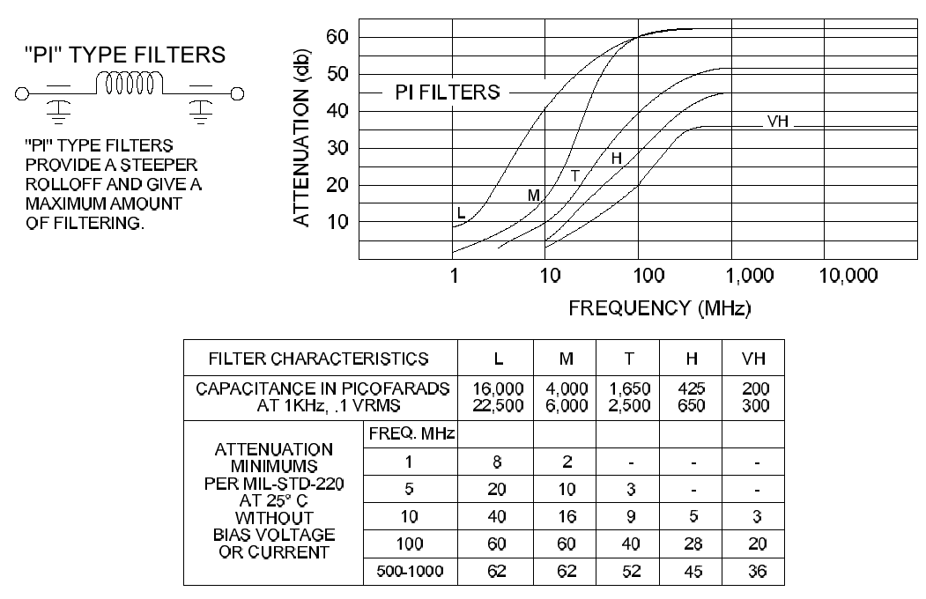

Figure 4-57 – Attenuation curves for the MDM filtered connectors used in SPIRE. The detectors use type ‘T’ while the subsystems use type ‘M’.

Bolometric Detector Arrays

Principle of semiconductor bolometers

The SPIRE detectors are semiconductor bolometers. The basic principles of operation are illustrated in Figure 4-58.

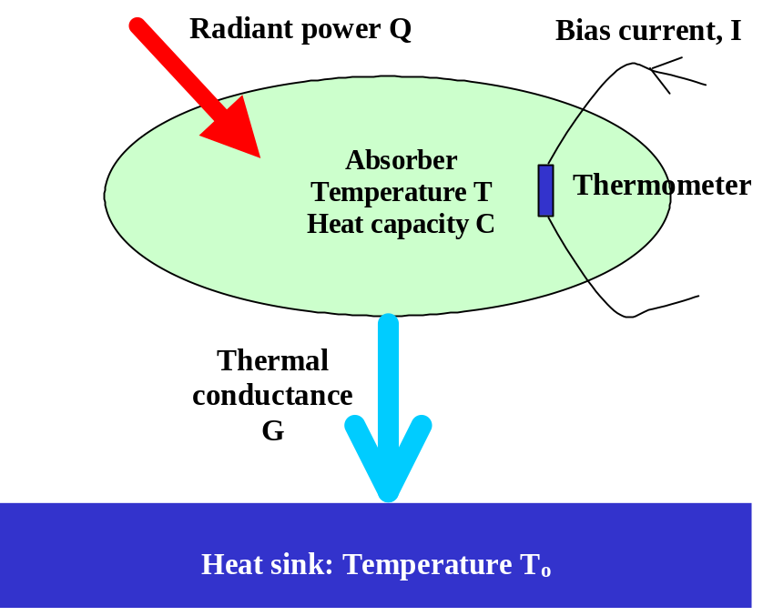
Figure 4-58 - Principles of bolometer operation.

The bolometer comprises a low heat capacity absorber designed to absorb the incident submillimetre radiation. The absorber is coupled to a heat sink at a fixed temperature T_{o} by a thermal conductance, G. Absorbed radiant power, Q, is thermalised in the absorber resulting in an increase in temperature over the equilibrium value in the absence of illumination. A semiconductor thermometer is attached to the absorber. A bias current, I, is passed throughout the thermometer, and the corresponding voltage across the thermometer is measured. The bias current dissipates electrical power P = I²R, which heats the bolometer to an operating temperature T, slightly higher than T_{o}. The main performance parameters for bolometric detectors are:

Responsivity: | S = dV/dQ
Noise Equivalent Power: | NEP = a(4kT_{o}²G)^{1/2} where k is Boltzmann's constant and a is a constant of order 1.
Time constant: | τ ~ C/G where C is the heat capacity of the bolometer.

For a full account of the theory and practice of semiconductor bolometers, see, for example, Mather (1982), Griffin & Holland (1988), Richards (1998).

SPIRE bolometer performance requirements

The combination of good sensitivity and speed of response requires low-temperature operation. The ultimate limit to the sensitivity of the SPIRE instrument is determined by the thermal background power from the telescope. The background power incident on a SPIRE detector is typically a few pW , almost all of which is from the telescope. This corresponds to a background photon rate of ~ 10¹⁰ photons per second. Note that this is enormously larger than in the case of optical observations. The accurate subtraction of this thermal background is essential if the much fainter astronomical signals are to be measurable. Furthermore, statistical fluctuation in the arrival rate of these background photons creates a fluctuating noise power which represents a fundamental thermodynamic limitation to the sensitivity. For SPIRE, the associated photon-noise limited NEP, NEP_{ph}, is a few x 10⁻¹⁷ W Hz^{-1/2}. In order to achieve photon noise-limited performance, the inherent NEP of the detector system must be comparable to or lower than this. The noise of the bolometer itself is a combination of Johnson noise and phonon noise (due to the quantised flow of thermal energy from the bolometer to the heat sink).

The instrument performance models described in RD13 contain detailed calculations of the background power levels and sensitivity for SPIRE. In addition, the operating modes require time constants of around 30 ms for the photometer detectors and 16 and 8 ms for the two FTS arrays. With current bolometer technology, these sensitivity and time constant requirements can be met by detectors operating at a temperature of around 0.3 K, cooled by a ³He refrigerator.

SPIRE bolometer design and specifications

SPIRE will use arrays of semiconductor bolometers developed at Caltech/JPL. illustrates the basic detector design. The absorber is a "spider-web" of metallised silicon nitride. This appears as a filled planar absorber to the submillimetre radiation which has a wavelength much longer than the grid spacing. The spider-web structure has high mechanical strength and a low filling, factor providing low heat capacity and immunity to glitches that can be caused by ionising radiation. The diameter of the spider-web is typically a few times the wavelength to be detected. The thermometer is a small (20 x 100 x 300 μm) crystal of Neutron Transmutation Doped (NTD) germanium. This material is highly suited for use in low temperature bolometers as its thermal behaviour closely approaches that of an ideal thermal device, the material displays very low 1/f noise, and the manufacturing processes are highly repeatable and reliable. A wide range of NTD materials are available to tailor the impedance of the device to the desired range for the chosen operating temperature. Large arrays of bolometers can now be made, as illustrated by the array wafer shown in .
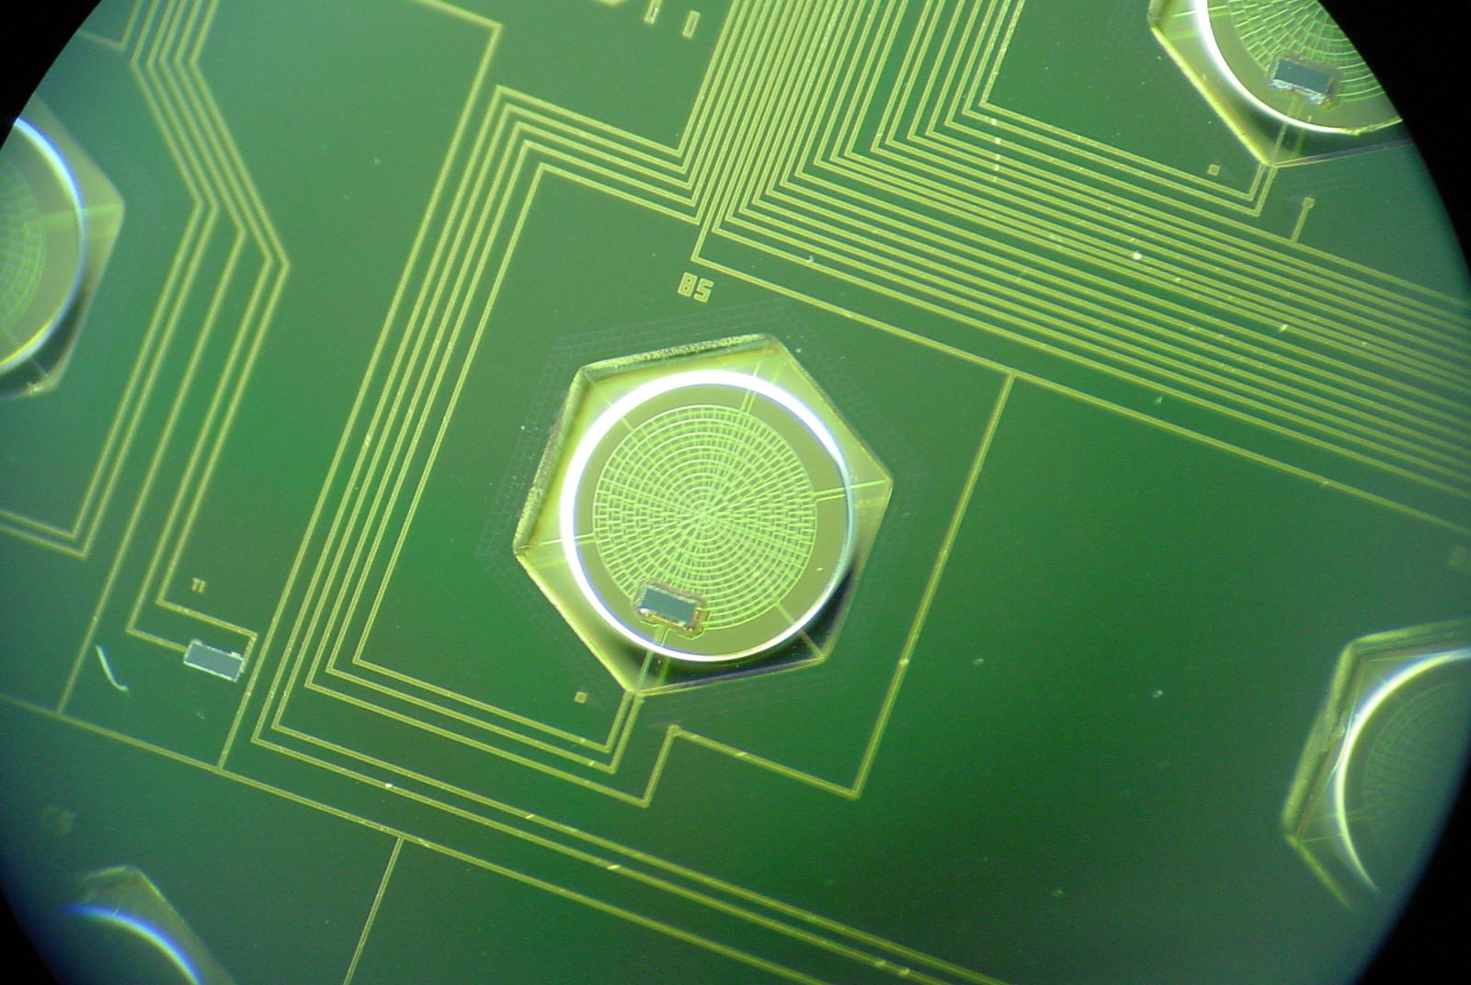
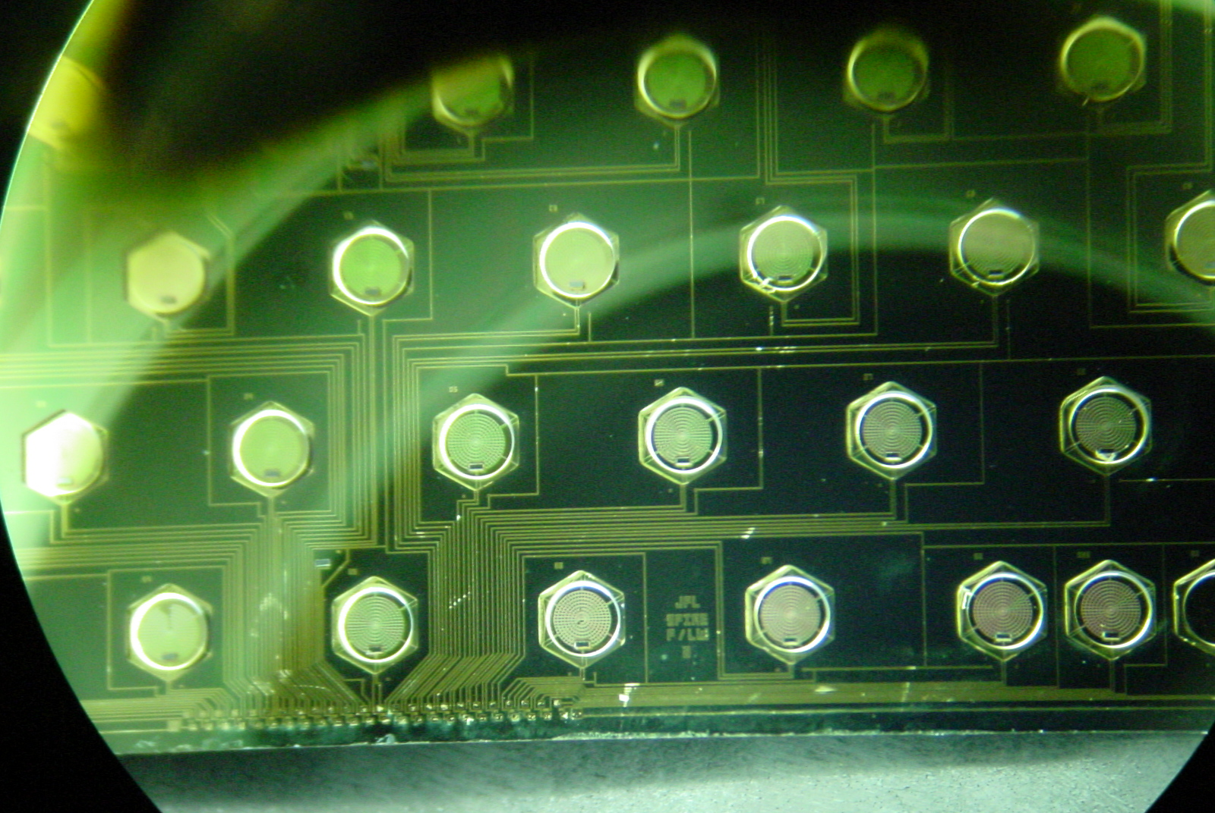

Figure 4-59 - Left: Photograph of part of a SPIRE P/LW (520-μm) array wafer, showing individual spider-web bolometers and lithographed electrical connections. Right: close-up of an individual bolometer. The dark rectangle is the 100x300-μm NTD thermometer.

Bolometer readout electronics

The resistance of the detector at the operating point is typically 5 MΩ. Lower values make it difficult to avoid being preamplifier noise limited while higher values can pose problems with electromagnetic pick-up and sensitivity to microphonic disturbance. The detector noise is typically 10-20 nV/Hz^{-1/2}, and the noise of the readout amplifier must be of this order or less. With current transistor technology, this requires the use of silicon JFETs, which must operate at a temperature of around 120 K, and must also be located as close as possible to the detectors. This is why SPIRE employs JFET amplifier modules as part of its cold FPU. The essential features of the readout electronics are shown in Figure 2-36. The bolometer is biased (heated to its optimum operating temperature of around 1.3T_{o}) by a sinusoidal current bias at a frequency of at least 100 Hz, applied via the 10-MΩ load resistors. The bias excitation is much faster than the thermal time constant, so that bias itself does not produce a temperature modulation. This is preferred over DC bias as it up-converts the signal information to the bias frequency, getting well above the 1/f noise knee of the JFET readout amplifiers. With this arrangement, because of the inherently low 1/f noise of the bolometers, the1/f noise knee of the system can be very low (less than 0.1 Hz).

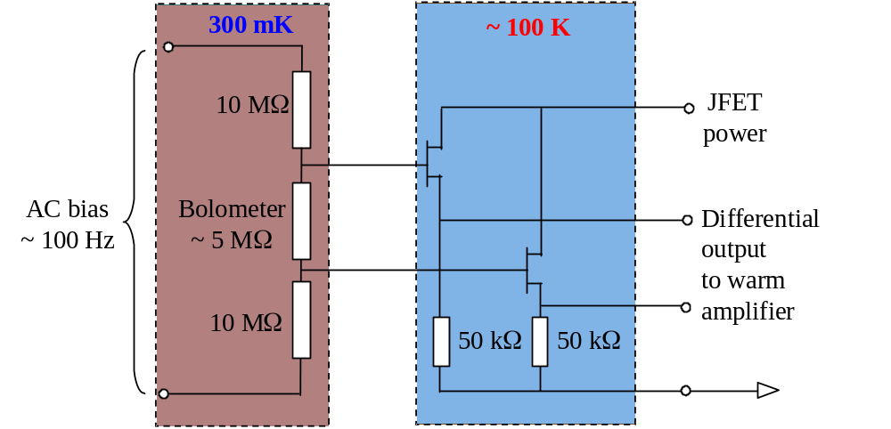
Figure 4-60 - Bolometer bias and cold readout circuit.

Feedhorns and bolometer cavities

The size of a composite bolometer (typically mm diameter) is small compared to the telescope diffraction spot (in the case of SPIRE, with f/5 final optics, the spot size is 2.44λF = 12.2 mm at 500 μm) and the first-pass absorption efficiency of the absorber is only ~ 50%. In order to couple the telescope beam onto the detectors in the array, conical feedhorns are used, with a short section of waveguide at the end of the horn to feed the radiation into a cavity containing the bolometer, as shown schematically in Figure 4-61. The waveguide acts as a low-pass filter as it does not propagate radiation of free space wavelength > 3.4a where a is the radius. For high efficiency, the absorber is located in the centre of the cylindrical cavity with λ/4 spacing between the front of the cavity and a reflecting back-short at the back. The feedhorns are packed in a hexagonal arrangement in the focal plane to fit as many as possible into the area available.
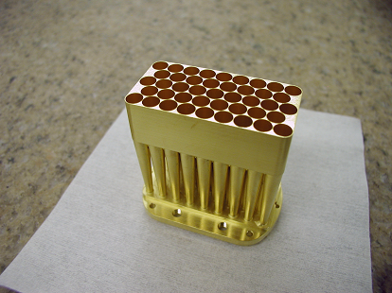
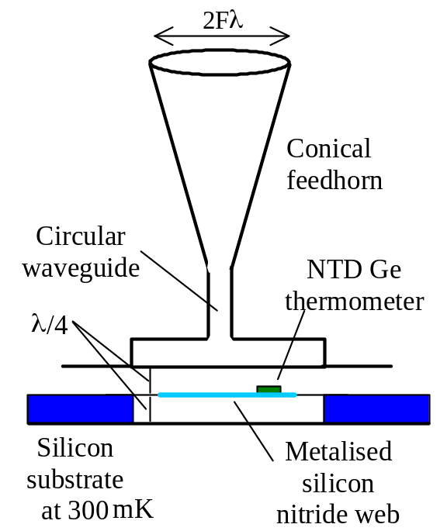
Figure 4-61 - Left: feedhorn eedhorn and cavity design. Right: photograph of SPIRE P/LW (500-μm) feedhorn array.
Maximum feedhorn aperture efficiency of 70-80% is achieved for a horn diameter close to 2Fλ (e.g., Griffin, Bock and Gear, 2002), corresponding to a beam spacing on the sky ~ 2λ/D, where D is the telescope diameter. The horn restricts the detector field of view, giving a tapered (near Gaussian) illumination of the telescope primary mirror (with an edge taper of approximately 8 dB in the case of SPIRE). Whilst the horns are close-packed in the focal plane, their beams on the sky do not fully sample the image unless the horn diameter is = 0.5Fλ. Several separate telescope pointings are therefore needed to create a fully-sampled image. For the 2Fλ horns 16 pointings are required in principle, as illustrated in Figure 4-62. In the case of SPIRE, the step size is dictated by the shortest wavelength channel (P/SW - 250 μm) and the number of steps is dictated by the longest wavelength channel (P-LW - 520 μm) so that a 64 point jiggle map is needed to achieve simultaneous full spatial sampling in all photometer bands.

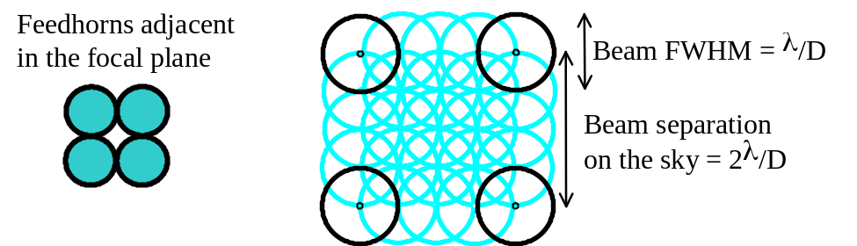
Figure 4-62 A 16-point “jiggle pattern” is needed to achieve a fully sampled map with 2Fλ feedhorns (for hexagonal packing the jiggle pattern is slightly different but 16 steps are still required).

The main advantages of feedhorn arrays are:

- maximum efficiency for detection of a point source with known position;
- well understood horn properties, allowing good control of the beam and reliable design;
- good stray light rejection - the bolometer field of view is restricted to the telescope;
- good rejection of EM interference - the horn plus integrating cavity act as a Faraday enclosure;
- minimum number of detectors for a given total field size.

The main disadvantages are that the observing modes are complicated (jiggling or scanning) and that the efficiency for mapping is a less than the ideal (Griffin, 2000). This means that the full collecting area of the telescope is not used with maximum efficiency.

In order to collect the radiation from a point source with good efficiency, the detector through put must be of the order of λ². The diffraction-limited beamsize of a telescope of diameter D is approximately θ ≈ 1.2λ/D. The corresponding solid angle on the sky is Ω_{sky} = π(θ/2)². The throughput (the product of area and solid angle, which is conserved in an ideal optical system) is therefore
A_{tel}Ω_{sky} ≈ [πD²/4][π(1.2λ/2D)²] ≈ λ².

The SPIRE photometer uses smooth wall, single-mode feedhorns - the circular waveguide section allows propagation of only one mode (TE₁₁). The corresponding throughput (defined as the area-solid angle product) is exactly λ². The spectrometer uses multi-mode feedhorns that pass both TE and TM modes.

Bolometer array thermal-mechanical design

The design of the SPIRE array units (called Bolometer Detector Arrays, BDA's) is illustrated Figure 4-63. Each BDA unit is split into a 2-K and a 300-mK section. The 300-mK section contains the feedhorns, waveguides, bolometer array wafer and the supporting structure. The 2-K detector structure forms the mechanical interface between the 300-mK structure and the photometer or spectrometer 2-K enclosures. The enclosures are connected via thermal straps to the 1.7-K stage of the Herschel cryostat. The heat load from the 2-K structure to the 300-mK structure of the BDA is minimised by suspending the 300-mK section from the 2-K structure with two pre-tensioned 3000-denier Kevlar cords. Kevlar has high mechanical strength in tension and a very low thermal conductivity at this temperature, and forms gives good thermal isolation between the assemblies. The estimated heat load is less than 1.6 μW per array. The high mechanical rigidity of the Kevlar cord yields a high resonant frequency (> 200Hz).

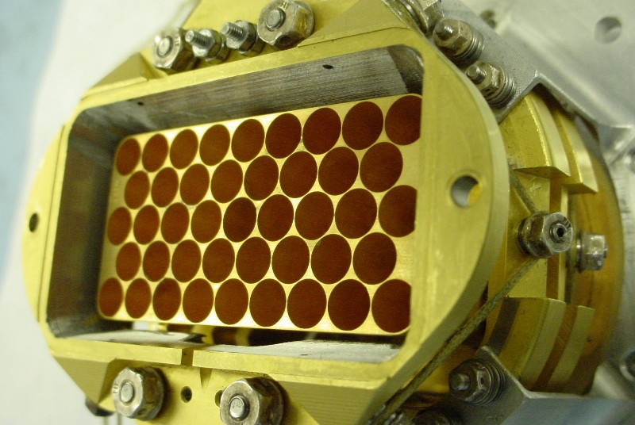
Filter
300-mK strap attachment point
Kevlar supports
2-K
interface
flange
Kapton
ribbon cables
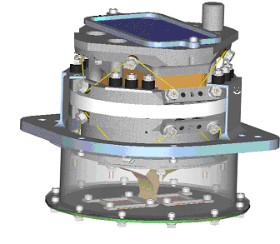
Figure 4-63 - Left: Bolometer Detector Array module design (not incorporating some superficial modifications to the design that have been recently been introduced). Right: photograph of a prototype P/LW BDA (without the array filter).
Table 4-7 lists the some of the main design and performance parameters for the SPIRE detectors. .

Yield | > 90%
Operating Resistance | ~ 5 MΩ
Time constant | < 32 ms (photometer)  < 14 ms (spectrometer/LW)  < 8 ms (spectrometer/SW)
Responsivity | 0.4 GV W⁻¹
Detector noise | 14 nV Hz^{-1/2}
Efficiency of bolometer-cavity-feedhorn combination | > 0.65
Average BDA mass | < 0.6 kg
Lowest BDA resonant frequency | > 200 Hz
Total heat load budget on ³He cooler (5 BDAs) | < 15 μW
Total JFET power dissipation (photometer mode) | < 42 mW
Table 4-7 - Main design and performance parameters for the SPIRE detectors.

A more detailed description of the bolometers can be found in Turner et al. (2001), and the design, modelling and performance of the feedhorns is described in Rownd et al. (2002) and Chattopadhyay et al. (2003). Full details of the SPIRE BDA specifications are given in the Detector Subsystem Specification Document.

JFET units

The CMRR of the JFETs is 40dB (Check with Bruce)

The functionality of the JFET in the read out electronics of the BDAs is adequately described in §4.4.4 above. The JFET boxes are described here as a sub-system in themselves. Electrically isolated

Model U401 Silicon JFETS are used to read out the SPIRE detectors, mounted in groups of 24 on silicon nitride membranes. The contract traces and JFET source resistors are lithographed on the membranes. The JFET modules for the photometer and spectrometer are mounted in separate enclosures (illustrated in Figure 4-64) on either side of the FPU.

There are two sets of JFET boxes, one set drives the signals from the photometer detectors and the other set drive the spectrometer detectors. To minimise the signal loss or phase distortion due to harness capacitance, the length of the harnesses between the JFETS and the bolometers needs to be minimised. Hence, the two groups of |JFETs are located on the Herschel optical bench as close to the FPU structure as is practical.

Thermal Design: To attain the required noise performance, the individual JFET devices need to operate at around 110K. This poses several challenges to the thermal design of the modules:
- the surrounding structure is at the same temperature as the Herschel optical bench. The thermal load from the JFETs to the JFET structure has to be minimised so as to minimise the power used to heat the JFETs. The nominal limit for all the JFETs in a single operating mode is 33 mW.;
- the thermal load from the JFETs to the structure needs also to be limited to ensure that the heat load to the FPU through the detector harnesses is minimised.
High thermal impedance is therefore required between the JFETs and the rest of the structure. This requirement is achieved through the mounting of the devices on thin silicon nitride membranes and low cross section lithographed wires to the individual JFET terminals. The silicon nitride membrane also meets the functional requirement of providing a high resonant frequency.

Filters identical to the ones described above in §4.3 are inserted on all the inputs to the JFET boxes. Included in the structure of the JFET box is the provision of filter units identical to the ones used inside the FPU to filter the AC bias signals going to the detectors. All the harnesses passing from the JFET units to the FPU are shielded. This effectively enlarges the RF shielding provided by the FPU enclosure to include these shields.

The structure is rigidly attached to the Herschel optical bench by four bolts. It is fabricated from aluminium in order not to generate thermal stresses at cryogenic temperatures. The first mode of vibration is above 100 Hz. The structure also has a thermal strap connecting it to Level-2 of the cryostat. The structure is electrically isolated from the Herschel optical bench by Vespel washers.
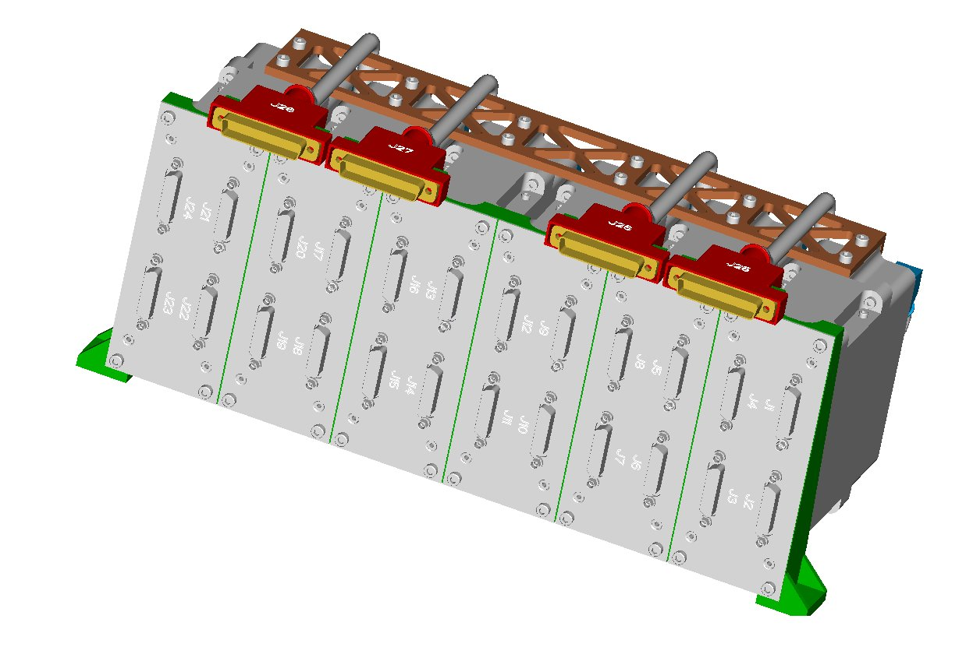
Figure 4-64 - Front view of Photometer JFET rack. (JFP).

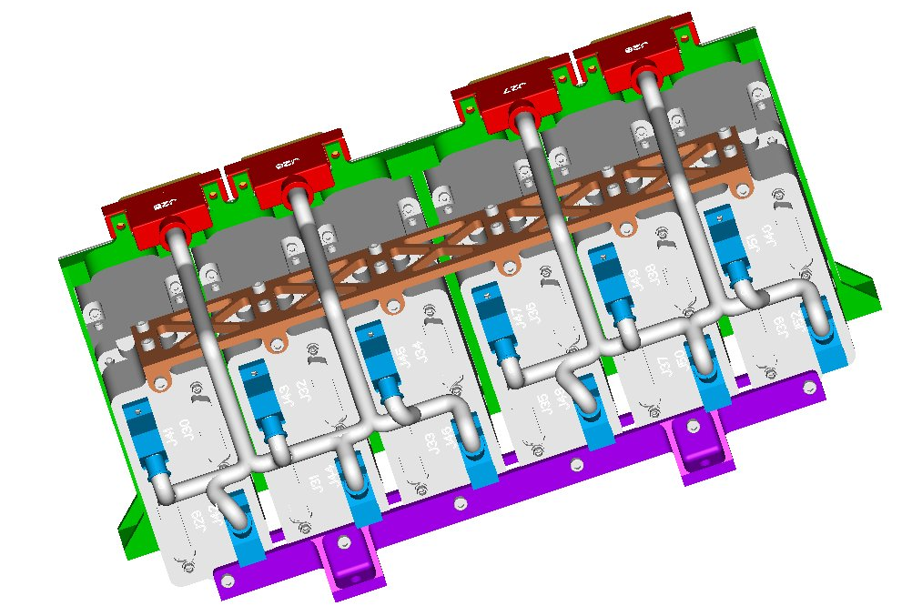
Figure 4-65 - Rear view of Photometer JFET Rack (JFP) including details of the routing of the back harness.

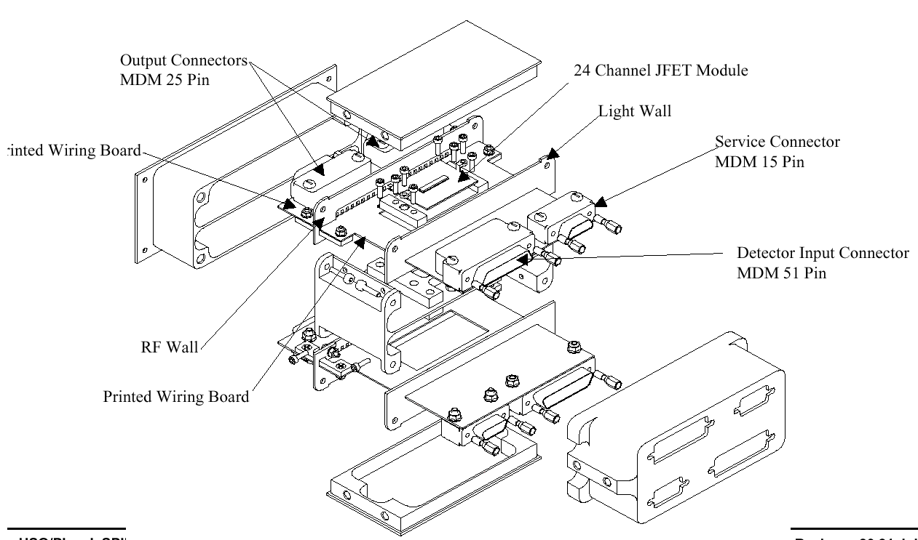
Figure 4-66 - Exploded view of a single JFET module.
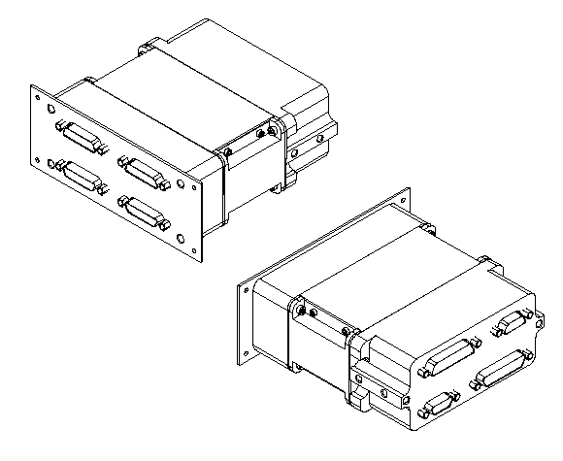
Figure 4-67 - View showing assembled JFET modules.

Mirrors

The basic design of the mirrors is the same as the one used for ISO-LWS. The mirrors are made from Al-6061. They all have a standard interface with the structure, i.e. an M8 screw and a pin. Each mirror is machined in a single block of aluminium (diamond cutting). Before the final finishing of the machining process, the mirrors are annealed to remove any residual stresses that may cause distortions at cryogenic temperatures. The screw part of the attachment exerts pressure only on the shoulder part of the mirror, avoiding deformation of the optical surface. The mount of each mirror is located on the optical bench by means of several hollow pins. These pins ensure that in case of dismounting of the mirror, it will be reassembled in the same position. During integration of the mirrors in the SPIRE structure, the mirrors are mounted on brackets. The mirror mounts are designed to have the first natural mode of vibration above 200 Hz. Figure 4-69 below shows a drawing of the CM5 mirror, which is the heaviest one.

For the mechanical interface between the mirror mounts and the SPIRE optical bench, the standard technique of using a hollow dowel pin is adopted. The mounting accuracy is nominally within 0.5 arc minute and 0.05 mm linearly. The mechanical interface between the mirror and the mirror mount is illustrated in Figure 4-70. This technique ensures that the rotational and translational degrees of freedom for the mirror are tightly constrained in a repeatable fashion.

The finish of the mirrors is to optical quality. This is to permit the alignment of the mirrors to be performed within the optical wave lengths (< 10 nm RMS, specular reflectivity > 80%). The emissivity of the surfaces within the sub-millimetre wavelength is to be less than 1% to minimise the spurious emissions transmitted to the detectors. The specular reflectivity in the same wavelength is in excess of 99%.

All the common mirrors, the photometer mirrors and the spectrometer mirrors are listed and briefly described in Table 4-8. The locations of the mirrors with respect to the other optical components are illustrated in Figure 4-71 and Figure 4-72. Information on the optical alignment of the instrument, and details of the corner cubes is found in the FIRST SPIRE: Optical alignment verification plan, (Origne and Dohlen 2000).

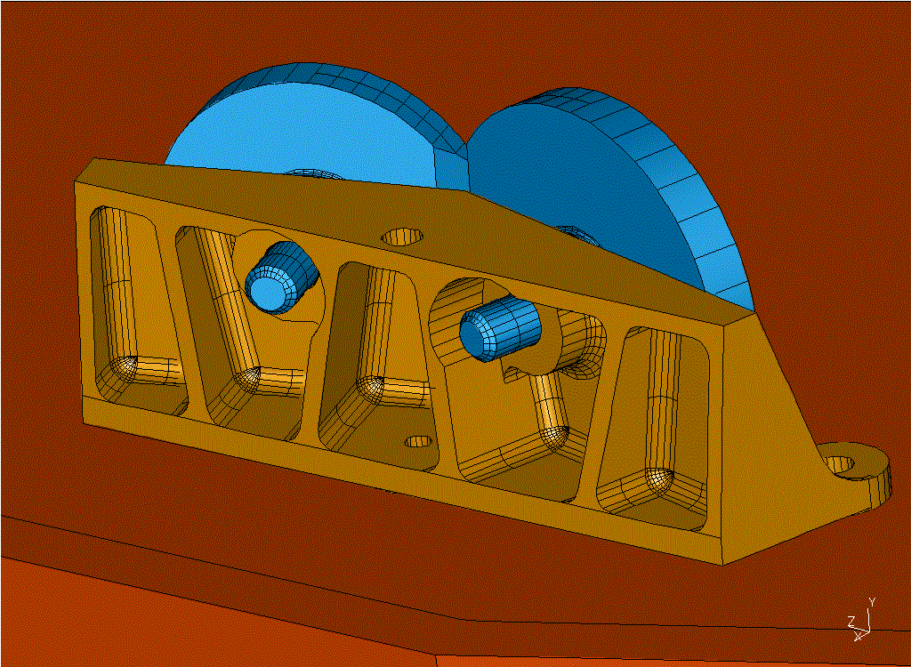
Figure 4-68 – Example of mirror mounts.

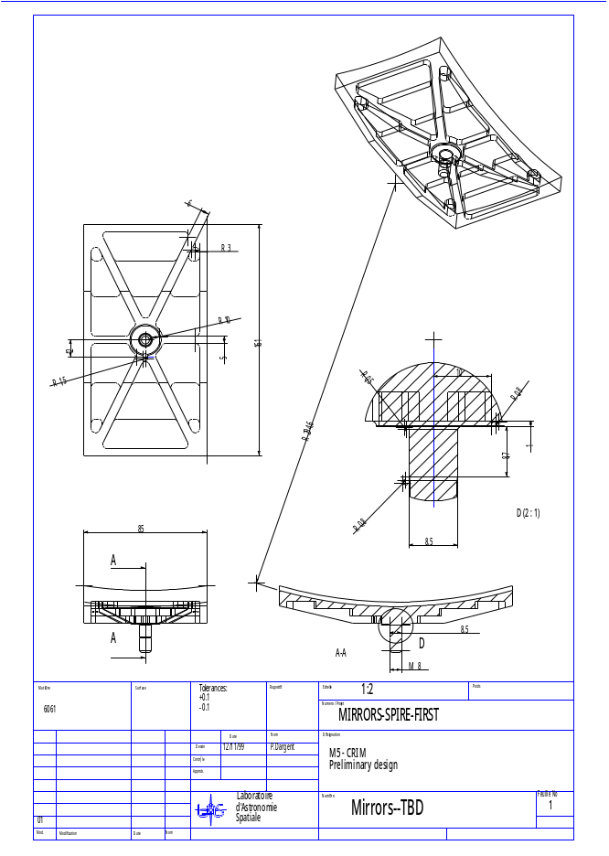
Figure 4-69 - Engineering drawing of CM5

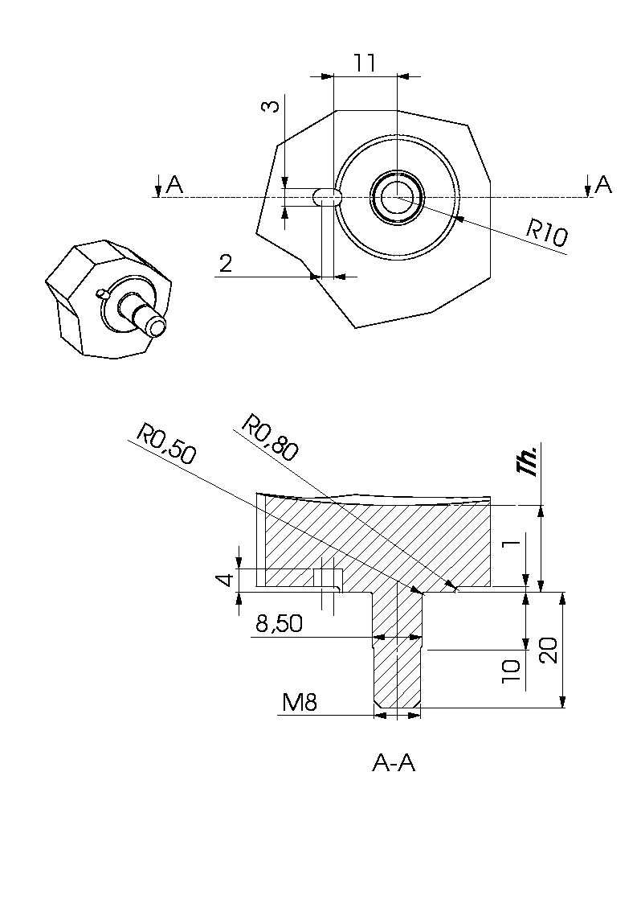
Figure 4-70 – Drawing of the Mirror/Mirror Mount mechanical interface.

Subass'y | Mirror | Type | R or Ry  (mm) | CC or Rx  (mm) | Shape | Dimensions  a x b or dia  decenters  [c , d]  (mm) | Mass (kg)
Fore optics | CM3 | Off-axis asphere | 365.963 | -0.5095 | Rectangular | 139x62  [-19.5, 145]  See fig. | 0.256
Fore optics | CM4 (BSM) | Flat |  |  |  | 15x16 | 0.021
Fore optics | CM5 | Toric | 294.638 | 278.418 | Rectangular | 161x85  [19.5, -1.5] | 0.360
Photometer | PM6  (Pick-off) | Toric | -307.49 | -359.42 | Rectangular | 46x27 | 0.027
Photometer | PM7 | Sphere | 330.70 |  | Rectangular | 118x101  [0, -1.0] | 0.300
Photometer | PM8 | Sphere | -286.651 |  | Circular | Ø 60 | 0.056
Photometer | PM9 | Sphere | 350.851 |  | Circular | Ø 112 | 0.223
Photometer | PM10  (Fold mirror) | Flat |  |  | Rectangular | 78x40  [2.5, 0] | 0.065
Photometer | PM11  (Fold mirror) | Flat |  |  | Rectangular | 56x53  [0, -2.75] | 0.060
Spectrometer | SM6  (Pick-off) | Toric | 523.79 | 269.92 | Elliptical | 9x12  [0, 1.0] | TBD
Spectrometer | SM7  (Fold mirror) | Flat |  |  | Rectangular | 40x57  [0, 4.0] | 0.044
Spectrometer | SM8A, B  (Relay in) | Toric | 230.34 | 202.00 | Circular | Ø 60 | 0.112
Spectrometer | SM9A, B  (Collimator) | Sphere | 259.50 |  | Special | Ø50 | 0.074
Spectrometer | CC face1 | Flat |  |  | Special | 40x60 | 0.044
Spectrometer | CC face2 | Flat |  |  | Special | 28x68 | 0.070
Spectrometer | CC face3 | Flat |  |  | Special | 28x68 | 0.070
Spectrometer | SM10A, B  (Camera) | Sphere | 260.00 |  | Special | Ø60 | 0.112
Spectrometer | SM11A, B  (Relay out) | Toric | 196.99 | 169.84 | Circular | Ø 74  [0, 1] | 0.194
Spectrometer | SM12A, B  (Fold mirrors) | Flat |  |  | Elliptical | 21x16  [-1, 0] | 0.050
Table 4-8 – General mirror specifications. The locations of these mirrors are illustrated in Figure 4-71 and Figure 4-72.

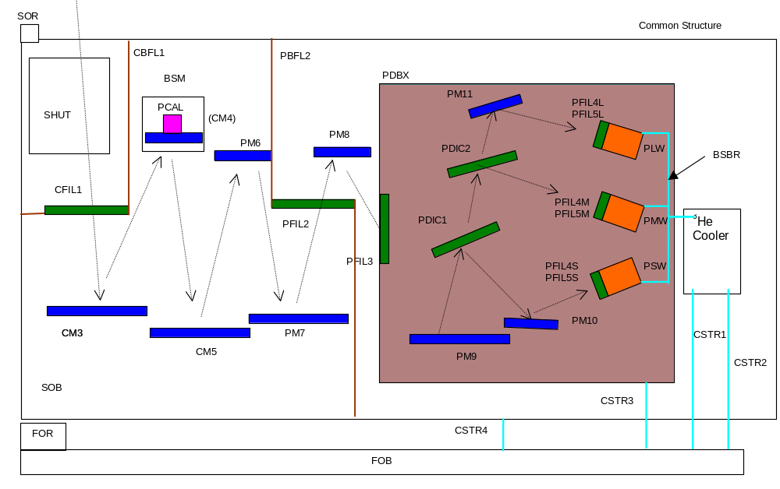
Figure 4-71 – Nomenclature for the SPIRE common and photometer mirrors, filters, beam splitters and dichroics.

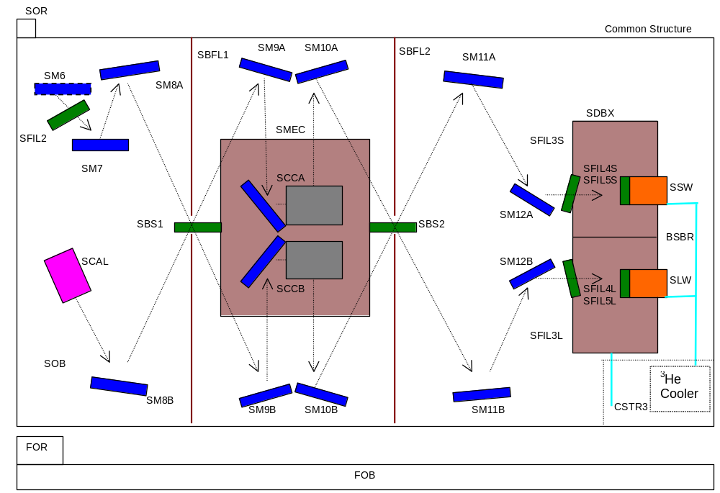
Figure 4-72 - Nomenclature for the SPIRE spectrometer mirrors, filters, beam splitters and dichroics.

Filters and beam splitters

Filters are placed at a number of positions within the SPIRE FPU, serving the following functions:

- definition of the spectral passbands;
- minimisation of the thermal loading on the 300-mK, Level-0 and Level-1 stages by rejecting short wavelength thermal energy;
- minimisation of stray light getting to the detectors;
- maximisation of the in-band spectral transmission.

The filters are implemented as combinations of capacitative and inductive grids formed by evaporation of copper on thin (~ 2 μm) mylar or polypropylene substrates (Lee et al., 1996). Several grids are used in each filter. The grids must be maintained at accurate spacings. This is achieved either by the use of annular rings for vacuum-gap filters or solid dielectric spacers for “hot-pressed” filters. The latter are formed by pressing together a stack of grids and spacers while heating the combination. The result is a solid and robustly self-supporting filter.

The SPIRE filter chains are designed on the pessimistic assumption that the telescope surface is perfect even out to UV wavelengths. For complete blocking out to UV, 3 or 4 blocking filters are needed in the chain

The filters can withstand multiple cycling to low temperature, and are robust with respect to low temperature vibration. They are unaffected by UV and high energy particle irradiation and have a very low outgassing rate. They are based on technology developed and implemented in the ISO Long Wavelength Spectrometer and also used in numerous ground-based submillimeter instruments. The filters are interfaced to the structure by simple 3-point mounts to ensure that flatness of the grids is not affected by mechanical stress on the support rings.

Photometer filtering scheme

The photometer filtering and dichroic scheme is summarised in Table 4-9. The relative positioning of these items is illustrated in Figure 4-71 and Figure 4-72. The two dichoics allow the spectral bands to be directed to the three arrays with high efficiency.

CFIL1 | A common blocking filter at the entrance to the instrument, designed to block radiation short of 100 μm.
PFIL2 | A thermal second thermal blocker with an edge at 110 μm at Level-1 providing additional blocking and located at a baffle.
PFIL3 | Third blocket with a 170-μm edge located at the Level-0 pupil, at the entrance to the detector enclosure
PDIC1 | 2-K dichroic with edge at 306 μm. Reflects onto PSW and tramnsmits to PMW and PLW
PDIC2 | 2-K dichroic with edge at 431 μm. Reflects onto PMW and tramnsmits to PLW
PFIL4S  PFIL5S | Blocker over the PSW array at 300 mK (edge at 200 μm)  Short-wavelength edge definer (208 μm) for the PSW array (the long-wavelength edge is defined by the feedhorn waveguide)
PFIL4M  PFIL5M | Blocker over the PMW array at 300 mK (edge at 232 μm)  Short-wavelength edge definer (303 μm) for the PMW array (the long-wavelength edge is defined by the feedhorn waveguide). Note: this baseline is to leave this filter out as this edge will be defined by the dichroic PDIC1.
PFIL4L  PFIL5L  PFIL6L | Blocker over the PSW array at 300 mK (edge at 333 μm)  Short-wavelength edge definer (431 μm) for the PLW array. Note: this baseline is to leave this filter out as this edge will be defined by the dichroic PDIC2.  Long-wavelength edge definer (580 μm) for the PLW array. Note: this baseline is to leave this filter out as this edge will be defined by the PSL feedhorn waveguide.
Table 4-9 Photometer filtering scheme.

Figure 4-73 shows a prototype photometer 350-μm band filter chain transmission profile on linear and logarithmic plots. The optical and UV transmissions of the individual elements have been measured separately and multiplied together to derive the overall transmission. The horizontal lines on the logaritmic plot indicate the out-of-band rejection requirements, which are comfortably met by the filter chain.
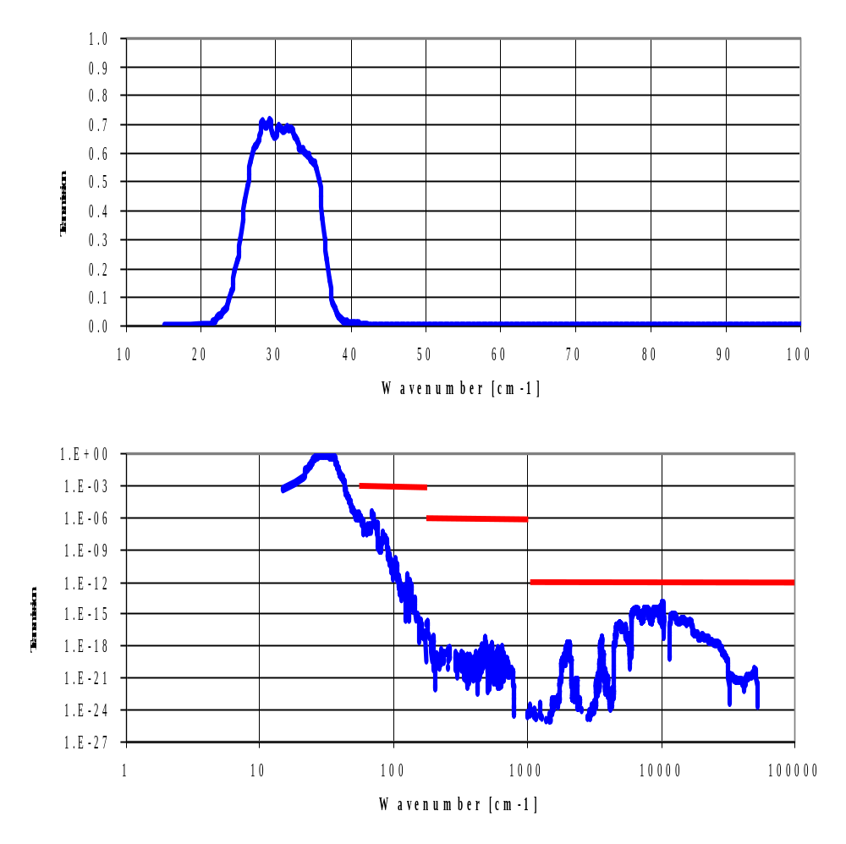
Figure 4-73 - Transmission characteristics of prototype 350-μm photometer filter chain.

The SPIRE dichroics are implemented as capacitative low-pass edge filters placed at an angle to the beam. To maintain the sharpness of the edge, the angle of incidence is set at < 25º. Figure 4-74 shows typical transmission and reflection profiles for such a dichroic.

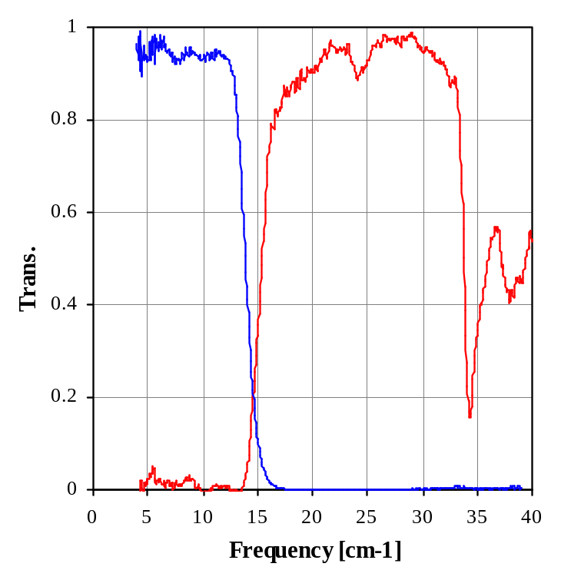
Figure 4-74 - Performance of a prototype 15-cm-1 dichroic (red: reflection; blue: transmission).

Spectrometer filtering scheme

The spectrometer filtering and beam-dividing scheme is summarised in Table 4-10. The beam dividers are designed to have near 50% transmitivity (T) and reflectivity (R) over the FTS spectral range. The beam splitter efficiencies as viewed by the two detector arrays are 4RT and R² + T², both of which should be close to 100%.

CFIL1 | Common blocking filter at the entrance to the instrument, designed to block radiation short of 100 μm.
SFIL2 | A thermal second thermal blocker with an edge at 110 μm at Level-1 providing additional blocking and located at a baffle. Identical to PFIL2.
SBS1 | Broadband beam divider covering entire FTS range with efficiency 4RT > 90%
SBS2 | Identical to SBS1
SFIL3S | Blocker for SLW array at entrance to Level-0 detector enclosure with 143-μm edge.
SFIL3L | Blocker for SSW array at entrance to Level-0 detector enclosure with 167-μm edge.
SFIL4S  SFIL5S  SFIL6S | 300-mK blocker for SSW. Edge at 168 μm.  300-mK short-wavelength (200-μm) band-defining edge for SSW  300-mK long-wavelength band defining edge for SSW. Note: the baseline is to leave this filter out as this edge will be defined by the SSW feedhorn waveguide. :
SFIL4L  SFIL5L  SFIL6L | 300-mK blocker for SLW. Edge at 233 μm.  300-mK short-wavelength (315-μm) band-defining edge for SLW  300-mK long-wavelength band defining edge for SLW. Note: the baseline is to leave this filter out as this edge will be defined by the SSW feedhorn waveguide. :

Table 4-10 Spectrometer filtering scheme.

Figure 4-75 shows the measured efficiency of a prototype beam splitter with the SPIRE wavelength range indicated by the shaded region.

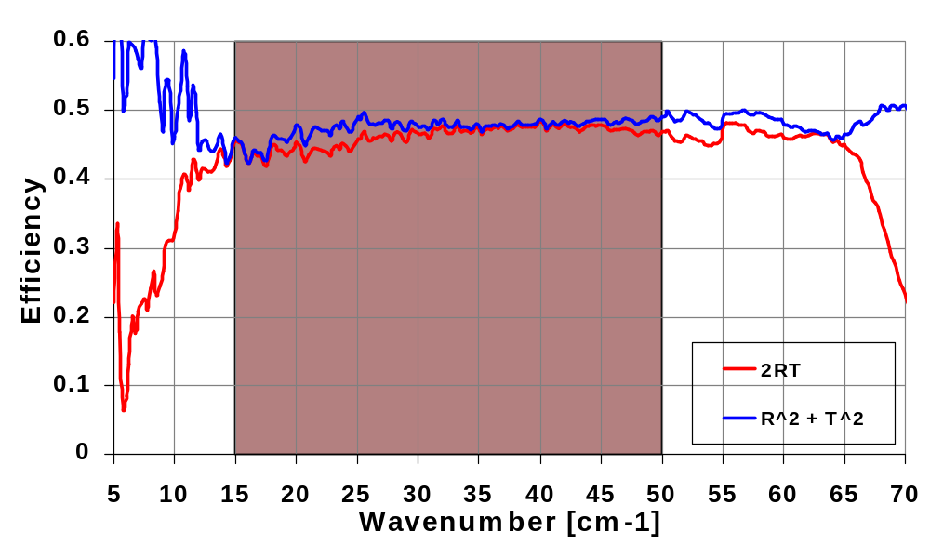
Figure 4-75 Measured efficiency of FTS beam splitter prototype.

Internal calibrators

Photometer calibrator (PCAL)

The purpose of the photometer calibrator is to provide a repeatable signal for monitoring of detector health and responsivity during ground testing and in-flight operation. It is not an absolute calibrator, but may be useful as part of the overall calibration scheme. PCAL consists of a thermal source inside an integrating cavity, the body of which is at (Level-1). The cavity has a light pipe output with a 3-mm diameter aperture. Two identical sources are provided for cold redundancy, both feeding into a single output light-pipe. PCAL has a mass of TBD gm and is located in the Beam Steering Mirror housing behind the beam steering mirror itself (M4), at an image of the system pupil (the telescope secondary mirror). M4 has a central hole of 2.8 mm diameter ,corresponding to the region of the pupil obscured by the hole in the primary mirror, through which PCAL shines.
The electrical connections to PCAL and to the BSM are made using a common harness bundle.

Because all of the detectors in the photometer arrays view the pupil with near equal efficiency, PCAL produces a very uniform illumination over the arrays (this is an advantage but not a requirement). It is envisaged that the calibrator will be operated in flight at regular but not frequent intervals (at present we assume a notional frequency of once per hour). Operation of PCAL requires the BSM to be switched off and the telescope pointing to be fixed, so that there are no sources of detector power modulation except the calibrator itself. A predetermined current excitation sequence will be applied over a period of ~ 10 seconds, and the corresponding detector signals recorded.

The requirement for the brightness of PCAL is that the area:surface brightness product of its emitting aperture shall be ≥ 1% of the area:surface brightness product of the telescope image at the position of M4 (with an assumed telescope temperature of 80 K and emissivity of 4%) over the wavelength range 200 < λ < 700 μm. This will result in an instantaneous S/N of around 500 from the detectors when viewing PCAL.

The 150-ms time constant requirement (30 ms goal) for PCAL ensures that it be comparable to or faster than the photometer detectors. A power dissipation requirement of < 2 mW has been adopted to ensure that PCAL operation makes a negligible contribution to the average load of the SPIRE FPU on the Herschel helium tank, and that local heating of the environment will not result when it is operated.

The active element of PCAL is an inverse bolometer, similar to a device developed by J. Beeman of UC Berkeley for use in the SIRTF MIPS instrument. The device is also similar in principle to the one used in the ISO Long Wavelength Spectrometer (but with faster speed of response and lower power dissipation). A thin dielectric substrate is coated with a metallic film and thermally isolated from its helium-temperature housing. Electrical contacts allow a current to be passed through the metal film, heating it up to a temperature of 40 K or more. The PCAL emitter is a 1 x 1 mm NiCr coated Mica chip suspended from the 4-K housing by 25-μm diameter brass wires. These wires are soldered on a glass fibre PC board. The baseline emitter architecture and a photograph of a prototype device (in this case with nylon-wire suspension) are shown in Figure 4-76. A typical resistance is 300 Ω, requiring ~ 2.5 mA drive current for 2 mW power. There is a 1% stability requirement on the constant-current drive, which translates to a comparable stability for the radiant power output. Prototype devices tested to date show that the radiant output requirement can be met comfortably, with some design iteration still needed to achieve the required time constant.
1 x 1 mm source
Gold tracks on Sapphire
Electrical wires and suspension
Silver epoxy bonds to NiCr film on Mica
Gold-plated copper mount
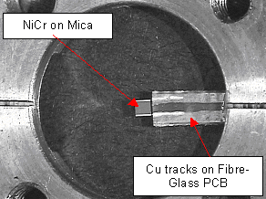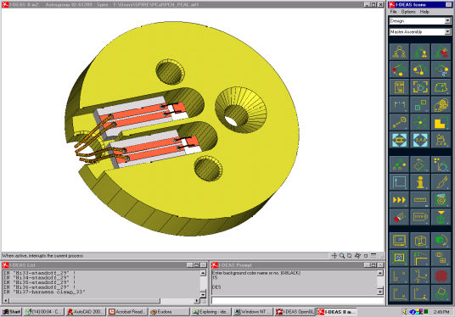

Figure 4-76 - Photograph of PCAL prototype and schematic diagram of PCAL design.

Figure 4-77 shows a schematic of the PCAL housing design. The unit is attached to the BSM structure behind the mirror.

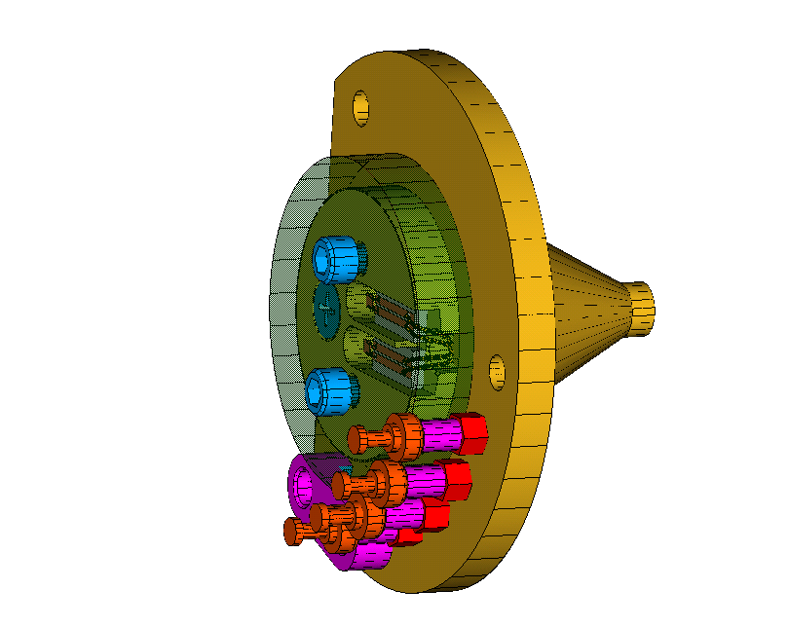
PCAL enclosure
Source inside cover (transparent for clarity)
Electrical connections to BSM wiring harness
Emitting aperture
Figure 4-77 - Schematic diagram of PCAL source unit.

Spectrometer calibrator (SCAL)

The signal output from one of the FTS detectors represents the difference between the spectra presented at the two input ports. When the FTS is at its zero path difference position, all frequencies are in phase and the signal is at its maximum. Astronomical signals will usually be much smaller than the thermal background from the telescope. To minimise the required dynamic range for detector signal measurement, it is desirable to replicate the telescope spectrum in the second input port. SCAL is required to null the intensity of the interferogram central maximum to accuracy of 5% (goal 2%), and to replicate the dilute spectrum of the telescope to an accuracy of better than 20% (goal 5%) over the 200-400 μm range. The telescope is assumed to be at 80 K and to have an overall emissivity of 4%. It is assumed that the overall emissivity of the system is uncertain by a factor of two, and that the actual value will not be known before launch, and SCAL must therefore have sufficient adjustability to accommodate this uncertainty.

SCAL is located at the second input port to the FTS, at an image of the telescope pupil (diameter = 26 mm). The baseline SCAL design is shown in Figure 4-78.
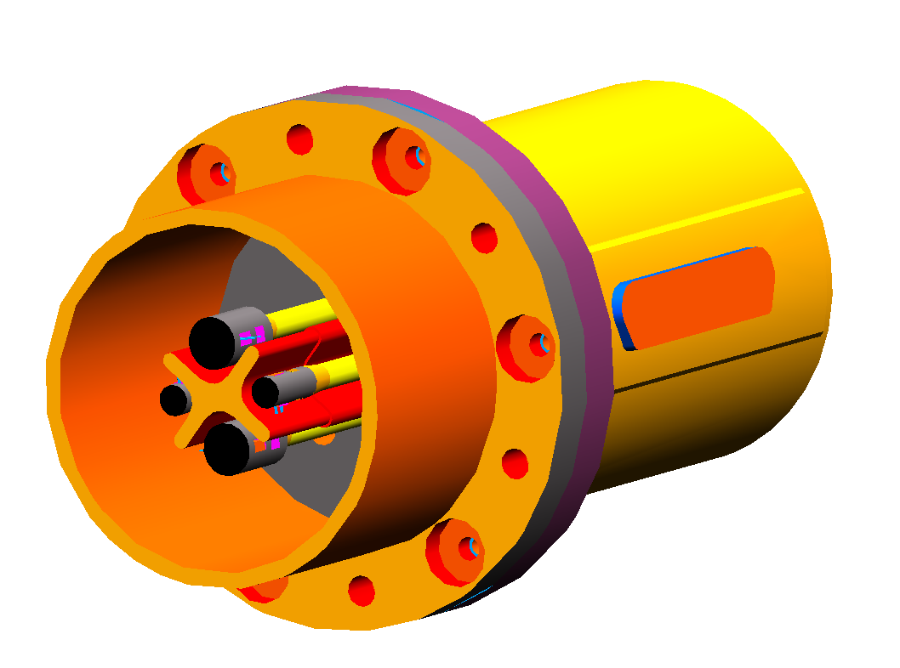
Prime sources
Redundant sources
Baffle
Black
5-K plate
SCAL enclosure
Figure 4-78 - Model of SCAL assembly showing prime and redundant sources and baffle.

Because SCAL is at a pupil, the effective emissivity can be controlled by using a geometrical fill factor. A black (emissivity ~ 1) source that fills only 4% of the pupil area, produces an effective emissivity of ~ 4%. A second, smaller source is provided to accommodate the possibility that the telescope emissivity is lower than the nominal 4%. This source will have an effective geometric emissivity of ~ 2%. Each source consists of a surface-blackened aluminium end cap, with embedded heater and thermometer, on a Torlon strut for thermal isolation. If the telescope emissivity is higher than expected, both sources can be used together to match the telescope spectrum. In order to provide full redundancy, a second redundant pair of identical sources is included. A radiation baffle between the sources minimises radiant heating of the passive sources by the active source(s). The plate to which the source assemblies are mounted forms the back plane of a cavity at Level-1 temperature, and is also blackened. SCAL is thus completely non-reflecting, avoiding any potential standing waves that could be set up between the detectors and the calibrator

SCAL is required to have stable emission over the timescale of a long FTS observation. The radiant output is required to be stable to within 1% over a period of > 1 hr. A long time constant is therefore desirable. A PID controller, implemented in software is baselined to control the SCAL temperature, and the device shall be designed to have a long intrinsic time constant. However, the cool-down time should not be excessive to prevent emission persisting after the FTS has been switched off (this could, for instance, create stray light problems for photometer observations ). SCAL will be designed to have a warm-up time (to stable operating temperature) of < 15 minutes, and to cool from its nominal operating temperature to < 10 K within 3 hrs (with a goal of 30 minutes).
Thermal testing of SCAL prototypes indicates that all of the requirements can be met, and that the spectral matching goal can be met over a wide range of assumed telescope temperature and emissivity.

Note that failure of SCAL does not result in loss of the FTS, but the performance for low resolution spectrophotometery would be degraded.

Further details in of the PCAL and SCAL device may be found in the SPIRE Calibrators SSSD.

Beam Steering Mechanism (BSM)

The BSM is designed to allow the image of the sky to be positioned and moved across the detector arrays in a controlled manner. Its specifications are fully described in the BSM SSSD.

The BSM is mounted on the photometer side of the SPIRE Optical Bench, with the moveable mirror coincident with an image of the system pupil stop, the Herschel secondary mirror. The BSM must be able to steer the FOV in two independently controlled orthogonal axes. Rotations of the mirror around the Y-axis of the satellite represent “chopping” motions of the FOV while rotations about the Z-axis represent jiggling motions. Various observation modes of the telescope call for simultaneous rotations in both axes.

The key specifications of the BSM are summarised in Table 4-11.

 | Chop stage | Jiggle Stage
On-sky rotation | ± 2 arcminutes | ± 30 arcseconds
Mirror rotation | ± 2° 24’ | ± 0° 36’
Frequency | 2 Hz (design), 5 Hz (goal) | 0.5 Hz (design), 1 Hz (goal)
Maximum power dissipation within FPU | 4 mW
Total Mass | 1100g
Settling time to within 5% of demand position | 10 msec | 50 msec
Angular measurement resolution | 0.002°
True angular position accuracy | 0.04°
Angular position repeatability | 0.004°
Table 4-11 - Key specifications of the BSM.

The BSM is composed of the following components:
- Mechanism (BSMm)
- Mirror and Photometer calibration source (P-Cal)
- Flex-pivots
- Gimbal frame
- Magnetic actuators
- Position sensor
- Stray light baffle
- Thermometer
- Structural interface to the SPIRE Optical Bench (BSMs)
- Warm electronics (BSMe)
- Launch-lock device

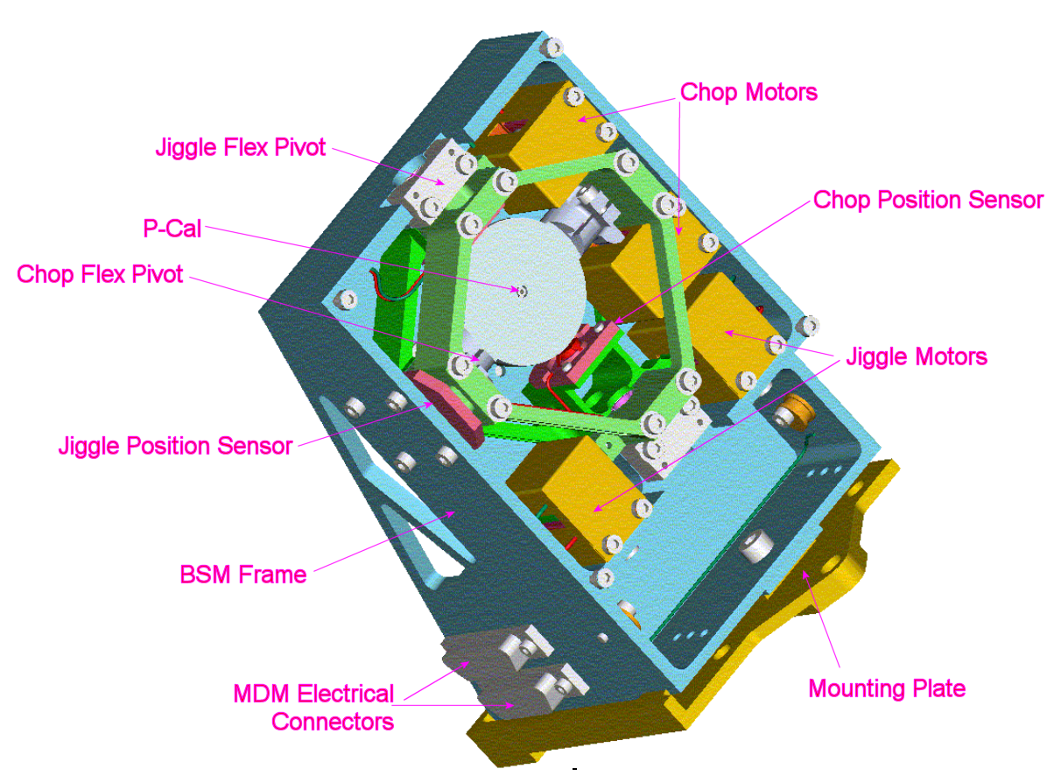
Figure 4-79 - General view of the Beam Steering Mechanism with the stray light baffle removed to illustrate the interior components.

Mirror/Chop Stage: The mirror has a diameter of 32 mm and is machined from a monolithic block of Al-6160. The mirror rotates about the chop axis on an integrally machined shaft. The front reflecting surface of the BSM is machined flat to within 1 μm rms and polished to within 10 nm RMS. The mirror has a specular reflectivity in excess of 99% and an emissivity of less than 1% in the wavelength range 200-670 μm. Perpendicular stiffening ribs machined into the rear surface of the mirror minimises the suspended mass while retaining sufficient in plane stiffness. There is a 2.0-mm diameter (TBC) hole at the centre of the mirror, through which PCAL, the photometer calibration source (see §4.8.1), radiates during operation. This hole is conjugate with the central obscuration of the Herschel telescope. The PCAL source is mounted behind the BSM mirror with a short length of light-pipe coupling the radiation to the aperture at the centre of the mirror. The underside of the mirror is light-weighted and has pockets for the iron plates for the magneto-resistive position sensors. The moment of inertia of the chop stage is 2.1 kg.mm² and has been minimised to reduce power consumption during chop transitions.

Flexure Pivots: The Flexural Pivots allow rotation of the mirror about the Chop and the Jiggle axes while constraining all translational degrees of freedom. These pivots have high radial stiffness, which virtually eliminates unwanted rotation of the mirror due to bearing flexibility. They have minimal static friction to overcome which would greatly complicate the design of the control system and possibly increase the power demand on the actuator. This restoring force provided by the pivots ensures that the mirror returns to the neutral position in the event of power failure to the BSM motors. The mounts for the pivots are designed in such as way so that if the pivots fracture, they are constrained and effectively become journal bearings. This aspect of the design renders this contingency a soft failure mechanism.

Several different options are open for the final selection of the industrial supplier of the pivots. The main criteria used in the selection are as follows:

- Spring rate/Pivot Strength: A tradeoff exists between the strength of the pivots and the sping rate. It is desirable that the spring rate of both the chop and jiggle pivots be as low as possible (within other constraints) as a low spring rate will lower the power demanded by the motors. It is also desirable that the pivots be as strong as possible to give as much margin on the launch loads as is possible. It is currently estimated that the spring rate will be approximately 5 Nm/° for the jiggle stage and 0.6 Nm/° for the chop stage and the design loads of approximately 200 N and 25 N respectively. The jiggle stage must be much stronger than the chop stage as the suspended mass is proportionately higher.
- Material: The flex pivots must take the forces generated by the accelerations imposed on the suspended components of the BSM during launch. The BSM will be at cryogenic temperatures during launch which renders some materials brittle. In particular, grades 420/429 Stainless Steel which are commonly used in flex pivot construction become brittle at cryogenic temperatures. Inconel 718 does not suffer from this problem and is baselined as the material to be used in the BSM flex pivots.

Jiggle Stage: The jiggle stage is in the form of a split frame split and clamps together around the flex pivots. To balance the jiggle stage the framework in the opposite corner to the coils of the actuator has been made solid. This also increases the stiffness of the structure. This structure carries the chop stage, and is inevitably heavier. Since the amplitude and frequency requirements in this axis a stiffer flexures pivot is used for increased strength and reliability.

Position sensors for the chop axis are mounted on the jiggle stage, which means flexible cable connections are required, unlike the jiggle stage position sensors, which mount directly on the non-moving housing. An alternative to this may be to place the chop axis sensor also to the housing and compensate for the movement in the jiggle axis in the look up table using this in conjunction with the jiggle axis position. The gimbal frame is fabricated from Al-6061.
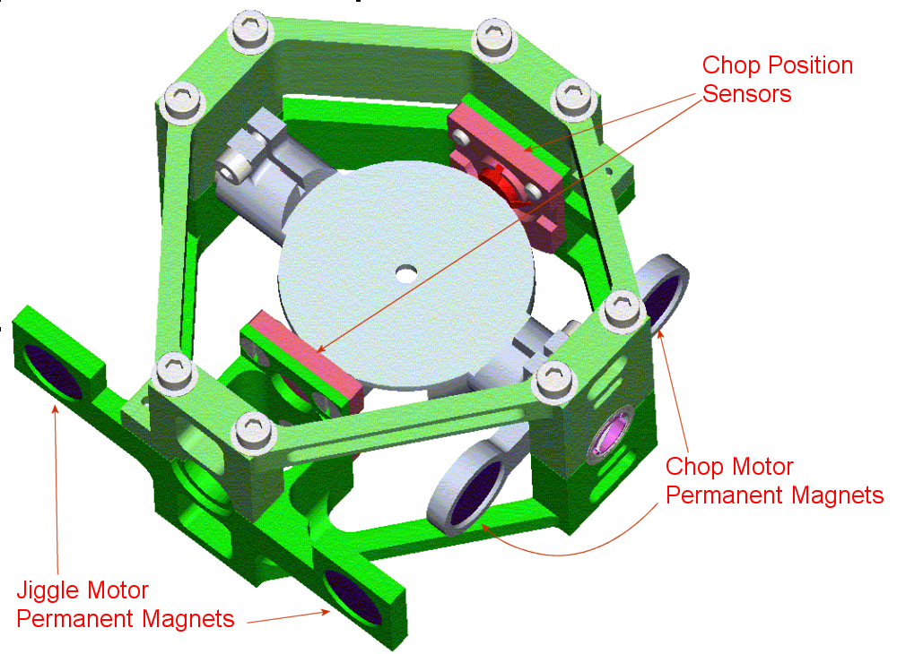
Figure 4-80 - Chop (shown in grey) and Jiggles stages of the BSM.

BSM Motors: The magnetic actuators are located at the edge of each stage of the BSM. There is a primary and a redundant motor for each axis. The estimated power consumption is 0.4 mW when chopping at 2Hz with maximum amplitude and an average power consumption of 1.6 mW when jiggling at 1 Hz with maximum amplitude. Depending on implementation, the motor for a single axis will either have:
- the prime coil on one side of the rocker beam and the redundant on the other, leading to an unbalanced load but a more rugged coil, or
- a balanced set of coils with the prime and redundant motor coils wound onto the same bobbin.

The coils may be potted (encapsulated) if required, and will certainly require extensive magnetic shielding and strong thermal linking to the thermal straps. All the motor coils mount directly to the BSMs, i.e. the chop stage air gaps must be slightly over-size to accommodate chopping whilst in various jiggle modes.

A prototype coil is illustrated below in Figure 4-81. The prototype has copper windings. The flight version of the motor will have Aluminum windings, which is more efficient and dissipates less power into the structure.

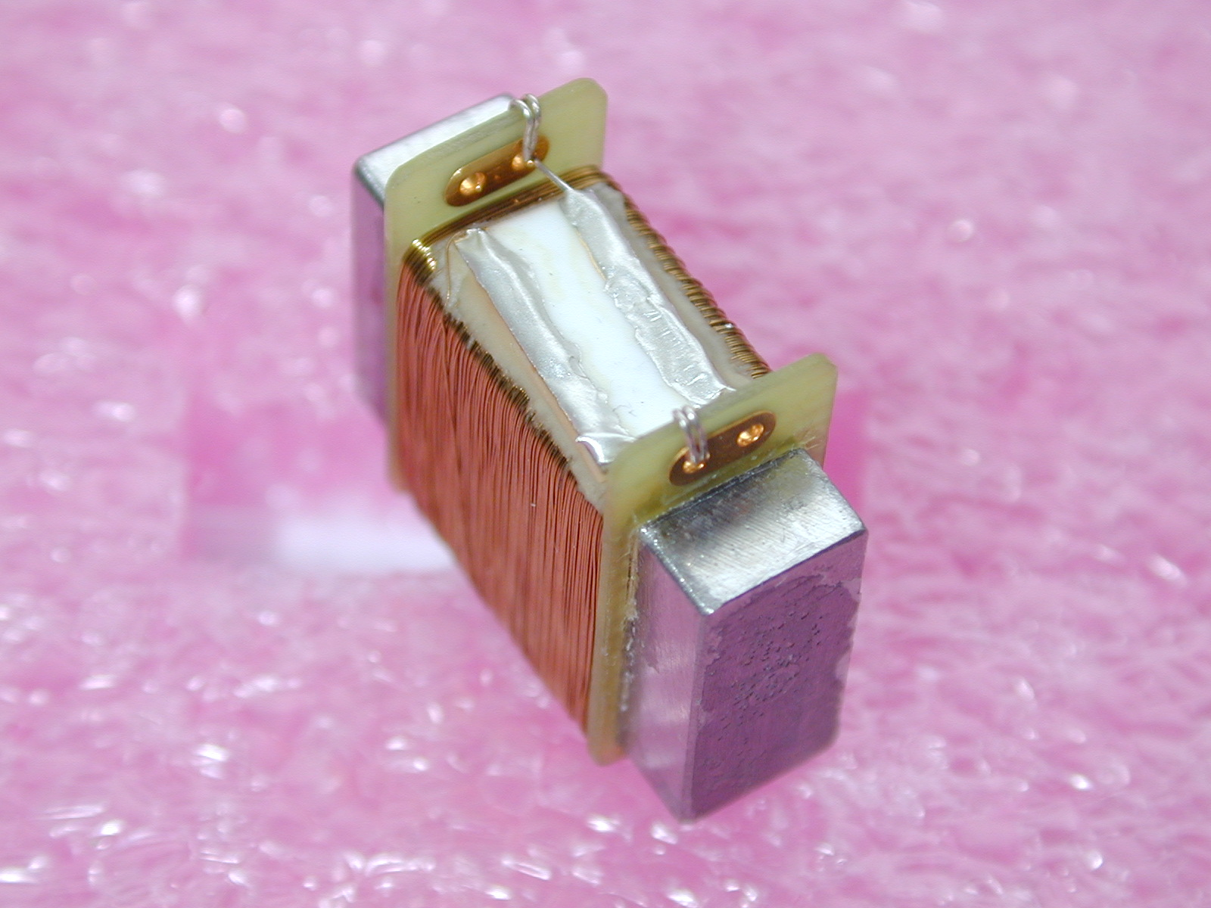
Figure 4-81 - Prototype BSM motor.

Position sensors: These sensors are Infineon (ex-Siemens) FP 212 L100-22 differential field plates that sense the position of soft iron pieces in the moving parts. The sensors are dual InSb/NiSb magneto-resistive elements, biased with a permanent magnet and forming part of a bridge circuit. As the position of the gimbal frame moves relative to the position of the sensor, the resistance of the element changes in proportion to the displacement. The sensor is connected in a Wheatstone bridge configuration driven by a constant current source. Hence, the voltage measured across the bridge is proportional to the displacement of the mirror.
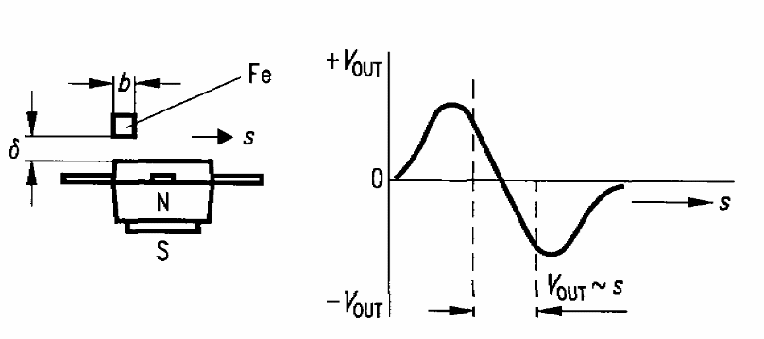
Figure 4-82 – Schematic drawing of the Infineon magneto-resistive position sensor.
Position sensors for the chop axis are mounted on the jiggle stage, which means flexible cable connections are required. The jiggle stage position sensors mount directly on the non-moving housing and do not require these flexible wires.

Stray light baffle: Parasitic losses in the actuators, electronics and wiring may cause the temperature of some of the items mounted on the BSM to rise above the 4 K temperature of the Level-1 enclosure. Any radiation emitted from these items must be shielded from the detector arrays. This is achieved through a baffle made from 0.25-mm thick (TBC) Al-6160 (TBC) placed over the components and around the mirror. The baffle fits tightly around the mirror allowing full movement without interfering with the primary beam.
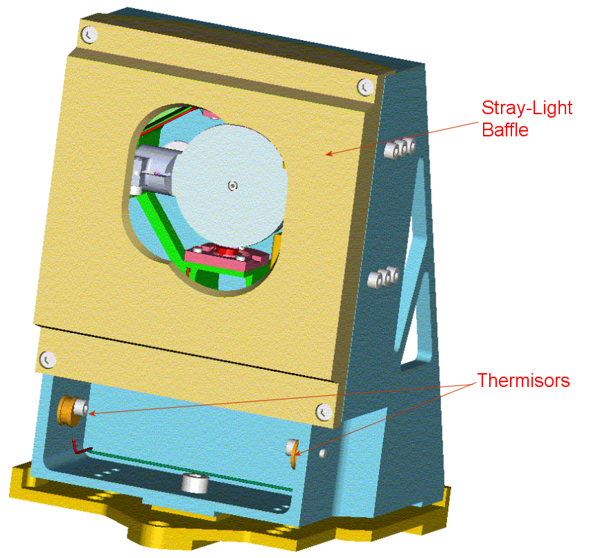
Figure 4-83 - View of the BSM with the stray light baffle covering the electrical components.

Structural interface to SPIRE Optical Bench: The mirror needs to be accurately mounted on the SPIRE optical bench. The mounting interface is shown below.
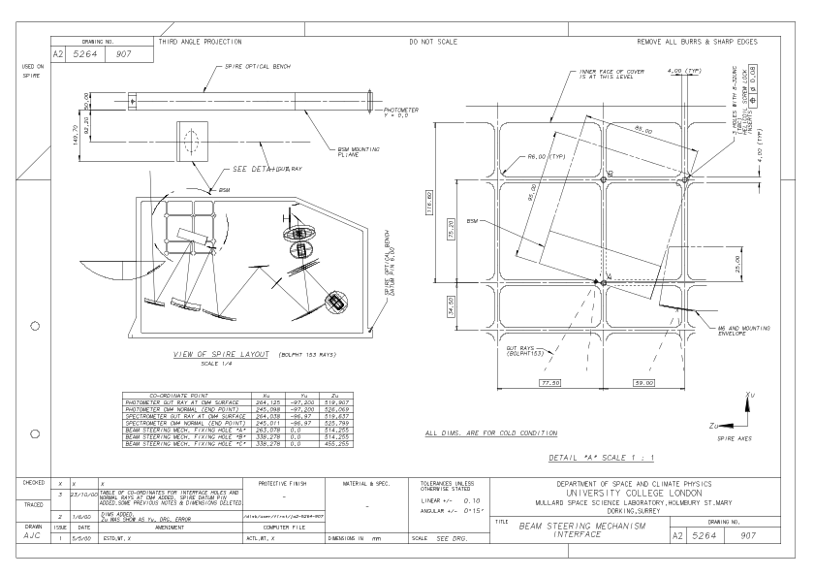
Figure 4-84 - Mechanical interface drawing between the BSM and the SPIRE optical bench.

Electrical connector: Two 37-way MDM connectors (one prime and one redundant) accommodates all electrical connections to the BSM and the PCAL device. These connectors are located on the mounting frame.

Control system: The BSM has a prime and redundant electrical interface with the FCU to provide the necessary feedback control of the mirror-pointing angle. The position of the mirror is controlled via a PID algorithm which is part of the OBS of the MCU. The control scheme treats each rotational axis of the mirror independently of the other. More detail on the hardware implementation of the actuator control and power system is described in §4.2.2.

Spectrometer Mechanism

The Spectrometer mirror MEChanism subsystem (SMEC) controls the movement of the rooftop mirrors inside the SPIRE spectrometer. The movement of the mirrors causes there to be an optical path difference between the two beams that enter the spectrometer 2-K detector box. The critical performances of SMEC are the mirror velocity and its stability, the mirror movement around its travel axis and the required accuracy of the mirror position measurements.

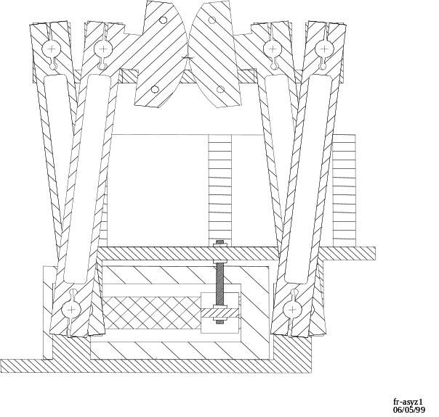
Figure 4-85 - CAD drawing of the link mechanism used for the SMEC.

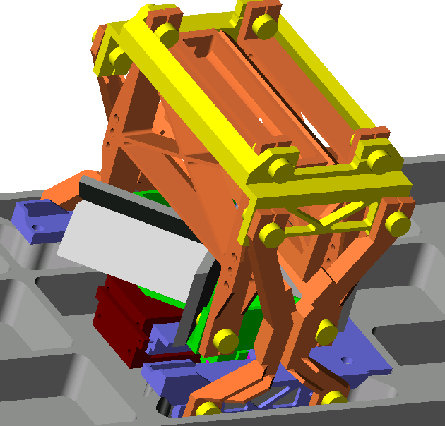
Figure 4-86 - Solid model of the SPIRE FTS Mechanism.

Requirements on the mirror mechanism

The design of the FTS spectrometer (see §2.3.4.2) means that there is an effective folding of the optical path difference of a factor of four between the actual movement of the mirror mechanism and the change in the optical path difference (OPD). The required resolution of the spectrometer is for a maximum Δσ = 0.4 cm⁻¹ at all points in the field of view with a goal of reaching 0.04 cm⁻¹ for at least point sources viewed on axis. There is a further requirement that the systematic noise induced by the movement of the mirrors will not prevent low resolution spectroscopy down to at least Δσ = 2 cm⁻¹. The goal resolution imposes a maximum change in the OPD of ~ 12 cm or 3 cm in actual mirror movement. In order to Nyquist sample the interferogram at the highest frequency present in the optical band (50 cm⁻¹) , the optical path difference must be sampled every 20 microns, or every 5 microns of actual mirror movement.

The most efficient method of operating an FTS is the so-called rapid scanning method. Here, the mirror is kept in constant motion while the signal and mirror position are sampled. This method of operation effectively transforms the optical frequency to audio frequencies by the relationship f = v_{opd}σ. Where f is the detection frequency, v_{opd} the rate of change of the optical path difference and σ the optical frequency. The maximum OPD velocity required will be determined by the frequency response of the detectors. For an assumed detector response of 20 Hz the maximum v_{opd} will be 0.4 cm/s or 0.1 cm/s in actual mirror speed. In fact some “head room” may required in case of problems with microphonic interference so the maximum velocity requirement on the mirror mechanism has been set at 0.2 cm/s.

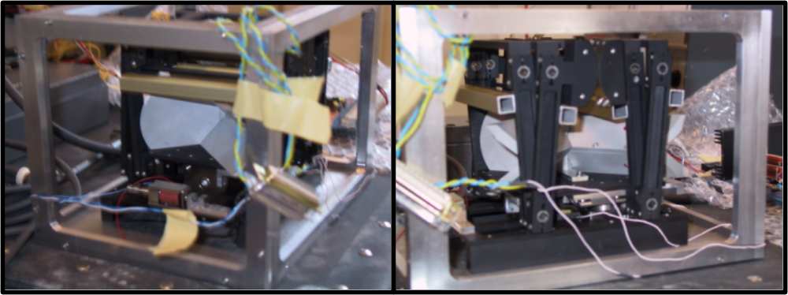
Figure 4-87 - Views of the engineering model of the SMEC.

In order to further improve efficiency, the interferograms can be taken “single sided”. That is only a short movement is needed on one side of the zero path difference (ZPD) to enable the position of the ZPD to be established and as long a distance as necessary is scanned beyond that to achieve the required resolution.

As in the photometer, the signal in the recorded interferograms will be dominated by the telescope emission. The shape of the optical pass band means that the rate of change of the signal is greatest over the scan region close to the ZPD (Figure 4-89); that is at low resolution. In order to fulfil the requirement on the low resolution performance of the spectrometer it is necessary to have good control of the variation in the velocity and knowledge of the mirror position over the scan range close to the ZPD. Further away from the ZPD the requirement is less strict as the rate of change of the signal is much reduced.

These scientific and operational requirements impose the following baseline performance on the FTS mirror mechanism or SMEC:
- maximum mirror travel required (w.r.t. the ZPD position): – 0.32 to +3.2 cm;
- minimum measurement interval of 5 μm is required;
- required mirror position measurement accuracy 0.1 μm over +- 0.32 scan range and 0.3 μm thereafter;
- the mirror velocity shall be within 0.001 cm/s r.m.s. within a band width of 0.03 to 25 Hz over the entire scan range;
- additionally movement of the mirrors must not impose any translation or rotation on the optical beam such as to affect the fringe visibility in the recorded interferogram.

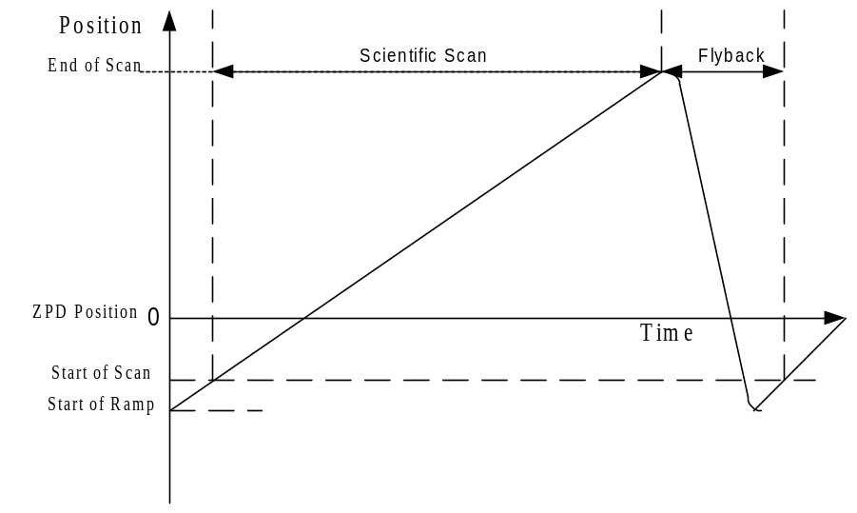
Figure 4-88 - Definition of a typical scan trajectory for the SMEC.

Control System and Readout

The baseline design of the spectrometer is that it should be operated in “rapid scan” mode with a constant mirror velocity and the time at which each position is passed recorded. The mirror movement will be controlled by a digital feed back loop that uses the time between successive pulses from the optical encoder to control the speed of the mirrors. In order that the mirror velocity jitter in the signal detection band (essentially 0.03-25 Hz) does not affect the signal to noise ratio achieved, the feedback loop will be operated at about 2 kHz. The digital feedback loop is implemented using the TEMIC TSC21020 digital signal processor which is also used as the CPU in the DPU. The detectors could be read out in one of two methods given the encoder type we plan to implement:

Position sampling with synchronised detector readout. In this technique, the mirror position pulse is used to trigger the readout of the detectors. The time taken to readout the detector array will need to include any possible uncertainty in the time interval between positions due to the uncertainty in the mirror velocity. This method has the advantage that each frame will be recorded at a known mirror position within the uncertainty of the mirror velocity from one position sample to the next. This means the interferograms can be safely co-added with no need to interpolate the data onto a common position grid. The disadvantage of this method is that it requires both a synchronisation pulse from the mirror drive electronics to the detector read-out electronics (and therefore makes the electronics more complicated) and a higher readout rate for the detectors.

Time sampling. Here the time of each pulse from the position sensor is recorded and the detectors are independently sampled; with perhaps a start pulse at the start of the scan to synchronise the readout. The advantage of this technique is that it is simpler to implement in the electronics and will be less prone to operational difficulties associated with timing between the position readout and detector readout. The disadvantage is that, because of the uncertainty in the mirror velocity and any hysteresis or scan-to-scan variability in the positioning of the mirror, the detector readouts will have to be interpolated onto a common position grid before co-addition of the interferograms. In practical terms, this will probably prevent on board co-addition of the interferograms and the mirror scan speed will therefore have to be adjusted to allow the data sampling rate to fit within the 100 kbs telemetry bandwidth available for the Herschel instruments.

After an assessment of the implementation of the two methods in the electronics system for the SPIRE instrument, it was decided to adopt the time sampling method as the default operating mode.

The cryogenic mechanism (SMECm)

The SMECm is the mechanism which moves the mirrors. The mirrors are considered a part of SMECm. Basically, the movement of the mirrors is a translation only, obtained through the action of a linear actuator. The mechanical design is based on a prototype Goddard Space Flight Center design for a balloon project (Figure 4-85 and Figure 4-87). A base plate supports the mechanism and is mounted on the SPIRE Optical Bench. On the base plate are mounted the fixed part of the actuator and the optical encoder. A moving plate supports the rooftop mirrors and the rule for the optical encoder. The base plate and the moving plate are linked by four "legs", each of which has two arms; one linking the base plate and the intermediate moving plate, the other linking the intermediate moving plate and the moving plate. The articulations at both extremities of the legs use flex pivots. The stiffness of the articulation is very low to keep the actuator power consumption within the specified limits. Consequently, for SPIRE, a launch latch item is added to allow the mechanism to sustain the launch vibrations without damage. The latch is placed between the base plate and the mirror moving plate.

Position measurement

For the position measurement system, a Heidenhain LIP interferential linear encoder is used over the complete travel range of the mirror with a linear variable differential transformer (LVDT) transducer implemented over the movement range around ZPD as a redundant device. The LVDT also provides absolute position measurement close to the ZPD, unlike the optical linear encoder, which only provides relative position information. LVDT devices have already flown on many previous space experiments and were used cryogenically on the ISO LWS grating mechanism. Cryogenic tests indicate that the Heidenhain encoder may be used at liquid helium temperatures with only minor modifications to the optical head. The optical encoder will have a resolution of 0.1 μm or better and gives a “pulse” as each position is passed rather than an absolute distance measurement. The encoder will be fitted to the outside of the mirror carriage.

Measuring the position at a distance from the signal beam imposes stringent requirements on the “nodding” movement of the mirror mechanism, possibly stricter than those imposed by the optical requirements of the spectrometer. The actual value of the requirement will depend on the final configuration of the flight optical encoder and the final carriage design.

The preamplifier (SMECp)

Due to the loss of current on the output signals of the optical encoders when they are cooled down to 4 K, a preamplifier is necessary. The electronic components (JFETs, etc..) are implemented on a card integrated in a separate box on the SPIRE structure. The temperature of the components is set around 100 K.

The driving and control of the SMEC is carried out by the SMEC and MAC boards in the MCU.

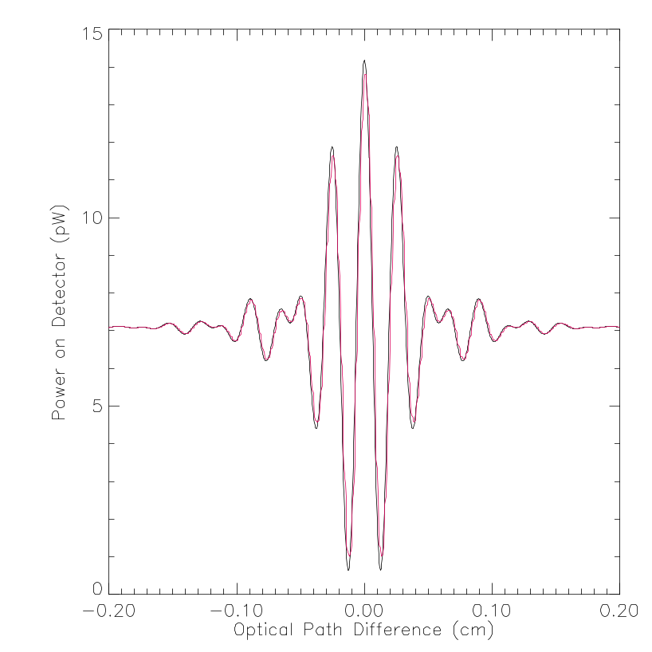
Figure 4-89 - Simulated spectrum of the 80 K telescope seen through the SPIRE FTS with representation optical filtering. The black line is before applying the frequency response of the detectors the red line after. Note the much larger rate of change of the sign

FPU structure

A general view of the FPU structure is shown below in Figure 4-90. The FPU is mounted on the Herschel Optical Bench (HOB) by a three point, isostatic mounting scheme comprising of a single Cone and two A-Frame Supports. These three supports provide a rigid mount for the FPU to the Herschel Optical Bench while allowing for differential contraction between the instrument and the HOB during instrument cool-down. Three main structural elements are mounted off the supports, viz.; (i) the SPIRE Optical Bench, (ii) the Photometer Cover and (iii) the Spectrometer Cover. All subsystems within the FPU are mounted on the SPIRE Optical Bench (with the exception of the instrument harness connectors and the instrument thermal strap interfaces with the Level-0 straps). Figure 4-90 illustrates the coordinate system used in for the SPIRE structure and the main components of the FPU structure.

The Spire Optical Bench is machined from a single block of Al-6061 approximately 675 mm long (aligned with the Spacecraft Z axis, See Figure 2-2) by 410mm high (aligned in the X axis) and 50 mm thick. All optical components of the spectrometer are located on the +Y side of the SOB while all the components of the photometer are located on the –Y side. The mass of the SOB is minimised by machining ribbed pockets (nominally 70 x 70 mm) on both sides.

The structure has the following set of general requirements:

- The structure must mechanically support and positively locate the subsystems mounted inside the FPU.
- The structure must meet the mass budget allocation of 9884g.
- The structure must provide the correct thermal isolation between the various temperature stages of the instrument.
- The structure must provide adequate EM shielding and stray-light shielding to the photometer and spectrometer such that the detectors see no detectable spurious EM power.
- The structure must allow for simple integration and de-integration of the structure and FPU subsystems.

These requirements are the means by which they are met are discussed below.

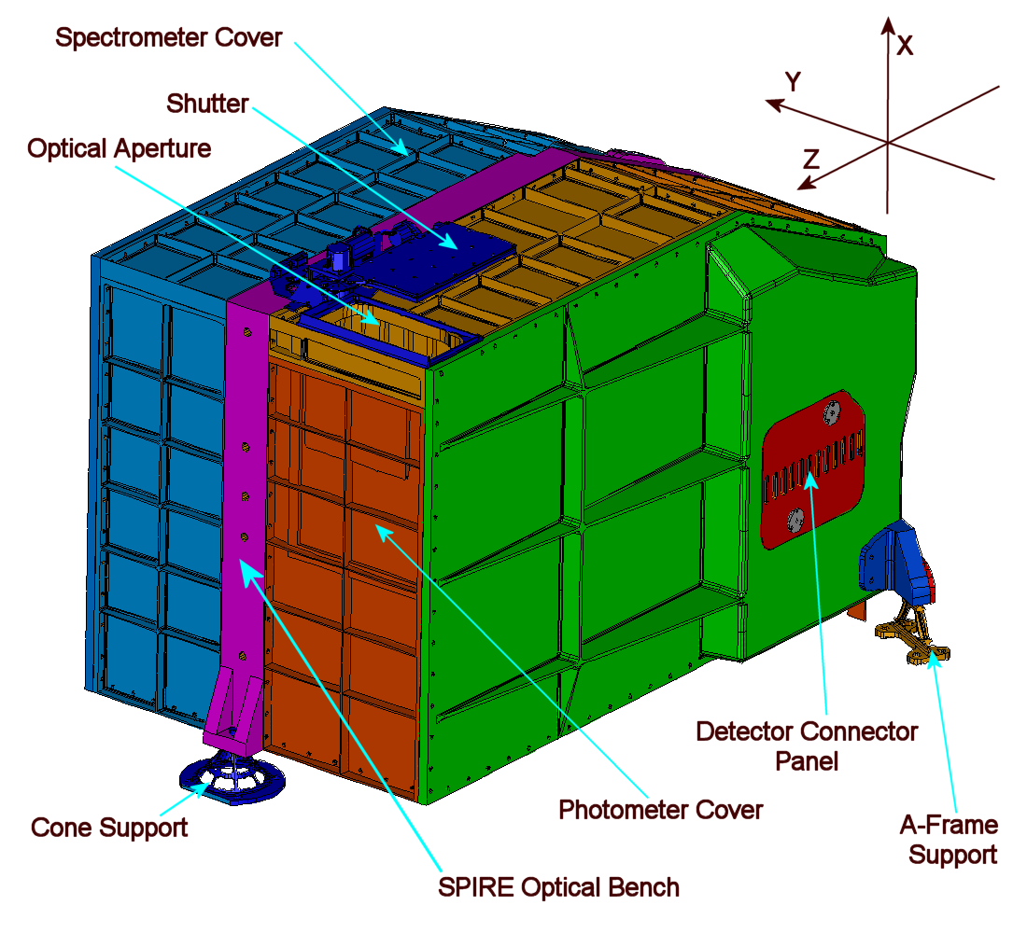
Figure 4-90 - General view of the FPU and the Herschel coordinate system. Only one A-Frame Support can be seen in this view. The second A-Frame is located in a similar position on the Spectrometer Cover.

Mechanical Requirements

The main structural loads imposed on the FPU are those arising from the acceleration and vibration loads seen during launch. The various qualification acceleration levels at the interface between the Herschel Optical Bench and the FPU are set out in the IID-A. These are quoted below for in formation only.

Interface load | Axis | Level
Quasi static acceleration (Case 1) | Longitudinal | 20g
Quasi static acceleration (Case 1) | Lateral | 2
Quasi static acceleration (Case 2) | Longitudinal | -
Quasi static acceleration (Case 2) | Lateral | 14g
Sine | Longitudinal (5-40Hz) | 20g
 | Longitudinal (40-100Hz) | 10g
 | Lateral (5-100Hz) | 14g
Random | Longitudinal /Lateral (20-100Hz) | + 6 dB per octave
Random | Longitudinal /Lateral (100-300Hz) | 0.05g²/Hz
Random | Longitudinal /Lateral (300-2 kHz) | - 6 dB per octave
Table 4-12 - General interface acceleration loads for the FPU and JFET Boxes. Taken from the IID-A for information only.
To ensure that there is no serious vibrational energy absorbed into the structure during launch, there is also a requirement that the first natural frequency of the structure has to be greater than 100 Hz in both the longitudinal and lateral directions. Over and above this, it is desirable that the structure be as stiff as is practical so that the interface accelerations for the various subsystems mounted off the common structure be as close to those listed in Table 4-12. A finite element model was constructed of the entire instrument to confirm the structural integrity of the structure and the various subsystems under the launch loads listed above. This model indicated a positive margin of safety for yield, ultimate and buckling failure. The first mode of vibration was identified at 136 Hz.

Thermal Isolation Requirements

The structure of the instrument is designed to operate at three temperature levels, which gives three passive heat load budgets for the structure. These three budget allocations are listed in Table 4-13 below.

Passive Heat Load | Budget Allocation
Level-2 to Level-1 | 6 mW
Level-1 to Level-0 | 1 mW
Level-0 to 300-mK Strap and stray-light baffles | 1.6 μW
Table 4-13 - Thermal budget allocations to the structure taken from SPIRE Thermal Configuration Control Document for information only.

Level-2 to Level-1: The SPIRE Optical Bench, Photometer and Spectrometer covers, BSM, FTS, Sorption Cooler, Mirrors, Filters and Calibrators are all intended to remain at the Level-1 temperature (approximately 4 K). Heat will be conducted from the Herschel Optical Bench (Level-2; approximately 10 K) through the FPU supports to the Level-1 structure. The harnesses will also contribute to this budget allocation.

The mechanical supports designed for this interface are shown below in Figure 4-91. These supports are particularly difficult to design as they have very stringent and competing requirements on thermal isolation (pushing for a slender design) and mechanical rigidity (pushing for a heavier design). Thermal and mechanical tests have been carried out on the A-Frames which indicate that each of these competing requirements have been met.

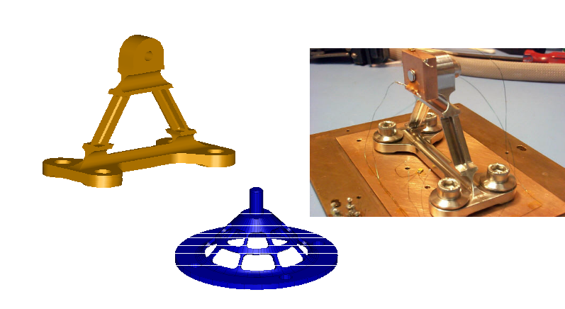
Figure 4-91- FPU/HOB interface A-Frame and Cone Supports.

The material used in the construction of these supports is Stainless Steel. This was chosen for its high ratio of Young’s Modulus to integrated thermal conductivity between 4 K and 10 K. It should be noted that Titanium alloy TaV6 has a superior figure of merit at lower temperatures. Carbon Fibre could also be used for these supports but the complexity of Carbon Fibre design and development precluded this option.

Level-1 to Level-0: This thermal interface is between the Spectrometer and Photometer Detector Boxes and the SPIRE Optical Bench. It is similar to the interface between the FPU and the HOB in that there are competing thermal and mechanical design requirements. A similar solution has been adopted of an isostatic mount with a single Cone and two A-Frame Supports.

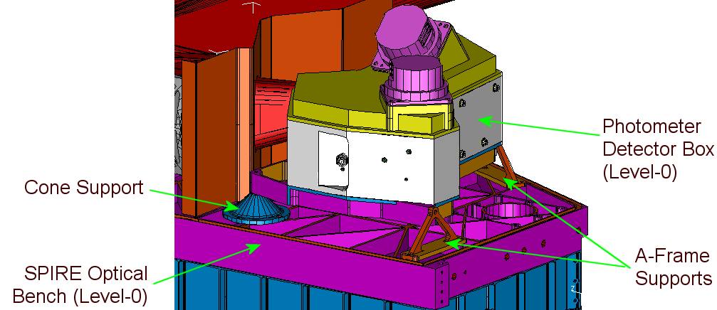
Figure 4-92 - Thermal isolation between Level-1 (SOB) and Level-0 (Detector Box).

Level-0 to 300-mK Architecture: The Bolometer Detector Arrays used in SPIRE work most efficiently below 300-mK A thermal strap between the cold tip of the sorption cooler that runs to a bolted interface with each of the BDAs provides the cooling necessary to achieve these temperatures. (Note: The passive heat load budget allocation to the 300-mK components of the Sorption Cooler and BDAs are held by the respective subsystem providers. The budget allocation to the support structure of the thermal strap is held by the structure.) The strap is thermally isolated from the Detector Boxes by a Kevlar string up. This part of the design is very challenging as the random vibration loads within the detector boxes are very high and failure of the suspension system could result in a thermal short of the 300-mK system and loss of the SPIRE instrument.

Stray light and RF shielding

The detectors on SPIRE are extremely sensitive to stray light and spurious electromagnetic radiation. The structure utilises two main techniques to shield the detectors and the read-out electronics from this interference; (1) RF tight joint configuration, and (2) Stray light baffling.

RF-tight joint Design
When an electric field impinges on a conducting surface, such as the FPU cover, electric currents are induced immediately below the surface that create electric fields that tend to cancel out the incident fields. This effect accounts for most of the electromagnetic shielding of a metallic enclosure. When these currents are impeded from flowing, the structure is unable to cancel out the waves and they will re-radiate into the enclosure. One of the most frequent occurring disruptions to the current flow within an enclosure is at joints between different panels, in fact, a poorly designed joint will act as a slot antenna. This undesirable effect can be minimised by incorporating the following features in the joints in the enclosure.
- Bolt spacing: The bolt spacing has two main effects. Firstly, a small bolt spacing will increase the clamping force on the joint. A high clamping force will help in ensure that good electrical contact is made between the two interface surfaces. Secondly, bolt spacing delimits the maximum length of any potential gap between the two interface surfaces which reduces the maximum wavelength that can penetrate into the FPU. A maximum bolt spacing of 30mm has been used on SPIRE which is consistent with good EMC practice.
- Joint quality: The better the dimensional tolerancing of the joint, the better will be the electrical contact between the two halves of the joint. The joints on SPIRE have been toleranced accordingly.
- Labarinth: The provision of sharp edged corners around which any stray light or RFI has to reflect greatly assists in improving the performance of the enclosure. Any radiation entering the FPU has to be reflected around at least four corners. The details of this joint can be seen in Figure 4-93. This join design is also effective in preventing the ingress of stray light.

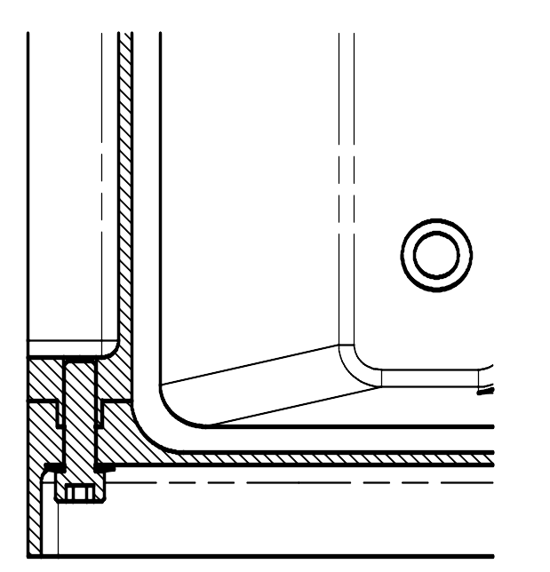
Figure 4-93 - RF and stray light tight joint design used in the FPU.

Alignment requirements

The optical components are located on the bench by hollow dowel pins and 8-32 UNC screws provide positive the mechanical attachment. The SOB is manufactured and toleranced in such a way so that the position of the components located on the bench are in the correct position when the bench has undergone the contraction during cooling from room temperature to the nominal operating temperature of 4K.

Mirror mount PM6 in the photometer and SM6 in the spectrometer have provisions for remachining to correct any misalignments.
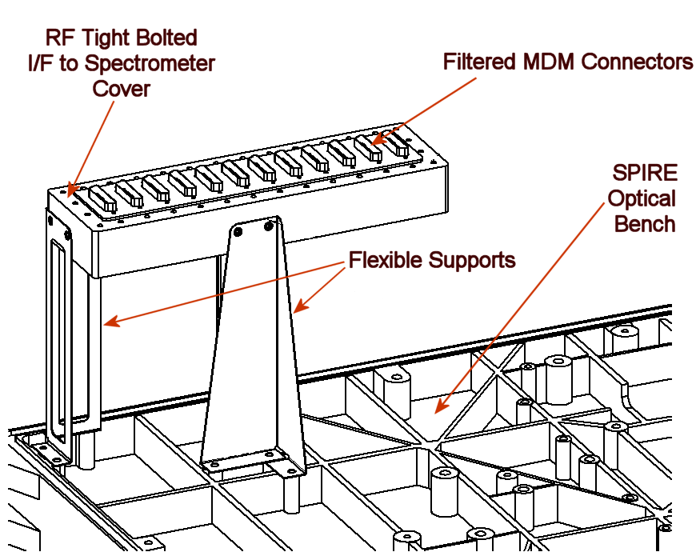
Figure 4-94 - Details of the mounting of the enclosure for the filtered MDM connectors.

Thermometry

Lakeshore, Cernox CX-1030 thermistors are located throughout the FPU. Figure 4-95 shows the dimensions of these thermistors.

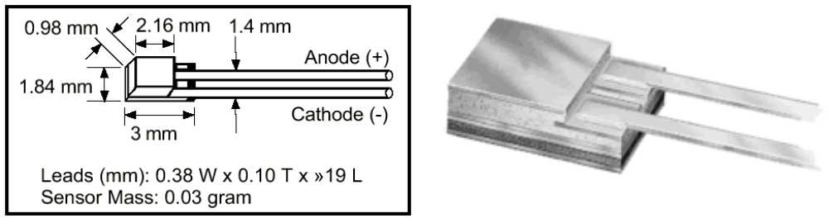
Figure 4-95 - View of the Lakeshore, Cernox SD hermetically sealed RTD thermometers.

Location | Acronym | Temperature  Range | Resolution | Accuracy
PHOT Level 0 box | T_PL0_1 | 1 K -10 K | 2 mK | 2 mK
FPU SOB/BSM I/F | T_SOB_1 | 3 K - 300 K | 10 mK | 10 mK
Optical sub-bench | T_SUB_1 | 3 K-100 K | 25 mK | 25 mK
Input Baffle | T_BAF_1 | 3 K-100 K | 10 mK | 10 mK
SMEC Mechanism | T_FTS_1 | 3 K - 20 K | 10 mK | 10 mK
SMEC/SOB Interface | T_FTS_3 | 3 K - 100 K | 25 mK | 50 mK
SPEC Calibrator 4% | T_SCL4_1 | 10 K - 80 K | 5 mK | 5 mK
SPEC Calibrator 2% | T_SCL2_1 | 10 K - 80 K | 5 mK | 5 mK
SPEC Calibrator Structure | T_SCST_1 | 10 K - 100 K | 10 mK | 10 mK
Cooler Sorption Pump | T_CPMP_1 | 1.5 K - 50 K | 0.5 K | 1 K
Cooler Evaporator | T_CEV_1 | 0.25 K - 10 K | 0.1 mK | 5 mK
Cooler Pump heat switch | T_CPHS_1 | 1.5 K - 25 K | 0.5 K | 1 K
Cooler Evap. Heat switch | T_CEHS_1 | 1.5 K - 25 K | 0.5 K | 1 K
Cooler Shunt | T_CSHT_1 | 1.5 K 10 K | 0.1 K | NA
BSM Mechanism | T_BSM_1 | 3 K - 20 K | 10 mK | 10 mK
SPEC JFET chassis | T_FTBS_1 | 3 K - 100 K | 25mK | 50 mK
PHOT JFET box | T_FTBP_1 | 3 K - 100 K | 25 mK | 50 mK
SPEC level 0 box | T_SL0_1 | 1K – 10 K | 2 mK | 2 mK
Table 4-14- Location and details of the FPU thermometry.

Helium-3 Cooler

Introduction

The detectors used in the SPIRE BDAs must be cooled down below 300 mK to perform correctly. This is done by a ³He sorption cooler. This sub-Kelvin sorption cooler relies on the capability of porous materials to adsorb or release a gas when cooled or heated. Using this physical process, one can design a compressor/pump that controls the gas pressure in a closed system, condensing liquid at an appropriate location and then performing evaporative pumping on the liquid bath to reduce its temperature thereby providing cooling to a piece of equipment. The total amount of cooling delivered by such a cooler is dependant on (i) the mass of liquid ³He condensed within the evaporator, (ii) the latent heat of evaporation of the ³He at the temperature of the evaporator and, (iii) the parasitic loads to the cooler. The cooler has no moving parts, is vibrationless and is designed to be self contained and compact with high duty cycle efficiency.

A summary of the principal design characteristics of the cooler used in SPIRE is presented in .

Cooler cold tip temperature | 290 mK (at design conditions)
Net heat lift | 10 μW (at design conditions)
Parasitic heat loss | Less than 12 μW (at design conditions)
Hold time | More than 48 hours (at design conditions)
Recycle time | Less than 2 hours
³He charge | 6 litre at STP
Recycle energy (energy dumped into Herschel cryostat during recycle) | Less than 860 J per cycle
Cooler mass | 1680 g
Volume | 228.5 x 100 x 100 mm
First natural frequency | Higher than 120 Hz
Cold tip temperature fluctuations | Less than 10 µK.Hz^{-1/2} in a frequency band from 0.1-10 Hz
Ultimate temperature | 264 mK
Cold tip drift requirement | 0.1 mK/h
Table 4-15 - Principal cooler design characteristics.

Cooler components

The cooler hardware comprises five main components;
  - the sorption pump (SP),
  - the evaporator (EV),
  - the thermal shunt (TS), comprising a thermal link between the pump tube and the cryostat level 0, and two gas gap heat switches connecting the sorption pump and the evaporator to Level 0 (HSP and HSE respectively),
  - the sorption pump (SP), and
  - the support structure (SST).

These components are labelled on Figure 4-96, which is a view of the entire cooler assembly without the extra structure used to mount the cooler to the SPIRE optical bench. A pumping line connects the sorption pump and the evaporator. The sorption pump, the evaporator, the thermal shunt and the pumping line are assembled to form a single component, which is the actual “heart” of the cooler. This component is held within the support structure, which provides firm mechanical support (launch environment) while minimising any parasitic conductive load on the cooler (low temperature environment).

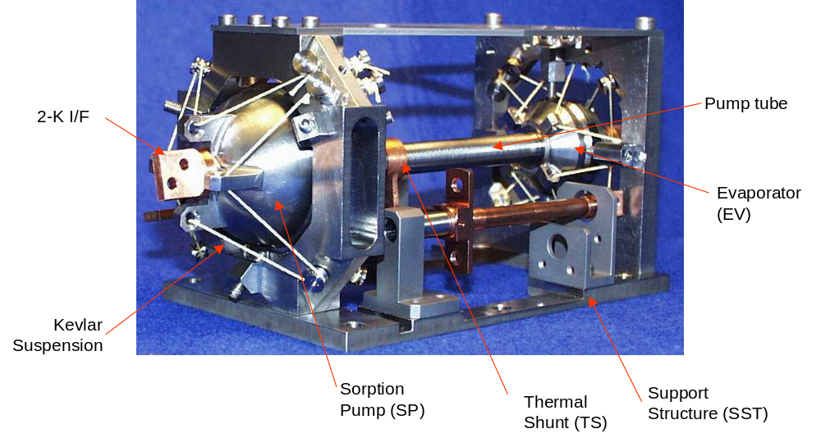
Figure 4-96 - Illustration of the 2-K cooler without cooler to SPIRE optical bench mounting structure.

The heat switch of the sorption pump is coupled to Level 0 of the Herschel cryostat via a dedicated thermal strap that passes through the wall of the FPU. Similarly, a second thermal strap couples the thermal shunt and the evaporator heat switch to Level-0 of the cryostat.

Ohmic heaters are located on (1) the sorption pump, (2) the sorption pump heat switch and (3) the evaporator heat switch. Each heater comprises two RLR/2H3 402Ω Vishay metal film resistors connected in series. For each of these devices there is a prime and a redundant heater independently powered and controlled giving a total of six heaters. Cernox thermistors similar to those used elsewhere in the instrument (see §4.11.5) are used to monitor the state of the cooler. They are mounted on (1) the sorption pump, (2) the evaporator; (3) the evaporator and (4) sorption pump heat switches and on (5) the thermal shunt. There are both prime and redundant thermistors on each of the above devices giving a total of ten sensing elements. Thermometry is the only means used to sense the state of the cooler during flight; hence important state parameters such as the residual mass of ³He in the evaporator must be inferred from this data along with ground calibration data and onboard software.

A prime and a redundant harness connect the cooler to the filter boxes. The cooler has a 37-way MDM plug for each of these harnesses. The cooler is controlled and powered by the FCU. This hardware is described in §4.2.3. The associated software is described in §4.1.1.1.

Tight specifications on the drift and stability of the cooler cold tip temperature are placed on the cooler and associated control electronics. It is currently not known if these stability requirements will be able to be met during cold AIV and during flight. Provision has been made to incorporate a NTD Germanium thermistors similar to those used in the SPIRE BDAs at the cold tip along with an ohmic heater element. The temperature of the cold tip would be monitored by the thermistors and a control algorithm incorporated into the SCU to modulate the power delivered to the heater element. The power dissipated by the heater element would, of course represent a parasitic heat load to the cooler and would reduce the cooling capacity available to the detectors. This scheme would therefore only be implemented if the system could not meet the temperature stability requirements. The hardware will not be implemented in the baseline design, but would only require the installation of the heater and thermistors.

Cooler construction and thermo-mechanical design

The main components of the cooler are fabricated from Ta6V Titanium alloy. This material was used for its combination of high mechanical strength and low thermal conductivity. This is particularly important in the construction of the integral evaporator-pump tube-sorption pump assembly. During operation, the evaporator must remain at approximately 280 mK while the sorption pump must remain at approximately 2 K. If excessive heat flows along the pump tube, the parasitic load to the evaporator will rise above an acceptable level. Similar arguments can be made about the use of Titanium alloy in the construction of the heat switches.

The cooler contains 6 litres of ³He at STP. This quantity of gas assumes a pressure of approximately 8 MPa when confined inside the heart of the cooler at room temperature. Thus, the mechanical design of the components of the heart of the cooler is important to ensure the mechanical integrity of the unit. It has been designed on a leak before burst principle (i.e. the critical crack size is greater than the wall thickness of titanium alloy). All welds are made using an electron beam welding machine.

The cooler is hard mounted off the SPIRE optical bench which is coupled to Level 1 of the cryostat. The cooler support structure will therefore be at approximately the same temperature as Level-1, which is around 4 K. The components of the heart of the cooler (which are below 2 K) must be rigidly connected to this support structure. The conducted heat flow between the structure and the cooler heart must be minimised so that the parasitic heat load to the cooler is minimised. This is achieved through a Kevlar cord support structure. These cords connect to the evaporator and to the sorption pump and constrain all six degrees of freedom. As discussed in §4.4.6, Kevlar cord has been used for this application for its’ combination of high mechanical strength, high modulus of elasticity and low thermal conductivity at cryogenic temperatures. The Kevlar supports can be seen in Figure 4-96. The total parasitic heat load to the heart of the cooler is 12 μW at the nominal operating condition. The first natural frequency of the entire cooler assembly is TBD Hz.

The sorption pump is filled with carbon cylinders. They are attached to the lining of the cooler with Stycast prior to the final welding of the assembly. Carbon is used for its ability to condense liquid Helium readily on its surface. The evaporator contains a low volume ratio fibrous material, Procelit P160 which assists in keeping the liquid helium in the evaporator via surface tension.

The ³He isotope is used as opposed to the more common ⁴He for two basic reasons. Firstly, ³He does not become super fluid at the cryogenic temperatures seen in the SPIRE cooler and behaves like a normal fluid. This removed confinement problems associated with super fluid liquid ⁴He which becomes a superfluid at approximately 2.2 K. Secondly, ³He is a superior cryogen, having a higher saturated vapour pressure at a given temperature. This makes the cryogenic pumping of the liquid helium simpler.

Heat switch operation

Two heat switches are required for operation of the cooler. They are used to control the temperature gradient between the evaporator and condenser along the pump tube. Gas gap heat switches have been selected as the preferred design for the present project (see Figure 4-97). Gas gap heat switches utilise concentric copper cylinders separated by a small gap (in the order of 100 μm), which is filled with or emptied of He gas to achieve the switching action. The helium acts as the breakable thermal link across the “terminals” of the switch. The thermal separation between the two ends is achieved by a thin-walled Titanium Alloy tube, which also provides the mechanical support. A miniature cryogenic adsorption pump controls the presence or absence of gas within the heat switch by regulating the temperature of the miniature sorption pump. Actuation of the heat switch is achieved by the modulation of the current delivered to the miniature absorption pump and without the use of any moving mechanical parts.

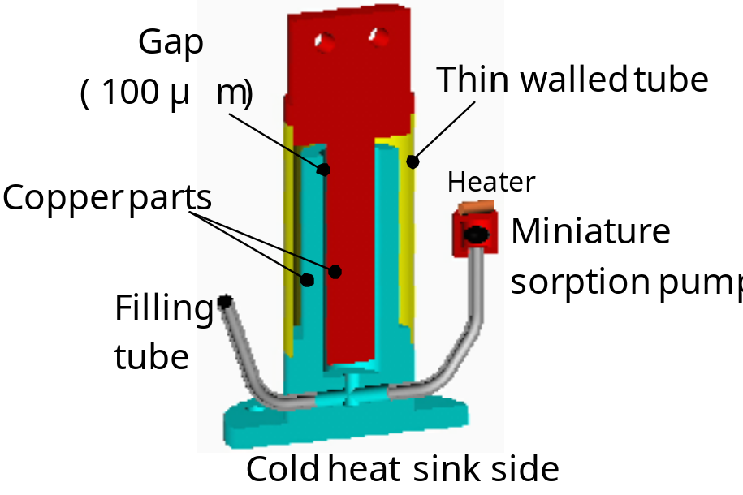
Figure 4-97 - Schematic representation of the gas gap heat switch.

Cooler operation

During normal operation of the cooler in flight, it is delivering 10μW of cooling power to the 300-mK strap connected to the BDAs. During nominal operation, the cooler can maintain these conditions for around 48 hours. This allows for two full days of astronomical observations to be carried out between cooler recycling. It is anticipated that the cooler will be recycled during the two-hour nominal downlink period each day.

During steady state operation, the net cooling power can be described by the equation:

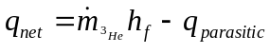

Where 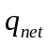 is the cooling power of the evaporator, 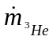is the mass flow rate from the evaporator to the sorption pump (i.e. the rate of evaporation), 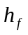is the latent heat of evaporation and 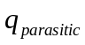 is obviously the total parasitic heat load to the evaporator. The only variable on the right hand side of this equation that is controllable by the cooler electronics is the mass flow rate of helium. Thus, to modulate the temperature of the cold tip and the amount of cooling power delivered to the 300-mK system is via modulation of the sorption pump, pumping speed. This is achieved in practice by changing the temperature of the sorption pump with the sorption pump heater. As the heater dissipates more heat, the charcoal in the sorption pump rises in temperature and the rate of absorption of ³He gas falls. The pressure in the pump tube rises and consequently the saturation temperature of the liquid ³He bath in the evaporator rises. Hence the temperature of the cold tip and the cooling power falls. This state of operation is illustrated in Figure 4-98c.

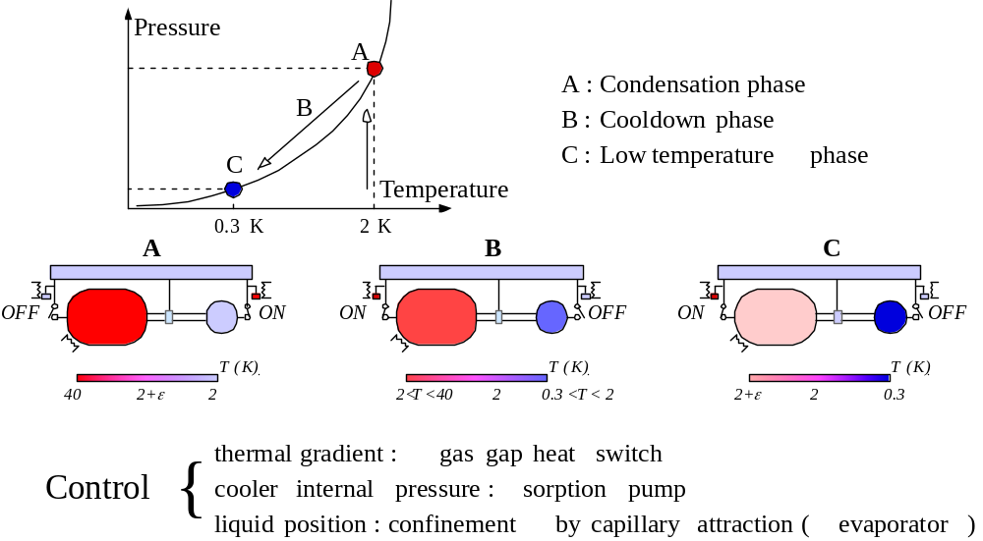
Thermal Gradient: Gas gap heat switch
Cooler internal pressure: Sorption pump
Liquid position: Confinement by capillary action (evaporator)
Figure 4-98 - Operation of the 3He cooler during recycle, (A and B) and normal operation (C).

At the end of the cooling cycle, there is no liquid ³He remaining in the evaporator and therefore the cold tip cannot provide any more cooling power. At this point, all the ³He will be contained in the sorption pump. To recycle the cooler, current is fed to the evaporator heat switch, heating element, ES1 (see Figure 4-99). The Helium absorbed in the miniature sorption pump is driven off and fills the gap between the copper cylinders in the gas gap heat switch. The thermal conductivity of the switch rises greatly and the evaporator becomes thermally shorted to the Level 0 stage of the cryostat. At the same time, no current is passed to the evaporator heat switch and all the Helium remains in the gas gap miniature sorption pump. A vacuum exists between the copper cylinders in the gas gap switch and the evaporator remains thermally insulated from the Level 0 stage of the cryostat. The evaporator heater (PH1, Figure 4-99) is switched on and the temperature rises to approximately 40K. This state can be seen in Figure 4-98a. A shunt halfway along the pump tube prevents heat leaking from the pump to the evaporator. At 40 K, the ³He that has been held in the pump is driven off and re-condenses in the evaporator. Once all the ³He has condensed in the evaporator, the pump heat switch is closed to cool the pump back down to approximately 2-K while the evaporator heat switch is opened to thermally isolate it and allow it to cool below Level 0 temperature. This state is represented by Figure 4-98b. Once the pump nears 2 K, it starts to pump on the evaporator and liquid ³He starts to boil off. The latent heat of evaporation of the ³He causes the temperature of the liquid to drop below 300mK and simultaneously provide cooling power to the BDAs. (see Figure 4-98c).

Cooler redundancy

Figure 4-99 illustrates the redundancy scheme adopted for the cooler. There is full redundancy on the drive electronics. The possibility of implementing parallel heat switches for the evaporator and the condenser was investigated. This was discarded as (i) the heat switches represent a parasitic heat load to the evaporator even when the switch is open, and (ii) the switch can fail in either the open or the closed state. The addition of an extra switch does not compensate for a switch failed in the closed position.

The Kevlar support system is designed in such a way so that if one of the cords breaks, the cooler hear remains located by the remaining supports. End stops are installed to prevent movement of the cooler heart in the event of complete failure of the Kevlar cords.

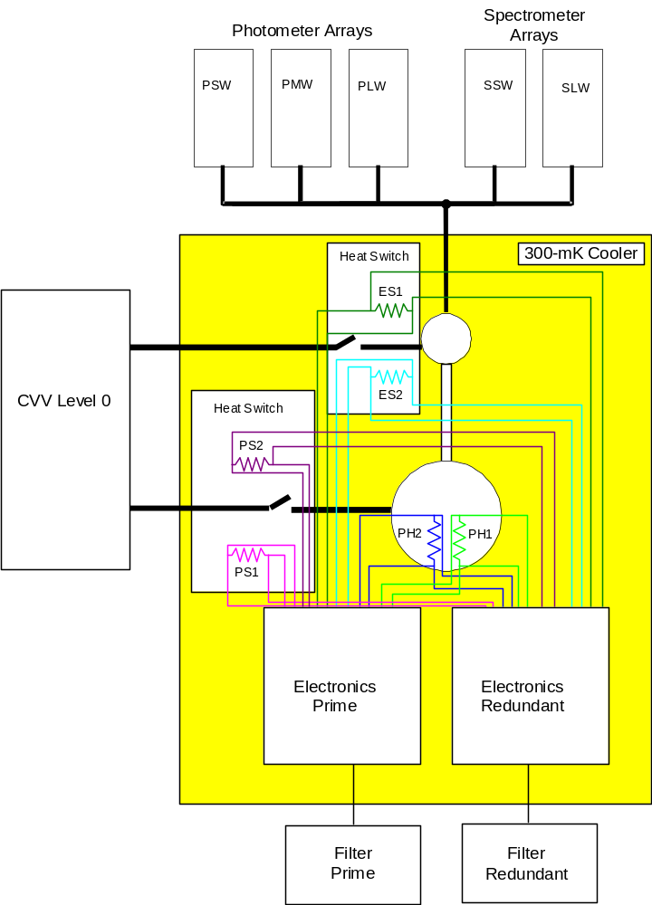
Figure 4-99 - ³He Cooler cryogenic redundancy scheme.

Thermal straps

Level-0

The ³He cooler and the detector boxes require thermal straps from the Herschel Level-0 stage of the cryostat to maintain the correct temperature. These straps are fabricated from Copper and are supplied to SPIRE by the satellite platform.

As shown in Figure 4-99, the cooler requires two straps; one connected to the evaporator and one connected to the condenser. These two straps must pass through the cover of the photometer, which is a part of the FPU from the CVV. A further strap passes through the cover of the spectrometer to the detector boxes. The temperature immediately outside the FPU is at a temperature of between 10 and 15 K and is therefore radiating strongly in the frequency band of the detectors. A stray light baffle is therefore required to greatly attenuate this stray light from entering the FPU close to the detectors.

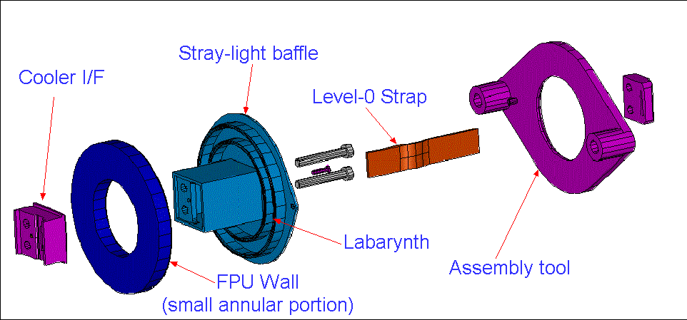
Figure 4-100 – Conceptual design of the stray light baffle on the 2-K straps entering the FPU.
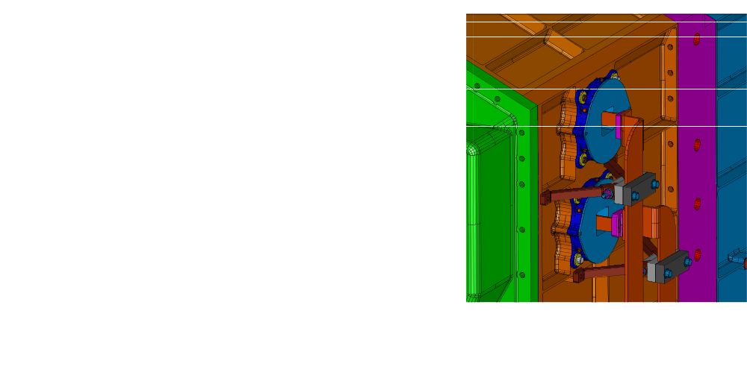
Figure 4-101 Position of the Level-0 straps on the exterior of the FPU.

300-mK Thermal Straps

For the photometer and spectrometer detectors to operate correctly, they have to be maintained below a temperature of 300mK during operation. Power is constantly being dissipated within the bolometers due to ohmic heating caused by the bias current and power is being absorbed due to photon thermailization, and conduction from warmer parts of the instrument. This heat needs to be carried away from the bolometers to prevent them from heating up. Two 300-mK straps between the photometer and spectrometer BDAs to the ³He cooler conduct this heat away. The routing of the photometer 300mK strap is shown in Figure 4-104 and Figure 4-105 shows the routing of the spectrometer strap.

The design of these straps is challenging. They have the following requirements:
- the straps need to be supported rigidly so that the first mode of vibration is above 120 Hz (TBC);
- the entrance of the strap into the 2-K detector box must not allow excessive stray light to enter. The stray light requirements for this are far less stringent than those emplaced on the entrance of the 2-K straps into the FPU;
- the mechanical supports must positively and reliably locate the straps so the there can be no possibility of the strap touching the surrounding structure and causing a thermal short. This contingency is highly undesirable as it could compromise the functionality of the detectors by either greatly reducing the hold time of the cooler at the operating temperature or preventing the cooler from maintaining the detectors at the required 300 mK;
- the suspension system must not place an excessive heat load directly to the strap. This is limited to 1 μW per strap (TBC).

The strap will be fabricated from ∅3 mm copper rod with a flexible lighter gauge copper wire running the last tract to the BDAs. These joints are formed by electron beam welding. A Kevlar suspension system will provide the mechanical support for the strap while maintaining a sufficient thermal impedance so as to meet the thermal requirements. The final design is illustrated in Figure 4-102.

There is a stray light baffle around the entrance of the strap into the two detector boxes. This is to prevent unfiltered 4-K stray from entering the detector box. A solid model illustrating the final design is shown in

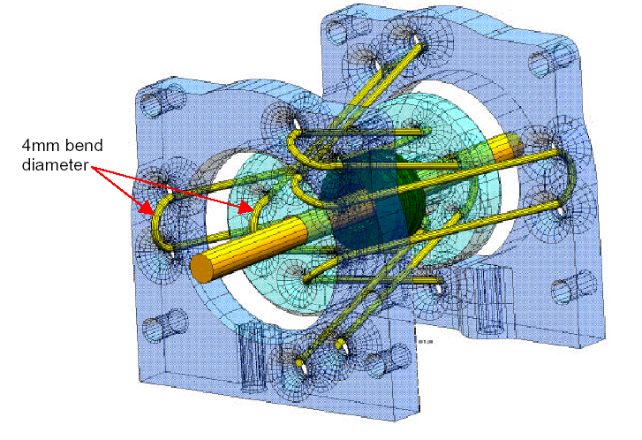
Figure 4-102 – Solid model of the 300-mK thermal isolation supports. These supports use Kevlar cord to mechanically support and thermally isolate the 300-mK copper strap from the Level-0 Photometer Detector Box structure.
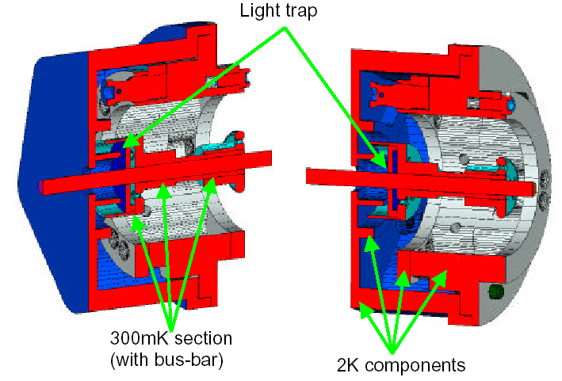
Figure 4-103 - Section view of the detector box stray-light baffle.
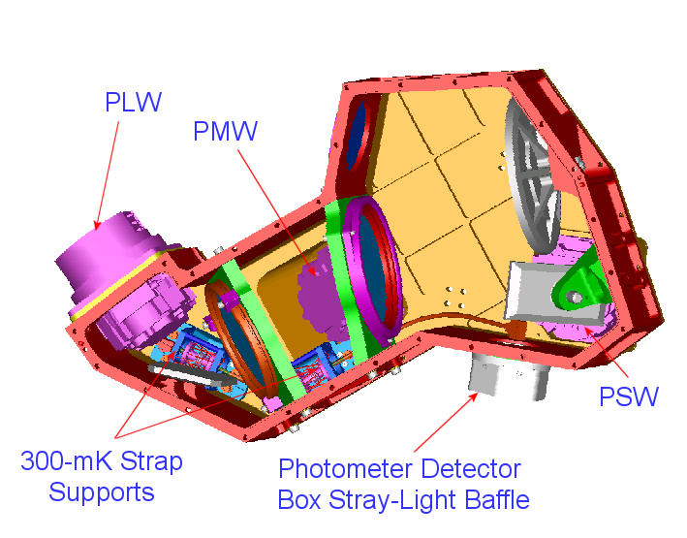
Figure 4-104 - Routing of the 300-mK strap inside the photometer detector box.

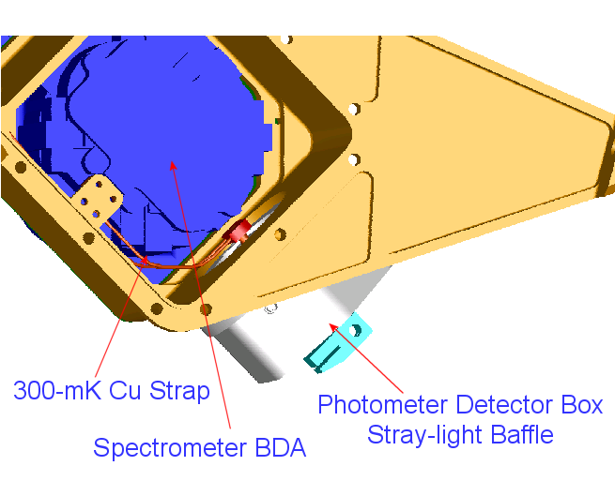
Figure 4-105 - Routing of the 300-mK strap through the Spectrometer Detector Box to the BDAs

Harnesses and Connectors

There are five sets of harnesses for the SPIRE instrument. They are briefly described below in Table 4-16.

Name | Prefix | Connection One | Connection Two | Description
FPU Harnesses | F | JFP, JFS, RF Filters | FPU subsystems | Internal connection within FPU RF shield
Cryo-harnesses | C | CVV Wall bulkhead connectors | JFP, JFS, FPU | Relays FPU signals within CVV
Interconnect Harness | I | DCU, FCU | CVV Wall bulkhead connectors | Relays analogue signals from CVV wall
Warm Interconnect Harness | W | DPU | DCU, FCU | Digital and power interfaces
Test | T | EGSE | HSDPU, HSFCU | Test harnesses only used during testing of integrated electrical systems
Table 4-16 SPIRE harnesses.
The layout of these harnesses is shown in Figure 4-106 and Figure 4-107.

The design of these harnesses is constrained by the following design drivers:

Passive thermal load

Thirteen I-Harnesses run from the SVM to the wall of the CVV where they are connected to 128-way circular connectors. Inside the CVV these harnesses continue as thirteen C-Harnesses. The SVM is kept at approximately room temperature; the wall of the CVV at around 80K and the termination of the C-Harnesses at the FPU and JFS/JFP around 4-10K. The conduction of heat along the harnesses, principally along the conductors and harness shield braid represents a passive thermal load on the cryostat that directly limits the mission duration. Stainless steel wires with low thermal conductivity have been used where possible for these harnesses. Brass wires have also been used where a low electrical resistance was required. The harnesses inside the FPU and those on the SVM are isothermal, therefore the limitation of the thermal conductivity is of no concern and copper can be used.

Ohmic dissipation

The harness current will cause ohmic power dissipation in the harnesses. For a given current in the C-Harnesses, the dissipated power will be proportional to the harness resistance. This is of particular concern in the C-Harnesses where the dissipated power will consume cryogen. It is also of concern in the harnesses outside the cryostat as the resistance of the conductors must be low enough to allow the flow of the maximum design current without overheating.

EMC, ESD and Signal Integrity Considerations

It is essential that the harnesses neither emit unacceptable RFI nor be susceptible to interference from electromagnetic disturbances present on the satellite. To achieve this, a harness overshield is utilised between on all external and internal harnesses. Where necessary, inner shields are also used to limit pick up of RFI and reduce cross talk between wires.

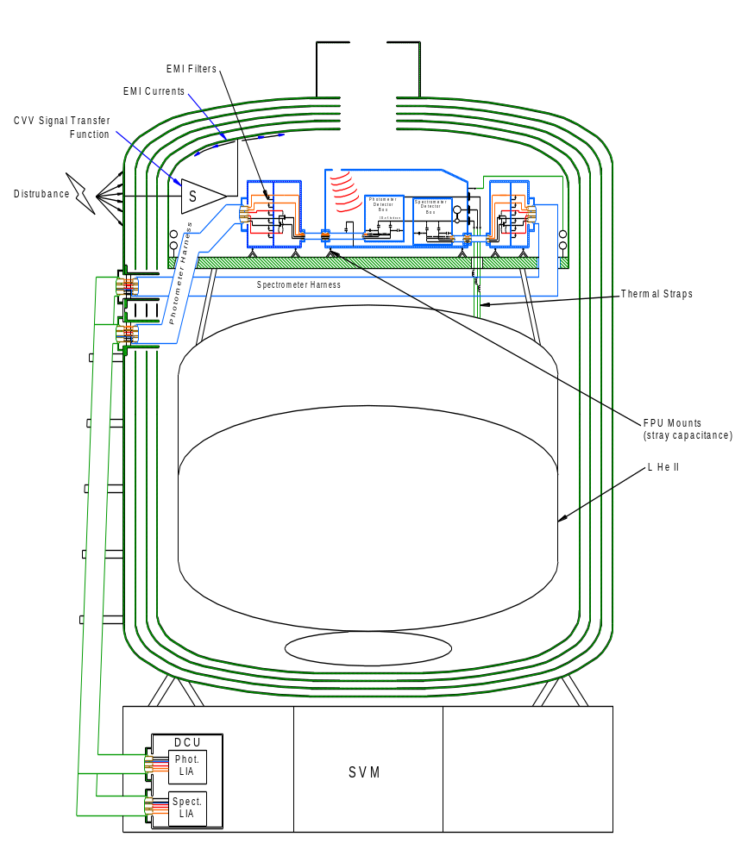
Table 4-17 - Layout of harnessing between the FPU and the Warm Electronics on the SVM.
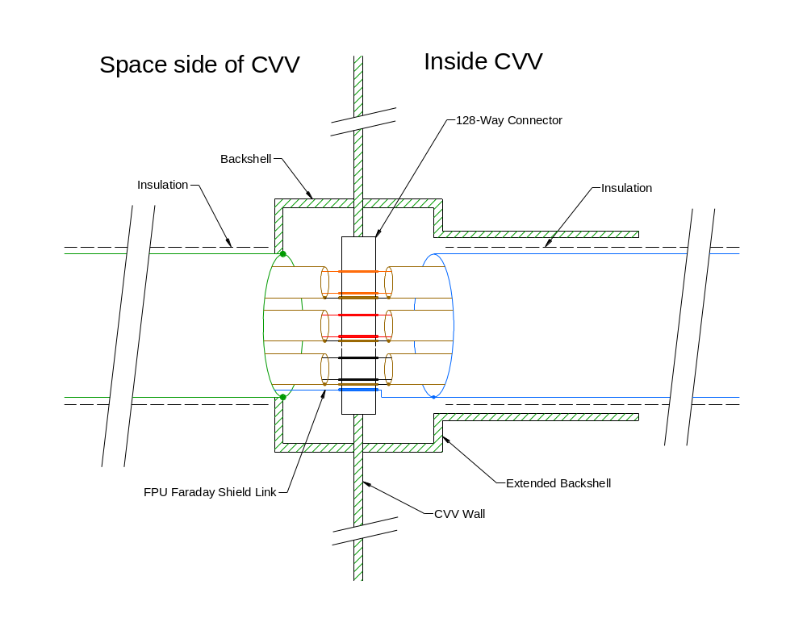
Table 4-18 - Schematic reprsentation of the bulkhead connectors on the wall of the CVV.

Noise Budget Allocation

An overall noise budget has been created for the detector readout system. One component of this budget is allocated to Johnson noise sourced in the harnesses according to:

V_{Johnson} = sqrt(4kTRB)

where V_{Johnson} is the RMS noise voltage attributed to Johnson noise in the harness, k is Boltzmann’s constant, B is the noise bandwidth, T is the temperature of the harness and R is the harness resistance. As can be seen from this relation, the Johnson noise will be proportional to the square root of the harness resistance. The resistance needs to be low enough to keep the harnesses within the overall system noise budget.

Harness Reliability

The cryo-harnesses represents a critical part of the design. Previous experience in cryogenic harnesses for space application has shown that they are a common failure point. For this reason, great care is to be taken in the thermal/mechanical design, connector selection, fabrication and routing design.

Detector harnesses

The harnesses from the detectors to the JFET boxes also represent a critical part of the design of the instrument. As previously stated in §2.3.7.3, the detectors are very susceptible to signal disturbances caused by microphonic vibrations of the harnesses To minimise this, these harnesses have the following provisions:
- they are mechanically clamped at intervals of approximately 10 mm to raise the first mode of vibration of the harnesses as high as possible;
- they have mechanical supports for the free runs from the detectors down to the SPIRE optical bench and for the free run from the FPU to the JFET boxes;
- the length is minimised as far as it practical;
- the supporting structure is as rigid as is practical.

The harnesses that are contained within the FPU are shown in Figure 4-106 while the harnesses that run from the FPU to the warm electronics is shown in Figure 4-107.

Connectors

Four types of connectors are used in SPIRE. All connectors on the Warm Electronics units are D-Sub-miniature. The bulk-head connectors on the wall of the CVV are 128-way circular. All connectors inside the CVV are Micro-D type with the exception of the connectors on the BDAs which are Nanonnics connectors. All connectors have EMC backshells to prevent the ingress of RFI.
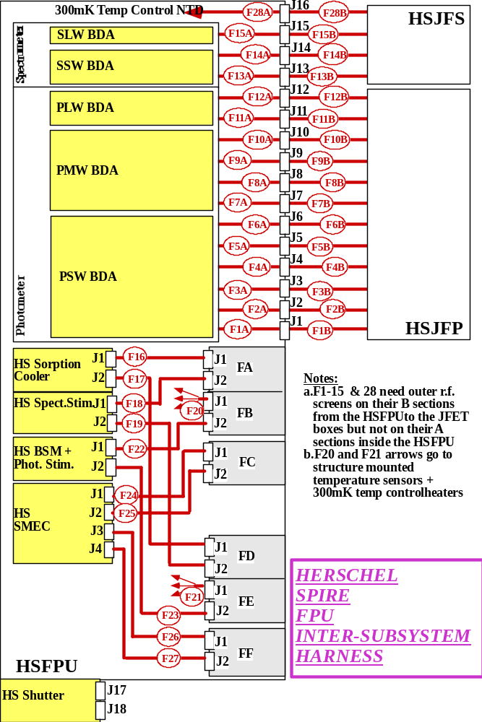
Figure 4-106 – SPIRE harnessing inside FPU.

Figure 4-107 - SPIRE harnesses outside the FPU.

Instrument Interfaces

External Interfaces

Power Interface
This is defined in RD04 (and in RD10 and RD11)

Mechanical Interface
This is defined in RD04 (and in RD10 and RD11 for the Warm Electronics units)

Thermal Interface
This is defined in RD04

Electrical Interface
This is defined in RD04 (and in RD11 for the DPU)

Control/Data Interfaces
These are defined in RD07

Internal Interfaces

Power Interface
This is defined in RD10

Mechanical Interface
This is defined in RD10

Thermal Interface
This is defined in RD10

Electrical Interface
This is defined in RD10 and RD11

Control/Data Interfaces
These are defined in RD08

Instrument performance

Thermal constraints for external temperature monitoring
There are no constraints

Internal temperature range
The following information comes from RD04.

For information the table below shows the measurement of instrument cryogenic temperatures. These data are available in DPU science packets (unless otherwise indicated) via whichever is powered of the prime and redundant sides of the Spire electronics. They may also be included in some housekeeping packets. Each Prime/Redundant side uses different, electrically isolated sensors and will therefore have subtlety differing electrical to temperature calibrations. Note that the accuracy columns that follow refer to the performance of the complete system including cryoharness and electronics, not the sensors alone. "Resolutions" and "Accuracy" will need to be further defined as they are actually temperature dependant.
Cernox sensors type CX-1030 are used for all HSFPU SPIRE conditioned housekeeping temperatures.

Location IN HSFPU | Acronym | Sensor Type | Temp. Range | Resol. | Acc.
PSW BDA_1 | T_PSW_1 | NTD Ge Thermistor* | 0.2 K>5 K | 0.5mK | 2mK
PSW BDA_2 | T_PSW_2 | NTD Ge Thermistor | 0.2 K>5 K | 0.5mK | 2mK
PMW BDA_1 | T_PMW_1 | NTD Ge Thermistor | 0.2 K>5 K | 0.5mK | 2mK
PMW BDA_2 | T_PMW_2 | NTD Ge Thermistor | 0.2 K>5 K | 0.5mK | 2mK
PLW BDA_1 | T_PLW_1 | NTD Ge Thermistor | 0.2 K>5 K | 0.5mK | 2mK
PLW BDA_2 | T_PLW_2 | NTD Ge Thermistor | 0.2 K>5 K | 0.5mK | 2mK
SSW BDA_1 | T_SSW_1 | NTD Ge Thermistor | 0.2 K>5 K | 0.5mK | 2mK
SSW BDA_2 | T_SSW_2 | NTD Ge Thermistor | 0.2 K>5 K | 0.5mK | 2mK
SLW BDA_1 | T_SLW_1 | NTD Ge Thermistor | 0.2 K>5 K | 0.5mK | 2mK
SLW BDA_2 | T_SLW_2 | NTD Ge Thermistor | 0.2 K>5 K | 0.5mK | 2mK
300mK Plumbing Cntrl_1 | PTC_Ch1 | NTD Ge Thermistor | 0.2 K>5 K | 0.05mK | 0.2mK
300mK Plumbing Cntrl_2 | PTC_Ch2 | NTD Ge Thermistor | 0.2 K>5 K | 0.05mK | 0.2mK
300mK Plumbing Cntrl_3 | PTC_Ch3 | NTD Ge Thermistor | 0.2 K>5 K | 0.05mK | 0.2mK
HSFPU EMC filters | EMCFIL | CX-1030 | 3K>100K | 25mK | 50mK
Spectrometer 2K box | T_SL0 | CX-1030 | 1K>10K | 2mK | 2mK
Photometer 2K box | T_PL0 | CX-1030 | 1K>10K | 2mK | 2mK
M3,5,7 Optical SubBench | T_SUB | CX-1030 | 3K>100K | 25mK | 50mK
HSFPU Input Baffle | T_BAF | CX-1030 | 3K>80K | 5mK | 5mK
BSM/SOB I/F | T_BSMS | CX-1030 | 3K>80K | 5mK | 5mK
HS Spect. Stimulus Flange | T_SCST | CX-1030 | 1K>50K | 10mK | 10mK
Sorption Pump | T_CPHP | CX-1030 | 1K>50 K | 10mK | 10mK
Evaporator | T_CEV | CX-1030 | 0.2 K>5 K | 1mK | 1mK
Sorption Pump Heat Switch | T_CPHS | CX-1030 | 1K>50K | 10mK | 10mK
Evaporator Heat Switch | T_CEHS | CX-1030 | 1K>50K | 10mK | 10mK
Thermal Shunt | T_CSHT | CX-1030 | 0.2 K>5 K | 1mK | 1mK
HS Spect. Stim 4% | T_SCL4 | CX-1030 | 3K>80K | 5mK | 5mK
HS Spect. Stim 2% | T_SCL2 | CX-1030 | 3K>80K | 5mK | 5mK
BSM | T_BSMM | CX-1030 | 3K>20K | 10mK | 10mK
SMEC | T_FTSM | CX-1030 | 3K>20K | 10mK | 10mK
SMEC/SOB I/F | T_FTSS | CX-1030 | 3K>100K | 25mK | 50mK
*NTD Ge Thermistor is equivalent to a detector element, but it is not mounted on an isolating web.
Table 6-19 SPIRE Instrument Temperature Sensors.

Shutter Temperature Sensors
The SPIRE shutter has been removed. Temperature sensors are therefore not required.

Satellite Temperature sensors
Reference HP-SPIRE-REQ-0460
In addition to the SPIRE conditioned temperature channels, SPIRE requires that Herschel itself shall monitor the temperatures of certain locations on the cryostat and SVM. These are given in the table below.

 |  |  | CCU Measurement |  | EGSE Measurement
Position | Type (1) | Name (1) | Range | Accuracy | Range | Accuracy
On Instrument Shield, close to SPIRE | C100 | T213 | 3.0K - 20.0K | ± 0.1K | 3.0K – 20.0K | ± 0.1K
L0; Cooling Strap 5; to "SPIRE SM Detector enclosure" | C100 | T225 | 1.6K - 2.0K | ± < 0.001K | 1.6K - 2.0K | ± < 0.008K
L0; Cooling Strap 6; to "SPIRE Cooler Pump HS" | C100 | T226 | 2.0K - 10.0K | ± 0.01K | 2.0K – 10.0K | ± 0.01K
L0; Cooling Strap 7; to "SPIRE Cooler Evaporator HS" | C100 | T227 | 1.5K - 2.2K | ± < 0.01K | 1.5K - 2.2K | ± < 0.01K
L1; on Ventline upstream strap 4 to "SPIRE Optical Bench" | C100 | T235 | 2.0K - 10.0K | ± 0.01K | 2.0K – 10.0K | ± 0.01K
L1; on Ventline downstream strap 4 to "SPIRE Optical Bench" | C100 | T236 | 2.0K - 10.0K | ± 0.01K | 2.0K – 10.0K | ± 0.01K
L3; on Ventline to JFET-Phot | C100 | T246 | 3.0K - 20.0K | ± 0.1K | 3.0K – 20.0K | ± 0.1K
L3; on Ventline to JFET-Spec | C100 | T247 | 3.0K - 20.0K | ± 0.1K | 3.0K – 20.0K | ± 0.1K
L1; on Strap 4 on SPIRE FPU side | C100 | T248 | 2.0K - 10.0K | ± 0.01K | 2.0K – 10.0K | ± 0.01K
On Spire JFET-Spec (Pos on Structure or L3 strap) | PT1000 | T249 |  |  | 13K – 370K | ± 1K
On Spire JFET-Spec (Pos on Structure or L3 strap) | C100 | T250 | 3.0K - 20.0K | ± 0.1K | 3.0K – 20.0K | ± 0.1K
On Spire JFET-Phot (Pos on Structure or L3 strap) | PT1000 | T251 |  |  | 13K – 370K | ± 1K
On Spire JFET-Phot (Pos on Structure or L3 strap) | C100 | T252 | 3.0K - 20.0K | ± 0.1K | 3.0K – 20.0K | ± 0.1K
OB Plate near SPIRE foot (center) | PT1000 | T253 |  |  | 13K – 370K | ± 1K
OB Plate near SPIRE foot (center) | C100 | T254 | 3.0K - 20.0K | ± 0.1K | 3.0K – 20.0K | ± 0.1K
OB Plate near SPIRE foot (-z+y) | PT1000 | T255 |  |  | 13K – 370K | ± 1K
OB Plate near SPIRE foot (-z+y) | C100 | T256 | 3.0K - 20.0K | ± 0.1K | 3.0K – 20.0K | ± 0.1K
OB Plate near SPIRE foot (-y-z) | C100 | T258 | 3.0K - 20.0K | ± 0.1K | 3.0K – 20.0K | ± 0.1K
(1): Type and name for information only
Table 6-20 SPIRE Satellite Temperature Sensors.

Heat dissipation
The information in this section comes from RD14. The operating modes are defined in RD03.

Power Dissipation Outside the Cryostat
For each instrument mode listed the current and voltage were recorded form the power supplies
All measurements were taken at 28v.
These measurements represent average dissipation at BOL

Unit | Measured value during PFM 4 (W) |  |  |  | ref | IID-B values (W) Max Average
 | Observing |  | Ready | Cooler recycle
 | Phot | Spec
HSFCU | 60 | 38 | 24.4 | 24.4 |  | 42.9
HSDCU |  |  |  |  |  | 37
HSDPU | 12.8 | 12.8 | 12.8 | 12.8 |  | 15.3
HSWIH | Included in above |  |  |  |  | 0.1

Power Dissipation Inside the Cryostat
The figures quoted are based on measurements performed during PFM4 and PFM5 test campaigns.

Photometer Power Budget

The table below describes the power dissipated by the SPIRE BSM and PJFET when operating in photometer mode. The dissipations represent the “average power” dissipated during a given mode of observation i.e. the power dissipated by the BSM at the various chop/jiggle positions of the 7pt jiggle map varies between 0mW and 0.7mW. The 0.3mW given in the table represents the average dissipation for all positions of a single map. The duty cycle gives an indication of the amount of time which will be allocated to the various observation modes for a nominal observation period of 46hr i.e. the chopping mode is to be used for only a quarter of the overall 46hr period.

Mechanisms | Ref | Average Dissipation [mW] | Duty Cycle [%] (*)
BSM – POF8 – Calibration with PCAL | 2 | 0.0243 | 100
BSM Sensors | 1 | 0.8 | 100
BSM Motor - POF1 – Chopping (+/-63”) | 1 | 0.548 | 25
BSM Motor - POF2 – 7pt Jiggle Map | 1 | 0.3 | 25
BSM Motor - POF3 – 64pt Jiggle Map | 1 | 1.55 | 25
BSM Motor – POF5 – Scan | 1 | 0.0 | 25
Extra power component during BSM dynamic switching | 1 | 0.25 | 100
Photometer JFETs | 3 | 56.64 | 100
(*) Over a nominal 46hr observation period in photometer mode.

Assumptions:
- It is currently assumed that POF1, POF2, POF3 and POF5 will be equally used. This will depend on the scientific community needs.

Spectrometer Power Budget
The table below describes the power dissipated by the SPIRE SMEC, SCAL, BSM, PCAL and SJFET when operating in spectrometer mode. The dissipations represent the “average power” dissipated during a given mode of observation i.e. the power dissipated by the SMEC actuator during a high resolution scan varies quadratically between 0 and ~17mW. The 3.56mW given in the table represents the integrated power dissipation of the actuator over the full scan range. The duty cycle gives an indication of the amount of time which will be allocated to the various observation modes for a nominal observation period of 46hr i.e. the SMEC HI resolution mode is to be used half the time of the overall 46hr period.

Mechanisms | Ref | Average  Dissipation [mW] | Duty Cycle [mW] (*)
SCAL2 at 80K | 2 | 2 | 100
Extra power component during SCAL dynamic switching | 2 | 0.87 | 50
SMEC Actuator R1000 (HI Resolution) | 4 | 3.56 | 50
SMEC Actuator R100 (MED Resolution) | 4 | 0.46 | 25
SMEC Actuator R10 (L0 Resolution) | 4 | 0.43 | 25
SMEC Encoder (Level 2) | 4, 5 | 1.2 | 100
SMEC LVDT | 5 | 0.112 | 100
BSM Sensors | 1 | 0.8 | 100
BSM Motor - POF3 – 64pt Jiggle Map | 1,6,7 | 1.55 | 50
Extra power component during BSM dynamic switching | 1, 6 | 0.25 | 50
BSM Calibrator (PCAL) | 2 | 0.0243 | 100
Spectrometer JFETs | 3 | 15.17 | 100
(*) Over a nominal 46hr operation period in Spectrometer mode.

Nominal power consumption for different modes/configurations
This is included in 6.3

Constraints for power consumption
SPIRE DPU non and redundant, LCL class I, 1 A nominal limit.
SPIRE FCU prime and redundant, LCL class III. 5A nominal limit.

Instrument Operations Modes

Overview of Operating Modes
This section gives a brief overview of the instrument operating modes, their purpose and the conditions in which they are used. Finally a mode transition diagram is presented to identify the operating procedures needed to switch between modes.

OFF
All instrument sub-systems are switched off - including the DPU - and there will be no instrument telemetry.

INIT
The instrument enters this mode after power on of the DPU while the Boot Software checks the memory areas of the DPU hardware (if an anomaly is found the boot software issues a TM event packet describing the problem and its location). At the end of this check the boot software stops and waits for further commands. These commands may either load and start the full OBS application software from EEPROM or load and execute new OBS software in the DPU. In either case the instrument will then be in DPU_ON mode.

DPU_ON
In this mode the DPU is switched on and executing the full OBS application software. It can receive and interpret all instrument commands, but no other sub-systems will be switched on (including the DRCU). Full housekeeping TM data will be generated but only those parameters relating to the DPU will be enabled.

REDY
The DPU and DRCU are powered on and the on-board software is ready to receive and execute all instrument commands. Temperature measurements are enabled in the SCU and the MCU is ON (The DSP has been booted up and the application software started so that the MCU is able to execute commands. The DCU is OFF. Full housekeeping data is generated, but at a rate consistent with SPIRE not being the prime instrument.

This is the normal mode for SPIRE when it is not the Prime instrument and from which the instrument is switched into one of its observation standby modes or engineering operations (including cooler recycling) are started.

Standby Modes
There are two standby modes defined for SPIRE – one for the Photometer (PHOT_STBY) and one for the spectrometer (SPEC_STBY). This is required because it is not possible to have both sides of the instrument running concurrently for thermal dissipation reasons. For both of these modes the following assumptions are made:

- The cooler has been recycled and the detectors are at ~300 mK.
- The spacecraft may be pointed in an arbitrary direction
- The instrument is the Prime instrument.
- No Science data will be generated.

PHOT_STBY
The photometer detectors, including JFETs, are switched on – the spectrometer detectors, including JFETs are switched off. The beam steering mirror is initialised and set to its HOME position - it is necessary to actively place the BSM at this position and hold it there to ensure that it is always at a known and controlled position – it cannot be assumed that the BSM will return to its central position when not powered. From this mode it is possible to switch to the Photometer Observing modes.

SPEC_STBY
The spectrometer detectors, including JFETs are switched on – the photometer detectors, including JFETs are switched off. The beam steering mirror is initialised and set to its HOME position. The SMEC is initialised and set to its HOME position. This places it ready to carry out any subsequent observation. From this mode it is possible to switch to the Spectometer Observing modes.

CREC
This is the cooler recycling mode. The ³He cooler requires recycling every 46 hours (TBC) in order to replenish the coolant for subsequent observations. It is planned that this action will be undertaken during a ground contact period to take advantage of the ability to monitor the recycling progress and to minimise the impact on the observing programme (the observing attitude is restricted during these periods in order to use the S/C high gain antenna to enable the maximum telemetry rate downlink to the ground). During this time it is not possible to collect science data because the temperature of the detectors is raised above the normal operating point and all subsystems, apart from the warm electronics and cooler, will be switched off.

It is intended that cooler recycling will be automatic on receipt of a command from the ground, but could be carried out manually, if necessary.

The recycling takes approximately 2 hours (TBC) to complete, including time for the detectors to stabilise sufficiently for instrument operations to recommence. Note: for ultimate signal to noise performance the detectors will need to stabilise for up to 12 hours (TBC) before use. This needs to be taken into account in the scheduling of such observations.

SAFE
In the event of an anomaly either within the instrument or with the interface to the spacecraft, both monitored by the OBS, the instrument may be switched to a SAFE mode. In this mode only the DPU is switched on (the spacecraft is requested to switch off the DRCU).

Observing Modes
There are two basic sets of observing modes for the instrument, corresponding to use of the Photometer and Spectrometer sub-instruments. The details of these modes are to be found in the Operating Modes for the SPIRE instrument document (RD03) and are summarised below

Photometer Observing Modes
Observation  Type | Operating  Mode ID | Name | Comments
Point source photometry | POF1 | Chop without jiggling | Requires accurate pointing and  source position (not baseline)
Point source photometry | POF2 | Seven-point jiggle map | Inaccurate pointing or source position. Default point-source observing mode
Jiggle  mapping | POF3 | n-point jiggle map | Field mapping (baseline)
Jiggle  mapping | POF4 | Raster map | Extended field mapping (not baseline  – scan map to be adopted)
Scan  mapping | POF5 | Scan map without chopping | Large-area mapping (baseline for area greater than one jiggle-map field)
Scan  mapping | POF6 | Scan map with chopping | Large area mapping (with 1/f noise)  (not baseline)
Peak-up | POF7 | Photometer peak-up | Determination of pointing offsets (not  baseline)
Calibrate | POF8 | Photometer calibrate | Responsivity tracking (not baseline but may be introduced if deemed optimal)
Parallel |  | SPIRE PACS Parallel Mode | Observing in parallel with PACS. For large-area scan maps only
Photometer  Serendipity | POF10 | Photometer Serendipity | Only used during slew between targets. Data will be taken but no ICC  provision for processing

Spectrometer Observing Modes
 | Operating Mode ID | Name | Comments
 | SOF1 | Continuous Scan  (baseline) | Point source/sparse map  Requires accurate pointing & source position.
 | SOF3 | Step-and-Integrate  (not baseline) | Point source/sparse map  Requires accurate pointing & source position.
 | SOF2  SOF2_int | Continuous Scan  (baseline) | Field mapping; fully sampled image  Field mapping; intermediate image sampling
 | SOF4  SOF4_int | Step-and-Integrate  (not baseline) | Field mapping; fully sampled imageField mapping; intermediate image sampling
 | SOF5 | Spectrometer Serendipity | Only used during slew between targets

Mode Transitions
Error: Reference source not found Figure 7-108 & Figure 7-109 show the modes and procedures for switching the instrument OFF to ON and ON to OFF respectively.

OFF
DPU_START_PP/SP
LOAD_OBS_BSW
DPU_ON
DRCU_START
DRCU_ON
SCU_ON
SCU_ON
MCU_BOOT
REDY
BSM_ON
BSM_ON
BSM_INIT
PDET_ON
PHOTSTBY
SMEC_ON
SMEC_ON
SMEC_INIT
SDET_ON
SPECSTBY
SMEC_INIT
CREC_VM
CREC
BSM_INIT
MOIS Procedure
Mode
LOAD_OBS_ASW
Sub-Mode

Figure 7-108 SPIRE Instrument Operating Mode Transitions: From OFF to PHOTSTBY or SPECSTBY. The transition to and from cooler recycle mode is also shown. The DPU INIT mode can be used for loading OBS from the boot software.

PHOTSTBY
BSM_OFF
PDET_OFF
SCU_OFF
REDY
MCU_OFF
SCU_ON
DRCU_OFF
SDET_OFF
DPU_OFF
DRCU_ON
SPECSTBY
SDET_OFF
DPU_ON
OFF
MOIS Procedure
Mode
PDET_OFF
SMEC_OFF
SMEC_OFF
Sub-Mode
Figure 7-109 SPIRE Instrument Operating Mode Transitions: From PHOTSTBY or SPECSTBY to OFF. The transition to and from cooler recycle mode is not shown here (see previous transition diagram).

Summary of Mode Configurations
 | OFF | INIT | DPU_ON | DRCU_ON | REDY | PHOT STBY | SPEC STBY | CREC | SAFE
DPU |  | ON | ON | ON | ON | ON | ON | ON | ON
Essential Hsk packets |  |  | 0.5Hz | 0.5Hz | 0.5Hz | 0.5Hz | 0.5Hz | 0.5Hz | 0.5Hz
Normal Hsk packets |  |  | 1.0Hz | 1.0Hz | 0.25Hz | 1.0Hz | 1.0Hz | 0.25Hz | 0.25Hz
TC Acceptance |  | TBC | Yes | Yes | Yes | Yes | Yes | Yes | Yes
Event packets |  | Yes | Yes | Yes | Yes | Yes | Yes | Yes | Yes
Science packets
VM |  |  |  |  |  |  |  | CREC
VM1 |  |  |  |  |  | PTC? | SCAL?
VM2
VM3
MODE |  |  | 0x0000 | 0x0100 | 0x0200 | 0x0300 | 0x0400 | 0x0600 | 0x0900
DRCU |  |  | ON | ON | ON | ON | ON | ON
SCU
Temp Channels powered |  |  |  |  | Yes | Yes | Yes | Yes
SubK Channel powered |  |  |  |  | Yes | Yes | Yes | Yes
PCAL source powered
SCAL sources powered |  |  |  |  |  |  | Yes?
TC Heater powered |  |  |  |  |  | Yes?
Cooler SP Heater powered |  |  |  |  |  |  |  | Yes
Cooler EV HS powered |  |  |  |  |  |  |  | Yes
Cooler SP HS powered |  |  |  |  | Yes | Yes | Yes | Yes
DCU
Photometer BIAS |  |  |  |  |  | Yes
Photometer JFETS |  |  |  |  |  | Yes
Photometer LIAs |  |  |  |  |  | Yes
TC BIAS |  |  |  |  |  | Yes
TC JFETS |  |  |  |  |  | Yes
TC LIAs |  |  |  |  |  | Yes
Spectrometer BIAS |  |  |  |  |  |  | Yes
Spectrometer JFETS |  |  |  |  |  |  | Yes
Spectrometer LIAs |  |  |  |  |  |  | Yes
MCU
DSP |  |  |  |  | On | On | On | On
BSM |  |  |  |  |  | Hold | Home
SMEC |  |  |  |  |  |  | Home
Table 7-21 Non-Operating Modes

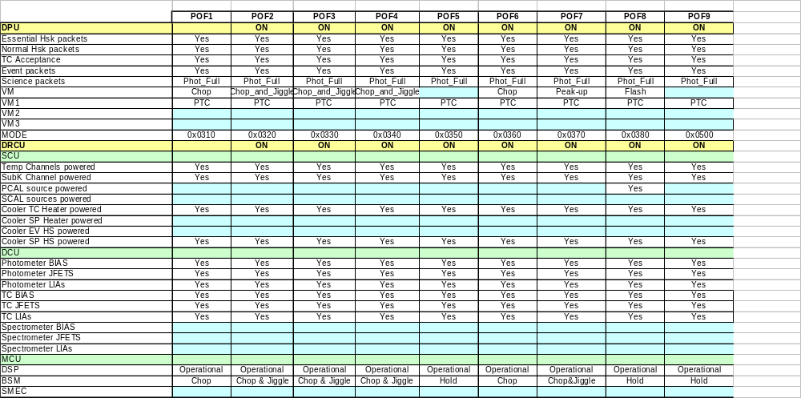
Table 7-22 Photometer Observing Modes

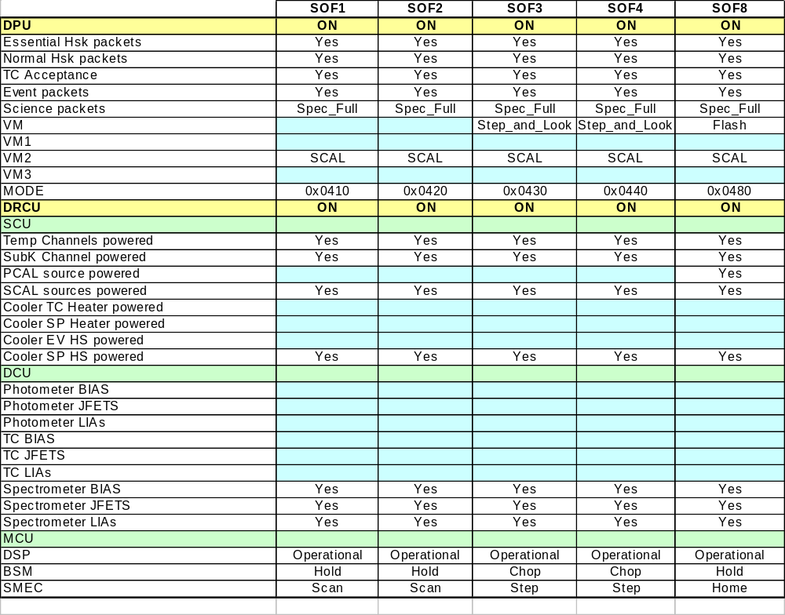
Table 7-23 Spectrometer Observing Modes

Mode descriptions

OFF

Pre-requisites
Power for both DPU and DRCU is OFF

Resources
Power:
DPU | 0 W
DRCU | 0 W
WIH | 0 W

Data Rate (maximum average):
 | Data Rate  bits/sec | Packet Rate  pkts/sec
Essential HK | 0 | 0
Nominal HK | 0 | 0
Science | 0 | 0

Operational Constraints
No operations possible

Mode Transition Operations
To enter INIT mode:
DPU_START_PP Start from Primary Partition of EEPROM
DPU_START_SP Start from Secondary Partition of EEPROM
LOAD_OBS_BSW Load OBS via Boot Software and start

Unit Status
See Table 7-21

Instrument Monitoring by CDMU
None

Internal Instrument Monitoring
None

DPU_ON

Pre-requisites
DPU Powered on and OBS application software installed

Resources
Power:
DPU | 15.3 W
DRCU | 0 W
WIH | 0 W

Data Rate (maximum average):
 | Data Rate  bits/sec | Packet Rate  pkts/sec
Essential HK | 288 | 0.5
Nominal HK | 6240 | 1.0
Science | 0 | 0.0

Operational Constraints
Normal operations not possible

Mode Transition Operations
To enter DRCU_ON mode:
DRCU_START
To switch off instrument:
DPU_OFF

Unit Status
See Table 7-21

Instrument Monitoring by CDMU
None

Internal Instrument Monitoring
 | Monitoring Status | Check  definition | Action
DPUP5V | Always Monitored | Limits | DPU Power Failure - see RD05
DPUP15V | Always Monitored | Limits | DPU Power Failure - see RD05
DPUM15V | Always Monitored | Limits | DPU Power Failure - see RD05
DPUTEMP | Always Monitored | Limits | DPU Temperature Anomaly - see RD05 (TBI)

DRCU_ON

Pre-requisites
DPU powered on and executing OBS application
DRCU Powered on

Resources
Power:
DPU | 15.3 W
DRCU | 79.9 W
WIH | 0.1 W

Data Rate (maximum average):
 | Data Rate  bits/sec | Packet Rate  pkts/sec
Essential HK | 288 | 0.5
Nominal HK | 6240 | 1.0
Science | 0 | 0.0

Operational Constraints
None

Mode Transition Operations
To enter REDY mode:
SCU_ON
MCU_BOOT
To switch off DRCU:
DRCU_OFF

Unit Status
See Table 7-21

Instrument Monitoring by CDMU
None

Internal Instrument Monitoring
 | Monitoring Status | Check  definition | Action
DPUP5V | Always Monitored | Limits | DPU Power Failure - see RD05
DPUP15V | Always Monitored | Limits | DPU Power Failure - see RD05
DPUM15V | Always Monitored | Limits | DPU Power Failure - see RD05
DPUTEMP | Always Monitored | Limits | DPU Temperature Anomaly - see RD05 (TBI)
SCUP5V | Always Monitored | Limits | DRCU Power Failure - see RD05
SCUP9V | Always Monitored | Limits | DRCU Power Failure - see RD05
SCUM9V | Always Monitored | Limits | DRCU Power Failure - see RD05
SCUCHT2.5V | Always Monitored | Limits | DRCU Power Failure - see RD05

REDY

Pre-requisites
DPU powered on and executing OBS application
DRCU Powered on

Resources
Power:
DPU | 15.3 W
DRCU | 79.9 W
WIH | 0.1 W

Data Rate (maximum average):
 | Data Rate  bits/sec | Packet Rate  pkts/sec
Essential HK | 288 | 0.5
Nominal HK | 1560 | 0.25
Science | 0 | 0.0

Operational Constraints
None

Mode Transition Operations
To enter PHOT_STBY mode:
BSM_ON
BSM_INIT
PDET_ON
To enter SPEC_STBY mode:
BSM_ON
BSM_INIT
SMEC_ON
SMEC_INIT
SDET_ON
To enter CREC mode:
CREC_VM
To return to DRCU_ON mode:
MCU_OFF
SCU_OFF

Unit Status
See Table 7-21

Instrument Monitoring by CDMU
None

Internal Instrument Monitoring
 | Monitoring Status | Check  definition | Action
DPUP5V | Always Monitored | Limits | DPU Power Failure - see RD05
DPUP15V | Always Monitored | Limits | DPU Power Failure - see RD05
DPUM15V | Always Monitored | Limits | DPU Power Failure - see RD05
DPUTEMP | Always Monitored | Limits | DPU Temperature Anomaly - see RD05 (TBI)
SCUP5V | Always Monitored | Limits | DRCU Power Failure - see RD05
SCUP9V | Always Monitored | Limits | DRCU Power Failure - see RD05
SCUM9V | Always Monitored | Limits | DRCU Power Failure - see RD05
SCUCHT2.5V | Always Monitored | Limits | DRCU Power Failure - see RD05
CCUTEMP | Always Monitored | Limits | DRCU Temperature Anomaly - see RD05
TCUTEMP | Always Monitored | Limits | DRCU Temperature Anomaly - see RD05
PSUTEMP1 | Always Monitored | Limits | DRCU Temperature Anomaly - see RD05
PSUTEMP2 | Always Monitored | Limits | DRCU Temperature Anomaly - see RD05
MCUP5V | If SCUDCDCSTAT bit 2 = 1 | Limits | DRCU Power Failure - see RD05
MCUP14V | If SCUDCDCSTAT bit 2 = 1 | Limits | DRCU Power Failure - see RD05
MCUM14V | If SCUDCDCSTAT bit 2 = 1 | Limits | DRCU Power Failure - see RD05
MCUP15V | If SCUDCDCSTAT bit 2 = 1 | Limits | DRCU Power Failure - see RD05
MCUM15V | If SCUDCDCSTAT bit 2 = 1 | Limits | DRCU Power Failure - see RD05
MCUMACTEMP | If SCUDCDCSTAT bit 2 = 1 | Limits | DRCU Temperature Anomaly - see RD05
MCUSMECTEMP | If SCUDCDCSTAT bit 2 = 1 | Limits | DRCU Temperature Anomaly - see RD05
MCUBSMTEMP | If SCUDCDCSTAT bit 2 = 1 | Limits | DRCU Temperature Anomaly - see RD05
BIASTEMP | Always Monitored | Limits | DRCU Temperature Anomaly - see RD05
DAQTEMP | Always Monitored | Limits | DRCU Temperature Anomaly - see RD05
PUMPHTRTEMP | If SCUTEMPSTAT bit 0 = 1 | Limits | SCU DC Temperature Anomaly - see RD05
PUMPHSTEMP | If SCUTEMPSTAT bit 1 = 1 | Limits | SCU DC Temperature Anomaly - see RD05
EVAPHSTEMP | If SCUTEMPSTAT bit 2 = 1 | Limits | SCU DC Temperature Anomaly - see RD05
SHUNTTEMP | If SCUTEMPSTAT bit 3 = 1 | Limits | SCU DC Temperature Anomaly – see RD05
EMCFILTTEMP | If SCUTEMPSTAT bit 4 = 1 | Limits | SCU DC Temperature Anomaly – see RD05
SL0TEMP | If SCUTEMPSTAT bit 5 = 1 | Limits | SCU DC Temperature Anomaly – see RD05
PL0TEMP | If SCUTEMPSTAT bit 6 = 1 | Limits | SCU DC Temperature Anomaly – see RD05
OPTTEMP | If SCUTEMPSTAT bit 7 = 1 | Limits | SCU DC Temperature Anomaly – see RD05
BAFTEMP | If SCUTEMPSTAT bit 8 = 1 | Limits | SCU DC Temperature Anomaly – see RD05
BSMIFTEMP | If SCUTEMPSTAT bit 9 = 1 | Limits | SCU DC Temperature Anomaly – see RD05
SCAL2TEMP | If SCUTEMPSTAT bit 10 = 1 | Limits | SCU DC Temperature Anomaly – see RD05
SCAL4TEMP | If SCUTEMPSTAT bit 11 = 1 | Limits | SCU DC Temperature Anomaly – see RD05
SCALTEMP | If SCUTEMPSTAT bit 12 = 1 | Limits | SCU DC Temperature Anomaly – see RD05
SMECIFTEMP | If SCUTEMPSTAT bit 13 = 1 | Limits | SCU DC Temperature Anomaly – see RD05
SMECTEMP | If SCUTEMPSTAT bit 14 = 1 | Limits | SCU DC Temperature Anomaly – see RD05
BSMTEMP | If SCUTEMPSTAT bit 15 = 1 | Limits | SCU DC Temperature Anomaly – see RD05
SUBKTEMP | If SUBKSTAT = 1 | Limits | SubKTemp Anomaly – see RD05

PHOT_STBY

Pre-requisites
Both DPU and DRCU are powered on
SPIRE Cooler has been recycled

Resources
Power:
DPU | 15.3 W
DRCU | 79.9 W
WIH | 0.1 W

Data Rate (maximum average):
 | Data Rate  bits/sec | Packet Rate  pkts/sec
Essential HK | 288 | 0.5
Nominal HK | 1560 | 0.25
Science | 0 | 0.0

Operational Constraints
None

Mode Transition Operations
All Photometer Observing modes can be used

To return to REDY mode:
PDET_OFF
BSM_OFF

Unit Status
See Table 7-21

Instrument Monitoring by CDMU
None

Internal Instrument Monitoring
 | Monitoring Status | Check  definition | Action
DPUP5V | Always Monitored | Limits | DPU Power Failure - see RD05
DPUP15V | Always Monitored | Limits | DPU Power Failure - see RD05
DPUM15V | Always Monitored | Limits | DPU Power Failure - see RD05
DPUTEMP | Always Monitored | Limits | DPU Temperature Anomaly - see RD05 (TBI)
SCUP5V | Always Monitored | Limits | DRCU Power Failure - see RD05
SCUP9V | Always Monitored | Limits | DRCU Power Failure - see RD05
SCUM9V | Always Monitored | Limits | DRCU Power Failure - see RD05
SCUCHT2.5V | Always Monitored | Limits | DRCU Power Failure - see RD05
CCUTEMP | Always Monitored | Limits | DRCU Temperature Anomaly - see RD05
TCUTEMP | Always Monitored | Limits | DRCU Temperature Anomaly - see RD05
PSUTEMP1 | Always Monitored | Limits | DRCU Temperature Anomaly - see RD05
PSUTEMP2 | Always Monitored | Limits | DRCU Temperature Anomaly - see RD05
MCUP5V | If SCUDCDCSTAT bit 2 = 1 | Limits | DRCU Power Failure - see RD05
MCUP14V | If SCUDCDCSTAT bit 2 = 1 | Limits | DRCU Power Failure - see RD05
MCUM14V | If SCUDCDCSTAT bit 2 = 1 | Limits | DRCU Power Failure - see RD05
MCUP15V | If SCUDCDCSTAT bit 2 = 1 | Limits | DRCU Power Failure - see RD05
MCUM15V | If SCUDCDCSTAT bit 2 = 1 | Limits | DRCU Power Failure - see RD05
MCUMACTEMP | If SCUDCDCSTAT bit 2 = 1 | Limits | DRCU Temperature Anomaly - see RD05
MCUSMECTEMP | If SCUDCDCSTAT bit 2 = 1 | Limits | DRCU Temperature Anomaly - see RD05
MCUBSMTEMP | If SCUDCDCSTAT bit 2 = 1 | Limits | DRCU Temperature Anomaly - see RD05
BIASTEMP | Always Monitored | Limits | DRCU Temperature Anomaly - see RD05
DAQTEMP | Always Monitored | Limits | DRCU Temperature Anomaly - see RD05
PUMPHTRTEMP | If SCUTEMPSTAT bit 0 = 1 | Limits | SCU DC Temperature Anomaly - see RD05
PUMPHSTEMP | If SCUTEMPSTAT bit 1 = 1 | Limits | SCU DC Temperature Anomaly - see RD05
EVAPHSTEMP | If SCUTEMPSTAT bit 2 = 1 | Limits | SCU DC Temperature Anomaly - see RD05
SHUNTTEMP | If SCUTEMPSTAT bit 3 = 1 | Limits | SCU DC Temperature Anomaly – see RD05
EMCFILTTEMP | If SCUTEMPSTAT bit 4 = 1 | Limits | SCU DC Temperature Anomaly – see RD05
SL0TEMP | If SCUTEMPSTAT bit 5 = 1 | Limits | SCU DC Temperature Anomaly – see RD05
PL0TEMP | If SCUTEMPSTAT bit 6 = 1 | Limits | SCU DC Temperature Anomaly – see RD05
OPTTEMP | If SCUTEMPSTAT bit 7 = 1 | Limits | SCU DC Temperature Anomaly – see RD05
BAFTEMP | If SCUTEMPSTAT bit 8 = 1 | Limits | SCU DC Temperature Anomaly – see RD05
BSMIFTEMP | If SCUTEMPSTAT bit 9 = 1 | Limits | SCU DC Temperature Anomaly – see RD05
SCAL2TEMP | If SCUTEMPSTAT bit 10 = 1 | Limits | SCU DC Temperature Anomaly – see RD05
SCAL4TEMP | If SCUTEMPSTAT bit 11 = 1 | Limits | SCU DC Temperature Anomaly – see RD05
SCALTEMP | If SCUTEMPSTAT bit 12 = 1 | Limits | SCU DC Temperature Anomaly – see RD05
SMECIFTEMP | If SCUTEMPSTAT bit 13 = 1 | Limits | SCU DC Temperature Anomaly – see RD05
SMECTEMP | If SCUTEMPSTAT bit 14 = 1 | Limits | SCU DC Temperature Anomaly – see RD05
BSMTEMP | If SCUTEMPSTAT bit 15 = 1 | Limits | SCU DC Temperature Anomaly – see RD05
SUBKTEMP | If SUBKSTAT = 1 | Limits | SubKTemp Anomaly – see RD05
BIASP5V | Always Monitored | Limits | DRCU Power Failure - see RD05
BIASP9V | Always Monitored | Limits | DRCU Power Failure - see RD05
BIASM9V | Always Monitored | Limits | DRCU Power Failure - see RD05
PLIAP5V | If SCUDCDCSTAT bit 0 = 1 | Limits | DRCU Power Failure - see RD05
PLIAP9V | If SCUDCDCSTAT bit 0 = 1 | Limits | DRCU Power Failure - see RD05
PLIAM9V | If SCUDCDCSTAT bit 0 = 1 | Limits | DRCU Power Failure - see RD05
LIAP1TEMP | If LIASTAT  bit 15 = 1 | Limits | DRCU Temperature Anomaly - see RD05
LIAP2TEMP | If LIASTAT  bit 14 = 1 | Limits | DRCU Temperature Anomaly - see RD05
LIAP3TEMP | If LIASTAT  bit 13 = 1 | Limits | DRCU Temperature Anomaly - see RD05
LIAP4TEMP | If LIASTAT  bit 12 = 1 | Limits | DRCU Temperature Anomaly - see RD05
LIAP5TEMP | If LIASTAT  bit 11 = 1 | Limits | DRCU Temperature Anomaly - see RD05
LIAP6TEMP | If LIASTAT  bit 10 = 1 | Limits | DRCU Temperature Anomaly - see RD05
LIAP7TEMP | If LIASTAT  bit 9 = 1 | Limits | DRCU Temperature Anomaly - see RD05
LIAP8TEMP | If LIASTAT  bit 8 = 1 | Limits | DRCU Temperature Anomaly - see RD05
LIAP9TEMP | If LIASTAT  bit 7 = 1 | Limits | DRCU Temperature Anomaly - see RD05
TCHTRV | Always Monitored | Limits | SCU Heater Failure – see RD05
SPHSV | Always Monitored | Limits | SCU Heater Failure – see RD05

SPEC_STBY

Pre-requisites
Both DPU and DRCU are powered on
SPIRE Cooler has been recycled

Resources
Power:
DPU | 15.3 W
DRCU | 79.9 W
WIH | 0.1 W

Data Rate (maximum average):
 | Data Rate  bits/sec | Packet Rate  pkts/sec
Essential HK | 288 | 0.5
Nominal HK | 1560 | 0.25
Science | 0 | 0.0

Operational Constraints
None

Mode Transition Operations
All Spectrometer Observing modes can be used

To return to REDY mode:
SDET_OFF
SMEC_OFF
BSM_OFF

Unit Status
See Table 7-21

Instrument Monitoring by CDMU
None

Internal Instrument Monitoring
 | Monitoring Status | Check  definition | Action
DPUP5V | Always Monitored | Limits | DPU Power Failure - see RD05
DPUP15V | Always Monitored | Limits | DPU Power Failure - see RD05
DPUM15V | Always Monitored | Limits | DPU Power Failure - see RD05
DPUTEMP | Always Monitored | Limits | DPU Temperature Anomaly - see RD05 (TBI)
SCUP5V | Always Monitored | Limits | DRCU Power Failure - see RD05
SCUP9V | Always Monitored | Limits | DRCU Power Failure - see RD05
SCUM9V | Always Monitored | Limits | DRCU Power Failure - see RD05
SCUCHT2.5V | Always Monitored | Limits | DRCU Power Failure - see RD05
CCUTEMP | Always Monitored | Limits | DRCU Temperature Anomaly - see RD05
TCUTEMP | Always Monitored | Limits | DRCU Temperature Anomaly - see RD05
PSUTEMP1 | Always Monitored | Limits | DRCU Temperature Anomaly - see RD05
PSUTEMP2 | Always Monitored | Limits | DRCU Temperature Anomaly - see RD05
MCUP5V | If SCUDCDCSTAT bit 2 = 1 | Limits | DRCU Power Failure - see RD05
MCUP14V | If SCUDCDCSTAT bit 2 = 1 | Limits | DRCU Power Failure - see RD05
MCUM14V | If SCUDCDCSTAT bit 2 = 1 | Limits | DRCU Power Failure - see RD05
MCUP15V | If SCUDCDCSTAT bit 2 = 1 | Limits | DRCU Power Failure - see RD05
MCUM15V | If SCUDCDCSTAT bit 2 = 1 | Limits | DRCU Power Failure - see RD05
MCUMACTEMP | If SCUDCDCSTAT bit 2 = 1 | Limits | DRCU Temperature Anomaly - see RD05
MCUSMECTEMP | If SCUDCDCSTAT bit 2 = 1 | Limits | DRCU Temperature Anomaly - see RD05
MCUBSMTEMP | If SCUDCDCSTAT bit 2 = 1 | Limits | DRCU Temperature Anomaly - see RD05
BIASTEMP | Always Monitored | Limits | DRCU Temperature Anomaly - see RD05
DAQTEMP | Always Monitored | Limits | DRCU Temperature Anomaly - see RD05
PUMPHTRTEMP | If SCUTEMPSTAT bit 0 = 1 | Limits | SCU DC Temperature Anomaly - see RD05
PUMPHSTEMP | If SCUTEMPSTAT bit 1 = 1 | Limits | SCU DC Temperature Anomaly - see RD05
EVAPHSTEMP | If SCUTEMPSTAT bit 2 = 1 | Limits | SCU DC Temperature Anomaly - see RD05
SHUNTTEMP | If SCUTEMPSTAT bit 3 = 1 | Limits | SCU DC Temperature Anomaly – see RD05
EMCFILTTEMP | If SCUTEMPSTAT bit 4 = 1 | Limits | SCU DC Temperature Anomaly – see RD05
SL0TEMP | If SCUTEMPSTAT bit 5 = 1 | Limits | SCU DC Temperature Anomaly – see RD05
PL0TEMP | If SCUTEMPSTAT bit 6 = 1 | Limits | SCU DC Temperature Anomaly – see RD05
OPTTEMP | If SCUTEMPSTAT bit 7 = 1 | Limits | SCU DC Temperature Anomaly – see RD05
BAFTEMP | If SCUTEMPSTAT bit 8 = 1 | Limits | SCU DC Temperature Anomaly – see RD05
BSMIFTEMP | If SCUTEMPSTAT bit 9 = 1 | Limits | SCU DC Temperature Anomaly – see RD05
SCAL2TEMP | If SCUTEMPSTAT bit 10 = 1 | Limits | SCU DC Temperature Anomaly – see RD05
SCAL4TEMP | If SCUTEMPSTAT bit 11 = 1 | Limits | SCU DC Temperature Anomaly – see RD05
SCALTEMP | If SCUTEMPSTAT bit 12 = 1 | Limits | SCU DC Temperature Anomaly – see RD05
SMECIFTEMP | If SCUTEMPSTAT bit 13 = 1 | Limits | SCU DC Temperature Anomaly – see RD05
SMECTEMP | If SCUTEMPSTAT bit 14 = 1 | Limits | SCU DC Temperature Anomaly – see RD05
BSMTEMP | If SCUTEMPSTAT bit 15 = 1 | Limits | SCU DC Temperature Anomaly – see RD05
SUBKTEMP | If SUBKSTAT = 1 | Limits | SubKTemp Anomaly – see RD05
BIASP5V | Always Monitored | Limits | DRCU Power Failure - see RD05
BIASP9V | Always Monitored | Limits | DRCU Power Failure - see RD05
BIASM9V | Always Monitored | Limits | DRCU Power Failure - see RD05
SLIAP5V | If SCUDCDCSTAT bit 1 = 1 | Limits | DRCU Power Failure - see RD05
SLIAP9V | If SCUDCDCSTAT bit 1 = 1 | Limits | DRCU Power Failure - see RD05
SLIAM9V | If SCUDCDCSTAT bit 1 = 1 | Limits | DRCU Power Failure - see RD05
LIAS1TEMP | If LIASTAT  bit 6 = 1 | Limits | DRCU Temperature Anomaly - see RD05
LIAS2TEMP | If LIASTAT  bit 5 = 1 | Limits | DRCU Temperature Anomaly - see RD05
LIAS3TEMP | If LIASTAT  bit 4 = 1 | Limits | DRCU Temperature Anomaly - see RD05
SPHSV | Always Monitored | Limits | SCU Heater Failure – see RD05

CREC

Pre-requisites
DPU powered on and executing OBS application
DRCU Powered on

Resources
Power:
DPU | 15.3 W
DRCU | 79.9 W
WIH | 0.1 W

Data Rate (maximum average):
 | Data Rate  bits/sec | Packet Rate  pkts/sec
Essential HK | 288 | 0.5
Nominal HK | 6240 | 1.0
Science | 0 | 0.0

Operational Constraints
No observations can be made in this mode

This mode must be executed less than 46 hrs (TBC) before observations can be made by SPIRE

Mode Transition Operations
To return to REDY mode:
Automatic at end of CREC_VM

Unit Status
See Table 7-21

Instrument Monitoring by CDMU
None

Internal Instrument Monitoring
 | Monitoring Status | Check  definition | Action
DPUP5V | Always Monitored | Limits | DPU Power Failure - see RD05
DPUP15V | Always Monitored | Limits | DPU Power Failure - see RD05
DPUM15V | Always Monitored | Limits | DPU Power Failure - see RD05
DPUTEMP | Always Monitored | Limits | DPU Temperature Anomaly - see RD05 (TBI)
SCUP5V | Always Monitored | Limits | DRCU Power Failure - see RD05
SCUP9V | Always Monitored | Limits | DRCU Power Failure - see RD05
SCUM9V | Always Monitored | Limits | DRCU Power Failure - see RD05
SCUCHT2.5V | Always Monitored | Limits | DRCU Power Failure - see RD05
CCUTEMP | Always Monitored | Limits | DRCU Temperature Anomaly - see RD05
TCUTEMP | Always Monitored | Limits | DRCU Temperature Anomaly - see RD05
PSUTEMP1 | Always Monitored | Limits | DRCU Temperature Anomaly - see RD05
PSUTEMP2 | Always Monitored | Limits | DRCU Temperature Anomaly - see RD05
MCUP5V | If SCUDCDCSTAT bit 2 = 1 | Limits | DRCU Power Failure - see RD05
MCUP14V | If SCUDCDCSTAT bit 2 = 1 | Limits | DRCU Power Failure - see RD05
MCUM14V | If SCUDCDCSTAT bit 2 = 1 | Limits | DRCU Power Failure - see RD05
MCUP15V | If SCUDCDCSTAT bit 2 = 1 | Limits | DRCU Power Failure - see RD05
MCUM15V | If SCUDCDCSTAT bit 2 = 1 | Limits | DRCU Power Failure - see RD05
MCUMACTEMP | If SCUDCDCSTAT bit 2 = 1 | Limits | DRCU Temperature Anomaly - see RD05
MCUSMECTEMP | If SCUDCDCSTAT bit 2 = 1 | Limits | DRCU Temperature Anomaly - see RD05
MCUBSMTEMP | If SCUDCDCSTAT bit 2 = 1 | Limits | DRCU Temperature Anomaly - see RD05
BIASTEMP | Always Monitored | Limits | DRCU Temperature Anomaly - see RD05
DAQTEMP | Always Monitored | Limits | DRCU Temperature Anomaly - see RD05
PUMPHTRTEMP | If SCUTEMPSTAT bit 0 = 1 | Limits | SCU DC Temperature Anomaly - see RD05
PUMPHSTEMP | If SCUTEMPSTAT bit 1 = 1 | Limits | SCU DC Temperature Anomaly - see RD05
EVAPHSTEMP | If SCUTEMPSTAT bit 2 = 1 | Limits | SCU DC Temperature Anomaly - see RD05
SHUNTTEMP | If SCUTEMPSTAT bit 3 = 1 | Limits | SCU DC Temperature Anomaly – see RD05
EMCFILTTEMP | If SCUTEMPSTAT bit 4 = 1 | Limits | SCU DC Temperature Anomaly – see RD05
SL0TEMP | If SCUTEMPSTAT bit 5 = 1 | Limits | SCU DC Temperature Anomaly – see RD05
PL0TEMP | If SCUTEMPSTAT bit 6 = 1 | Limits | SCU DC Temperature Anomaly – see RD05
OPTTEMP | If SCUTEMPSTAT bit 7 = 1 | Limits | SCU DC Temperature Anomaly – see RD05
BAFTEMP | If SCUTEMPSTAT bit 8 = 1 | Limits | SCU DC Temperature Anomaly – see RD05
BSMIFTEMP | If SCUTEMPSTAT bit 9 = 1 | Limits | SCU DC Temperature Anomaly – see RD05
SCAL2TEMP | If SCUTEMPSTAT bit 10 = 1 | Limits | SCU DC Temperature Anomaly – see RD05
SCAL4TEMP | If SCUTEMPSTAT bit 11 = 1 | Limits | SCU DC Temperature Anomaly – see RD05
SCALTEMP | If SCUTEMPSTAT bit 12 = 1 | Limits | SCU DC Temperature Anomaly – see RD05
SMECIFTEMP | If SCUTEMPSTAT bit 13 = 1 | Limits | SCU DC Temperature Anomaly – see RD05
SMECTEMP | If SCUTEMPSTAT bit 14 = 1 | Limits | SCU DC Temperature Anomaly – see RD05
BSMTEMP | If SCUTEMPSTAT bit 15 = 1 | Limits | SCU DC Temperature Anomaly – see RD05
SUBKTEMP | If SUBKSTAT = 1 | Limits | SubKTemp Anomaly – see RD05
EVHSV | Always Monitored | Limits | SCU Heater Failure – see RD05
SPHTRV | Always Monitored | Limits | SCU Heater Failure – see RD05
SPHSV | Always Monitored | Limits | SCU Heater Failure – see RD05

SAFE

Pre-requisites
None – the instrument may enter this mode from any other

Resources
Power:
DPU | 15.3 W
DRCU | 0.0 W
WIH | 0.0 W

Data Rate (maximum average):
 | Data Rate  bits/sec | Packet Rate  pkts/sec
Essential HK | 288 | 0.5
Nominal HK | 1560 | 0.25
Science | 0 | 0.0

Operational Constraints
No operations possible
The instrument must either be switched off completely or restarted

Mode Transition Operations
To enter OFF mode:
DPU_OFF
To enter DPU_ON mode
RESTART, TBW

Unit Status
See Table 7-21

Instrument Monitoring by CDMU
None

Internal Instrument Monitoring
 | Monitoring Status | Check  definition | Action
DPUP5V | Always Monitored | Limits | DPU Power Failure - see RD05
DPUP15V | Always Monitored | Limits | DPU Power Failure - see RD05
DPUM15V | Always Monitored | Limits | DPU Power Failure - see RD05
DPUTEMP | Always Monitored | Limits | DPU Temperature Anomaly - see RD05 (TBI)

Photometer Observing Modes

Pre-requisites
Both DPU and DRCU are powered on
SPIRE Cooler has been recycled
Entered from the PHOT_STBY mode only

Resources
Power:
DPU | 15.3 W
DRCU | 79.9 W
WIH | 0.1 W

Data Rate (maximum average):
 | Data Rate  bits/sec | Packet Rate  pkts/sec
Essential HK | 288 | 0.5
Nominal HK | 6240 | 0.25
POF1 Science | 119303 | 21.8
POF2 Science | 119303 | 21.8
POF3 Science | 119303 | 21.8
POF4 Science | 119303 | 21.8
POF5 Science | 105944 | 20.1
POF6 Science | 119303 | 21.8
POF7 Science | 119303 | 21.8
POF8 Science | 115823 | 21.4
POF9 Science (SPIRE data only) | 56664 | 10.1
POF10 Science | 105944 | 20.1

Operational Constraints
None

Mode Transition Operations
All photometer observations start from and return to PHOT_STBY mode

Unit Status
See Table 7-21

Instrument Monitoring by CDMU
None

Internal Instrument Monitoring
 | Monitoring Status | Check  definition | Action
DPUP5V | Always Monitored | Limits | DPU Power Failure - see RD05
DPUP15V | Always Monitored | Limits | DPU Power Failure - see RD05
DPUM15V | Always Monitored | Limits | DPU Power Failure - see RD05
DPUTEMP | Always Monitored | Limits | DPU Temperature Anomaly - see RD05 (TBI)
SCUP5V | Always Monitored | Limits | DRCU Power Failure - see RD05
SCUP9V | Always Monitored | Limits | DRCU Power Failure - see RD05
SCUM9V | Always Monitored | Limits | DRCU Power Failure - see RD05
SCUCHT2.5V | Always Monitored | Limits | DRCU Power Failure - see RD05
CCUTEMP | Always Monitored | Limits | DRCU Temperature Anomaly - see RD05
TCUTEMP | Always Monitored | Limits | DRCU Temperature Anomaly - see RD05
PSUTEMP1 | Always Monitored | Limits | DRCU Temperature Anomaly - see RD05
PSUTEMP2 | Always Monitored | Limits | DRCU Temperature Anomaly - see RD05
MCUP5V | If SCUDCDCSTAT bit 2 = 1 | Limits | DRCU Power Failure - see RD05
MCUP14V | If SCUDCDCSTAT bit 2 = 1 | Limits | DRCU Power Failure - see RD05
MCUM14V | If SCUDCDCSTAT bit 2 = 1 | Limits | DRCU Power Failure - see RD05
MCUP15V | If SCUDCDCSTAT bit 2 = 1 | Limits | DRCU Power Failure - see RD05
MCUM15V | If SCUDCDCSTAT bit 2 = 1 | Limits | DRCU Power Failure - see RD05
MCUMACTEMP | If SCUDCDCSTAT bit 2 = 1 | Limits | DRCU Temperature Anomaly - see RD05
MCUSMECTEMP | If SCUDCDCSTAT bit 2 = 1 | Limits | DRCU Temperature Anomaly - see RD05
MCUBSMTEMP | If SCUDCDCSTAT bit 2 = 1 | Limits | DRCU Temperature Anomaly - see RD05
BIASTEMP | Always Monitored | Limits | DRCU Temperature Anomaly - see RD05
DAQTEMP | Always Monitored | Limits | DRCU Temperature Anomaly - see RD05
PUMPHTRTEMP | If SCUTEMPSTAT bit 0 = 1 | Limits | SCU DC Temperature Anomaly - see RD05
PUMPHSTEMP | If SCUTEMPSTAT bit 1 = 1 | Limits | SCU DC Temperature Anomaly - see RD05
EVAPHSTEMP | If SCUTEMPSTAT bit 2 = 1 | Limits | SCU DC Temperature Anomaly - see RD05
SHUNTTEMP | If SCUTEMPSTAT bit 3 = 1 | Limits | SCU DC Temperature Anomaly – see RD05
SOBTEMP | If SCUTEMPSTAT bit 4 = 1 | Limits | SCU DC Temperature Anomaly – see RD05
SL0TEMP | If SCUTEMPSTAT bit 5 = 1 | Limits | SCU DC Temperature Anomaly – see RD05
PL0TEMP | If SCUTEMPSTAT bit 6 = 1 | Limits | SCU DC Temperature Anomaly – see RD05
OPTTEMP | If SCUTEMPSTAT bit 7 = 1 | Limits | SCU DC Temperature Anomaly – see RD05
BAFTEMP | If SCUTEMPSTAT bit 8 = 1 | Limits | SCU DC Temperature Anomaly – see RD05
BSMIFTEMP | If SCUTEMPSTAT bit 9 = 1 | Limits | SCU DC Temperature Anomaly – see RD05
SCAL2TEMP | If SCUTEMPSTAT bit 10 = 1 | Limits | SCU DC Temperature Anomaly – see RD05
SCAL4TEMP | If SCUTEMPSTAT bit 11 = 1 | Limits | SCU DC Temperature Anomaly – see RD05
SCALTEMP | If SCUTEMPSTAT bit 12 = 1 | Limits | SCU DC Temperature Anomaly – see RD05
SMECIFTEMP | If SCUTEMPSTAT bit 13 = 1 | Limits | SCU DC Temperature Anomaly – see RD05
SMECTEMP | If SCUTEMPSTAT bit 14 = 1 | Limits | SCU DC Temperature Anomaly – see RD05
BSMTEMP | If SCUTEMPSTAT bit 15 = 1 | Limits | SCU DC Temperature Anomaly – see RD05
SUBKTEMP | If SUBKSTAT = 1 | Limits | SubKTemp Anomaly – see RD05
BIASP5V | Always Monitored | Limits | DRCU Power Failure - see RD05
BIASP9V | Always Monitored | Limits | DRCU Power Failure - see RD05
BIASM9V | Always Monitored | Limits | DRCU Power Failure - see RD05
PLIAP5V | If SCUDCDCSTAT bit 0 = 1 | Limits | DRCU Power Failure - see RD05
PLIAP9V | If SCUDCDCSTAT bit 0 = 1 | Limits | DRCU Power Failure - see RD05
PLIAM9V | If SCUDCDCSTAT bit 0 = 1 | Limits | DRCU Power Failure - see RD05
LIAP1TEMP | If LIASTAT  bit 15 = 1 | Limits | DRCU Temperature Anomaly - see RD05
LIAP2TEMP | If LIASTAT  bit 14 = 1 | Limits | DRCU Temperature Anomaly - see RD05
LIAP3TEMP | If LIASTAT  bit 13 = 1 | Limits | DRCU Temperature Anomaly - see RD05
LIAP4TEMP | If LIASTAT  bit 12 = 1 | Limits | DRCU Temperature Anomaly - see RD05
LIAP5TEMP | If LIASTAT  bit 11 = 1 | Limits | DRCU Temperature Anomaly - see RD05
LIAP6TEMP | If LIASTAT  bit 10 = 1 | Limits | DRCU Temperature Anomaly - see RD05
LIAP7TEMP | If LIASTAT  bit 9 = 1 | Limits | DRCU Temperature Anomaly - see RD05
LIAP8TEMP | If LIASTAT  bit 8 = 1 | Limits | DRCU Temperature Anomaly - see RD05
LIAP9TEMP | If LIASTAT  bit 7 = 1 | Limits | DRCU Temperature Anomaly - see RD05
TCHTRV | Always Monitored | Limits | SCU Heater Failure – see RD05
SPHSV | Always Monitored | Limits | SCU Heater Failure – see RD05

Spectrometer Observing Modes

Pre-requisites
Both DPU and DRCU are powered on
SPIRE Cooler has been recycled
Entered from the SPEC_STBY mode only

Resources
Power:
DPU | 15.3 W
DRCU | 79.9 W
WIH | 0.1 W

Data Rate (maximum average):
 | Data Rate  bits/sec | Packet Rate  pkts/sec
Essential HK | 288 | 0.5
Nominal HK | 6240 | 0.25
SOF1 Science | 126511 | 15.4
SOF2 Science | 126511 | 15.4
SOF3 Science | 122764 | 14.9
SOF4 Science | 122764 | 14.9
SOF5 Science (SPIRE data only) | 126511 | 15.4

Operational Constraints
None

Mode Transition Operations
All spectrometer observations start from and return to SPEC_STBY mode

Unit Status
See Table 7-21

Instrument Monitoring by CDMU
None

Internal Instrument Monitoring
 | Monitoring Status | Check  definition | Action
DPUP5V | Always Monitored | Limits | DPU Power Failure - see RD05
DPUP15V | Always Monitored | Limits | DPU Power Failure - see RD05
DPUM15V | Always Monitored | Limits | DPU Power Failure - see RD05
DPUTEMP | Always Monitored | Limits | DPU Temperature Anomaly - see RD05 (TBI)
SCUP5V | Always Monitored | Limits | DRCU Power Failure - see RD05
SCUP9V | Always Monitored | Limits | DRCU Power Failure - see RD05
SCUM9V | Always Monitored | Limits | DRCU Power Failure - see RD05
SCUCHT2.5V | Always Monitored | Limits | DRCU Power Failure - see RD05
CCUTEMP | Always Monitored | Limits | DRCU Temperature Anomaly - see RD05
TCUTEMP | Always Monitored | Limits | DRCU Temperature Anomaly - see RD05
PSUTEMP1 | Always Monitored | Limits | DRCU Temperature Anomaly - see RD05
PSUTEMP2 | Always Monitored | Limits | DRCU Temperature Anomaly - see RD05
MCUP5V | If SCUDCDCSTAT bit 2 = 1 | Limits | DRCU Power Failure - see RD05
MCUP14V | If SCUDCDCSTAT bit 2 = 1 | Limits | DRCU Power Failure - see RD05
MCUM14V | If SCUDCDCSTAT bit 2 = 1 | Limits | DRCU Power Failure - see RD05
MCUP15V | If SCUDCDCSTAT bit 2 = 1 | Limits | DRCU Power Failure - see RD05
MCUM15V | If SCUDCDCSTAT bit 2 = 1 | Limits | DRCU Power Failure - see RD05
MCUMACTEMP | If SCUDCDCSTAT bit 2 = 1 | Limits | DRCU Temperature Anomaly - see RD05
MCUSMECTEMP | If SCUDCDCSTAT bit 2 = 1 | Limits | DRCU Temperature Anomaly - see RD05
MCUBSMTEMP | If SCUDCDCSTAT bit 2 = 1 | Limits | DRCU Temperature Anomaly - see RD05
BIASTEMP | Always Monitored | Limits | DRCU Temperature Anomaly - see RD05
DAQTEMP | Always Monitored | Limits | DRCU Temperature Anomaly - see RD05
PUMPHTRTEMP | If SCUTEMPSTAT bit 0 = 1 | Limits | SCU DC Temperature Anomaly - see RD05
PUMPHSTEMP | If SCUTEMPSTAT bit 1 = 1 | Limits | SCU DC Temperature Anomaly - see RD05
EVAPHSTEMP | If SCUTEMPSTAT bit 2 = 1 | Limits | SCU DC Temperature Anomaly - see RD05
SHUNTTEMP | If SCUTEMPSTAT bit 3 = 1 | Limits | SCU DC Temperature Anomaly – see RD05
EMCFILTTEMP | If SCUTEMPSTAT bit 4 = 1 | Limits | SCU DC Temperature Anomaly – see RD05
SL0TEMP | If SCUTEMPSTAT bit 5 = 1 | Limits | SCU DC Temperature Anomaly – see RD05
PL0TEMP | If SCUTEMPSTAT bit 6 = 1 | Limits | SCU DC Temperature Anomaly – see RD05
OPTTEMP | If SCUTEMPSTAT bit 7 = 1 | Limits | SCU DC Temperature Anomaly – see RD05
BAFTEMP | If SCUTEMPSTAT bit 8 = 1 | Limits | SCU DC Temperature Anomaly – see RD05
BSMIFTEMP | If SCUTEMPSTAT bit 9 = 1 | Limits | SCU DC Temperature Anomaly – see RD05
SCAL2TEMP | If SCUTEMPSTAT bit 10 = 1 | Limits | SCU DC Temperature Anomaly – see RD05
SCAL4TEMP | If SCUTEMPSTAT bit 11 = 1 | Limits | SCU DC Temperature Anomaly – see RD05
SCALTEMP | If SCUTEMPSTAT bit 12 = 1 | Limits | SCU DC Temperature Anomaly – see RD05
SMECIFTEMP | If SCUTEMPSTAT bit 13 = 1 | Limits | SCU DC Temperature Anomaly – see RD05
SMECTEMP | If SCUTEMPSTAT bit 14 = 1 | Limits | SCU DC Temperature Anomaly – see RD05
BSMTEMP | If SCUTEMPSTAT bit 15 = 1 | Limits | SCU DC Temperature Anomaly – see RD05
SUBKTEMP | If SUBKSTAT = 1 | Limits | SubKTemp Anomaly – see RD05
BIASP5V | Always Monitored | Limits | DRCU Power Failure - see RD05
BIASP9V | Always Monitored | Limits | DRCU Power Failure - see RD05
BIASM9V | Always Monitored | Limits | DRCU Power Failure - see RD05
SLIAP5V | If SCUDCDCSTAT bit 1 = 1 | Limits | DRCU Power Failure - see RD05
SLIAP9V | If SCUDCDCSTAT bit 1 = 1 | Limits | DRCU Power Failure - see RD05
SLIAM9V | If SCUDCDCSTAT bit 1 = 1 | Limits | DRCU Power Failure - see RD05
LIAS1TEMP | If LIASTAT  bit 6 = 1 | Limits | DRCU Temperature Anomaly - see RD05
LIAS2TEMP | If LIASTAT  bit 5 = 1 | Limits | DRCU Temperature Anomaly - see RD05
LIAS3TEMP | If LIASTAT  bit 4 = 1 | Limits | DRCU Temperature Anomaly - see RD05
SPHSV | Always Monitored | Limits | SCU Heater Failure – see RD05

Skeleton Operational Days
This section provides skeleton operational days, i.e. it says what modes for SPIRE are used during an OD. These skeletons are to inform what modes should be in the OD along with the astronomical observations to be performed.

A Cooler Recycle Day
This is for an OD when a SPIRE cooler recycle was not performed on the previous day.

- Instrument in REDY
- Run CREC (cooler recycle)
- Go from REDY to STBY for the sub-instrument to be used (i.e. REDY to PHOT_STBY or REDY to SPEC_STBY)

- Perform AORs made up of the sub-instrument’s operating modes.

- The last instrument change of the OD is to go back to REDY (i.e. PHOT_STBY to REDY or SPEC_STBY to REDY) [Note it is TBC if going to REDY is needed when the same sub-instrument is prime instrument on the next day]

Day without a Cooler Recycle being run

This is for an OD when a SPIRE cooler recycle was performed on the previous day (the cooler recycle is not needed to be performed because the hold time of the cooler is 46 hours (TBC)).

- Instrument in REDY [Note it is TBC if SPIRE will be in REDY or STBY if the same sub-instrument was used on the previous day]
- Go from REDY to STBY for the sub-instrument to be used (i.e. REDY to PHOT_STBY or REDY to SPEC_STBY)

- Perform AORs made up of the sub-instruments operating modes.

- The last instrument change of the OD is to go back to REDY (i.e. PHOT_STBY to REDY or SPEC_STBY to REDY)

Others items
Usually in an OD only the Photometer or the Spectrometer would be used, however it is possible to change between the two (for example when a calibration observation is required but there isn't the necessary sub-instrument scheduled, or when a Target of Opportunity (ToO) is scheduled requiring a different instrument or sub--instrument). It would usually be best to do the photometer observations first then switch to the spectrometer at the end of the SPIRE ODs (because of SCAL, TBC). If another instrument is needed to be used during a SPIRE OD (for example a ToO during a Parallel Mode (SPIRE Photometer) day) then SPIRE should first go from STBY to REDY. Then the other instrument should do its observations. Once they are done SPIRE should be returned from REDY to STBY.

Note. It may be decided to run PCAL flashes regularly outside of observations rather than as standard within observations < X minutes. In this case after going from REDT to STBY a PCAL flash observation would be performed. Then observations will be started and regular PCAL flashes would be placed between the observations (such that they occur every X minutes). At the end of the OD a PCAL flash would be performed before going back to REDY

Instrument Failures

Instrument fault management and redundancy provisions
An on-board task will monitor critical housekeeping parameters and trigger the FDIR in case of an anomaly event will be raised to safe the instrument or take correct active as appropriate. See RD05.

Failure identification
RD06 describes the internal failures identified within the instrument and the action to be taken in the event of their occurrence

RD05 describes the handling of failures by the instrument and the interactions with the spacecraft needed to handle the failures identified in RD06

Instrument On-Board Software

Functional description
This is given in RD12, Section 3 (OBS Architecture)

Physical description
This is given in RD18

Memory addressing information
This is given in RD18

Instrument on-board software operations
This is given in RD07 and RD18

Summary of Instrument HK Telemetry Data

Critical Housekeeping Report

Packet definition
Service Type: 3 Subtype 25
SID:0x300
Default sampling interval 2000ms

Packet Contents
These are described in RD07, Section 4.2.3.2

Nominal Housekeeping Report

Packet definition
Service Type: 3 Subtype 25
SID:0x301
Default sampling interval 1000ms. The actual sampling interval is mode-dependant – see section 7.2

Packet Contents
These are described in RD07, Section 4.2.3.3

Event Reports
The following table lists the Event reports generated by the instrument. Details of the contents of each report are given in RD07 section 4.2.5

Events
Service Type: 5 Subtype 1

These reports provide information on events in the instrument which may impact on the scientific results, but which should have no impact on the health and safety of the instrument. These will include the reporting of anomalies which have been dealt with by the DPU

Event Type | Event ID | Description | Action
New Step Report | 0x0501 | Indicates a new step in the current operation Mode. This event is issued every time the MODE or STEP Number is changed
Peak_up Report | 0x0504 | This report is issued at the end of a peak up operation | CDMU: passes information to ACMS to re-point telescope
Unallocated Block Report | 0x0505 | The OBS failed to allocate a memory block from the VIRTUOSO Memory Pools | Ground: ICC to investigate
Frame ID Error | 0x0506 | When copying data frames from the FIFO to the internal science data buffer, the frame ID is not correct. | OBS: The DPU will execute a procedure to resynchronise with the science data in the FIFO
Frame length Error | 0x0507 | When copying data frames from the FIFO to the internal science data buffer, the frame length is not correct | OBS: The DPU will execute a procedure to resynchronise with the science data in the FIFO
Frame Checksum Error | 0x0508 | When copying data frames from the FIFO to the internal science data buffer, the Checksum word at the end of the frame is not correct. | OBS: The DPU will execute a procedure to resynchronise with the science data in the FIFO
Unknown Command Report | 0x0509 | In response to a command the DRCU indicated that the Command ID was not known | Ground: ICC to investigate
Forbidden Command Report | 0x050A | In response to a command the DRCU indicated that the Command ID was forbidden | Ground: ICC to investigate
Subsystem Timeout Error | 0x050B | This is issued when the DRCU responds with a timeout to a sent command. | Ground: ICC to investigate
Subsystem Response error | 0x050C | This is issued when there is an error in the transmission of a GET command to the DRCU, i.e. when the CID returned by the DRCU is not identical to the CID sent. | Ground: ICC to investigate
DPU Pool Error | 0x050D | This (a warning more than an error) is issued when the DPU internal memory pools (where the TM packets are stored before being sent to the 1553 I/F, it will be detailed in the ADD some time) reach a 80% occupation | Ground: ICC to investigate
DPU FIFO Error | 0x050E | This (a warning more than an error) is issued when the DPU internal VIRTUOSO FIFOs (used to exchange messages between OBS tasks, it will be detailed in the ADD some time) reach a 80% occupation. | Ground: ICC to investigate
LS Overflow Error | 0x050F | The number of commands send to the DRCU exceeds the maximum allowed rate. | Ground: ICC to investigate
Unknown TM Packet Error | 0x0510 | A TM packet ready to be sent has an unknown combination of Type/Subtype and SID | Ground: ICC to investigate
TC Sequence Error | 0x0511 | This event is issued when there is a gap in the TC sequence number. | Ground: ICC to investigate
No DCU Response Error | 0x0520 | The DCU does not respond to a “SET” or “GET” command | Ground: ICC to investigate
No MCU Response Error | 0x0521 | The DCU does not respond to a “SET” or “GET” command | Ground: ICC to investigate
No SCU Response Error | 0x0522 | The DCU does not respond to a “SET” or “GET” command | Ground: ICC to investigate
Out of Limits errors  POWER_FAILURE  BTEMP_FAILURE  THERM_FAILURE  HEATER_FAILURE  MCU_FATAL_ERROR  CONFIG_ERROR | 0x5100  0x5110  0x5120  0x5130  0x5140  0x5150 | OBS parameter monitoring has identified a parameter out of limits | OBS: Internal FDIR (RD05) will take appropriate action

Exceptions
Service Type: 5 Subtype 2

These reports normally indicate an anomaly with the instrument that cannot be dealt with by the DPU and that action should be taken by the spacecraft.

Event Type | Event ID | Description | Action
Function Unarmed | 0x0832 | Attempt to engage or disengage the SMEC Launch Latch when the function is not active. | CDMU: Take no action.  Ground: Notify SPIRE by phone following Section 12.3.5.3.
Boot ROM Memory Check | 0x8008 | This packet is generated by the Boot ROM after checking the memory contents provided no errors are found.  Note: This packet does not conform to the format defined for Event Packets in AD02. | Ground: Do not procedure with the switch on. Communicate with ICC@MOC or if not present then notify SPIRE by phone following Section 12.3.5.3.
DRCU Anomaly | 0xC000 | OBS has detected an unrecoverable anomaly in the DRCU. | CDMU: The expected action is for the CDMU to switch off the DRCU. See FDIR (RD05)
DPU Anomaly | 0xC010 | OBS has detected an unrecoverable anomaly in the DPU. | CDMU: The expected action is for the CDMU to switch off the DPU and DRCU. See FDIR (RD05)
Observation Anomaly | 0xC100 | OBS has detected a problem during an observation. | CDMU: The expected action is for the CDMU to suspend SPIRE commanding until the instrument is ready to resume. See FDIR (RD05)
Observation Corrected | 0xC110 | The OBS has corrected and observation anomaly. | CDMU: Resume SPIRE Commanding with the next subschedule. See FDIR (RD05)

Error/Alarms
Service Type: 5 Subtype 4

These reports normally indicate an anomaly with the instrument that the instrument and spacecraft cannot deal with and should be handled on the ground.

Event Type | Event ID | Description | Action
PM Error | 0x8001 | The Boot SW has detector one or more errors in the Program Memory | Ground: Do not procedure with the switch on. Communicate with ICC@MOC or if not present then notify SPIRE by phone following Section 12.3.5.3.
DM Error | 0x8002 | The Boot SW has detector one or more errors in the Data Memory | Ground: Do not procedure with the switch on. Communicate with ICC@MOC or if not present then notify SPIRE by phone following Section 12.3.5.3.
EEPROM Error | 0x8003 | The Boot SW has detector one or more errors in the EEPROM | Ground: Do not procedure with the switch on. Communicate with ICC@MOC or if not present then notify SPIRE by phone following Section 12.3.5.3.
Telecommand Validation Error | 0x8004 | Generated when the Boot Software telecommand check fails.  Note: This packet does not conform to the format defined for Event Packets in AD02 | Ground: Do not procedure with the switch on. Communicate with ICC@MOC or if not present then notify SPIRE by phone following Section 12.3.5.3.
EEPROM to PM Loading Error | 0x8005 | Generated when the Boot Software data transfer from EEPROM to PM fails.  Note: This packet does not conform to the format defined for Event Packets in AD02 | Ground: Do not procedure with the switch on. Communicate with ICC@MOC or if not present then notify SPIRE by phone following Section 12.3.5.3.
DM to PM Loading Error | 0x8006 | Generated when the Boot Software data transfer from DM to PM fails.  Note: This packet does not conform to the format defined for Event Packets in AD02 | Ground: Do not procedure with the switch on. Communicate with ICC@MOC or if not present then notify SPIRE by phone following Section 12.3.5.3.
PM Boot Error | 0x8007 | Generated when the Boot Software DM-to-PM Immediate Boot fails  Note: This packet does not conform to the format defined for Event Packets in AD02 | Ground: Do not procedure with the switch on. Communicate with ICC@MOC or if not present then notify SPIRE by phone following Section 12.3.5.3.

Definition of On-ground Limit Check information for parameters
The FDIR does important monitoring of parameters, but if there is a parameter out of hard limit then notify SPIRE by phone following Section 12.3.5.3.

Summary of Instrument Telecommand Data

Summary of TC Packets
CCF Name | SPIRE Name | Description | PktID | Type | Sub  type | #parms  Fixed and Editable
SCM00500 | LOAD_MEMORY | LOAD MEMORY USING ABSOLUTE ADDRESSES | GX000000 | 6 | 2 | 5
SCM01500 | DUMP_MEMORY | DUMP MEMORY USING ABSOLUTE ADDRESSES | GX000000 | 6 | 5 | 3
SCM02500 | CHECK_MEMORY | CHECK MEMORY USING ABSOLUTE ADDRESSES | GX000000 | 6 | 9 | 3
SCM03500 | ABORT_MEMORY_DUMP | ABORT CURRENT MEMORY DUMP | GX000000 | 6 | 11 | 0
SCL00515 | ENABLE_SMEC_LATCH | ENABLE EXECUTION OF SMEC LAUNCH LATCH COMMANDS | GX000000 | 8 | 1 | 3
SCL01515 | DISABLE_SMEC_LATCH | DISABLE EXECUTION OF SMEC LAUNCH LATCH COMMANDS | GX000000 | 8 | 2 | 2
SCB00500 | SET_TABLE | SET SPACE FOR A TABLE | GX000000 | 8 | 4 | 5
SCB01500 | REPORT_TABLE | REQUEST TM PACKETS REPORTING CONTENTS OF A TABLE | GX000000 | 8 | 4 | 6
SCB02500 | UPDATE_TABLE | UPDATE CONTENTS OF A TABLE | GX000000 | 8 | 4 | 7
SCC00500 | EXECUTE_COMMAND_  LIST | EXECUTE COMMAND LIST HELD IN TM PACKET | GX000000 | 8 | 4 | 5
SCV00500 | RUN_VM | EXECUTE COMMAND LIST HELD IN A TABLE BY INTERRUPT DRIVEN VM | GX000000 | 8 | 4 | 7
SCV01500 | HALT_VM | HALT VM | GX000000 | 8 | 4 | 3
SCV02500 | RUN_VM1 | EXECUTE COMMAND LIST HELD IN A TABLE BY S/W DRIVEN VM1 | GX000000 | 8 | 4 | 7
SCV03500 | HALT_VM1 | HALT VM1 | GX000000 | 8 | 4 | 3
SCV04500 | RUN_VM2 | EXECUTE COMMAND LIST HELD IN A TABLE BY S/W DRIVEN VM2 | GX000000 | 8 | 4 | 7
SCV05500 | HALT_VM2 | HALT VM2 | GX000000 | 8 | 4 | 3
SCV06500 | RUN_VM3 | EXECUTE COMMAND LIST HELD IN A TABLE BY S/W DRIVEN VM3 | GX000000 | 8 | 4 | 7
SCV07500 | HALT_VM3 | HALT VM3 | GX000000 | 8 | 4 | 3
SCV08500 | RUN_VMAFX | EXECUTE COMMAND LIST FOR ONBOARD MONITORING VMAFX | GX000000 | 8 | 4 | 7
SCV09500 | HALT_VMAFX | HALT ONBOARD MONIRORING VMAFX | GX000000 | 8 | 4 | 3
SCL02515 | ENGAGE_LATCH | ENGAGE THE SMEC LAUNCH LATCH | GX000000 | 8 | 4 | 3
SCL03515 | RELEASE_LATCH | RELEASE THE SMEC LAUNCH LATCH | GX000000 | 8 | 4 | 3
SCU00500 | PERFORM_PEAKUP | PERFORM PHOTOMETER PEAKUP | GX000000 | 8 | 4 | 5
SC000500 | SET_OBSID | SET OBSERVATION IDENTIFIER | GX000000 | 8 | 4 | 4
SC001500 | SET_BBID | SET BUILDING BLOCK IDENTIFIER | GX000000 | 8 | 4 | 4
SC002500 | SET_OBS_MODE | SET OBSERVING MODE | GX000000 | 8 | 4 | 4
SC003500 | SET_OBS_STEP | SET OBSERVATION STEP | GX000000 | 8 | 4 | 4
SCD00505 | RESET_DRCU_  COUNTERS | RESET DRCU COUNTERS | GX000000 | 8 | 4 | 3
SCD01505 | FLUSH_FIFO | FORCE DPU TO READ SCIENCE DATA FROM FIFOS AND FLUSH CONTENTS | GX000000 | 8 | 4 | 4
SCD02505 | SET_TM_NOMINAL_MODE | SET TM INTERFACE TO THE CDMS TO OPERATE IN NOMINAL MODE | GX000000 | 8 | 4 | 3
SCD03505 | SET_TM_BURST_MODE | SET TM INTERFACE TO THE CDMS TO OPERATE IN BURST MODE | GX000000 | 8 | 4 | 3
SCD06505 | SEND_DRCU_COMMAND | SEND A SINGLE COMMAND TO THE DRCU | GX000000 | 8 | 4 | 5
SCD07505 | RESET_FIFOS | RESET ALL FIFOS | GX000000 | 8 | 4 | 4
SCD08505 | WRITE2EEPROM | COPY PM TO EEPROM | GX000000 | 8 | 4 | 8
SCD11505 | LOAD_TC_AND_BOOT | LOAD OBS USING TELECOMMANDS AND BOOT | GX000000 | 8 | 4 | 3
SCD09505 | FORCE_BOOT_PRIMARY | LOAD OBS FROM EEPROM PRIMARY PARTITION AND BOOT | GX000000 | 8 | 4 | 4
SCD0A505 | FORCE_BOOT_  SECONDARY | LOAD OBS FROM EEPROM SECONDARY PARTITION AND BOOT | GX000000 | 8 | 4 | 4
SCD10505 | RESET_DPU | PERFORM A WARM RESET OF THE DPU | GX000000 | 8 | 4 | 3
SCD04505 | ENABLE_SELECTION | ENABLE SELECTION OF DATA FROM SCIENCE FRAME | GX000000 | 8 | 4 | 6
SCD05505 | DISABLE_SELECTION | DISABLE SELECTION OF DATA FROM SCIENCE FRAME | GX000000 | 8 | 4 | 4
SCR00500 | DEFINE_NEW_HK_  REPORT | DEFINE NEW HOUSEKEEPING PARAMETER REPORT | GX000000 | 8 | 4 | 8
SCR01500 | CLEAR_HK_REPORT | CLEAR HOUSEKEEPING PARAMETER REPORT DEFINITION | GX000000 | 8 | 4 | 4
SCR02500 | REPORT_HK_REPORT | REPORT HOUSEKEEPING PARAMETER REPORT DEFINITIONS | GX000000 | 8 | 4 | 4
SC004500 | REPORT_FUNCTION | REPORT FUNCTION STATUS | GX000000 | 8 | 5 | 2
SCT00500 | ENABLE_TIME_  VERIFICATION | SEND TIME VERIFICATION REPORT ON RECEIPT OF THIS COMMAND | GX000000 | 9 | 7 | 0
SCP00500 | ENABLE_TM_  GENERATION | ENABLE GENERATION OF TM PACKETS ON RECEIPT OF THIS COMMAND | GX000000 | 14 | 1 | 4
SCP01500 | DISABLE_TM_  GENERATION | DISABLE GENERATION OF TM PACKETS ON RECEIPT OF THIS COMMAND | GX000000 | 14 | 2 | 4
SCP02500 | REPORT_ENABLED_TM_  INFO | REPORT ON TM PACKETS THAT ARE ENABLED FOR TRANSMISSION | GX000000 | 14 | 3 | 0
SCL00500 | TEST_CONNECTION | PERFORM CONNECTION TEST | GX000000 | 17 | 1 | 0
SC006500 | START_MONITORING | START ONBOARD MONITORING | GX000000 | 8 | 1 | 4
SC007500 | STOP_MONITORING | STOP ONBOARD MONITORING | GX000000 | 8 | 2 | 2
SC008500 | SUSPEND_MONITORING | SUSPEND ONBOARD MONITORING | GX000000 | 8 | 4 | 3
SC009500 | RESUME_MONITORING | RESUME ONBOARD MONITORING | GX000000 | 8 | 4 | 3
SC010500 | ENABLE_SS_TC | ENABLE SUBSYSTEM TELECOMMANDS | GX000000 | 8 | 4 | 7
SC011500 | DISABLE_SS_TC | DISABLE SUBSYSTEM TELECOMMANDS | GX000000 | 8 | 4 | 7
SCM04500 | LOAD_DM | LOAD DATA MEMORY USING ABSOLUTE ADDRESSES | GX000000 | 6 | 2 | 5
SCM05500 | LOAD_PM | LOAD PROGRAM MEMORY USING ABSOLUTE ADDRESSES | GX000000 | 6 | 2 | 5
SCM06500 | CLONE_OBS | CLONE AN OBS IMAGE TO PATCHING AREA | GX000000 | 8 | 4 | 6
SCM07500 | COMMIT_OBS_AND_  REBOOT | COMMIT OBS IMAGE AND REBOOT | GX000000 | 8 | 4 | 6

Additional information for these Telecommand packets are defined in detail in RD07

Reflection of telecommands in TM

TM paramter(s) reflecting the telecommand echo
None

TM parameter(s) reflecting telecommand counters
TCRECV increments by one for each TC packet Received
TCRECN reflects the Packet Sequence Control, Sequence Count of latest received telecommand
TCEXEC increments by one for each TC packet executed
TCEXEN reflects the Packet Sequence Control, Sequence Count of latest executed telecommand

Table of affected TM parameters per telecommand

Telecommand | TC Parameter(s) | Affected HK Parameter(s) | Expected Range
LOAD_MEMORY
DUMP_MEMORY
CHECK_MEMORY
ENABLE_SMEC_LATCH
DISABLE_SMEC_LATCH
SET_TABLE
REPORT_TABLE
UPDATE_TABLE
EXECUTE_COMMAND_LIST
RUN_VM | TABLEID | VMSTAT | TABLEID
HALT_VM |  | VMSTAT | 0xFFFF
RUN_VM1 | TABLEID | VM1STAT | TABLEID
HALT_VM1 |  | VM1STAT | 0xFFFF
RUN_VM2 | TABLEID | VM2STAT | TABLEID
HALT_VM2 |  | VM2STAT | 0xFFFF
RUN_VM3 | TABLEID | VM3STAT | TABLEID
HALT_VM3 |  | VM3STAT | 0xFFFF
RUN_VMAFX | TABLEID | VMSTATAFX | TABLEID
HALT_VMAFX |  | VMSTATAFX | 0xFFFF
ENGAGE_LATCH
RELEASE_LATCH
PERFORM_PEAKUP
SET_OBSID | OBSID | OBSID  BBID | OBSID  0
SET_BBID | BBID | BBID | BBID
SET_OBS_MODE | MODE | MODE | MODE  A TM(5,1) New Step Report is issued
SET_OBS_STEP | STEP | STEP | STEP  A TM(5,1) New Step Report is issued
RESET_DRCU_COUNTERS |  | TRESET | set to current on board time
FLUSH_FIFO | FIFOFLAGS
SET_TM_NOMINAL_MODE |  | TMMODE | 0
SET_TM_BURST_MODE |  | TMMODE | 1
SEND_DRCU_COMMAND | See Section 11.2.4
EXEC_DRCU_COMMAND | Not used at present
RESET_FIFOS | RESETFLAGS
WRITE2EEPROM
LOAD_TC_AND_BOOT
FORCE_BOOT_PRIMARY
FORCE_BOOT_SECONDARY
CALL_BOOT
RESET_DPU
ENABLE_SELECTION | FRAMEID:  0x0 – 0xF  TABLEID | DCUSELECTFRM  DCUSELECTTAB | FRAMEID  TABLEID
ENABLE_SELECTION | FRAMEID:  0x10,0x12,0x14,0x15  TABLEID | MCUSELECTFRM  MCUSELECTTAB | FRAMEID  TABLEID
ENABLE_SELECTION | FRAMEID:  0x20,0x21  TABLEID | SCUSELECTFRM  SCUSELECTTAB | FRAMEID  TABLEID
DISABLE_SELECTION | FRAMEID:  0x0 – 0xF | DCUSELECTTAB | 0
DISABLE_SELECTION | FRAMEID:  0x10,0x12,0x14,0x15 | MCUSELECTTAB | 0
DISABLE_SELECTION | FRAMEID:  0x20,0x21 | SCUSELECTTAB | 0
DEFINE_NEW_HK_REPORT | PCKTID :  0x300 – Critical  0x301 - Nominal  SID:  0x300 – Critical  0x301 - Nominal  INTERVAL:  Interval between HK packets  REPEAT: 0  TABLEID:  0x0 – Critical  0x1 – Nominal | CHK_SSC – Critical HK packet SSC  NHK_SSC – Nominal HK packet SSC | Critical or Nominal HK report generation starts at the commanded interval.  Parameter CHK_SSC on Display SAP2_505 starts incrementing at the commanded interval:  0x7D0 milliseconds (2 seconds)  Parameter NHK_SSC on Display SAP1_505 starts incrementing at the commanded interval:  0xFA0 milliseconds (4 seconds – non-prime) or 0x3E8 milliseconds (1 second – prime)
CLEAR_HK_REPORT | PCKTID :  0x300 – Critical  0x301 - Nominal | Critical or Nominal HK report generation stops
REPORT_HK_REPORT
REPORT_FUNCTION
ENABLE_TIME_VERIFICATION
ENABLE_TM_GENERATION
DISABLE_TM_GENERATION
REPORT_ENABLED_TM
TEST_CONNECTION
START_MONITORING
STOP MONITORING
SUSPEND MONITORING
RESUME MONITORING
ENABLE_SS_TC
DISABLE_SS_TC
LOAD_DM
LOAD_PM
FLASH | Not used at present
CHOP | Not used at present
JIGGLEMAP | Not used at present
BSMMOVE | Not used at present
SCAL | Not used at present
PTC | Not used at present
CREC | Not used at present
PTCTEST | Not used at present
Telecommand | TC Parameter(s) | Affected HK Parameter(s) | Expected Range
LOAD_MEMORY
DUMP_MEMORY
CHECK_MEMORY
ENABLE_SMEC_LATCH
DISABLE_SMEC_LATCH
SET_TABLE
REPORT_TABLE
UPDATE_TABLE
EXECUTE_COMMAND_LIST
RUN_VM | TABLEID | VMSTAT | TABLEID
HALT_VM |  | VMSTAT | 0xFFFF
RUN_VM1 | TABLEID | VM1STAT | TABLEID
HALT_VM1 |  | VM1STAT | 0xFFFF
RUN_VM2 | TABLEID | VM2STAT | TABLEID
HALT_VM2 |  | VM2STAT | 0xFFFF
RUN_VM3 | TABLEID | VM3STAT | TABLEID
HALT_VM3 |  | VM3STAT | 0xFFFF
RUN_VMAFX | TABLEID | VMSTATAFX | TABLEID
HALT_VMAFX |  | VMSTATAFX | 0xFFFF
ENGAGE_LATCH
RELEASE_LATCH
PERFORM_PEAKUP
SET_OBSID | OBSID | OBSID  BBID | OBSID  0
SET_BBID | BBID | BBID | BBID
SET_OBS_MODE | MODE | MODE | MODE  A TM(5,1) New Step Report is issued
SET_OBS_STEP | STEP | STEP | STEP  A TM(5,1) New Step Report is issued
RESET_DRCU_COUNTERS |  | TRESET | set to current on board time
FLUSH_FIFO | FIFOFLAGS
SET_TM_NOMINAL_MODE |  | TMMODE | 0
SET_TM_BURST_MODE |  | TMMODE | 1
SEND_DRCU_COMMAND | See Section 11.2.4
EXEC_DRCU_COMMAND | Not used at present
RESET_FIFOS | RESETFLAGS
WRITE2EEPROM
LOAD_TC_AND_BOOT
FORCE_BOOT_PRIMARY
FORCE_BOOT_SECONDARY
CALL_BOOT
RESET_DPU
ENABLE_SELECTION | FRAMEID:  0x0 – 0xF  TABLEID | DCUSELECTFRM  DCUSELECTTAB | FRAMEID  TABLEID
ENABLE_SELECTION | FRAMEID:  0x10,0x12,0x14,0x15  TABLEID | MCUSELECTFRM  MCUSELECTTAB | FRAMEID  TABLEID
ENABLE_SELECTION | FRAMEID:  0x20,0x21  TABLEID | SCUSELECTFRM  SCUSELECTTAB | FRAMEID  TABLEID
DISABLE_SELECTION | FRAMEID:  0x0 – 0xF | DCUSELECTTAB | 0
DISABLE_SELECTION | FRAMEID:  0x10,0x12,0x14,0x15 | MCUSELECTTAB | 0
DISABLE_SELECTION | FRAMEID:  0x20,0x21 | SCUSELECTTAB | 0
DEFINE_NEW_HK_REPORT | PCKTID :  0x300 – Critical  0x301 - Nominal  SID:  0x300 – Critical  0x301 - Nominal  INTERVAL:  Interval between HK packets  REPEAT: 0  TABLEID:  0x0 – Critical  0x1 – Nominal | CHK_SSC – Critical HK packet SSC  NHK_SSC – Nominal HK packet SSC | Critical or Nominal HK report generation starts at the commanded interval.  Parameter CHK_SSC on Display SAP2_505 starts incrementing at the commanded interval:  0x7D0 milliseconds (2 seconds)  Parameter NHK_SSC on Display SAP1_505 starts incrementing at the commanded interval:  0xFA0 milliseconds (4 seconds – non-prime) or 0x3E8 milliseconds (1 second – prime)
CLEAR_HK_REPORT | PCKTID :  0x300 – Critical  0x301 - Nominal | Critical or Nominal HK report generation stops
REPORT_HK_REPORT
REPORT_FUNCTION
ENABLE_TIME_VERIFICATION
ENABLE_TM_GENERATION
DISABLE_TM_GENERATION
REPORT_ENABLED_TM
TEST_CONNECTION
START_MONITORING
STOP MONITORING
SUSPEND MONITORING
RESUME MONITORING
ENABLE_SS_TC
DISABLE_SS_TC
LOAD_DM
LOAD_PM
FLASH | Not used at present
CHOP | Not used at present
JIGGLEMAP | Not used at present
BSMMOVE | Not used at present
SCAL | Not used at present
PTC | Not used at present
CREC | Not used at present
PTCTEST | Not used at present

DRCU Parameters in Telecommands
To control the DRCU the generic ‘SEND_DRCU_COMMAND’ is used. There are two parameters to this command:

- The first parameter is a 32-bit ‘Set’ command to the DRCU, with the 16 most significant bits (MSB) identifying the actual command (CMD). The 16 least significant bits (LSB) are allocated to the CMD parameter value.
- The second parameter is a 16-bit OVERRIDE flag which is normally set to 0, indicating to the OBS that the command should only be sent if it has not been inhibited by the on board monitoring tasks. If the OVERRIDE flag is not set to 0 then the OBS is expected to send the command to the DRCU, even if it has been inhibited by the onboard monitoring tasks.

The table below shows the DRCU ‘Set’ commands together with the allowed parameter ranges. The last column gives the name of parameter in the Nominal Housekeeping packet which reflects the actual parameter value to ‘Set’ command. Note that this table includes only those DRCU commands which directly affect the Nominal Housekeeping parameter values. The OVERRIDE parameter mentioned above is not shown.

CMD  16 MSB | CMD Description | CMD Parameter Ranges and/or Default Value  16 LSB | Nominal HK Parameter Name
843C | SetDCUDataMode | Bits 0 to 2:  Data Type  000= acquisition photometer  001= acquisition PSW  002= acquisition PMW  003= acquisition PLW  004= acquisition Spectrometer  005= acquisition SLW  006= acquisition SSW  008= Test Pattern photometer  00C= Test Pattern Spectrometer  010= Automatic offset photometer set  014= Automatic offset spectrometer set  018= Get offset photometer  01C= Get offset spectrometer  Other values = do nothing  Bit 3: Test Pattern  Bit 4: Offset | DCUDATAMODE
843D | SetDCUFrameCount | 0 = continuous frames  1 to 255 = number of frames | DCUDATAFRMS
843E | SetDCUStartFrame | 0x0000 – Stop DCU science frames  0x0001 – Start DCU science frames | DCUDATASTAT
8418 | SetPhotoBiasDiv | 0x0002 – 0x00FF | PHOTBIASDIV
8400 | SetPhotoBiasMode | 0x0000 – 0x00FF | PHOTBIASMODE
8419 | SetPhotoMClkDiv | 0x0040 – 0x01FF | PHOTMCLKDIV
8401 | SetPhotoBiasAmpl for Photo SW Channels | 0x0000 – 0x00FF | PSWBIAS
8402 | SetPhotoBiasAmpl for Photo MW Channels | 0x0000 – 0x00FF | PMWBIAS
8403 | SetPhotoBiasAmpl for Photo LW Channels | 0x0000 – 0x00FF | PLWBIAS
8404 | SetPhotoBiasAmpl for Photo TC Channels | 0x0000 – 0x00FF | TCBIAS
841A | SetPhaseShift for Photo SW Channels | 0x0000 – 0x00FF | PSWPHASE
841B | SetPhaseShift for Photo MW Channels | 0x0000 – 0x00FF | PMWPHASE
841C | SetPhaseShift for Photo LW Channels | 0x0000 – 0x00FF | PLWPHASE
841D | SetPhaseShift for Photo TCChannels | 0x0000 – 0x00FF | TCPHASE
8412 | SetPSW JFET Drain Bias Voltage settings  PSW_JFET_1  PSW_JFET_2  PSW_JFET_3  PSW_JFET_4  PSW_JFET_5  PSW_JFET_6 | 0x0000 – 0x001F  Bit  0  1  2  3  4  5 | PSWJFETSTAT
8413 | SetPMW/PLW/TC JFET Drain Bias Voltage settings  PMW_JFET_1  PMW_JFET_2  PMW_JFET_3  PMW_JFET_4  PLW_JFET_1  PLW_JFET_2  TC_JFET | 0x0000 – 0x003F  Bit  0  1  2  3  4  5  6 | PMLWJFETSTAT
8405 | SetPSW JFET Source Voltage for Channel 1 | 0x0000 – 0x00FF | PSWJFET1V
8406 | SetPSW JFET Source Voltage for Channel 2 | 0x0000 – 0x00FF | PSWJFET2V
8407 | SetPSW JFET Source Voltage for Channel 3 | 0x0000 – 0x00FF | PSWJFET3V
8408 | SetPSW JFET Source Voltage for Channel 4 | 0x0000 – 0x00FF | PSWJFET4V
8409 | SetPSW JFET Source Voltage for Channel 5 | 0x0000 – 0x00FF | PSWJFET5V
840A | SetPSW JFET Source Voltage for Channel 6 | 0x0000 – 0x00FF | PSWJFET6V
840B | SetPMW JFET Source Voltage for Channel 1 | 0x0000 – 0x00FF | PMWJFET1V
840C | SetPMW JFET Source Voltage for Channel 2 | 0x0000 – 0x00FF | PMWJFET2V
840D | SetPMW JFET Source Voltage for Channel 3 | 0x0000 – 0x00FF | PMWJFET3V
840E | SetPMW JFET Source Voltage for Channel 4 | 0x0000 – 0x00FF | PMWJFET4V
840F | SetPLW JFET Source Voltage for Channel 1 | 0x0000 – 0x00FF | PLWJFET1V
8410 | SetPLW JFET Source Voltage for Channel 2 | 0x0000 – 0x00FF | PLWJFET2V
8411 | SetPhotoHeaterBias | 0x0000 – 0x00FF | PHOTHTRV
8414 | SetTC JFET Source Voltage | 0x0000 – 0x00FF | TCJFETV
8438 | SetSpectroBiasDiv | 0x0001 – 0x00FF | SPECBIASDIV
8430 | SetSpectroBiasMode | 0x0000 – 0x00FF | SPECBIASMODE
8439 | SetSpectroMClkDiv | 0x0040 – 0x01FF | SPECMCLKDIV
8431 | SetSpectroBiasAmpl for Spectro SW Channels | 0x0000 – 0x00FF | SSWBIAS
8432 | SetSpectroBiasAmpl for Spectro LW Channels | 0x0000 – 0x00FF | SLWBIAS
843A | SetPhaseShift for Spectro SW Channels | 0x0000 – 0x00FF | SSWPHASE
843B | SetPhaseShift for Spectro LW Channels | 0x0000 – 0x00FF | SLWPHASE
8437 | SetSLW/SSW JFET Drain Bias Voltage settings  SLW_JFET1  SSW_JFET1  SSW_JFET2 | 0x0000 – 0x0007  Bit  0  1  2 | SPECJFETSTAT
8435 | SetSSW JFET Source Voltage for Channel 1 | 0x0000 – 0x00FF | SSWJFET1V
8436 | SetSSW JFET Source Voltage for Channel 2 | 0x0000 – 0x00FF | SSWJFET2V
8340 | SetSLW JFET Source Voltage | 0x0000 – 0x00FF | SLWJFETV
8433 | SetSpectro Heater Bias | 0x0000 – 0x00FF | SPECHTRV
9001 | SetCmdIfCtrl – Set the Subsystem I/F control word (command for diagnostic purposes only)  DataIfReset  SubSystemRst  StatusRst | 0x0000 – 0x0007  Bit  0  1  2 | MCUIFCTRL
91C0 | SetTelemetryPacket  10Sampling –  SMEC frame sampling interval (in units of 420microseconds) | 0x000A-0x02C0 | MCUTM10TSAMPLE
91C1 | SetMCUFrameStart | 0x0000 – Stop MCU science frames  0x0001 – Start MCU science frames | MCUFRAMESTART
91C2 | SetTelemetryPacket  12Sampling –  BSM frame sampling interval (in units of 420microseconds) | 0x000A-0x02C0 | MCUTM12TSAMPLE
91C3 | SetFrameNumber | 0x0000 – 0xFFFF  0x0000 – 0xFFFE – Number of frames  0xFFFF – Continuous frames | MCUFRAMES
91C4 | SetTelemetryPacket  14Sampling –  MCU Engineering frame sampling interval (in units of 420microseconds) | 0x000A-0x02C0 | MCUTM14TSAMPLE
91C5 | SetTelemetryPacket  15Sampling –  MCU Test Pattern frame sampling interval (in units of 420microseconds) | 0x000A-0x02C0 | MCUTM15TSAMPLE
9040 | SetSEncoderPwr | 0x0000 – 0x0007  Nominal & Redundant Warm Default: 6  Nominal Cold Default: 1  Redundant Cold Default: 2 | SMECENCPWR
9041 | SetSLVDTPwr | 0x0000 – 0x0001 | SMECLVDTPWR
9044 | SetSLoopMode  Open Loop  Closed Loop (Encoder)  Closed Loop (LVDT)  Open Loop (FF + BEMF) | 0x0000  0x0001  0x0004  0x0006 | SMECLOOPMODE
9046 | SetSTrajStartPosition | 0x0000-0x9C40 (0-40mm) | SCANSTART
9045 | SetSTrajEndPosition | 0x0000-0x9C40 (0-40mm) | SCANEND
9047 | SetSScanFwdSpeed | 0x0000-0x4E20 (0-2mm/s)  Default: 0x1482 | SCANFSPEED
9048 | SetSScanNumber | 0x0000-0xFFFF | SCANS
9049 | SetSTrajMode – type of SMEC trajectory  Stopped  Filtered Step Mode  Scan Mode  Initialisation | 0  1  2  4 | SCANMODE
904A | SetSKp | 0x0000 – 0xFFFF  Default: 0x03E8 | SMECKP
904B | SetSKd | 0x0000 – 0xFFFF  Default: 0x02BC | SMECKD
904C | SetSDerivFilter | 0x0000 – 0xFFFF  Default: 0x07D0 | SMECDFILT
904D | SetSKi | 0x0000 – 0xFFFF  Default: 0x03E8 | SMECKI
904E | SetSIntegrationLimit | 0x0000 – 0xFFFF  Default: 0x07D0 | SMECINTLIMIT
904F | SetSIntegration Threshold | 0x0000 – 0xFFFF  Default: 0xFFFF | SMECINTTHRESH
9051 | SetSRateLimit | 0x0014 – 0xFFFF  Default: 0x012C | SMECRATELIMIT
9054 | SetSFeedFwdGain | 0x0000 – 0xFFFF  Default: 0x4E26 | SMECFFGAIN
9055 | SetSFeedFwdOffset | 0x0000 – 0xFFFF  Default: 0x7D00 | SMECFFOFFSET
9056 | SetSScanRevSpeed | 0x0000 – 0x4E20 (0-2mm/s)  Default: 0x1482 | SMECRSPEED
9090 | SetSMotorBEMFGain | 0x0000 – 0xFFFF | SMECBEMFGAIN
9091 | SetSMotorResistance | 0x0000 – 0xFFFF | SMECMOTORRES
9093 | SetSRateScaleFactor | 0x0000 – 0xFFFF | SMECRATESCALE
9058 | SetEncoderSignal1Offset | 0x0000 – 0xFFFF  Nominal Warm Default: 0x5998  Redundant Warm Default: 0x3B14  Nominal Cold Default: 0xE678  Redundant Cold Default: 0x7D00 | SMECENCSIG1OFF
905A | SetEncoderSignal2Offset | 0x0000 – 0xFFFF  Nominal Warm Default: 0x6C89  Redundant Warm Default: 0x58B7  Nominal Cold Default: 0xBF68  Redundant Cold Default: 0xC738 | SMECENCSIG2OFF
905E | SetLVDTOffset | 0x0000 – 0xFFFF  Default: 0x1F40 | SMECLVDTOFFSET
905F | SetLVDTScale | 0x0000 – 0xFFFF  Default: 0x161C | SMECLVDTSCALE
90C0 | SetCSensorPwr  Off  On | 0  1 | CHOPSENSPWR
90C2 | SetChopLoopMode  Open Loop  Closed Loop (MR Sensor)  No Sensor | 0  1  3 | CHOPLOOPMODE
90C3 | SetChopTargetPosition | 0x1000 – 0xF000 | CHOPPOSN
90C4 | SetChopTargetPosition2 | 0x1000 – 0xF000 | CHOPPOSN2
90C6 | SetBSMMove  Chop & Jiggle Independent  Chop & Jiggle Synch  Test Pattern | 0  1  2 | BSMMODE
90C7 | SetCFFOFFSET | 0x0000 – 0xFFFF  Default - 0x8000 | CHOPFFOFFSET
90C8 | SetCKp | 0x0000 – 0xFFFF  Default: 0x03E8 | CHOPKP
90C9 | SetCKd | 0x0000 – 0xFFFF  Default: 0x0DB0 | CHOPKD
90CA | SetCKi | 0x0000 – 0xFFFF  Default: 0x0218 | CHOPKI
90CB | SetCIntegrationThreshold | 0x0000 – 0xFFFF  Default: 0xFFFF | CHOPINTREF
90CC | SetCIntegratorLimit | 0x0000 – 0xFFFF  Default: 0xFFFF | CHOPINTLIMIT
90CD | SetCFeedForwardGain | 0x0000 – 0xFFFF  Default: 0x0770 | CHOPFFGAIN
90CE | SetCFeedForwardDiffGain | 0x0000 – 0xFFFF  Default: 0x0000 | CHOPFFGAINDIFF
90CF | SetDiffFilterTC1 | 0x0000 – 0xFFFF  Default: 0x1000 | CHOPDIFFTC1
90D0 | SetDiffFilterTC2 | 0x0000 – 0xFFFF  Default: 0x208D | CHOPDIFFTC2
90D1 | SetCRateLimit | 0x0000 – 0xFFFF  Default: 0xFFFF | CHOPRATELIMIT
90D2 | SetCMotorBEMFGain | 0x0000 – 0xFFFF  Default: 0x0000 | CHOPMOTBEMFGAIN
90D3 | SetCMotorResistance | 0x0000 – 0xFFFF  Default: 0x0000 | CHOPMOTRES
90D4 | SetCMotorInductance | 0x0000 – 0xFFFF  Default: 0x0000 | CHOPMOTIND
90D6 | SetChopPositionScalefactor | 0x0000 – 0xFFFF  Default: 0x0BEB | CHOPPOSNSCALE
90D7 | SetCBEMFRateFilter1 | 0x0000 – 0xFFFF  Default: 0x0000 | CHOPBEMFRATFIL1
90D8 | SetCBEMFRateFilter2 | 0x0000 – 0xFFFF  Default: 0x0000 | CHOPBEMFRATFIL2
90D9 | SetC2JCrosscoupling | 0x0000 – 0xFFFF  Default: 0x8000 | CHOPJIGGCOUPLE
9140 | SetJSensorPwr  Off  On | 0  1 | JIGGSENSPWR
9142 | SetJigLoopMode  Open Loop  Closed Loop (MR Sensor)  No Sensor | 0  1  3 | JIGGLOOPMODE
9143 | SetJigTargetPosition | 0x0000 – 0xFFFF | JIGGPOSN
9144 | SetJigTargetPosition2 | 0x0000 – 0xFFFF | JIGGPOSN2
9148 | SetJKp | 0x0000 – 0xFFFF  Default: 0x05DC | JIGGKP
9149 | SetJKd | 0x0000 – 0xFFFF  Default: 0x1B58 | JIGGKD
914A | SetJKi | 0x0000 – 0xFFFF  Default: 0x01F4 | JIGGKI
914B | SetJIntegrationThreshold | 0x0000 – 0xFFFF  Default: 0x01F4 | JIGGINTREF
914C | SetJIntegratorLimit | 0x0000 – 0xFFFF  Default: 0xFFFF | JIGGINTLIMIT
914D | SetJFeedForwardGain | 0x0000 – 0xFFFF  Default: 0x0F6E | JIGGFFGAIN
914E | SetJFeedForwardDiffGain | 0x0000 – 0xFFFF  Default: 0x0000 | JIGGFFGAINDIFF
914F | SetJDiffFilterTC1 | 0x0000 – 0xFFFF  Default: 0x1A0B | JIGGDIFFTC1
9150 | SetJDiffFilterTC2 | 0x0000 – 0xFFFF  Default: 0x208D | JIGGDIFFTC2
9151 | SetJRateLimit | 0x0000 – 0xFFFF  Default: 0xFFFF | JIGGRATELIMIT
9152 | JMotorBEMFGain | 0x0000 – 0xFFFF  Default: 0x0000 | JIGGMOTBEMFGAIN
9153 | SetJMotorResistance | 0x0000 – 0xFFFF  Default: 0x0000 | JIGGMOTRES
9154 | JMotorInductance | 0x0000 – 0xFFFF  Default: 0x0000 | JIGGMOTIND
9156 | SetJPositionScalefactor | 0x0000 – 0xFFFF  Default: 0x0BEB | JIGGPOSNSCALE
9157 | SetJBEMFRAteFilter1 | 0x0000 – 0xFFFF  Default: 0x0000 | JIGGBEMFRATFIL1
9158 | SetJBENFRateFilter2 | 0x0000 – 0xFFFF  Default: 0x0000 | JIGGBEMFRATFIL2
9159 | SetJ2CCrosscoupling | 0x0000 – 0xFFFF  Default: 0x8000 | JIGGCHOPCOUPLE
91C6 | SetPack10Param5 | 0x0000 – 0xFFFF  Default: 0x0092 | MCUPCKT10PARM05
91C7 | SetPack10Param1 | 0x0000 – 0xFFFF  Default: 0x0061 | MCUPCKT10PARM01
91C8 | SetPack10Param2 | 0x0000 – 0xFFFF  Default: 0x006B | MCUPCKT10PARM02
91C9 | SetPack10Param3 | 0x0000 – 0xFFFF  Default: 0x0067 | MCUPCKT10PARM03
91CA | SetPack10Param4 | 0x0000 – 0xFFFF  Default: 0x0070 | MCUPCKT10PARM04
91CB | SetPack12Param1 | 0x0000 – 0xFFFF  Default: 0x0103 | MCUPCKT12PARM01
91CC | SetPack12Param2 | 0x0000 – 0xFFFF  Default: 0x0104 | MCUPCKT12PARM02
91CD | SetPack12Param3 | 0x0000 – 0xFFFF  Default: 0x0106 | MCUPCKT12PARM03
91CE | SetPack12Param4 | 0x0000 – 0xFFFF  Default: 0x0183 | MCUPCKT12PARM04
91CF | SetPack12Param5 | 0x0000 – 0xFFFF  Default: 0x0184 | MCUPCKT12PARM05
91D0 | SetPack12Param6 | 0x0000 – 0xFFFF  Default: 0x0186 | MCUPCKT12PARM06
91D1 | SetPack14Param1 | 0x0000 – 0xFFFF  Default: 0x0061 | MCUPCKT14PARM01
91D2 | SetPack14Param2 | 0x0000 – 0xFFFF  Default: 0x0062 | MCUPCKT14PARM02
91D3 | SetPack14Param3 | 0x0000 – 0xFFFF  Default: 0x0063 | MCUPCKT14PARM03
91D4 | SetPack14Param4 | 0x0000 – 0xFFFF  Default: 0x006B | MCUPCKT14PARM04
91D5 | SetPack14Param5 | 0x0000 – 0xFFFF  Default: 0x0067 | MCUPCKT14PARM05
91D6 | SetPack14Param6 | 0x0000 – 0xFFFF  Default: 0x0066 | MCUPCKT14PARM06
91D7 | SetPack14Param7 | 0x0000 – 0xFFFF  Default: 0x0070 | MCUPCKT14PARM07
91D8 | SetPack14Param8 | 0x0000 – 0xFFFF  Default: 0x0071 | MCUPCKT14PARM08
91D9 | SetPack14Param9 | 0x0000 – 0xFFFF  Default: 0x0103 | MCUPCKT14PARM09
91DA | SetPack14Param10 | 0x0000 – 0xFFFF  Default: 0x0105 | MCUPCKT14PARM10
91DB | SetPack14Param11 | 0x0000 – 0xFFFF  Default: 0x0106 | MCUPCKT14PARM11
91DC | SetPack14Param12 | 0x0000 – 0xFFFF  Default: 0x0183 | MCUPCKT14PARM12
91DD | SetPack14Param13 | 0x0000 – 0xFFFF  Default: 0x0185 | MCUPCKT14PARM13
91DE | SetPack14Param14 | 0x0000 – 0xFFFF  Default: 0x0186 | MCUPCKT14PARM14
91DF | SetTelemetryStatus  SMEC frames  BSM frames  MCU Eng frames  MCU Test Pattern | Bit  0 - 0 (Off), 1 (On)  1 - 0 (Off), 1 (On)  2 - 0 (Off), 1 (On)  3 - 0 (Off), 1 (On) | MCUTMSTATUS
A001 | SetSCUCmdIfCtrl  DataIfReset  SubSystemRst  StatusRst | Bit  0  1  2 | SCUIFCTRL
A085 | SetTempOnOff | 0x0000 – 0xFFFF | SCUTEMPSTAT
A087 | SetDRelOnOff | 0x0000 – 0x0007 | SCUDCDCSTAT
A083 | SetFrameConf  SCUFRAMETYPE  SCUFRAMERATE | Bit 15 – 0 (Nominal SCU science), 1 (SCU Test Pattern)  Bits 0-7: 0x00-0xFF (80Hz-0.3Hz) | SCUFRAMECONF
A084 | SetSeqLength | 0x0000 – 0x001F – Number of frames  0x000 – Continuous frames | SCUFRAMES
A082 | SetFrameCtrl | 0x0000 – 0x0001  0x0000 – Stop SCU science frames  0x0001 – Start SCU science frames | SCUFRAMESTAT
A081 | SetScuContrl  Resets or enables ADC latch-up flag detection | Bit  0 - SCU Control function control parameter  1-2 - Number of conversions | SCUCTRL
A0C8 | SetPhCalBias | 0x0000 – 0x0FFF  Maximum commanded value when warm: 0x0039 | PCALCURR
A0CA | SetSCal2Bias | 0x0000 – 0x0FFF  Maximum commanded value when warm: 0x0039 | SCAL2CURR
A0CC | SetScal4Bias | 0x0000 – 0x0FFF  Maximum commanded value when warm: 0x0039 | SCAL4CURR
A086 | SetSubKOnOff | 0x0000 – 0x0001  0x0000 – Off  0x0001 – On | SUBKSTAT

Definition of Telecommand Sequences
None.

Instrument Operations Procedures

Instrument Operations Procedures for Commissioning
AD04 is the applicable document and will be updated as required, information in this section is copied here (this section may become out of date).

Cold Functional Test Procedures
The table below gives the complete sequence of cold functional tests to be performed on the prime and redundant instrument. On ground the highlighted tests of the SMEC can only be performed with the Herschel cryostat horizontal (+Y-axis pointing up).

Step # | MOIS Procedure Name | Purpose | Duration
 | SPIRE_DPU_START_SP or SPIRE_DPU_START_PP | DPU Power up and OBS start | 10 min
 | SPIRE_DRCU_START | DRCU Power up | 10 min
 | SPIRE-CP-FUNC-SCU-02-P | SCU Nominal Science Contents check PRIME | 5 min
 | SPIRE-CP-FUNC-SCU-03-P | SCU DC Thermometry check PRIME | 10 min
 | SPIRE-CP-FUNC-SCU-06-P | SCU AC Thermometry check PRIME | 5 min
 | SPIRE-CP-FUNC-SCU-07-P | Sorption Cooler Heaters Check PRIME | 10 min
 | SPIRE-CP-FUNC-PCAL-01-P | PCAL Characterisation Test PRIME | 10 min
 | SPIRE-CP-FUNC-SCAL-01-P | SCAL Characterisation Test PRIME | 20 min
 | SPIRE-CP-FUNC-MCU-01-P | MCU Boot Check PRIME | 10 min
 | SPIRE-CP-FUNC-MCU-03-P | MCU Nom. Science Contents Check PRIME | 10 min
 | SPIRE-CP-FUNC-BSM-01-P | BSM Chop/Jiggle Sensors check PRIME | 10 min
 | SPIRE-CP-FUNC-BSM-03-P | BSM Open Loop Dynamics Check PRIME | 10 min
 | SPIRE-CP-FUNC-BSM-05A-P | BSM Open Loop Chop Test PRIME | 10 min
 | SPIRE-CP-FUNC-BSM-05B-P | BSM Close Loop Chop Test PRIME | 10 min
 | SPIRE-CP-FUNC-BSM-06-P | BSM Close Loop Operational Mode Chop Test PRIME | 10 min
 | SPIRE-CP-BSM-0FF-P | BSM switch OFF PRIME | 10 min
 | SPIRE-CP-FUNC-DCU-02-P | DCU Nominal Science Contents Check PRIME | 10 min
 | SPIRE-CP-FUNC-DCU-11-PHOT-P | Photometer BDAs Switch ON Check PRIME | 20 min
 | SPIRE-CP-FUNC-DCU-13-PHOT-P | Photometer BDAs Integrity Check PRIME | 30 min
 | SPIRE-CP-FUNC-DCU-14-PHOT-P | Photometer BDAs Noise Check PRIME | 5 min
 | SPIRE-CP-PHOT-VSS-P | Photometer BDAs Vss Test PRIME | 45 min
 | SPIRE-CP-PDET-OFF-P | Photometer BDAs Switch OFF PRIME | 10 min
 | SPIRE-CP-FUNC-DCU-11-SPEC-P | Spectrometer BDAs Switch ON Check PRIME | 20 min
 | SPIRE-CP-FUNC-DCU-13-SPEC-P | Spectrometer BDAs Integrity Check PRIME | 30 min
 | SPIRE-CP-FUNC-DCU-14-SPEC-P | Spectrometer BDAs Noise Check PRIME | 5 min
 | SPIRE-CP-SPEC-VSS-P | Spectrometer BDAs Vss Test PRIME | 45 min
 | SPIRE-CP-SDET-OFF-P | Spectrometer BDAs switch OFF | 10 min
 | SPIRE-CP-FUNC-SMEC-01-P | SMEC Encoder and LVDT check PRIME | 10 min
 | SPIRE-CP-FUNC-SMEC-03-P | SMEC Encoder Levels Check PRIME | 10 min
 | SPIRE-CP-FUNC-SMEC-02A-P | SMEC Open Launch Latch PRIME | 30 min
 | SPIRE-CP-FUNC-SMEC-FFOFFSET-P | SMEC Feed Forward Offset PRIME | 90 min
 | SPIRE-CP-FUNC-SMEC-04A-P | SMEC Open Loop Position check PRIME | 30 min
 | SPIRE-CP-FUNC-SMEC-09-P | SMEC Open Loop Scan check PRIME | 20 min
 | SPIRE-CP-FUNC-SMEC-04B-P | SMEC Close Loop Position check PRIME | 30 min
 | SPIRE-CP-FUNC-SMEC-07-P | SMEC Close Loop Scan check PRIME | 30 min
 | SPIRE-CP-SMEC-OFF-P | SMEC switch OFF PRIME | 10 min
 | SPIRE-CP-MCU-OFF-P | MCU switch OFF PRIME | 2 min
 | SPIRE-CP-SCU-OFF-P | SCU switch OFF PRIME | 2 min
 | SPIRE_DRCU_OFF | DRCU power OFF | 5 min
 | SPIRE_DPU_OFF | DPU power OFF | 5 min
Redundant Cold Functional Tests
Only to be executed if there is an anomaly on the PRIME side.
 | SPIRE_DPU_START__PP or SPIRE_DPU_START_SP | DPU. Power up and OBS start | 10 min
 | SPIRE_DRCU_START | DRCU. Power up | 10 min
 | SPIRE-CP-FUNC-SCU-02-R | SCU Nominal Science Contents check REDUN. | 5 min
 | SPIRE-CP-FUNC-SCU-03-R | SCU DC Thermometry check REDUN. | 10 min
 | SPIRE-CP-FUNC-SCU-06-R | SCU AC Thermometry check REDUN. | 5 min
 | SPIRE-CP-FUNC-SCU-07-R | Sorption Cooler Heaters Check REDUN. | 10 min
 | SPIRE-CP-FUNC-PCAL-01-R | PCAL Characterisation Test REDUN. | 10 min
 | SPIRE-CP-FUNC-SCAL-01-R | SCAL Characterisation Test REDUN. | 20 min
 | SPIRE-CP-FUNC-MCU-01-R | MCU Boot Check REDUN. | 10 min
 | SPIRE-CP-FUNC-MCU-03-R | MCU Nom. Science Contents Check REDUN. | 10 min
 | SPIRE-CP-FUNC-BSM-01-R | BSM Chop/Jiggle Sensors check REDUN. | 10 min
 | SPIRE-CP-FUNC-BSM-03-R | BSM Open Loop Dynamics Check REDUN. | 10 min
 | SPIRE-CP-FUNC-BSM-05A-R | BSM Open Loop Chop Test REDUN. | 10 min
 | SPIRE-CP-FUNC-BSM-05B-R | BSM Close Loop Chop Test REDUN. | 10 min
 | SPIRE-CP-FUNC-BSM-06-R | BSM Close Loop Operational Mode Chop Test REDUN. | 10 min
 | SPIRE-CP-BSM-0FF-R | BSM switch OFF REDUN. | 10 min
 | SPIRE-CP-FUNC-DCU-02-R | DCU Nominal Science Contents Check REDUN REDUN. | 1- min
 | SPIRE-CP-FUNC-DCU-11-PHOT-R | Phot. BDAs Switch ON Check REDUN. | 20 min
 | SPIRE-CP-FUNC-DCU-13-PHOT-R | Phot. BDAs Integrity Check REDUN. | 30 min
 | SPIRE-CP-FUNC-DCU-14-PHOT-R | Phot. BDAs Noise Check REDUN. | 5 min
 | SPIRE-CP-PHOT-VSS-R | Photometer BDAs Vss Test REDUN. | 45 min
 | SPIRE-CP-PDET-OFF-R | Photometer BDAs Switch OFF REDUN. | 10 min
 | SPIRE-CP-FUNC-DCU-11-SPEC-R | Spectrometer BDAs Switch ON Check REDUN. | 20 min
 | SPIRE-CP-FUNC-DCU-13-SPEC-R | Spectrometer BDAs Integrity Check REDUN. | 30 min
 | SPIRE-CP-FUNC-DCU-14-SPEC-R | Spectrometer BDAs Noise Check REDUN. | 5 min
 | SPIRE-CP-SPEC-VSS-R | Spectrometer BDAs Vss Test REDUN. | 45 min
 | SPIRE-CP-SDET-OFF-R | Spectrometer BDAs switch OFF REDUN. | 10 min
 | SPIRE-CP-FUNC-SMEC-01-R | SMEC Encoder and LVDT check REDUN. | 10 min
 | SPIRE-CP-FUNC-SMEC-03-R | SMEC Encoder Levels Check REDUN. | 10 min
 | SPIRE-CP-FUNC-SMEC-02A-R | SMEC Open Launch Latch REDUN. | 30 min
 | SPIRE-CP-FUNC-SMEC-FFOFFSET-R | SMEC Feed Forward Offset REDUN. | 90 min
 | SPIRE-CP-FUNC-SMEC-04A-R | SMEC Open Loop Position check REDUN. | 30 min
 | SPIRE-CP-FUNC-SMEC-09-R | SMEC Open Loop Scan check REDUN. | 20 min
 | SPIRE-CP-FUNC-SMEC-04B-R | SMEC Close Loop Position check REDUN. | 30 min
 | SPIRE-CP-FUNC-SMEC-07-R | SMEC Close Loop Scan check REDUN. | 30 min
 | SPIRE-CP-SMEC-OFF-R | SMEC switch OFF REDUN. | 10 min
 | SPIRE-CP-MCU-OFF-R | MCU switch OFF REDUN. | 2 min
 | SPIRE-CP-SCU-OFF-R | SCU switch OFF REDUN. | 2 min
 | SPIRE-CP-DRCU-OFF-R | DRCU power OFF REDUN. | 5 min
 | SPIRE-CP-DPU-OFF-R | DPU power OFF REDUN. | 5 min
 |  | Total Duration | ~ 12 hrs

Peak-Up Procedure
This is not a MOIS procedure, it will be done as an AOR and will be delivered to HSC for inclusion in the mission timeline.

BSM PID Tuning Procedure
This is not a MOIS procedure, it will be done as an AOR and will be delivered to HSC for inclusion in the mission timeline.

SMEC PID Tuning Procedure
This is not a MOIS procedure, it will be done as an AOR and will be delivered to HSC for inclusion in the mission timeline.

SMEC LVDT Backup Procedure
SPIRE-CP-FUNC-SMEC-LVDT. This procedure will only be used in the case that the SMEC encoders fail.

Spectrometer Calibrator (SCAL2 and SCAL4) PID Tuning Procedure
The procedure is to be tested in the TB/TV and the MOIS procedure will be delivered after analysis of the results of this test.

Manual Cooler Recycle Procedure
SPIRE-CP-CREC-MANUAL

Photometer Thermal Control PID Tuning Procedure
The procedure is to be tested in the TB/TV and the MOIS procedure will be delivered after analysis of the results of this test.

SPIRE Instrument Apertures Determination Procedure
This is not a MOIS procedure, it will be done as an AOR and will be delivered to HSC for inclusion in the mission timeline.

SPIRE Straylight Test Procedure
A working group is being setup to characterise straylight and the procedure will be prepared following its recommendations. It is likely to be submitted to the HSC and performed on the mission timeline.

Instrument Operations Procedures for Normal Operations

GENERAL Assumptions/Comments:

- SPIRE is the PRIME instrument.
- ALL specified instrument settings are for guidance (in red), the actual values have to be determined by calibration on ILT.
- Unless otherwise stated it is understood that delay between successive commands is the one imposed by the spacecraft bus when SPIRE is the PRIME instrument ( 2 TC/s).

DPU_ON

Initial configuration: | SPIRE OFF
Final configuration: | SPIRE INIT

Step | Action | SPIRE Command(s) | Key parameter(s) | SCOS display Id | Expected value before | Expected value after
1 | Power on DPU (28V DPU Prime) | N/A- Spacecraft command | N/A | N/A | N/A | N/A
2 | Note:  An event telemetry packet (type 5, subtype 1) is generated. | N/A | N_ERRORS_BRMC | SA019500 | 0 | 0

Note:
Procedure to be converted to MOIS procedures for Prime and Redundant DPU.

DPU_OFF

Initial configuration: | SPIRE DPU_ON
Final configuration: | SPIREOFF

Step | Action | SPIRE Command(s) | Key parameter(s) | SCOS display Id | Expected value before | Expected value after
1 | Power on DPU (28V DPU Prime) | N/A- Spacecraft command | N/A | N/A | N/A | N/A

Note:
Procedure to be converted to MOIS procedures for Prime and Redundant DPU.

DPU_START

Initial configuration: | SPIRE INIT
Final configuration: | SPIRE DPU_ON

TBW – Procedure not available as MOC does not yet support variable-length telecommands

DRCU_ON

Initial configuration: | SPIRE DPU_ON
Final configuration: | SPIRE DRCU_ON

Procedures (see Annex A):
To switch on Nominal DRCU: H_FCP_SPI_NDRN
To switch on Redundant DRCU: H_FCP_SPI_RDRN

DRCU_OFF

Initial configuration: | SPIRE DRCU_ON
Final configuration: | SPIRE DPU_ON

Procedures (see Annex A):
To switch off Nominal DRCU: H_FCP_SPI_NDRF
To switch off Redundant DRCU: H_FCP_SPI_RDRF

SCU_ON

Initial configuration: | SPIRE DRCU_ON
Final configuration: | SPIRE SCU_ON

Procedure (see Annex A):
H_FCP_SPI_SCUN

SCU_OFF

Initial configuration: | SPIRE SCU_ON
Final configuration: | SPIRE DRCU_ON

Procedure (see Annex A):
H_FCP_SPI_SCUF

MCU_ON

Initial configuration: | SPIRE SCU_ON
Final configuration: | SPIRE REDY

Procedure (see Annex A):
H_FCP_SPI_MCUN

MCU_OFF

Initial configuration: | SPIRE REDY
Final configuration: | SPIRE SCU_ON

Procedure (see Annex A):
H_FCP_SPI_MCUF

BSM_ON

Initial configuration: | SPIRE REDY
Final configuration: | SPIRE BSM_ON

Procedure (see Annex A):
H_FCP_SPI_BSMN

BSM_INIT

Initial configuration: | SPIRE BSM_ON
Final configuration: | SPIRE BSM_INIT

Procedure (see Annex A):
H_FCP_SPI_BSMI

BSM_OFF

Initial configuration: | SPIRE PHOTSTBY or SPIRE SMEC_OFF
Final configuration: | SPIRE BSM_OFF

Procedure (see Annex A):
H_FCP_SPI_BSMF

PDET_ON

Initial configuration: | SPIRE BSM_INIT
Final configuration: | SPIRE PHOTSTBY
Constraints: | SPIRE cooler evaporator temperature is < 300mK

Procedure (see Annex A):
H_FCP_SPI_PHON

Note:
Procedure PDET_ON is NOT applicable during IST phase.

PDET_OFF

Initial configuration: | SPIRE BSM_OFF
Final configuration: | SPIRE REDY

Procedure (see Annex A):
H_FCP_SPI_PHOF

SMEC_ON

Initial configuration: | SPIRE BSM_INIT
Final configuration: | SPIRE SMEC_ON

Procedure (see Annex A):
H_FCP_SPI_SMCN

SMEC_INIT

Initial configuration: | SPIRE SMEC_ON
Final configuration: | ????

Procedure (see Annex A):
TBW – Procedure not available

SMEC_OFF

Initial configuration: | SPIRE SPECSTBY
Final configuration: | SPIRE SMEC_OFF

Procedure (see Annex A):
H_FCP_SPI_SMCF

SDET_ON

Initial configuration: | SPIRE SMEC_ON
Final configuration: | SPIRE SPECSTBY
Constraints: | SPIRE cooler evaporator temperature is < 300mK

Procedure (see Annex A):
H_FCP_SPI_SDEN

Note:
Procedure SDET_ON is NOT applicable during IST phase.

SDET_OFF

Initial configuration: | SPIRE BSM_OFF
Final configuration: | SPIRE REDY

Procedure (see Annex A):
H_FCP_SPI_SDEF

CREC

Initial configuration: | SPIRE REDY
Final configuration: | SPIRE REDY

Procedure (see Annex A):
H_FCP_SPI_CREC

Note:
Instrument enters (and leaves) CREC mode during this procedure.

Instrument Operations Procedures Contingency Recovery Operations

Exception Events

Event Type,  Subtype | Description | Event ID | SID | Action
5,2 | DRCU Anomaly | 0xC000 | 0x5200 | 1. Check DRCU LCL current is zero  2. Notify SPIRE ICC by phone
5,2 | DPU Anomaly | 0xC010 | 0x5200 | 1. Check DRCU LCL current is zero  2. Check DPU LCL current is zero  3. Notify SPIRE ICC by phone
5,2 | OBS Anomaly Found | 0xC100 | 0x5200 | 1. Check the MTL has been suspended  2. Notify the SPIRE ICC by phone
5,2 | OBS Anomaly Corrected | 0xC110 | 0x5200 | 1. Check the MTL is enabled  2. Notify the SPIRE ICC by phone
5,2 | Function Unarmed | 0x0832 | 0x5200 | 1. Notify the SPIRE ICC by phone

Alarm Events
Event Type,  Subtype | Description | Event ID | SID | Action
5,4 | Memory Check Error (PM) | 0x8001 | 0x00FF | This only occurs when switching on the instrument  1. Abort the current procedure  2. Notify the SPIRE ICC by phone
5,4 | Memory Check Error (DM) | 0x8002 | 0x00FF | This only occurs when switching on the instrument  1. Abort the current procedure  2. Notify the SPIRE ICC by phone
5,4 | Memory Check Error (EEPROM) | 0x8003 | 0x00FF | This only occurs when switching on the instrument  1. Abort the current procedure  2. Notify the SPIRE ICC by phone
5,4 | Telecommand Validation Error | 0x8004 | 0x0009 | This only occurs during upload of new OBS through the boot sw (LOAD_OBS_BSW)  1. Abort current procedure  2. Notify the SPIRE ICC by phone
5,4 | EEPROM to PM Loading Error | 0x8005 | 0x0001 | This only occurs during upload of new OBS through the boot sw (LOAD_OBS_BSW)  1. Abort current procedure  2. Notify the SPIRE ICC by phone
5,4 | DM to PM Loading Error | 0x8006 | 0x0001 | This only occurs during upload of new OBS through the boot sw (LOAD_OBS_BSW)  1. Abort current procedure  2. Notify the SPIRE ICC by phone
5,4 | PM Boot Error | 0x8007 | 0x0001 | This only occurs during upload of new OBS through the boot sw (LOAD_OBS_BSW)  1. Abort current procedure  2. Notify the SPIRE ICC by phone

Limit Check Failures
Anomaly | Action
DRCU LCL Current High | 1. SWITCH_OFF_DRCU  2. Notify the SPIRE ICC by phone
DRCU LCL Current Low | 1. SWITCH_OFF_DRCU  2. Notify the SPIRE ICC by phone
DPU LCL Current High | 1. SWITCH_OFF_DPU  2. Notify the SPIRE ICC by phone
DPU LCL Current Low | 1. SWITCH_OFF_DPU  2. Notify the SPIRE ICC by phone

Telecommand Verification Failures

Any Telecommand Verification failures during DTCP should be notified to the ICC by Phone (see Section 12.3.5.3).

Recovery Procedures

SWITCH_OFF_DRCU
Defined in Section 12.2.5

SWITCH_OFF_DPU
Defined in Section 12.2.2

Notify SPIRE by phone
Call the SPIRE Operations Centre (+44 1235 445021).

This hunts to the currently responsible SPIRE operator or, if not available, allows a voicemail message to be left.

OBS Upload Procedures

LOAD_OBS_BSW: Procedure to Upload OBS from the Boot Software

Version | 1.0
Date | 12th Nov 2007
Purpose | To upload complete SPIRE OBS DM image from the BSW
Initial configuration | SPIRE DPU and DRCU are switched off
Final configuration | SPIRE DPU is ON and SPIRE HK is being produced , SPIRE DRCU is OFF
Preconditions | - SPIRE FM DPU is electrically integrated with the Herschel Satellite  - SPIRE MIB PRIME is imported in the HPSDB.  - OBSM tool is up and running  - ICC@MOC is running  - DPU AND OBS PARAMETERS display is selected on the MOC
Duration | ~20-30 minutes
Pass/Fail criteria | Verification of successful upload is that nominal and critical HK reports start being generated at their nominal rates of 1Hz and 0.5Hz respectively.

Procedure Steps:
Step | Description | Parameter | Expected Values Before/  After | Actual  Values Before/  After | Pass/  Fail
- 1 | Select DPU AND OBS PARAMETERS display is on the MOC | — | — | —
- 2 | Verify with the ICC@MOC staff which side of the DPU is to be powered on.  Power ON the SPIRE DPU PRIME or REDUNDANT unit using the dedicated spacecraft LCL line and configure 1553 Spacecraft bus for SPIRE DPU (RT = 21 PRIME), (RT = 22 REDUNDANT). | — | — | —
- 3 | Wait for the boot software to produce at least 2 event packets TM(5,1) | — | — | —
- 4 | Prepare to load the SPIRE OBS from file  SPDPRMDA  _0000<n1><n2><n3>_REF_<YYYY>_<DDDD>T<HHMMSS>.IMG  Confirm with ICC@MOC staff the values of n1, n2 and n3. These should be recorded in the log.  The OBS image is in ICD 14 format.  NOTE: This image specifies the addresses in DM. | — | — | —
- 5 | Verify with the ICC@MOC staff the actual sequence of Load Memory commands which will be uplinked to the DPU. This is to verify that the upload is to the correct Memory Area:  In the Load Memory TCs generated by the OBSM tool, is the Memory ID set to 0x11?  Record the number of Load Memory TCs that have been generated by the OBSM tool.  Ensure that the TCs generated by the OBSM tool respect DM page boundaries. A DM page is 1024 SAUs, where a DM SAU is 32-bits. | Memory ID  Number of (6,2) Load Memory TCs | 0x11  TBD
- 6 | Once instructed by the ICC@MOC staff, proceed with the upload of OBS.  For N Load Memory (6,2) TCs the upload will take N/2 seconds | Time taken for upload | —
- 7 | Copy the OBS FROM DM to PM and start it by executing the SPIRE TC (8,4) SCD11505: LOAD_TC_AND_BOOT | — | — | —
- 8 | Check that Nominal and Critical HK packets are arriving at the MOC:  SPIRE Nominal HK:  - (type ,subtype) : (3,25)  - APID : 0x502/0x503 (Prime/Redundant)  SPIRE Critical HK:  - (type ,subtype) : (3,25)  - APID: 0x500/0x501 (Prime/Redundant)
- 9 | Check that THSK parameter is refreshing every second | THSK | Refreshing @ 1 Hz
- 10 | Check that TM2N parameter is incrementing by 1 every second | TM2N | Incrementing by 1 @ 1Hz
- 11 | Check that TM1N parameter is incrementing by 1 every 2 second | TM1N | Incrementing by 1 @ 0.5Hz
- 12 | Check the version of the OBS which has been uploaded | OBSVER1  OBSVER2  OBSVER2 | <n1>  <n2>  <n3>

LOAD_OBS_ASW_01: Procedure to Upload Complete OBS from the Application Software
Version | 1.0
Date | 12th Nov 2007
Purpose | To upload the complete SPIRE OBS PM image from the ASW and reboot
Initial configuration | SPIRE DPU is ON and generating nominal and critical HK
Final configuration | SPIRE DPU is ON and SPIRE HK is being produced , SPIRE DRCU is OFF
Preconditions | - SPIRE FM DPU is electrically integrated with the Herschel Satellite  - SPIRE MIB is imported in the HPSDB  - MOC is up and running  - ICC@MOC is up and running  - DPU AND OBS PARAMETERS display is selected on the MOC
Duration | ~20-30 minutes
Pass/Fail criteria | - The new OBS starts up after upload and produces nominal and critical HK reports at 1Hz and 0.5Hz respectively  - Memory dumps and checks produce expected results

Procedure Steps:

Step | Description | Parameter | Expected Values Before/  After | Actual  Values  Before/  After | Pass/  Fail
- 1 | Select DPU AND OBS PARAMETERS display on the MOC | — | — | —
 | Record the current version of the OBS | OBSVER1  OBSVER2  OBSVER2 | —
- 2 | Send command from the Manual Stack to stop Nominal HK report generation:  TC(8,4) Name & Parameter: CLEAR_HK_REPORT(0x301)  TC Mnemonic: SCR01500  The Nominal HK report generation should stop. | TM2N | Not incrementing anymore | —
- 3 | Prepare to load PM image from file  SPDPRMPG  _0000<n1><n2><n3>_REF_  <YYYY>_<DDDD>T  <HHMMSS>.IMG  Confirm with ICC@MOC staff the image file name. The full image filename should be recorded in the log.  The OBS image is in ICD 14 format.  NOTE: This image specifies the addresses in PM | —  OBS PM Image File | — | —
- 4 | Verify with the ICC@MOC staff the actual sequence of Load Memory commands which will be uploaded to the DPU. This is to verify that the upload is to the correct Memory Area and Address:  In the Load Memory TCs generated by the OBSM tool, is the Memory ID set to 0x0?  Record the PM offset and the number of Load Memory TCs that have been generated by the OBSM tool. | Memory ID  PM Offset  Number of (6,2) Load Memory TCs | 0x0  0x40000 (TBC)  TBD
 | Once instructed by the ICC@MOC staff, proceed with the upload of OBS.  For N Load Memory (6,2) TCs the upload will take N/2 seconds | Time taken for upload | — | —
 | Once all the Load Memory TCs have been executed successfully, send the following command to check the contents of uploaded image in high PM using SPIRE TC(6,9) SCM02500:  CHECK_MEMORY(  MEMORYID=0x0,  STARTADDR,  NSAU)  Checksum in TM(6,10) packet (penultimate 16-bit word in packet)  It will be necessary to issue more than one CHECK_MEMORY TC to check the entire uploaded image. | STARTADDR  NSAU  Checksum | TBC  TBC  TBC
 | If previous step is successful then send the command to commit the new OBS and reboot:  SPIRE TC(8,4) SCM07500:  COMMIT_OBS_AND_  REBOOT  (FROM_ADDR=, N_PM_WORDS)  Confirm the parameter values with the ICC@MOC staff | FROM_ADDR  N_PM_WORDS | TBC  TBC
 | Check that Nominal HK packets have started arriving again at the MOC:  SPIRE Nominal HK:  - (type ,subtype) : (3,25)  - APID : 0x502/0x503 (Prime/Redundant)  Check that THSK parameter is refreshing every second  Check that TM2N parameter is incrementing by 1 every second | THSK  TM2N | Refreshing @ 1 Hz  Incrementing @ 1Hz
 | Check the version of the OBS which has been uploaded | OBSVER1  OBSVER2  OBSVER2 | <n1>  <n2>  <n3>
 | Now send commands to verify the checksum of the new OBS in low PM using SPIRE TC(6,9) SCM02500:  CHECK_MEMORY(  MEMORYID=0x0,  STARTADDR,  NSAU)  Checksum in TM(6,10) packet  (penultimate 16-bit word in packet)  It will be necessary to issue more than one CHECK_MEMORY TC to check the entire uploaded image. | STARTADDR  NSAU  Checksum | TBC  TBC  TBC

Procedure LOAD_OBS_ASW_02:

Version | 1.0
Date | 12th Nov 2007
Purpose | To patch the SPIRE OBS in PM and reboot
Initial configuration | SPIRE DPU is on and the OBS is running
Final configuration | SPIRE DPU is on and the patched OBS is running.
Preconditions | - SPIRE FM DPU is electrically integrated with the Herschel Satellite  - SPIRE MIB is imported in the HPSDB  - MOC is up and running  - ICC@MOC is up and running  - DPU AND OBS PARAMETERS display is selected on the MOC
Duration | ~5-10 minutes, depending on the number of patch commands
Pass/Fail criteria | The correct patching of the OBS is verified

Procedure Steps:

Step | Description | Parameter | Expected Values Before/  After | Actual  Values  Before/  After | Pass/  Fail
- 1 | Select DPU AND OBS PARAMETERS display on the MOC | — | — | —
 | Record the current version of the OBS  The version should match the one in the current image file,  i.e. SPDPRMPG  _0000<m1><m2><m3>_REF_  <YYYY>_<DDDD>T<HHMMSS>  .IMG | OBSVER1  OBSVER2  OBSVER2 | <m1>  <m2>  <m3>
- 2 | Send command from the Manual Stack to stop Nominal HK report generation:  TC(8,4) Name & Parameter: CLEAR_HK_REPORT(0x301)  TC Mnemonic: SCR01500  The Nominal HK report generation should stop. | TM2N | Not incrementing anymore | —
 | Execute SPIRE TC(8,4) SCM06500 to clone the current OBS into high PM:  Check with ICC@MOC staff for the value of TC parameters  CLONE_OBS(DEST_ADDR,  N_PM_WORDS) | —  DEST_ADDR  N_PM_WORDS | —  TBC  TBC
- 3 | Using the OBSM tool compare the current OBS Image on-board with the new image to be uploaded.  Current Image: SPDPRMPG  _0000<m1><m2><m3>_REF_  <YYYY>_<DDDD>T<HHMMSS>  .IMG  NEW Image: SPDPRMPG  _0000<n1><n2><n3>_REF_<YYYY>_<DDDD>T<HHMMSS>.IMG.IMG  Confirm with the ICC@MOC staff the names of the image files.  actual PM offset address where the image patch is to be loaded. Apply this offset when using the OBSM tool to generate the patch (Type=6,Subtype2) TCs | —  Current PM Image File  New PM Image File  PMOFFSET | —  TBC | —
- 4 | Once instructed by the ICC@MOC staff, proceed with the patching of the OBS image in high PM.  For N Load Memory (6,2) TCs the upload will take N/2 seconds | Time taken for upload | — | —
 | Once all the Load Memory TCs have been executed successfully, send the following command to check the contents of uploaded image in high PM using SPIRE TC(6,9) SCM02500:  CHECK_MEMORY(  MEMORYID=0x0,  STARTADDR,  NSAU)  Checksum in TM(6,10) packet (penultimate 16-bit word in packet)  It will be necessary to issue more than one CHECK_MEMORY TC to check the entire uploaded image. | STARTADDR  NSAU  Checksum | TBC  TBC  TBC
 | If previous step is successful then send the command to commit the new OBS and reboot:  SPIRE TC(8,4) SCM07500:  COMMIT_OBS_AND_  REBOOT  (FROM_ADDR=, N_PM_WORDS)  Confirm the parameter values with the ICC@MOC staff | FROM_ADDR  N_PM_WORDS | TBC  TBC
 | Check that Nominal HK packets have started arriving again at the MOC:  SPIRE Nominal HK:  - (type ,subtype) : (3,25)  - APID : 0x502/0x503 (Prime/Redundant)  Check that THSK parameter is refreshing every second  Check that TM2N parameter is incrementing by 1 every second | THSK  TM2N | Refreshing @ 1 Hz  Incrementing @ 1Hz
 | Check the new version of the OBS which has been uploaded | OBSVER1  OBSVER2  OBSVER2 | <n1>  <n2>  <n3>
 | Now send commands to verify the checksum of the new OBS in low PM using SPIRE TC(6,9) SCM02500:  CHECK_MEMORY(  MEMORYID=0x0,  STARTADDR,  NSAU)  Checksum in TM(6,10) packet  (penultimate 16-bit word in packet)  It will be necessary to issue more than one CHECK_MEMORY TC to check the entire uploaded image. | STARTADDR  NSAU  Checksum | TBC  TBC  TBC

WRITE_OBS_EEPROM: Write the OBS into EEPROM

Version | 1.0
Date | 12th Nov 2007
Purpose | To write the uploaded SPIRE OBS into the DPU EEPROM partitions
Initial configuration | SPIRE DPU is on and the OBS is running
Final configuration | SPIRE DPU is on and the OBS is running.  The OBS is written into the EEPROM
Preconditions | - MOC is up and running  - ICC@MOC is up and running  - DPU AND OBS PARAMETERS display is selected on the MOC  - One of the following procedures has been successfully run: LOAD_OBS_BSW, LOAD_OBS_ASW_01 or LOAD_OBS_ASW_02.
Duration | ~5 minutes
Pass/Fail criteria | TC to write the OBS into the EEPROM is successful

Step | Description | Parameter | Expected Values Before/After | Actual  Values Before/After | Pass/  Fail
1 | Select DPU AND OBS PARAMETERS display is on the MOC | — | — | —
2 | Send TC(8,4) SCD08505 to write the OBS into primary partition of the EEPROM:  WRITE2EEPROM(  STARTADDR  ENDADDR  PARTITION_FLAG  JUMP_NPAGES  Group Repeater JUMP_PAGEIDS)  The TC parameters will be supplied by the ICC@MOC staff.  Note: For the Prime and Redundant DPU this TC may have to be executed twice if writing to both primary and secondary partitions. | — | — | —
3 | Wait for ~30 seconds to receive TM(1,7) report | — | — | —
Procedure Steps:

Instrument Budgets
A summary of budgets is given in RD02.

Power
TBW

Data
SPIRE should generate less than 130 kbps of data on average over an operational day.

Mass
The Focal Plane Mass Budget is 57.6 kg and the SVM Mass Budget is 30 kg.

Error and Alignment
The calculation of the optical alignment budget is given in RD19.

Timing
TBW

Instrument Science Data Definition
Details of the Science Data packets that may be generated by the SPIRE instrument are given in RD07. This section describes only those planned to be used during normal operations. These are generated as Nominal Science Data Report packets (packet type 21, subtype1)

DCU Science Packets

Photometer Full Array
This science data packet (SID 0x0200) contains a single 16-bit sample from each of the 288 photometer detector channels (including dark pixels, resistors and temperature sensors). The format of the packet is

0 | 0 | 0 | 0 | 1 | APID
1 | 1 | Count
Length
0 | 0 | 0 | 0 | 0 | 0 | 0 | 0 | 0 | 0 | 0 | 1 | 0 | 1 | 0 | 1
0 | 0 | 0 | 0 | 0 | 0 | 0 | 1 | 0 | 0 | 0 | 0 | 0 | 0 | 0 | 0
TIME
SID
OBSID
BBID
Block Length=294
FrameID=0x00
288 Detector Values

ADC_Flags
Frame_Time MSW
Frame_Time LSW
Checkword
Checksum

Figure 14-110, Figure 14-111, and Figure 14-112 show the location of each pixel on the instrument focal plane and its location within the science data packet.
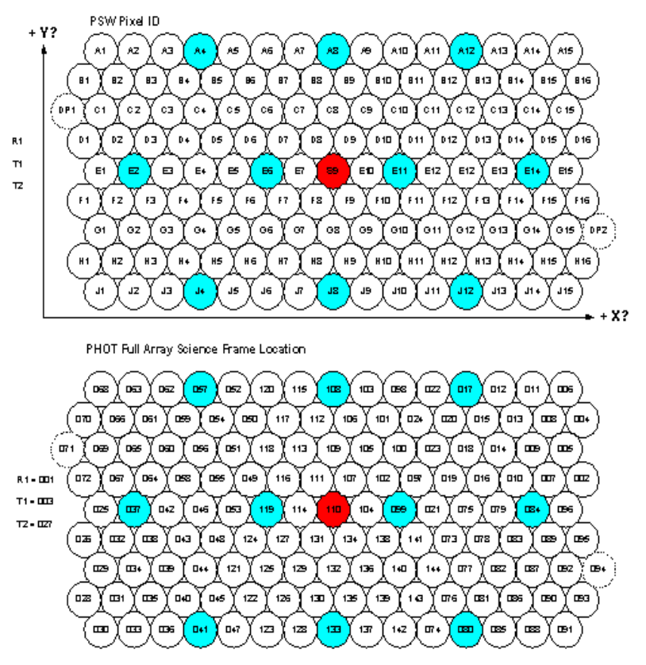
Figure 14-110 PSW Detector Pixel Locations
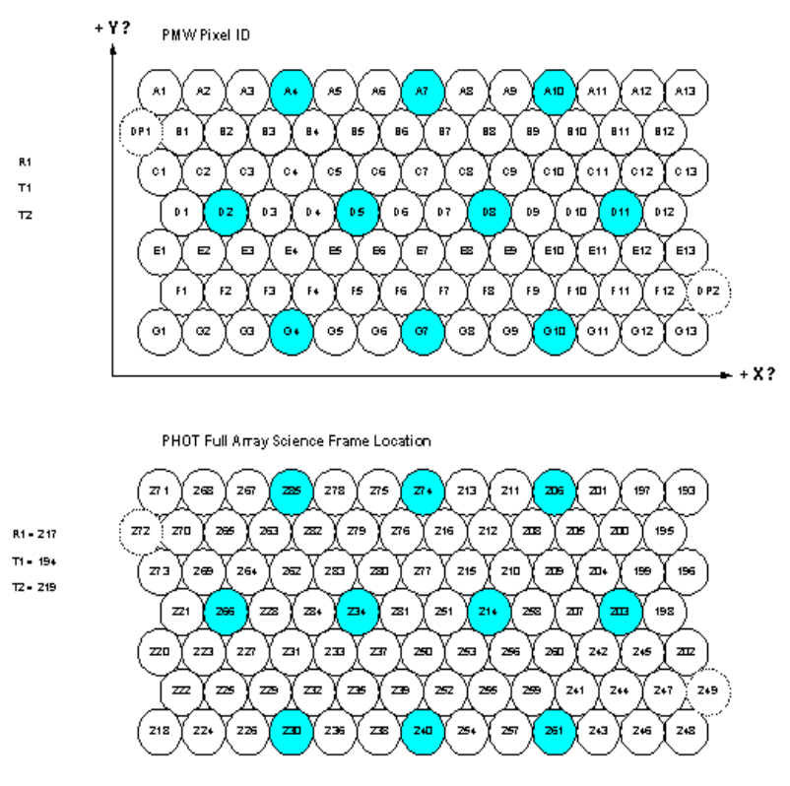
Figure 14-111 PMW Detector Pixel Locations
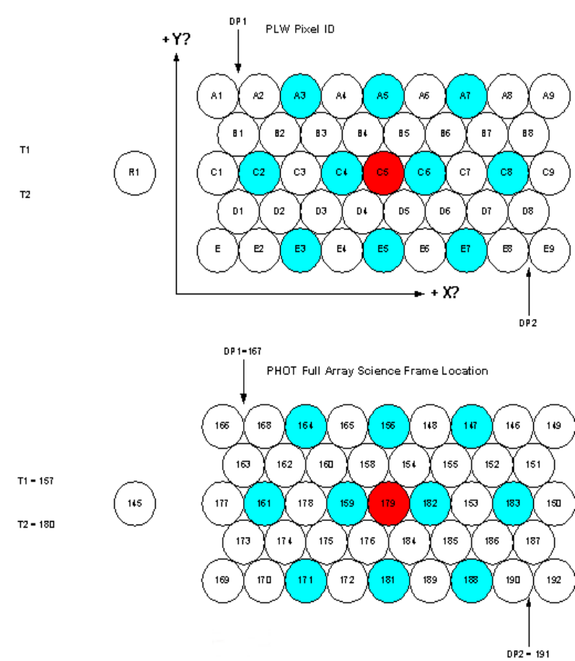
Figure 14-112 PLW Detector Pixel Locations

Spectrometer Full Array
This science data packet (SID 0x0201) contains a single 16-bit sample from each of the 72 photometer detector channels (including dark pixels, resistors and temperature sensors) repeated 6 times. The format of the packet is

0 | 0 | 0 | 0 | 1 | APID
1 | 1 | Count
Length
0 | 0 | 0 | 0 | 0 | 0 | 0 | 0 | 0 | 0 | 0 | 1 | 0 | 1 | 0 | 1
0 | 0 | 0 | 0 | 0 | 0 | 0 | 1 | 0 | 0 | 0 | 0 | 0 | 0 | 0 | 0
TIME
SID
OBSID
BBID
Block Length=78

Block 1
FrameID=0x00
72 Detector Values

ADC_Flags
Frame_Time MSW
Frame_Time LSW
Checkword
Block 2
Block 3
Block 4
Block 5
Block 6
Checksum

Figure 14-113, and Figure 14-114 show the location of each pixel on the instrument focal plane and its location within the science data packet.

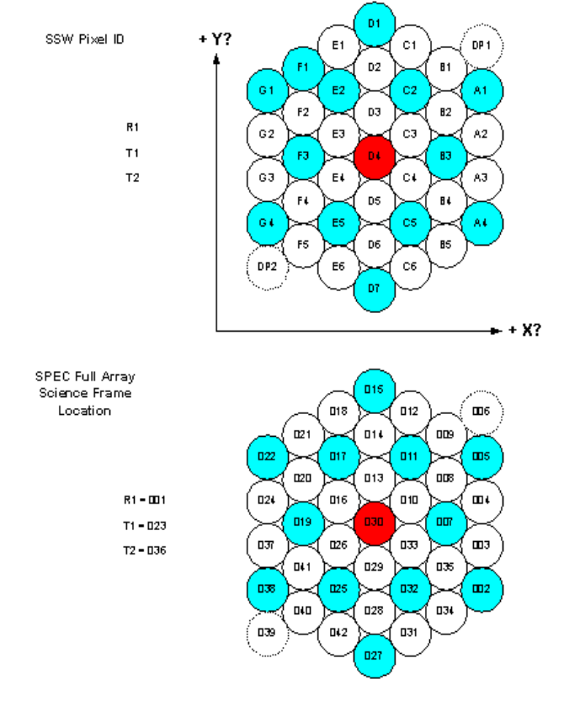
Figure 14-113 SSW Detector Pixel Locations
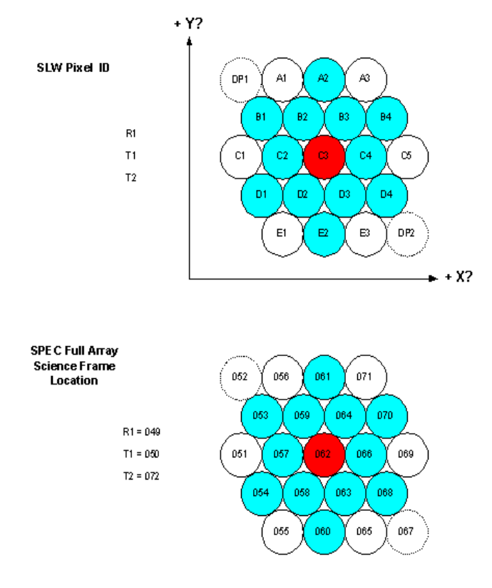
Figure 14-114 SLW Detector Pixel Locations

SCU Science Packet
This science data packet (SID 0x0A20) contains a single 16-bit sample from each of the 24 SCU channels, repeated 16 times. The format of the packet is
Block Length=30
FrameID=0x20
PUMPHTRTEMP
PUMPHSTEMP
EVAPHSTEMP
SHUNTTEMP
SOBTEMP
SL0TEMP
PL0TEMP
OPTTEMP
BAFTEMP
BSMIFTEMP
SCAL2TEMP
SCAL4TEMP
SCALTEMP
SMECIFTEMP
SMECTEMP
BSMTEMP
SUBKTEMP
TCHTRV
PCALCURR
PCALV
SCAL2CURR
SCAL2V
SCAL4CURR
SCAL4V
ADC _Flags
Frame_Time MSW
Frame_Time LSW
Checkword

0 | 0 | 0 | 0 | 1 | APID
1 | 1 | Count
Length
0 | 0 | 0 | 0 | 0 | 0 | 0 | 0 | 0 | 0 | 0 | 1 | 0 | 1 | 0 | 1
0 | 0 | 0 | 0 | 0 | 0 | 0 | 1 | 0 | 0 | 0 | 0 | 0 | 0 | 0 | 0
TIME
SID
OBSID
BBID
Block 1
Block 2
..
..

Block 15
Block 16
Checksum

MCU Science Packets

BSM Science Packet
This science data packet (SID 0x0612) contains a single 16-bit sample from each of the 6 BSM channels, repeated 38 times. The format of the packet is

0 | 0 | 0 | 0 | 1 | APID
1 | 1 | Count
Length
0 | 0 | 0 | 0 | 0 | 0 | 0 | 0 | 0 | 0 | 0 | 1 | 0 | 1 | 0 | 1
0 | 0 | 0 | 0 | 0 | 0 | 0 | 1 | 0 | 0 | 0 | 0 | 0 | 0 | 0 | 0
TIME
Block Length=13
FrameID=0x12
Acquisition date MSW
Acquisition date LSW
CHOPSENSSIG
CHOPMOTORCURR
CHOPBEMF
JIGGSENSSIG
JIGGMOTORCURR
JIGGBEMF
Transmission_Time MSW
Transmission_Time LSW
Checkword

SID
OBSID
BBID
Block 1
Block 2
..
..

Block 37
Block 38
Checksum

SMEC Science Packet
This science data packet (SID 0x1410) contains a single 16-bit sample from each of the 4 SMEC channels (plus timing information), repeated 83 times. The format of the packet is

0 | 0 | 0 | 0 | 1 | APID
1 | 1 | Count
Length
0 | 0 | 0 | 0 | 0 | 0 | 0 | 0 | 0 | 0 | 0 | 1 | 0 | 1 | 0 | 1
0 | 0 | 0 | 0 | 0 | 0 | 0 | 1 | 0 | 0 | 0 | 0 | 0 | 0 | 0 | 0
TIME
SID
OBSID
Acquisition Time MSW
Aquisition Time LSW
SMECENCPOSN
SMECENCFINEPOSN
SMECLVDTPOSN
SMECMOTORBEMF

BBID
Block 1
Block 2
..
..

Block 82
Block 83
Checksum

Packet Generation
Science data packets are only generated during observing modes. The rate at which they rate generated is:

Mode | DCU Packets  Pkts/sec | SCU Packets | MCU Packets
POF1 | 20 (Phot Full) | 0 | 1.4 (BSM)
POF2 | 20 (Phot Full) | 0 | 1.4 (BSM)
POF3 | 20 (Phot Full) | 0 | 1.4 (BSM)
POF4 | 20 (Phot Full) | 0 | 1.4 (BSM)
POF5 | 20 (Phot Full) | 0 | 0.1 (BSM)
POF6 | 20 (Phot Full) | 0 | 1.4 (BSM)
POF7 | 20 (Phot Full) | 0 | 1.4 (BSM)
POF8 | 20 (Phot Full) | 20 | 0.1 (BSM)
POF9 | 10 (Phot Full) | 0 | 0.1 (BSM)
POF10 | 20 (Phot Full) | 0 | 0.1 (BSM)
SOF1 | 12 (Spec Full) | 0 | 0.4 (BSM) 2.9 (SMEC)
SOF2 | 12 (Spec Full) | 0 | 0.4 (BSM) 2.9 (SMEC)
SOF3 | 12 (Phot Full) | 0 | 1.4 (BSM) 1.2 (SMEC)
SOF4 | 12 (Phot Full) | 0 | 1.4 (BSM) 1.2 (SMEC)
SOF5 | 12 (Spec Full) | 0 | 0.4 (BSM) 2.9 (SMEC)

 The requirement on the Level-0 temperature set by the background power level from the Level-0 stage is a very weak one, because the 2-K stage emits so little power in the FIR/submillimetre region. In practice, the Level-0 temperature will have to be much more stable than this to ensure that the 300-mK temperature stability requirement is met. This has yet to be analysed in detail .
Several notches in the qualification spectrum may be requested in order to meet the structural requirements of the entire instrument.

