Brief note on SMEC WFT
We carried out the following tests on the 2 Feb 2005 with the PFM1 FPU out of the cryostat attached to the QM1 DRCU and AVM DPU via the cryoharness.

We followed the procedures given in LAM.PJT.SPI.PRC.041020_01 Ed 1 Rev 0 which specifies the test sequence for the warm operation of the BSM and SMEC using the LAM DPU simulator.

i) We switched on the MCU and conditioned the optical encoder and set up the feed forward gain. The command sequence is taken from the Log and translated into something a bit more meaningful – see table 1.

ii) We disengaged the launch latch with no current supplied to the SMEC.

iii) We tried using closed loop control but the MCU fell over and it wasn’t clear whether the SMEC had moved – table 2

iv) After rebooting the MCU we checked to see if the mechanism moved using open loop mode where we directly command the position with no feedback loop – table 3

When we did this the optical encoder position sometimes changed and sometimes didn’t. But the encoder signals were clearly showing the sinusoidal output. It was not clear whether we had really set the encoder signal offsets as these were always reported as 0 in the housekeeping display.

By trial and error we were able to move the mechanism to within the LVDT range and stepped through a set of positions and recorded the LVDT position and the output of the LVDT and the optical encoder detectors. The plots below show the results. I don’t know why the plots have so many glitches all over them – this could be a QLA problem. Once I am able to look at the data directly I will follow this up.

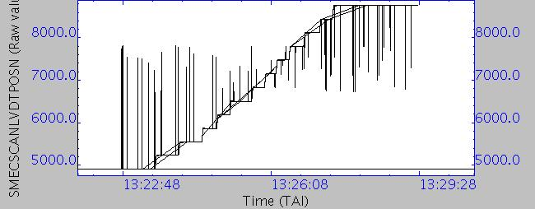

LVDT Position over period of test

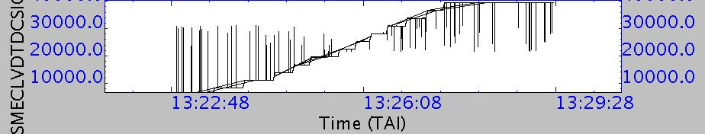

LVDT DC output over period of test
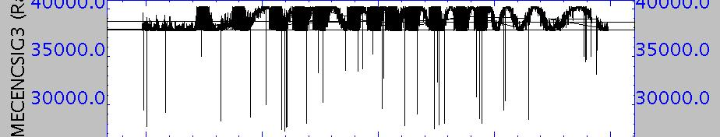

Encoder signal 3 over period of test

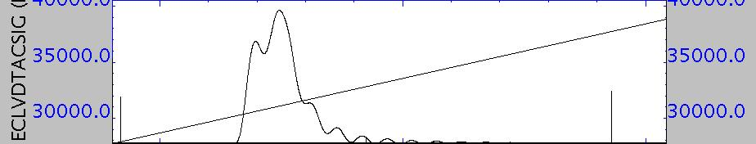

LVDT AC output during step

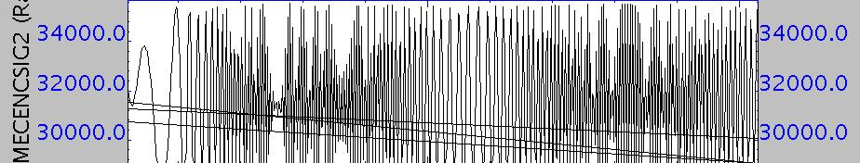

Encoder signal 2 during step

Tabel 1 Log of commands for MCU switch on and Latch release.
Command released at 2005.033.10.13.47 Hex A0870004 ComType A087 SCUDrelOnOFF Value 4
Command released at 2005.033.10.14.15 Hex 90010005 ComType 9001 FPGA Command Value 5
Command released at 2005.033.10.14.19 Hex 90010007 ComType 9001 FPGA Command Value 7
Command released at 2005.033.10.14.23 Hex 90010003 ComType 9001 FPGA Command Value 3
Command released at 2005.033.10.14.29 Hex 90010007 ComType 9001 FPGA Command Value 7
Command released at 2005.033.10.14.32 Hex 9021C000 ComType 9021 DownLoadConf Value 49152
Command released at 2005.033.10.14.40 Hex 90240001 ComType 9024 BootRAM Value 1
Command released at 2005.033.10.17.49 Hex 90541899 ComType 9054 SFeedForwardgain Value 6297
Command released at 2005.033.10.18.08 Hex 90558000 ComType 9055 SFeedForwardOffset Value 32768
Command released at 2005.033.10.18.20 Hex 90400007 ComType 9040 SEncoderPwr Value 7
Command released at 2005.033.10.18.33 Hex 90586590 ComType 9058 EncoderSignal1Offs Value 26000
Command released at 2005.033.10.18.55 Hex 905A7918 ComType 905A EncoderSignal2Offs Value 31000
Command released at 2005.033.10.19.03 Hex 90558665 ComType 9055 SFeedForwardOffset Value 34405
Command released at 2005.033.10.19.35 Hex 90490000 ComType 9049 STrajMode Value 0
Command released at 2005.033.10.19.52 Hex 90554000 ComType 9055 SFeedForwardOffset Value 16384
Command released at 2005.033.10.20.25 Hex 90450000 ComType 9045 STrajEndPosition Value 0
Command released at 2005.033.10.20.33 Hex 90460000 ComType 9046 STrajStartPosition Value 0
Command released at 2005.033.10.20.46 Hex 90490001 ComType 9049 STrajMode Value 1
Command released at 2005.033.10.21.05 Hex 90490004 ComType 9049 STrajMode Value 4
Command released at 2005.033.10.21.17 Hex 90490001 ComType 9049 STrajMode Value 1
Command released at 2005.033.10.21.27 Hex 90558000 ComType 9055 SFeedForwardOffset Value 32768
Command released at 2005.033.10.23.22 Hex 90490000 ComType 9049 STrajMode Value 0
Command released at 2005.033.10.23.31 Hex 90430002 ComType 9043 SLaunchLatch Value 2

Table 2 Log of commands attempting to run SMEC in closed loop
Command released at 2005.033.10.39.33 Hex 90410001 ComType 9041 SLVDTPwr Value 1
Command released at 2005.033.10.40.05 Hex 905F161C ComType 905F LVDTScale Value 5660
Command released at 2005.033.10.40.19 Hex 905E1F40 ComType 905E LVDTOffset Value 8000
Command released at 2005.033.10.43.07 Hex 90558000 ComType 9055 SFeedForwardOffset Value 32768
Command released at 2005.033.10.46.25 Hex 904A07D0 ComType 904A SKp Value 2000
Command released at 2005.033.10.46.37 Hex 904B02BC ComType 904B SKd Value 700
Command released at 2005.033.10.46.46 Hex 904D03E8 ComType 904D Ski Value 1000
Command released at 2005.033.10.47.02 Hex 904E07D0 ComType 904E SIntegrationLimit Value 2000
Command released at 2005.033.10.47.11 Hex 9051012C ComType 9051 SRateLimit Value 300
Command released at 2005.033.10.51.02 Hex 90490000 ComType 9049 STrajMode Value 0
Command released at 2005.033.10.51.06 Hex 90459858 ComType 9045 STrajEndPosition Value 39000
Command released at 2005.033.10.51.13 Hex 90460000 ComType 9046 STrajStartPosition Value 0
Command released at 2005.033.10.51.25 Hex 90471388 ComType 9047 SScanSpeedFoward Value 5000
Command released at 2005.033.10.51.47 Hex 90561388 ComType 9056 SRevScanSpeed Value 5000
Command released at 2005.033.10.51.59 Hex 90480001 ComType 9048 SScanNumber Value 1
Command released at 2005.033.10.52.10 Hex 90440001 ComType 9044 SLoopMode Value 1
Command released at 2005.033.10.52.33 Hex 90558000 ComType 9055 SFeedForwardOffset Value 32768
Command released at 2005.033.10.52.48 Hex 90490002 ComType 9049 STrajMode Value 2

Table 3 Log of commands to set up SMEC and carry out open loop step test.
Command released at 2005.033.12.18.51 Hex 91C4000A ComType 91C4 TelemetryPacket14S Value 10
Command released at 2005.033.12.18.58 Hex 91C3FFFF ComType 91C3 FrameNumber Value 65535
Command released at 2005.033.12.19.02 Hex 91C10001 ComType 91C1 FrameStart Value 1
Command released at 2005.033.12.22.14 Hex 91C10000 ComType 91C1 FrameStart Value 0
Command released at 2005.033.12.22.46 Hex 91C0000A ComType 91C0 TelemetryPacket10S Value 10
Command released at 2005.033.12.22.51 Hex 91C10001 ComType 91C1 FrameStart Value 1
Command released at 2005.033.12.27.43 Hex 90541899 ComType 9054 SFeedForwardgain Value 6297
Command released at 2005.033.12.27.55 Hex 90558000 ComType 9055 SFeedForwardOffset Value 32768
Command released at 2005.033.12.28.04 Hex 90400007 ComType 9040 SEncoderPwr Value 7
Command released at 2005.033.12.29.04 Hex 90586590 ComType 9058 EncoderSignal1Offs Value 26000
Command released at 2005.033.12.29.46 Hex 905A7918 ComType 905A EncoderSignal2Offs Value 31000
Command released at 2005.033.12.30.40 Hex 90490000 ComType 9049 STrajMode Value 0
Command released at 2005.033.12.31.02 Hex 90554000 ComType 9055 SFeedForwardOffset Value 16384
Command released at 2005.033.12.31.50 Hex 90450000 ComType 9045 STrajEndPosition Value 0
Command released at 2005.033.12.32.01 Hex 90460000 ComType 9046 STrajStartPosition Value 0
Command released at 2005.033.12.32.08 Hex 90490001 ComType 9049 STrajMode Value 1
Command released at 2005.033.12.32.27 Hex 90490004 ComType 9049 STrajMode Value 4
Command released at 2005.033.12.32.38 Hex 90490001 ComType 9049 STrajMode Value 1
Command released at 2005.033.12.32.46 Hex 90558000 ComType 9055 SFeedForwardOffset Value 32768
Command released at 2005.033.12.35.14 Hex 90410001 ComType 9041 SLVDTPwr Value 1
Command released at 2005.033.12.35.27 Hex 905F161C ComType 905F LVDTScale Value 5660
Command released at 2005.033.12.35.32 Hex 905E1F40 ComType 905E LVDTOffset Value 8000
Command released at 2005.033.12.39.08 Hex 90490000 ComType 9049 STrajMode Value 0
Command released at 2005.033.12.39.12 Hex 90451F40 ComType 9045 STrajEndPosition Value 8000
Command released at 2005.033.12.39.28 Hex 90490001 ComType 9049 STrajMode Value 1
Command released at 2005.033.12.41.38 Hex 90490000 ComType 9049 STrajMode Value 0
Command released at 2005.033.12.41.51 Hex 90459000 ComType 9045 STrajEndPosition Value 36864
Command released at 2005.033.12.42.39 Hex 90452F40 ComType 9045 STrajEndPosition Value 12096
Command released at 2005.033.12.43.56 Hex 90452320 ComType 9045 STrajEndPosition Value 8992
Command released at 2005.033.12.44.16 Hex 90452328 ComType 9045 STrajEndPosition Value 9000
Command released at 2005.033.12.44.28 Hex 90490001 ComType 9049 STrajMode Value 1
Command released at 2005.033.12.45.58 Hex 90400006 ComType 9040 SEncoderPwr Value 6
Command released at 2005.033.12.46.54 Hex 90490000 ComType 9049 STrajMode Value 0
Command released at 2005.033.12.46.59 Hex 90452710 ComType 9045 STrajEndPosition Value 10000
Command released at 2005.033.12.47.04 Hex 90490001 ComType 9049 STrajMode Value 1
Command released at 2005.033.12.48.31 Hex 90490000 ComType 9049 STrajMode Value 0
Command released at 2005.033.12.48.37 Hex 90458000 ComType 9045 STrajEndPosition Value 32768
Command released at 2005.033.12.48.43 Hex 90490001 ComType 9049 STrajMode Value 1
Command released at 2005.033.12.54.19 Hex 90490000 ComType 9049 STrajMode Value 0
Command released at 2005.033.12.54.24 Hex 90459000 ComType 9045 STrajEndPosition Value 36864
Command released at 2005.033.12.55.17 Hex 90490001 ComType 9049 STrajMode Value 1
Command released at 2005.033.12.56.44 Hex 90490000 ComType 9049 STrajMode Value 0
Command released at 2005.033.12.56.48 Hex 90454E20 ComType 9045 STrajEndPosition Value 20000
Command released at 2005.033.12.56.56 Hex 90490001 ComType 9049 STrajMode Value 1
Command released at 2005.033.13.01.38 Hex 90490000 ComType 9049 STrajMode Value 0
Command released at 2005.033.13.02.10 Hex 90450FA0 ComType 9045 STrajEndPosition Value 4000
Command released at 2005.033.13.02.15 Hex 90490001 ComType 9049 STrajMode Value 1
Command released at 2005.033.13.03.33 Hex 90490000 ComType 9049 STrajMode Value 0
Command released at 2005.033.13.03.37 Hex 90450000 ComType 9045 STrajEndPosition Value 0
Command released at 2005.033.13.03.41 Hex 90460000 ComType 9046 STrajStartPosition Value 0
Command released at 2005.033.13.03.45 Hex 90490001 ComType 9049 STrajMode Value 1
Command released at 2005.033.13.05.01 Hex 90490004 ComType 9049 STrajMode Value 4
Command released at 2005.033.13.07.30 Hex 90490000 ComType 9049 STrajMode Value 0
Command released at 2005.033.13.07.36 Hex 90450FA0 ComType 9045 STrajEndPosition Value 4000
Command released at 2005.033.13.07.45 Hex 90490001 ComType 9049 STrajMode Value 1
Command released at 2005.033.13.22.10 Hex 90400007 ComType 9040 SEncoderPwr Value 7
Command released at 2005.033.13.24.02 Hex 90490000 ComType 9049 STrajMode Value 0
Command released at 2005.033.13.24.09 Hex 90451388 ComType 9045 STrajEndPosition Value 5000
Command released at 2005.033.13.24.16 Hex 90490001 ComType 9049 STrajMode Value 1
Command released at 2005.033.13.24.35 Hex 90490000 ComType 9049 STrajMode Value 0
Command released at 2005.033.13.24.42 Hex 90451770 ComType 9045 STrajEndPosition Value 6000
Command released at 2005.033.13.24.48 Hex 90490001 ComType 9049 STrajMode Value 1
Command released at 2005.033.13.25.07 Hex 90490000 ComType 9049 STrajMode Value 0
Command released at 2005.033.13.25.14 Hex 90451B58 ComType 9045 STrajEndPosition Value 7000
Command released at 2005.033.13.25.20 Hex 90490001 ComType 9049 STrajMode Value 1
Command released at 2005.033.13.25.30 Hex 90490000 ComType 9049 STrajMode Value 0
Command released at 2005.033.13.25.35 Hex 90451F40 ComType 9045 STrajEndPosition Value 8000
Command released at 2005.033.13.25.39 Hex 90490001 ComType 9049 STrajMode Value 1
Command released at 2005.033.13.25.47 Hex 90490000 ComType 9049 STrajMode Value 0
Command released at 2005.033.13.25.51 Hex 90452328 ComType 9045 STrajEndPosition Value 9000
Command released at 2005.033.13.25.57 Hex 90490001 ComType 9049 STrajMode Value 1
Command released at 2005.033.13.26.17 Hex 90490000 ComType 9049 STrajMode Value 0
Command released at 2005.033.13.26.22 Hex 90452710 ComType 9045 STrajEndPosition Value 10000
Command released at 2005.033.13.26.27 Hex 90490001 ComType 9049 STrajMode Value 1
Command released at 2005.033.13.26.37 Hex 90490000 ComType 9049 STrajMode Value 0
Command released at 2005.033.13.26.40 Hex 90452AF8 ComType 9045 STrajEndPosition Value 11000
Command released at 2005.033.13.26.44 Hex 90490001 ComType 9049 STrajMode Value 1
Command released at 2005.033.13.26.51 Hex 90490000 ComType 9049 STrajMode Value 0
Command released at 2005.033.13.26.54 Hex 90452EE0 ComType 9045 STrajEndPosition Value 12000
Command released at 2005.033.13.27.00 Hex 90490001 ComType 9049 STrajMode Value 1
Command released at 2005.033.13.27.08 Hex 90490000 ComType 9049 STrajMode Value 0
Command released at 2005.033.13.27.12 Hex 904532C8 ComType 9045 STrajEndPosition Value 13000
Command released at 2005.033.13.27.17 Hex 90490001 ComType 9049 STrajMode Value 1
Command released at 2005.033.13.27.29 Hex 90490000 ComType 9049 STrajMode Value 0
Command released at 2005.033.13.27.32 Hex 904536B0 ComType 9045 STrajEndPosition Value 14000
Command released at 2005.033.13.27.37 Hex 90490001 ComType 9049 STrajMode Value 1
Command released at 2005.033.13.27.52 Hex 90490000 ComType 9049 STrajMode Value 0
Command released at 2005.033.13.27.55 Hex 90453A98 ComType 9045 STrajEndPosition Value 15000
Command released at 2005.033.13.27.58 Hex 90490001 ComType 9049 STrajMode Value 1
Command released at 2005.033.13.28.07 Hex 90490000 ComType 9049 STrajMode Value 0
Command released at 2005.033.13.28.10 Hex 90453E80 ComType 9045 STrajEndPosition Value 16000
Command released at 2005.033.13.28.16 Hex 90490001 ComType 9049 STrajMode Value 1
Command released at 2005.033.13.28.39 Hex 90490000 ComType 9049 STrajMode Value 0

