SPIRE-RAL-REP-002127
PTC Drive Test

Re: Request for test of PTC heater drive (See attachment)

Notes:

A 6000 Ohm (±1 Ohm) resistor as measured by a calibrated DVM was used to connect (V+ and I+) to (V- and I-) of the PTC drive. The SCU used to carry out the test was the QM1.
The DAC was stepped through the values indicated in Table 1. Both the raw and the converted telemetry values were recorded. The DVM was used to measure the voltage drop across the resistor. The current being driven through the resistor as measured by the DVM is shown in Figure 1. The current as measured by the SCU and contained in the TM is shown in Figure 2.

Doug Griffin

Tuesday, 31 August 2004

DAC Value | TM |  | TM inferred current (A) | DVM reading (V) | DVM inferred Current (A)
DAC Value | raw | conv (mV) | TM inferred current (A) | DVM reading (V) | DVM inferred Current (A)
4095 | 31234 | 297.49 | 4.96E-05 | 0.2983 | 4.972E-05
3412 | 26023 | 247.87 | 4.13E-05 | 0.2486 | 4.143E-05
2730 | 20820 | 198.3 | 3.31E-05 | 0.1989 | 3.315E-05
2047 | 15612 | 148.67 | 2.48E-05 | 0.1491 | 2.485E-05
1365 | 10406 | 99.16 | 1.65E-05 | 0.0994 | 1.657E-05
682 | 5196 | 49.47 | 8.25E-06 | 0.0497 | 8.283E-06
0 | -9 | -0.076 | -1.27E-08 | 0 | 0.000E+00
Table 1 - test results
Figure 1

Figure 2

-----Original Message-----
From: TRIOU Henri DAPNIA [mailto:HTRIOU@dapnia.cea.fr]
Sent: 12 July 2004 16:08
To: 'Swinyard, BM (Bruce) '; CARA Christophe DAPNIA; FONTIGNIE Jean DAPNIA; 'Matt Griffin '; 'King, KJ (Ken) '; 'Sawyer, EC (Eric) '; 'Sidher, SD (Sunil) '
Cc: AUGUERES Jean-Louis DAPNIA
Subject: TC Heater current measurement inconsistency
Hi all,

As agrred during our last teleconf, I recall you, the content of FA n°138 concerning SCU TC Heater.

The investigations performed during functional tests shew significant differences on TC Heater channel current measurements (from FPU simulator) with respect to STB (Simplified Test Board from CEA/SEDI) values.

The TC Heater currents measured with FPU simulator are non consistent with Simplified Test Board (STB from SEDI with a heater resistance of 6 KOhm) measurements, as shown on the following graphic :

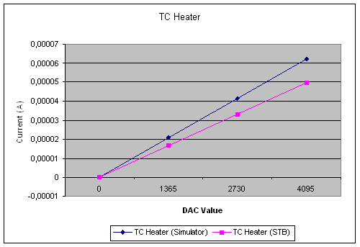

In order, to investigate that particular point, we recomment to perform voltage measurements on that channel with a fixed well know resistor value of 6 KOhm to confirm that there is no problem with the current being sent by SCU on that channel (there may be a leakage current in the simulator ?).

One should test DAC levels between 0 and 4095 (at least levels 0, 1365, 2730, 4095)
Resistor value : 6 KOhm (to be measured accurately).

Thanks,

Regards

Henri
~~~~~~~~~~~~~~~~~~~~~~~~~~~~~~~~~~~~~~~~~~~~~~~~~~~~~~~~~~~~~~~~~
Henri TRIOU
Ingénieur Chercheur
Ingénierie Système et Architecture Spatiale
CEA/Saclay/Service d'Astrophysique
Orme des Merisiers - bat. 709
91191 Gif Sur Yvette Cedex
France
Tel : (33) 1 69 08 62 93
Fax : (33) 1 69 08 79 96
E mail : htriou@discovery.saclay.cea.fr
~~~~~~~~~~~~~~~~~~~~~~~~~~~~~~~~~~~~~~~~~~~~~~~~~~~~~~~~~~~~~~~~~

