SPIRE CQM1
THERMAL BALANCE TEST REPORT

THERMAL ENGINEERING SECTION
PREPARED BY: | A.S. GOIZEL | (RAL)
CHECKED BY: | B. SHAUGHNESSY | (RAL)

SPIRE PROJECT TEAM
CHECKED BY: | D. GRIFFIN | (RAL)
 | B. SWINYARD | (RAL)
APPROVED BY: | E. SAWYER | (RAL)

“Page intentionally left blank”

CHANGE RECORD

Issue | Date | Section | Change
Draft A | 14-Jul-04 | - | New Document.

ACRONYM LIST

BDA | Bolometer Detector Array
²He | Helium 2
³He | Helium 3
BSM | Beam Steering Mechanism
CQM | Cryogenic Qualification Model
DD | Design Driver
DTMM | Detailed Thermal Mathematical Model
FM | Flight Model
FPU | Focal Plane Unit
GMM | Geometrical Mathematical Model
HOB | Herschel Optical Bench
ITMM | Interface Thermal Mathematical Model
JFET | Junction Field Effect Transistor
L0 | Temperature Level 0 (~1.7K)
L1 | Temperature Level 1 (~4K)
L2 | Temperature Level 2 (~12K)
L3 | Temperature Level 3 (~15K)
PCAL | Photometer Calibration Source
PTC | Photometer Thermal Control
RTMM | Reduced Thermal Mathematical Model
SCAL | Spectrometer Calibration Source
SMEC | Spectrometer Mechanism
SOB | SPIRE Optical Bench
SPIRE | Spectral and Photometric Imaging Receiver
SST | Stainless-steel
STP | Screened Twisted Pairs
TBC | To Be Confirmed
TBD | To Be Defined
TBT | Thermal Balance Test
TMM | Thermal Mathematical Model

CONTENT

1 Scope 1
2 Applicable Documents 2
3 Reference Documents 2
4 SPIRE CQM1 Thermal Balance Post-Test Review 3
4.1 Test Objectives 3
4.2 SPIRE CQM1 Standard Built 3
4.3 SPIRE Calibration Cryostat 6
4.4 Additional Thermal Hardware 7
4.4.1 Thermal sensors Post-Test Review 7
4.4.2 Instrument Internal Power Dissipation Post-Test Review 8
4.5 Thermal Test Cases performed during First Test Campaign 9
5 SPIRE CQM1 Thermal Test Results 11
5.1 Cooler Recycling at 1.7K 11
5.1.1 General Observations 11
5.1.2 Cooler Temperature Observations during Recycling 12
5.1.3 Detector L0 Enclosures Temperature Observations 14
5.2 Cooler Characterisation 16
5.2.1 Test Description and Results 16
5.2.2 Cooler Characterisation Analysis 18
5.3 Photometer, Spectrometer and OFF Cases 20
6 Additional Analysis 22
6.1 Sensitivity Analysis on L0 Enclosures Heat Load and Interface Joint Conductance 22
6.2 Sensitivity Analysis on error in thermal sensor readings 24
7 Conclusion 26
7.1 SPIRE CQM1 Thermal Performances Overview 26
7.1.1 Cooler and 300-mK System Performances Observations 26
7.1.2 L0 Enclosures Observations 27
7.1.3 L1 FPU Observations 27
7.2 SPIRE CQM1 - Issues to be corrected for next test campaign 28

LIST OF TABLES

Table 2-1 – Applicable documents 2
Table 3-1 – Reference documents 2
Table 4-1 – SPIRE CQM1 Thermal Design Summary [AD1] 4
Table 4-2 - Trade-off for BDA detector configuration in SPIRE CQM1 5
Table 4-3 – Non-working CQM1 Thermal Sensors 7
Table 4-4 - Period of Thermal Testing during CQM1 Test Campaign 10
Table 5-1 – Cooler Temperature at beginning of characterisation Test 16
Table 5-2 – Commanded command to the Cooler Pump 16
Table 5-3 – Cooler Characterisation Test Results 17
Table 6-1 – Predictions on L0 Enclosures Temperature and Heat Loads 22
Table 6-2 – Thermal Sensor Reading Errors due to self-heating 24
Table 6-3 – Estimated Error in Analysis of temperature drop along L0 enclosure thermal Path 25
Table 7-1 – SPIRE Overall Performances during CQM1 Test Campaign 26

LIST OF FIGURES

Figure 5-1 – Level-0 Temperatures Overview before Recycling 11
Figure 5-2 – Cooler Temperature During Recycling at 1.7K 12
Figure 5-3 - Cooler Temperature During Recycling at 1.7K 13
Figure 5-4 – L0 Enclosure Temperature before and during Recycling at 1.7K 14
Figure 5-5 – Cooler Characterisation Test Results 17
Figure 5-6 – Cooler Characterisation Test Results 18
Figure 5-7 – Cooler Characterisation test Results 19
Figure 5-8 - Cooler Characterisation test Results 19
Figure 5-9 – SPIRE Thermal Balance Test Results 20
Figure 5-10 - SPIRE Thermal Balance Test Results 20
Figure 5-11 - SPIRE Thermal Balance Test Results 21
Figure 5-12 - SPIRE Thermal Balance Test Results 21

Scope

This document summarises the Thermal Balance Test (TBT) results obtained during the first Cryogenic Qualification Model (CQM) test campaign of the SPIRE instrument. A short review of the test facility and of the tests performed during this campaign is also described in this document. The instrument model used for this test will be denominated as CQM1 herein to differentiate it from the second CQM test campaign for which a “refurbished” SPIRE CQM1 will be used.

Section 4 of this document provides a summary of the CQM1 thermal balance post-test review.

Additional material and literature can be found in section 2 and 3 to support any aspect of the thermal testing which isn’t described in details in this document.

Section 5 provides a description and detailed analysis of the thermal test results.

In section 6, additional analyses results are presented, which help understanding the various issues that have been encountered during the first test campaign.

Section 7 states the conclusion reached at the end of this first test campaign as well as a list of suggestions and changes required for the second CQM2 test campaign.

Applicable Documents

ID | Title | Number
AD1 | SPIRE CQM1 Thermal Balance Test Specification | SPIRE-RAL-DOC-002077  Draft 3  29-Jan-04
AD2 | CQM Thermal Hardware Specification 2-2.xls | 19-Dec-03  Version 2.2
AD3 | CQM Thermometers 1.0.xls | -
AD4 | AIV Logbook for CQM Test Campaign 1 | -
AD5 | SPIRE CQM2 Thermal Balance Test Specification | SPIRE-RAL-DOC-002077
Table 2-1 – Applicable documents

Reference Documents

ID | Title | Number
RD1 | SPIRE Thermal Requirement Document | SPIRE-RAL-PRJ-002075  Draft B  13-Jul-04
RD2 | SPIRE Thermal Configuration Control Document | SPIRE-RAL-PRJ-000560
Table 3-2 – Reference documents

SPIRE CQM1 Thermal Balance Post-Test Review

This section summarises the various aspects of the thermal balance tests carried out during the first CQM test campaign of the SPIRE instrument. Additional information about the instrument standard-built, the calibration cryostat and test set-up is given in AD1.

Test Objectives

The objectives of the thermal balance test on the SPIRE Cryogenic Qualification Model can be summarised as follow [AD1]:

- Validate the SPIRE thermal design as far as the hardware and thermal environment of the calibration cryostat would allow,

- Provide thermal test data to allow correlation with thermal mathematical model and more accurate predictions of flight performances.

SPIRE CQM1 Standard Built

Table 4.1 on next page describes the differences between the thermal design implemented for the SPIRE CQM1 and the thermal design currently baselined for the instrument Flight Model (FM). A detailed description of the FM thermal design is given in RD2.

The differences in thermal hardware arise mainly due to late changes in the thermal design of the instrument. Because most of the hardware was already manufactured and assembled at that time, those changes could not be implemented on the CQM1 without introducing important time delays in the test campaign.

A new set of temporary external Level-0 straps (from the cooler heat switches and L0 spectrometer enclosure to the calibration cryostat Level-0 interfaces) had to be designed and manufactured however to replace the original set of straps as those were unlikely to achieve the required cooler recycling performances. More information about the thermal design of these temporary straps is given in AD2.

In addition to thermal balance testing, the CQM1 test campaign was also aiming at testing and validating the performances of the instrument scientific payload when operating in photometer mode (using the only working PLW detector).

Because of the large uncertainties about the thermal conductivity of the copper used for the 300-mK straps, and at the time, some issues with the cooler (an additional 8μW parasitic load used to be present which has since been solved) it had been decided that the SPIRE CQM1 should be operated with only the PLW detector connected in order to limit the total amount of load on the cooler. The advantages and disadvantages this approach would offer had been considered in details at the time. A short summary of the criteria used to do this trade-off is given in table 4.2 for information.

Temperature  Stage | Component | CQM1 | FM
300-mK | BDA Detectors | Only the “operating” PLW detector on the photometer side will be connected to the cooler cold tip. No detector connected on the spectrometer side of the cooler cold tip. | 5 Detectors connected (PLW, PMW, PSW, SLW, SSW).
300-mK | Photometer Busbar | 4Ns un-annealed. | 5Ns annealed.
300-mK | Photometer Cooler Strap | 4Ns annealed with electrical isolation implemented. | 5Ns annealed and electrical isolation on the 300-mK photometer side is not part of the baseline anymore.
300-mK | Spectrometer Cooler Strap | Not used as no detectors to be connected on this side. | 5Ns annealed.
Level-0 | Interbox Strap | 4Ns annealed with electrical isolation implemented. | 5Ns annealed with electrical isolation implemented.
 | Cooler and spectrometer straps | New strap designed to fit the calibration cryostat and ensure proper cooler performances. | Flight model designed to meet 0.15W/K.
 | Enclosure Supports | Stainless Steel. | CFRP (improvement factor of 4 expected in thermal isolation).
Level-1 | FPU Supports | Stainless Steel. | CFRP (improvement factor of 4 expected in thermal isolation).
 | Level-1 | Glued Joint used for electrical isolation. | Kapton sheet implemented at the Level-1 Ventline was the baseline at that time for the Level-1 electrical isolation.
Level-3 | SJFET | SJFET bolted only on three feet only (manufacturing error of mating holes on HOB). | 4 feet.
Table 4-3 – SPIRE CQM1 Thermal Design Summary [AD1]

Trade-off used to decide upon the BDA detector configuration in CQM1
(Number of connected detectors)
Advantages | Disadvantages
This approach has the effect of reducing the load on the cooler evaporator during operation:  - Reduces risk of large temperature drop along the 300-mK Busbar and detector running at excessive temperature.  - Reduces risk of running the cooler with short hold time periods, which would make the thermal and scientific testing difficult, as the cooler would have to be recycled more often.  - Because the PLW detector and the evaporator cold tip are the only known 300-mK stage temperature during thermal testing, the correlation of the overall 300-mK Level will be quite difficult. This configuration has also the advantage to provide a better insight of the PLW and Busbar parasitic loads only, therefore helping with the future correlation. | - The load on the cooler will not be flight representative and therefore it will not be possible to validate the overall thermal design of the instrument at that stage.
Table 4-4 - Trade-off for BDA detector configuration in SPIRE CQM1

Although connecting only one detector for the CQM1 would not allow to validate the thermal design at this stage, this test would still provide a good insight of the overall instrument thermal performances and the decision of the connecting the whole set of detectors for the second thermal balance test campaign would then have to be re-assessed. The results of this assessment are presented in the section 7 of this report.

SPIRE Calibration Cryostat

A detailed description of the differences between the calibration cryostat used for the CQM test campaign and the Herschel flight cryostat is given in AD1.

The CQM1 test campaign was the first time the cryostat was being operated with the full SPIRE instrument and has allowed to gain a better understanding of the thermal environment in which the thermal balance test in being done. The following observations have been made following the operation of the cryostat during the test campaign:

- It takes a minimum of 4 to 5 hours to top-up the cryostat Level-2 with Helium and wait for its temperatures to “stabilise” again. Please note however that because the Level-1 and Level-0 temperature stages are quite isolated from the HOB, their temperatures remain relatively constant and/or stabilise back to their steady-state temperature very quickly. A cooler recycling can therefore be done while the cryostat Level-2 temperatures are still stabilising.

- The temperatures at which the cryostat Level-2 and the Level-0 interfaces are run have a direct impact on the cryostat hold time – lower Level-2 temperature and higher Level-0 temperatures shorten considerably the hold time of the cryostat.

- The control of the Level-0 interface temperature was performed with the use of a heater on the Level-0 can. This approach isn’t straightforward and requires some effort in order to obtain the required interface temperature.

- The Level-2 temperatures (which include the HOB and the instrument shield) are drifting slowly.

- After the test campaign, a closed inspection showed that some harness potting had not been clamped properly on the 77K shield.

All this information is very valuable and will be taken into account when planning for the second test campaign. Additional actions have been taken to improve the way the cryostat is operated:

- A manostat has been implemented at the Level-0 to ease the control of the interface temperatures for the next thermal balance testing,

- A new Helium gauge has also been implemented which should provide better predictions for the cryostat hold time. This will help greatly when planning for the thermal testing (i.e. reduces the risks of the cryostat running out of helium before the instrument temperatures have had time to stabilise during the TBT).

Additional Thermal Hardware

Thermal sensors Post-Test Review

The thermometry consists of:

- 17 flight sensors mounted on the instrument and driven by the instrument onboard software (using a 10mV constant voltage drive),

- 31 sensors mounted on the cryostat and driven through a 218 Lakeshore unit (using a 10μA constant current drive),

- 13 additional temperatures sensors used for the instrument monitoring and driven through a 218 Lakeshore unit (using a 10μA constant current drive). Those sensors provide an additional insight of the instrument thermal behaviour (in critical areas such as strap interfaces) and will greatly help with the correlation of the thermal model.

Additional information about those sensors can be found in AD1 and AD3.

The only temperatures available on the 300-mK stage are:

- The evaporator cold tip,

- The temperature of PLW BDA detector, obtained using load curves, which provide an estimation of the detector temperature at +/- 5mK (according to Jamie Bock).

Following the cooldown, several sensors appeared to be not working or read erroneous data. Table 4.3 provides a list of the non-working sensors.

ID | Description | Status | Reasons
S28 | Level-0 Enclosure interface temperature at the cryostat shoe. | Seems to read warmer temperature than at the instrument itself | Not calibrated below ~1.55K. Extrapolation has been used below this temperature.
S29 | Level-0 pump interface temperature at the cryostat shoe. | Read 1.1K at all time | Dead sensors or wiring issue.
S30 | Level-0 evaporator interface temperature at the cryostat shoe. | Read temperatures around 3K at all time. | Dead sensors, calibration or wiring issue.
T_BSMS_1 | BSM/SOB I/F (SOB side) | Erroneous Data | Not calibrated below 4.987K
T_BSMM_1 | BSM | Erroneous Data | Not calibrated below 4.987K
Table 4-5 – Non-working CQM1 Thermal Sensors

During testing, it has been found that the Lakeshore unit (which was initially set to log converted temperature data rather raw resistance data) could not read any data below 1.4K (and would instead saturate and display 1.4K at all time). Following this, it has been decided to set-up the Lakeshore unit to read and log raw data from the sensors (i.e. resistances). This approach also has the advantage that recalculation of temperatures can be done at later stage in case errors were found in the calibration tables. Additional information about the approach used for the post-processing of the temperature raw data is given in Appendix A.

The self-heating of thermal sensors has also been considered as a possible issue which is being investigated in more details in section 6.1.

Instrument Internal Power Dissipation Post-Test Review

The CQM Photometer and Spectrometer Calibration Sources (PCAL and SCAL respectively) were controlled via the instrument software whereas the BSM and SMEC STM mechanisms were controlled via the “MCU”.

Some issues have been encountered when operating the SCAL, which is currently under investigation.
In addition, instabilities (current oscillations) when operating the MCU have prevented the use of the SMEC and the setting of the BSM power dissipation was itself really tedious.

As a result, the MCU will not be used for the second test campaign. Instead, a simple power supply and a 4-wire measurement will allow the power dissipation of the BSM and the SMEC to be set and known very accurately.

Thermal Test Cases performed during First Test Campaign

Several thermal test cases have been performed during the duration of the CQM1 test campaign, which will help to better understand the instrument thermal performances as well as provide data to allow the correlation of the instrument thermal model after the second test campaign.

An overview of the tests performed is given in table 4.4 on next page. More information about procedures followed during the thermal balance test can be found in AD1 and AD4.

Please note that only the test cases where the steady-state criteria have been reached can be used in future for the future correlation of the thermal model.

The first OFF case allowed to verify the instrument overall thermal performances. An important temperature drop between the calibration cryostat Level-0 interface (at less then 1.4K) and the instrument Level-0 photometer enclosure (at ~2K) could already be observed at that stage. To optimise the cooler hold time as well as the cryostat hold time, it was decided to run the Level-0 at 1.4K instead of 1.7K as initially specified in AD1.

The Level-1 interface temperature of the cryostat has been left running thermally unregulated at 4.1K at all time while the Level-2 has been thermally controlled at 10K initially but also at 12K, and at 17K in nominal operation during others test levels to optimise the cryostat hold time.

The following thermal tests have been analysed in more detailed in the following sections as they presented some interesting characteristics:

- The cooler characterisation test was a test suggested by Lionel Duband. This test allows to analyse some aspects of the cooler performances for a given thermal environment.

- A cooler recycling with the Level-0 interfaces running at 1.7K (instead of the nominal 1.4K) has also been performed and is described hereafter.

- Finally, the Thermal Balance Test cases have been performed at the end of the CQM1 test campaign for the instrument in Photometer, Spectrometer and Off modes. Steady-State conditions have been achieved for the first two test cases with the exception of the Off case during which the cryostat run out of Helium, therefore compromising the thermal balance of the instrument.

Overall, the SPIRE instrument has shown to stabilise very quickly (within 2 to 4 hours) assuming the cryostat temperatures are stable.

Start Period |  | End Period |  | Thermal Test Cases  Description | Level-2  [K] | Level-1  [K] | Level-0  [K] | Comments | Steady-State  Reached
Date | Time | Date | Time
30-01-04 | 18.00 | 31-01-04 | 20.00 | OFF | 10 | 4.12 | <1.4 | At 13.30 the turbo pump switched off. | -
02-02-04 | 17.00 | 02-02-04 | 21.00 | Recycle 1 | 10 | 4.12 | <1.4 | - | -
03-02-04 | 9.26 | 04-01-02 | 10.00 | Recycle 2  Photometer mode | 10 | 4.12 | <1.4 | Load curves taken at same time as the photometer thermal balance case. | x
04-02-04 | 12.00 | 04-02-04 | 14.00 | Cooler Characterisation | 10 | 4.12 | <1.4 | - | -
05-02-04 | 7.30 | 05-02-02 | 11.30 | Recycle 3 | 10 | 4.12 | <1.4 | - | -
11-02-04 | 8.00 | 11-02-04 | 12.00 | Recycle at 1.7K | 10 | 4.12 | 1.7 | - | -
12-02-04 | 18.00 | 13-02-04 | 12.00 | Photometer with HOB at 17K | 17 | 4.12 | <1.4 | Lakeshore unit set-up to log raw data. | -
13-02/04 | 12.00 | 14-02-04 | 20.00 | All cases:  - Photometer mode  - Spectrometer mode  - Off mode | 12 | 4.12 | <1.4 | - | x
 |  |  |  |  |  |  |  |  | x/?
 |  |  |  |  |  |  |  |  | -
Table 4-6 - Period of Thermal Testing during CQM1 Test Campaign

SPIRE CQM1 Thermal Test Results

Cooler Recycling at 1.7K

General Observations
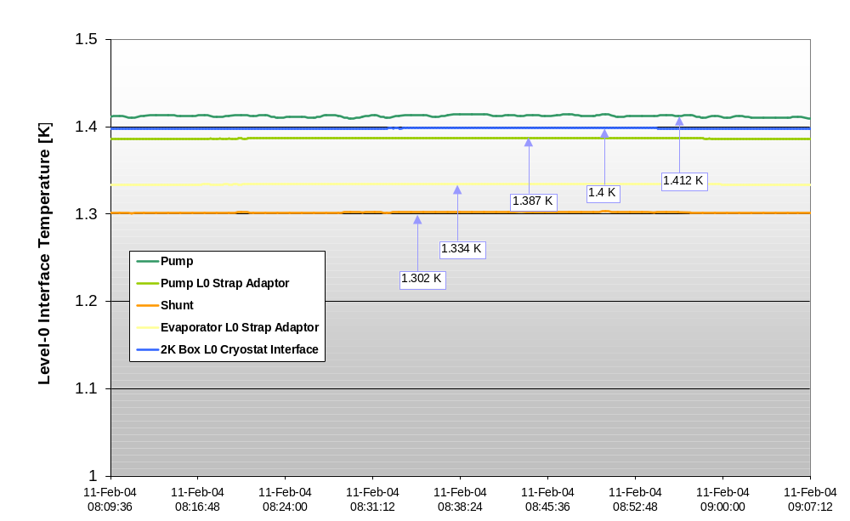

Figure 5-1 – Level-0 Temperatures Overview before Recycling
Because the thermal sensors at the cryostat L0 pump and evaporator cryostat interfaces aren’t working, the sensor at the 2K Box L0 cryostat interface has been used as an indication (based on the assumption that the Helium pot is isothermal).

In the graph above, we can see that the 2K Box L0 cryostat interface temperature seats at 1.4K at all time whereas the temperature at the top of the L0 evaporator external strap indicate a temperature around 1.33K. From this observation, it can be concluded that the L0 stage of the cryostat is running at a temperature lower than 1.4K and possibly close to 1.3K, but that the Lakeshore unit (which at that time was still logging converted data) was saturating the signal to 1.4K.

The shunt temperature, which is directly connected to the L0 evaporator strap (via the Evaporator Heat Switch), appears to have a lower temperature than the strap itself. This is not possible as the shunt is located at the warmer end of this strap. According to the thermal analysis predictions, the temperature at the strap is expected to be really close to the shunt one (as evaporator heat switch is OFF during normal operation of the cooler).

This might be an indication that reading errors (most likely caused by self-heating of the sensor) are present at the strap sensor, or that the sensor itself isn’t thermally well coupled to the strap.

The delta error in the sensor readings appears to be around 30-mK at a minimum.

Cooler Temperature Observations during Recycling

At the beginning of the test, the cryostat L0 temperature is increased from 1.4K to 1.7K (tap number 1 on the graph below). A small overshoot in L0 temperatures can be observed as a result of this change.

The SOB temperature decreases slightly from 4.7K to 4.5K as the HOB temperature decreases from 18.2K to 13.2K.

The L1 cooler enclosure temperature increases of about ~0.5K during the cooler recycling period due to the pump heater operation (this has been predicted by transient analysis with the thermal model in cooler recycle mode).

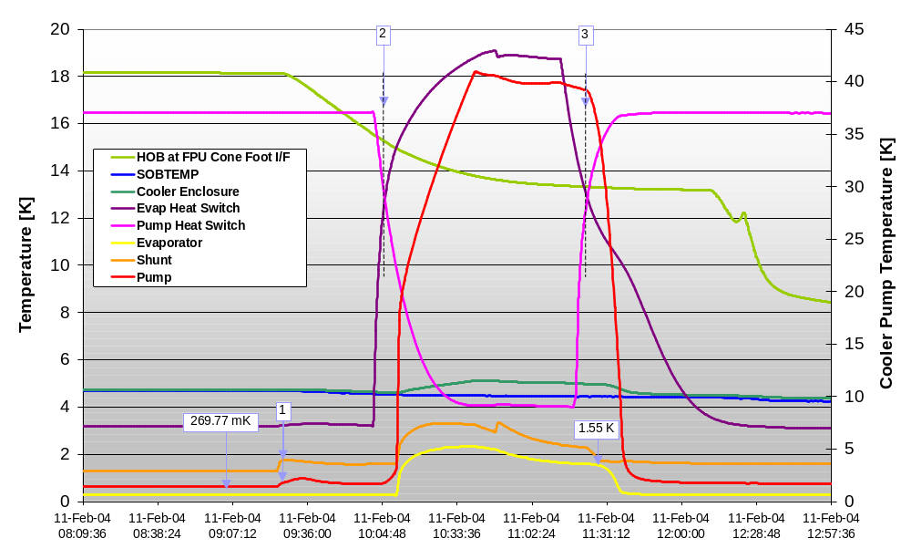
Figure 5-2 – Cooler Temperature During Recycling at 1.7K

At the start of the recycling the evaporator heat switch is being activated (as described by its increasing temperature) while the pump heat switch is closed (as described by its decreasing temperature), see tap number 2 on above graph.

When the pump starts being heated up, the evaporator and shunt temperatures increase considerably, indicating the beginning of the recycling phase.

The pump temperature is then maintained at a temperature around 40-45K and as soon as the evaporator reaches an acceptable temperature (below 2K), the pump and evaporator heat switches states are inverted, the pump heater is turned off and the cryo-pumping phase then starts.

The pump starts cooling down really quickly and a peak can be observed at the pump L0 strap adaptor as a result of the large heat flowing along the strap (see tap 3 on graph 5.1.3 on next page).

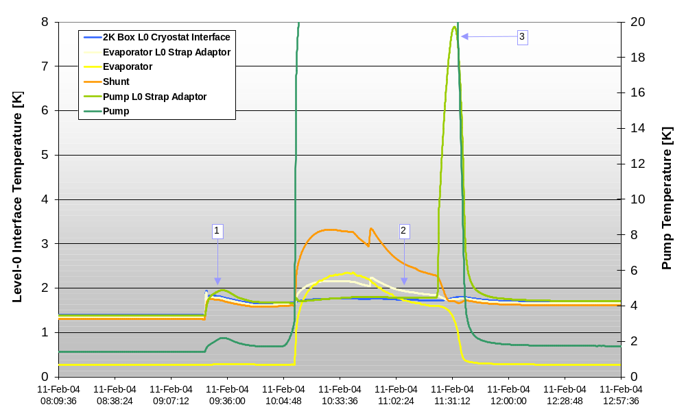
Figure 5-3 - Cooler Temperature During Recycling at 1.7K

The observed temperature increase at L0 pump strap adaptor goes as high as ~7.9 K when the pump heat switch in turned back on again.

It can be seen that the evaporator L0 strap adaptor temperature follows a temperature profile identical to the shunt temperature, which confirms that a good thermal coupling exists between the two.

The temperature at the L0 evaporator strap adaptor appears to lie between the evaporator and the shunt temperature during the cooler recycling. In this case, both the evaporator and the shunt are thermally connected to the strap (the evaporator heat switch is ON during recycling).

As described previously, during recycling the L0 evaporator strap adaptor temperature profile follows the shunt temperature profile. It has also been observed that an identical temperature profile appears at the 2K-box L0 cryostat interface, see graph 5.1.4 on next page.

This observation allows to confirm that the Helium in the L0 pot is isothermal and that the Helium bath warms up as a result of the cooler recycling.

Detector L0 Enclosures Temperature Observations

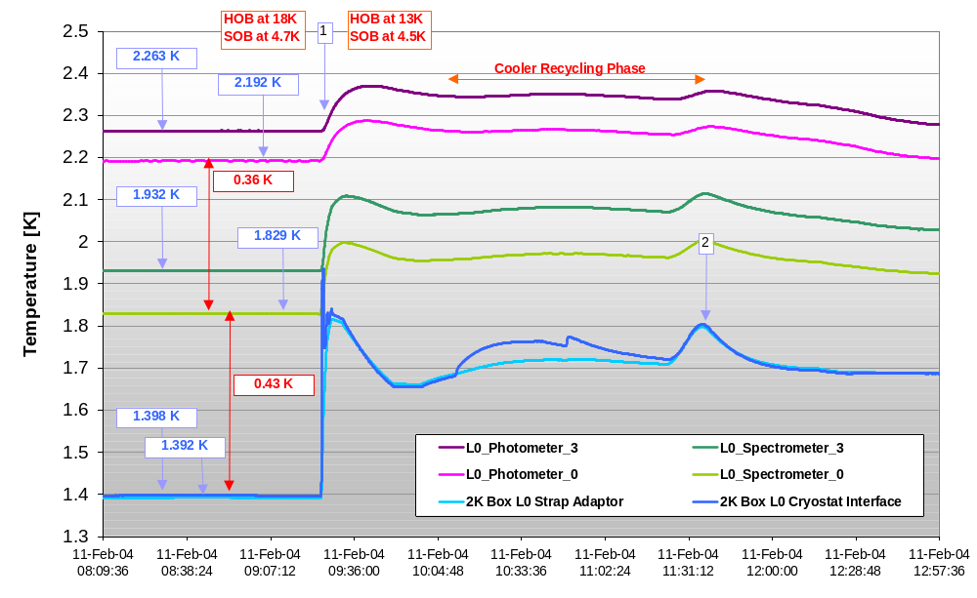
Figure 5-4 – L0 Enclosure Temperature before and during Recycling at 1.7K

On the figure above, the full thermal path from the cryostat L0 interface to the L0 photometer enclosure is described. The temperature drops at various locations along this path can therefore be analysed in details.

Each L0 enclosure contains 2 thermal sensors, one, which is monitored by the instrument onboard software and the other, monitored by Lakeshore 218 unit.

The L0_spectrometer_0 sensor (monitored by the instrument software) is located at the strap interface on the spectrometer box while the L0_spectrometer_3 is located at the foot interface on the spectrometer box.

The L0_photometer_0 sensor (monitored by the instrument software) is located at the strap interface on the photometer box while the L0_photometer_3 is located close to the PLW interface on the enclosure spin.

It is expected that reading errors introduced by the sensors self-heating and parasitic loads will be slightly different from one sensor to the other because of the difference in the way they are driven. The instrument on-board software uses a constant voltage to drive the sensors which should have less self-heating errors than the Lakeshore unit which uses a constant current drive.

Please note however that the relative accuracy between the sensors is what is really important when analysing temperature drops.

In figure 5.4.1, the gradients along the thermal path of the L0 enclosures seem to vary before and during the recycling. It is important to note that the Level-1 temperature decreases by 0.2K during this period. This would most certainly affect the heat loads flowing along the L0 enclosure straps and therefore the temperature drop observed along it.

- Before the recycling, a larger heat flow is expected; therefore a greater temperature drop would be expected at the given interfaces.

- During the recycling, the SOB runs cooler (because of the HOB cooling down) and therefore a lower heat flow is expected; therefore the temperature drop would appear less important. It is important to note however that during the recycling period, the temperatures have not had time yet to stabilise. Those results must therefore be used as an indication only and must not be used for proper correlation exercise.

The temperature drop measured between coldest point on the photometer enclosure and the strap interface on the spectrometer enclosure is ~0.36K for a SOB temperature of 4.69K [SOBTEMP used as a reference].

The temperature drop measured between the L0 enclosure strap interface on the spectrometer enclosure and the adaptor of the L0 enclosure strap itself, is ~0.43K for a SOB temperature of 4.69K [SOBTEMP used as a reference].

The following possible causes for such a temperature gradient at those interfaces have been considered and analysed in more details in section 6.1:

- A higher load on both the 2K interbox strap and the L0 enclosure straps than expected could introduce a larger delta T. This could be caused by the following items:
  - Larger parasitic loads from the L0 strap standoff mounted off the FPU,
  - Larger heat leak from the L0 enclosure supports and the F-harness,
  - Thermal short with the FPU via the light baffle.

- A very bad joint interfaces conductances or/and straps conductance could also be the reason for this temperature drop,

- Errors in thermal sensor temperature readings.

A more detailed analysis has been carried out for each of the stated point above and is described in section 6.

Cooler Characterisation

Test Description and Results

Purpose of the test:

This test allows to characterise the cooler performances by studying the variations in pump temperature for a varying heat load on the pump itself. Following this test, a curve of Pump temperature versus applied power can be plotted and the slope of the curve can then be used to characterise the load on evaporator cold tip based on the assumption that when in operation, the pump sees a heat load equal to 48-50 time the total load on the evaporator at 300mK.

For the cooler characterisation, the following test set-up has been used:
- Cooler in operating mode (evaporator temperature at 300-mK),
- Power is applied to cooler pump by step of 5, 10 and 15 mW,
- The temperature increase of the pump is then measured along with the evaporator temperature.

The cooler temperatures at the beginning of the test were as follows:

Description | Temperature
Cooler Enclosure | 4.406 K
Photometer L0 Enclosure | 2.164 K
Pump | 1.42 K
Shunt | 1.318 K
Evaporator | 264.4 mK
Table 5-7 – Cooler Temperature at beginning of characterisation Test

With Pump Heater resistance of 402 ohms, the following commands had to be sent to the cooler via the on-board software (see Appendix B for more information on current conversion):

Command to Pump Heater |  | Current | P
[Hex] | [Dec] | [A] | [mW]
124 | 292 | 0.003526 | 5.00
19C | 412 | 0.004985 | 9.99
1F8 | 504 | 0.006103 | 14.97
28B | 651 | 0.007889 | 25.02
302 | 770 | 0.009335 | 35.03
397 | 919 | 0.011146 | 49.94
418 | 1048 | 0.012714 | 64.98
48B | 1163 | 0.014112 | 80.05
Table 5-8 – Commanded command to the Cooler Pump

The results from this test are presented in the tables and figure below:

Pump Power | Pump Temperature | Evaporator Temperature
[mW] | [K] | [mK]
0 | 1.4178 | 264.4
5 | 1.8706 | 264.6
10 | 2.2227 | 264.8
15 | 2.5368 | 265
25 | 3.0929 | 265.4
35 | 3.576 | 266.3
50 | 4.2267 | 267.8
65 | 4.8184 | 269.1
80 | 5.3789 | 271
Table 5-9 – Cooler Characterisation Test Results

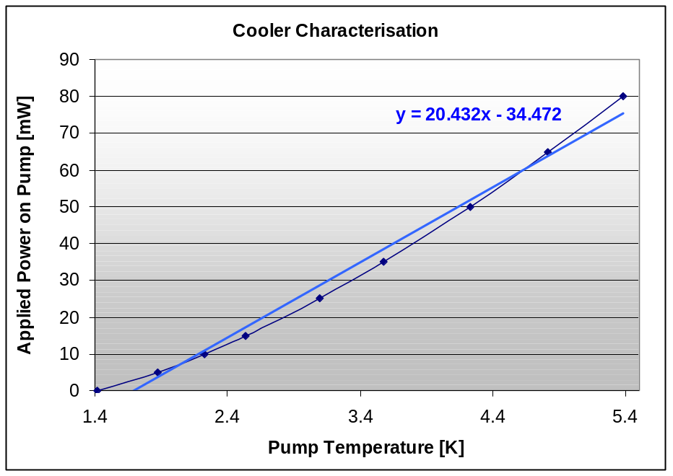
Figure 5-5 – Cooler Characterisation Test Results

A slope about 20.4mW/K has been measured. Lionel Duband suggested that a typical value for this slope is around 15mW/K.

Cooler Characterisation Analysis

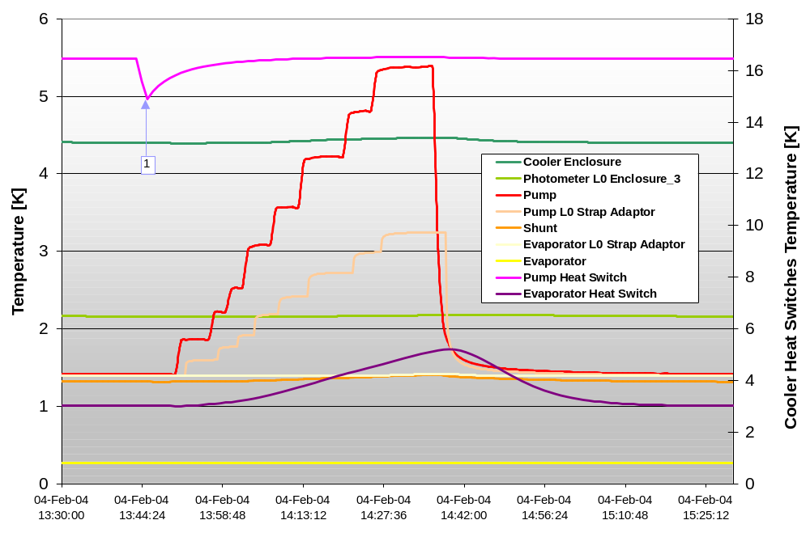
Figure 5-6 – Cooler Characterisation Test Results

The following observations have been made during the cooler testing:

- The shunt temperature ranges between 1.318K and 1.407K,
- The pump temperature increases from 1.42K to 5.38K, as the power increased,
- The Level-0 photometer enclosure increases from 2.159K to 2.179K,
- The evaporator temperature increases from 264.4mK to 271mK as a result of the shunt increase in temperature.

The L0 Pump Strap adaptor temperature profile follows the pump temperature profile, confirming that the pump heat switch is ON as indicated by the temperature of pump heat switch sieve at ~16.5K.

Note: the glitch in the pump heat switch temperature corresponds to an error in the command sent to the cooler during testing (see test logfile in AD4)

The evaporator heat switch sieve is also warming up from 3K to 5K.
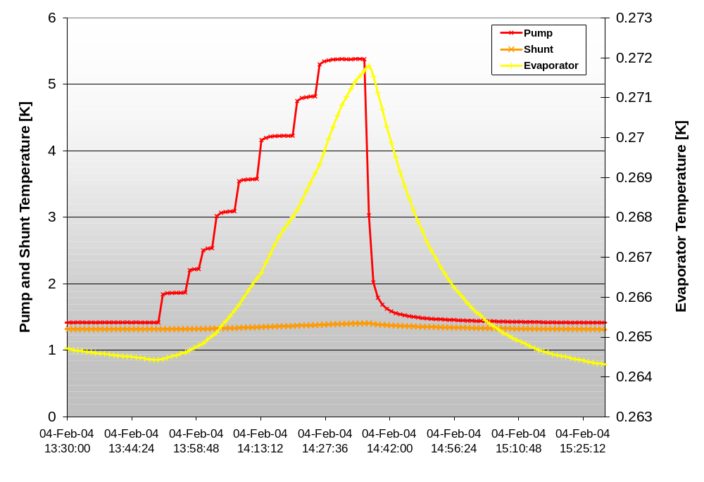
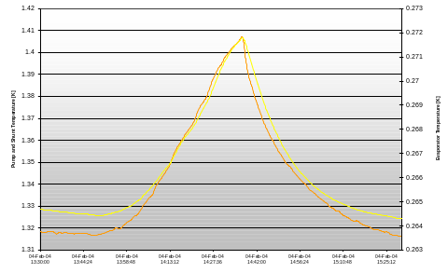

Figure 5-7 – Cooler Characterisation test Results
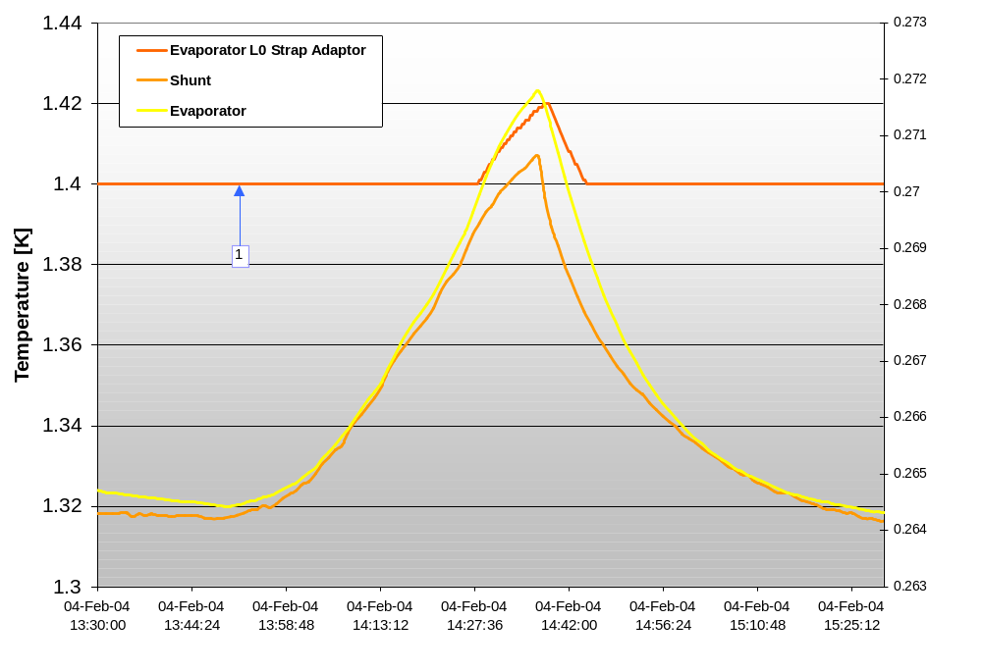
Figure 5-8 - Cooler Characterisation test Results

Photometer, Spectrometer and OFF Cases
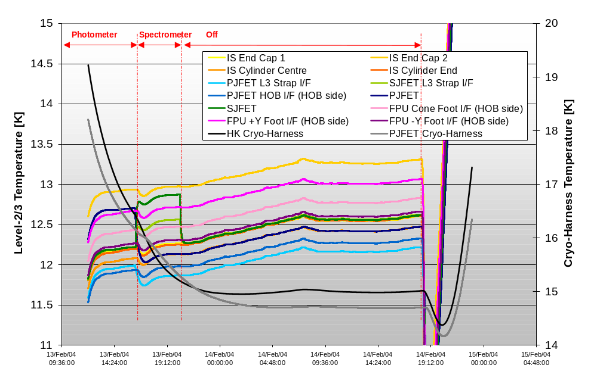
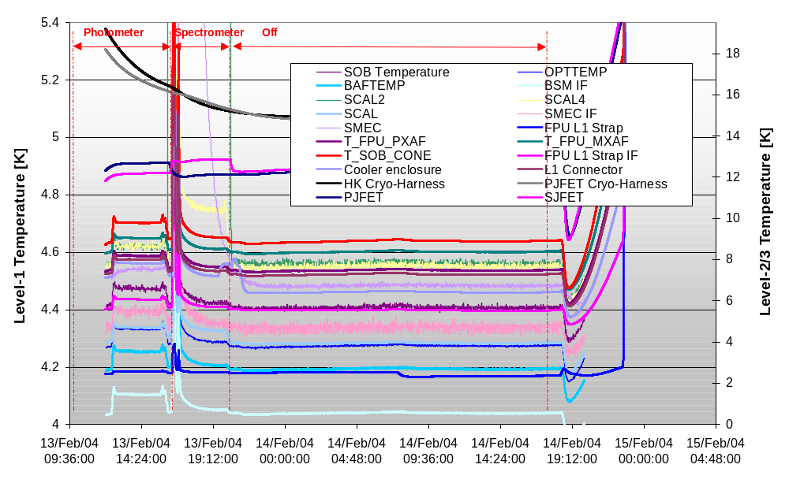
Figure 5-9 – SPIRE Thermal Balance Test Results

Figure 5-10 - SPIRE Thermal Balance Test Results

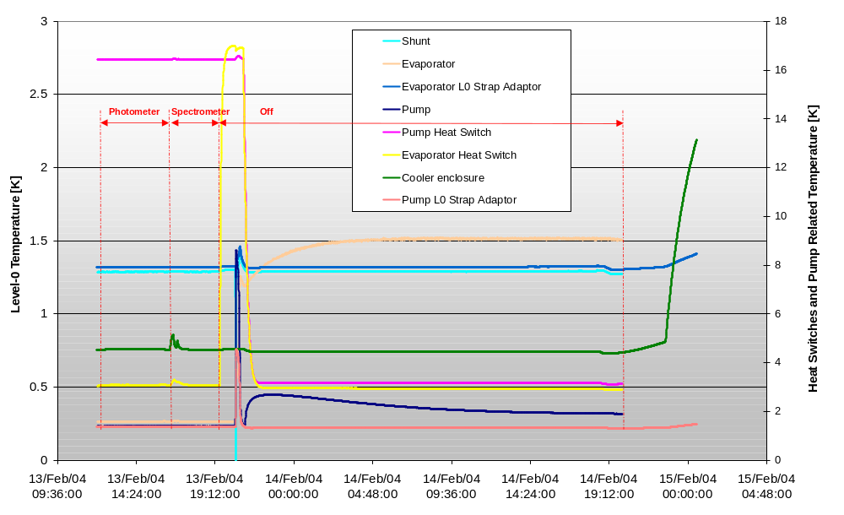
Figure 5-11 - SPIRE Thermal Balance Test Results

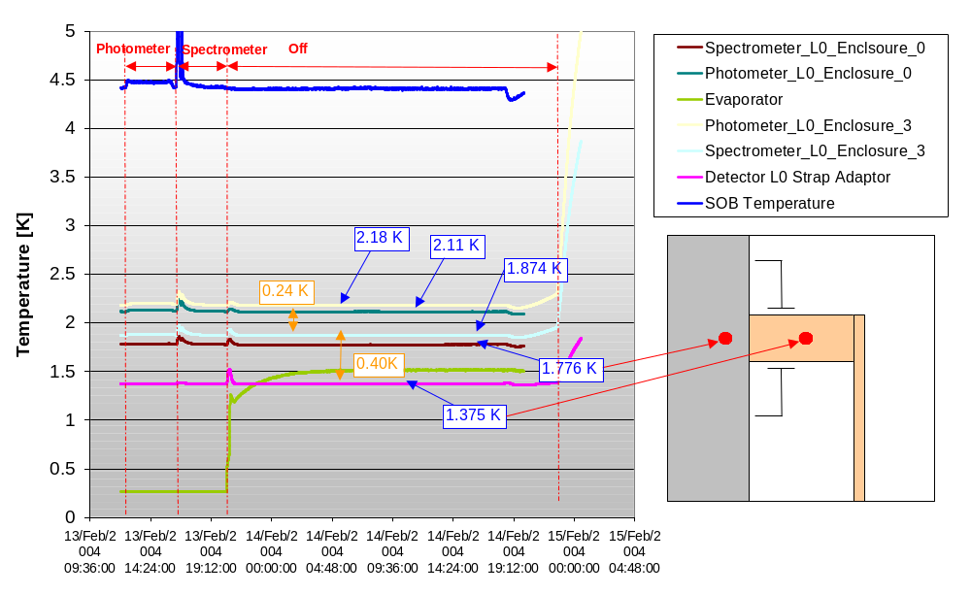
Figure 5-12 - SPIRE Thermal Balance Test Results

Additional Analysis

As described in sections 5.1.3 and 5.3, an important temperature drop has been observed at both Level-0 enclosure interfaces. Such a temperature drop at the spectrometer enclosure wasn’t predicted and a detailed analysis has been carried out to understand the possible causes.

Sensitivity Analysis on L0 Enclosures Heat Load and Interface Joint Conductance

Two possible causes are being considered in this section:

- Could a larger load than expected be flowing on both the 2K interbox strap and the L0 enclosure straps and introduces this large delta T?

- Could the joint interface conductances or/and straps conductance be lower than expected?

The table below provides an overview of the predicted performances for the Level-0 enclosures at a given set of boundary temperatures. Please note that the heat load flowing along those straps is expected to be a lot less for the flight model as the L0 enclosures supports have been replaced with more isolating standoffs.

 | Prediction | CQM1 Results | Comments
Level-1 FPU/SOB Temperature | 4.6K - 4.8K | 4.4K mean
Level-0 Photo Enclosure Temperature | 1.9K – 2K | 2.11K – 2.18K
Level-0 Spectro Enclosure Temperature | 1.75K -1.76K | 1.77K – 1.87K
L0 Enclosure Strap IF Temperature | 1.7K | <1.4K
Load on 2K Interbox Strap Load | 1.8 mW | -
L0 Enclosure Strap Load | 2.6 mW | -
Temperature drop along interbox strap | 0.15K | 0.24K  0.36K | L1 at 4.4K  L1 at 4.7K
Temperature drop at spectrometer box | 0.01K | 0.4K  0.43K | L1 at 4.4K  L1 at 4.7K
Table 6-10 – Predictions on L0 Enclosures Temperature and Heat Loads

In addition, the following assumptions were used for the interface conductance of Cu/Al joints (assumptions used by Astrium for their thermal modelling):

Cu/Al joint conductance at 1.7K = 0.06 W/kN.K

So for the joint at the spectrometer box where 2xM3 were used with an assumed force of 1.34kN on each screw, the overall joint conductance was estimated to be: 0.16W/K.

For the predicted 2.6mW load in table 6.1, this should provide a maximum temperature drop of 0.016K (27 times less than the temperature drop measured during testing).

Assuming the joint conductance used for this calculation is correct, and that the measured temperature drop is correct as well, this would mean that a 69mW load is flowing along the strap.

The following points could explain such a large heat load flowing on the L0 enclosure straps:

  - Larger parasitic loads from the L0 strap standoff mounted off the FPU,

  - Larger heat leak from the L0 enclosure supports and the F-harness,

  - Thermal short with the FPU via the light baffle.

Although recent analyses have shown that the parasitic load previously estimated for the L0 strap standoffs was underestimated by a factor 5 minimum, due to an error in material arrays (from 0.1mW to 0.5mW), this would not explain such a large load.

A larger load from the supports and the F-harness would mean that the temperature drop between the two boxes would also be important. The predictions show however that the measured interbox temperature drop isn’t far from the predicted one (taking into account the possible error in sensor readings and also the difference in boundary temperatures).

Finally, a thermal short between the external L0 enclosure strap and the instrument FPU could be a good reason for a large increase in heat load along the L0 enclosure straps. However, it would also mean that the temperature at the strap adaptor would locally warm up (indicating that an additional load is flowing from that point onwards) and the spectrometer enclosure temperature would effectively follow the strap temperature.

Following the previous observation, it appears unlikely that such a larger load has been flowing on the enclosure straps. If the load isn’t the cause, then a poor joint conductance might be.

Assuming the predicted load flowing on the external L0 enclosure strap is within 30% of the real one (2.6mW x 1.3 = 3.4mW) to account for uncertainties in temperature measurements and predictions, and that the measured temperature drop is correct as well, this would mean that the joint interface conductance between the spectrometer enclosure and the external L0 enclosure strap is about 0.008 W/K (20 times worse than the predicted one).

This observation appears more likely as 0.01W/K seemed to have been quoted in some literature papers for bad Aluminium/Copper joint interface conductance.

Errors in temperature sensors readings must also be analysed to obtain a full picture of the problem and gain a good understanding of the thermal environment.

Sensitivity Analysis on error in thermal sensor readings

In addition to analysis of the thermal hardware, it is important to understand the various sources of errors that can be present in temperature readings of thermal sensors.

Errors in temperature readings of thermal sensors can come from various sources:

- The sensor is badly fitted on the surface being measured. This would effectively increase the contact resistance between the sensor and the surface and the sensor would read warmer temperature as improperly heat sunk.

- Error come from the conversion of the sensor resistance measurement back into temperature values using calibration curves (ADC accuracy, calibration curve accuracy, …).

- Error in sensors resistance measurements can also come from:
  - EMF error occur at thermal joint when using DC measurements (as with the Lakeshore unit)
  - Self-heating of the sensor due to parasitic load along the sensor leads if not properly heat sunk as well as to the ohmic heating of the sensor itself.

The table 6.2 below provide an overview of the estimated temperature error introduced in the thermal sensors. This analysis is based on an assumed sensor/surface contact resistance of 300000 K/W as suggested by lakeshore for cernox fitted with CU packages.

The STM sensors used a fixed constant current of 10 μA while the flight sensors are driven using constant voltage of 10mV.

A parasitic load of 0.02 μW has been assumed for all sensors based on the fact that their leads were not heat sunk.

Sensor | Resistance | Temperature | Current | Self Heating | Parasitic heat | Total | Delta T
CU Package | ohms | K | A | μW | μW | μW | K
PL0 – photo enclosure | 954 | ~ 2 | 1.05E-05 | 0.10 | 0.02 | 0.12 | 37.45
PL3 – photo enclosure | 955 | ~ 2 | 1.00E-05 | 0.10 | 0.02 | 0.12 | 34.65
SL0 – spectro enclosure | 900 | ~ 1.8 | 1.11E-05 | 0.11 | 0.02 | 0.13 | 39.33
SL3 – spectro enclosure | 650 | ~ 1.8 | 1.00E-05 | 0.07 | 0.02 | 0.09 | 25.50
Enclosure strap adaptor | 1660 | ~ 1.4 | 1.00E-05 | 0.17 | 0.02 | 0.19 | 55.80
Table 6-11 – Thermal Sensor Reading Errors due to self-heating

Note 1: Please note however that the relative accuracy between the sensors is what is really important when analysing temperature drops.

Note2: The data obtained in table 6.2 should only be used as an indication rather than a true performances as the contact resistance of a sensor with a surface might vary from one sensor to another.

Table 6.3 on next page provide an indication of the impact such temperature reading errors would have on the interpretation of the various temperature drops along the L0 enclosures thermal path.

Temperature Drop Between |  | Error due to self-heating between the two sensors | Impact on Analysis
Sensor 1 | Sensor 2 | Error due to self-heating between the two sensors | Impact on Analysis
L0 Enclosure Strap Adaptor | L0 Spectrometer Enclosure strap interface (SL0) | Error on sensor 1 (STM) is greater than on sensor 2 (flight). | This would means that the temperature drop at this interface is currently under-estimated
L0 Spectrometer Enclosure strap interface (SL0) | L0 Spectrometer Enclosure foot interface (SL3) | Error on sensor 1 (flight) is larger than on sensor 2 (STM). | This would means that the temperature gradient within the spectrometer enclosure is currently under-estimated
L0 Spectrometer Enclosure strap Interface (SL0) | L0 Photometer Enclosure strap interface (PL0) | Error on sensor 1 (flight) is identical to the one on sensor 2 (flight). | Any error present in both sensors should roughly cancel itself out, which means that the estimated temperature drop is correct.
L0 Photometer Enclosure strap interface (PL0) | L0 Photometer Enclosure Spin (PL3) | Error on sensor 1 (flight) is almost identical to the one on sensor 2 (STM). | This would means that the temperature gradient within the photometer enclosure is currently correct.
Table 6-12 – Estimated Error in Analysis of temperature drop along L0 enclosure thermal Path

Conclusion

SPIRE CQM1 Thermal Performances Overview

An overview of the thermal predictions for the instrument temperatures and heat flows can be found in Appendix C. This analysis was assuming a specific set of boundary temperatures at the interfaces of the instrument and must therefore be used with care when compared to the performances obtained during the testing as a different set interfaces boundary temperatures were used at that time.

The following general performances have been obtained with SPIRE during the CQM1 test campaign:

Nominal Interface temperatures
HOB and Shroud at 10K
L1 at 4.12K
L0 at <1.4K
Overall instrument temperatures
SOB temperature ranges within 4.3-4.5K
L0 enclosure photometer seats at 2.1K
L0 spectrometer enclosure at 1.78K
Evaporator Cold tip at 265mK
PLW BDA Temperature estimated at 295 mK
Table 7-13 – SPIRE Overall Performances during CQM1 Test Campaign

Cooler and 300-mK System Performances Observations

- The cooler ran very well with its evaporator cold tip as low as 265mK and a hold time as high as 60 hrs has been experienced, BUT:

  - The Level-0 heat sink interfaces were running most of the time at < 1.4K as indicated by the shunt temperature (which is connected to the L0 evaporator strap) which has been as low as 1.3K. This means that evaporator temperatures as low as 1.5K were present during the cooler recycling and this would greatly increase the cooler recycling efficiency.

  - The cooler was running with a reduced load on its evaporator cold tip as only one detector was connected. This represents a predicted load of 6.8uW against a total load of 24.5uW for five detectors (both in addition to the cooler internal parasitic loads).

- The evaporator cold tip increased by 9mK when the cryostat Level-0 interface temperatures have been increased from 1.4K to 1.7K (because of the increased parasitic load from 300-mK system and from the evaporator heat switch).

- A 30-mK temperature drop has been measured along between the evaporator at 265mK and detector temperature estimated to be between 290mK and 295mK. A 35-mK temperature drop was estimated with the thermal model for a similar Level-0 photometer enclosure temperature.

- A local warn up of 0.5K at the cooler enclosure has been measured the pump heater is turn ON (as predicted by the thermal analysis in transient mode).

- The evaporator heat switch takes up to an hour to switch ON.

- Sieve temperature increased up to 20K in some instance. Future analysis will have to check what would be the impact of this radiation load on the cooler components.

- Some temperature drift has also been observed at the evaporator cold tip.

L0 Enclosures Observations

- It has been observed that the level-0 Photometer enclosure temperature is lagging behind the Level-0 spectrometer enclosure temperature during cooldown and then eventually catch up. This is predictable as the photometer is located at the extreme end of the thermal link.

- Despite the large temperature at the spectrometer enclosure, the measured temperature drop between the two enclosures was very close to the estimated one (0.24K versus 0.15K) which confirms that the current 4Nine copper strap and the small epoxy joint area are not good enough and therefore requires some improvement. The goal is to reduce this temperature drop to 0.03K maximum.

- Insight about the dynamic thermal behaviour of instruments in terms of stability and time it takes for the temperature to settle down has been obtained during this test.

L1 FPU Observations

No specific observation could be made on the gradient present within the SOB during the various operation modes because of the various problems experienced when running the internal mechanisms.

SPIRE CQM1 - Issues to be corrected for next test campaign

- A manostat has been integrated on the calibration cryostat to provide a better control of the Level-0 interface temperatures,

- All Level-0 cryostat interfaces will be controlled at 1.7K (rather than 1.4K) to make sure all sensors are within the range of the calibration curves and also be flight representative,

- To avoid any more instability when using the MCU, the SMEC and BSM STM mechanisms will be controlled via a simple power supply using a 4-wire measurement to be able to determine the power dissipated accurately,

- The few lost sensors have been rewired for the next test campaign,

- The lead of all sensors at the Level-0 stage will be better heat sunk and an AC bridge will be used to read the STM sensors out and reduce the error readings due to self-heating,

- The method to perform load curve has been optimised and will allow to obtain the PLW detector temperature on a more regular basis rather than punctually,

- All five 300-mK detectors will be connected,

- The thermal interface of the external strap to Level-0 spectrometer enclosure as well as at the interbox strap has been re-designed and the new interfaces will be implemented on the instrument for the next test campaign.

Details of the next thermal balance test and validation of the thermal design and hardware can be found in AD5.

Appendix A

Converting data logged with the Lakeshore 218 unit:

1 - Set Excel to calculate dates using the 1904-year baseline,
2 - Use the following expression to obtain the correct date and time: timestamp / (24*3600)
3 - Use Cernox and TVO calibration curves and check that the resistance readings remain within the range of calibration.

Converting data logged with the instrument on-board software:

- Convert raw data to signed data (if count>32767, then count = count-65536 else count = count),
- Use signed data sheet as input to the Matlab subroutine,
- Use calib03.xls spreadsheet as a calibration curves input (file must be present in folder),
- Interpolate data,
- Set Excel to calculate dates using the 1904-year baseline,
- Use the following expression to obtain the correct date and time: (timestamp / (24*3600))+19724.

Appendix B

R heater = 402 ohms applicable to both heat switches heater and the sorption pump heater.

Sorption Pump Heater control

Current Command = (Ia + 2.254x10-5) / 1.21532x10-5

Sorption Pump HS Heater control

Current Command = (Ia + 2.05x10-6) / 3.9353x10-7

Sorption Evaporator HS Heater control

Current Command = (Ia + 2.44x10-6) / 3.9357x10-7

Appendix C – Predictions

SPIRE Cooler TEMPERATURES

Evaporator Cold Tip 0.280 K

SPIRE DETECTORS TEMPERATURES

photo_LW_detector1 2750 0.311 K
photo_LW_Feedhorn 0.301 K
photo_LW_Strap 0.300 K
Internal T drop 0.011 K

photo_MW_detector2 2850 1.983 K
photo_SW_detector3 2950 2.052 K
spect_LW_detector1 3750 1.764 K
spect_SW_detector2 3850 1.764 K

SPIRE BUSBAR TEMPERATURES

cooler_photo_strap_flang 0.284 K
photo_busbar_feedthru 0.285 K
photo_busbar_cold 0.286 K
photo_busbar 0.288 K
photo_busbar 0.288 K
photo_busbar 0.291 K
photo_busbar_warm 0.291 K
Busbar T drop 0.020 K

SPIRE L0 ENCLOSURES TEMPERATURES

photo_L0_box_px[2400] 1.914 K
photo_L0_box_mid[2410] 1.966 K
photo_L0_box_mx[2420] 2.024 K

spect_L0_box_px[3400] 1.765 K
spect_L0_box_mx[3410] 1.749 K

SPIRE COOLER TEMPERATURES

Cooler L1 4.314 K
Cooler Pump 1.832 K
HS Pump Cold 1.808 K
HS Pump Base 1.726 K
Cooler Shunt 1.704 K
Cooler Evaporator 0.280 K
HS Evap Cold 0.280 K
HS Evap Base 1.704 K

SPIRE MECHANISM TEMPERATURES
photo_calibrator 4.749 K and QI = 0.033 mW
photo_bsm 4.745 K and QI = 0.200 mW
spect_SMECm_base 4.818 K and QI = 0.000 mW
spect_SMECm_actuator 4.899 K and QI = 2.600 mW
spect_SMECm_LVDT 4.822 K and QI = 0.100 mW
spect_SMECm_encoder 4.834 K and QI = 0.500 mW
SCAL_enclosure 4.844 K and QI = 1.500 mW
SCAL_disc01 4.844 K and QI = 0.000 mW
SCAL_disc02 4.844 K and QI = 0.000 mW
SCAL_disc03 4.844 K and QI = 0.000 mW
SCAL_disc04 4.844 K and QI = 0.000 mW
photo_JFET_mem1 10.005 K and QI = 0.000 mW
spect_JFET_mem1 151.147 K and QI = 4.700 mW

SPIRE INTERFACE TEMPERATURES
PJFET_L3 IF 10.003 K
SJFET_L3 IF 10.635 K
L1_Cryo-Harness SIF 4.777 K
L1_Cryo-Harness PIF 4.786 K
L1_HK-Harness IF 4.835 K
L1_strap_IF1 4.336 K
L0 Enc IF 1.749 K
L0 Pump IF 1.726 K
L0 Evap IF 1.704 K

CALIB CRYO INTERFACES TEMPERATURES
HOB - 1001 10.195 K
HOB - 1002 10.201 K
HOB - 1003 10.193 K
HOB - 1004 10.218 K
HOB - 1005 10.212 K
HOB - 1006 10.227 K
HOB - 1007 10.200 K
HOB - 1008 10.205 K
HOB - 1009 10.201 K
LN2 Shield 77.000 K
L2 Shield 10.000 K
L1 IF 4.200 K
L0 IF 1.700 K

Heat Fluxes for SPIRE Cooler
Photo 300mK 5.663 uW
Spectro 300mK 0.000 uW
L1 Parasitics 1.826 uW
Shunt Parasitics 7.182 uW
Heat Switch Parasitics 2.958 uW
Total Cooler Load 17.629 uW

Heat Fluxes for SPIRE 300mK System
PLW Kevlar Parasitic 2.103 uW for L0 Encl Temp at 1.914 K
PLW Harness Parasitic 1.078 uW
PMW Kevlar Parasitic 0.000 uW for L0 Encl Temp at 1.966 K
PMW Harness Parasitic 0.000 uW
PSW Kevlar Parasitic 0.000 uW for L0 Encl Temp at 2.024 K
PSW Harness Parasitic 0.000 uW
Busbar Supports Parasitic 0.784 uW for L0 Encl Temp at 1.914 K
Busbar Supports Parasitic 0.784 uW for L0 Encl Temp at 1.914 K
Busbar FeedThru Parasitic 0.913 uW for L0 Encl Temp at 2.024 K
Total Photo 300mK Load 5.663 uW
Balance on photo 300mK 0.000 uW

SLW Kevlar Parasitic 0.014 uW for L0 Encl Temp at 1.765 K
SLW Harness Parasitic 0.002 uW
SSW Kevlar Parasitic -0.013 uW for L0 Encl Temp at 1.749 K
SSW Harness Parasitic -0.003 uW
Spectro FeedThru Parasitic 0.001 uW for L0 Encl Temp at 1.765 K
Total Spectro 300mK Load 0.000 uW
Balance on Spectro 300mK 0.000 uW

Heat Fluxes for SPIRE Level 0 - Enclosure
L0 Photometer Enc Foot Supports 1.487 mW
L0 Harn Parasitic for PLW 0.063 mW
L0 Harn Parasitic for PMW 0.125 mW
L0 Harn Parasitic for PSW 0.219 mW
Load into Photo 300mK System 0.006 mW
Load into L0 Spectrometer Enc 1.888 mW
Balance on L0 Photometer Enc 0.000 mW

L0 Spectrometer Enclosure Foot Supp 0.493 mW
L0 Harn Parasitic for SLW 0.032 mW
L0 Harn Parasitic for SSW 0.061 mW
Load into Spectro 300mK System 0.000 mW
L0 Enc Strap Standoffs 0.099 mW
Balance on L0 Spectrometer Enc 0.000 mW

L0 Enclosure Strap Load 2.573 mW for IF Temp at

Heat Fluxes for SPIRE Level 0 - Pump
Pump Supports 0.002 mW
Initial Pump Dissipation 1.400 mW
Pump Heat Switch Dissipation 0.400 mW
Pump Heat Switch Support Parasitic 0.216 mW
Pump Heat Switch Harness Parasitic 0.005 mW
Additional Pump Dissipation -0.519 mW
L0 Pump Strap Standoffs 0.099 mW
Balance on L0 pump Strap Load 0.000 mW
Balance on Pump Dissipation 0.000 mW

L0 Pump Strap Load 1.603 mW for IF Temp at

Heat Fluxes for SPIRE Level 0 - Evaporator
Evap Heat Switch Dissipation 0.000 mW
Evap Heat Switch Support Parasitic 0.217 mW
Evap Heat Switch Harness Parasitic 0.005 mW
Evap Heat Switch Shunt Strap load -0.001 mW
Evap Heat Switch leak to evap -0.003 mW
L0 Evap Strap Standoffs 0.100 mW
Balance on L0 evap Strap Load 0.000 mW

L0 Evap Strap Load 0.317 mW for IF Temp at

Heat Fluxes for SPIRE Level 1
Harness Load from PJFET 0.919 mW
Harness Load from SJFET 0.237 mW
L1 Foot Supports 8.885 mW
L1 Housekeeping Harness 2.566 mW
Total Radiation Load 7.130 mW

PCAL Dissipation 0.033 mW
BSM Dissipation 0.200 mW
SMEc Actuator Dissipation 2.600 mW
SMEc LDVT Dissipation 0.100 mW
SMEc Encoder Dissipation 0.500 mW
SCAL Dissipation 1.500 mW
Aperture Filter Dissipation 0.015 mW
HK IF Dissipation 0.000 mW
Total Mechanisms Dissipation 4.948 mW

Leak to L0 via Supports (pump+HS) -0.439 mW
Leak to L0 via Harness (shunt+HS) -0.013 mW
Leak to L0 straps -0.298 mW
Leak to L0 Detector Boxes -2.480 mW

Balance on L1 0.000 mW

L1 Strap1 Load 21.456 mW for IF Temp at 4.200 K
Total L1 Load 21.456 mW

Heat Fluxes for SPIRE Level 3
PJFET Harness Load to FPU -0.919 mW
PJFET Harness Load to HOB -0.002 mW
PJFET Foot Supports to HOB 0.379 mW
PJFET Strap Load -0.131 mW for IF Temp at 10.000 K
PJFET Radiation Load 0.674 mW
PJFET Dissipation Load 0.000 mW
PJFET Harness Dissip Load 0.000 mW
Balance on PJFET 0.000 mW

SJFET Harness Load to FPU -0.237 mW
SJFET Harness Load to HOB -0.115 mW
SJFET Foot Supports to HOB -0.934 mW
SJFET Strap Load -12.958 mW for IF Temp at 10.000 K
SJFET Radiation Load 0.144 mW
SJFET Dissipation Load 14.100 mW
SJFET Harness Dissip Load 0.000 mW
Balance on SJFET 0.000 mW

“Page intentionally left blank”

The simulated SPIRE internal power dissipation was non-flight representative due to the mechanism limitations (as explained in section 4.4.2.)
Please note that only the test cases where the steady-state criteria have been reached can be used in future for the correlation of the thermal model. Others test cases are shown here because they provide an insight about the instrument thermal performances even so they will not be used for correlation.

