Note on possible implementation of improvement to Level-0 inter-box strap
Pete Hargrave – 28/04/04 SPIRE-UCF-NOT-002003

Thermal modelling of SPIRE indicates that the thermal conductivity of the level-0 interbox strap is too low, by a factor of about two.
The current strap design includes Stycast/Dacron electrical isolation on the photometer end. This copper-epoxy-copper sandwich is then bolted to the aluminium photometer box base, using Vespel insulating bushes.
Adam Woodcraft pointed out that we have two “bad” joints in this system; the epoxy sandwich, and the bolted copper-aluminium interfaces on the photometer and spectrometer boxes. Why don’t we try and combine our two bad joints into one not-so-bad joint. This note defines a possible solution to implementing this.
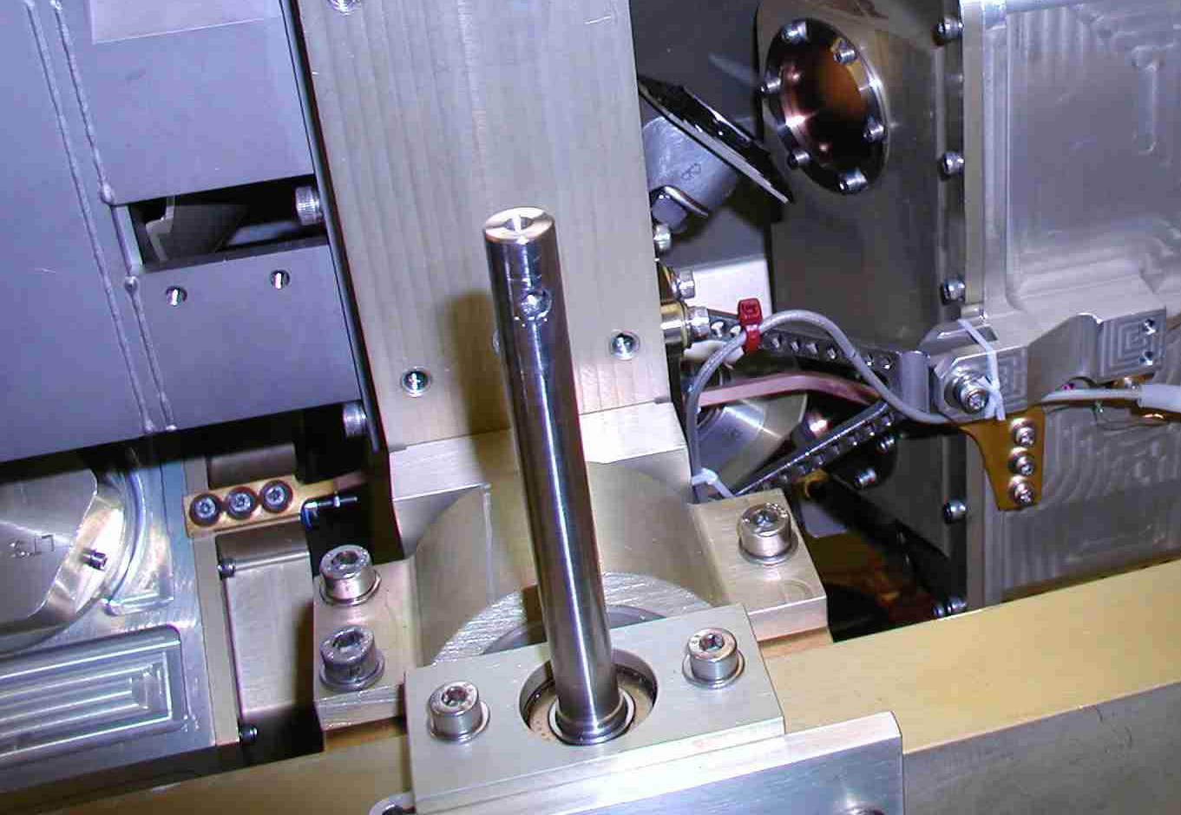
Copper-epoxy-copper sandwich, bolted to aluminium
Copper – aluminium interface
Figure 1 Current situation employed on SPIRE-CQM for the first cold test run.

Concept
The idea is that we could bond a copper plate to the aluminium panels of the photometer and spectrometer boxes over a relatively large area, using the Dacron/Stycast insulation. In this way, the thermal conductance of this joint is maximised, while effectively eliminating the two copper-aluminium interfaces. The copper plates will have tabs that can sit over torlon isolation plates at the location of the current strap interfaces. The interbox strap will then not need electrical isolation, and the strap is bolted directly to the copper tabs, using insulating bushes.
I make an attempt to clarify this waffle below……

Spectrometer box modification
The proposed modification is illustrated below.
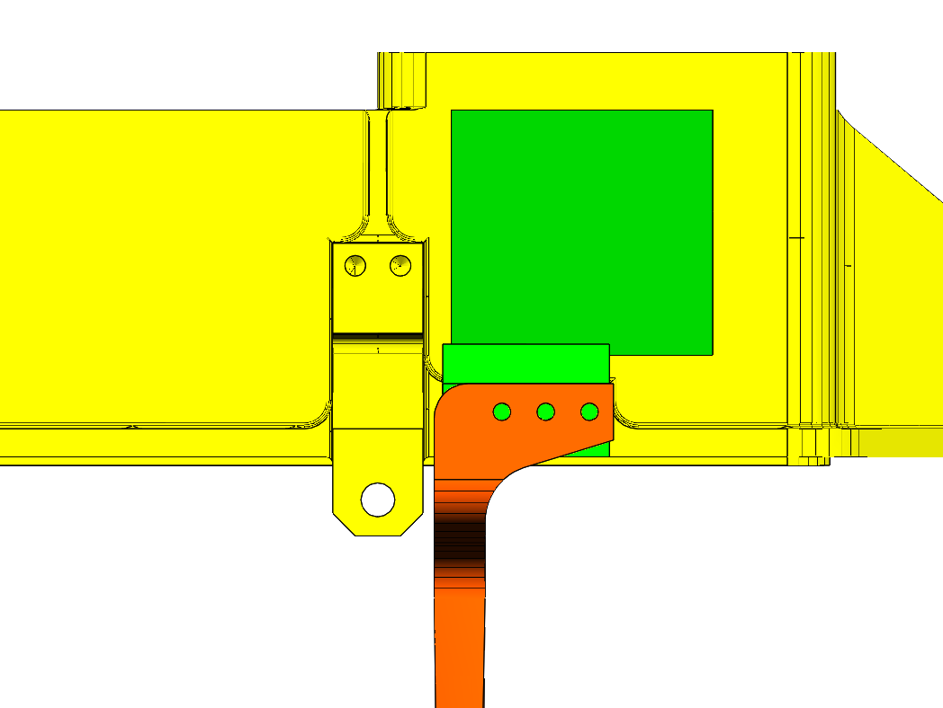
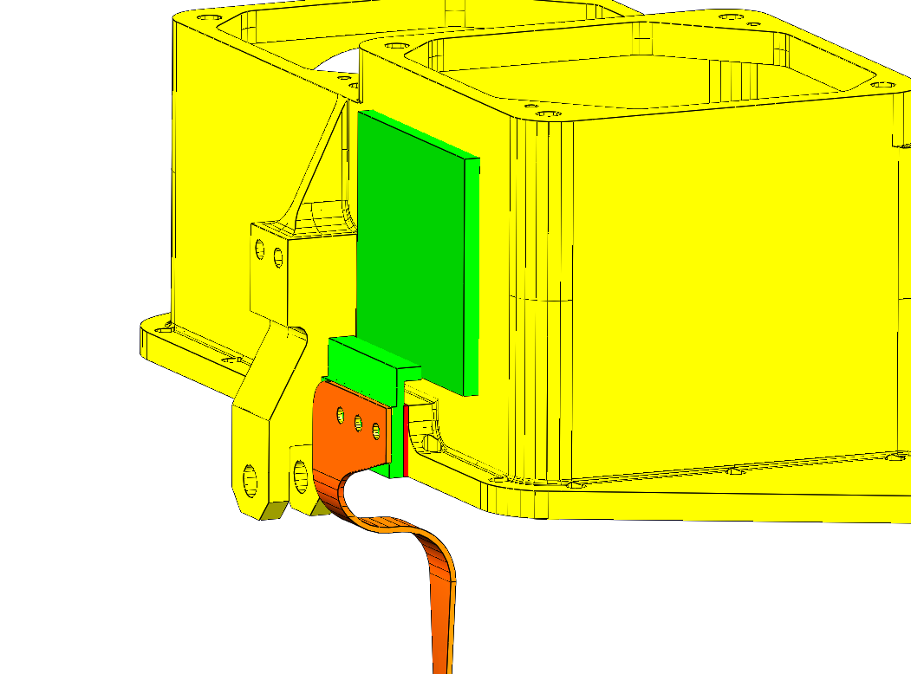
Copper plate on stycast/dacron
Copper plate (5N) bonded to Al wall using stycast/dacron
Compliant link to tab – machined from same copper block, or e-beam welded
Torlon or Vespel electrical isolation plate
Level-0 interbox strap
Use Vespel bushes for isolating bolts

Photometer box modification

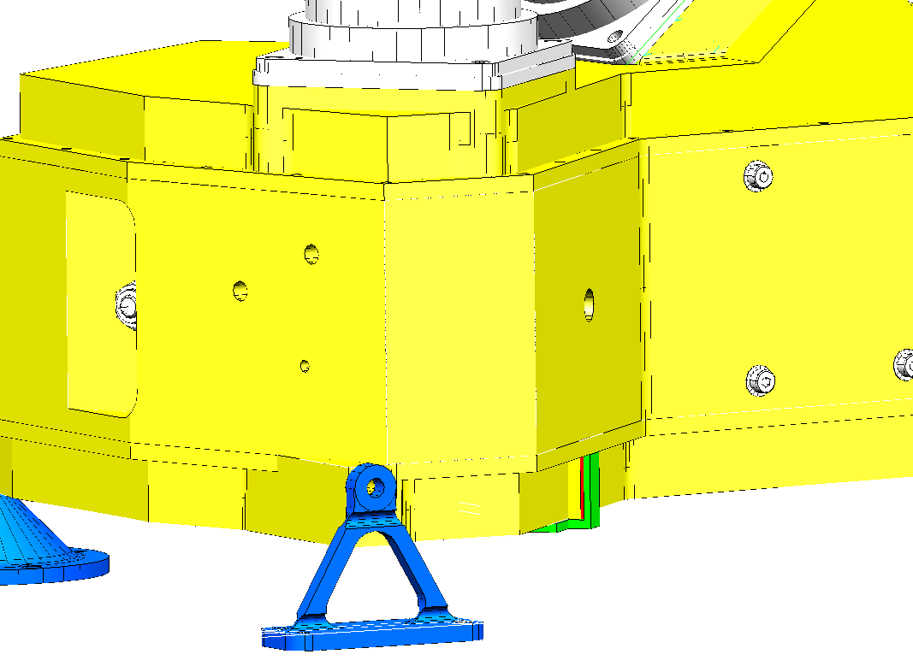
Copper tab from plate (under box)
Torlon/Vespel insulating plate
5N copper plate, bonded to Al with stycast/dacron
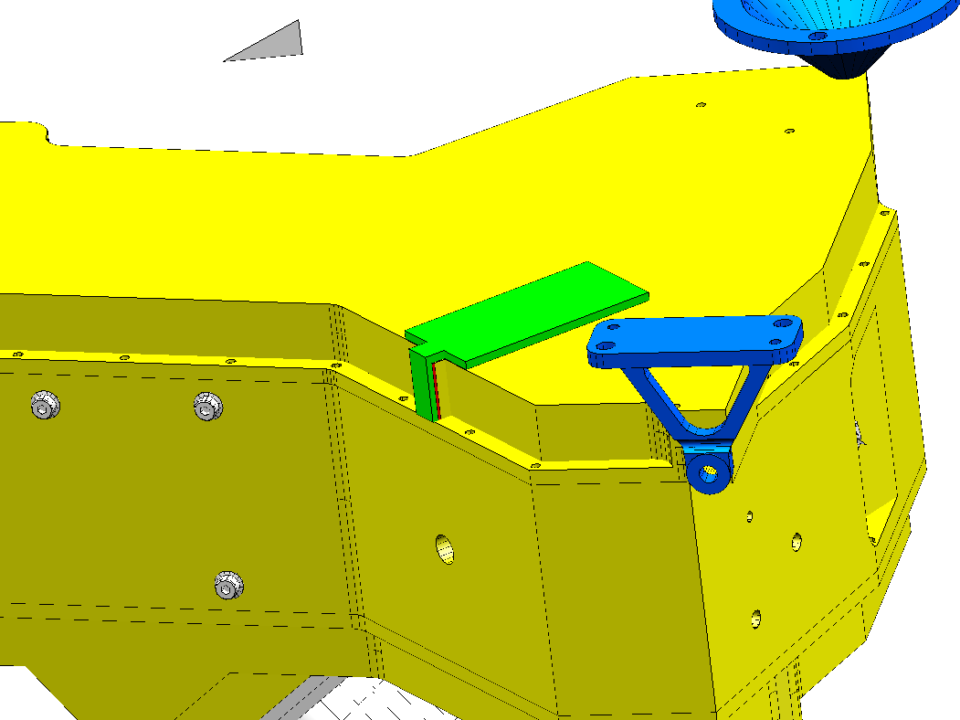
Compliant link, as for spectrometer tab

Advantages
- Huge increase in epoxy isolating joint area possible - ~20mm² to 2500mm²
- Easier implementation of isolating joint (compared with isolating the 2K strap)
- Deletion of 2 poor copper-aluminium interfaces – swapped for copper-copper.
- No modification needed to existing interbox straps

Disadvantages
- Gluing directly to flight structure – procedure must be perfected beforehand
- Small mass increase – may affect dynamics of boxes
- Differential thermal contraction of Al and Cu may be an issue….

Work done so far….
I have built a replica joint – copper block, 60x60x5mm bonded to 2mm thick aluminium sheet. The assembly was straightforward, with no electrical shorting issues. This joint has subsequently gone through 10 350K-77K-350K shock cycles, with no evidence of electrical shorting, bond weakening, or plate distortion.

What next?
This note simply presents a solution to achieving enhanced thermal performance for the level-0 interbox strap. It is meant purely to progress the discussions from the RAL thermal meeting, with a view to trying to improve things for the next CQM test run.
- The thermal model needs to be run, assuming this new configuration (assume 2 epoxy interfaces, typically 2500mm² each, in place of the (Al-Cu-Cu-epoxy-Cu-Al) chain we presently have).
- Mechanical analysis – impact of 50x50x2mm(typical) copper plates at roughly the locations indicated.
- Verification of joint integrity & production of gluing procedure.
- Detailed design of plates.

