

SUBJECT: | SPIRE Failure Detection Isolation and Recovery
PREPARED BY: | K.J. King
DOCUMENT No: | SPIRE-RAL-PRJ-001978
ISSUE: | Issue 1.0 | Date: | 13th July 2004

APPROVED BY:

Instrument Engineer
(B.Swinyard)

AGREED BY:

OPS Scientist
(S. Sidher)

Distribution

B.Swinyard | RAL
Sunil Sidher | RAL
S. Molinari | IFSI
R. Orfei | IFSI
J. Long | RAL

Change Record

ISSUE | DATE | Changes
1.0 Draft 1 | 17th March 2004 | First draft for internal discussion
1.0 Draft 2 | 16th June 2004 | Updated draft for internal review
1.0 | 13th July 2004 | First Version

Table of Contents
1. Introduction 6
1.1 Scope 6
1.2 Structure of Document 6
1.3 Documents 6
1.3.1 Applicable Documents 6
1.3.2 Reference Documents 6
2. Subsystem Failures 7
2.1 DPU Power 8
2.2 DRCU Power 9
2.3 DRCU Board Temperatures 10
2.4 DC Thermistors 11
2.5 AC Thermistor 12
2.6 Heaters 13
2.7 Calibrators 14
2.8 SMEC 15
2.9 BSM 16
2.10 MCU DSP 17
2.11 DCU 18
3. DRCU Interfaces 19
3.1 Low Speed Interface Failures 19
3.1.1 LSI Timeout 21
3.1.2 LSI Response 22
3.1.3 LSI Acknowledge 23
3.2 High Speed Interface Failures 24
3.2.1 HSI Data 24
3.2.2 HSI Frames 25
4. OBS Runtime Errors 26
4.1 Memory Errors 26
4.2 Time Sync Error 27
5. S/C Interface 28
5.1 Bus Failures 28
5.1.1 TC Transmission 28
5.1.2 TM Transmission 29
5.1.3 DLL 30
5.2 Spacecraft Commands 31
5.2.1 Go to Standby 31
6. General Purpose Procedures 32
6.1 SAFE 32
6.2 DRCU Anomaly 33
6.3 DPU Anomaly 34
6.4 Operations Anomaly 35
6.5 Operations Resume 36

Figures

Tables

Glossary

OBS | On-Board Software
SPIRE | Spectral and Photometric Imaging REceiver

Introduction

Scope
This document defines the requirements on the SPIRE instrument for detection, isolation and recovery from hardware and software failures of the instrument based on the policy described in AD03. The failures to be dealt with are described in AD01 and AD02.

These requirements will lead to requirements on the OBS autonomy function to detect and isolate the failure and provide a mechanism for recovery from it. The implementation of the recovery procedures will be made in the OBS itself and/or in recovery procedures defined for the CDMS.

In this document FDIR actions are described in flowchart form. Actions carried out by the OBS in internal code are labelled ‘OBS’ and those carried out by the Autonomy Virtual Machine are labelled ‘VM’. Actions carried out by the CDMS are labelled ‘S/C’.

Assumptions
- ‘Inhibit TC Execution’ implies that the instrument will no longer execute any telecommands received. It will, however, respond with a telecommand reception acknowledgement. This is to stop any newly received TC restarting a VM or sending a command to a subsystem while the recovery is in progress.
- ‘Inhibit Subsystem Commands’ implies that all telecommands received by the OBS which would generate commands to a subsystem are inhibited. The OBS is still able to send commands to the subsystem as part of the recovery procedure.
- The FDIR is suspended on the first instance of an anomaly being detected. I.e. the Autonomy Virtual Machine cannot be interrupted by another error.

Structure of Document
The failures themselves can be split into two types: those detected by the instrument OBS and handled by it (possibly with help by the S/C CDMS) – these are described in Section2 (subsystem failures), Section 3 (interface failures), and Section 4 (OBS runtime errors); and those detected by the S/C CDMS and dealt with by it – these are described in section 5.

Section 6 contains those general purpose procedures called during some of the recovery actions described in previous sections

Documents

Applicable Documents

AD01 | Hardware Software Interaction Analysis for SPIRE in-flight Autonomy Functions Specification (SPIRE-RAL-NOT-001719), Issue 1.1, 3rd December 2003
AD02 | System Operation and FDIR Requirements (H-P-1-ASP-SP-0209), October 2003  Appendix 1: 1553 Bus FDIR
AD03 | Failure Detection Isolation and Recovery Policy in the SPIRE Instrument (S{PIRE-RAL-PRJ-001128)

Reference Documents

Subsystem Failures
Failures within the subsystems of the instrument (both DPU and DRCU) may be identified by monitoring housekeeping parameters generated by the subsystem. Each housekeeping parameter being monitored is checked against a set of soft and hard limits. The parameter has to remain out of limits for a set number (SoftMax or HardMax) of readings before an anomaly is declared. A the soft limit monitoring is disabled once reported, to prevent multiple event packets being generated from a ’noisy’ signal. It is expected that it will be re-enabled at the start of each observation, or other suitable time period.

SoftMax and HardMax are set to zero on initialisation of the parameter monitoring system

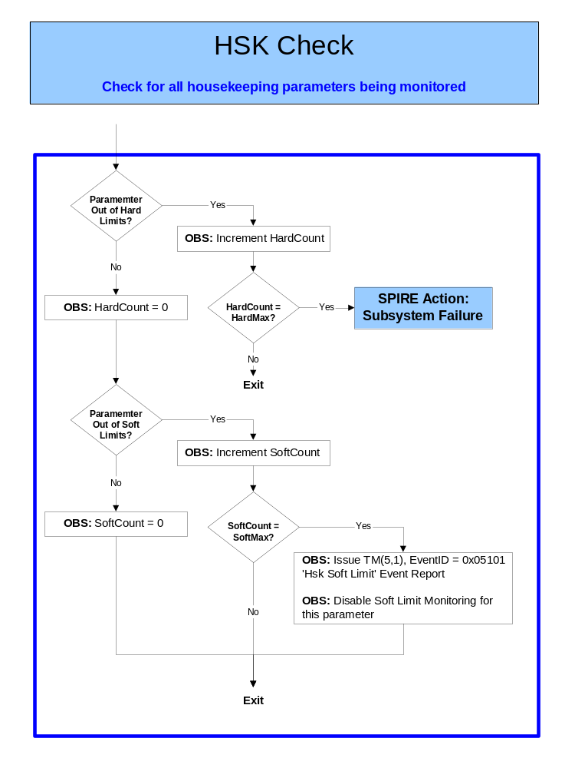

DPU Power

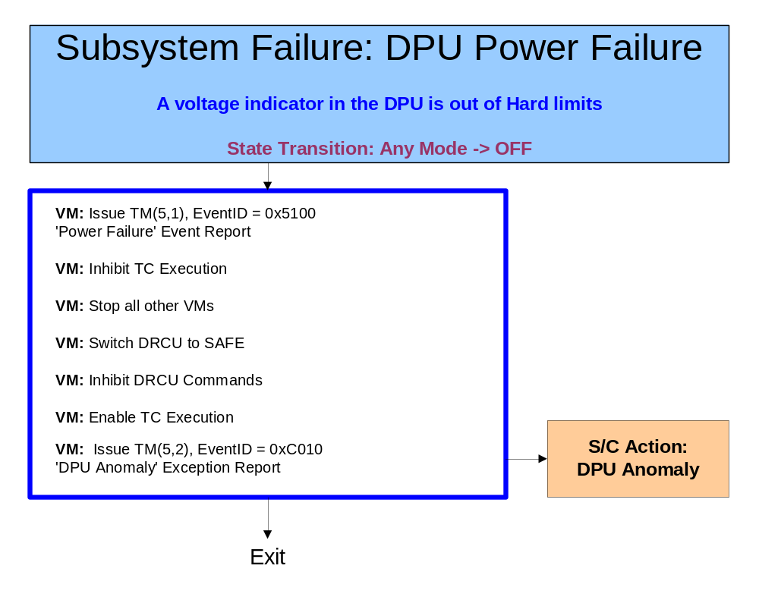

DRCU Power

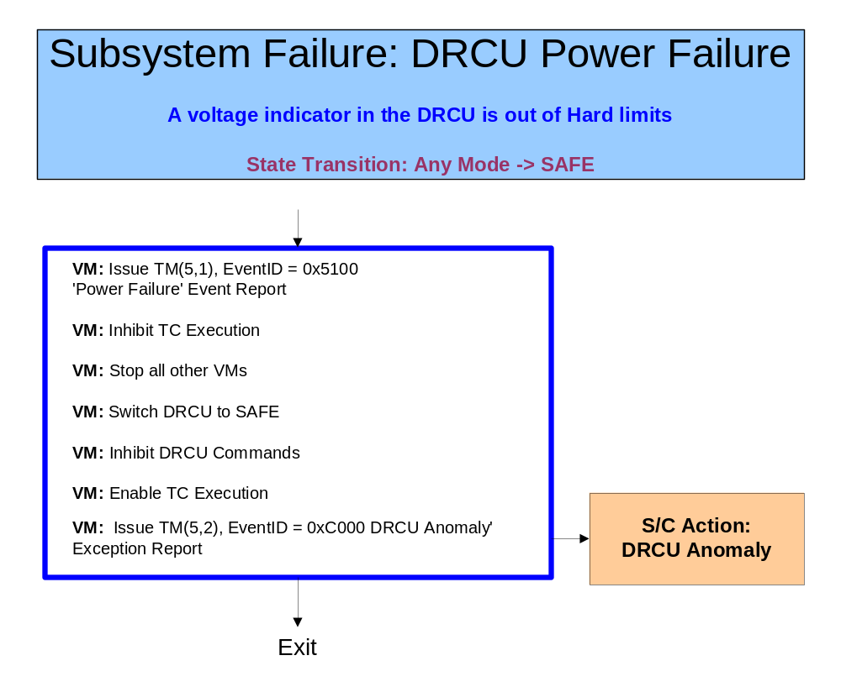

DRCU Board Temperatures
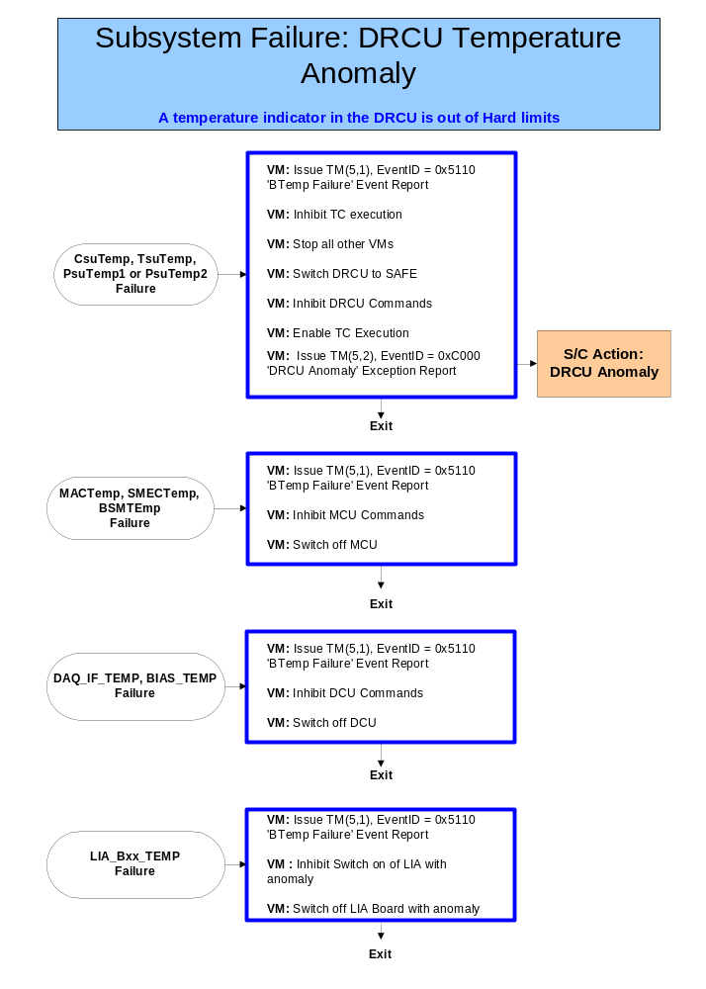

DC Thermistors
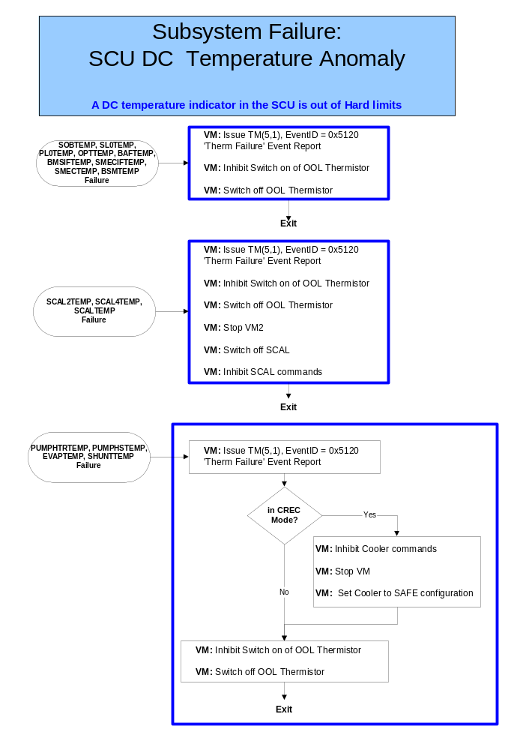

AC Thermistor
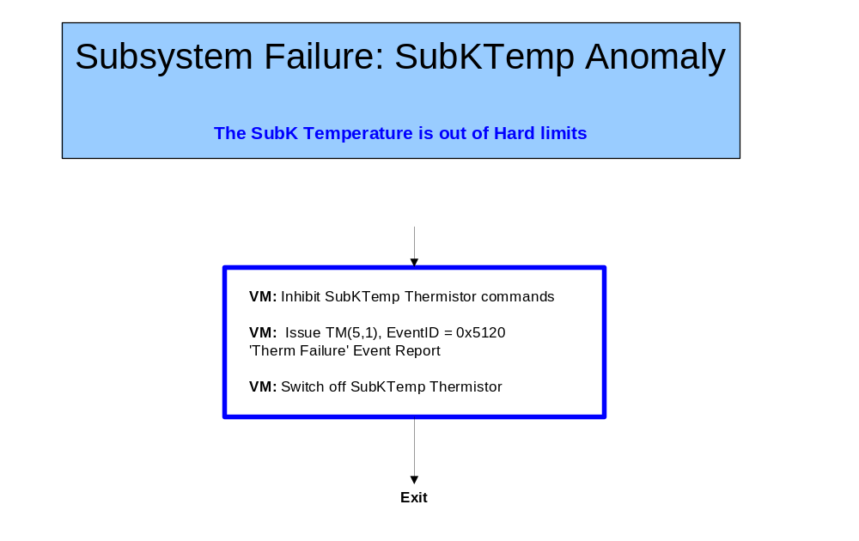

Heaters
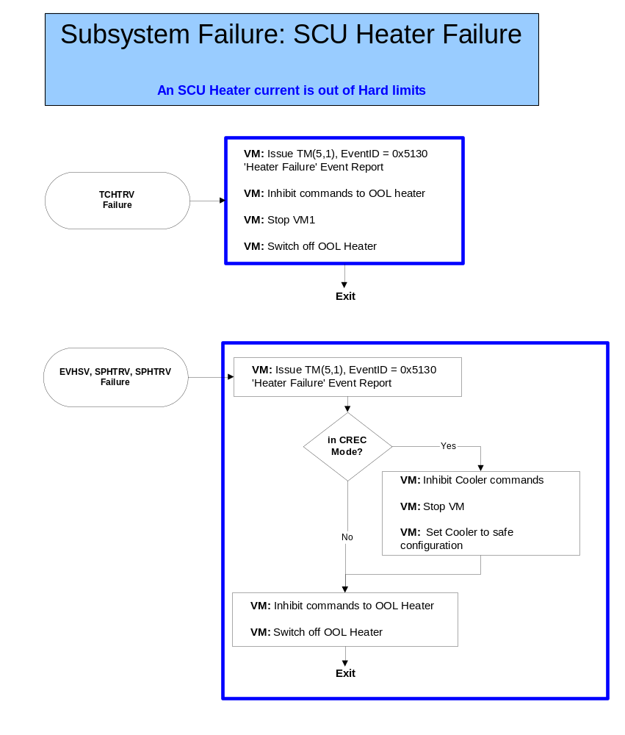

Calibrators
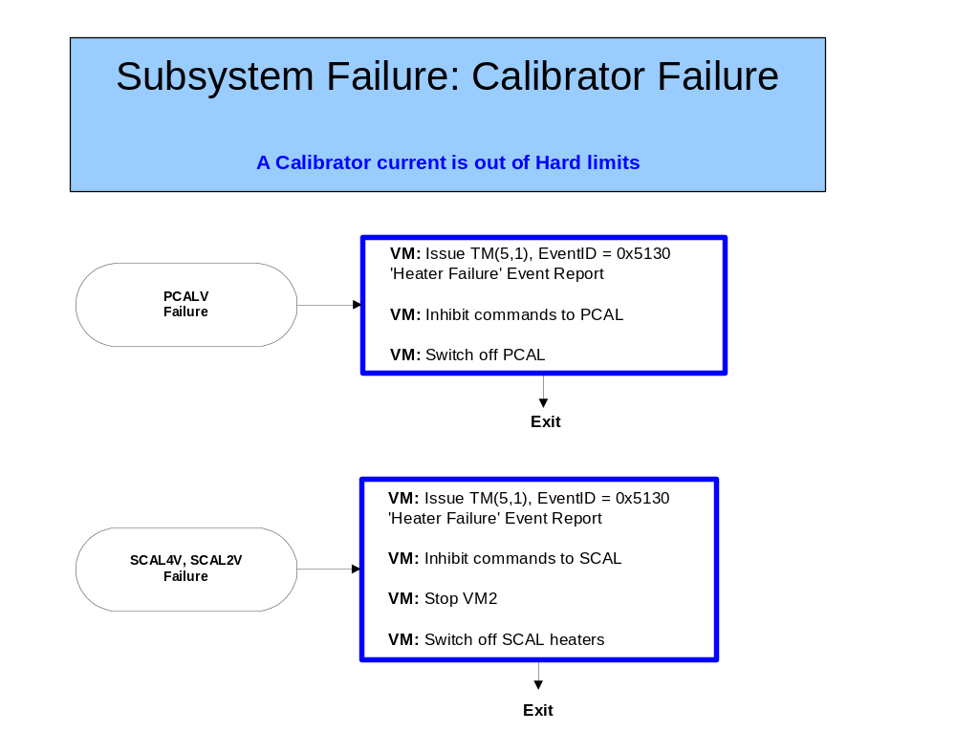

SMEC
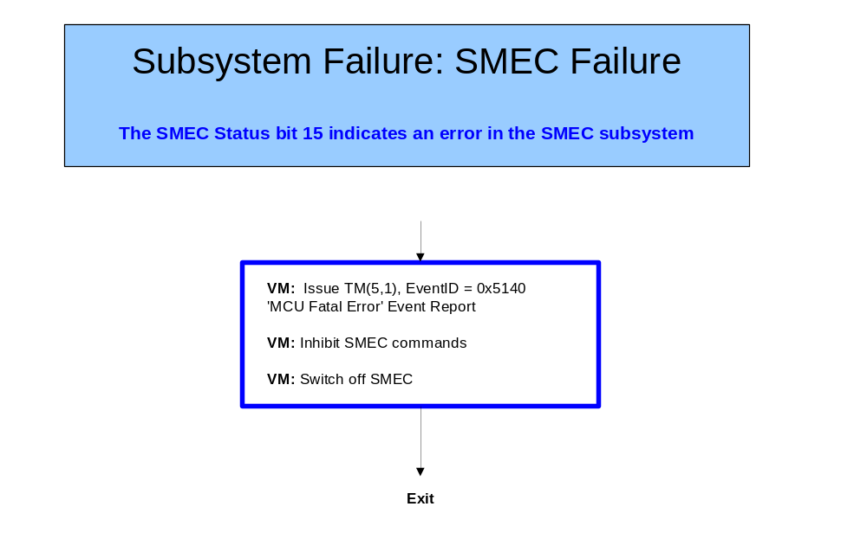

BSM
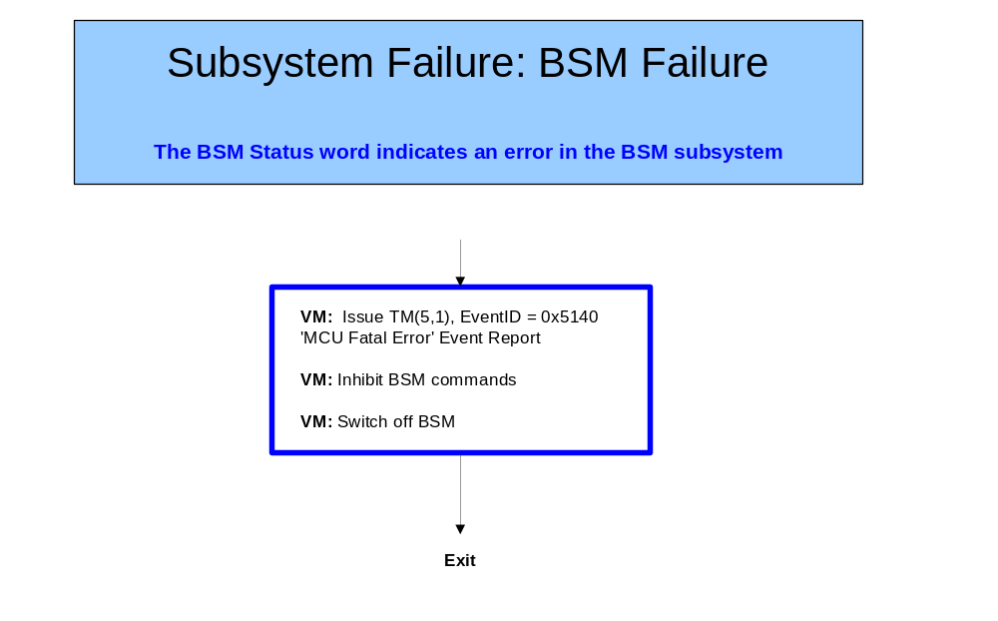

MCU DSP
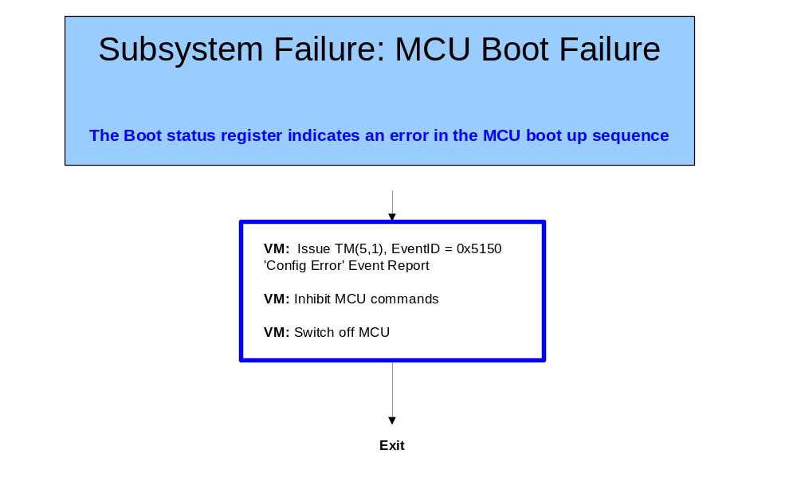

DCU
No specific DCU monitoring has been identified

DRCU Interfaces
Subsystems are commanded and monitored through data passing through the interfaces with the DRCU. These interfaces have to be checked to be operating correctly before correct operation of the instrument can be expected.

The DRCU contains three units; the DCU, MCU and SCU, and each one has one slow speed interface (used to send commands to the unit and to collect housekeeping parameters) and one high speed interface (used to transfer science data from the unit to the DPU).

Low Speed Interface Failures
For each command sent through the LSI a series of checks is made to ensure that the command has been executed correctly. In the event of failure the command is repeated a set number (LSIMax) of times before a failure is declared.

RespMax is set to zero on initialisation of the autonomy system

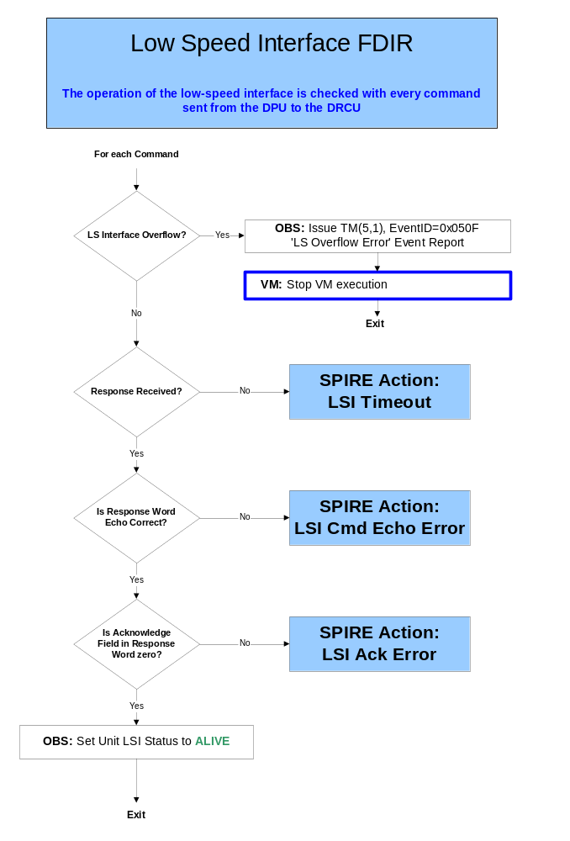

LSI Timeout
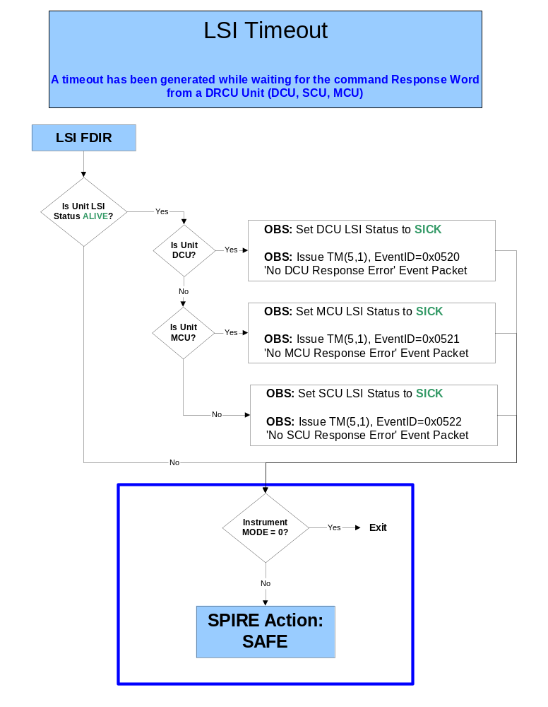

LSI Response
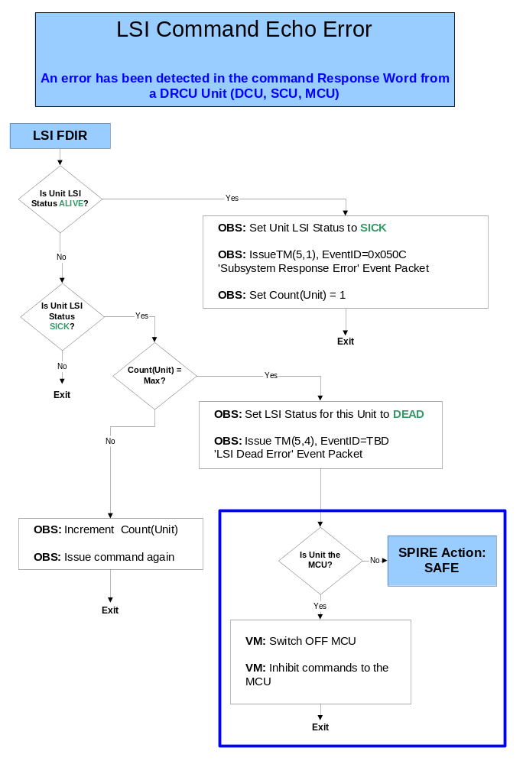

LSI Acknowledge
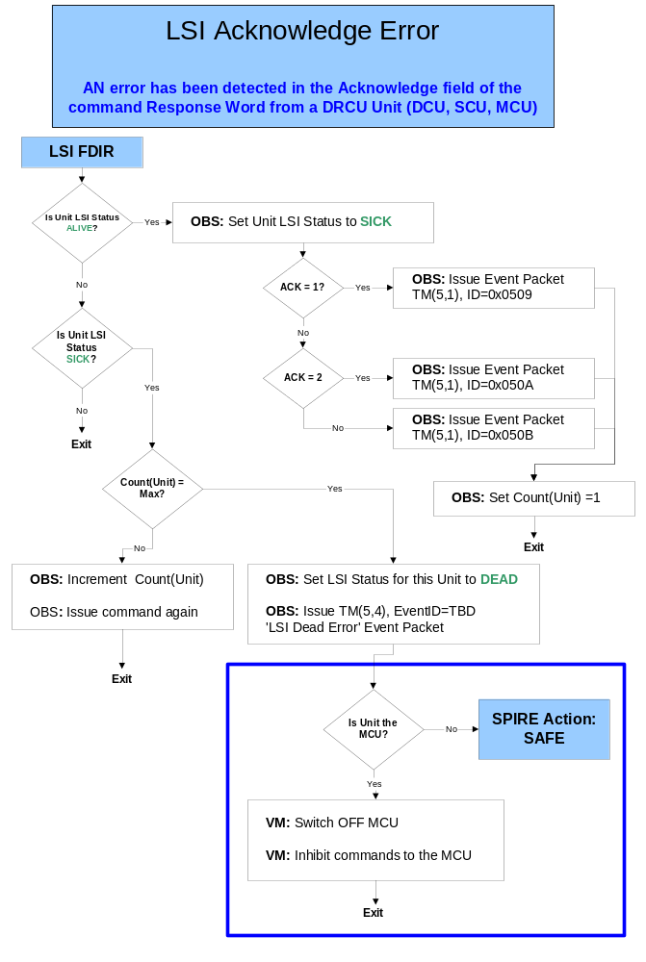

High Speed Interface Failures
The high speed interfaces transfer science data from the DRCU units to the DPU. Data is collected by the DPU into FIFO buffers which trigger the DPU to empty them when they are half full.

HSI Data
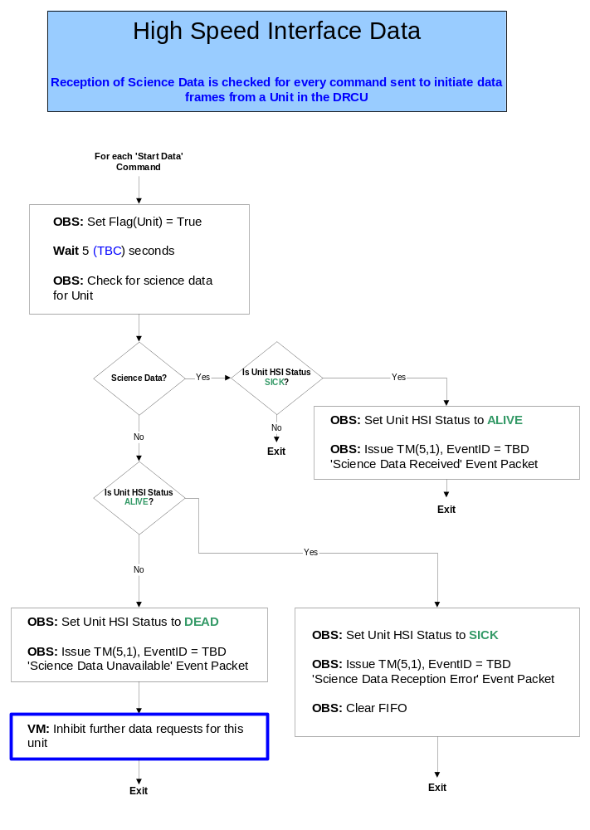

HSI Frames
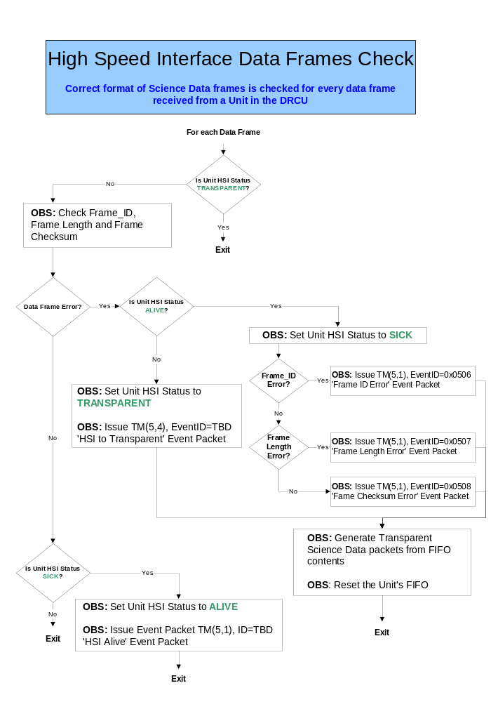

OBS Runtime Errors

Memory Errors
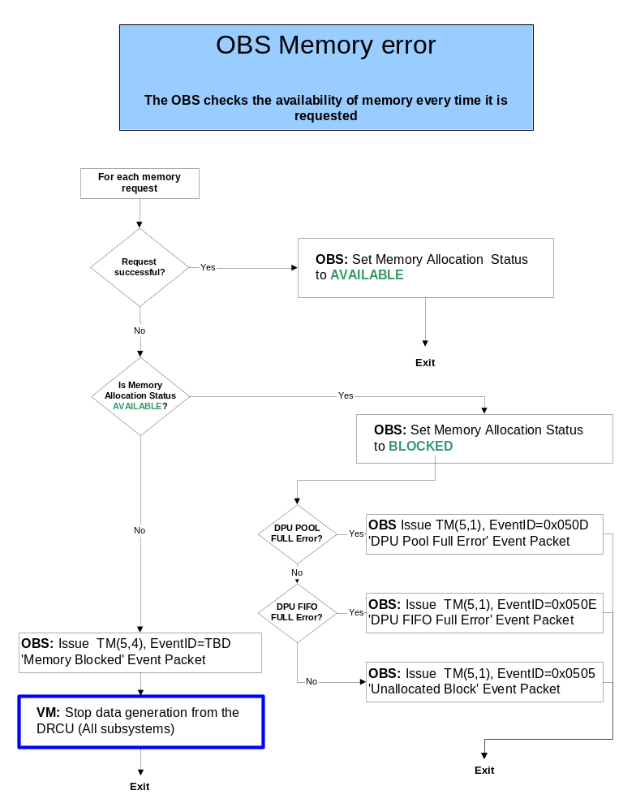

Time Sync Error
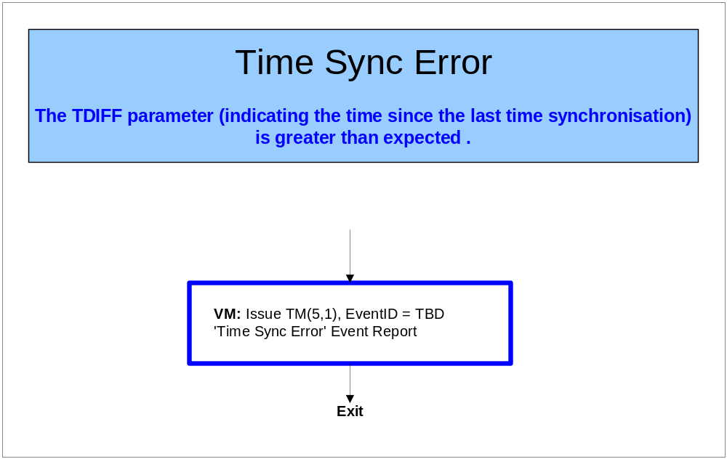

S/C Interface

Bus Failures
Detected by the S/C SOFDIR

TC Transmission
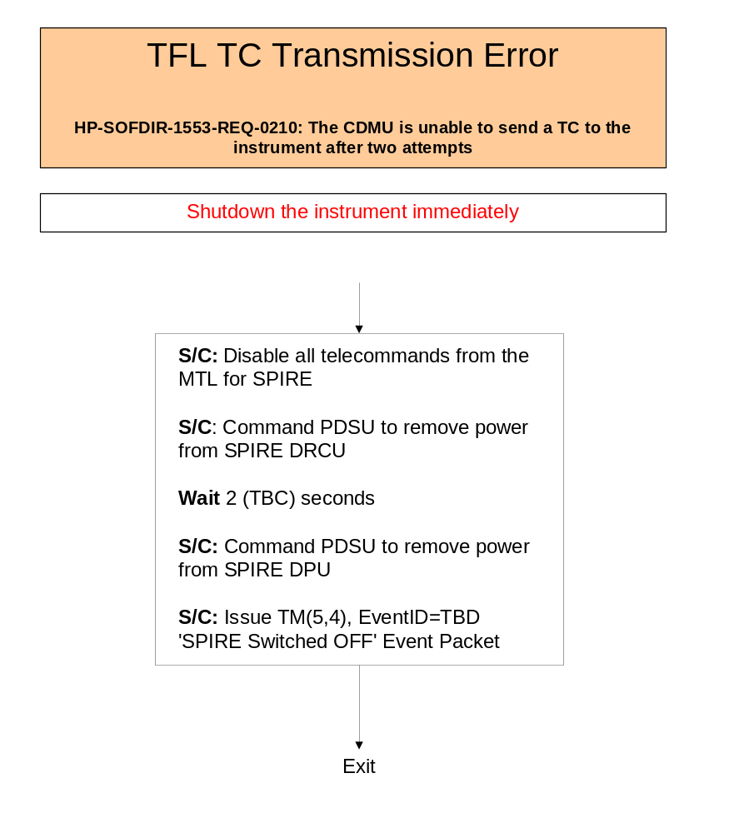

TM Transmission
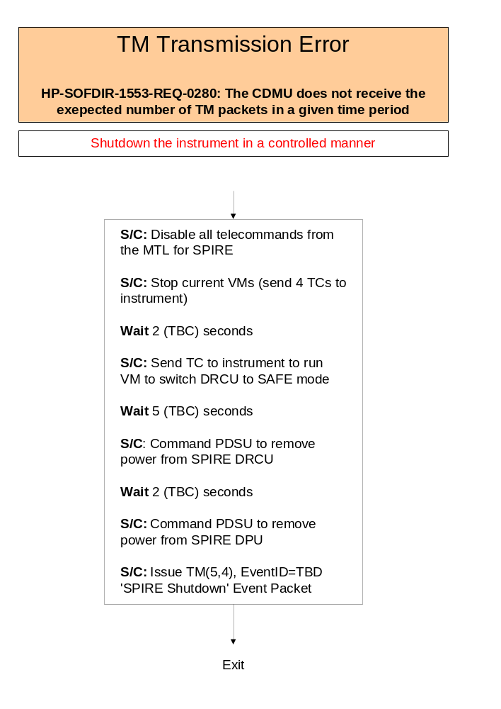

DLL

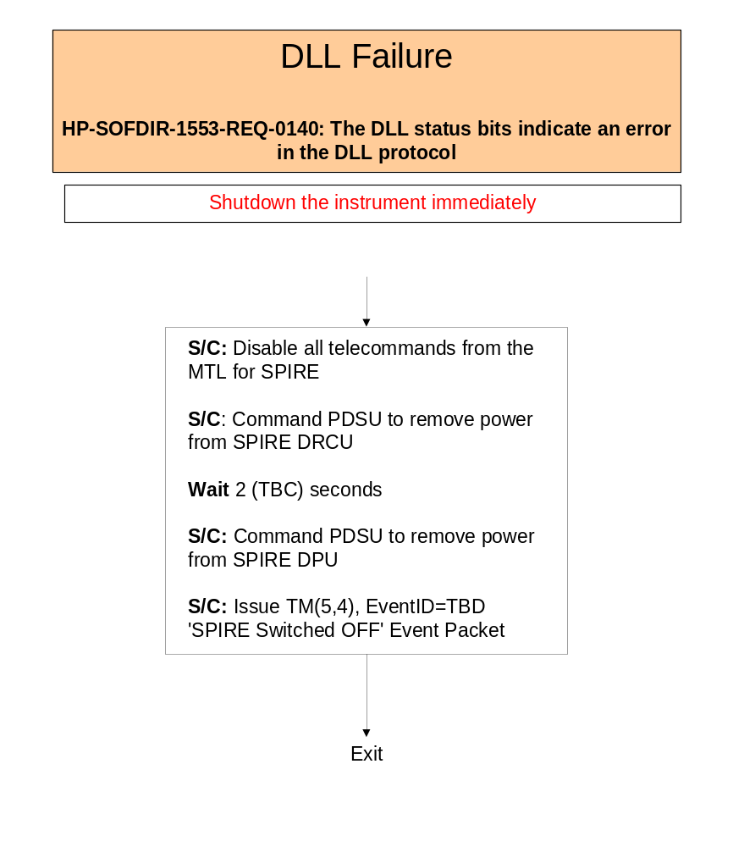

Spacecraft Commands

Go to Standby
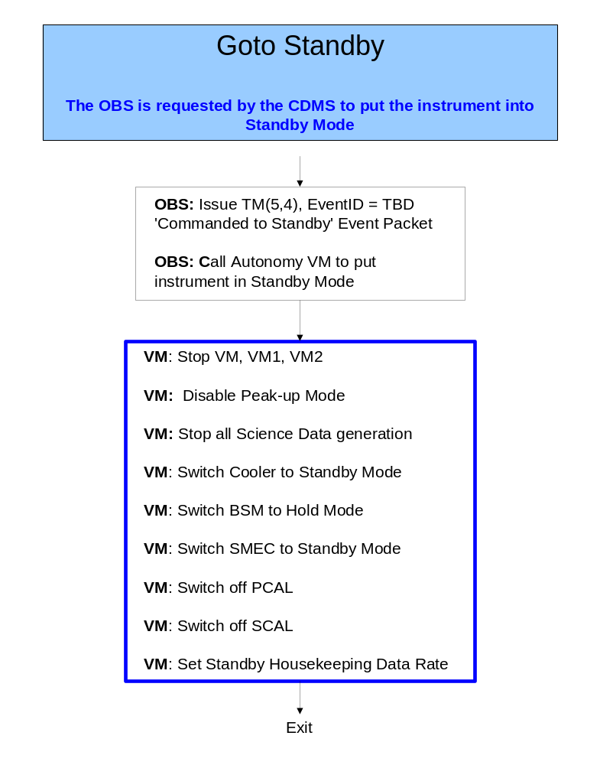

General Purpose Procedures

SAFE
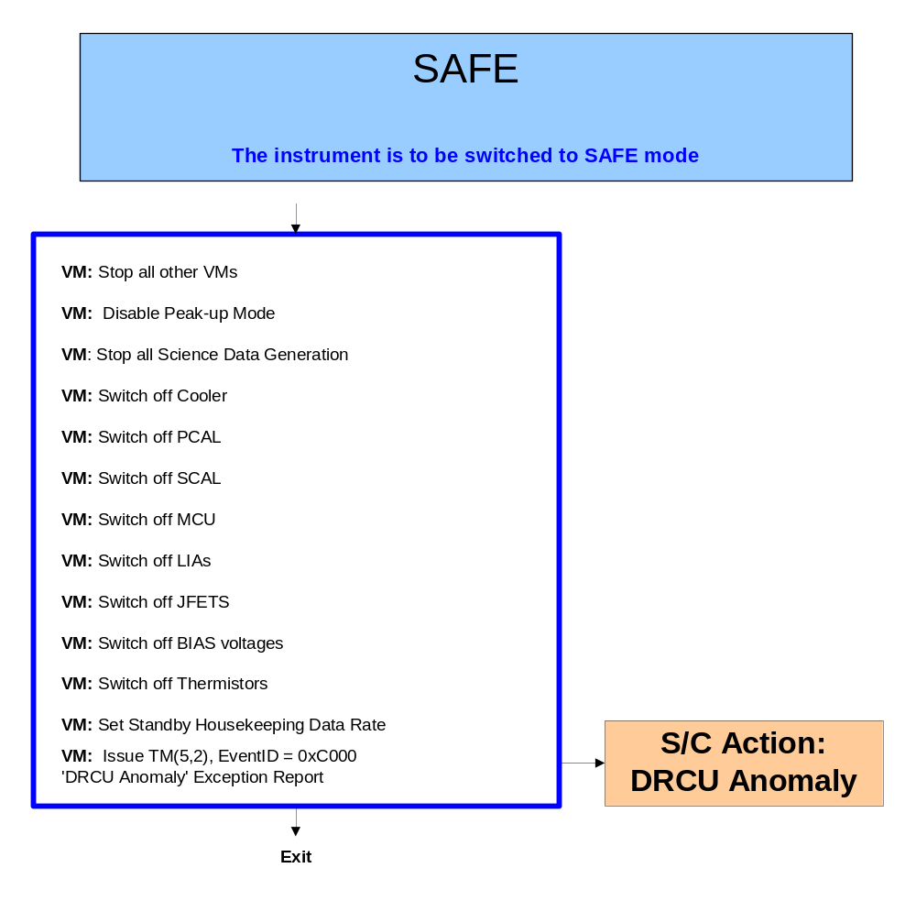

DRCU Anomaly

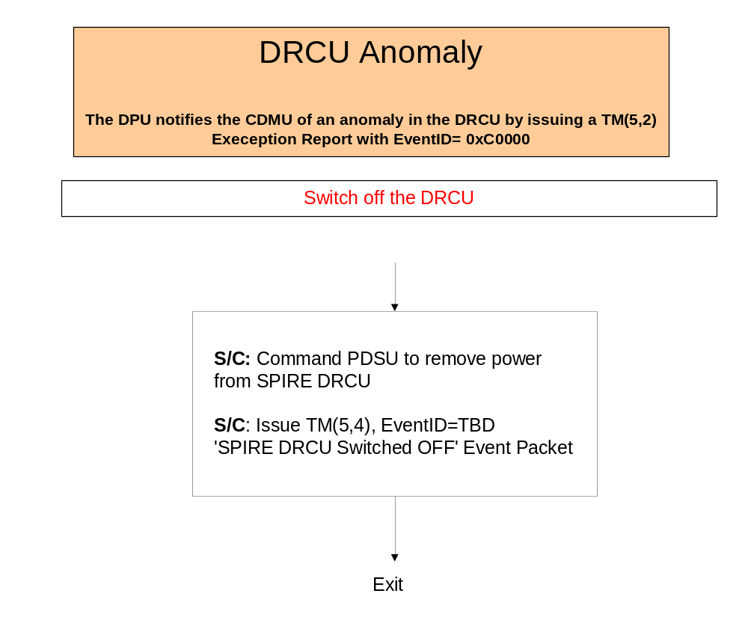

DPU Anomaly

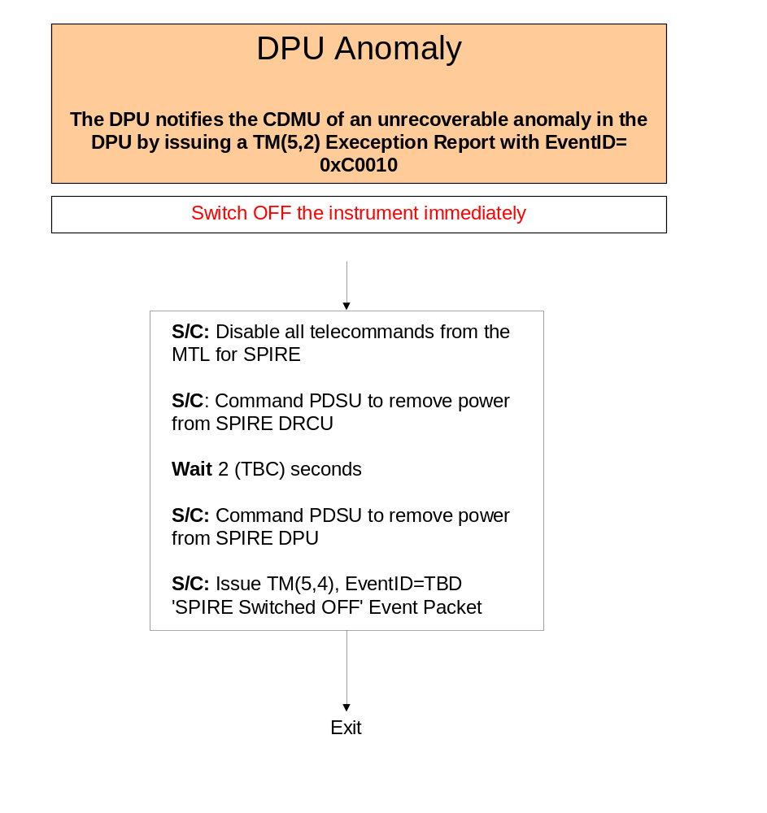

Operations Anomaly

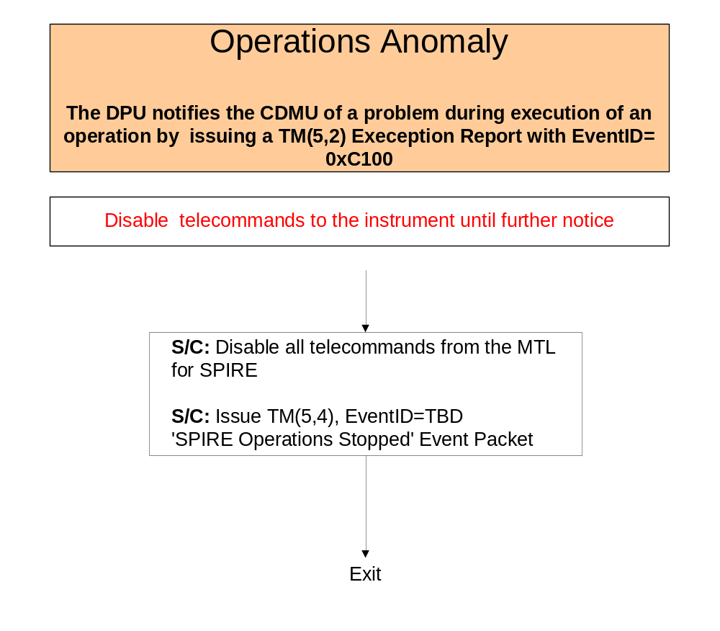

Operations Resume



