Herschel/SPIRE SPIRE-MSS-PRJ-001650

MULLARD SPACE SCIENCE LABORATORY
UNIVERSITY COLLEGE LONDON | Author: C BROCKLEY-BLATT

SPIRE – STRUCTURE ASSEMBLY, INTREGRATION AND HANDLING
Document Number: MSSL/SPIRE/SP006.02 March 2003 DRAFT

Distribution:

Spire Project Office |  | B Winter
ESA PX |  | A Heske
 |  | J Bruston
 |  | J Rautakoski
RAL |  | B Swinyard
 |  | E Sawyer
 |  | J Delderfield
 |  | J Long (Project Office)
Mullard Space Science Laboratory |  | A Smith
 |  | J Coker
 |  | C Brockley-Blatt
 |  | A Dibbens
ATC |  | C Cunningham
 |  | I Pain
 |  | T Paul
Cardiff |  | P Hargrave
CSA |  | D Peterson
COMDEV |  | J Hacket
JPL |  | J Bock
 |  | J Lilienthal
UofS |  | J Taylor
CEA |  | L Duband
Herschel Project |  | Herschel.Planck@esa.int
Author: | C Brockley-Blatt |  | Date:
Checked: | B Winter |  | Date:
Approved: | Tony Dibbens |  | Date:

Change Record

ISSUE | Date | Brief description of change
1.0 | December 2002 | New document
2.0 | March 03 | Updated with the results from the MSSL fit check

Table of Contents

1. Scope of Document 4
1.1 Description of Parts 4
2. Documents 6
3. Drawing List 6
4. Packing and Unpacking 6
5. Handling 6
6. Cleaning 7
7. Storage 7
8. Installation onto MGSE 7
8.1 Part and Fixings Preparation 7
8.2 Base Plate Assembly 7
8.3 Optical Bench Attachments 9
8.4 Locking 10
8.5 Spire Optical Bench Fitting 10
8.6 Optical Bench Alignment 13
9. Lubrication Application 14
10. Assembly of subsystems 14
10.1 Optical Bench 15
10.2 Photometer 2K Detector Box 16
10.3 Spectrometer 2k Detector Box 17
10.4 Spectrometer 300mK Thermal Strap System 17
10.5 Photometer 300mK Thermal Strap System 18
10.6 Photometer Cover 18
10.7 Spectrometer Cover 21
10.8 Mounts onto the Optical bench 21
10.9 Mirror on Mount 22
10.10 General Assembly 22
11. Integration 22
11.1 Integration Procedure 22
APPENDIX 1 23

Table of Figures

Figure 1 Structure Hardware Tree
Figure 2 Structure Drawing List

Glossary

All terms are listed in the CIDL.

Scope of Document
This document presents integration and handling procedures for the Spire Structure (breakdown of the product into sub-assemblies), and a list of associated drawings. These procedures relate only to the STM. A separate document will be issued for the EQM and FM. This document will have accompanying diagrams in later issues.

Description of Parts
The SPIRE structure consists of a monocoque shell with a central optical bench. The structure is mounted on a fixed point (cone-shaped), suppressing translation in all directions. This fixed point is located on the corner of the optical bench. On the other side of the instrument (+Z direction) two blade mounts (A-frames) are mounted suppressing each translation in the plane of the frame itself. All in all this results in a semi-kinematic suspension with as a fixed reference with regard to the HERSCHEL optical bench, the cone.
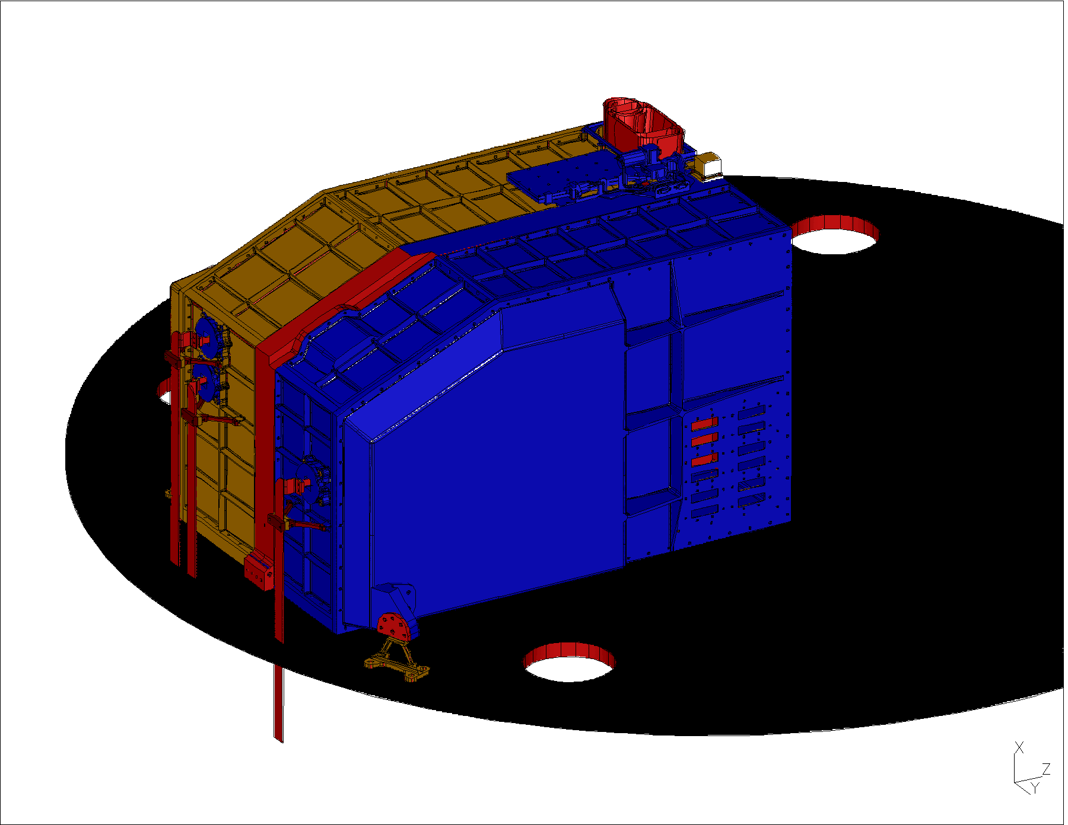
Figure 1.1-1: View of the outside of the instrument – Common Structure + Mounting

As said before the SPIRE instrument consists of a monocoque shell that provides a bending stiff, internal, SPIRE optical bench. This optical bench supports a photometer and a spectrometer. All parts of these two sub-instruments are mounted on the SPIRE optical bench. See figure 1.1-2 for the photometer side of the optical bench, including IR-beams.
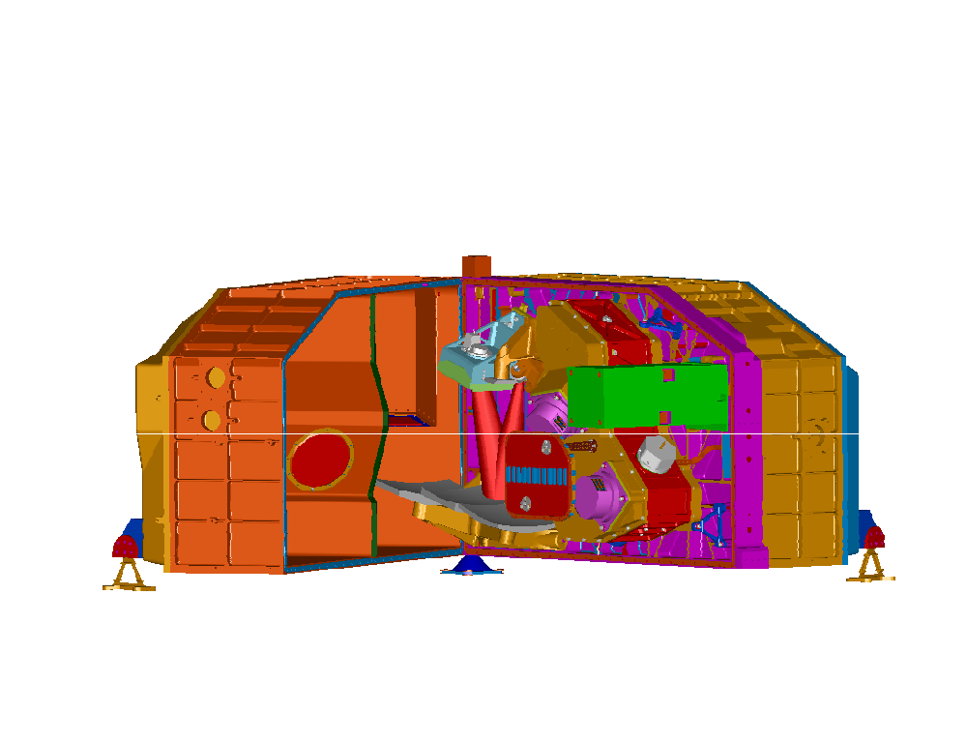
Figure 1.1-2: View of the inside of the instrument – photometer side, cover taken off
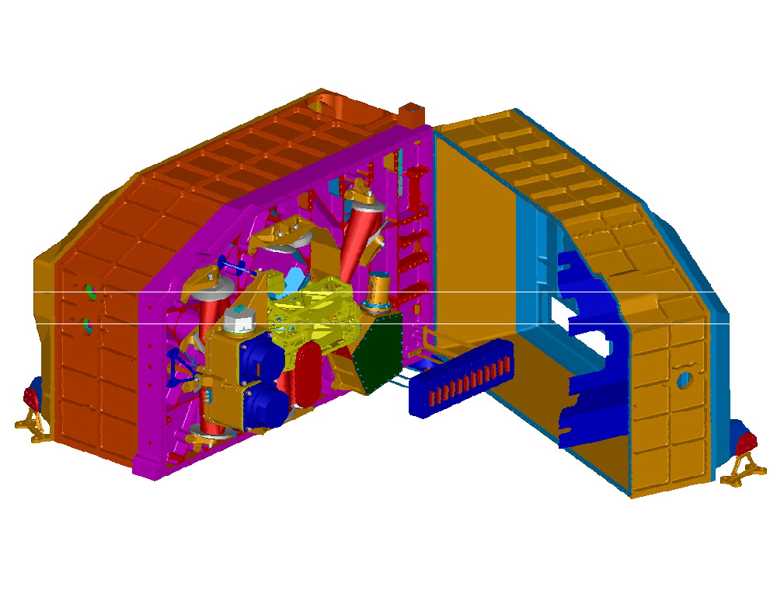
Figure 1.1-3: View of the inside of the instrument – spectrometer side, cover taken off

The instrument is divided into different temperature zones. The reason for this is the relative high interface temperature of the HERSCHEL optical bench and the low operating temperature of the detectors inside the instrument. The interface temperature is 6-10 Kelvin where as the operating temperature of the detectors is ~0.3 Kelvin. The temperature zones in between are the temperature of the monocoque structure with the optical bench at ~4 Kelvin and the boxes holding the detectors, filters and dichroics at ~2 Kelvin.

Documents
All documents are listed in Figure 3.2 of the CIDL.

Drawing List
The Structure Hardware Tree and associated Drawings for integration are presented in the figures in Appendix 1.

Packing and Unpacking

All parts of the Spire Structure STM are double bagged in clean-room standard bagging material (i.e. bagging material should not outgas contaminants to contents) and positioned in their individual custom transport containers.

Handling
The SPIRE STRUCTURE STM is clean and must be handled using approved clean room gloves. It should be kept in a clean room of class 100,000 or better . If this is not available, the units should be bagged with clean room bagging material. Failure to keep the unit either in a clean room or bagged particulate tight will allow the re-introduction of contaminants and require re-cleaning.

The SPIRE STRUCTURE STM contains no active electronics and therefore does not require any special ESD precautions.

From the mechanical point of view, the STMs should be handled exactly as demanded by flight hardware, including the following precautions:
- Aperture Cover should remain on the SPIRE STRUCTURE STM at all times when it is not in use.
- Before installation or fit check of any part, all surfaces on the SPIRE STRUCTURE STM assembly and the part itself should be visually checked for damage. It is recommended that any small crevices should be blown out with dry nitrogen before mating. Before engagement, check the condition of screw threads and helicoils and after engagement, tighten the screw to the specified torque given on the assembly interface drawing or in this document.

Cleaning
After testing and prior to delivery, the SPIRE STRUCTURE STM will be ultrasonically cleaned. The protective covers will be removed for this operation and cleaned separately using either Isopropyl or ethyl alcohol (reagent grade or better).
After cleaning, the SPIRE STRUCTURE STM will be vacuum baked at 80 °C at <10⁻⁵ mbar for a minimum of 48 hours. The cleaned covers will then be refitted. The SPIRE STRUCTURE STM will then be double bagged in clean-room bags, with the inner bag purged with dry nitrogen.
In the event that further cleaning becomes necessary, use only a vacuum cleaner.
Particulate matter may be removed using ionised filtered air or dry nitrogen.
For further detail, refer to the Spire Structure Cleanliness Document, AD54.

Storage
When not in use, it is recommended that the SPIRE STRUCTURE STM be double bagged in clean-room bags, and fitted into its transport container. All parts and the assembly should be covered when not in use even when in a clean room.

Installation onto MGSE

Use these instructions in conjunction with drawing A1-5264-404 shts1 and 2 SPIRE OPTICAL BENCH ASSEMBLY FIXTURE (GENERAL ARRANGEMENT) See this drawing for orientation of Right and LEFT hand

Part and Fixings Preparation
All parts are to be cleaned with IPA and bagged for entry into a cleanroom environment

Base Plate Assembly

- Lay base plate on a suitable flat surface (block up if preferred)

- Fit end plates and loosely secure fixings. The end plates are marked A and B (Right is A and the Left is B)
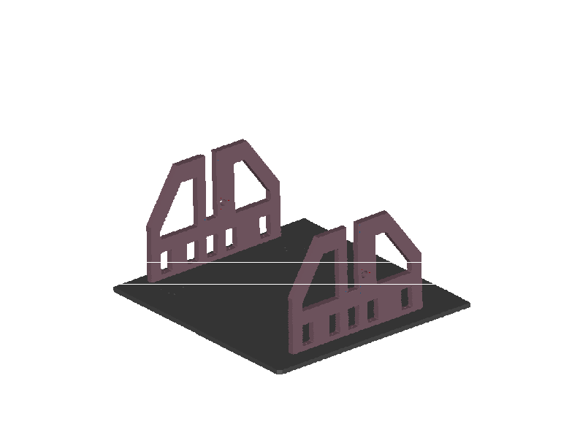
- Fit a Gusset Plate at each end of the End Plate (Left and right Gusset Plate, marked 1 to 4)
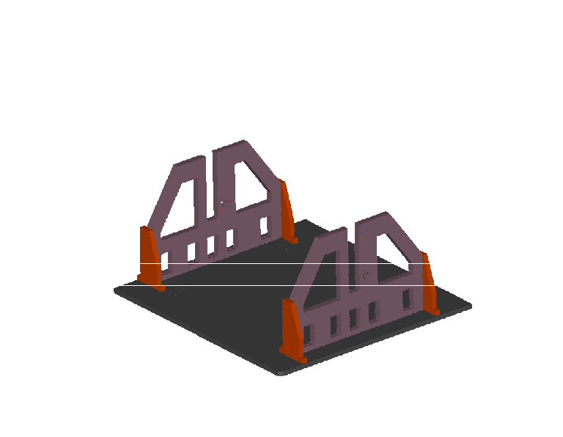
- Tighten all screws to securely fix these items into position. The Dowels should be lubricated.

Optical Bench Attachments
- Fit a bearing into a Lower Bearing Housing.
- Attach the Lower Bearing Housing to the left hand End Plate
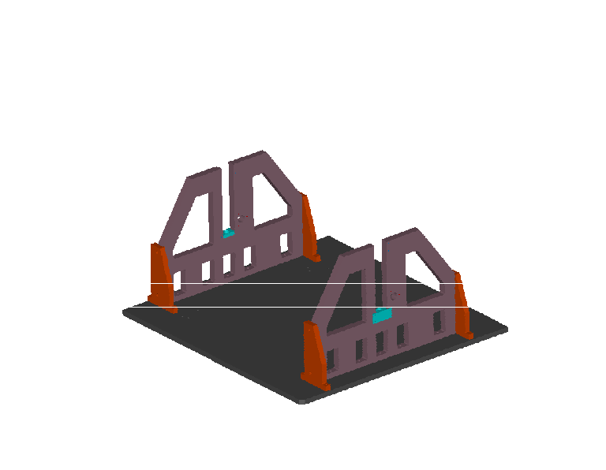
- Fit a bearing into an Upper Bearing Housing
- Wind a Jacking Nut onto one of the Lead Screws until centered on the shaft with the "V" upper most (towards the long plain shaft end). Lubricate.
- Engage the shorter plain end of the Lead Screw into the Lower Bearing at the left hand End Plate with the Jacking Nut "V" facing toward the other End Plate and engaged into the End Plate slot. Lubricate.
- Fit one Upper Bearing and Housing onto the top end of the Lead Screw.
- Locate the Upper Bearing Housing into the End Plate slot and secure into position at top of the End Plate.
- Fit a Bearing Cap over the Lead Screw onto the Upper Bearing
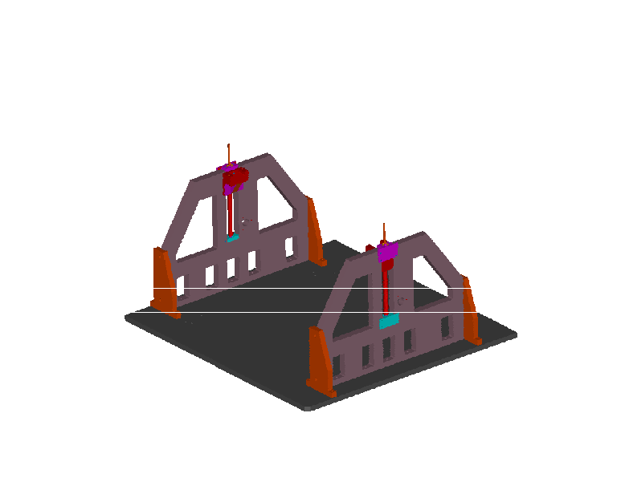
- Fit a Winding handle to the top of this Lead Screw and secure then wind the Nut up just short of the Bearing Housing lower surface.
- Repeat this section for the right hand end.

Locking
- Fit the Locking Shaft Assembly to the left hand End Plate and allow Shaft and Locking Ring to run freely.
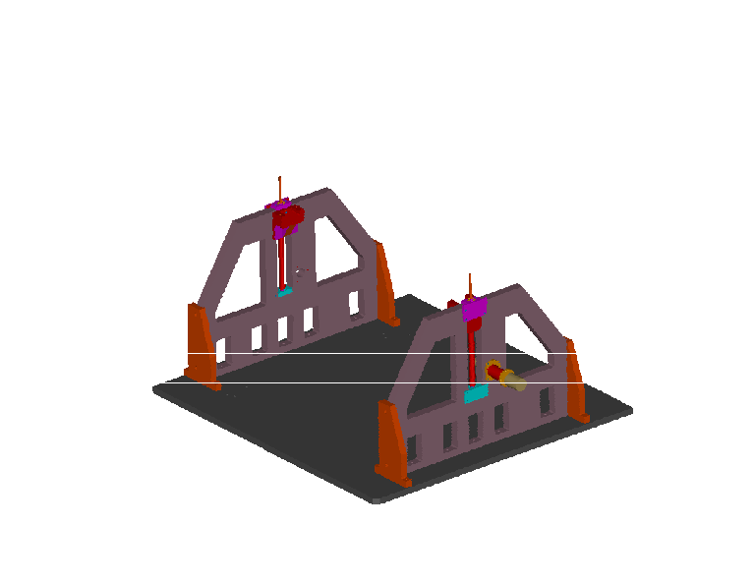
- Pull the Shaft out against the pin stop and leave loose

Spire Optical Bench Fitting

- Fit the Combined Pivot to the front surface of the Spire Optical Bench (Cone mounting end)
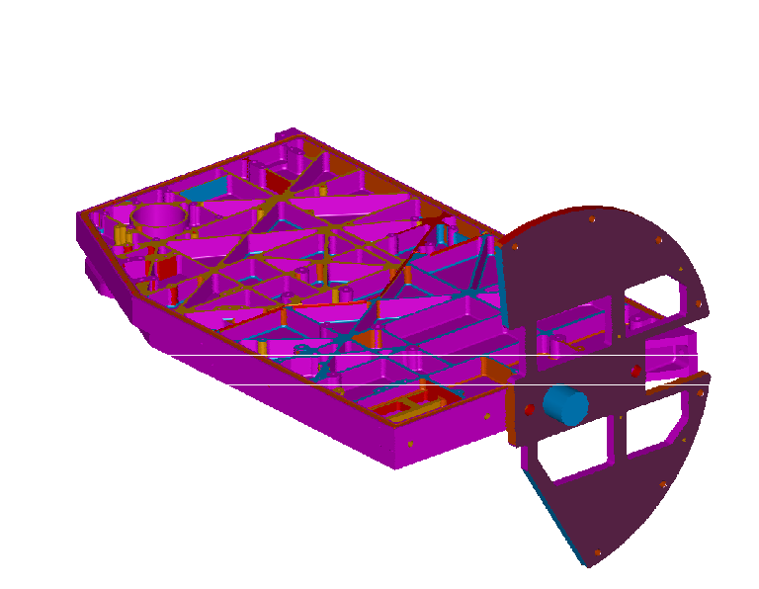
The Photometer Cover has been removed for clarity in this figure
- Fit the Rear Pivot to the other end face.
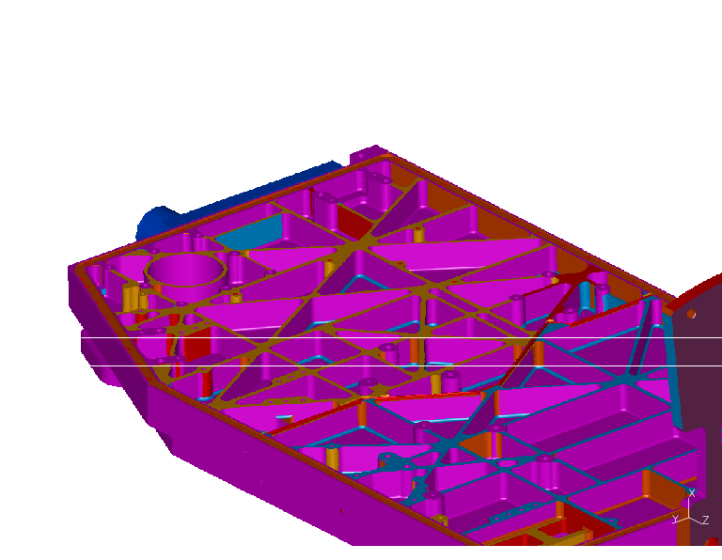
The Photometer Cover has been removed for clarity in this figure
- Fit the Front and Rear Blade Mounts to the Pivots.
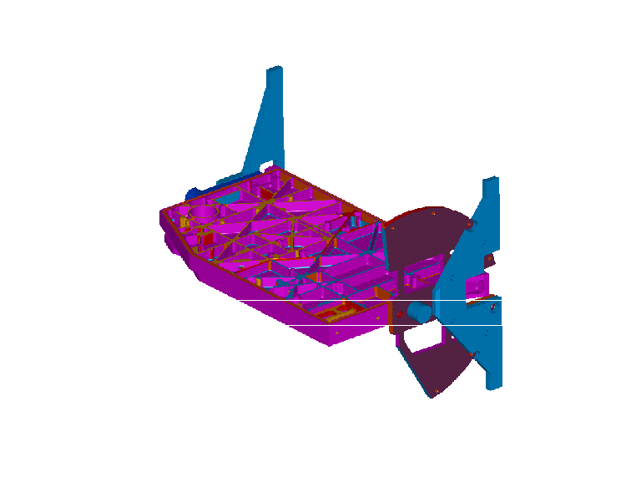
The Photometer Cover has been removed for clarity in this figure
- Screw 2 Fine Jacking Screws into each Blade Mount.
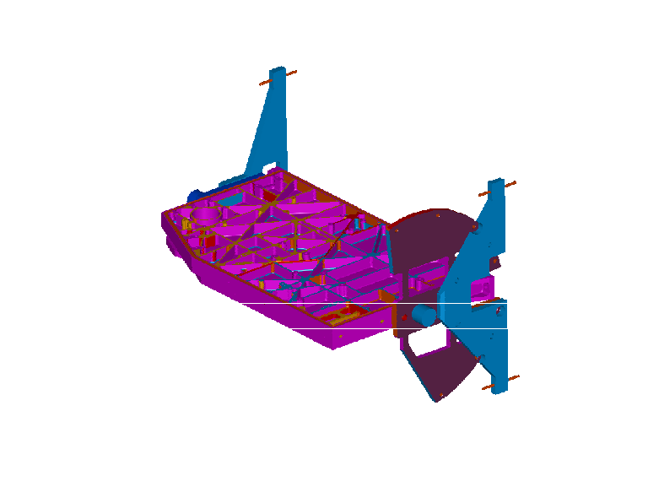
The Photometer Cover has been removed for clarity in this figure
- The Optical Bench is now ready to mount into the fixture.
- Insert preformed stainless steel shims into each Jacking Nut "V" (smear inside surface with a minimum amount of Apiazon AP100)
- Lift the Optical Bench complete with end Pivots and lower until each Pivot boss is located the preformed shims.
- Verify that the Optical Bench rotates forward and backward to an angle of +/-90 degrees from the vertical position.
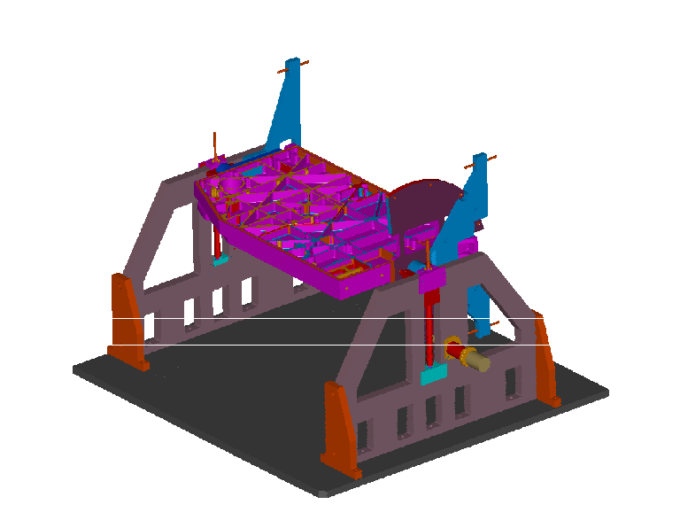
The Photometer Cover has been removed for clarity in this figure
- Fit a Pivot Clamp over each Pivot Boss tighten down to allow bench to rotate back and forth loosely.

Optical Bench Alignment
- Rotate the Optical Bench to a vertical position with the Photometer side facing the operator.
- Ensure that the base plate is level
- Wind both Jacking Nuts up to mate with the underside of each Upper Bearing Housing, check that the Optical Bench top surface is level +/- 3 arc' (an inspection quality spirit level should be used for this operation) minor adjustments should be made to the heights of the Jacking Nuts.
- Secure the Pivot Clamps to allow +/- 90 degrees rotation from the vertical without any slop at the Pivot Boss/Jacking Nut interface.
- Screw the Lock Shaft into the mating hole in the Combined Pivot (screw up so that the mating faces lock together without tending to deflect the Combined Pivot - the complete Optical Bench / Pivots assembly should be eased towards the Lock Shaft End Plate while carrying out this operation, if necessary. When complete there should be approximately 3mm clearance between the Combined Pivot Shaft end face and the end face of the Jacking Nut "V").
- With the Lock Shaft firmly engaged with the Combined Pivot, lock the assembly in position using the Lock Ring but do not over tighten either the Lock Shaft or Lock Ring.
- Verify that the Optical Bench Photometer surface is vertical and top surface is horizontal
- Disengage the Lock Ring and Shaft then rotate the Optical bench 90 degrees forward or backward then re-engage the Lock Shaft with the Combined Pivot and secure. Always disengage the lockshaft before rotating the optical bench.
- Using the spirit level verify that the Optical Bench upper most surface is level to 3arc' in 2 opposite directions from face to face and diagonal.
- Do this operation for the opposite rotation.
- Put the jack nut clamp plates in place.
- 0nce all alignments have been verified and any amendments carried out, assembly of the Spire Optical Bench can continue to completion.
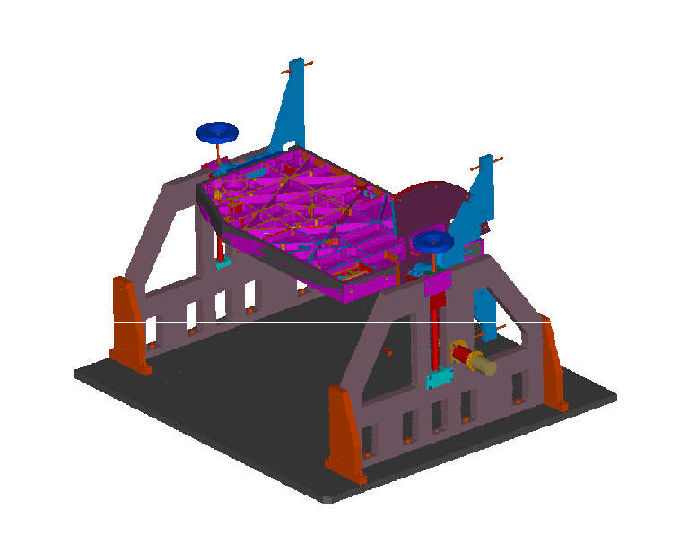
The Photometer Cover has been removed for clarity in this figure

Lubrication Application

The following is the application procedure:

- Clean the screw
- Apply with scriber tip a small dab of Apiezon Ap100 to the first thread of screw
- Wind screw into hole.

Ensure that the lubricant is not picked up on gloves and distributed to parts during assembly/disassembly procedures. If in doubt, change gloves after handling areas.

Assembly of subsystems
The SPIRE instrument consists of a monocoque shell that provides bending stiffness to the stiff optical bench. This optical bench supports a photometer and a spectrometer. All parts of these two measurement devices are mounted on the optical bench. The instrument is mounted on the FIRST optical bench via three interfaces. Two A-frames and a conical fixed point. These interfaces ensure a controlled contraction of the instrument when it is cooled down. The optical bench panel is on one side mounted on the fixed point, the side closest to the optical axis of the telescope. The two A-frames are mounted on the two corners furthest away from the fixed point. The bending flexible direction of the A-frames is pointing towards the fixed point. Thus making the whole suspension semi-kinematic.

The integration of the Spire structure is a very delicate operation. During the whole process great care has to be taken not to compromise the (future) alignment of the optical components. The inaccuracy of machining of the various parts will lead to a build up of alignment errors of the structural interfaces upon which the various optical components will be mounted. The build up of this misalignment runs through the whole structure. It starts with the mounting of the instrument, continues through the covers and the optical bench. It is therefore of paramount importance that during integration the build-up of misalignment is minimised and moreover, to ensure that the construction and integration is done such that what ever the misalignment is, it will not change significantly after dismounting and re-mounting the covers.

The total allowable misalignment (error budget) of the optical components is given in AD24. The development plan, giving a listing of the various models required, is AD28. A more detailed description of the structure can be found in AD27.

Optical Bench
With reference to drawing A1/5264/305- Optical Bench Assembly and the following points.

- Mount Optical Bench onto the surface table
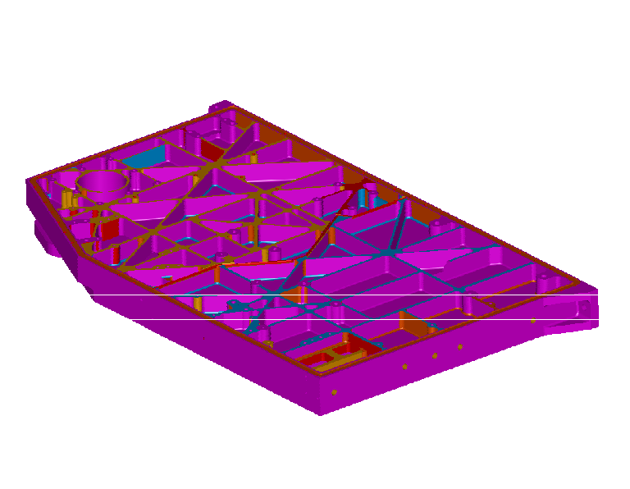
- Fit Photometer covers to procedure 10.6
- Install into MGSE, following procedure 8
- Fit Spectrometer cover to procedure 10.7
- Remove photometer cover
- Fit secondary optical bench
- Fit SM06 and PM06 mirror mounts
- Fit PM8 mirror mount
- Fit SM06 mirror (if available)
- Fit Common Mirrors, CM03 and CM05 onto the secondary optical bench (if available)
- Fit PM07 mirror onto the secondary optical bench (if available)
- Fit the Beam Steering Mechanism
- Replace the Photometer cover
- Take off the spectrometer cover – Please note that there are 3 screws adjacent to the SCAL box where there is no access to unscrew them. Leave these out during alignment and integration but should be included during the final assembly.
- Assemble SFIL2 mount on a separate bench
- Epoxy SOB dowels into the SFIL2 mount
- Fit SFIL2 assembly
- Fit SM7 mirror mount
- Fit SM8A mirror mount
- Assemble SBS 1 and SBS 2 on a separate bench
- Fit SBS 1 assembly
- Assemble SCAL Box on a separate bench
- Fit the SMEC (if available)
- Fit SCAL box
- Fit SM9A/10A mirror mounts
- Fit SM9B/10B mirror mounts
- Fit SBS 2 assembly
- Fit SM11A mirror mount
- Fit SM11B mirror mount
- Fit SM12A Mirror mount
- Fit SM12B Mirror mount
- Fit all of the spectrometer mirrors to the standard procedure
- Fit all of the spectrometer baffles
- Fit the Spectrometer Detector box assembly
- Fit the RF filter box
- Replace the spectrometer cover
- Remove the photometer cover
- Fit PM08 mirror (if available)
- Fit PM06 mirror (if available)
- Fit detector box straps to cooler
- Fit cooler to optical bench
- Fit the photometer box
- Connect 2K interconnecting strap to photometer box
- Fit the jointing strap that runs between the two detector boxes
- Replace photometer cover - Please note that there are 3 screws adjacent to the Secondary Optical Bench where there is no access to unscrew them. Leave these out during alignment and integration but should be included during the final assembly.
- Remove spectrometer cover
- Connect up the Spectrometer detector box to its straps.

Photometer 2K Detector Box

With reference to Drawing A1/5274/306 – Photometer Box Assembly and the following points,

- Slide the two bus bar supports (Cardiff) onto the bus bar upper (Reference Cardiff MAIV plan AD40)
- Secure the supports to the detector box outer cover
- Fit the lower bus bar to the joint with the upper bus bar. Note that the end of the bus bar is vulnerable
- Assemble the PDIC1 and PDIC2 mounts into the photometer box spine
- Fit the mirror mounts using the standard procedure
- Fit the mirrors using the standard procedure
- Fit PFIL 3
- Fit the dichronics and their rings
- Fit the spine to the outer cover
- Fit the detectors and make the joints between them and the bus bar
- Fit the light trap to the spine, feeding it along the bus bar
- Fit the harness supports to the outer cover
- Fit the inner cover to the spine
- Fit the BDA connector assembly to the harness supports
- Fit the blade mounts to the inner cover. These should be left loose until the final fitting of the box to the optical bench. (Note that the blade mounts should not be fitted during transport of the detector, except when the box is fitted to the bench).
- Fit photometer box cone to the optical bench

To disassemble the Photometer detector box,

- Unscrew photometer detector box spine from the inner cover
- Remove the spine, thus leaving the inner cover and legs on the optical bench

Spectrometer 2k Detector Box
With reference to Drawing A1/5274/307 – Spectrometer Box Assembly and the following points,

- Integrate BDAs into bottom box
- Assembly the 300mK Thermal Strap System separately to Procedure 10.4
- Feed through the busbar assembly in to the spectrometer box
- Check Flexible wire link with BDA
- Mount straylight trap over the end of the busbar and screw it to the box.
- Connect up thermal Busbar, by locking all screws and tying the busbar to the pads available on the detector.
- Fit the filters, SFIL3, on the filter holder on a separate bench
- Fit the filter holder onto the box
- Fit the blade mounts

Spectrometer 300mK Thermal Strap System

With reference to Drawing A3/5264/307B – Bus Bar assembly Spectrometer and the following points;

- Silver solder the feed through and the light baffle junction
- Silver solder the cold interface plate into the light trap straps (1 mm diameter rods)
- Silver solder the rods on to the light baffle junction
- Slide the loose bushes onto the feed through (3 mm diameter rod)

Photometer 300mK Thermal Strap System
With reference to Drawing A3/5264/306B – Bus Bar assembly Photometer and the following points;

- Silver solder the two stop sleeves on to the upper bus bar
- Silver solder the lower bus bar and the light trap feed through to the light trap bus junction
- Silver solder each of the BDA to bus bar links (1 mm diameter rod) to the pads at both ends
- Screw the clamp for the PSW link onto the lower bus bar
- The other parts will be assembled during the photometer detector box assembly

Photometer Cover
With reference to Drawing A1/5274/302 – Photometer Cover Assembly and the following points;

- Check cleanliness of surfaces
- Fit Photometer cover wall to Optical bench
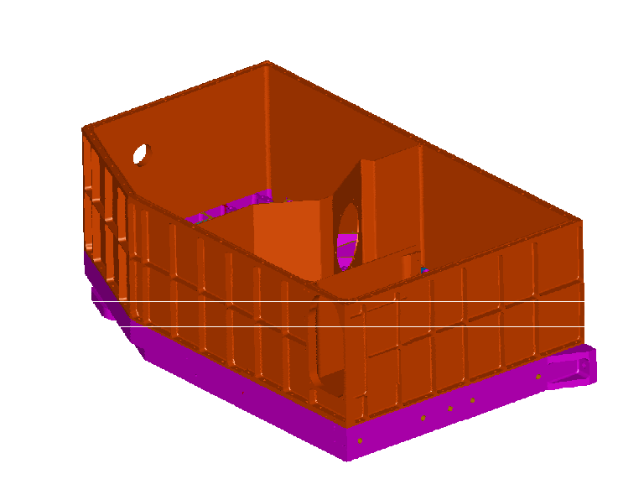
- Check flatness before bolting down in sequence
- Fit the bottom seal into the photometer cover wall
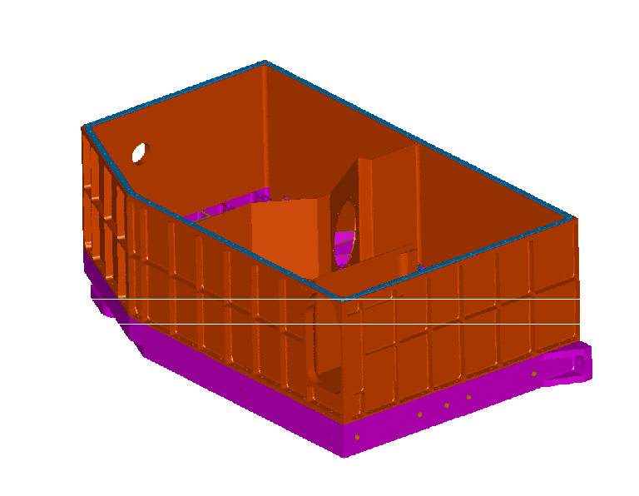
- Fit the lid to the photometer cover wall
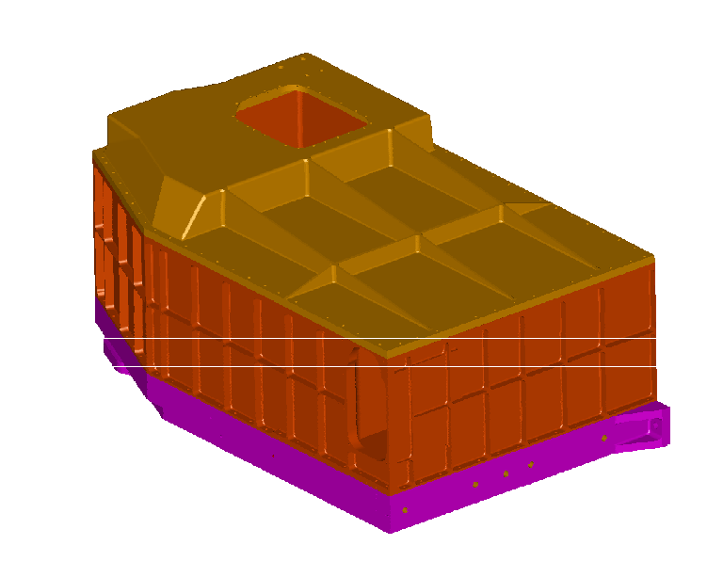
- Check trueness of the lid with the wall before bolting down in sequence
- Fit the blade mount bracket to the photometer cover lid
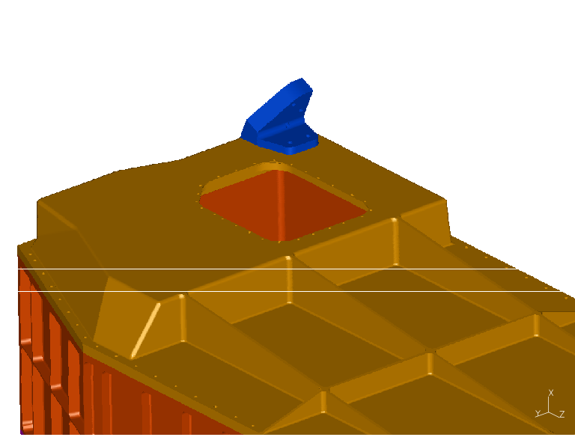
- Fit the blade mount to the bracket. (Note that the blade mounts should not be fitted during transport of the cover, except where the FPU is fitted to the HOB and the MSSL MGSE is in place. Failure to do this will result in damage to the A-frames)
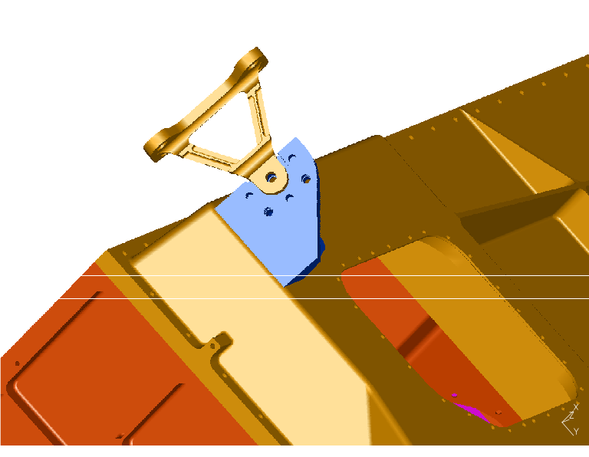
- Fit the Dowel retention plate.
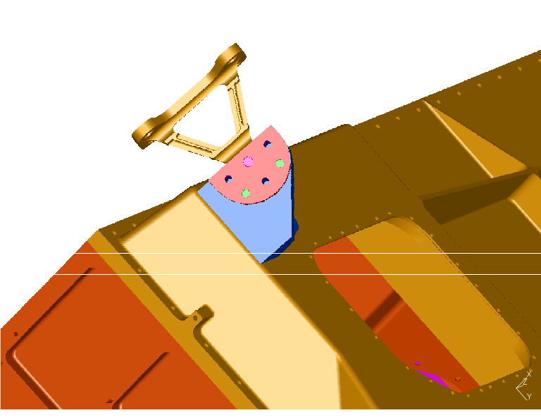

Spectrometer Cover
With reference to Drawing A1/5274/303 – Spectrometer Cover Assembly and the following points,

1. Check cleanliness of surfaces
2. Fit Spectrometer cover wall to Optical bench
- Check flatness before bolting down in sequence
- Fit the bottom seal into the spectrometer cover wall
- Fit the main stray light baffle
- Fit the lid to the spectrometer cover wall
- Check trueness of the lid with the wall before bolting down in sequence
- Fit the blade mount bracket to the spectrometer cover lid
- Fit the blade mount to the bracket. (Note that the blade mounts should not be fitted during transport of the cover, except where the FPU is fitted to the HOB and the MSSL MGSE is in place. Failure to do this will result in damage to the A-frames)
- Fit the Dowel retention plate.

Mounts onto the Optical bench

With reference to drawing A1/5264/916 – Mirror fixing envelope and the following points;

- Put two tubular dowels into the optical bench
- Lubricate
- Fit the mount (note this can be applied to BSM and SMEC)

Mirror on Mount
With reference to drawing A1/5264/916 – Mirror fixing envelope and the following points;

- fit the dowel to the mount
- Offer up the mirror, after having lubricated it with ethanol
- Slide it with a smooth movement into the mount
- Secure with LAM supplied nuts and washers. Torque to (TBD)

General Assembly
With reference to drawing A1/5264/301 – General Assembly and the following points;

- Fit the light traps to the covers
- Fit the thermal strap frames to the cover
- Fit the thermal straps
- Do not fit straps during transit

Integration

Integration Procedure

The integration procedure is the same for either the HOB (Herschel Optical Bench) simulator or the HOB on the spacecraft. With reference to drawing A1/5264/300 – Spire FPU Interface Drawing and the following points;

- Fit the cone to the HOB (either on spacecraft or the plate)
- Fit the blade mounts to the FPU
- Lower the FPU down onto the cone
- Secure the FPU to the Cone and the blade mounts to the HOB.

APPENDIX 1
A1/5264/302
Common Structure

A1/5264/303
Spectrometer Cover
A1/5264/306
Photometer 2K Box
A1/5264/301
General Assembly
A1/5264/300
SPIRE Interface
A1/5264/302
Photometer Cover
A1/5264/305
Optical Bench
A1/5264/307
Spectrometer 2K Box
Thermal Straps
A1/5264/309
Stray Light Baffles

Splitter Mounts
A1/5264/315
Harness
A1/5264/310-311
Dichroics
Filters
Connect Panels
HIFI/PACS Astrium I/F Drawings
A1/5264/305
Mirror Mount
Figure 1

Dwg Level |  |  |  |  |  |  |  |  | Drawing Number |  |  | Issue |  |  | Sheets |  |  | System |  |  | Title |  |  | Material
X |  |  |  |  |  |  |  |  | A1/5264/300 |  |  | 17 |  |  | 7 |  |  | SPIRE Interface |  |  | SPIRE Interface |  |  | -
 |  |  | X |  |  |  |  |  | A2/5264/904 |  |  | 1 |  |  | 1 |  |  | SPIRE Interface |  |  | Beam Splitter Mounts (Spectrometer) |  |  | -
 |  |  | X |  |  |  |  |  | A3/5264/905 |  |  | 1 |  |  | 1 |  |  | SPIRE Interface |  |  | Dichroic Mounts (Photometer) |  |  | -
 |  |  | X |  |  |  |  |  | A3/5264/906 |  |  |  |  |  |  |  |  | SPIRE Interface |  |  | Optical Bench Dimension WRT Focal Plane |  |  | -
 |  |  | X |  |  |  |  |  | A2/5264/907 |  |  | 6 |  |  | 1 |  |  | SPIRE Interface |  |  | Bean Steering Mechanism Interface |  |  | -
 |  |  | X |  |  |  |  |  | A2/5264/908 |  |  | 3 |  |  | 1 |  |  | SPIRE Interface |  |  | Cooler Interface |  |  | -
 |  |  | X |  |  |  |  |  | A1/5264/909 |  |  | 3 |  |  | 2 |  |  | SPIRE Interface |  |  | SMEC Interface |  |  | -
 |  |  | X |  |  |  |  |  | A2/5264/910 |  |  | 3 |  |  | 1 |  |  | SPIRE Interface |  |  | Spectrometer Calibrator Interface |  |  | -
 |  |  | X |  |  |  |  |  | A3/5264/911 |  |  | 2 |  |  | 1 |  |  | SPIRE Interface |  |  | Detector Interface Adapter Plate |  |  | Alum Alloy BS1470 6082 T6
 |  |  | X |  |  |  |  |  | A1/5264/912 |  |  |  |  |  |  |  |  | SPIRE Interface |  |  | Wiring Harness Spectrometer Side/Photometer Side
 |  |  | X |  |  |  |  |  | A3/5264/913 |  |  |  |  |  |  |  |  | SPIRE Interface |  |  | Detector Focal Plane Definition Check
 |  |  | X |  |  |  |  |  | A1/5264/914 |  |  | 1 |  |  | 1 |  |  | SPIRE Interface |  |  | Shutter Interface |  |  | -
 |  |  | X |  |  |  |  |  | A3/5264/915 |  |  |  |  |  |  |  |  | SPIRE Interface |  |  | 4K Cooler Strap Joint & Light Baffles
 |  |  | X |  |  |  |  |  | A1/5264/916 |  |  | 1 |  |  | 1 |  |  | SPIRE Interface |  |  | Mirror Fixing Envelope |  |  | -
 |  |  | X |  |  |  |  |  | A1/5264/917 |  |  | 2 |  |  | 1 |  |  | SPIRE Interface |  |  | RFI Filter Interface |  |  | -
 |  |  | X |  |  |  |  |  | A2/5264/918 |  |  | 1 |  |  | 1  1  1 |  |  | SPIRE Interface |  |  | PCS/PFIL 3 Interface
 |  |  | X |  |  |  |  |  | A2/5264/919 |  |  | 2 |  |  | 1 |  |  | SPIRE Interface |  |  | SFIL - 3 Interface
 |  |  | X |  |  |  |  |  | A1/5264/920 |  |  | 4 |  |  | 3 |  |  | SPIRE Interface |  |  | SFIL - 2 Interface
 |  |  | X |  |  |  |  |  | A1/5264/921 |  |  | 2 |  |  | 1 |  |  | SPIRE Interface |  |  | CFIL - 1 Interface
 |  |  | X |  |  |  |  |  | A1/5264/922 |  |  | 1 |  |  | 1 |  |  | SPIRE Interface |  |  | PFIL - 2 Interface
 |  |  | X |  |  |  |  |  | A1/5264/923 |  |  | 1 |  |  | 1 |  |  | SPIRE Interface |  |  | Harness Hole Interface
 |  |  | X |  |  |  |  |  | A1/5264/924 |  |  | 1 |  |  | 1 |  |  | SPIRE Interface |  |  | Interface – 4K - Baffles
 |  |  | X |  |  |  |  |  | A1/5264/925 |  |  | 2 |  |  | 1 |  |  | SPIRE Interface |  |  | Light trap end Stops - Photometer
 |  |  | X |  |  |  |  |  | A1/5264/926 |  |  | 3 |  |  | 1 |  |  | SPIRE Interface |  |  | Photo. Light Trap Junct. with PTC
Dwg Level |  |  |  |  |  |  |  |  | Drawing Number |  |  | Issue |  |  | Sheets |  |  | System |  |  | Title |  |  | Material
X |  |  |  |  |  |  |  |  | A1/5264/301 |  |  | 1 |  |  | 2 |  |  | General Assembly |  |  | General Assembly
 |  |  |  |  |  |  |  |  | A1/5264/301-1 |  |  |  |  |  |  |  |  | General Assembly
 |  |  |  |  |  |  |  |  | A1/5264/301-2 |  |  |  |  |  |  |  |  | General Assembly
 |  |  |  |  |  |  |  |  | A1/5264/301-3 |  |  |  |  |  |  |  |  | General Assembly
 |  |  |  |  |  |  |  |  | A1/5264/301-4 |  |  | 1 |  |  | 1 |  |  | General Assembly |  |  | Cold Strap Support Leg
 |  |  |  |  |  |  |  |  | A1/5264/301-5 |  |  |  |  |  |  |  |  | General Assembly
 |  |  |  |  |  |  |  |  | A1/5264/301-6 |  |  |  |  |  |  |  |  | General Assembly
 |  |  |  |  |  |  |  |  | A1/5264/301-7 |  |  |  |  |  |  |  |  | General Assembly
 |  |  |  |  |  |  |  |  | A1/5264/301-8 |  |  |  |  |  |  |  |  | General Assembly
 |  |  |  |  |  |  |  |  | A1/5264/301-9 |  |  | 1 |  |  | 1 |  |  | General Assembly |  |  | Clamp Pate
 |  |  |  |  |  |  |  |  | A1/5264/301-10 |  |  | 1 |  |  | 1 |  |  | General Assembly |  |  | Cold Strap Support
 |  |  |  |  |  |  |  |  | A1/5264/301-11 |  |  | 1 |  |  | 1 |  |  | General Assembly |  |  | Cold Strap Support Clamp
 |  |  |  |  |  |  |  |  | A1/5264/301-12 |  |  |  |  |  |  |  |  | General Assembly
X |  |  |  |  |  |  |  |  | A1/5264/302 |  |  | 1 |  |  | 2 |  |  | Common Structure |  |  | Photometer Cover Assembly
 |  |  | X |  |  |  |  |  | A2/5264/302-1 |  |  | 3 |  |  | 1 |  |  | Common Structure |  |  | FPU Blade Mount Unit
 |  |  | X |  |  |  |  |  | A3/5264/302-2 |  |  | 2 |  |  | 1 |  |  | Common Structure |  |  | Insulating Bush
 |  |  | X |  |  |  |  |  | A3/5264/302-3 |  |  | 1 |  |  | 1 |  |  | Common Structure |  |  | Special Washer
 |  |  | X |  |  |  |  |  | A1/5264/302-4 |  |  | 2 |  |  | 5 |  |  | Common Structure |  |  | Optical Bench
 |  |  | X |  |  |  |  |  | A1/5264/302-5 |  |  | 4 |  |  | 1 |  |  | Common Structure |  |  | Fixed Mount
 |  |  | X |  |  |  |  |  | A1/5264/302-6 |  |  | 6 |  |  | 3 |  |  | Common Structure |  |  | One Piece Photometer Cover
 |  |  | X |  |  |  |  |  | A1/5264/302-6A |  |  | 1 |  |  | 1 |  |  | Common Structure |  |  | Repair Plate
 |  |  | X |  |  |  |  |  | A1/5264/302-7 |  |  | 2 |  |  | 1 |  |  | Common Structure |  |  | Photometer Cover Bottom Seal
 |  |  | X |  |  |  |  |  | A1/5264/302-8 |  |  | 2 |  |  | 1 |  |  | Common Structure |  |  | Photometer Cover Top Seal
 |  |  | X |  |  |  |  |  | A1/5264/302-9 |  |  | 2 |  |  | 1 |  |  | Common Structure |  |  | Photometer Cover Insert
 |  |  | X |  |  |  |  |  | A1/5264/302-10 |  |  | 6 |  |  | 2 |  |  | Common Structure |  |  | Photometer Top Cover
 |  |  | X |  |  |  |  |  | A1/5264/302-11 |  |  |  |  |  |  |  |  | Common Structure |  |  | Spectrometer Cover Seal
 |  |  | X |  |  |  |  |  | A1/5264/302-12 |  |  | 1 |  |  | 1 |  |  | Common Structure |  |  | Pfil 2 Backplate
Dwg Level |  |  |  |  |  |  |  |  | Drawing Number |  |  | Issue |  |  | Sheets |  |  | System |  |  | Title |  |  | Material
 |  |  | X |  |  |  |  |  | A1/5264/302-13 |  |  | 1 |  |  | 1 |  |  | Common Structure |  |  | PFIL 2 H Seal
 |  |  | X |  |  |  |  |  | A1/5264/302-14 |  |  | 1 |  |  | 1 |  |  | Common Structure |  |  | A Frame Bracket
 |  |  | X |  |  |  |  |  | A1/5264/302-15 |  |  | 2 |  |  | 1 |  |  | Common Structure |  |  | A Frame Support Plate
 |  |  | X |  |  |  |  |  | A1/5264/302-16 |  |  | 1 |  |  | 1 |  |  | Common Structure |  |  | CFIL 1 H Section
 |  |  | X |  |  |  |  |  | A1/5264/302-17 |  |  | 1 |  |  | 1 |  |  | Common Structure |  |  | PFIL2 Clamp Ring
 |  |  | X |  |  |  |  |  | A1/5264/302-18 |  |  | 1 |  |  | 1 |  |  | Common Structure |  |  | Tubular Dowel
 |  |  | X |  |  |  |  |  | A1/5264/302-19 |  |  | 1 |  |  | 1 |  |  | Common Structure |  |  | Tubular Dowel
 |  |  | X |  |  |  |  |  | A3/5264/302-20 |  |  | 2 |  |  | 1 |  |  | Common Structure |  |  | 2K Interconnecting strap
 |  |  | X |  |  |  |  |  | A3/5264/302-21 |  |  | 1 |  |  | 1 |  |  | Common Structure |  |  | Cold Strap Clamp Plate
 |  |  | X |  |  |  |  |  | A2/5264/302-22 |  |  | 2 |  |  | 1 |  |  | Common Structure |  |  | BDA Connector flange – Photo.
 |  |  | X |  |  |  |  |  | A1/5264/302-23 |  |  | 2 |  |  | 1 |  |  | Common Structure |  |  | BDA connector flange – Spectro.
 |  |  | X |  |  |  |  |  | A1/5264/302-24 |  |  |  |  |  | 1 |  |  | Common Structure |  |  | Plug, BDA Connector Flange
 |  |  | X |  |  |  |  |  | A1/5264/302-25 |  |  |  |  |  | 1 |  |  | Common Structure |  |  | Harness support BDA connector Flange
 |  |  | X |  |  |  |  |  | A1/5264/302-26 |  |  | 1 |  |  | 1 |  |  | Common Structure |  |  | A Frame Bracket (Spec)
 |  |  | X |  |  |  |  |  | A1/5264/302-27 |  |  | 1 |  |  | 1 |  |  | Common Structure |  |  | RFI Filter Frame Corner Bracket
 |  |  | X |  |  |  |  |  | A1/5264/302-28 |  |  | 2 |  |  | 1 |  |  | Common Structure |  |  | Temporary RF Bracket
 |  |  | X |  |  |  |  |  | A1/5264/302-29 |  |  | 1 |  |  | 1 |  |  | Common Structure |  |  | FRI Filter frame Edge Bracket
 |  |  | X |  |  |  |  |  | A1/5264/302-30 |  |  | 2 |  |  | 1 |  |  | Common Structure |  |  | Cooler to Photo Detector Box Strap
 |  |  | X |  |  |  |  |  | A1/5264/302-31 |  |  | 2 |  |  | 1 |  |  | Common Structure |  |  | Cooler to Spec Detector Box Strap
 |  |  | X |  |  |  |  |  | A1/5264/302-32 |  |  | 3 |  |  | 1 |  |  | Common Structure |  |  | Cooler Strap Isolation Plate
 |  |  | X |  |  |  |  |  | A1/5264/302-33 |  |  | 1 |  |  | 1 |  |  | Common Structure |  |  | Clamp Plate Photometer Strap
 |  |  | X |  |  |  |  |  | A1/5264/302-34 |  |  | 1 |  |  | 1 |  |  | Common Structure
 |  |  | X |  |  |  |  |  | A1/5264/302-35 |  |  | 1 |  |  | 1 |  |  | Common Structure |  |  | Isolating Plate Interconnecting Strap
 |  |  | X |  |  |  |  |  | A1/5264/302-36 |  |  | 2 |  |  | 1 |  |  | Common Structure |  |  | Insulating bush cooler straps
 |  |  | X |  |  |  |  |  | A1/5264/302-37 |  |  | 1 |  |  | 1 |  |  | Common Structure
 |  |  | X |  |  |  |  |  | A1/5264/302-38 |  |  | 2 |  |  | 1 |  |  | Common Structure |  |  | Insulating bush interconnecting straps
 |  |  | X |  |  |  |  |  | A1/5264/302-39 |  |  | 1 |  |  | 1 |  |  | Common Structure |  |  | Dowel retaining Plate
 |  |  | X |  |  |  |  |  | A1/5264/302-40 |  |  | 1 |  |  | 1 |  |  | Common Structure |  |  | Tubular Dowels (8mm)
Dwg Level |  |  |  |  |  |  |  |  | Drawing Number |  |  | Issue |  |  | Sheets |  |  | System |  |  | Title |  |  | Material
 |  |  | X |  |  |  |  |  | A1/5264/302-41 |  |  | 1 |  |  | 1 |  |  | Common Structure |  |  | Dowel – ‘A’ Frame Support
 |  |  | X |  |  |  |  |  | A1/5264/302-42 |  |  | 1 |  |  | 1 |  |  | Common Structure |  |  | Dowel – ‘A’ Frame Top
 |  |  | X |  |  |  |  |  | A1/5264/302-43 |  |  | 1 |  |  | 1 |  |  | Common Structure |  |  | Special Washer – A Frame Bracket
 |  |  | X |  |  |  |  |  | A1/5264/302-44 |  |  | 1 |  |  | 1 |  |  | Common Structure |  |  | Blanking Plug |  |  | Alum Alloy BS1414 6082 T6
X |  |  |  |  |  |  |  |  | A1/5264/303 |  |  |  |  |  |  |  |  | Spectrometer Cover |  |  | Spectrometer Cover Assembly
 |  |  | X |  |  |  |  |  | A1/5264/303-1 |  |  | 2 |  |  | 2 |  |  | Spectrometer Cover |  |  | Spectrometer Cover Wall
 |  |  | X |  |  |  |  |  | A1/5264/303-2 |  |  | 1 |  |  | 2 |  |  | Spectrometer Cover |  |  | Spectrometer Cover Lid
 |  |  | X |  |  |  |  |  | A1/5264/303-3 |  |  | 1 |  |  | 3 |  |  | Spectrometer Cover |  |  | Spectrometer Cover Baffle
 |  |  | X |  |  |  |  |  | A1/5264/303-4 |  |  | 1 |  |  | 1 |  |  | Spectrometer Cover |  |  | Spectrometer Cover Bottom Seal
 |  |  | X |  |  |  |  |  | A1/5264/303-5 |  |  | 2 |  |  | 1 |  |  | Spectrometer Cover |  |  | Spectrometer Cover Top Seal
 |  |  | X |  |  |  |  |  | A1/5264/303-6 |  |  | 2 |  |  | 1 |  |  | Spectrometer Cover |  |  | Spectrometer Baffle SM12 |  |  | Alum Alloy BS1414 6082 T6
X |  |  |  |  |  |  |  |  | A1/5264/304 |  |  |  |  |  |  |  |  | Photometer Cover |  |  | Photometer Cover Assembly
 |  |  | X |  |  |  |  |  | A1/5264/304-1 |  |  |  |  |  |  |  |  | Photometer Cover |  |  | Top Plate |  |  | Not Used
 | X |  |  |  |  |  | A1/5264/304-2 |  |  |  |  |  |  |  |  | Photometer Cover |  |  | Top Rear Plate |  |  | Not Used
 | X |  |  |  |  |  | A1/5264/304-3 |  |  |  |  |  |  |  |  | Photometer Cover |  |  | Front Plate |  |  | Not Used
 | X |  |  |  |  |  | A1/5264/304-4 |  |  |  |  |  |  |  |  | Photometer Cover |  |  | Back Plate |  |  | Not Used
 | X |  |  |  |  |  | A1/5264/304-5 |  |  |  |  |  |  |  |  | Photometer Cover |  |  | Outer Plate |  |  | Not Used
 | X |  |  |  |  |  | A1/5264/304-6 |  |  | 6 |  |  | 1 |  |  | Photometer Cover |  |  | CFIL 1 Baffle Mount |  |  | Alum Alloy BS1414 6082 T6
 | X |  |  |  |  |  | A2/5264/304-7 |  |  | 2 |  |  | 1 |  |  | Photometer Cover |  |  | CFIL 1 Clamp Ring |  |  | Alum Alloy BS1414 6082 T6
 | X |  |  |  |  |  | A1/5264/304-8 |  |  | 1 |  |  | 1 |  |  | Photometer Cover |  |  | CFIL 1 Baffle Tube |  |  | Alum Alloy BS1414 6082 T6
 | X |  |  |  |  |  | A1/5264/304-9 |  |  | 1 |  |  | 2 |  |  | Photometer Cover |  |  | PFIL 2 Baffle |  |  | Alum Alloy BS1414 6082 T6
X |  |  |  |  |  |  | A1/5264/305 |  |  |  |  |  |  |  |  | Optical Bench |  |  | Optical Bench Assembly
 | X |  |  |  |  |  | A1/5264/305-1 |  |  | 1 |  |  | 1 |  |  | Optical Bench |  |  | Optical Bench Harness Tie Positions
 | X |  |  |  |  |  | A1/5264/305-2 |  |  | 2 |  |  | 1 |  |  | Optical Bench |  |  | SM06 Mirror Mount |  |  | Alum Alloy BS1470 6082 T6
 | X |  |  |  |  |  | A1/5264/305-3 |  |  | 2 |  |  | 1 |  |  | Optical Bench |  |  | SM07 Mirror Mount |  |  | Alum Alloy BS1470 6082 T6
 | X |  |  |  |  |  | A1/5264/305-4 |  |  | 1 |  |  | 1 |  |  | Optical Bench |  |  | SM08A Mirror Mount |  |  | Alum Alloy BS1470 6082 T6
 | X |  |  |  |  |  | A1/5264/305-5 |  |  | 1 |  |  | 1 |  |  | Optical Bench |  |  | SM08B Mirror Mount |  |  | Alum Alloy BS1470 6082 T6
 | X |  |  |  |  |  | A1/5264/305-6 |  |  | 2 |  |  | 1 |  |  | Optical Bench |  |  | SM09A & SM10A Mirror Mount |  |  | Alum Alloy BS1470 6082 T6
Dwg Level |  |  |  |  |  |  | Drawing Number |  |  | Issue |  |  | Sheets |  |  | System |  |  | Title |  |  | Material
 | X |  |  |  |  |  | A1/5264/305-7 |  |  | 2 |  |  | 1 |  |  | Optical Bench |  |  | SM09B &SM10B Mirror Mount |  |  | Alum Alloy BS1470 6082 T6
 | X |  |  |  |  |  | A1/5264/305-8 |  |  | 2 |  |  | 1 |  |  | Optical Bench |  |  | SM11A Mirror Mount |  |  | Alum Alloy BS1470 6082 T6
 | X |  |  |  |  |  | A1/5264/305-9 |  |  | 1 |  |  | 1 |  |  | Optical Bench |  |  | SM11B Mirror Mount |  |  | Alum Alloy BS1470 6082 T6
 | X |  |  |  |  |  | A1/5264/305-10 |  |  | 1 |  |  | 1 |  |  | Optical Bench |  |  | SM12A Mirror Mount |  |  | Alum Alloy BS1470 6082 T6
 | X |  |  |  |  |  | A1/5264/305-11 |  |  | 1 |  |  | 1 |  |  | Optical Bench |  |  | SM12B Mirror Mount |  |  | Alum Alloy BS1470 6082 T6
 | X |  |  |  |  |  | A1/5264/305-12 |  |  | 1 |  |  | 1 |  |  | Optical Bench |  |  | Secondary Optical Bench (CM3/SPMOT) |  |  | Alum Alloy BS1470 6082 T6
 | X |  |  |  |  |  | A1/5264/305-13 |  |  | 1 |  |  | 1 |  |  | Optical Bench |  |  | PM06 Mirror Mount |  |  | Alum Alloy BS1470 6082 T6
 | X |  |  |  |  |  | A1/5264/305-14 |  |  | 1 |  |  | 1 |  |  | Optical Bench |  |  | PM08 Mirror Mount |  |  | Alum Alloy BS1470 6082 T6
 | X |  |  |  |  |  | A1/5264/305-15 |  |  | 1 |  |  | 1 |  |  | Optical Bench |  |  | SM06 & SM07 Bulkhead |  |  | Alum Alloy BS1470 6082 T6
 | X |  |  |  |  |  | A3/5264/305-16 |  |  | 7 |  |  | 1 |  |  | Optical Bench |  |  | Optical Reference Cube |  |  | Alum Alloy BS1470 6082 T6
 | X |  |  |  |  |  | A2/5264/305-17 |  |  | 1 |  |  | 1 |  |  | Optical Bench |  |  | PM10 Mirror mount |  |  | Alum Alloy BS1470 6082 T6
 | X |  |  |  |  |  | A1/5264/305-18 |  |  | 1 |  |  | 1 |  |  | Optical Bench |  |  | SM06 Mirror mount - Spare |  |  | Alum Alloy BS1470 6082 T6
 | X |  |  |  |  |  | A1/5264/305-19 |  |  | 1 |  |  | 1 |  |  | Optical Bench |  |  | PM06 Mirror mount – Spare |  |  | Alum Alloy BS1470 6082 T6
 | X |  |  |  |  |  | A2/5264/305-20 |  |  | 4 |  |  | 1 |  |  | Optical Bench |  |  | SFIL 2 Mount |  |  | Alum Alloy BS1470 6082 T6
 | X |  |  |  |  |  | A3/5264/305-21 |  |  | 2 |  |  | 1 |  |  | Optical Bench |  |  | SFIL 2 Clamp |  |  | Alum Alloy BS1470 6082 T6
 | X |  |  |  |  |  | A3/5264/305-22 |  |  | 3 |  |  | 1 |  |  | Optical Bench |  |  | SFIL 2 Cold Stop |  |  | Alum Alloy BS1470 6082 T6
 | X |  |  |  |  |  | A1/5264/305-23 |  |  | 3 |  |  | 1 |  |  | Optical Bench |  |  | SBS 1 and SBS 2 Filter Mount |  |  | Alum Alloy BS1470 6082 T6
 | X |  |  |  |  |  | A2/5264/305-24 |  |  | 1 |  |  | 1 |  |  | Optical Bench |  |  | SBS 1 and SBS 2 Filter Clamp |  |  | Alum Alloy BS1470 6082 T6
 | X |  |  |  |  |  | A2/5264/305-25 |  |  |  |  |  |  |  |  | Optical Bench
 | X |  |  |  |  |  | A2/5264/305-26 |  |  |  |  |  |  |  |  | Optical Bench
 | X |  |  |  |  |  | A2/5264/305-27 |  |  |  |  |  |  |  |  | Optical Bench
 | X |  |  |  |  |  | A2/5264/305-28 |  |  |  |  |  |  |  |  | Optical Bench
 | X |  |  |  |  |  | A2/5264/305-29 |  |  | 1 |  |  | 1 |  |  | Optical Bench |  |  | SM9B/SBS1 Baffle |  |  | Alum Alloy BS1470 6082 T6
 | X |  |  |  |  |  | A2/5264/305-30 |  |  | 1 |  |  | 2 |  |  | Optical Bench |  |  | SM9A/SBS1 Baffle |  |  | Alum Alloy BS1470 6082 T6
X |  |  |  |  |  |  | A1/5264/306 |  |  | 1 |  |  | 2 |  |  | Photometer 2K Box |  |  | Photometer 2K Box Assembly
 | X |  |  |  |  |  | A1/5264/306A |  |  | 2 |  |  | 1 |  |  | Photometer 2K Box |  |  | Photometer BDA Cable Routes |  |  | -
Dwg Level |  |  |  |  |  |  | Drawing Number |  |  | Issue |  |  | Sheets |  |  | System |  |  | Title |  |  | Material
 | X |  |  |  |  |  | A1/5264/306B |  |  | 2 |  |  | 1 |  |  | Photometer 2K Box |  |  | Photometer Bus Bar Assembly |  |  | -
 | X |  |  |  |  |  | A1/5264/306-1 |  |  | 4 |  |  | 3 |  |  | Photometer 2K Box |  |  | Back Cover |  |  | Alum Alloy BS1470 6082 T6
 | X |  |  |  |  |  | A1/5264/306-2 |  |  | 6 |  |  | 4 |  |  | Photometer 2K Box |  |  | Spine |  |  | Alum Alloy BS1470 6082 T6
 | X |  |  |  |  |  | A1/5264/306-3 |  |  | 4 |  |  | 3 |  |  | Photometer 2K Box |  |  | Front Cover |  |  | Alum Alloy BS1470 6082 T6
 |  | X |  |  |  |  |  | A1/5264/306-4 |  |  | 1 |  |  | 1 |  |  | Photometer 2K Box |  |  | Photometer Cold Stop Clamp |  |  | Alum Alloy BS1470 6082 T6
 |  | X |  |  |  |  |  | A1/5264/306-5 |  |  | 2 |  |  | 1 |  |  | Photometer 2K Box |  |  | Photometer Cold Stop |  |  | Phosper bronze
 |  |  |  |  |  |  |  | A1/5264/306-6 |  |  | 1 |  |  | 1 |  |  | Photometer 2K Box |  |  | Cable Anchor (Tie Down Points) |  |  | Alum Alloy BS1470 6082 T6
 |  |  |  |  |  |  |  | A3/5264/306-7 |  |  | 2 |  |  | 1 |  |  | Photometer 2K Box |  |  | Bus Bar Upper |  |  | OFHC Copper
 |  |  |  |  |  |  |  | A3/5264/306-8 |  |  | 2 |  |  | 1 |  |  | Photometer 2K Box |  |  | Busbar Lower |  |  | OFHC Copper
 |  |  |  |  |  |  |  | A3/5264/306-9 |  |  | 1 |  |  | 1 |  |  | Photometer 2K Box |  |  | BDA-Busbar Flange |  |  | OFHC Copper
 |  |  |  |  |  |  |  | A3/5264/306-10 |  |  | 2 |  |  | 1 |  |  | Photometer 2K Box |  |  | Bus Connector PLW |  |  | OFHC Copper
 |  |  |  |  |  |  |  | A3/5264/306-11 |  |  | 2 |  |  | 1 |  |  | Photometer 2K Box |  |  | Bus Junction ans PMW Connector |  |  | OFHC Copper
 |  |  |  |  |  |  |  | A3/5264/306-12 |  |  | 2 |  |  | 1 |  |  | Photometer 2K Box |  |  | Bus Junction Clamp Plate |  |  | OFHC Copper
 |  |  |  |  |  |  |  | A3/5264/306-13 |  |  | 3 |  |  | 1 |  |  | Photometer 2K Box |  |  | Light Trap to Bus Junction |  |  | OFHC Copper
 |  |  |  |  |  |  |  | A3/5264/306-14 |  |  | 3 |  |  | 1 |  |  | Photometer 2K Box |  |  | Bus Connector PSW |  |  | OFHC Copper
 |  |  |  |  |  |  |  | A3/5264/306-15 |  |  | 1 |  |  | 1 |  |  | Photometer 2K Box |  |  | BDA-Busbar Flange |  |  | OFHC Copper
 |  |  |  |  |  |  |  | A3/5264/306-16 |  |  | 1 |  |  | 1 |  |  | Photometer 2K Box |  |  | PLW Bus Strap |  |  | OFHC Copper
 |  |  |  |  |  |  |  | A3/5264/306-17 |  |  | 1 |  |  | 1 |  |  | Photometer 2K Box |  |  | PMW Bus Strap |  |  | OFHC Copper
 |  |  |  |  |  |  |  | A3/5264/306-18 |  |  | 1 |  |  | 1 |  |  | Photometer 2K Box |  |  | PSW Bus Strap |  |  | OFHC Copper
 |  |  |  |  |  |  |  | A3/5264/306-19 |  |  | 2 |  |  | 1 |  |  | Photometer 2K Box |  |  | End Stop Photometer Light Trap |  |  | OFHC Copper
 |  |  |  |  |  |  |  | A3/5264/306-20 |  |  | 1 |  |  | 1 |  |  | Photometer 2K Box |  |  | Light Trap Feedthrough Photometer |  |  | OFHC Copper
 |  |  |  |  |  |  |  | A3/5264/306-21 |  |  |  |  |  |  |  |  | Photometer 2K Box |  |  | Stop Bush – Bus Bar Mountings |  |  | OFHC Copper
X |  |  |  |  |  |  |  | A1/5264/307 |  |  | 1 |  |  | 1 |  |  | Spectrometer 2K Box |  |  | Spectrometer 2K Box Assembly |  |  | Various
 |  | X |  |  |  |  |  | A1/5264/307A |  |  | 2 |  |  | 1 |  |  | Spectrometer 2K Box |  |  | Spectrometer BDA Cable Routes |  |  | -
 |  | X |  |  |  |  |  | A1/5264/307B |  |  | 1 |  |  | 1 |  |  | Spectrometer 2K Box |  |  | Bus Bar Assy. Spectrometer
 |  | X |  |  |  |  |  | A1/5264/307-1 |  |  | 4 |  |  | 3 |  |  | Spectrometer 2K Box |  |  | Spectrometer 2K Box Assembly |  |  | Alum Alloy BS1470 6082 T6
 |  | X |  |  |  |  |  | A1/5264/307-2 |  |  | 4 |  |  | 2  1 |  |  | Spectrometer 2K Box |  |  | Filter Mounting plate Spec. 2K Box |  |  | Alum Alloy BS1470 6082 T6
 |  | X |  |  |  |  |  | A1/5264/307-3 |  |  | 1 |  |  | 1 |  |  | Spectrometer 2K Box |  |  | Clamp plate SFIL-3 |  |  | Stainless Steel BS970 303/S31
Dwg Level |  |  |  |  |  |  |  | Drawing Number |  |  | Issue |  |  | Sheets |  |  | System |  |  | Title |  |  | Material
 |  | X |  |  |  |  |  | A1/5264/307-4 |  |  | 2 |  |  | 1 |  |  | Spectrometer 2K Box |  |  | Blade Mount 2K Spectrometer Box |  |  | Stainless Steel BS970 303/S31
 |  | X |  |  |  |  |  | A1/5264/307-5 |  |  | 1 |  |  | 1 |  |  | Spectrometer 2K Box |  |  | Blade Top Bush |  |  | Stainless Steel BS970 303/S31
 |  | X |  |  |  |  |  | A1/5264/307-6 |  |  | 1 |  |  | 1 |  |  | Spectrometer 2K Box |  |  | Light Trap Feedthrough spect.
 |  | X |  |  |  |  |  | A1/5264/307-7 |  |  | 1 |  |  | 1 |  |  | Spectrometer 2K Box |  |  | Light Baffle Junction
 |  | X |  |  |  |  |  | A1/5264/307-8 |  |  | 1 |  |  | 1 |  |  | Spectrometer 2K Box |  |  | SSW Spect. BDA to light trap strap
 |  | X |  |  |  |  |  | A1/5264/307-9 |  |  | 1 |  |  | 1 |  |  | Spectrometer 2K Box |  |  | SLW Spect. BDA to Light Trap Strap
 |  | X |  |  |  |  |  | A1/5264/307-10 |  |  | 1 |  |  | 1 |  |  | Spectrometer 2K Box |  |  | BDA Cold Interface Spectrometer
 |  | X |  |  |  |  |  | A1/5264/307-11 |  |  | 1 |  |  | 1 |  |  | Spectrometer 2K Box |  |  | Bush, Inner spect. Light Trap
 |  | X |  |  |  |  |  | A1/5264/307-12 |  |  | 1 |  |  | 1 |  |  | Spectrometer 2K Box |  |  | Bush, Outer spect. Light Trap
 |  | X |  |  |  |  |  | A1/5264/307-13 |  |  | 1 |  |  | 1 |  |  | Spectrometer 2K Box |  |  | Cold Strap Support
X |  |  |  |  |  |  |  | A3/5264/309 |  |  | 3 |  |  | 1 |  |  | Level 0 Feed Thorough |  |  | Strap/Light Baffle Assembly
 |  | X |  |  |  |  |  | A3/5264/309-1 |  |  | 2 |  |  | 1 |  |  | Level 0 Feed Thorough |  |  | Baffle Inner
 |  | X |  |  |  |  |  | A3/5264/309-2 |  |  | 2 |  |  | 1 |  |  | Level 0 Feed Thorough |  |  | Baffle Outer
 |  | X |  |  |  |  |  | A3/5264/309-3 |  |  | 2 |  |  | 1 |  |  | Level 0 Feed Thorough |  |  | Junction Plate Inner
 |  | X |  |  |  |  |  | A3/5264/309-4 |  |  | 2 |  |  | 1 |  |  | Level 0 Feed Thorough |  |  | Junction Plate Outer
 |  | X |  |  |  |  |  | A3/5264/309-5 |  |  | 1 |  |  | 1 |  |  | Level 0 Feed Thorough |  |  | Anti Torque Plate
 |  | X |  |  |  |  |  | A3/5264/309-6 |  |  | 1 |  |  | 1 |  |  | Level 0 Feed Thorough |  |  | Special Washer
 |  | X |  |  |  |  |  | A3/5264/309-7 |  |  | 1 |  |  | 1 |  |  | Level 0 Feed Thorough |  |  | Stop Screw
X |  |  |  |  |  |  |  | A2/5264/310 |  |  | 1 |  |  | 1 |  |  | Dichroics |  |  | PDIC-1 Assy |  |  | -
 |  | X |  |  |  |  |  | A2/5264/310-1 |  |  | 2 |  |  | 1 |  |  | Dichroics |  |  | PDIC-1 Mount |  |  | Alum Alloy BS1470 6082 T6
 |  | X |  |  |  |  |  | A2/5264/310-2 |  |  | 1 |  |  | 1 |  |  | Dichroics |  |  | PDIC-1 Clamp Ring |  |  | Alum Alloy BS1470 6082 T6
 |  | X |  |  |  |  |  | A2/5264/310-3 |  |  | 2 |  |  | 1 |  |  | Dichroics |  |  | Dowel Bolt 6-32 UNC |  |  | Stainless Steel BS970 303/S31
 |  | X |  |  |  |  |  | A2/5264/311 |  |  | 1 |  |  | 1 |  |  | Dichroics |  |  | PDIC-2 Assy |  |  | -
 |  | X |  |  |  |  |  | A2/5264/311-1 |  |  | 2 |  |  | 1 |  |  | Dichroics |  |  | PDIC-2 Mount |  |  | Alum Alloy BS1470 6082 T6
 |  | X |  |  |  |  |  | A2/5264/311-2 |  |  | 1 |  |  | 1 |  |  | Dichroics |  |  | PDIC-2 Clamp Ring |  |  | Alum Alloy BS1470 6082 T6
X |  |  |  |  |  |  |  | A2/5264/312 |  |  | 1 |  |  | 1 |  |  | Photometer 2K Box |  |  | Cone Mount – 2K Photometer Box |  |  | Stainless Steel BS970 321/S31
X |  |  |  |  |  |  |  | A2/5264/313 |  |  | 2 |  |  | 1 |  |  | Photometer 2K Box |  |  | A Frame Mount 2K Photometer Box |  |  | Stainless Steel BS970 321/S31
Dwg Level |  |  |  |  |  |  |  | Drawing Number |  |  | Issue |  |  | Sheets |  |  | System |  |  | Title |  |  | Material
 |  | X |  |  |  |  |  | A3/5264/313-1 |  |  | 1 |  |  | 1 |  |  | Photometer 2K Box |  |  | Blade Washer 2K |  |  | Stainless Steel BS970 321/S31
 |  | X |  |  |  |  |  | A3/5264/313-2 |  |  | 1 |  |  | 1 |  |  | Photometer 2K Box |  |  | Blade top bush |  |  | Stainless Steel BS970 321/S31
X |  |  |  |  |  |  |  | A3/5264/314 |  |  | 1 |  |  | 2 |  |  | SCAL Box |  |  | SCAL Box Assembly |  |  | Alum Alloy BS1470 6082 T6
 |  | X |  |  |  |  |  | A3/5264/314-1 |  |  | 4 |  |  | 2 |  |  | SCAL Box |  |  | SCAL Baffle Box Main Body |  |  | Alum Alloy BS1470 6082 T6
 |  | X |  |  |  |  |  | A3/5264/314-2 |  |  | 1 |  |  | 1 |  |  | SCAL Box |  |  | SCAL Cover |  |  | Alum Alloy BS1470 6082 T6
 |  | X |  |  |  |  |  | A3/5264/314-3 |  |  | 1 |  |  | 1 |  |  | SCAL Box |  |  | SCAL Baffle Riing |  |  | Alum Alloy BS1470 6082 T6
 |  | X |  |  |  |  |  | A3/5264/314-4 |  |  | 1 |  |  | 1 |  |  | SCAL Box |  |  | SCAL Baffle Mask |  |  | Phosphor Bronze
 |  | X |  |  |  |  |  | A3/5264/314-5 |  |  | 1 |  |  | 1 |  |  | SCAL Box |  |  | SCAL Baffle Box internal wall |  |  | Alum Alloy BS1470 6082 T6
X |  |  |  |  |  |  |  | A1/5264/315 |  |  |  |  |  |  |  |  | Harness |  |  | Harness Assembly
 |  | X |  |  |  |  |  | A1/5264/315-1 |  |  | 1 |  |  | 1 |  |  | Harness |  |  | BSM Harness 1 Assembly
 |  | X |  |  |  |  |  | A1/5264/315-2 |  |  | 1 |  |  | 1 |  |  | Harness |  |  | BSM Harness 2 Assembly
 |  | X |  |  |  |  |  | A1/5264/315-3 |  |  | 1 |  |  | 1 |  |  | Harness |  |  | BSM Assembly General Views

