REPORT

SPIRE Cryostat Window Analysis Report

 |  | Name | Signature
Prepared by |  | Ruben Edeson
Approved by

DISTRIBUTION

Name | Iss/Rev  Date | Iss/Rev  Date | Iss/Rev  Date | Iss/Rev  Date | Iss/Rev  Date | Iss/Rev  Date | Iss/Rev  Date | Iss/Rev  Date

CHANGE RECORD

Date | Iss/Rev | Section | Comments
20/3/03 | Draft 1 |  | First Issue
24/3/03 | Issue 1 | 3.2.3; 3.5 | Wording changed
 |  | 5.1; 5.3 | Conclusions on proof testing added.

1 INTRODUCTION 1
2 DOCUMENTS 1
2.1 Reference Documents 1
2.2 Applicable Documents 1
3 Window analysis 2
3.1 Failure Criteria 2
3.2 FE Analysis 2
3.3 Stress Results 4
3.4 Damage to Window 4
3.5 Window Lifetime and Proof Testing 6
4 Seal Analysis 7
4.1 Seal Description 7
4.2 Load/Compression Test 7
4.3 O-ring FEA Results 8
5 Conclusions 10
5.1 Window 10
5.2 Seal 10
5.3 Recommendations 10

INTRODUCTION
This report gives the results of a stress analysis of the SPIRE Cryostat window under vacuum load, as well as an investigation of the O-ring seal which has been chosen for it.

DOCUMENTS

Reference Documents

 | Title | Number
RD 1 | SPIRE Cryostat Quartz Vacuum Window Calculation; Mark Harman
RD 2 | Cystran Website - Fused Silica Properties | http://www.crystran.co.uk/sio2data.htm
RD 3 | Cystran Website – Design Guidelines | http://www.crystran.co.uk/optics.htm
RD 4 | Assessment of the Reliability of the Windows of Vacuum Vessels; Juranek, Doll, Kleer, Richter & Richter | Proceedings of the International Symposium on Environmental Testing for Space Programmes; ESA SP-304; Sept. 1990
RD 5 | Subcritical Crack Growth in Ceramics; S.M. Weiderhorn | Fracture Mechanics of Ceramics; Plenum Press 1973
RD 6 | Metric Dimensions of Toroidal Sealing Rings (O-rings) and Their Housings | BS4518:1982
RD 7 | Physical Testing of Rubber | BS903-A26:1995
RD 8 | Precision O-ring Handbook | Parker Seals Catalogue 5705E

Applicable Documents

 | Title | Number
AD 1 | Calibration Cryostat Visible Window | Drawing KG0710-111
AD 2 | Calibration Cryostat Visible Window Mount | Drawing KG0710-112

Window analysis

Failure Criteria
It is assumed that failure will be due to surface crack propagation in areas of tension. Therefore the resulting stresses of interest are the first principal stresses on the window surface. The manufacturer’s quoted elastic limit is 55 MPa (RD 2), on which they suggest a “conservative safety factor” (RD 3). A telephone call with Cystran revealed that this figure is backed up by substantial empirical evidence, but is limited to windows that have a “standard optical finish” or better.

RD 3 gives an equation for computing the minimum safe thickness for a vacuum window. Using this formula on a 308mm diameter fused silica window gives a minimum safe thickness of 14mm. This equates to a factor of safety of about 4 on the 55MPa limit.

Any glass to metal contact under load will result in localised stresses which are high and difficult to determine, so this condition is treated as a failure.

FE Analysis

Model Description
A finite element model was produced using the program ANSYS 6.1. Only half the window was modelled due to geometric symmetry. Second order elements were used. A plot of the mesh is shown below.

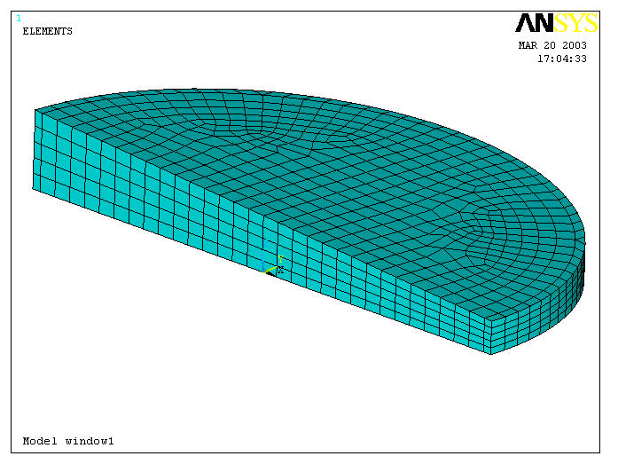
Z
Y
X

Assumptions
- The mounting flange is infinitely stiff and contains no deviation in flatness around the circumference. The O-ring is also infinitely stiff and frictionless.
- Gravity is not simulated.
- Any loads due to retaining clips or devices which compress the O-ring before the vacuum is applied are ignored.
- Thermal loads are ignored.

Boundary Conditions and loads
- Atmospheric pressure is acting on all external window surfaces (including the sides) and is 101,325Pa.
- The window is simply supported (in the Z direction only) by a ring of nodes on a diameter of 298.3mm to simulate the O-ring contact. Two other nodes were restrained in a kinematic fashion, holding the model without over-constraint.

Material Properties
- The material is assumed to be linear and isotropic.
- All properties are at room temperature, and are taken from RD 3.
- Properties are as follows:
  - Youngs Modulus: 73.1GPa.
  - Poissons Ratio: 0.17
  - Density: 2203kg/m³

Stress Results
A plot of the first principal stresses is shown below:

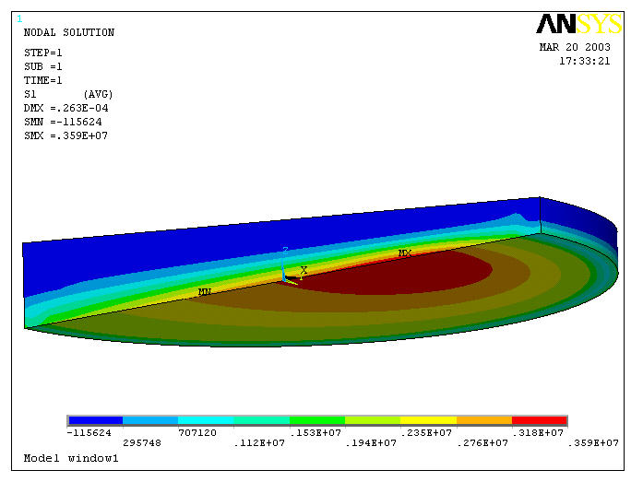

The peak stress is 3.59MPa on the vacuum side of the window. This gives a safety factor of 15 on the manufacturer’s limit load.

Damage to Window
There is a small chip in the window, on the edge between the outer face and the side at the thinner end of the window. This is shown below:

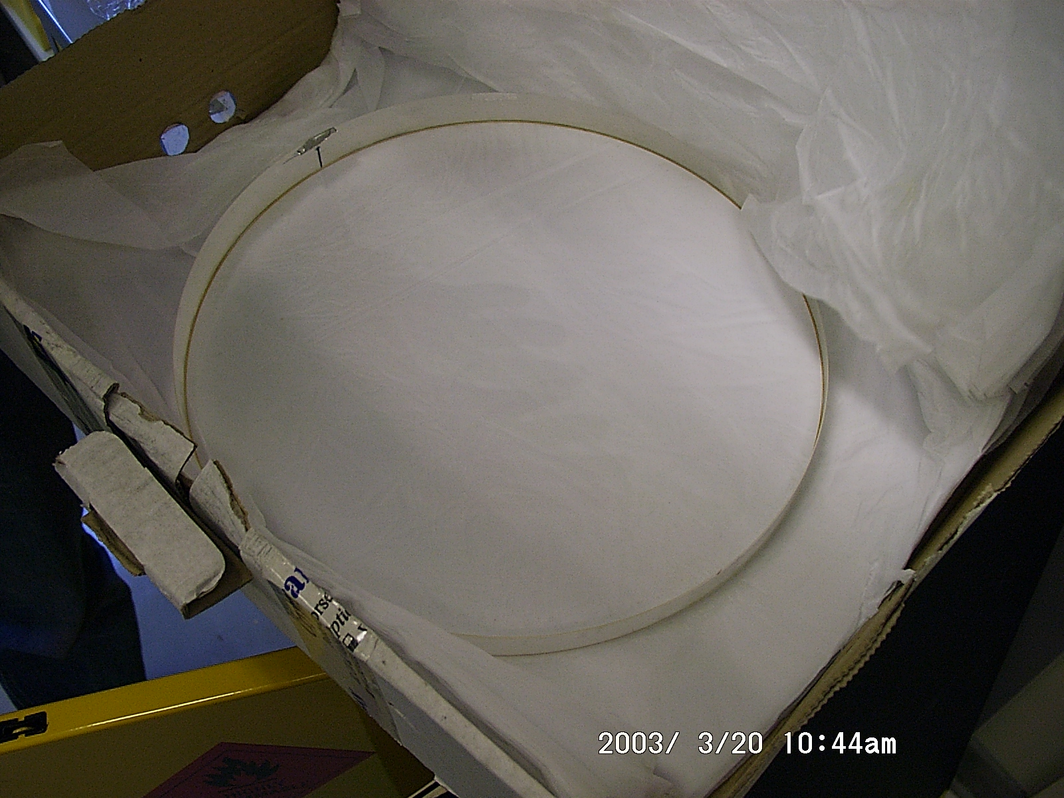

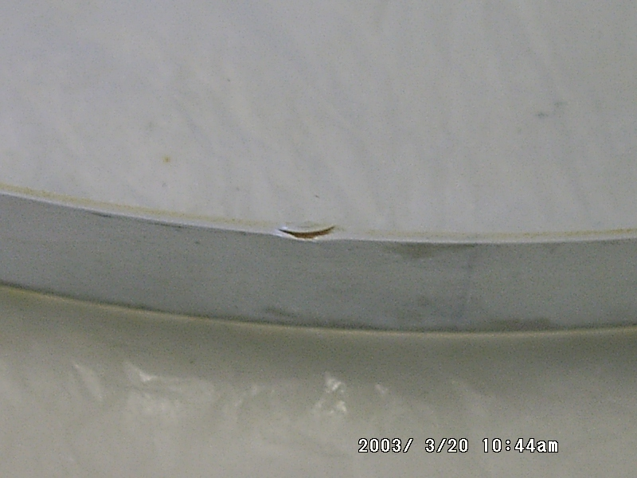

From the FEA results, this chip is in a region of low compression, so crack propagation is unlikely.

Window Lifetime and Proof Testing
The lifetime of the window under load is dependent on the initial sizes of cracks in areas subject to tensile loading (in this case, on the vacuum side of the window). It is not usually possible to inspect these cracks optically, because by the time they are large enough to observe, failure will be imminent. Inspection would also have to take place under tensile loading to visibly open up the crack.

A successful proof test can demonstrate that there are no cracks above a certain size, and relate this to a minimum expected lifetime for the window under operational conditions. Typically for a vacuum window, a proof test of several atmospheres will predict a minimum lifetime of a number of years (RD 4).

Another factor which affects crack propagation and lifetime is the presence of moisture in the air. Water reacts with glass in areas of stress (around crack tips) and results in a faster crack growth for a given stress intensity (RD 5).

Seal Analysis

Seal Description
The seal chosen for the application is a Ø5.7mm nitrile O-ring. It is to be constructed from a splicing kit supplied by RS Components (RS stock number 159-1507). Its hardness is (70 Shore A).

It is to be located in a rectangular-profile groove 4.4mm deep and 7.1mm across (AD 1). These dimensions are approximately the same as those given in the relevant British Standard (RD 6) for static face sealing under an external pressure. They assume that both faces are metallic and come into contact.

It is not retained, and compression is achieved solely by atmospheric pressure (i.e. there is no pre-compression of the seal).

Load/Compression Test
A length of the O-ring was cut approximately 12mm long and subjected to a load-compression test using a spring-mass balance and a dial gauge indicator as shown below:
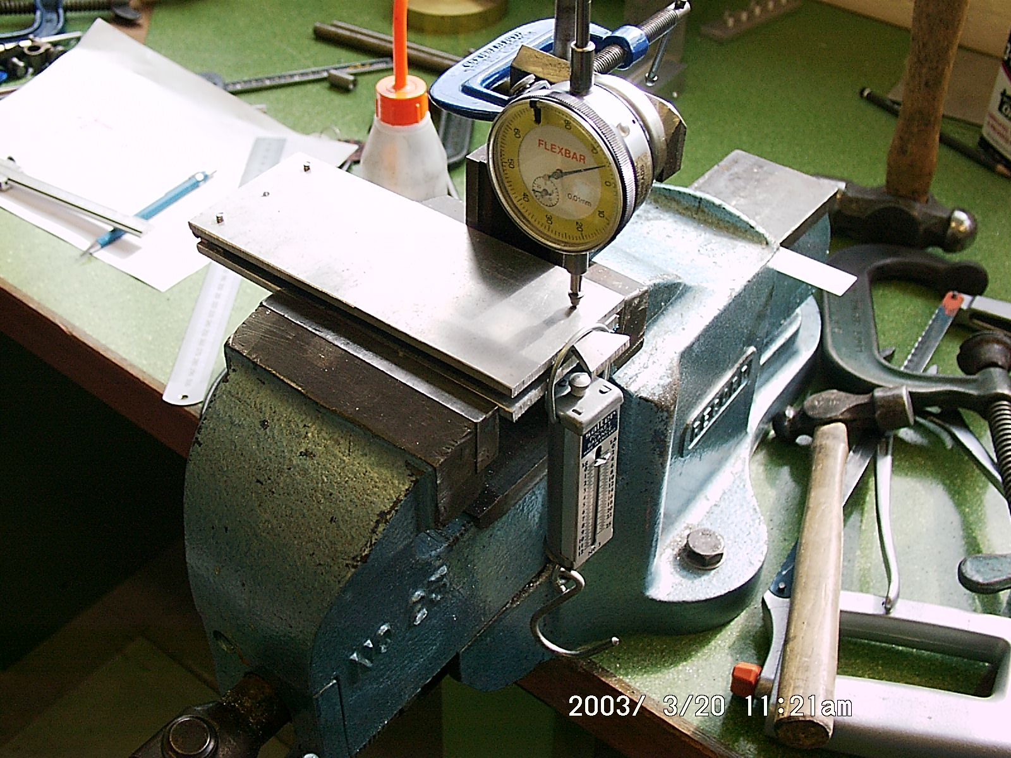
Hinge
O-ring Sample Between Plates
Dial Gauge Indicator
LOAD
Spring Balance

The resulting load (per unit length of seal) versus compression curve is shown below:

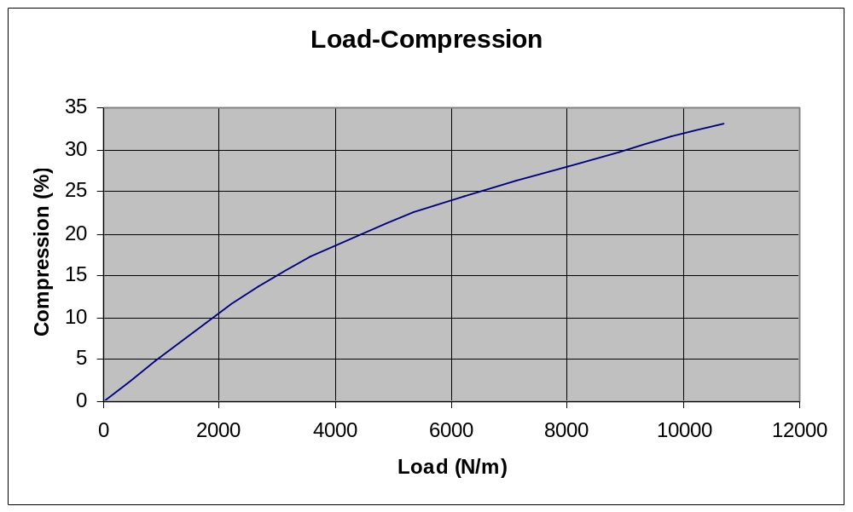

This gives an approximate Youngs Modulus of about 7.7MPa. This figure suggests the material is closer to a Shore A hardness of 80 than the quoted 70 (4-6 MPa, from RD 7).

This also means that under the load we expect to see on the cryostat window (8055N/m), the seal will compress about 28% assuming no glass-metal contact. Parker Seals (RD 8) recommend that the maximum compression for an O-ring of this size should be about 19% to avoid “compression set”, a loss of elasticity.

O-ring FEA Results

A 2-dimensional FEA model was created for the seal, simulating contact between the window, O-ring and groove, and incorporating atmospheric pressure on the exposed side of the O-ring. The result is shown below:

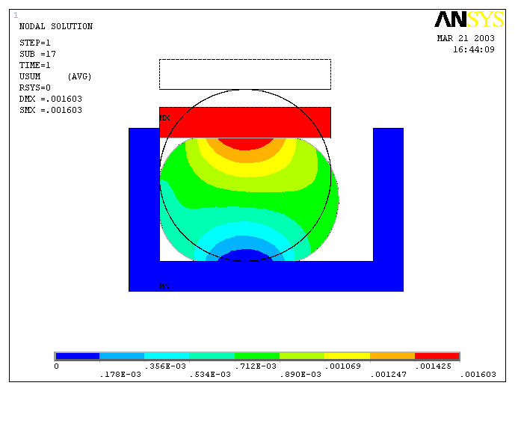
Undeformed Shape
Deformed Shape

The results show a deflection in the O-ring of about 1.6mm which would result in a direct contact between the window and the metal seat. The maximum deflection allowable in the O-ring to avoid contact (including the worst case tolerance on groove depth) is 1.2mm.

Conclusions

Window
Stresses in the window were found to be low, and not a cause for concern provided the surface finish on the surface of the vacuum side is of optical quality. The region in which the damage is located is under slight compression, and is unlikely to be a problem.

There is a small (and difficult to quantify) probability that there are already cracks large enough to cause failure in the window over its expected lifetime. The fact there is a chip suggests the part has been treated roughly, and there may be additional, less visible damage. The window has already been subjected to vacuum loading in a mount where glass-metal contact would have occurred, also possibly causing damage.

Proof testing the window at the required elevated pressure would give confidence that the window will survive through the duration of the test campaign. Without the test, the lifetime is unknown, and there is a small possibility that the window could break at any time.

Seal
The current seal is designed for metal-metal contact situations. In this case, metal-glass contact would occur which will result in high localised stresses under load. If glass-metal contact were not made (ie, the O-ring groove made shallower), the current O-ring is compressed too much under atmospheric loading and will lose elasticity.

Recommendations
- The window should be stored in an area of low humidity. When in operation, the humidity should be minimised if possible.
Deformed Shape
- A Perspex guard should be mounted in front of the window as a safety precaution.
- A new seal needs to be designed. A larger O-ring section diameter or a harder material is required. Glass-metal contact must be avoided, and total O-ring compression must be below 19%.
- The flatness of the bottom of the O-ring groove should be assessed. If there is a variation in flatness, further stresses will be introduced. Further analysis may be required if this is the case.
- When the window is mounted, it should not be in contact at any point on its side with the metal housing. This may be difficult in practice as the clearance around the window is small. It is mounted with the window axis horizontal, so unless retained or supported, it will either fall out of its housing or fall to the bottom, contacting the metal rim.
- A method of pre-compressing the O-ring is suggested, so a vacuum seal is achieved without having to rely on the pumpdown. The mechanism used for this could also act as a retainer for the O-ring and the window in the housing. Further analysis would be required to assess the effects of this on stress levels in the window.
- The possibility of performing a proof test should be investigated if full confidence in the window lifetime is required.
- A visual inspection should be made of the area where the glass-metal contact would have occurred when previously tested, to assess any obvious damage.

