Introduction
In collaboration with the HIFI team, Cardiff University is developing an absorbing coating for use in the sub-mm and far infrared. This coating is to be used on the SPIRE instrument for the suppression of unwanted radiation caused by scattering or reflection from the walls of the instrument enclosure. The coating, called ABS, was first developed at SRON (ref 1) and consists of a layer of Stycast 2850 (Catalyst 23 LV) epoxy on a thin aluminium sheet, into which silicon carbide (SiC) crystals are glued. It is these that form the absorbing surface. In this form (figure 1a and b) the material appears to be not entirely stable as the crystals are easily dislodged especially around the edges of the samples. A development of the technique, therefore, has been proposed by Cardiff university whereby a second layer of epoxy is cast over the top of the crystals to further bond them and prevent them being dislodged.

In this report I describe tests carried out on a sample provided by SRON in to the reflectivity of the material at 118.834 μm (as a baseline check); on the outgassing properties of the original SRON material and into the ability of the Cardiff modified material to survive cryogenic vibration.

The Material Samples
A sample of ABS material prepared using the method described in ref 1. and baked at 80ºc for 48 hours was delivered to RAL.

The sample consists of a 45 mm aluminium disk of thickness 1 mm (see section micrograph) onto which a layer of the epoxy of approximately 0.4 mm is laid to hold the SiC crystals, which range in size from 0.4 to 0.6 mm. The sample was weighed on receipt and found to be 9.9±0.1 g. The surface density of the material is therefore ~0.62 g cm⁻². Of the total mass, the breakdown by material is approximately as follows:

Aluminium (ρ=2.7 g cm⁻³) = 4.3 g
Stycast 2850 (ρ = 2.29 g cm⁻³) ≈ 1.4 g
SiC (ρ = 3.21 g cm⁻³) ≈ 4.2 g (the balance) – this gives an equivalent thickness of SiC of 0.8 mm

As shown in figure 1 the approximate envelope of the material thickness is about 3 mm – however due to the uneven nature of the surface it should be treated as having a thickness of 3.5 mm.
Al
Epoxy and SiC

The sample as it arrived at RAL in October 2002 is shown in figure 2a, a close up of the surface is shown in figure 2b. After the sample was measured for reflectivity (section 3) and had been assessed for its outgassing properties (section 4) it was divided in two. One half was kept as built, the other was coated with another layer of Stycast (type/catalyst?) in an attempt to bond the crystals better. This sample was then used for cryogenic vibration tests (section 5).

Reflectivity Measurements
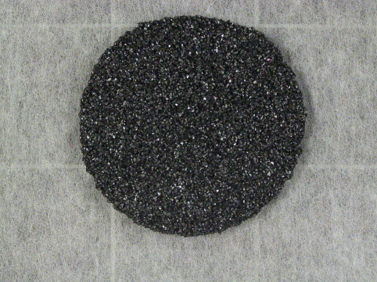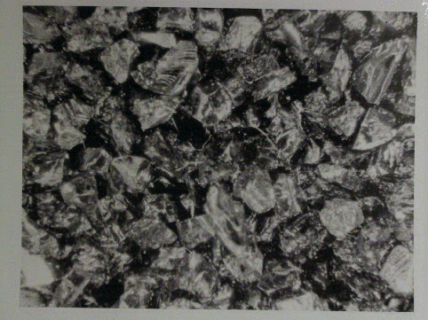

Figure 2a (left) the SRON prepared sample as it arrived at RAL. 2b (right) a micrograph of the sample surface showing the SiC crystals.
In order to provide a baseline for comparison of optical properties before and after testing, a relative measurement of the reflectivity of the SRON provided sample was made using an Edingburgh Instruments FIR laser at 118.834 μm. The test set up is shown in figure 3. The sample to be measured is placed in a rotatable holder and the signal seen in a Golay cell with the sample in the beam is compared to that seen with an unpolished piece of bare aluminium (in this case the reverse side of the sample!). The signal from the laser is stabilised and monitored using a dedicated stabilisation system as indicated in figure 3. Because the laser power is directly measured the only variable is the relative reflectivity of the sample compared to the bare aluminium reference. The bare aluminium will have a reflectivity in the FIR >90% so the power onto the Golay cell is reduced by placing calibrated attenuating filters (or sheets of printer paper!) in the beam path. With the poorly reflecting sample in the measurement position the sheets are removed so increasing the measurement range of the system. The Mylar beam splitter does not have a good reflectivity so only ~5-10% of the laser power goes into the measurement beam. Using this system, together with the gain range available on the signal amplifier, I estimate we have a measurement range of ~ few 10⁴. One can also assess the change in reflectivity as a function of the angle of the sample to the beam in this set up.

Figure 1: Sectioned sample of SRON ABS. The scale at bottom is marked at 0.5 mm intervals.
Al
SiC in Stycast

The reflectivity relative to the bare aluminium measured for the sample was 0.87%; I estimate the uncertainty on this at ±0.05. This was with the sample rotated to give maximum signal into the Golay cell (~45 degrees to the beam). The reflectivity was a weak function of the angle of the sample to the beam. This should be compared to the result in ref 2 where they found 0.14% specular reflectivity for a sample made of 1 mm SiC grains again with a weak dependence on angle. The difference in the absolute level could be explained by the different grain size or there could be some extra signal present in the RAL test set up – this will be investigated..

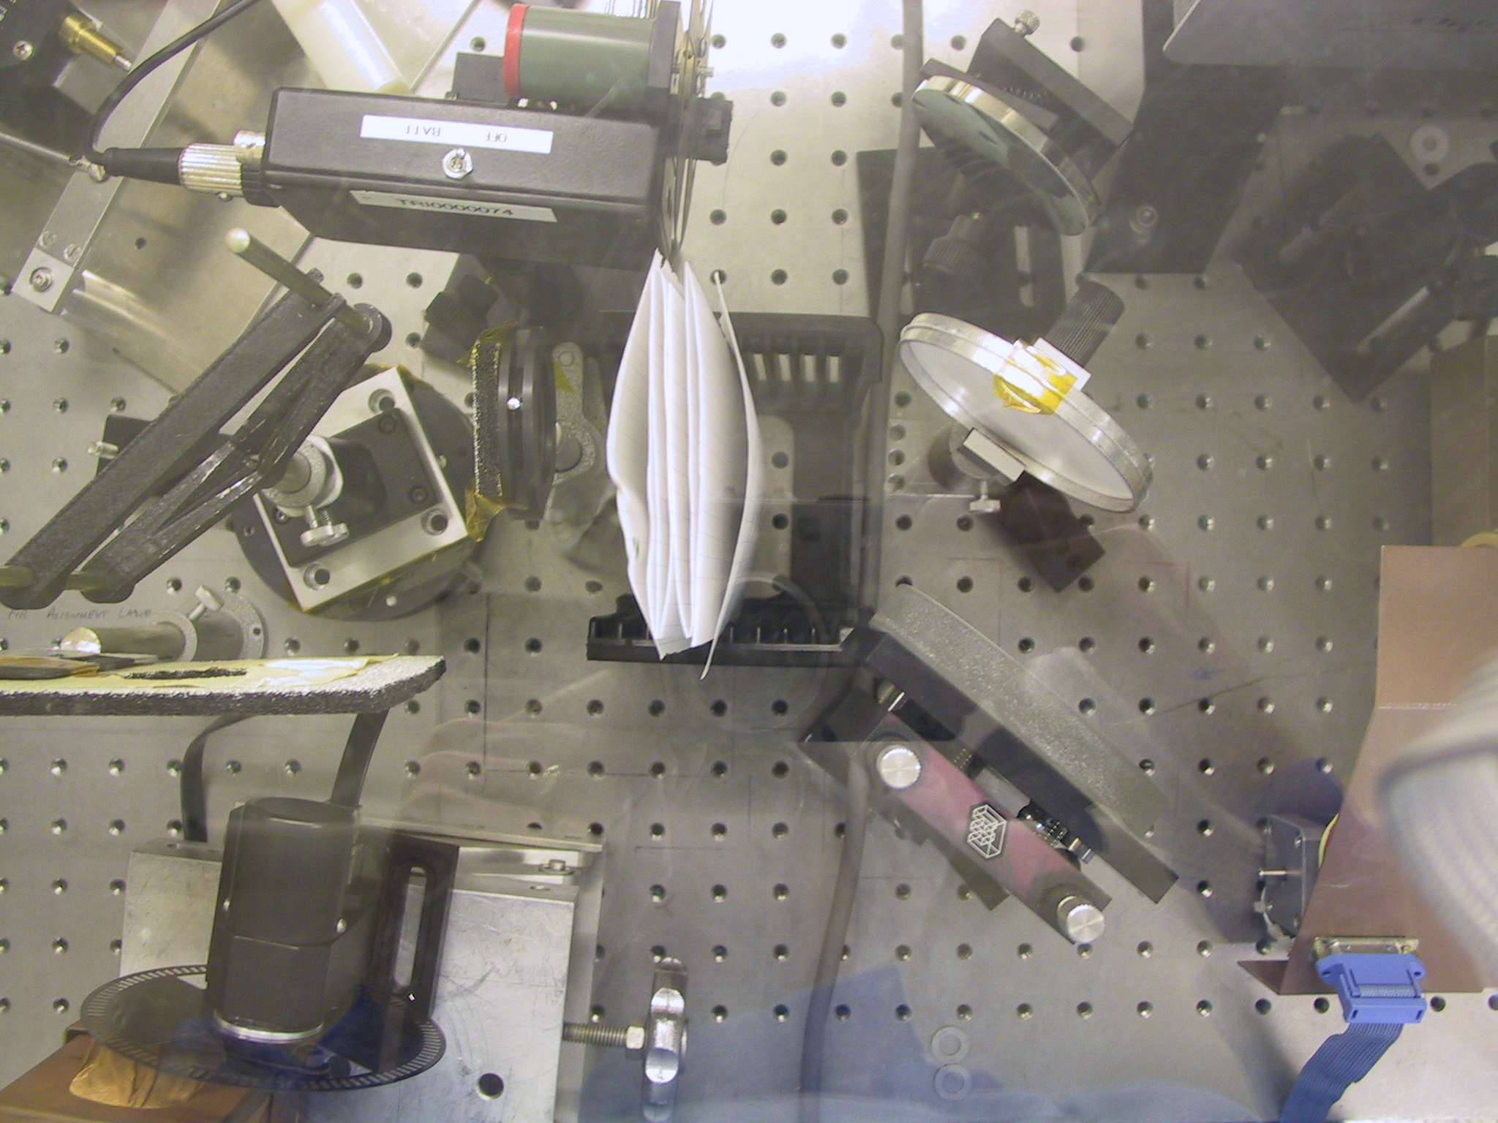
Lack of time with the laser, it resides in the same room as the main cryogenic test facility so access was limited due to the need to work on the facility, meant that I was only able to make a single measurement on this sample and did not fully asses the reflectivity as a function of angle to the beam. I will extend the wavelength range and the fidelity of the angular measurements when access permits. I will also make comparison measurements on the samples from Cardiff that are in preparation.
Beam from laser
Mylar beam splitter
Focussed beam to laser stabiliser detector
Pyrolectric detector for stabiliser
Beam to sample
Attenuating “filters”
Sample on rotating stage
Golay cell with chopper
Figure 3: Set up for the reflectivity measurements on the samples

Outgassing Assessment
It is not possible to carry out the full ECSS-Q-70-02A test using the equipment available at RAL. A sample was sent to Estec where the correct test can be carried out, however it appears that the sample was not in the correct form for the test. Never the less the equipment at RAL (see figure 4) can be used to make an assessment of the Collected Volatile Condensable Material (CVCM) by using a twin quartz crystal microbalance (TQCM) which converts surface density of material into frequency, is extremely stable and is very accurate.

The sample was placed in the chamber in contact with a copper plate which was heated using a radiation from a tungsten filament placed below the sample. The temperature of the copper plate and the sample were measured separately to ensure that the sample followed the plate accurately. The temperature, pressure and surface density measurements during the experiment are shown in figures 5a through 5c as a function of time. A 100 atomic mass unit range mass spectrometer was also fitted to chamber to monitor for any large mass (>40 a.m.u.) molecules indicating the emission complex hydrocarbons from the substance under test. No significant peaks were seen >40 a.m.u. during the whole experiment and essentially all of the pressure rise seen is accounted for by water.

The witness mirror was measured before and after the experiment using a Perkin-Elmer infrared spectrometer to look for deposited material. No difference was seen in the reflectance characteristics before and after the experiment – this is perhaps not unexpected as, if the density of the substance is ~>1 g cm⁻³ then the layer thickness is no more than 5 nm.

The total deposited surface density onto the TQCM was 5.45x10⁻⁷ g cm⁻² at the end of the experiment with the sample at ambient temperature and under vacuum. This reading did not change when the chamber was let up to atmospheric pressure leading me to assume that this represented the true CVCM from the sample – i.e. it was not due to volatiles such as water or solvents. The test conditions were not those specified in ECSS-Q-70-02A as the sample was only held above 80ºc for about 2 hours (rather than the 24 specified), but do give a reasonable indication of the nature of the substance and we should be able to compare the CVCM figures published in the literature.

If we assume that the material is evenly emitted from the surface of the sample into a hemisphere with the radius given by the distance to the TQCM then we can calculate the total mass of volatile condensable material (VCM).

Area of hemisphere = 2π(10)² = 628 cm²
Net surface density measured while sample was at >80ºc= 3.9x10⁻⁷ g cm⁻²
Total mass emitted = 2.4x10⁻⁴ g
Percentage of total mass of sample = 100*(2.4x10⁻⁴/9.9) = 0.0025%
Percentage of mass of Stycast = 100*(2.4x10⁻⁴/1.4) = 0.016%

The CVCM value for Stycast 2850 (LV23) published on the NASA website (outgassing.nasa.gov) is 0.01%. Given the uncertainty about the actual mass of the Stycast used in the sample, the result here is in broad agreement (certainly within a factor 2) with that value if perhaps somewhat higher given the shorter time used for the outgas test. The value for absorber as an integrated whole is what is of interest and this, even given the non-standard nature of the test, is well within the limits prescribed for space materials.

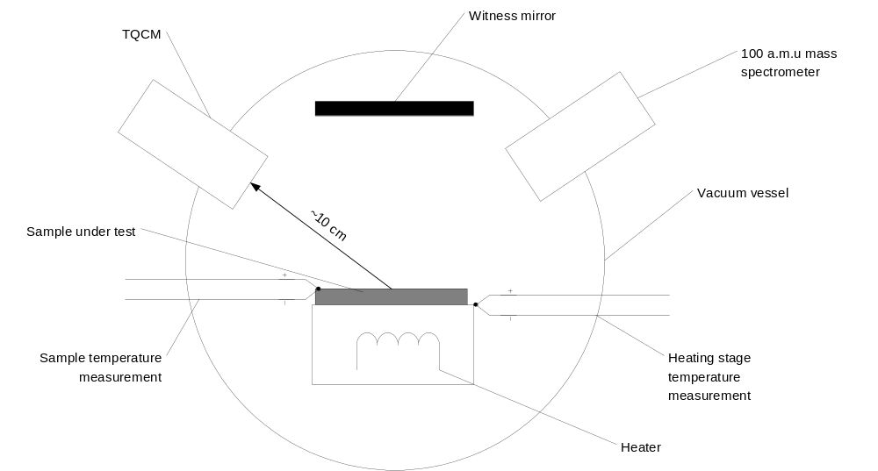

Figure 4: General configuration of the outgassing test set up.

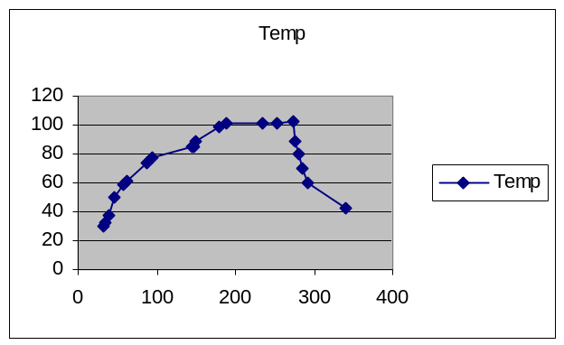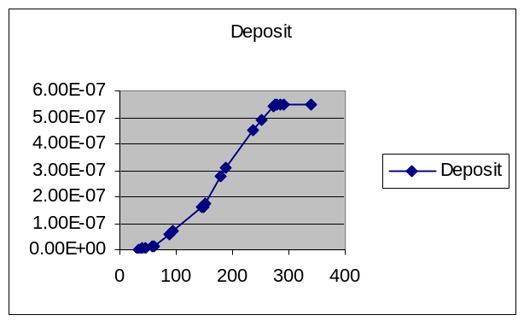
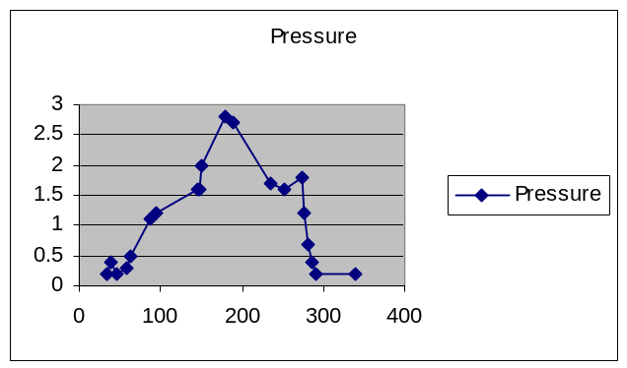
Figures 5a to c (clockwise) showing temperature of the sample (in degrees centigrade); deposited material on the TQCM (in g/cm²) and pressure (in 10⁻⁶ mBar) as a function of time during the outgas experiment. Time is in minutes.

Cryogenic Vibration Test
An opportunity to vibrate an absorber sample at cryogenic temperature (<90 K) was given by the testing of the PACS and SPIRE STM coolers at RAL. The coating as supplied by SRON was not suitable for vibration as SiC crystals were easily dislodged – especially at the edges - and a vibration test in which we were looking for shedding of particles would have been compromised. We therefore proceeded by applying a thin coating of Stycast 2850 to the surface of one half of the SRON sample. This was glued onto the lid of a standard die cast box using Scotch Weld 2216 (figure 6). The bottom of the die cast box was lined with double sided adhesive tape to catch any particles that might fall off during vibration. The second half of the box was used to take a prototype SPIRE calibration source.

The vibration test carried out on the box is reported as part of the cooler STM test report (ref 3). The box saw levels commensurate with the qualification levels for sub-systems on the SPIRE optical bench at a temperature of 89 K. No particulates were observed on the adhesive tape before or after the vibration test and there is no evidence of cracking or peeling of the layer. Figure 7 shows the sample after vibration
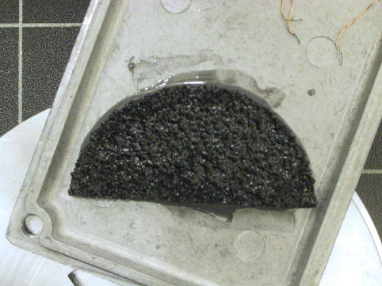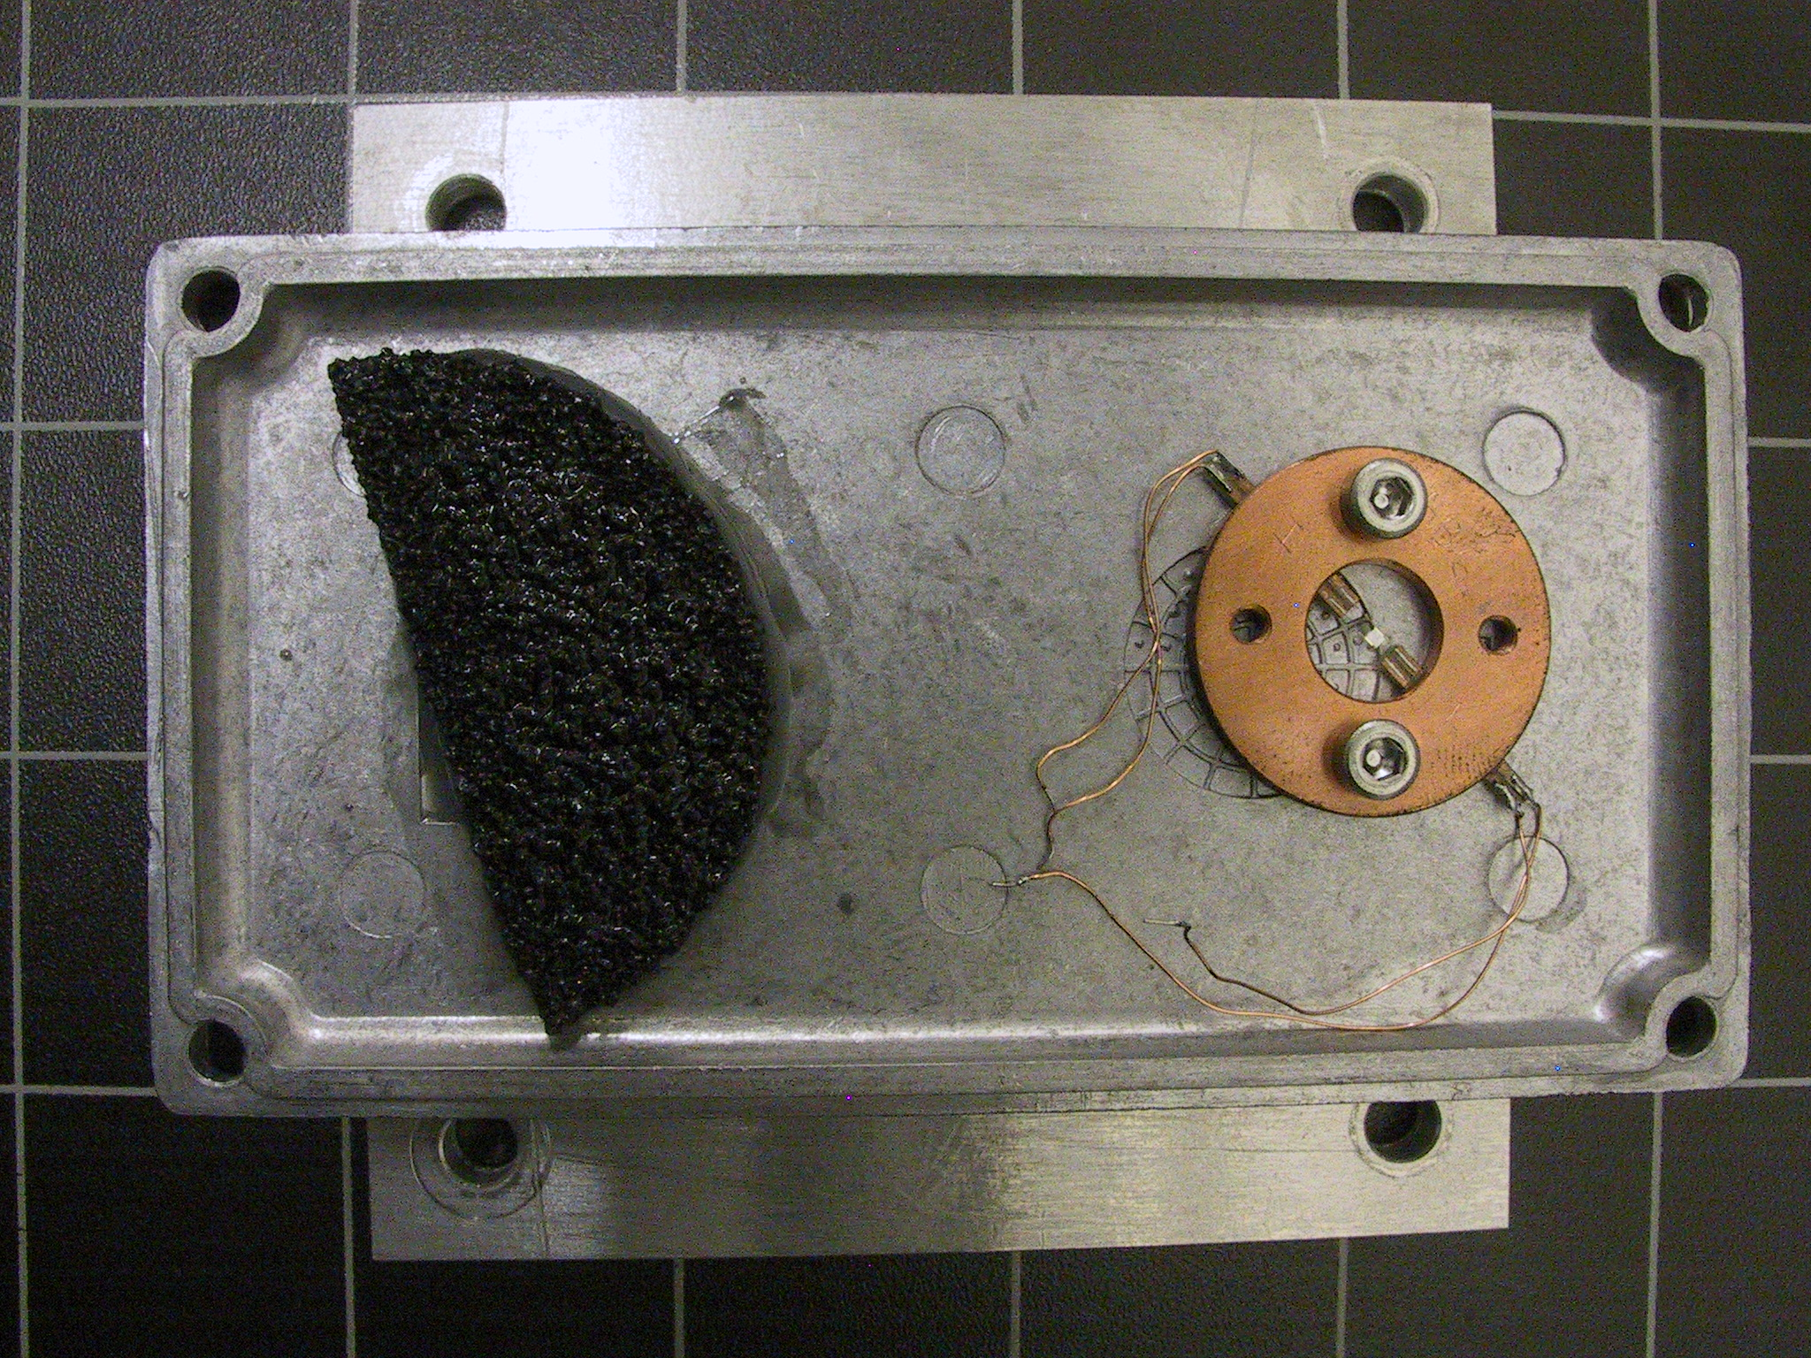
Figure 6: The modified ABS sample as fitted to the vibration fixture before vibration. The copper coloured item is a prototype SPIRE calibration source.
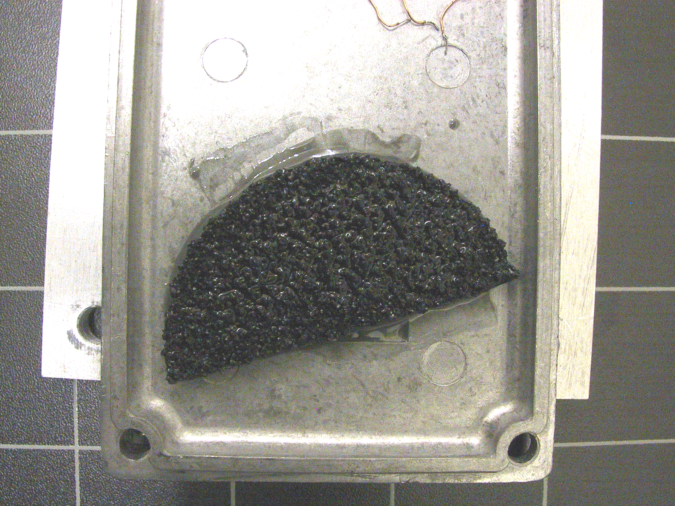
Figure 7: The modified ABS sample after cryogenic vibration

Conclusions
The initial tests carried out at RAL on the SRON and modified SRON absorber samples show that it should be suitable for use at cryogenic temperatures in the Herschel instruments. In particular we have shown:

- We have a method of measuring the reflectivity that can be used for comparing between different samples. The reflectivity measured of the SRON sample was somewhat higher than obtained in measurements at Delft (on a different material) and the measurement system needs to be looked at again. It is certainly sufficient for relative measurements but we may need to improve the reference if it is to be used for absolute measurements.
- A simple outgassing measurement indicates that the properties of the SRON prepared sample are essentially the same as the epoxy used in the manufacture, which is already approved for space use.
- A modification to the SRON provided sample has been carried out to ensure that the crystals are firmly held in place. This modified coating has been subjected to full qualification vibration tests at cryogenic temperatures and no particulate contamination was seen.
- The method of attaching the absorbing layer to the SPIRE structure has been tested. The absorbing layer will be applied to aluminium carriers and glued in place using Scotch Weld 2216. This was the method employed for the cryogenic vibration test.

Further work is needed to fully qualify the absorber:

- New samples are required constructed with the additional Stycast layer over the SiC crystals – these will be prepared by Cardiff University.
- These shall be measured for reflectivity compared to the original and, if possible, compared to an absolute reference.
- These samples shall undergo the correct cleaning and bakeout procedure for sub-systems within the SPIRE FPU. The reflectivity will be measured before and after.
- The clean samples will be subjected to a more rigorous outgas test – we can attempt to get closer to the approved procedure using RAL equipment, or we will find a test house that can do the test on the samples as they are to be used in SPIRE
- The samples will undergo a further cryogenic vibration test after being attached to the vibration fixture using the method to be employed for the SPIRE FPU.

Once this is done we will attach small test pieces to the SPIRE STM structure before it goes to CSL for cold vibration testing. This test will be the final qualification of the absorber and attachment method before committing to the flight model.

References
Ref 1. Fabricage- en kwalificatieplan voor de 500 µm SiC stycast absorbing coating – HIFI Note FPSS-00300 – Wildeman and Jasper October 2002 (In Dutch)
Ref 2. Sub-millimetre absorbing coatings for HIFI – HIFI Note FPSS-0017 – Klaasen et al December 2000 (In English)
Ref 3. HERSCHEL : SPIRE/PACS SORBTION COOLERS Vibration Test Report – RAL SSTD report AIV-2002-107-VIB

