INTRODUCTION
After delivery of the Herschel instruments to industry they will be integrated on to the payload/spacecraft and tested as part of the verification activities of the integrated system. Instrument testing requires the participation of the instrument teams in order to verify the correct operation of their instrument and to do this they will use a set of equipment delivered and integrated into the system-level test system. This equipment has been labelled the ’Instrument Station’ in earlier documentation, even though it will consist of several workstations and associated peripherals. To clarify this situation, the equipment is now called the Instrument EGSE (IEGSE).

In order to be consistent with the philosophy of smooth transition between mission phases, the IEGSE will be based on the instrument–level EGSE used by the instrument teams for testing their instruments before delivery to industry. As the three instrument teams are already using identical EGSE systems for these tests it is thought sensible to provide a common Instrument EGSE for the Integrated System Tests (IST) based on this design. This has the added benefit that the total amount of equipment to be delivered may be reduced.

Industry (TERMA) have provided a description (see AD01, AD02) of the Central Checkout System (CCS), which will be used for the Integrated System Tests, which describes the interface between the CCS and IEGSE in general terms. The detailed interface specification is given in AD03. This note describes the configuration of the Herschel common Instrument EGSE proposed for use in the IST, its interfaces to the CCS and the deliverables that will be made. This configuration is based on the proposed CCS-IEGSE interface described in RD01.

This is the first draft for comments. Please let me know where I have misunderstood/misrepresented or missed out anything. Those statements that I believe need to be confirmed are coloured.

Documentation

Applicable Documents
AD01 | Central Checkout System, System Design Document – Software  (H-P-4-TE-DD-2010), Issue 1.0, 20th May 2002
AD02 | Central Checkout System, System Design Document – Hardware  (H-P-4-TE-DD-2020), Issue 1.0, 13th May 2002
AD03 | EGSE Interface Requirements Specification  (H-P-ASPI-IS-0121), Issue 03, 18th June 2002

Reference Documents
RD01 | Role of Instrument EGSE at System Level (TOS-EMG/2002.1061/bm),  3rd July 2002
RD02 | SPIRE EGSE for ILT, TBW

IST configuration
Figure 2.1 shows the configuration of the components of the Instrument Station for IST. This is similar to that used for the instrument-level tests (RD01), except that an additional component is introduced to handle the interface with the CCS component of the system-level test system (PIPE Interface) and additional functionality is introduced into the HCSS component to handle parameter requests from the CCS.

PIPE Interface
This component interfaces to the CCS using the PIPE protocol (RD02). It handles three types of interaction:
- Connection and setup of the interface.
- Reception of telemetry packets from the CCS and their transport to the IEGSE Router, which distributes them to the rest of the IEGSE.
- Reception of requests from the CCS for the values of parameters to be inserted into the command sequences, which are sent to the instrument. These requests are passed to the HCSS, which returns the values required and these are passed on to the CCS.

HCSS
This component is used in the instrument–level test EGSE to generate the command sequences related to an observation. While generating these, the HCSS creates a new observation instance and prepares the database to accept the telemetry data generated when the command sequences are executed.

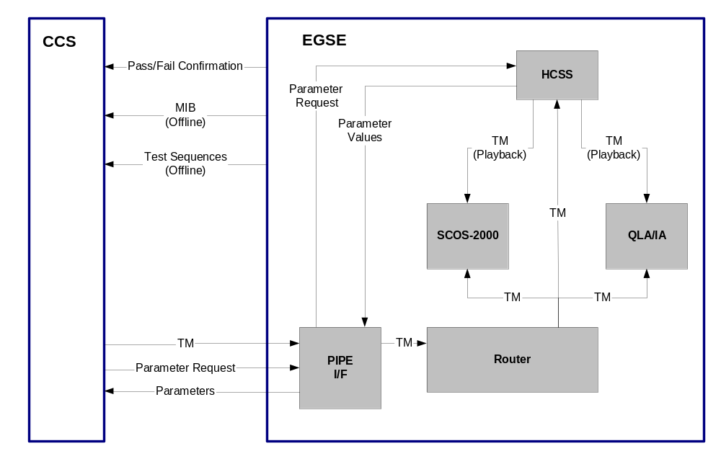The additional functionality of this component for IST operation is to create a new observation instance from the request for parameters received from the CCS and to return the parameters requested from that observation instance.

Hardware Configuration
Figure 2.2 shows the hardware configuration for IST. Two complete IEGSE systems will be provided. One is operated in real time during the testing, while the other may be used for analysis of previous test results and acts as a backup for the operational system.

6 different items are identified:

- SCOS workstation – used primarily to run the SCOS-2000 software. This will be a PC running Linux with a dual display card driving two displays. The specification is defined in RDxxx
- Analysis workstation – used to run the instrument analysis software (QLA/IA/PCSS). This will be a PC running Linux with a dual display card driving two displays.
- Data Server – used primarily to run the HCSS software. This will be a PC running Linux with a single display and large disk drives with backup facility (to tape/CD TBD)
- Colour laser printer
- LAN switch - protects the Operational System from the Analysis System allowing access to the external internet from the Analysis System
- Laptops – used to run instrument specific analysis tools. These are not provided as part of the EGSE but may be used by instrument experts as necessary during testing.
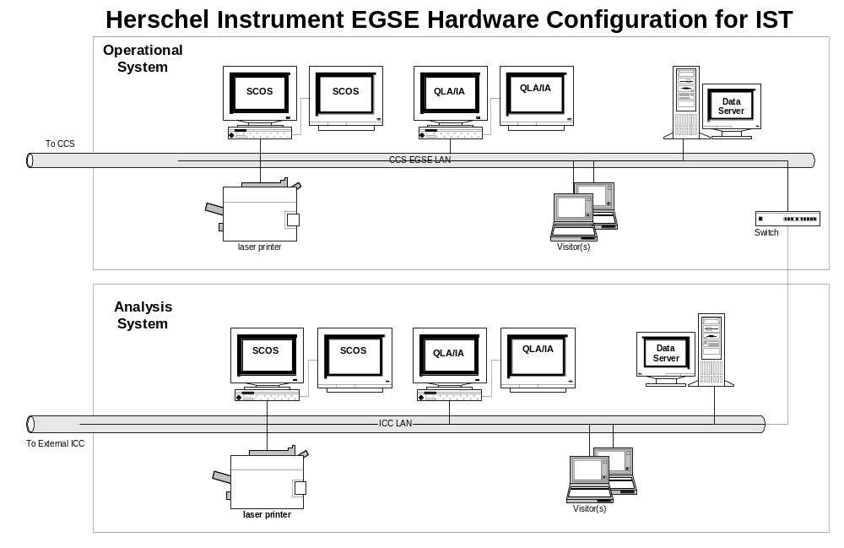

Software Configuration
Figure 2.3 shows the software components, which run on each piece of hardware in the Instrument EGSE
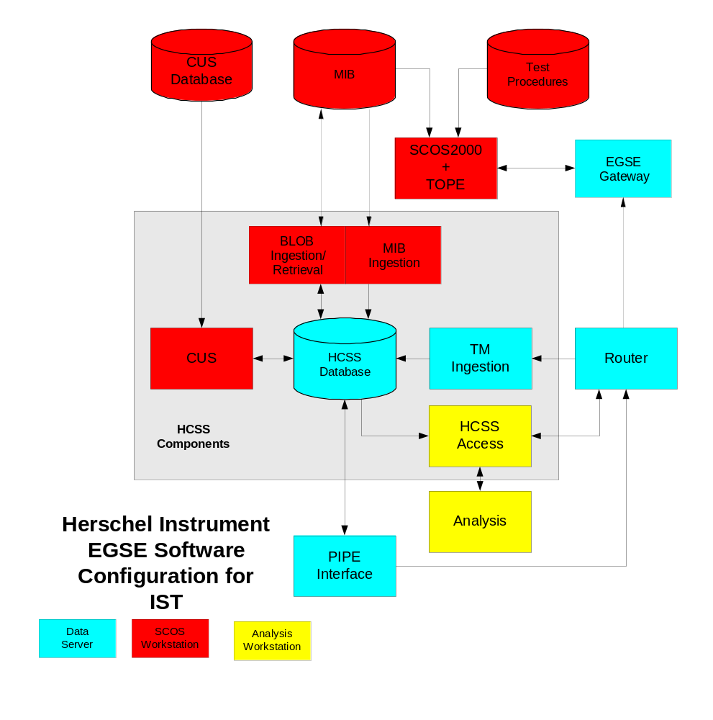

Deliveries
- A single delivery of the IEGSE will be made before the first Integrated System Test to allow time for integration with the CCS. The date of this delivery is TBD.

- This equipment will be relocated, by industry, as necessary to continue tests on all the delivered instrument models. Instrument teams will not be responsible for relocation of the equipment, but will provide support for checking the operation of the instrument EGSE after each relocation, if necessary.

- The instrument teams will be responsible for maintenance of the IEGSE systems after delivery.

To Industry
This section describes the items that will be delivered to industry as the IEGSE.

Item | Title | Description
IE-DS-01 | Data Server 1 | PC running Linux, one Display, keyboard, mouse
IE-DS-02 | Data Server 2 | PC running Linux, one Display, keyboard, mouse
IE-AN-01 | Analysis 1 | PC running Linux, two Displays, keyboard, mouse
IE-AN-02 | Analysis 2 | PC running Linux, two Displays, keyboard, mouse
IE-SC-01 | SCOS 1 | PC running Linux, two Displays, keyboard, mouse
IE-SC-02 | SCOS 2 | PC running Linux, two Displays, keyboard, mouse
IE-PR-01 | Printer 1 | Colour Laser Printer, Type TBD
IE-PR-02 | Printer2 | Colour Laser Printer, Type TBD
IE-SW-01 | Switch | LAN Switch

From Industry
- Industry will be responsible for providing consumables (printer paper, ink, tapes, CDs) used by the IEGSE

- Industry will be responsible providing a high speed access point to the internet.

- Industry will provide a simulator of the CCS to enable testing of the interface between the CCS and IEGSE. This simulator should:

  - Simulate the connection with the CCS
  - Simulate the protocol necessary to connect to and set up the IEGSE interface
  - Provide telemetry packets corresponding to an instrument executing a command sequence in a test procedure
  - Provide parameter requests corresponding to command sequences in a test procedure
  - Accept parameter values corresponding to the request made to the IEGSE

