Tipo Doc.:  Doc.Type: | REPORT SPIRE-CGS-REP-001294 |  |  |  |  | N° DRD:  DRD N°: | N.A.
N° Doc.:  Doc. N°: | DPU-RP-CGS-031 | Ediz.:  Issue: | 1 | Data:  Date: | 24/04/2002 |  | Pagina  Page | 1 | Di  Of | 69
Titolo :  Title : | EM DC/DC CONVERTER BOARD (SPIRE VERSION) P/N DPU-EM-300.00-0 S/N 03 ELECTRICAL AND FUNCTIONAL TEST REPORT

 | Nome & Funzione  Name & Function | Firma  Signature | Data  Date |  | LISTA DI DISTRIBUZIONE  DISTRIBUTION LIST | N | A | I
Preparato da:  Prepared by: | FIRST-DPU TEAM |  |  |  | Interna / Internal
 |  |  |  |  | Francini E. (PA/QA)  Sciortino A. (DT/EE)  Longoni A. (DP/PL)  Vucetich L. (DT/EE) | 1  1  1  1 | X  X  X  X
Approvato da:  Approved by: | Francini E. (PA/QA)  Di Gioia L. (PC/CC)  Sciortino A. (DT/EE)
Applicazione autorizzata da:  Application authorized by: | Longoni A. (DP/PL) |  |  |  | Esterna / External
 |  |  |  |  | Orfei R. (CNR-IFSI) | 1 | X
Customer / Higher Level Contractor
Accettato da:
Accepted by:
Approvato da:
Approved by:
N=Numero di copie A=Applicazione I=Informazione
N=Number of copy A=Application I=Information

Gestione documenti:
Data Management:
Gestione documenti:  Data Management: | Firma / Signature Data / Date |  | File: | 0000.doc

REGISTRAZIONE DELLE MODIFICHE / CHANGE RECORD
EDIZIONE  ISSUE | DATA  DATE | AUTORIZZAZIONE  CHANGE AUTHORITY | OGGETTO DELLA MODIFICA E SEZIONI AFFETTE  REASON FOR CHANGE AND AFFECTED SECTIONS
1 | 24/04/2002

LISTA DELLE PAGINE VALIDE / LIST OF VALID PAGES
PAGINA  PAGE | EDIZIONE  ISSUE | PAGINA  PAGE | EDIZIONE  ISSUE | PAGINA  PAGE | EDIZIONE  ISSUE | PAGINA  PAGE | EDIZIONE  ISSUE | PAGINA  PAGE | EDIZIONE  ISSUE
1 - 69 | 1

TABLE OF CONTENT

1. SCOPE 6
2. documents 7
2.1 applicable documents 7
2.2 reference documents 7
3. acronyms 8
4. participants required 9
4.1 general 9
4.2 responsibility 9
4.3 qa witness of test and sign-off 9
4.4 Non conformance and failures 9
4.5 calibration requirements 9
5. test article 10
5.1 description 10
5.1.1 pin function 11
5.2 test matrix 14
6. test configuration 15
6.1 requirements cross reference 15
6.2 tests applicability 15
7. INSTRUMENTATION AND TEST EQUIPMENT 16
8. test condition 18
9. Test data sheets 18
9.1 data sheets filling up 18
ISOLATION VERIFICATION 21
10. test procedure variation sheets 50
PROCEDURE VARIATION SHEET ref. N°: 01 50
PROCEDURE VARIATION SHEET ref. N°: 02 51
PROCEDURE VARIATION SHEET ref. N°: 03 52
11. ANNEX TO THE PROCEDURE 53
11.1 ANNEX 1: Test set up for input impedance measurement 53
11.2 ANNEX 2: POWER BUS IMPEDANCE 54
11.3 ANNEX 3: TEST SET UP FOR CONDUCED EMISSION FREQUENCY DOMAIN DM 55
11.4 ANNEX 4: LIMIT FOR CEP-DIFFERENTIAL MODE 56
11.5 ANNEX 5: TEST SET UP FOR CONDUCED EMISSION FREQUENCY DOMAIN CM 57
11.6 ANNEX 6: NB CE POWER LINES-COMMON MODE 58
11.7 ANNEX 7: TEST SET UP FOR CONDUCED EMISSION TIME DOMAIN 59
11.8 ANNEX 8 Inrush current 26v (f5.9) 60
11.9 annex 9 inrusch current 29v ( f5.5) 61
11.10 annex 10 input impedance (f6.3) 62
11.11 annex 11 ce input power line d.m. ambient noise (f12.3) 63
11.12 annex 12 ce input power line d.m. positive line (f12.4) 64
11.13 annex 13 ce input power line d.m. negative line ambient noise (f12.7) 65
11.14 annex 14 ce input power line d.m. negative line (f12.8) 66
11.15 annex 15 ce input power line c.m. ambient noise (f13.3) 67
11.16 annex 16 ce input power line c.m. (f13.4) 68
11.17 annex 17 current ripple positive input power line (f14.4) 69
11.18 annex 18 current ripple return input power line (f14.6) 70
10mA/div 70
12. conclusions 71

LIST OF TABLES

Tab. 5-1 DC-DC Converter board: P1 pin function 12
Tab. 5-2 DC-DC Converter board: P2 pin function 13
Tab. 5-3 TEST MATRIX 14
Tab. 6-1 REQUIREMENTS CROSS REFERENCE 15
Tab. 7-1 INSTRUMENT LIST 17

LIST OF FIGURES

Fig. 5-1 DC/DC Board functional diagram (“DPU+PL version”) 11

SCOPE

The aim of the present document is to provide a detailed test report of EM DC/DC BOARD P/N DPU-EM-300.00-0 S/N 03 (SPIRE version) to be used to supply the Data Processing Units (DPU version) developed in the framework of the HSO/FIRST program.

The test to be performed according to the Test Procedure [AD 6] are to demonstrate the compliance of the above item to the requirements specified in the applicable document as part of the overall verification program.
For the “DPU version” of the DC/DC converter board, only test applicable to “DPU version” must be considered.

documents

applicable documents
[AD1]: CNR.IFSI.2000TR01 "Documento di Specifiche Tecniche per il Contratto delle Data Processing Units del Satellite First dell'ESA" IFSI (Issue: 1 - 15/09/2000)
[AD2]: Technical proposal CGS (Ref. S9-030 November 99)
[AD3]: “Allegato Tecnico al Contratto ASI"
[AD4]: Product Assurance Plan for the FIRST DPU (DPU-PL-CGS-001 Issue 1 Jan. 2001)
[AD5]: DC/DC Board Specification DPU-SP-CGS-004-Iussue 1 dated May 21st 2001
[AD6]: EM/QM/FM DC/DC Converter Board Electrical and Functional Test Procedure DPU-PR-CGS-003-Issue 1 dated Feb. 04st 2002

reference documents
[RD1] - FIRST/Planck Instrument Interface Document Part A. (Ref. SCI-PT-IIDA-04624 Issue-Rev. No. : 1/1)
[RD2] - FIRST/Planck Instrument Interface Document Part B - Instrument “HIFI” (Ref. SCI-PT-IIDB/HIFI-02125 Issue-Rev No. : 1/0)

acronyms
AD | Applicable Document Number
BB | Broadband
CE | Conducted Emission
C.I. | Configuration Item. Also called Part Number (P/N)
CGS | Carlo Gavazzi Space
CS | Conducted Susceptibility
DPU | Data Processing Unit
EMC | Electro-Magnetic Compatibility
EMI | Electro-Magnetic Interference
FIRST | Far Infra-Red and Sub-millimeter Telescope
FPU | Focal Plane Unit
FCU | Focal Control Unit
GND | Ground
HIFI | Heterodyne Instrument for First
HK | House Keeping
ICD | Interface Control Document
ICU | Instrument Control Unit
IID | Instrument Interface Document
I/F | Interface
LCL | Latching Current Limiter
NA | Not Applicable
NB | Narrowband
OCP | Over-Current Protection
OVP | Over-Voltage Protection
P/N | Part Number. Also called Configuration Item C.I.
PA | Product Assurance
PACS | Photoconductor Array Camera and Spectrometer
PDU | Power Distribution Unit
PL | Payload
PVS | Procedure Variation Sheet
QA | Quality Assurance
RD# | Reference Document Number
RE | Radiated Emission
RS | Radiated Susceptibility
RTN | Return Line
S/C | Spacecraft
S/N | Serial Number
SPIRE | Spectral and Photometric Imaging receiver
TBC | To Be Confirmed
TBD | To Be Determined
TM/TC | Telemetry & Tele-command
uut | Unit Under Test

participants required

general
All test will be performed under QA surveillance in accordance with, and following detailed procedure of applicable PA Plan. Start of the Test shall be notified to Prime Contractor and/or Customer as applicable.

responsibility
The technical responsibility for testing and test results is up to the Engineering department.

QA is responsible for ensuring that all the agreed procedures are carefully observed, that test equipment and instrumentation used during testing is calibrated and within validity date: that the test data sheets are recorded in the Test Report and signed by the operators and QA witnesses, that all non conforming condition and test results are properly documented and notified to the Prime Contractor, and that all requirements of applicable PA Plan, specification and Statement of Work pertaining to the acceptance tests, are fully satisfied.

qa witness of test and sign-off
QA inspector, or its delegate, shall witness the tests described in this procedure in accordance to the requirement specified in the applicable PA Plans.

Non conformance and failures
Any malfunction/defect which occurs during the test will be processed along the Non Conformance Procedure described in the applicable PA Plans.

calibration requirements
All instruments used for testing shall be calibrated.

Evidence of certification shall be provided by a label attached to the instruments itself, showing the calibration date, the expiring date and the signature of the operator.

test article
The test article consists as in following table:

Item | Model | Remarks | P/N | S/N
DC/DC converter SPIRE | EM | DPU Version | DPU-EM-300.00-0 | 03

Before starting the test, the P/N and S/N of the test article(s) to be tested shall be recorded on the step-by-step procedure sheets under the table cell “UNIT UNDER TEST”.

description
The DC/DC board (Push-Pull topologies) must provide a set of supply voltages for to the DPU internal electronics of the payload experiments HIFI, PACS and SPIRE. For the payload experiment HIFI only, the DC/DC board must provide a further external set of supply voltages for the HIFI/FCU unit.
Therefore the board must provide, considering the DPU+PL version, the following two sets of output voltages:
- “DPU-Outputs” to supply the DPU internal electronics
- “PL-Outputs” to supply the payload instrument HIFI/FCU unit.
In the DPU version only the DPU-Outputs shall be provided.

DPU-Outputs and PL-Outputs shall be isolated from primary power side and from each other ( except for DPU RTN output that are connected together at board side) as described in [AD5].
The DC/DC board shall switch on automatically when the input voltage is within the range established in [AD5].

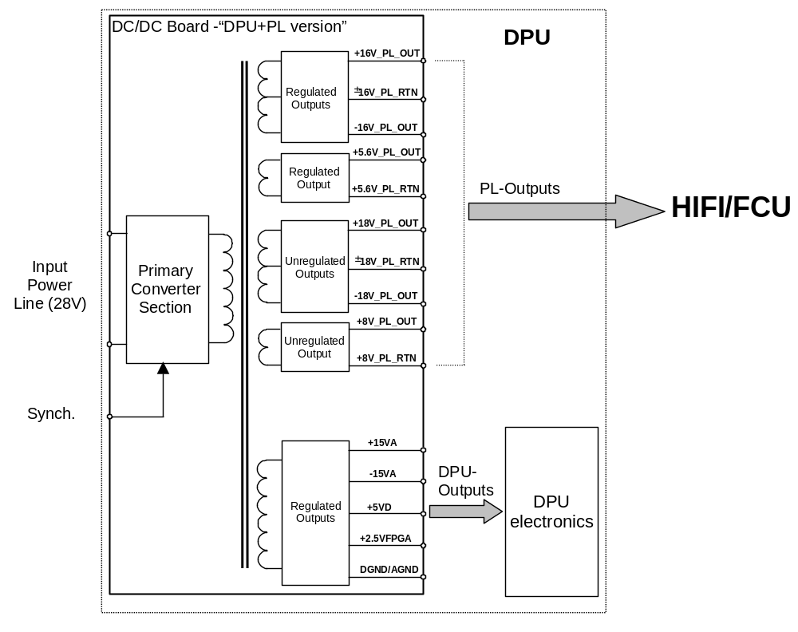
Fig. 5-1 DC/DC Board functional diagram (“DPU+PL version”)

pin function
In the following tables the pin function of the board is reported

Pin # | Signal | Pin # | Signal | Pin # | Signal
1 | +5VD | 33 | +5VD | 65 | +5VCORE
2 | +VEEPROM | 34 | +2.5VFPGA | 66 | +5VCORE
3 | +VFIFO | 35 | +5VBU61582 | 67 | NOT USED
4 | NOT USED | 36 | +VIFMEZZ | 68 | NOT USED
5 | NOT USED | 37 | NOT USED | 69 | NOT USED
6 | NOT USED | 38 | NOT USED | 70 | NOT USED
7 | NOT USED | 39 | NOT USED | 71 | NOT USED
8 | NOT USED | 40 | NOT USED | 72 | NOT USED
9 | NOT USED | 41 | NOT USED | 73 | NOT USED
10 | NOT USED | 42 | NOT USED | 74 | NOT USED
11 | NOT USED | 43 | NOT USED | 75 | NOT USED
12 | NOT USED | 44 | NOT USED | 76 | NOT USED
13 | NOT USED | 45 | NOT USED | 77 | NOT USED
14 | NOT USED | 46 | NOT USED | 78 | NOT USED
15 | NOT USED | 47 | NOT USED | 79 | NOT USED
16 | NOT USED | 48 | NOT USED | 80 | NOT USED
17 | DGND | 49 | NOT USED | 81 | DGND
18 | BONDING | 50 | BONDING | 82 | BONDING
19 | BONDING | 51 | BONDING | 83 | BONDING
20 | NOT USED | 52 | NOT USED | 84 | NOT USED
21 | NOT USED | 53 | NOT USED | 85 | NOT USED
22 | NOT USED | 54 | NOT USED | 86 | NOT USED
23 | NOT USED | 55 | NOT USED | 87 | NOT USED
24 | NOT USED | 56 | NOT USED | 88 | NOT USED
25 | NOT USED | 57 | NOT USED | 89 | NOT USED
26 | NOT USED | 58 | NOT USED | 90 | NOT USED
27 | NOT USED | 59 | NOT USED | 91 | NOT USED
28 | NOT USED | 60 | NOT USED | 92 | NOT USED
29 | -15VA | 61 | -15VA | 93 | -15VA
30 | AGND | 62 | AGND | 94 | AGND
31 | +15VA | 63 | +15VA | 95 | +15VA
32 | DGND | 64 | DGND | 96 | DGND
Tab. 5-1 DC-DC Converter board: P1 pin function

Pin # | Signal | Pin # | Signal | Pin # | Signal
1 | +28V | 33 | +28V | 65 | +28V
2 | NOT USED | 34 | NOT USED | 66 | NOT USED
3 | +28V_RTN | 35 | +28V_RTN | 67 | +28V_RTN
4 | NOT USED | 36 | NOT USED | 68 | NOT USED
5 | SYNCH_MAIN+ | 37 | SYNCH_MAIN+ | 69 | SYNCH_MAIN+
6 | SYNCH_MAIN- | 38 | SYNCH_MAIN- | 70 | SYNCH_MAIN-
7 | SYNCH_RED+ | 39 | SYNCH_RED+ | 71 | SYNCH_RED+
8 | SYNCH_RED- | 40 | SYNCH_RED- | 72 | SYNCH_RED-
9 | NOT USED | 41 | NOT USED | 73 | NOT USED
10 | INCUR_MNT | 42 | +5V_MNT | 74 | +15V_ MNT
11 | RTN_MNT0 | 43 | RTN_MNT1 | 75 | RTN_MNT2
12 | -15V_MNT | 44 | +TEMP_MNT | 76 | AINP5
13 | RTN_MNT3 | 45 | RTN_MNT4 | 77 | RTN_MNT5
14 | AINP6 | 46 | NOT USED | 78 | NOT USED
15 | RTN_MNT6 | 47 | AGND | 79 | AGND
16 | NOT USED | 48 | NOT USED | 80 | NOT USED
17 | NOT USED | 49 | NOT USED | 81 | NOT USED
18 | NOT USED | 50 | NOT USED | 82 | NOT USED
19 | NOT USED | 51 | NOT USED | 83 | NOT USED
20 | NOT USED | 52 | NOT USED | 84 | NOT USED
21 | NOT USED | 53 | NOT USED | 85 | NOT USED
22 | +16V_PL_OUT | 54 | +16V_PL_OUT | 86 | +16V_PL_OUT
23 | -16V_PL_OUT | 55 | -16V_PL_OUT | 87 | -16V_PL_OUT
24 | ±16V_PL_RTN | 56 | ±16V_PL_RTN | 88 | ±16V_PL_RTN
25 | +5.6V_PL_OUT | 57 | +5.6V_PL_OUT | 89 | +5.6V_PL_OUT
26 | +5.6V_PL_RTN | 58 | +5.6V_PL_RTN | 90 | +5.6V_PL_RTN
27 | +18V_PL_OUT | 59 | +18V_PL_OUT | 91 | +18V_PL_OUT
28 | -18V_PL_OUT | 60 | -18V_PL_OUT | 92 | -18V_PL_OUT
29 | ±18V_PL_RTN | 61 | ±18V_PL_RTN | 93 | ±18V_PL_RTN
30 | +8V_PL_OUT | 62 | +8V_PL_OUT | 94 | +8V_PL_OUT
31 | +8V_PL_RTN | 63 | +8V_PL_RTN | 95 | +8V_PL_RTN
32 | NOT USED | 64 | NOT USED | 96 | NOT USED
Tab. 5-2 DC-DC Converter board: P2 pin function

test matrix
This procedure is applicable to EM, QM and FM models according to the following test matrix.

- Electrical procedure (E)
- Functional procedure (F)

Procedure  Step | TEST | EM | QM | FM
E1 | Isolation verification | X | X | X
E2 | Minimum loads and DC/DC internal power consumption during shut-down | X | X | X
E3 | Switching Frequency | X | X | X
F1 | Output voltage regulation-Load regulation | X | X | X
F2 | Output voltage regulation-Line regulation | X | X | X
F3 | Ripple and Spikes | X | X | X
F4 | Efficiency and power consumption | X | X | X
F5 | Inrush Current | X | X | X
F6 | Input Impedance | X
F7 | Input protection | X | X | X
F8 | DPU Output protections | X | X | X
F9 | Regulated PL Outputs Protections | X | X | X
F10 | Voltage monitors | X | X | X
F11 | Temperature monitor | X | X | X
F12 | CE on Input Power Line; Frequency Domain, Differential Mode, NB | X | X
F13 | CE on Input Power Line; Frequency Domain, Common Mode, NB | X | X
F14 | Current Ripple, Time Domain, Differential Mode | X | X
Tab. 5-3 TEST MATRIX

test configuration
Test set up are described in the step-by-step procedure sheets provided in § 11.

requirements cross reference
Cross reference among requirements and procedure steps is provided in table 6.-1

Tab. 6-4 REQUIREMENTS CROSS REFERENCE

REQ. n° (of DPU-SP-CGS-004 Is_1) | CGS SPEC. | PROCEDURE STEP | REMARKS
Paragraph 9.1 | DPU-SP-CGS-004 Issue1 | E1
Paragraph 9.2 | DPU-SP-CGS-004 Issue1 | E1
Paragraph 9.3 | DPU-SP-CGS-004 Issue1 | E1
Paragraph 7.1 | DPU-SP-CGS-004 Issue1 | F1, F2, F3
Paragraph 7.2.1 | DPU-SP-CGS-004 Issue1 | F1, F2, F3
Paragraph 7.2.2 | DPU-SP-CGS-004 Issue1 | F1, F2, F3
Chapter 7. | DPU-SP-CGS-004 Issue1 | F4
Paragraph 8.2 | DPU-SP-CGS-004 Issue1 | F5
Paragraph 8.1.4 | DPU-SP-CGS-004 Issue1 | F6
Paragraph 8.4 | DPU-SP-CGS-004 Issue1 | F7
Paragraph 7.1.1 | DPU-SP-CGS-004 Issue1 | F8
Paragraph 7.2.1.1 | DPU-SP-CGS-004 Issue1 | F9
Paragraph 8.5 | DPU-SP-CGS-004 Issue1 | F10, F11
Paragraph 10.1.1 | DPU-SP-CGS-004 Issue1 | F12
Paragraph 10.1.2 | DPU-SP-CGS-004 Issue1 | F13
Paragraph 10.1.3 | DPU-SP-CGS-004 Issue1 | F14

tests applicability
Item | Applicable Tests
DC/DC converter SPIRE | E1;E2;E3;F1;F2:F3;F4;F5;F6;F7;F8;F10;F11;F12;F13
DC/DC converter HIFI | E1;E2;E3;F1;F2:F3;F4;F5;F6;F7;F8;F9;F10;F11;F12;F13
DC/DC converter PACS | E1;E2;E3;F1;F2:F3;F4;F5;F6;F7;F8;F10;F11;F12;F13

INSTRUMENTATION AND TEST EQUIPMENT
The complete list of the instrumentation used during the test shall be recorded in table 7.-1.

The list shall be filled up during tests and reported in Test Report.

Tab. 7-5 INSTRUMENT LIST
N. | EQUIPMENT | MANUFACTURER | P/N | S/N | NEXT CAL. DATE | REMARKS
1 | Multimeter | Fluke | 45 | 5415119 | 17/04/2002
2 | Multimeter | Hewlett Packard | 34401A | 3146A12807 | 17/04/2002
3 | Current probe | Tektronix | TM502A | B022557 | 17/04/2002
4 | Current probe amplifier | Tektronix | AM503 | B047991 | 17/04/2002
5 | Oscilloscope | Tektronix | TDS224 | B020221 | 17/04/2002
6 | Dual power supply | B.A.S. | 6303A | 998090

test condition
- The CI shall be tested in its defined configuration: all electrical loads shall be present and the CI interface function(s) shall be simulated.

- Unless otherwise specified, all measurements are to be performed at the following ambient condition:

Temperature | 25 °C +/- 3°C
Relative humidity | between 30 % and 60 % RH
Pressure | Ambient
Cleanliness | 100000 class

- All tests, unless otherwise specified, shall be performed internally to CGS laboratories in a proper area. General disposition shall be applied to maximize personnel safety from potential hazards

- Connectors savers shall be used on FM/QM model as applicable to protect the UUT interface connectors.

- Skilled personnel shall be employed

- All used instruments shall meet the necessary accuracy and shall not degrade the UUT performances.

Test data sheets
The step-by-step procedure sheets are provided in the following pages.

data sheets filling up
The following fields of the data sheets:

- UUT DATA (including Model, Item, C.I., S/N)
- Measured value

shall be filled up during the test performances and shall be part of the Test Report together with photographs, sketches, etc. eventually useful to document the test execution/result.

Remarks field shall be used as a minimum to provide, where appropriate, reference to NCRs and PVS.

Test Report reference data shall be added in the relevant field.

Each data sheet (including the attachments) shall be certified by QA stamp and signature together with the Test Conductor signature and date.

This page is intentionally left blank.

This page is intentionally left blank.
E1 | ISOLATION VERIFICATION |  |  | If the board under test is a “DPU Version”, only the DPU pins are object of this test.
 | The board shall be in OFF condition, disconnected from any cable or test equipment and placed on an insulated table. | OK | OK | OBJECTIVE: Verification of isolation between each output power return line and between power return lines and chassis.
E1.1 | Verify that DC isolation between each outputs power return lines is higher than 1MΩ (except for DPU output return lines that are tied together at board level) | OK | OK
E1.2 | Verify that DC isolation between each outputs power return line and bonding pins is higher than 1MΩ | OK | OK
E1.3 | Verify that DC isolation between each output power return lines and input return line is higher than 1MΩ | OK | OK
E1.4 | Verify that AC isolation between each output power return lines and bonding pins is lower than 50nF | OK | OK
E1.5 | Verify that AC isolation between each output power return lines and input line is lower than 5nF | OK | OK
E1.6 | Verify that DC isolation between input power return line and chassis is higher than 1MΩ shunted by no more than 5nF | OK | OK

08/04/2002

E2 | Minimum loads and DC/DC internal power consumption during shut-down |  |  | OBJECTIVE: Verification of power consumption
 |  |  |  | INSTRUMENTATION: Power supply Voltmeter and Ammeter.
E2.1 | Power the board through the input connectors at 26V (Ilimit=1A) with minimum loads connected as for table below
E2.2 | Measure the value of current absorbed by the board | <0.5A | 0.355A
  Output | Voltage (V) | Min Current (mA)
  DPU Electronic | +5 | 1000
  DPU Electronic | +15 | 0
  DPU Electronic | -15 | 0
  DPU Electronic | +2,5 | 0
  HIFI | 5,6 | 0
  HIFI | 16 | 0
  HIFI | -16 | 0
  HIFI | 8 | 0
  HIFI | 18 | 0
  HIFI | -18 | 0
E2.3 | Power the board through the input connectors at 28V with minimum loads connected
E2.4 | Measure the value of current absorbed by the board | <0.5A | 0.337A
E2.5  08/04/2002 | Power the board through the input connectors at 29V with minimum loads connected
E2.6 | Measure the value of current absorbed by the board | <0.5A | 0.329A
E.2.7 | Decrease the input voltage until the UV protection is reached (at about 24V the DC/DC converter shut-down)
E.2.8 | Measure the input power consumption and report the value. | < 1W  < 2,8W | 0.736W  N.A. | DPU Version  DPU+PL Version

08/04/2002
E3 | SWITCHING FREQUENCY |  |  | OBJECTIVE: Verification of switching frequency
 |  |  |  | INSTRUMENTATION: Oscilloscope
E3.1 | Connect an oscilloscope probe between, gate and source dedicated test points of Q9.(DPU section)
E3.2 | Measure the frequency of the driving signal and verify that the frequency is within the expected value | 55kHz ± 10% | 54.95KHz
E3.3 | Connect an oscilloscope probe between gate and source dedicated test points of Q10. .(DPU section)
E3.4  E3.3 | Measure the frequency of the driving signal and verify that the frequency is within the expected value  Measure the time between Gate rise edge of MOSFETs Q9 and Q10 and verify that the corresponding frequency is within the expected value. .(DPU section)  Connect an oscilloscope probe between gate and source dedicated test points of Q7.(PL section) | 55kHz ± 10%  110KHz ± 10% | 54.95KHz  111.1 KHz
E3.4 | Measure the frequency of the diving signal and verify that the frequency is within the expected value | 55Hz ± 10% | N.A. | Only DPU+PL Version
 | Connect an oscilloscope probe between gate and source dedicated test points of Q8.(PL section)  Measure the frequency of the diving signal and verify that the frequency is within the expected value  Measure the time between Gate rise edge of MOSFETs Q7 and Q8 and verify that the corresponding frequency is within the expected value. .(PL section) | 55kHz ± 10%  110KHz ± 10% | N.A.  N.A. | Only DPU+PL Version
E3.5 | Verify that the switching frequency of DPU and PL are synchronized | OK | N.A. | Only DPU+PL Version
08/04/2002
F1 | OUTPUT VOLTAGE REGULATION/LOAD REGULATION |  |  | OBJECTIVE: Verify output voltage regulation with different load conditions
UUT must be powered at 28Vin and load condition as in the following table:

Output | Voltage (V) | Min Current (mA) | Max Current (mA)
DPU Electronic | +5 | 1000 | 3.500
DPU Electronic | +15 | 0 | 100
DPU Electronic | -15 | 0 | 250
DPU Electronic | +2,5 | 0 | 200
HIFI | 5,6 | 0 | 240
HIFI | 16 | 0 | 190
HIFI | -16 | 0 | 150
HIFI | 8 | 0 | 350
HIFI | 18 | 0 | 330
HIFI | -18 | 0 | 230

 |  |  |  | INSTRUMENTATION: Voltmeter, Ammeter
F1.1 | Set the outlet +5VD at Imax
F1.2 | Set the other outlets at Imin
F1.3 | Measure voltage across outlet +5VD (DPU) | Vmin = 4.75V  Vmax = 5.25V | 4.98V
F1.4 | Set the outlet +5VD at Imin
F1.5 | Set the other outlets at Imax
F1.6 | Measure voltage across outlet +5VD(DPU) | Vmin = 4.75V  Vmax = 5.25V | 5.01V
F1.7  08/04/2002 | Set the outlet +15VA at Imax
F1.8 | Set the other outlets at Imin
F1.9 | Measure voltage across outlet +15VA (DPU) | Vmin = 14.25V  Vmax = 15.75V | 15.028V
F1.10 | Set the outlet +15VA at Imin
F1.11 | Set the other outlets at Imax
F1.12 | Measure voltage across outlet +15VA (DPU) | Vmin = 14.25V  Vmax = 15.75V | 15.040V
F1.13 | Set the outlet -15VA at Imax
F1.14 | Set the other outlets at Imin
F1.15 | Measure voltage across outlet -15VA (DPU) | Vmin = -15.75V  Vmax = -14.25V | -15.130V
F1.16 | Set the outlet -15VA at Imin
F1.17 | Set the other outlets at Imax
F1.18 | Measure voltage across outlet -15VA(DPU) | Vmin = -15.75V  Vmax = -14.25V | -15.183V
F1.19 | Set the outlet +2.5VFPGA at Imax
F1.20 | Set the other outlets at Imin
F1.21 | Measure voltage across outlet +2.5VFPGA(DPU) | Vmin = 2.375V  Vmax = 2.625V | 2.483V
F1.22 | Set the outlet +2.5VFPGA at Imin
F1.23 | Set the other outlets at Imax
F1.24 | Measure voltage across outlet +2.5VFPGA (DPU) | Vmin = 2.375V  Vmax = 2.625V | 2.484V
F1.25 | Set the outlet +5.6V_PL_OUT at Imax
F1.26 | Set the other outlets at Imin
F1.27 | Measure voltage across outlet +5.6V_PL_OUT | Vmin = 5.5V  Vmax = 5.8V | N.A. | Only DPU+PL Version
F1.28  08/04/2002 | Set the outlet +5.6V_PL_OUT at Imin
F1.29 | Set the other outlets at Imax
F1.30 | Measure voltage across outlet +5.6V_PL_OUT | Vmin = 5.5V  Vmax = 5.8V | N.A. | Only DPU+PL Version
F1.31 | Set the outlet +16V_PL_OUT at Imax
F1.32 | Set the other outlets at Imin
F1.33 | Measure voltage across outlet +16V_PL_OUT | Vmin = +15.6V  Vmax = +16.4V | N.A. | Only DPU+PL Version
F1.34 | Set the outlet +16V_PL_OUT at Imin
F1.35 | Set the other outlets at Imax
F1.36 | Measure voltage across outlet +16V_PL_OUT | Vmin = +15.6V  Vmax = +16.4V | N.A. | Only DPU+PL Version
F1.37 | Set the outlet -16V_PL_OUT at Imax
F1.38 | Set the other outlets at Imin
F1.39 | Measure voltage across outlet -16V_PL_OUT | Vmin = -16.4V  Vmax = -15.6V | N.A. | Only DPU+PL Version
F1.40 | Set the outlet -16V_PL_OUT at Imin
F1.41 | Set the other outlets at Imax
F1.42 | Measure voltage across outlet -16V_PL_OUT | Vmin = -16.4V  Vmax = -15.6V | N.A. | Only DPU+PL Version
F1.43 | Set the outlet +8V_PL_OUT at Imax
F1.44 | Set the other outlets at Imin
F1.45 | Measure voltage across outlet +8V_PL_OUT | Vmin = +7V  Vmax = +9V | N.A. | Only DPU+PL Version
F1.46 | Set the outlet +8V_PL_OUT at Imin
F1.47 | Set the other outlets at Imax
F1.48 | Measure voltage across outlet +8V_PL_OUT | Vmin = +7V  Vmax = +9V | N.A. | Only DPU+PL Version
F1.49  08/04/2002 | Set the outlet +18V_PL_OUT at Imax
F1.50 | Set the other outlets at Imin
F1.51 | Measure voltage across outlet +18V_PL_OUT | Vmin = +17V  Vmax = +20V | N.A. | Only DPU+PL Version
F1.52 | Set the outlet +18V_PL_OUT at Imin
F1.53 | Set the other outlets at Imax
F1.54 | Measure voltage across outlet +18V_PL_OUT | Vmin = +17V  Vmax = +20V | N.A. | Only DPU+PL Version
F1.55 | Set the outlet -18V_PL_OUT at Imax
F1.56 | Set the other outlets at Imin
F1.57 | Measure voltage across outlet -18V_PL_OUT | Vmin = -17V  Vmax = -20V | N.A. | Only DPU+PL Version
F1.58 | Set the outlet -18V_PL_OUT at Imin
F1.59 | Set the other outlets at Imax
F1.60 | Measure voltage across outlet -18V_PL_OUT | Vmin = -17V  Vmax = -20V | N.A. | Only DPU+PL Version

08/04/2002
F2 | OUTPUT VOLTAGE REGULATION/LINE REGULATION |  |  | OBJECTIVE: Verify output voltage regulation with different line conditions
 |  |  |  | INSTRUMENTATION: Voltmeter, Ammeter
F2.1 | Power the board through the input connectors at 26V
F2.2 | Set all outputs to Imax
F2.3 | Measure voltage across outlet +5VD | Vmin = 4.75V  Vmax = 5.25V | 4.97V
F2.4 | Measure voltage across outlet +15VA | Vmin = 14.25V  Vmax = 15.75V | 15.02V
F2.5 | Measure voltage across outlet -15VA | Vmin = -15.75V  Vmax = -14.25V | -15.16V
F2.6 | Measure voltage across outlet +2.5VFPGA | Vmin = 2.375V  Vmax = 2.625V | 2.47V
F2.7 | Measure voltage across outlet +5.6V_PL_OUT | Vmin = 5.5V  Vmax = 5.8V | N.A. | Only DPU+PL Version
F2.8 | Measure voltage across outlet +16V_PL_OUT | Vmin = +15.6V  Vmax = +16.4V | N.A. | Only DPU+PL Version
F2.9 | Measure voltage across outlet -16V_PL_OUT | Vmin = -16.4V  Vmax = -15.6V | N.A. | Only DPU+PL Version
F2.10 | Measure voltage across outlet +8V_PL_OUT | Vmin = +7V  Vmax = +9V | N.A. | Only DPU+PL Version
F2.11 | Measure voltage across outlet +18V_PL_OUT | Vmin = +17V  Vmax = +20V | N.A. | Only DPU+PL Version
F2.12 | Measure voltage across outlet -18V_PL_OUT | Vmin = -17V  Vmax = -20V | N.A. | Only DPU+PL Version
F2.13 | Power the board through the input connectors at 29V
F2.14 | Set all of outputs to Imax
F2.16 | Measure voltage across outlet +5VD | Vmin = 4.75V  Vmax = 5.25V | 4.97V
F2.17 | Measure voltage across outlet +15VA | Vmin = 14.25V  Vmax = 15.75V | 15.02V
F2.18  08/04/2002 | Measure voltage across outlet -15VA | Vmin = -15.75V  Vmax = -14.25V | -15.16V
F2.19 | Measure voltage across outlet +2.5VFPGA | Vmin = 2.375V  Vmax = 2.625V | 2.47V
F2.20 | Measure voltage across outlet +5.6V_PL_OUT | Vmin = 5.5V  Vmax = 5.8V | N.A. | Only DPU+PL Version
F2.21 | Measure voltage across outlet +16V_PL_OUT | Vmin = +15.6V  Vmax = +16.4V | N.A. | Only DPU+PL Version
F2.22 | Measure voltage across outlet -16V_PL_OUT | Vmin = -16.4V  Vmax = -15.6V | N.A. | Only DPU+PL Version
F2.23 | Measure voltage across outlet +8V_PL_OUT | Vmin = +7V  Vmax = +9V | N.A. | Only DPU+PL Version
F2.24 | Measure voltage across outlet +18V_PL_OUT | Vmin = +17V  Vmax = +20V | N.A. | Only DPU+PL Version
F2.25 | Measure voltage across outlet -18V_PL_OUT | Vmin = -17V  Vmax = -20V | N.A. | Only DPU+PL Version

08/04/2002
F3 | RIPPLE AND SPIKES |  |  | OBJECTIVE: Verify output voltage spikes and ripple
INSTRUMENTATION: Oscilloscope.
Spikes measurements shall be performed with a 50MHz BW Oscilloscope.
For ripple measurements, a 2MHz BW limitation shall be introduced.
F3.1 | Load the board with a dummy load. The dummy load shall sink a DC load current of Imax in parallel with a 20 uF capacitance in series with a 10 Ohm resistance
F3.2 | Measure ripple of outlet +5VD in differential mode | < 200mVpp | 164mVpp | See PVS 01
F3.3 | Measure spikes of outlet +5VD in differential mode | < 100mVpp | 37mVpp | See PVS 01
F3.4 | Measure ripple of outlet +15VA in differential mode | < 400mVpp | 16mVpp | See PVS 01
F3.5 | Measure spikes of outlet +15VA in differential mode | < 200mVpp | 12mVpp | See PVS 01
F3.6 | Measure ripple of outlet -15VA in differential mode | < 400mVpp | 4.4mVpp | See PVS 01
F3.7 | Measure spikes of outlet -15VA in differential mode | < 200mVpp | 4.4mVpp | See PVS 01
F3.8 | Measure ripple of outlet +2.5VFPGA in differential mode | < 200mVpp | 12mVpp | See PVS 01
F3.9 | Measure spikes of outlet +2.5VFPGA in differential mode | < 100mVpp | 50mVpp | See PVS 01
F3.10 | Measure ripple of outlet +5.6V_PL_OUT in differential mode | 140mVpp | N.A. | Only DPU+PL Version
F3.11 | Measure spikes of outlet +5.6V_PL_OUT in differential mode | 100mVpp | N.A. | Only DPU+PL Version
F3.12 | Measure ripple of outlet +16V_PL_OUT in differential mode | 140mVpp | N.A. | Only DPU+PL Version
F3.13 | Measure spikes of outlet +16V_PL_OUT in differential mode | 100mVpp | N.A. | Only DPU+PL Version
F3.14 | Measure ripple of outlet -16V_PL_OUT in differential mode | 140mVpp | N.A. | Only DPU+PL Version
F3.15 | Measure spikes of outlet -16V_PL_OUT in differential mode | 100mVpp | N.A. | Only DPU+PL Version
F3.16 | Measure ripple of outlet +8V_PL_OUT in differential mode | 850mVpp | N.A. | Only DPU+PL Version
F3.17 | Measure spikes of outlet +8V_PL_OUT in differential mode | 200mVpp | N.A. | Only DPU+PL Version
F3.18  09/04/2002 | Measure ripple of outlet +18V_PL_OUT in differential mode | 1400mVpp | N.A. | Only DPU+PL Version
F3.19 | Measure spikes of outlet +18V_PL_OUT in differential mode | 200mVpp | N.A. | Only DPU+PL Version
F3.20 | Measure ripple of outlet -18V_PL_OUT in differential mode | 1400mVpp | N.A. | Only DPU+PL Version
F3.21 | Measure spikes of outlet -18V_PL_OUT in differential mode | 200mVpp | N.A. | Only DPU+PL Version

09/04/2002
F4 | EFFICIENCY AND POWER CONSUMPTION |  |  | OBJECTIVE: Verify efficiency of the DC/DC board
 | UUT must be powered at Vin =28V |  |  | INSTRUMENTATION: Voltmeter, Amperometer r
F4.1 | Set at Imax all outputs as following table: |  |  | Full load is obtained only in DPU+PL Version
Output | Voltage (V) | Max Current (mA)
DPU Electronic | +5 | 3.500
DPU Electronic | +15 | 100
DPU Electronic | -15 | 250
DPU Electronic | +2,5 | 200
HIFI | 5,6 | 240
HIFI | 16 | 190
HIFI | -16 | 150
HIFI | 8 | 350
HIFI | 18 | 330
HIFI | -18 | 230

 | Measure input current | <2.6A and >1.9A  <1.5A and >0.9A | N.A.  1.171A | DPU+PL Version  DPU Version
09/04/2002 | Calculate Pin=Vin*Iin | <72.8W and >67.2W  <42W and >28W | N.A.  32.79W | DPU+PL Version  DPU Version
F4.2 | Calculate Pout as the sum of all power outputs | <50W and >40W  <25W and >20W | N.A.  21.39W | DPU+PL Version  DPU Version
F4.3 | Calculate DC/DC Converter efficiency with  Efficiency is given by:  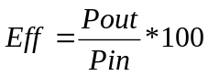 [%] | >70%  >65% | N.A.  65.2% | DPU+PL Version  DPU Version

09/04/2002
F5 | INRUSH CURRENT |  |  | OBJECTIVE: Verify the inrush current
 |  |  |  | INSTRUMENTATION: Multimeter, Oscilloscope, Current Probe
F5.1 | Place the current probe on positive power lead of the 28V Main Bus
F5.2 | Set Vbus at 29V
F5.3 | Set at Imax all outlets
F5.4 | Switch ON the Main Bus
F5.5 | Make hardcopy of the inrush current | See Remark | OK  SEE ANNEX 9 | Note:  The DC/DC board inrush current due to DC/DC board switch on shall be limited to 1.5 times the DC/DC input peak current, specified as 1.2 the nominal current.  The duration of the inrush peak shall not exceed 0.5ms  The rate of change (slope) of the inrush current shall not exceed 50mA/usec
F5.6 | Set Vbus at 26V
F5.7 | Set at Imax all outlets
F5.8 | Switch ON the Main Bus
F5.9 | Make hardcopy of the inrush current | See Remark | OK  SEE ANNEX 8 | Note:  The DC/DC board inrush current due to DC/DC board switch on shall be limited to 1.5 times the DC/DC input peak current, specified as 1.2 the nominal current.  The duration of the inrush peak shall not exceed 0.5ms  The rate of change (slope) of the inrush current shall not exceed 50mA/usec

09/04/2002
F6 | INPUT IMPEDANCE |  |  | OBJECTIVE: Verify input impedance of DC/DC board
 |  |  |  | INSTRUMENTATION: Oscilloscope, gain phase
F6.1 | The measurement of input impedance of the DC/DC board shall be performed with a set-up as shown in ANNEX 1 |  |  | Analyzer with test set-up of annex 1A
F6.2 | Set at Imax all outputs
F6.3 | Measure the input impedance of the DC/DC board and annex the plot |  | SEE ANNEX 10
F6.4 | Verify that impedance measurement is 6dB higher than the power bus impedance mask. | OK | OK | NOTE:  The power bus impedance mask is shown in the ANNEX 2

09/04/2002
F7 | INPUT PROTECTION |  |  | OBJECTIVE: Verify input protection
 |  |  |  | INSTRUMENTATION: Voltmeter
F7.1 | Starting from 28V decrease the input voltage power bus and verify that DC/DC converter output voltages switch OFF. | >23V < 25V | 23.15V
F7.2 | Increase than input voltage and verify that DC-DC properly works | >23V < 25V | 23.60V

09/04/2002
F8 | DPU OUTPUT PROTECTIONS |  |  | OBJECTIVE: Verify DPU output protections
 |  |  |  | INSTRUMENTATION: Voltmeter, Ammeter
F8.1 | Check the over-voltage protection (OVP) on +5VD outlet (this test will be done before the board closure)
F8.2 | Power on the UUT at 28Vdc and maximum load:
F8.3 | -Via dedicated jumper, placed in series to R158 (+5VD output voltage sense), connect a voltage generator referred to DGND .  Starting from 0V increase the voltage until the protection voltage value is reached ( controller shut-down and all outlet switch to OFF) and report the voltage value.  Verify that the input power consumption is lower than 2.8W. | 5.5 ±10% V | 5.54V | See PVS 02
F8.7 | Check the over-current protections on +5VD outlet.
F8.8 | The test shall be performed as follow:
F8.9 | -Connect to the +5VD outlet a variable load.
F8.10 | -Place the current probe on positive power lead of the +5VD outlet.
F8.11 | -By reducing the load resistance increase the current through the +5VD outlet.  When the OVC protection threshold is reached the DC/DC outlets switch to OFF and the power consumption became lower than 2,8W. | < 2W (DPU+PL)  1W < 1.5W (DPU) | 1.32W | See PVS 02
F8.12 | Verify that the measured over-current protection values is as expected. | 4000±10%mA TBC | 4.12A | See PVS 02
F8.13 | Check the over-current protections on +15VA outlet .
F8.14 | The test shall be performed in the following manner:
F8.15 | -Connect to the +15VA outlet a variable load.
F8.16 | -Place the current probe on positive power lead of the +15VA outlet.
F8.17 | -By reducing the load resistance increase the current across the +15VA outlet .  When the OVC protection threshold is reached the DC/DC outlets switch to OFF and the power consumption became lower than 2,8W. | < 2W (DPU+PL)  1W < 1.5W (DPU) | 1.32W | See PVS 02
F8.18 | Verify that the measured over-current protection values is as expected. | 200±10%mA | 204mA
F8.19 | Check the over-current protections on -15VA outlet.
F8.20 | The test shall be performed in the following manner:
F8.21 | -Connect to the -15VA outlet a variable load.
F8.22 | -Place the current probe on negative power lead of the -15VA outlet.
F8.23  09/04/2002 | -By reducing the load resistance increase the current across the -15VA outlet .  When the OVC protection threshold is reached the DC/DC outlets switch to OFF and the power consumption became lower than 2,8W. | < 2W (DPU+PL)  1.32W  See PVS 02  1W < 1.5W (DPU)
F8.24 | Verify that the measured over-current protection values is as expected. | 500±10%mA | 534mA

09/04/2002
F9 | REGULATED PL OUTPUTS PROTECTIONS (IS) |  |  | OBJECTIVE: Verify the regulated output protections
 |  |  |  | INSTRUMENTATION: Voltmeter, Ammeter
F9.1 | Check the over-voltage protections with crow-bar on +5.6V_PL_OUT outlet using the following set-up  +5.6_PL_OUT  A  DC/DC  CONVERTER  EXTERNAL  POWER  SUPPLY  +  LOAD  V  -  +5.6_PL_RTN  Power on the UUT with 28V input .  Connect all output to the loads.  By means of external power voltage generator ( limited to 2Amax)simulate an Over Voltage condition on the output.  Starting from 0V increase the external voltage generator to about 6V on outlet DC/DC pin.  Disconnect the output voltage generator and verify that the output is in on condition ( 5,6V)  Reconnect the generator at 0V  Increase the voltage to about 6,5V ( over voltage threshold).and when the current flown into outlet line  (due to shunt transistor of the outlet) switch off the external generator and report the voltage and current values.  Remove the external power supply and verify that the output voltage is equal to 0V.  Verify that all other outputs properly work | 6.5±5%V  <2A | N.A. | Only DPU+PL Version
09/04/2002
F9.2 | Check the over-voltage protections on +16V_PL_OUT outlet
F9.3 | Power on the UUT with 28V input .  Connect all output to the loads.  By means of external power voltage generator ( limited to 100mA)simulate an Over Voltage condition on the output.  Starting from 0V increase the external voltage generator to about 16,3V on outlet DC/DC pin.  Disconnect the output voltage generator and verify that the output is in on condition ( 16V)  Reconnect the generator at 0V  Increase the voltage to 18V ( over voltage threshold) ,and switch off the external generator .  Remove the external power supply and verify that the output voltage is equal to 0V.  Verify that all other outputs properly work | OK  17.2±5%V | N.A. | Only DPU+PL Version
F9.4 | Check the over-voltage protections on -16V_PL_OUT outlet |  |  | Only DPU+PL Version
F9.5 | Power on the UUT with 28V input .  Connect all output to the loads.  By means of external power voltage generator ( limited to 100mA)simulate an Over Voltage condition on the output.  Starting from 0V increase the external voltage generator to about -16,3V on outlet DC/DC pin.  Disconnect the output voltage generator and verify that the output is in on condition ( -16V)  Reconnect the generator at 0V  Increase the voltage to - 18V ( over voltage threshold) ,and switch off the external generator .  Remove the external power supply and verify that the output voltage is equal to 0V.  Verify that all other outputs properly work | -17.2±5%V | N.A. | Only DPU+PL Version
F9.6 | Check the current limitation on +5.6V_PL_OUT outlet. |  | N.A. | Only DPU+PL Version
F9.7 | The test shall be performed in the following manner: |  | N.A. | Only DPU+PL Version
F9.8 | -Connect to the +5.6V _PL_OUT outlet a variable load. |  | N.A. | Only DPU+PL Version
F9.9  09/04/2002 | -Place the current probe on negative power lead of the +5.6V _PL_OUT outlet. |  | N.A. | Only DPU+PL Version
F9.9 | -By reducing the load resistance increase the current through the +5.6V _PL_OUT outlet.
F9.10 | Verify that the measured current limitation value is as expected. | 285±5%mA | N.A. | Only DPU+PL Version
F9.11 | Check the current limitation on +16V_PL_OUT outlet.
F9.12 | The test shall be performed in the following manner:
F9.13 | -Connect to the +16V_PL_OUT outlet a variable load.
F9.14 | -Place the current probe on negative power lead of the +16V_PL_OUT outlet.
F9.15 | -By reducing the load resistance increase the current through the +16V_PL_OUT outlet.
F9.16 | Verify that the measured current limitation value is as expected. | 285±5%mA | N.A. | Only DPU+PL Version
F9.17 | Check the current limitation on -16V_PL_OUT outlet.
F9.18 | The test shall be performed in the following manner:
F9.19 | -Connect to the -16V_PL_OUT outlet a variable load.
F9.20 | -Place the current probe on negative power lead of the -16V_PL_OUT outlet.
F9.21 | -By reducing the load resistance increase the current through the -16V_PL_OUT outlet.
F9.22 | Verify that the measured current limitation value is as expected. | 285±5%mA | N.A. | Only DPU+PL Version

09/04/2002
F10 | VOLTAGE MONITORS |  |  | OBJECTIVE: Verify voltage monitors
 |  |  |  | INSTRUMENTATION: Voltmeter
F10.1 | Check the telemetry of +5V_MNT outlet
F10.2 | Measurement has to be performed between pin 42 of connector P2B and pin 43f connector P2B | 4.17±5% | 4.16V | Notes:  Scale of telemetry: 0V⇒ 0V, 6V⇒ 5V  Accuracy: ±5%
F10.3 | Check the telemetry of +15V_MNT outlet
F10.4 | Measurement has to be performed between pin 74 of connector P2C and pin 75 connector P2C | 4.17±5% | 4.09V | Notes:  Scale of telemetry: 0V⇒ 0V, 18V⇒5V  Accuracy: ±5%
F10.5 | Check the telemetry of -15V_MNT outlet
F10.6 | Measurement has to be performed between pin 12 of connector P2A and pin 13f connector P2A | 4.17±5% | 4.17V | Notes:  Scale of telemetry: 0V⇒ 0V, -18V⇒ 5V  Accuracy: ±5%

10/04/2002
F11 | TEMPERATURE MONITOR |  |  | OBJECTIVE: Verify temperature monitor
 |  |  |  | INSTRUMENTATION: Power supply, multimeter
F11.1 | Check the telemetry of +TEMP_MNT
 | Set limitation current of power supply to 50mA |  |  | Notes:  Scale of telemetry: -50°C⇒ 0V, +80°C⇒ 5V  Accuracy: ±5%
 | Measure resistance Rmis between TP1 and TP3 | Rmis | 8673Ω
 | Supply TP1 (Positive) and TP3(Negative) with the following voltage: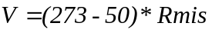 |  | 1.933V
F11.2 | Measure voltage between pin 44 and 45 of connector P2B | 0±96mV | +9.6mV | -50°C Case
 | Supply TP1 (Positive) and TP3(Negative) with the following voltage V: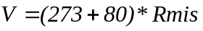 |  | 3.060V
F11.2 | Measure voltage between pin 44 and 45 of connector P2B | 5V±154mV | 4.979V | 80°C Case

24/04/2002
F12 | CE on Input Power Line; Frequency Domain, Differential Mode, NB |  |  | OBJECTIVE: Verify the conducted emission differential mode on input power line
 |  |  |  | INSTRUMENTATION: Spectrum analyzer with preselector
F12.1 | The measurement shall be performed with a test set-up as shown on ANNEX 3
F12.2 | Set the outputs at Imax
F12.3 | Take measurements of the ambient noise (positive input line) and make hardcopy | OK | OK (See Annex 11) | See PVS 03
F12.4 | Switch on the UUT, repeat the measurements and make hardcopy (positive input line) | OK | OK (See Annex 12) | See PVS 03
F12.5 | Verify that the measurements are as expected | OK | OK
F12.6 | Set the outputs at Imax
F12.7 | Take measurements of the ambient noise (return line) and make hardcopy | OK | OK (See Annex 13) | See PVS 03
F12.8 | Switch on the UUT, repeat the measurements and make hardcopy (return line) | OK | OK (See Annex 14) | See PVS 03
F12.9 | Verify that the measurements are as expected | OK | OK (see note nearby) | NOTE: Narrow-Band conducted emission Differential Mode in the frequency range 30Hz 50MHz generated by the DC/DC board on the input power line shall not exceed the following adjustable limit:  - For Nominal DC input current less than 1A, use the curve in ANNEX 4  - For Nominal DC input current greater than  1A, increase the level (in dBmA) of the  curve in ANNEX 4 by 10*Log[I (A)]. I(A) is  the nominal input current in Ampere.

10/04/2002
F13 | CE on Input Power Line; Frequency Domain, COMMON Mode, NB |  |  | OBJECTIVE: Verify the conducted emission common mode on input power line
 |  |  |  | INSTRUMENTATION: Spectrum analyzer with preselector
F13.1 | The measurement shall be performed with a test set-up as shown in ANNEX 5
F13.2 | Set the outputs at Imax
F13.3 | Take measurements of the ambient noise and make hardcopy | OK | OK (See Annex 15) | See PVS 03
F13.4 | Switch on the UUT, repeat the measurements and make hardcopy | OK | OK (See Annex 16) | See PVS 03
F13.5 | Verify that the measurements are as expected | OK | OK (see note nearby) | NOTE: Narrow-Band conducted emission Differential Mode in the frequency range 10kHz 50MHz generated by the DC/DC board on the input power line shall not exceed the following adjustable limit:  - For Nominal DC input current less than 1A, use the curve in ANNEX 6  - For Nominal DC input current greater than  1A, increase the level (in dBmA) of the  curve in ANNEX 6 by 10*Log[I (A)]. I(A) is  the nominal input current in Ampere.

10/04/2002
F14 | CURRENT RIPPLE, TIME Domain, Differential Mode |  |  | OBJECTIVE: Verify current ripple on input power line
 |  |  |  | INSTRUMENTATION: Oscilloscope
F14.1 | The measurement shall be performed with a test set-up as shown in ANNEX 7
F14.2 | Set the outputs at Imax
F14.3 | Place the current probe on positive power lead of the power line
F14.4 | Record the current ripple and make hardcopy | OK | OK (See Annex 17) | See PVS 03
F14.5 | Place the current probe on return power lead of the power line.
F14.6 | Record the current ripple and make hardcopy | OK | OK (See Annex 18) | See PVS 03
F14.7 | Verify that the measurements are as expected |  | OK (see note nearby) | NOTE:  Differential mode, time domain current ripple and spikes on the input power line of the DC/DC board shall not exceed the following limits:  - For nominal DC input current less than 1A:  Ripple: less than 20mApp.  Spikes, including ripple: less than 60mApp  - For nominal DC input current greater than 1A:  Ripple: multiply 20mApp by a factor √I(A), I(A) is the nominal input current in Ampere  Spikes, including ripple: multiply 60mApp by  a factor √I(A), I(A) is the nominal input  current in Ampere.
10/04/2002

test procedure variation sheets
PROCEDURE VARIATION SHEET ref. N°: 01
Test Procedure Ref.: DPU-PR-CGS-003 Issue 1 |  |  | Page Revised: 31 |  | Paragraph Revised: F3.2÷F3.9
Description of Change:
F3.2 EXPECTED VALUE: WAS 200 mVpp
IS < 200 mVpp

F3.3 EXPECTED VALUE: WAS 100 mVpp
IS < 100 mVpp

F3.4 EXPECTED VALUE: WAS 400 mVpp
IS < 400 mVpp

F3.5 EXPECTED VALUE: WAS 200 mVpp
IS < 200 mVpp

F3.6 EXPECTED VALUE: WAS 400 mVpp
IS < 400 mVpp

F3.7 EXPECTED VALUE: WAS 200 mVpp
IS < 200 mVpp

F3.8 EXPECTED VALUE: WAS 200 mVpp
IS < 200 mVpp

F3.9 EXPECTED VALUE: WAS 100 mVpp
IS < 100 mVpp
Reason for Change:
Typing error.
CONCURRENCE
Test Cond.  09/04/2002 | QA | System Eng. |  |  |  | Customer
Date | Date | Date |  |  |  | Date

PROCEDURE VARIATION SHEET ref. N°: 02
Test Procedure Ref.: DPU-PR-CGS-003 Issue 1 |  |  | Page Revised: 38 |  | Paragraph Revised: F8.3, F8.11, F8.12, F8.17, F8.23
Description of Change:
F8.3 EXPECTED VALUE: WAS 5.5V
IS 5.5±10%V

F8.11 EXPECTED VALUE: WAS 2W (DPU+PL) 1W (DPU)
IS <2W (DPU+PL) <1.5W (DPU)

F8.12 EXPECTED VALUE: WAS 4000±10%mA TBC
IS 4000±10%mA

F8.17 EXPECTED VALUE: WAS 2W (DPU+PL) 1W (DPU)
IS <2W (DPU+PL) <1.5W (DPU)

F8.23 EXPECTED VALUE: WAS 2W (DPU+PL) 1W (DPU)
IS <2W (DPU+PL) <1.5W (DPU)

Reason for Change:
Typing error.
CONCURRENCE
Test Cond.  09/04/2002 | QA | System Eng. |  |  |  | Customer
Date | Date | Date |  |  |  | Date

PROCEDURE VARIATION SHEET ref. N°: 03
Test Procedure Ref.: DPU-PR-CGS-003 Issue 1 |  |  | Pages Revised: 45,46,47 |  | Paragraph Revised: F12.3, F12.4, F12.7, F12.8, F13.3, F13.4, F14.4, F14.6
Description of Change:
F12.3 EXPECTED VALUE: WAS Blank
IS OK

F12.4 EXPECTED VALUE: WAS Blank
IS OK

F12.7 EXPECTED VALUE: WAS Blank
IS OK

F12.8 EXPECTED VALUE: WAS Blank
IS OK

F13.3 EXPECTED VALUE: WAS Blank
IS OK

F13.4 EXPECTED VALUE: WAS Blank
IS OK

F14.4 EXPECTED VALUE: WAS Blank
IS OK

F14.6 EXPECTED VALUE: WAS Blank
IS OK
Reason for Change:
Typing error.
CONCURRENCE
Test Cond.  10/04/2002 | QA | System Eng. |  |  |  | Customer
Date | Date | Date |  |  |  | Date

ANNEX TO THE PROCEDURE

ANNEX 1: Test set up for input impedance measurement

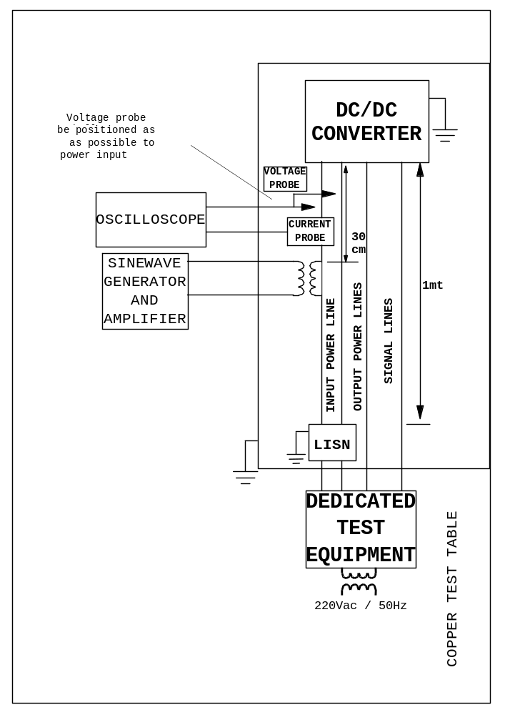

ANNEX 2: POWER BUS IMPEDANCE

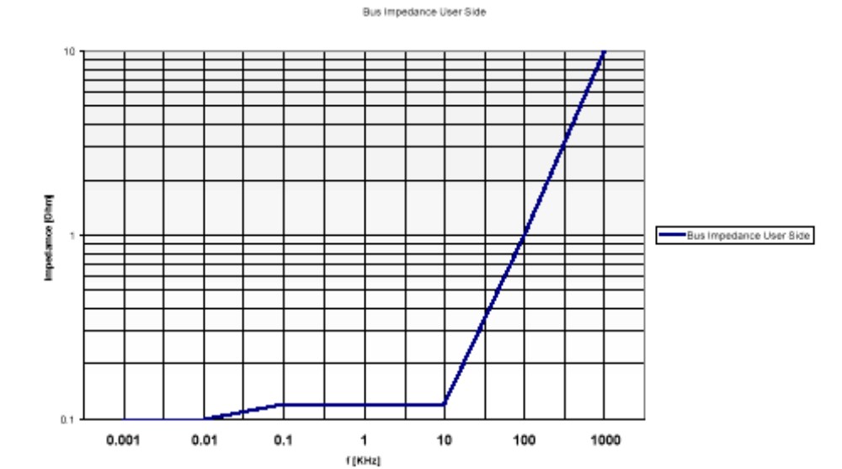

ANNEX 3: TEST SET UP FOR CONDUCED EMISSION FREQUENCY DOMAIN DM

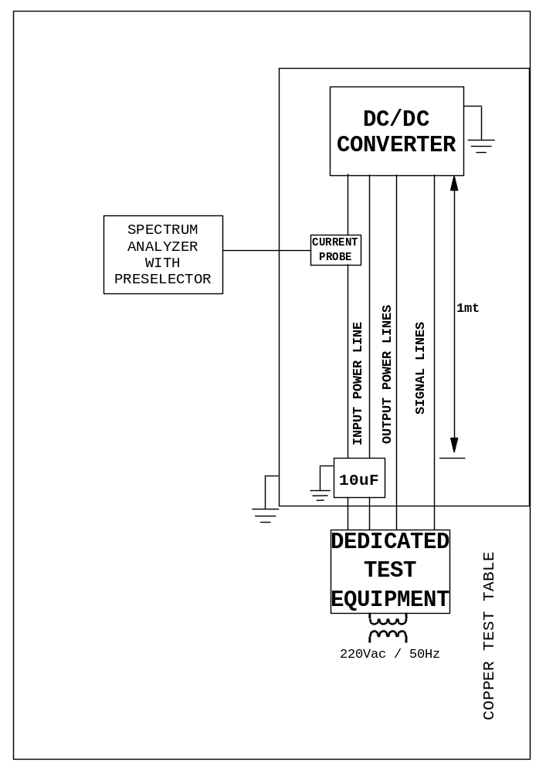

ANNEX 4: LIMIT FOR CEP-DIFFERENTIAL MODE

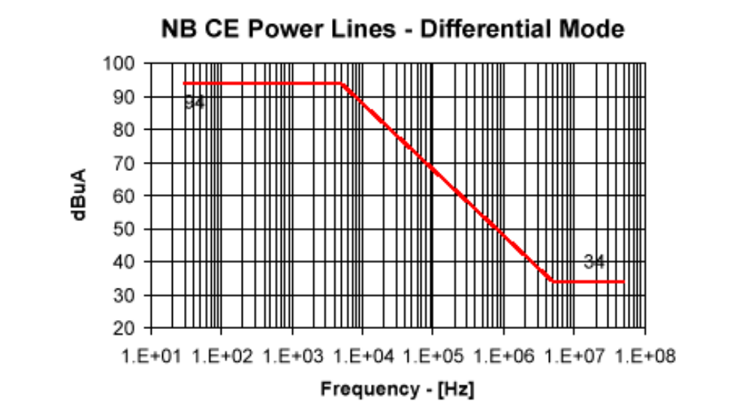

ANNEX 5: TEST SET UP FOR CONDUCED EMISSION FREQUENCY DOMAIN CM

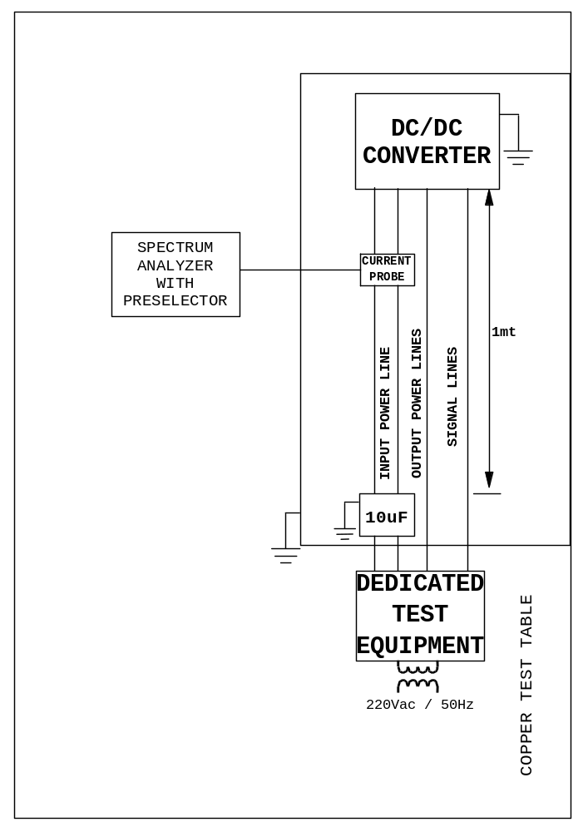

ANNEX 6: NB CE POWER LINES-COMMON MODE

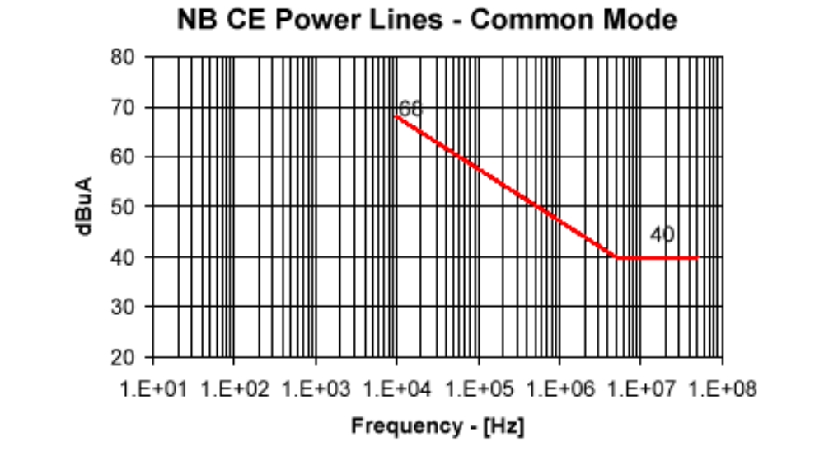

ANNEX 7: TEST SET UP FOR CONDUCED EMISSION TIME DOMAIN

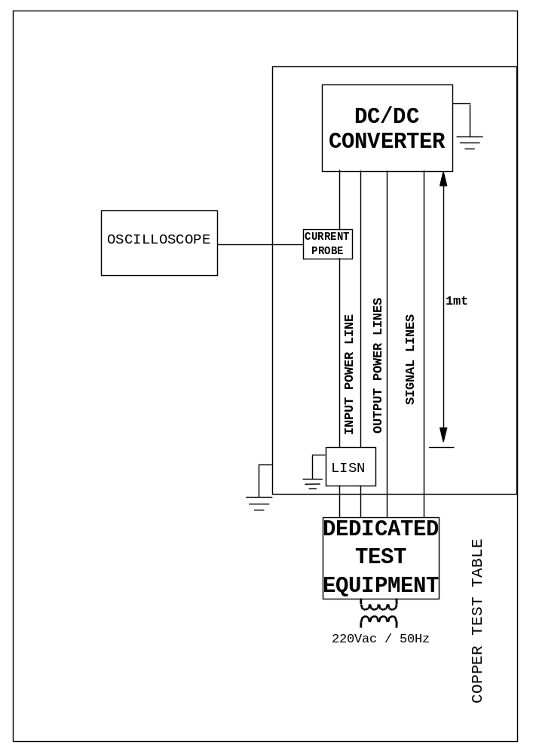

ANNEX 8 Inrush current 26v (f5.9)

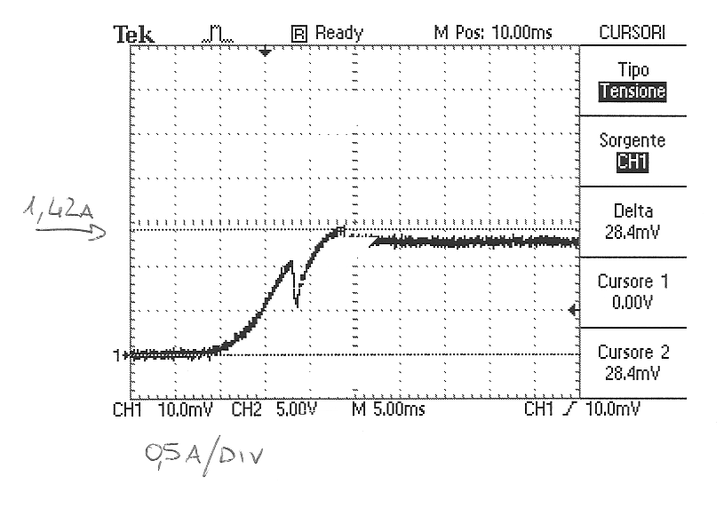

- I peak: 1.42A

- I nom: 1.24A

- Rate: 0.175 [mA/us]

DATE: 10/04/02

TEST CONDUCTOR:

annex 9 inrusch current 29v ( f5.5)

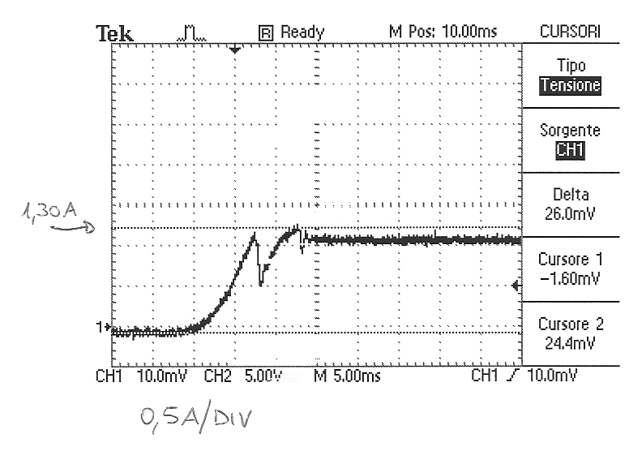

- I peak: 1.30A

- I nom: 1.12A

- Rate: 0.229 [mA/us]

DATE: 10/04/02

TEST CONDUCTOR:

annex 10 input impedance (f6.3)

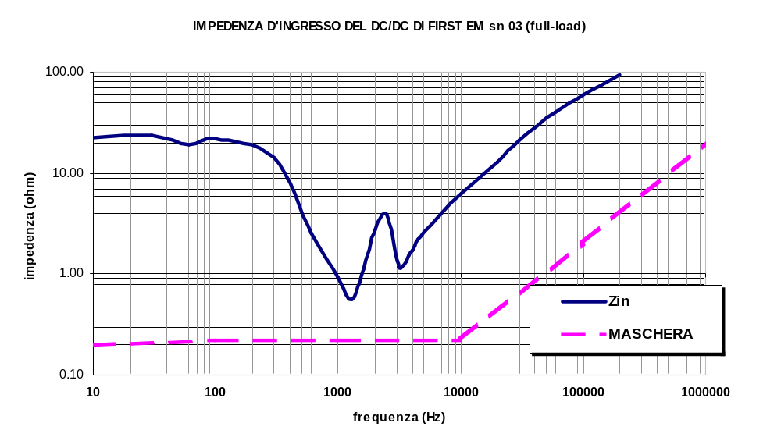

DATE: 10/04/02

TEST CONDUCTOR:

annex 11 ce input power line d.m. ambient noise (f12.3)

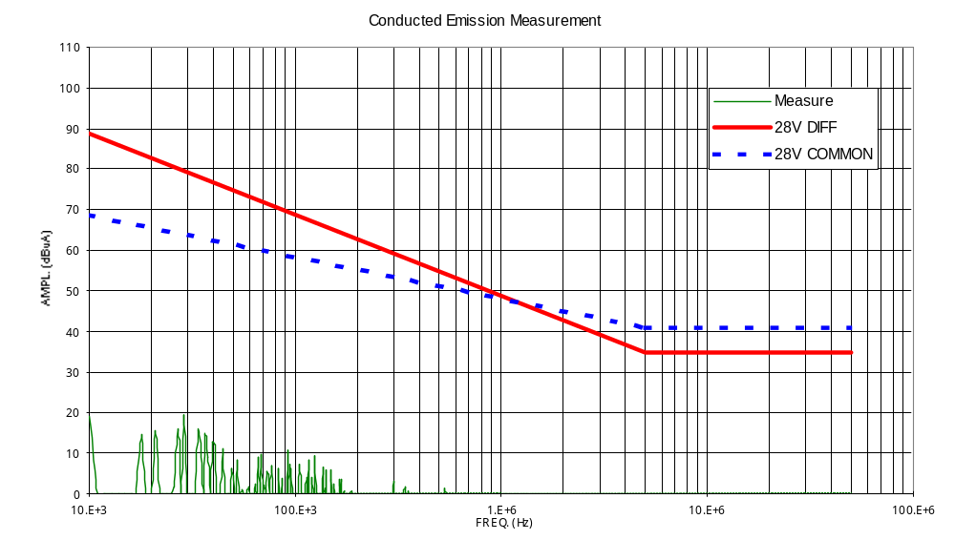

DATE: 10/04/02

TEST CONDUCTOR:

annex 12 ce input power line d.m. positive line (f12.4)

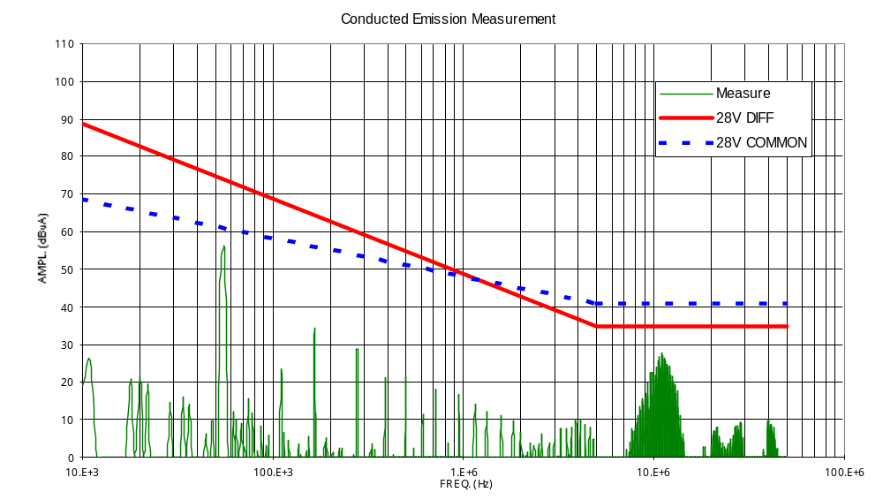

DATE: 10/04/02

TEST CONDUCTOR:

annex 13 ce input power line d.m. negative line ambient noise (f12.7)

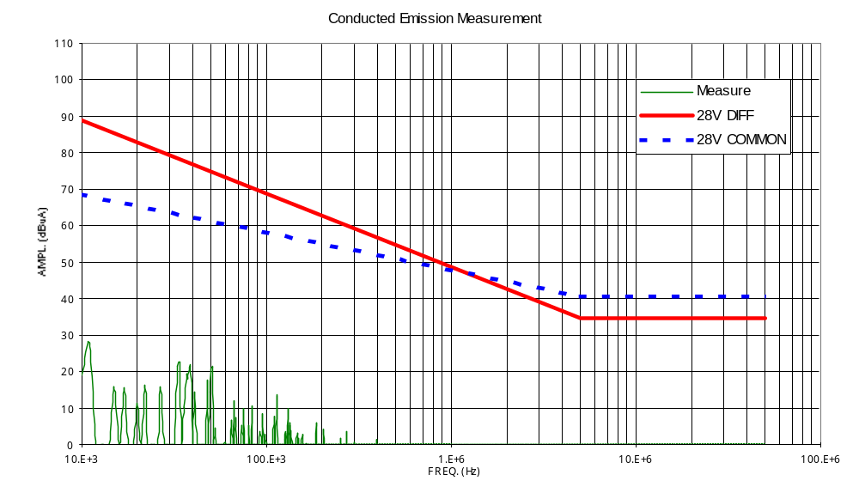

DATE: 10/04/02

TEST CONDUCTOR:

annex 14 ce input power line d.m. negative line (f12.8)

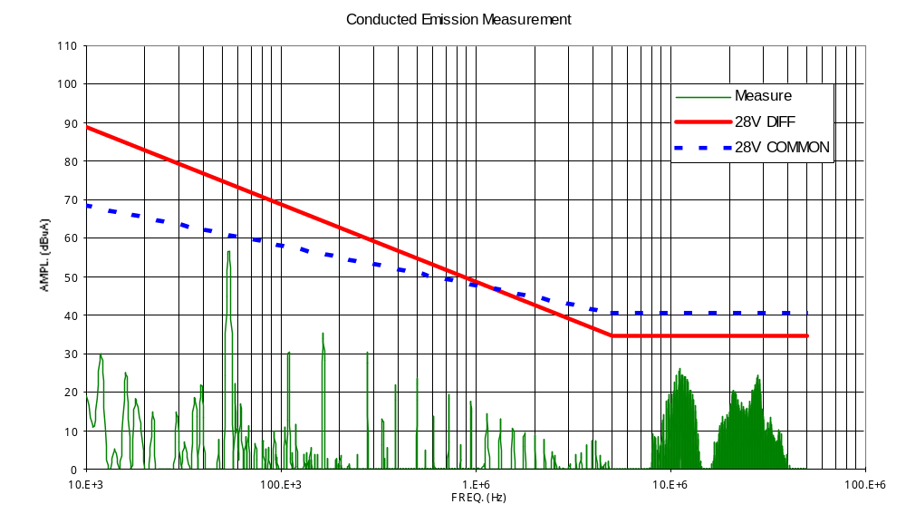

DATE: 10/04/02

TEST CONDUCTOR:

annex 15 ce input power line c.m. ambient noise (f13.3)

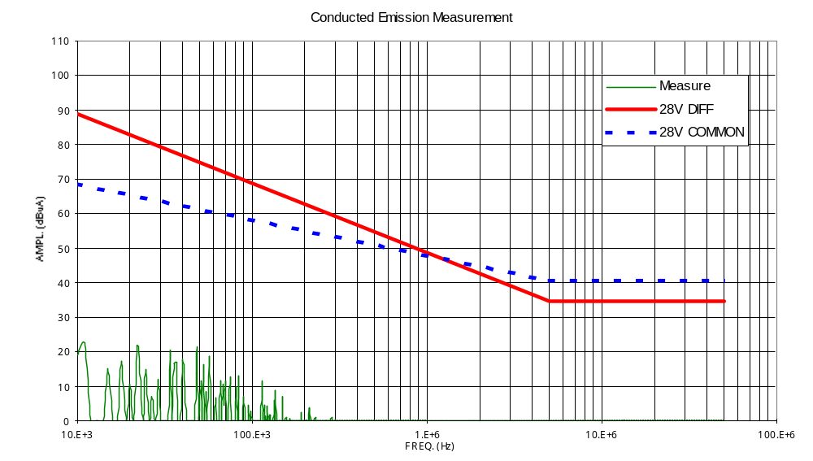

DATE: 10/04/02

TEST CONDUCTOR:

annex 16 ce input power line c.m. (f13.4)

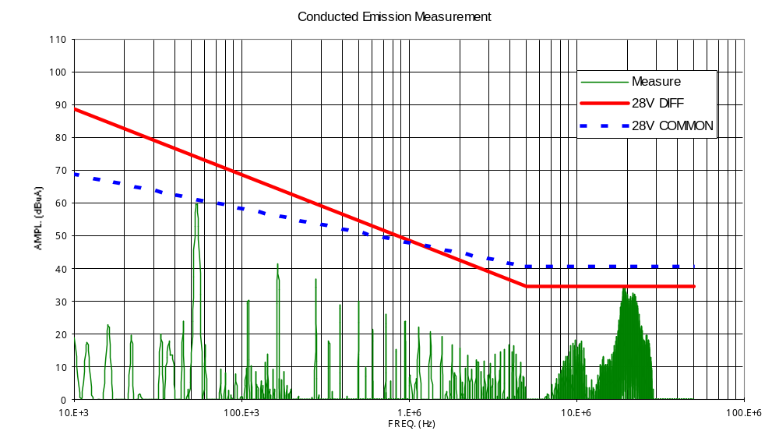

DATE: 10/04/02

TEST CONDUCTOR:

annex 17 current ripple positive input power line (f14.4)

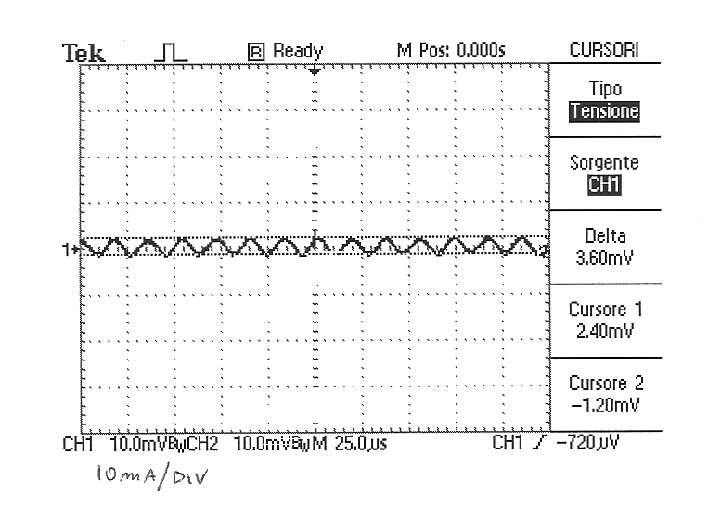

DATE: 10/04/02

TEST CONDUCTOR:

annex 18 current ripple return input power line (f14.6)

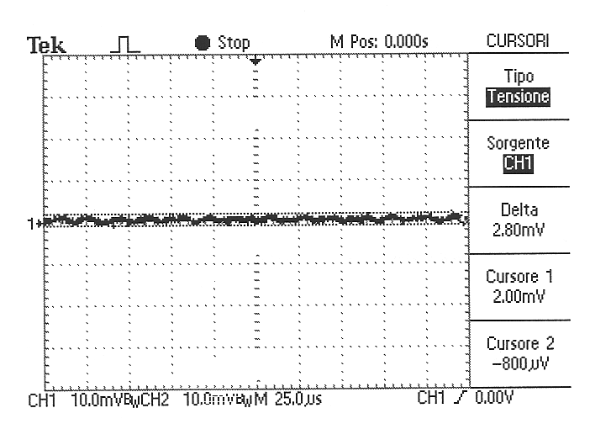
10mA/div

DATE: 10/04/02

TEST CONDUCTOR:

conclusions

The unit DC-DC Converter Board DPU-EM-300.00-0 S/N 03 was tested according to the specification and following the procedures DPU-PR-CGS-003 Issue 1.
The results of the tests are contained in this document. All the measurements are in agreement with the specifications.

