Spectrometer Calibrator (SCAL)

Subsystem Design Description

SPIRE Ref.: SPIRE-QMW-PRJ-001104
Cardiff Ref.: HSO-CDF-DD-33
Issue: 1.0

Prepared by: Peter Hargrave & Matt Griffin
Last Modified on: 23 January 2002
Approved by:

Distribution list

Update history

Date | Version | Remarks
4/9/01 | 1.0 | First issue for DDR

List of Acronyms
Term | Meaning | Term | Meaning
AD | Applicable Document | IR | Infrared
ADC | Analogue to Digital Converter | IRD | Instrument Requirements Document
AIV | Assembly, Integration and Verification | IRTS | Infrared Telescope in Space
AME | Absolute Measurement Error | ISM | Interstellar Medium
AOCS | Attitude and Orbit Control System | JFET | Junction Field Effect Transistor
APART | Arizona's Program for the Analysis of Radiation Transfer | ISO | Infrared Space Observatory
APE | Absolute Pointing Error | LCL | Latching Current Limiter
ASAP | Advanced Systems Analysis Program | LIA | Lock-In Amplifier
ATC | Astronomy Technology Centre, Edinburgh | LVDT | Linear Variable Differential Transformer
AVM | Avionics Model | LWS | Long Wave Spectrometer (an instrument used on ISO)
BDA | Bolometer Detector Array | MAC | Multi Axis Controller
BFL | Back Focal Length | MAIV | Manufacturing, Assembly, Integration and Verification
BRO | Breault Research Organization | MCU | Mechanism Control Unit = HSMCU
BSM | Beam Steering Mirror | MGSE | Mechanical Ground Support Equipment
CBB | Cryogenic Black Body | M-P | Martin-Puplett
CDF | Cardiff, Department of Physics & Astronomy | NEP | Noise Equivalent Power
CDMS | Command and Data Management System | NTD | Neutron Transmutation Doped
CDMU | Command and Data Management Unit | OBS | On-Board Software
CDR | Critical Design Review | OGSE | Optical Ground Support Equipment
CEA | Commissariat a l’Energie Atomique | OMD | Observing Modes Document
CMOS | Complimentary Metal Oxide Silicon | OPD | Optical Path Difference
CoG | Centre of Gravity | PACS | Photodetector Array Camera and Spectrometer
CPU | Central Processing Unit | PCAL | Photometer Calibration source
CQM | Cryogenic Qualification Model | PFM | Proto-Flight Model
CVV | Cryostat Vacuum Vessel | PID | Proportional, Integral and Differential (used in the context of feedback control loop architecture)
DAC | Digital to Analogue Converter | PLW | Photometer, Long Wavelength
DAQ | Data Acquisition | PMW | Photometer, Medium Wavelength
DCU | Detector Control Unit = HSDCU | POF | Photometer Observatory Function
DDR | Detailed Design Review | PROM | Programmable Read Only Memory
DM | Development Model | PSW | Photometer, Short Wavelength
DPU | Digital Processing Unit = HSDPU | PUS | Packet Utilisation Standard
DSP | Digital Signal Processor | RAL | Rutherford Appleton Laboratory,
DQE | Detective Quantum Efficiency | RD | Reference Document
EDAC | Error Detection and Correction | RMS | Root Mean Squared
EGSE | Electrical Ground Support Equipment | SCAL | Spectrometer Calibration Source
EM | Engineering Model | SCUBA | Submillimetre Common User Bolometer Array
EMC | Electro-magnetic Compatibility | SED | Spectral Energy Distribution
EMI | Electro-magnetic Interference | SMEC | Spectrometer Mechanics
ESA | European Space Agency | SMPS | Switch Mode Power Supply
FCU | FCU Control Unit = HSFCU | SOB | SPIRE Optical Bench
FIR | Far Infrared | SOF | Spectrometer Observatory Function
FIRST | Far Infra-Red and Submillimetre Telescope | SPIRE | Spectral and Photometric Imaging Receiver
FOV | Field of View | SRAM | Static Random Access Memory
F-P | Fabry-Perot | SSSD | SubSystem Specification Document
FPGA | Field Programmable Gate Array | STP | Standard Temperature and Pressure
FPU | Focal Plane Unit | SVM | Service Module
FS | Flight Spare | TBC | To Be Confirmed
FTS | Fourier Transform Spectrometer | TBD | To Be Determined
FWHM | Full Width Half maximum | TC | Telecommand
GSFC | Goddard Space Flight Center | URD | User Requirements Document
HK | House Keeping | UV | Ultra Violet
HOB | Herschel Optical Bench | WE | Warm Electronics
HPDU | Herschel Power Distribution Unit | ZPD | Zero Path Difference
HSDCU | Herschel-SPIRE Detector Control Unit
HSDPU | Herschel-SPIRE Digital Processing Unit
HSFCU | Herschel-SPIRE FPU Control Unit
HSO | Herschel Space Observatory
IF | Interface
IID-A | Instrument Interface Document - Part A
IID-B | Instrument Interface Document - Part B
IMF | Initial Mass Function

Table of Contents
1 Scope of this document 6
2 Document list 8
2.1 Applicable documents 8
3 Outline description of the Spectrometer CALibrator (SCAL) 8
4 SCAL requirements 9
4.1 SCAL requirements descriptions 10
4.1.1 CALS-R01 (radiated spectrum) 10
4.1.2 CALS-R02 (beam pattern) 11
4.1.3 CALS-R03 (adjustability) 11
4.1.4 CALS-R04 (uniformity) 11
4.1.5 CALS-R05 (repeatability and drift) 11
4.1.6 CALS-R06 (operation) 11
4.1.7 CALS-R07 (number of operations) 11
4.1.8 CALS-R08 (transient response) 12
4.1.9 CALS-R09 (operating voltage) 12
4.1.10 CALS-R10 (power dissipation in the focal plane) 12
4.1.11 CALS-R11 (mechanical envelope) 12
4.1.12 CALS-R12 (thermal isolation) 12
4.1.13 CALS-R12 (operating temperature) 12
4.1.14 CALS-R12 (redundancy) 13
4.1.15 CALS-R12 (thermometry) 13
5 Description of the SCAL design 13
6 Computer simulation and modelling 16
6.1 Nulling of telescope emission 16
6.2 Thermal Modelling 20
6.3 Mechanical modelling 23
7 Detailed Design Description 24
7.1 Thermal Sources 24
7.1.1 Source Assembly – Heater Body 24
7.1.2 Heater Details 24
7.1.3 Thermometer details 25
7.1.4 Strut Details 26
7.2 SCAL Baseplate 27
7.3 Attachment of Thermal Sources to Torlon Legs 28
7.4 Attachment of Torlon Struts to SCAL Baseplate 29
7.5 Connector Brackets and Rear Cover 30
7.6 Mechanical Interface 32
7.6.1 Launch Environment 32
7.6.2 Experiment to Verify Mechanical Model 33
7.6.3 Interface to SCAL/SM8B baffle 34
7.7 Thermal Design Details 34
7.7.1 Wire Heatsinking 35
7.7.2 Baffling 35
7.8 Thermal Interface 35
7.9 Optical Design Details 36
7.10 Optical Interface 36
7.11 Electrical Design Details 36
7.11.1 Wiring 36
7.11.2 Connector Pin-Outs and Harness Definition 37
7.12 Electrical Interface 39
7.12.1 Maximum Drive Current 39
7.12.2 Adjustability of the drive current 40
7.12.3 Required Maximum Drive Voltage 40
7.12.4 Drive Current Stability 40
7.12.5 Power Supply Redundancy 40
7.12.6 Requirements on Thermometry Accuracy 40
8 Hardware Tree 41
9 Reliability & Redundancy 42
9.1 Reliability Block Diagram 42
9.2 Fault Tree Analysis 42
9.3 Single Point Failures 43
9.4 FMECA 43
9.5 Critical Components Identification 43
10 Assembly, Integration & Verification 48
10.1 General 48
10.2 Assembly 48
10.3 Integration 48
10.4 Verification 48
10.5 Transport & Storage 48
10.6 Handling 48
A. Appendices 50
A.1. Appendix 1 – Details of Computer Models 50
A.1.1. Nulling of Telescope Emission Spectrum 50
A.1.2. Source Thermal Model 54
A.1.3. Source Deflection Under Load 59
A.1.4. Resonant Frequency and Static Load Bearing Calculation 61

List of Figures
Figure 1 Layout of the SPIRE spectrometer, showing the location of SCAL. 8
Figure 2 Topological diagram of spectrometer side of the SPIRE instrument showing the position of SCAL, and the baffle to which it interfaces. 9
Figure 3 Model of SCAL assembly showing prime and redundant sources and baffle. 14
Figure 4 Isometric view of SCAL interface to baffle. 14
Figure 5 Plan view of SCAL and baffle. 15
Figure 6 Plan view of SCAL and baffle. Top cover has been removed to show SM8B and beams. 15
Figure 7 Optimal layout of the thermal sources for SCAL. Prime sources are shown in green, redundant in red. The centre of each source is 5mm from the pupil centre, and the minimum gap between adjacent sources is 3.07mm. 16
Figure 8 Telescope matching achievable for an 80-K, 4% emissivity telescope. 17
Figure 9 Telescope matching achievable for an 80-K, 2% emissivity telescope. 17
Figure 10 Telescope matching achievable for an 80-K, 8% emissivity telescope. 18
Figure 11 Telescope matching achievable for a 65-K, 4% emissivity telescope. 19
Figure 12 Telescope matching achievable for a 65-K, 2% emissivity telescope. 19
Figure 13 Telescope matching achievable for a 65-K, 8% emissivity telescope. 20
Figure 14 Heating/cooling for SCAL_A (5 mm diameter x 7 mm deep) 21
Figure 15 Heating/cooling curve for SCAL_B (3 mm diameter x 7 mm deep). 21
Figure 16 Warm-up curve for SCAL_B for an applied power of 6.6 mW 22
Figure 17 Warm-up curve for SCAL_A for an applied power of 0.06 mW 22
Figure 18 Telescope matching for 80-K, 4% emissivity telescope – matching achievable with reduced power dissipation. 23
Figure 19 Heating curve for SCAL_A for an applied power of 1.2 mW 23
Figure 20 Details of aluminium heater body and assembly 24
Figure 21 Details of the heaters to be used for SCAL (CHPHR 0505) 25
Figure 22 Package details for Cernox 1030 SD sensor 25
Figure 23 Typical resistance and sensitivity values for Cernox 1000 family sensors 26
Figure 24 Details of Torlon Struts. 26
Figure 25 Rear view of SCAL baseplate. 27
Figure 26 Front view of SCAL showing details of baffle. 28
Figure 27 Details of integration of thermal source assemblies and strut retention plate. 28
Figure 28 Details of aluminium-Torlon interface. 29
Figure 29 Schematic of strut interface to SCAL baseplate. 29
Figure 30 View of baseplate with integrated thermal sources and retaining plate. 30
Figure 31 Assembly of electrical connector brackets on SCAL baseplate 30
Figure 32 Details of connector mounting to rear of SCAL baseplate. 31
Figure 33 SCAL rear cover mounting 31
Figure 34 Simple experiment to determine maximum beam deflection under load. 33
Figure 35 Thermal block diagram for SCAL (one source). Green indicates Cardiff supplied SCAL components, blue indicates MSSL supplied components. 35
Figure 36 Routing of thermal source wiring. 36
Figure 37 Illustration of wiring to connectors. The wiring for the prime sources is shown in blue, redundant in red. 37
Figure 38 Schematic of SCAL harness wiring scheme. The same scheme is used for prime and redundant harnesses. 38
Figure 39 Schematic of pin allocation on SCAL prime and redundant connectors 39
Figure 40 Hardware tree 41
Figure 41 Exploded view of SCAL components. 49

List of Tables
Table 1 Optimal configuration for SCAL sources 16
Table 2 Predicted peak source deflection as a function of launch acceleration. The final row (*) shows the predicted deflection of a 2.5 mm diameter solid rod for the quoted acceleration. 32
Table 3 Wiring details for SPIRE cryoharness, C10. Error! Bookmark not defined.
Table 4 Failure Modes Effects and Criticality Analysis (FMECA) for the SCAL system 44

Scope of this document
This document describes the design of the Herschel-SPIRE Spectrometer Calibrator (SCAL) subsystem. The intention of this document is to present all design information available at a given release date and will be updated as and when changes to the design are made under configuration control.

Document list

Applicable documents
All applicable documents are listed in the AD chapter of the CIDL (HSO-CDF-LI-029).

Outline description of the Spectrometer CALibrator (SCAL)
The SPIRE Fourier Transform Spectrometer (FTS) uses two broadband, high-efficiency, intensity beam splitters in a Mach-Zender configuration. This configuration has two input ports, and the measured spectrum represents the difference between the two radiant inputs at these ports. One input is located at a 26-mm diameter pupil image of the telescope, at which the radiant input will be dominated by the emission from the telescope itself (several pW of power over the FTS range), with the signal from all except the brightest astronomical sources being negligible by comparison. The Spectrometer Calibrator (SCAL) is located at a complementary pupil at the second input port of the FTS, as shown in Figure 1 and Figure 2, and its function is to provide a thermal input that mimics the dilute 80-K black body emission of the telescope. This allows the large telescope background to be nulled, thereby reducing the dynamic range requirements for the detector sampling: ideally, if the telescope spectrum is perfectly nulled, the dynamic range is then dictated by the (much smaller) power from the astronomical source.
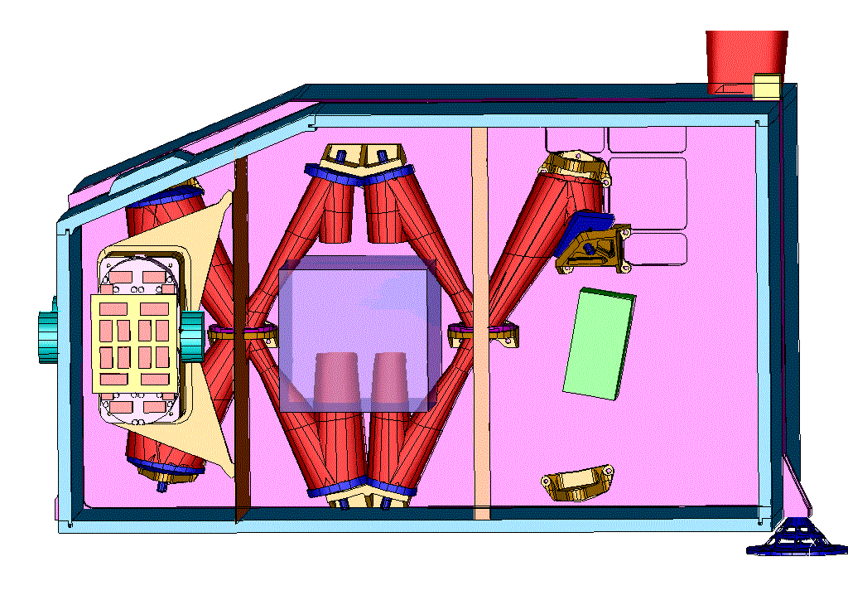
SCAL
Figure 1 Layout of the SPIRE spectrometer, showing the location of SCAL.
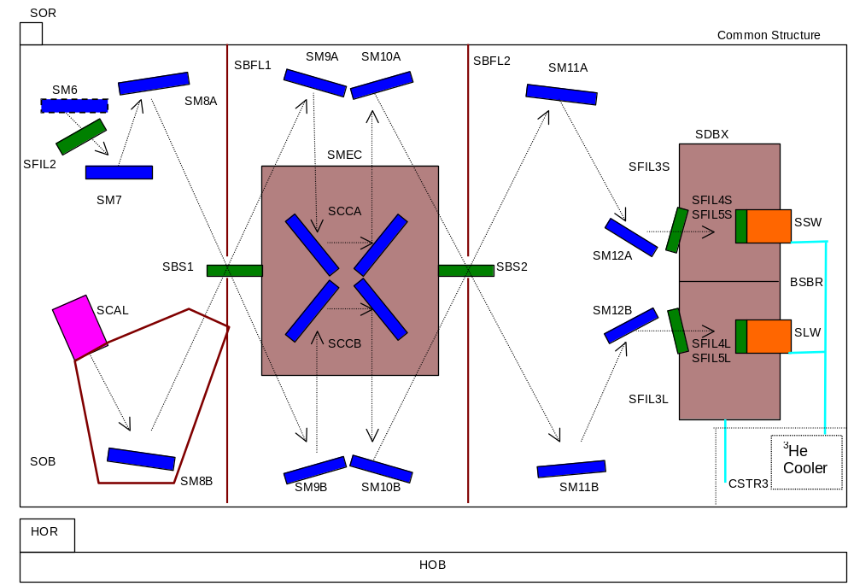
Figure 2 Topological diagram of spectrometer side of the SPIRE instrument showing the position of SCAL, and the baffle to which it interfaces.

SCAL requirements
The following tables summarise the SCAL requirements, as stated in the SPIRE Instrument Requirements Document and the System Budgets Document, taking into account the changes requested by (July 25 2001) and the response of the SPIRE Instrument Scientist (e-mail, August 30 2001). Each requirement is discussed individually below.

The main design drivers for SCAL are derived from the Instrument Requirements Document (AD11) and from the SCAL ICD (AD 27).

SCAL Performance Requirements
Requirement ID | Description | Value
IRD-CALS-R01 | Radiated spectrum | Null the central maximum to accuracy of 5% (goal 2%) [TBC]  Replicate the dilute spectrum of the telescope to an accuracy of better than 20% (goal 5%) [TBC] over 200-400 μm.
IRD-CALS-R02 | Beam pattern | Replicate the appropriate beam pattern at the second input port pupil image.  This requirement has been deleted as SCAL can be designed as a Lambertian emitter.
IRD-CALS-R03 | Adjustability: | Zero - maximum in 256 steps
IRD-CALS-R04 | Uniformity | The uniformity of the intensity from the calibration source across the second input port pupil image shall be better than TBD%.  Deletion of this requirement has been requested and is currently under consideration.
IRD-CALS-R05 | Repeatability and drift | The output intensity of the calibration source shall drift by no more than 1% over one hour of continuous operation. The absolute change in the output intensity of the source shall be no more than 15% over the mission lifetime
IRD-CALS-R06 | Operation | The calibration source shall be capable of continuous operation for periods of up to 2 hours with no loss of operational performance.
IRD-CALS-R07 | Number of operations | The calibration source shall be capable of up to 12000 operational cycles
IRD-CALS-R08 | Transient response | SCAL should take no longer than 30 minutes (15 goal) to heat to operating temperature from 4 K, and no more than 3 hrs (30 min. goal) to cool from operating temperature to 4 K.  New requirement proposed by Cardiff.

SCAL System Requirements
Requirement ID | Description | Value
IRD-CALS-R09 | Operating Voltage | No more than 28 V DC
IRD-CALS-R10 | Power dissipation in the focal plane | Shall be within the specification given in . . . .  What is this specification?Systems Budgets now states that total budget for spectroscopy is 8.4mW. This does not show the breakdown for SMEC and SCAL.
IRD-CALS-R11 | Mechanical envelope | The SCAL unit shall fit within a volume envelope to be specified by MSSL
IRD-CALS-R12 | Thermal Isolation | The temperature of the SCAL housing and surrounding structure shall rise by no more than 1 K over the temperature of the FPU structure after one hour of continuous operation.  To ensure that this requiremetn can be met, provision shll be made for a direct thermal strap fro the SCAL housing to the SPIRE optical bench  The above change to this requirement has been requested by Cardiff team.
IRD-CALS-R13 | Operating Temperature | < 6 K
IRD-CALS-R14 | Redundancy | Fully redundant systems shall be provided for the active elements.
IRD-CALS-R15 | Thermometry | Thermometers shall be provided on the spectrometer calibrator.

SCAL Technical Requirements
Requirement ID | Description | Value
SCAL-T1 | Mass | < 200 gm

SCAL requirements descriptions

CALS-R01 (radiated spectrum)

The dynamic range is set by the intensity of the central maximum of the interferogram, which is in turn determined by the difference in the total power received from the two ports. The origin of this requirement is that in order to carry out low-resolution spectrophotometry with SPIRE, the central maximum must be nulled to a high level to prevent phase errors associated with inadequate sampling from affecting the spectrum.

Besides reducing the dynamic range, it is also desirable that the spectrum of the calibrator be identical or nearly identical to that of the telescope. Ideally they will be the same, resulting in a null interferogram when viewing blank sky. The requirement covers the range 200-400 μm, which is the prime band for the FTS. Nulling over the 400 - 670 μm range should be as good as possible but is not the subject of a specific requirement.

CALS-R02 (beam pattern)

Requirement deleted: SCAL has been designed as a non-reflective Lambertian emitter with the appropriate spectral properties.

CALS-R03 (adjustability)

In the design and modelling of the SPIRE instrument, the telescope is assumed to be at 80 K and to have an effective emissivity of 0.04. These values are both subject to uncertainty. The temperature is expected to be in the range 60-80 K. The emissivity is subject to much larger uncertainty - it could easily be a factor of two lower or higher - and the value will not be known until after launch. SCAL must therefore be adjustable in order to provide the required nulling and spectral matching over a wide range of conditions.

CALS-R04 (uniformity)

It was originally envisaged that the SCAL pupil would have to be uniformly bright. Analysis of the FTS performance shows that this is not the case. Being located at a pupil, the detectors view all parts of SCAL with the same angular distribution. The Cardiff team has therefore requested that this requirement be deleted and the current design of SCAL assumes that the pupil does not need to be uniformly bright.

CALS-R05 (repeatability and drift)

A typical long integration with the FTS may comprise a sequence of interferograms (each taking around one minute), repeated for an our or more. It is important that the power received from the calibrator not vary significantly on the timescale of an observation.

The in-orbit telescope temperature and emissivity are not expected to change significantly even on timescales of months. It is envisaged that the optimum settings for SCAL will be determined empirically early in the mission and should need only occasional checking and adjustment. A calibrator output drift less than 15% over the mission lifetime means that only occasional re-adjustment of the calibrator excitation levels will be needed.

CALS-R06 (operation)

SCAL operation . . .

CALS-R07 (number of operations)

In order to define the life-test requirement for SCAL, it is necessary to specify the number of operations that SCAL must be able to tolerate. This is derived using the following conservative assumptions:

Mission operational lifetime: 4.5 years
Fraction of lifetime for which SPIRE operates: 33%
Fraction of SPIRE time for which SCAL used: 50%
Number of operational hours per day: 21
Frequency with which SCAL is powerd down/up Once every 2 hours
Margin factor (and allowing for ground operation): 1.5

These assumptions result in a total operation time of 238 days and a number of cycles of 4300 (a factor of three less than the 12,000 operations specified).
The Cardiff team therefore requests that IRD-CALS-R06 be changed to 4,500 operations instead of 12,000

Note: A continuous accelerated life test with 15-minutes per cycle will achieve 4500 cycles in approximately 47 full 24-hr days (the need for such a test is TBD).

CALS-R08 (transient response)

To minimise set-up time, it is desirable that SCAL can be warmed up or cooled down as quickly as possible. The envisaged operational scenario for Herschel and SPIRE involves each instrument being operated for substantial periods of time (e.g., one cooler cycle - equivalent to 48 hrs). During such a period when SPIRE is operating, the FTS or photometer are also likely to be used continuously for long periods of time (typically hours). The warm-up and cool-down time should therefore be on the order of minutes or tens of minutes. There is a trade-off here between stability (requiring a long time constant) and short warm-up time (requiring a short time constant).

Note that when SCAL is switched off to allow change-over from SPIRE FTS to photometer operation, there will be a settling time of at least 15 minutes associated with the JFETs, and in any case SCAL cannot be viewed by the photometer detectors. It should therefore be possible to start photometer operation as soon as the JFETs are warmed up without any delay imposed by SCAL cool-down.

CALS-R09 (operating voltage)

This requirement is dictated by maximum voltage that the warm electronics can provide.

CALS-R10 (power dissipation in the focal plane)

SCAL will be powered up continuously while the FTS is operating, and its dissipation will load the Level-1 (4-K) stage, the temperature of which is to a large extent determined by the total FPU dissipation. It is important that this load be as small as possible to avoid the Level-1 temperature being raised too much (and to maximise the Herschel lifetime).

CALS-R11 (mechanical envelope)

SCAL must fit within the available volume, which will be defined in the Structure Interface Control Document.

CALS-R12 (thermal isolation)

When SCAL is switched on, almost all of the electrical power will be conducted to the SCAL mounting (only a tiny fraction is actually radiated by the device). The rise in temperature of the environment must be small to avoid changes in the radiated power by the structure affecting the overall sensitivity of the system. The mounting and FPU structure must thus be designed to be able to conduct efficiently this power into the Herschel cryostat 4-K strap. In case it proves necessary, the SCAL housing and the SPIRE optical Bench must be equipped with appropriate lugs to allow a direct thermal strap to be fitted.

CALS-R12 (operating temperature)

The SOB temperature determines the nominal temperature of the SCAL housing. The current SPIRE thermal model predicts that this should be about 5 K. In practice this temperature could rise by one or two degrees depending on the total power dissipation of the SPIRE FPU. This will have no significant impact on the operation of SCAL.

CALS-R12 (redundancy)

SCAL is vital to the correct functioning of several key observing modes. It must therefore have fully redundant heaters and thermometers.

CALS-R12 (thermometry)

To null the telescope spectrum it is not strictly necessary to know the temperature of SCAL, merely to be able to adjust it to a suitable value. However, instrument calibration will be greatly assisted if the temperature is known.

Description of the SCAL design
SCAL will employ two sources at the second input port to the FTS. As this port is a pupil, the effective can be control emissivity by using a geometrical fill factor. A black (emissivity ~ 1) source (SCAL_A(P)) that fills only 4% of the pupil area, produces an effective emissivity of ~ 4%. A second, smaller source (SCAL_B(P)) is provided to accommodate the possibility that the telescope emissivity is lower than the nominal 4%. This source will have an effective geometric emissivity of ~ 2%. If the telescope emissivity is higher than expected, both sources can be used together to match the telescope spectrum to within the requirements (although not necessarily meeting the SCAL overall dissipation requirements in this case). In order to provide full redundancy, two secondary sources (SCAL_A(R), SCAL_B(R)) are included, which are identical to the primary sources. Radiation shields are used between the sources to minimise radiant heating of passive sources by the active source(s). The plate to which the source assemblies are mounted forms the back plane of a cavity at Level-1 temperature (which we take here to be ~ 5 K), and is also blackened. SCAL is thus non-reflecting, avoiding any potential standing waves that could be set up between the detectors and SCAL.
Each source consists of an Aluminium end cap, with embedded heater and thermometer, on a Torlon strut for thermal isolation. The main design features of SCAL are shown in Figure 3.

Torlon Strut
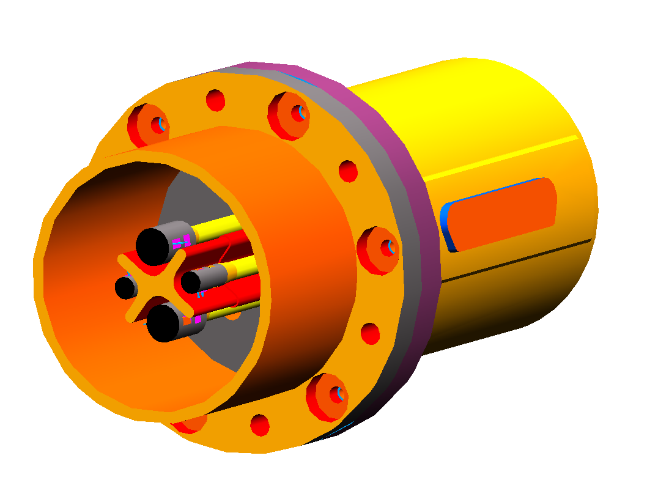
Prime Sources
Redundant Sources
SCAL_A
SCAL_B
Baffle
Figure 3 Model of SCAL assembly showing prime and redundant sources and baffle.
The SCAL assembly will bolt directly to a baffle, provided by MSSL, which also houses SM8B (see Figure 4, Figure 5 and Figure 6). To ensure adequate heat sinking, provision will be made for the attachment of a thermal strap.

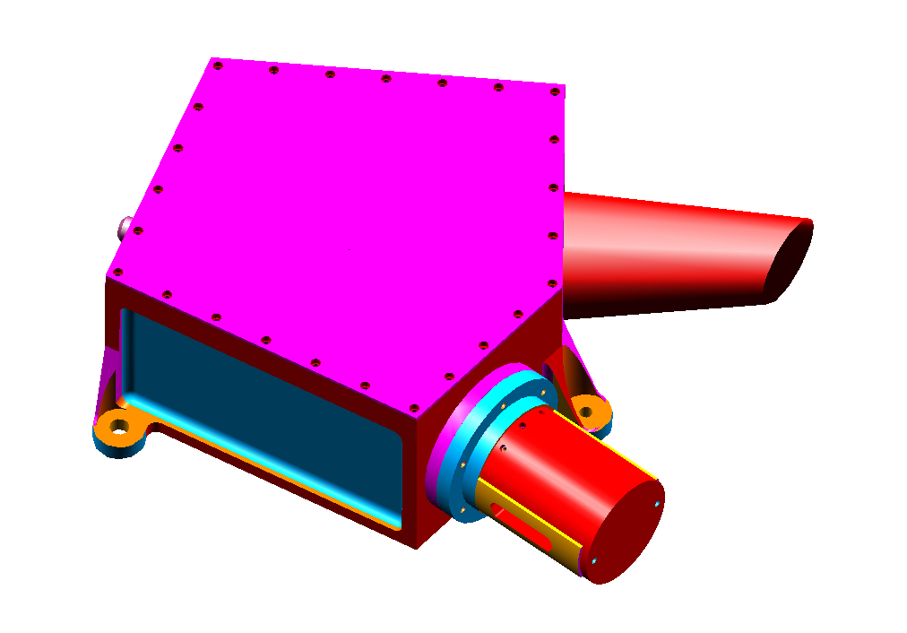
Figure 4 Isometric view of SCAL interface to baffle.
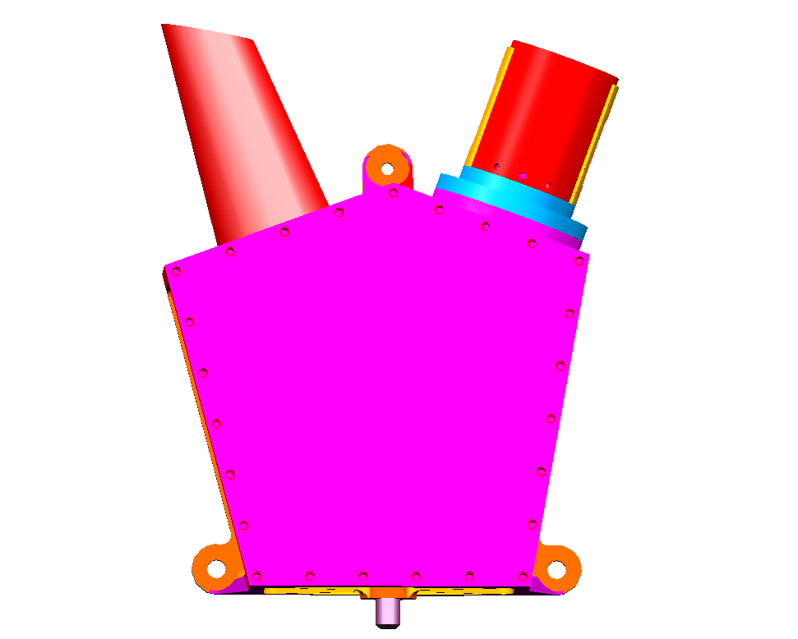
Figure 5 Plan view of SCAL and baffle.
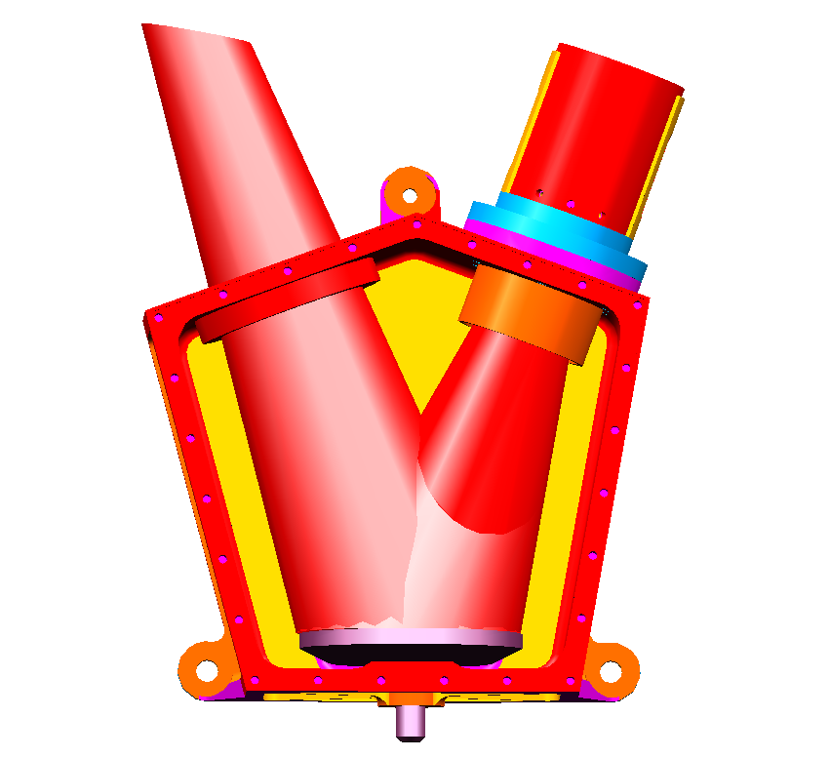
SCAL snout
SM8B
To SBS1
Figure 6 Plan view of SCAL and baffle. Top cover has been removed to show SM8B and beams.

A photometric model of SCAL and how it is viewed by the detectors (discussed further in Section 6) has shown that the configuration needed for optimal spectral matching, as well as maximum flexibility to cope with variations in the telescope temperature and emissivity from the specifications, is as shown in Table 1 and Figure 7.
Table 1 Optimal configuration for SCAL sources
Source | SCAL_A(P), SCAL_A(R) | SCAL_B(P), SCAL_B(R)
Diameter (mm) | 5 | 3
Distance from source centre to pupil centre (mm) | 5 | 5
The detectors view the 26-mm diameter pupil with an approximately Gaussian illumination profile with an edge taper of approximately 8 dB. Ideally, all sources would be placed at the pupil centre for maximum illumination efficiency. The source distribution to be used, illustrated in Figure 7, is the best compromise due to mechanical constraints.

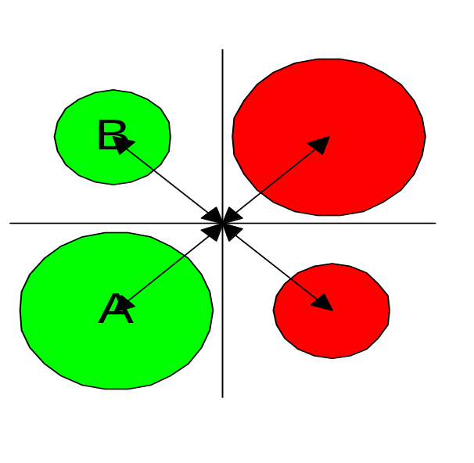
Figure 7 Optimal layout of the thermal sources for SCAL. Prime sources are shown in green, redundant in red. The centre of each source is 5mm from the pupil centre, and the minimum gap between adjacent sources is 3.07mm.

Computer simulation and modelling

Nulling of telescope emission
A MathCAD model has been produced (Appendix - A.1.1) to predict the degree of spectral matching attainable with different source dimensions, distributions, and temperatures, for different telescope temperature/emissivity scenarios. It takes into account the difference in transmission between the telescope and detectors, and SCAL and the detectors, due to the different number of filters in the paths. It also accounts for an assumed wavelength dependent emissivity of the black source coating, and for the Gaussian illumination of the pupil. It assumes that the telescope emissivity is wavelength independent - an explicit variation with wavelength can easily be incorporated, but at present there is no available information on this.

Model results are presented below for the source configuration shown in Figure 7 for a variety of telescope temperatures and emissivities.

80 K, 4% emissivity: Optimum spectral matching for an 80K, 4% emissivity telescope is achieved with the following parameters:

- SCAL_A temperature = 13 K
- SCAL_B temperature = 105 K

This produces the following nulling errors:
- 200 μm – 1.3%
- 400 μm – 1.4%
The nulling ratio as a function of wavelength is shown in Figure 8.

The spectral matching goal can also be achieved by running SCAL_A at 5K (i.e. unpowered) and SCAL_B at 108K, although the nulling isn’t quite as good (200μm – 3.4%, 400μm – 3.0%).
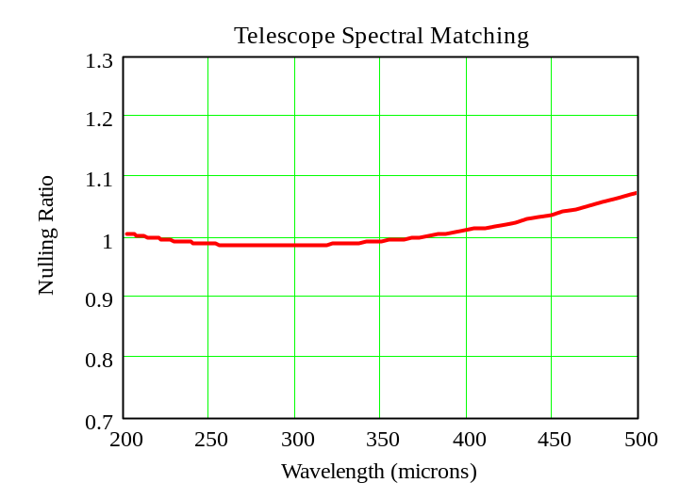
GOAL
REQUIREMENT
Figure 8 Telescope matching achievable for an 80-K, 4% emissivity telescope.

80 K, 2% emissivity: Optimum spectral matching for an 80-K, 2% emissivity telescope is achieved with the following parameters:

- SCAL_A temperature = 5 K
- SCAL_B temperature = 64 K

This produces the following nulling errors:
- 200 μm – 5.5%
- 400 μm – 4.9%

The nulling ratio as a function of wavelength is shown in Figure 9. In this scenario, it is not possible to achieve the spectral matching goal, but the requirement is easily met.

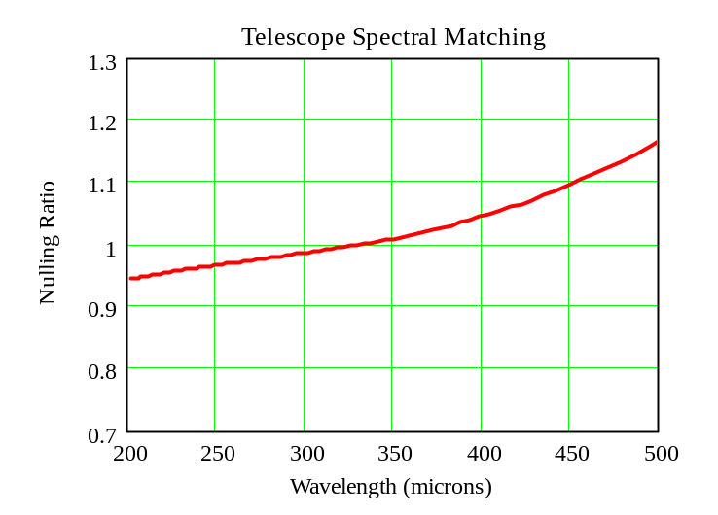
GOAL
REQUIREMENT
Figure 9 Telescope matching achievable for an 80-K, 2% emissivity telescope.

80 K, 8% emissivity: Optimum spectral matching for an 80-K, 8% emissivity telescope was achieved with the following parameters:

- SCAL_A temperature = 84 K
- SCAL_B temperature = 5 K

This produces the following nulling errors:

- 200 μm – 1.7%
- 400 μm – 0.4%

The nulling ratio as a function of wavelength is shown in Figure 10. The spectral matching goal is easily achieved in this scenario.
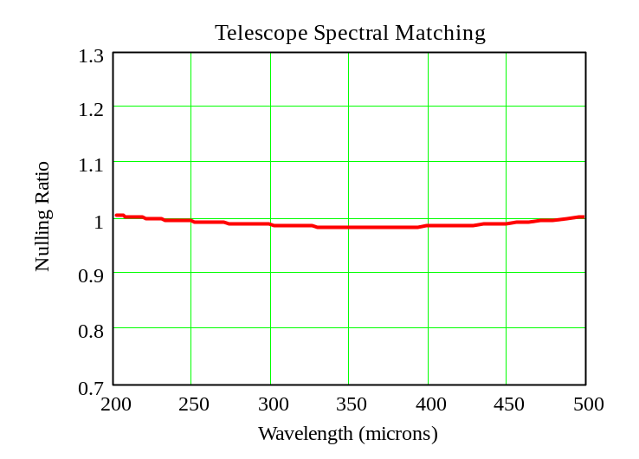
GOAL
REQUIREMENT
Figure 10 Telescope matching achievable for an 80-K, 8% emissivity telescope.

65 K, 4% emissivity: Optimum spectral matching for a 65-K, 4% emissivity telescope was achieved with the following parameters:

- SCAL_A temperature = 12 K
- SCAL_B temperature = 84 K

This produces the following nulling errors:

- 200μm –1.5%
- 400μm – 1.8%
The nulling ratio as a function of wavelength is shown in Figure 11. The spectral matching goal is easily achieved in this scenario.
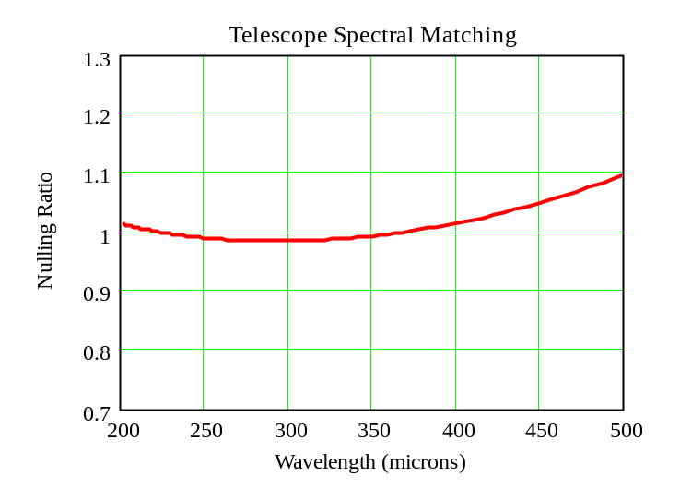
GOAL
REQUIREMENT
Figure 11 Telescope matching achievable for a 65-K, 4% emissivity telescope.

Optimum spectral matching for a 65-K, 2% emissivity telescope was achieved with the following parameters:

- SCAL_A temperature = 5 K
- SCAL_B temperature = 53 K

This produces the following nulling errors:

- 200μm – 5.6%
- 400μm – 5.9%
The nulling ratio as a function of wavelength is shown in Figure 12. The spectral matching goal is not met in this scenario, although the requirement is comfortably met.
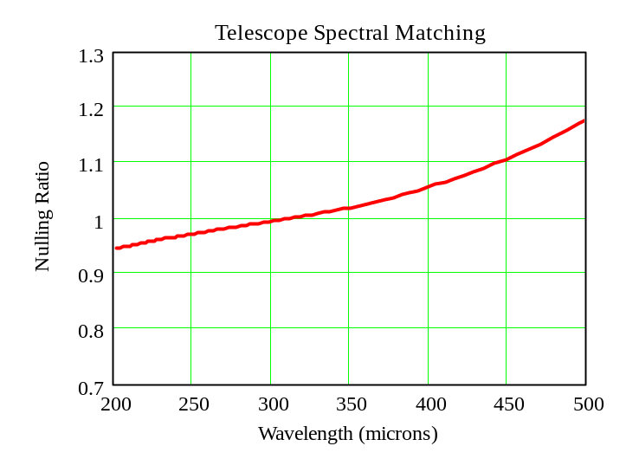
GOAL
REQUIREMENT
Figure 12 Telescope matching achievable for a 65-K, 2% emissivity telescope.

65 K, 4% emissivity: Optimum spectral matching for a 65-K, 8% emissivity telescope was achieved with the following parameters:

- SCAL_A temperature = 68 K
- SCAL_B temperature = 13 K

This produced the following nulling errors:

- 200μm – 0.6%
- 400μm – 0.8%
The nulling ratio as a function of wavelength is shown in Figure 13. The spectral matching goal is easily achieved in this scenario.
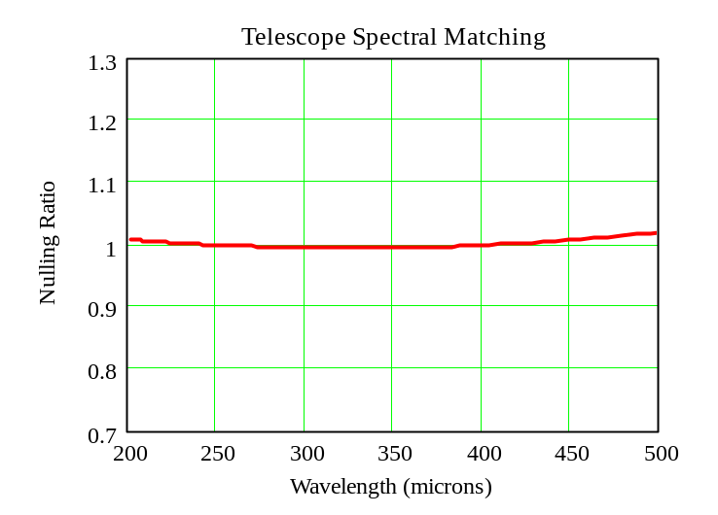
GOAL
REQUIREMENT
Figure 13 Telescope matching achievable for a 65-K, 8% emissivity telescope.

Thermal Modelling
A thermal model (appendix A.1.2) has been produced to simulate the thermal behaviour of the SCAL sources. Thermal data has been extracted from extensive literature surveys and, where possible, been verified and added to by experiments in our laboratory. The model uses an iterative program loop in a MathCAD worksheet. The algorithm takes as its input a designated constant power applied to the heater at a set base temperature, and for a small time interval, calculates the temperature rise. The next time interval is then calculated according to the slope of the warm-up curve, and the temperature rise in this interval is then calculated using temperature-dependant heat capacities and thermal conductivities for all components. Once equilibrium has been achieved (slope set by user), the power is switched off, and the cool-down curve is calculated in the same way. This model has been validated by tests in the lab on thermal prototypes.

Warm-up and cool-down curves are shown for SCAL_A and SCAL_B in Figure 14 and Figure 15 respectively. These models show the predicted thermal behaviour for a variety of applied powers.
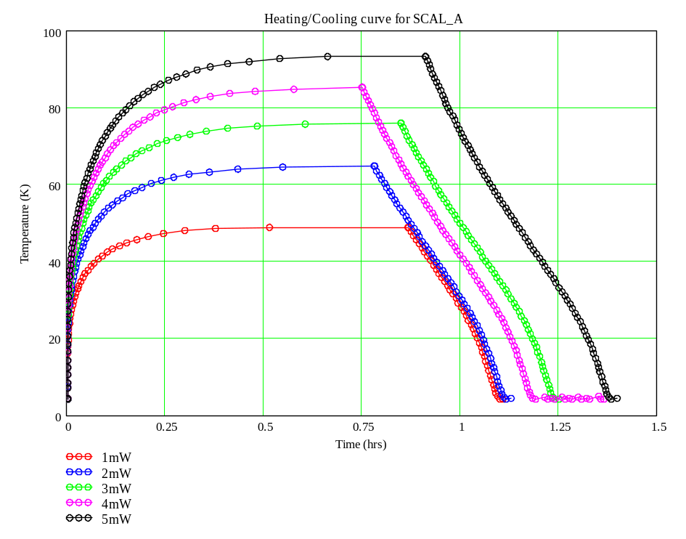
Figure 14 Heating/cooling for SCAL_A (5 mm diameter x 7 mm deep)
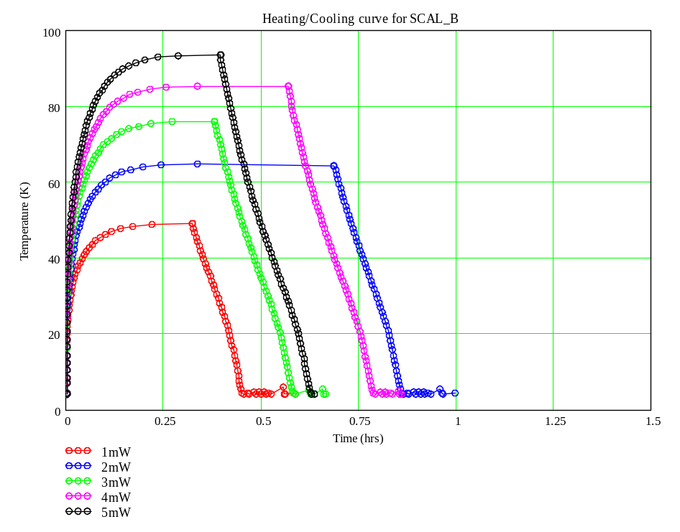
Figure 15 Heating/cooling curve for SCAL_B (3 mm diameter x 7 mm deep).
This model has been used in conjunction with the spectral matching model to estimate the power required to null the telescope emission to within the requirements. The most demanding case is where we have a telescope temperature of 80 K with 4% emissivity (Section TBD). The spectral matching model predicts that SCAL_B needs to be run at 105K, with SCAL_A at 13 K to get the best spectral match. The thermal model predicts that 6.6 mW and 0.06mW needs to be applied to SCAL_B and SCAL_A respectively to achieve these temperatures. These curves are shown in Figure 16 and Figure 17.
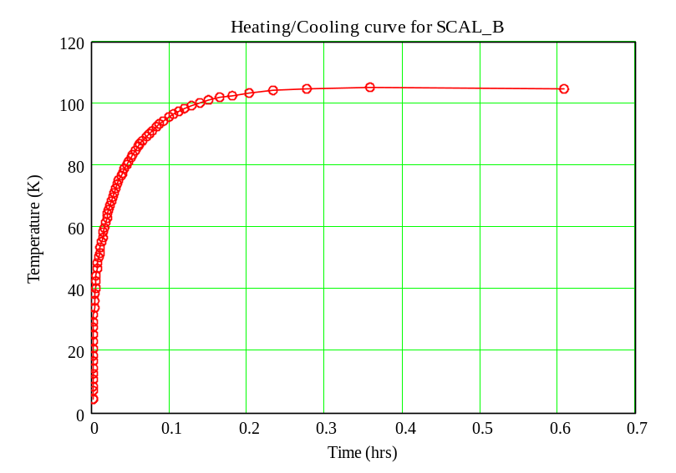
Figure 16 Warm-up curve for SCAL_B for an applied power of 6.6 mW
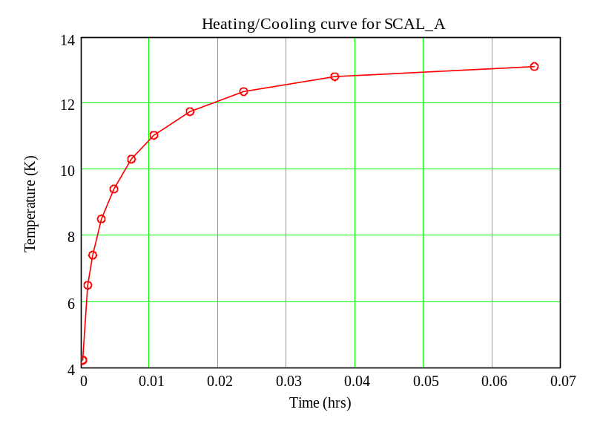
Figure 17 Warm-up curve for SCAL_A for an applied power of 0.06 mW
The case shown above is the required emitter temperatures for excellent spectral matching, to within 1.4%, across the 200-μm to 400-μm band. This requires applying a total power of 6.6 mW. However, a very good spectral match (to within 7.8%) can also be achieved by running only SCAL_A at 52.5 K, as shown in Figure 18.
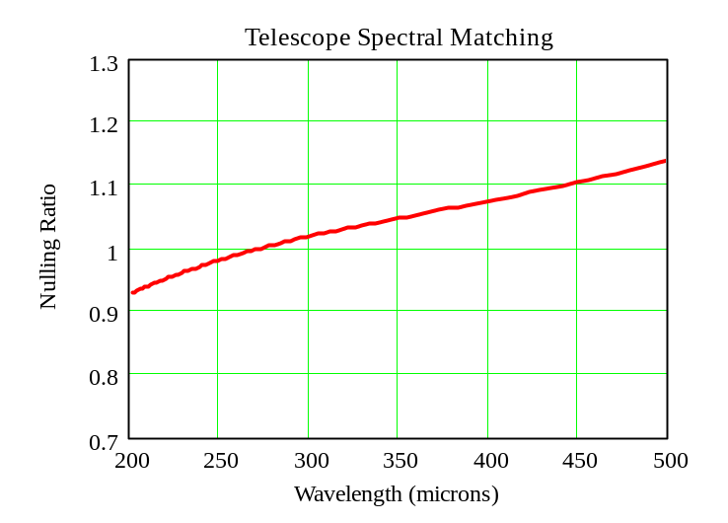
GOAL
REQUIREMENT
Figure 18 Telescope matching for 80-K, 4% emissivity telescope – matching achievable with reduced power dissipation.
Running SCAL_A at 52.5 K will require an applied power of 1.2 mW, as shown in Figure 19.

This discussion shows that there are numerous possibilities for combinations of source temperatures to meet the spectral matching requirement. It also shows that in some cases, there is a trade-off between the goodness of the match and power dissipation.
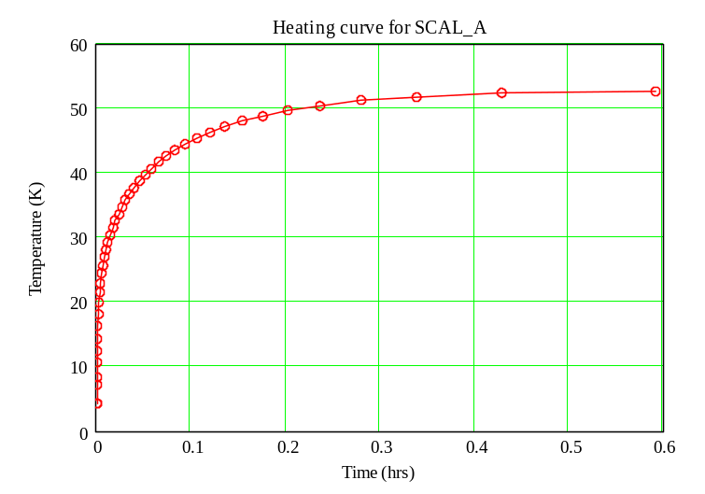
Figure 19 Heating curve for SCAL_A for an applied power of 1.2 mW

Mechanical modelling
At the time of writing, mechanical modelling has been restricted to analysis of the sources on the Torlon rods due to time constraints. A full mechanical FEA will be carried out on the whole system before the SPIRE instrument DDR.

Source deflection under load: A MathCAD model has been produced to predict the maximum expected deflection of the sources on the Torlon legs for different launch accelerations. Details of this model are presented in Appendix A.1.3 and results are presented and discussed in Section 7.7.1.

Resonant Frequency Calculation: A simple MathCAD worksheet has been produced to calculate the first resonant frequency of the system, treating the system as a mass on a spring, and as a mass on a cantilever. For this analysis, the shear modulus was used (worst case) to predict the first resonant frequency, using the mass as the total mass of the aluminium end cap and Torlon leg (overestimate). Details of this worksheet are presented in Appendix A.1.4 and results are presented and discussed in Section 7.7.1.

Static Load Bearing Capacity: A simple MathCAD worksheet has been produced to calculate the static load bearing capacity of the Torlon legs. Details of this worksheet are presented in appendix A.1.4 and results are presented and discussed in Section 7.7.1.
Mechanical FEA: A full mechanical FEA will be carried out on the entire system before the SPIRE instrument IBDR.

Detailed Design Description

Thermal Sources
Two prime heated sources are used, one of 5 mm diameter (~ 4% pupil area) and one of 3 mm diameter (~ 2% pupil area), and are referred to as SCAL_A(P) and SCAL_B(P) respectively. This configuration provides flexibility to compensate for uncertainties in the telescope emissivity and temperature (see Section 6.1). Full redundancy is provided by two additional sources, SCAL_A(R) and SCAL_B(R).

Source Assembly – Heater Body
Each source consists of an aluminium end cap, with embedded heater (Vishay CHPHR 0505 chip resistor) and thermometer (Cernox-1030), on a Torlon rod. The face of the Aluminium end cap is treated with carbon-loaded Epotek-920 epoxy to produce a high emissivity finish.

Aluminium heater body
M1.6 Thread – Interface to Torlon Strut
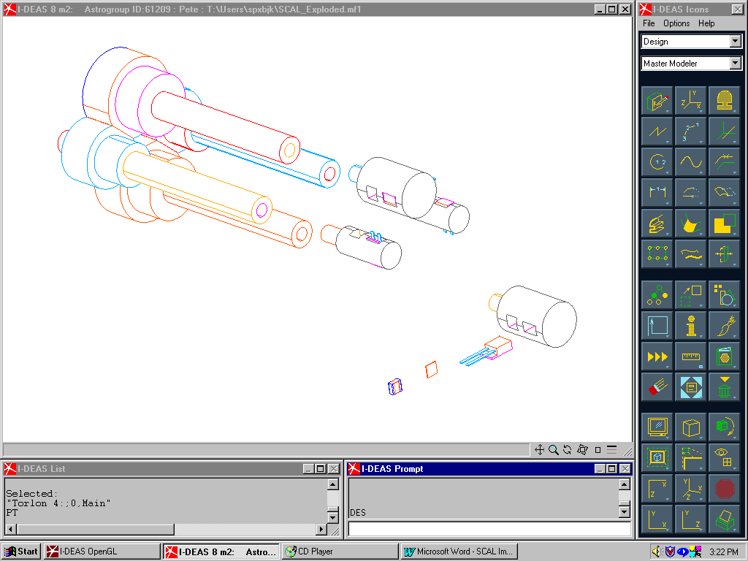
Blackened End Face
CX-1030 Thermometer
Quartz Substrate
Heater Resistor
Figure 20 Details of aluminium heater body and assembly

Heater Details
The heaters to be used are 0.125-W, 500-Ω high reliability chip resistors (CHPHR 0505), manufactured by Vishay/Sfernice. These components are on the ESA preferred parts list, but have not been qualified for use at 4 K (TBC) – samples will be tested in the Cardiff lab between September and November 2001. Details of these components are shown in Figure 21. The heater resistor will be mounted on a 100-μm thick Quartz or Sapphire substrate (Goodfellow) using Epotek 920 epoxy.
The heater on its substrate will be mounted in a slot in each heater body, as shown in Figure 20. Wires will be bonded to the end caps of the heater resistor using silver loaded conductive epoxy (Epotek H20-S).
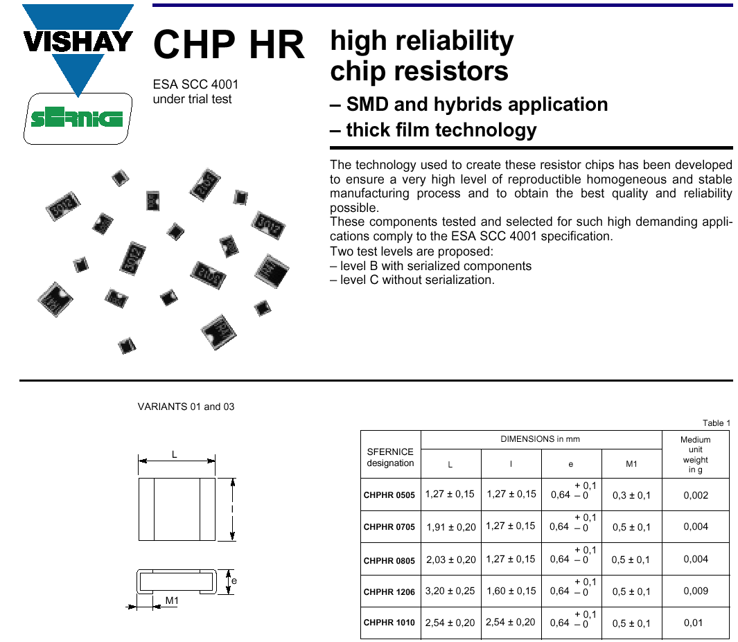
Figure 21 Details of the heaters to be used for SCAL (CHPHR 0505)

Thermometer details
The thermometers to be used in the heater bodies are Lakeshore Cernox 1030 sensors. These components have been selected as they have the performance required by the SCAL subsystem (Figure 23), and for commonality with the rest of the SPIRE systems, drive electronics and software. They are also of a convenient size to fit into the small thermal source assemblies (Figure 22).
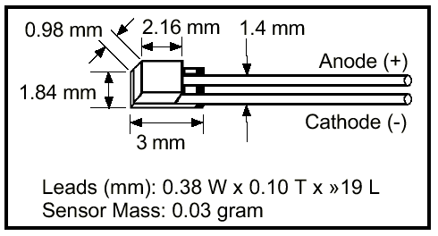
Figure 22 Package details for Cernox 1030 SD sensor
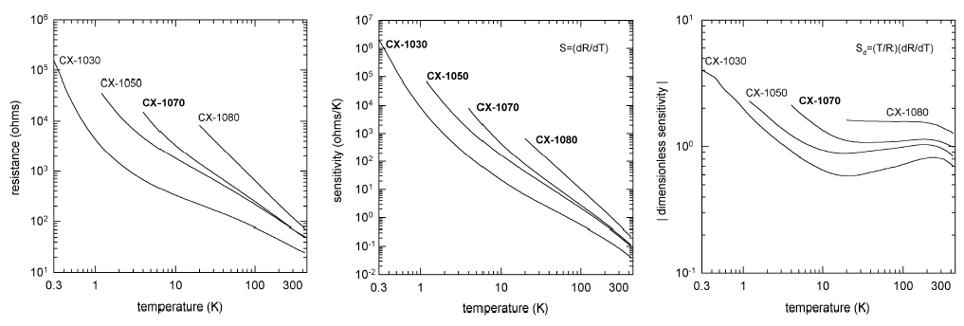
Figure 23 Typical resistance and sensitivity values for Cernox 1000 family sensors

Strut Details
Details of the Torlon support struts are shown in Figure 24. Each strut is machined from a single piece of Torlon.
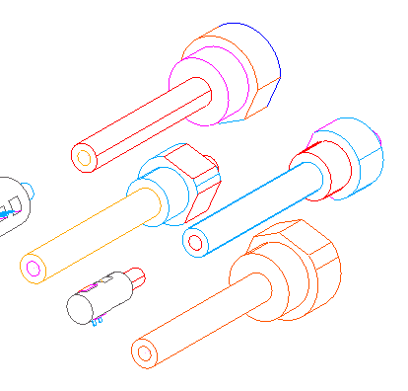
SCAL_A(P) Strut
SCAL_B(P) Strut
M1.6 threaded interface to heater body
Interface to SCAL Baseplate
Thermal isolation provided by 3mm O/D, 1.5mm I/D Torlon Tube – 20mm long
Figure 24 Details of Torlon Struts.
Wires will be wrapped helically around the legs to gain sufficient wiring length for thermal isolation purposes. Near the base of each strut will be a hole in the tube wall through which wiring will be routed to the tube cavity, and potted with epoxy (Figure 38).

SCAL Baseplate
The SCAL baseplate is shown in Figure 25 and Figure 26. During thermal prototype tests, a degree of radiant heating of passive sources by the active source was noticed. Therefore the SCAL baseplate features a baffle, shown in Figure 26, which is machined as one part with the SCAL baseplate for optimal heatsinking. The rear of the SCAL baseplate has four shouldered holes to accept the thermal source assemblies. These holes are 7 mm and 5 mm diameter for SCAL_A and SCAL_B sources respectively, with a larger diameter shoulder for retention of the Torlon struts. These oversized holes enable pre-assembly of the thermal sources prior to feeding the completed assemblies through the holes from the rear of the baseplate. The source assemblies are then clamped in place with the strut retaining plate, as shown in Figure 27.

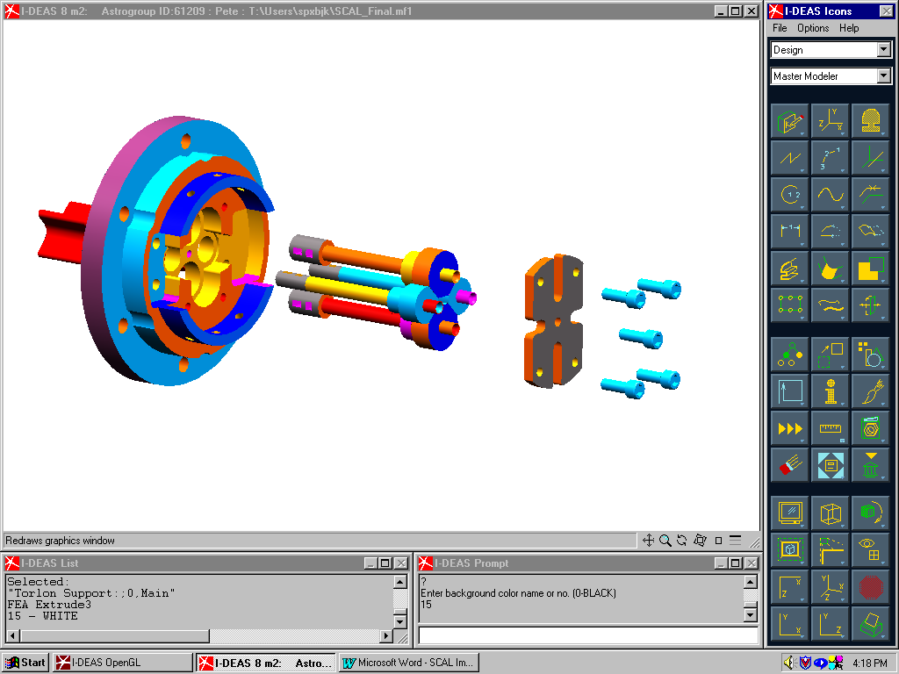
Figure 25 Rear view of SCAL baseplate.
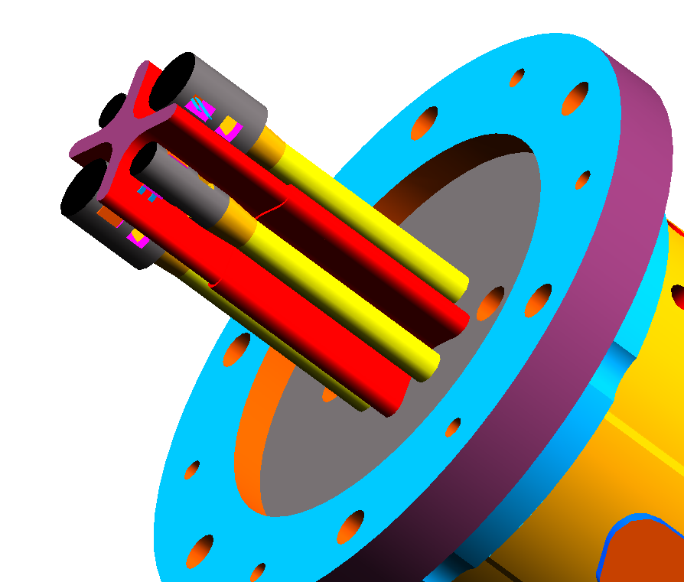
Figure 26 Front view of SCAL showing details of baffle.

Figure 27 Details of integration of thermal source assemblies and strut retention plate.

Attachment of Thermal Sources to Torlon Legs
The interface of the aluminium heater bodies to the Torlon struts is critical, as if a heater body breaks free, it could affect other subsystems and, possibly, compromise the operation of the spectrometer. At the time of writing design modification is underway which involves placing a cover – either a filter or just polypropylene – over the front face of SCAL to contain any failed components.
The heater bodies are attached to the Torlon struts using an M1.6 thread, together with Epotek 920 epoxy as shown in Figure 28. The static load bearing capacity of this arrangement is considered in Section 7.7.1. This interface will be the subject of a series of mechanical tests and thermal cycles on test pieces.
M1.6 thread and epoxy joint
SCAL baseplate interface
Figure 28 Details of aluminium-Torlon interface.

Attachment of Torlon Struts to SCAL Baseplate
The interface for the Torlon struts is illustrated in Figure 27, Figure 28 and Figure 29. The interface consists of shouldered holes, as discussed in Section 7.2, and a retaining plate. Figure 30 shows a rear view of the baseplate with the thermal source assemblies in place and held with the retaining plate. The retaining plate has machined slots to fit around the bases of the Torlon struts. The strut bases also serve as wiring channels, and these slots enable assembly without damaging the wires.

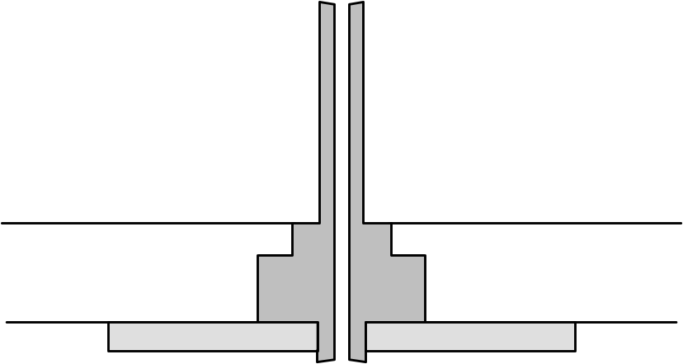
Torlon strut
SCAL baseplate
Strut retaining plate

Figure 29 Schematic of strut interface to SCAL baseplate.
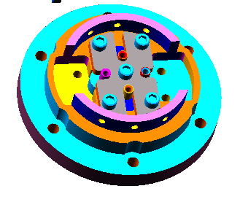
Retaining plate
Base of Torlon struts, showing wiring channels
Figure 30 View of baseplate with integrated thermal sources and retaining plate.

Connector Brackets and Rear Cover
The electrical connectors (MDM37 PSB) are mounted on brackets as shown in Figure 32. These brackets have slots milled to accept the rear cover, as shown in Figure 32 and Figure 33
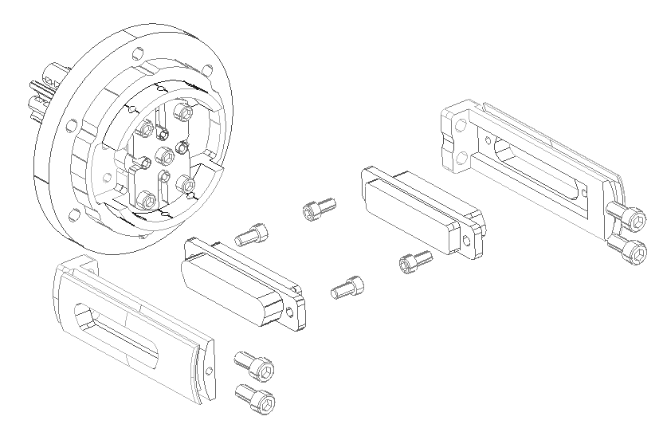
Figure 31 Assembly of electrical connector brackets on SCAL baseplate

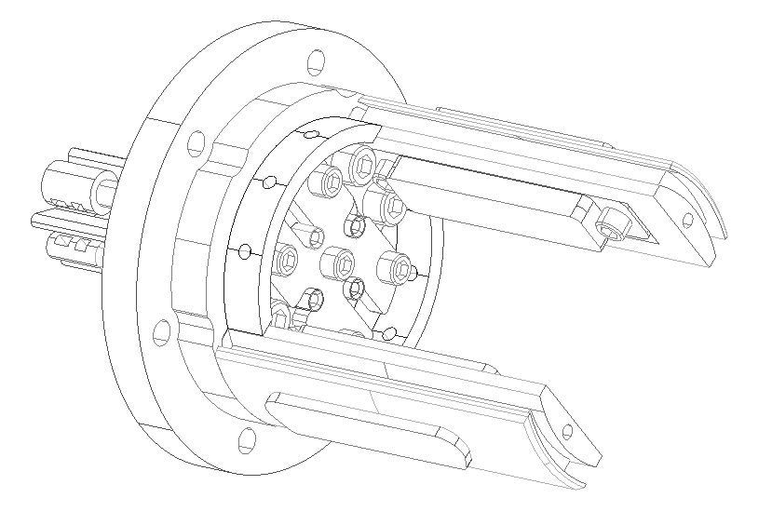
Figure 32 Details of connector mounting to rear of SCAL baseplate.

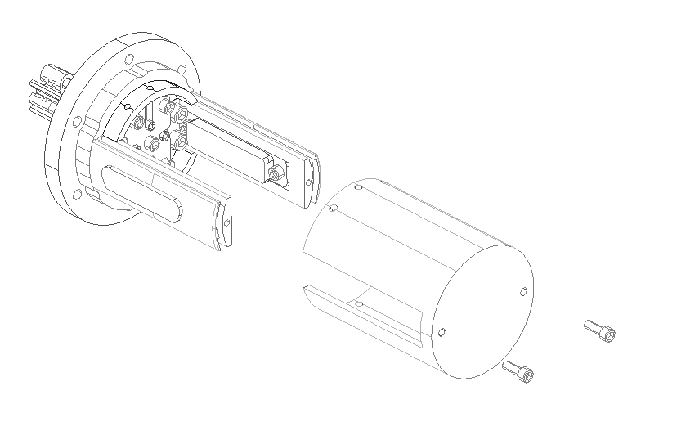
Figure 33 SCAL rear cover mounting

SCAL Snout
The front face of SCAL is protected by a snout, as shown in Figure 34. The front flange of this snout also forms the mating interface to the SCAL/SM8B baffle (provided by MSSL). This interface is further discussed in section 7.7.6. We are currently investigating the possibility of placing a filter or cover over the open SCAL face. This would make SCAL completely self-contained, and confine any catastrophic failure mode (e.g. heater body coming adrift) to SCAL.
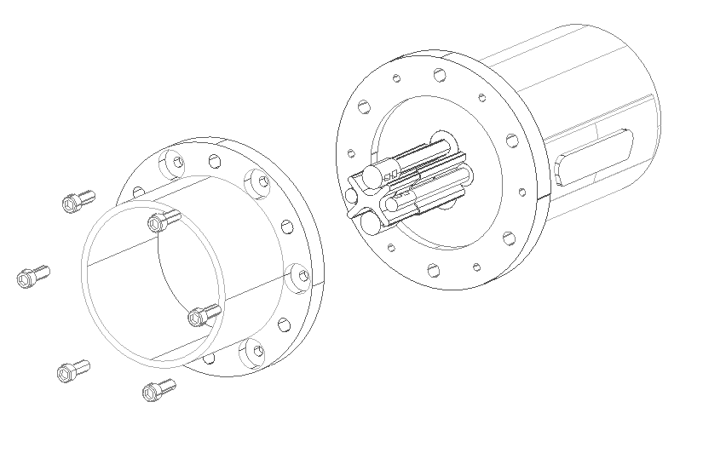
Figure 34 Illustration of SCAL snout.

Mechanical Interface

Launch Environment
The requirements from the SPIRE mechanical dictate that SCAL should withstand a maximum launch accelerations of 100 g (static) in the X, Y and Z directions. This section details a preliminary analysis of the system to get a first order estimate of the mechanical parameters. A full FEA analysis of the whole system will be performed before the instrument IBDR, as well as all necessary mechanical tests on prototypes to prove the design.

Maximum Deflection of Sources:
A MathCAD model has been produced (appendix A.1.3) to predict the maximum expected deflection of the sources on the Torlon legs for different launch accelerations. This analysis has been conducted only for the SCAL_A sources, as these are the sources that will experience the most severe forces (largest). It was also assumed that the acceleration was in a plane perpendicular to the rods (worst case).
The results are summarised in Table 2.

Table 2 Predicted peak source deflection as a function of launch acceleration. The final row (*) shows the predicted deflection of a 2.5 mm diameter solid rod for the quoted acceleration.
Launch Acceleration (g) | Peak Deflection (mm)
20 | 0.011
50 | 0.029
100 | 0.057
150 | 0.086
200 | 0.115
300 | 0.172
500 | 0.286
1350* | 1.503*

Experiment to Verify Mechanical Model
An experiment was carried out to verify these predictions. A piece of 2.5mm diameter Torlon 4203 rod was clamped in a bench vice, with 22mm protruding as shown in Figure 35.

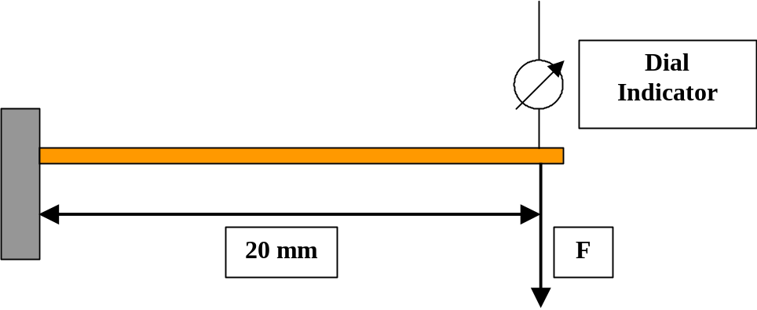
Figure 35 Simple experiment to determine maximum beam deflection under load.
In this experiment, with reference to Figure 35, the force, F, was applied by a 0.5kg mass hanging 20mm from the clamp point. The point of deflection measurement was at the point of application of this force. The deflection measured, for four different Torlon 4203 samples in the configuration shown above, was 1.58±0.15mm.
A mass of 0.5kg corresponds to a launch acceleration of 1350g. The final row of Table 2 shows the predicted deflection for this acceleration to be 1.503mm, in excellent agreement with the experimental result.

Static Load Bearing Capability:
- Torlon –Using data from the BP/AMOCO Torlon designers handbook for the shear strength of Torlon 4203, the static load strength limit corresponds an acceleration of 7.86x10⁴g. However, this is the predicted acceleration needed for the Torlon itself to break. The weak point of the system will be the glued interface to the aluminium end caps.
- Glued aluminium/Torlon interface:- The BP/AMOCO Torlon designers handbook quotes a value for the shear strength of a Torlon-aluminium 2024 interface joined with epoxy as 4000 psi. This translates into a maximum acceleration of 1.70x10⁴g.
- Screw holding strength:- The screw pull-out strength for a 4-40 UNC bolt in a 4.8 mm thick Torlon block has been quoted as 240 kg. This equates to an acceleration of around 6x10⁵g.
- The SCAL sources will be fixed to the struts with an M1.4 thread and also fixed with epoxy, as described in section 7.3. A series of test pieces will be constructed to verify the pull-apart strength of this joint.

Resonant Frequency Calculation:
The first resonant frequency of the thermal sources is calculated using the following expressions:-
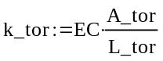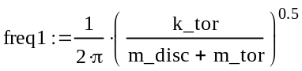
where EC is the compressive modulus of elasticity (strictly, we should use the flexural modulus, but we use EC as this has the lowest value of the quoted moduli – worst case), A_tor and L_tor are the cross-sectional area and length of the Torlon strut, and m_tor and m_disc are the masses of the Torlon and aluminium end cap respectively.
This calculation gives a first resonant frequency of the SCAL_A source (most massive) as 5.97x10³ Hz.
It should be noted that this calculation is for a simple mass on a spring. The system is more closely modelled by a mass on a cantilever, in which case the above quoted frequency should be multiplied by a factor of Pi. It is also made assuming the weakest of the quoted moduli, and assumes that the “mass on the spring” is the total mass of the aluminium cap and the whole Torlon strut.

Interface to SCAL/SM8B baffle
The SCAL mechanical interface consists of six 4-40 UNC bolts on a 42.5 mm PCD as illustrated in Figure 36. Full details of this interface are contained in AD27 (SCAL ICD, HSO-CDF-ICD-012).
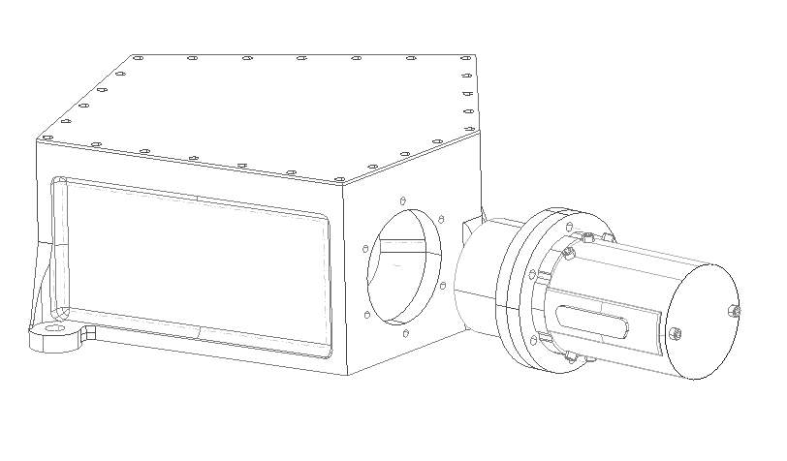
Figure 36 Illustration of interface to SCAL/SM8B baffle.

Thermal Design Details
A thermal model has been produced (appendix A.1.2) which models the thermal behaviour of the sources as a function of applied power. The components considered in this model are encompassed by the yellow shaded area in Figure 37. In the model, it is assumed that the SCAL baseplate is at 4.2 K. This model takes into account the temperature dependant heat capacity and thermal conductivity of all components shown, and has been validated by experiments in the lab with thermal prototypes.
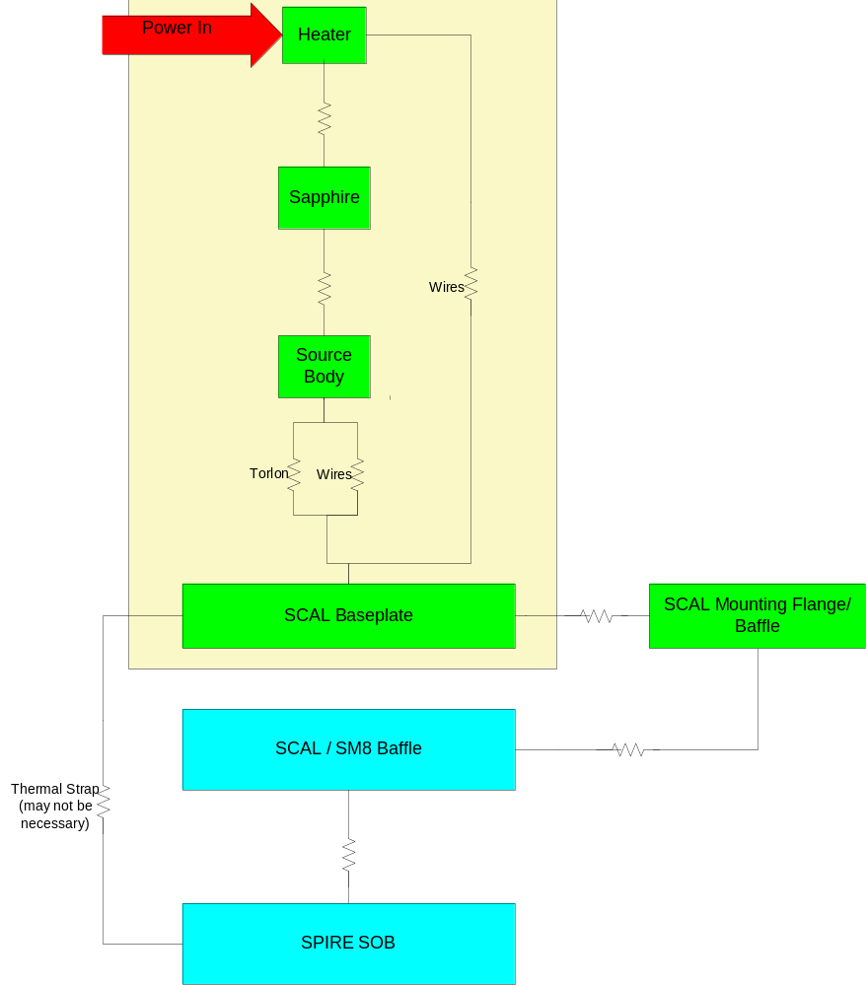
Figure 37 Thermal block diagram for SCAL (one source). Green indicates Cardiff supplied SCAL components, blue indicates MSSL supplied components.

Wire Heatsinking
Special care will be taken to ensure adequate heatsinking of all wires. This will be achieved by fixing wires to the heatsink points with Epotek 920 epoxy.

Baffling
A degree of radiant heating of passive sources by the active source was observed during preliminary lab tests. Therefore SCAL will have a baffle to separate the sources, as shown in Figure 26. This baffle will be machined with the baseplate as a single part to ensure good heatsinking. In addition, the baffle will be coated with a low emissivity finish (carbon loaded Epotek 920).

Thermal Interface
There is no direct thermal interface with SCAL and the SPIRE optical bench, as SCAL is mounted off the SCAL/SM8 baffle (Figure 36). In the unlikely event of heat sinking through the baffle to the SOB proving insufficient, provision is made for a thermal strap from the SCAL baseplate directly to the SOB. This strap will be in the form of a well annealed, gold plated 99.999% pure copper strip.
The temperature of the SCAL interface with the baffle will be monitored by a thermometer on the SCAL baseplate.

Optical Design Details
- Talk to Kjetil – need verification that partial filling of pupil OK – need more info. on the true illumination of the pupil.
- Stray light – Tony

Optical Interface
To be written – need to consult with Kjetil & Tony

Electrical Design Details

Wiring
All heaters and thermometers will be wired in a four-wire configuration with manganin wire. Wiring for each source will be passed through holes in the SCAL strut where they will be anchored with epoxy, and then wrapped down the strut as shown in Figure 38 to gain sufficient wire length for thermal isolation purposes. At the base of each strut, the wires are passed through another hole through the tube wall, and into the centre of the strut. At the point where they emerge from the base of the strut, they will be anchored with epoxy.

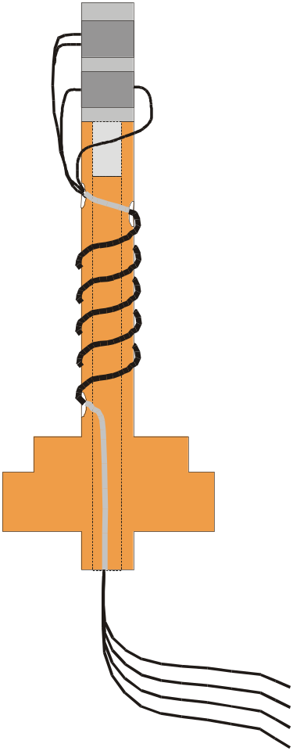
Wires anchored with epoxy at these points
Wires passed into centre of strut
Figure 38 Routing of thermal source wiring.
After integration of the thermal sources to the SCAL baseplate, the wires are soldered directly to the prime and redundant MDM37PSB connectors. The mounting of the connectors is illustrated in Figure 32, and an indication of the wiring is shown in Figure 39. Connector savers will be employed for the CQM, PFM and FS models, and mate/demate log books kept.
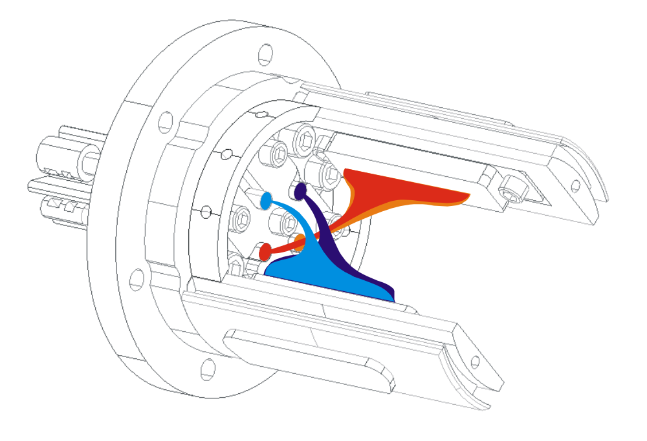
Figure 39 Illustration of wiring to connectors. The wiring for the prime sources is shown in blue, redundant in red.

Connector Pin-Outs and Harness Definition
A schematic of the SCAL harness is shown in Figure 40. This harness, to be supplied by Cardiff with SCAL, is isothermal, and runs between SCAL and the RF filter box. All conductors will be made from copper, and the harness length and routing is to be defined by MSSL. The pin allocation for the MDM37 PSB connectors (prime and redundant) is illustrated by Figure 41, and wiring details of the SPIRE cryoharness, C10, are shown in Table 3 and Figure 40.

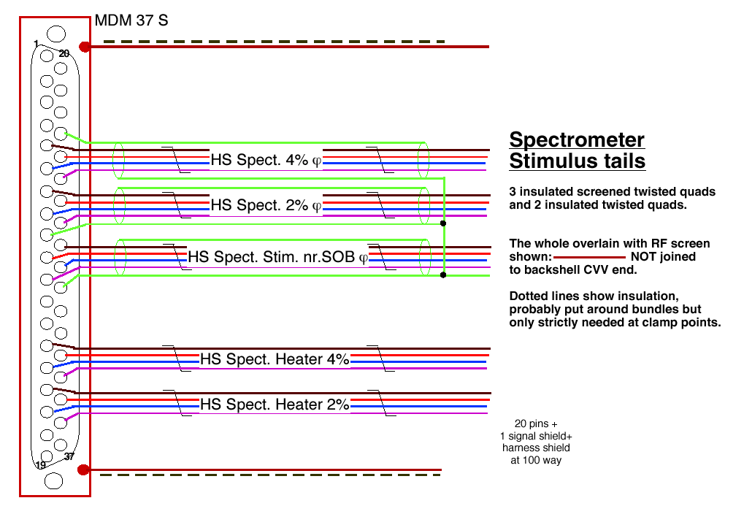
Figure 40 Schematic of SCAL harness wiring scheme. The same scheme is used for prime and redundant harnesses.
Table 3 Wiring details for SPIRE cryoharness, C10.
Function | 37way  J21 | Max.  current | Wire  lay-up | Max  Ohms | 100way #10
HS Spect. 4% temperature I+ SCAL_A | 5 | 1 µA | Insulated screened twisted quad | 1000
HS Spect. 4% temperature V+ | 6 | N/A | Insulated screened twisted quad | 1000
HS Spect. 4% temperature V- | 24 | N/A | Insulated screened twisted quad | 1000
HS Spect. 4% temperature I- | 25 | 1 µA | Insulated screened twisted quad | 1000
HS Spect. 4% temperature shld* | 23 | N/A | Insulated screened twisted quad | N/A
HS Spect. 2% temperature I+ SCAL_B | 7 | 1 µA | Insulated screened twisted quad | 1000
HS Spect. 2% temperature V+ | 8 | N/A | Insulated screened twisted quad | 1000
HS Spect. 2% temperature V- | 26 | N/A | Insulated screened twisted quad | 1000
HS Spect. 2% temperature I- | 27 | 1 µA | Insulated screened twisted quad | 1000
HS Spect. 2% temperature shld* | 9 | N/A | Insulated screened twisted quad | N/A
HS Spect. Stim near SOB temperature I+ | 10 | 1 µA | Insulated screened twisted quad | 1000
HS Spect. Stim near SOB temperature V+ | 11 | N/A | Insulated screened twisted quad | 1000
HS Spect. Stim near SOB temperature V- | 28 | N/A | Insulated screened twisted quad | 1000
HS Spect. Stim near SOB temperature I- | 29 | 1 µA | Insulated screened twisted quad | 1000
HS Spect. Stim near SOB temperature shld* | 30 | N/A | Insulated screened twisted quad | N/A
HS Spect. 4% heater I+ SCAL_A | 14 | 9 mA | Twisted quad | 30
HS Spect. 4% heater V+ | 15 | 9 mA | Twisted quad | 30
HS Spect. 4% heater I- | 33 | 9 mA | Twisted quad | 30
HS Spect. 4% heater V- | 34 | 9 mA | Twisted quad | 30
HS Spect. 2% heater I+ SCAL_B | 16 | 7 mA | Twisted quad | 30
HS Spect. 2% heater V+ | 17 | 7 mA | Twisted quad | 30
HS Spect. 2% heater I- | 35 | 7 mA | Twisted quad | 30
HS Spect. 2% heater V- | 36 | 7 mA | Twisted quad | 30

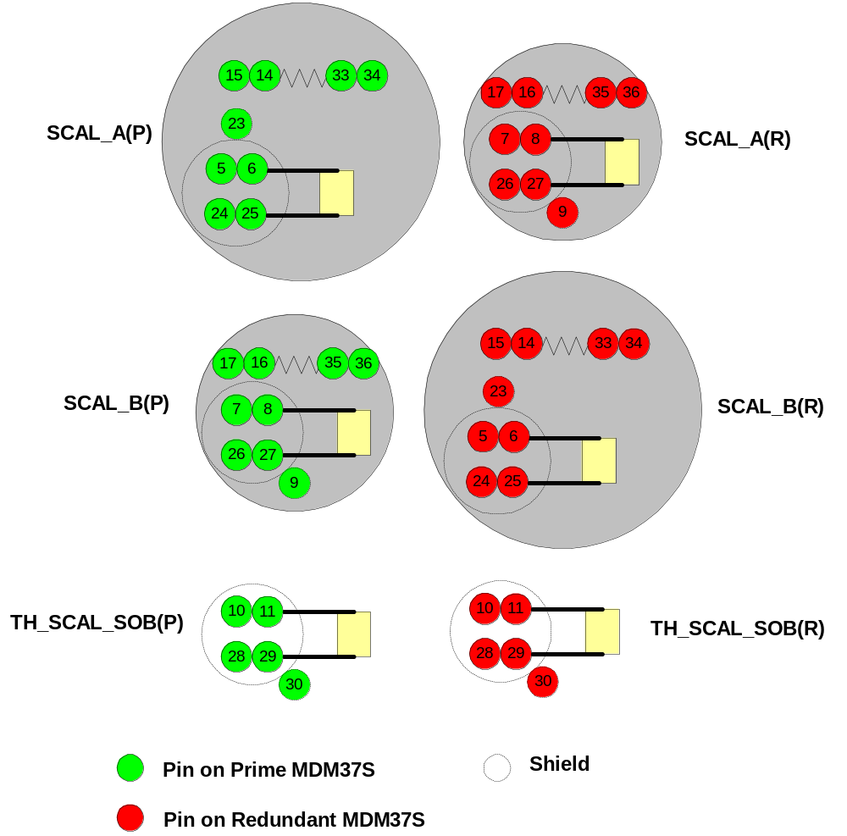
Figure 41 Schematic of pin allocation on SCAL prime and redundant connectors

Electrical Interface
Current drive for the SCAL heaters was agreed at the SPIRE interface review in November 2000. The requirements listed below assume a final heater impedance of 500 Ω and wiring impedance of 30 Ω per wire.
The design of SCAL has changed significantly since the interface review. There is a need for two more thermometry channels (one prime, one redundant) over what was agreed at the review. We need to verify with the warm electronics providers (CEA-SAp) that this is not a problem.

Maximum Drive Current
Maximum power is specified as 5mW (goal - TBC), but we may want to run at higher power. Therefore we have allowed for a maximum power dissipation of 15mW. Assuming a 500 Ω heater resistor, this gives a required drive current of 5.5mA.

Adjustability of the drive current
12-bit resolution (minimum) is required in the range 0 – 5.5mA. This will give a minimum of 2275 adjustment steps in the target operating range.

Required Maximum Drive Voltage
The required maximum drive voltage, assuming a 30 Ω harness impedance in each direction, is 3.08 V. The voltage drop across the heater in this situation will be 2.75 V.

Drive Current Stability
The required repeatability for calibrator radiant power is 1%.
The stability and repeatability of the drive current should be within 5μA or 0.5% of the drive current, whichever is the greater.

Power Supply Redundancy
Separate power supplies are required for each SCAL heater – 2 prime, 2 redundant. Completely independent circuits will drive the prime and redundant SCAL heaters.

Requirements on Thermometry Accuracy
In deriving these requirements, we have made the following assumptions:
- Cernox 1030 thermometer with properties close to generic example in Lakeshore catalogue.
- Required temperature measurement range = 4 K – 120 K
- Nominal operating temperature range = 5 – 90 K (to match dilute 80 K telescope Rayleigh-Jeans telecope spectrum).
- Goal temperature accuracy & stability = 1% in nominal range, 2% at 80 K. Note: this is not stated in the IRD, but internally decided.
Based on these assumptions, we have created a MathCad spreadsheet (Cernox_spec.mcd) to analyse the corresponding warm electronics requirements for the SCAL thermometers, which are:
- Constant current drive
- Drive current in the range 10 – 30 μA. Currents above this range may cause unacceptable self-heating.
- 16-bit ADC resolution.
- Stability: 1% on drive current required, driving through resistances of (500+2000)Ω (2kΩ from two harness wires), up to ~35kΩ.

Hardware Tree
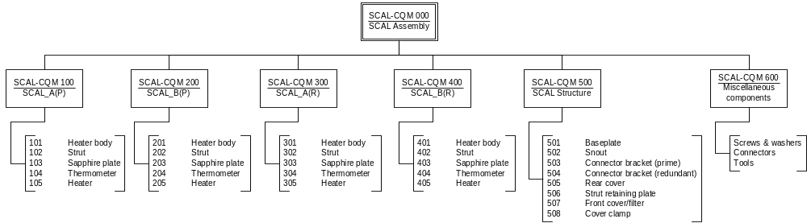
Figure 42 Hardware tree

Mass Breakdown
The mass breakdown of all SCAL components is shown in Table 4 below.
This breakdown does not include the option of fitting a front cover over the snout to protect other SPIRE subsystems from SCAL component failure. Therefore we request that the current mass budget allocation of 200g remains in place until further notice.

Table 4 SCAL mass breakdown
SCAL COMPONENT MASS CALCULATION

Component Total mass Single part mass

REAR COVER 0.0263716 Kg
- top retaining hex (2) 0.000653416 Kg 0.000326708 Kg
- base retaining hex (4) 0.001120766 Kg 0.0002801915 Kg

CONNECTOR BRACKET (2) 0.01183558 Kg 0.00591779 Kg
- retaining hex (4) 0.002544804 Kg 0.000636201 Kg

CONNECTOR (Ali 6061) (2) 0.01085444 Kg 0.00542722 Kg
- retaining hex (4) 0.001120736 Kg 0.000280184 Kg

STRUT CLAMP 0.0014163
- retaining hex (5) 0.00163354 Kg 0.000326708 Kg

STRUT 5mm (2) (Torlon 5030) 0.001538742 Kg 0.000769371 Kg
STRUT 3mm (2) (Torlon 5030) 0.001006218 Kg 0.000503109 Kg

BASE 0.0342416 Kg
- retaining hex (6) 0.00665784 Kg 0.00110964 Kg

SNOUT 0.0212208 Kg
- retaining hex (6) 0.001960248 Kg 0.000326708 Kg

SOURCE 5mm (2) 0.000659434 Kg 0.000329717 Kg
SOURCE 3mm (2) 0.000235732 Kg 0.000117866 Kg

HEATER (4) 0.0000098782 Kg 2.46955E-006 Kg
THERMOMETER (4) 0.0000021168 Kg 5.292E-007 Kg
SAPPHIRE PLATE (4) 0.000046638 Kg 1.16587E-006 Kg

Main assembly (Rear Cover, Connector Brackets, Strut Clamp, Base, Snout) = 93.08588 g

Entire assembly = 126.2 g

Reliability & Redundancy

Reliability Block Diagram
RELEX models to be included

Fault Tree Analysis
RELEX models to be included

Single Point Failures
No single point failure modes have been identified

FMECA
A failure modes effects and criticality analysis has been performed (Table 5) on all functional elements of SCAL (excluding structural elements whose integrity has been assessed with stress analysis and fracture mechanics analysis as necessary) which can cause failure effects within the experiment or cause damage to or interfere with, the proper functioning of the HERSCHEL spacecraft.

Each failure effect identified has been given a criticality category according to the definition below:

- Category 1: The failure effect is not confined to the subsystem. When this failure results also in loss or degradation of the instruments function this shall be stated.

- Category 2: The failure results in loss or degradation of the subsystems function but the effect is confined to the subsystem.

- Category 3: Minor internal subsystem failures.

The following attributes have been added to the criticality category as appropriate:

- "R", if the design contains a redundant item which can perform the same function
- "SH", if the failure effect causes a safety hazard
- "SPF" if the failure is caused by a single point failure.

The following failure modes have been considered: -

Premature operation
Failure to operate (at the prescribed time)
Failure to cease operation (at the prescribed time)
Failure during operation
Degradation or out of tolerance operation
For failure at component level e.g. hardware interface
- short circuit
- open circuit
- incorrect function e.g. from single event upset - ex: latch-ups.
Incorrect commands or sequence of commands
Incorrect software functions
Mechanical failure

Design specifications, descriptions functional diagrams etc. used in the preparation of the FMECA shall be attached or referenced.

Critical Components Identification
Table 5 Failure Modes Effects and Criticality Analysis (FMECA) for the SCAL system
FAILURE MODES EFFECTS AND CRITICALITY ANALYSIS (FMECA)

Product: SPIRE Instrument
Project/Phase: Herschel
System/Subsystem/Equipment: SCAL
Mission phase/Operational Mode: Space Flight
Prepared by: P.Hargrave
Approved by:
Date: 25/08/01
Document reference:
Issue:

Id  number | Item/  block | Function | Failure mode | Failure  cause | Failure effects  a. Local effects  b. End effects | Severity | Failure  detection method/  observable symptoms | Compensation  provisions | Correction  actions | Remarks
000.001 | SCAL Assembly |  | Input power short to ground (source A or B) | Connector Failure | a. Loss of SCAL_A or SCAL_B sources  b. Degraded dynamic range for spectrometer detectors | 2R | No source heating for one of the prime sources | Switch to redundant side | Can run second prime source – impaired telescope nulling | There are two prime sources with full redundancy. Running the other prime source will still allow some degree of telescope nulling with perhaps increased power dissipation
000.002 | SCAL assembly |  | Input power open circuit  (source A or B) | Connector Failure | a. Loss of SCAL_A or SCAL_B sources  b. Reduced dynamic range for spectrometer detectors | 2R | No source heating for one of the prime sources | Switch to redundant side | Can run second prime source – impaired telescope nulling | There are two prime sources with full redundancy. Running the other prime source will still allow some degree of telescope nulling with perhaps increased power dissipation
000.003 | SCAL assembly |  | Thermometry short  (source A or B) | Connector Failure | a. Inability to monitor SCAL_A or SCAL_B temperatures  b. Loss of thermometry data for source | 3R | Low impedance reading on source thermometer | Switch to redundant side | Can still run source “blind” based on experimental data until we maximise the central peak in the interferogram
000.004 | SCAL assembly |  | Thermometry open circuit  (source A or B) | Connector Failure | a. Inability to monitor SCAL_A or SCAL_B temperatures  b. Loss of thermometry data for source | 3R | Open circuit reading for thermometer | Switch to redundant side | Can still run source “blind” based on experimental data until we maximise the central peak in the interferogram
100.001 | SCAL_A(P) – prime 4% source assembly | Radiant source for telescope nulling | Heater body breaks off strut | Manufacturing error. Part failure. | a. Loss of SCAL_A(P) source  b. Degraded dynamic range for spectrometer detectors. Possible damage to other subsystem and instrument components (e.g. SM8B, beam splitter) | 1R | Open circuit reading for thermometer and heater | a. Switch to redundant side  b. None | Can run second prime source – impaired telescope nulling
101.001 | SCAL_A(P) – heater body |  | Loss of black coating | Manufacturing error. | a. Reduced emissivity of source – increased power dissipation to achieve required level of nulling. Impaired nulling.  b. Possible damage to other subsystem and instrument components (e.g. SM8B, beam splitter) from coating fragments | 1R |  | a. Switch to redundant side  b. None | Can run second prime source – impaired telescope nulling | May not be possible to match spectrum within requirements
102.001 | SCAL_A(P) – strut | Supports heater body – provides thermal isolation | Breaks | Material failure | a. Loss of source  b. Reduced dynamic range for spectrometer detectors. Possible damage to other subsystem and instrument components (e.g. SM8B, beam splitter) | 1R |  | a. Switch to redundant side  b. None | Can run second prime source – impaired telescope nulling
103.001 | SCAL_A(P) – sapphire plate | Provides electrical isolation for heater resitor & good thermal path to heater body | Cracks | Manufacturing error. Differential thermal contraction | a. Impaired thermal path to heater body – increased warm-up time  b. Longer warm-up | 3R |  | Switch to redundant side |  | May be detectable by performing cross-calibration with redundant side sources.
104.001 | SCAL_A(P) – thermometer | Monitors source temperature | Short | Manufacturing error. Part failure. | a. Inability to monitor SCAL_A temperature  b. Loss of thermometry data for source | 3R | Low impedance reading on source thermometer | Switch to redundant side | Can still run source “blind” based on experimental data until we maximise the central peak in the interferogram
104.002 |  |  | Open | Manufacturing error. Part failure. | a. Inability to monitor SCAL_A temperature  b. Loss of thermometry data for source | 3R | Open circuit reading for thermometer | Switch to redundant side | Can still run source “blind” based on experimental data until we maximise the central peak in the interferogram
104.003 |  |  | Erratic output | Manufacturing error. Part failure. | a. Inability to monitor SCAL_A temperature  b. Loss of thermometry data for source | 3R |  | Switch to redundant side | Can still run source “blind” based on experimental data until we maximise the central peak in the interferogram
104.004 |  |  | No output | Manufacturing error. Part failure. | a. Inability to monitor SCAL_A temperature  b. Loss of thermometry data for source | 3R |  | Switch to redundant side | Can still run source “blind” based on experimental data until we maximise the central peak in the interferogram
105.001 | SCAL_A(P) – Heater resistor | Heater for source | Open | Manufacturing error. Part failure. | a. Loss of source  b. Reduced dynamic range for spectrometer detectors | 2R | No source heating | Switch to redundant side | Can run second prime source – impaired telescope nulling | There are two prime sources with full redundancy. Running the other prime source will still allow some degree of telescope nulling with perhaps increased power dissipation
105.002 |  |  | Short | Manufacturing error. Part failure. | a. Loss of source  b. Reduced dynamic range for spectrometer detectors | 2R | No source heating | Switch to redundant side | Can run second prime source – impaired telescope nulling | There are two prime sources with full redundancy. Running the other prime source will still allow some degree of telescope nulling with perhaps increased power dissipation
105.003 |  |  | Changed value | Manufacturing error. Part failure. | a. Change in drive requirements  b. None | 3R | Monitor I/V values for heater (4 wire configuration) | Change drive current  Switch to redundant side? | Change drive current

Assembly, Integration & Verification
A Manufacturing, Assembly, Integration and Verification (MAIV) flow chart has been prepared (HSO-CDF-FC-014) and will be updated under configuration control.
A full AIV plan is in preparation at the time of writing.

General
An overall exploded view of the SCAL assembly is shown in Figure 43.

Assembly
A full AIV plan is in preparation at the time of writing.

Integration
A full AIV plan is in preparation at the time of writing.

Verification
A full AIV plan is in preparation at the time of writing.

Transport & Storage
SCAL will be delivered in a nitrogen purged box for storage. SCAL will be supplied with a cover for the normally open emitter face. We require that this cover remains in place unless the cleanliness of the environment is class 10,000 or better. For the purposes of integration to the instrument, it is permissible to remove the SCAL cover in a class 100,000 environment for short periods. We assume there will be no need to disassemble SCAL once delivered to RAL. If that need arises, members from Cardiff must be present.

Handling
For the purposes of integration to the instrument, it is permissible to remove the SCAL cover in a class 100,000 environment for short periods. We assume there will be no need to disassemble SCAL once delivered to RAL. If that need arises, members from Cardiff must be present.

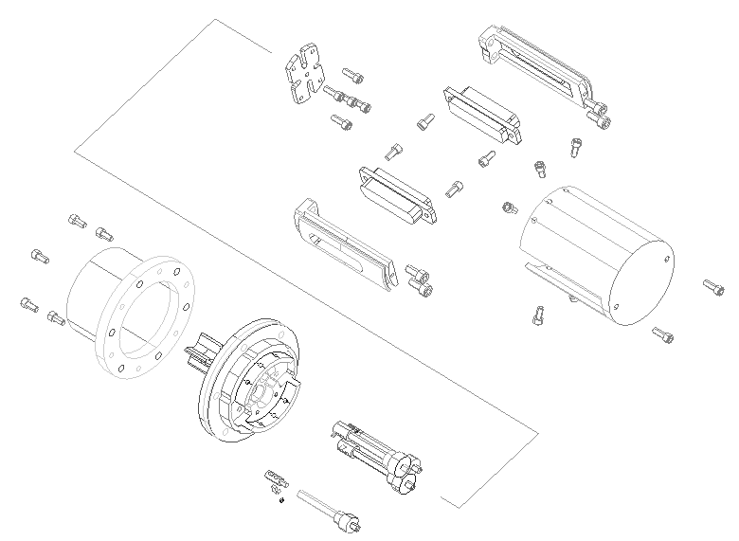
Figure 43 Exploded view of SCAL components.

Appendices

Appendix 1 – Details of Computer Models

Nulling of Telescope Emission Spectrum
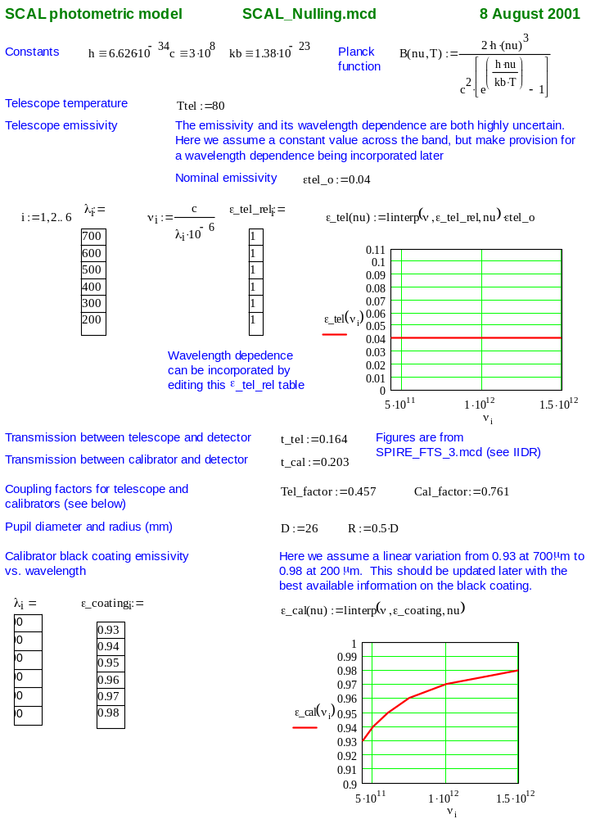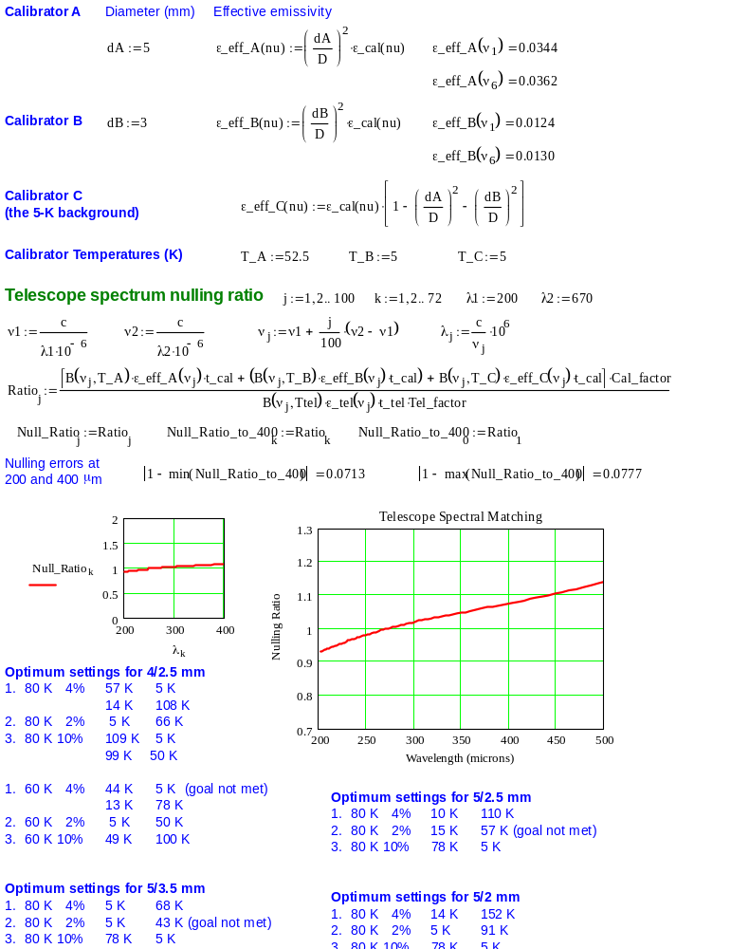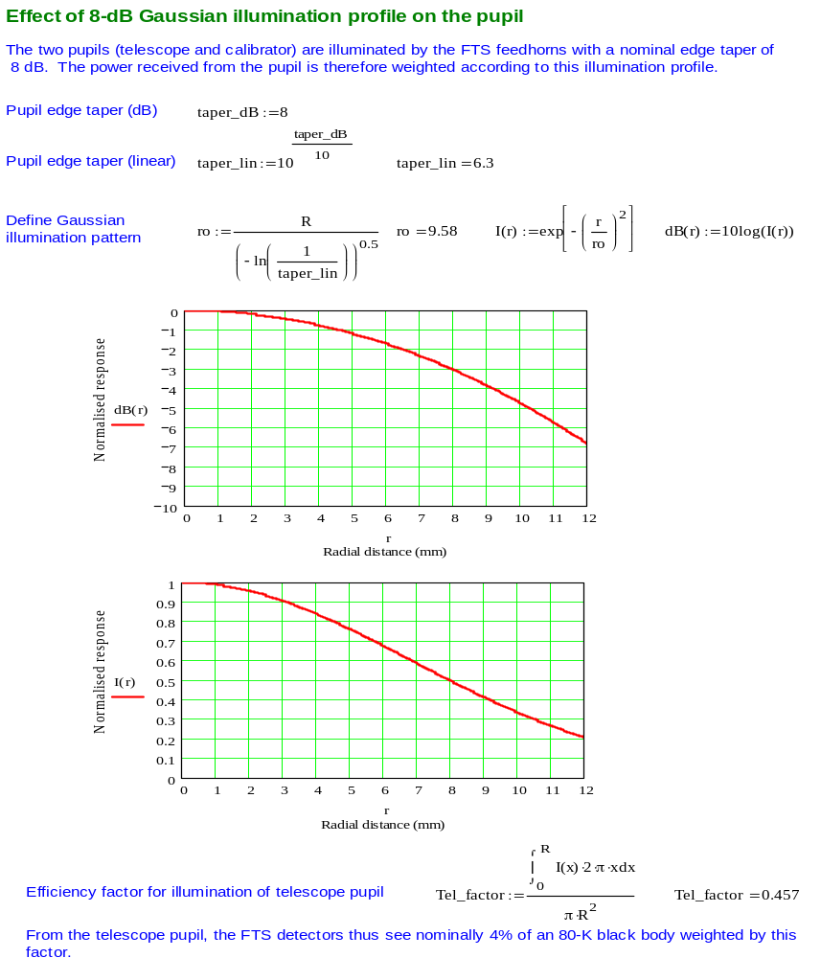

Source Thermal Model
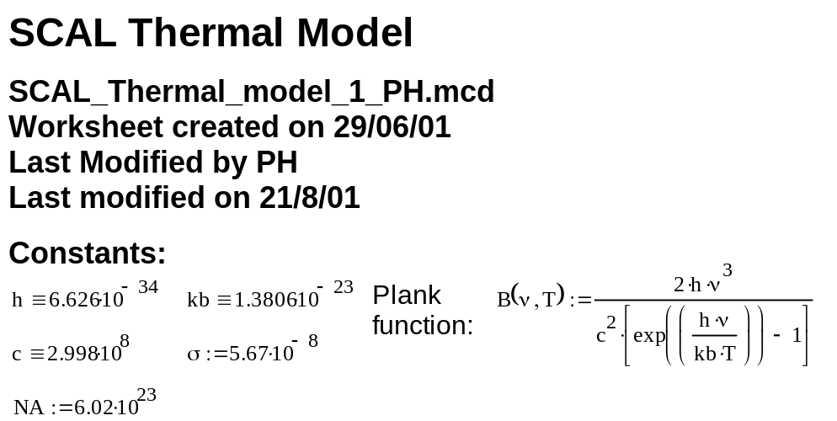
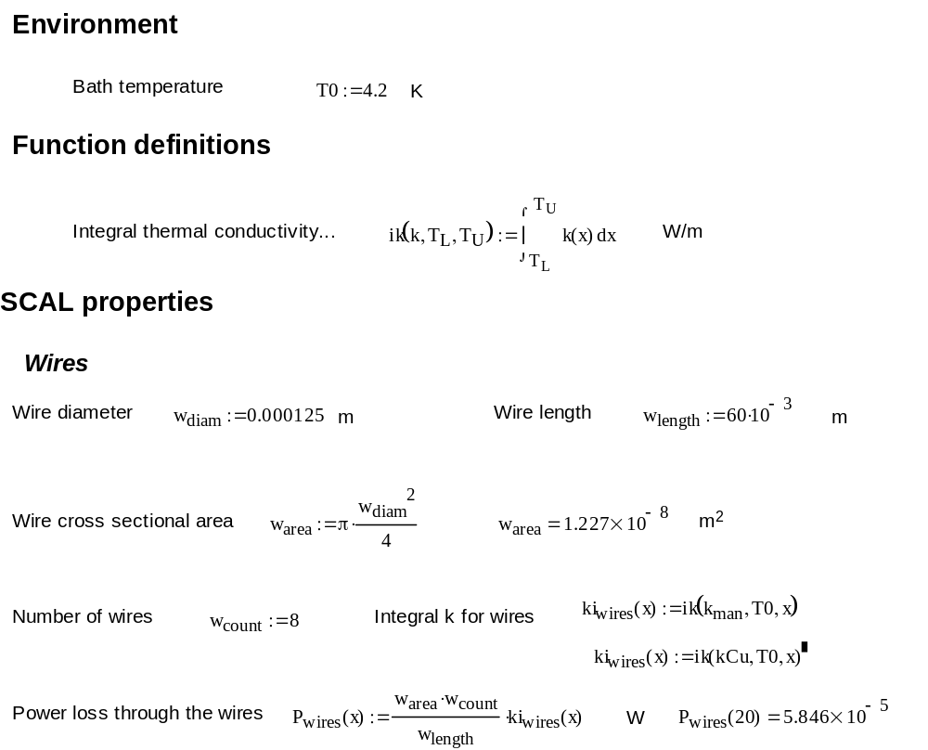
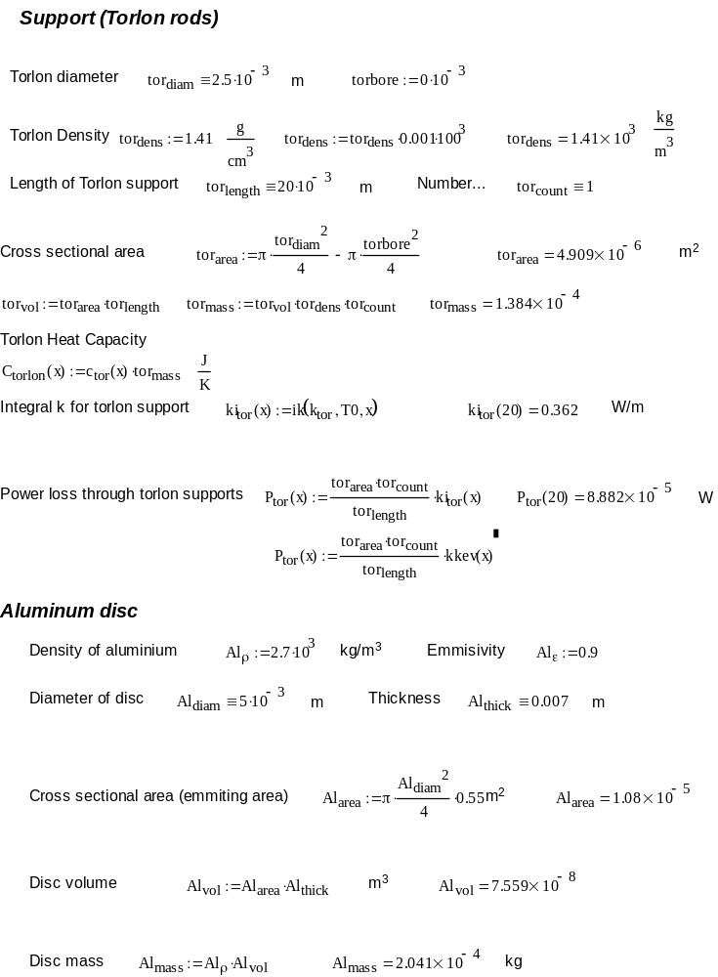
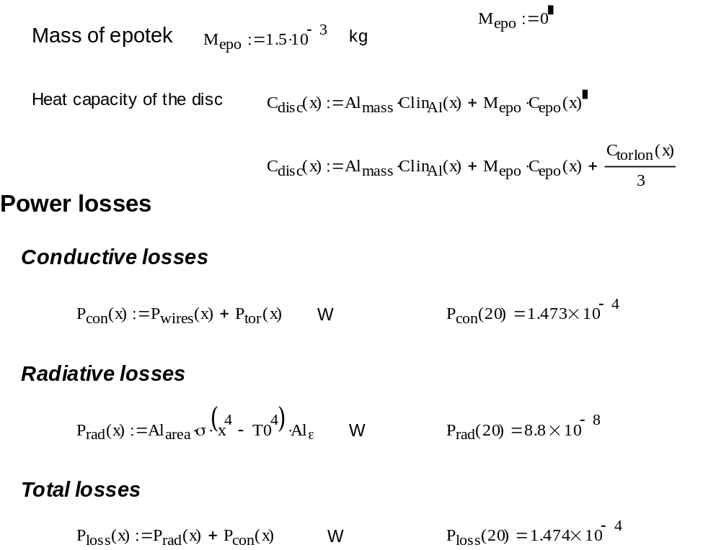

The simulation (Thermal model from Pete)
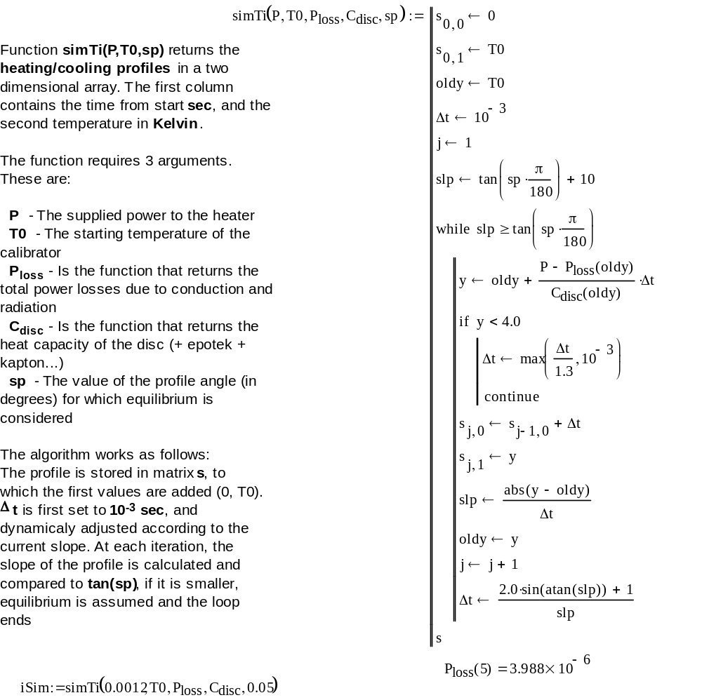
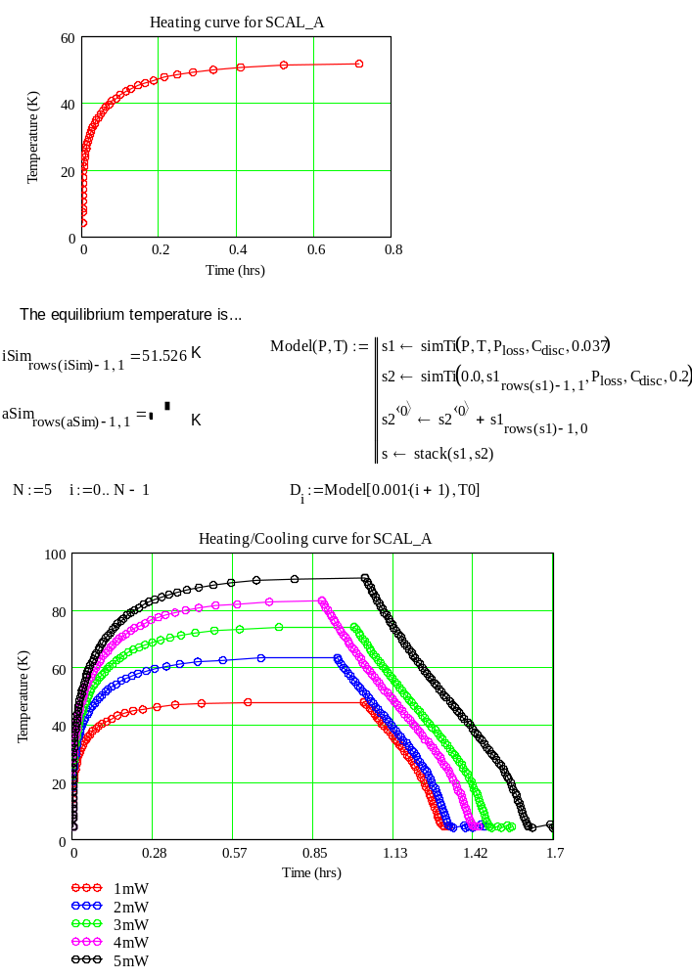

Source Deflection Under Load
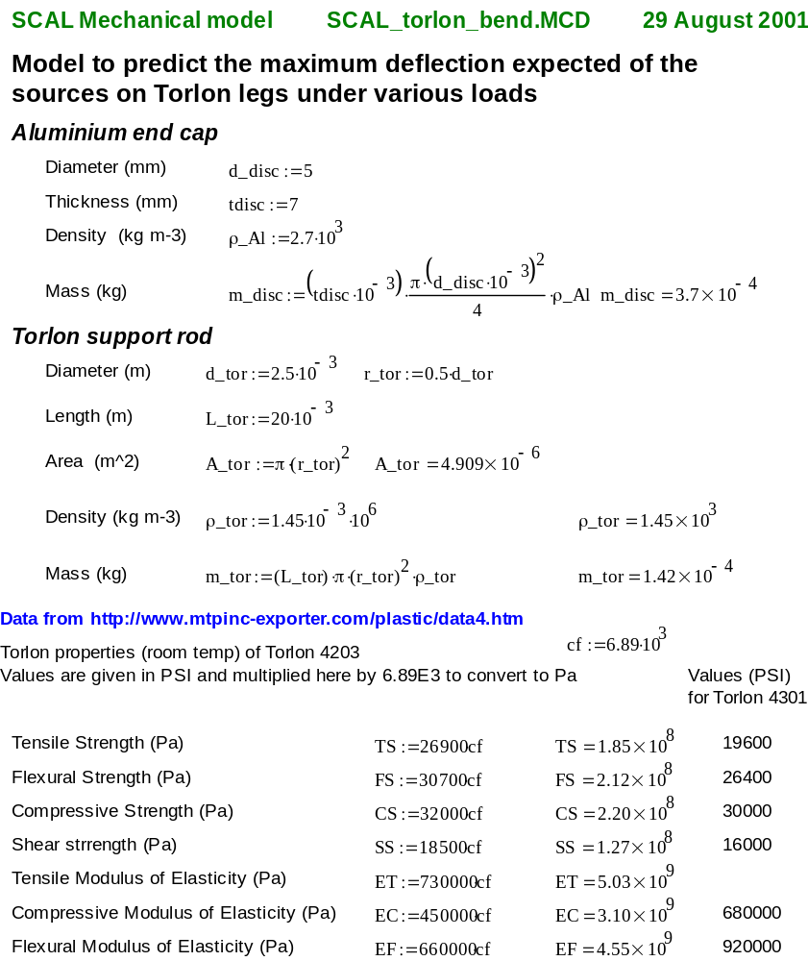
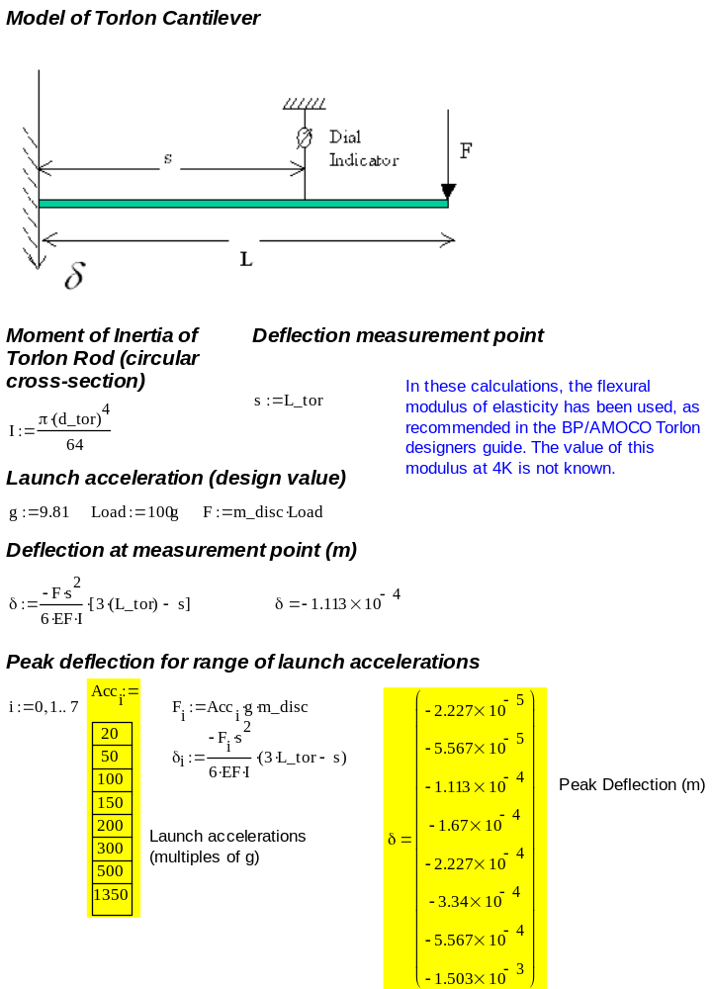

Resonant Frequency and Static Load Bearing Calculation


