Photometer Calibrator (PCAL)

Subsystem Design Description

SPIRE Ref.: SPIRE-QMW-PRJ-001100
Cardiff Ref.: HSO-CDF-DD-033
Issue: 1.0

Prepared by: Giampaolo Pisano, Peter Hargrave, Matt Griffin

Last Modified on: 23 January 2002

Approved by:

Distribution list

Update history

Date | Version | Remarks
15/08/01 | 1.0 | First issue for DDR

List of Acronyms
Term | Meaning | Term | Meaning
AD | Applicable Document | IR | Infrared
ADC | Analogue to Digital Converter | IRD | Instrument Requirements Document
AIV | Assembly, Integration and Verification | IRTS | Infrared Telescope in Space
AME | Absolute Measurement Error | ISM | Interstellar Medium
AOCS | Attitude and Orbit Control System | JFET | Junction Field Effect Transistor
APART | Arizona's Program for the Analysis of Radiation Transfer | ISO | Infrared Space Observatory
APE | Absolute Pointing Error | LCL | Latching Current Limiter
ASAP | Advanced Systems Analysis Program | LIA | Lock-In Amplifier
ATC | Astronomy Technology Centre, Edinburgh | LVDT | Linear Variable Differential Transformer
AVM | Avionics Model | LWS | Long Wave Spectrometer (an instrument used on ISO)
BDA | Bolometer Detector Array | MAC | Multi Axis Controller
BFL | Back Focal Length | MAIV | Manufacturing, Assembly, Integration and Verification
BRO | Breault Research Organization | MCU | Mechanism Control Unit = HSMCU
BSM | Beam Steering Mirror | MGSE | Mechanical Ground Support Equipment
CBB | Cryogenic Black Body | M-P | Martin-Puplett
CDF | Cardiff, Department of Physics & Astronomy | NEP | Noise Equivalent Power
CDMS | Command and Data Management System | NTD | Neutron Transmutation Doped
CDMU | Command and Data Management Unit | OBS | On-Board Software
CDR | Critical Design Review | OGSE | Optical Ground Support Equipment
CEA | Commissariat a l’Energie Atomique | OMD | Observing Modes Document
CMOS | Complimentary Metal Oxide Silicon | OPD | Optical Path Difference
CoG | Centre of Gravity | PACS | Photodetector Array Camera and Spectrometer
CPU | Central Processing Unit | PCAL | Photometer Calibration source
CQM | Cryogenic Qualification Model | PFM | Proto-Flight Model
CVV | Cryostat Vacuum Vessel | PID | Proportional, Integral and Differential (used in the context of feedback control loop architecture)
DAC | Digital to Analogue Converter | PLW | Photometer, Long Wavelength
DAQ | Data Acquisition | PMW | Photometer, Medium Wavelength
DCU | Detector Control Unit = HSDCU | POF | Photometer Observatory Function
DDR | Detailed Design Review | PROM | Programmable Read Only Memory
DM | Development Model | PSW | Photometer, Short Wavelength
DPU | Digital Processing Unit = HSDPU | PUS | Packet Utilisation Standard
DSP | Digital Signal Processor | RAL | Rutherford Appleton Laboratory,
DQE | Detective Quantum Efficiency | RD | Reference Document
EDAC | Error Detection and Correction | RMS | Root Mean Squared
EGSE | Electrical Ground Support Equipment | SCAL | Spectrometer Calibration Source
EM | Engineering Model | SCUBA | Submillimetre Common User Bolometer Array
EMC | Electro-magnetic Compatibility | SED | Spectral Energy Distribution
EMI | Electro-magnetic Interference | SMEC | Spectrometer Mechanics
ESA | European Space Agency | SMPS | Switch Mode Power Supply
FCU | FCU Control Unit = HSFCU | SOB | SPIRE Optical Bench
FIR | Far Infrared | SOF | Spectrometer Observatory Function
FIRST | Far Infra-Red and Submillimetre Telescope | SPIRE | Spectral and Photometric Imaging Receiver
FOV | Field of View | SRAM | Static Random Access Memory
F-P | Fabry-Perot | SSSD | SubSystem Specification Document
FPGA | Field Programmable Gate Array | STP | Standard Temperature and Pressure
FPU | Focal Plane Unit | SVM | Service Module
FS | Flight Spare | TBC | To Be Confirmed
FTS | Fourier Transform Spectrometer | TBD | To Be Determined
FWHM | Full Width Half maximum | TC | Telecommand
GSFC | Goddard Space Flight Center | URD | User Requirements Document
HK | House Keeping | UV | Ultra Violet
HOB | Herschel Optical Bench | WE | Warm Electronics
HPDU | Herschel Power Distribution Unit | ZPD | Zero Path Difference
HSDCU | Herschel-SPIRE Detector Control Unit
HSDPU | Herschel-SPIRE Digital Processing Unit
HSFCU | Herschel-SPIRE FPU Control Unit
HSO | Herschel Space Observatory
IF | Interface
IID-A | Instrument Interface Document - Part A
IID-B | Instrument Interface Document - Part B
IMF | Initial Mass Function
Table of Contents

1. Scope of this document 5
2. Document list 5
2.1 Applicable documents 5
2.2 Reference documents 5
3. Outline description of the Photometer CALibrator (PCAL) 6
4. PCAL requirements 7
4.1 PCAL requirements descriptions 7
4.1.1 CALP-R01-R02 (operating output and range) 7
4.1.2 CALP-R03 (pupil obscuration) 8
4.1.3 CALP-R04 (time constant) 8
4.1.4 CALP-R05 (repeatability and drift) 9
4.1.5 CALP-R06 (operation) 9
4.1.6 CALP-R07 (frequency) 9
4.1.7 CALP-R8-R9 (interface and volume envelope) 9
4.1.8 CALP-R10 (thermal isolation) 9
4.1.9 CALP-R11 (operating temperature) 10
4.1.10 CALP-R12 (cold power dissipation) 10
4.1.11 CALP-R14 (operating voltage) 10
4.1.12 CALP-R15 (cold redundancy) 10
4.1.13 CALP-R16 (number of operations) 10
5. Description of the PCAL design 11
5.1 Thermal source 11
5.2 Thermal model 13
5.3 Housing and mechanical interface with the BSM structure 14
6. PCAL prototype evaluation 16
6.1 Absolute photometric calibration 17
6.1.1 Experimental set-up 17
6.1.2 Results 18
6.2 Relative photometric calibration 19
6.2.1 Experimental set-up 19
6.2.2 Relative photometric calibration of HB5 against HB1 20
6.3 Transient response 20
6.4 Conclusions 21
6.5 Baseline PCAL CQM device design 22
6.6 Proposed modifications to the design 22
7. Interfaces 23
7.1 Mechanical 23
7.2 Electrical 23
7.2.1 Harness details 23
7.2.2 Electrical drive requirements 24
7.3 Software 25
7.4 Thermal 25
8. Hardware Tree 25
9. Reliability & Redundancy 25
9.1 Reliability Block Diagram 25
9.2 Fault Tree Analysis 25
9.3 Single Point Failures 25
9.4 FMECA 25
9.5 Critical Components Identification 26

Scope of this document

This document describes and discusses the requirements on the internal calibration source (PCAL) for the SPPIRE photometer, and presents a description of the PCAL design and the results of tests and modelling of prototype devices. Although this document will be updated periodically to reflect the evolution and detailing of the subsystem design, the information contained herein is not necessarily accurate in all details, and this
document should therefore not be used as a reliable source of design information. Up-to-date information on the detailed design may be found in the PCAL Subsystem Specification Document and the PCAL Interface Control Document.

Document list

Applicable documents
All applicable documents are listed in the AD chapter of the CIDL (HSO-CDF-LI-029).

Reference documents

Outline description of the Photometer CALibrator (PCAL)

PCAL is an electrically heated thermal source of submillimetre radiation the purpose of which is to provide a repeatable signal for monitoring of health and responsivity of the SPIRE photometer detectors. It is not required to provide absolute calibration or uniform illumination of the array, although it may be used as part of the overall calibration scheme in flight.
PCAL will be located at the position of a hole in the centre of the Beam Steering Mirror (BSM), which is at a pupil image. Although PCAL is optimised for the photometer, it can also be viewed by the FTS detector arrays. The thermal source will be positioned behind the mirror with a light pipe connecting the aperture in the mirror to a cavity in which the source is mounted, as shown in Figure 1. The BSM will be switched off when PCAL is operating, and some clearance will be needed to ensure the BSM does not foul on the light pipe when chopping. The location of PCAL and the BSM in the photometer opto-mechanical layout is shown in Figure 2

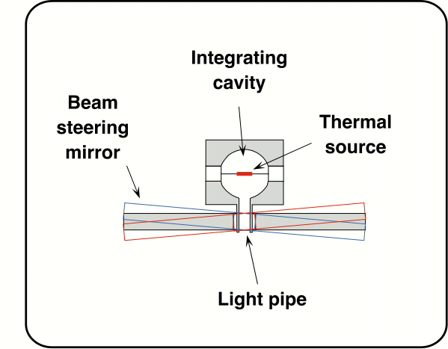

Figure 1: Conceptual design of PCAL

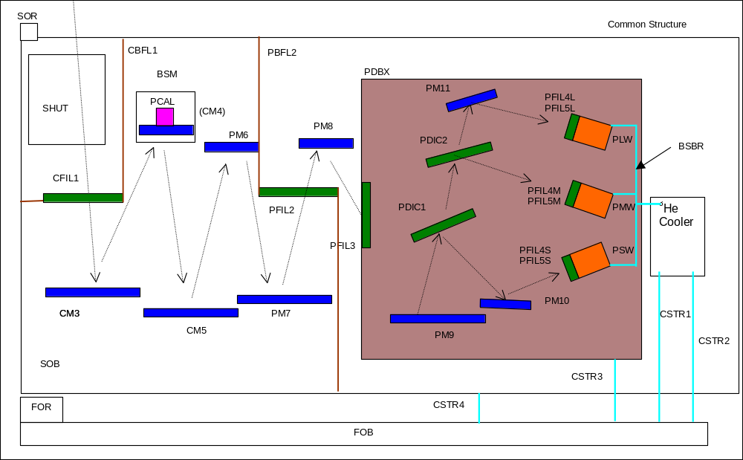
Figure 2: Location of the BSM and PCAL in the SPIRE FPU

PCAL requirements
The following tables summarise the PCAL performance and system requirements, as stated in the SPIRE Instrument Requirements Document, taking into account the changes requested by Cardiff (July 25 2001) and the response of the SPIRE Instrument Scientist (e-mail, August 30 2001). Each requirement is discussed individually below.

 | PCAL Performance Requirements
 | Requirement ID | Description | Value
 | IRD-CALP-R01 | Nominal operating output | Equivalent to εT = 40 K for 200 < λ < 700 μm
 | IRD-CALP-R02 | Operating temperature range | Commandable in 256 steps with at least 124 steps covering the range from zero output to εT = 40 K
 | IRD-CALP-R03 | Pupil obscuration | The outside envelope of the calibrator housing shall not foul on any part of the BSM for any angular position that the BSM may attain in operation or under vibration.
 | IRD-CALP-R04 | Time constant | In response to a step change in applied electrical power, the 90% settling time of the radiant power output shall be less than 350 ms (requirement); 70 ms (goal)
 | IRD-CALP-R05 | Repeatability | RMS better than 1% over 20 operations equi-spaced over a period of 12 hours, with uniform base temperature and drive current. An operation is here defined as an appropriate standard sequence of On/Off excitation cycles.
 | IRD-CALP-R06 | Operation | Nominally once per hour for no more than 10 seconds
 | IRD-CALP-R07 | Frequency | Continuously or pseudo continuously variable between 0 and 2 Hz.
PCAL System Requirements
Requirement ID |  | Description |  | Value
IRD-CALP-R08 |  | Interface |  | The calibrator will be integrated into the BSM
IRD-CALP-R09 |  | Volume envelope |  | This shall be compatible with the space available within the BSM enclosure as described in the BSM SSSD.
IRD-CALP-R10 |  | Thermal isolation |  | The temperature of the PCAL housing shall rise by no more than 1 K over the temperature of the BSM structure after 10 seconds when the calibrator is operated unmodulated at nominal power output.
IRD-CALP-R11 |  | Operating temperature |  | 4 K
IRD-CALP-R12 |  | Cold power dissipation |  | Calibrator power dissipation in the FPU when operating continuously at nominal radiant output shall be less than 4 mW (requirement); 2 mW (goal)
IRD-CALP-R13 |  | Warm power dissipation |  | Removed – IRD issue 1.0
IRD-CALP-R14 |  | Operating voltage |  | Less than 28 V at input power level of 5 mW
IRD-CALP-R15 |  | Redundancy |  | Cold redundancy for the thermal source
IRD-CALP-R16 |  | Number of operations |  | The calibration source shall be capable of up to 300,000 operational cycles at the nominal electrical power.

PCAL requirements descriptions

CALP-R01-R02 (operating output and range)

During the life of the instrument, the responsivity of the detectors could change for various reasons. For example, responsivity is a strongly dependent on the overall background power level on the detector. This will be different during for different situations:
- instrument-level testing in the SPIRE AIV facility;
- spacecraft-level testing in the Herschel cryostat;
- in-flight operation (during which the thermal radiation level may vary depending on telescope temperature and source brightness) .
There may also be variations due to ageing or other changes in FPU component properties.

So, at suitable times, is will be important to monitor the detectors' optical responsivities. A practical way to do this is to illuminate the detectors with a repeatable thermal source, so that the output signals are proportional to the optical responsivities.

To facilitate rapid characterisation of the SPIRE detectors, it is required that PCAL provide a high instantaneous S/N. As viewed by the detectors, PCAL is a grey body emitter with a certain area, emissivity (ε), and temperature (T). The requirement of εT > 40 K is designed to ensure a S/N of at least 500 in all bands. The SPIRE photometric model (see Appendix A for the latest version) computes the required effective temperature (εT) for the emitting area assuming nominal instrument and detector parameters. The requirement is set by the 250 μm band. For a 1-mm aperture, a minimum S/N of 500 is achieved with εT = 29 K (circular area) or 26 K (square area).

To provide margin in the event of degraded instrument performance, it is appropriate to allow for a factor two on the final temperature achieved at the maximum allowed power. If a 1-mm square emitting area can be used (which at the time of writing is believed to be feasible) then the desired temperature is about 53 K with an input power of 4 mW: this has therefore been adopted as the goal for PCAL.
The PCAL electronics are required to supply the electrical power in 256 discrete steps under command from the DPU, allowing any desired kind of modulation between different temperatures.

CALP-R03 (pupil obscuration)

The SPIRE optics are designed to form a pupil image of the telescope secondary on the BSM (M4). The BSM is uniformly illuminated by an astronomical source and the telescope central obscuration is reproduced proportionally. This unused free circular area is chosen as a good place where place the calibration source. The size of the hole in the BSM is dictated by the optical design rather than the calibrator, and is assumed here to be 2.8 mm (TBC). The PCAL mechanical envelope should be such that it cannot foul on the BSM in any position of the mirror, with a suitable margin of safety. The necessary clearance will be specified in the Calibrators Interface Control Document.

CALP-R04 (time constant)

The warm-up and cool-down of a calibrator do not necessarily follow a single-time constant curve. The speed of response is therefore specified in the form of the 90% settling time (for a single time constant system the 90% settling time is 2.3τ where τ is the time constant). The nominal chopping frequency for point source or jiggle-map mode is 2 Hz, and it is desirable (but not essential) to operate the calibrator at a similar frequency. The goal is based on a 2-Hz excitation with the requirement based on a slower excitation frequency of 0.5 Hz.

Figure 3 shows the single-time-constant response to a 2-Hz square wave excitation with the goal time constant (30 ms) and a 0.5-Hz excitation with the required time constant (150 ms).
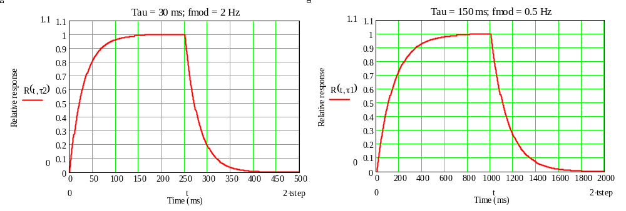
Figure 3: Single-time constant system response for (τ = 30 ms; f_{chop} = 2 Hz) and (τ = 150 ms; f_{chop} = 0.5 Hz)

CALP-R05 (repeatability and drift)

This repeatability requirement is dictated by the fact that the calibration accuracy of the relative detector responsivities cannot be any better than the repeatability of the calibrator radiant output.

A calibrator efficiency drift less than 10% over the mission lifetime means that only occasional re-calibration of the detectors with respect to astronomical sources will be necessary, and ensures that the S/N and operational levels will not change greatly over the course of the mission.

CALP-R05 is in need of further clarification:
Comment from Instrument Scientist: “What does an "operation" consist of? The requirement is on both the repeatability over the short term - i.e. rms of 1% over 20 >cycles< on/off within one calibration operation; and the long term drift 10% over the mission. Perhaps we should have a medium term - i.e. within 12 or 24 hours - requirement as well?”

Cardiff Team response: The function of the calibrator is to provide a series of signals at nominal one-hour intervals which are repeatable to the desired level. There should be no requirement on the repeatability of the individual ON-OFF cycles within an hourly operation. Due to short-term localise heating effects, this may be difficult to achieve, and in any case is unnecessary: provided the overall result (e.g., as represented by the integrated signal over 10 seconds) is repeatable hour-to-hour, then the relative calibration requiremetn is met. We therefore recommend that the wording of CALP-R05 as above be adopted.

CALP-R06 (operation)

The envisaged mode of operation will involve PCAL being driven according to a pre-set sequence of output levels over a period of around 10 seconds. The interval between such operations will depend on the overall stability of the instrument and its environment, but is expected to be at least one hour.

CALP-R07 (frequency)

This requirement follows from the required chopping frequency of the BSM. (This is essentially a requirement on the PCAL drive electronics and the On-Board Software.)

CALP-R8-R9 (interface and volume envelope)

PCAL will be integrated into the BSM structure, and so must be compatible with the available space.

CALP-R10 (thermal isolation)

The Cardiff team had originally requested that this requirement be deleted as it is effectively a requirement on the BSM structure. When PCAL is switched on, almost all of the electrical power will be conducted to the BSM mounting (only a tiny fraction is actually radiated by the device). The rise in temperature of the BSM environment must be small to avoid changes in the radiated power by the BSM structure affecting the overall sensitivity of the system. The BSM mounting and FPU structure must thus be designed to be able to conduct efficiently this power into the Herschel cryostat 4-K strap.

The wording in the table above is proposed by the Cardiff team, in response to the following comment from the Instrument Scientist: IRD-CALP-10 - there is such a requirement on the BSM - this is supposed to constrain the design of PCAL to prevent its case heating up - if the better way to express this is through the thermal impedance to the case then o.k.

CALP-R11 (operating temperature)

The nominal temperature of the PCAL housing is the same of the BSM structure, that is 4 K. In practice this temperature could rise by one or two degrees depending on the total power dissipation of the SPIRE FPU. This will have no significant impact on the operation of PCAL.

CALP-R12 (cold power dissipation)

PCAL will be in the ON condition for only about 5 seconds every hour. Allowing for the maximum dissipation of 4 mW, during this period, the time-averaged dissipation of PCAL will be less than 6 μW, which is negligible compared to other contributions from the FPU. However, to prevent local transient heating of the BSM environment during and after PCAL operation, it is desirable to keep the power dissipation as low as possible.

This requirement as proposed here is still under consideration by the SPIRE Project Team.

CALP-R14 (operating voltage)

This requirement is dictated by maximum voltage that the warm electronics can provide.

CALP-R15 (cold redundancy)

The Cardiff Team had requested that cold redundancy be a goal rather that a requirement on the grounds that loss of PCAL would not severely compromise SPIRE science, and that implementing cold redundancy would complicate the design of PCAL or require a much larger radiating area than is necessary to meet the photometric requirement or available given the size of the hole in the BSM.
This request was not accepted by the SPIRE Instrument Scientist, with the following comments: We have prime and redundant electronics sides - and they must be isolated from each other and therefore drive cold redundant systems in the FPU. I also don't agree that loss of the calibrator will have minimal scientific impact. This will only be true when we have established that the performance of the instrument is as it was on the ground or what the difference is with what we did on the ground. The only sure fire way of doing this is by carrying a ground reference source into flight - PCAL is it for the photometer. We don't need to go overboard but cold redundancy is mandatory as far as I am concerned.

Cardiff Team Response: The basic design presented here does not have cold redundancy. However, we indicate conceptually how the design might be modified in order to implement it. We propose that this issue be considered and a decision made at the DDR.

CALP-R16 (number of operations)

In order to define the life-test requirement for PCAL, it is necessary to specify the number of operations that PCAL must be able to tolerate. This is derived using the following conservative assumptions:

Mission operational lifetime: 4.5 years
Fraction of lifetime for which SPIRE operates: 33%
Fraction of SPIRE time for which PCAL used: 100% *
Number of operational hours per day: 21
Frequency with which PCAL sequence is carried out: Once per hour
Duration of each sequence: 10 seconds
Modulation frequency during the sequence: 2 Hz
Margin factor (and allowing for ground operation): 1.5

* This assumes that PCAL will also be used during spectrometer operation. This results in a larger number
of operations than previously estimated when operation was envisaged only during photometer time.

These assumptions result in a total number of cycles of 300,000. A continuous accelerated life test with 2-Hz modulation frequency will achieve this total number of cycles in approximately 48 hours.

Description of the PCAL design

Thermal source
The active emitter in PCAL will be a thermal source manufactured by Haller-Beeman Associates of Berkeley, California. The device functions as an infrared test lamp: with few mW of power they can produce blackbody signals up to 100 K. Devices of very similar construction have been built and qualified for the MIPS, the Multi-band Infrared Photometer for SIRTF, with entirely satisfactory results. The design and performance of the MIPS devices and its use in the MIPS calibration scheme is described in MIPS project document 674-MIPS-300D, Chapter 6.

The source operates as a reversed bolometer. The emitter is a square NiCr coated Sapphire (or Mica) substrate, 1 - 1.5 mm in size, with heat capacity C, connected to a cryogenic bath by means of a thermal conductivity G. An electrical circuit provides the current that flows through the resistive NiCr coating that warms up the substrate and the metal film itself (Figure 4).

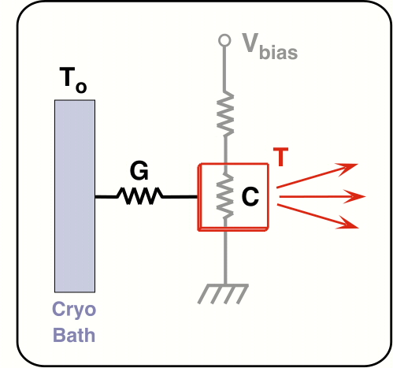

Figure 4: PCAL source thermal and electrical circuit

In the practical realisation the sapphire emitter substrate is suspended with nylon fibres and connected to the cryogenic bath by brass wires that also supply the electrical power (Figure 5).

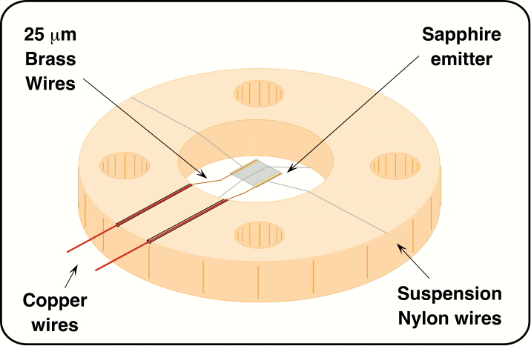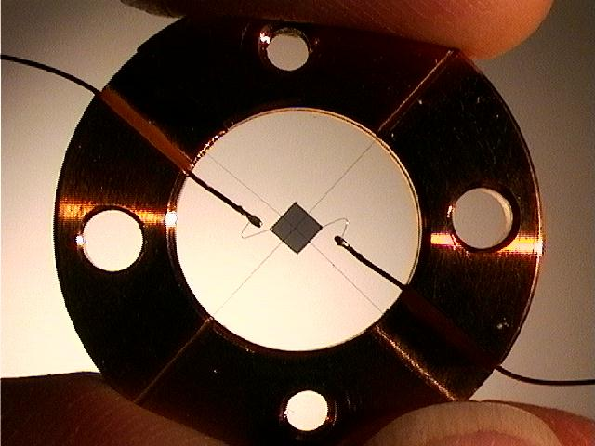

Figure 5: Schematic diagram and photograph of a PCAL prototype with metallised sapphire substrate and nylon support threads

In the case of a Mica (Muscovite) substrate, which is much lighter, the brass wires, soldered to a small little PC board glued on the copper ring, also serve to hold the emitter (see Figure 6).

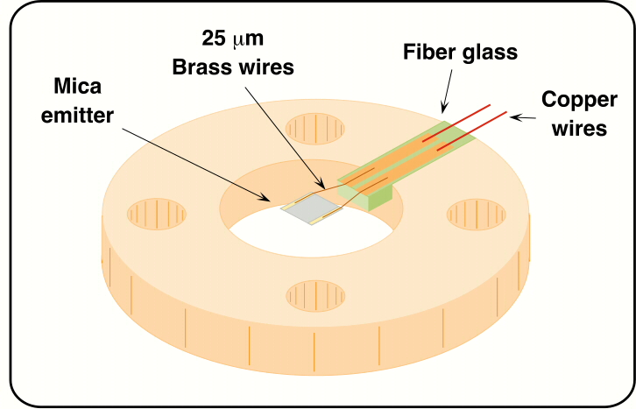

Figure 6: PCAL source with metallised Mica emitter

The brass wires thermal conductivity G_{Brass} define the final temperature reached by the illuminator when an electrical power RI² is applied:
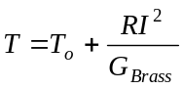
The illuminator consists of:

- 1-mm square sapphire or Mica substrate
- Sapphire thickness = 35 μm
- Mica thickness = 6 μm
- 100 Angstroms thick NiCr metal film coating on front surface;
- 25-μm dia. brass wires, approx. 1 mm long;
- Silver epoxy connections of the wires to the emitter;
- 20-μm nylon fibre suspension (sapphire substrate version only);

Test results on prototypes show that the Mica substrate is most suitable for SPIRE (see Section 6 below).

Thermal model
The thermal model is based on a finite element analysis. The brass wires and the nylon suspension wires are sub-divided into short elements, each of which is ascribed the appropriate C and G as shown in Figure 7. The helium bath heat capacity is considered infinite and the supplied electrical power is applied directly on the emitter. We can also include the effects of the Joule dissipation along the wires and the radiated emitted power from the sapphire chip (in practice both are negligible). The wire portions in contact with the emitter are also included in the heat capacity calculation.

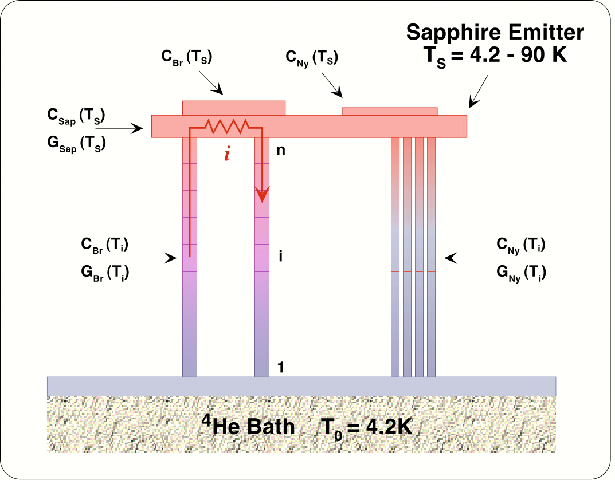

Figure 7: Schematic representation of PCAL thermal model
The typical temperature-dependence of the materials' specific heats and thermal conductivities are summarised in Figure 8. The values quoted in the literature depend on the purity of the materials and also on the fabrication process and mechanical stress suffered by the material. This forces us to parameterise some of the G and C curves to allow for this uncertainty. Experimental results on prototypes are compared with the model in Section 6.
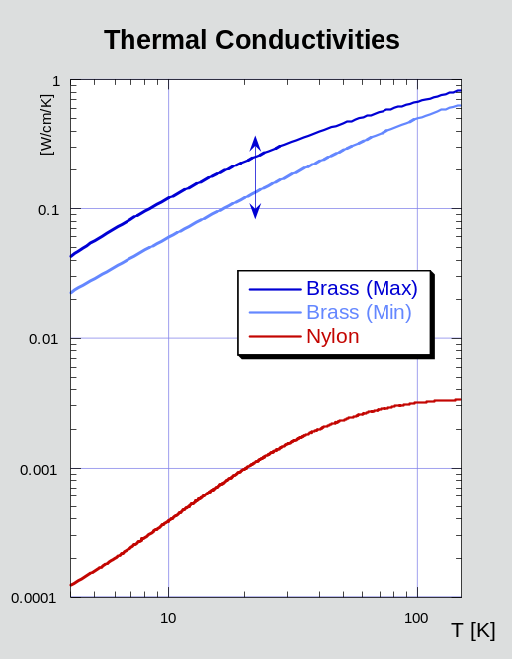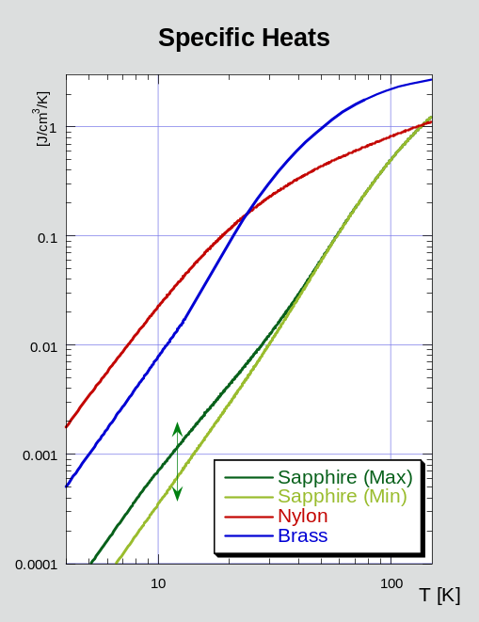
Figure 8: PCAL thermal source material thermal properties

Housing and mechanical interface with the BSM structure

PCAL will be placed on the rear of the BSM supporting structure with the emitting aperture at the central hole of the moving mirror. The relevant BSM dimensions and distances are indicated in Figure 9. The 2.8 mm (TBC) mm circular aperture in the centre of the BSM will accommodate the PCAL light-pipe. A physical gap of 0.4 mm (TBC) is necessary to avoid contact with the mirror for any operational angular position or during launch. The BSM can rotate around two perpendicular axes. The ‘jiggle-axis’, coplanar with the mirror surface, rotates over the range ±0.6°. The ‘chopping-axis’, placed 2.25 mm below the mirror surface, rotates over the range ±2.4° (see Figure 10).

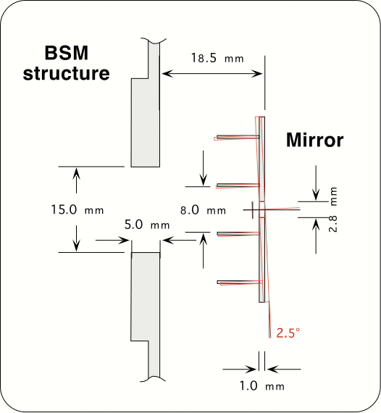

Figure 9: Location of PCAL in the BSM housing

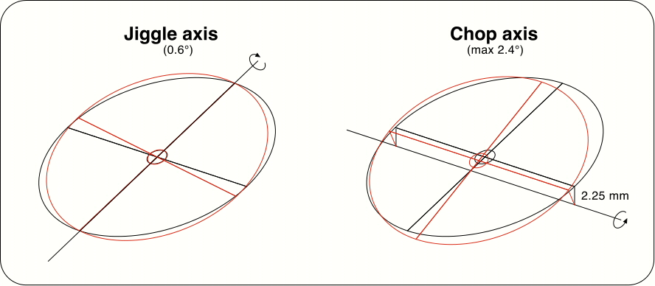

Figure 10: BSM chop and jiggle movements

The PCAL housing mechanical design is shown in Figure 11 and Figure 12. The cylindrically symmetric structure is made of gold-plated OFHC copper. The emitter is placed on the extremity next to the moving mirror inside a hemispherical cavity. An OFHC copper cap (screwed or glued - TBD) incorporates a 1.5-mm diameter (TBC) light-pipe bringing the output radiation to an aperture exactly at the centre of the BSM (Figure 13). A longitudinal off-axis hole allows the two electrical wires (diameter 250 μm - TBC) to reach the illuminator from the rear.

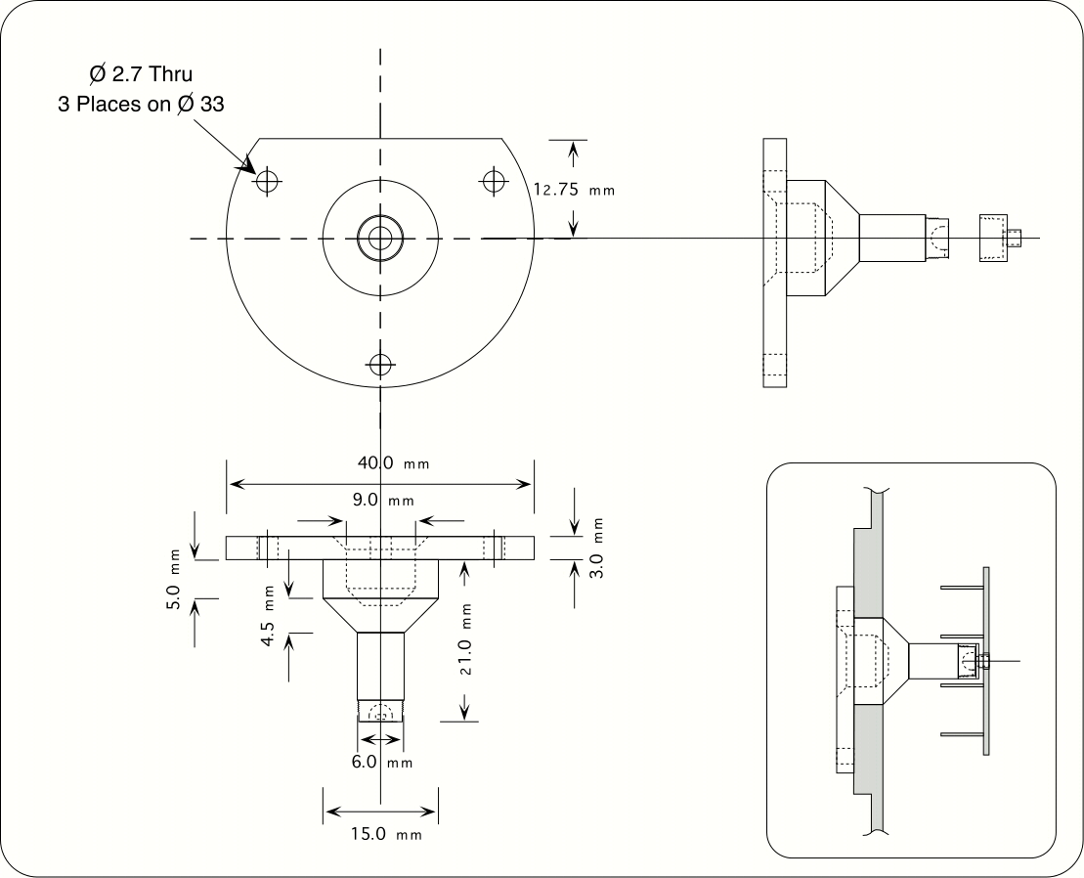

Figure 11: PCAL housing design

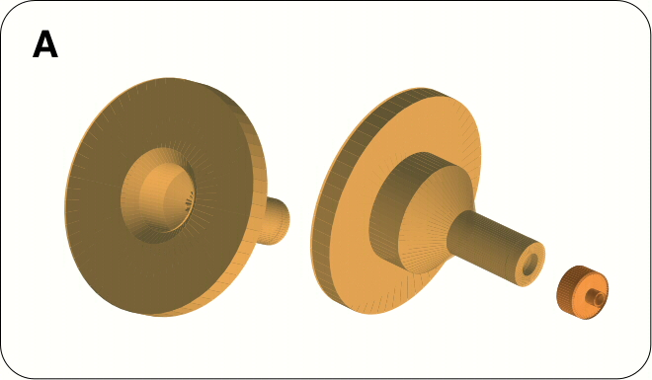

Figure 12: 3-D view of PCAL housing envelope

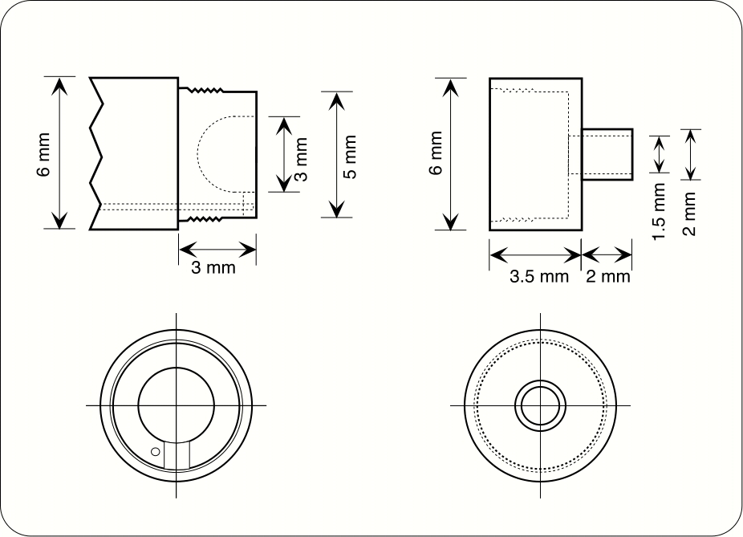

Figure 13: PCAL internal design

The emitter is located at the front of the cavity, directly behind the light pipe. All the internal surfaces of the cavity are gold plated to guarantee the maximum reflectance, although this is not critical since the surface of the emitter is viewed directly through the light pipe.

The emitter is a 1x1 mm (TBC) NiCr coated Mica chip suspended by 25-μm diameter brass wires. These wires are soldered on a glass fibre PC board. The baseline architecture for the PCB board, brass wires and emitter is shown in Figure 14).

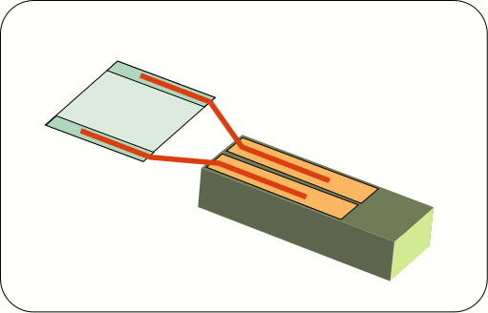

Figure 14: Baseline PCAL emitter architecture

PCAL prototype evaluation
The submillimetre radiant output, transient response and electrical power dissipation of prototype PCAL thermal sources, provided by Haller-Beeman Associates, have been characterised in the laboratory to verify their suitability for SPIRE and to optimise the design parameters. Several devices were tested; here we report on measurements on two representative devices, denoted HB1 and HB5, which had the following characteristics:

HB1
- 1 x 1 mm sapphire, 35 μm thick
- 100 Ångstroms NiCr deposited on one side
- Ti/Au traces deposited on the NiCr, 100/3000 Ångstroms thick, 75 μm x 1 mm surface area
- Indium soldered, 25 μm diameter brass leads, ~ 2 mm free length
- Nylon fiber “criss-cross” suspension, 20 μm diameter nylon
- 30-gauge copper “heat sink” wires.

HB5
- 1 x 1 mm Mica (Muscovite), 6 μm thick
- 100 Ångstroms NiCr deposited on one side
- Ti/Au traces deposited on the NiCr, 100/3000 Ångstroms thick, 75 μm x 1 mm surface area
- Indium soldered, 25 μm diameter brass leads, ~ 0.3 mm free length
- Suspension by brass wires only
- Copper-plated PC board heat sink.

Absolute photometric calibration
The purpose of these tests was to calibrate the effective emitting temperature and to characterise it as a function of the electrical power dissipation. HB1 was absolutely calibrated and then used as a secondary standard against which other prototypes were compared.

Experimental set-up

Absolute calibration experiments experiment was conducted using a 300-mK cryostat. The source and detector were contained in an internally blackened 2-K enclosure. The detector was a spider-web bolometer used in combination with a TBD-mm aperture single-mode feedhorn. A standard voltage divider and a cooled differential JFET amplifier were adopted for the detector read-out. (This detector set-up is very similar to the set-up to be used in SPIRE). The detector feedhorn viewed the source directly through a set of three filters which defined a spectral window centred at 432 μm with bandwidth of Δλ/λ= 0.045 (423 – 443 μm). The source-feedhorn distance was TBD.

A schematic diagram of the set-up is shown in Figure 15.
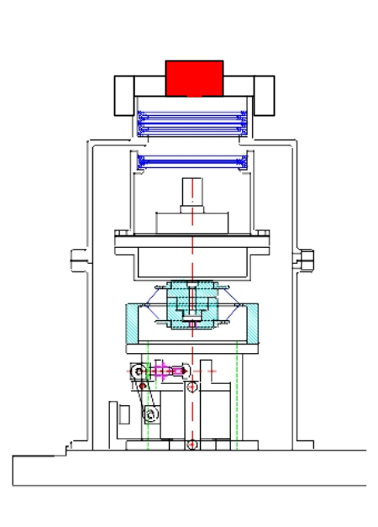
HB source or cryogenic black
body with 1 mm
diameter aperture
432 μm bandpass filter 53 cm⁻¹ edge filter
33 cm⁻¹edge filter
Feedhorn
Bolometer (JPL-C2)

Figure 15: Cryostat internal set-up for PCAL absolute calibration
The source electrical power was supplied via a simple voltage divider and a four-wire method was used to read the voltage across the illuminator. A direct measure of the voltage across an external resistance allowed us to calculate the circuit current, then the real dissipated illuminator electrical power.
To provide an absolute calibration, the PCAL thermal source was compared directly to a 1-mm aperture cryogenic black body (CBB) source originally used for calibration of the ISO LWS instrument. In a separate experiment he CBB was mounted with its aperture in exactly the same position as that of the PCAL source. The CBB can be heated to a temperature of up to 150 K, and its temperature is measured directly by means of a calibrated thermometer inside the black body cavity. By comparing the relative signals measured by the bolometer when viewing the two sources, the PCAL device was calibrated against the CBB in a manner that did not require any knowledge of the detailed properties of the detector system

Results

Bolometer load curves were measured for various illuminator dissipation powers, and were used to calculate the FIR power absorbed by the detector. To calculate the absorbed optical power, a line of constant resistance is superimposed on VI plots taken with the device unpowered and powered. The intersection of this line with the load curves corresponds to points of constant bolometer resistance (and thus constant temperature). By subtracting the electrical power (P = VI) dissipated on the bolometer at the intersection points from that of a blank VI, the absorbed optical power is found (see Figure 16).
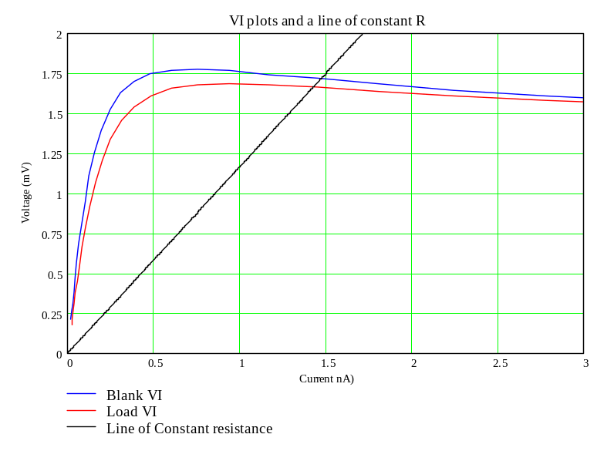
I₂, V₂
I₁, V₁
P_{absorbed} = V₁I₁ - V₂I₂

Figure 16: Method of calculating the absorbed optical power absorbed by the bolometer.

By comparing measurements made using the PCAL prototype and the CBB source, an equivalent black body temperature can be assigned to the PCAL source. This is the temperature the source would have to be at, assuming it emits as perfect black body, in order to emit as much power as is detected. Figure 17 is a plot of the final equivalent temperature vs. supplied electrical power for the HB1 illuminator. For this device, a temperature of 45 K is attained for 1 mW electrical power, and 80 K is attained with an electrical input power of 4 mW.

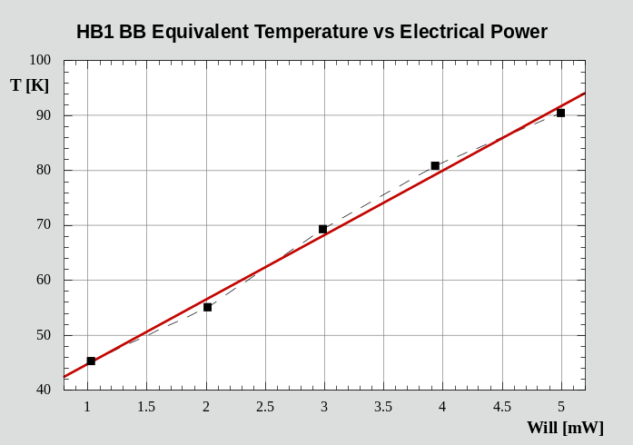

Figure 17: Equivalent black body temperature vs. applied electrical power for HB1

Relative photometric calibration
Because the cycle-time of the large ³He test cryostat is rather long, and because the speed of response of the bolometer is too slow to allow time constant measurements, a ⁴He cryostat system, equipped with a FIR photoconductive detector, was used to make additional tests:
(i) the photometric output of various devices was compared with that of HB1, which had already been calibrated in the ³He system;

(ii) the transient response of the PCAL sources was measured.

Experimental set-up

The photodetector cryostat set-up is shown in Figure 18.

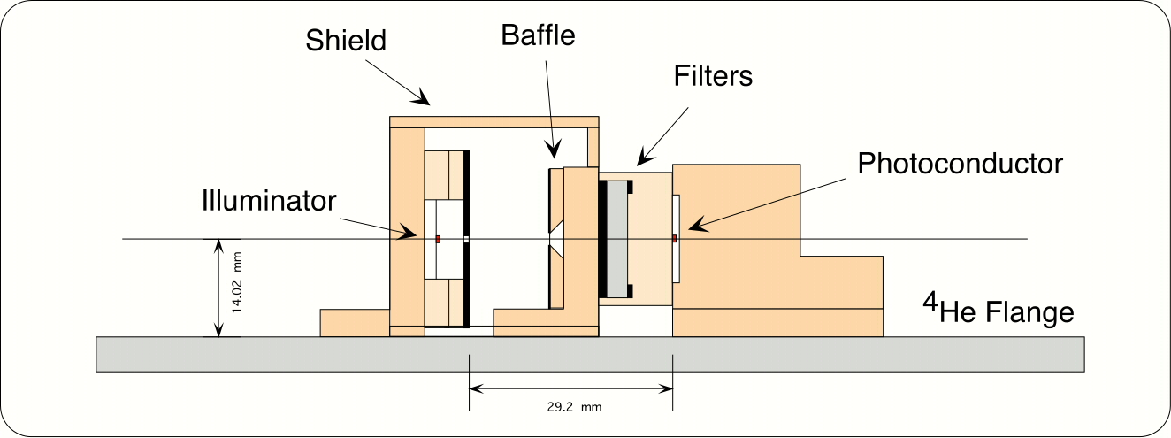

Figure 18: Cryostat set-up for photodetector relative calibration and transient response tests

A ⁴He cooled unstressed Ge-Ga photoconductive detector looked directly at the illuminator placed inside a cavity similar to the one used in the previous section. The spectral band was defined by two filters and by the detector cut-off frequency in the range 82 - 145 μm. A Trans-Impedance Amplifier (TIA) circuit was used to read the detector signals. The amplifier consists of a cold dual-JFET unit mounted close to the detector on the ⁴He work surface and a room temperature external preamplifier. Careful choice of the value of the feedback resistor (1-2.5 GΩ) resulted in a time constant of ~1 ms for the detector system.

Relative photometric calibration of HB5 against HB1

The HB5 temperature vs. electrical power characteristic has been derived by comparing the photodetector output signals with those of HB1 (see Figure 19). From the photometric data we know that HB1 reaches a temperature of 45 K applying a power of 1 mW. HB5 generates comparable radiant power when the applied electrical power is about 3 mW. This is compatible with the requirement of < 4 mW. For an applied power of 4 mW, HB5 achieves a temperature of about 50 K, which is close to the goal (53 K) for this device.

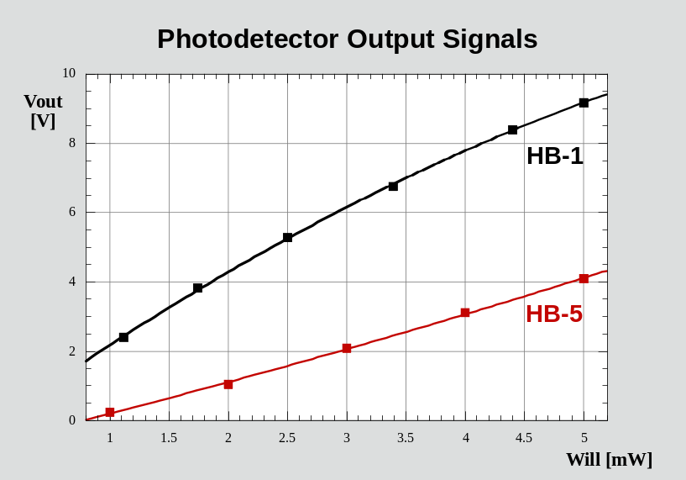

Figure 19: Comparison of HB1 and HB5 photometric output

Transient response
The purpose of these tests was to characterize the step response of the PCAL source for different electrical powers. A fast detector was necessary to avoid combining the illuminator and detector transient responses. Electrical power steps in the range 1-5 mW were applied and the rise and decay of the output signal was recorded. Results are plotted in Figure 20 for HB1. The response is very slow, of the order of seconds, and is not well described by a single time constant behaviour.

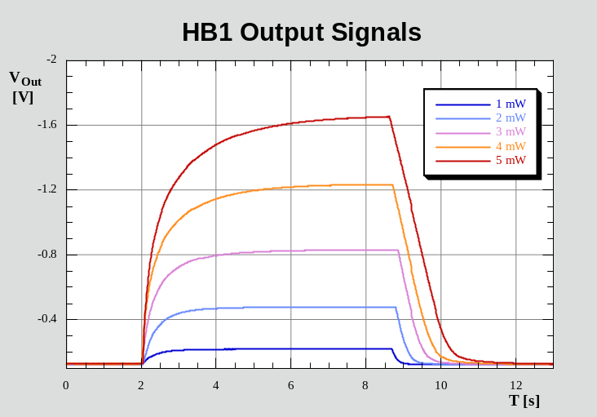

Figure 20: HB1 step response for various applied power levels

The slow response of HB1 is due to the large heat capacity of the sapphire and also to the G wires length. The HB5 device, with a Mica substrate, has much lower thermal mass. The HB5 and HB1 90% settling times are shown in Figure 21 as a function of the applied power. HB5 is much faster than HB1, with τ₉₀ < 100 ms for applied power up to 5 mW. The transient response curves are accurately reproduced by the thermal model - an example is shown in Figure 22 .

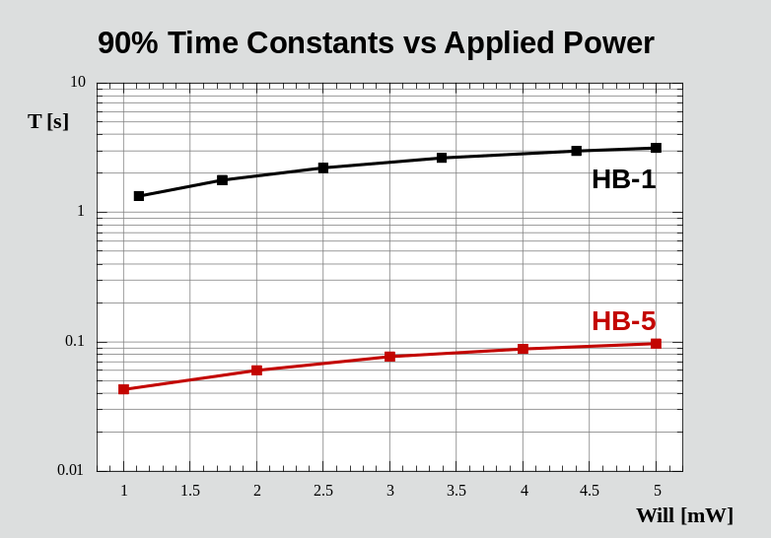

Figure 21: 90% settling time vs. applied power for HB1 and HB5

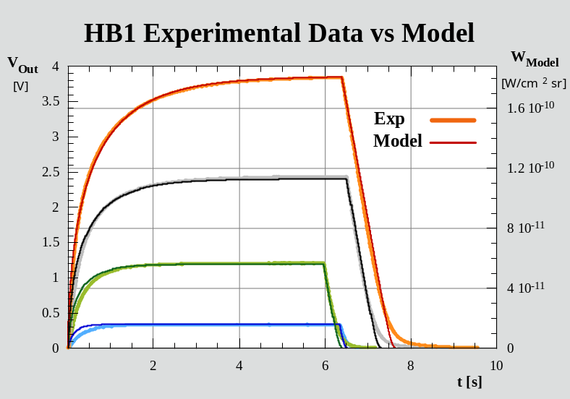
P_{applied} (mW)
1.69
1.09
0.61
0.27

Figure 22: Typical transient response and model fits for HB1

Conclusions
The Haller-Beeman HB5 device fully meets the IRD requirements, achieving an equivalent black body temperature of 45 K with an electrical power of 3 mW and 50 K for 4 mW. The 90% settling time is less than 100 ms. Further optimisation of the device is feasible without changing significant features of the design or any external interfaces. This may allow this performance to be improved for the CQM and PFM devices.

Baseline PCAL CQM device design
Based on the measured properties of the prototypes, the following design parameters have been adopted for the next prototype. The only difference from HB5 is that the brass wires are 0.6 mm in length instead of 0.3 mm. This will increase the radiant output for a given electrical input at the expense of a slightly slower transient response. It is likely that the CQM calibrator will have very similar characteristics.
- 1 x 1 mm Mica (Muscovite), 6 μm thick
- 100 Ångstroms NiCr deposited on one side
- Ti/Au traces deposited on the NiCr, 100/3000 Ångstroms thick, 75 μm x 1 mm surface area
- Indium soldered, 25 μm diameter brass leads, ~ 0.6 mm free length
- Suspension by brass wires only
- Copper-plated PC board heat sink.

Proposed modifications to the design
A modified design is under consideration and is proposed for discussion and review at the DDR. The alternative design can accommodate the cold redundancy requirement and also eliminates any possibility of the mirror touching PCAL in operation or under vibration. The essential features are shown in Figure 23. The PCAL housing is now withdrawn completely behind the BSM and the emitter, so that there is no possibility of the mirror ever touching it. The emitter is viewed directly rather than through a light pipe. Elimination of the light pipe allows a larger aperture to be used - large enough to accommodate two 1 x 1 mm emitters for cold redundancy. The two emitters are mounted side-by-side occupying a 2 x 1 mm area. They are offset along the viewing axis to allow zero gap between them.

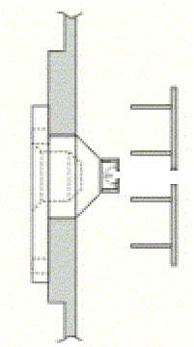
Emitter housing is
completely behind the mirror
2.8-mm dia.
BSM aperture
Emitter housing
with 1 x 2 mm
aperture plate
Prime and redundant 1 x 1 mm emitters
Emitters offset for small or zero effective gap between them
Aperture plate

Figure 23: Left: Alternative PCAL housing. Right: Arrangement of prime and redundant emitters
Features of the design which must be evaluated are:
- the emitters have to be accurately aligned with respect to the BSM aperture to ensure that they are viewable directly through the 2.8-mm BSM aperture;
- the emitters are no longer exactly at the pupil, which may have some impact on the uniformity of illumination of the arrays

Neither of these is thought to pose a major problem.

Interfaces

Mechanical
PCAL mounts directly to the BSM structure as shown in Figure 24. An extensive mechanical FEA has been performed by the ATC for the BSM structure, and the results of this analysis will be used as inputs for FEA and qualification tests on the PCAL assembly.
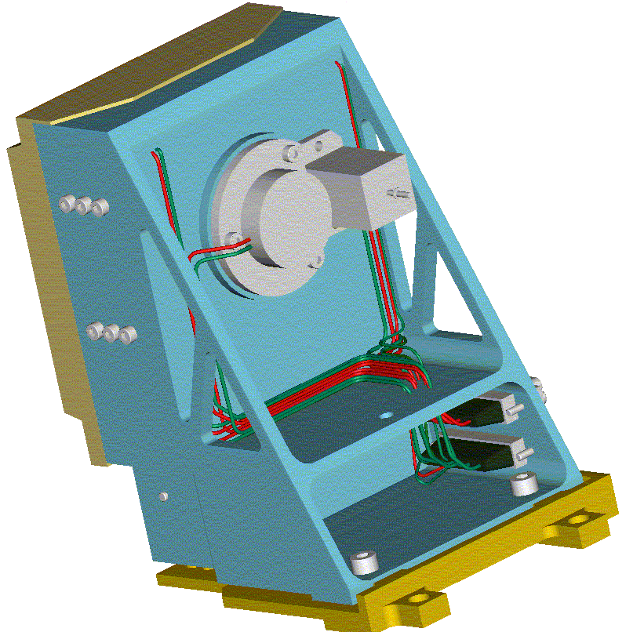
PCAL
BSM Launch Latch
Figure 24 View of PCAL assembly mounted on the BSM.

Electrical

Harness details
PCAL will be presented with four wires as part of the BSM prime harness. This harness will be duplicated for the redundant systems. The PCAL wiring will consist of an insulated, screened, twisted quad sub-harness. The maximum harness impedance requested for PCAL is 10 Ohms per wire. A schematic of the BSM prime connector wiring is shown in Figure 25. The redundant wiring will be an exact copy of this harness.
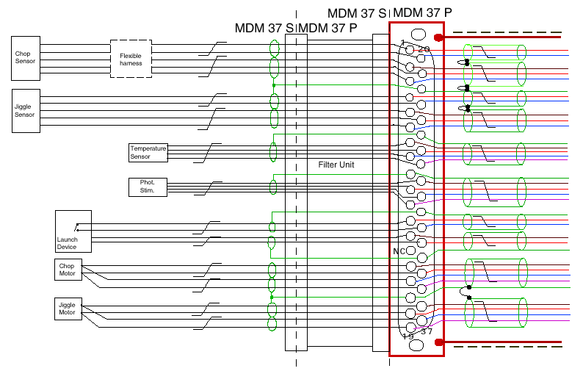
Figure 25 Details of BSM/PCAL harness (C11).

Electrical drive requirements
Current drive for PCAL in a four-wire configuration was agreed at the interface review in November 2001. The following specifications are extracted from the PCAL ICD (HSO-CDF-ICD-013), and are derived to allow for final device impedances in the range 200-500 Ω:-
- Maximum drive current - Maximum power is specified as 2mW (goal), but we may want to run at higher power. Therefore we have allowed for a maximum power dissipation of 10mW. Allowing for the case of a 200Ω device, this gives a required drive current of 7mA.
- Drive current adjustability - 12-bit resolution (minimum) is required in the range 0 – 7mA. This will give a minimum of 1170 adjustment steps in the target operating range.
- Maximum drive voltage - Assuming worst case (R=500Ω), the maximum drive voltage is 3.9V when delivering 7mA. The maximum expected voltage drop across the devices is 3.5V.
- Time constant - The time constant associated with a PCAL current drive step should be less than 6ms.
- Drive current stability - Required repeatability for calibrator radiant power is 1%. The stability and repeatability of the drive current should be within 5μA or 0.5% of the drive current, whichever is the greater.
- Safety limits on the drive current - The specifications on what the warm electronics can provide will be such that the power dissipation in the calibrator can get very high, depending on the final value of the device impedance. Therefore, we require provision for the placement of a set-on-test resistor in the warm electronics, the value of which will be determined by the final value of the calibrator impedance.
- Power supply redundancy - Two completely independent power supplies and circuits are required for PCAL – 1 prime, 1 redundant.

Software
Normal operation of PCAL will involve the application of a pre-determined sequence of commands based on an OBS script under DPU control. Envisaged frequency of operation is no more than once per hour for a period of ~10 seconds.
Table 1 Summary of software commands needed to control PCAL
Command ID | Name | Description
PC1 | On/Off | Switches PCAL drive circuit on/off
PC2 | Current level | PCAL will be driven by a 12-bit DAC over the range 0 to 7mA. Therefore the software should allow for the commanding of 4096 current levels in the range 0 to 7mA.

Thermal
The thermal path for dissipation of PCAL power is through the BSM structure. The interface, illustrated in Figure 11 and Figure 24, will be a gold to gold contact (TBC) held by three bolts. In addition, the whole BSM structure will be gold plated (TBC) for improved heat-sinking and reduced surface emissivity.

Hardware Tree

Reliability & Redundancy

Reliability Block Diagram
RELEX models to be included

Fault Tree Analysis
RELEX models to be included

Single Point Failures
No single point failure modes have been identified

FMECA
A failure modes effects and criticality analysis has been performed (Error: Reference source not found) on all functional elements of SCAL (excluding structural elements whose integrity has been assessed with stress analysis and fracture mechanics analysis as necessary) which can cause failure effects within the experiment or cause damage to or interfere with, the proper functioning of the HERSCHEL spacecraft.

Each failure effect identified has been given a criticality category according to the definition below:

- Category 1: The failure effect is not confined to the subsystem. When this failure results also in loss or degradation of the instruments function this shall be stated.

- Category 2: The failure results in loss or degradation of the subsystems function but the effect is confined to the subsystem.

- Category 3: Minor internal subsystem failures.

The following attributes have been added to the criticality category as appropriate:

- "R", if the design contains a redundant item which can perform the same function
- "SH", if the failure effect causes a safety hazard
- "SPF" if the failure is caused by a single point failure.

The following failure modes have been considered: -

Premature operation
Failure to operate (at the prescribed time)
Failure to cease operation (at the prescribed time)
Failure during operation
Degradation or out of tolerance operation
For failure at component level e.g. hardware interface
- short circuit
- open circuit
- incorrect function e.g. from single event upset - ex: latch-ups.
Incorrect commands or sequence of commands
Incorrect software functions
Mechanical failure

Design specifications, descriptions functional diagrams etc. used in the preparation of the FMECA shall be attached or referenced.

Critical Components Identification
FAILURE MODES EFFECTS AND CRITICALITY ANALYSIS (FMECA)

Product: SPIRE Instrument
Project/Phase: Herschel
System/Subsystem/Equipment: PCAL
Mission phase/Operational Mode: Space Flight
Prepared by: P.Hargrave
Approved by:
Date: 25/08/01
Document reference:
Issue:

Id  number | Item/  block | Function | Failure mode | Failure  cause | Failure effects  a. Local effects  b. End effects | Severity | Failure  detection method/  observable symptoms | Compensation  provisions | Correction  actions | Remarks

