HSO/FIRST-DPU

CARLO GAVAZZI SPACE SpA

DOCUMENT TYPE: SUBSYSTEM TEST PROCEDURE
TITLE: DC / DC CONVERTER Board Test Procedure
DOCUMENT No: DPU-PR-CGS-003 |  |  |  |  |  | PAGE: 1
SPIRE-CGS-DOC-001088
ISSUE No: 1 |  |  |  |  |  | DATE: 31/08/2001
PREPARED BY: L. VUCETICH
APPROVED BY: V CHIAVERINI
THIS DOCUMENT IS SUBJECT TO THE APPROVAL OF:

 | YES |  |  | NO
Product Assurance | X
 |  |  |  |  |  |  |  |  |  | Approval Signature |  |  |  |  |  | Date
Configuration Control | X
 |  |  |  |  |  |  |  |  |  | Approval Signature |  |  |  |  |  | Date
Project Control |  |  | X
 |  |  |  |  |  |  |  |  |  | Approval Signature |  | Date
Engineering | X
 |  |  |  |  |  |  |  |  |  | Approval Signature |  |  |  | Date
Managing Director |  |  | X
 |  |  |  |  |  |  |  |  |  | Approval Signature |  |  |  | Date
CGS Program Manager | X
 |  |  |  |  |  |  |  |  |  | Approval Signature |  |  | Date
 | YES |  |  | NO
Higher Level Contractor
 |  |  |  |  |  |  |  |  |  | Approval Signature |  |  | Date
Customer
 |  |  |  |  |  |  |  |  |  | Approval Signature |  |  | Date
Data Management
 |  |  |  |  |  |  |  |  |  | Signature |  |  | Date

DOCUMENT CHANGE RECORD

ISSUE N° | DATE | CHANGE  AUTHORITY | PAGES AFFECTED | REMARKS
1 | 31/08/2001 |  |  | First Emission

LIST OF VALID PAGES

PAGE | ISSUE N° | PAGE | ISSUE N° | PAGE | ISSUE N° | PAGE | ISSUE N° | PAGE | ISSUE N°
1-101 | 1

TABLE OF CONTENTS
1 LIST OF ACRONYMS 6
2 scope 7
3 Documents 9
3.1 APPLICABLE DOCUMENTS 9
3.2 REFERENCE DOCUMENTS 9
4 GENERAL INFORMATION 9
5 TEST EXECUTION 11
5.1 PHYSICAL PROPERTIES VERIFICATION 11
5.2 ELECTRICAL TEST 11
5.2.1 Isolation and grounding 13
5.2.2 Push-Pull Characteristics Waveform 13
5.2.2.1 Fets Gate/Source voltage verification: 13
5.2.2.2 Switching Frequency: 16
5.2.2.3 Fets Drain Voltage and Snubber Verification: 16
5.2.2.4 Primary current limit value: 19
5.2.3 Power consumption 19
5.2.3.1 Power consumption in DPU version: 20
5.2.3.2 Power consumption in DPU+PL version: 20
5.2.4 Output Voltage Stability 21
5.2.4.1 Load regulation (static condition): 21
5.2.4.2 Load Regulation (Transient Condition) 22
5.2.4.3 Line regulation: 26
5.2.5 Ripple And Spikes 27
5.2.6 Efficiency 30
5.2.7 Start-up Verification 31
5.2.7.1 Inrush Current 31
5.2.7.2 Output Voltage soft start 34
5.2.8 Stability Verification 37
5.2.9 Input Impedance 40
5.2.10 Protection Circuitry Verification 44
5.2.10.1 Input Protection 44
5.2.10.2 Output DPU Protections 44
5.2.10.3 Unregulated PL-Outputs Protections 44
5.2.10.4 Regulated PL-Outputs Protections 45
5.2.11 Monitor Verification 46
5.3 THERMAL TEST 47
5.3.1 Low Temperature Test (-25°) 47
5.3.1.1 Power consumption 47
5.3.1.2 Output Voltage Stability 49
5.3.1.3 Line regulation: 56
5.3.1.4 Efficiency 57
5.3.1.5 Monitors Verification 58
5.3.2 High Temperature Test (+45°) 59
5.3.2.1 Power consumption 59
5.3.2.2 Power consumption in DPU version: 59
5.3.2.3 Power consumption in DPU+PL version: 59
5.3.2.4 Output Voltage Stability 60
5.3.2.5 Line regulation: 67
5.3.2.6 Efficiency 68
5.3.2.7 Monitors Verification 69
5.4 EMC TEST 70
5.4.1 Conducted Emission on Input Power Line 70
5.4.1.1 CE on Input Power Line, Frequency Domain, Differential Mode, NB 70
5.4.1.2 CE on Input Line, Frequency Domain, Common Mode, NB 77
5.4.1.3 Current Ripple, Time Domain, Differential Mode 81
5.4.2 Conducted Susceptibility from Input Power Line 85
5.4.2.1 CS from Input Power Line, Differential Mode, Steady State 85
5.4.2.2 CS from Input Power Line, Common Mode, Steady State 88
5.4.2.3 CS Common Mode Voltage- Steady State 90
5.4.2.4 CS Common Mode Voltage Transients 91
5.4.2.5 CS from Input Power Line – Transients due to Switching 94
5.4.3 Conducted Emissions on PL-Output Lines 97
5.4.4 Arc Discharge Susceptibility 97
5.5 VIBRATION TEST Input Protections 97
6 Pin function 97
7 conclusion 100

LIST OF ACRONYMS

AD# | Applicable Document Number
BB | Broadband
CE | Conducted Emission
CS | Conducted Susceptibility
DPU | Data Processing Unit
EMC | Electro-Magnetic Compatibility
EMI | Electro-Magnetic Interference
FIRST | Far Infra-Red and Sub-millimeter Telescope
FPU | Focal Plane Unit
GND | Ground
HIFI | Heterodyne Instrument for First
HK | House Keeping
ICD | Interface Control Document
ICU | Instrument Control Unit
IID | Instrument Interface Document
I/F | Interface
LCL | Latching Current Limiter
OCP | Over-Current Protection
OVP | Over-Voltage Protection
NA | Not Applicable
NB | Narrowband
PA | Product Assurance
PACS | Photoconductor Array Camera and Spectrometer
PDU | Power Distribution Unit
PL | Payload
RD# | Reference Document Number
RE | Radiated Emission
RS | Radiated Susceptibility
RTN | Return Line
S/C | Spacecraft
SPIRE | Spectral and Photometric Imaging receiver
TBC | To Be Confirmed
TBD | To Be Determined
TM/TC | Telemetry & Tele-command
uut | Unit Under Test

scope
Scope of this document is to define a Test Procedure for Engineering , Qualification and Flight Models of the DC/DC board which shall be used to supply the Data Processing Unit (DPU) of the Payload Instruments HIFI, PACS and SPIRE to be developed in the framework of the FIRST program.
For the payload experiment HIFI only, the DC/DC board, besides the supply of the DPU, shall provide supplying voltages for the HIFI instrument itself. In this case the DC/DC board shall be called, in this document, as “DPU+PL version”.
The DC/DC board devoted to supply the DPU unit only, shall be called, in this document, as “DPU version”.
The sequence of Tests for each model is given in Table 2.1 .
The applicable Test Matrix which defines the applicability of the various tests for each test category is given in Table 2.2 .

TEST | EM | QM | FM
Physical properties verification | X | X | X
Electrical Test | X | X (1) | X (1)
Thermal Test | X (2) | X | X (1)
EMC Test | X (1) | X | X ( 1)
Vibration Test

Note: (1) Reduced Test DEFINIRE
Note: (2) These Test are valid only if components with appropriate temperature range are utilized.

TABLE 2.1 – TEST SEQUENCE
DEFINIRE

 | TEST | EM | QM | FM
5.1 | PHISICAL PROPERTIES VERIFICATION | X | X | X
5.2 | ELECTRICAL TEST | X | X | X
5.2.1 | - Isolation and Grounding | X | X | X
5.2.2 | - Push-Pull characteristics waveform  - Fet Gate/Source Voltage  - Switching Frequency  - Snubber peak voltage  - Controller primary current limit value and waveform. | X  X  X  X | X  X  - | X  X  -
5.2.3 | - Power Consumption | X | X | X
5.2.4 | - Output Voltage Stability  - Load regulation  - Line regulation | X  X | X  X | X  X

TABLE 2.2 – TEST MATRIX
TABLE 2.2 – TEST MATRIX (continued)
 | TEST | EM | QM | FM
5.2.5 | - Ripple and Spikes | x | x | x
5.2.6 | - Efficiency | x | x | x
5.2.7 | - Start Up Verification  - Inrush Current  - Output Voltage soft-start  - Internal Power Supply Voltage | x  x  x | x  x  - | x  x  -
5.2.8 | - Stability verification | x | x | x
5.2.9 | - Input Impedance | x | x | x
5.2.10 | - Protection Circuitry verification  - Input protection  - Output PDU protections  - Unregulated PL-Outputs Protections  - Regulated PL-Outputs Protections | x  x  x  x | x  x  x  x | x  x  x  x
5.2.11 | - Monitors Verification  - Output DC/DC service voltage monitors  - Temperature monitor | x  x | x  x | x  x
5.3 | THERMAL TEST | - | x | x
5.3.1 | - Low Temperature Test (-25°)  - Power Consumption  - Output Voltage Stability  - Efficiency  - Monitors Verification | -  -  -  -  - | x  x  x  x  x | x  x  x  -
5.3.2  5.3.2.1  5.3.2.2  5.3.2.3  5.3.2.4 | - High Temperature Test (+45°)  - Power Consumption  - Output Voltage Stability  - Efficiency  - Monitors Verification | -  -  -  -  - | x  x  x  x  x | x  x  x  -
5.4 | EMC TEST | x | x | x
5.4.1 | - Conducted Emission on Input Power Line  - CE on Input Power Line; Frequency Domain, Differential Mode, NB  - CE on Input Power Line; Frequency Domain, Common Mode, NB  - Current Ripple , Time Domain , Differential Mode | x  x  x | x  x  x | x  x  x
5.4.2 | - Conducted Susceptibility from input Power Line  - CS from Input Power Line ; Differential Mode , Steady State  - CS from Input Power Line ; Common Mode ; Steady State  - CS Common Mode Voltage Steady State  - CS Common Mode Voltage Transient  - CS from Input Power Line – Transient due to Switching | -  -  -  -  - | x  x  x  x  x | x  x  x  x  x
5.4.3 | - Conducted Emission on PL-Output Lines | - | x | x
5.4.4 | - Arc Discharge Susceptibility | - | - | -
5.5 | VIBRATION TEST | - | x | -

Documents

The following documents were utilized to write this document:

APPLICABLE DOCUMENTS

[AD1]: CNR.IFSI.2000TR01 "Documento di Specifiche Tecniche per il Contratto delle Data Processing Units del Satellite First dell'ESA" IFSI (Issue: 1 - 15/09/2000)
[AD2]: Technical proposal CGS (Ref. S9-030 November 99)
[AD3]: “Allegato Tecnico al Contratto ASI"
[AD4]: Product Assurance Plan for the FIRST DPU (DPU-PL-CGS-001 Issue 1 Jan. 2001)
[AD5]: DC/DC Board Specification DPU-SP-CGS-004

REFERENCE DOCUMENTS

[RD1] - FIRST/Planck Instrument Interface Document Part A. (Ref. SCI-PT-IIDA-04624 Issue-Rev. No. : 1/1)
[RD2] - FIRST/Planck Instrument Interface Document Part B - Instrument “HIFI” (Ref. SCI-PT-IIDB/HIFI-02125 Issue-Rev No. : 1/0)

GENERAL INFORMATION

The DC/DC board ( Push-Pull topologies) must provide a set of supply voltages for to the DPU internal electronics of the payload experiments HIFI, PACS and SPIRE. For the payload experiment HIFI only, the DC/DC board must provide a further external set of supply voltages for the HIFI/FCU unit.
Therefore the board must provide, considering the DPU+PL version, the following two sets of output voltages:
- “DPU-Outputs” to supply the DPU internal electronics
- “PL-Outputs” to supply the payload instrument HIFI/FCU unit.
In the DPU version only the DPU-Outputs shall be provided.

DPU-Outputs and PL-Outputs shall be isolated from primary power side and from each other as described in [AD5]: DC/DC Board Specification DPU-SP-CGS-004.
The DC/DC board shall switch on automatically when the input voltage is within the range established in [AD5]:DC/DC Board Specification DPU-SP-CGS-004.

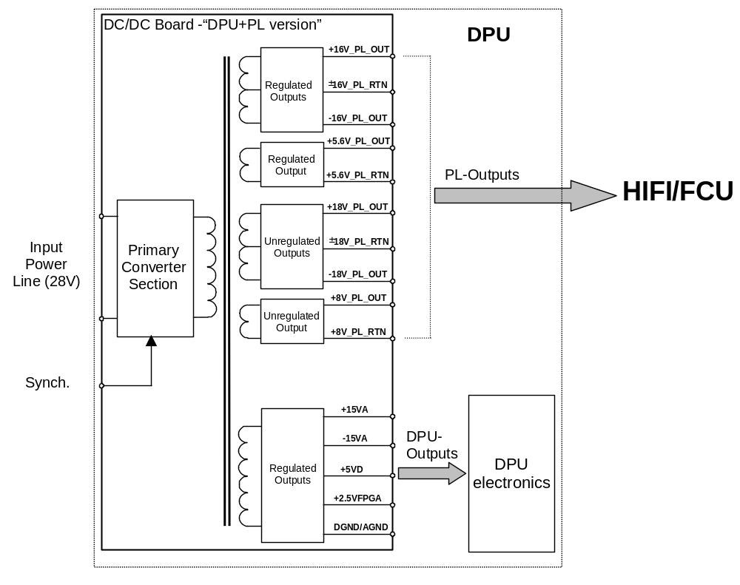

Figure 4-1 DC/DC Board functional diagram (“DPU+PL version”)

TEST EXECUTION
In the following pages the procedures to be used for test execution are described in detail and several form to be filled in are given.

Test sequence has been subdivided into five steps:

- Physical Properties Verification
- Electrical Test
- Thermal Test
- EMC Test
- Vibration Test

PHYSICAL PROPERTIES VERIFICATION

The DC/DC board shall be located within the DPU.
The DC/DC board is implemented through one Printed Circuit Board.
The mechanical constraints and the measured value are reported in the following Table

MEASUREMENT | NOMINAL | MEASURED
Size (DPU+PL version) | Double Euro (160mm x 233.35mm)
Size (DPU version) | Double Euro (160mm x 233.35mm)
Overall thickness: (both versions) | 38mm
Card retainers: | Calmark series 260
Connectors (connection to back plane): | 90°, male, DIN41612 type

Table 5-1-1 Board constraints

MEASUREMENT | NOMINAL | MEASURED
Overall Weight (DPU+PL version) | ≈1000gr TBC
Overall Weight (DPU version) | ≈750gr TBC

Table 5-1-2 Board weight

ELECTRICAL TEST
Electrical Test to be perform on the DC/DC converter board are described in detail in this paragraph.
Before test execution complete the table 5-2-1 with instrumentation equipment data.

Project : | Name for Test :

Equipment required
To check and accomplish before the tests. To complete eventually during test.

Label of equipment (c.g.name) | Manufact. Type | Inventur No. | Next  Calibration  date | Accuracy | Remarks

TABLE 5-2-1 – instrumentation equipment data

Isolation and grounding

The Power return lines DGND and AGND shall be connected into the DC/DC board
When the output power return lines are disconnected from ground, the isolation between the output power return lines and the DC/DC board chassis shall be at least 1MΩ shunted by not more than 50nF (exclusive of PL-Outputs filters).
Output lines shall maintain an isolation of at least 1MΩ shunted with a capacity less than 5nF with respect to primary power return line before any grounding of the secondary reference is made.

With a Mega-Ohmmeter and LRC meter (for capacitive measurement ) verify the isolation.

OUTPUT RETURNS | MEASURED PRIMARY RETURN (MΩ / nF) |  | MEASURED DC/DC CHASSIS (MΩ / nF)
+5V DPU RTN
+2.5V DPU RTN
±15V DPU RTN
±18V_PL_RTN
±16V_PL_RTN
+8V_PL_RTN
+5.6V_PL_RTN
DGND

Push-Pull Characteristics Waveform

Fets Gate/Source voltage verification:
- with a oscilloscope measure the fets Gate/Source voltage waveform in DPU and DPU+PL version and make hardcopy
- Report the plots in the following figures:
figure 5.2.2.1-1, 5.2.2.1-2,)

Figure 5.2.2.1-1 Fets Gate/source voltage DPU version

Figure 5.2.2.1-2 Fets Gate/source voltage PL converter

Switching Frequency:
the DC/DC converter/s switching frequency shall be 110kHz±10%.

DC/DC CONVERTER | SWITCHING FREQUENCY REFERENCE VALUE (KHz) | MEASURED SWITCHING FREQUENCY (KHz)
DPU converter
PL converter

Fets Drain Voltage and Snubber Verification:
the maximum peak FETs Drain Voltage shall not exceed 75V.
- With a oscilloscope verify the fets Drain Voltage waveform in DPU and DPU+PL version and make hardcopy.
- Report the plots in the following figures:
figure 5.2.2.3-1, 5.2.2.3-2 ,)

Figure 5.2.2.3-1 Fets Drain voltage DPU version

Figure 5.2.2.3-2 Fets Drain voltage PL converter

Primary current limit value:

The DC/DC controller primary peak current limit value shall be set to about 3.5A .
Set a DPU load to a maximum value , measure the input peak current and measure the output power consumption ( about21W ).
Increase the load at 120% of maximum load ( about 25W ) and measure the input peak current and output power.
The measured in input peak current must be limited to a limit peak current value ( 3,5A)

 | VIN (V) | LOAD | INPUT PEAK CURRENT (A) | OUTPUT POWER (W)
DPU | 28 | MAX.
DPU | 28 | 120% of MAX.

Repeat this step for DPU_PL DC/DC converter section

 | VIN (V) | LOAD | INPUT PEAK CURRENT (A) | OUTPUT POWER (W)
DPU_PL | 28 | MAX.
DPU_PL | 28 | 120% of MAX.

Power consumption

Maximum overall output power of the DC/DC board in the DPU+PL version shall be 42 W ± 20%.
Maximum overall output power of the DC/DC board in the DPU version shall be 21W ± 20%.

Power consumption in DPU version:
With ammeter in series on positive input line, measure input current at different values of Vin and load current.

V in (V) | I in (A) | P in (W) | Vout / Iout |  | Vout / Iout |  | Vout / Iout |  | Vout / Iout |  | Pout (W)
26
28
29

Power consumption in DPU+PL version:
With ammeter in series on positive input line, measure input current at different values of Vin and load current.

V in (V) | I in (A) | P in (W) | Vout/ Iout |  | Vout/ Iout |  | Vout / Iout |  | Vout / Iout |  | Vout / Iout |  | Vout / Iout |  | Pout (W)
26
28
29

Output Voltage Stability

Load regulation (static condition):
The DPU-Outputs are regulated and the electrical requirements and measured value are reported in
the following table:

Output | V_{min} [V] | V_{max} [V] | I_{min} [mA] | I_{max} [mA] | Vmin measured | Vmax measured
+5VD | 4.75 | 5.25 | 1000 | 3500
+15VA | 14.25 | 15.75 | TBD | 100
-15VA | -15.75 | -14.25 | TBD | 250
+2.5VFPGA | 2.375 | 2.625 | TBD | 200

Table 5.2.4.1-1 DPU Load regulation (static condition)

The PL-Outputs electrical requirements and measured value are reported in the following table:

Output | V_{min} [V] | V_{max} [V] | I_{min} [mA] | I_{max} [mA] | Vmin measured | Vmax measured
+5.6V_PL_OUT | +5.5 | +5.8 | 0 | 240
+16V_PL_OUT | +15.6 | +16.4 | 0 | 190
-16V_PL_OUT | -16.4 | -15.6 | 0 | 150
+8V_PL_OUT | +7 | +9 | 0 | 350
+18V_PL_OUT | +17 | +20 | 0 | 330
-18V_PL_OUT | -17 | -20 | 0 | 230

Table 5.2.4.1-2 PL Load regulation (static condition)

V_{min} is the output voltage ( with max. output current) delivered when the other outlets are loaded with a min. current.
V_{max} is the output voltage ( with min. output current).delivered when the other outlets are loaded with the maximun current.

Load Regulation (Transient Condition)

During the load variations the outlet voltage can not exceed the min./max. voltage tolerance .

- For each outlet generate an instantaneous load variations (low to high) between 25% and 75% of maximum current.
- Report in the following table the minimum output voltage and the recovery time .
- Make and report the waveform hardcopy of +5VD and +5,6V_PL_OUT

OUTLET | I low [mA] | I high [mA] | Time [ms] | Min Voltage [V]
+5VD | 875 | 2625
+15VA | 25 | 75
-15VA | 62.5 | 187.5
+2.5VFPGA | 50 | 150
+5.6V_PL_OUT | 60 | 180
+16V_PL_OUT | 47.5 | 142.5
-16V_PL_OUT | 37.5 | 112.5
+8V_PL_OUT | 87.5 | 262.5
+18V_PL_OUT | 82.5 | 247.5
-18V_PL_OUT | 57.5 | 172.5

Table 5.2.4.2-1 Load Regulation Low to High (Transient Condition)

Figure 5.2.4.2-1 Load Regulation Low to High ( Transient Condition )

- For each outlet generate an instantaneous load variations (high to low) between 75% and 25% of maximum current .
- Report in the following table the minimum output voltage and the recovery time .
- Make and report the waveform hardcopy of +5VD and +5,6V_PL_OUT

OUTLET | I high [mA] | I low [mA] | Time [ms] | Max Voltage [V]
+5VD | 2625 | 875
+15VA | 75 | 25
-15VA | 187.5 | 62.5
+2.5VFPGA | 150 | 50
+5.6V_PL_OUT | 180 | 60
+16V_PL_OUT | 142.5 | 47.5
-16V_PL_OUT | 112.5 | 37.5
+8V_PL_OUT | 262.5 | 87.5
+18V_PL_OUT | 247.5 | 82.5
-18V_PL_OUT | 172.5 | 57.5

Table 5.2.4.2-2 Load Regulation High to Low (Transient Condition)

Figure 5.2.4.2-2 Load Regulation High to Low ( Transient Condition )

Line regulation:
With multimeter measure all output voltage at minimum, Nominal and Maximum value of Input Voltage with Nominal Load current on each Secondary output. Output Voltage will be measured in correspondence of board pads or board connectors pins.

In Addition measure :

- V int. only fot DPU Version
- Auxiliary voltage V aux only for DPU+PL version.

output | V in min  26 (V) | V in nom  28 (V) | V in max  29 (V) | NOTE
V out 5V DPU
Vout+15V DPU
Vout -15V DPU
V out +8V PL
V out +18V PL
V out -18V PL
V out +5,6V PL
V out +16V PL
V out –16V PL
V int.
V aux

Table 5.2.4.3-1 DC/DC converter Line regulation

Ripple And Spikes
Ripple and spikes shall be measured with a representative dummy load, the dummy load shall sink a DC load current of I_{max} in parallel with a 20μF capacitance in series with a 10Ω resistance. Spikes measurements shall be performed with a 50MHz BW Oscilloscope. For ripple measurements, a 2MHz BW limitation shall be introduced. Measurements shall be performed in differential mode.
In Figure 5.2.5-2 the meaning of ripple and spikes peak to peak envelopes is shown.

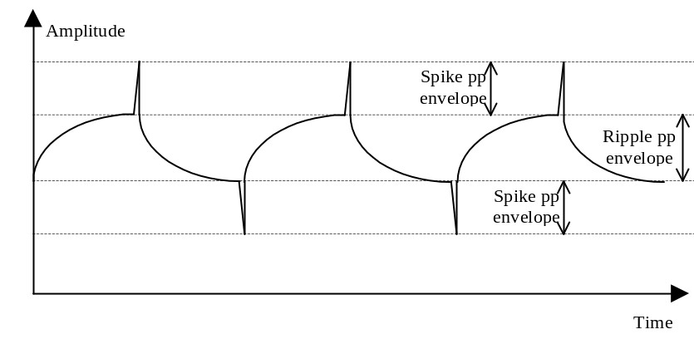
Figure 5.2.5-2

Measure and report in the following table the outputs ripple and spike and print out the +5VD and +5.6V_PL_OUT waveforms

Output | Ripple [mV_{PP}] | Measured | Spikes [mV_{pp}] | Measured | Note
+5VD | 200 |  | 100
+15VA | 400 |  | 200
-15VA | 400 |  | 200
+2.5VFPGA | 200 |  | 100
+5.6V_PL_OUT | 140 |  | 100
+16V_PL_OUT | 140 |  | 100
-16V_PL_OUT | 140 |  | 100
+8V_PL_OUT | 850 |  | 200
+18V_PL_OUT | 1400 |  | 200
-18V_PL_OUT | 1400 |  | 200

Table 5.2.5-1 Ripple and Spikes

Figure 5.2.5-2 Ripple and Spikes DPU converter

Figure 5.2.5-3 Ripple and Spikes PL converter

Efficiency

The conversion efficiency shall be at least 70% at maximum output power.

With available data on Power Consumption and output voltage values at different input voltage and load current, calculate DC/DC Converter efficiency for all input and load conditions.
Efficiency is given by:
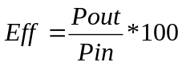 [%]

Where Pout will be computed taking into account actual resistive loads or measured output current on each secondary output.

DPU EFFICIENCY | VIN MIN | VIN NOM | VIN MAX
LOAD MIN
LOAD NOM
LOAD MAX

DPU+PL EFFICIENCY | VIN MIN | VIN NOM | VIN MAX
LOAD MIN
LOAD NOM
LOAD MAX

Start-up Verification

Inrush Current
DC/DC board inrush current due to DC/DC board switch-on shall be limited to 1.5 times the DC/DC input peak current, specified as 1.2 times the nominal current. The duration of the inrush peak shall not exceed 0.5ms. The rate of change (slope) of the inrush current shall not exceed 50mA/μsec.

- Measure and print out the inrush current.
- Report the waveform hardcopy in figure 5.2.7.1-1 and

BAORD | PEAK CURRENT (A) | DURATION (ms) | RATE (mA/μsec.)
DPU
DPU+PL

Figure 5.2.7.1-1 DPU Inrush current

Figure 5.2.7.1-2 DPU+PL Inrush Current

Output Voltage soft start

Measure and report in the following table the outputs voltages waveform and print out the +5VD and +5.6V_PL_OUT waveforms

OUTPUT | AMPLITUDE (V) | DURATION (ms) | NOTE
+5VD
+15VA
-15VA
+2.5VFPGA
+5.6V_PL_OUT
+16V_PL_OUT
-16V_PL_OUT
+8V_PL_OUT
+18V_PL_OUT
-18V_PL_OUT

Figure 5.2.7.2-1 +5VD Output Voltage Soft Start

Figure 5.2.7.2-2 +5,6V_PL-OUT Output Voltage Soft Start

Stability Verification
With the Set-up shown in fig. 5.2.8-1 measure and report in the following Table the Gain and Phase Margin , with Nominal load current on each Secondary output.
Print out and report the plot of Gain and Phase Margin in the following figures:
- DPU Converter figures 5.2.8-2
- PL Converter figures 5.2.8-3

BAORD | GAIN (dB) | PHASE (°)
DPU converter
PL converter

Power
Supply
probe
Probee
Probe
dd

ddddddd

dddd
DC/DC CONVERTER
To PWM
To OUT
CH.
CH.
CH.
Amp.

Adapt.
V1
V2
GEN

GAIN / PHASE

ANALYZER
+
-
+ +
-
Feedback Loop

Figure 5.2.8-1 Stability Verification Test Set-up

Generator Amplitude : 10mV sine
Frequency Range : 20Hz to 50KHZ

Figure 5.2.8-2 DPU Converter Gain and Phase Margin

Figure 5.2.8-3 PL Converter Gain and Phase Margin

Input Impedance

This test shall be performed to measure the input impedance of DPU and DPU+PL converter.
The DC/DC board input impedance shall be 6dB higher than the power bus impedance mask.
The Power Bus Impedance mask is shown in the following figure 5.2.9-1
The measurement shall be performed at maximum output power with a test set-up as shown on figure 5.2.9-4
- Measure the input power bus impedance envelope.
- Report in figure 5.2.9-2the input power bus impedance envelope of DPU converter.
- Report in figure 5.2.9-3 the input power bus impedance envelope of DPU+PL converter.

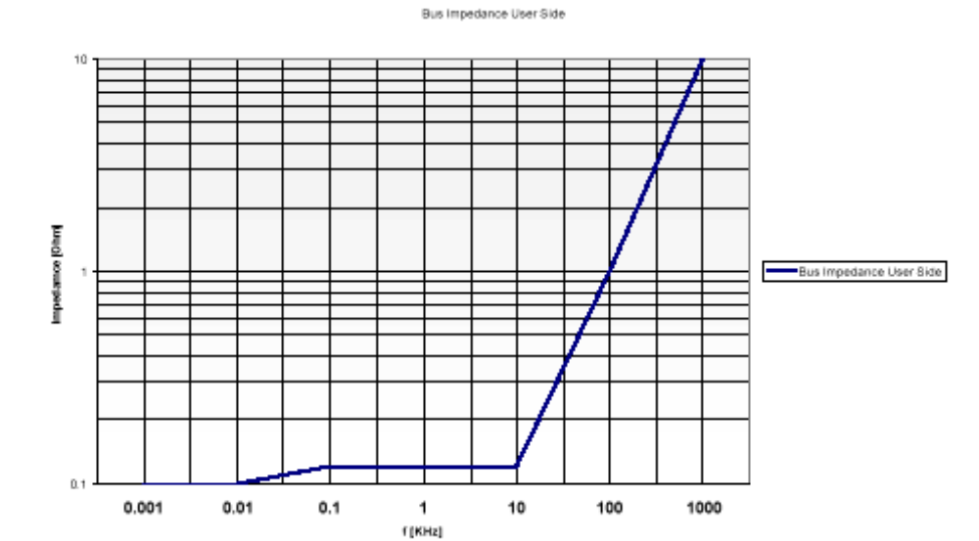
Figure 5.2.9-1 The Power Bus Impedance

Figure 5.2.9-2 DPU Input Impedance

Figure 5.2.9-3 DPU+PL Input Impedance

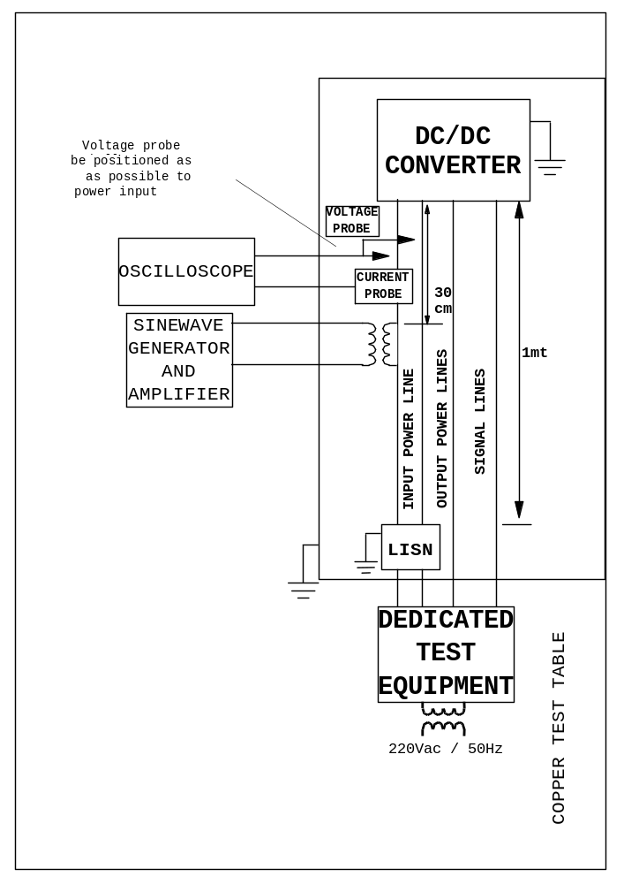

Figure 5.2.9-4 Test set up for input impedance measurement

Protection Circuitry Verification

The following protections shall be implemented on the DC/DC board DPU-outputs:

Input Protection
The DC/DC board shall operate with nominal performance with a Input Voltage between 26÷29
Only Under voltage protection is foreseen .
Decrease the input voltage power bus to about 20V and verify that DC/DC converter output voltages switch OFF , report in the following table the input under voltage and current value .

VIN | Iin | Pin

Output DPU Protections
The following protections shall be implemented on the DC/DC board DPU-Outputs:
- Over-voltage protection (OVP) on +5VD outlet. (Set at about 5.5V) (come farlo)
- Over-current protection value on +5VD, +15VA and -15VA outlets are reported in the following table:
Increase the output load current on each output voltage and report in the table the over current value

Outlet | Threshold Current [mA] | Current measured [mA]
+5VD | 4000±10% TBC
+15VA | 200±10% TBC
-15VA | 500±10% TBC
Table 5.2.10.2-1
Each protection intervention will shutdown the DC/DC board.

Unregulated PL-Outputs Protections
The following protections shall be implemented on the DC/DC board Unregulated PL-Outputs:

- Over-voltage protection (OVP) on the +8V_PL_OUT, +18V_PL_OUT and -18V_PL_OUT outputs.
- The over-voltage protection are performed by series output voltage regulators
The protection characteristics are summarized in the following table.

Outlet | Threshold Voltage [V] | V measured [V]
+8V_PL_OUT | 10±1
+18V_PL_OUT | 22±2
-18V_PL_OUT | -22±2
Table 5.2.10.2-1

- Over-current protection (OCP) on the +8V_PL_OUT, +18V_PL_OUT and -18V_PL_OUT outlets as reported in the following table: ( LIMITI dei Regolatori)

Outlet | Threshold Current [mA] | Current measured [mA]
+8V_PL_OUT | 600±100
+18V_PL_OUT | 600±100
-18V_PL_OUT | 600±100
Table 5.2.10.3-2

Regulated PL-Outputs Protections
The following protections shall be implemented on the DC/DC board Regulated PL-Outputs:

- Over-voltage protection (OVP) with crow-bar on the +5.6V_PL_OUT, with the following characteristics :

Output | Threshold Voltage [V] | I_{clamp} [A] | V_{lim} [V] | V measured [V]
+5.6V_PL_OUT | +6.5±5% | -2…+2 | -0.7…+7
+16V_PL_OUT | +17.2±5% | -2…+2 | -0.7…+18
-16V_PL_OUT | -17.2±5% | -2…+2 | -18…+0.7
Table 5.2.10.4-1

I_{clamp} is the maximum current that the over-voltage protection should be able to handle (crowbar). The voltage on the output shall be within V_{lim} range when I_{clamp} is injected.
Note: in case of short circuit between output “hot lines” with current injection (within the range of I_{clamp}) from one line into the other, the output voltage shall be limited within the range established in the V_{lim} column.

+16V_PL_OUT and -16V_PL_OUT outputs overvoltage protection is realized by series voltage regulator.(come provarlo)

- Current limitation (CL) on the +5.6V_PL_OUT, +16V_PL_OUT and -16V_PL_OUT outlets.
The current limitation values and the measured values are reported in the following table.

Output | I_{lim} [mA] | Current measured [mA]
+5.6V_PL_OUT | 285±5%
+16V_PL_OUT | 950±5%
-16V_PL_OUT | 950±5%
Table 5.2.10.4-2

I_{lim} is also the maximum output current for inrush currents when downstream electronics is switched ON.
To simulate the inrush current of the load connected to each Regulated PL-Output a 100μF capacitor with no significant series impedance can be used. (da testare?)

Monitor Verification

The DC/DC board shall provide the telemetries described in the following table:
Telemetry | Function | Accuracy | Type | Scale | Reference
+5V_MNT | +5VD voltage monitor | ±5% | Voltage monitor  Single Ended | 0V ⇒ 0V MNT  6V ⇒ 5V MNT | RTN_MNT1
+15V_MNT | +15VA voltage monitor | ±5% | Voltage monitor  Single Ended | 0V ⇒ 0V MNT  18V ⇒ 5V MNT | RTN_MNT2
-15V_MNT | -15VA voltage monitor | ±5% | Voltage monitor  Single Ended | 0V ⇒ 0V MNT  -18V ⇒ 5V MNT | RTN_MNT3
+TEMP_MNT | Temperature monitor | ±5% | Temperature Monitor  Single Ended | -50°C ⇒ 0V MNT  +80°C ⇒ 5V MNT | RTN_MNT4

Table 5.2.11-1 Telemetries
Note: RTN_MNT0, RTN_MNT1, RTN_MNT2, RTN_MNT3 and RTN_MNT4 shall be connected, into the DC/DC board, to DPU-Outputs Return line.

Measure and report in the following table the measured telemetry values

Telemetry | Measured outputs voltages | V telemetry expected [V] | V telemetry measured [V] | Error [%]
+5V_MNT
+15V_MNT
-15V_MNT
TEMP_MNT

Table 5.2.11-2 Telemetries

THERMAL TEST
The DC/DC board shall be designed to be compatible with the environmental constraints summarized in the following table:

Board operating temperature: | -25 ÷ +45 °C
Board non operating temperature: | -35 ÷ +85 °C

Table 5.3-1 Thermal Environmental constraints

Note: The above mentioned temperature ranges are valid only if components with appropriate extended temperature range are utilized.

Low Temperature Test (-25°)

Power consumption

Maximum overall output power of the DC/DC board in the DPU+PL version shall be 42 W ± 20%.
Maximum overall output power of the DC/DC board in the DPU version shall be 21W ± 20%.

Power consumption in DPU version:

With ammeter in series on positive input line, measure input current at different values of Vin and load current.

V in (V) | I in (A) | P in (W) | Vout / Iout |  | Vout / Iout |  | Vout / Iout |  | Vout / Iout |  | Pout (W)
26
28
29

- Power consumption in DPU+PL version:

With ammeter in series on positive input line, measure input current at different values of Vin and load current.

V in (V) | I in (A) | P in (W) | Vout/ Iout |  | Vout/ Iout |  | Vout / Iout |  | Vout / Iout |  | Vout / Iout |  | Vout / Iout |  | Pout (W)
26
28
29

Output Voltage Stability

Load regulation (static condition):
The DPU-Outputs are regulated and the electrical requirements and measured value are reported in
The following table

Output | V_{min} [V] | V_{max} [V] | I_{min} [mA] | I_{max} [mA] | Vmin measured | Vmax measured
+5VD | 4.75 | 5.25 | 1000 | 3500
+15VA | 14.25 | 15.75 | TBD | 100
-15VA | -15.75 | -14.25 | TBD | 250
+2.5VFPGA | 2.375 | 2.625 | TBD | 200

Table 5.3.1.2-1 DPU Load regulation (static condition)

The PL-Outputs electrical requirements and measured value are reported in following table:

Output | V_{min} [V] | V_{max} [V] | I_{min} [mA] | I_{max} [mA] | Vmin measured | Vmax measured
+5.6V_PL_OUT | +5.5 | +5.8 | 0 | 240
+16V_PL_OUT | +15.6 | +16.4 | 0 | 190
-16V_PL_OUT | -16.4 | -15.6 | 0 | 150
+8V_PL_OUT | +7 | +9 | 0 | 350
+18V_PL_OUT | +17 | +20 | 0 | 330
-18V_PL_OUT | -17 | -20 | 0 | 230

Table 5.3.1.2-2 PL Load regulation (static condition)

V_{min} is the output voltage ( with max. output current) delivered when the other outlet is loaded with a min. current.
V_{max} is the output voltage ( with min. output current)delivered when the outlet is loaded with a current in

- Load Regulation (Transient Condition):

During the load variations the outlet voltage can not exceed the min./max. voltage tolerance .

For each outlet generate an istantaneus load variations (low to high) between 25% and 75% of maximum current.

- Report in the following table the minimum output voltage and the recovery time.
- Make and report the hardcopy of and in following figure:
- +5VD waveform in figure 5.3.1.2-1.
- +5,6V_PL_OUT waveform in figure 5.3.1.2-2.

OUTLET | I low [mA] | I high [mA] | Time [ms] | Min Voltage [V]
+5VD | 875 | 2625
+15VA | 25 | 75
-15VA | 62.5 | 187.5
+2.5VFPGA | 50 | 150
+5.6V_PL_OUT | 60 | 180
+16V_PL_OUT | 47.5 | 142.5
-16V_PL_OUT | 37.5 | 112.5
+8V_PL_OUT | 87.5 | 262.5
+18V_PL_OUT | 82.5 | 247.5
-18V_PL_OUT | 57.5 | 172.5

Table 5.3.1.2-3 Load Regulation Low to High (Transient Condition)

Figure 5.3.1.2-1 +5VD Load Regulation Low to High ( Transient Condition )

Figure 5.3.1.2-2 +5,6V_PL_OUT Load Regulation Low to High ( Transient Condition )

For each outlet generate an instantaneous load variations (high to low) between 75% and 25% of maximum current .
- Report in the following table the minimum output voltage and the recovery time.
- Make and report the hardcopy of and in following figure:
- +5VD waveform in figure 5.3.1.2-3.
- +5,6V_PL_OUT waveform in figure 5.3.1.2-4.

OUTLET | I high [mA] | I low [mA] | Time [ms] | Max Voltage [V]
+5VD | 2625 | 875
+15VA | 75 | 25
-15VA | 187.5 | 62.5
+2.5VFPGA | 150 | 50
+5.6V_PL_OUT | 180 | 60
+16V_PL_OUT | 142.5 | 47.5
-16V_PL_OUT | 112.5 | 37.5
+8V_PL_OUT | 262.5 | 87.5
+18V_PL_OUT | 247.5 | 82.5
-18V_PL_OUT | 172.5 | 57.5

Table 5.3.1.2-4 Load Regulation High to Low (Transient Condition)

Figure 5.3.1.2-3 +5VD Load Regulation High to Low ( Transient Condition )

Figure 5.3.1.2-4 +5,6V_PL_OUT Load Regulation High to Low ( Transient Condition )

- Line regulation:

With multimeter measure all output voltage at minimum, Nominal and Maximum value of Input Voltage with Nominal Load current on each Secondary output. Output Voltage will be measured in correspondence of board pads or board connectors pins.

In Addition measure :

- Vint only fot DPU Version
- auxiliary voltage V aux only for DPU+PL version.

output | V in min  26 (V) | V in nom  28 (V) | V in max  29 (V) | NOTE
V out 5V DPU
Vout+15V DPU
Vout -15V DPU
V out +8V PL
V out +18V PL
V out -18V PL
V out +5,6V PL
V out +16V PL
V out –16V PL
V int.
V aux

Table 5.3.1.2-5 DC/DC converter Line regulation

Efficiency

The conversion efficiency shall be at least 70% at maximum output power.

With available data on Power Consumption and output voltage values at different input voltage and load current, calculate DC/DC Converter efficiency for all input and load conditions.
Efficiency is given by:
[%]

Where Pout will be computed taking into account actual resistive loads or measured output current on each secondary output.

DPU EFFICIENCY | VIN MIN | VIN NOM | VIN MAX
LOAD MIN
LOAD NOM
LOAD MAX

DPU+PL EFFICIENCY | VIN MIN | VIN NOM | VIN MAX
LOAD MIN
LOAD NOM
LOAD MAX

Monitors Verification

The DC/DC board shall provide the telemetries described in the following table:

Telemetry | Function | Accuracy | Type | Scale | Reference
+5V_MNT | +5VD voltage monitor | ±5% | Voltage monitor  Single Ended | 0V ⇒ 0V MNT  6V ⇒ 5V MNT | RTN_MNT1
+15V_MNT | +15VA voltage monitor | ±5% | Voltage monitor  Single Ended | 0V ⇒ 0V MNT  18V ⇒ 5V MNT | RTN_MNT2
-15V_MNT | -15VA voltage monitor | ±5% | Voltage monitor  Single Ended | 0V ⇒ 0V MNT  -18V ⇒ 5V MNT | RTN_MNT3
+TEMP_MNT | Temperature monitor | ±5% | Temperature Monitor  Single Ended | -50°C ⇒ 0V MNT  +80°C ⇒ 5V MNT | RTN_MNT4

Table 5.3.1.4-1 Telemetries

Note: RTN_MNT0, RTN_MNT1, RTN_MNT2, RTN_MNT3 and RTN_MNT4 shall be connected, into the DC/DC board, to DPU-Outputs Return line.

Measure and report in the following table the measured telemetry values

Telemetry | Measured outputs voltages | V telemetry expected [V] | V telemetry measured [V] | Error [%]
+5V_MNT
+15V_MNT
-15V_MNT
TEMP_MNT

Table 5.4.1.4-2 telemetry values

High Temperature Test (+45°)

Power consumption

Maximum overall output power of the DC/DC board in the DPU+PL version shall be 42 W ± 20%.
Maximum overall output power of the DC/DC board in the DPU version shall be 21W ± 20%.

- Power consumption in DPU version:

With ammeter in series on positive input line, measure input current at different values of Vin and load current.

V in (V) | I in (A) | P in (W) | Vout / Iout |  | Vout / Iout |  | Vout / Iout |  | Vout / Iout |  | Pout (W)
26
28
29

- Power consumption in DPU+PL version:

With ammeter in series on positive input line, measure input current at different values of Vin and load current.

V in (V) | I in (A) | P in (W) | Vout/ Iout |  | Vout/ Iout |  | Vout / Iout |  | Vout / Iout |  | Vout / Iout |  | Vout / Iout |  | Pout (W)
26
28
29

Output Voltage Stability

- Load regulation (static condition):

The DPU-Outputs are regulated and the electrical requirements and measured value are reported in the following table:

Output | V_{min} [V] | V_{max} [V] | I_{min} [mA] | I_{max} [mA] | Vmin measured | Vmax measured
+5VD | 4.75 | 5.25 | 1000 | 3500
+15VA | 14.25 | 15.75 | TBD | 100
-15VA | -15.75 | -14.25 | TBD | 250
+2.5VFPGA | 2.375 | 2.625 | TBD | 200

Table 5.3.2.2-1 DPU Load regulation (static condition)

The PL-Outputs electrical requirements and measured value are reported in following table:

Output | V_{min} [V] | V_{max} [V] | I_{min} [mA] | I_{max} [mA] | Vmin measured | Vmax measured
+5.6V_PL_OUT | +5.5 | +5.8 | 0 | 240
+16V_PL_OUT | +15.6 | +16.4 | 0 | 190
-16V_PL_OUT | -16.4 | -15.6 | 0 | 150
+8V_PL_OUT | +7 | +9 | 0 | 350
+18V_PL_OUT | +17 | +20 | 0 | 330
-18V_PL_OUT | -17 | -20 | 0 | 230

Table 5.3.2.2-2 PL Load regulation (static condition)

V_{min} is the output voltage ( with max. output current) delivered when the other outlet is loaded with a min. current.
V_{max} is the output voltage ( with min. output current)delivered when the outlet is loaded with a current in

- Load Regulation (Transient Condition)

During the load variations the outlet voltage can not exceed the min./max. voltage tolerance .

For each outlet generate an istantaneus load variations (low to high) between 25% and 75% of maximum current.

- Report in the following table the minimum output voltage and the recovery time.
- Make and report the hardcopy of and in following figure:
- +5VD waveform in figure 5.3.2.2-1.
- +5,6V_PL_OUT waveform in figure 5.3.2.2-2.

OUTLET | I low [mA] | I high [mA] | Time [ms] | Min Voltage [V]
+5VD | 875 | 2625
+15VA | 25 | 75
-15VA | 62.5 | 187.5
+2.5VFPGA | 50 | 150
+5.6V_PL_OUT | 60 | 180
+16V_PL_OUT | 47.5 | 142.5
-16V_PL_OUT | 37.5 | 112.5
+8V_PL_OUT | 87.5 | 262.5
+18V_PL_OUT | 82.5 | 247.5
-18V_PL_OUT | 57.5 | 172.5

Table 5.3.2.2-3 Load Regulation Low to High (Transient Condition)

Figure 5.3.2.2-1 +5VD Load Regulation Low to High ( Transient Condition )

Figure 5.3.2.2-2 +5,6V_PL_OUT Load Regulation Low to High ( Transient Condition )

For each outlet generate an instantaneous load variations (high to low) between 75% and 25% of maximum current
- Report in the following table the minimum output voltage and the recovery time.
- Make and report the hardcopy of and in following figure:
- +5VD waveform in figure 5.3.2.2-3.
- +5,6V_PL_OUT waveform in figure 5.3.2.4-4.

OUTLET | I high [mA] | I low [mA] | Time [ms] | Max Voltage [V]
+5VD | 2625 | 875
+15VA | 75 | 25
-15VA | 187.5 | 62.5
+2.5VFPGA | 150 | 50
+5.6V_PL_OUT | 180 | 60
+16V_PL_OUT | 142.5 | 47.5
-16V_PL_OUT | 112.5 | 37.5
+8V_PL_OUT | 262.5 | 87.5
+18V_PL_OUT | 247.5 | 82.5
-18V_PL_OUT | 172.5 | 57.5

Table 5.3.2.2-4 Load Regulation High to Low (Transient Condition)

Figure 5.3.2.2-3 +5VD Load Regulation High to Low ( Transient Condition )

Figure 5.3.2.4-4 +5,6V_PL_OUT Load Regulation High to Low ( Transient Condition )

- Line regulation:

With multimeter measure all output voltage at minimum, Nominal and Maximum value of Input Voltage with Nominal Load current on each Secondary output. Output Voltage will be measured in correspondence of board pads or board connectors pins.

In Addition measure :

- Vin only fot DPU Version
- Auxiliary voltage Vaux only for DPU+PL version.

output | V in min  26 (V) | V in nom  28 (V) | V in max  29 (V) | NOTE
V out 5V DPU
Vout+15V DPU
Vout -15V DPU
V out +8V PL
V out +18V PL
V out -18V PL
V out +5,6V PL
V out +16V PL
V out –16V PL
V int.
V aux

Table 5.3.2.2-5 DC/DC converter Line regulation

Efficiency

The conversion efficiency shall be at least 70% at maximum output power.

With available data on Power Consumption and output voltage values at different input voltage and load current, calculate DC/DC Converter efficiency for all input and load conditions.
Efficiency is given by:
[%]

Where Pout will be computed taking into account actual resistive loads or measured output current on each secondary output.

DPU EFFICIENCY | VIN MIN | VIN NOM | VIN MAX
LOAD MIN
LOAD NOM
LOAD MAX

DPU+PL EFFICIENCY | VIN MIN | VIN NOM | VIN MAX
LOAD MIN
LOAD NOM
LOAD MAX

Monitors Verification

The DC/DC board shall provide the telemetries described in the following table:

Telemetry | Function | Accuracy | Type | Scale | Reference
+5V_MNT | +5VD voltage monitor | ±5% | Voltage monitor  Single Ended | 0V ⇒ 0V MNT  6V ⇒ 5V MNT | RTN_MNT1
+15V_MNT | +15VA voltage monitor | ±5% | Voltage monitor  Single Ended | 0V ⇒ 0V MNT  18V ⇒ 5V MNT | RTN_MNT2
-15V_MNT | -15VA voltage monitor | ±5% | Voltage monitor  Single Ended | 0V ⇒ 0V MNT  -18V ⇒ 5V MNT | RTN_MNT3
+TEMP_MNT | Temperature monitor | ±5% | Temperature Monitor  Single Ended | -50°C ⇒ 0V MNT  +80°C ⇒ 5V MNT | RTN_MNT4

Table 5.3.2.4-1 Telemetries

Note: RTN_MNT0, RTN_MNT1, RTN_MNT2, RTN_MNT3 and RTN_MNT4 shall be connected, into the DC/DC board, to DPU-Outputs Return line.

Measure and report in the following table the measured telemetry values

Telemetry | Measured outputs voltages | V telemetry expected [V] | V telemetry measured [V] | Error [%]
+5V_MNT
+15V_MNT
-15V_MNT
TEMP_MNT

Table 5.3.2.4-2 Telemetries values

EMC TEST

Conducted Emission on Input Power Line

CE on Input Power Line, Frequency Domain, Differential Mode, NB

Type of measur. | : | Differential mode
Frequency range Emission type | :  : | 30 Hz ÷ 50 MHz  Narrowband
Measured line | : | Input power lines

This test shall be performed to measure the current ripple appearing on input power lines in frequency domain.

The measurement shall be performed at maximum output power with a test set-up as shown on figure 5.4.1.1-1

- Take measurement of the ambient noise and make hardcopy (positive input line)
- Switch-on the UUT, repeat the measurements and make hardcopy (positive input line)
For the highest emissive mode the applied voltage shall be the worst case among the range from 26V-29V
- Repeat the above test for return line.
- Report the plots in the following figures:
figure 5.4.1.1-3, 5.4.1.1-4, 5.4.1.1-5, 5.4.1.1-6)

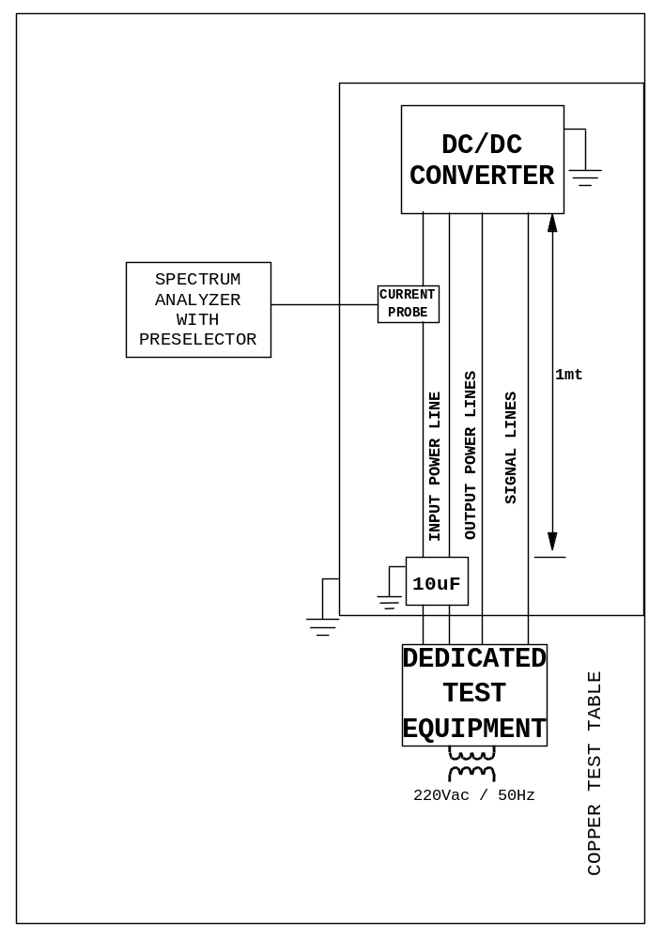

Figure 5.4.1.1-1 test set up for conduced emission frequency domain DM

Narrow-Band conducted emission Differential Mode in the frequency range 30Hz÷50MHz generated by the DC/DC board on the input power line shall not exceed the following adjustable limit:

A) For Nominal DC input current less than 1A, use the curve in figure 5.4.1.1-2
B) For Nominal DC input current greater than 1A, increase the level (in dBμA) of the curve in figure 5.4.1.1-2 by 10*Log[I (A)]. I(A) is the nominal input current in Ampere.

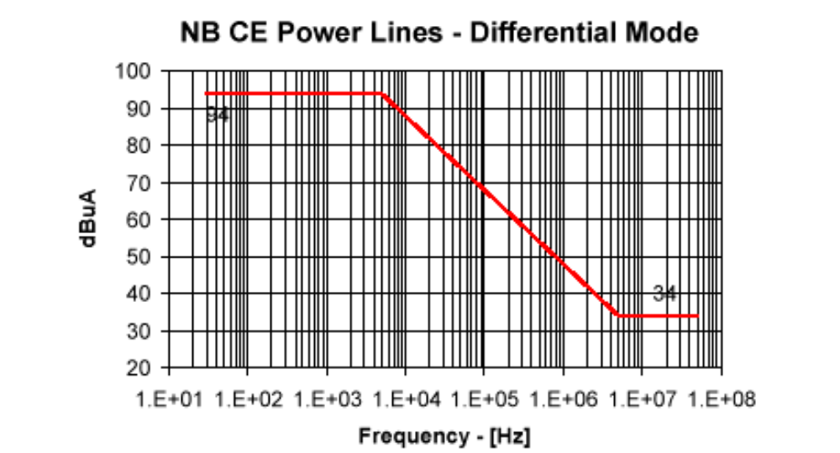

Figure 5.4.1.1-2 limit for CEP-Differential mode

Figure 5.4.1.1-3 Hardcopy of the UUT CEP on the positive input line

Figure 5.4.1.1-4 Hardcopy of the ambient noise on the return input line

Figure 5.4.1.1-5 Hardcopy of the UUT CEP on the return input line

Figure 5.4.1.1-6 Hardcopy of the ambient noise on the positive input line

CE on Input Line, Frequency Domain, Common Mode, NB

Type of measur. | : | Common mode
Frequency range Emission type | :  : | 10 KHz ÷ 50 MHz  Narrowband
Measured line | : | Input power lines

This test shall be performed to measure the current ripple appearing on input power lines in frequency domain.

The measurement shall be performed at maximum output power with a test set-up as shown on figure 5.4.1.2-2

- Take measurement of the ambient noise and make hardcopy
- Switch-on the UUT, repeat the measurements and make hardcopy
For the highest emissive mode the applied voltage shall be the worst case among the range from 26V-29V
- Report the plots in the following figures:
figure 5.4.1.2-3, 5.4.1.2-4)

Narrow-Band conducted emission Common Mode in the frequency range 10kHz ÷50MHz generated by the DC/DC board on the input power line shall not exceed the following adjustable limit:

- For nominal DC input current less than 1A, use the curve of figure 5.4.1.2-1 as shown.
- For nominal DC input current greater than 1A, increase the level (in dBμA) of the curve in figure 5.4.1.2-1 by 10*log[I(A)]. I(A) is the nominal input current in Ampere.

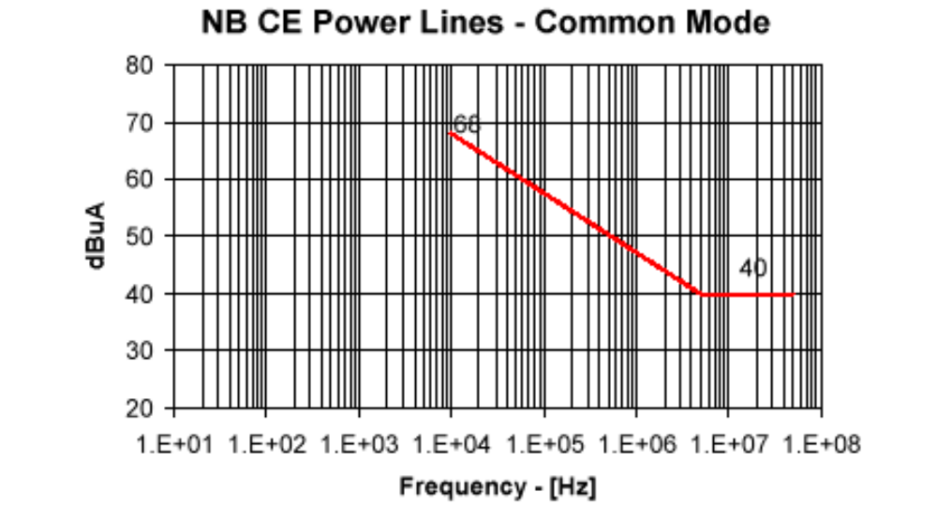

Figure 5.4.1.2-1

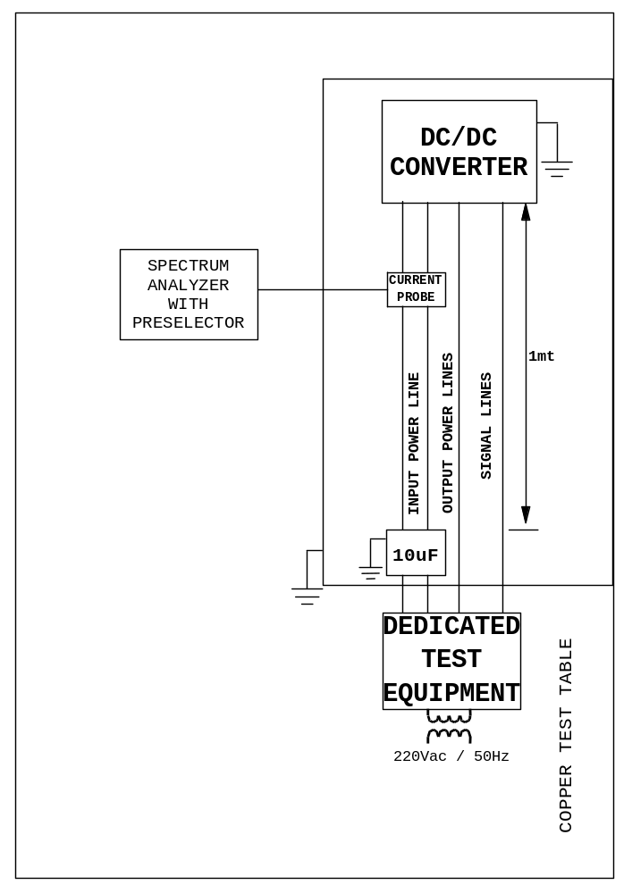

Figure 5.4.1.2-2 test set up for conduced emission frequency domain CM

Figure 5.4.1.2-3 Hardcopy of the ambient noise on the input line

Figure 5.4.1.2-4 Hardcopy of the UUT CEP on the input line

Current Ripple, Time Domain, Differential Mode

Type of measur. | : | Differential mode
Bandwidth | : | 50 MHz
Measured line | : | Input power lines

This test shall be performed to measure the exported spikes from the equipment on the input power lines in time domain.

The measurement shall be performed at maximum output power with a test set-up as shown on figure 5.4.1.3-1

- Place the current probe on positive power lead of the power line.
- Record the current ripple and make hardcopy
- Place the current probe on return power lead of the power line.
- Record the current ripple and make hardcopy
- Report the plots in the following figures:
figure 5.4.1.3-2, 5.4.1.3-3)

The current ripple and spikes on the input power line of the DC/DC board shall not exceed the following adjustable limits:
A) For nominal DC input current less than 1A:
Ripple: less than 20mApp.
Spikes, including ripple: less than 60mApp.
B) For nominal DC input current greater than 1A:
Ripple: multiply 20mApp by a factor √I(A), I(A) is the nominal input current in Ampere.
Spikes, including ripple: multiply 60mApp by a factor √I(A), I(A) is the nominal input current in Ampere.

Ripple and spikes shall be measured on both the primary and return lines with at least 50MHz bandwidth.

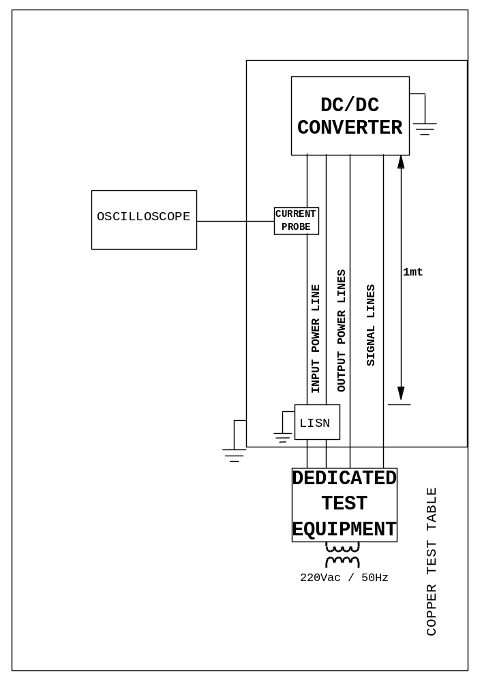

Figure 5.4.1.3-1 test set up for conduced emission time domain

Figure 5.4.1.3-2 Hardcopy of the current ripple on positive power lead of the power line

Figure 5.4.1.3-3 Hardcopy of the current ripple on return power lead of the power line

Conducted Susceptibility from Input Power Line

CS from Input Power Line, Differential Mode, Steady State

This test shall be performed to verify the immunity of the UUT to sine wave differential mode noise injected on power lines.

The measurement shall be performed at maximum output power with a test set-up as shown on figure 5-4-2-2 and figure 5-4-2-3

The DC/DC board shall not exhibit any malfunction, degradation of performance or deviation beyond the tolerance indicated in the electrical specification when sinusoidal voltages with amplitude specified in figure 5-4-2-1are injected into the input power leads in the frequency range 30Hz÷50MHz:

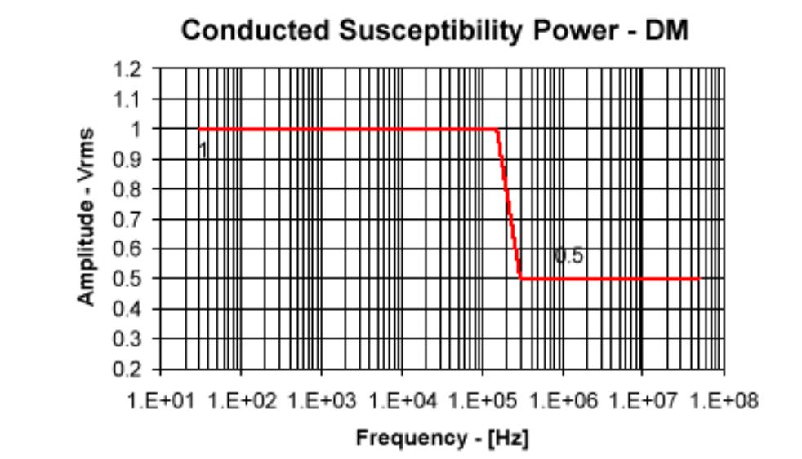

Figure 5-4-2-1

The frequency sweep rate shall not be faster than 5 min/decade.
In the frequency range 50kHz – 50MHz, the applied sinusoidal voltage shall be 1kHz amplitude modulated (30% AM).
With a oscilloscope monitoring the input bus (current and voltage) and the output voltage.
The requirement shall be considered to have been met when:
- Frequency range 30Hz – 50kHz
The specified test voltage level cannot be generated but the injected current has reached 3 Arms and the subsystem equipment is still operating without malfunctions within its specified tolerances.
- Frequency range 50kHz – 50MHz
A power source of 1 Watt, 50Ω impedance cannot develop the required voltage at the equipment power input terminals and the subsystem equipment is still operating without malfunctions within its specified tolerances.
Every not conformal parameter shall be describle with a dedicate Not Conformance Report.

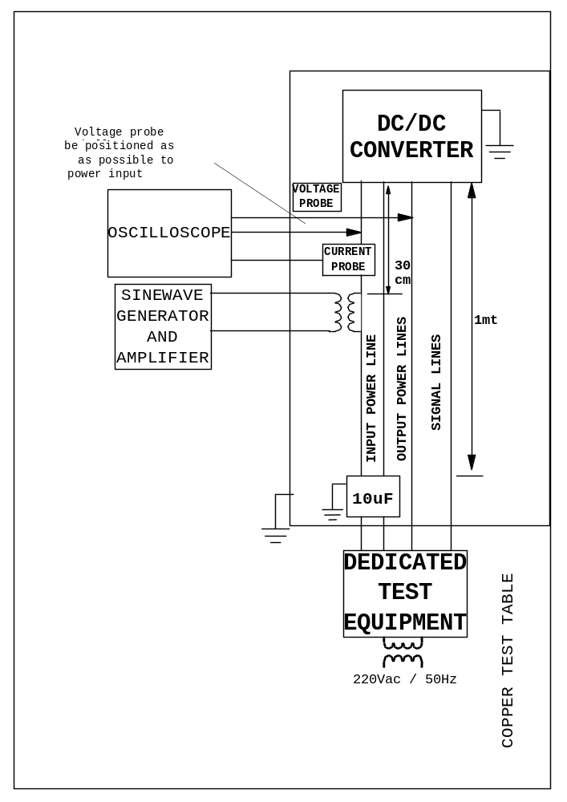

Figure 5-4-2-2 test set up for CPS, voltage, Steady state (30Hz – 50Hz)

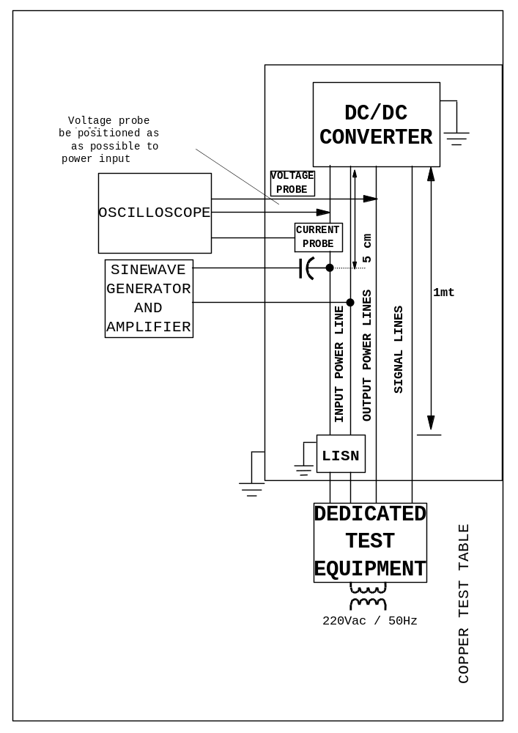

Figure 5-4-2-3 test set up for CPS, voltage, Steady state (50KHz – 50MHz)

CS from Input Power Line, Common Mode, Steady State
The DC/DC board shall not exhibit any malfunction, degradation of performance or deviation beyond the tolerance indicated in the electrical specification when sinusoidal common mode currents are injected in both the input power leads via Bulk Current Injection (BCI).

The measurement shall be performed at maximum output power with a test set-up as shown on figure 5.4.2.2-2

The injection shall be in accordance with the following adjustable limit:

A) For nominal DC input current less than 1A, use the curve of figure 5.4.2.2-1as shown.
B) For nominal DC input current greater than 1 A, increase the level (in dBμA) of the curve in figure 5.4.2.2-1by 10*Log[I(A)].

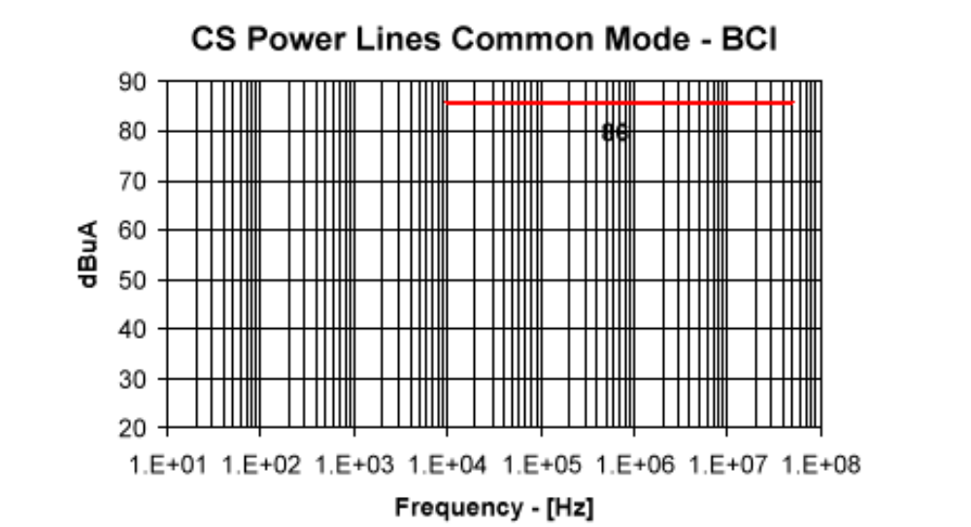
Il grafico non sembra descrivere le caratteristiche del disturbo da indurre ma, piuttosto, una maschera per accettare o meno gli effetti del disturbo!

Ma allora che cosa bisogna iniettare?

Figure 5.4.2.2-1

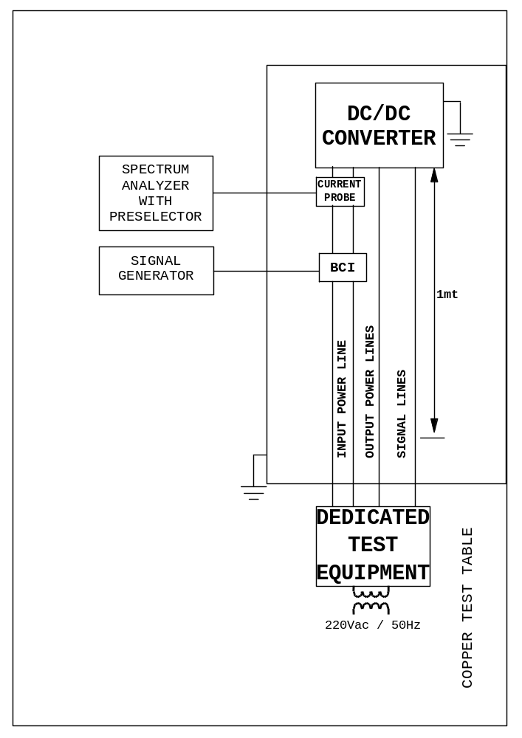

Figure 5.4.2.2-2 test set up for CPS, current, Steady state CM

CS Common Mode Voltage- Steady State

This test shall be performed to verify the immunity of the UUT to sine wave common mode noise.

The measurement shall be performed at maximum output power with a test set-up as shown on figure5.4.2.3-1

- Verify all shields are disconnected from PDU connector and PDU chassis is floating.
- Switch-on the UUT .
- apply a signal with the following characteristics :

 |  | Sinewave
Frequency range | : | 50 KHz - 50 MHz
Voltage Amplitude | : | 2Vpp
Current limits | : | 0.2 Arms
Injection method | : | Series
Coupling method | : | Transformer
Sweep mode | : | Sweep 5min./dec.

- for the check of the injected signal the voltage probe shall be connected (differential mode) between PDU chassis and ground plane.
- Monitoring the output voltage with a oscilloscope, the voltage probe shall be connected (differential mode) between positive output pole and return output pole.

The DC/DC board shall not exhibit any malfunction, degradation of performance or deviation beyond the tolerance indicated in the electrical specification; in that case each one shall be describle with a dedicate Not Conformance Report.

Chamber ground plane
Insulating plane
dc/dc board
Amplifier
Signal generator
Bus 28v generator
+28V line
+28V rtn
220Vac / 50Hz
220Vac / 50Hz
Dedicated test equipment
OUT line
OUT rtn
Dc/dc chassis
Oscilloscope

(differential probe CH1-CH2)

Figure 5.4.2.3-1 test set up for CS Common Mode voltage-Steady State

CS Common Mode Voltage Transients

This test shall be performed to verify the immunity of the UUT to transient common mode noise.

The measurement shall be performed at maximum output power with a test set-up as shown on figure 5.4.2.4-2.

- Verify all shields are disconnected from PDU connector and PDU chassis is floating.
- Switch-on the UUT .
- Apply a signal with the following characteristics :

 |  | Transient
Duration between | : | 150ns-250ns
Voltage Amplitude | : | ± 3 Vpp
Current limits | : | 0.2 Arms
Injection method | : | Series
Coupling method | : | Transformer
Rep. Rate/ test duration | : | 5Hz-10Hz / >3min.

The DC/DC converter shall not exhibit any malfunction, degradation of performance or deviation beyond the tolerance indicated in the electrical specification when transient voltages typically shaped as shown figure 5.4.2.4-1 are applied between the equipment signal reference and the ground plane. With reference to figure 5.4.2.4-1 , the peak amplitude shall be calibrated to ±3V and Td shall be between 150ns and 250ns when the source having output impedance of 50Ω is connected to a 50Ω resistor. Then the source is applied to the equipment after it is detached from the ground plane. The pulse repetition frequency of the waveform shall range from 5Hz to 10Hz and the test duration shall be at least 3 minutes.

- check the output voltage with a oscilloscope, the voltage probe shall be connected (differential mode) between positive output pole and return output pole.
- Record the output response and make hardcopy
- Report the plot in figure 5.4.2.4-3.

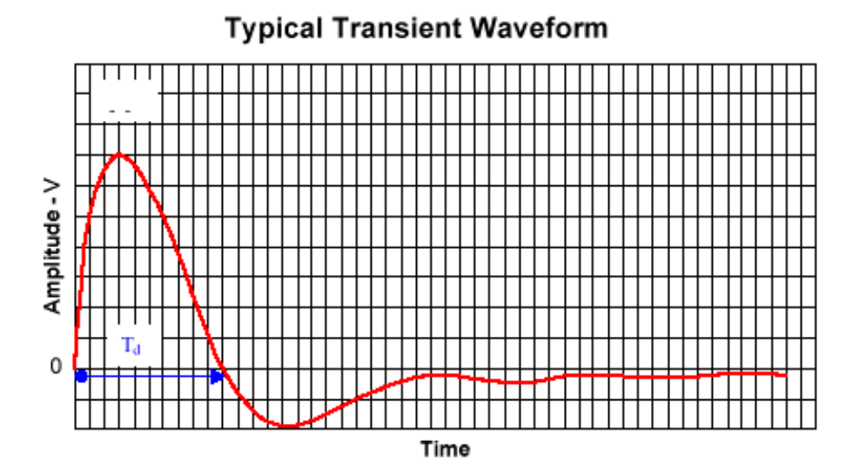
Figure 5.4.2.4-1

Chamber ground plane
Insulating plane
dc/dc board
Amplifier
Signal generator
Bus 28v generator
+28V line
+28V rtn
220Vac / 50Hz
220Vac / 50Hz
Dedicated test equipment
OUT line
OUT rtn
Dc/dc chassis
Oscilloscope

(differential probe CH1-CH2)

Figure 5.4.2.4-2 test set up for CS Common Mode voltage-Steady State

Figure 5.4.2.4-3 Hardcopy of the output response to input common mode voltage transient

CS from Input Power Line – Transients due to Switching

This test shall be performed to verify the immunity of the UUT to transient differential mode noise.

The measurement shall be performed at maximum output power with a test set-up as shown on figure 5.4.2.5-2.

- Apply a signal with the following characteristics :

 |  | Transient
Duration between | : | 700μs±10%.
Voltage Amplitude | : | ± 2.5 Vpp
Injection method | : | Series
Rep. Rate/ test duration | : | 5Hz-10Hz / >5min.

The DC/DC board shall not exhibit any malfunction, degradation of performance or deviation beyond the tolerance indicated in the electrical specification when transient voltages typically shaped as shown in figure 5.4.2.5-1 are applied to the DC/DC board input power leads. With reference to figure 5.4.2.5-1 the peak amplitude shall be ±2.5V and T_{d} shall be 700μs±10%. The pulse repetition frequency of the waveform shall range from 5Hz to 10Hz and the test duration shall be at least 5 minutes.

- check the output voltage with a oscilloscope, the voltage probe shall be connected (differential mode) between positive output pole and return output pole.
- Record the output response and make hardcopy.
- Report the plot in figure 5.4.2.5-3.

Figure 5.4.2.5-1

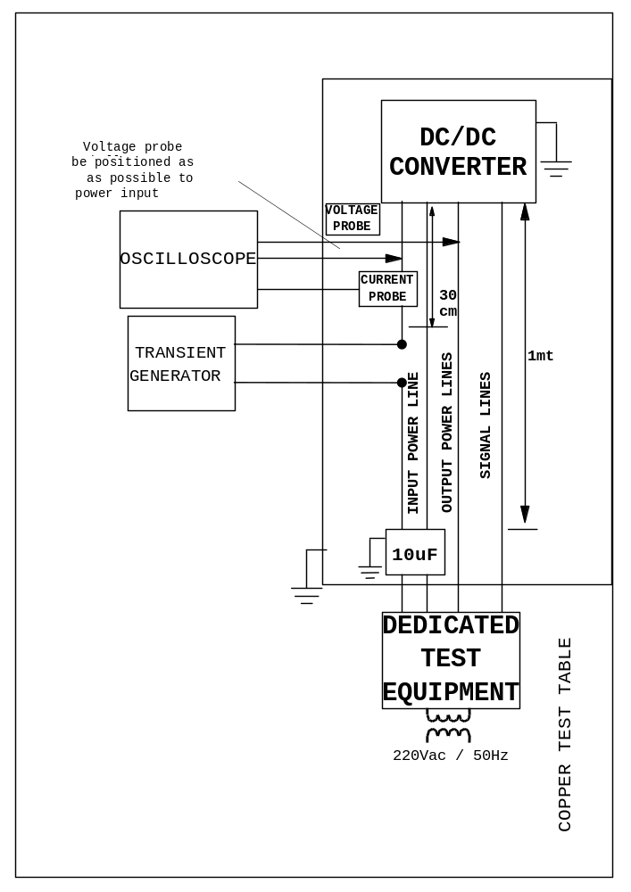

Figure 5.4.2.5-2 test set up for CS from Input Power Line – Transients due to Switching

Figure 5.4.2.5-3 Hardcopy of the output response to input common mode voltage transient

Conducted Emissions on PL-Output Lines
To avoid problems arising from common mode disturbances on the output lines, use of a common mode filter on the output lines shall be foreseen.

Arc Discharge Susceptibility
No malfunction, degradation of performance or deviation beyond the tolerance indicated in the electrical specification shall occur when the DC/DC board input line is exposed to a repetitive electrostatic conducted arc discharge of at least 5.6mJ energy/15kV.

VIBRATION TEST Input Protections

Random environment for each perpendicular axis
Freq | level g^2/Hz
10 | 0.02
100 | 0.15
300 | 0.15
2000 | 0.001
 | 8gRMS ( 70 sec )
Quasistatic environment
Quasistatic environment for in plane axes | 1.6 [g]
Quasistatic environment for out of plane axis | 6.8 [g]

Table 5.5-1 Limit Mechanical environmental constraints at DPU box interface

Note: the above mentioned limit loads at box interface are valid for a DPU box first global frequency >120 Hz.

Pin function
The pin function of the DC-DC Converter board is shown in and .

Pin # | Signal | Pin # | Signal | Pin # | Signal
1 | +5VD | 33 | +5VD | 65 | +5VCORE
2 | +VEEPROM | 34 | +2.5VFPGA | 66 | +5VCORE
3 | +VFIFO | 35 | +5VBU61582 | 67 | NOT USED
4 | NOT USED | 36 | +VIFMEZZ | 68 | NOT USED
5 | NOT USED | 37 | NOT USED | 69 | NOT USED
6 | NOT USED | 38 | NOT USED | 70 | NOT USED
7 | NOT USED | 39 | NOT USED | 71 | NOT USED
8 | NOT USED | 40 | NOT USED | 72 | NOT USED
9 | NOT USED | 41 | NOT USED | 73 | NOT USED
10 | NOT USED | 42 | NOT USED | 74 | NOT USED
11 | NOT USED | 43 | NOT USED | 75 | NOT USED
12 | NOT USED | 44 | NOT USED | 76 | NOT USED
13 | NOT USED | 45 | NOT USED | 77 | NOT USED
14 | NOT USED | 46 | NOT USED | 78 | NOT USED
15 | NOT USED | 47 | NOT USED | 79 | NOT USED
16 | NOT USED | 48 | NOT USED | 80 | NOT USED
17 | DGND | 49 | NOT USED | 81 | DGND
18 | BONDING | 50 | BONDING | 82 | BONDING
19 | BONDING | 51 | BONDING | 83 | BONDING
20 | NOT USED | 52 | NOT USED | 84 | NOT USED
21 | NOT USED | 53 | NOT USED | 85 | NOT USED
22 | NOT USED | 54 | NOT USED | 86 | NOT USED
23 | NOT USED | 55 | NOT USED | 87 | NOT USED
24 | NOT USED | 56 | NOT USED | 88 | NOT USED
25 | NOT USED | 57 | NOT USED | 89 | NOT USED
26 | NOT USED | 58 | NOT USED | 90 | NOT USED
27 | NOT USED | 59 | NOT USED | 91 | NOT USED
28 | NOT USED | 60 | NOT USED | 92 | NOT USED
29 | -15VA | 61 | -15VA | 93 | -15VA
30 | AGND | 62 | AGND | 94 | AGND
31 | +15VA | 63 | +15VA | 95 | +15VA
32 | DGND | 64 | DGND | 96 | DGND

Table 6-5 DC-DC Converter board: P1 pin function

Note: +VEEPROM, +VFIFO, +5VBU61582, +5VCORE and +5VD shall be connected, into the DC/DC board, to the +5VD outlet.

Pin # | Signal | Pin # | Signal | Pin # | Signal
1 | +28V | 33 | +28V | 65 | +28V
2 | NOT USED | 34 | NOT USED | 66 | NOT USED
3 | +28V_RTN | 35 | +28V_RTN | 67 | +28V_RTN
4 | NOT USED | 36 | NOT USED | 68 | NOT USED
5 | SYNCH_MAIN+ | 37 | SYNCH_MAIN+ | 69 | SYNCH_MAIN+
6 | SYNCH_MAIN- | 38 | SYNCH_MAIN- | 70 | SYNCH_MAIN-
7 | SYNCH_RED+ | 39 | SYNCH_RED+ | 71 | SYNCH_RED+
8 | SYNCH_RED- | 40 | SYNCH_RED- | 72 | SYNCH_RED-
9 | NOT USED | 41 | NOT USED | 73 | NOT USED
10 | INCUR_MNT | 42 | +5V_MNT | 74 | +15V_ MNT
11 | RTN_MNT0 | 43 | RTN_MNT1 | 75 | RTN_MNT2
12 | -15V_MNT | 44 | +TEMP_MNT | 76 | AINP5
13 | RTN_MNT3 | 45 | RTN_MNT4 | 77 | RTN_MNT5
14 | AINP6 | 46 | NOT USED | 78 | NOT USED
15 | RTN_MNT6 | 47 | AGND | 79 | AGND
16 | NOT USED | 48 | NOT USED | 80 | NOT USED
17 | NOT USED | 49 | NOT USED | 81 | NOT USED
18 | NOT USED | 50 | NOT USED | 82 | NOT USED
19 | NOT USED | 51 | NOT USED | 83 | NOT USED
20 | NOT USED | 52 | NOT USED | 84 | NOT USED
21 | NOT USED | 53 | NOT USED | 85 | NOT USED
22 | +16V_PL_OUT | 54 | +16V_PL_OUT | 86 | +16V_PL_OUT
23 | -16V_PL_OUT | 55 | -16V_PL_OUT | 87 | -16V_PL_OUT
24 | ±16V_PL_RTN | 56 | ±16V_PL_RTN | 88 | ±16V_PL_RTN
25 | +5.6V_PL_OUT | 57 | +5.6V_PL_OUT | 89 | +5.6V_PL_OUT
26 | +5.6V_PL_RTN | 58 | +5.6V_PL_RTN | 90 | +5.6V_PL_RTN
27 | +18V_PL_OUT | 59 | +18V_PL_OUT | 91 | +18V_PL_OUT
28 | -18V_PL_OUT | 60 | -18V_PL_OUT | 92 | -18V_PL_OUT
29 | ±18V_PL_RTN | 61 | ±18V_PL_RTN | 93 | ±18V_PL_RTN
30 | +8V_PL_OUT | 62 | +8V_PL_OUT | 94 | +8V_PL_OUT
31 | +8V_PL_RTN | 63 | +8V_PL_RTN | 95 | +8V_PL_RTN
32 | NOT USED | 64 | NOT USED | 96 | NOT USED

Table 6-6 DC-DC Converter board: P2 pin function

conclusion

