HERSCHEL - SPIRE

HERSCHEL - SPIRE

File : 0000.doc

Prepared by : | Date :
Dominique Pouliquen | 16 oct 2001
Checked by : | Date :

Distribution List

RAL | Ken J. King | X | Bruce M. Swinyard | X
ATC | Colin Cunningham |  | Ian Pain
CEA-Sap | Jean-Louis Auguères |  | Christohe Cara
CNES | Yvan Blanc | X | Martine Joubert | X
DESPA | Guy Michel
GSFC | Don. E. Jennings |  | Dave Fraser
LAM | Bruno Travers | X | Jean-Paul Baluteau | X
 | Claude Colin | X | Pascal Dargent | X
 | Kjetil Dohlen | X | Didier Ferrand | X
 | Michel Jevaud | X | Patrick Levacher | X
 | Alain Origné | X | Dominique Pouliquen | X

Document change record

Date | Indice | Remarks
27 June 2000 | 1 | Creation of the document
20 Dec 2000 | 2 | Distribution list changed  Redundancy philosophy updated for the optical encoder
15 May 2001 | 3 | FIRST replaced by HERSCHEL  Documents reference updated  Mass and power budget added
16 Oct 2001 | 4 | Update of figures

Glossary

AD Applicable Document
AVM Avionic Model
BOL Begin Of Life
BSM Beam Steering Mirror
BSMm BSM cryogenic mechanism
CEA Commissariat à l'Energie Atomique
CDR Critical Design Review
CNES Centre National des Etudes Spatiales
CoG Center of Gravity
CQM Cryogenic Qualification Model
DDR Detailed Design Review
DESPA Département des Etudes SPAtiales
DM Development Model
DPU Digital Processing Unit
DRCU Digital Read-out and Control Unit
DSP Digital Signal Processor
EGSE Electrical Ground Support Equipment
EM Electrical Model
EOL End Of Life
ESA European Space Agency
FPU Focal Plane Unit
FS Flight Spare model
FTS Fourier Transform Spectrometer
GSFC Goddard Space and Flight Center
H/K House Keeping
H/W Hardware
I/F Interface
JPL Jet Propulsion Laboratory
LAM Laboratoire d'Astrophysique de Marseille
MAC Multi Axis Controller
MCU Mechanism Control Unit
MGSE Mechanical Ground Support Equipment
MM Mechanical Model
MSSL Mullard Space Science Laboratory
NA Not Applicable
OGSE Optical Ground Support Equipment
PDR Preliminary Design Review
PFM Prototype Flight Model
RAL Rutherford Appleton Laboratory
RD Reference Document
S/C Spacecraft
S/W Software
SMEC Spectrometer mirror MEChanism
SMECm SMEC cryogenic mechanism
SPIRE Spectral and Photometric Imaging REceiver
TBC To Be Confirmed
TBD To Be Defined
TBU To Be Updated
TBW To Be Written
TC TeleCommands
TM TeleMetry
WE Warm Electronics

Table of contents

1. Scope of the document 5
2. Documents 5
2.1. Applicable documents 5
2.2. Reference documents 5
3. SMEC subsystem function 6
4. Mechanism overall description 7
5. The mirror carriage 9
5.1. Prototypes 9
5.2. Distance between two pivots on one arm. 10
6. The pivots 10
7. The synchronisation device 11
8. The launch latch 11
9. The position sensor 12
9.1. Choice of the type of sensor 12
9.2. The Heidenhain optical encoder 12
9.3. Feasability of the optical encoder 13
9.4. Flight design 13
10. The actuator 14
10.1. Prototypes actuator 14
10.2. Flight actuator 15
11. Mass budget 15
12. Power budget (at 4K) 16

Scope of the document
This document gives an overview of the design of the SPIRE Spectrometer mirror mechanism.

Documents

Applicable documents
 | Title | Author | Reference | Date
AD1 | Spectrometer mechanism subsystem specifications | D.Pouliquen | LAM.PJT.SPI.NOT.200002 Ind 7 | 12 Apr 2001

Reference documents

 | Title | Author | Reference | Date
RD1 | Heidenhain on line documentation | Heidenhain | http://www.heidenhain.com/ | 2000
RD2 | MCU electronics design description | D.Ferrand and P.Levacher | LAM.ELE.SPI.000619 Iss 2 Rev 0 | 12 Apr 2001
RD3 | SMECm Actuator Technical Specifications | D.Ferrand | LAM.ELE.SPI.011007 Ind 1 | 9 Oct 2001
RD4 | SMECm : mass breakdown | P.Dargent | SPI-PFM-00-LB-01-1 | 16 Oct 2001
RD5 | SMECm Design Calculations | D.Pouliquen | LAM.PJT.SPI.NOT.200114 Ind 1 | 15 Oct 2001
RD6 | Comparative linear FEA of two different Flex Pivots | P.Dargent | SPI.STM.23.RC.01.A | 15 Oct 2001

SMEC subsystem function
The main function of the SMEC subsystem is to guide the movement of the corner cubes of the SPIRE FTS.
The movement travel is –3.2 to 32 mm with a linear trajectory aligned in the SPIRE structure w.r.t. to the optical path position, at a constant speed in the range 0.2 to 1 mm/s with a 10 µ/s RMS stability, at least in a +/- 3.2 mm travel sub range around the Zero Path Difference (ZPD), the ZPD being the 0 position of the corner cubes.
For scientific purpose, the subsystem must be able to output the positions measurements along its travel at a « frequency » up to 250 Hz with a 0.1µ relative precision in the +/- 3.2mm sub travel range and a 0.3µ relative precision elsewhere.

The SMEC subsystem is made of two principal parts, the mechanism (SMECm) and its control electronic in the Mechanims Control Unit (MCU).
By convention the corner cubes are not considered a part of the mechanism. They are a part of the mirrors subsystem.
The MCU is described in RD2.
The SMECm is the object of the present document.

Basically, the mechanism is fitted with :
- a position sensor to measure the position of the corner cubes along the trajectory so that this position can be sent along the detector data.
- a ZPD position sensor in order to give a « fiducial » mark at this very important point

A view of the SMECm location inside SPIRE Structure :

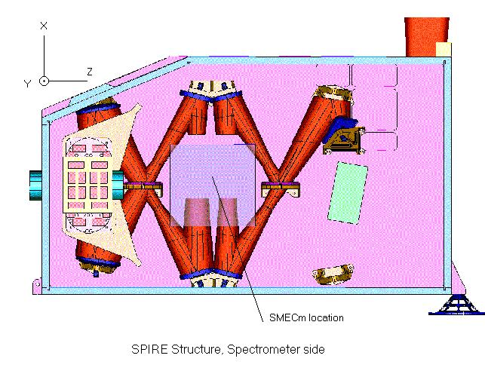

Mechanism overall description
The linear trajectory (translation) is obtained by suspending the corner cubes to the SMECm base plate with a double parallelogram fitted with a mechanical synchronisation device.
To be as friction and shock free as possible, the double parallelogram articulations must be flexible.
The movement along the trajectory is obtained through the action of a linear actuator on the corner cubes plate.
The overall dimensions of the mechanism are driven by the travel to be achieved and the angular displacement the pivots allow.
To measure the position with the correct precision, an optical encoder is used for relative position measurement and a LVDT for absolute position measurement..
A base plate supports the mechanism. On the baseplate are mounted the fixed part of the actuator and the optical encoder. A moving plate supports the corner cubes and the rule for the optical encoder. The base plate and the mirror moving plate are linked by four "legs". Each leg has two arms, one arm linking the base plate and the intermediate moving plate, the other linking the intermediate moving plate and the mirror moving plate. The articulations at both extremities of the legs use flex pivots. As there are four legs, there are 8 arms. The distance between pivots on one arm must be the same for all the arms. This along with a synchronisation device ensures that the mirror plate moves parallel to the base plate.
For launch, the mechanism is put at one extremity of its travel and locked.
To relieve stresses in the pivots during the launch, the pivots are at their rest position during launch, meaning that the scientific travel will always rotate the pivots on a unique side of their rotational envelope.

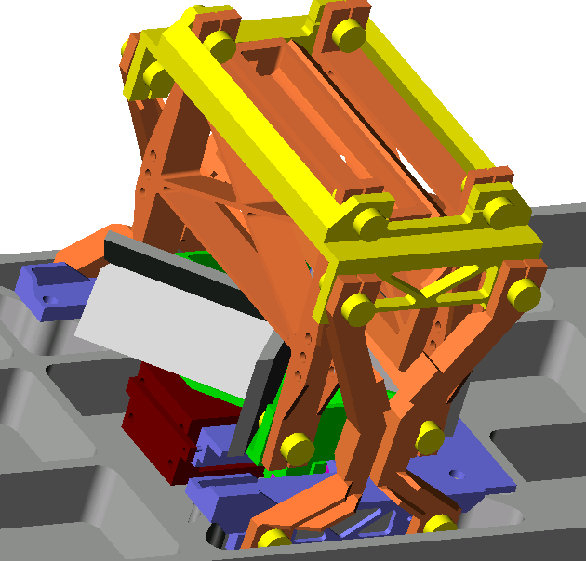
A view of the flight design in the SPIRE structure

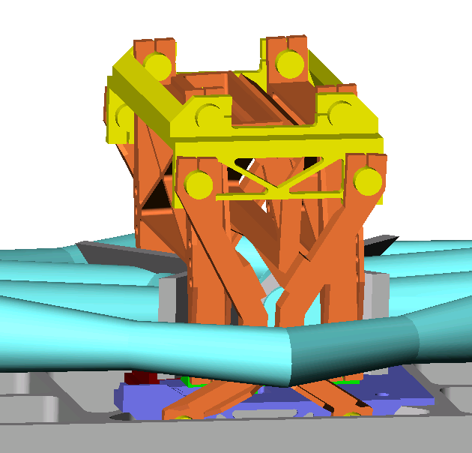

Another view of the flight design, showing the optical rays envelope.

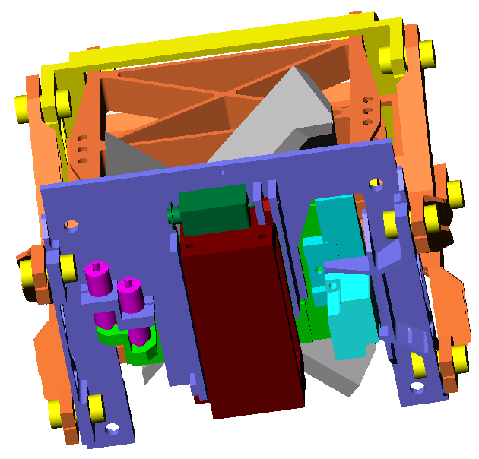
An underneath view of the flight design, showing the LVDT's location, the actuator and the optical encoder

The mirror carriage
The principle is the one developed by Don Jennings and David Walser (GSFC) and implemented on two prototypes.

Prototypes
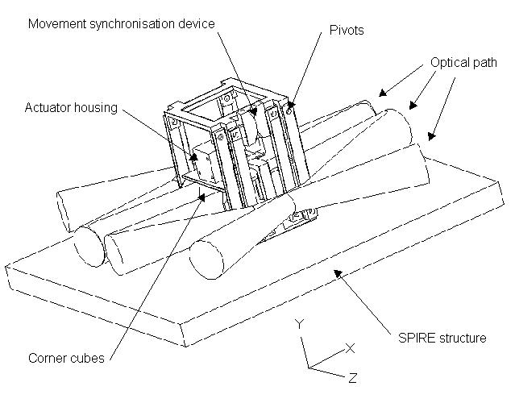
Here is a photograph of the prototype#1 at LAM, equiped with a Heidenhain LIP401 optical encoder.

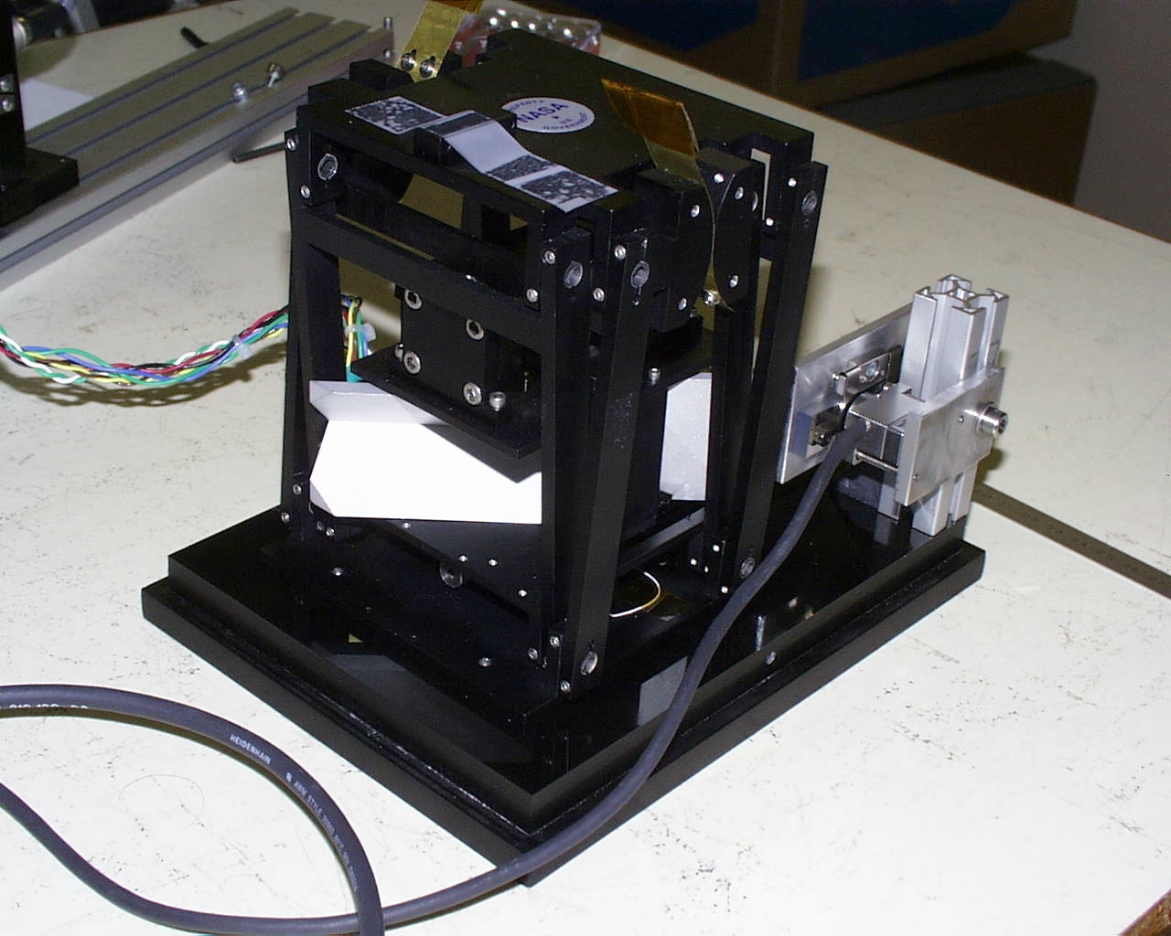

- Mass OK with ICD Structure / Mechanism
- Prototype tested at 300K
- Optical encoder mounted at LAM with success
- On prototype #1, the control loop was closed at up to 20 Hz with the LAM DSPACE system due to problems with higher resonance frequencies 30 Hz, 55 Hz, 120 Hz, etc...
- On prototype #2, the actuator has been fixed under the corner cubes plate to avoid the resonance frequencies of the structure on which it is suspended in the prototype #1 and the legs have been stiffened. This has improved the lowest resonance frequency which is now around 50 Hz.
- Actuator mean power consumption : less than 40mW at 300K i.e. 0.4 mW at 4K EST.
- Protection during launch needed : The stiffness of the articulation is very low to keep the actuator power consumption within the specified limits. The mirror carriage must be latched during launch.
- The geometry is modified to fit inside the SPIRE structure. The optical path in the SPIRE structure is 28.5 mm above the optical bench instead of 40mm as assumed for the prototypes. The mechanism baseplate has no room for stiffeners. The baseplate stiffness will be driven by the SPIRE structure.

Conclusion : Basic design Ok but needs modifications.

Distance between two pivots on one arm.
One of the carriage modification is the distance between the axis of two pivots on the same arm.
Due to the choice of the pivots and the allocated power, this distance is put at 100 mm. (See RD5) This means that for the maximum travel (R=1000), the rotation angle of the pivots is 11.5°. This eliminates the TRW pivots which are limited to 7.5°.
In the prototype#2, this distance is #83mm, leading to a 14° rotation angle (the pivots rest position is in mid travel). This angle is already too high for the TRW pivots.

The pivots
The chosen flex pivots are BE System Celtic type, outer diameter 11 mm, blade thickness 0.15 mm, torsion stiffness 0.0891 N.m/rad.
These pivots can bear the launch vibrations loads with an estimated 20% margin, provided that the corner cubes carriage is latched.
Not to stress the blades during launch, the pivots are in their mechanical rest angle position. To avoid any interference between the launch latch device and the scientific movement, the latched position is put at -8mm from the ZPD.
The maximum infinite life angle of these pivots is +/-15°.
See RD5 for details.
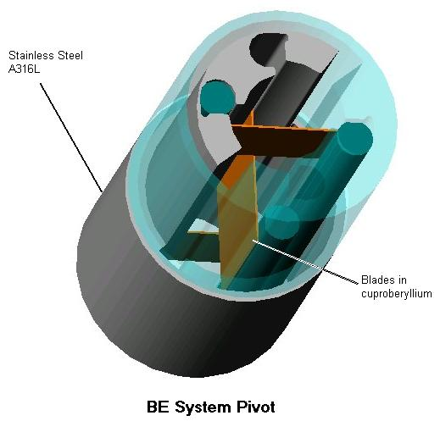

The synchronisation device
The synchronisation device ensures that the plate bearing the corner cubes has a linear movement.
It is made of two pulleys, one fixed to one baseplate to intermediate plate arm, the other fixed to one intermediate plate to corner cubes plate arm, with a belt linking the two pulleys.
When one arm moves, this system forces the other arm to move in the opposite direction by the same angle.
This forces the corner cubes to remain in the same plane along their displacement.
To avoid any torsion effort on the mechanism structure, there is one set of pulleys on each side of the mechanism.
For the flight design, Al7075 is chosen for the belt material due to its high tensile strength. The choice of aluminium is driven by the fact that as the structure is in aluminium, no differential dilatation will occur between the belts and the structure when changing the temperature from 300K to 4K.

The launch latch
A protection against the launch vibration is to be used.
This protection will be a launch latch (bistable solenoid driving a pin blocking the carriage). Consequently, a launch latch item is added to allow the mechanism to sustain the launch vibrations without damage.
In the launch position, the launch latch will block the corner cubes moving plate along the X direction (launch direction) while Teflon coussinets limit the movement of the actuator along the Y and Z directions.
The mechanism is put in its launch posiiton by the actuator force. The gap between the coussinets and the actuator is sufficient to prevent any friction. This gap is on the order of a few tens of microns.
Here is a candidate launch latch :

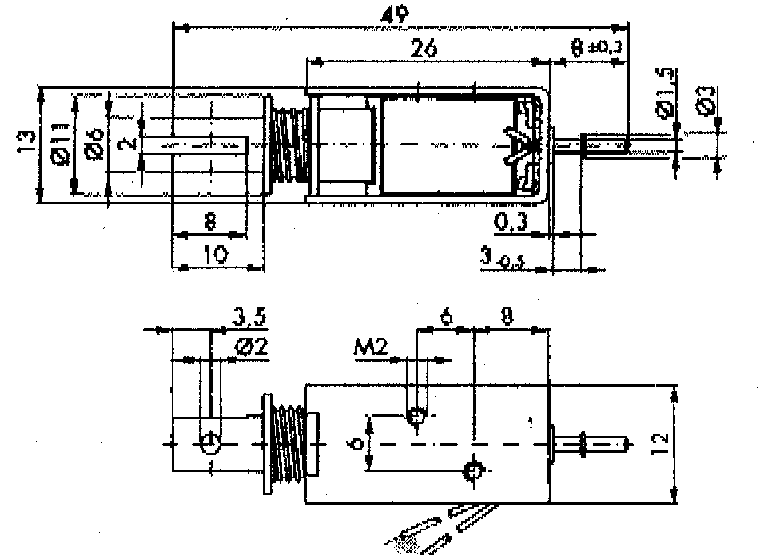

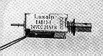

The position sensor

Choice of the type of sensor
To measure the position of the corner cubes along their travel, the choice was between an LVDT and an optical encoder.
 | LVDT | Optical encoder
Position accuracy | 10 nm/VHz | << 10 nm
Position resolution | infinite | 1µm
Absolute position | Yes | No
Alignment tolerances | TBD | 1'
Gap tolerance between fixed an dmoving parts
Consumption | <1mW | ~1mW
Qualified | Yes | No
Choice | Backup design | Nominal

The choice is the optical encoder due to its much better performances for the position accuracy.

The Heidenhain optical encoder
Here is a figure showing the principle of the Heidenhain optical encoder [RD1]:

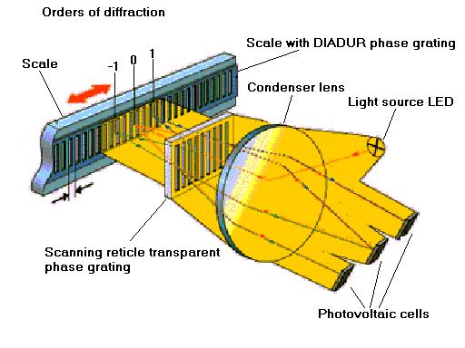
Interferential scanning produces at the index grating essentially three beam components with the 0, +1, and -1 orders of diffraction. The beam components are diffracted once again at the phase grating of the scale, at which point the zero order of diffraction is eliminated. The beam components of the +1, and -1 orders reflected from the scale now contain the distance information in their phase positions and are brought into interference at the index grating.
From the resulting light modulation, the photovoltaic cells produce three approx120°-phase shifted signals which are then converted to the two 90° phase-shifted signals that are characteristic of Heidenhain encoders.

Feasability of the optical encoder
Extensive tests have been conducted by Guy Michel (DESPA) and Jerôme Martignac (CEA) at 300K and 4K using a LIP403A and a LIP401A Heidenhain commercial products and on an alternate of electronic components, LED GaAlAs Optodiode OD880W and Si PIN photodiode Hamamatsu S2386.

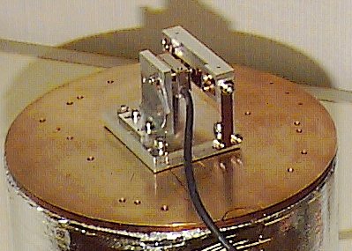

Main results
- The scale and the scanning reticle must be in the same material
- The scanning reticle must not be stressed by its mechanical mounting in the housing
- A preamplifier as near as possible to the encoder is needed to amplify the output signals of the encoder
None of these results questions the feasibility of the optical encoder for a space cryogenic application.

Flight design
- The commercial housing is to be used, remachined to relieve the stress on the grating as on the prototype.
- The scanning reticle and the scale are in ZeroDur.
- The scale is mounted on the mirror carriage.
- The encoder housing is mounted on the baseplate.
- The preamplifier is in a separate light tight box mounted on the SMECm structure, to be as near as possible to the encoder. The baseline preampli components are Infrared Labs TIA (space qualified, thermal control incorporated).
- The redundancy / back-up is done by packing twice the number of components inside the housing, i.e. 2 LEDs and 6 photodiodes.
- As the optical encoder gives only a relative position, 2 LVDT's (one nominal and one redundant) are added to get the absolute position. They are of MHR100 type, giving a good accuracy in the R=100 travel range.

The actuator
The actuator design is driven by:
- The travel range to be achieved
- The allocated volume (room below the corner cubes plate)
- The pivots stiffness which dimensions the force to be applied to move the corner cubes to a given displacement along with the arma length (to be more precise the distance between the axis ot two pivots on the same arm)
- The maximum current allowed in the cryoharness
- The maximum voltage applicable at the extremities of the actuator electrical circuit
- The allocated dissipated power in the mechanism at 4K
The power dissipated in the actuator is proportional to:
- The force sensitivity
- The square of the displacement range : the force to be applied by the actuator is proportional to the rotation angle of the pivots, nearly proportional to the displacement (small angles), thus to the current in the windings, thus to the square root of the power
- The resistance of the windings
- The square of the pivots stiffness : the force to be applied by the actuator is proportional to the pivot stiffness, thus to the current in the windings, thus to the square root of the power

To avoid having moving wires, the coils are mounted on the fixed part of the structure.

Prototypes actuator
A BEI-KIMCO LA-13-30-000A actuator is mounted in the prototypes.
Magnet material : Samarium-Cobalt
Mass = 400 g
Resistance at 300K = 4.6 Ohm
Force sensitivity, KF = 3.7 N/A
Back EMF Constant = 5 W/(m/s)
This model is not suitable for this application due to its size.

For the prototype, the TRW 5008-800 pivots have a torsion stiffness of 0.0115 N.m/rad
The KIMCO actuator force would be limited to 0.33 N under the harness current limitation. This necessitates a modification of the actuator design to make it suitable for the flight.

Flight actuator
The flight actuator is extrapolated from the KIMCO actuator.
It takes into account the torsion stiffness of the chosen pivots.
This stiffness induces a force of 1.46N for the R=1000 max travel (+32mmm w.r.t. ZPD and +40mm w.r.t. pivots mechanical rest position)
The same type of magnet will be used (Samarium-Cobalt)
The voltage applied at the ends of the electrical circuit in the SMEC board must not exceed 20V, taking into account the 20 ohms cryoharness resistance. This specs applies at both 300K and 4K.

The requirements are (RD3):
- Cryogenic capability
- Force sensivity, KF = 20.5 N / A,
- resistance at 300K = 199 ohms, 1.9 ohms at 4K
- length = 110 mm, width = 32 mm, height =35 mm
- mass = 463 g, among which stator = 407g, coils = 26g,
- travel = 50 mm,
- 2 independant windings in the magnetic circuit, one for nominal use, one for redundant use.
Due to max current limitation in the harness, the actuator output force is limited to 1.87 N. This leaves a 0.4N margin.

Mass budget
The allocated mass is 1300 g excluding margins.
The designed overall mass of the mechanism is 1648 g, excluding margins.
See RD4 for details.

Item | Elément | Mass (g) | Comment
Fixed part | Bâti | 183
Moving mechanical part | Guidage | 754
Actuator | Moteur | 463
Corner Cubes Plate | Chariot | 62
Optical encoder | Codeur optique | 45
LVDTs | LVDTs | 27
Launch latch | Verrou | 27
Internal harness | Harnais | 87
TOTAL Mechanism |  | 1648
Corner Cubes |  | 155 | Not in the SMECm budget, but in the optics budget
TOTAL SMECm |  | 1803

Power budget (at 4K)
The allocated power is the mean power over the mission and is 2.4 mW for the mechanism.
 |  | Prototype #2 | Flight model
Optical Encoder | LED | 500 µW | 300 µW
 | Preamplifier | 300 µW | 200 µW
LVDT's |  | N/A | 100 µW  (EST w.r.t. ISO-LWS)
Actuator | Mean power over the mission |  | 1 540 µW
 | At 32mm (R=1000) displacement  EST at 4K | 460 µW  (46 mW at 300K) | 10 000 µW
Temp sensors |  | N/A | 0
Margin | 10% of allocation (Alloc = 2.4 mW) | 240 µW | 240 µW
TOTAL |  | 1340 µW | 2400 µW

The mean power over the mission is calculated taking into account 1/3 SPIRE mission time for R=10 observations, 1/3 mission time for R=100 observations and 1/3 mission time for R=1000 observation.
See RD5 for more details.

