Change notice:
3/9/2001: Draft 0.2 Amended to take into account which pixels will be used for chopping and comments from Jamie that the calibration errors won’t add up as the alignment error is fixed and in principle knowable. The alignment requirement is recast therefore in terms of absolute signal loss.

I have removed reference to the number of the sigma for random misalignments – i.e. repeatability of the array position during thermal cycling or following vibration. For the pixel-to-pixel (fixed) misalignment I suggest these as being 3-sigma. For the rotation and lateral repeatability they could be 1-sigma in line with telescope error if we are prepared to accept that the total signal loss could in reality be up to 6%.

17/10/2001: Draft 0.3 Changes to section on P/MW orientation with recipe for orientating the detector from Tony Richards now inserted and figure 6B replaced.

Orientation of S/SW and S/LW changed to take into account the fact that the chop track forms a smile and to give positive direction on location of thermal interface.

Scope
This note lays out the required arrangement for the SPIRE detector arrays with respect to the telescope focal plane and translates this into the required orientation of the arrays with respect to the local normal at the location of the arrays in the SPIRE instrument.

Alignment requirements for the Focal Plane Arrays

Desired Arrangement at Telescope Focal Plane
Figure 1 shows the desired arrangement for the pixels in the three photometer and two spectrometer arrays as seen at the telescope focal plane at the entrance aperture. The red pixels define the centres of the arrays and the instrument boresight, the blue pixels represent those pixels in the arrays which should view the same portion of the field.
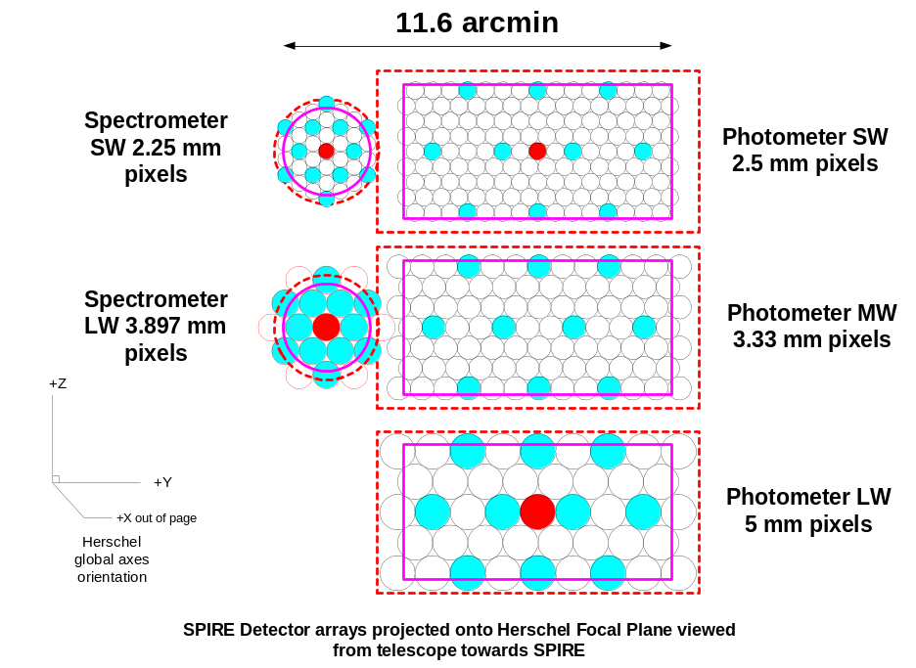
Figure 1: Desired arrangement of photometer and spectrometer pixels as projected onto the telescope focal plane. The chop direction is along the global Y-axis.

Pixel alignment requirements for chopping
The BSM is design to chop such that the movement of the field is along the Y-axis – i.e. the chop axis is the global Z-axis. The basic requirement on the arrays is that, when a point source is being chopped between one of the nominated chop pixels and another, there is negligible loss in efficiency between the three arrays. The default chop pixels are the pair either side of centre of the arrays for the photometer and the centre and blue coloured pixel to the left or right for the spectrometer. In case of failure or poor performance in one or other of the default pixels for the photometer the pair of pixels at one edge of the arrays will be used (see figure 3)

Figure 2 is taken from the Operating Modes Document (q.v.) and shows the signal loss in the three photometer bands as a function of the misalignment of a point source with respect to a pixel centre.
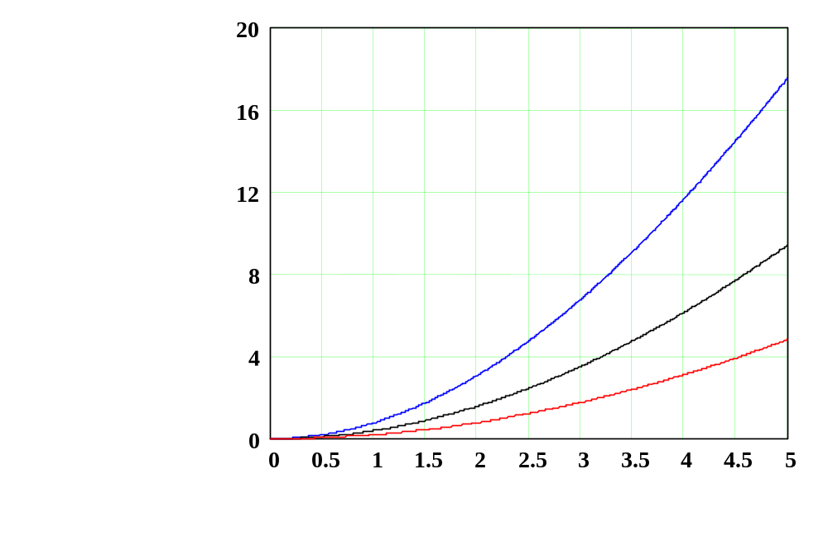
Figure 2: Signal loss as a function of point source misalignment in each of the three signal bands.
Signal loss
(%)
Offset (arcseconds)
250 μm

350 μm

500 μm

We can see from figure 2 that the 250 μm channel has the most sensitivity to misalignment. The goal telescope pointing performance (1-sigma) is 1.5 arcsec random error equivalent to a loss in signal of 2% at 250; 1% at 350 and 0.5% at 500 microns. We wish any internal alignments within the arrays or between the arrays to cause signal losses much lower than the maximum imposed by the telescope performance.

Note in passing: The calculation of the signal error here is optimistic – the pointing error is a 1-sigma figure – I have run a simple IDL model of the standard deviation for random pointing error on a 2-D gaussian of the beam width at 250 um – this gives a SD of 3.2% for 1.5 arcsec pointing error. We’ll stick to the figures above for the purposes of this note.

Photometer array alignment requirements
If we assume that the P/SW array is used as the primary array for pointing purposes we can further assume that we will have an average 2% signal loss imposed by inaccurate pointing of the telescope – we wish to keep the signal loss of the other two arrays within this value. If the arrays were perfectly aligned we would have a 1% and 0.5% signal loss caused by the telescope pointing. If the total alignment error on the sky between the co-aligned chop pixels were another 1.5 arcsec then we would have an average signal loss of 2% for the P/MW and 1% for the P/LW as the signal loss will add linearly. This seems sufficient to prevent the internal errors dominating over the telescope errors.

There are three parts to the alignment budget for the chop pixels:

- The alignment between the array boresights
- The alignment between the pixels in the array and the projected direction of chop at the array
- The linear displacement between the pixels along the direction of chop.

The first of these will be much more difficult to achieve than the other two and, therefore most of the “budget” will be allocated to the array co-alignment.

Platescale at the Photometer Arrays
The telescope has a focal length of 28500 mm and a focal ratio of f/8.68, the platescale at the array will be (approximately as the final f-number is not quite f/5):

28500 tan(1/3600) (8.68/5) = 12.5 arcsec/millimetre

One arcsec is therefore equivalent to ~80 μm.

Photometer P/SW pixel alignment requirement
This requirement needs to be defined in terms of the physical position of the pixels with respect to the array local co-ordinates. The point source chopped observations will place the most stringent requirements on both the array-to-array alignment and the pixel-to-pixel alignment within an array. Figure 3 indicates which pixels will be used for point source chopped observations in the P/SW array. We might define the requirement on the alignment of these pixels as shown in figure 4. This then defines the pixel-to-pixel alignment along the local chop axis (the long axis of the rectangular array) and the maximum distance the outer secondary chop pixel can be from the local chop axis which can, in turn, be related to a rotation requirement on the array. The outer secondary pixel is used as it will have the tightest requirement being furthest from the axis.

As we wish to give as much of the total 1.5 arcsec alignment requirement to the boresight alignment we need to know that the chop pixels are accurately aligned with respect to the chop axis. This is because any systematic error in the alignment of the chop pixels will add to the loss of signal caused by telescope pointing inaccuracy. If we again assume that the errors add linearly then an additional error of 0.5 arcsec from the pixel alignment will bring the total source to pixel misalignment to 2 arcsec in one of the two pixels (if the first is used as the boresight) and cause only a small further loss in signal.

The misalignment allowed between the two chop pixels along the local chop axis is therefore ±40 μm. The outer secondary pixel is at 10 mm from the centre of the array along the secondary chop direction, with the same ±40 μm requirement along the short axis of the array with respect to the local chop direction axis, the allowed rotation of the array around its centre is ±14 arcmin. This places the two primary pixels to within ±20 μm of the nominal chop direction axis of the P/SW array which is taken to be the alignment fiducial for the other two arrays.

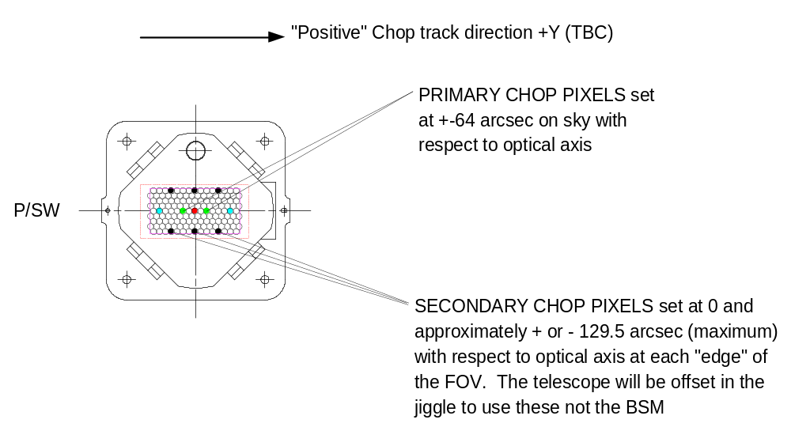
Figure 3: Sketch indicating which pairs of pixels will be used for chopping in the P/SW array. The secondary chop pixels will be used in case of failure in the primary chop pixels.
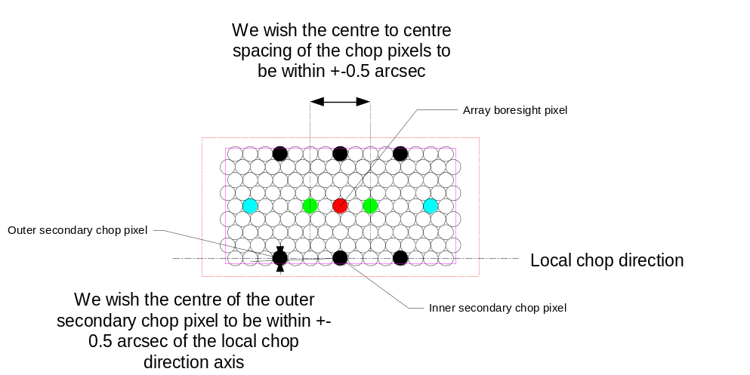

Figure 4: Definition of the alignment requirements for the P/SW array. The red pixel is the central pixel on the array; the green pixels are those used for the point source chopping.

Photometer P/MW and P/LW alignment requirement
The requirements on the internal alignment for the other two photometer arrays are the same the same ±40 μm pixel to pixel. This imposes the same ±14 arcmin rotation limit for the BDAs with respect to the P/SW chop direction axis as installed in the instrument.

These arrays also have to be well aligned in absolute terms with respect to the P/SW array boresight to the 1.5 arcsec absolute limit discussed above. This corresponds to an absolute alignment requirement of 120 μm in any direction between the centres of the P/MW and P/LW arrays with respect to that of the P/SW array.

Spectrometer Arrays
For the spectrometer arrays the S/SW pixels are slightly smaller than the P/SW ones, however the central wavelength, and hence the PSF are about the same. The platescale at the detectors is also nearly the same as for the photometer so we can apply the same ±40 μm pixel to pixel alignment limit for the “blue” pixels here as well. The rotation requirements are less stringent however as the arrays are smaller so the requirement is ATAN(0.02/3.897)*60=17.6 arcmin.

The absolute alignment requirement between the two arrays is the same as for the photometer, i.e. the centre of the S/LW array must be within 120 μm of that of the S/SW array in any direction.

Array alignment requirements from distortion considerations
Whilst the chop pixels impose the most stringent requirements on the pixel and array alignment, the other pixels within the arrays must also be positioned with certain limits to prevent systematic errors or poor spatial sampling arising from image distortion. The geometrical optical performance of the SPIRE instrument is such that the maximum distortion in the photometer is 6 arcsec at the edges of the FOV. A safe assumption for the pixel alignment requirement is that the pixels at the corners of the FOV in all arrays should be within 1/3 of this maximum distortion of the nominal square pattern – i.e. 2 arcsec or 160 μm. If we assume that the positioning errors are distributed randomly between each of the ~10 pixels between the centre and the edge the requirement per pixel is 160/sqrt(10) ~ 50 μm. In fact this is close enough to the chop pixel limit that we will adopt an absolute position error limit of ±40 μm for all pixels in the photometer and spectrometer arrays. This is over specified for the spectrometer arrays but, as it must be achieved for the photometer, it should be easily achievable for the spectrometer.

Detector angular alignment requirements
Another consideration for array alignment is the absolute angular displacement of the arrays with respect to the beam direction. The major effect here will be loss of signal due to a mismatch between the physical location of the cold stop and the illumination pattern from the feedhorns. I have modelled this using Fourier optics and calculated the coupling between the clipped Airy pattern from the telescope and foreoptics (clipped only at the focal plane aperture) and a pure Gaussian beam with a waist size equal to the single mode waist at the instrument focal plane. Everything is referred to the cold stop location in angular space for the final f/5 beam. Figure 5a shows the 1-D slices through the 250 μm horn patterns and point source patterns as seen at the cold stop as the direction of the feedhorn beam is stepped in units of 0.1 degree with respect to the effective gut ray direction. Figure 5b shows the relative detected intensity as a function of the angular misalignment – the result is much the same for the 350 and 500 μm cases. If we wish to keep the signal loss to below 1% then the pixels must be aligned to within 30 arcmin of the gut ray direction. Again this requirement must be split between the pixel alignment and the BDA alignment. I assume that the pixel alignment will be inherently very much better than this and can therefore be ignored – the BDAs must therefore be aligned to within ±30 arcmin of the gut ray direction at the location of the arrays.

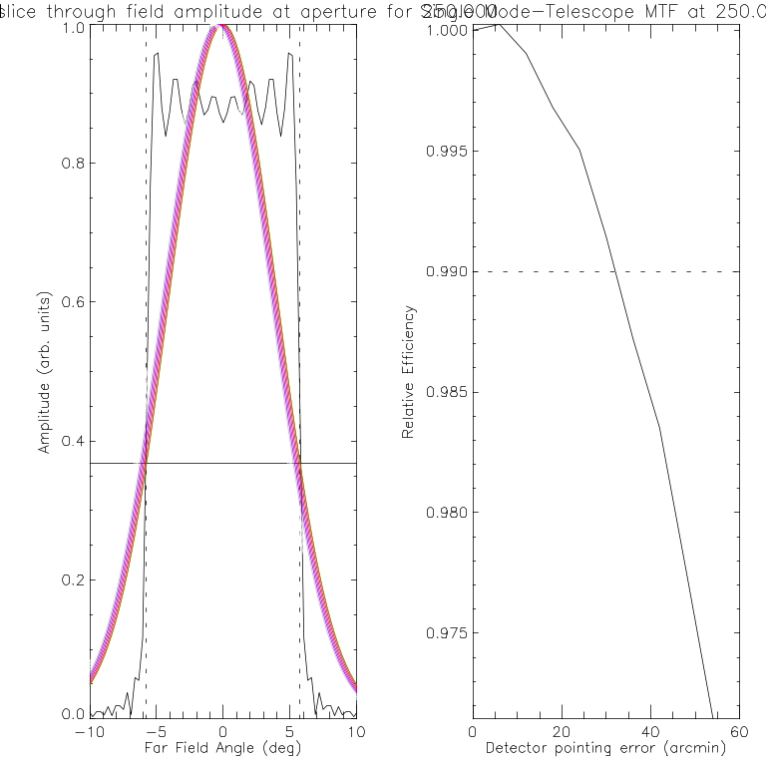
Figure 5a(left) and 5b(right): Results of a Fourier optics calculation of the coupling between a misaligned detector and the beam from the telescope. The integral is carried out at the cold stop as represented in the far field angular space.

Z-alignment of the arrays
Technical note RAL-NOT-000566 by Martin Caldwell shows that a defocus of the detectors – i.e. a change in position along the beam direction – of many millimetres is required before there is even a 1% drop in efficiency. As there will be mechanical constraints more stringent than this, for instance the possibility of hitting another component, a suggested alignment limit is ±0.5 mm.

Orientation of Chop and Jiggle directions for each detector

General notes
Co-ordinate frame used is the ESA frame: +X towards M2. +Z away from SPIRE, +Y is 90 degrees to SPIRE fold plane, towards the spectrometer. Co-ordinate data are co-ordinates of centre of field gut ray intersections with a detector. Image centroids may be several microns away from this position. The gut ray is tracked over the detector by CHOPPing CM4 (i.e. rotating it about an axis parallel to global Z) to get the CHOP track direction. The JIGGLE track direction is obtained by JIGGLEing CM4 (i.e. rotating it about an axis parallel to the global Y-axis)

Photometer
For all photometer arrays the long axis of the rectangular array is defined as the local chop axis. The following tables give the orientation of these in SPIRE global co-ordinates

Detector #1 (P/SW)

Chop/jiggle angle (degrees) | Xglobal | Yglobal | Zglobal | dXglobal | dYglobal | dZglobal
CHOP
0.0 | 139.94243 | -50.0000 | -619.80277 | 0 | 0 | 0
0.2 | 140.52912 | -50.0000 | -619.25230 | .58669 | 0 | .55047
0.4 | 141.11546 | -50.0000 | -618.70149 | 1.17303 | 0 | 1.10128
0.6 | 141.70144 | -50.0000 | -618.15035 | 1.75900 | 0 | 1.65242
0.8 | 142.28705 | -50.0000 | -617.59890 | 2.34462 | 0 | 2.20387
1.0 | 142.87226 | -50.0000 | -617.04715 | 2.92983 | 0 | 2.75562
JIGGLE
0.0 | 139.94243 | -50.0000 | -619.80277 | 0.0 | 0 | 0.0
0.1 | 139.65864 | -50.0000 | -619.50013 | -.28379 | 0 | .302640
0.2 | 139.37436 | -50.0000 | -619.19696 | -.56807 | 0 | .605810
0.3 | 139.08959 | -50.0000 | -618.89326 | -.85284 | 0 | .909510
0.4 | 138.80433 | -50.0000 | -618.58906 | -1.1381 | 0 | 1.21371
0.5 | 138.5786 | -50.0000 | -618.28434 | -1.36383 | 0 | 1.51843

Comments: Detector normal is parallel to global Y-axis. As CM4 is chopped and jiggled, axial image moves in plane parallel to global X-Z plane. Orientation of chop and jiggle directions can be obtained from the table. Figure 5 translates the table into orientation of the arrays and gives a location sketch for the axis orientation.

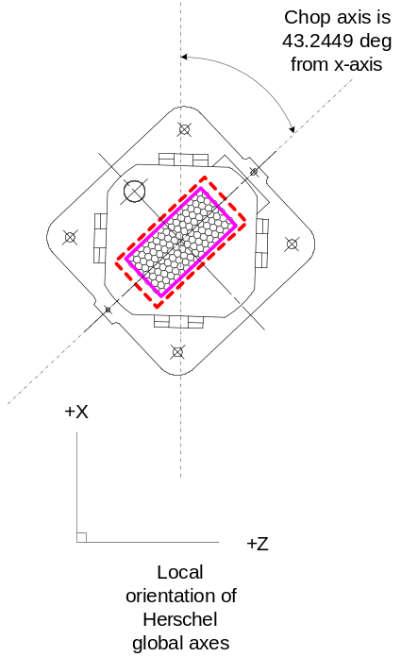
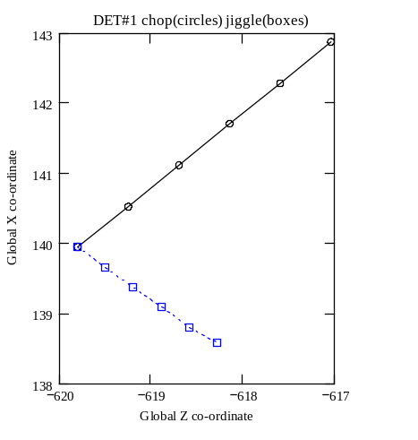
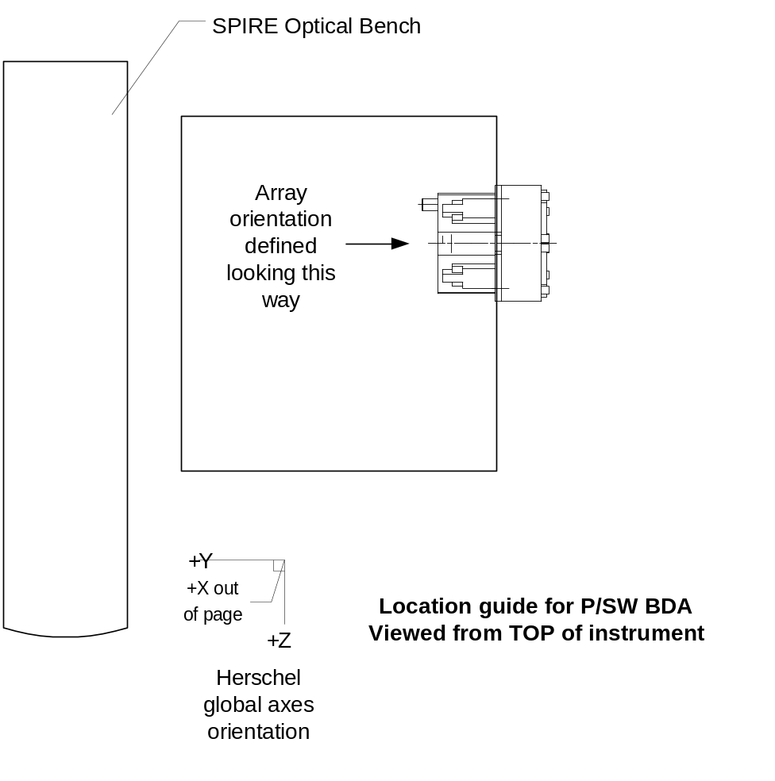
Figure 5: Location sketch for the P/SW BDA (upper panel) showing its general orientation with respect to the Herschel co-ordinate scheme. The lower left panel shows the track of the chop and jiggle directions in the global X-Z plane and the right panel shows how the array must be orientated with respect to the BDA local X direction
Photometer detector box

Detector #2 P/MW

Chop/jiggle angle (degrees) | Xglobal | Yglobal | Zglobal | dXglobal | dYglobal | dZglobal
CHOP
0.0 | 283.42936 | -65.11378 | -521.80701 | 0.0 | 0.0 | 0.0
0.1 | 283.12361 | -64.85522 | -521.84535 | -.305750 | .25856 | -.03834
0.2 | 282.81785 | -64.59666 | -521.88357 | -.611510 | .51712 | -.07656
0.3 | 282.51208 | -64.3381 | -521.92167 | -.91728 | .77568 | -.11466
0.4 | 282.2063 | -64.07955 | -521.95965 | -1.22306 | 1.03423 | -.15264
0.5 | 281.90051 | -63.821 | -521.9975 | -1.52885 | 1.29278 | -.19049
JIGGLE
0.0 | 283.42936 | -65.11378 | -521.80701 | 0.0 | 0.0 | 0.0
0.2 | 283.32587 | -65.11378 | -520.98300 | -.10349 | 0.0 | .82401
0.4 | 283.22202 | -65.11378 | -520.15614 | -.20734 | 0.0 | 1.65087
0.6 | 283.11782 | -65.11378 | -519.32653 | -.31154 | 0.0 | 2.48048
0.8 | 283.01329 | -65.11378 | -518.49425 | -.41607 | 0.0 | 3.31276
1.0 | 282.90843 | -65.11378 | -517.65938 | -.52093 | 0.0 | 4.14763

Comments: This detector is at a compound angle with respect to the ESA co-ordinate system it needs to be rotated both about the global Z and Y-axes. Once rotated the CHOP moves spot EXACTLY along detector local X (give or take a micron or so) JIGGLE moves spot EXACTLY along detector local Y (spot-on). See figure 6A for the projections of the detector co-ordinate system in the ESA global frame.

To orient the detector with +xlocal along chop direction and +y local along jiggle direction follow this recipe (see figure 6B):
Locate the origin (xlocal=0,ylocal=0,zlocal=0) at the centre of the input (active) face of the detector (geometric) focal plane.

Define +Zlocal as the normal to the detector, pointing into the detector body, in the same direction as the incident light travelling along the gut ray. Xlocal and Ylocal are at 90 degrees to each other and in the 'plane' of the 'detector'. Xlocal is parallel to the long axis of the detector

Start with the detector normal (+Zlocal) parallel to the telescope axis (+Xesa), pointing towards M2, i.e detector faces towards -Xesa
Start with the detector +Ylocal parallel to +Zesa
Start with the detector +Xlocal parallel to +Yesa.

The following rotations apply about axes meeting at the detector's centre:
First, rotate through 180-7.1586 degrees positively about xlocal (positive x-axis rotation rotates +Ylocal towards +Zlocal). Detector +Ylocal finishes up pointing at 7.1586 degrees from the original -Ylocal direction.
Detector +Zlocal finishes up pointing at 7.1586 degrees from the original -Zlocal direction.

Second, rotate through -50.0000 degrees about new ylocal axis (i.e. negative y-axis
rotation angle, rotates Xlocal towards Zlocal).

Finally, shift the centre of the detector to (283.42936, -65.11378, -521.80701) in ESA
global co-ordinates.

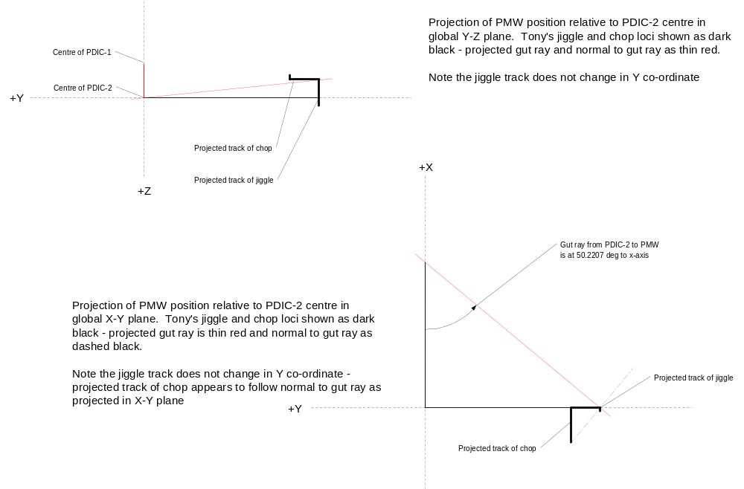
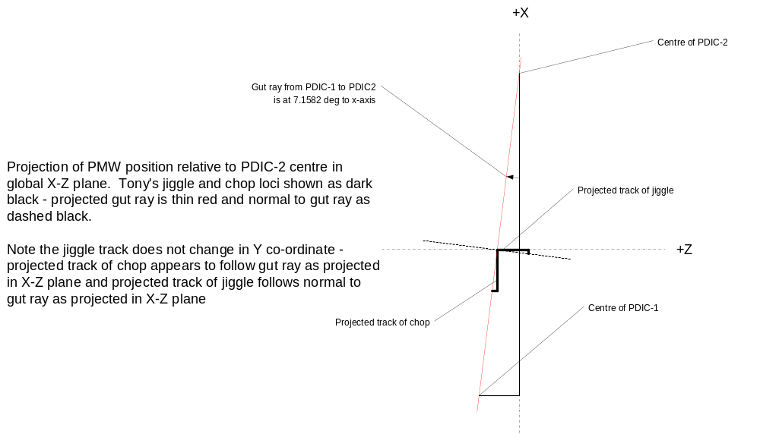
Figure 6a: Projection of the chop and jiggle loci onto PMW seen in each of the three global axes planes.
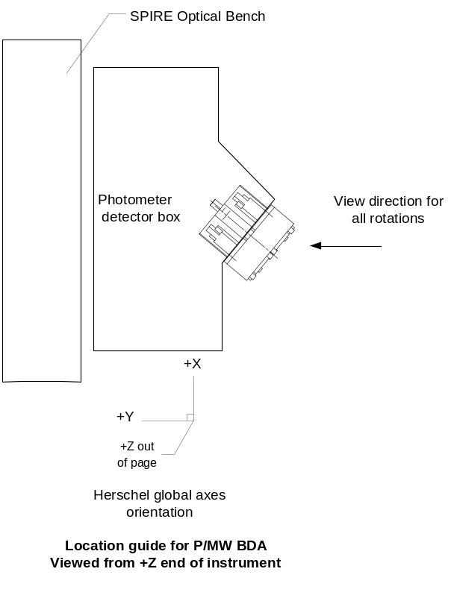
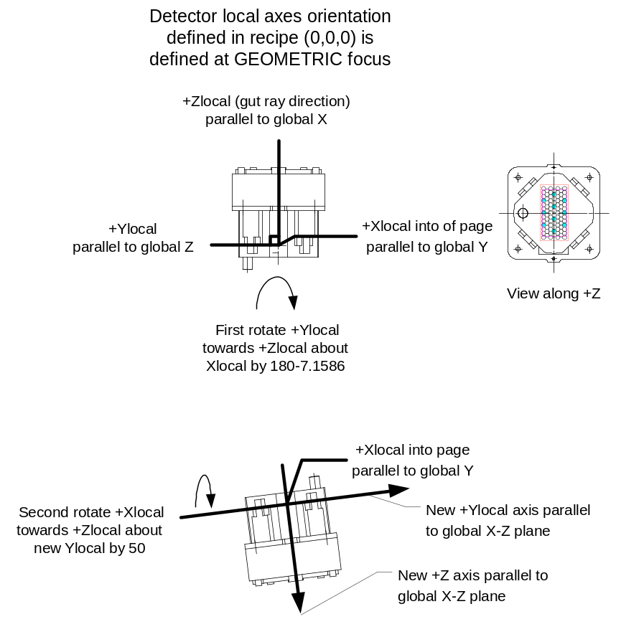
Figure 6b: Location and rotation guide for P/MW

Detector #3 (P/LW)
Chop/jiggle angle (degrees) | Xglobal | Yglobal | Zglobal | dXglobal | dYglobal | dZglobal
CHOP
0.0 | 381.29841 | 0.0 | -468.5152 | 0.0 | 0.0 | 0.0
0.1 | 381.29848 | 0.40225 | -468.5152 | 0.00007 | 0.40225 | 0.0
0.2 | 381.29866 | 0.8045 | -468.5152 | 0.00025 | 0.8045 | 0.0
0.3 | 381.29896 | 1.20674 | -468.5152 | 0.00055 | 1.20674 | 0.0
0.4 | 381.29938 | 1.60898 | -468.5152 | 0.00097 | 1.60898 | 0.0
0.5 | 381.29993 | 2.01121 | -468.5152 | 0.00152 | 2.01121 | 0.0
JIGGLE
0.0 | 381.29841 | 0 | -468.51520 | 0.0 | 0.0 | 0.0
0.2 | 382.1289 | 0 | -468.51522 | 0.83049 | 0.0 | -0.00002
0.4 | 382.96226 | 0 | -468.51524 | 1.66385 | 0. | -0.00004
0.6 | 383.79838 | 0 | -468.51526 | 2.49997 | 0.0 | -0.00006
0.8 | 384.63721 | 0 | -468.51528 | 3.3388 | 0.0 | -0.00008
1.0 | 385.47863 | 0 | -468.5153 | 4.18022 | 0.0 | -.0001

Comments: Chop and Jiggle amplitudes swapped compared to Detector#1. CHOP axis is almost exactly aligned with global Y-axis. JIGGLE axis is almost perfectly aligned with global X-axis. Detector#3 normal is therefore almost exactly parallel to global Z-axis.
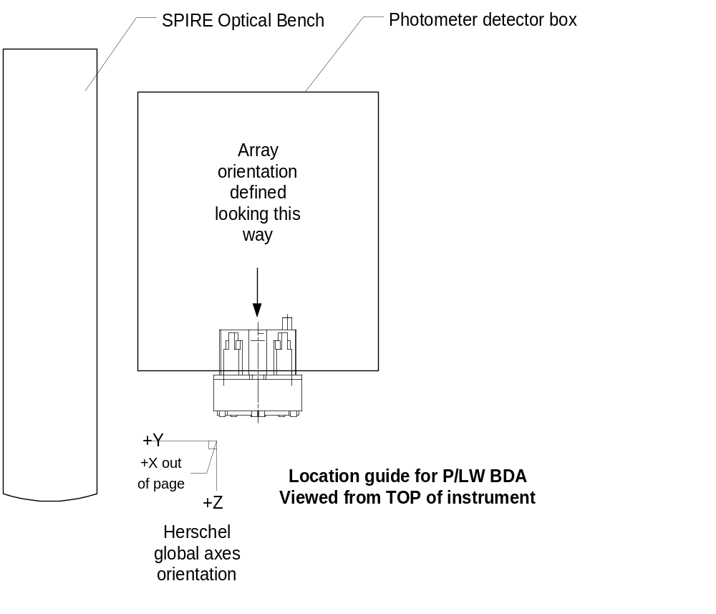
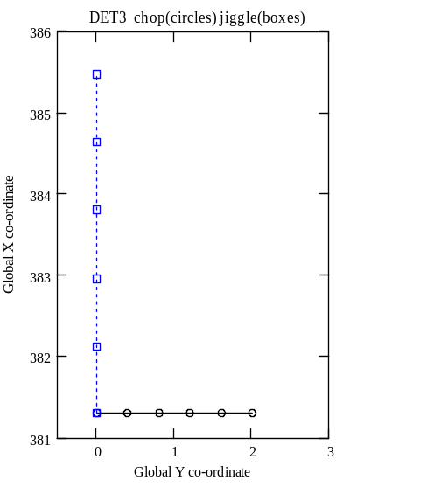
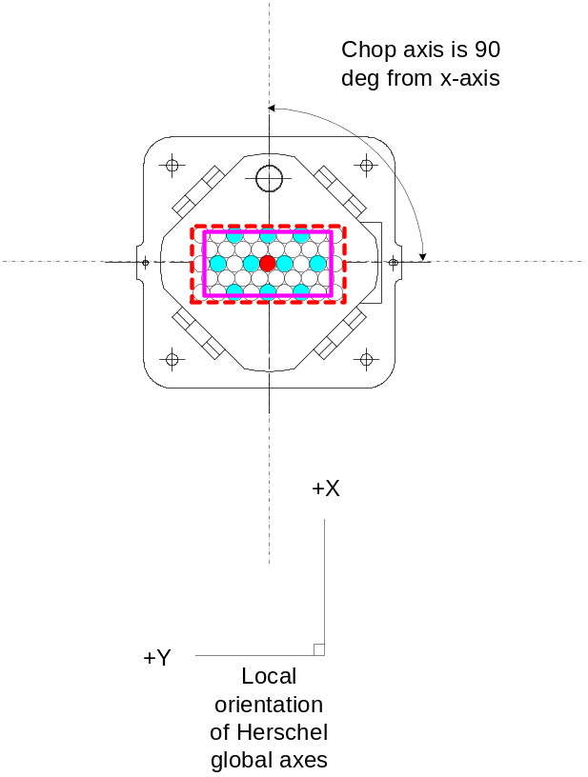
Figure 7: Location sketch for the P/LW BDA (upper panel) showing its general orientation with respect to the Herschel co-ordinate scheme. The lower left panel shows the track of the chop and jiggle directions in the global X-Y plane and the right panel shows how the array must be orientated with respect to the BDA local X direction

Location and orientation of spectrometer detectors

S/SW (upper detector viewing spectrometer from +Y direction)

Chop/jiggle angle (degrees) | Xglobal | Yglobal | Zglobal | dXglobal | dYglobal | dZglobal
CHOP
0.0 | 263.58239 | 250.85711 | -636.66518 | 0.0 | 0.0 | 0.0
0.2 | 262.77151 | 250.85711 | -636.66159 | -.81088 | 0.0 | .00359
0.4 | 261.96368 | 250.85711 | -636.67043 | -1.61871 | 0.0 | -.005250
0.6 | 261.15873 | 250.85711 | -636.6916 | -2.42366 | 0.0 | -.026420
0.8 | 260.3566 | 250.85711 | -636.72499 | -3.22579 | 0.0 | -.059810
1.0 | 259.55721 | 250.85711 | -636.7705 | -4.02518 | 0.0 | -.1053208
JIGGLE
0.0 | 263.58239 | 250.85711 | -636.66518 | 0.0 | 0.0 | 0.0
0.1 | 263.59236 | 250.85711 | -637.08256 | .00997 | 0.0 | -.41738
0.2 | 263.60203 | 250.85711 | -637.50189 | .01964 | 0.0 | -.836710
0.3 | 263.61216 | 250.85711 | -637.92319 | .02977 | 0.0 | -1.25801
0.4 | 263.62196 | 250.85711 | -638.34649 | .03957 | 0.0 | -1.68131
0.5 | 263.6317 | 250.85711 | -638.77181 | .04931 | 0.0 | -2.10663

Comments: Gut ray arrives at centre of detector parallel to +Y global. Plane of detector is hence parallel to X-Z global plane. Track of CHOPPED image on the detector is very slightly curved. JIGGLE track is straight and the angle between the JIGGLE track and global Z is about 1.36 degrees clockwise. Slope of chord joining start and end points of chop curve is 1.5 degrees. Note chop amplitude used is twice the jiggle amplitude.
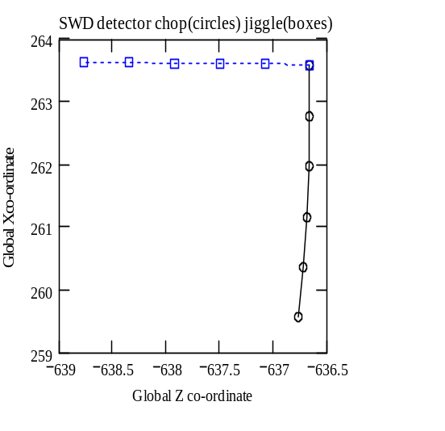

NB: In fact when positive and negative chop angles are used the chop track is found to be symmetric about the zero chop point. That is it forms a “smile” – therefore NO ROTATION of the array is required as this will make matters worse rather than better.

S/LW (lower detector)

Chop/jiggle angle (degrees) | Xglobal | Yglobal | Zglobal | dXglobal | dYglobal | dZglobal
CHOP
0.0 | 182.67306 | 250.85711 | -636.66518 | 0.0 | 0.0 | 0.0
0.2 | 183.48389 | 250.85711 | -636.66159 | -.81088 | 0.0 | .00359
0.4 | 184.29172 | 250.85711 | -636.67043 | -1.61871 | 0.0 | -.005250
0.6 | 185.09667 | 250.85711 | -636.6916 | -2.42366 | 0.0 | -.026420
0.8 | 185.8988 | 250.85711 | -636.72499 | -3.22579 | 0.0 | -.059810
1.0 | 186.69819 | 250.85711 | -636.7705 | -4.02518 | 0.0 | -.1053208
JIGGLE
0.0 | 182.67306 | 250.85711 | -636.66518 | 0.0 | 0.0 | 0.0
0.1 | 182.66304 | 250.85711 | -637.08256 | .00997 | 0.0 | -.41738
0.2 | 182.6531 | 250.85711 | -637.50189 | .01964 | 0.0 | -.836710
0.3 | 182.64324 | 250.85711 | -637.92319 | .02977 | 0.0 | -1.25801
0.4 | 182.63344 | 250.85711 | -638.34649 | .03957 | 0.0 | -1.68131
0.5 | 182.6237 | 250.85711 | -638.77181 | .04931 | 0.0 | -2.10663

Comments: Gut ray arrives at centre of detector parallel to +Y global. Plane of detector is hence parallel to X-Z global plane. Track of CHOPPED image on the detector is slightly curved. Angle between JIGGLE track and global Z is about 1.36 degrees anti-clockwise. Note chop amplitude used is twice the jiggle amplitude
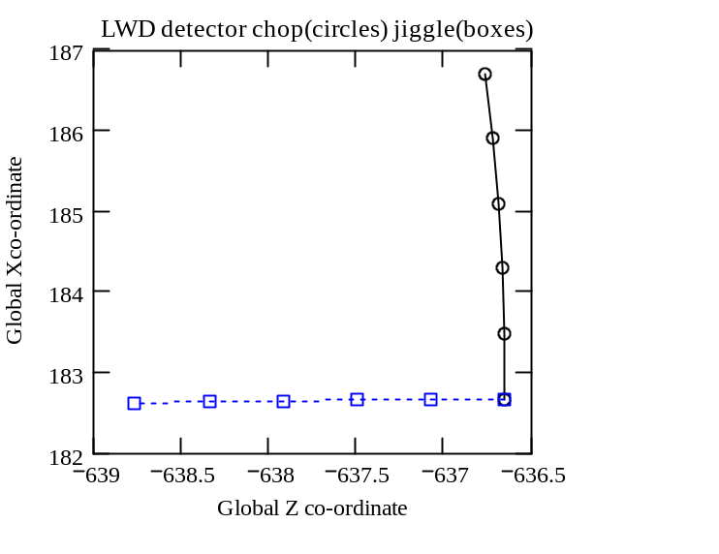
NB: In fact when positive and negative chop angles are used the chop track is found to be symmetric about the zero chop point. That is it forms a “smile” – therefore NO ROTATION of the array is required as this will make matters worse rather than better.

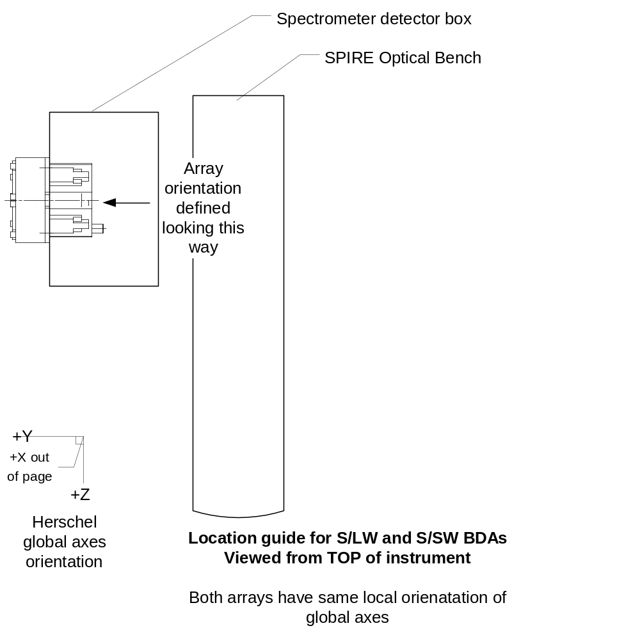

Figure 8: Location sketch for the spectrometer arrays.

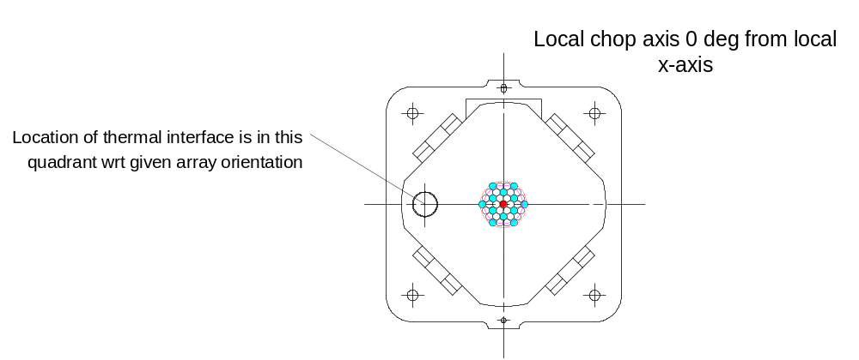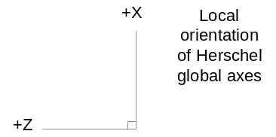

Figure 9: S/SW Orientation – the orientation of the array with respect to the local x-axis is critical.

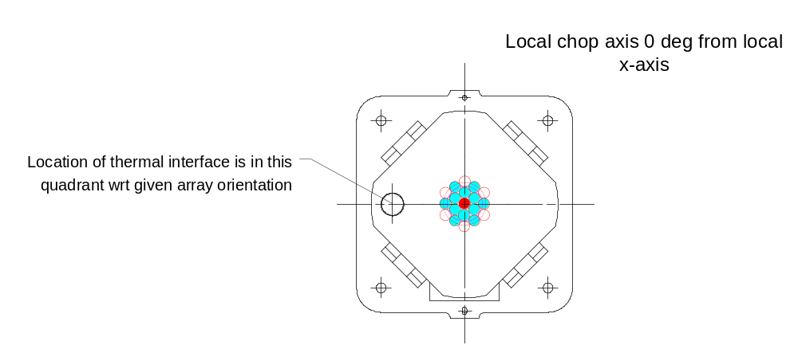

Figure 10: S/LW Orientation – the orientation of the array with respect to the local x-axis is critical.

