TITLE: Straylight path issue in the FTS system of SPIRE Spectrometer

DISTRIBUTION

B Swinyard (RAL)
M Caldwell (RAL)
A Richards (RAL)
B Winter (MSSL)
K Dohlen (LAM)
M Ferlet (RAL)

change record

ISSUE SECTION REASON FOR CHANGE

- First issue of the document (11/09/01).

CONTENTS

- Introduction.

- Description of the method.

- Results and conclusion.

Applicable and reference documents

RD1 ‘Beam patterns in FTS for case of smooth-wall horn detectors’, SPIRE-RAL-NOT-000613 issue 3.0 (19/06/2000).
RD2 ‘Optical design – Diffraction analysis and design’, SPIRE-RAL-NOT-000441 issue 1.0 (14/06/2000).
RD3 SPIRE Design Description Document, SPIRE-RAL-PRJ-000 620 issue 0.1 (12/04/2001).
RD4 ‘SPIRE Mirrors specifications’, LAM.PJT.SPI.SPT.200007 Ind6 (12/06/2001) + mirror mechanical drawings ref. SPI.MIR.34.DD.01.1 and SPI.MIR.36.DD.01.1

1. Introduction

Previous SPIRE diffraction analysis documents (RD1 and the optical design diffraction analysis ref. RD2) describe how the beam pattern on the collimating mirror SM10A (in outward propagation from the detector array) spills over the neighbouring mirror SM9A. A split part of the beam incident on SM10A may therefore miss the mirror and interact directly with SM9A. After reflection on the later, it may give rise to potentially important straylight paths hitting others hotter components (i.e. closer to the common optics and SPIRE box aperture), as part of baffling wall (referenced as SBFL1 in RD3, page 81 figure 4-26) above SBS1, between SM9A and SM8 has been removed.
The purpose of this note is to identify straylight issues arising as consequences of such removal via GO modelling, using ASAP, as described in following sections.

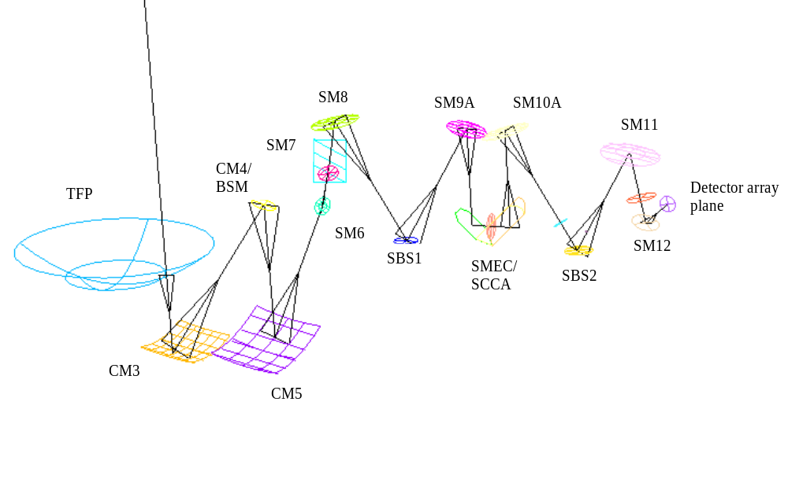
Figure 1: ASAP model of SPIRE spectrometer optics (BOLSP502) with GO forward ray-trace (centre of FOV).

2. Description of the method

First tests of the reverse GO beam propagation within the spectrometers optics were carried out with ASAP file BOLSP501E.inr (obtained by conversion from same ref. original design SYNOSPSIS file). Since the release of the latest version of the instrument optical design i.e. BOLSP502 (from Kjetil Dohlen’s email 29/08/2001), the method was re-applied to the most recent ASAP geometry file BOLSP502.inr (see figure 1 above).

It can be decomposed into 3 steps:

1 - pre-processing of the raw file translated from SYNOPSIS to ASAP for full adaptation to further ASAP analysis and visulation of the original design key features;
2 - tranfer into the global ESA coordinate system reference frame with +X axis the rotational symmetry axis (towards the sky) of Herschel Telescope elements M1, M2 and TFP;
3 - definition of GO rays at the extreme FOV position in the detector array plane for simulating reverse beam propagation (i.e. what would be geometricly seen by the detector array).

It should be noticed that the geometry of the original optical design was not changed during this process. However due to consequence of the SYNOPSIS->ASAP translation the definition of some components of interest (mainly SM9A and SM10A) was redefined (following mirror specifications in doc and drawings ref. RD4) in the ASAP model, so the original design was as strictly respected as possible. The change of global coordinate system did not introduce errors in component location as checked with the SPIRE optics configuration control files.

The third step in the method is briefly discussed. The circular detector plane has a diameter which allows ~2.6 arcmin. of field-of-view (FOV) on the sky. At the array position, it translates into ~12.4 mm after using an average 4.769 mm/arcmin. The normal to the array plane is colinear to the Y axis, leading to the definition of the following 4 extreme FOV GO source-point positions, in local (x,z) coordinates: (0,+6.2), (0,-6.2), (+6.2,0) and (-6.2,0). The GO rays are set to defined a f/5 beam with source at the detector plane, propagating backward through the instrument optics chain.

3. Results and conclusion

The GO ray-tracing from the extreme FOV positions seems to show no significant effect (spillover due to miss components, over-illuminated component edges) within the first elements from the detector array. On the other hand, no specific clipping was applied at an eventual aperture stop (TBC/TBD) between the detector and the beam-splitter SBS2.

However as displayed in figure 2 (left) below, the mirror SM10A can hardly accommodate the GO beam from the (x,z)=(0,+6.2) position: no oversize is found because of the mirror edge truncation. On the contrary to the opposite extreme position (x,z)=(0,-6.2) where it can be seen (figure 2, right) that the GO beam impacts on SM10A at a margin distance from the mirror edge.

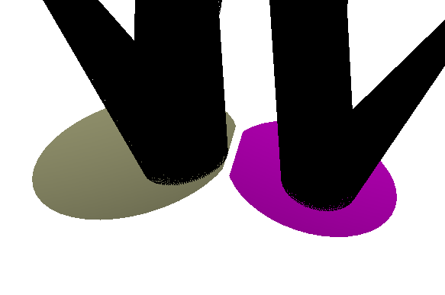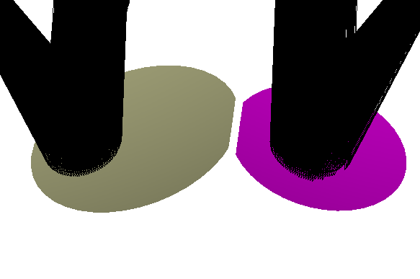
SM10A
SM10A
SM9A
SM9A
Figure 2: Local zoom in 3D of f/5 reverse GO beams on SM10A (grey) and SM9A (pink) from an initial extreme FOV position at z=+6.2mm (left) and z=-6.2mm (right) respectively at the spectrometer detector plane.

The spreading of a long-wavelength diffractive beam (‘wings’ or ‘tail’ in the beam pattern) extends beyond the GO beam limits and, therefore in this case, part of the incident beam on SM10A may interact directly with SM9A (and so not entering the corner-cube of the FTS system).

In order to estimate qualitatively the effect of such spillover, a GO beam from the same extreme FOV position at the detector plane but with an F number slightly smaller (faster beam than f/5) which extends the limits of the GO beam reaching SM10A. A split part of the beam passing beyond the truncated edge of SM10A is then created (figure 3 below). Further reflection of this split part of the oversized beam on the mirror SM9A makes appear rays-supported paths far outside the main beam paths (see figure 4 and figure 1 for comparison).

The straylight path P0 identified in the right insert of figure 3 stays in the X-Z plane and aims at the SPIRE box wall behind SM9A and SM10A. Actually due to close proximity and real size/shape of these 2 mirrors, it may more likely to undergo multiple diffraction by the edge of SM9A and back of SM10A and SM9A.

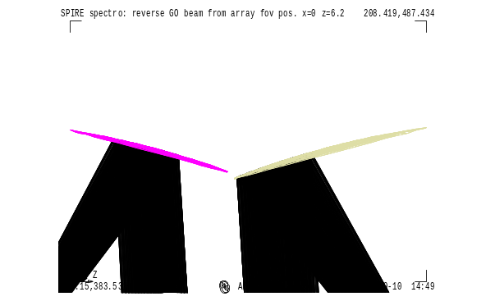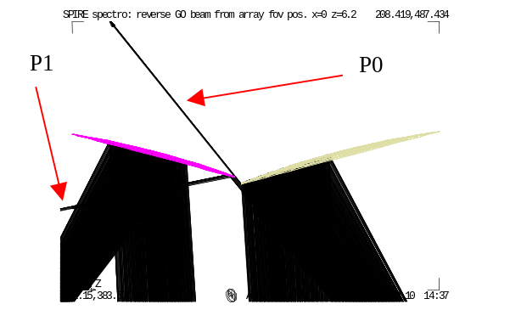
SM9A
SM10A
SM10A
SM9A
Figure 3: Local zoom in 2D of reverse GO beams on SM10A (grey) and SM9A (pink) from an initial extreme FOV position at z=+6.2mm, with F~5 (left) and F smaller (i.e. slightly faster beam) than 5 (right) respectively.

The split part impinging directly on SM9A creates, after reflection, a straylight path P1 better viewed in figure 4 below. P1 remains also mostly in the X-Z plane until it splits again when interacting with SM7. The spreading of rays-direction in P1 induces extra splitting at SM7 into P1a (reflection of P1 on fold mirror SM7) and P1b (continuity of P1, missing the edge of SM7). The main directions the paths P1a and P1b are supported by the following centroid unit vectors (direction cosine):
P1a: Centroid direction: X=0.384916 Y=0.613275 Z=-.689735
P1b: Centroid direction: X=-0.20177 Y=0.010122 Z=-.979380
P1b remains therefore mostly in the X-Z plane and aims at a SPIRE box wall behind SM7 and SCAL. The next hit surface by P1a is more difficult to establish but the reflection on SM7 does not send the beam towards SM6 and the ‘hotter’ common optics chain.
It should be noticed that P1 would have hit the upper part of the baffle wall SBFL1 before impact on SM7 if this wall were still in place above the beam-splitter SBS1.
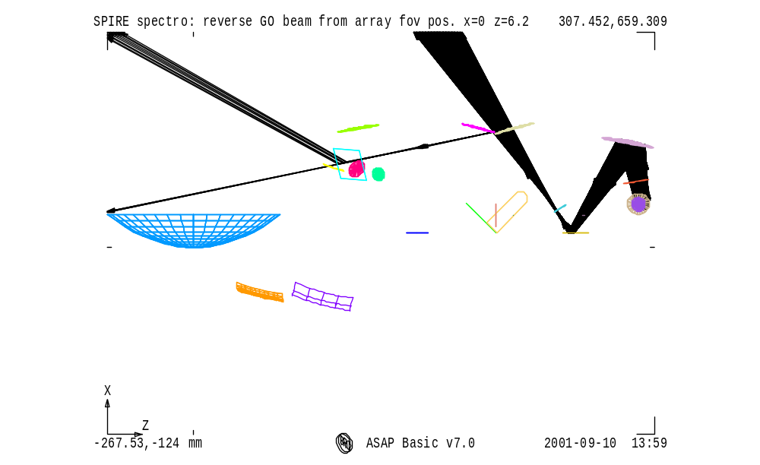
P1a
P1b
P1
SBFL1, upper wall (removed)
Figure 4: 2D view of the spectrometer optics with extreme FOV position oversized GO beam ray-traced. Interaction with only SM9A shows possible straylight path P1 getting splitted further on flat mirror SM7.

Only one half (upper part A following nomenclature in RD3 and RD4) of the FTS system is shown in figure 4. Due to identical optical geometry in the other FTS part (arm B), the same straylight effect would occur between SM10B and SM9B. The presence of the bottom part of the wall SBFL1, separating the FTS-arm B from the calibrator SCAL + mirror SM8B, prevents such equivalent straylight path in the FTS-arm B to reach other optical components. The attention should be focused on achieving an equivalent (and low) straylight signal level in both arms of the FTS system.

More quantitative analysis can be carried out if defined as relevant following this present GO analysis but some conclusion can be already drawn. From the results of this analysis, the following recommendations (excluding modification of the FTS + mirrors optical design) can be made:
- either: both walls (with identical surface temperature and emissivity) forming SBFL1 around SBS1, are re-installed,
- or: in order to keep the radiative signal in both arms (A and B) of the FTS at equivalent level, the surface temperature and emissivity differences between the remaining bottom part of SBFL1 (for arm B) and the surfaces hit by the above defined straylight paths P1a and P1b (surfaces to be identified with SPIRE structural CAD model), should be minimised.

M. Caldwell private communication, after SPIRE Optics DDR meeting in Marseille (July 2001)
In agreement with previous GO modelling and analysis with SPIRE spectrometer optical model under CodeV, from Tony Richards, private communication.

