t

Title: |  | EQM Test Program Definition  Technical Note
CI-No:
Prepared by: |  | Christian Schlosser | Date:
Checked by: |  | Wolfgang Rühe
Product Assurance: |  | Rene Stritter
Project Management: |  | Dr. K. Moritz
Distribution: |  | See Distribution List
 | Copying of this document, and giving it to others and the use or communication of the contents there-of, are forbidden without express authority. Offenders are liable to the payment of damages. All rights are reserved in the event of the grant of a patent or the registration of a utility model or design.

Quantity | Name | Dep./Comp. | Quantity | Name | Dep./Comp.
 | Alberti von Mathias Dr. | ED 544 | X | Wagner Adalbert | OTN/IP 35
 | Barlage Bernhard | ED 62 | X | Wilz Eberhard | OTN/ED 37
X | Bayer Thomas | ED 532 |  | Ziegler Fred | OTN/ED 522
 | Faas Horst | ED 12 |  | Zipf Ludwig | OTN/EC 32
 | Grasl Andreas | OTN/TN 42
 | Hartmann Hans Dr. | ED 522
 | Hauser Armin | ED 541
X | Hohn Rüdiger | ED 531
X | Hölzle Edgar | ED 12
 | Huber Johann | ED 532
 | Idler Siegmund | ED 521
 | Ivády von András | EC 32
 | Jahn Gerd Dr. | ED 541
 | Kameter Rudolf | OTN/ED 37
 | Knoblauch August | ED 51
 | Koelle Markus
 | Kroeker Jürgen | ED 515
 | Lamprecht Ernst | OTN/TP82
 | Lang Jürgen | ED 556
 | Langfermann M. |  | X | Mr. J. J. Juillet | Alcatel
 | Maier Hans-Ulrich | ED 61 | X | Mr. T. Passvogel | ESTEC
 | Moritz Konrad Dr. | ED 37
 | Peitzker Helmut | ED 37
 | Peltz Heinz-Willi | ED 515
 | Peters, Gerhard | ED 533
 | Pietroboni Karin | ED 37
 | Puttlitz Joachim | OTN/ED 37
 | Rebholz Reinhold | ED 531
 | Reuß Friedhelm | ED 7
X | Rühe Wolfgang | ED 52
 | Sachsse Bernt | EC 34
X | Sagner Udo | OTN/TN 42
 | Schink Dietmar | ED 522
X | Schlosser Christian | OTN/TN 42
 | Schweickert Gunn | ED 544
 | Steininger Eric | ED 522
 | Stritter Rene | ED 61
 | Tenhaeff Dieter | ED 544
 | Thörmer Klaus-Horst Dr. | OTN/ED 37

Issue | Date | Sheet |  | Description of Change | Release

Issue | 1 | 2 | 3 | 4 | 5 | 6 | 7 | 8 | Issue | 1 | 2 | 3 | 4 | 5 | 6 | 7 | 8
Date  Sheet |  |  |  |  |  |  |  |  | Date  Sheet

Table of Content

1. Scope 5
2. Documents 6
2.1 Applicable Documents 6
2.2 Reference Documents 6
3. Objectives of the EQM Test Program 7
4. Summary of Requirements 8
4.1 General Requirements 8
4.2 Thermal Requirements 8
5. Consequences for the EQM Design 10
5.1 Transfer of the Requirements into a Conceptual Design 10
5.2 Bulkhead design 12
5.3 Concepts to Achieve the Required Mass Flow Rate 12
5.3.1 Usage of an Additional Auxiliary Tank 12
5.3.2 Throttling the Suction Capacity of the Helium Pumping Unit 2 13
5.3.3 Sub-cooling of the Thermal Shields with Additional Helium S/S 14
5.3.4 Combination of the Three Solutions 16
5.4 Harness Design 16
5.5 Summary 17
6. Alignment 19
6.1 General Remarks 19
6.2 EQM Alignment 19
7. GSE 20
7.1 MGSE 20
7.2 CVSE 20
7.3 EGSE 20
8. Set-Up 22
8.1 Integration 22
8.2 Test 22
9. Test-flow 24
10. Schedule 25
11. Annex 29
11.1 Template to instruments 29

Table of Figures

Figure 5-1: ISO PLM QM 10
Figure 5-2: Helium-flow-scheme solution 1 13
Figure 5-3: Helium-flow-scheme of solution 2 14
Figure 5-4: Helium-flow-scheme of solution 3 15
Figure 5-5: Helium-flow-scheme of baseline concept 16
Figure 5-6: Main Components of the Baseline Concept 18
Figure 7-1: EGSE Set-Up for EQM Tests 21
Figure 8-1: Test Set-Up of Herschel EQM (former ISO QM) in cleanroom class 100 000 23
Figure 9-1: Herschel EQM Test-Flow 24

Scope
This document gives an overview of the EQM test program as it begins to evolve in early phase B.
It summarises the objectives and the major requirements for the EQM program. A major part of this document is dedicated to a discussion of conceptual designs which meet the applicable requirements and enable the tests to be performed under realistic environmental conditions.
Such an approach will reduce the risk during the PFM program. Comparable tests cannot be performed before mid of 2005, and with respect to the correct temperature profiles and He mass flow rate are unlikely to be reproduced during the PFM testing.
This document shall serve as a basis for further discussion with the experimenters.
For the next steps, associated with the establishment of a detailed design and to prepare a detailed test plan, which needs to be done during phase B, it is necessary to get some more information about the instrument tests, which are to be performed with the EQM. We therefore have prepared a template, which can be found in the annex of this document.
The principal investigators are invited to fill in these templates outlining the tests they would like to perform which will enable us to prepare a more detailed test plan.

Documents

Applicable Documents
AD 1 | Instrument Interface Document IID - Part A  SCI-PT-IIDA-04624, Issue 1/0, 01.09.2000
AD 2 | Instrument Interface Document IID - Part B, HIFI  SCI-PT-IIDB/HIFI-02125, Issue 1/0, 01.09.2000
AD 3 | Instrument Interface Document IID - Part B, PACS  SCI-PT-IIDB/PACS-02126, Issue 1/0, 01.09.2000
AD 4 | Instrument Interface Document IID - Part B, SPIRE  SCI-PT-IIDB/SPIRE-02124, Issue 1/0, 01.09.2000
AD 5 | HERSCHEL EPLM AIV and HERSCHEL Satellite AIT Requirement Specification  Document no. HP-1-ASPI-SP-0008
AD 6 | H-EPLM Requirements Specification  HP-2-ASED-SP-0003: draft
AD 7 | EMC Requirements Specification  H-P-1-ASPI-SP-0037

Reference Documents

RD 1 | Technical Note: Herschel Alignment Concept  HP-2-ASED-TN-0002

Objectives of the EQM Test Program
The main objectives of the EQM test program of the Herschel PLM are as follows:
- To verify the compatibility of the instruments (mechanical, electrical and thermal) both individually and together, in orbital representative cryogenic conditions.
- To perform early tests which include a complete a detection chain as possible (detectors, warm units, CCS, and instrument EGSE.
- To perform a conducted EMC test at orbital representative cryogenic conditions.
Beside the above major objectives, the EQM test program offers some additional opportunities to reduce risk to the FM test program. These are mainly:
- An alignment procedure verification of all three instruments w.r.t. the optical bench (OB) and of the OB w.r.t. the CVV and the LOU as defined in the Herschel Alignment Concept TN [RD 1]. This shall be done at ambient and at cryogenic conditions.
- Validation of the thermal background conditions with the use of the GSE test cavity as it is foreseen in the FM test program. (Details to be discussed)
- To gain operational experience with cryogenic procedures

Summary of Requirements
The requirements applicable for the EQM test program are defined in the Instrument Interface Documents part A (AD 1)and part B (AD 2 to AD 4) and in the Herschel EPLM AIV and System AIT Requirement Specification (AD 5)
The thermal requirements to reach an orbit representative thermal environment for the instruments are defined in the IID's.

General Requirements
The general requirements for the EQM test program are mainly described in the IID-A. The following requirements have an impact on the design of the PLM EQM:
- BOLA and LOU shall be mounted
- The LOU shall be mounted within a test cryostat (TBC)
- The cryostat cover shall be either a Herschel QM or a GSE test cover.
- The upper part of the PLM allows mounting of a GSE cavity to simulate orbital representative background conditions.
- The mass flow rate through the optical bench shall be as expected in orbit (about 2.5 mg/s). This should be achieved at least for the instrument test periods.
- The cryostat harness shall be electrically representative to PFM.
- The instrument AVM's shall be mounted on an electrically representative plate (e.g. grounding).
- The instrument units will be connected to a functionally representative CDMS and power S/S (including EGSE deployment)

Thermal Requirements
The thermal requirements necessary to operate the instruments are described in the IID-B's. The present requirements for the three different levels are summarised in the following table. The stability requirements for the HIFI FPU are not yet agreed. Any formal updates of these requirements will be taken into account in the detailed design:

 | HIFI | PACS | SPIRE
Level 0 | 0 K ... 2 K  stability: 6 mK/100s | 1.6 K ... 1.75 K  1.6 K ... 2.2 K  1.6 K ... 3.5 K | N/A ... 2 K
Level 1 | TBD ... 6 K  stability: 6 mK/100s | 3 K ... 5 K | N/A ... 6 K
Level 2 | TBD ... 20 K  stability: 15 mK/100s | N/A | N/A ... 15 K
Table: 4-: Summary of thermal requirements
Additional requirements, which have to be considered by the PLM design and the test set-up are coming from the necessity to recycle the He₃ coolers of PACS and SPIRE. PACS requires a tilting of up to 30° around the z-axis and SPIRE a tilting by more than 17° around the z-axis.
To operate the SPIRE FTS mechanism it is necessary to tilt the PLM around the z-axis by 90°.
Besides, SPIRE requires a monitoring of I/F temperatures on the optical bench's mechanical interfaces (3 on level 0, 1 on level 1 and 2 on level 3).

Consequences for the EQM Design

Transfer of the Requirements into a Conceptual Design
The Herschel PLM EQM design is based on the re-use of the existing ISO PLM QM. The ISO QM was used in the early 90^{’s} for the thermal and mechanical qualification of the ISO cryostat, the predecessor of the Herschel cryostat.
The design of the Herschel and the ISO Helium subsystem are very similar. The main tank of ISO is a torus-tank. The auxiliary tank of ISO is actually about at the position, where the optical bench of Herschel will be. The figure below shows the design of the existing ISO PLM QM.
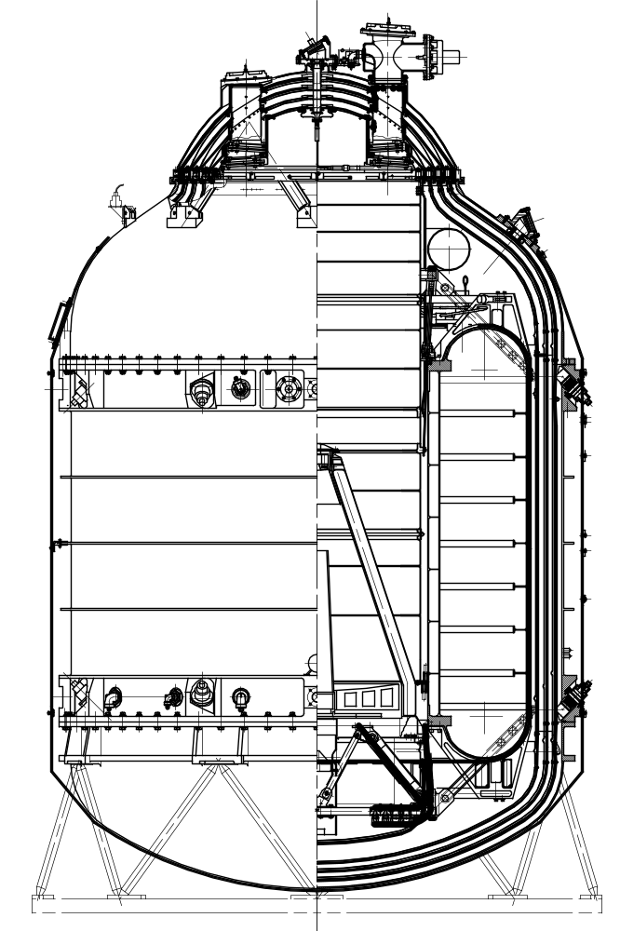
ISO Cover (only base-plate mounted)
Auxiliary tank
Baffle
Main tank (torus)
SVM - upper platform
Upper bulkhead
Figure 5-1: ISO PLM QM
In order to meet the requirements listed in section 4 of this document, some modifications will be necessary. The following table summarises the consequences of each of these requirements on the conceptual design and/or the testing.

BOLA and LOU shall be mounted | ⇒ | Upper cylindrical part of the CVV acc. Herschel design (see chapter 5.2)
LOU within a test cryostat (TBC) | ⇒ | Baseline is to operate the LOU at room temperature. Upper cylindrical part of the CVV acc. Herschel design. Possibility to mount the LOU-cryostat (which is a CFE) has to be checked. (see chapter 5.2)
Cover either Herschel QM or GSE test cover | ⇒ | GSE test cover (see chapter 5.2)
Upper part of PLM allows mounting of GSE cavity | ⇒ | Upper part of PLM according Herschel design (see chapter 5.2)
Mass flow rate about 2.5 mg/s | ⇒ | Will be achieved by a combination of using an aux. tank and/or additional shield cooling and/or throttling of the pumping performance. Mass flow rate will be adapted to the predicted value, which can be in the range of 2.0 mg/s ... 2.5 mg/s (see chapter 5.3)
Cryostat harness shall be electrically representative to PFM | ⇒ | QM harness will be electrically of FM standard (see chapter 5.4)
Instrument AVM's mounting requirements | ⇒ | AVM's will be mounted on support structure, similar to PFM design, at the interface plate of the ISO SVM (TBC) - (see chapter 5.5)
Instrument units connected to functionally representative CDMS and power S/S | ⇒ | EGSE configuration (see chapter 7.3)
Level 0 temperature requirements | ⇒ | He II tank temperature ≤ 1.7 K
Level 1 & 2 temperature requirements | ⇒ | Combination of He II tank temperature and concepts to reduce mass flow to 2.5 mg/s (see chapter 5.3)
Tilting up to 90° around z-axis | ⇒ | Combination of test set-up and test plan (liquid level in He II tank) - (see chapter 8.2)
I/F temperature monitoring on OB | ⇒ | QM OB according FM design - (see chapter 5.5)
Table: 5-: Requirements versus conceptual design

Bulkhead design
The upper bulkhead of the existing ISO QM has to be removed. The upper part of the PLM will then be modified according to Herschel design to achieve the requirements for the EQM program.
The upper part of the Herschel EQM will be composed of the following main parts:
- OB QM, with the same design as the OB PFM, mounted onto the spatial framework, including OB shield
- QM inner instrument cryostat harness (see chapter 5.4)
- Connector ring, mounted onto the cylindrical part of the CVV including thermal shields and MLI
- Upper cylindrical part of the CVV according FM design, to allow mounting of LOU and BOLA including thermal shields and MLI. Possibility to mount a LOU-cryostat if needed has to be checked, but baseline is to operate the LOU at room temperature.
- Upper bulkhead according Herschel PFM design to allow mounting of the GSE test cavity
- This cavity replaces the cover. With this test cavity one has the possibility to insert a cold plate onto the shields to achieve the thermal background conditions as it will be done on PFM.
The only difference to the design as described in the proposal is that the upper bulkhead will be according Herschel PFM design instead of the re-use of the ISO upper bulkhead. The advantage of this solution is the possibility to mount the GSE test cavity. With this test cavity it is possible to use the same approach for reaching the thermal background conditions as on PFM. This will reduce risk from the PFM and enables a better correlation of the EQM and FM instrument tests results.

Concepts to Achieve the Required Mass Flow Rate
We investigated several concepts to reduce the mass-flow rate to an orbit representative value of 2.0 mg/s ... 2.5 mg/s. First estimations implies that three of all concepts, or better a combination of these three solutions, will give us the ability to adjust the mass-flow rate to the required value without loosing the required level 0, 1 and 2 temperatures and that of the inner radiation shield. These three solutions are described below.

Usage of an Additional Auxiliary Tank
The ISO auxiliary tank has to be removed to enable the mounting of the optical bench with the instruments. It was planned to replace it by a simple by-pass. In this solution we replace the ISO auxiliary tank by an auxiliary tank, which will be mounted inside the torus of the ISO main tank. This main tank serves as "1.7 K" shield for the auxiliary tank. This auxiliary tank will be filled with He II and the main tank will be closed during instrument testing. The heat load on the auxiliary tank will be very low so that the remaining mass-flow rate from the auxiliary tank will be less 1 mg/s. The required mass flow rate of 2.5 mg/s will be adjusted with heaters on the auxiliary tank. The helium flow is shown in the figure below.
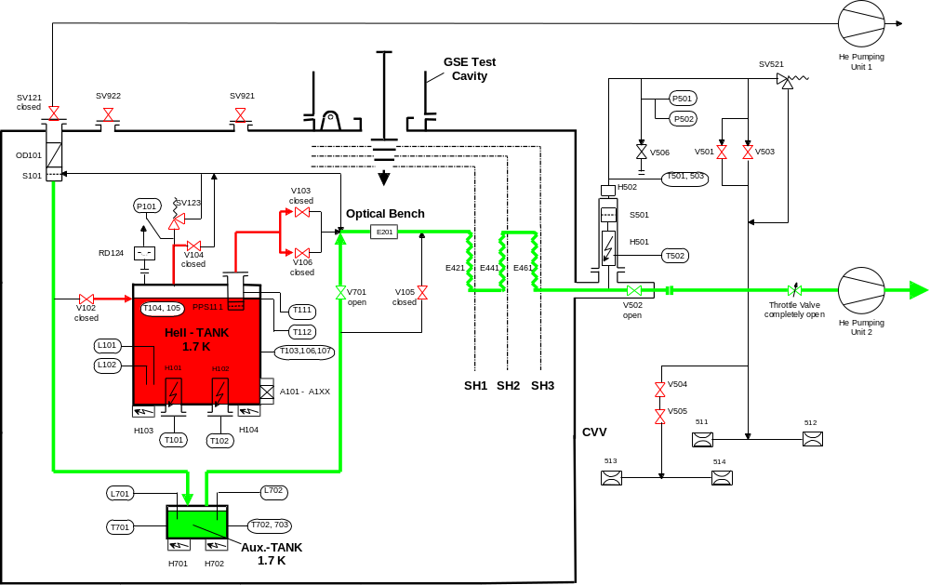
Figure 5-2: Helium-flow-scheme solution 1
The major steps of this attempt are:
- The main tank is filled with LHe II at ≤ 1.7 K
- The auxiliary tank, mounted inside the torus of the main tank, is filled with LHe II at ≤ 1.7 K
- The main tank will then be closed during test (closing V 104)
- Continuing pumping with He pumping unit 2
- Expected remaining mass flow from auxiliary tank < 1 mg/s (TBC by analysis)
- Adjustment of required mass flow with auxiliary tank heaters H 701, H 702
- At the end of the test (each evening), re-opening of the main tank (V 104) and pumping down of the main tank over night to ≤ 1.7 K
The initial helium temperature inside the main tank will be obtained, such, that the level 0 temperature can be kept inside the requirements throughout the test. However, the shield temperatures, especially the temperature of the innermost shield will increase because of the low mass-flow. A detailed analysis of the main tank and shield temperatures of this transient case has to be performed after establishing a thermal model out of the ISO model and the new Herschel optical bench model to estimate the consequences on the instruments background during testing.

Throttling the Suction Capacity of the Helium Pumping Unit 2
In this solution, the ISO auxiliary tank will be removed and replaced by a by-pass as planned, to enable the mounting of the optical bench with the instruments. The main tank is filled with LHe II at ≤ 1.7 K. The mass flow of approximately 30 mg/s will then be reduced by throttling the suction of helium by the Helium pumping unit 2 with the - already existing - throttle valve at the pumping unit's inlet. The required mass flow rate of 2.5 mg/s has to be re-adjusted with the throttle valve during test. The helium flow is shown in the figure below.
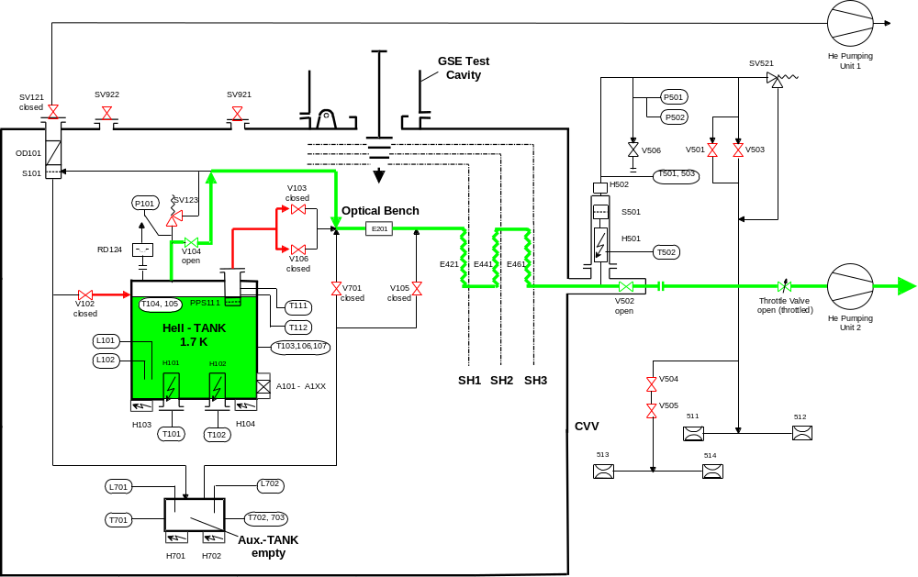
Figure 5-3: Helium-flow-scheme of solution 2
The major steps of this attempt are:
- The main tank is filled with LHe II at ≤ 1.7 K
- Continuing pumping with He pumping unit 2
- Expected mass flow from main tank ~ 30 mg/s (according ISO experience - TBC by analysis)
- Adjustment of required mass flow by throttling suction at inlet valve of He pumping unit 2
- At the end of the test (each evening), completely opening of inlet valve of Helium pumping unit 2 and pumping down of the main tank over night to ≤ 1.7 K
The initial helium temperature inside the main tank will be obtained, such, that the level 0 temperature can be kept inside the requirements throughout the test. However, the shield temperatures, especially the temperature of the innermost shield will increase because of the low mass-flow. It could become necessary to re-adjust the throttle valve several times during testing. A detailed analysis of the main tank and shield temperatures of this transient case has to be performed after establishing a thermal model out of the ISO model and the new Herschel optical bench model to estimate the consequences on the instruments background during testing.

Sub-cooling of the Thermal Shields with Additional Helium S/S
In this solution, the ISO auxiliary tank will be removed and replaced by a by-pass as planned, to enable the mounting of the optical bench with the instruments. The main tank is filled with LHe II at ≤ 1.7 K. The mass flow of approximately 30 mg/s will then be reduced by sub-cooling the thermal shields with LHe I from an external dewar through an additional helium S/S. This separate Helium S/S consists of an filling airlock, heat exchangers at the thermal shields and an GHe outlet. The required mass flow rate of 2.5 mg/s will be adjusted by cooling the shields, especially the innermost shield to a predefined value. The helium flow is shown in the figure below.
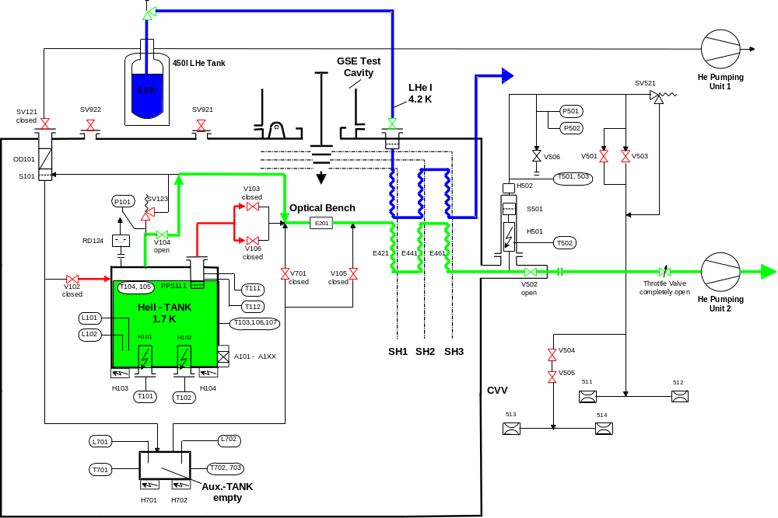
Figure 5-4: Helium-flow-scheme of solution 3
The major steps of this attempt are:
- The main tank is filled with LHe II at ≤ 1.7 K
- Continuing pumping with He pumping unit 2
- Expected mass flow from main tank without sub-cooling of shields ~ 30 mg/s (according ISO experience - TBC by analysis)
- Adjustment of required mass flow by sub-cooling the thermal shields with LHe I from external dewar
The helium temperature inside the main tank shall remain constant. The shield temperatures will stabilise at lower temperature levels than in orbit and could suffer from a problem of temperature gradients . It could become necessary to re-adjust the mass-flow by heating the main tank. A detailed analysis of the main tank and shield temperatures of this case has to be performed after establishing a thermal model out of the ISO model and the new Herschel optical bench model to estimate the consequences on the instruments background during testing.

Combination of the Three Solutions
The behaviour of the cryostat cannot be predicted exactly without testing. In order to keep a maximum of flexibility during test, it is proposed not yet to decide for one of the described solution, but to provide a combination of these solutions. This means, that the cryostat shall be equipped with an auxiliary tank inside the torus, which enables us to adjust the mass-flow very fast and very exactly, and with an additional helium S/S to cool-down the thermal shields to provide a good thermal background temperature of the shields during testing. Throttling the suction through the Helium pumping unit 2 avoids that the temperature of the helium inside the auxiliary tank decreases to an unreasonable low value. The helium flow of this concept is shown in the figure below.
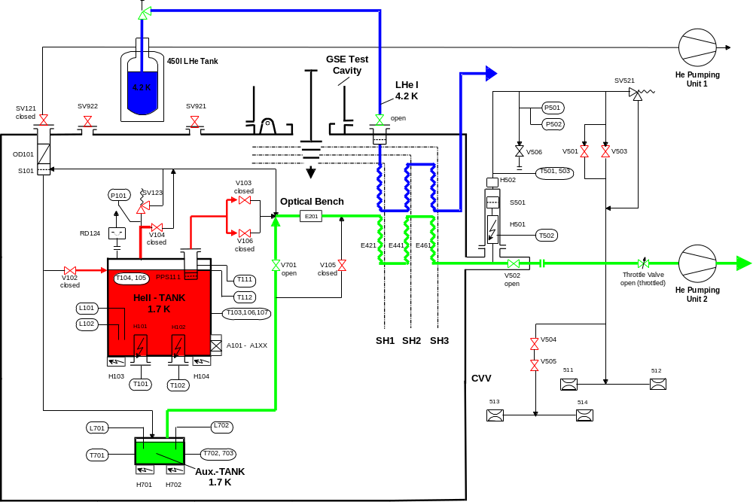
Figure 5-5: Helium-flow-scheme of baseline concept
In conclusion, there is high confidence that after further analysis cooling solutions can be found which will simulate for the instruments the in-orbit cryogenic environment. Such conditions are unlikely to be available to the instruments during the PFM testing.

Harness Design
The cryostat internal and external harness for the instrument will be electrically of FM standard. Also the thermal anchoring of the cables will be representative to FM. The location of the connectors at the Herschel EQM will be very similar to the PFM.
The requirement, that the cryostat harness shall be electrically representative to PFM is therefore achieved.

Summary
The baseline cryogenic concept for the Herschel EQM testing is demonstrated in the figure below. It will be reworked during the design phase, supported by detailed thermal analysis. It consists of:
- the ISO QM lower part (up to the I/F flange between cylindrical and upper conical part of the CVV)
- Herschel optical bench
- Herschel upper part (upper cylindrical part and upper conical part of the CVV)
- GSE test cavity
- internal cryostat harness (as Herschel PFM)
- external cryostat harness
- additional auxiliary tank
- additional helium S/S for shield cooling
- modified ISO SVM upper platform
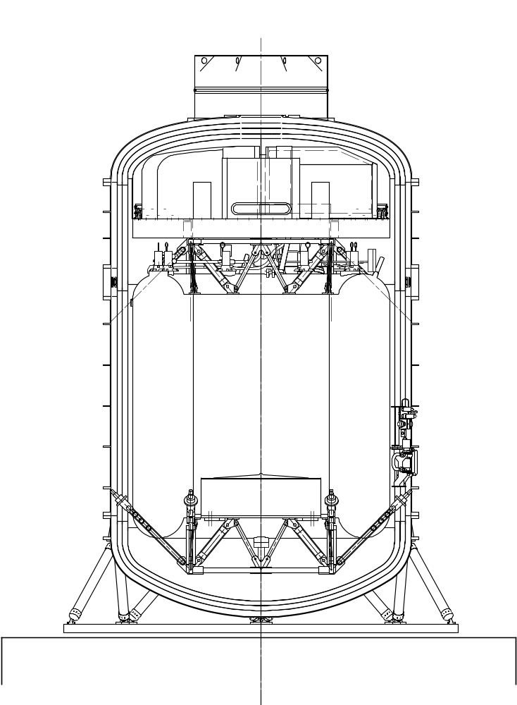
Herschel Test Cavity
Herschel Upper Bulkhead
Herschel Optical Bench with Instruments
Herschel Internal Harness
Connector Ring for Harness Feed-Throughs
ISO Lower Structure
ISO Support Frame
Modified ISO SVM Platform
Herschel External Harness
Additional Auxiliary Tank
ISO Main Tank
Figure 5-6: Main Components of the Baseline Concept

Alignment

General Remarks
Proper functioning of the three Herschel scientific instruments HIFI, PACS and SPIRE requires their precise alignment to the Herschel telescope focus.
Within the integration sequence, the telescope is the last optical subsystem to be mounted upon and outer side the cryostat when the cryostat cover has been already closed. As a consequence the instruments have to be aligned to an optical reference system without the telescope. Then, as a last step, the telescope will be integrated and aligned w.r.t. the same reference.
As a further constraint , the alignment requirements are valid for in-orbit and cold conditions, whereas the on-ground alignment can only be performed at warm conditions. This means, that the effects implied by change of environment conditions have to be determined by analyses and must be pre-compensated by a corresponding offset during the on-ground alignment process.
The alignment measurements can be subdivided into two major categories:
- Linear measurements (axial and lateral)
- Angular measurements (tilt and roll).
The angular alignment is subdivided into tilt measurements (rotation about the y and z axes) and roll measurements (rotation about the S/C x axis). For both measurements auto-collimation and linear alignment, both representing standard techniques, will be applied.

EQM Alignment
Within the EQM programme the alignment procedure shall be verified at an early stage of the AIV program. The effect on alignment due to pressure change and cool down will also be determined. The effect on alignment due to outer CVV temperature change can only be verified with the STM inside the TV chamber. The test sequence for the EQM (concerning alignment) is as follows (see also AIT flow in section 9):
.....PLM Integration→Alignment→Closing Cryostat→Evacuation→Alignment check →
Cooling→Alignment check→Other Tests.....
Only the alignment relevant steps have been shown. The complete test plan is shown below.
The main objectives of the EQM alignment activities are:
- Early verification of the alignment
- Verification of pressure and temperature change effects on alignment (outer CVV temperature at 300K)
- Lessons learned with the EQM can already be applied for the STM
- Risk reduction for the STM and FM program
Detailed descriptions of the alignment processes and sequences, as well as of procedure validation aspects are given in the technical note: "Herschel Alignment Concept", HP-2-ASED-TN-0002 (RD 1).

GSE

MGSE
De-integration, modification and re-integration of the ISO QM / Herschel EQM will be done using the refurbished / modified ISO MGSE, namely the
- cleanroom class 100 integration dolly (de-integration, modification, re-integration)
- test dolly (part of the re-integration)
- PLM hoisting equipment
Additional MGSE will be needed at the end of integration:
- GSE test cavity (to close the cryostat)
- test dolly (to turn the PLM together with the mounted AVM's - same as during integration TBC)
- Hoisting equipment (for lifting the PLM during movement)
The integration will take place in the cleanroom class 100 at Astrium until the cryostat is closed. The cryostat will be closed with the GSE test cavity. Integration of the external parts will take place in cleanroom class 100 000 environment.
The test will be performed with the PLM EQM mounted in a test dolly with the capability to turn the PLM up to 90° around the z-axis.

CVSE
Refurbished / modified CVSE from ISO will be used for cryo-servicing operations and during test, namely:
- Helium pumping unit 1 (at filling airlock for He II production and top-up)
- Helium pumping unit 2 (at GHe-outlet to keep He II conditions during cryo-servicing and testing)
- LHe I and LHe II transfer-lines (for cryo-servicing operations)
- Ventlines, suction-lines, vacuum hoses
- Leak-detector
- 450 l Helium supply dewars
Details are given in the CVSE specification.

EGSE
The EGSE set-up is shown in the figure below. It consists of a Herschel representative data- and a power front end to operate the instruments and the CryoSCOE to control the cryostat. A CCS "light" serves as Core EGSE. The interfaces between Core EGSE and Experiment EGSE are the same as on satellite level.
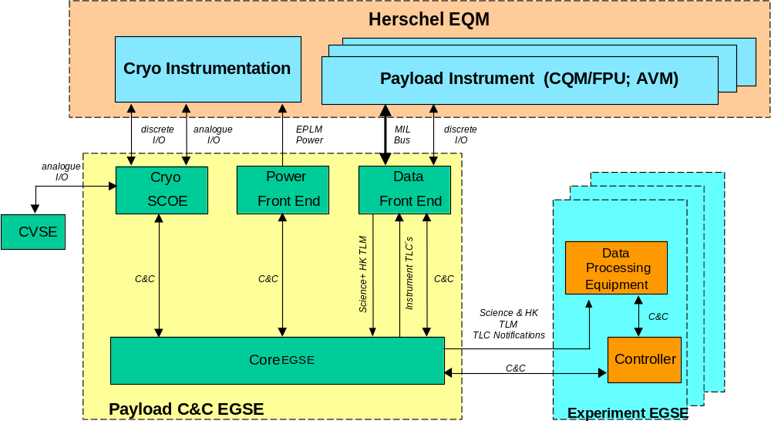
Figure 7-7: EGSE Set-Up for EQM Tests

Set-Up

Integration
Most of the integration will be performed in a cleanroom class 100 with the PLM mounted in an integration dolly, which can be turned around two axis and moved up and down.
Instrument integration can be done within this integration dolly or in a test dolly, but in any case in cleanroom class 100 environment.
After cryostat closure and evacuation, the PLM will be moved with the test dolly in a cleanroom class 100 000, where a leak-test at ambient conditions will be performed. The external parts integration, as LOU or the external harness, but also the integration of the warm units will be done after the leak-test.

Test
The tests will take place in a cleanroom class 100 000. The set-up of the PLM is shown in the figure below in the facility at Ottobrunn. The tubing to the Helium pumping units will be fixed installed. A working platform around the PLM will provide good access for AIT operations.
The EMC test is also planned to be performed in this area. Baseline is, that only conducted EMC tests will be performed. If the EMC working group decides that radiated EMC tests are necessary, these tests can be done using antennas to simulate the SVM. Thus, no EMC test on EQM level is planned to be done in a special EMC chamber.
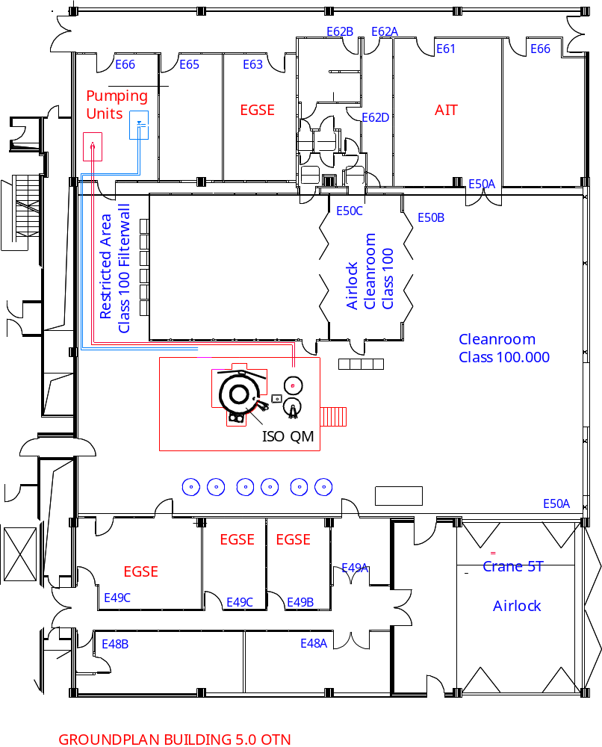
Figure 8-8: Test Set-Up of Herschel EQM (former ISO QM) in cleanroom class 100 000

Test-flow
The figure below gives a rough overview of the Herschel EQM program. Not all of the alignment steps are implemented in this test-flow. The instrument integration on the optical bench will be accompanied with an alignment measurement as well as the cool-down of the cryostat. The Integrated Module Test (IMT) includes the functional instrument testing and the simulated operational timelines for all three instruments with the verification of the level 0, 1 and 2 temperature requirements. A detailed test plan for the IMT will be established using the filled in templates from the instruments (see Annex of this document).
A more detailed test-flow will be established during phase B.

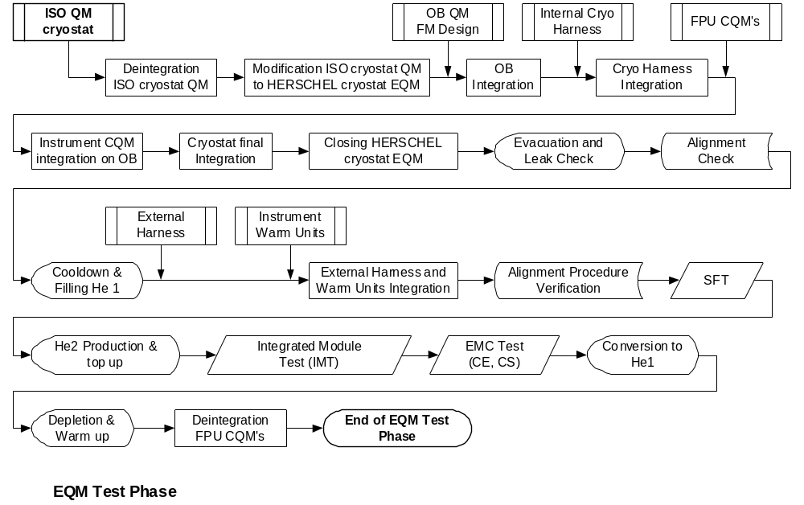
Figure 9-9: Herschel EQM Test-Flow

Schedule

The schedule on the next pages is only meant to give an overview of the planned EQM program and is for information only. It does not give the exact dates for the activities. It will be revised during phase B and the exact dates for all activities will be defined when the delivery dates of all items are known. However, it should be noted that it is proposed to move the schedule forward with integration of the FPU QM’s onto the optical bench in April 2003. This should allow longer, and more meaningful tests to be performed.

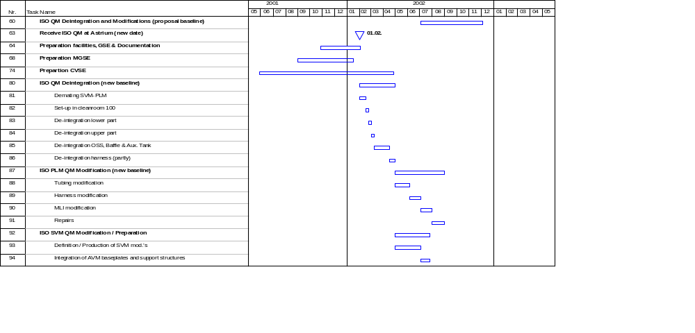

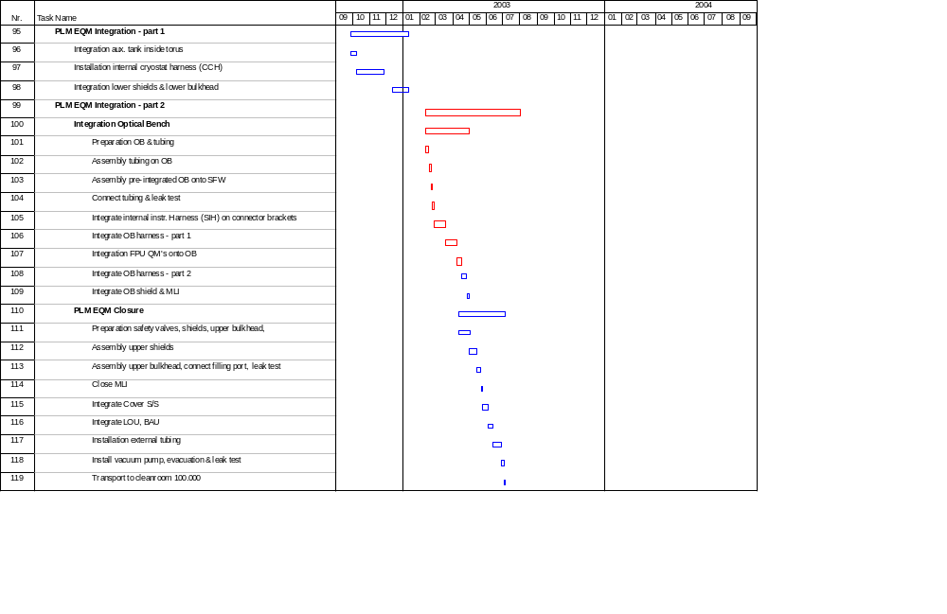

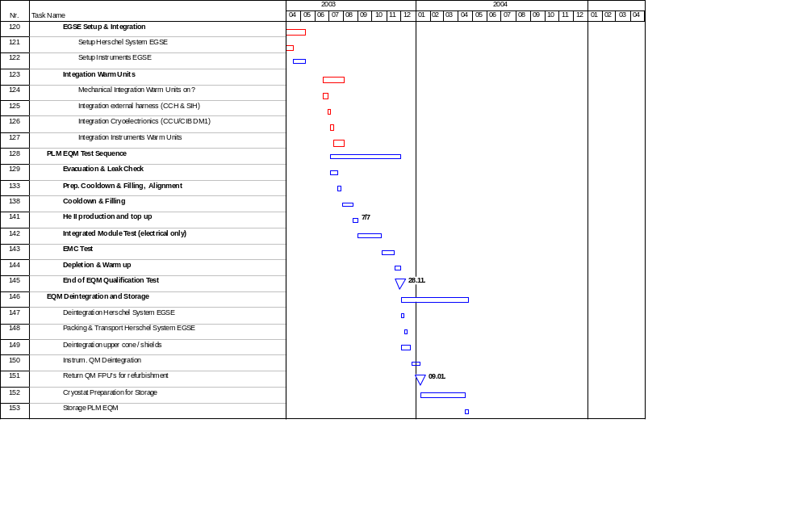

Annex

Template to instruments
In order to better understand the instruments needs a Test Case Form is attached and it is requested that the instruments fill in these forms and return them to Mr. W. Ruehe (Astrium) for each test they would like to perform on the EQM and if possible PFM. These test case forms shall support establishing a detailed EQM test plan They should also detail the specific thermal requirements for each test and how long they have to be achieved.

Title: e.g. Full Performance Test, or more detailed
Experiment: HIFI, PACS or SPIRE
Objectives: a short description of the purpose of the test
Test Description: e.g. scenario, timing, measurements, mode diagram, operating mode
Instrument Configuration: a short description of the instrument configuration
Specific requirements on PLM: e.g. specific spacecraft configuration, protections, tilting angles
Particular Environmental Constraints: e.g. specific ESD constraints, temperature or mass-flow constraints
Success Criteria: e.g. expected results for HK and science TM
Duration: Estimated duration of the test
Applicable for EQM, PFM: test could be performed on EQM and/or PFM level

.
Test Case Form
Title: |  | Experiment:

Objectives:
e.g. Verification of the xxx functional performance in modes X and Y at S/C level under in orbit conditions

Test Description:
e.g. The instrument will be operated according to the test mode xy. The measuring channels x, y, ... will be exercised by stimulation/simulation of ... The results will be evaluated by ...

Instrument Configuration: |  | Specific Requirements on PLM (e.g. PLM tilted about 30° around z-axis):

Particular Environmental Constraints (e.g. level 0-2 temperatures, mass-flow - during what time):

Success Criteria:

Duration: |  | Applicable: PLM EQM  PFM

