FIRST / SPIRE

MCU Design Description

Prepared by : | Date :
Patrick Levacher  Michel Jevaud  Didier Ferrand | 15-12-2000
Checked by : | Date :
Dominique Pouliquen | 20-12-2000
Systems Engineer
John Delderfield

Project Manager
Ken King

Document change record
________

Revision |  |  | Modified Pages
Issue - rev. | Date | Approved by | Modified Pages
0 - 0 | 25-04-00 |  | All : draft issue
1 - 0 | 19-06-00 |  | First issue
1 - 1 | 25-12-00 |  | Updated issue –all pages

Distribution list
________

Jean Louis Auguères | CEA | X
Christophe Cara | CEA | X
Colin Cunningham | ROE | X
Brian Stobie | ROE | X
Ian Pain | ROE | X
Didier Ferrand | LAM | X
Michel Jevaud | LAM | X
Patrick Levacher | LAM | X
Dominique Pouliquen | LAM | X
Bruce Swinyard | RAL | X
Ken King | RAL | X

Acronyms
________

AD Applicable Document
AVM Avionics Model
BOL Begin Of Life
BSM Beam Steering Mirror
CQM Cryogenic Qualification Model
EGSE Electrical Ground Support Equipment
EOL End of Life
ESA European Space Agency
FIRST Far InfraRed ans Sub-millimetre Telescope
FM Flight Model
FPU Focal Plane Unit
FTS Fourrier Transform Spectrometer
FTSE FTS warm Electronics
FTSP FTS Preamplifier for the position encoder signals
H/K House Keeping
H/W Hardware
I/F Interface
LAM Laboratoire Astrophysique de Marseille
MAC Multi Axes Controller
MCU Motorization Control Unit
N/A Not Applicable
RAL Rutherford Appleton Laboratory
RD Reference Document
ROE Royal Observatory of Edinburgh
S/C Spacecraft
SM Spare Model
SMEC Spectrograph MEChanism
S/W Software
TBC To Be Confirmed
TBD To Be Define
TBW To Be Written
TC Tele-Command
TM TeleMetry
WE Warm Electronics

Table of contents
________

1 Introduction 8
1.1 Purpose and Scope 8
1.2 Applicable and reference documents 8
1.2.1 Applicable documents 8
1.2.2 Reference documents 8
2 SYSTEM OVERVIEW 9
2.1 General architecture 9
2.2 Communication and telemetry principles 10
2.2.1 Low rate Command interface 11
2.2.2 High rate Telemetry serial link 12
3 SMEC Axis trajectory and control 13
3.1 Scan in closed loop operation 13
3.1.1 Home and limit position acquisition 14
3.1.2 Optical Encoder Position Acquisition 14
3.2 SMEC Position data for telemetry 15
3.2.1 Synchronization with DPU 16
3.2.2 Position data for telemetry sampling rate 17
4 principle of operation OF BSM control 18
4.1 Requirements 18
4.2 BSM Modes 20
4.3 Command/Parameter list 20
4.4 Telemetry data list 20
5 MAC Operation 21
5.1 Command format 21
5.1.1 Bufferized commands and parameters 22
5.1.2 Digital Servo Filter commands 22
5.1.3 Trajectory Profile commands 23
5.1.4 I/O and Encoder signals related commands 24
5.1.5 DSP Software related commands 24
5.1.6 Communication related commands 24
5.1.7 Motion and control modes related commands 25
5.1.8 Trace and telemetry related commands 26
5.1.9 HK on the command line related commands 26
5.1.10 Event Status Register 27
5.1.11 Activity Status Register 27
5.1.12 I/O Error code register 27
6 MAC SOFTWARE 28
6.1 21020 DSP Software principles 28
6.1.1 Watchdog mechanism 28
6.1.2 Digital I/O polling 28
6.1.3 Reset 28
6.1.4 ITs 29
6.2 MAC Software architecture 29
6.2.1 MAC Master Scheduler (MMS) 29
6.2.2 MAC Main task 29
6.2.3 SMEC and BSM axis Control Algorithms 30
6.2.4 SMEC Servo Loop algorithm 30
6.2.5 BSM Chopping axis Servo loop 30
7 MCU Electronics DESIGN 31
7.1 Overall description. 31
7.2 MCU Mechanical implementation. 31
7.2.1 Mechanism control unit (MCU) 32
7.2.2 Position encoder preamplifier box 32
7.2.3 Mass 33
7.2.4 Power dissipation 33
7.3 Interfaces 34
7.3.1 MCU I/F with SMEC 34
7.3.2 MCU I/F with BSM 35
7.3.3 MCU I/F with DPU 36
7.4 Board Design description. 37
7.4.1 MAC Board 37
7.4.2 SMEC Board 38
7.4.2.1 MOTOR Power amplifier 39
7.4.2.2 Encoder acquisition electronics AND PREAMP 39
7.4.3 BSM Board 39
7.5 Power Supply 40
7.6 Grounding Scheme. 41
7.7 Use of Special Components/Component list. 42
8 Redundancy and degraded modes 43
8.1 Redundancy 43
8.2 Limitation of failure propagation 44
8.3 BSM Redundancy and degraded modes 45

List of figures

Figure 1: Control system architecture 10
Figure 2: SMEC Scan characteristics 13
Figure 3: Fine position (solid line) derived by arctan computation 15
Figure 4: Time count (solid line) between encoder pulses for telemetry 15
Figure 5 : Principle of position sampling timer synchronization with DRCU 16
Figure 6: BSM Trajectory specification 19
Figure 7 : BSM Control system chronogram 19

List of Tables
Table 1 : SMEC scan specifications 13
Table 2 : Telemetry rates for zero crosing every 1 micron on the optical encoder 17
Table 3: BSM Control system specifications 18

Introduction

Purpose and Scope

The purpose of this document is to describe the electronics design for the control and monitoring of the FIRST/SPIRE FTS Mechanism (SMEC) associated with the Beam Steering Mirror mechanism (BSM) control.
The control electronics unit of the 2 mechanical subsystems is called MCU (Motorisation Control Unit).

The MCU is part of the DRCU and has electrical and mechanical interfaces with it.

Applicable and reference documents

Applicable documents

AD1 | Operating Modes for the SPIRE Instrument (SPIRE-RAL-DOC-000320)
AD2 | FIRST/Planck Packet Structure Interface Control Document (SCI-PT-IF-07527)
AD3 | Spire Spectrometer Mirror Mechanism Subsystem Specification (SPIRE-LAM-PRJ-000460)
AD4 | FIRST / Planck Instrument Interface Document Part B (SCI-PT-IIDB/SPIRE-02124)
AD5 | DRCU Electrical Interface Control Document (SAp-SPIRE-CCa-24-00)
AD6 | SPIRE Instrument Requirements Specification (IRD) (SPIRE-RAL-PRJ-000034)

Reference documents

RD1 | Beam Steering Mirror Control Software Requirements (Spire-ATC-Draft)
RD2 | Beam Steering Mirror Warm Electronics (Spire-ATC-Draft)
RD3 | Beam Steering Mirror Electronics Electrical Interface (Spire-ATC-Draft)

SYSTEM OVERVIEW

The MCU is dedicated to the control and monitoring of the following 3 axis of the SPIRE instrument:

- the Spectrometer Mechanism (SMEC). The control is based on a scan at a configurable speed,
- the chopper and jiggle axis of the Beam Steering Mirror subsystem . The control is a position step control pattern.

Furthermore, the MCU shall provide H/K data of the 3 axis for telemetry and scientific interferogram calibration and detector synchronisation purpose.

The trajectory control of the 3 axis is performed by a 21020 DSP on the basis of PID controllers associated by feedforward for trajectory generation and filtering for notching of mechanism modes.

The software shall be based on a master scheduler on the principle of time sharing without the use of a specific multi tasking kernel. The tasks to be performed shall be called on the basis of a software interrupt generated by the inner DSP timer, allowing interlaced tasks such as FTS and BSM control algorithms, command polling, etc…

The DSP software, in order to be as simple as possible, will time share within one single 100 micro sec (TBC) cycle task :

- the SMEC control task
- the chopper control task,
- the jiggle control task,
- the communication and other various internal DSP tasks.

The scan parameters are put in memory for configuration purpose by mean of the command serial line described hereafter.

General architecture

The MCU control electronics includes:

- the MAC Board: common digital control board based on a 21020 DSP

- a SMEC Board: analog electronics for the power amplification of the actuators and acquisition electronics for sensors preamplification and conditioning of the SMEC subsystem
- 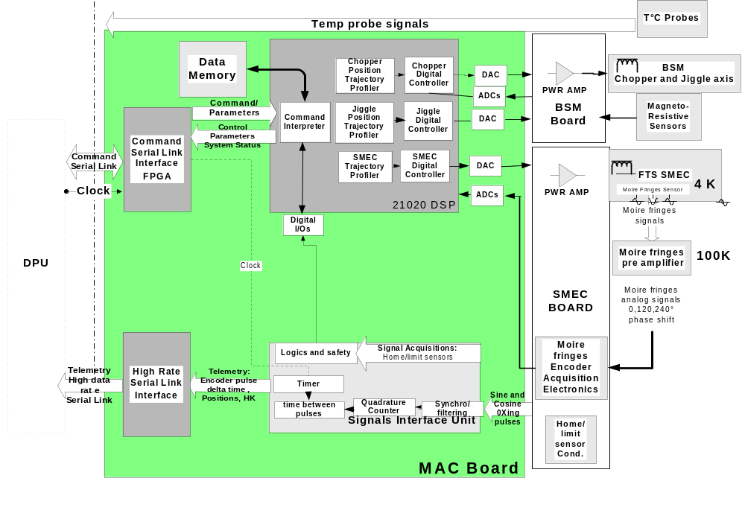a BSM Board: analog electronics for the power amplification of the actuators and acquisition electronics for sensors preamplification and conditioning of the BSM subsystem

Figure 1: Control system architecture

Communication and telemetry principles

The MCU communication with DPU shall be done through 2 serial lines :

- Low rate command interface link 300 kbits, based on 32 Bits word. By mean of a FPGA dedicated to serial interface, the commands and parameters are decoded and put in a register to be read by the 21020 DSP

- High rate telemetry interface link 1Mbits, based on 16 bits.

On the basis of this principle, the MCU DSP shall read the command register every cycle of the common time sharing monitoring of the 3 axis (ie 100 micro seconds).

Low rate Command interface

The MCU shall receive a 32 bits word for each command. The 32 bit word shall include (i) 2 bits for subsystem id (ii) 8 bits for command type (e.g. set scan_length), (iii) the rest for the parameter itself.
The MCU communication FPGA shall decode if the command concerns its subsystem, since all systems shall be adressed.
If yes, the MCU FPGA put the parameter value after header decoding in a register. The DSP reads pediocally the interface register et put in its own memory the parameters according to a table pointer.
For every command, a handshake is done with DPU, so that only one command can be sent at one time until the parameter of the control shall be taken into account.
-With this handshake, a first assesment shows that two commands can be sent in about 320 micro second (TBC). The handshake shall consist of only one 32 bits word return. Since the DSP readout of the command is done periodically every 100 μs, the maximum delay for a command to be taken into acount is between about 350 and 500 μs.
FPGA Command Interface
Command
Interpreter
command_in
register

Dedicated_bit_register
start_telemetry
command_ack
register

data memory
read
/write
WR
RD
memory mapped registers

Command Interface
Link
Serial_in
Serial_out
unserialize
serialize
variables table with parameters:
Scan_Length
Speed,
Position reference
Kp
Kd, etc...
ADSP 21020
with command
link task

High rate Telemetry serial link

Some specific values such as position and motor current samples are delivered on a fast mono directional serial link to provide data for telemetry purpose.

The telemetry shall use a 1Mbit/s 16 bits serial link.

For the sharing of telemetry channel:

- there is only one common FPGA connected to one high rate serial link,

- this FPGA shall have two communication mode :

- jiggle mode : the telemetry data are the BSM axis with some additional SMEC information. In this mode the telemetry is synchronized by a clock
- scan mode : the telemetry data are the delta time SMEC position with some optional BSM information. In this mode, the telemetry rate depends on the SMEC encoder pulses counts, ie the scan speed in an asynchronous way.

For the SMEC the telemetry packet as defined in the DRCU Electrical Interface Control Document (AD5), shall consists in a delta time between two zero crossing of a sine optical encoder signal, ie every 1 micron in the scan. At the nominal speed of 500 micron/sec, the delta time between two encoder pulses shall be delivered at a rate of 500 Hz.

The value of 1 micron is to be considered as a minimum value and shall be programmable. The possible values shall be, for example, 1, 2, 4 or 8 microns (TBC).

SMEC Axis trajectory and control

Scan in closed loop operation

The SMEC axis is controlled by a digital PID with a ramp reference to insure a scan with configurable length and speed. The scan may be single with a flyback at the end or a double scan (single and return) with the same common speed and length.
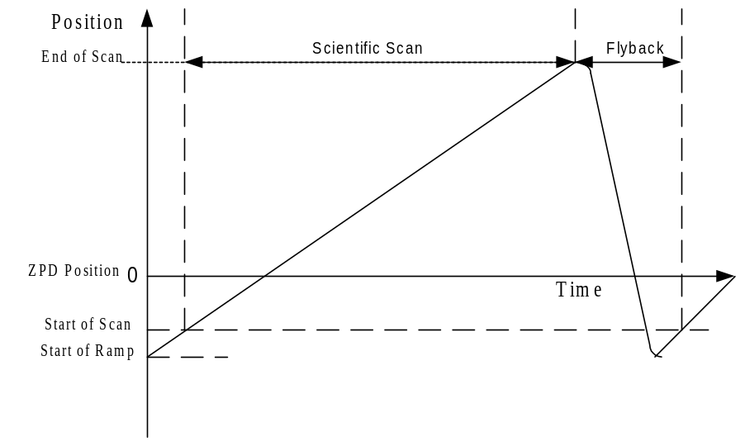
Figure 2: SMEC Scan characteristics

Scan characteristic | Specification  (Initial Requirement) | Comment
Scan length | - 0.3 cm min to 3.2 cm max | Programmable length  Value referred to the home position
Scientific Scan Length resolution | 0.5 μm | based on a 16 bits parameter reference
Max scan speed | 2000 μm/s
Min scan speed | 200 μm/s
Nominal scan speed | 500 μm/s | The nominal speed is the basis for velocity stability requirements
Speed reference resolution | 0.03 μm/s | based on a 16 bits word reference parameter
Stability of the velocity scan | (1% -goal 0.5 % rms). | on the basis of a filtered velocity fluctuation by a 29 Hz / 3rd order low-pass filter
Flyback duration | less than 10% of the scientific scan | including acceleration phase

Table 1 : SMEC scan specifications

Home and limit position acquisition

The home and limit positions acquisitions are based on 3 magnetoresistive sensors with same conditioning electronics as BSM ones, with few microns resolution. The sensors shall define the:

- upper limit
- lower limit
- home position

Optical Encoder Position Acquisition

The position is determined from the 3 sine optical encoder signals after pre-amplification, conditionning and a sine / cosine signals format conversion to be read directly by the DSP via 2X 16 bits ADC for fine position on the basis of an arctan computation in the DSP. The complete absolute position is then computed by addition of an incremental value of 2 μm every encoder cycle. Since that, the sampling time of the DSP does not depend on velocity (it is not the case with a 1/T speed counting between encoder pulses with some problems at very low speeds). Furthermore, the arc tangent computation of the position is dedicated for a fine and continuous position control, avoiding speed jitter that should be generated by encoder pulses if these signals enters directly in the control loop. The number of sine/cosine samples to be acquired to arctan computation is given by :

N = Sine period / (Speed * t_{sampling}), with Sine period = 2 μm

By the mean time, the encoder pulses generated by the encoder electronics are entering an Encoder Unit Interface (FPGA) for pulses counting and crude position determination. The incremental position count is done in the FPGA for in order to verify the trajectory controlled by the DSP and acts the role of a watchdog. Furthermore, the Encoder Unit Interface includes error signals generation for whatever problem occures during the trajectory (limit switches reached, etc...). If one on the logics signal is high, the DSP is interrupted and put in safe configuration.

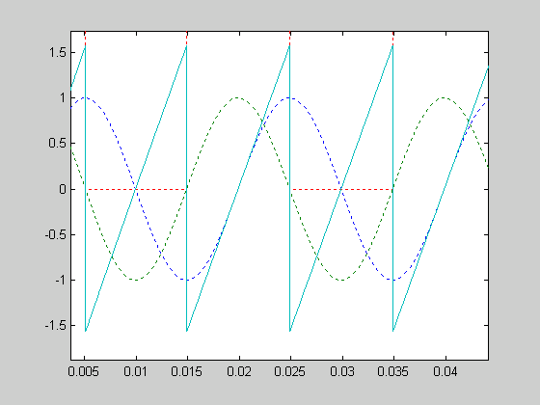
Figure 3: Fine position (solid line) derived by arctan computation

SMEC Position data for telemetry

In order to reconstruct interferograms, the detector readout data must be concatenated with position sampling data.

There is no absolute time tag in the SMEC Control System, but an extra signal on the timer of the Encoder Interface Unit is implemented.

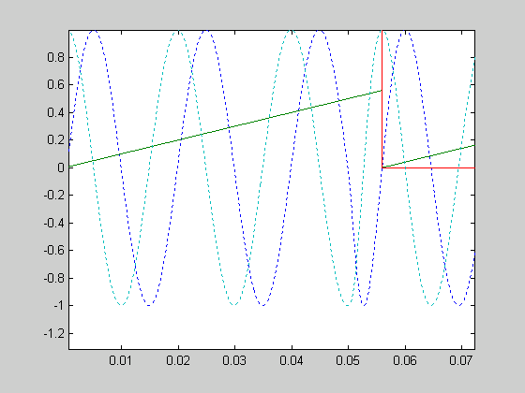
For this purpose, the SMEC control electronics provides the time elapsed between encoder pulses corresponding to, for example, 6 μm displacement (ie 3 encoder engraving wave of 2 μm ), by mean of a timer triggered by an external clock. This is done by the Encoder Interface Unit on the basis of a zero crossing every 3 cycles as seen on the next figure.These data are then delivered to telemetry high data rate serial link.
The value of the number of encoder cycles is programmable with a minimum value of 1 micron corresponding to the zero crossing of an elementary sine wave of the moire fringe optical encoder.
Figure 4: Time count (solid line) between encoder pulses for telemetry

Synchronization with DPU

The measurement of the delta time elapsed between 2 or more encoder zero crossing starts on the receipt of a specific synchronization signal. This synchro signal reset the internal timer of the delta time count in the Encoder Interface Unit FPGA. This function is implemented to allow synchronisation with detector data frames acquisitions. Since that the first delta time value provided to telemetry is representative of the time delay between the synchro signal provided by the DPU/DRCU and the first optical encoder pulse of the scientific scan. The delta time counter is incremented by the Low Speed Serial link clock set to 330 kHz. The counter range is defined to 32 bits.
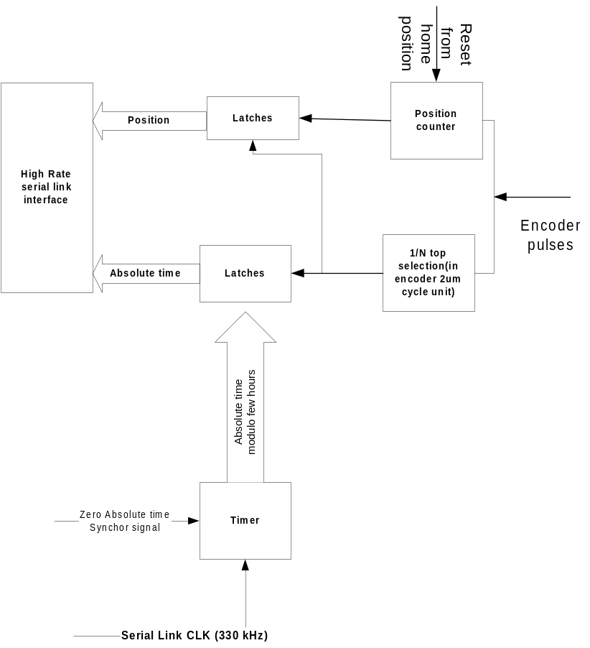

Figure 5 : Principle of position sampling timer synchronization with DRCU

Position data characteristic | As designed specification  (Initial Requirement) | Comment
Position data sampling | 1 μm  (5 μm) | Provides a time count every 2 encoder main pulses (encoder engraving of 2 μm)  Initial requirement based on the mini scientific wave length (200 um) divided by :  - 4 (interferometer arm ratio) x  - 5 (position data over sampling for calibration)
Position data accuracy | 0.01 μm  (0.1 μm) | Resolution given by the optical encoder after systematic non linearity correction
Position data synchronization | time count start between pulse triggered by external signal | allows to reconstruct the trajectory starting from a reference start signal to be synchronized with start of detector samples

Position data for telemetry sampling rate

The position for telemetry sampling data rate depends on the FTS SMEC velocity.
Consequently, le telemetry to be provided shall be asynchronous and not synchronised by a dedicated clock, the encoder pulses assuming to latch the delta-time counter.
The values of the sampling rate are proportional to the speed as specified in the following table. The sampling rate depends also proportionnaly on the length between the encoder pulses zero-crossing (eg every 2 or 4 sine waves).

Scan speed  (μm/s) | Position data sampling rate  (Hz) for 1micron delta time
200 | 200
500 | 500
1000 | 1000

Table 2 : Telemetry rates for zero crosing every 1 micron on the optical encoder

principle of operation OF BSM control

Requirements

The BSM is used to steer the optical beam of the SPIRE photometer channel over the detector arrays. The beam steering mirror will be used to perform jiggle mapping ( to produce fully sampled images for feedhorn arrays, and to improve image quality ) and perform chopping (to remove background and background variations and perform fine pointing corrections). This peaking up mode will be used to quickly ensure that point sources are well centred on individual detectors

The BSM comprises a flat mirror which is mounted on a two axis pivot system. This pivot system allows precise angular motion of the mirror over a small range of angular travel in two orthogonal axes. Electrical actuators are used to provide motion of the mirror. Magnetoresistive sensors are used to measure the mirror position to allow control of the mirror position. Control of each axis is done by a digital conventional PID (3-term) controller - with corrections for cross-coupling between axes- in the MAC Board.

Position profile specification | Axis | Value
Angular Travel | Chop (around Z axis in telescope coordinates) | ±3°
Angular Travel | Jiggle (around Y axis) | ±0.72°
Minimum step increment (demand) | Chop & Jiggle | 0.01°
Angular measurement resolution | Chop & Jiggle | 0.002°
True angular position accuracy | Chop & Jiggle | 0.04°
Angular position repeatability | Chop & Jiggle | 0.004°
Maximum chop axis frequency at max amplitude | Chop | 5 Hz
Maximum jiggle axis frequency at max amplitude | Jiggle | 1 Hz
Settling time to within 5% (TBC) of demand position (Chop axis) | Chop | 10 msec
Settling time to within 5% (TBC) of demand position (Jiggle axis) | Jiggle | 50 msec

Table 3: BSM Control system specifications

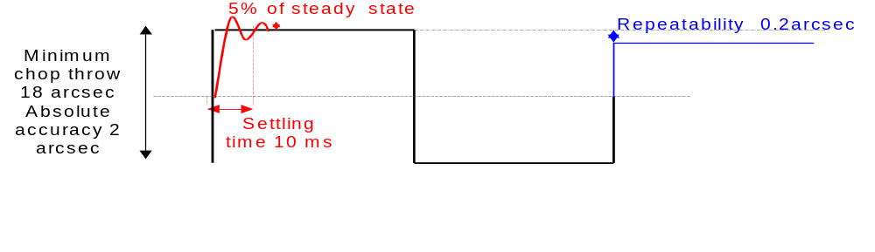
Figure 6: BSM Trajectory specification

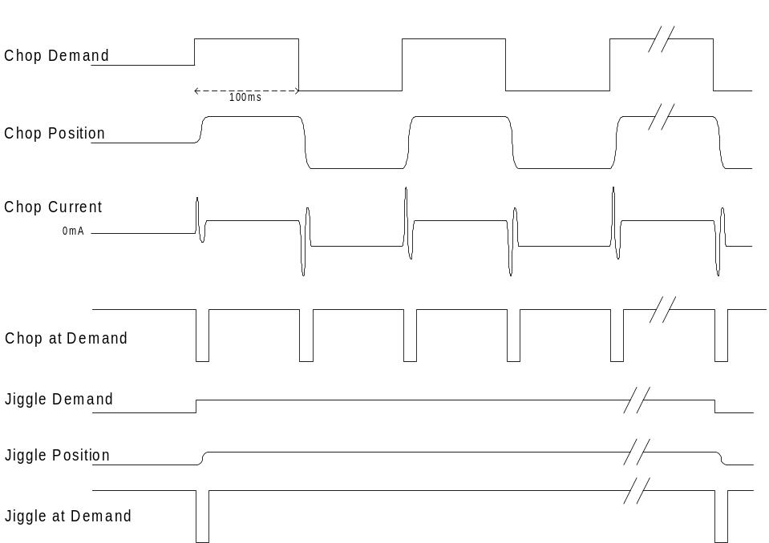

Figure 7 : BSM Control system chronogram

BSM Modes
- Off
- On
- On axis in Chop (z) at angle θ_{c}=0
- On axis in Jiggle (y) at angle θ_{j}=0
- Moving to position (θ_{c ,}θ_{j})
- Holding in position (θ_{c ,}θ_{j})

- TBC modes - which could be all software driven by master controller, by sending stream of positions to BSM controller
- Chopping on z axis
- Jiggling on z axis
- Jiggling on y axis

Command/Parameter list
Chop axis :
- Set point
- Proportional Term
- Integral Term
- Derivative Term
- TBC : Waveform : 1024 points - default is to drive by a series of set point commands from the DPU processor

Jiggle axis :
- Set point
- Proportional Term
- Integral Term
- Derivative Term
- TBC : Waveform : 1024 points - default as above

Status Parameters
- Chop axis position
- Chop axis motor current
- Chop axis position error
- Chop axis moving flag
- Jiggle axis position
- Jiggle axis motor current
- Jiggle axis position error
- Jiggle axis moving flag

Telemetry data list

- Chop and Jiggle axis positions to housekeeping @ 20 ms rate.

MAC Operation

The MAC Board may be operated by a set of commands according to the following table.

Mode # | Mode  Name |  |  |  | Action | Possible Next Mode | On Command
0 | Off |  |  |  | The set of boards is not powered. No function available | On | Power On
1 | On |  |  |  | The set of boards (main or redundant) board is powered . | Off | Power Off
1.0 |  | Booting |  |  | - The software is initialized after reset.  - The software is downloaded from Prom memory to SRam memory | Downloaded | MAC Reset On
1.1 |  | Downloaded |  |  | - The communication is available.  - The status of the system is available.  - Waiting for commands  - Goes initially to Open loop mode | Booting | MACReset On  ‘ResetMAC’
1.1.0 |  |  | Open Loop |  | - Waiting for Advanced Configuration Commands  (Control gains,etc ...)  - Goes initially to open loop standby | Close Loop | ‘CloseLoop’
1.1.1 |  |  | Close Loop |  | - nominal control loop mode using a digital PID controller at 100 μs sampling rate  - Goes initially to Stand By mode | Open Loop | ‘OpenLoop’
1.1.1.0 |  |  |  | CLoop Stand By | Waiting for motion configuration:  (Scan Length, etc..) | Motion init | ‘Init Motion’
1.1.1.1 |  |  |  | CLoop Motion Init | Searching for limits and diagnostics | Ready | End of Motion initialization
1.1.1.2 |  |  |  | CLoop Ready | Waiting for motion commands and configuration | Scan | ‘StartMotion’
1.1.1.3 |  |  |  | CLoop Scan | Motion underway: scan for the SMEC, chopping and jiggling for BSM | Ready | End of Motion  ‘StopMotion’  ‘ResetMotion

Command format

A command is a 32 bits word with the following allocation:

Bits 29-28 | Bits 27-20 | Bits 19-18 | Bits 17-0
MCU header | Command type | Axis id. | Parameter

Axis id:

- 0: all axis
- 1: SMEC axis
- 2: Chopper axis
- 3: Jiggle axis

Bufferized commands and parameters

Some commands should not take immediate effect on the control. These commands are called bufferized commands. They are taken into acount when a specific Update command is sent. This is useful for a configuration set definition such as the scan speed and length before a validation of the configuration. The parameters that are bufferized are :

- ClearPositionError,
- Acceleration,
- deceleration,
- Position,
- Velocity,
- Scan length
- PID parameters,
- MotorCommand.

Digital Servo Filter commands

Command type | Action
SetKp | Proportional gain of the digital PID controller
SetKd | Derivative Gain of the digital PID controller
SetDerivativeTime | Sets the sampling time to calculate the derivative term in number of servo cycles
GetDerivativeTime
GetDerivative | Only in Closed-loop mode:Returns the derivative of the current position error as calculated by the servo filter. The derivative value is defined as the previous position error substracted from the current position error.
SetKi | Integral gain of the digital PID controller
GetIntegral | Returns the current integrated position error of the servo.Can be used for Integration limit survey
SetIntegrationLimit | Loads/Reads the integration saturation for the intergral compensation of the servo
GetIntegrationLimit
SetPositionErrorLimit | determine/reads the position error value that causes an error on the servo
GetPositionErrorLimit
ClearPositionError | In case of the position error exceeds a thresold, the motion is stopped for further diagnostic. This command is used to reset the position error by forcing the position refernce to be equal to the actual position counter.
GetPositionError | Returns the difference between the actual position and commanded position
SetMotorBias | Sets a bias voltage of the digital servo.Used for a static effort cancel out on the mechanism
GetMotorBias
SetMotorLimit | Sets a saturation on the output of the motor output command issued by the servo filter
GetMotorLimit
SetSampleTime | Sets the cycle time for the servo of the specified axis
GetSampleTime | Sets the cycle time for the servo of the specified axis
SetNotchParam Axis i | Parameters for notch filtering of mechanical modes

Trajectory Profile commands

Command type | Action
SetPosition | specifies the trajectory detination  For BSM= position step level (um)  For the SMEC : moves the SMEC by a step by step way.  Unit= 1 um Range: 5.5 cm: 55000 values  B0-B21: position reference from the home position
GetPosition | Allows the measurement of a position step by step.  Usefull for engineering mode to get position for step response.  B0-B21: actual position from the home position
GetCommandedAcceleration | returns the current commanded acceleration value for the specified axis.
GetCommandedPosition | The commanded position is the instantaneous position value output by the trajectory generator
GetCommandedVelocity | The commanded velocity is the instantaneous velocity value output by the trajectory generator.
SetAcceleration | Load the max acceleration of the motion
GetAcceleration | Load the max acceleration of the motion
SetActualPosition | loads the actual position register and at the same time the commanded position
SetJerk | Loads the acceleration variation limitation on the trajectory of the specified axis
GetJerk
SetScanLength  GetScanLength | Load / update a table defining a spectrometer scan.  The scan is defined as a start position, ie a number of position sensor fringes move
SetScanSpeedRef  GetScanSpeedRef | Load/Read the desired speed of the control  scan reference speed: 16 bits  if value=0 the servo is in position mode
SetProfileMode Axis i | ‘SetProfileMode’=0 => Mode= Position_Closed_Loop  ‘SetProfileMode’=1 => Mode= Scan_Closed_Loop  The number of scan to be performed is within parameter

I/O and Encoder signals related commands

GetCaptureValue | Returns the contents of the Position Capture register
GetActualPosition | reads the contents of the encoder’s actual position counter
SetCaptureSource | Defines which signal is used for encoder counter initialization (Home,Limits switches,Current position)
SetEncoderSource | Set the tyep of encoder feedback. Can be incremental mode using sine cosine A/B signals, or arctan computation
SetEncoderRatio | Converts the number of encoder pulses in scan length micron units
GetEncoderRatio
GetSignalStatus | Returns the signal status register: Encoder A,Encoder B,Home,Positive limit,Negative Limit
SetLimitSwitchMode | Enables or disables the limit switches sensing

DSP Software related commands

GetTime | retuns the number of cycles since last reset
GetVersion | Returns software version number
Reset | restores the chipset to initial default conditions
ResetEventStatus | reste the event stus and related error bits for re-initialisation
Update | Updates in the chipset the buffered parameters (eg PID parameters)

Communication related commands

GetHostIOError | returns the IO Error code
SetIOPollingTime | Set a maximum time between 2 commands before a IO Error code is generated, meaning a communication problem
NoOperation | No effect on the chipset.It is usefull as a ‘null’ operation to verify communication with the Motion Processor
SetPortMode | Determines the instructions set that can be executed.When set to Limited, only the base instructions may be used
GetPortMode

Motion and control modes related commands

Command type | Parameter | Action
GetEventStatus |  | reads the event register for a specified axis.
GetActivityStatus | Axis# | reads the Activity Status Register. This Stuatus Register can only be read and no bit cna be cleared since the word is refreshed by the chipset.
GetCurrentMotorCommand |  | Returns the current motor command for the specified axis. In closed loop, this is the output of the servo filter. In the open loop mode it is the contents of the motor output command register.
SetMotionCompleteMode |  | establishes the source for the comparison which determines the motion complete status
GetMotionCompleteMode
SetMotorMode |  | Determines the mode of operation: open loop,closed loop,back EMF loop
SetMotorMode | Axis# | ‘SetMotorMode’= 1 => Mode = Closed_Loop  ‘SetMotorMode’= 0 => Mode = Open_Loop
GetMotorMode |  | The error / internal mode status word allows the DPU to identify problems  B0-B3: idem set_SMEC_mode  B4-B21: error/internal mode status
SetSettleTime |  | Sets the time that the specified axis must remain within the tracking before the axis settled indicator is set to 1
GetSettleTime
SetStop |  | Stops the specified axis in abrupt or smooth mode
GetStop |  | Stops the specified axis in abrupt or smooth mode
SetAutoStopMode |  | Defines the conditions onwhich the motion sould stop
SetBreakpoint |  | Defines an action of a specified event
GetBreakpoint |  | Reads the register defining breakpoint conditions

Trace and telemetry related commands

The trace mode allows to record up to 4 data in a memory allocation for further read out of servo loop values. The trace table is , after recording, read by a dedicated command on the low rate serial command line (point to point).

Command type | Parameter | Action
GetTraceCount |  | Returns the number of points stored in the DSP Trace Buffer it defines the length of telemetry sample
GetTraceStatus |  | B0=  1 when in synchronous mode,  0 when in asynchronous encoder pulses mode
SetTraceMode |  | The trace may be in rolling on or one shot time
SetTracePeriod |  | Sets the time period, expressed in ms, between successive trace points.  or the number of encoder zero crossing to be sampled in asynchronous mode
SetTraceStart |  | 0=Immediate start of the trace  1= Stop on next Update command  2= Event Status Register  3= Activity Status register  4= Signal Register Bit  + mask of the register fro trace trigger
SetTraceStop |  | 0=Immediate stop of the trace  1= Stop on next Update command  2= Event Status Register  3= Activity Status register  4= Signal Register Bit
SetTraceVariable |  | Specifies up to 4 variable to be put in the DSP trace register and sent to telemetry channel. It consists in the telemetry data mux selection
TelemetryCounterReset  (broadcast) | 1 dedicated bit | Starts the telemetry counter on a broadcast synchronized signal

HK on the command line related commands

This commands allow to recover some data for H/K in order to build a table representative of the inner state of the servo control.

Command type | Parameter | Action
GetActualVelocity | Axis # | Get the instantaneous velocity
GetScanMeanSpeed | Axis # | actual scan mean measured speed: 16b  Allows to verify the velocity scan error
SetMeanSpeedMeasure | Axis # | Length of the speed sample used for Mean Speed measurement
ReadAnalog | Value to be read | Returns a 16 bits value representing the value of a specified analog input

Event Status Register

Bit | Name | Description
0 | Motion Complete | Set when a trajectory profile/scan is complete
1 | Position wrap | Set when the actual motor position exceeds 7FFF.. (the most positive position) and wraps to 8000... (the most negative positin)or vice versa
2
3
4 | Motion error | Set when the actual position differs from the commanded position by an amount more than the specified maximum position error
5 | Positive limit
6 | Negative limit
7 | Instruction error | Set when an instruction error occurs

Activity Status Register

Bit | Name | Description
0
1 | @ Maximum velocity | Set to 1 when the trajectory is @ maximum velocity. This bit is determined by the trajectory generator, not by the actual encoder position.
2 | Tracking | Set to 1 when the axis is within the tracking window
3 | Current profile mode | on 3 bits: velocity scan, position step, trapezoidal
4 | Axis setteld
5 | Motor Mode on/off
6 | Position capture
7 | In-motion
 | In positive limit
 | In negative limit | Set to 1 when the negative limit switch is active

I/O Error code register

Bit | Name | Description
0 | No error
1 | Processor reset
2 | Invalid instruction
3 | Invalid axis
4 | Invalid parameter
5 | Block out of bounds
6 | Bad serial CKS
7 | Not primary port
8 | Invalid parameter change
9 | Invalid move within limits

MAC SOFTWARE

21020 DSP Software principles

The DSP software is in 21020 assembly language without the use of a specific off-the-shelf real time operating kernel. The assembly language is choses because Analog Devices provides directly specific libraries to produce PID, filtering, arctan computation with a high efficiency (and even readability). For this reason C coding is not foreseen since the software shall be simple, dedicated to pure signal processing (ie realisation of IIR Filters with product/sommation operations) without complexe command interpreting nor complex mode of operations.
The main tasks to be realized are called by a Master scheduler which is a routine interrupted by a software interrupt generated by the inner timer of the DSP.
Mainly, the software does not use other interrupt, excepted for the the following functions :

- watchdog interrupt to recover from a loss of control of the DSP,
- interrupt when the command / parameter buffer between the WE interface chip and the DSP is full, indicating that the flow of data entering the DSP is too high.

Code uploading in the DSP is not foressen, the DSP beeing only used for control, in substitution of analogue electronics, with very poor load regarding communication / command interpreter. Code uploading would imply a very heavy software management task.

Watchdog mechanism

- The DSP resets periodically a counter implemented in the telemetry FPGA.
- This counter is incremented on the basis of the telemetry FPGA internal clock.
- If the DSP does not ensure the counter reset, the telemetry FPGA automatically resets the DSP.

Digital I/O polling

The DSP comprises an digital I/O area for the following signals :

- reach of the home limit

- trajectory count error

Reset

The reset of the DSP shall be activated on the following events :

- no watchdog signal
- communication FIFO full

ITs

the ITs are used for emergency in case of :

- Limit sensor reached
- Error in the trajectory detected by the encoder interface FPGA

MAC Software architecture

The software is designed to be as simple as possible. For this purpose, there is an only task running every time defined by the digital servo sampling time parameter. The digital servo sampling time is defined by the MMS (Mac Master Shceduler).

MAC Master Scheduler (MMS)

The principle of the MMS is the management of the main cycle to be performed in the MAC DSP.

The main cycle is set by default to 100 us (TBC), but is configurable.

The MMS uses the internal clock of the DSP , incrementing an internal counter set to deliver an interrupt every 100 us triggering the start of the main task.

MAC Main task

SMEC Digital Control
Chopping Digital Control

Jiggling Digital Control

Update Trace Table

Read Command on Command Link Input register, load in memory and reply

MM Scheduler
@ 100 us
Wait For next scheduler IT

SMEC and BSM axis Control Algorithms

- Read Digital I/O (Home, Upper and Lower limits)
- Compute control status
- Compute servo loop

SMEC Servo Loop algorithm

- Step 1 : read sinus and cosinus (1 DSP cycle = 50 ns)
- Step 2 : read cosinus (1 DSP cycle = 50 ns)
- Step 3 : filtering sinus (T1 = 40 DSP cycles = 2 µs)
- Step 4 : filtering cosinus (T1=40 DSP cycles = 2 µs)
- Step 5 : compute arctangent (T2 = 120 DSP cycles = 6 µs)
- Step 6: compute current trajectory,that is the same that a speed filtering (T1=40 DSP cycles=2 µs)
- Step 7 : compute current error and “do something” if error > max error (T3=40 DSP cycles=2 µs)
- Step 8 : with error, compute output DAC for FTS motor amplifier (T4 = 80 DSP cycles = 4 µs)
- Step 9 : write output DAC (1 DSP cycle = 50 ns)

T1, T2 are roughly given and are to be exactly defined.
T3,T4 and T6 are estimated with Analog Device application notes, for example the number of cycles for a FIR Filter is given by : number of cycles = 7 + number of taps used for filtering.
Another example is the compute of PID in 10 cycles (ref : DSP-Based Motor Controller Seminar of Analog Devices)
These numbers don’t include error test , overflow… so we must reserve about 20 cycles for this.
The compute of Arctangent is given for 82 cycles maximum from Analog Devices (ref ADSP-21000 Family Application Handbook), but we must reserve about 40 cycles for overflow and error tests.
So, the total timing for execute step 1 to 11 can be estimated to about 17 µs.

BSM Chopping axis Servo loop

Nota : the BSM software is specified in the Reference Document RD1 Beam Steering Mirror Control Software Requirements (Spire-ATC-Draft)

- Step 1: set analog multiplexer to BSM chop position magneto-resistive sensor (1 DSP cycle = 50ns)
- Step 2: wait 300 ns (analog mux transition time)
- Step 3: write Start of Conversion to ADC (1 DSP cycle = 50 ns)
- Step 4: wait 15 µs (ADC conversion time)
- Step 5: read position (1 DSP cycle = 50 ns)
- Step 6: compute position filter (T1 = 40 DSP cycles = 2 µs)
- Step 7: compute current error and “do something” if error>max error (T2 = 40 DSP cycles = 2 µs)
- Step 8: with error, compute output DAC for BSM Chopping axis (T3 = 40 DSP cycles = 2 µs)
- Step 9: write output DAC (1 DSP cycle = 50 ns)
So, the total timing for execute step 1 to 9 can be estimated to about 7 µs.
The steps are exactly similar to the previous task.

MCU Electronics DESIGN

This Section is intended to describe the features and the architecture of the Subsystem dedicated electronics (i.e. electronics circuitry and interconnection including complex circuits like FPGAs and/or dedicated micro-controllers.

Overall description.

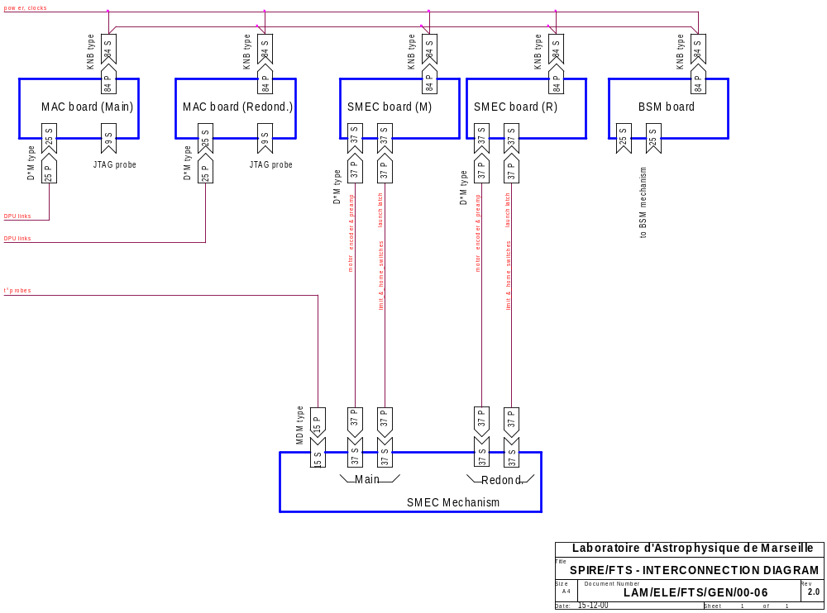

MCU Mechanical implementation.

Mechanism control unit (MCU)

WE includes :
- 2 Multi Axes Controllers (MAC) boards,
- 2 SMEC boards,
- 1 BSM board.
Two MAC boards, SMEC boards and BSM board are plugged on the same mother board.

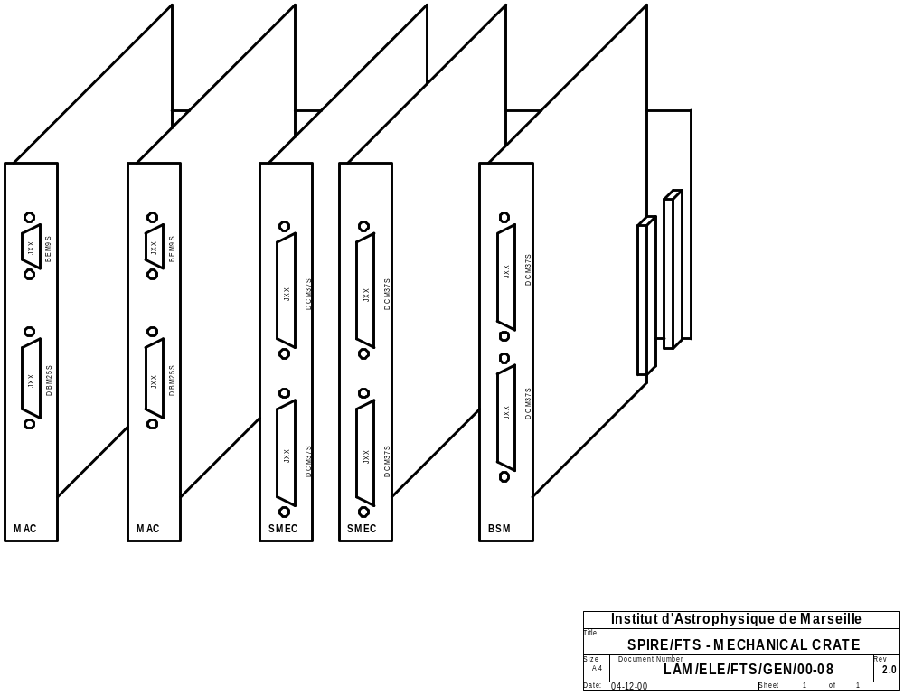

Dimensions of the MAC, SMEC and BSM boards are 220 x 223 mm² (TBC).

Position encoder preamplifier box

The preamplifier box include the two preamplifiers for main and redundant channels. It is located in the SMEC mechanism, near the position encoder heads.
Dimensions are TBD
The mass of the electronics boards is estimated to 98 g.

Mass

Subsystem | Number | Nominal mass / unit  (g) | Margin / unit (g) | Dispersion / unit (g) | Total max. mass  (g) | Remarks
MAC module  board | 2 | 380 | 76 | 9 | 930 | TBC
MAC module  mechanical and thermal parts | 2 | TBD | TBD | TBD | TBD
SMEC module  board | 2 | TBD | TBD | TBD | TBD
SMEC module  mechanical and thermal parts | 2 | TBD | TBD | TBD | TBD
BSM module  board | 2 | TBD | TBD | TBD | TBD
BSM module  mechanical and thermal parts | 2 | TBD | TBD | TBD | TBD
preamplifier board | 2 | 40 | 8 | 1 | 98 | TBC
TOTAL |  |  |  |  | TBD

Power dissipation

Subsystem | Voltage | Average power (TBC) | Peak power / time  (TBC) | Average / peak current | Remarks
MAC board DSP and logic | + 5 V | 8000 mW  (TBC) | 13500 mW  (TBC)  t = 100 ms (TBC) | 1.6 A /  2.7 A (TBC) | - power peak happens during DSP boot
MAC board analogue & data converters | ± 13 V | 2500 mW | 2500 mW | 90 mA on + 13 V  77 mA on – 13 V
SMEC board analogue electronics | ± 13 V | 1500 mW (TBC) | 1500 mW (TBC) | 58 mA on + 13 V  58 mA on – 13 V
SMEC board PWR Amplifier | ± 15 V (TBC) | 45 mW on + 15V or  45 mW on - 15V | 120 mW on + 15V or  120 mW on -15V  t < 10 ms | 3 mA  8 mA max (TBC) | - motor harness resistance at 300 K less than 600 ohms  - power peak happens during acceleration of the mirror.
BSM board analogue electronics | ± 13 V | 1500 mW (TBC) | 1500 mW (TBC) | 58 mA on + 13 V  58 mA on – 13 V
BSM board PWR Amplifier | ± 15 V (TBC) | 150 mW on + 15V or 150 mW on - 15V | 300 mW on + 15V or  300 mW on -15V  t < 10 ms | 10 mA  20 mA max (TBC) | - motor harness resistance at 300 K less than 600 ohms  - power peak happens during acceleration of the mirror.
TOTAL |  | 13700 mW | 19420 mW |  | - power peaks on SMEC and MAC boards are nether at the same time.

Interfaces

MCU I/F with SMEC

I/F | Type | Nb. of cond. | I/O | Value | Constraints
Linear Motor Coil | analogue current | 2 | out | 8 mA max. (TBC) | 20 Ω load for total harness resistance.
Linear Motor Coil | back EMF analogue voltage | 2 | in | 10 µA max.
Optical Encoder | Sinusoidal low level signals provided and preamplified by 3 photodiodes delivering moire fringes signals | 12 | in | 5 μA peak  (TBC) | distance from position encoder to preamplifier as short as possible.
Optical Encoder | analogue current delivered to LED | 2 | out | 0.5 mA DC (TBC)
Optical Encoder | analogue current delivered to preamplifier | 2 | out | 200 µA DC (TBC)
Optical Encoder | analogue current delivered to heaters | 3 | out | 30 µA DC (TBC)
Temperature probe | analogue current delivered to t° probe | 2 | out | 10 µA DC (TBC)
Temperature probe | analogue t° signals provided by t° probe | 2 | in | TBD mV
Home Position magneto-resistive sensors | analogue current delivered to resistors bridge | 3 | out | 2 x 0.5 mA (TBC)
Home Position magneto-resistive sensors | analogue  voltage delivered by resistors bridge | 2 | in | +/- 50 mV
Limit Position magneto-resistive sensors | analogue current delivered to resistors bridge | 2  x 2 switches | out | 0.5 mA (TBC)
Limit Position magneto-resistive sensors | analogue  voltage delivered by resistors bridge | 2  x 2 switches | in | +/- 50 mV

MCU I/F with BSM

I/F | Type | Nb. | I/O | Value | Constraints
Voice Coil Motor | analogue current | 2 x 2 motors | out | 20 mA max (TBC)
Home Position magnetoresistive sensors | analogue current delivered to resistors bridge | 3 x 2 bridges | out | 2 x 1 mA (TBC)
Home Position magnetoresistive sensors | analogue  voltage delivered by resistors bridge | 2 x 2 bridges | in | +/-100 mV

Position sensor specification :

- resistance at 300K : 2 x 100 Ω nominal
- small change at 4K
- excitation current : 1 mA DC
- dissipation : 0.5 mW (constant)
- output voltage : +-0.1 V
- Hysteresis : ~ 0.05° - corrected as part of control algorithm

- Infineon (ex-Siemens) FP 212 L100-22 differential field plates sensing moving soft iron pieces
- The sensors are dual InSb/NiSb magnetoresistive elements, biased with a permanent magnet and forming part of a bridge circuit.

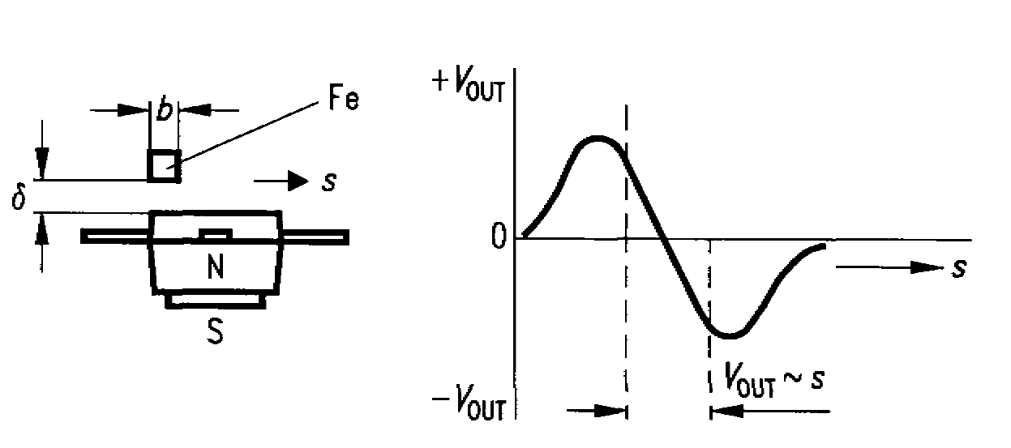

MCU I/F with DPU

The interface with the SPIRE DPU consists of :
- 2 synchronized serial links :
- the command serial link for configuration order and low speed exchanges with the DPU
- the telemetry / HK serial link for high-speed data transfer to the DPU.

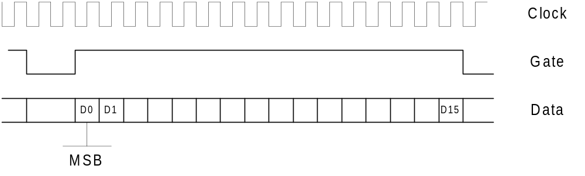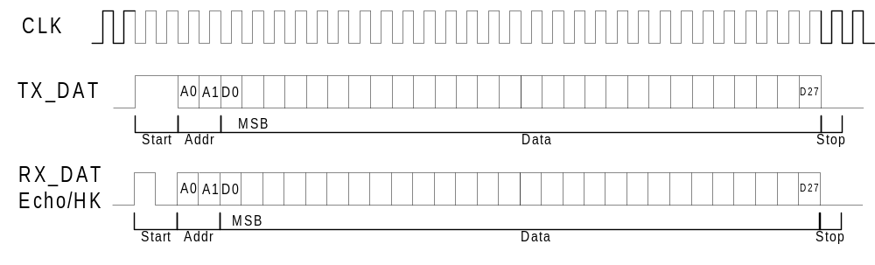

Board Design description.

MAC Board

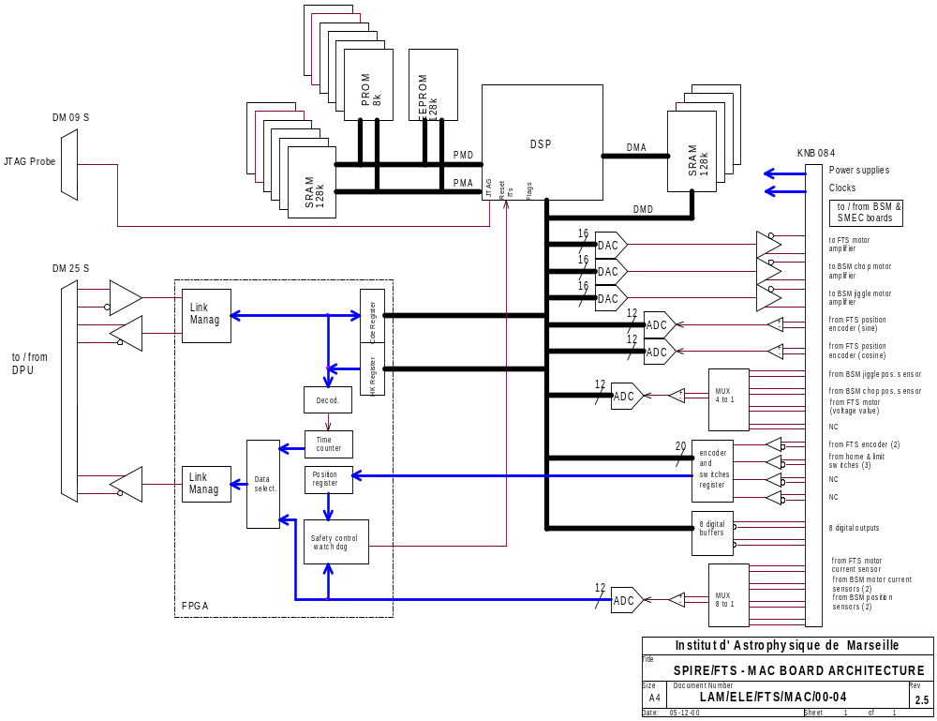

SMEC Board

The SMEC Board is a double europe card including all analog electronics interfacing the SMEC Subsystem. It includes:

- the motor amplifier

- the optical encoder acquisition

- the limit position sensors conditionning

Main and redundant chains are included on the same board.

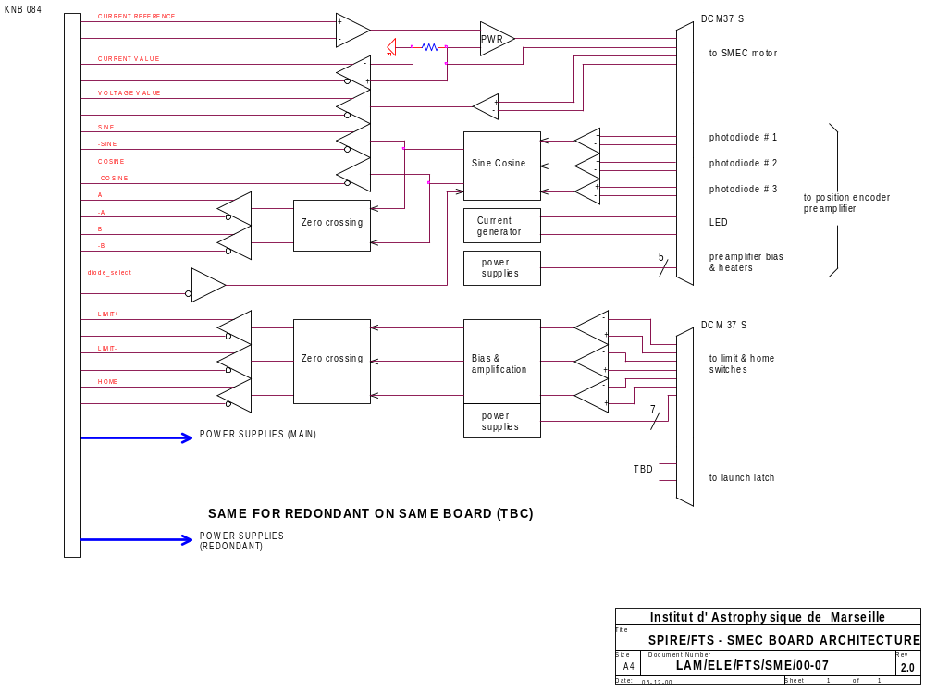

MOTOR Power amplifier

The Power Amp is based on bipolar transistors (complementary pairs of 2N2905A) providing a gain of 2mA/V with abandwidth àf 3.3 kHz.

The layout is To Be inserted

Encoder acquisition electronics AND PREAMP

see SMEC Board Layout for encoder acquisition electronics.

Optical Encoder Preamplifier

- The preamplifier box include the two preamplifiers for main and redundant channels. It is located in the SMEC mechanism, near the position encoder heads.

- 3 TIA (IRLAB Components) with inner thermal regulation (+ 3 redundant)

- PB: Needs 20 mn to rize from 4K to 100 K => Major issue for operations

- 100 mwatt/TIA

BSM Board
- Position sensor read-out :
- Bridge circuit with switchable DC bias,
- Instrumentation Amplifier eg AMP 01 or OP 27,
- Multiplexer and 12 bit A/D converter eg 9221LPRP
- Motor drive
- Complimentary bipolar transistor pair eg 2N 5153/4 or 2N2219 / 2N 2905
- Motor Current Measurement
- series resistor and connection to A/D converter

Power Supply

Subsystem | Nominal voltage | Average current | Peak current / time | Voltage stability | Voltage Noise | Remarks
MAC board DSP and logic | + 5 V | 1.6 A (TBC) | 2.7 A (TBC) /  100 ms (TBC) | ± 2.5 % | TBD
MAC board analogue elec. & data converters | ± 13 V | 90 mA on + 15 V  77 mA on – 15 V | - | ± 2.5 % | TBD
SMEC board analogue electronics | ± 13 V | 50 mA on + 15 V  50 mA on – 15 V | - | ± 2.5 % | TBD | includes power for preamplifiers and position encoder.
SMEC board PWR Amplifier | +/-15 V (TBC) | 3 mA  (TBC) | 8 mA (TBC) / 50 ms (TBC) | ± 5 % | TBD | motor harness resistance < 600 ohms at 300 K
BSM board analogue electronics | ± 13 V | 50 mA on + 15 V  50 mA on – 15 V | - | ± 2.5 % | TBD | includes power for position encoder.
BSM board PWR Amplifier | +/-15 V (TBC) | 10 mA  (TBC) | 20 mA (TBC) / 50 ms (TBC) | ± 5 % | TBD

- Two complete sets of these above power lines are needed (main power lines & redundant power lines).
- Encoder preamplifier boards (M & R) are powered by SMEC board.
- All the electrical components in the SMEC mechanism are powered by the SMEC board.
- All the electrical components in the BSM mechanism are powered by the BSM board.

Grounding Scheme.

- Motor PWR Analog ground to be added on the schematics
- The analog grounds not connected @ MCU level
- Analog/Digital grounds connected @ ADC level
- Analog ground not connected to mechanics
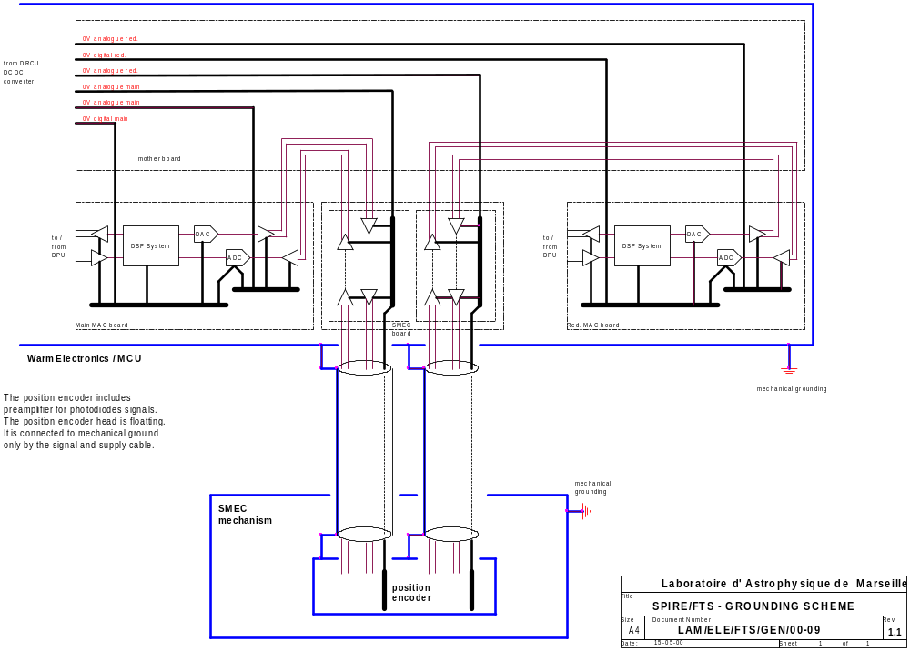

Use of Special Components/Component list.

See the EEE part list for the complete set of components (doc ref LAM/ELE/FTS/QUA/000201).

Redundancy and degraded modes

The design is oriented in order to avoid :

- single point failures by mean of dedicated redundancy,
- propagation of failures to other sub systems by mean of specific protections.

Redundancy

The SMEC Control electronics consists of 2 independent sets of boards without cross switching.
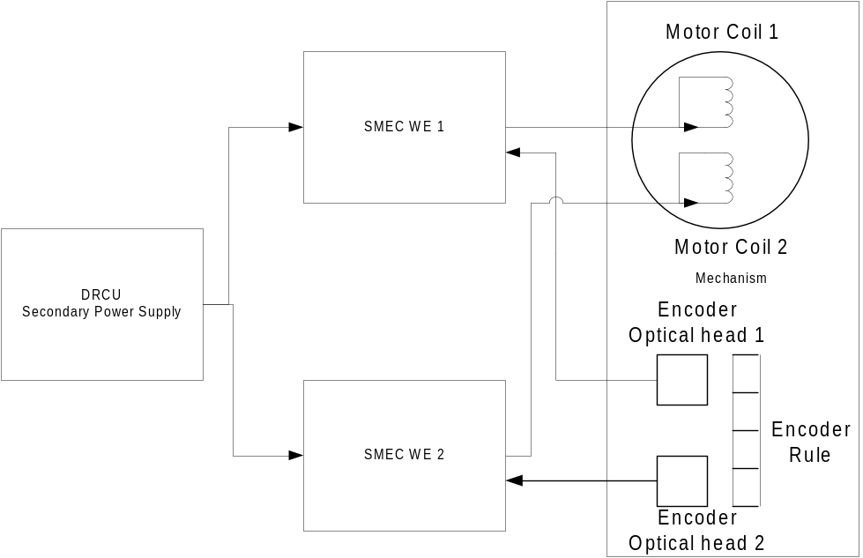The related reliability is expressed by :
WE1.M1.OE1 + WE2.M2.OE2
Wei : FTS electronics board
Mi : motor coil
Oei : optical encoder
Note : the solution with cross switching of the components would imply non reliable complexity and single point failure with the following reliability layout : (WE1+WE2).(M1+M2).(OE1+OE2).Ics with Ics : Necessary Interface for cross switching

Limitation of failure propagation

The limitation of the failure propagation is ensured by design as demonstrated in the following AMDEC analysis :

Subsystem/Component in failure | Event during a specific mode of operation | identification mean | Effect | Recovering  Degraded mode
Interface electronics | No command can be received | the DPU has no command handshake | FTS WE out of control
Interface electronics | Bad command/parameter | Checksum/No recognition of a command |  | Stop of the scan  Status report  Switch to stand-by mode waiting for another control mode operation
DSP and related interface components | Control algorithm diverging | software limits | Increase of the actuator command up to limitation | Stop of the scan  Status report  Switch to stand-by mode waiting for another control mode operation
DSP and related interface components | No control on the DSP | Watchdog |  | Emergency stop on watchdog action
Motor and related PWR amp | Short cut in the motor coil | Motor current measurement | Limitation of current value by the PWR amplifier | Use of the redundant board + motor coil.
Optical encoder and related acquisition electronics | Loss of some individual incremental pulses  during closed loop operation | Difference between fiducial mark and position counter | Perturbation on the trajectory | Status report  Adjust the position counter on next scan
Optical encoder and related acquisition electronics | Total loss of incremental encoder pulses | id. | Error vs ramp reference increase ->  Increase of the actuator command due to integral effect and position ramp increase ->  Excessive motion speed up to speed limitation. ->  Emergency stop. | Stop of the scan  Status report  Switch to stand-by mode waiting for another control mode operation
Optical encoder and related acquisition electronics | Glitch on the absolute position counter (decreasing) | Additional position switch on the mechanics | The scan goes to hardware limits | Flyback operation and reset of the absolute position counter
Optical encoder and related acquisition electronics | Glitch on the absolute position counter (increasing) | The scan ends before the nominal scan length parameter, and a difference between fiducial mark and position counter occurs at the end of flyback | The scientific scan is not achieved completely | Status report  Readjust the position counter on next scan

BSM Redundancy and degraded modes

- SPIRE BSM will have 2 position sensors per axis, all permanently connected to separate analogue inputs,
- The motors will wired and driven so that failure of one coil allows operation at reduced performance

Failure Mode | Effect | Remedy | Criticality
Chop Pos Sensor 1 fails | Cannot measure Ch1 position | Use C2 pos coil | No effect
Chop Pos Sensor 2 fails | Cannot measure Ch2 position | Use C1 pos coil | No effect
Chop Drive Coil 1 fails off | Cannot move from nominal position | Use C2 drive coil on its own | Longer rise-time – lose some efficiency
Chop Drive Coil 2 fails off | Cannot move from nominal position | Use C1 drive coil on its own | Longer rise-time – lose some efficiency
Chop Drive Coil 1 fails on | Cannot move from last position | Switch off BSM controller | Cannot chop or jiggle – only scan mode
Chop Drive Coil 2 fails on | Cannot move from last position | Switch off BSM controller | Cannot chop or jiggle – only scan mode
Both Pos Sensors fail | Cannot measure position | Run open loop | Reduced accuracy of chop or jiggle – or use scan mode
Both Drive coils fail off | Cannot move from nominal position | None – 2 point failure | Cannot chop or jiggle – only scan mode
Mechanism sticks | Cannot move from last position | None | Cannot chop or jiggle – only scan mode  May lose some FOV

